

IRMS: MOSFIRE on TMT
TMT.INS.CDD.07.001.REL01

Ian Powell, Jenny Atwood, Peter Byrnes
HIA
17 Apr 2007

Table of ContentS
1 Introduction 4
1.1 Purpose 4
1.2 Scope 4
1.3 Applicable Documents 4
1.4 Reference Documents 4
1.5 Change Record 5
1.6 Abbreviations and Acronyms 5
1.7 Glossary 5
1.8 Verb Convention 5
1.9 Acknowledgements 5
2 IRMS introduction and top-level requirements 6
3 Optical DESCRIPTIONs 7
3.1 MOSFIRE on KECK 7
3.2 MOSFIRE on TMT (with no modifications) 7
3.3 MOSFIRE on TMT (with modifield field lens) 8
3.4 PERFORMANCE COMPARISON OF MOSFIRE on KECK and TMT 8
4 MECHANICAL ISSUES 23
4.1 General Description 23
4.2 Interface Modifications 23
4.3 Impact of modifying pupil location 26
4.4 Constraints affecting field lens position 27
4.5 Recommended Solution: Displaced CSU 29
5 Recommendations 30

Figures
Figure 3-1 Schematic of sideview of MOSFIRE (KECK) - imaging mode. Light enters from the left and passes through the slit mask mechanism to the large field lens and then to a fold mirror. 9
Figure 3-2 Top view of MOSFIRE (KECK) after the fold mirror - imaging mode 9
Figure 3-3 Foot-prints associated with beams from a total of 9 field points at (a) one of the field lens surfaces, and (b) 36x36mm detector, assuming a 4.8x4.8’ FOV and a spectral range from λ: 0.97 to 2.40μm 10
Figure 3-4 Spot diagrams associated with KECK + MOSFIRE for 4.8x4.8’ FOV - imaging mode 10
Figure 3-5 Spot diagrams associated with KECK + MOSFIRE for 4.8x1.8’ FOV - spectral mode 11
Figure 3-6 Foot-prints associated with beams from a total of 9 field points at reference surface 328mm in front of fold mirror/grating location for (a) imaging mode with 4.8x4.8’ FOV (λ: 0.97 to 2.40μm) and (b) spectral mode with 4.8x1.8’ FOV (λ: 2.00 to 2.35μm) 11
Figure 3-7 Spot diagrams associated with pupil imagery of KECK + MOSFIRE for 4.8x4.8’ FOV - imaging mode 12
Figure 3-8 Distortion mapping associated with pupil imagery of KECK + MOSFIRE for 4.8x4.8’ FOV-imaging mode 12
Figure 3-9 Top view of MOSFIRE (after fold mirror) + beam trajectories following TMT and NFIRAOS combination - imaging mode 13
Figure 3-10 Foot-prints associated with beams from a total of 9 field points with reference surface half way between last element of collimator & filter (a) imaging mode with 2.0x2.0’ FOV (λ: 0.97 to 2.40μm) & (b) spectral mode with 2.0x0.6’ FOV (λ: 2.00 to 2.35μm) 13
Figure 3-11 Spot diagrams associated with TMT + NFIRAOS + MOSFIRE for 2’ circular FOV - imaging mode 14
Figure 3-12 Spot diagrams associated with TMT + NFIRAOS + MOSFIRE for 2.0x0.6’ elliptical FOV-spectral mode 14
Figure 3-13 Spot diagrams associated with pupil imagery of TMT + NFIRAOS + MOSFIRE for 2’ circular FOV - imaging mode 15
Figure 3-14 Distortion mapping associated with pupil imagery of TMT + NFIRAOS + MOSFIRE for 2’ circular FOV - imaging mode 15
Figure 3-15 Top view of MOSFIRE with modified field lens + beam trajectories - imaging mode 16
Figure 3-16 Spot diagrams associated with TMT + NFIRAOS + MOSFIRE (modified field lens) for 2.0’ circular FOV - imaging mode 16
Figure 3-17 Spot diagrams associated with TMT + NFIRAOS + MOSFIRE (modified field lens) for 2.0x0.6’ elliptical FOV - spectral mode 17
Figure 3-18 Foot-prints associated with beams from a total of 9 field points with reference surface half way between last element of collimator & filter (a) imaging mode with 2.0x2.0’ FOV (λ: 0.97 to 2.40μm) & (b) spectral mode with 2.0x0.6’ FOV (λ: 2.00 to 2.35μm) 17
Figure 3-19 Spot diagrams associated with pupil imagery of TMT + NFIRAOS + MOSFIRE (modified field lens) for 2’ circular FOV - imaging mode 18
Figure 3-20 Distortion mapping associated with pupil imagery of TMT + NFIRAOS + MOSFIRE (modified field lens) for 2’ circular FOV - imaging mode 18
Figure 4-1 MOSFIRE/IRMS with Generic NFIRAOS Instrument Envelope Superimposed (in red) 24
Figure 4-2 MOSFIRE/IRMS Situated on Lateral Instrument Port of NFIRAOS 25
Figure 4-3 Section View showing Science Beam and MOSFIRE/IRMS Input Optics 26
Figure 4-4 View of MOSFIRE’s Optical System Components (from MOSFIRE PDR Report) 27
Figure 4-5 Section View showing Field Lens (A), Internal Structure Stiffening Tube (B), Collimator Lenses (C), and Internal Bulkhead A (D) 28
Figure 4-6 Section through Internal Structure showing Filter Wheel (grey) Clearance to Stiffening Tube (purple) 28

Tables
Table 3-1 Lens prescription of KECK telescope and MOSFIRE combination 19
Table 4-1 Field Lens Position Approximate Space Envelope for Alternative Re-engineering Cases. Parenthetical Values Indicate Combination of Each Case with the Modified Cell 29

Introduction
In December 2006, SAC recommended that a clone of the Keck MOSFIRE instrument (behind NFIRAOS) should become one of the first light instruments. This is an initial examination of how feasible it is to interface MOSFIRE and NFIRAOS from both optical and mechanical perspectives.

Purpose
Understand the mechanical and optical details of the Keck MOSFIRE instrument and identify possible TMT interface issues. Recommend any possible new requirements, if any, that NFIRAOS must meet in order to make this possible.

Scope
As necessary, concepts and requirements flow down from the TMT Science Requirements Document (SRD).
As necessary, new requirements implied by the current document flow down into:
- TMT Observatory Requirements Document (ORD)
- TMT Observatory Architecture Document (OAD)

Applicable Documents
Applicable documents are containing information that shall be applied in the current document. Examples are higher level requirements documents, standards, rules and regulations.
AD01 | Science-based Requirements Document v15 | TMT.PSC.DRD.05.001.REL15
AD02

Reference Documents
Reference documents are containing information complementing, explaining, detailing, or otherwise supporting the information included in the current document.
RD01 | Keck MOSFIRE PDR
RD02
RD03
RD04

Change Record
Version | Date | Remarks
Draft 0 | 16 Jan 2007 | Internal working draft
Draft 1 | 20 Jan 2007 | First internal release for comment
Draft 2 | 30 Jan 2007 | Second internal release for comment
Draft 2d | 16 April 2007 | Mechanical Interface sections updated based on PDR MOSFIRE design

Abbreviations and Acronyms
AIV Assembly, Integration, and Verification
AO Adaptive Optics
ELT Extremely Large Telescope
ESO European Southern Observatory
IRMOS Near IR Multi-Object Spectrograph
IRMS InfraRed Multi-Slit Spectrograph
ISM International Staff Member
ISO International Standards Organization
IT Information Technology
LRU Line Replaceable Unit
LSM Local Staff Member
LTQ Long-Term Queue
LTS Long-Term Schedule
MDT Mean Down-Time
MIS Management Information System
MTBF Mean Time Between Failures
NFIRAOS Narrow Field Infrared Adaptive Optics System
NRC National Research Council of Canada
SW Software
TBC To Be Confirmed
TMT Thirty Meter Telescope
TBD To Be Determined
UPS Uninterruptible Power Supply
VLT Very Large Telescope
VO Virtual Observatory

Glossary
TO BE COMPLETED

Verb Convention
‘Shall’ is used whenever a statement expresses a convention that is binding. The verbs ‘should’ and ‘may’ express non-mandatory provisions. ‘Will’ is used to express a declaration of purpose on the part of the design activity.

Acknowledgements
Chuck Steidel, Bob Weber

IRMS introduction and top-level requirements
The TMT SAC has consistently ranked some form of multi-object NIR spectroscopy (“IRMOS”) as one of their top priorities for first light. However, it became apparent from the IRMOS feasibility studies that a MOAO based deployable IFU system would be too risky and too expensive and so SAC recommended that a clone of the much simpler Keck MOSFIRE instrument be implemented behind NFIRAOS instead. This instrument would be named “IRMS” – InfraRed Multi-Slit imaging spectrograph.
On Keck, the MOSFIRE instrument is presented with a curved focal plane, approximately 2100mm concave radius, together with a pupil located near the secondary mirror roughly 20m from the focal plane. On the contrary, NFIRAOS delivers a flat focal plane with a pupil around 0.5Km away. In order to minimize background, IR instruments must image the pupil on a cold Lyot stop and so, given the above, obvious questions are how can the exit pupil of NFIRAOS be imaged onto a Lyot stop and what will that, and the different focal plane geometry, do to the IRMS image quality? A strong requirement is to minimize modifications to the MOSFIRE design in order to minimize cost, risk and schedule of IRMS.
As part of the interface to NFIRAOS, IRMS will have to provide (ideally) 3 NGS wavefront sensors that can access significant portions of the 2’ field. Ideally these should be identical to similar systems incorporated into IRIS (but their mechanical precision need not be as accurate since the image quality is an order of magnitude lower on average over the wide 2’ field).

Optical DESCRIPTIONs

MOSFIRE on KECK
MOSFIRE was specifically designed to work with one of the KECK telescopes. The lens prescription of the complete optical system is listed in table 1. Depending on whether a fold mirror or diffraction grating is employed imaging can be either ordinary polychromatic 2-dimensional imagery or imagery of a line object as a function of wavelength - spectral mode operation. The instrument comprises collimator, followed by fold mirror/grating, camera objective and a 2 dimensional Hawaii2-RG detector with 18mu pixels. Both collimator and camera objective have solely refractive elements. The collimator has a focal length of around 1800mm and an effective aperture of F/15 to match the output from KECK, while the camera objective has a focal length of 250mm and an aperture of F/2. The combination is such that there is a 7.2x reduction from the focal plane of the KECK telescope to the detector. A FOV of 6.14 x 6.14’ in object space is mapped onto an area 36 x 36mm at the detector. This is the size of field for ordinary imagery mode, but is reduced in one dimension in order to accommodate the spectral spread. Spectral coverage is from roughly 0.9 to 2.5μm, although not simultaneously. A choice of filter can be located between collimator and fold mirror/grating together with a Lyot stop for reducing unwanted radiation passing through to the detector.
Figure 3-1 illustrates a schematic of the complete optical package of MOSFIRE located behind KECK’s focal plane. Figure 3-2 illustrates an expanded top view of said package minus the large field lens. Ray-tracing the arrangement indicated that the field lens was in fact undersize to handle the full 6.14’ square FOV, restricting the FOV to a diameter of 6.8’ or an inscribed square of a 4.8’ on a side. This is evident from Figure 3-3 which depicts foot-prints at one of the field lens surfaces of beams associated with the 9 field points in the spot diagrams as given in Figure 3-4. Ray distributions for each of these field points are 24 (radial) x 24 (tangential) for the central and extreme wavelengths. Performance of the KECK + MOSFIRE combination for the imaging mode can be appreciated from the spot diagrams depicted in Figure 3-4 which are for a 4.8’ square FOV and the full spectral range from λ equals 0.97 to 2.40μm. Performance plots associated with its spectral imaging counterpart are depicted in Figure 3-5 for a 4.8 x 1.8’ FOV and reduced spectral range from λ equals 2.00 to 2.35μm. It can be clearly seen from Figure 3-2 that the image of the pupil (primary mirror of KECK) is located close to the reference surface located 328mm in front of the fold mirror. Foot-prints at this surface of beams associated with the same 9 field points are depicted in Figure 3-6a and Figure 3-6b respectively for the imaging and spectral mode of operation. Spot diagrams associated with the imagery of primary mirror onto Lyot stop are depicted in Figure 3-7. Mapping for this imagery is graphically represented in Figure 3-8, indicating 0.029% rms and 0.074% maximum distortion over the full circular aperture.

MOSFIRE on TMT (with no modifications)
Figure 3-9 illustrates the MOSFIRE package introduced behind the TMT + NFIRAOS combination together with associated beam trajectories for a 2.0’ circular FOV. The image of the pupil (primary mirror of the TMT) is seen to lie half way between the last optical element within the collimator lens group and filter. Foot-prints at the location of beams associated with the same 9 field points are depicted in Figure 3-10a and Figure 3-10b respectively for the imaging and spectral mode of operation. For comparison purposes similar analyses were undertaken on TMT configuration as were carried out on the KECK system. Assuming identical spectral content as above, spot diagrams for the imaging and spectral mode of operations are depicted in Figure 3-11 and Figure 3-12; a 2.0’ circular FOV for the former, while a 2.0 x 0.6’ elliptical FOV for the latter. Assuming a Lyot stop can be placed at the location mentioned above, the similarity in performance between MOSFIRE on TMT with that on KECK would suggest that this course of action would be the most convenient for incorporating MOSFIRE into TMT. Spot diagrams associated with the imagery of primary mirror onto Lyot stop are depicted in Figure 3-13. Mapping for this imagery is graphically represented in Figure 3-14, indicating 0.120% rms and 0.228% maximum distortion over the full circular aperture. Unfortunately, as discussed below, it isn’t feasible to relocate the Lyot stop to the desired location and consequentially we next explore the possibility of modifying the field lens.

MOSFIRE on TMT (with modifield field lens)
Decreasing the power of the field lens to force the pupil image to coincide with the same location as found with the KECK telescope and optimizing its shape and location to yield maximum performance resulted conveniently in a plano-convex element of the same size as the original but with the spherical surface having a radius of curvature of 518.0mm. This modification is also accompanied by a longitudinal displacement of the entire MOSFIRE assembly of 20mm from the NFIRAOS focal plane. A schematic of this modified arrangement, minus field lens, is illustrated in Figure 3-15 with its associated spot diagrams depicted in Figure 3-16 (imaging mode) and Figure 3-17 (spectral mode). Foot-prints at the surface in question of beams associated with the same 9 field points are depicted in Figure 3-18a and Figure 3-18b respectively for the imaging and spectral modes of operation. If the Lyot stop has to be located at its original location, simply modifying the field lens as described above would represent the next favourable possible course of action for incorporating MOSFIRE into TMT. Spot diagrams associated with the imagery of primary mirror onto Lyot stop are depicted in Figure 3-19. Mapping for this imagery is graphically represented in Figure 3-20, indicating 0.123% rms and 0.256% maximum distortion over the full circular aperture.

PERFORMANCE COMPARISON OF MOSFIRE on KECK and TMT
It would appear from the various spot diagrams for the three systems that performance is very much the same for both regular and pupil imagery. Rms spot sizes for the central and extreme field points for regular imaging are respectively 0.006 and 0.014mm for KECK, 0.005 and 0.013mm for TMT (original field lens) and 0.005 and 0.015mm for TMT (modified field lens). For the spectral imaging counterpart, these values are as follows: 0.011 and 0.030mm, 0.011 and 0.025mm and 0.011 and 0.029mm. These calculations are based on a spectral weighting of unity for the central and extreme wavelengths and for the spectral mode, dispersion has been ignored. Pupil imagery associated with the three arrangements is also similar as clearly seen from the spot diagrams which vary from 1.1 to 1.5mm rms over the entire area of the Lyot aperture. Pupil distortion is seen to be more prevalent in the TMT configurations, mainly because of the pair of off-axis parabolic mirrors, the relay optics for the NFIRAOS system. Finally because of pupil mismatch, a small amount of vignetting can be expected with the non-modified TMT system. Exactly how much would obviously depend on the clear apertures of all the optical components within the system. Certainly a small increase in the size of the mirror/grating would help reduce this problem. In any case, it appears that the field lens will have to be modified and so this is not an issue.

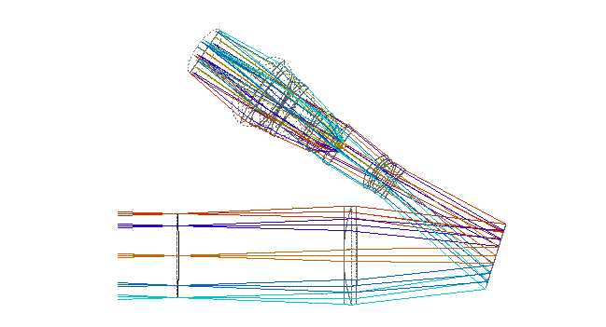

Figure 3-1 Schematic of side view of MOSFIRE (KECK) - imaging mode. Light enters from the left and passes through the slit mask mechanism to the large field lens and then to a fold mirror.
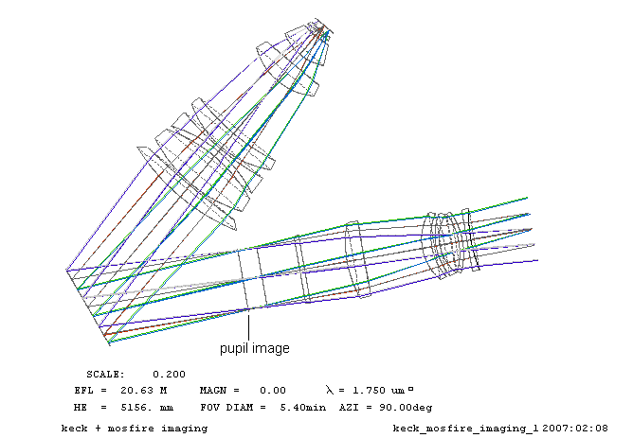
Figure 3-2 Top view of MOSFIRE (KECK) after the fold mirror - imaging mode

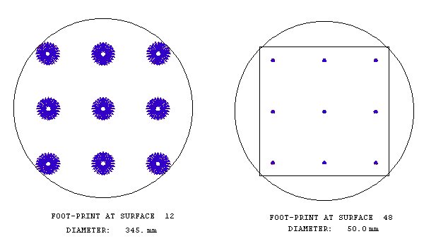
Figure 3-3 Foot-prints associated with beams from a total of 9 field points at (a) one of the field lens surfaces, and (b) 36x36mm detector, assuming a 4.8x4.8’ FOV and a spectral range from λ: 0.97 to 2.40μm

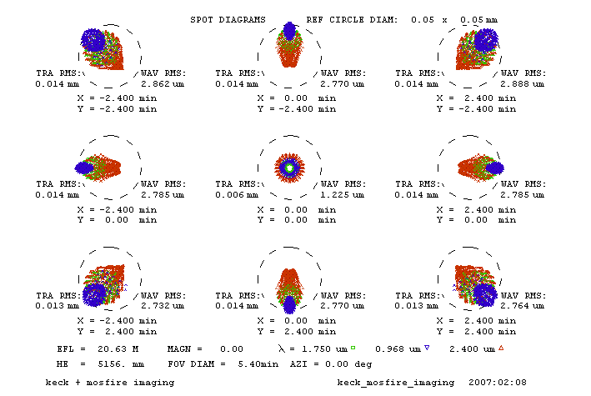
Figure 3-4 Spot diagrams associated with KECK + MOSFIRE for 4.8x4.8’ FOV - imaging mode

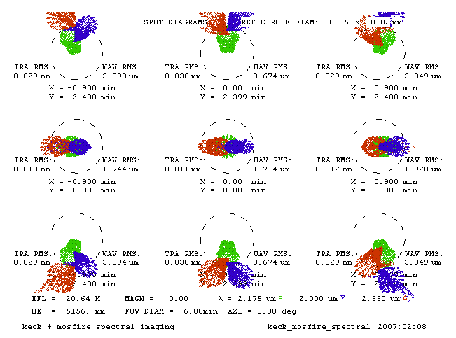
Figure 3-5 Spot diagrams associated with KECK + MOSFIRE for 4.8x1.8’ FOV - spectral mode

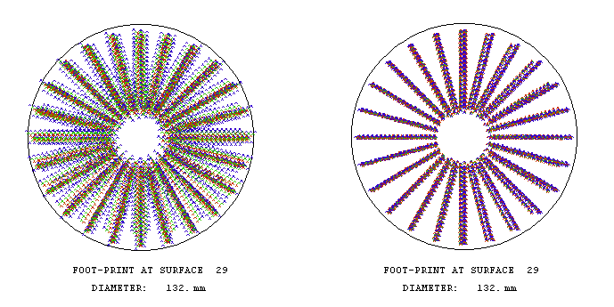
(a) (b)
Figure 3-6 Foot-prints associated with beams from a total of 9 field points at reference surface 328mm in front of fold mirror/grating location for (a) imaging mode with 4.8x4.8’ FOV (λ: 0.97 to 2.40μm) and (b) spectral mode with 4.8x1.8’ FOV (λ: 2.00 to 2.35μm)
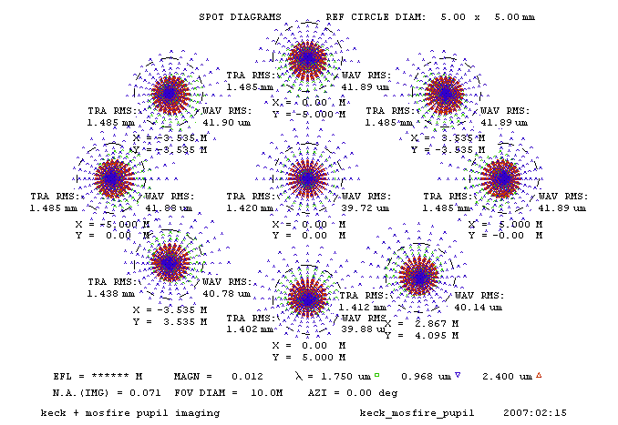
Figure 3-7 Spot diagrams associated with pupil imagery of KECK + MOSFIRE for 4.8x4.8’ FOV - imaging mode
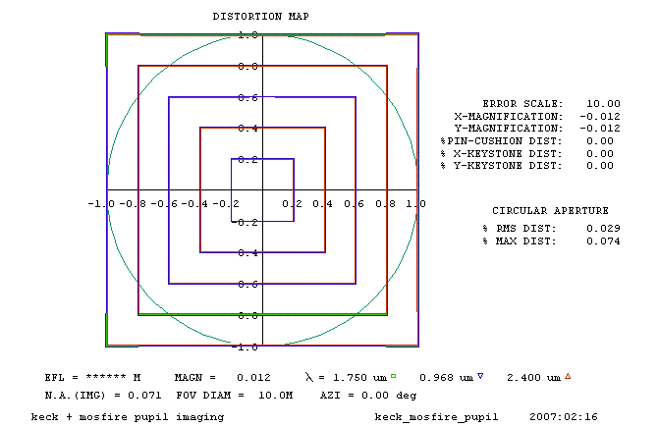
Figure 3-8 Distortion mapping associated with pupil imagery of KECK + MOSFIRE for 4.8x4.8’ FOV-imaging mode
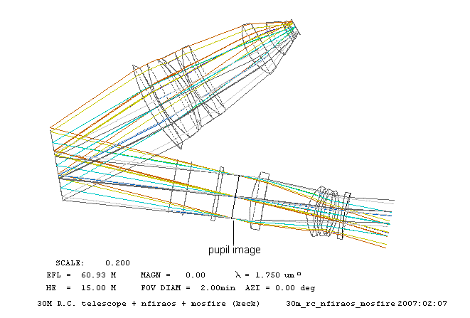
Figure 3-9 Top view of MOSFIRE (after fold mirror) + beam trajectories following TMT and NFIRAOS combination - imaging mode

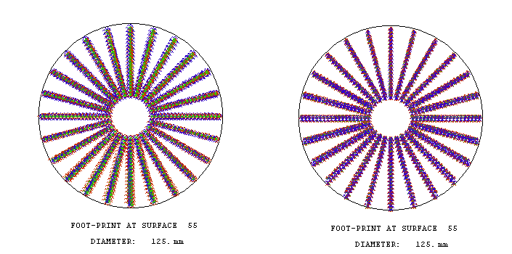
(a) (b)
Figure 3-10 Foot-prints associated with beams from a total of 9 field points with reference surface half way between last element of collimator & filter (a) imaging mode with 2.0x2.0’ FOV (λ: 0.97 to 2.40μm) & (b) spectral mode with 2.0x0.6’ FOV (λ: 2.00 to 2.35μm)
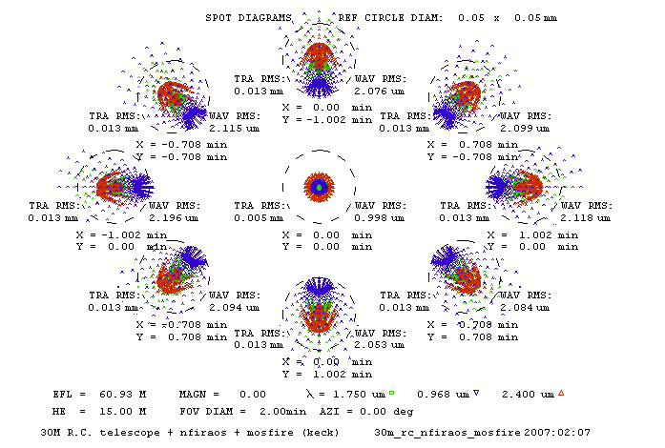
Figure 3-11 Spot diagrams associated with TMT + NFIRAOS + MOSFIRE for 2’ circular FOV - imaging mode
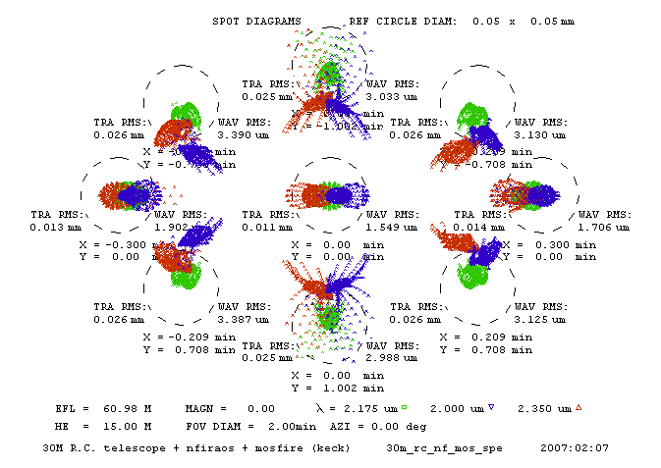
Figure 3-12 Spot diagrams associated with TMT + NFIRAOS + MOSFIRE for 2.0x0.6’ elliptical FOV-spectral mode
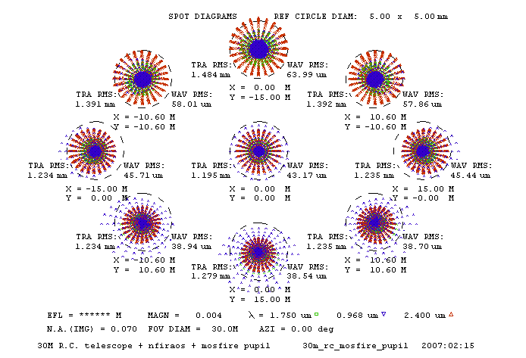
Figure 3-13 Spot diagrams associated with pupil imagery of TMT + NFIRAOS + MOSFIRE for 2’ circular
FOV - imaging mode
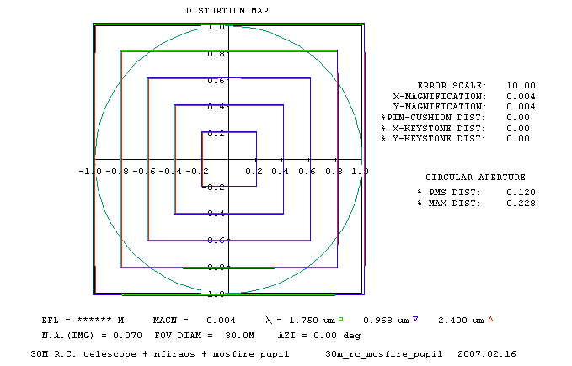
Figure 3-14 Distortion mapping associated with pupil imagery of TMT + NFIRAOS + MOSFIRE for 2’ circular FOV - imaging mode
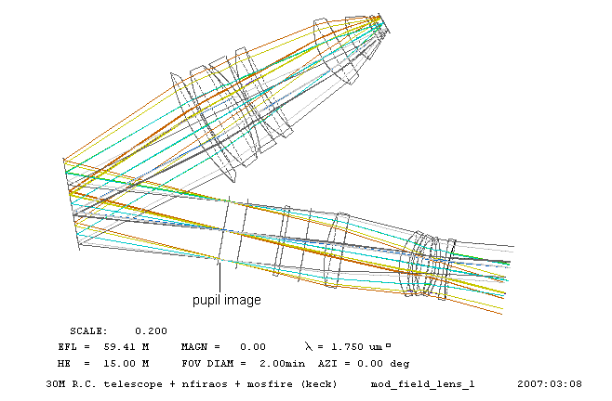
Figure 3-15 Top view of MOSFIRE with modified field lens + beam trajectories - imaging mode
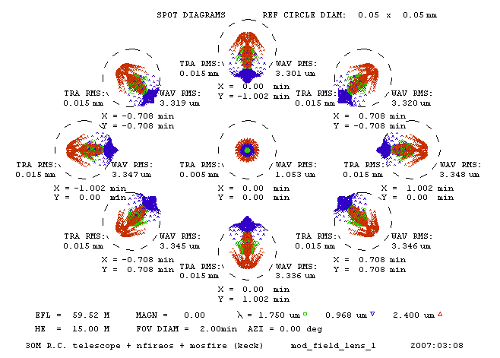
Figure 3-16 Spot diagrams associated with TMT + NFIRAOS + MOSFIRE (modified field lens) for 2.0’ circular FOV - imaging mode

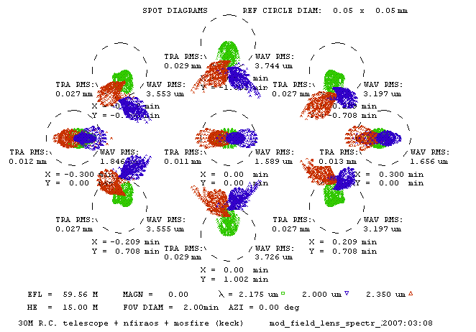
Figure 3-17 Spot diagrams associated with TMT + NFIRAOS + MOSFIRE (modified field lens) for 2.0x0.6’ elliptical FOV - spectral mode
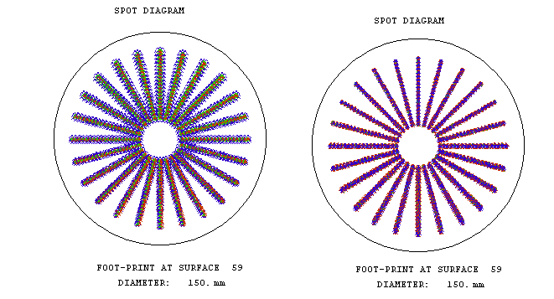
(a) (b)
Figure 3-18 Foot-prints associated with beams from a total of 9 field points with reference surface half way between last element of collimator & filter (a) imaging mode with 2.0x2.0’ FOV (λ: 0.97 to 2.40μm) & (b) spectral mode with 2.0x0.6’ FOV (λ: 2.00 to 2.35μm)
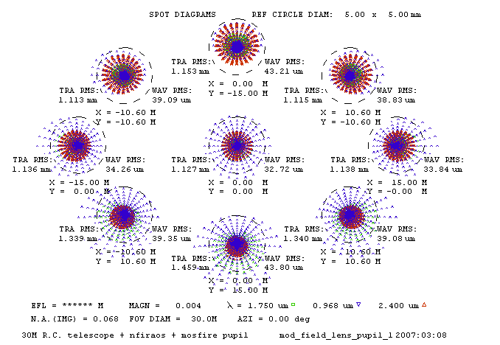
Figure 3-19 Spot diagrams associated with pupil imagery of TMT + NFIRAOS + MOSFIRE (modified field lens) for 2’ circular FOV - imaging mode
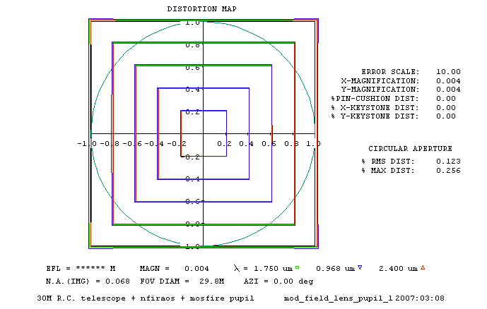
Figure 3-20 Distortion mapping associated with pupil imagery of TMT + NFIRAOS + MOSFIRE (modified field lens) for 2’ circular FOV - imaging mode
Table 3-1 Lens prescription of KECK telescope and MOSFIRE combination

OPTICAL SYSTEM DESIGN/ANALYSIS PROGRAM - OPTICSOFT-II (v0701)

keck + mosfire imaging keck_mosfire_imaging

SYSTEM CONSTRUCTIONAL PARAMETERS:
SURF RADIUS DISTANCE GLASS SEMI-DIAM COATING SPECIAL ATTRIBUTES
0 ************ 1.0000E+10 AIR ********* 0
1 ************ 0.0000 AIR 5156.610 0
2 -34973.9961 -15394.9834 -AIR 5156.610 0 STO,FIG,CAO,
3 -4737.9160 15394.9834 AIR 634.229 0 FIG,
4 ************ 1904.8470 AIR 215.552 0
5 ************ 34.9250 FQTZ_I 163.898 0
6 ************ 228.6000 AIR 163.245 0
7 ************ 12.7000 V76FQTZ 157.046 0
8 ************ 333.3750 AIR 156.808 0
9 -2123.5732 580.0000 AIR 147.936 0
10 ************ 0.0000 AIR 172.441 0
11 547.5947 47.0000 V76CAF2 173.624 0
12 -4438.9512 489.2183 AIR 172.553 0
13 ************ 0.0000 AIR ********* 0 TIL,HID,
14 ************ 0.0000 -AIR 116.529 0
15 ************ -441.7242 -AIR ********* 0 TIL,HID,
16 291.6063 -8.0000 -V76CAF2 64.846 0
17 ************ -9.4373 -AIR 64.659 0
18 -150.9766 -8.0000 -V76ZNSE 64.246 0
19 -137.6240 -40.1156 -AIR 61.929 0
20 92.6744 -8.0000 -V76FQTZ 61.975 0
21 130.6669 -8.8248 -AIR 65.738 0
22 128.3060 -20.0000 -V76BAF2 66.860 0
23 109.8851 -123.3233 -AIR 70.583 0
24 2500.0000 -35.6164 -V76CAF2 78.650 0
25 239.7622 -90.0000 -AIR 79.757 0
26 ************ -10.0000 -V76FQTZ 71.316 0
27 ************ -80.0000 -AIR 70.857 0
28 ************ -40.0000 -AIR 65.609 0
29 ************ -328.0000 -AIR 66.265 0
30 ************ 0.0000 -AIR ********* 0 TIL,HID,
31 ************ 0.0000 AIR 93.004 0
32 ************ 300.0000 AIR ********* 0 TIL,HID,
33 435.5621 31.0000 V76CAF2 135.000 0
34 1812.7576 4.0000 AIR 118.538 0
35 302.6267 75.0000 V76CAF2 118.221 0
36 -319.5752 13.2101 AIR 114.207 0
37 -276.5860 7.0000 V76FTM1 109.380 0
38 576.7587 4.0000 AIR 106.869 0
39 210.7587 38.0000 V76FPL51 107.062 0
40 454.7188 142.4862 AIR 103.292 0
41 135.3481 48.0000 V76BAF2 78.717 0
42 6620.2021 24.3616 AIR 71.264 0
43 108.5229 50.0000 V76BAF2 52.559 0
44 221.4500 11.0000 AIR 32.540 0
45 -175.2402 4.0000 V76FTM1 27.763 0
46 134.6514 13.4401 AIR 25.000 0
47 ************ 0.0000 AIR 25.000 0 CAO,
48 ************ 0.0000 AIR 25.000 0

MEDIUM # GLASS REFRACTIVE INDEX V-VALUE
1750.0nm 968.0nm 2400.0nm
0 AIR 1.000000 1.000000 1.000000 *********
1 AIR 1.000000 1.000000 1.000000 *********
2 -AIR -1.000000 -1.000000 -1.000000 *********
3 AIR 1.000000 1.000000 1.000000 *********
4 AIR 1.000000 1.000000 1.000000 *********
5 FQTZ_I 1.441660 1.450924 1.431756 23.042
6 AIR 1.000000 1.000000 1.000000 *********
7 V76FQTZ 1.440754 1.449987 1.430891 23.082
8 AIR 1.000000 1.000000 1.000000 *********
9 AIR 1.000000 1.000000 1.000000 *********
10 AIR 1.000000 1.000000 1.000000 *********
11 V76CAF2 1.427323 1.431343 1.423918 57.555
12 AIR 1.000000 1.000000 1.000000 *********
13 AIR 1.000000 1.000000 1.000000 *********
14 -AIR -1.000000 -1.000000 -1.000000 *********
15 -AIR -1.000000 -1.000000 -1.000000 *********
16 -V76CAF2 -1.427323 -1.431343 -1.423918 57.555
17 -AIR -1.000000 -1.000000 -1.000000 *********
18 -V76ZNSE -2.438282 -2.479140 -2.429707 29.096
19 -AIR -1.000000 -1.000000 -1.000000 *********
20 -V76FQTZ -1.440754 -1.449987 -1.430891 23.082
21 -AIR -1.000000 -1.000000 -1.000000 *********
22 -V76BAF2 -1.468621 -1.472017 -1.466537 85.510
23 -AIR -1.000000 -1.000000 -1.000000 *********
24 -V76CAF2 -1.427323 -1.431343 -1.423918 57.555
25 -AIR -1.000000 -1.000000 -1.000000 *********
26 -V76FQTZ -1.440754 -1.449987 -1.430891 23.082
27 -AIR -1.000000 -1.000000 -1.000000 *********
28 -AIR -1.000000 -1.000000 -1.000000 *********
29 -AIR -1.000000 -1.000000 -1.000000 *********
30 -AIR -1.000000 -1.000000 -1.000000 *********
31 AIR 1.000000 1.000000 1.000000 *********
32 AIR 1.000000 1.000000 1.000000 *********
33 V76CAF2 1.427323 1.431343 1.423918 57.555
34 AIR 1.000000 1.000000 1.000000 *********
35 V76CAF2 1.427323 1.431343 1.423918 57.555
36 AIR 1.000000 1.000000 1.000000 *********
37 V76FTM1 1.565632 1.577632 1.555743 25.841
38 AIR 1.000000 1.000000 1.000000 *********
39 V76FPL51 1.486369 1.492460 1.480693 41.332
40 AIR 1.000000 1.000000 1.000000 *********
41 V76BAF2 1.468621 1.472017 1.466537 85.510
42 AIR 1.000000 1.000000 1.000000 *********
43 V76BAF2 1.468621 1.472017 1.466537 85.510
44 AIR 1.000000 1.000000 1.000000 *********
45 V76FTM1 1.565632 1.577632 1.555743 25.841
46 AIR 1.000000 1.000000 1.000000 *********
47 AIR 1.000000 1.000000 1.000000 *********

CLEAR APERTURE AND CENTRAL OBSTRUCTION SURFACE DATA:
OUTER INNER OFF-SET
SURF RHO X Y RHO X Y X Y
2 0.000 0.000 0.000 1289.152 0.000 0.000 0.000 0.000
47 25.000 18.000 18.000 0.000 0.000 0.000 0.000 0.000

FIGURED SURFACE DATA: NORM
SURF Q A1 A2 A3 A4 A5 Y/N
2 -1.0037E+00 0.0000E+00 0.0000E+00 0.0000E+00 0.0000E+00 0.0000E+00 Y
3 -1.6443E+00 0.0000E+00 0.0000E+00 0.0000E+00 0.0000E+00 0.0000E+00 Y

TILT DATA:
SURF X Y Z ORDER
13 17.5000 0.0000 0.0000 1
15 17.5000 0.0000 0.0000 1
30 0.0000 20.0000 0.0000 1
32 0.0000 20.0000 0.0000 1

MECHANICAL ISSUES

General Description
A study of the NFIRAOS to MOSFIRE/IRMS interface has been undertaken, in which it has been assumed that MOSFIRE/IRMS will occupy the lateral instrument port of NFIRAOS. This is proposed because the Keck MOSFIRE has been designed to operate in a variable gravity vector environment and includes a rotator bearing. Since NFIRAOS does not offer field de-rotation nor can support the mass of an instrument on its lateral port, MOSFIRE/IRMS may be a logical choice for the lateral position.
A Generic NFIRAOS Instrument Envelope was defined for CoDR, having dimensions 4.0m length and 2.0m diameter. The mechanical interface was defined to be one end of this cylinder, and NFIRAOS delivers a 750mm back-focal distance relative to this interface plane. In addition, NFIRAOS permits a 250mm long instrument “snout” to protrude into NFIRAOS.
Figure 4-21 illustrates the Generic Instrument Envelope superimposed on MOSFIRE/IRMS. MOSFIRE/IRMS’s focal plane is taken to be the Configurable Slitmask Unit, and this has been situated accordingly within the envelope. The portion of MOSFIRE/IRMS that can be seen to extend outside the generic envelope is its Cassegrain Module Assembly, which incorporates the rotator bearing and cable wraps, and may therefore be retained to serve as the MOSFIRE/IRMS structural interface to the TMT Nasmyth structure. MOSFIRE/IRMS’s Dust Cover Assembly has been omitted, as it would be supplanted by a dynamic lip-seal between MOSFIRE/IRMS and the NFIRAOS enclosure. The Guider and Dust Cover Assemblies have also been suppressed in this view, for reasons explained below.

Interface Modifications
MOSFIRE/IRMS will be supported by a dedicated intermediate structure which likely will utilize all or part of the existing Cassegrain Module Assembly and which will rest on hard points provided by the TMT structure. Although MOSFIRE/IRMS will abut NFIRAOS, no cantilevered loads will be supported by NFIRAOS.
On-instrument wavefront sensors will need to be provided by MOSFIRE/IRMS. These will likely be located inside its main Dewar, and will supersede the Guider system present in the Keck MOSFIRE design. For this reason, the Guider Assembly has not been depicted in Figure 4-21. Similarly, the Dust Cover Assembly has been omitted, since the optical interface will be protected by NFIRAOS and a simple, manual cover will suffice for transportation and occasional operational usage, if required.
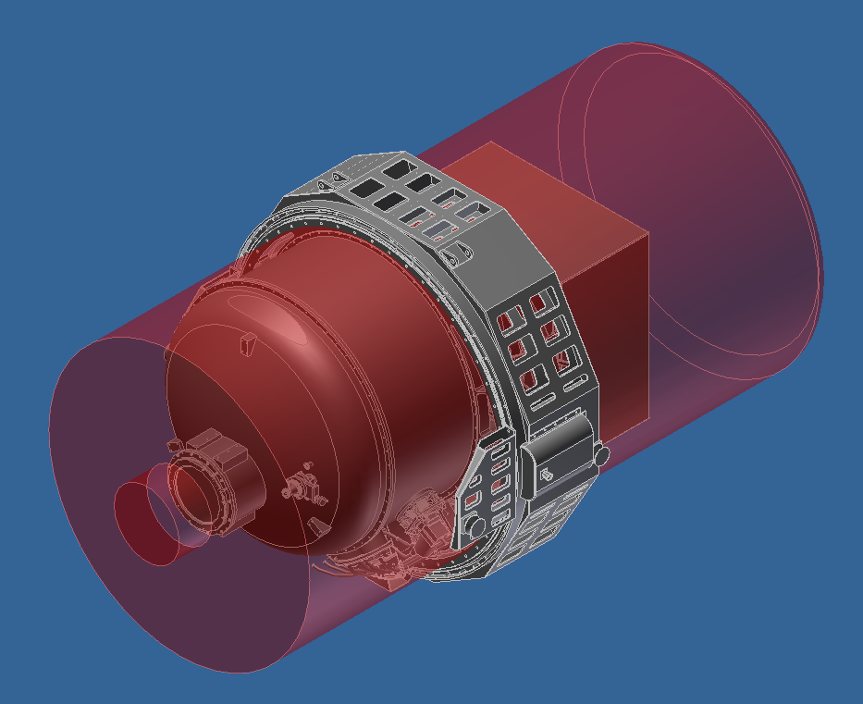
Generic EnvelopeØ 2.0m
Generic Envelope Length 4.0m
MOSFIRE/IRMS

Rotator Bearing + Cable Wrap

Figure 4-21 MOSFIRE/IRMS with Generic NFIRAOS Instrument Envelope Superimposed (in red)
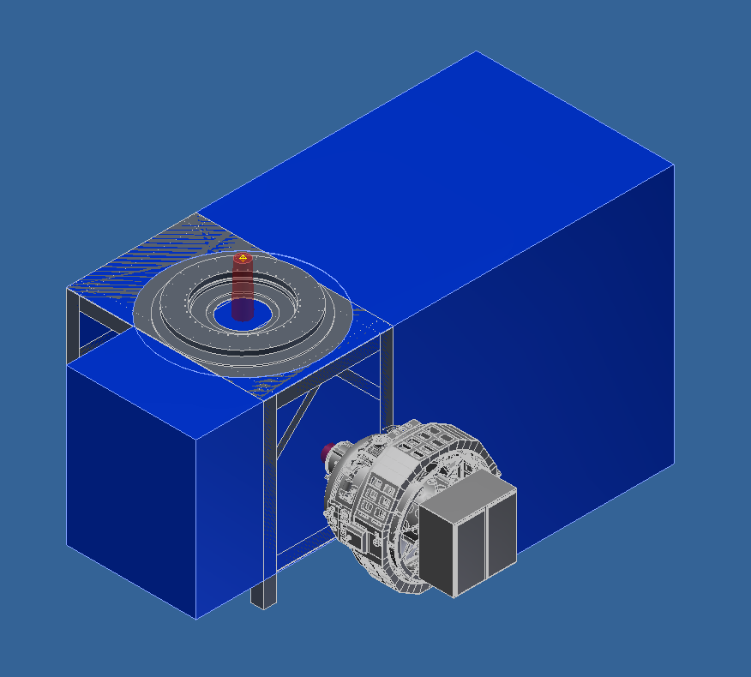
NFIRAOS
MOSFIRE/IRMS

NFIRAOS Length 9.2m
Figure 4-22 MOSFIRE/IRMS Situated on Lateral Instrument Port of NFIRAOS
Figure 4-22 depicts MOSFIRE/IRMS situated at the lateral instrument port of NFIRAOS. Note that NFIRAOS is shown “inverted” relative to its configuration presented at CoDR. This configuration has been proposed to lessen the wind cross section of NFIRAOS to alleviate telescope flushing concerns.
The focal plane delivered by NFIRAOS at CoDR was 264mm in diameter. The configurable slitmask unit of MOSFIRE, however, is 262mm square. The implications of a recent amendment to the TMT prescription will need to be evaluated to ascertain whether the amended focal plane diameter will fit within the slitmask window. A section view of this portion of MOSFIRE/IRMS is presented in Figure 4-23, which also shows the expanding beam after focus incident upon the field lens. The input beamprint is seen to be accommodated by the existing aperture of the field lens.
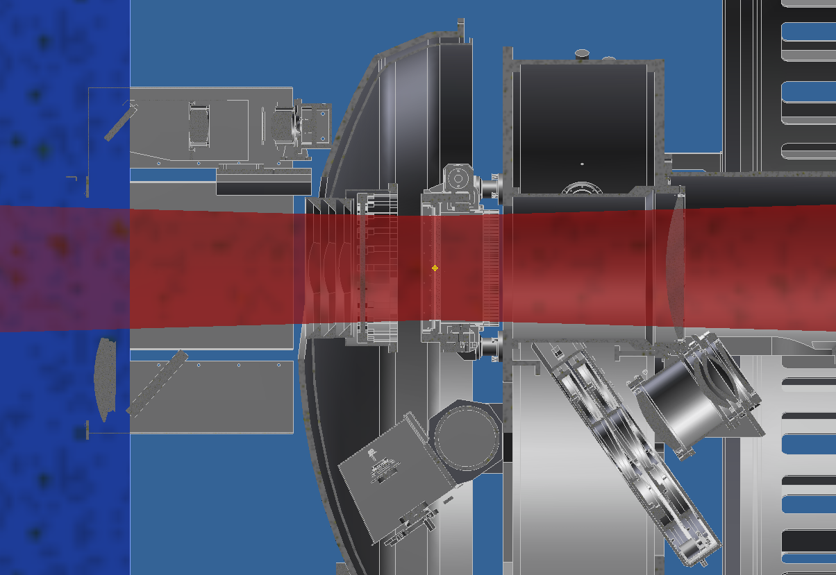
Focal Plane
(CSU)
Field Lens
Figure 4-23 Section View showing Science Beam and MOSFIRE/IRMS Input Optics

Impact of modifying pupil location
The pupil location predicted by the TMT+NFIRAOS+MOSFIRE/IRMS prescription is displaced from its location in the original MOSFIRE design (Keck+MOSFIRE), and falls within the space between the final collimator lens and the filter mechanism. To re-optimize image quality, the pupil stop (Lyot stop) would need to be placed at the new pupil location. The available space is approximately 38mm long, and by inspection of Figure 4-24 it appears unlikely that the Lyot stop mechanism can be accommodated there. The large size of the filter wheel mechanism precludes its position being altered to increase the distance from the collimator lens. Furthermore, vignetting has been noticed at the grating-mirror surface in the optical ray trace diagrams of this configuration. Significant re-engineering, including flexural analysis, would be required to alleviate these shortcomings.
A preferable approach may be to substitute a field lens having a prescription designed to deliver the pupil to the existing Lyot stop location. The axial position of the field lens is constrained by its distance from the adjacent folded beam, however some freedom may exist in its placement to optimize optical performance.
Figure 4-24 View of MOSFIRE’s Optical System Components (from MOSFIRE PDR Report)

Constraints affecting field lens position
The internal structure of MOSFIRE/IRMS consists of three bulkheads which are arranged axially by spacer tubes. The optical path entering MOSFIRE/IRMS passes through central holes in the largest two of these bulkheads, these holes being connected by a internal structure stiffening tube.
The field lens cell is mounted into the stiffening tube, as shown in Figure 4-25. In this view, the focal plane is near the left coinciding with the configurable slitmask unit (in grey). It can be seen that there is no opportunity to displace a replacement field lens to the right of its current position since it is very tightly constrained by the collimator lens assembly.
A field lens optimized for TMT could be positioned slightly to the left of its current position within the space envelope of the existing cell. There are, however, a number of mechanical and structural parts which would need to be altered to accommodate. A slight further gain in the space envelope available in this direction might be available by re-designing the internal structure stiffening tube. The constraints affecting this option are the existence of a lateral reinforcement forming part of the bulkhead weldment (in light green). If re-engineering of the bulkhead weldment is considered to be within scope, a further case can be envisaged where the ultimate constraint on field lens position would be the filter wheel mechanism enclosure. The current close proximity between these parts can be appreciated in Figure 4-26.
Table 4-2 summarizes the approximate range of field lens positions for the re-engineering cases described. Dimensions in this table are given relative to the current lens position.
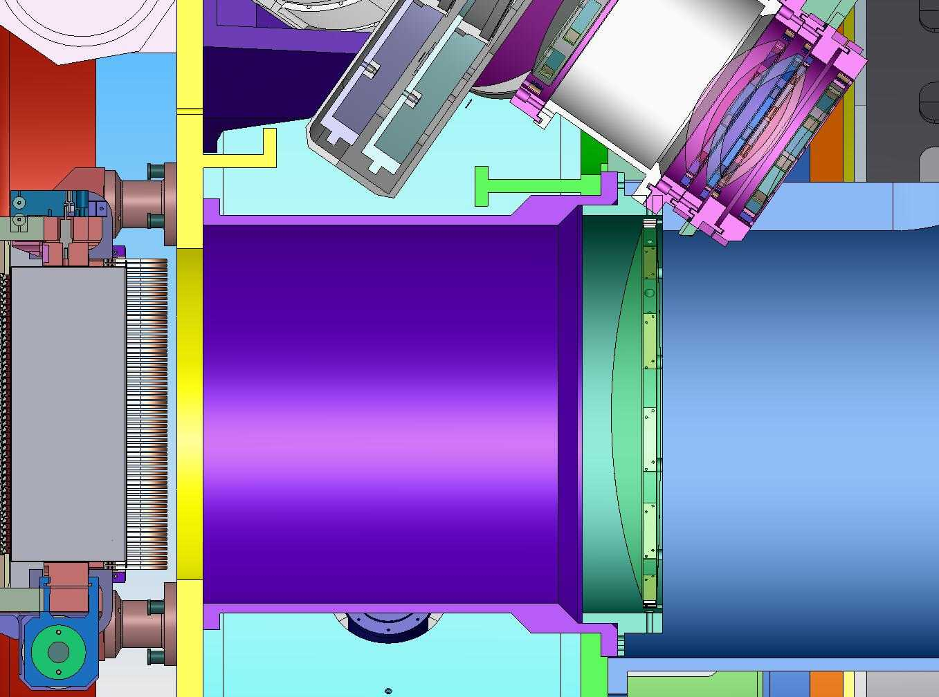
D
A
C
B
Figure 4-25 Section View showing Field Lens (A), Internal Structure Stiffening Tube (B), Collimator Lenses (C), and Internal Bulkhead A (D)
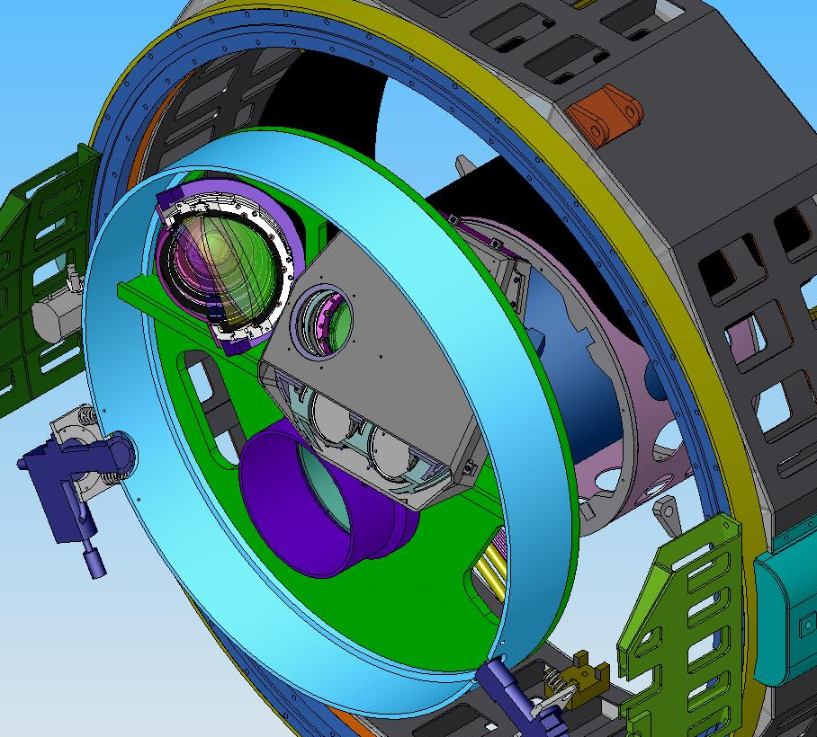
Figure 4-26 Section through Internal Structure showing Filter Wheel (grey) Clearance to Stiffening Tube (purple)

Design Case | Relative Axial Position Envelope [mm]
Design Case | Toward CSU | Toward Mirror
Modify Cell | 18 | 0
Modify Stiffening Tube | 25 (43) | 0
Re-design Stiffening Tube | 47 (65) | 0
Re-design Bulkhead weldment and stiffening tube. | 155 (173) | 0
Table 4-2 Field Lens Position Approximate Space Envelope for Alternative Re-engineering Cases. Parenthetical Values indicate combination of each case with the Modified Cell

Recommended Solution: Displaced CSU
To instate the required optical path length between the TMT-optimized Field Lens and the focal plane, it has been proposed to displace the focal plane, and hence the Configurable Slitmask Unit (CSU), ~20mm closer to the entrance window of MOSFIRE/IRMS. This will have the effect of positioning MOSFIRE/IRMS further from NFIRAOS by the same amount, when the science focus is superimposed onto the CSU plane.
The mechanical design of this proposal is likely to be much simpler in implementation than re-positioning of the Field Lens described in paragraph 4.4.
The CSU is supported by four interface columns, which are attached to a main structural feature called Internal Bulkhead A. To reposition the CSU, these interface columns should be lengthened by the required amount, approximately 20mm. There is a risk that this will cause the CSU to interfere with the Inner Window Rear Baffle. The baffle may need to be re-designed to remain compatible. The Inner Window Assembly which incorporates the baffle is supported by four support columns which are also attached to Internal Bulkhead A near the CSU interface columns. These support columns may also need to be adapted.
The Guider system will likely be replaced by on-instrument wavefront sensors which, in order to be effective at the desired wavelengths, will need to be cooled. It will also be desired that these wavefront sensors will patrol the field of view with minimal potential vignetting of candidate science objects. For these reasons, it is expected that the wavefront sensors will occupy space within the front portion of the MOSFIRE/IRMS Dewar. Although there is presently some unallocated volume in this region of the instrument, the wavefront sensors will likely require the creation of additional space.
Additional space could be created by extending the Dewar toward NFIRAOS probably though the use of a spacer ring. Figure 4-21 suggests this is possible while remaining within the volume of the Generic Instrument Envelope. Increasing the MOSFIRE/IRMS internal volume by this approach also provides the opportunity to address the details of repositioning the CSU and possibly the Inner Window Assembly in a coherent and optimal design.

Recommendations
The above optical and mechanical analyses indicate that adapting MOSFIRE for use with TMT/NFIRAOS should be relatively straightforward. The recommended solution involves exchanging the field lens and moving the configurable slit unit 20mm further away from the field lens. This implies redesign of the front end of MOSFIRE but this portion of the instrument will have to be modified in any case in order to interface with NFIRAOS and also to incorporate TMT wavefront sensors.

