IRMS Rotator Module Support Structure Analysis
Run A (Preliminary Analysis): Gravity Loading-
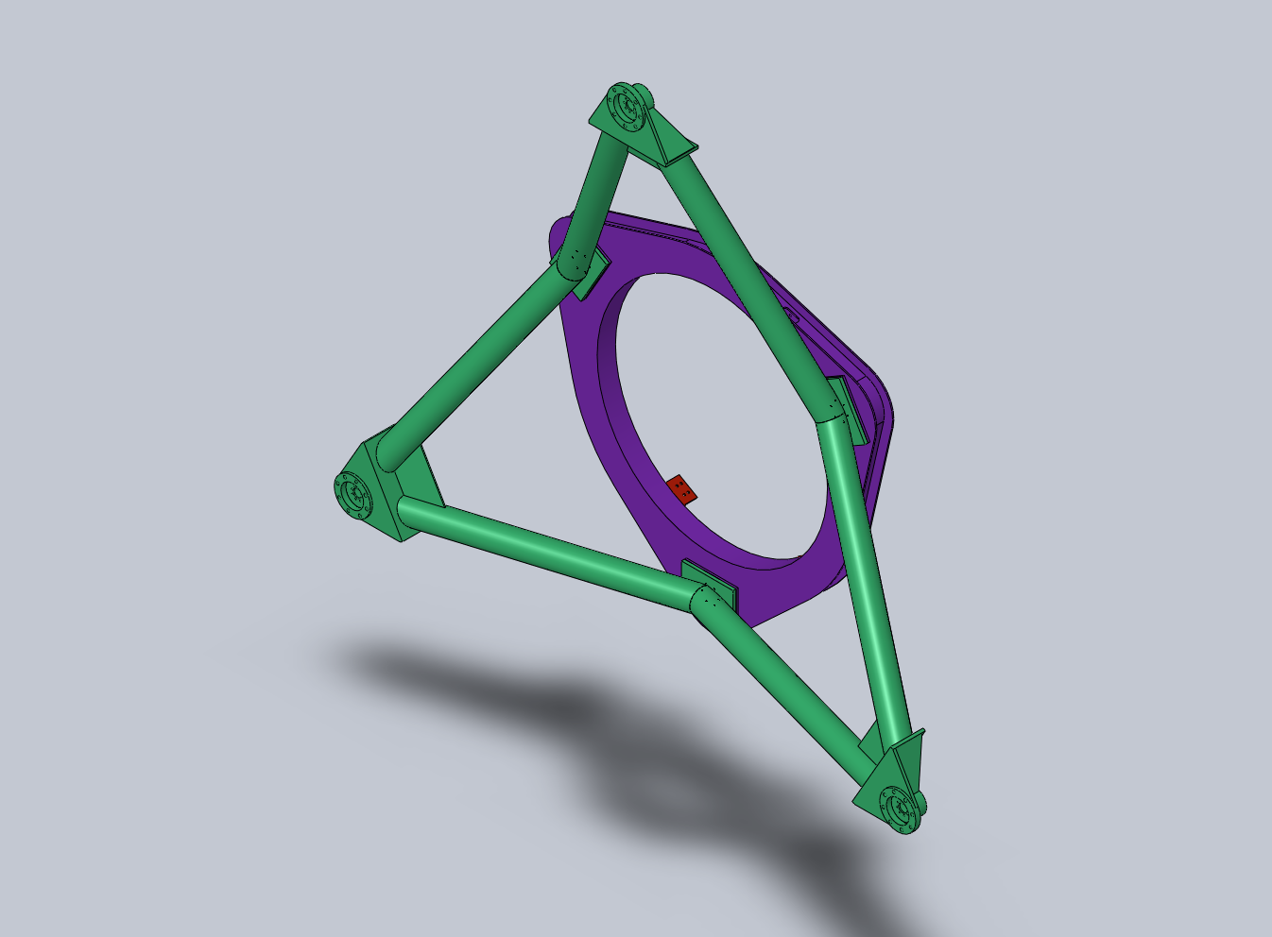
Y
X
Z
Figure 1: Run A model.

Individual Part Mesh Density/Tolerance [max AR/%<3/%>10/% Distorted]:

- Support Weldment (Hexapod)- 0.565/.028 [25.9/99.0/0.006/0]
  - Support Weldment (1 Arm)- 0.565/.028 [25.9/99.1/0.008/0]
- Interface Ring Weldment- .669/.033 [16.5/98.6/0.001/0]
- Rotator Module Mount Bracket- .429/.021 [7.5/98.8/0/0]

Assembly Model Mesh Parameters:

- Control 1- Rotator Module Mount Bracket (4X)- .390
- Control 2- Support Weldment (Hexapod) (1X)- .585
- Global Mesh- .519/.026 [18.6/99.1/0.001/0.0]
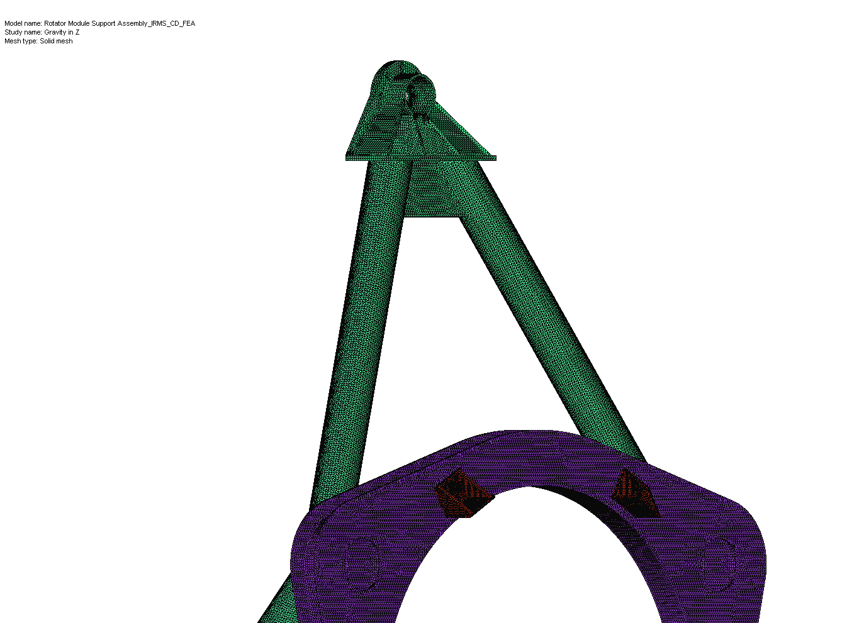
Figure 2: FEA model mesh.

Load Cases:

1) Gravity in Z: Gravity loading in nominal mounted orientation

Restraints:

- NFIRAOS interface pad surfaces: Roller/Slider in XY plane (3X)
- NFIRAOS interface pad bolt holes: fixed cylindrical surface- radial and along axis (24X)

Loads:

- Gravity (Z): 9.81 m/s^2 on all parts
- Force (Z): 2,000 lbs equally distributed on bolt holes of rotator module mount brackets (4X) to simulate 8000 lb weight of MOSFIRE and module
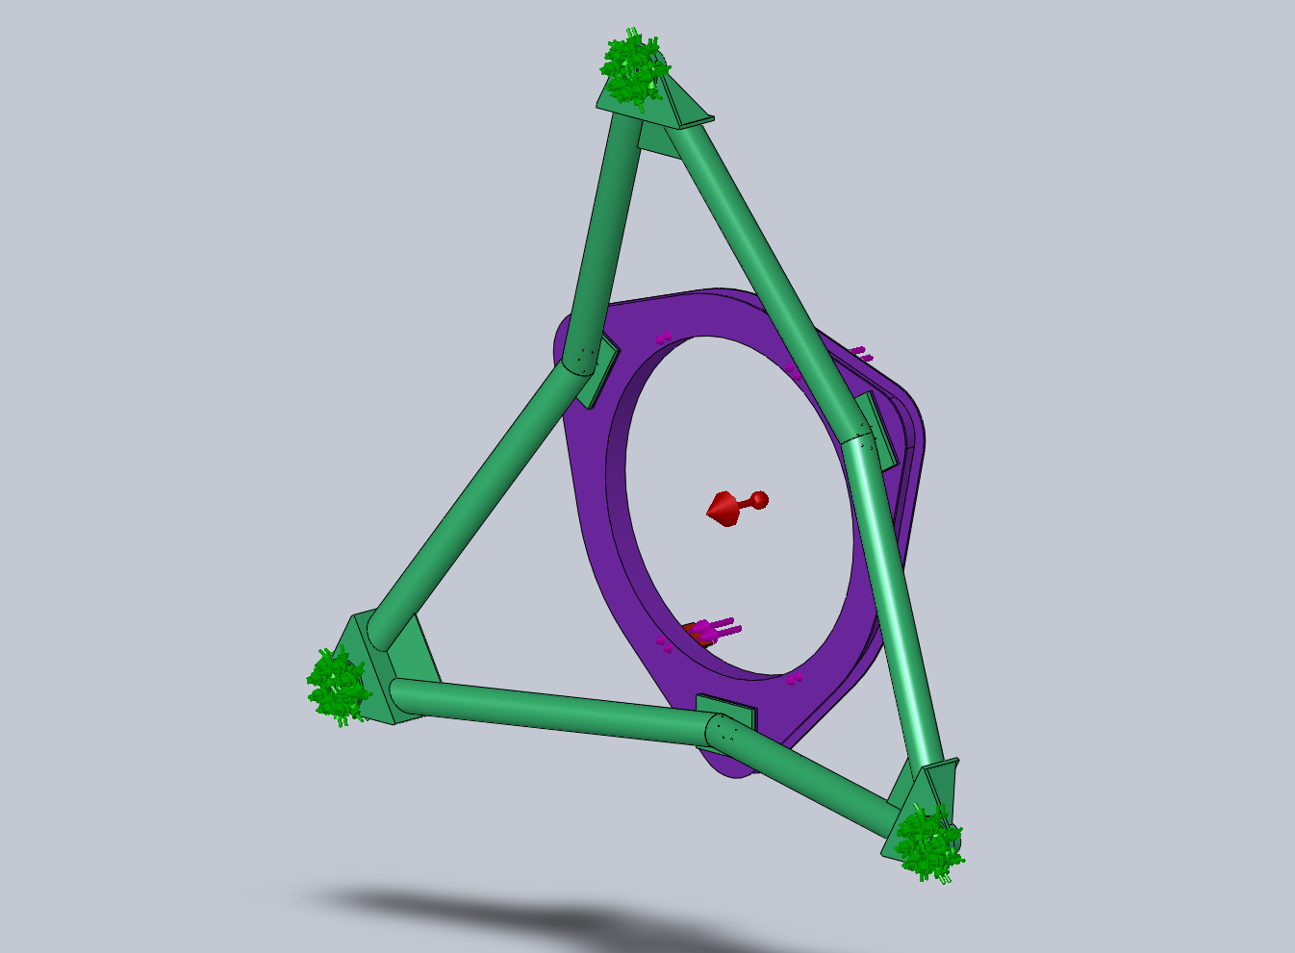
Pad A
Figure 3: Gravity in Z model constraints & loads.

Results:

- Maximum Y displacement (lateral): 0.0047" (Mount Bracket tips)
- Maximum Z displacement (vertical): .0269" (flexure of Interface Ring)
- Maximum X displacement (lateral): +/-.0047" (Mount Bracket tips)
- Node Stress (max): 6,483 psi (SF= 8.9 on ultimate stress {58,000-80,000 psi}; 5.6 on yield {36,000 psi})
- Element Stress (max): 4,603 psi (Δ41%)
- Requirement is: SF= 3 on ultimate
- Interface pad reaction forces:

Pad Location | X Reaction (lbs.) | Y Reaction (lbs.) | Z Reaction (lbs.)
A | -0.2 | -10579 | -4297.6
B | -9814.7 | 5289.1 | -4206.6
C | 9815.1 | 5289.7 | -4207

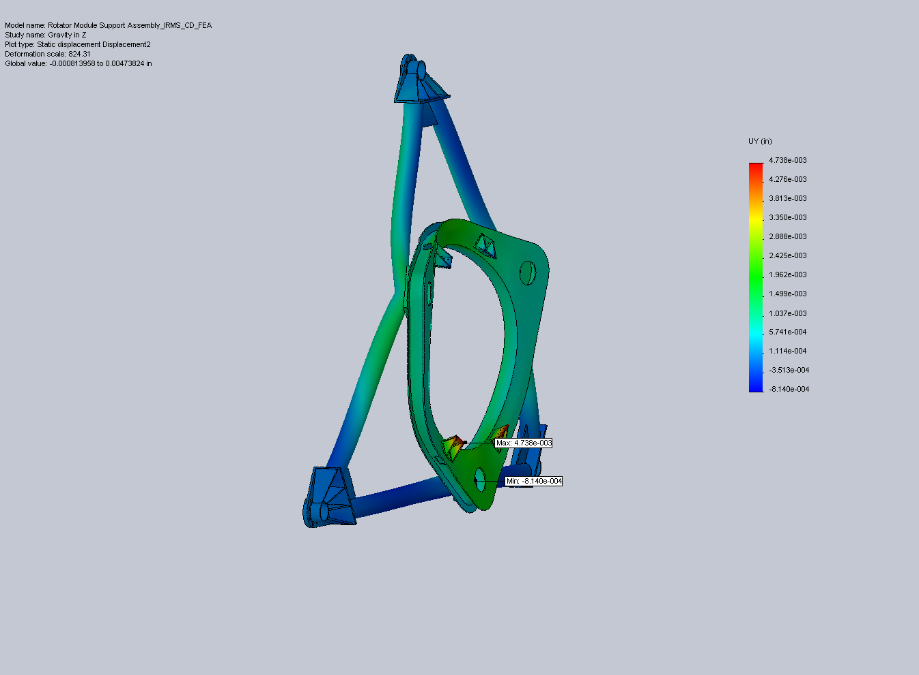
Figure 4: Maximum Y displacement for gravity Z.
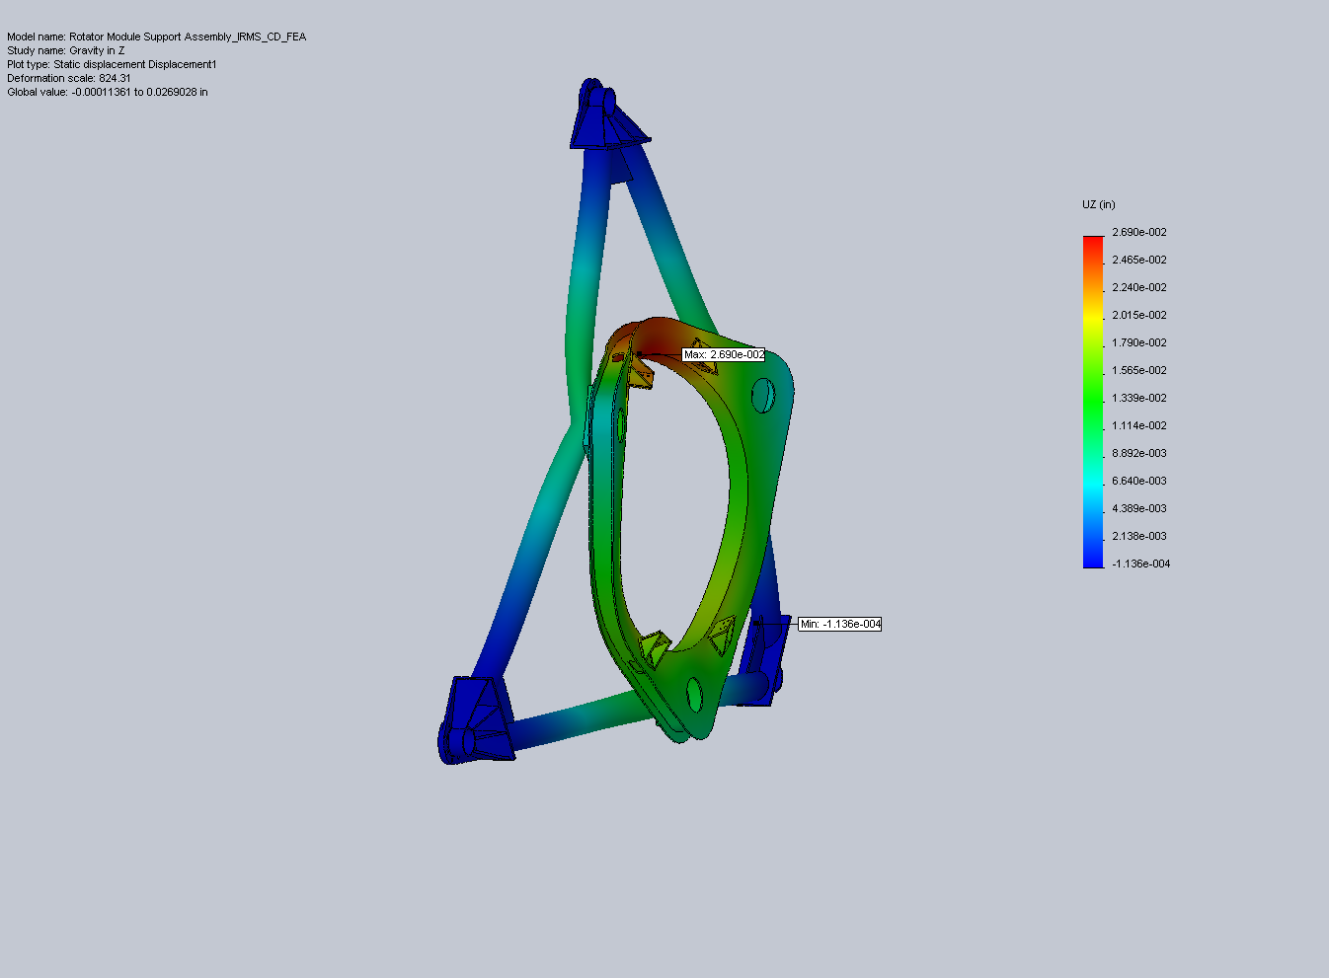
Figure 5: Maximum Z displacement for gravity Z.
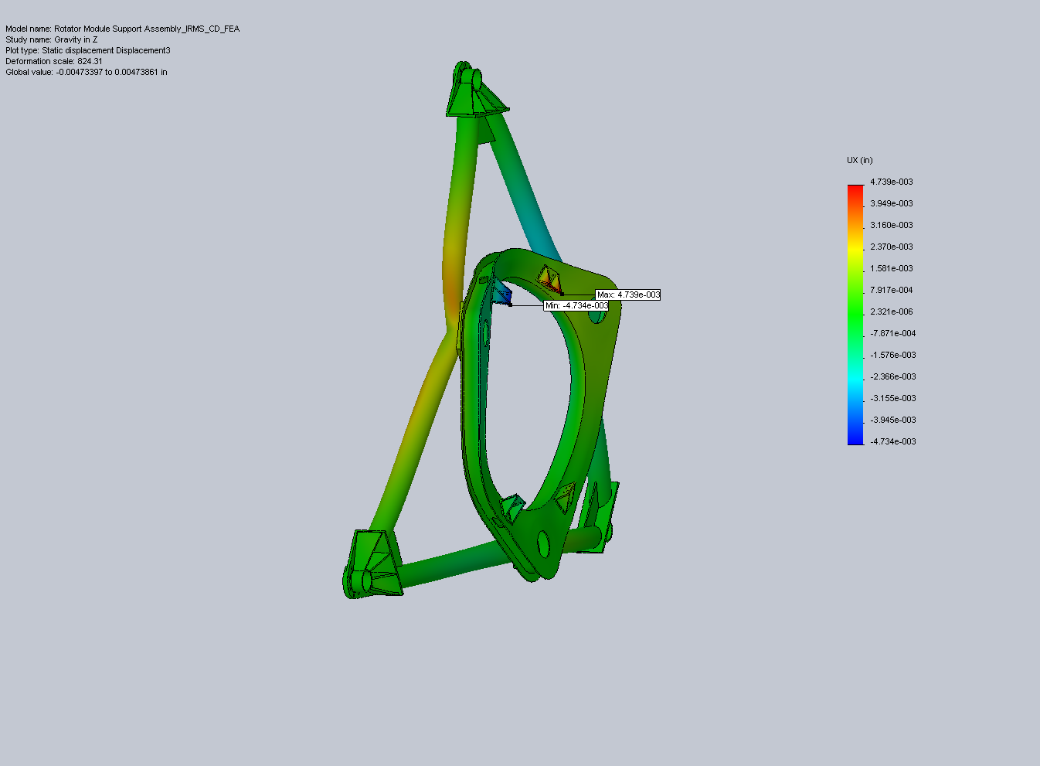
Figure 6: Maximum X displacement for gravity Z.
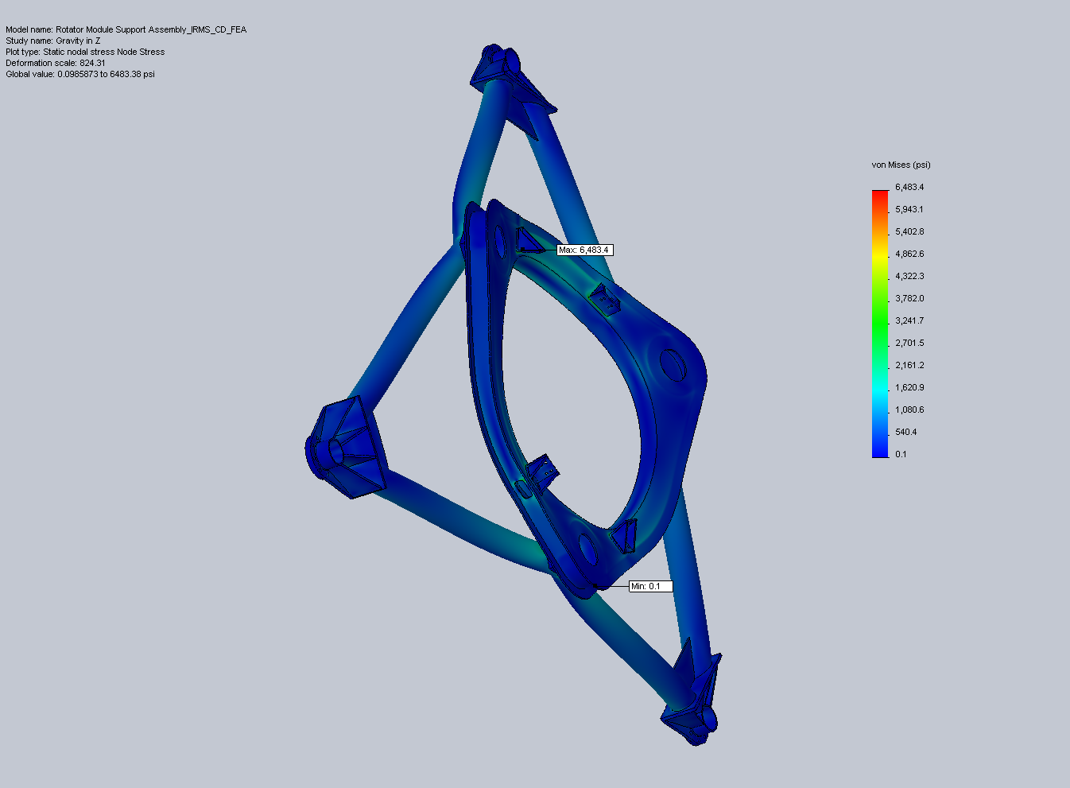
Figure 7: Node stress plot for gravity in Z. The maximum stress is where the sharp corner of a mount bracket presses into the surface of the Interface Ring.
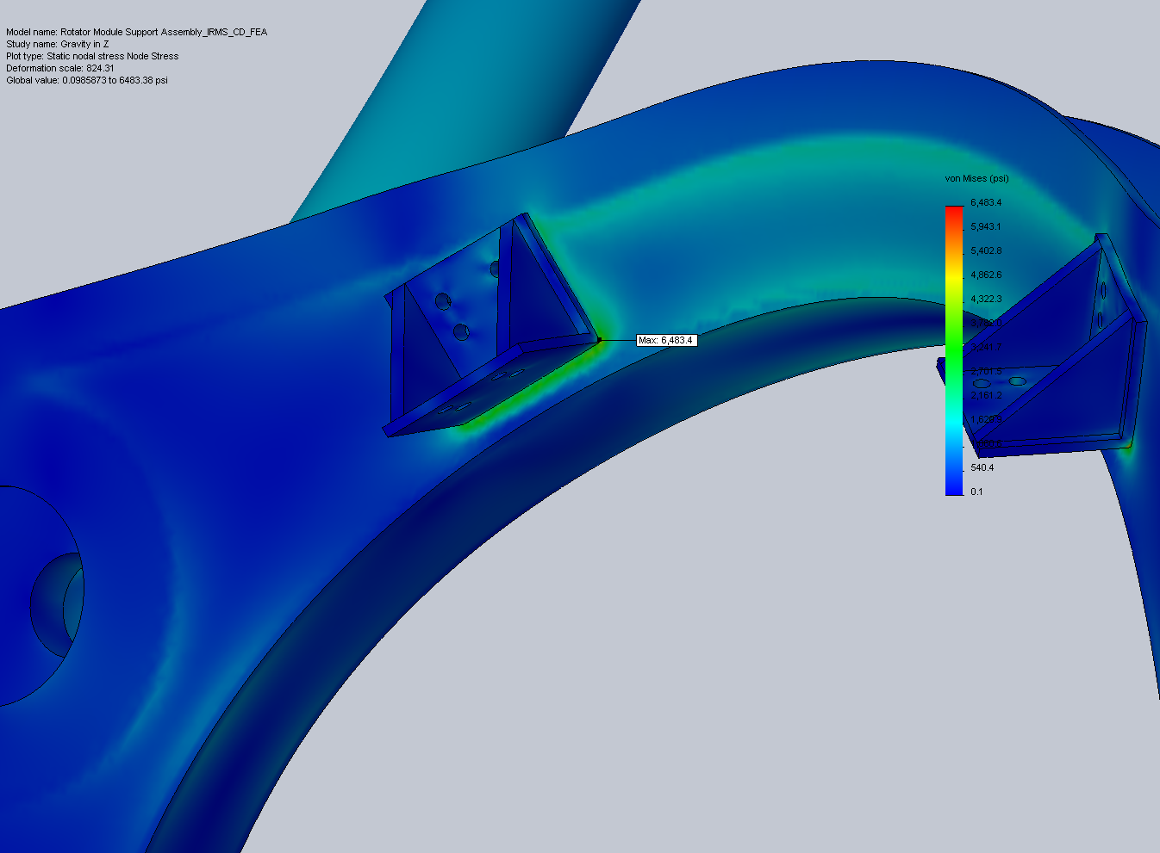
Figure 8: Close-up of max stress region.

2) Gravity in Y: Lateral 1G acceleration

Restraints:

- NFIRAOS interface pad surfaces: Roller/Slider in XY plane (3X)
- NFIRAOS interface pad bolt holes: fixed cylindrical surface- radial and along axis (24X)

Loads:

- Lateral 1G acceleration (Y): 9.81 m/s^2 on all parts
- Force (Y): 2,000 lbs equally distributed on bolt holes of rotator module mount brackets (4X) to simulate 8000 lb weight of MOSFIRE and module
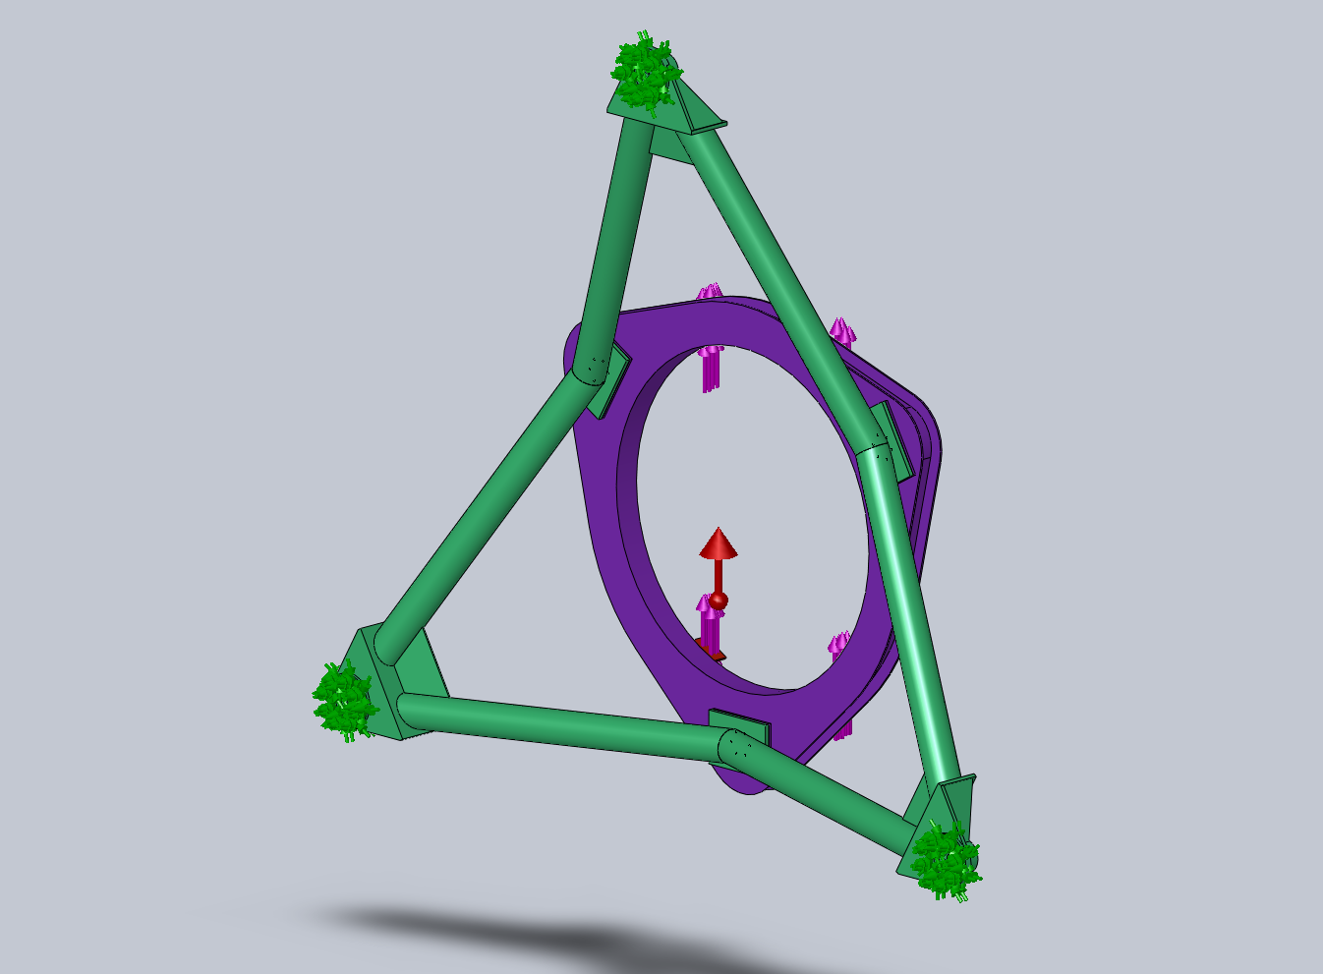
Pad A
Pad B
Pad C
Figure 9: Acceleration in Y model constraints & loads.

Results:

- Maximum Y displacement (lateral): 0.0096" (Mount Bracket tips)
- Maximum Z displacement (vertical): 0.0133" (flexure of Interface Ring)
- Maximum X displacement (lateral): +/-.0026" (+/- X direction strut/ring attachment)
- Node Stress (max): 8,844 psi (SF= 6.6 on ultimate stress {58,000-80,000 psi}; 4.1 on yield {36,000 psi})
- Element Stress (max): 6,785 psi (Δ30%)
- Requirement is: SF= 3.2 on ultimate
- Interface pad reaction forces:

Pad Location | X Reaction (lbs.) | Y Reaction (lbs.) | Z Reaction (lbs.)
A | 0 | -7458.6 | -2542
B | 2762.1 | -2626.1 | 1271
C | -2762.1 | -2626.4 | 1271

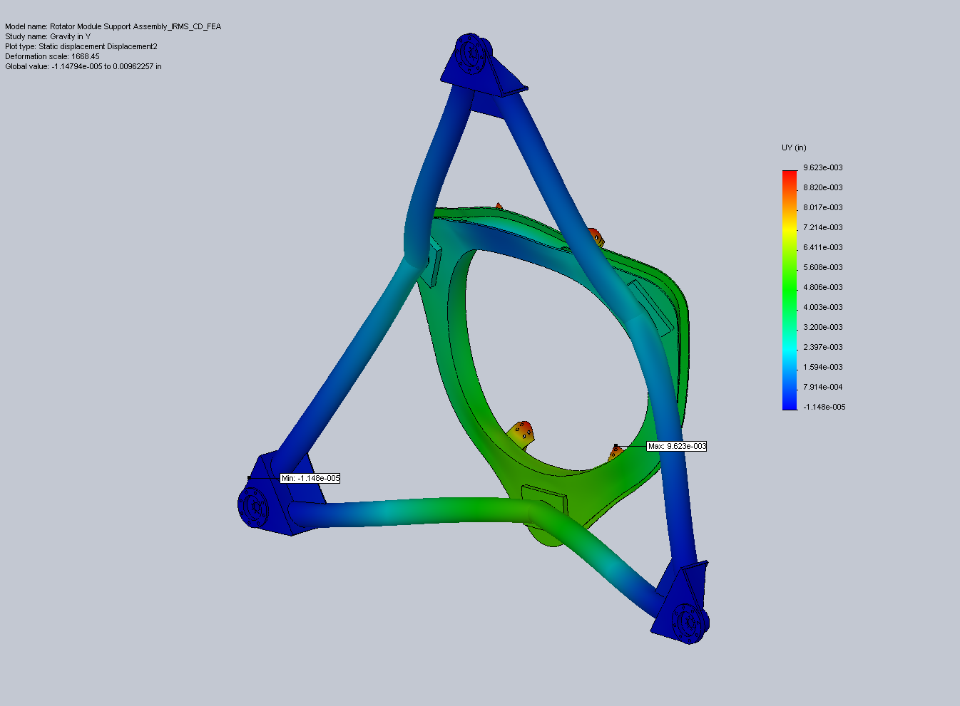
Figure 10: Maximum Y displacement for acceleration in Y.
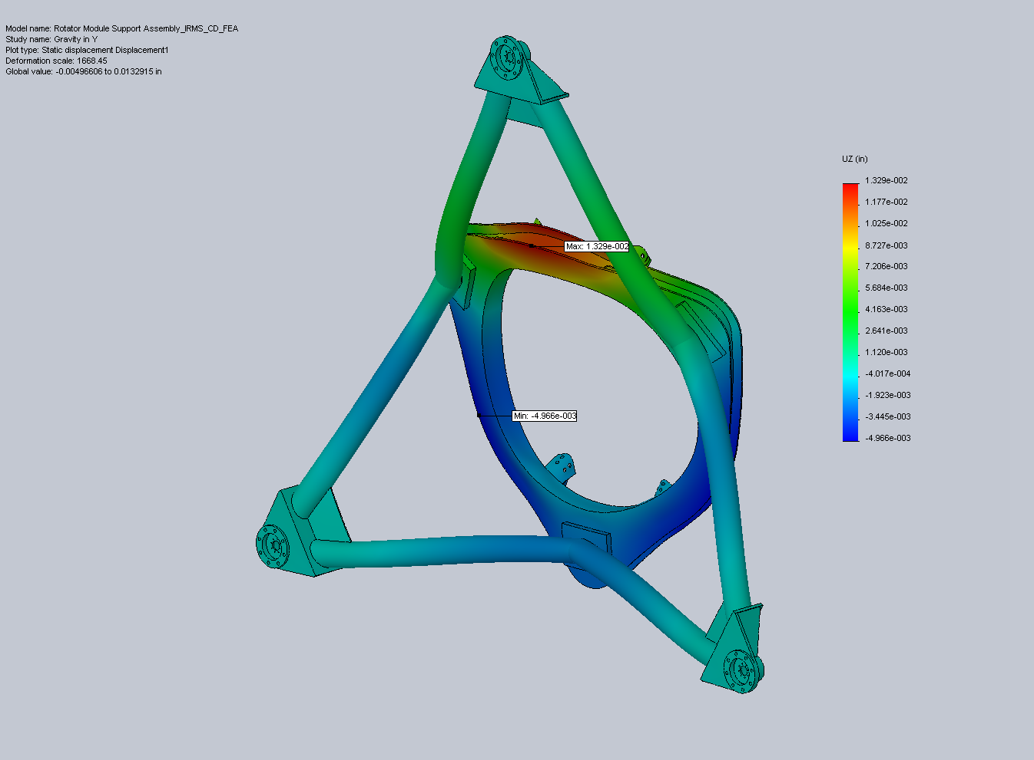
Figure 11: Maximum Z displacement for acceleration in Y.
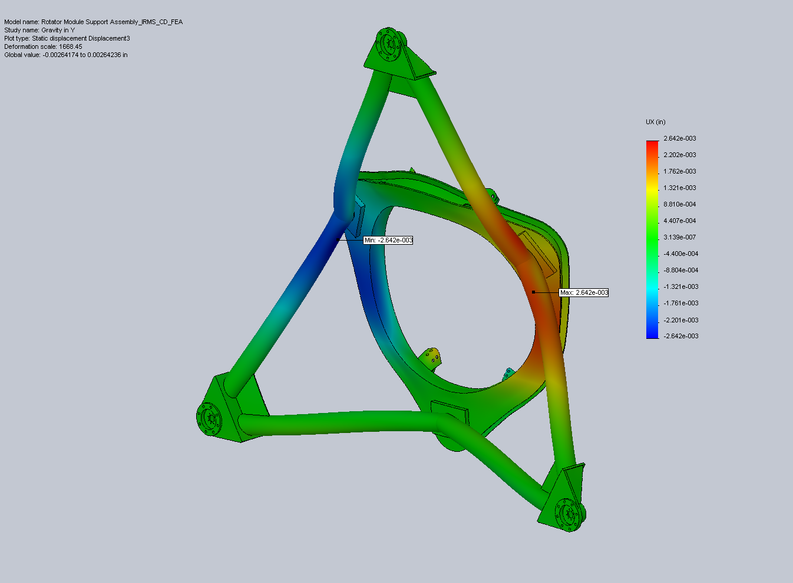
Figure 12: Maximum X displacement for acceleration in Y.
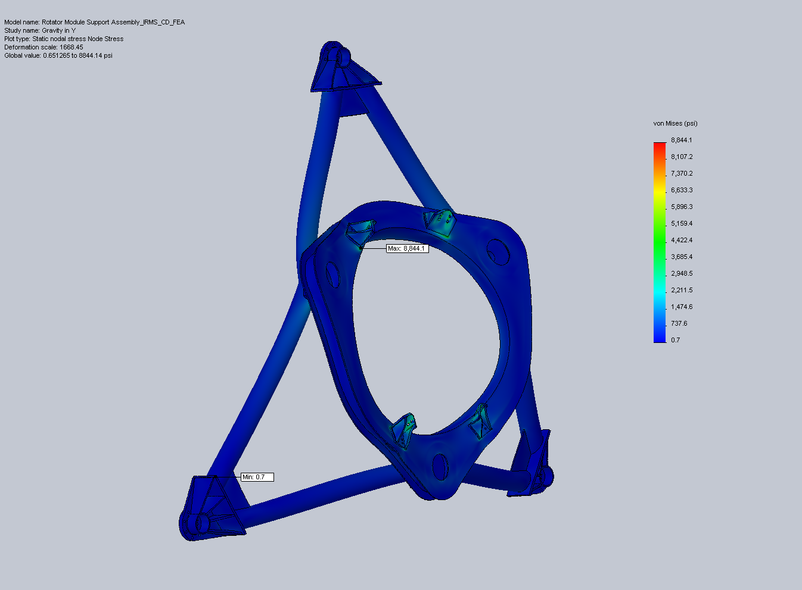
Figure 13: Node stress plot for acceleration in Y. The maximum stress is where the sharp corner of a mount bracket presses into the surface of the Interface Ring.
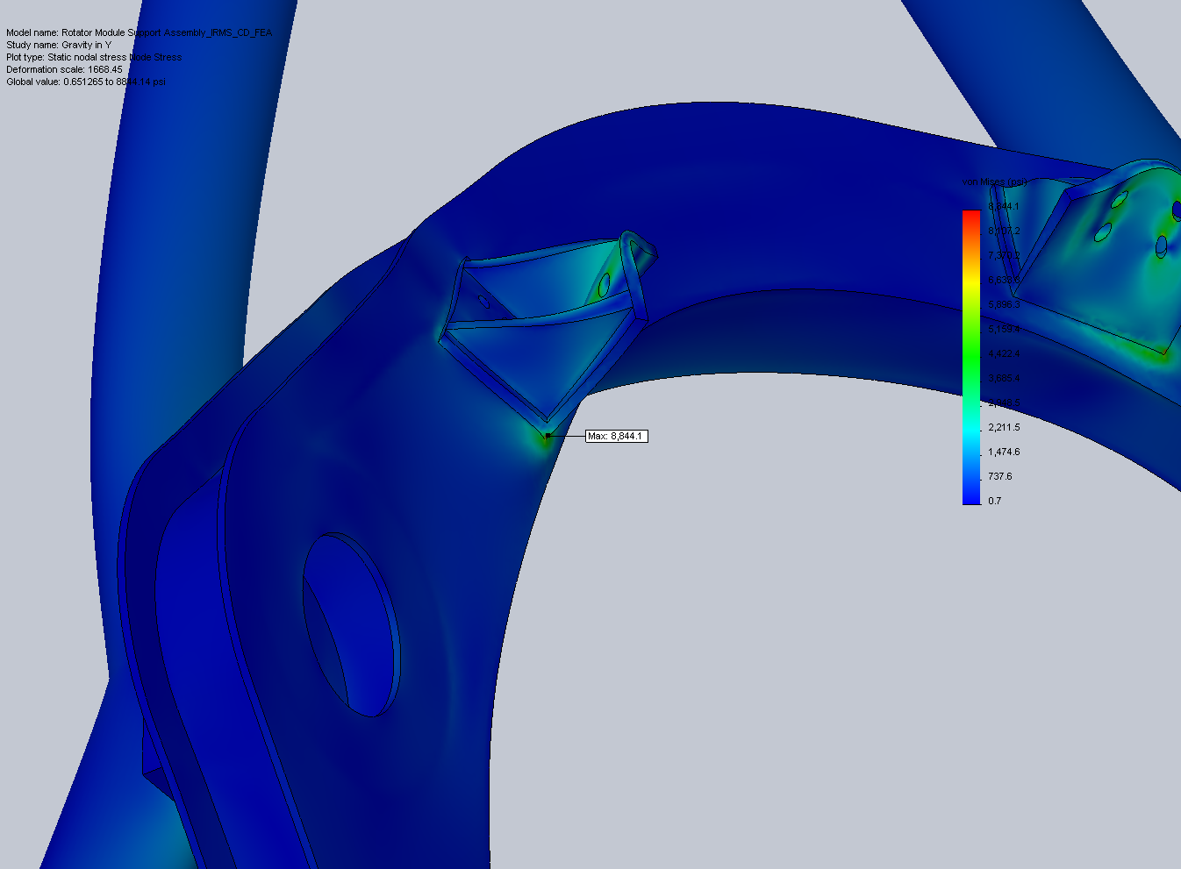
Figure 14: Close-up of max stress region.

3) Gravity in X: Lateral 1G acceleration

Restraints:

- NFIRAOS interface pad surfaces: Roller/Slider in XY plane (3X)
- NFIRAOS interface pad bolt holes: fixed cylindrical surface- radial and along axis (24X)

Loads:

- Lateral 1G acceleration (X): 9.81 m/s^2 on all parts
- Force (X): 2,000 lbs equally distributed on bolt holes of rotator module mount brackets (4X) to simulate 8000 lb weight of MOSFIRE and module
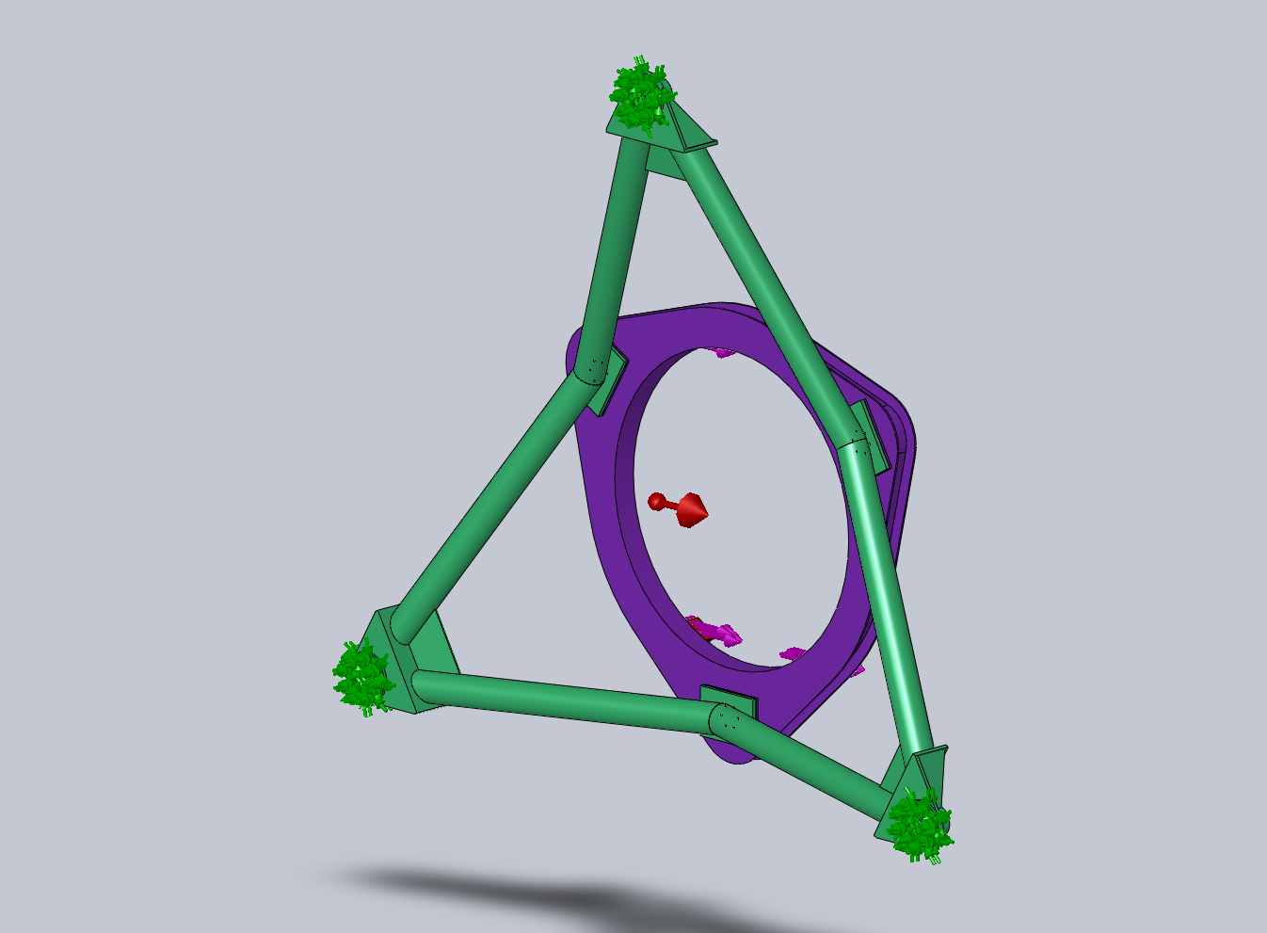
Pad A
Pad B
Pad C
Figure 15: Acceleration in X model constraints & loads.

Results:

- Maximum Y displacement (lateral): +/-0.0022" (+/- X direction strut/ring attachment)
- Maximum Z displacement (vertical): +/-0.0110" (flexure of Interface Ring)
- Maximum X displacement (lateral): 0.0086" (Mount Bracket tips)
- Node Stress (max): 9,999 psi (SF= 5.8 on ultimate stress {58,000-80,000 psi}; 3.6 on yield {36,000 psi})
- Element Stress (max): 6,603 psi (Δ51%)
- Requirement is: SF= 3.2 on ultimate
- Interface pad reaction forces:

Pad Location | X Reaction (lbs.) | Y Reaction (lbs.) | Z Reaction (lbs.)
A | -1063 | 0.2 | 0
B | -5824.1 | 2775.1 | -2204.8
C | -5824.2 | -2775.3 | 2204.8
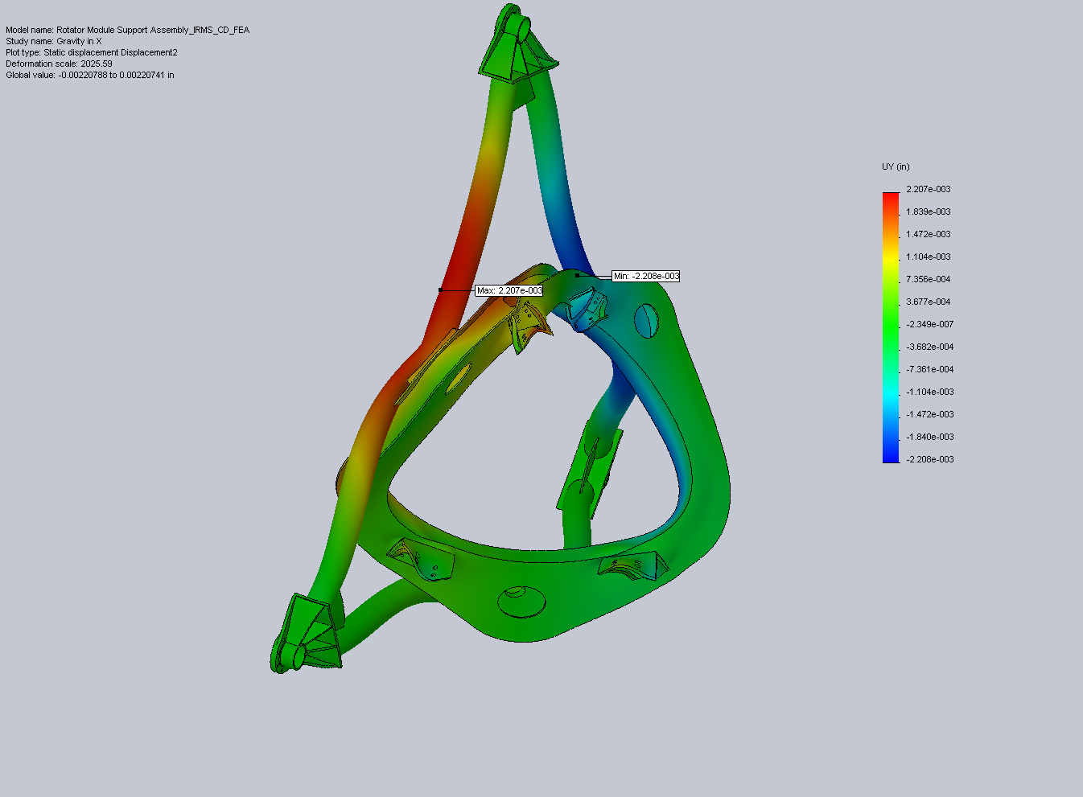

Figure 16: Maximum Y displacement for acceleration in X.
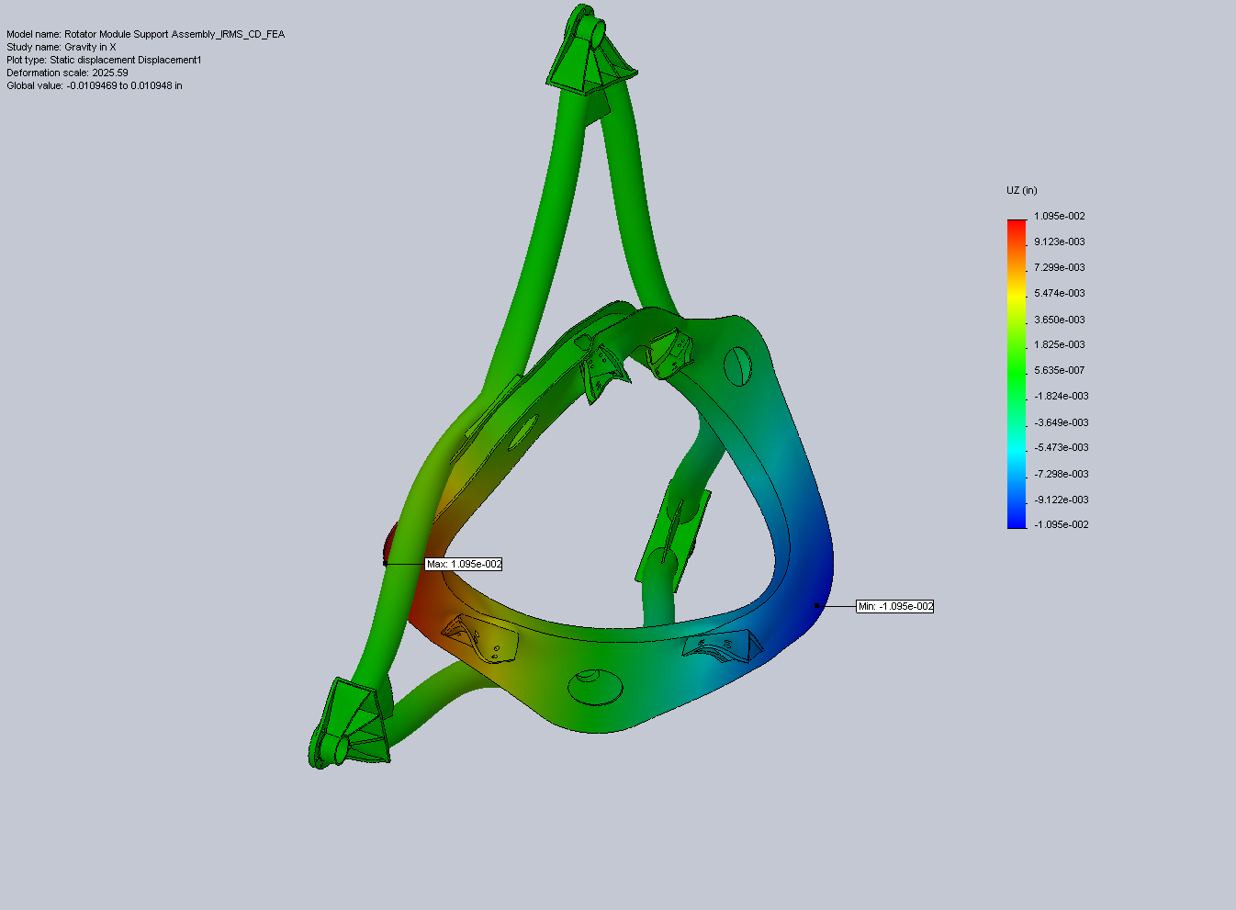
Figure 17: Maximum Z displacement for acceleration in X.
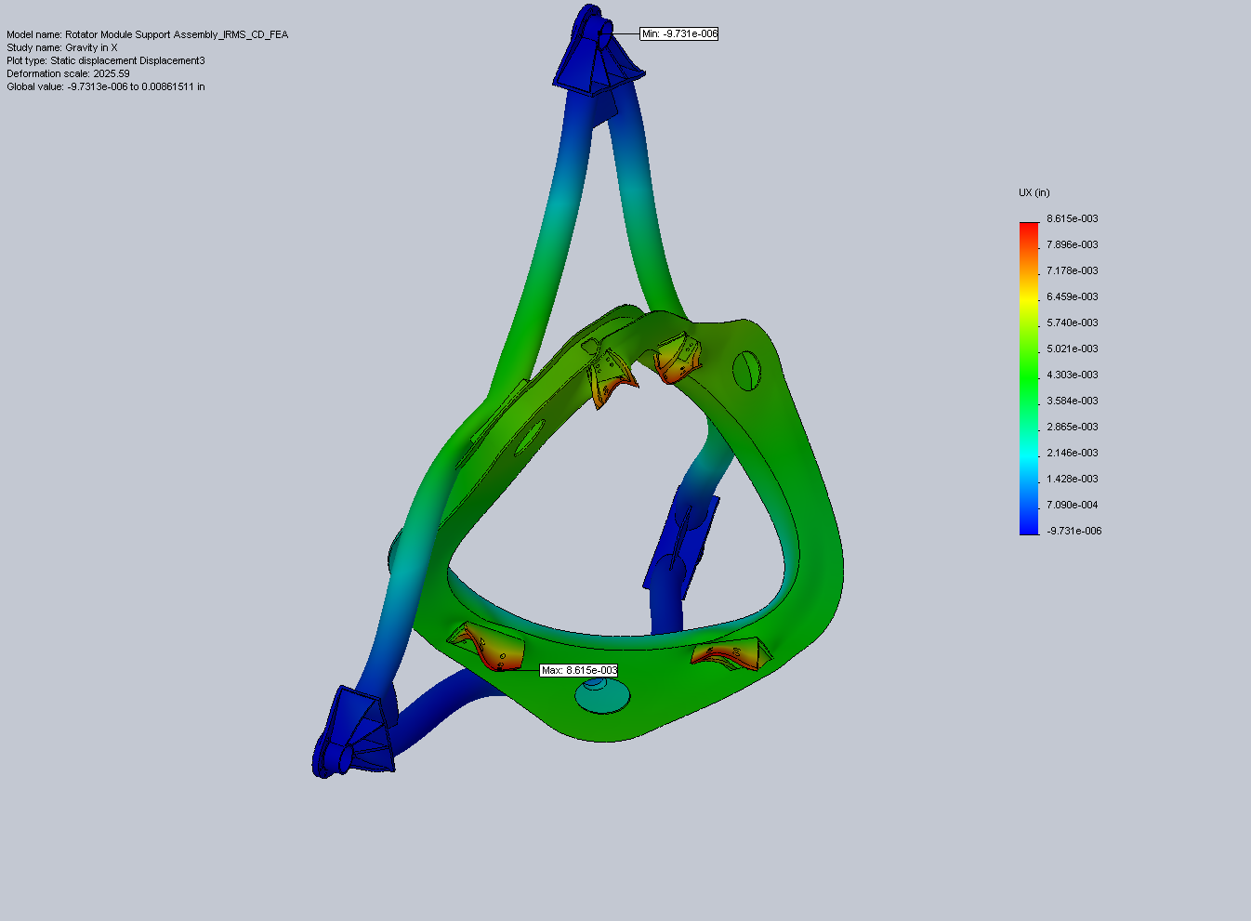
Figure 18: Maximum X displacement for acceleration in X.
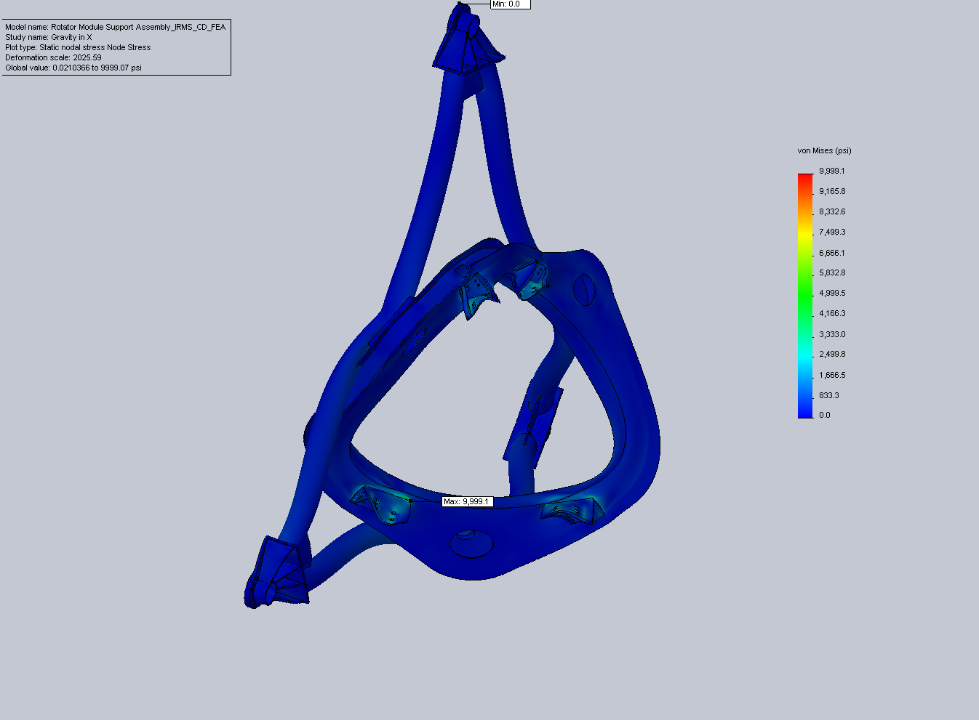
Figure 19: Node stress plot for acceleration in X. The maximum stress is where the sharp corner of a mount bracket presses into the surface of the Interface Ring.
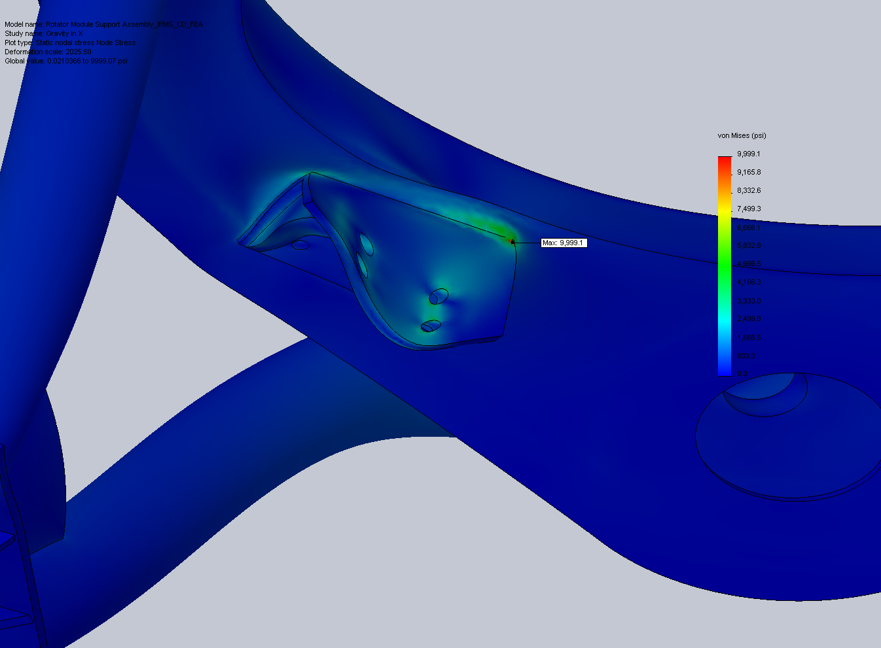
Figure 20: Close-up of max stress region.

Run B (Preliminary Analysis): Frequency Analysis-

Load Cases:

1) No External Loads: Frequency mode 1 for support structure only

Restraints:

- NFIRAOS interface pad surfaces: Roller/Slider in XY plane (3X)
- NFIRAOS interface pad bolt holes: fixed cylindrical surface- radial and along axis (24X)

Loads:

- No external loads

Results:

- Maximum resultant displacement (mode 1): 1.603"
- Mode shape 1 natural frequency: 53.5 Hz
- Requirement is: Natural frequency > 15 Hz

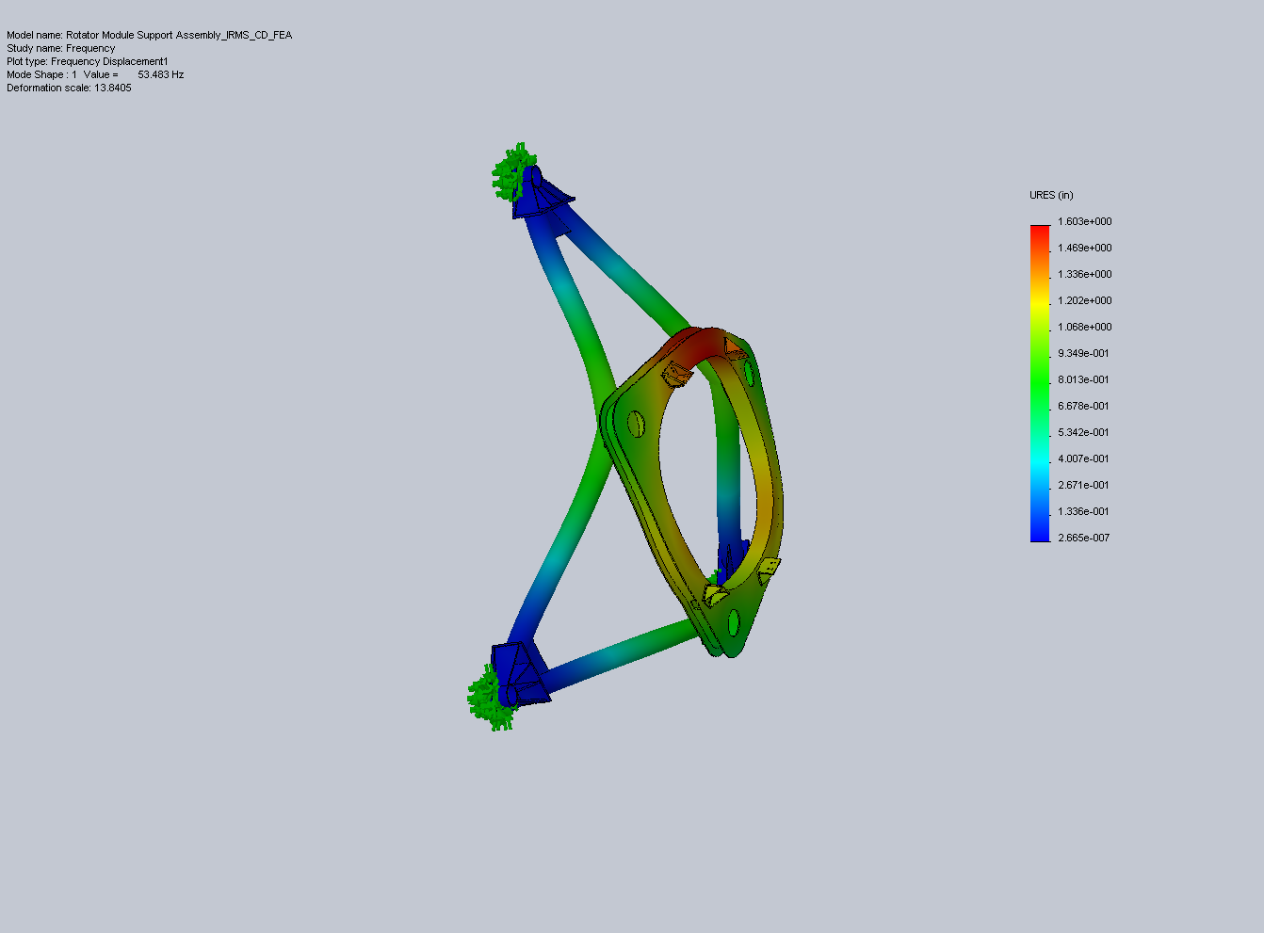
Figure 21: Resultant displacement for 1st natural frequency of unloaded structure.

