Fully differential signal path for the ZTF mosaic
Roger Smith and Stephen Kaye
California Institute of Technology

Abstract
The Zwicky Transient Facility is a 603 megapixel CCD mosaic under construction for the Palomar 1.2m Oschin Schmidt Telescope. To minimize beam obstruction and heating in the optical path, the readout electronics must be mounted outside the telescope beam. Sixty four video channels are transmitted over >1 m of cable at 1 MHz to meet the 10 second read time requirement. We review the electrical design of the signal path, which is fully differential from e2v CCD231-C6 to the differential inputs of the ADC, and discuss some of the benefits for high-speed signal processing beyond the obvious suppression of crosstalk and interference. We also discuss the packaging scheme that entirely eliminates hand wiring, while providing impedance control and good shielding over the whole path.

Introduction
The Zwicky Transient Facility, now in final design, is a wide-field CCD camera to be installed on Palomar’s 1.2m Oschin Schmidt Telescope, where it will survey the full visible sky more than twice per night to search for transient phenomena on short timescales. The 4x4 mosaic of e2v 231-C6 (6144x6160 pixel) CCDs spans 400mm by 400mm, a slightly larger area than the 14” photographic plates for which the telescope was originally designed.
Survey volume per unit time is maximized by observing at relatively high cadence and moderate depth. Total delivered image quality is typically 2”, so a relatively coarse plate scale, 1”/pixel, has been chosen to Nyquist sampling the PSF while maximizing signal per pixel. This choice has proven to be highly successful for the Palomar Transient Facility Error: Reference source not found(the re-purposed CFH12K*8K mosaic). The coarse plate scale allows readout to be only 10s with only 4 channel readout per CCD at 1 megapixel per second per channel. This read time requirement matches the time needed to offset the telescope the full 7.4 degree field width after every 25 second exposure. To achieve this, the telescope will be upgraded with new servo motors, lower declination gear ratio and direct encoding on both axes.
Space is very limited on the instrument since the focal plane is large compared to the telescope beam. Through careful optical and mechanical design the beam obstruction has been reduced to 23%, which is the area of the plano-convex window and supporting O-ring, plus spiders. Space on the rear is taken up by cooling systems and plumbing. To limit power dissipation within the beam, and the depth of the dewar (which can also affect beam obstruction for off axis rays), control electronics must be mounted outside the closed telescope tube. Thus the outputs for the 64 science CCDs, 3 focus/wavefront sensors and one guider must be transmitted at least a meter without degradation of performance in spite of the high channel count and relatively high pixel rate.
Due to the coarse pixel scale, the minimum photon shot noise per pixel is quite high, ~25 e- for 25 second exposures (g’ band on moonless nights). Given the relatively high pixel rate and >1m distance from CCD to controller, it is our belief that, in practice, better performance will be achieved through the use of differential transmission which will greatly attenuate all of the corrupting effects to be discussed in this paper. shows the percentage increase in total noise due to differential CCD output.
We present a very simple design and packaging for a signal path from CCD to controller that can be operated either single-sided or differentially. The associated differential receiver and Digital Correlated Double Sampler in the controller are described in a companion paper [2].
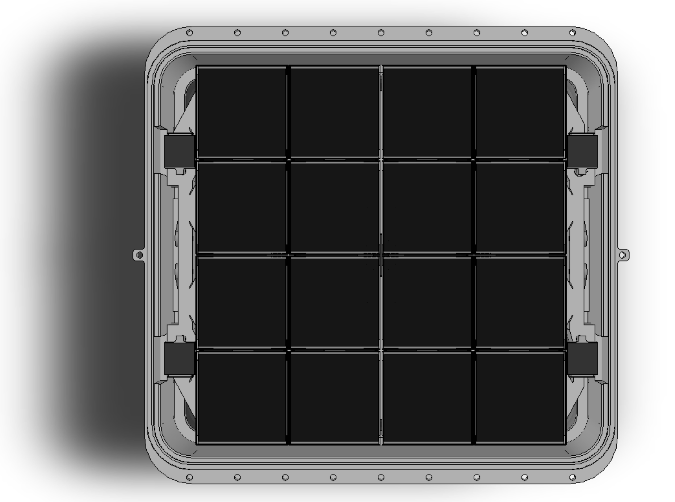
Figure 1: Camera for Zwicky Transient Facility is a 4x4 mosaic of e2v CCD231-C6 6144x6160 15µm pixel CCDs. The plano-convex window in conjunction with an achromatic triplet at the entrance of the telescope minimize aberrations but leave a weak curvature (7m radius) in the focal surface. CCDs tiled on the chords of this spherical surface each carry a thin plano convex field flattener which serves as filter substrate and as a radiation shield which halves the thermal load from the window.

CCD output
Fortunately the CCD231-C6 is equipped with a reference output, supporting true differential transmission. The various coupling capacitances and clock feedthroughs are replicated by the reference output, which includes the last few electrodes of a dummy serial register and CCD reset switch. The matching of these feedthrough pulses on signal and reference paths turns them into a common mode input. These transients are transmitted along the transmission line to the controller with common mode rejection occurring in the ADC buffer. This best common mode rejection at high frequencies may require tuning to account for any imbalance in the transmission lines. The fact that common mode gain is unity (a quarter the gain of the differential signal) will reduce the sensitivity to this effect. The ADC is isolated from common mode transients by the differential ADC buffer, an AD8139, which has 75dB CMRR at 1 MHz.
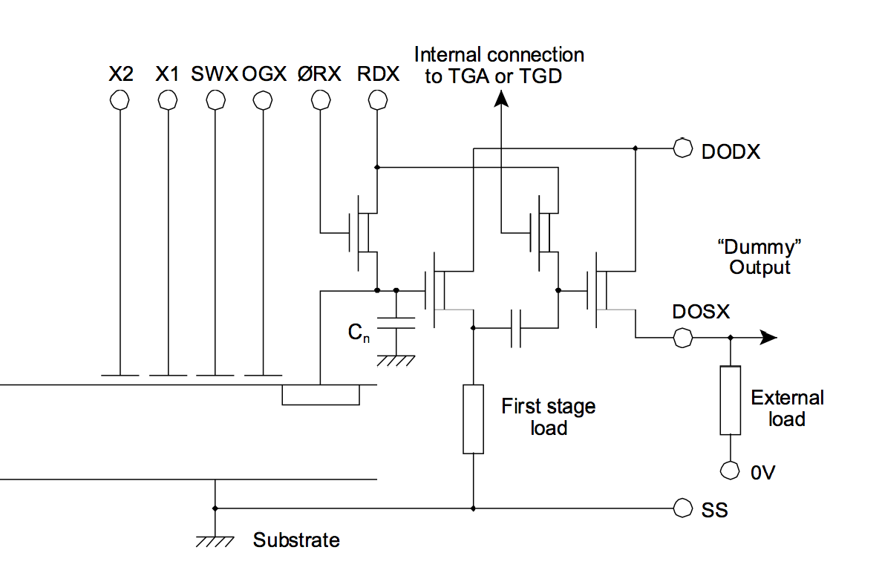
Figure 2: e2v CCD231-C6 reference output.

Since the signal and reference output share the same bias voltages and grounds, noise on these biases is attenuated to an extent described by the Common Mode Rejection Ratio (see section 6).
Table 1 shows the typical and maximum read noise for CCD alone comparing single sided and differential readout. The “typical” value is taken from the data sheet and represents the ideal case where there is no controller noise and none of the crosstalk problems common to high channel count systems running at high pixel rates. These are likely to degrade the single sided case but are mitigated by the differential signal transmission.

Table 1: Comparison of read noise (~typical, <max) for single sided and differential video
 | 500 kHz | 1 MHz
Single Sided | ~3.7, <6 | ~5, < 8.5 | electrons
Differential | ~5.2, <8.5 | ~7.1, <12 | electrons

Table 2: Percentage increase in total noise due to differential output (~typical, <max) in darkest 25s exposure (g’ band)
 | 500 kHz | 1 MHz
Single Sided | ~1.1, <2.8 | ~2.0, <5.6 | %
Differential | ~2.2, <5.6 | ~3.9, <11 | %

Ac coupler
Figure 3 shows matched AC couplers in both the signal and reference paths. To establish the black level, each of these has an analog switch in place of the usual resistor to ground. While the switch is open, the voltage at the input to the preamp changes linearly as the AC coupling capacitor integrates the input bias current of the preamp and switch leakage current. To the extent that these currents and the coupling capacitors match, this produces a common mode ramp, which is rejected by the differential ADC buffer. Given typical values of 100nF for the AC coupler and 3nA switch leakage (which dominates 25pA op amp bias current), only ~90 µV integrates on the coupling capacitor in a line time before being removed by the switch closure during parallel transfer.
Capacitance within the switch produces a transient when the digital control signal changes state (also known as charge injection), and the coupling capacitance provides a pathway for noise to enter from the switch power supplies or digital inputs. To reduce susceptibility to capacitive coupling of the analog switch control signal to the video, the black level clamp is often implemented as a separate AC coupler following the preamp. The low output impedance of the preamp then attenuates disturbances coupling through the analog switch. However in the differential design these effects become common mode and are thus attenuated, allowing the AC coupler to be clamped directly.
To provide added noise immunity and a degree of ground isolation, the clamp control signal is transmitted to the dewar as Low Voltage Differential Signal (LVDS) over twinax cable.
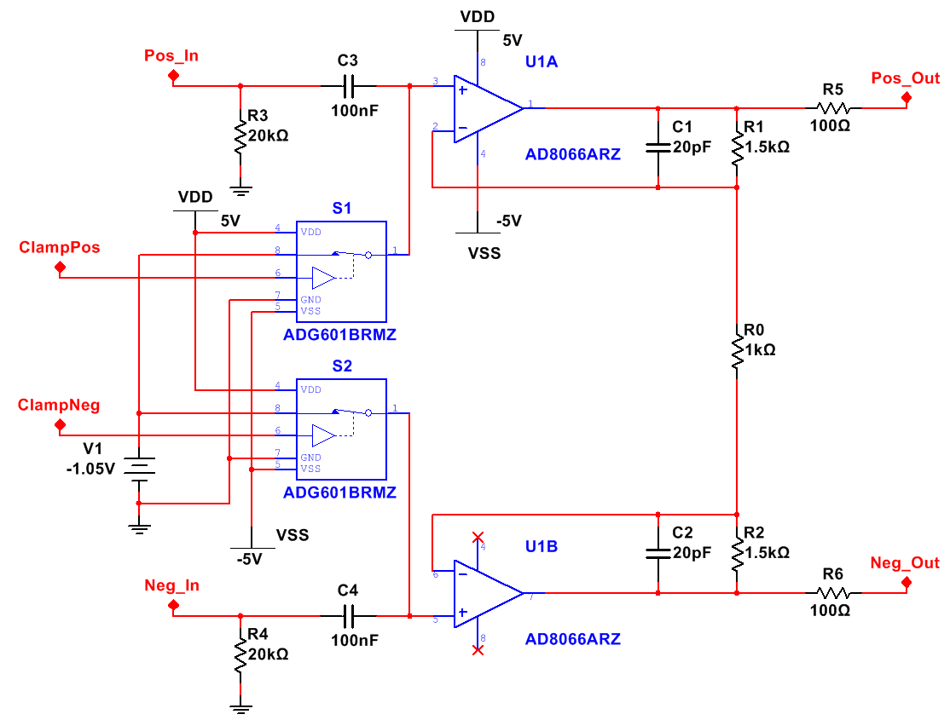
Figure 3: Differential AC coupler and preamplifier located at warm end of CCD flex.

Preamplifier near CCD
The differential preamplifier configuration, Figure 3, is that typically found in the front end of any standard instrumentation amplifier. Feedback ensures that the ends of the central resistor, R₀, are at almost the same voltage as the signal and reference inputs. For input voltages v₁ and v₂ , the current through the feedback resistors is
I = (v₁-v₂)/R₀
Output voltages (capitalized V₁, V₂) are simply offset from input voltages by the drop in the feedback resistors, thus:
V₁ = v₁ + I * R₁
= (1+R₁/R₀)*v₁ - R₁/R₀*v₂
V₂ = v₂ - I * R₂
= (1+R₂/R₀)*v₂ - R₂/R₀*v₁
Common mode gain,
A_{c} = (V₁+V₂) / (v₁+v₂)
= 1 when R₁ = R₂
Differential gain,
A_{d} = (V₁-V₂) / (v₁-v₂)
= (R₁+R₀+R₂)/R₀ for any R₁ or R₂
The CCD231-C6 data sheet promises 350,000 e- full in the image area however the summing well capacity is only 300,000 e- and only 200,000 e- is linear. With 7 µV/e- output node sensitivity (including source follower gains), the 300,000 e-range corresponds to 2.1V that must be digitized. The input range of the AD converter is +- 4.096V so we require differential gain, A_{d}≈3.9 prior to saturating the CCD, or less if some headroom is desired to avoid saturating the AD7626. This is a requirement for crosstalk correction for bright stars.

Op amp selection
In summary, the FET input amplifier operating with +-5V supplies provides enough input headroom to accommodate the 2.1V maximum voltage swing from the CCD, while the -4.94 V to 4.95V output swing accommodates the amplified signal provided that suitable common mode offsets is applied. The bias current is negligible compared to the black level clamping switch leakage and input noise is small compared to that of CCD. The gain bandwidth product of the amplifier is 145 MHz supports 1 Mpixel/second readout rate at the required differential gain, A_{d}≈3.9. Each of these topics are examined in more detail below.

Power Supplies
To minimize power dissipation within the dewar, preamp supply voltages are limited to +- 5V. Outputs can swing to within 60 mV of the supply rail. How much headroom does this provide? The signal output of the CCD swings negative by about 2.1V while the dummy output remains unchanged. By clamping the AC coupler to 1.05V, half the CCD signal swing, the preamp outputs swing from 1.05V to +4.2V and -4.2V respectively, keeping the signal within the +- 5V supply rails so that there is 20% headroom.
Quiescent supply current is 6.4 mA per op amp, so that quiescent power dissipation for the complete differential amplifier circuit is 128 mW.
At 1 MHz. the PSRR for the positive supply is -65 dβ, and -35 dβ for the negative supply. The modest PSRR for the negative supply requires an aggressive filtering scheme. e.g., 0.4 mV fluctuation in the negative supply produces 7 µV, equivalent to 1 electron, at the op amp input. Fortunately this error will appear on both op amps so, to the extent that the op amp behavior matches, immunity will be provided by common mode rejection of the ADC buffer.

Operating temperature
The thermal conductivity of each CCD flex cable is 1mW/K, providing 50mW of cooling to each preamplifier, partially offsetting its 128 mW power dissipation. To limit temperature excursion above ambient when powered or below ambient when off, lateral thermal conduction is provided by copper planes on the VIB. Low thermal resistance in the contact between the VIB and dewar wall is assured by the ~2 tonne compression force due to atmospheric pressure, about half of which is delivered to the VIB by the viton O-rings and the other half by direct contact to the shield planes on the outer surfaces. It is anticipated that with 6 ground planes, each 2oz/sq.ft copper, temperature rise from center to edge with all 64 science channels operating will be about 12 K. The electrically isolated outer surfaces will be at shield potential due to contact with the dewar. Two planes for preamp power will be located on the next-to-outermost layers followed by at least two ground planes, which surround the signal traces.

Input offset and bias current
Input offset voltage is removed by correlated double sampling since it is stable over a pixel time. Given the low signal gain, this offset will have negligible effect on dynamic range.
A ramp in the input offset is produced by leakage currents integrating on the AC coupling capacitor. Black level clamping occurs within the parallel transfer to avoid complicating the pixel timing. At 25 pA, the op amps input bias current is negligible compared to the leakage current of the analog switch providing the black level clamping. Allowing 3nA for switch leakage, a 90 µV ramp integrates on the 100nF AC coupling capacitance during the 3ms line time. With differential gain of four, this results in only 360µV loss of dynamic range at the ADC input and the slope results in negligible (0.004e-) signal offset during the 1µs pixel time. Furthermore, to the extent that the leakage currents and coupling capacitors are matched, this effect is common mode and is removed by the differential receiver just before the ADC.

Bandwidth
SPICE simulation was used to model the response of the preamplifier (Figure 4). Midband gain of 12 dβ is reduced by -3 dβ at 5 MHz by C1||R1 and C2||R2. The corner frequency is set intentionally low to serve as the first pole in a 2 pole antialiasing filter. The feedback capacitors reduce the gain to unity above 20 MHz, with subsequent roll off again above 100 MHz being caused by the 145 MHz gain-bandwidth product of the AD8066.
SPICE simulation for an input step representing a full scale signal of -2.1 V is used as the worst case for the settling time. The 8.4V output step is slew rate limited and takes 230ns to reach 0.1% of the final value then only 60ns more to reach 0.01%. For Digital CDS with 8 samples per pixel[2] and 230ns allowance for CCD reset and settling, memory from one pixel to the next is expected to be one part in ~4000 due to settling time. Pixel to pixel scene contrast is typically much less.

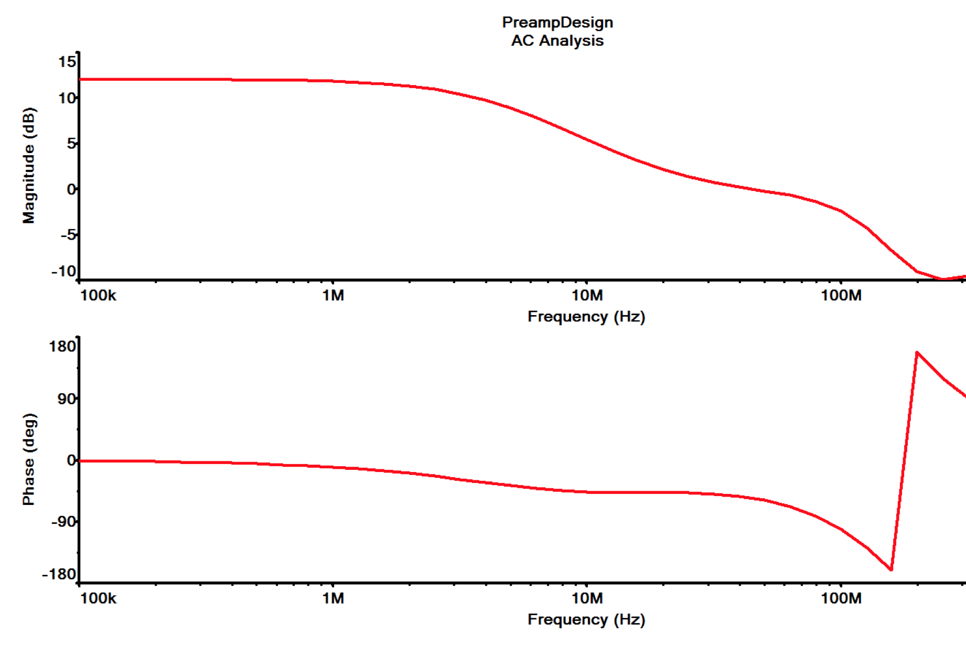
Figure 4: Frequency Response of preamplifier circuit with corner frequency set to 5Mhz

Input referred noise
The integral over all frequencies of the square of the transfer function (in Hz) for a dual slope integrator is equal to pixel rate. For a dual slope integrator with 20% overhead for CCD reset and Summing well feedthrough settling, for white noise density, e_{n} (in V/√Hz), CDS noise at the CCD output is given by:
Noise = e_{n} * [ 1.2*pixel_rate] ^{½} (volts rms)

Table 3: Preamplifier noise budget: input referred noise densities at 1 MHz
Source | Noise density | # | Basis of estimate
Op amp voltage noise | 7.0 nV/√Hz | 2 | AD8066
Op amp current noise | 0.8 fV/√Hz | 4 | R_source ~ 400 ohm
Feedback resistors | 2 nV/√Hz | 2 | R₁||R₀ = 300 Ω
ADC and postamp | 10 nV/√Hz | 1 | AD7626 = 0.5 ADU rms, 1MHz noise bandwidth
Power supplies | 6 nV/√Hz | 1 | Allocation for residual after filtering and PSRR
Total | 15 nV/√Hz | - | Added in quadrature

Given 7µV/e- output node sensitivity, 5e- typical noise at 1 MHz implies e_{n} ~35 nV/√Hz per CCD output if the noise spectrum is flat in this regime, thus 50 nV/√Hz differential. Table 3 shows expected noise contributions for the video signal chain: the projected 15nV/√Hz input referred total electronic noise density will degrade CCD noise by <5%. This has negligible effect when sky shot noise is taken into account. The single largest contribution to electronics noise is the ADC since the large signal range constrains the gain to be low (1 ADU = 4.6 e-). The ADC noise would have been √2 times higher than indicated if 4+4 Digital Correlated Double Sampling had not been used. [2]

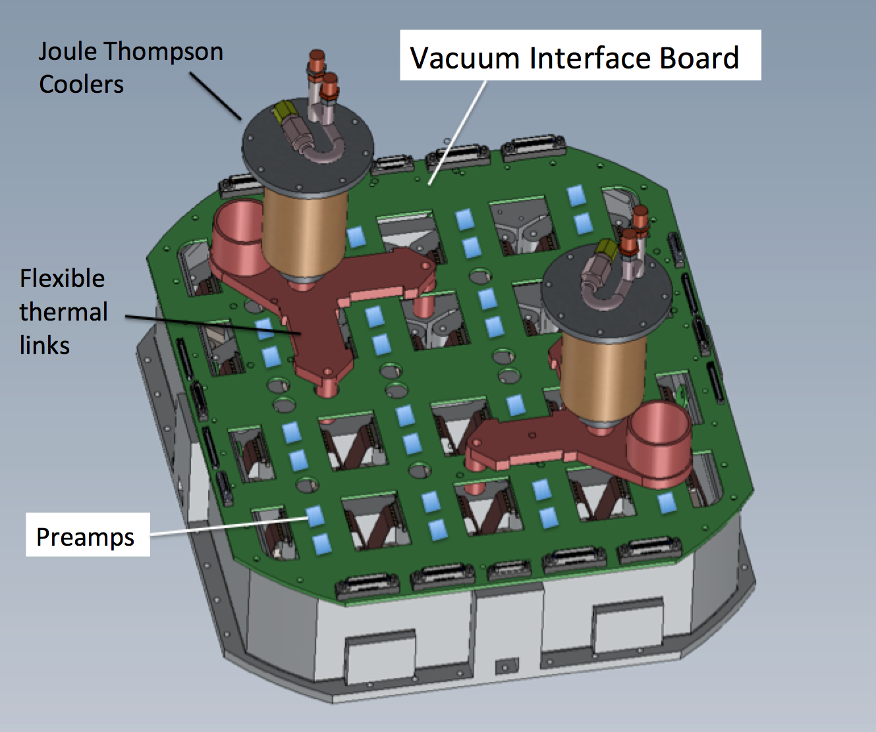
Figure 5: The preamplifiers are located adjacent to the connectors for the CCD flex circuits, on the warm Vacuum Interface Board (VIB) which is trapped between O-rings in the back cover (not shown) and sidewall. Preamplifiers and circuit traces on internal layers are located in “streets” while feedthroughs for thermal links penetrate the cross-streets.

Signal Transmission
A single large printed circuit board carries the preamplifiers allowing them to be located as close as possible to the CCD’s flex cable connector. The “Vacuum Interface Board” (VIB) is trapped between opposing O-rings at the interface between side wall and rear cover. Traces are routed from vacuum to atmospheric side on internal layers so that no hermetic connector is required. Signal and reference traces are routed to commercial-off-the-shelf cables containing multiple twinaxial conductors. These cables are from the ERDP series of high speed twinax cable assemblies from Samtec. The trace width and height over ground plane is adjusted to match the stripline’s characteristic impedance to that of the twinaxial cable (100 Ohm) so that reflections at the cable interface are minimized.
Resistors R5 and R6 are adjusted so that, in combination with the closed loop output impedance of the preamp, they match the transmission line impedance and thus absorb the reflected wave from the high impedance input at the receiver. This is preferable to terminating the receiver since the full transmitted amplitude appears at the receiver and the driver sees a load (twice the characteristic impedance) for only the ~10ns wave propagation time for the first reflection after any change. i.e. the driver is only charging and discharging the cable capacitance (49 pF/m). Transient current peaks at 20 mA, which is well within the 30mA that the AD 8066 can supply.

Common Mode and Power Supply Rejection Ratios
Using the equations above for an ideal amplifier, it can be shown that for differential gain of four, a 1% mismatch between R1 and R2 results in a 1 volt common mode input producing 15 mV differential output, compared to a 4 V output for a 1 volt differential input. i.e. with only standard component tolerances the CMRR is 266 or 48 dB, which may be adequate to suppress interference and bias noise.
Greater CMRR may make it possible to dispense with video crosstalk correction. This is highly desirable both for simplification of the data processing and because it would allow the gain to be set higher to digitize only the linear range of the CCD instead of the entire output voltage range. This would reduce susceptibility to noise in the output stages and provide better rejection of ADC quantization or DNL errors.
During initial test, both preamp inputs can be driven with a common mode signal to measure the Common Mode Rejection Ratio (CMRR) in the passband. One could modulate the common mode signal with a sharp step every ~10 pixels to reveal settling effects. A large resistor in parallel with R1 or R2 can be added to tune their matching. The post amplifier (digital CDS) and preamp need to be optimized separately for CMRR so that boards can be interchanged.
Common Mode Rejection Ratio (CMRR) of the AD8139 differential ADC buffer can be as high as 75dB (1:5600) at 1MHz if components are tuned. The CMRR of the ADC is 68 dB (1:2500) but common mode rejection has already occurred in the ADC buffer so this is not a limiting factor.
Power Supply Rejection Ratio (PSRR) generally deteriorates at high frequencies and can become a problem at the 1MHz pixel rate contemplated. PSRR can be improved by the common mode rejection of the differential input ADC, only if supply feedthrough on signal and reference sides match well. We will maximize the chances of this matching being useful in the CDS passband by using op amps sharing a common package.

Crosstalk
Crosstalk due to capacitive or inductive coupling in the cabling or routing of traces on printed circuit boards is attenuated because it is common mode interference.
Another common crosstalk mechanism is for a video signal to modulate its biases or grounds, which then couple to other video signals. The common mode rejection of bias fluctuations will attenuate this pathway and offers an opportunity for the wiring to be simplified by ganging bias signals together that would otherwise need to have been kept separate to avoid crosstalk.

Configuration options and self test
Holding both black-level-clamp switches closed throughout the readout provides an adequate approximation to a shorted input noise test. The CCD signal is still connected but is attenuated 160-fold by the potential divider formed by the 400 ohm CCD output impedance and the 2.5 ohm on-resistance of the switch.
Separate control signals are provided for reference and signal AC couplers so that the option is available for the signal chain to be operated in single sided mode, avoiding the √2 noise penalty of differential CCD outputs. The rejection of clock and bias feedthrough is lost in this mode but immunity to crosstalk in the cables is retained.
Holding the clamping switch closed on the signal side, while leaving the reference side operating, provides a way to measure the transients rejected by the differential signal path.

Summary of Pros and Cons
- Bias and ground noise rejection
- Reduced video cross talk
- Reduced susceptibility to interference
- Reset and clock feedthroughs not amplified → faster transient settling.
- AC coupler drift suppressed → clamp only once per line.
- Immunity to transients and noise entering through black level clamp.
- CCD noise is incurred twice.
- CCD power dissipation is increased by dummy outputs.

References
- G. Rahmer, et al., “The 12Kx8K CCD mosaic camera for the Palomar Transient Factory” SPIE Vol. 7014, 2008.
- R.Smith, S.Kaye, "Digital CDS for the ZTF" Scientific Detector Workshop 2013, Astrophysics and Space Science Library (these proceedings), 2013.
- J. Janesick, Scientific Charge Coupled Devices, SPIE press, ISBN 0-8194-3698-4, pp. 578-579.

