Design Note: Mechanical limits of 48"dome drive/bogie system
J. Zolkower

July 29, 2015------1st draft

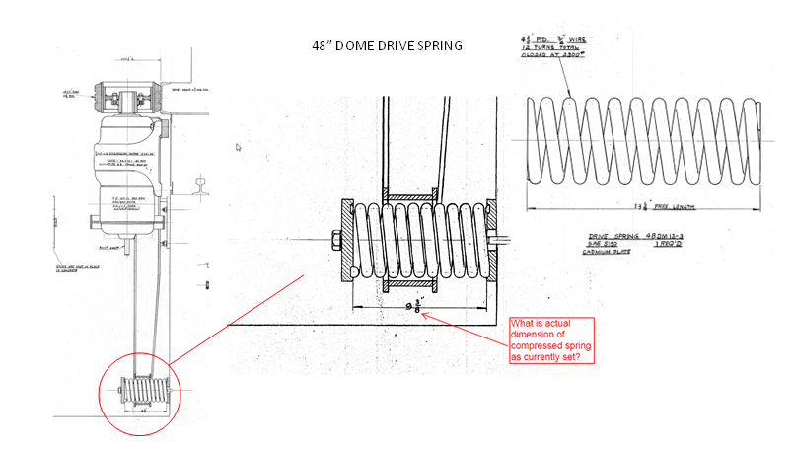

From dwg 101165 & 101166

Calculate Preload Spring rate:

Karl D reports that installed spring compressed length is 11.5". This is longer than shown in assembly dwg. (9.375")
Spring coil and wire diameter measure, # of coils counted. Confirmed spring is according to drawing.

Determine spring rate

Using calculator and assuming closed ground end………10 active coils.
http://www.acxesspring.com/spring-calculator.html
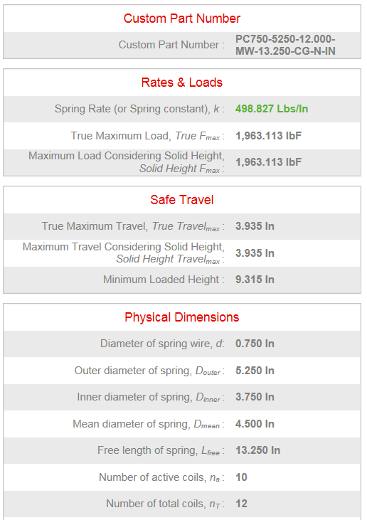

Currently installed preload on tire
Based on measured compressed length of 11.5" (from Karl D), and spring rate from above calculator: k= spring rate = 500 lbs/in
dL= compression from free length = 13.25 - 11.5=1.75"

Fs= Spring force= dL * k = 1.75" * 500lbs/in = 875 lbs

Ft = Load on tire from Spring force (current installed)

Fs * 38" = Ft * 28"
Ft = 875 *38/28= 1187.5 lbs

Nominal design preload on tire:
dL= compression from free length = 13.25 - 9.375 = 3.875 (nominal spring comp. from dwg)

Fs= Spring force= 3.875" * 500lbs/in = 1937.5 lbs
Ft = Load on tire from Spring force = 1937.5 *38/28= 2629.5 lbs (>50% higher force on tire than currently installed condition)

Dome drive calculations

Friction drive wheel reference
http://www.schwingmetall.com/download/catalog/WT5556_Rotafrix_Catalog_en.pdf

Typical coefficient of friction for elastomeric/steel Friction Drive: 0.7

Friction load:
We measured 320 lb pull to move the dome (breakaway from static was the same, there is no indication of higher static friction). Assuming 10° pull misalignment in Y and Z, gives 310 lb tangential pull. With a 21 ft radius, dome rolling friction ≈ 6510 lb-ft.

Inertial Load:
From calculations using dome and motor properties: ~7900 lb-ft torque
(see 48in Dome SpecSheet_V1)
This is worst case value based on theoretical motor output. A more realistic and lower value could be derived from actual dome acceleration measurements.

Total torque: Friction torque + Inertial torque: 6510 lb-ft + 7900 lb-ft = 14,410 lb-ft

Tangential start-up force on dome drive band: 14,410 lb-ft / 21ft = 686.2 lbs

Theoretical traction drive force:
Current Installed condition:
Drive wheel pre-load: 1187.5 lbs
With CoF: 1187.5 * 0.7 = 831.25 lbs

Nominal design spring preload condition:
Drive wheel pre-load: 2629.5 lbs
With CoF: 2629.5 * 0.7 = 1840.65 lbs
120% higher drive force capable than installed current settings;

Net radial force at drive wheel shaft:

Max Tire tractive force at contact = τ/r = 10100 lb-in / 8.125" = 1243 lb
(10100 in-lb is gearbox max output)
Nominal tire contact force = = 2630 lb (Ft from above)
Tractive force of tire generates a reaction force at shaft normal to contact force
Net radial shaft force = √ (x²+y²) = √ (2630² + 1243²) = 2909 lb

Dome truck radial bearing capacity

Dome truck radial bearing: MRC 5208
Double row angular contact bearing

Assume worst case that 2 radial bearings are loaded:

Net radial shaft force: 2909 lbs

Radial load per bearing: ~ 2909/2= 1454.5 lbs

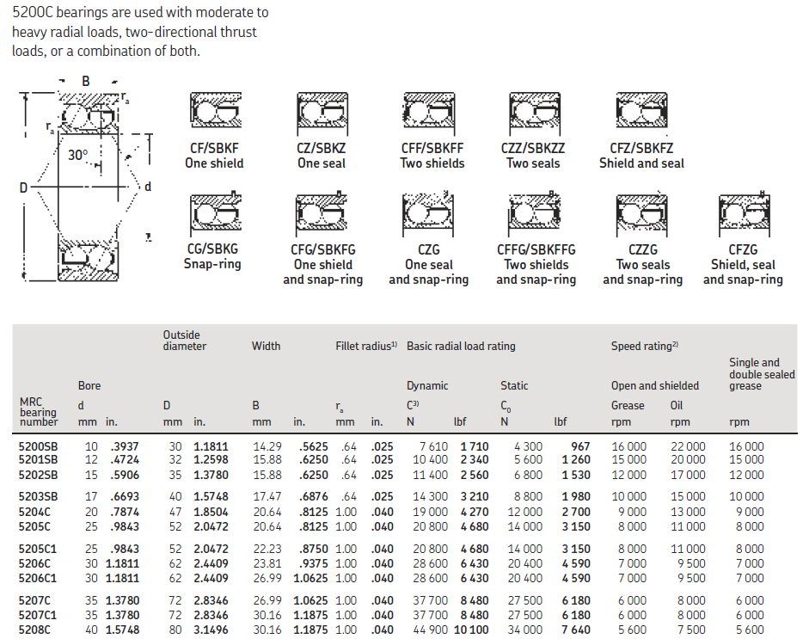

Per SKF Bearing literature:
Bearing 5208C 80mm OD
Dynamic Rating: 11,100 lbs
Static Rating: 7640 lbs

Assume no thrust load.
Equivalent radial load= P= 1454.5 lbs (from above)
C = Dynamic load rating = 11,100 lbs
L10 life = (C/P)^3 = (11,100 / 1454.5)^3 = 444 million revs
L10 life is 90% reliability of a single bearing life under defined loading.

Bearing dia" 80mm => 9.9" circumference
Rail circumference: 2*262*PI=1,646.19"
Bearing rev/dome rev = 1646/9.9= 166.2626 bearing rev/dome rev
444E6/166 = 3.6205E6 ≈ 2.6 million dome revs for L10 bearing life

- Assuming 20 year life on bearings, L10 bearing life => 350 dome revs/day.

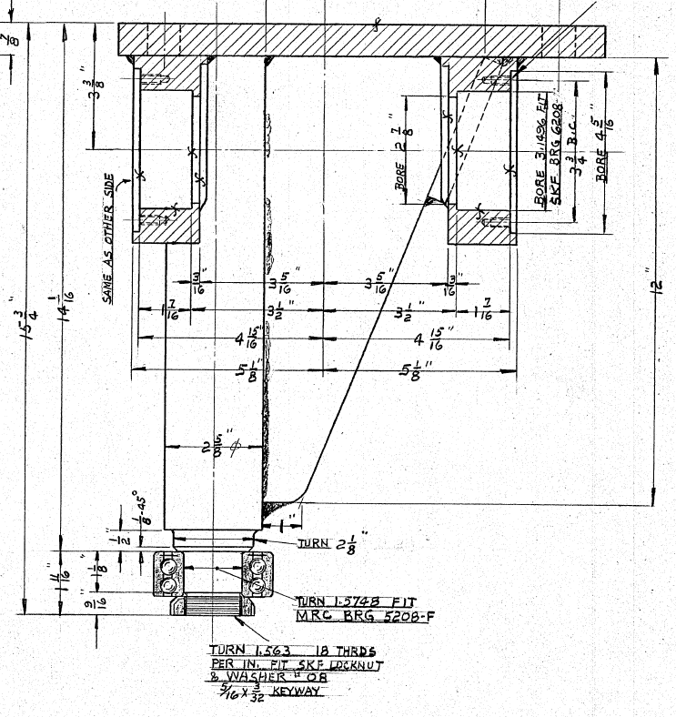

From drawing: 102160

