**Dynamic Load Testing of Bias Generation**

1. The setup has Analog and Clock Driver seating on Backplane Board. The Bias voltage is available on D Connector seating on Backplane board. The load is connected using short wires to this D connector. +All the Capacitors in the path on Analog Board (Bias generation part) and 1.5uF and 0.1uF Feedthrough capacitors on Backplane Card removed. Ferrite bead (RFI Filter) = 60 Ω (Murrata Part no. : BLM21PG600SN1D) on Backplane card is connected.

Load Current = 8 V/148 ohm= 54 mA Spike amplitude ~ 1600 mV. Amplitude of spike remains same except it’s either +ve or –ve depending on weather load is connected or disconnected.

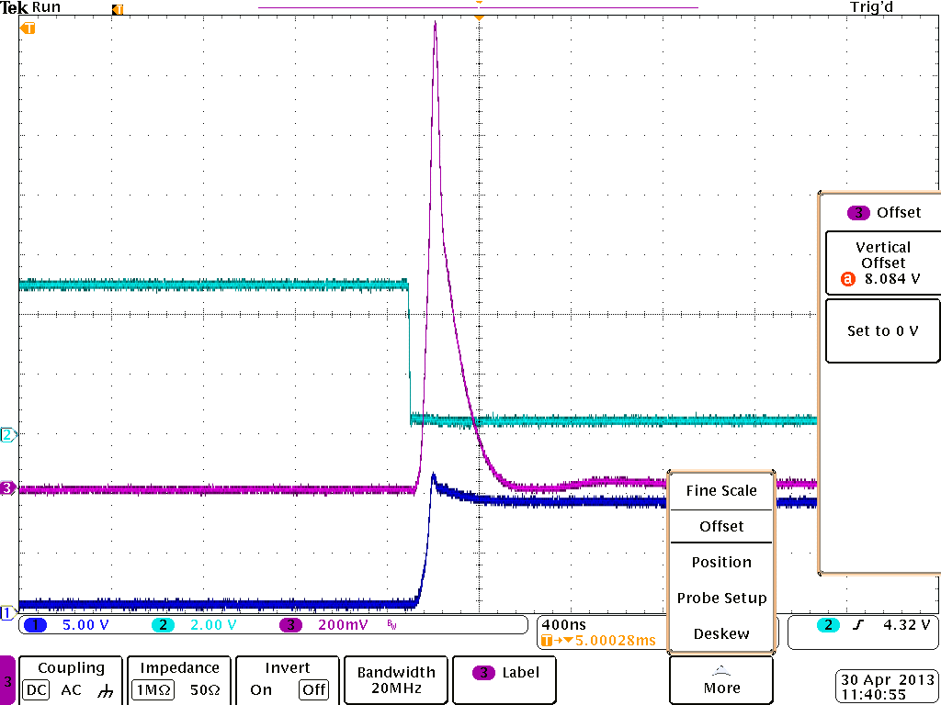

**Load Voltage**

**Gate to Source Voltage**

**Drain to Source Voltage**

1. Setup remains same as 1 except Ferrite bead (RFI Filter) = 60 Ω (Murrata Part no. : BLM21PG600SN1D) on Backplane Card removed (shorted).

Load Current = 8 V/148 ohm= 54 mA.

Spike amplitude ~ 1000 mV. Amplitude of spike remains same except it’s either +ve or –ve depending on w load is connected or disconnected.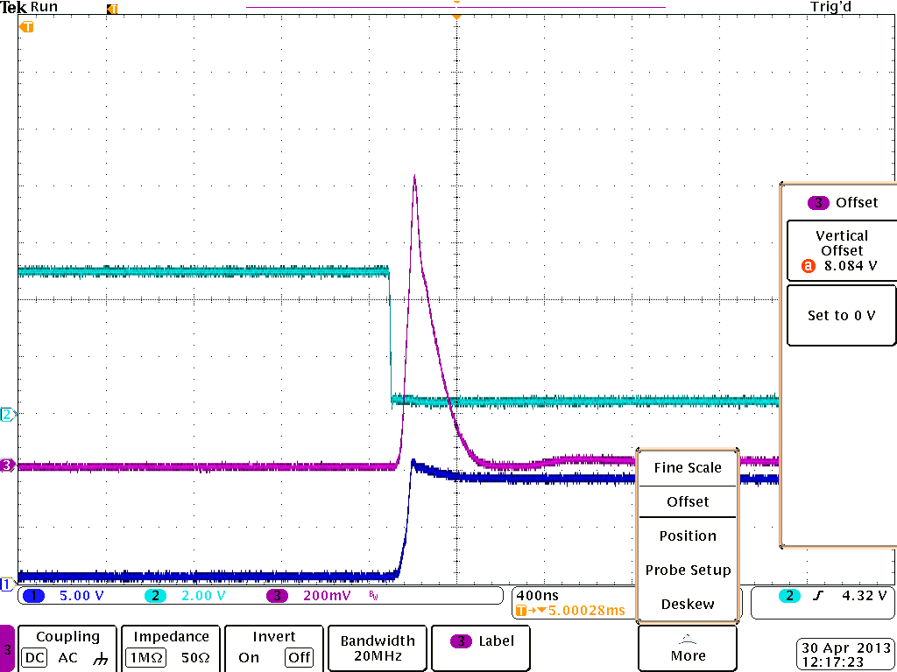

**Gate to Source Voltage**

**Drain to Source Voltage**

**Load Voltage**

1. 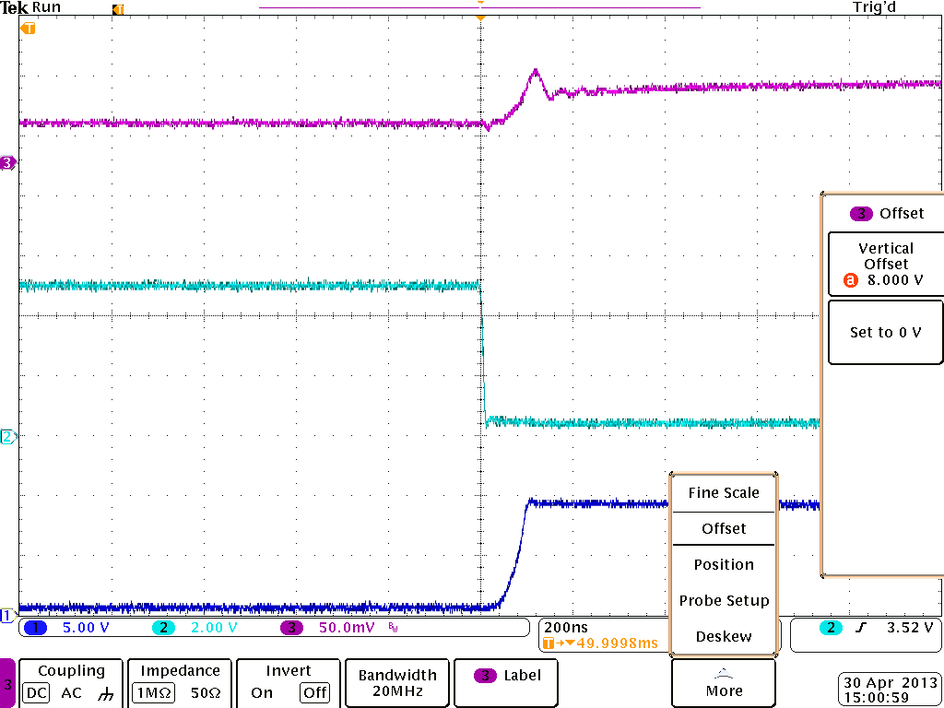All condition same as 1 and 2 except a 10 uF Tantalum Capacitor added near Load. This reduces the **spike amplitude to ~20 mV**.

**Drain to Source Voltage**

**Load Voltage**

**Gate to Source Voltage**

1. Same setup as 3 except the load and 10 uF capacitor connected right at Op-Amp output. This was done to make sure that track length from Op-Amp output to Backplane D connector does not have any contribution in Spike amplitude.

Spike shape is changed but amplitude is more or less same.

**Gate to Source Voltage**

**Load Voltage**

**Drain to Source Voltage**

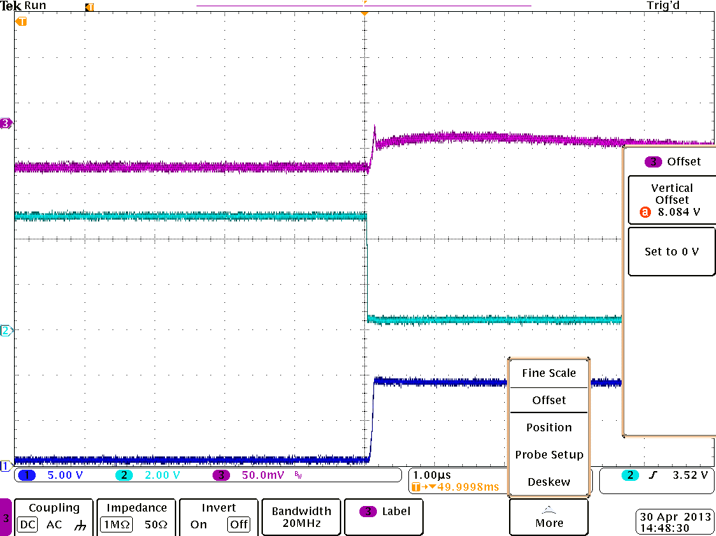

Drain to Source Voltage

Gate to Source Voltage

1. Same setup as 3 but compensation network added in Op-amp Circuit. With 10nF feedback cap and 10ohm series resistor in side feedback loop.

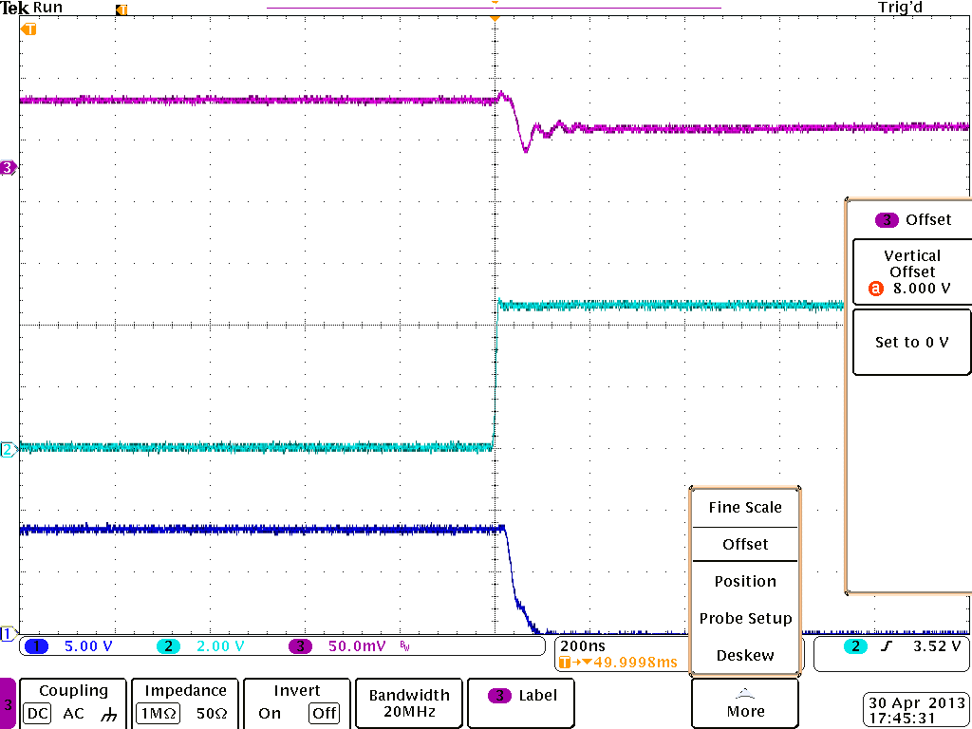

**Drain to Source Voltage**

**Gate to Source Voltage**

**Load Voltage**

1. Does the Op-Amp’s Output Impedance curve (Page 9 Data sheet) explain the spike while switching load ???

