Palomar Adaptive Optics Test Plan

Title | NGS Performance
Version | 1.0
Date released | 4/9/2008
Lead | A. Bouchez
Time requested | 3 hr.
Required conditions | Stable conditions, >50% Strehl on bright guidestar.

Purpose
Experimentally determine the science performanceas a function of guide star flux.

Previous analysis
A previous version of this test was performed in July 2004.
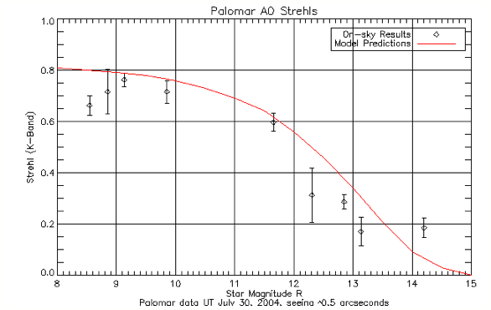
The above plot shows the performance (Strehl at 2.2 µm) of the AO system using natural guide stars of various magnitudes. For stars M_{R}<10 the system is limited by calibration error. Significant Strehl can be achieved on stars as dim as M_{R}=14. The model predictions are from first order analytical equations. It is not a fit to the data, but rather the predicted performance given the system parameters, measured r₀, and measured calibration errors. The excellent agreement is a demonstration of our understanding of the AO system error terms. See /home/mtroy/palao/data/04jul/30jul04/pharo for more details.

Test procedure
- Acquire a V~8 star (use Tycho 2 catalogue)
- Make best estimate of optimal frame rate (flux>200-300? at 0.4e/Dn)
- Acquire 3 images, 20 s. integration, K filter + ND or similar, record mean Strehl.
- Adjust frame rate and repeat step 3 until optimum framerate is found.
- Adjust TT and DM gain and repeat step 3 until optimum gain is found.
- Adjust log interval to record data at 200 Hz.
- Collect on source data:
  - Record starting timetag.
  - Record 6 exposures, 20 s integration each.
  - Record ending timetag.
- Open DM loop only and repeat step 7.
- Open both loops and repeat step 7.
- Reduce log rate to ~10 Hz.
- Offset to sky and record 3 20s sky frames.

- Repeat steps 2-11 for at several different star magnitudes. We actually want to span the flux values. Perhaps stars with V=8,10,12,14. Select stars of same spectral type (G-K, 0.6<B-V<1.1) near zenith. For V=8,10,12 stars, use Tycho-2 catalogue (good photometry with Hipparchos).

Results and conclusions
- Calculate the Strehl of PHARO images.
- Make a plot of Strehl vs flux and FWHM vs flux.
- Make a plot of Strehl (and FWHM) vs “real” star mag.
- Plot predicted system performance based on AO error model.

