The 1.064 µm line is hyperfine split into to lines, each 70 GHz wide separated by 55 GHz. One line is 72% the strength of the other line. The important parameter is the product of this line and the response of the etalon. Because the Nd:YAG is a mainly homogeneous transition the laser only emits near the peak of this product. For a 1 mm thick etalon the peak response of the laser is shown in red in figure 1. As the etalon is moved right the gain decreases; the profile for a 60 GHz shift is shown in green. If the etalon is moved another 10 GHz the laser jumps to the stronger region at -30 GHZ showing that we can only tune the laser over a spectral range of -30 to +60 GHz. At these wavelengths the gain of the slab is half that of the peak and the output power is less than half.

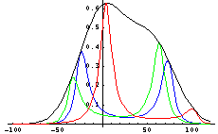

Figure 1 gain profiles of 1.064 µm laser with 1 mm 60% reflectivity etalon.
Red Etalon centered on gain peak
Green Etalon shifted 60 GHz right
Blue Etalon shifted 70 GHz right

If we increase the etalon thickness to 2 mm we find we can only tune between -18 to 30 GHz without mode hopping; the gain, however is above 85% of the peak gain throughout this region and this illustrates a central point of tuning - we want to operate the laser near the peak gain and restrict the tuning range of the etalon. Ideally we want to operate tune the etalon exactly to the peak gain and tune the frequency by changing the temperature of the slab [ bying changing the coolent temperature. We find that for the 1.064 µm line we do not want to use a single etalon much thicker than 2 mm. Multiple etalons give higher finesse over longer bandwidths but may not be appropriate for this work

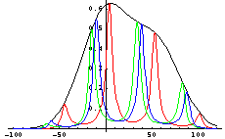

Figure 2 gain profiles of 1.064 µm laser with 2 mm 60% reflectivity etalon.
Red Etalon centered on gain peak
Green Etalon shifted 30 GHz right
Blue Etalon shifted 35 GHz right

A 3mm etalon may be useable, but the tuning range of +20 to - 10 GHz may be too small for the laser.

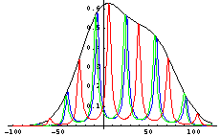

Figure 3: gain profiles of 1.064 µm laser with 3 mm 60% reflectivity etalon.
Red Etalon centered on gain peak
Green Etalon shifted 20 GHz right
Blue Etalon shifted 22 GHz right

The 1.32 µm line is a single line of width 70 GHz FWHM. The curves for the current 2mm thick 40% reflectivity etalon are shown in figure 4; the tuning range is +/- 22 GHz for a gain reduction to 70%.

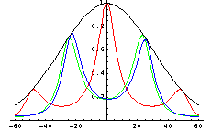

Figure 4: gain profiles of 1.319 µm laser with 2 mm 40% reflectivity etalon.
Red Etalon centered on gain peak
Green Etalon shifted 24 GHz right
Blue Etalon shifted 26 GHz right

A 4 mm etalon gives a tuning range of +/- 11 GHz

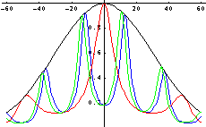

Figure 5: gain profiles of 1.319 µm laser with 4 mm 40% reflectivity etalon.
Red Etalon centered on gain peak
Green Etalon shifted 11 GHz right
Blue Etalon shifted 13 GHz right

Conclusion

We should chose etalons of the 1.064 µm from 1 mm to 2 mm (possibly 3 mm) and etalons of the 1.319 µn from 2 mm to 4mm. Reflectivity is another issue.

