Beam Transfer Optics Off-Zenith Calibration
A. Bouchez, 10/30/06

Introduction
The Palomar laser guide star adaptive optics (LGS-AO) system uses a free-space beam transfer optics (BTO) system to direct the 589 nm laser beam from the Coudé room to the laser launch telescope (LLT) located behind the 200-inch telescope primary. The BTO system includes three actively controlled mirrors (designated M1, M2, and M3) which are used to compensate for telescope flexure to keep the laser aligned to the LLT input pupil plane. Three quad-cell photodiode detectors (Q1, Q2, Q3) provide feedback on the position of the laser, controlling the active mirrors in closed loop while the telescope is tracking (see Figure 1).
However, the limited dynamic range of the quad cells (~1 cm radius) and laser safety considerations require us shutter the laser and command the active mirrors predictively during slews. We have therefore developed a calibration procedure which maps out the position of each mirror at every point in the sky. The calibration procedure is detailed in Section 2. Section 3 explains the data processing steps required to convert the BTO log files saved during calibration into two-dimensional tables for each motor. Finally, section 4 describes the region of the sky over which the current tables are valid.

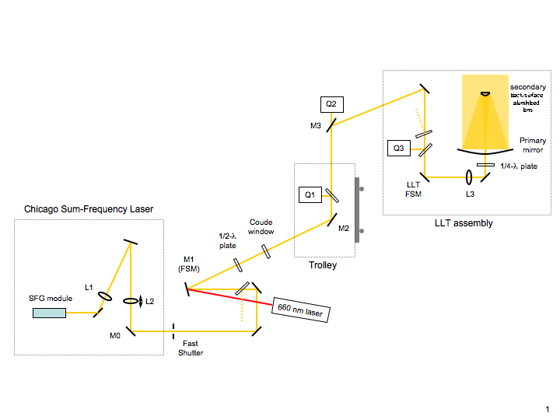
Figure 1: Schematic of the beam transfer optics system, showing the location of active mirrors M1, M2, and M3, and quad cell detectors Q1, Q2, and Q3.

BTO off-zenith calibration procedure
The calibration procedure takes approximately 5 hours to complete, but only requires the 660 nm stimulus laser and telescope moves in a closed dome. It is therefore most readily done in poor weather when the dome cannot be opened. Since the largest deviations in mirror positions are a function of declination (probably due to wobbles in the trolley track), we split the calibration into two phases, first recording mirror positions as a function of declination along the meridian, and then as a function of hour angle at a discrete set of declinations.
The first half of the procedure requires scanning the telescope along the meridian from zenith south, and then again from zenith north, with the BTO servo loops closed and while recording motor positions. We must scan at a slow enough rate that the servo loop can remain closed despite the uneven motion of the trolley. This can be achieved by setting the telescope's non-sidereal tracking rate to ±200000 "/hr in declination (the maximum allowed), +54000 "/hr in right ascension, and starting both tracking rates and telescope tracking at the same time. The telescope operator will have to update the right ascension rate occasionally to keep the telescope within a few arcminutes of the meridian. At ~1º per minute, it will take just over an hour to scan to the southern trolley limit (δ = -31.43º), and another half hour to scan from zenith to the northern trolley limit (δ = +65.45º), saving motor positions in a separate log file.
It is useful to pause the experiment at this point and perform the first step of the data analysis, described in Section 3, to be able to use new look-up tables valid only on the meridian to complete the second phase of the calibration procedure.
The second half of the calibration procedure requires slewing the telescope from the meridian east and west at several declinations, with the BTO servo loops closed and while recording motor positions. A Δδ =10º spacing between tracks is sufficient, and the actual spacing used depends on the time available for the experiment. Each track requires closing the BTO servo loops on the median at declination δ, starting a new log file, and instructing the telescope operator to slew first west until the elevation is ~30º, then back across the meridian to the same elevation in the east, then back to the meridian. This will take 5-10 minutes per track, with 5 minutes of setup time between tracks. Note that a large volume of LN₂ spills out of PHARO while performing this part of the procedure, and the telescope operator may need to take breaks to rest their of sore fingers. It will take approximately 3 hours to record tracks at δ = -20, -10, 0, 10, 20, 30, 40, 50, 60º (see Figure 2).
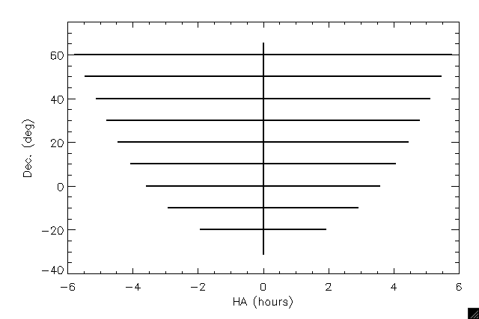
Figure 2: Schematic of calibration tracks, showing their increasing length in terms of hour angle at higher declination. All are shown cut off at el = 30º.

Data processing
The goal of the data processing steps is to interpolate motor positions recorded in the calibration procedure described above onto a regular grid which can then be queried by the BTO servo control software. The algorithm described here is motivated by the observation that most of the fine structure in the motor positions is a function of declination (see Figure 3, left), and the assumption that deviations due to flexure as the telescope moves in hour angle are additive to these meridian positions.
We therefore first combine and smooth the declination tracks to compute the motor positions as a function of declination. The IDL routine bto_1dlookup_calc.pro performs this task, averaging all positions of a given motor recorded in each 1º declination bin along the meridian to produce a single 6-column table of motor positions versus declination.
We then add each of these curves of motor position on the meridian with a two dimensional polynomial model of the deviations cause by flexure as the telescope moves in hour angle, which is given the form
C₀α + C₁α² + C₂αδ + C₃α³ + C₄α²δ + C₅αδ² + C₆α⁴ + ...
where α represents hour angle and δ declination, forcing it to be zero on the meridian. The coefficients C_{n} are optimized using a non-linear least-squares optimization algorithm to match the thousands of motor positions recorded in all the hour angle calibration tracks. A polynomial of 4th order (to C₉) appears to be sufficient to capture the hour angle dependence observed to 45º elevation. The combined model is finally sampled at 1º intervals in both declination and hour angle over the entire sky and output as six lookup tables, each with a header defining the sampling grid (see example in Figure 3, right). These tasks are performed by the IDL routine bto_2dlookup_calc.pro. Both of the programs, and required subroutines, can be found on harbor in the directory /users/aousr/abouchez/idl/bto.

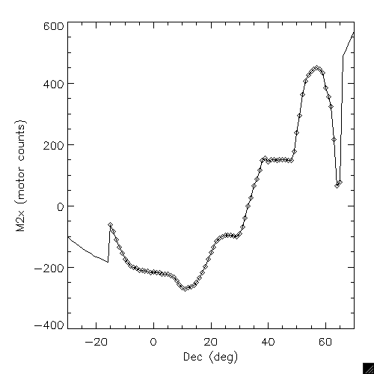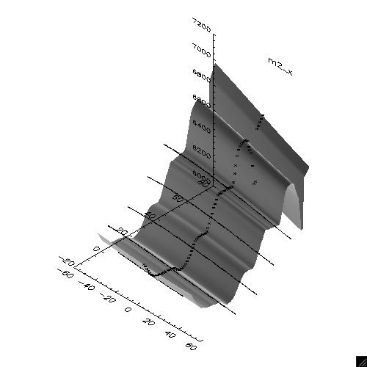
Figure 3: Left: M2y motor deviations from the zenith position as a function of declination along the meridian. Interpolated measurements from two tracks recorded on 12 Oct. 2006 are shown as diamonds. The fine structure is most likely due to torsional deviations in the trolley track. Right: Model of M2y position as a function of declination and hour angle, with positions recorded during hour angle tracks displayed as points.

Accuracy of off-zenith look-up tables
The most recent set of BTO look-up tables were computed on 13 October 2006 from meridian tracks recorded on 13 Oct., and hour angle tracks recorded on 12 Oct. at δ = -10, 5, 20, 33, 45º to HA = ±4 h. We tested the accuracy of these table on the night of 13 Oct., and compared them to a previous set based on data taken in June 2006. Both were found to have similar accuracy, placing the laser on Q3 over nearly the entire region currently accessible to LGS observations (see Figure 4). The only exception for the 13 Oct. tables occurred in the extreme northwest, at δ > 55º, more that 10º from the nearest recorded data. This suggests a more thorough calibration, with HA tracks separated by Δδ =10º and extended over the full hour angle range of interest, should be sufficient to allow reliable BTO alignment after a slew over the entire observable sky. A recalibration will most likely only need to be performed after mechanical modifications of the BTO.

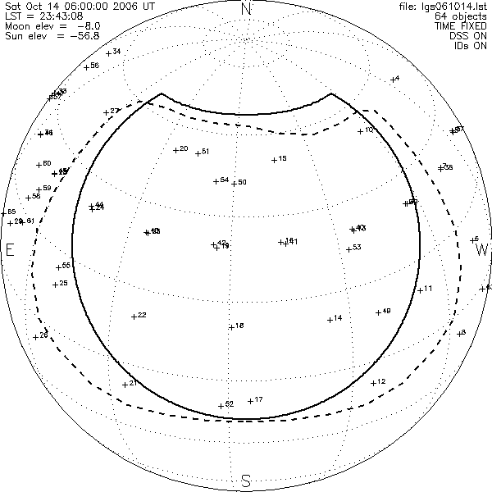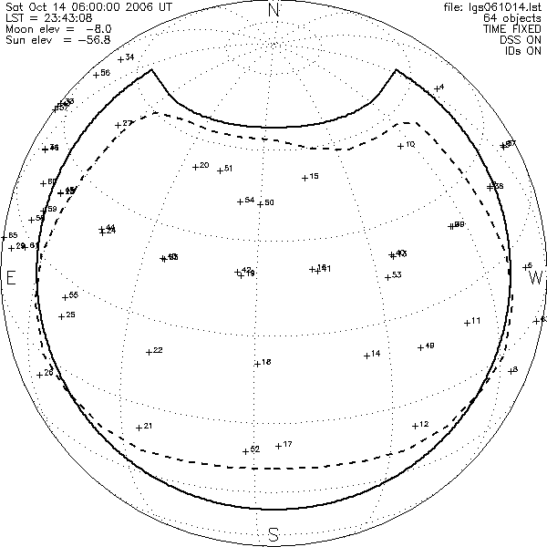
Figure 4: An orthographic representation of the Palomar sky at 06:00 14 October 2006 UT, with approved LGS targets numbered. The thick solid line represents the limits of the region of the sky accessible to LGS observations, with the current FAA elevation restriction of 45º (left) and a future reduction to 30º (right). The dashed line shows the irregular region over which the look-up tables computed on 14 October 2006 are valid.

C. Shelton, BTO Control Math, rev. 11 (14 Nov. 2005). (link)

