6/6/06 Beam Transfer Optics Update
A. Bouchez, C. Shelton, J. Angione, v2

This document summarizes the work performed at Palomar on 5-6 June, 2006.

Optomechanics

BTO stimulus breadboard alignment
We completed the alignment of the BTO stimulus breadboard in its initial layout on June 5. Its design (Figure 1, left) was based on the information given to us by E. Kibblewhite that the CSFL's output polarization linear, with the E-field parallel to the laser bench. This required two right angle reflections before the beamsplitter cube to preserve the horizontal linear polarization while rotating into the vertical plane of the polar axis. However, once we tested this design on June 6 with the actual CSFL laser, we found that its polarization is at a right angle to that indicated above, with the E-field perpendicular to the laser bench surface. This led to a redesign of the stimulus bench, with a final layout illustrated in Figure 1, right. The final design requires only one right angle reflection before the beamsplitter.

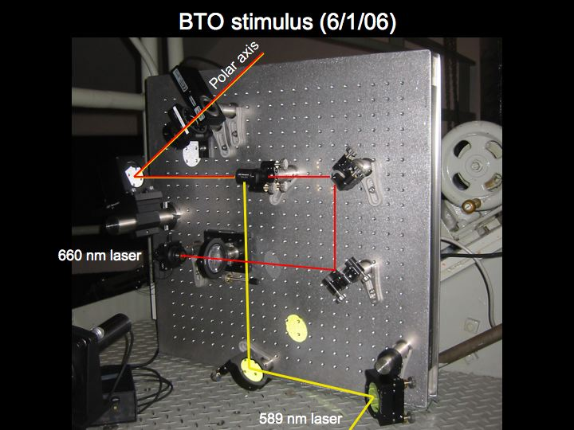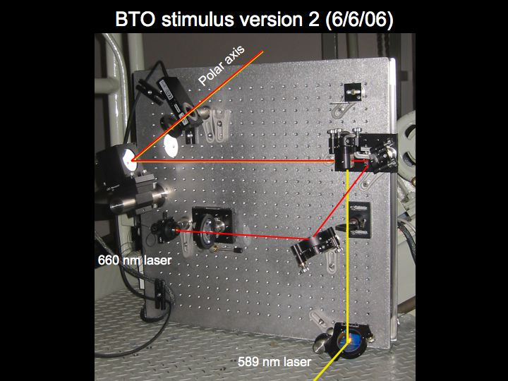
Figure 1: Left: Initial layout of BTO stimulus breadboad, for a horizontally polarized 589 nm beam. Right: Final layout of stimulus breadboard, for the vertically polarized 589 nm beam.
The 589 nm beam was aligned through the stimulus breadboard and onto the polar axis. The 660 nm fiber laser was then co-aligned to it, and the fiber chuck rotated to maximize its transmission through the beamsplitter cube. Note that the beamsplitter currently installed is designed for 620-1000 nm. An optimized beamsplitter cube (450-700 nm) is on order.

Half-wave plate calibration
We calibrated the half-wave plate orientation by estimating the polarization angle of the 589 nm light scattered from near the Coude exit window using polarized sunglasses. The angle at which the beam is horizontally polarized was found to be 84±1°. We then verified that a positive move of the rotation stage by 22.5° in fact preserved the degree of linear polarization of the transmitted beam and rotated the polarization angle by 45° clockwise, or East. Thus the commanded position should be (84 degrees) – (telescope hour angle in degrees) / 2.

BTO stimulus breadboard transmission
We estimated the transmission of the stimulus breadboard optics at 589 nm using the analogue bolometer power meter, as the Newport digital meter did not give sensible power measurements, showing a reading of 11.2 mW for all powers above a certain level, even with its attenuator attached. To the precision of the bolometer power meter (~5%), the fold mirror and polarizing beamsplitter cube do not measurably attenuate the beam. The total transmission of the stimulus breadboard optics (mirror, beamsplitter, FSM, ½-wave plate) is 82%±5%.

Checked laser focus lens alignment
We quickly checked that actuation of the stage on which the laser focus lens (on the CSFL bench just before the final fold mirror) will not cause the beam to wander on the BTO optics. No wander was seen as the stage was moved through ~2 cm of travel.

Tested transmission of RG610 filters
Colored glass filters were purchased to replace the ND2 filters previously used in front of Q1 and Q3, to allow the transmission of the 660nm alignment laser while attenuating the high-power 589 nm light. The 2mm thick Schott RG610 filters were found to transmit ~50% at 660 nm, and 13% at 589 nm. This is a factor of 21 greater transmission at 589 nm than expected from the Schott attenuation curves. We looked for a hidden red component in the beam to explain this difference, and saw nothing bright enough. We decided to therefore order a set of 3mm thick RG630 filters which should provide far greater attenuation at 589nm.

