12Kx8K Mosaic Camera for the Palomar Transient Factory

Thermo-Mechanical Design

Roger Smith and Khanh Bui
2008-07-14

Scope
This document describes the thermo-mechanical systems, which insulate, cool and thermally stabilize the 12Kx8K CCD mosaic.

Requirements

CCD temperature set-point range
150K < CCD Temperature < 185K

CCD temperature stability
Uniformity of CCD temperature only needs to be about 3K peak to peak, and might driven by CCD dark current, Charge transfer efficiency, or mounting plate warpage (TBD).

The requirement for stability on time scales greater than an exposure is determined by red QE dependence on temperature. Dark current stability is unlikely to be an issue since dark current is expected to be low compared to sky. A guess is that 200 mK peak to peak variation in temperature will be acceptable.

Short term stability of temperature need be no better since the correlated double sampling and overscan subtraction will remove signal offset changes which will occur on time scales much longer than a pixel or line time.

Since the thermal control system proposed will (based on prior experience) easily achieve 100 mK peak temperature variation and probably better than 10mk, then the need to define stability requirements (except perhaps for QE) is not pressing.

Time to reach operating temperature
Faster is more convenient, and saves manpower when debugging/commissioning so ideally one would cool at the maximum safe thermal slew rate (about 2K/min) and would thus cool to operating temperature in a bit over an hour, however this obliges us to use a liquid nitrogen system and even then is probably not consistent with other thermal constraints. Once the warming and cooling time exceeds a few hours opening and closing again within one working day becomes impractical. The next goal is for warming or cooling to occur overnight.

Goal < 16 hours, to allow cooling “overnight”.
Requirement < 24 hours.

Warm up time
Goal = 1K/min (with active heating).
Requirement < 16 hours (for overnight warm up)

Optical beam obstruction:
The camera is located at prime focus of the Schmidt telescope where is obstructs the 48” diameter telescope beam. In the current design the beam obstruction 15.3% of the beam is obstructed by the filter mechanism. The goal is for the cooling system to hide behind the filter footprint so that it does not add to this beam obstruction (more than say, 0.3%)
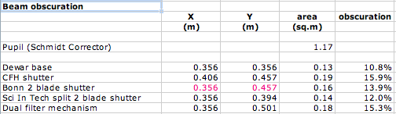
Figure 1: beam obstruction by the dewar is 10.8%, which is only increased to 12% by the shutter (made by Sci In Tech). The dual filter exchanger has a larger footprint increasing the total beam obstruction to 15.3%. The area of the spiders needs to be added to this.
Any hoses or cables associated with the cooling system must be hidden within the footprint of the prime focus support spiders to meet the above requirement.

Space constraints
The Mosaic must be mounted on the existing focusing hub, which lies at the center of the support spiders. Only 6.5” (TBC) is available between the focusing hub and the focal surface of the telescope. The vacuum enclosure and any protruding features must fit within the footprint of the filter mechanism and mostly (except for the window) fit between the focal surface and hub. Rear protrusions between the spiders but within the filter mechanism’s footprint are acceptable provided that they do not impede installation and removal of the instrument. (see below)

Orientation:
The mosaic camera must be operable in any down or side looking configuration and shippable in any orientation.

Handling requirements
It must be possible for the camera to be shipped to Palomar from Caltech, and to be installed or removed without breaking vacuum, and preferably while fully assembled, except for the connection of cables and hoses.

Maintenance interval
Pumping to restore vacuum must be needed no more frequently than once every 3 months with a one year goal.

Molecular sieve changes should be necessary only once after having the system open to atmosphere, and thence only once per year.

Pumping and molecular sieve changes must be possible while the camera is installed on the telescope.

Manual refill of liquid cryogens (Nitrogen) is discouraged unless the operating cost of alternative refrigeration systems is clearly higher than the manpower cost.

Condensation
Condensation on the entrance window due to radiative cooling must be prevented.
Condensation of water vapor on the detector must never occur.

Primary mirror protection
Condensation on plumbing or vacuum chamber must be prevented since the camera is positioned over the primary mirror. Lubricants, particles or other materials must not be shed by the camera since these will also fall on the primary mirror.

Cooling system options considered

Liquid Nitrogen with autofill
A large liquid Nitrogen reservoir and evacuated transfer lines were installed at the telescope to support the QUEST camera which the PTF Mosaic will replace. (Who owns the transfer lines? These may go away along with QUEST). While this infrastructure could be used the it has proven inefficient (expensive) in its consumption of liquid Nitrogen, and joints in the transfer lines produce condensation which sometimes drips in the primary mirror.

Continuous flow cryostat
Quest installed a large reservoir behind the focus hub with cold fingers reaching between the spiders to a camera head in front of the focus hub. We consider this unacceptable since the instrument cannot be installed and evacuated, or removed without disassembly.

To address this it is possible to have a small reservoir or heat exchanger within the camera head and to bleed Nitrogen (cold gas and liquid mixture) continuously through the system through evacuated transfer lines. Such systems have been used successfully at ESO but the lack of a location on the telescope for the large storage dewar requires the long hoses to the off telescope storage tank and thus poor thermal efficiency.

Gifford McMahon closed cycle cooler
GM closed cycle coolers utilizing compressed Helium will reach low temperature and remove plenty of heat but they require a relatively bulky head and employ a mechanism which may introduce unacceptable vibration into the telescope.

Pulse Tubes
Pulse tubes were not seriously considered due to their need to be operated in a restricted range of orientations.

Joule Thompson closed cycle cooler
A JT cooler (like a domestic refrigerator) consists of a small orifice through which a compressed gas expands into a small chamber surrounded by a heat exchanger, so there are no moving parts. Concentric tubes carry the cold low pressure return gas and room temperature inlet gas, providing for precooling of the inlet gas minimizing the energy transfer to the exterior via the gas transport.

The Polycold Compact Cooler (formerly known as Cryotiger) from Brookes Automation (see attached data sheet) with standard head and PT30 gas was selected since this provides 30W of cooling power and a cold head temperature around 128K which is sufficiently below the ~165K operating temperature of the CCDs. Possible concerns with using “Cryotiger” will be addressed here:
- Very slow cooling to operating temperature if there is little more cooling power available at intermediate temperatures than the thermal load. In the extreme there may be insufficient cooling power at intermediate temperatures to compensate for the thermal load at those temperatures such the system will not cool without assistance of a liquid Nitrogen precool loop.
- The pumping efficiency of the getter will be reduced due to the higher temperature of the cold head compared to liquid Nitrogen.
- The connection and disconnection of the compressed gas lines presents a risk of introducing contaminants into the gas lines that will condense at the gas expansion point and cause loss of cooling. Given that the camera will be left installed on the telescope so that the cooling lines are not normally decoupled this risk is diminished. 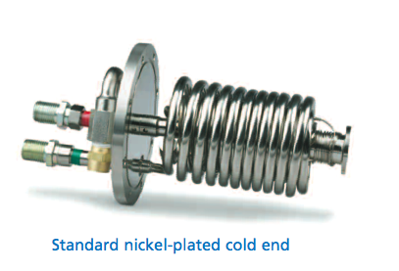 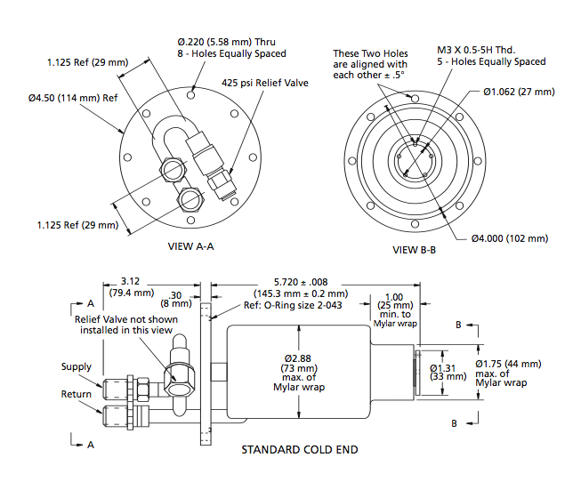
Figure 2: The Polycold Compact Cooler or “Cryotiger” is a JT cooler with coiled counterflow plumbing which fites within a 100mm diameter, 150mm long cylinder.
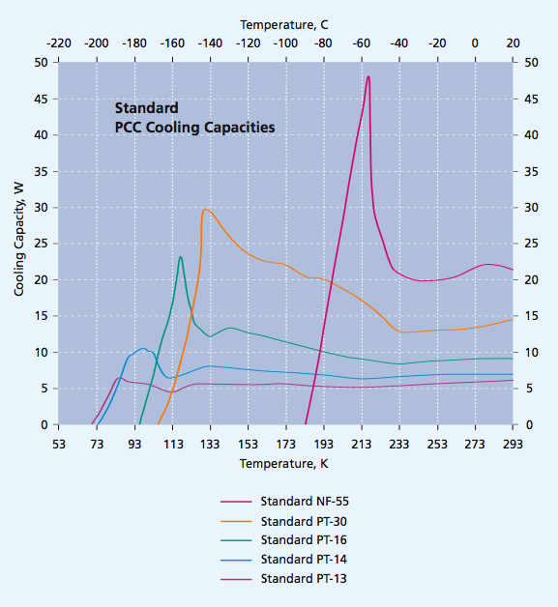
Figure 3: Cooling capacity versus cold end temperature for various gas options in the standard Polycold Compact Cooler. The PT30 gas was selected since this provides the greatest cooling capacity with cold head temperature (~128K) well below the minimum CCD temperature required (150K).

Camera overview
Please see the SolidWorks eDrawing showing the camera placement on the focus hub. The cylindrical section of the original CFH12K dewar and the Nitrogen tank within have been abandoned.

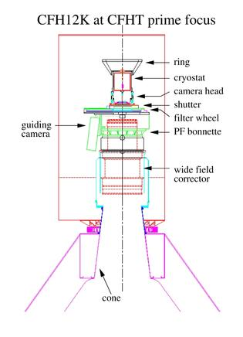
Figure 4: The CFH12K is shown here mounted on the CFH prime focus corrector. It attaches by its front flange to the corrector. There is ample space to the side for the filter mechanism and behind the focal plane for the liquid Nitrogen tank (cryostat). We will retain only the square front section fo the vacuum vessel marked “camera head” here, installing a refrigeration system within its volume and mounting this “camera head” by its rear surface to the focus hub of the Palomar 48” telescope.
The square front section containing the CCDs has been retained and the CCDs will remain installed throughout the cooling system upgrade. A new front plate will be installed which will carry a powered field flattener lens, replacing the CFH12K’s window. A new back plate closes the square front section for he CFH12K dewar where it originally interfaced to the LN2 tank. This back plate provides the mounting interface to the focus hub.

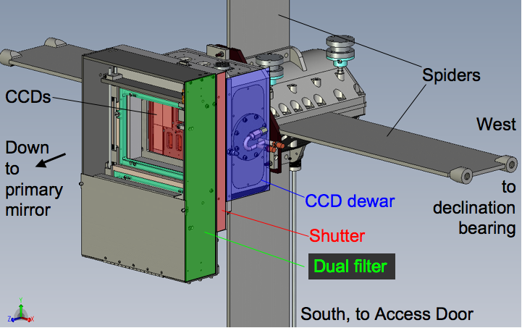
Figure 5: PTF Mosaic camera shown mounted at prime focus of the 48” diameter Oschin Schmidt Telescope.

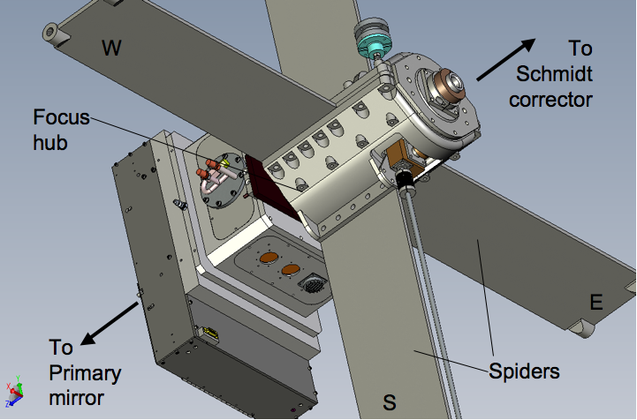
Figure 6: Rear view. Cables (not shown) will hidden from the incoming light beam beneath the south spider arm passing through the telescope wall to electronics boxes located just above the access door. The compressed gas lines (not shown) to the cryocooler will be hidden beneath the western spider arm and will pass through the telescope wall near the declination bearing, as for the present Nitrogen transfer lines for the QUEST camera.

Vacuum and cooling system implementation

Mechanical layout
The flange for the standard cold head was found to fit within one of the unused hatches on the side of the square front section of the existing vacuum enclosure. It extends to approximately the center of the space behind the focal plane without interfering with the back of the detector assembly, cable routing or the flexible cold straps attached to the back of each CCD sub-assembly. Side mounting of the cryocooler hides most of the cooler within the existing dewar with only a the connector for the gas lines protruding slightly into the telescope beam. The cooler is rotated so that one connector lies in the shadow of the other and the gas lines curve across to be quickly hidden beneath the spider.
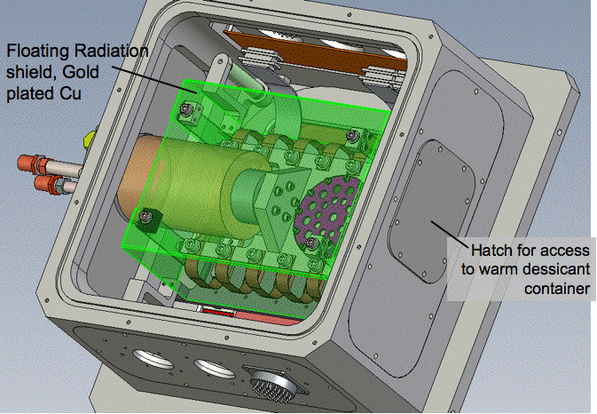
Figure 7: The back cover is removed to reveal the radiation shield, shown as transparent (green) when in reality it will be cold plated copper for low emissivity. It is thermally floating, being supported by vertical fiberglass sheets in each of the 4 corners. The Cryocooler is installed in an existing removable side plate on the western side. A hatch for accessing the desiccant container will be installed in the existing side plate on the eastern side. This plate also carries the hermetic connector (not shown) for the temperature sensors and heaters.
Rear mounting of the cryocooler in one of the corners of the back panel was considered but there I insufficient space on the back plate for the cooler, requiring an awkward overhanging extension of the dewar to the rear. Mounting the cooler on the back plate also requires that the cooler to be decoupled from the thermal path to the CCDs in order to open the dewar, whereas the side mounted location selected allows for access through the rear cover without disturbing the cryocooler or the thermal path.

To provide uniform cooling of the focal surface through flexible straps with similar geometry the straps are connected to the cold heat via an H-shaped copper heat spreader. A reservoir for an activated carbon getter container is incorporated into the heat spreader to ensure that the getter material is at the lowest available temperature.
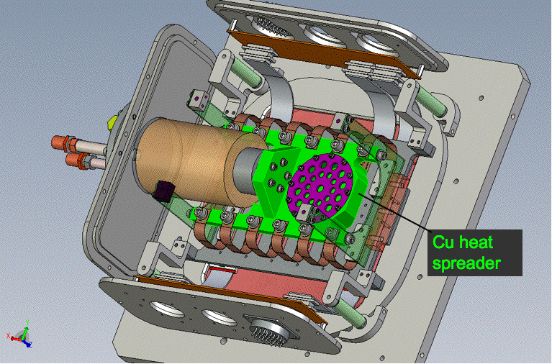
Figure 8: The vacuum enclosure walls have been hidden to give provide an unobstructed view. The copper heat spreader which is attached to the cryocooler head is highlighted in green.

Routing of compressed gas lines
The electrical cables from the hermetic connectors will be beneath the spider towards the electronics boxes mounted of the old photographic plate loader port on the south side fo the telescope which faces the dome floor when the telescope is parked and pointed nearly horizontally away, from the pole. The telescope access hatch is located below the plate loading port and thus faces the floor in this orientation too. The compressed gas lines for the cryocooler will be routes beneath the spider to the West (or is it East?) and pass through the tube wall near the declination axis following the path to the dome floor currently taken by one of the liquid nitrogen transfer lines. While this routing has not been fully investigated the fact that the Nitrogen transfer lines are thicker and less flexible suggests that no problems should be encountered.

The compressed gas lines are 100’ long in each direction. This is the maximum specified by Polycold but cryotigers in used at other telescopes have employed longer gas lines than the maximum specified by Polycold with improved rather than degraded performance. Thus no performance degradation is expected from being near the length limit.

Cryocooler suspension
The load limit published in the data sheet is 3lb. Conversations with the manufacturer revealed that this 3lb applies to radial load at the tip while axial loads may be up to 25lb. Vibration or shock during transport and handling can produced forced in excess of the 3lb limit and cause fatigue at the joints between the cooler and its mounting flange. The manufacturer recommends removing the cryocooler and for transport and installing it at the telescope. We considered this restriction to be neither convenient nor robust and sought to provide a suspension system for the cooler which will limit the forces at the cooling head to meet the manufacturer’s specification during transport, so that the system can be tested on campus and transported to the telescope without self destructing.

Since a failure, if any, is likely to result in a leak between the high pressure gas into the vacuum chamber we have provided a pressure relief valve to prevent explosion of the dewar.

We learned from the manufacturer that the cooling coils are moderately complaint (as would be expected given their spiral shape) and that the load on the cooling head is supported by a cylindrical stainless steel tube with 0.500” outer diameter and 0.010” wall thickness.

The copper heat spreader weighs less than 3lb <get the current number from Khanh>, but if this mass was unsupported it could easily resonate during transport to produce unacceptable forces and deflections. We constrained the radial motion by securing both ends of the heat spreader to fiberglass sheets connected to the focal plane assembly. The heat flow in these sheets is in parallel with the copper straps between the heat spreader and the detectors so thermal considerations do not limit thickness. The sheets are made thin enough to bend to accommodate the ~13um shrinkage of the stainless steel tube within the cryocooler, since the force produced if this motion was not allowed would be nearly equivalent to the 25lb axial load limit. This 25lb axial load limit for the crycooler is assumed to be high enough to provide dynamic support for the mass at the cold head tip, which is about 10% of this.

It is also necessary to ensure that the radial displacement of the cold head due to thermal contraction is acceptable. The total displacement is comprised of the four contractions shown in Figure 9 and quantified in Table 1. Depending on the metal used in the piece which connects the top of the fiberglass post to the focal plane, the radial displacement at the cold head due to contraction is estimated be from 63 μm to 165 μm. The integrated expansion coefficient which takes into account the variation in CTE with temperature was taken into account for this calculation but only thermal equilibrium condition was considered.

The radial force exerted at the cryocooler tip by this contraction was derived from the analytical equation for the deflection of a cylindrical thin walled tube. < Khanh, please provide the equation and reference > The 3 lb radial load allowed will deflect the stainless steel cylinder by 325 μm. Thus a maximum deflection of 165 μm due to contraction would seem to be entirely acceptable, however we must check whether the above a calculation was done for a free end, since the contraction does not allow the end to rotate and will thus generate larger internal stresses than an unconstrained 3lb mass.

An alternative approach would be to examine the stress induced by a 165 μm displacement and look at stresses to see how they compare to the yield stress ignoring the manufacturer’s guidelines which whose safety margin is unknown.

To mitigate stress it is possible to mount tighten the bolts connecting the heat spreader mass to the fiberglass flexures, which brace it while the gravity vector is away from the window. This will displace the cryocooler tip in the opposite direction to the thermal contraction so that the two effects compensate when cold.

Alternatively the Z shaped bracket could be made from Aluminum to maximize the compensation effect.
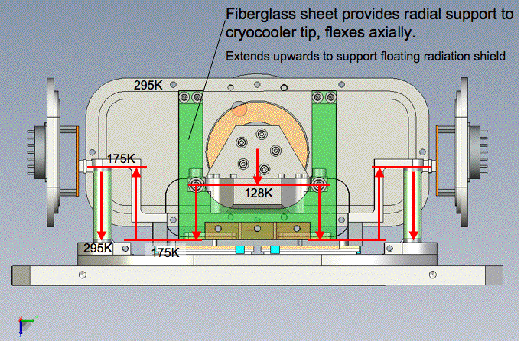
Figure 9: A radial displacement of the cold head tip occurs as the system cools, it is the sum of the contraction of the fiberglass posts supporting the focal plane assembly, the contraction of the fiberglass sheet supporting the heat spreader, and the contraction within the heat spreader, minus the contraction of the “Z shaped” piece between the top of the post and the focal plane.

 | FPA support posts | Z shaped bracket from post to FPA | Cold head brace | Copper heat spreader
Length | 54.2 mm | 52.1 mm | 40 mm | 23 mm
T1, T2 | 295K, 175K | 175K, 175K | 175K, 128K | 128K
Material | G10 along fiber direction | Molybdenum  Stainless Steel 304,  or Aluminum 6061 | G10 along fiber direction | Copper
Contraction per unit length | 0.00134 | 0.00054,  0.00174,  0.00251 | 0.00160 | 0.00247
Contraction | 73 um | 28 um,  91 um,  131 um | 64 um | 57 um
Total Displacement towards window | 165 um for Mb,  103 um for SS,  or 63 um for Al

Table 1: Calculation of the radial displacement of the cold head due to thermal contractions in the supporting structure.

Getters
A large container to hold activated carbon is built into the copper heat spreader to serve as getter for gases, which are not cryopumped at the 128K cooling head temperature. Since we were not able to find numbers for the pumping efficiency of activated carbon as this temperature we simply maximized the volume of the container. 55 ml of activated carbon granules can be accommodated. The current solid model does not yet show this correctly but activated carbon will be pressed lightly against the walls of the getter container by a weak circular wave spring (like a big soft spring washer) acting against a perforated sheet with >60% open area which in turn will compresses a fine stainless steel mesh against the activated carbon (McMaster Carr part number 85385T117, 304 SS wire cloth, 36% open area, 0.0015 opening size, 12"x12" sheet for $20). This is intended to provide both thermal contact and minimize particle production through motion of the carbon. Since the mesh compressing carbon has a gap around the perimeter a second mesh sheet will be placed overt the top and clamped at the edges to prevent particles from escaping as shown in Figure 10. In normal operation the container faces upwards to further discourage the shedding of particles.

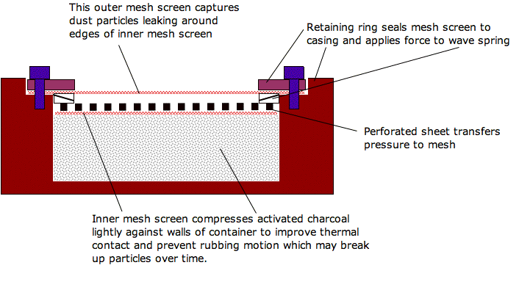
Figure 10: Concept for a getter container which provides a good seal at the edge of the retaining mesh to prevent the escape of fine particles while also lightly compressing the getter material against the walls to provide thermal contact and stop motion which might break down the activated charcoal into finer particles as is likely during transport.

Activated carbon was selected as the getter material because it pumps Nitrogen and Oxygen efficiently at low temperature while regenerating itself at room temperature. The flip side of this regeneration is that contaminants like water vapor are returned to the system and could condense on the detector in the likely event that the getter warms faster than the CCDs. We will attempt to use the CCD heaters to warm the CCDs faster than the cold head under normal circumstances but we can’t relay on active control to always be operative.

Therefore a second getter container holding zeolite is provided to act as a desiccant. This container is mounted at a room temperature on the interior of a hatch, which is easily accessed while the instrument is mounted on the telescope to facilitate the changing for the zeolite when saturated. This will probably need to be done only once after the dewar has been open to atmosphere for a prolonged period.
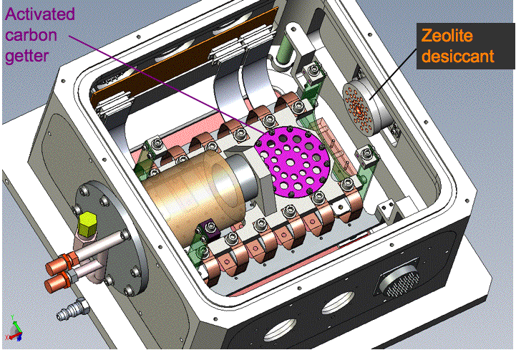
Figure 11: An getter holding ~55ml of activated carbon is embedded into the heat spreader so that it operates at the lowest available temperature (128K) for highest efficiency pumping Nitrogen, Oxygen and Argon which are not condensed at this temperature. Water vapor is continuously removed from the vacuum by a zeolite which resides in a room temperature container on the inner side of a hatch which can be easily accessed while the system is installed on the telescope, once it has been warmed and back-filled with dry air.

Vacuum valve and pump lines
To avoid beam obstruction the vacuum valve will be located on the back plate at a location easily accessed from the telescope entry hatch through which the vacuum lines will be routed. One inch diameter pumping lines connected by KF25 flanges should be adequate even though the distance to the pump will be several meters the pumping speed should be adequate since only air and not water vapor will need to be pumped since a zeolite dessicant will be provided within the dewar to remove water vapor. (Not yet shown in the solid model.)

Pressure gauge
A pressure gauge (Model TBD) will also be located on the back panel. Remote readout by the data acquisition system will be supported to allow logging of pressure in headers and in a telemetry logging system if implemented. Pressure readings to 10⁻⁵ Torr (TBC) will be supported to provide early diagnostics of vacuum problems. The resolution must be greater than the standard Granville Phillips Convectron gauges normally used for liquid Nitrogen cooled cameras since there is no boiloff as flow which normally serves as a measure of total power flow into the cooling system (and thus vacuum quality). Remote readout is to be supported since the system will be operated unattended for long periods. (Not yet shown in the solid model.)

Pressure relief valve
A pressure relief valve with 1 atmosphere trip point will be located on the back plate to protect against explosion in the event that a leak develops from the compressed gas lines into the vacuum enclosure. (Not yet implemented in the design.)

Thermal Circuit
The thermal circuit shown in Figure 12 is assumed in the spreadsheet “PTF thermal.xls” which simulates the cooling from ambient and calculates static loads.

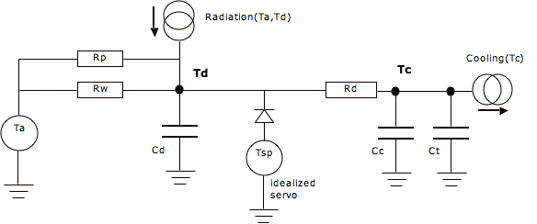
Figure 12: Thermal circuit used in simulations to determine the cooling time from ambient.
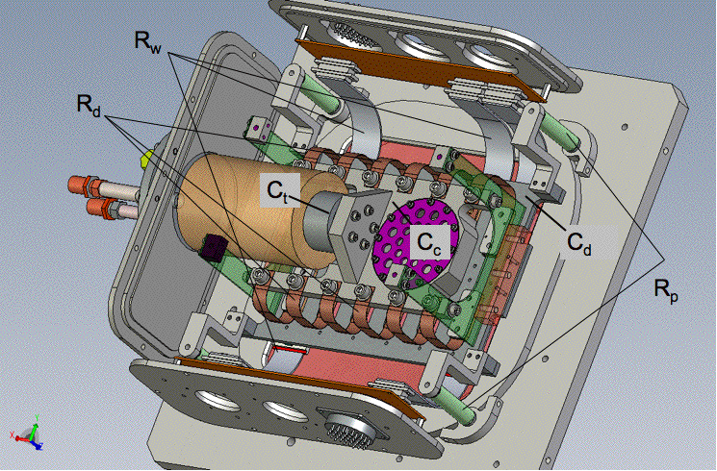
Figure 13: Physical locations are indicated for the components shown in the thermal circuit in Figure 12. Where there are 12 copper straps in parallel the combined resistance is shown as a single equivalent resistance Rd in the circuit diagram. Similarly the four parallel resistance of the posts are represented by the single equivalent resistance Rp, and so on for the 12 wiring resistances Rw.
Rp is the thermal resistance of focal plane support posts. Rw is the combined thermal resistance of the 12 flex circuits comprising the wiring from the CCDs to ambient. Rd is the combined thermal resistance of the 12 copper straps from the detectors to the heat spreader. The very small resistance of the Copper heat spreader is neglected. Cd is the total heat capacity at the focal plane. Cc is the heat capacity at the cooling head, which is dominated by the heat spreader. A perfect thermal servo is assumed and is simulated by clamping the detector temperature Td to prevent it falling below the set point temperature Tsp. Tc is the temperature at the cryocooler tip.

Radiative loads
Radiative transfer is dominated by coupling from the warm window to the CCDs, which are each assumed to have 97% emissivity. The radiative load on the rear of the focal plane is difficult to estimate due to the uncertainty in the emissivity of the more irregular surface, but the relatively low emissivity of the polished Aluminum dewar interior makes this a low contribution no matter what emissivity is assumed for the mostly polished but irregular back of the CCD support plate.
Conservative values (15% for dewar interior and 30% for CCD support plate) have been adopted.

In addition a floating radiation shield consisting of a copper box (5 sides) will be block the radiation path to the cryocooler and back of the CCD support plate with minimal gaps. This is to be polished and gold plated on both sides. It is treated as an easy-to-implement safety factor and its effect is not included in the thermal model.

For 295K ambient temperature, the combined radiative heat flow to the CCDs and back of the support plate is estimated to be 10.5W, rising to 12.5W if ambient temperature is 305K, and falling to 9W if ambient temperature is 285K, which is more likely on the mountaintop.

Conductive loads
The combined thermal resistance of the four fiberglass support rods is predicted to be about 2400 K/W based on actual dimensions, and the assumption the rods are solid all the way through and that the glass fibers run axially. The central hole of the bolt will tend to increase the resistance if it runs all the way through (unknown) while the insertion of a bolt will short out the end of the rod, however changing the rod resistance has little effect on the model since the thermal conductivity will remain mall compared to radiative loading and even to the wiring.

The thermal resistance of each of the 12 flex cables to the CCDs is guessed to be 37K/W based on a typical 250mW per detector for wiring.

These assumptions lead to a total conducted power <3.5W.

Thermal margin, heater power and cooling straps
Radiative plus conductive heating combined are predicted to be 14.25W when ambient temperature is 295K. This is dominated by radiation from the window. With 30W peak cooling power (at 131K) there is plenty of cooling margin. The copper straps will be tuned so heater power at nominal temperature set-point will be, 7.7W, approximately half the cooling margin.

Since the cryocooler head will be at 128K which is much closer to the CCD operating temperature (~175K) than liquid Nitrogen (77K), the thermal straps only see half the temperate drop and thus must be twice the width. We will make them nearly 3 times wider (20mm out of the ~30mm center to center distance) and nearly half the length (80mm) to take into account the significant contact resistance. If this contact resistance is 3.5K/W the above dimensions will give the required 2.2 K/W when 12 connections are made in parallel, one to the back of each CCD. The thickness is assumed to be 0.010” in high purity copper with two foils in parallel for each CCD. In practice the contact resistance is unknown and we will have to trim the width of these straps or add/subtract extra foils in parallel, but the above guess should get us close.

Thermal slew rates

Thermal slew rate must be limited to excessive stress within the CCD package to due to thermal expansion gradients associated with temperature gradients. We lack definitive recommendations but experience indicates that 1K/min is very safe for CCDs. Slew rate > 4K/min is to be avoided (and is unnecessary). The limited cooling power or the Cryotiger and considerable heat capacity of the focal plane assembly limit the cooling slew rate to -0.6K/min during cooling (see PTF thermal.xls).

A greater slew rate can be produced by the heater resistors mounted behind each CCD. If the heater resistor values were chosen to deliver the full 100W that can be sourced by the Lakeshore temperature controller, then the slew rate would be ~8 K/min, if the 25% lower specific heat for Molybdenum at low temperature is taken into account. This may be a lower limit since the CCD and heater sit on a sub assembly, which may not be perfectly coupled to the thermal inertia of the support plate. Such a high thermal slew rate is unnecessary and dangerous. To limit the slew rate to

The current heater resistance consists of twelve 150ohm power resistors rated at 5W each, connected as two banks in series with 6 resistors in parallel within each bank, so the total resistance is 2*(150/6) = 50 ohms, this will be reconfigurd to 3 banks of four 150ohm resistors for a total resistance of 3*(150/4) = 112.5 ohm. Given the peak voltage supplied by the Lakeshore controller (50V), the peak power will be 22.2W. Peak slew rate will be actively programmed into the Lakeshore but this change in resistance assures that even in failure modes the peak slew rate will not exceed 1.7 K/min, which is acceptable.

At the normal operating equilibrium the servo will slew have about half this slew rate available in either direction.

Cooling time
Cryotigers have a reputation for long cooling times and limited heat sinking capacity relative to liquid Nitrogen so considerable attention has been given to thermal modeling, to justify using only one cooler.

An excel spreadsheet, PTF_thermal.xls performs finite element analysis to simulate the thermal circuit in Figure 12 to estimate the time to reach a given temperature when cooling from ambient (Figure 14). Currently the cooling time to 175K is estimated to be only 5.2 hours for ambient temperature Ta = 295K, increasing to 6.7 hours for Ta=305K. I numerical analysis was performed rather than attempting an analytical solution since the heat flow into the cryocooler cold-head is a complicated function of the cold-head temperature (dotted red line in Figure 14), and radiative flows do not vary linearly but as T⁴.

The simulation is very simple. The temperature at each node is initially set to ambient. For every time increment, the current through each resistor is computed as the temperature difference across the resistor divided by the resistance (Ohms Law). Some of the currents into a node obey the equation for radiative transfer and others are defined by the cooler’s power-temperature relation. The current through the single heat capacitance per node is equal to the sum of the currents into the node (Kirchoff’s Law says all currents into a node sum to zero). The change in temperature at a given node is simply the net current divided by the heat capacitance at that node, multiplied by the time-increment, since by definition I = C * dT/dt.

The values used for the components of the thermal circuit in Figure 12 are shown in Table 2 together with an explanation for their derivation.

Symbol | Value/Units | Explanation | Derivation
 | W | Radiation(Ta,Td) | Stephan-Boltzman equation assuming infinite parallel plate approximation (shape factor=1), and conservative values for emissivities: 97% for window and CCDs, 30% for back of focal plane assembly and 15% for the interior of the enclosure.
 | W | Cooling(Tc) | Cooling curve from the data sheet for standard cold head and PT30 gas.
Ta | 295K | Ambient temperature
Td | K | Detector temperature | The CCDs, support plate and metal support fixtures are assumed to be a single lumped component (ie isothermal). Once Tc drops below Td, heater resistors drive the Td to equal Tsp,
.Tsp | 175K nominal | Detector temperature set-point | The temperature control servo is idealized by clamping Td to stop it from falling below Tsp.
Tc | K | Cooling head temperature | This varies during cool down settling to 128K at equilibrium according to simulations. The cooling power rises steeply with load so the head temperature varies little provided that peak cooling power is not exceeded.
Rp | 2419 K/W | Post resistance | This is the thermal resistance of the path from the Molybdenum CCD support plate to the enclosure, which is dominated by the fiberglass posts in the four corners. The value is calculated for the actual post dimensions (0.5” dia., 1.93” length) assuming they are solid and that the glass fibers run axially.
Rw | 37 K/W | Wiring resistance | No data available. 250mW at operating temperature was allocated per CCD since this is a typical value for wiring resistance and the flex circuits used should deliver typical or better thermal isolation.
Rd | 2.2 K/W | Detector to cold head resistance | This is resistance is dominate by the flexible copper straps and their contact resistances.
Cd | 962 J/K | Heat capacity of detector assy. | Calculated using the modeled volumes and room temperature specific heat for the CCD packages (Aluminum Nitride) the CCD support plate (Molybdenum) and various clamping parts.
Cc | 301 J/K | Heat capacity attached to cooling head | Calculated using the modeled volumes and room temperature specific heat for the copper heat spreader and getter.
Ct | 135 J/K | Heat capacity of cold head tip | This is not shown in Figure 12. The entire heat capacity of the cooler is treated as being located at the cold head tip. The value was chosen so that (when Rd is made very large) the simulation predicts the cooling time quoted for the unloaded cooler in the data sheet.
Table 2: Thermal circuit components and values used in cooling time and power simulations.
Since the data sheet, Polycold_Cooler.pdf, does not provide a figure for the heat capacity of the cooler itself, this was inferred to be 135 J/K by running the simulation with the thermal strap resistance, Rd, set very high to isolate the cold head and then adjusting the heat capacity at the cold head to see what value predicted the cooling time listed in the data sheet, 295K to 129K in 22 minutes, for an unloaded standard cold head with PT30 gas. This heat capacity was then added to that for the copper heat spreader and getter to get the total heat capacity at the cold head, which is still substantially less than that of the detector assembly, Cd.

Conductivity of the materials remains constant or increases moderately as temperature drops, while all materials exhibit a drop in specific heat nearing a factor of two over the cold head temperature range. The simulation has been setup to accommodate varying heat capacity but as yet a constant value near that at room temperature has been assumed. This was done for simplicity, knowing that it would produce an overestimate of the cooling time.

< Show graphs here of conductivity and specific heat for copper (heat spreader, cooler, thermal links), Molybdenum (detector support plate) and AlN (CCD package), SS304 (cooler) and Al (though not part of thermal circuit present) >

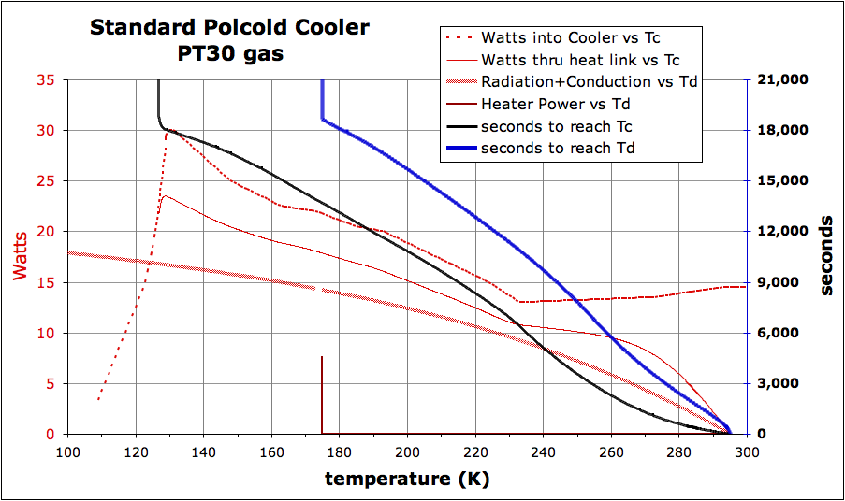
Figure 14: Power flows (red plots) are read from the left axis while time for the detectors (blue curve) or cold head (black curve) to reach a given temperature is read form the right axis. Ambient temperature = 295K for these plots.
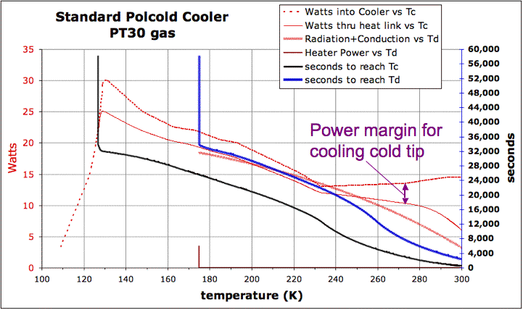
Figure 15: Cooling curves for the same parameters as in Figure 14, except that the ambient temperature has been increased from 295K to 315K, with commensurate increase in radiation and conduction.

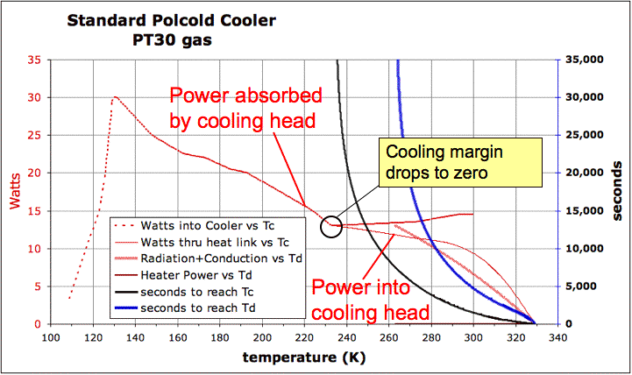
Figure 16: For ambient temperature of 328K a point is reached in the cooling curve where the radiation and conduction are equal the cooling power and the cold head no longer changes, and the system never reaches the demand temperature.

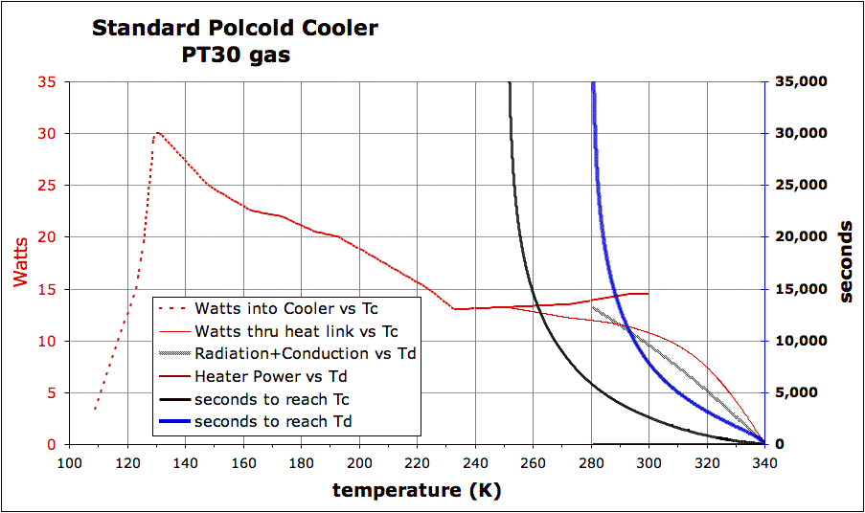
Figure 17: For Ta=328K cooling load equals cooling power at the lowest point in the cooling curve. As ambient temperature increases further this “crossover” occurs at higher temperatures as in this example where Ta=340K.

Warm up time
During warm up the slew rate achieved by applying full power to the CCD heaters will be at a least 22.2W / (Cd + Cc + Ct) = 0.95K/min which meets the ~1K/min goal, yielding a warm up time of approximately 2 hours.

In practice the warm up rate at full power will be faster than this since it will be assisted by conduction and radiation. This means that with active control the slew rate can be held constant.

Figure 18 shows simulation results for a normal cool down followed by the disconnection of the cryocooler after equilibration to allow the system to warm passively (no detector heaters). This warm up time is pessimistic (too long) since conduction by the cryocooler has been neglected. The asymptotic approach to room temperature will be accelerated as the getters desorb gas at higher temperatures, adding gas conduction to the heating mechanisms.

Maximum slew rate during passive warm up is predicted to be 0.54 K/min which is quite benign but as noted above this is a low estimate.

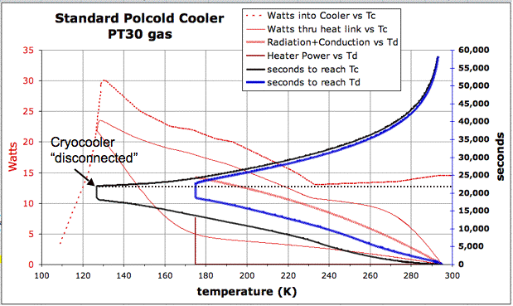
Figure 18: After a normal cool down and equilibration, the cryocooler is “disconnected” in the simulation allowing the system to warm up without the assistance of detector heaters. Although the 10 hour warm up time seems quite long in reality conduction in the cooling curves and by desorbed gas (as the getter warms up) will accelerate this warming time. Furthermore ample power is available in the detector heaters to further improve the warm up time.

Tasks pending
Fix up the design of the activated carbon retention screen and dust protection mesh.
Design dewar back plate & interface plate to hub with tip tilt adjustment
Pumping valve selection, purchase and interface to back plate
Gauge selection, purchase and interface to back plate
Pressure release valve selection, purchase and interface to back plate
Order lakeshore controller
Design side plates which attach filter and shutter to dewar.

Identify and fix leak in hermetic connector(s)

