Pictorial Physical Inventory Sheet For COO Storage
Item# 1 | Triple Output DC Supply | Date | 05/27/2016
Mfr | Power Desins Inc | P/N | TP325
Serial# |  | Note

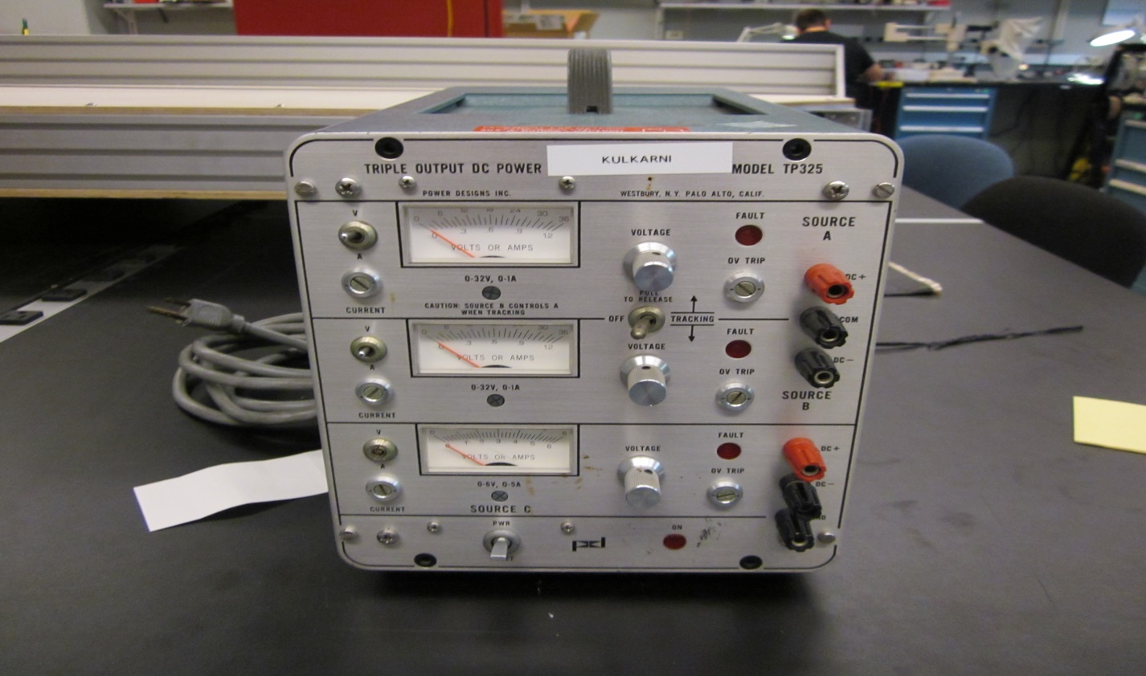

Item# 2 | DC Power Supply | Date | 05/27/2016
Mfr | GW instek | P/N | GPR-30H10D
Serial# | EF914448 | Note

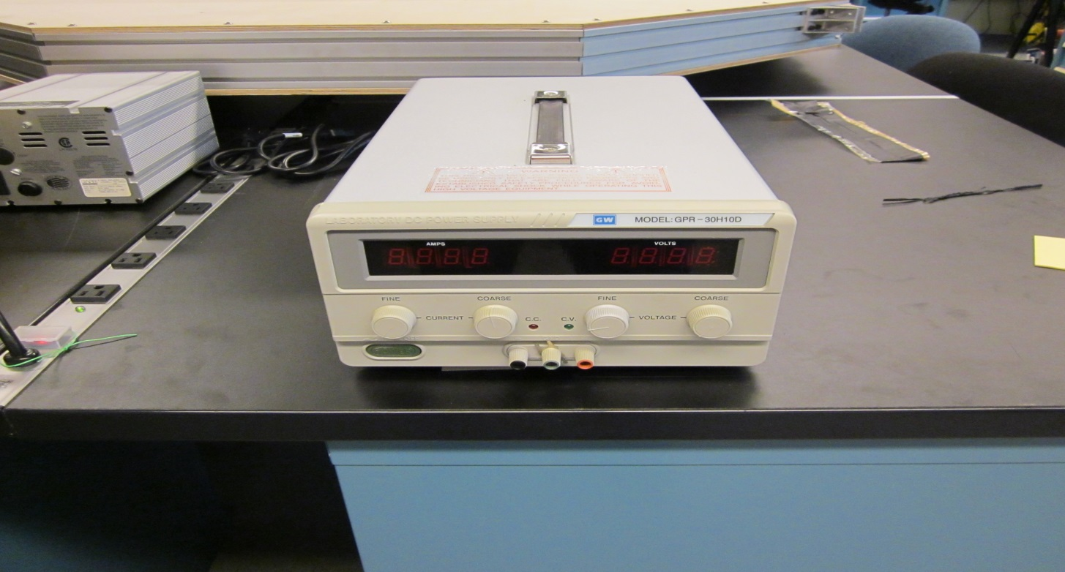

Pictorial Physical Inventory Sheet For COO Storage
Item# 3 | DC Supply Output 5 VDC 9 ampere | Date | 05/27/16
Mfr | Power One | P/N | HN5-9 / OVP-A
Serial# |  | Note

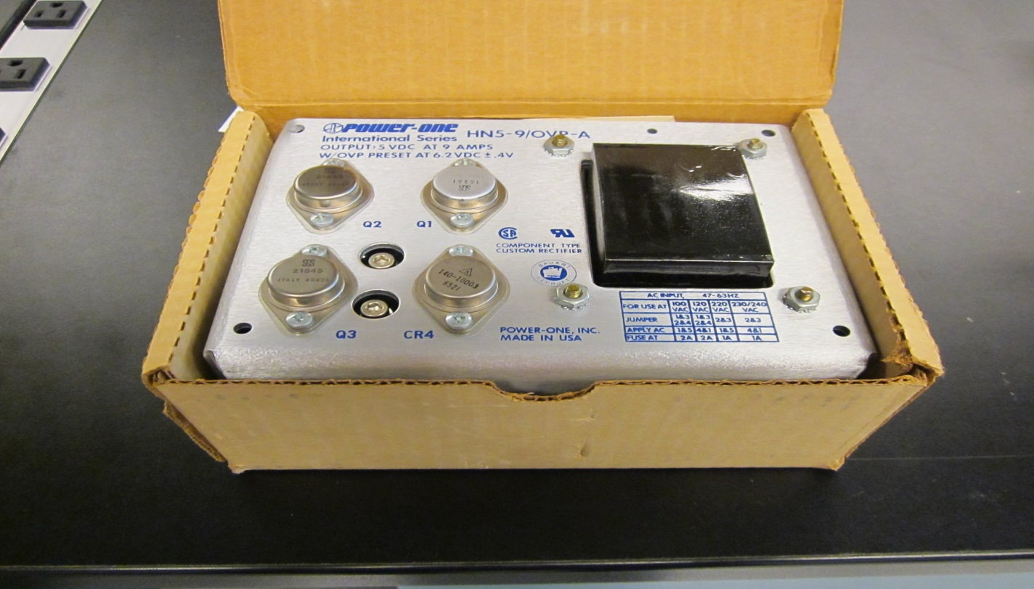

Item# 4 | DC Supply Output 5 VDC 9 ampere | Date | 05/27/*2016
Mfr | Power One | P/N | HB5-3 / OVP-A
Serial# |  | Note | 2 QTY

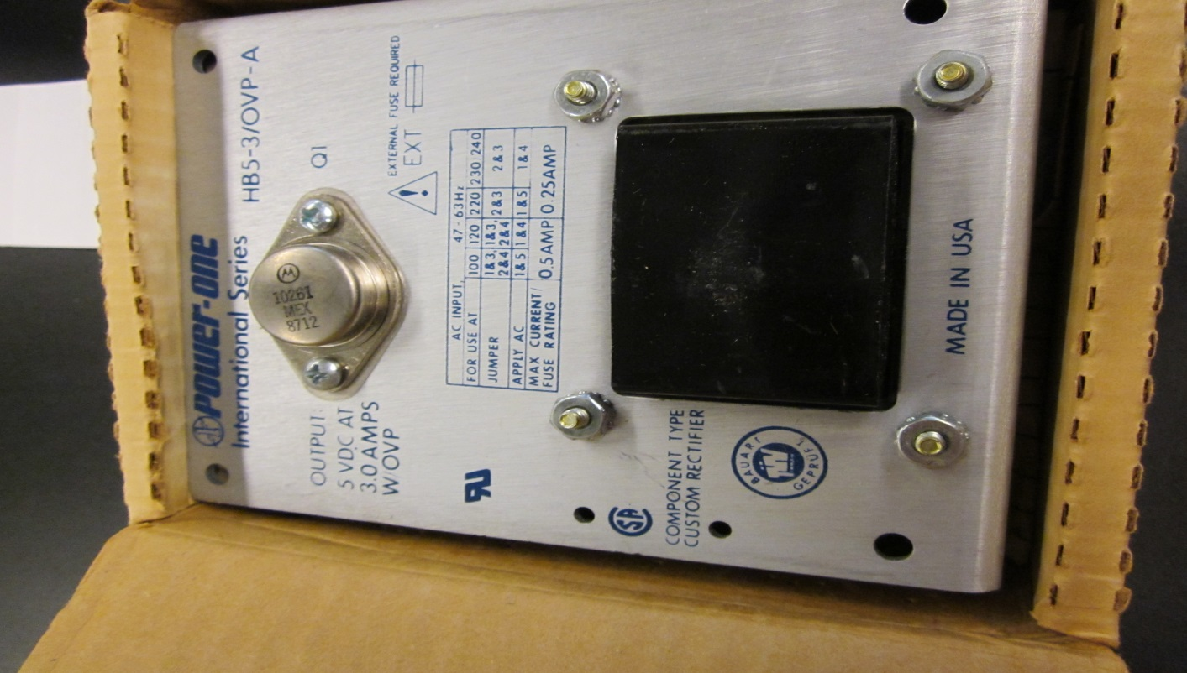

Pictorial Physical Inventory Sheet For COO Storage
Item# 6 | DC Power Supply 5VDC 1.5 Ampere | Date | 05/27/2016
Mfr | Power One | P/N | HA5-1.5 / OVP-A
Serial# |  | Note | 2 QTY

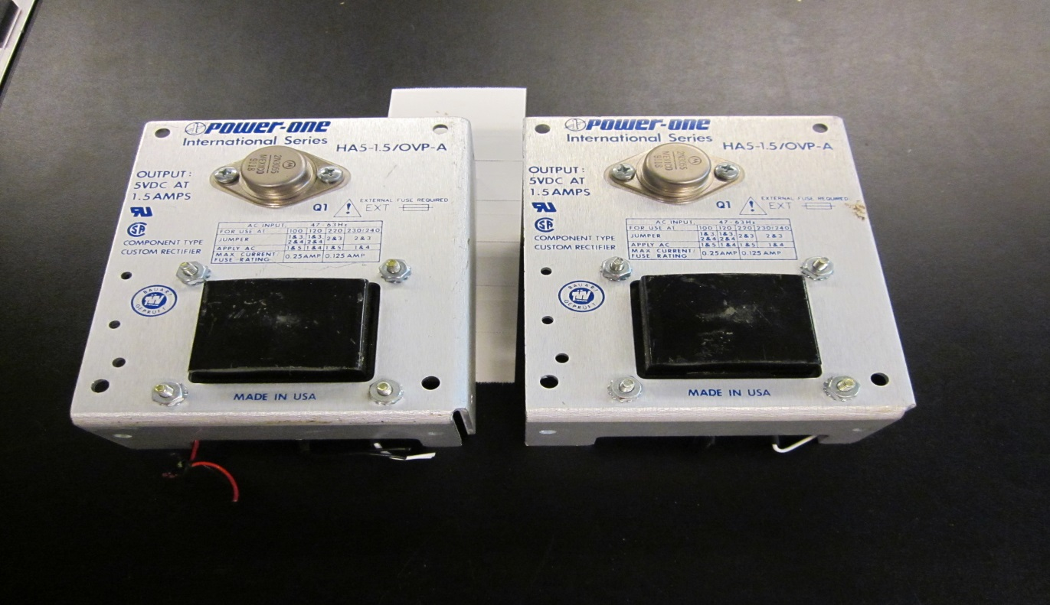

Item# 7 | High Voltage Power Supply 0 - 3kV 10 milliAmpere | Date | 05/31/2016
Mfr | BERTRAN | P/N | 603C-30N
Serial# | 7881 | Note

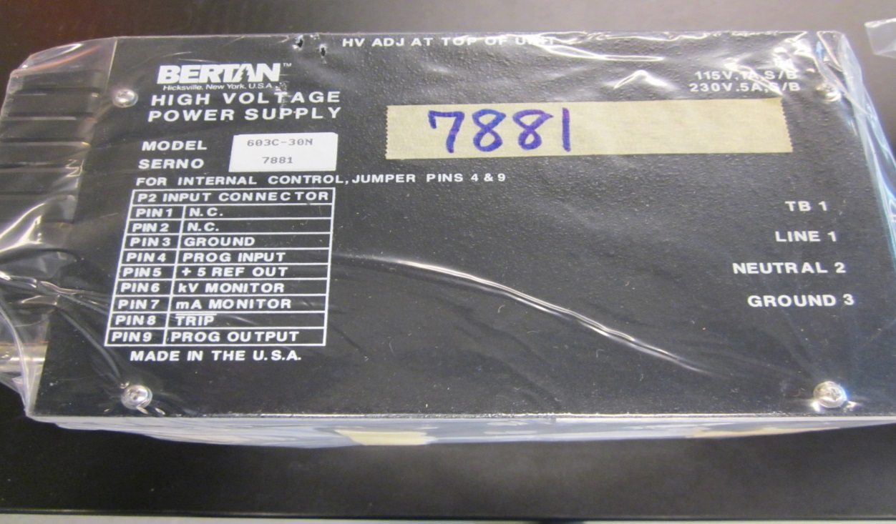

Pictorial Physical Inventory Sheet For COO Storage
Item# 8 | DC Power Supply | Date | 05/31/2016
Mfr | Acopian | P/N | U15yA150
Serial# |  | Note

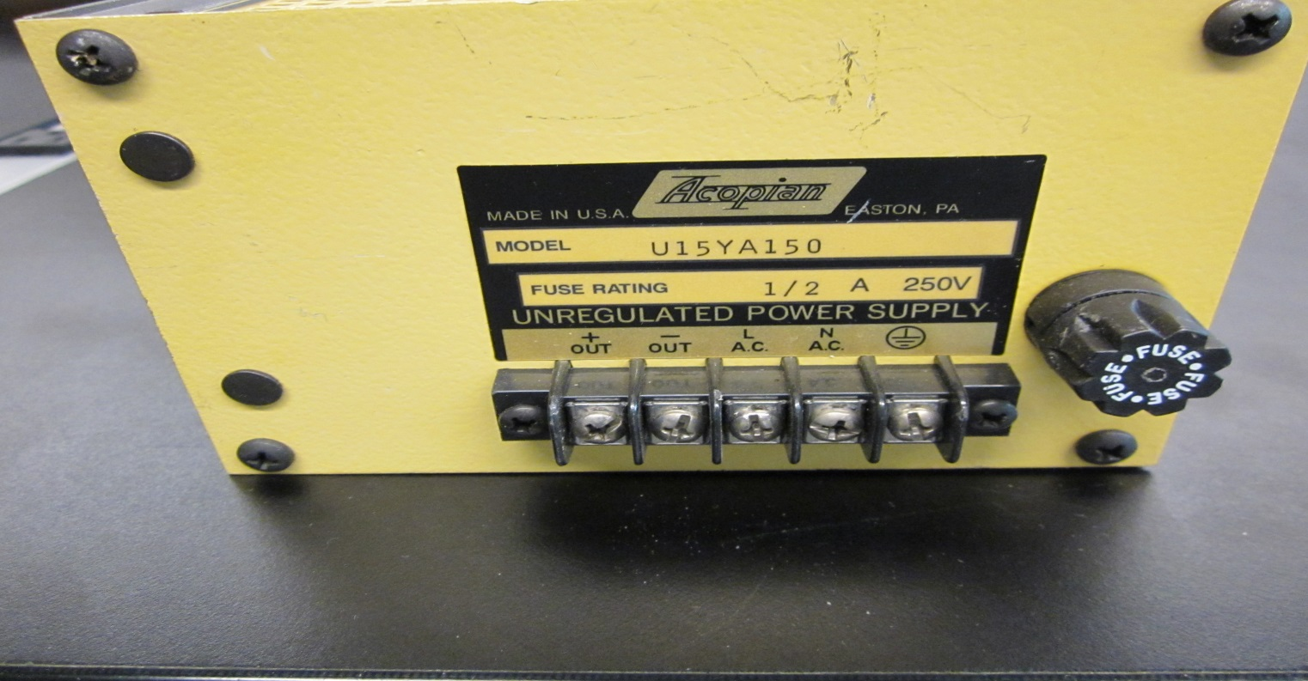

Item# 9 | Dual Tracking DC Supply | Date | 05/31/2016
Mfr | Acopian | P/N | TD5-250
Serial# |  | Note

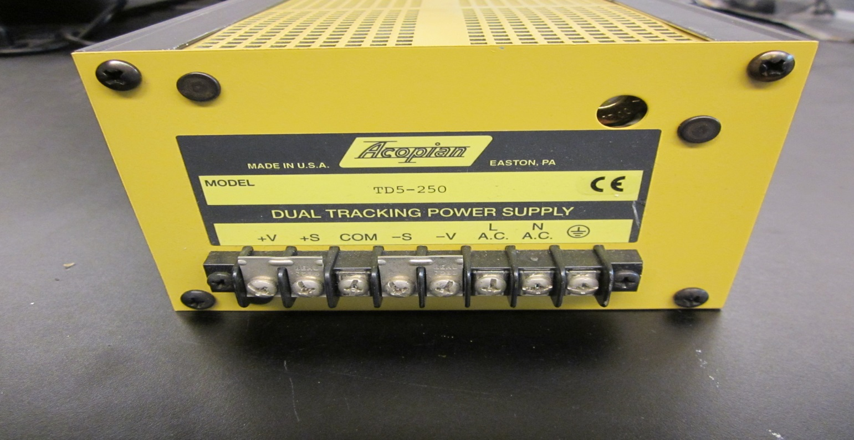

Pictorial Physical Inventory Sheet For COO Storage
Item# 10 | Regulated Power Supply | Date | 05/31/2016
Mfr | Acopian | P/N | RB5G50
Serial# |  | Note

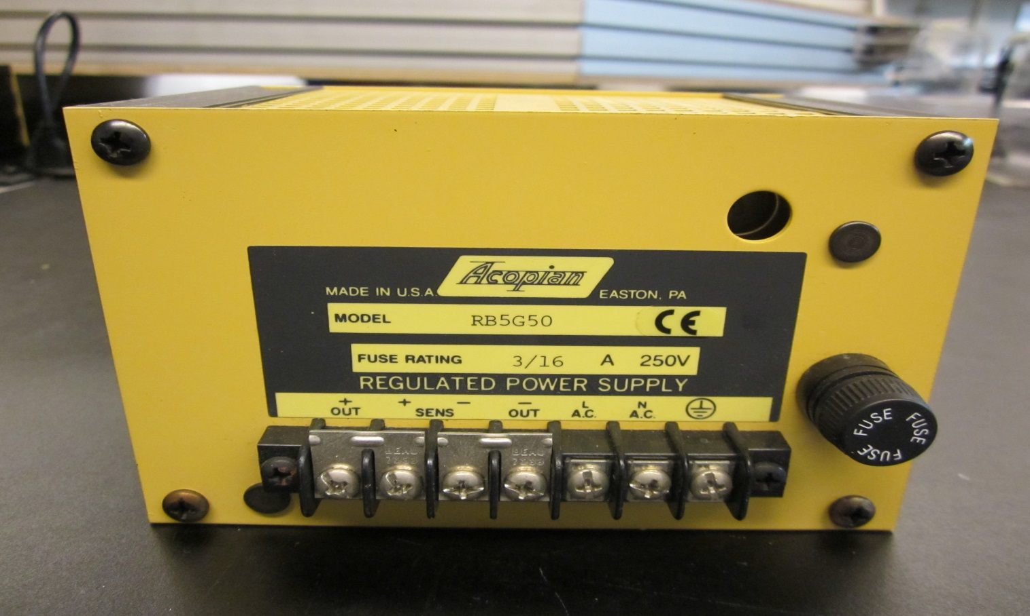

Item# 11 | Regulated Power Supply | Date | 05/31/2016
Mfr | Acopian | P/N | A3.3MT600
Serial# |  | Note

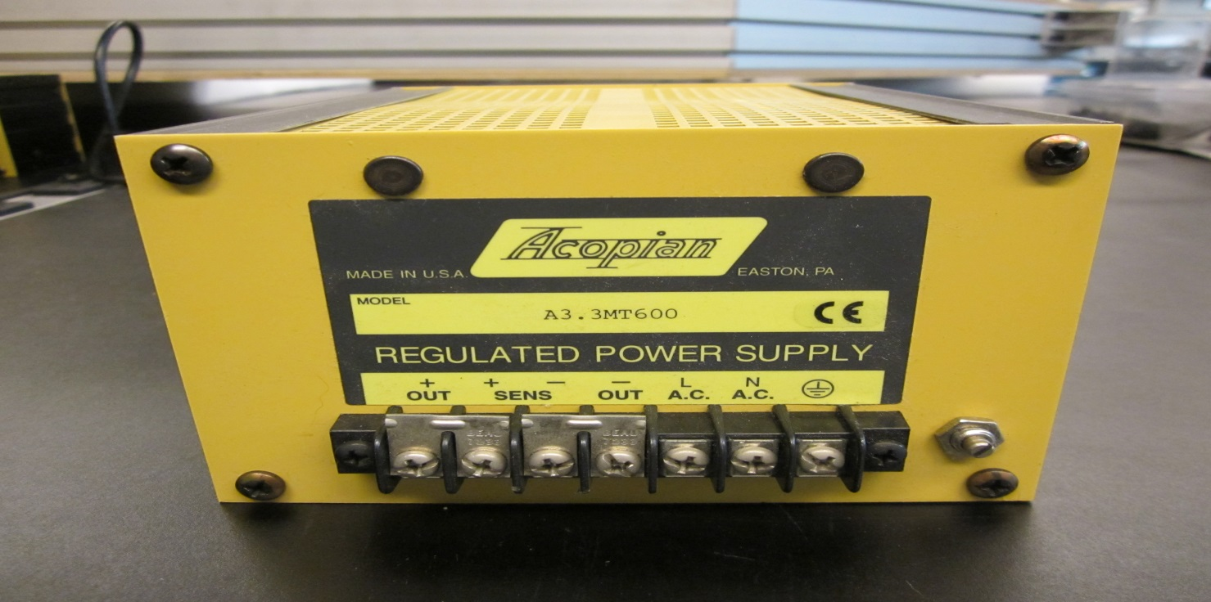

Pictorial Physical Inventory Sheet For COO Storage
Item# 12 | DC Supply | Date | 05/31/2016
Mfr | Transistor Devices Inc. | P/N | LRL-98-77D
Serial# |  | Note

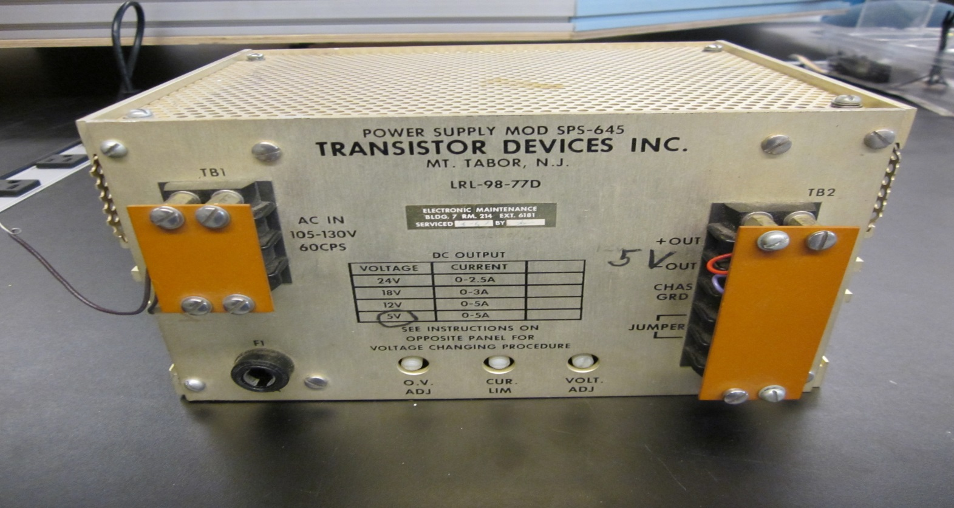

Item# 13 | Regulated DC Supply | Date | 05/31/2016
Mfr | Acopian | P/N | A5H3200
Serial# |  | Note

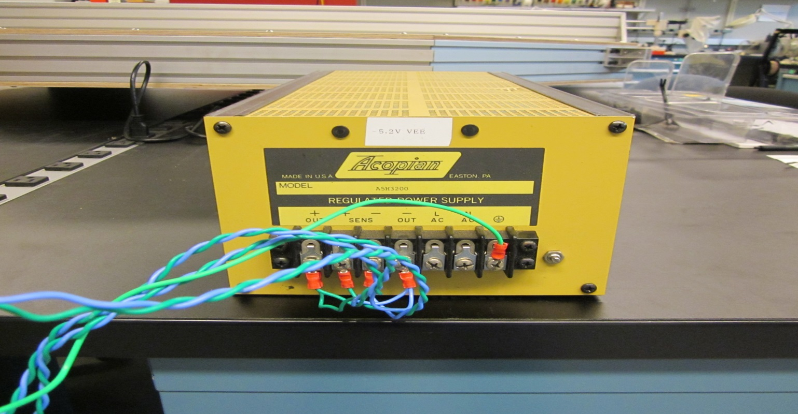

Pictorial Physical Inventory Sheet For COO Storage
Item# 14 | Dual Output Power Supply | Date | 05/31/20106
Mfr | Acopian | P/N | 56T50056T50D
Serial# |  | Note

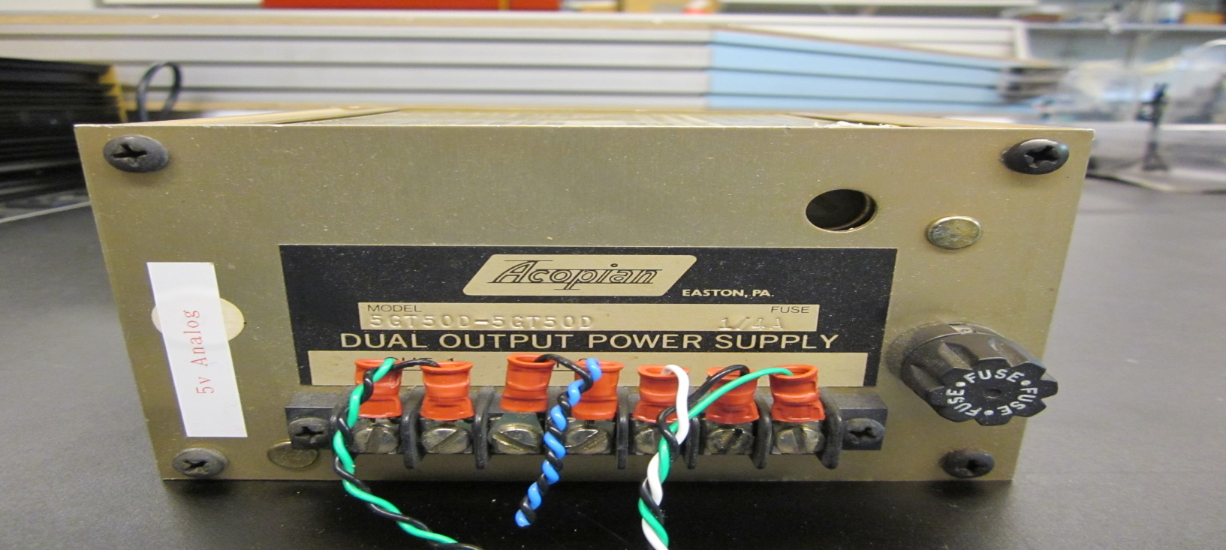

Item# 15 | Regulated Power Supply | Date | 05/31/2016
Mfr | Acopian | P/N | A15MT300
Serial# |  | Note

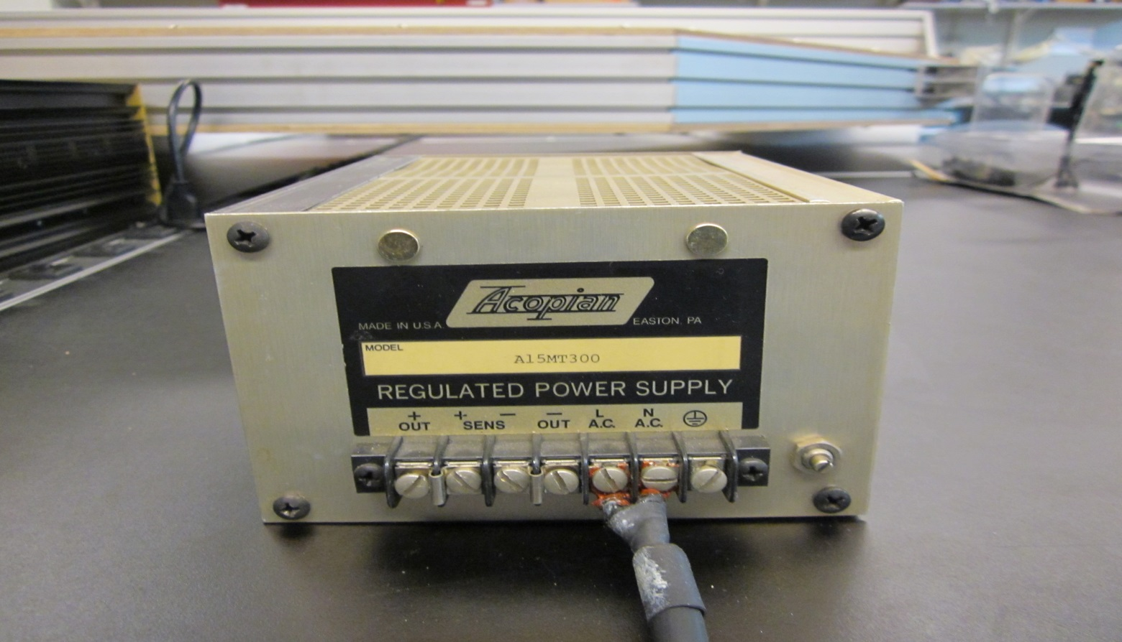

Pictorial Physical Inventory Sheet For COO Storage
Item# 16 | Regulated Power Supply | Date | 05/31/2016
Mfr | Acopian | P/N | A24H850M
Serial# |  | Note

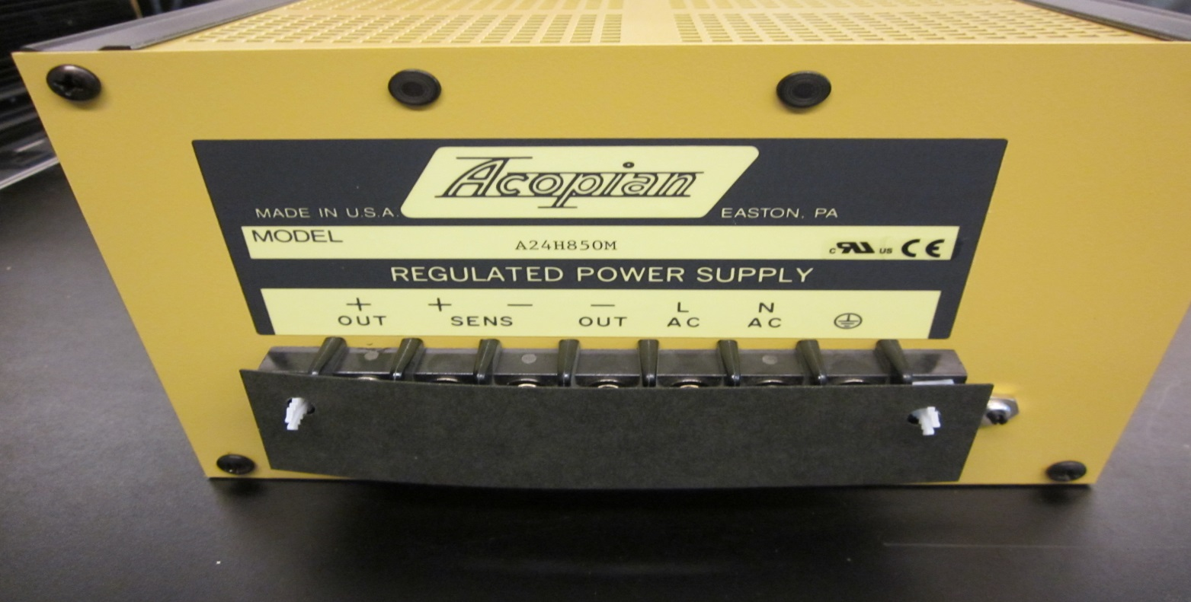

Item# 17 | Power Supply | Date | 05/31/2016
Mfr | ACDC Electronics | P/N | BX15D2.5
Serial# | 8517 | Note

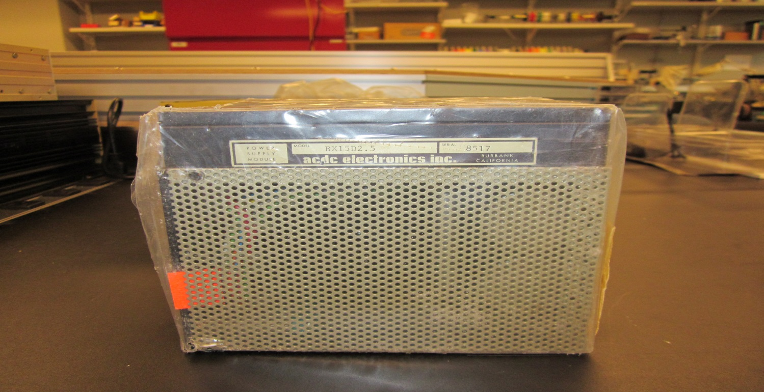

Pictorial Physical Inventory Sheet For COO Storage
Item# 18 | Power Supply | Date | 05/31/2016
Mfr | ACDC Electronics | P/N | BX15D2.5
Serial# | 14299 | Note

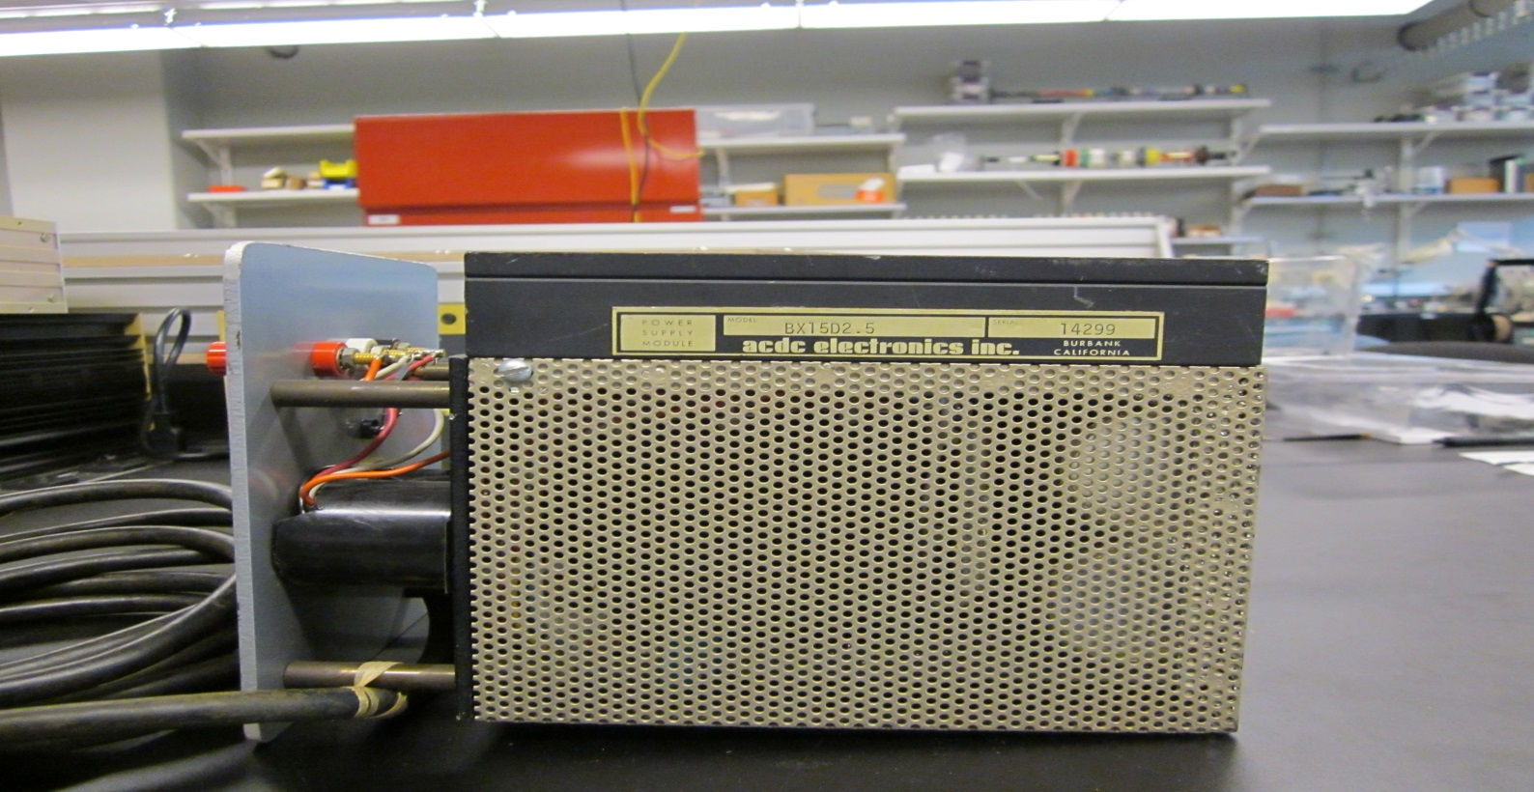

Item# 19 | Switching Regulated Power Supply | Date | 05/31/2016
Mfr | Acopian | P/N | W32NT860
Serial# |  | Note

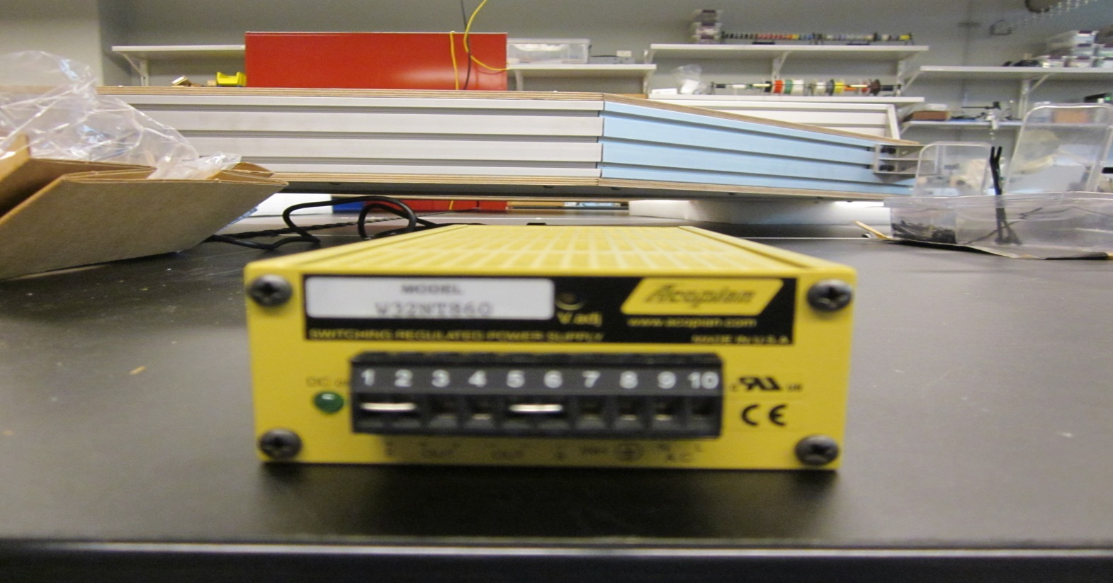

Pictorial Physical Inventory Sheet For COO Storage
Item# 20 | Power Supply | Date | 05/31/2016
Mfr | Acopian | P/N | A5NT220
Serial# |  | Note

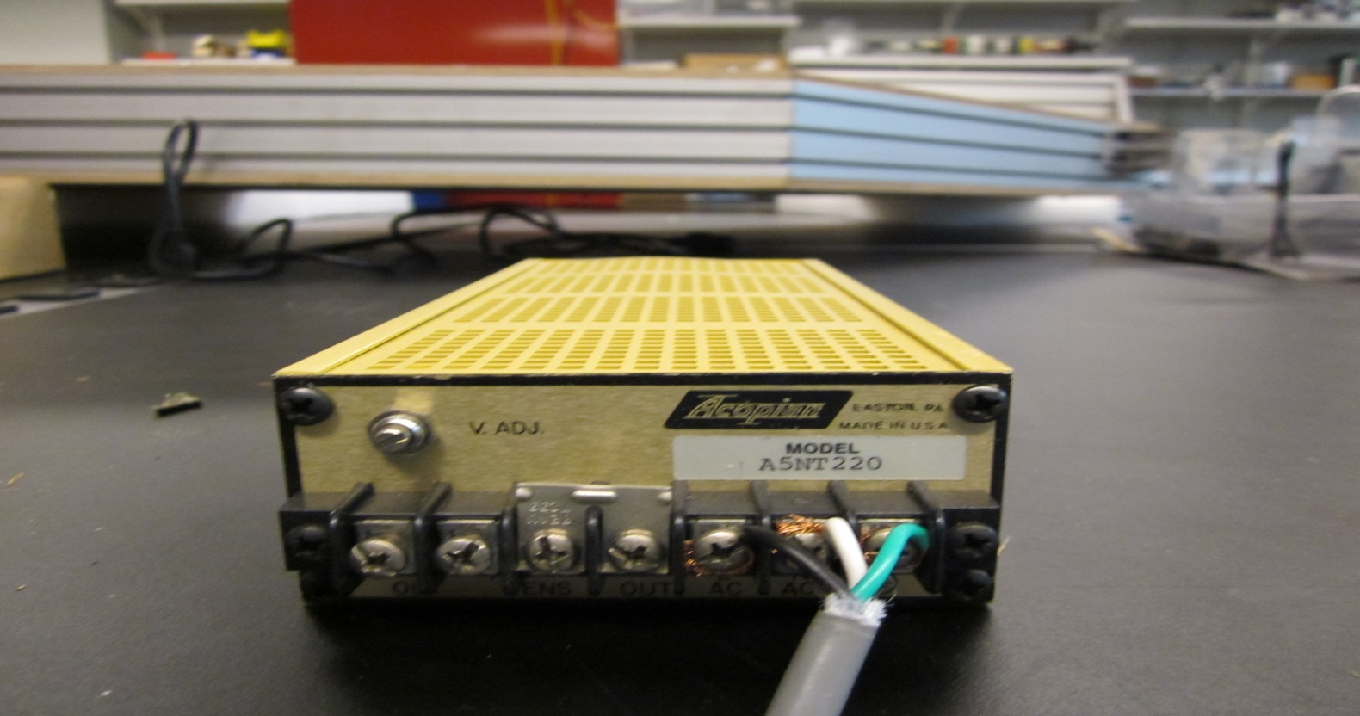

Item# 21 | Power Supply | Date | 05/31/20106
Mfr | HC Power Inc. | P/N | HC12-C1005
Serial# | 1001 | Note

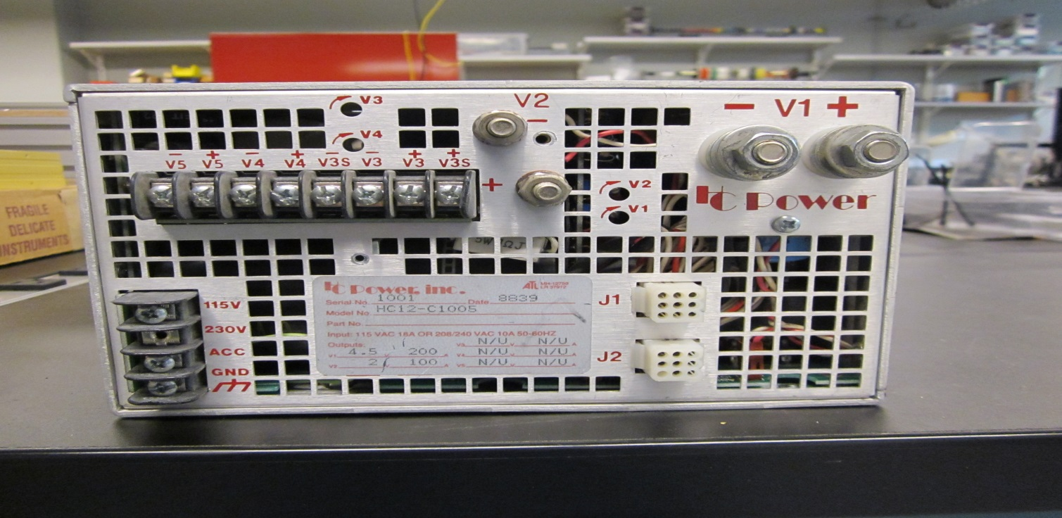

Pictorial Physical Inventory Sheet For COO Storage
Item# 22 | Regulated Power Supply | Date | 05/31/2016
Mfr | Lambda | P/N | LM D5
Serial# | C29413 | Note

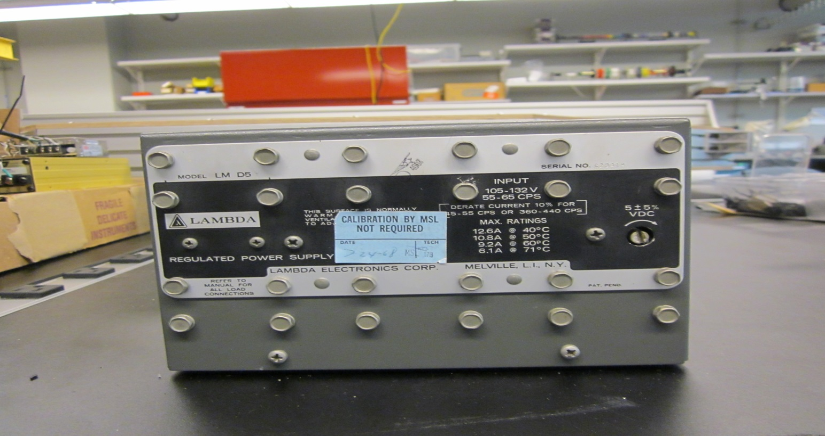

Item# 23 | Regulated Power Supply | Date | 06/01/2016
Mfr | LAMBDA | P/N | LK 345AFM
Serial# |  | Note

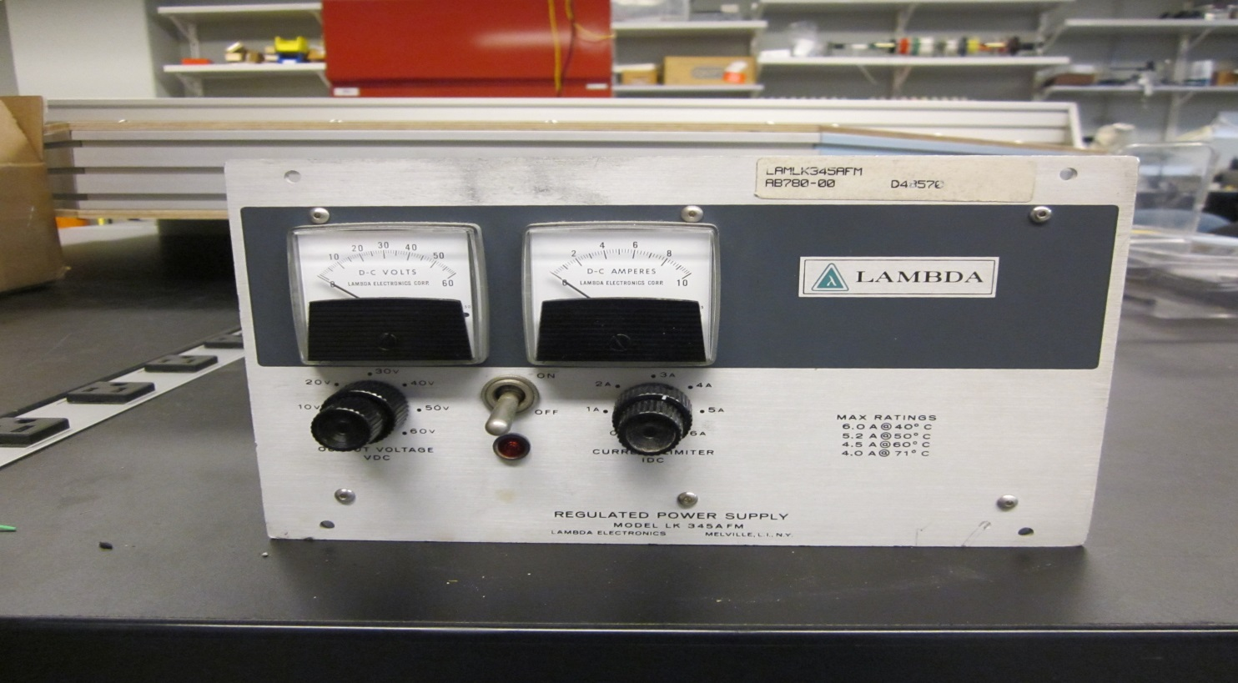

Pictorial Physical Inventory Sheet For COO Storage
Item# 24 | Regulated H.V. Power Supply | Date | 06/01/2016
Mfr | Schlumberger | P/N | SP 17A
Serial# |  | Note

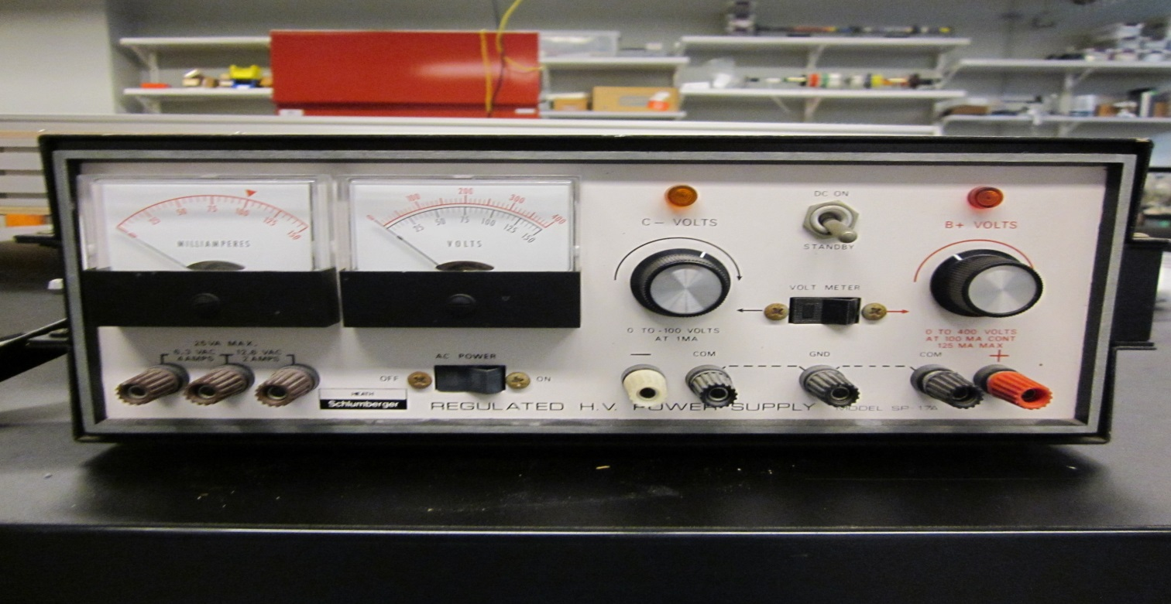

Item# 25 | Custom Equipment | Date | 06/01/2016
Mfr |  | P/N
Serial# |  | Note

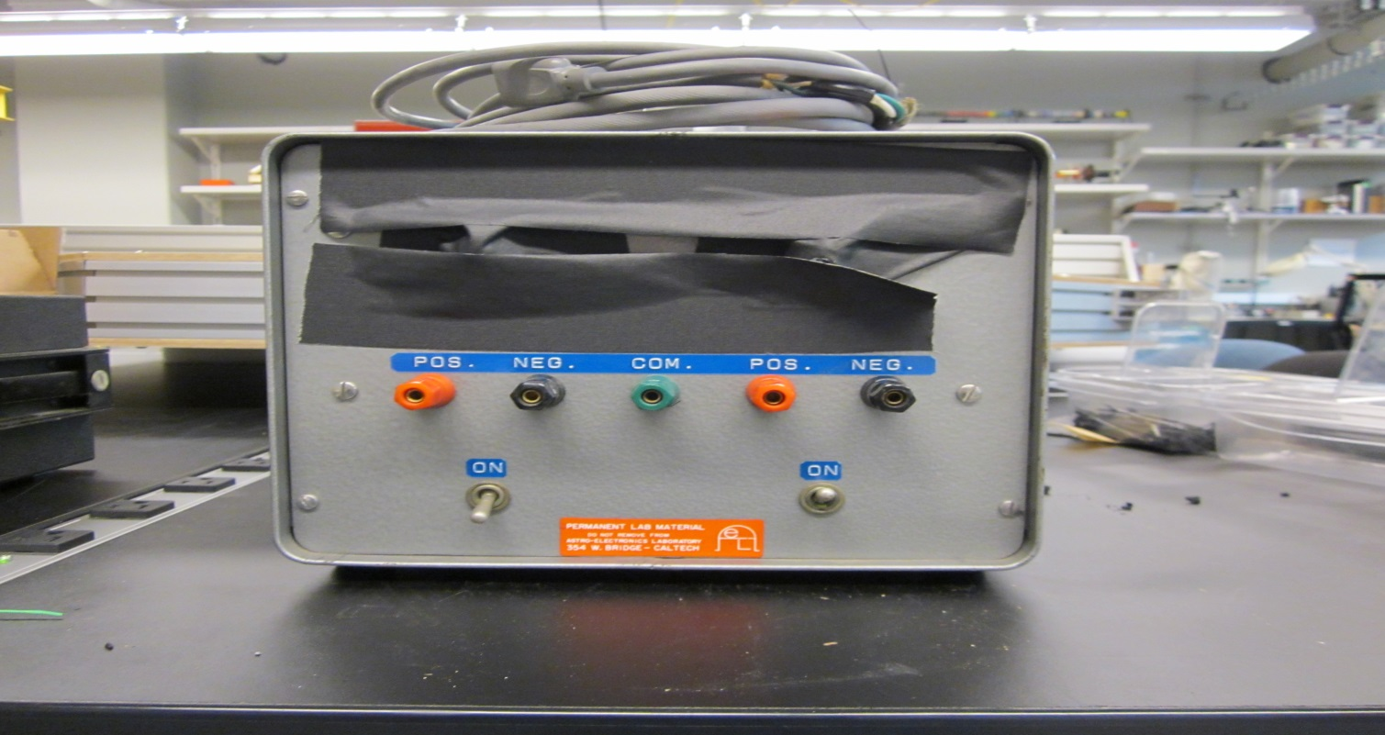

Pictorial Physical Inventory Sheet For COO Storage
Item# 26 | Custom Equipment | Date | 06/01/2016
Mfr |  | P/N
Serial# |  | Note

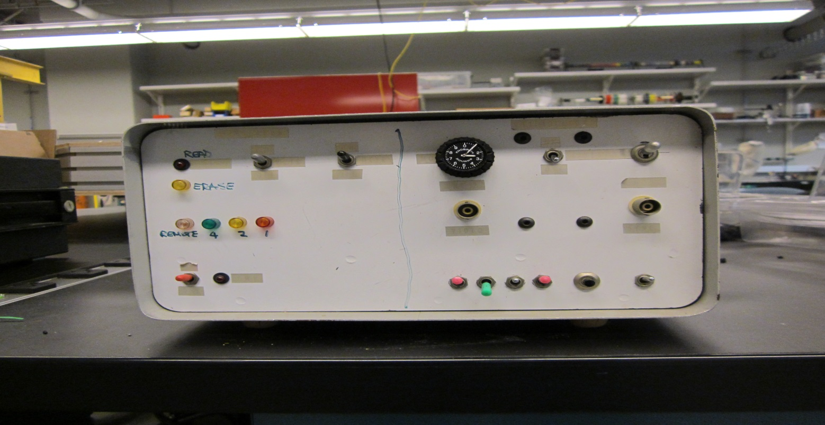

Item# 27 | Regulated Power Supply | Date | 06/01/2016
Mfr | LAMBDA | P/N | LM D5
Serial# | C28420 | Note

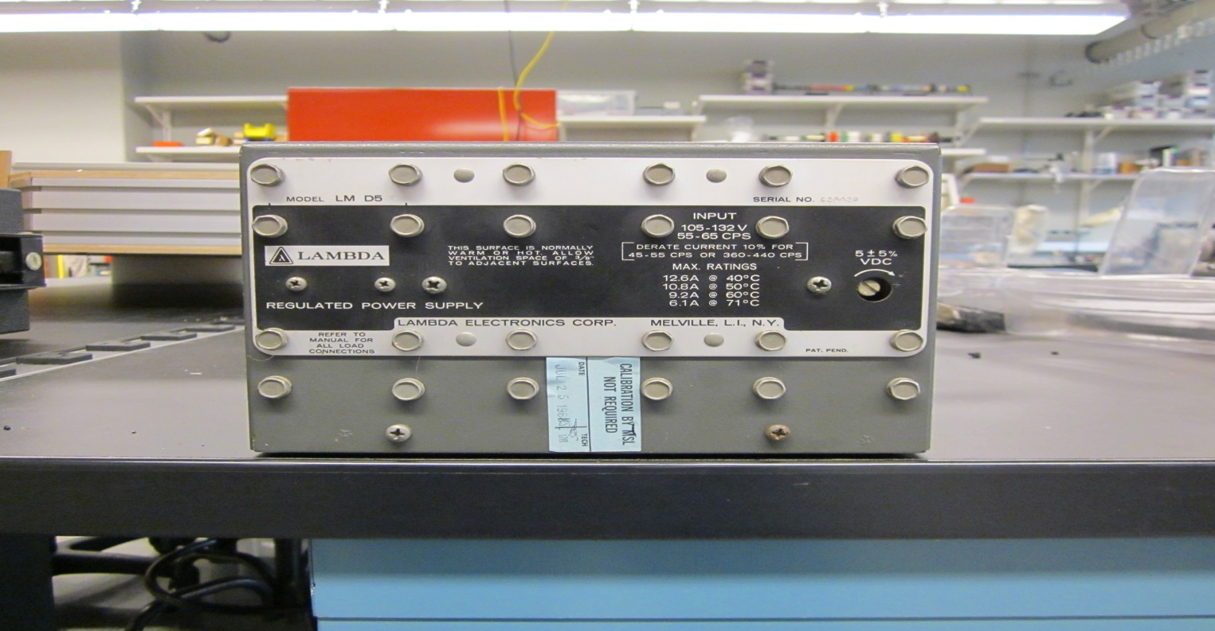

Pictorial Physical Inventory Sheet For COO Storage
Item# 28 | Power Supply | Date | 06/01/2016
Mfr | Raytheon | P/N | QSA18-1.1
Serial# | 3342 | Note

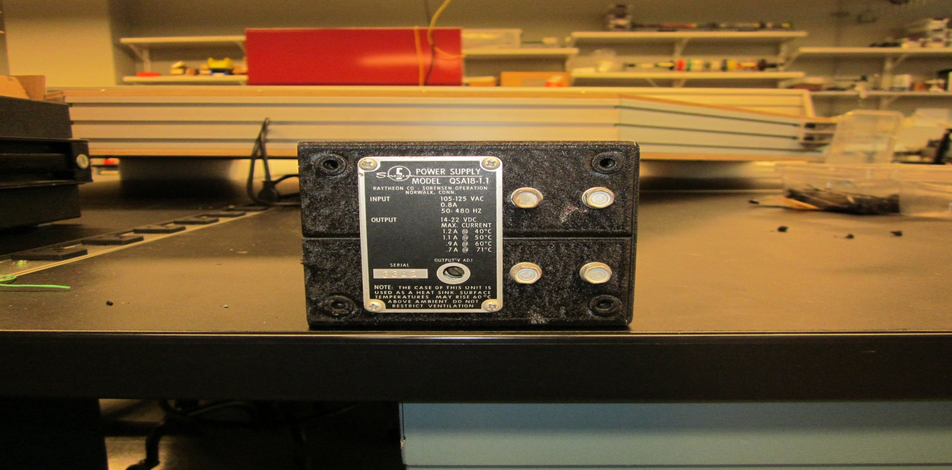

Item# 29 | Power Supply | Date | 06/01/2016
Mfr | General Fabrication Corp | P/N | 400000
Serial# | 3041 | Note

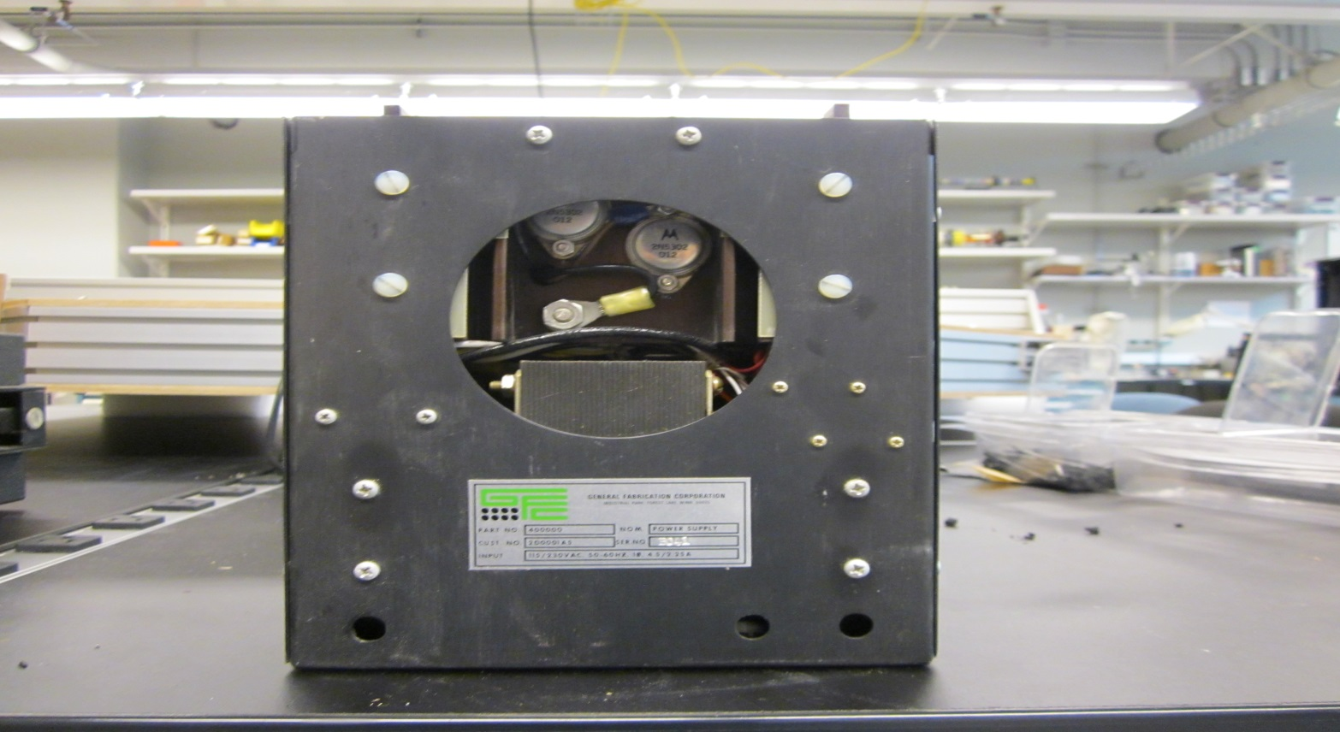

Pictorial Physical Inventory Sheet For COO Storage
Item# 30 | H.V. Power Supply | Date | 06/01/2016
Mfr | Beltran | P/N | 205A-05R
Serial# | 00105 | Note

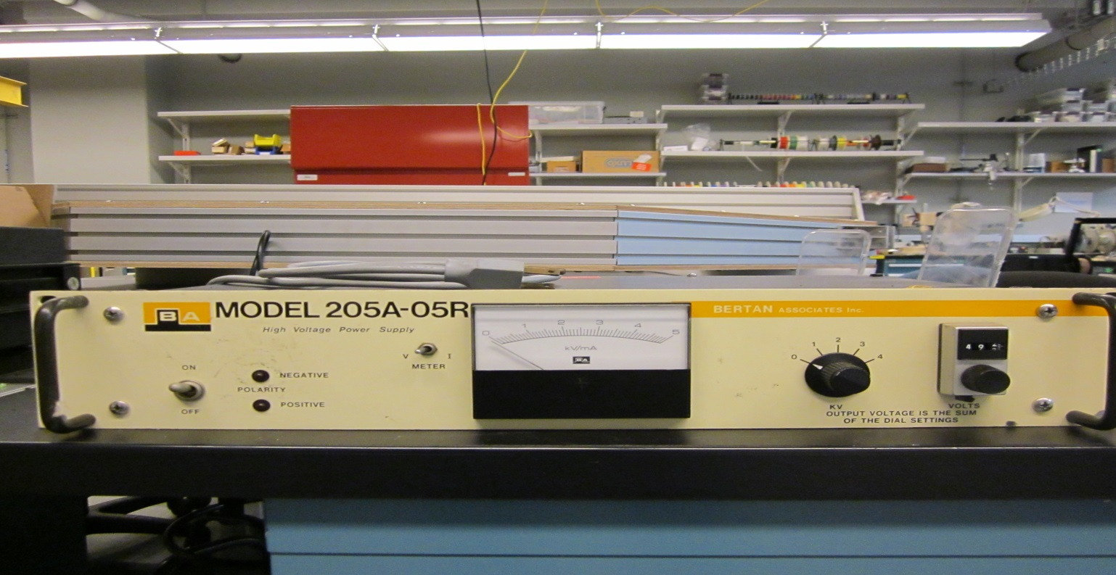

Item# 31 | Line-of-Sight Autocollimating Alignment Telescope | Date | 06/02/2016
Mfr | Brunson | P/N | Model 81
Serial# | 5107 | Note

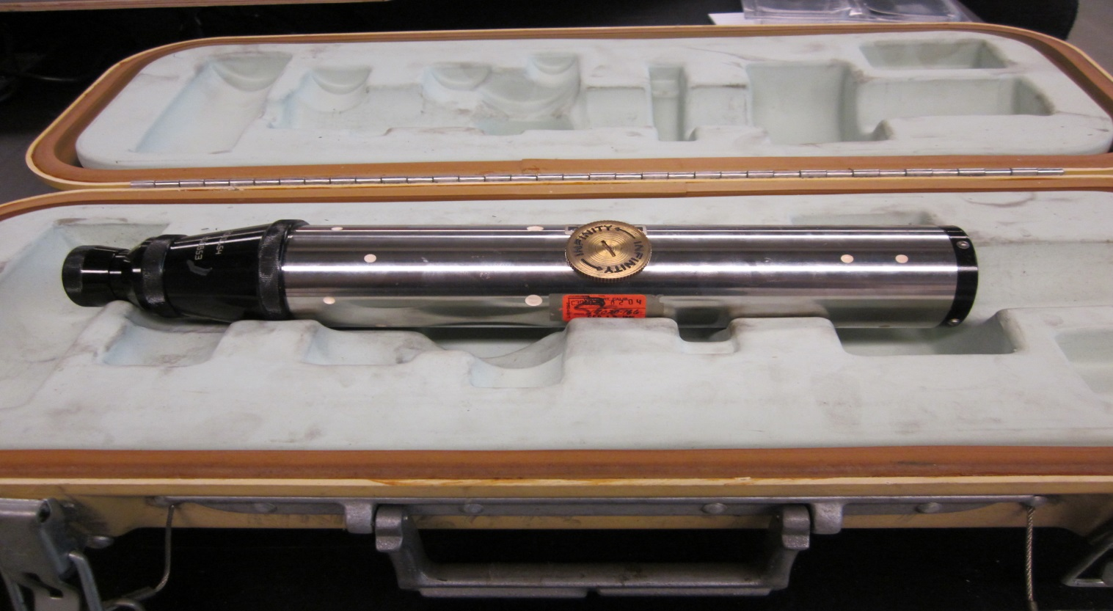

Pictorial Physical Inventory Sheet For COO Storage
Item# 32 | Line-of-Sight Autocollimating Alignment Telescope | Date | 06/02/2016
Mfr |  | P/N
Serial# |  | Note

Item# 33 | Optical Powermeter | Date | 06/02/2016
Mfr | Oriel | P/N | 70310
Serial# | 374 | Note

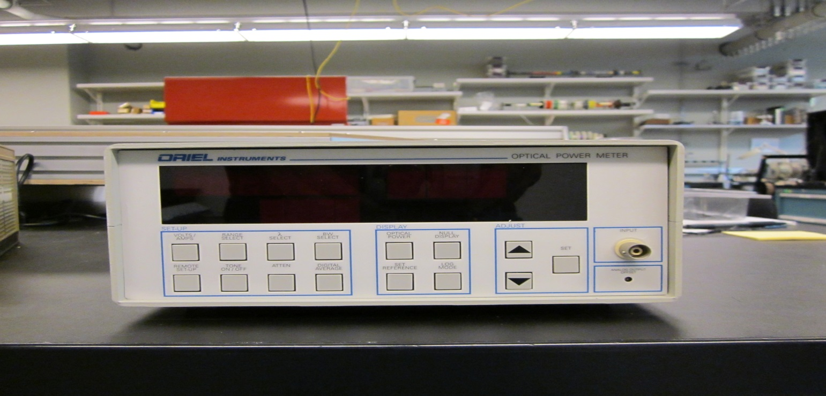

Pictorial Physical Inventory Sheet For COO Storage
Item# 34 | Optical Detector Head | Date | 06/02/2016
Mfr | Thermo Oriel | P/N | 71586
Serial# | 113 | Note | Use with Oriel P/N 70310

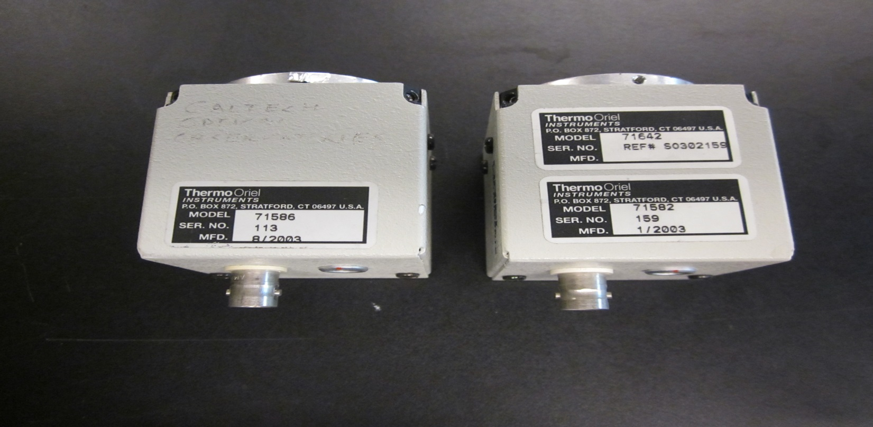

Item# 35 | Optical Detector Head | Date | 06/02/2016
Mfr | Thermo Oriel | P/N | 71582
Serial# | 159 | Note | Use with Oriel P/N 70310

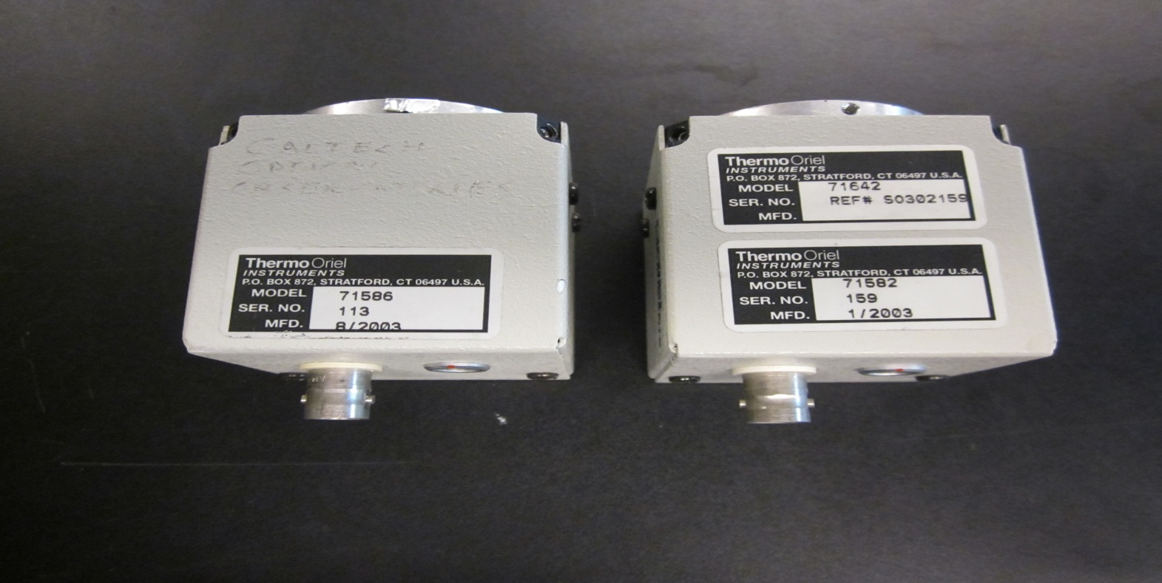

Pictorial Physical Inventory Sheet For COO Storage
Item# 36 | Autocollimator | Date | 06/02/2016
Mfr | Hilger and Watts | P/N | 90682
Serial# |  | Note | Missing Illumination source

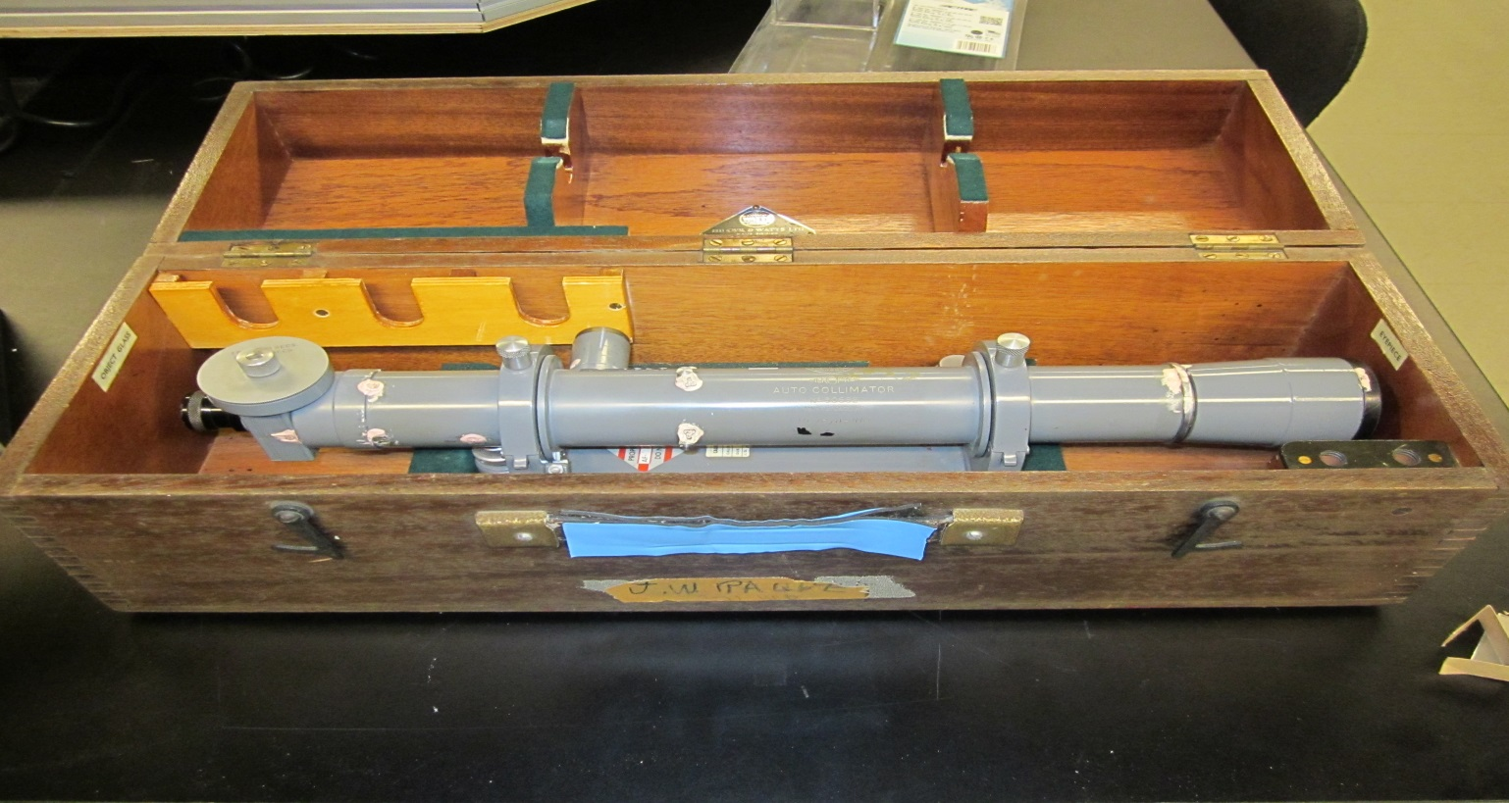

Item# 37 | Logic Analyzer | Date | 06/02/2016
Mfr | Tektronix | P/N | 3001GPX
Serial# | B010219 | Note | Caltech 000009252

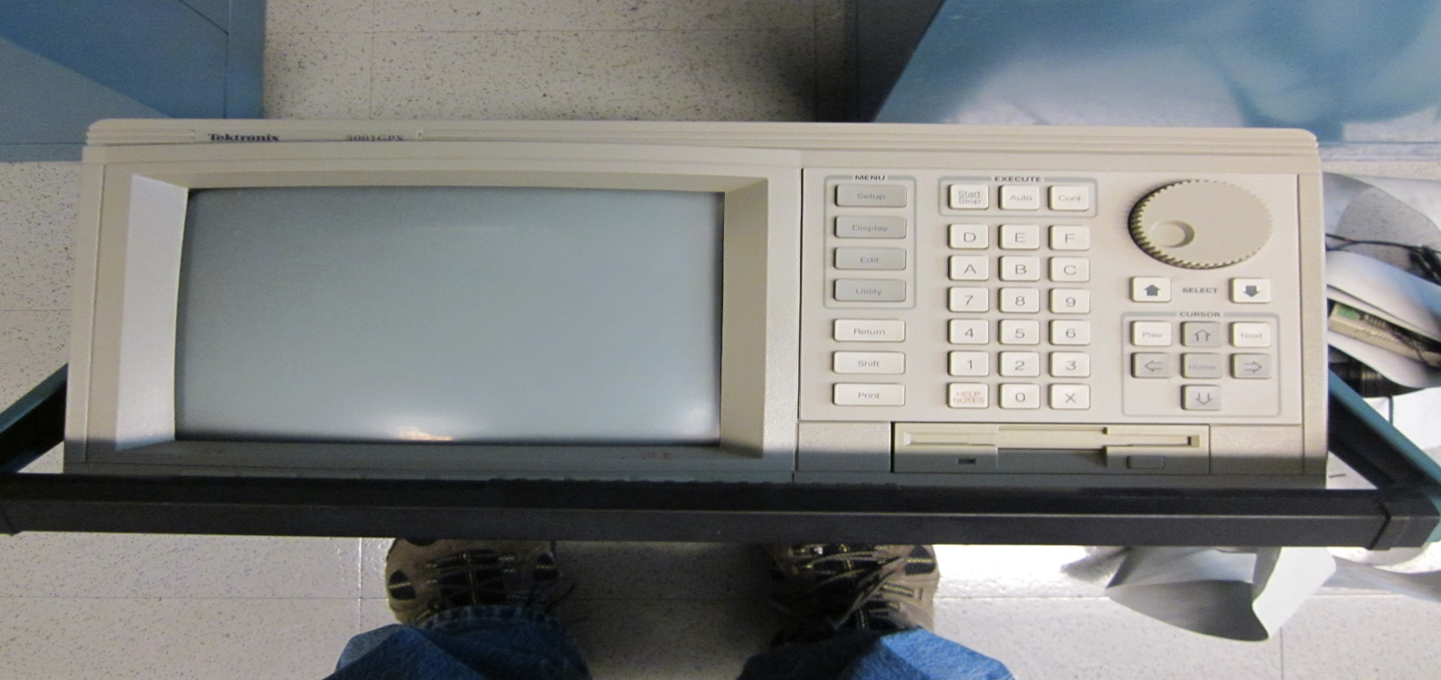

Pictorial Physical Inventory Sheet For COO Storage
Item# 38 | Sony Camera System | Date | 06/03/2016
Mfr | Sony | P/N | DXC-151A
Serial# | 104778 | Note | Caltech 000054551

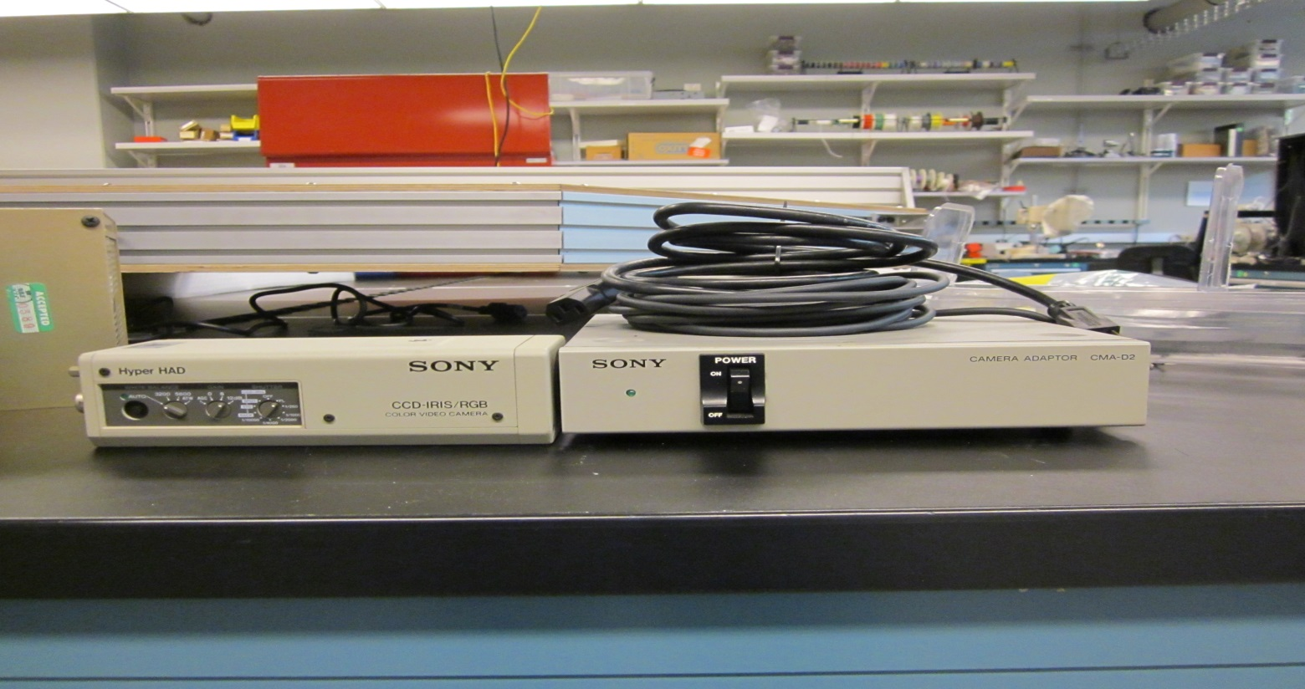

Item# 39 | Piezo Motion Controller | Date | 06/03/2016
Mfr | PI | P/N | P-925.323
Serial# | 07830496 | Note | Caltech 000054464

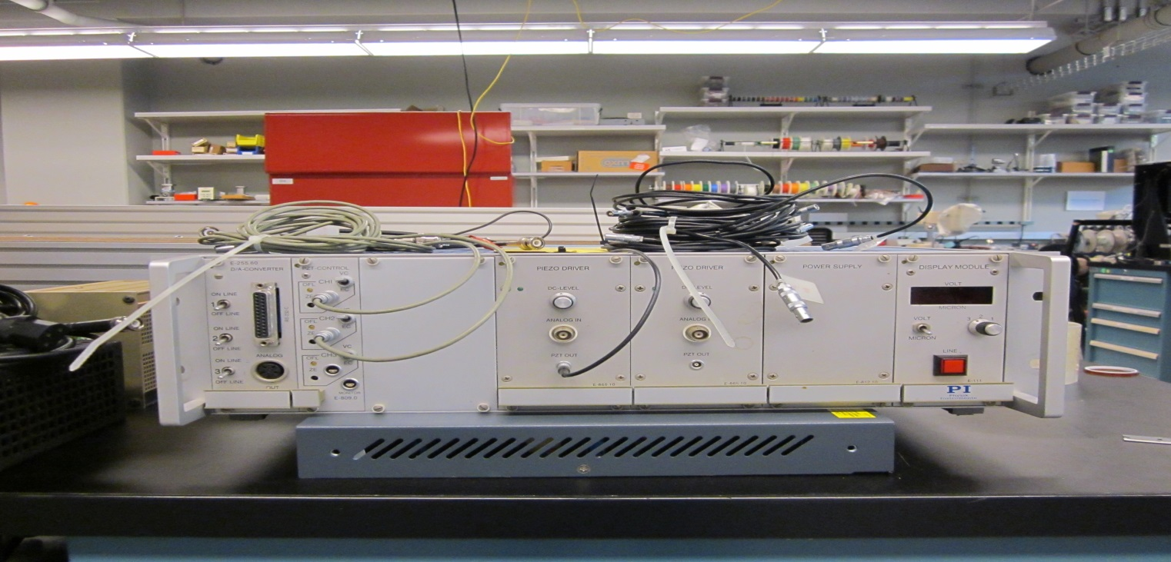

Pictorial Physical Inventory Sheet For COO Storage
Item# 40 | Triple Output DC Power Supply | Date | 06/03/2016
Mfr | Agilent | P/N | E3631A OEM
Serial# | MY40017128 | Note

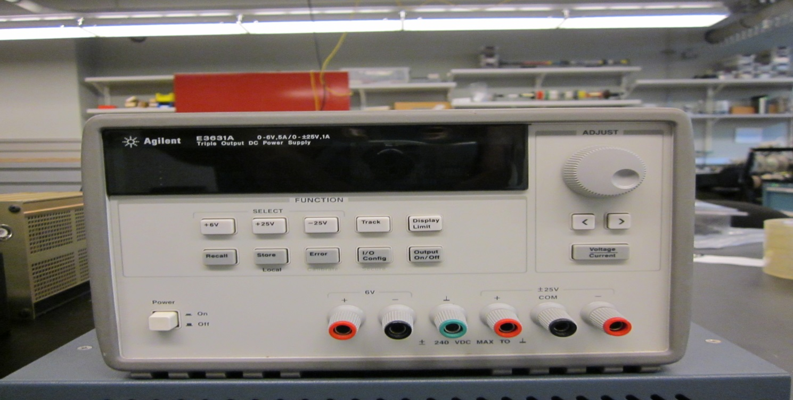

Item# 41 | SCSI-Bus Analyzer | Date | 06/06/2016
Mfr | Ancot | P/N | DSC202-STE
Serial# | 92090871-R | Note | Caltech 000009448

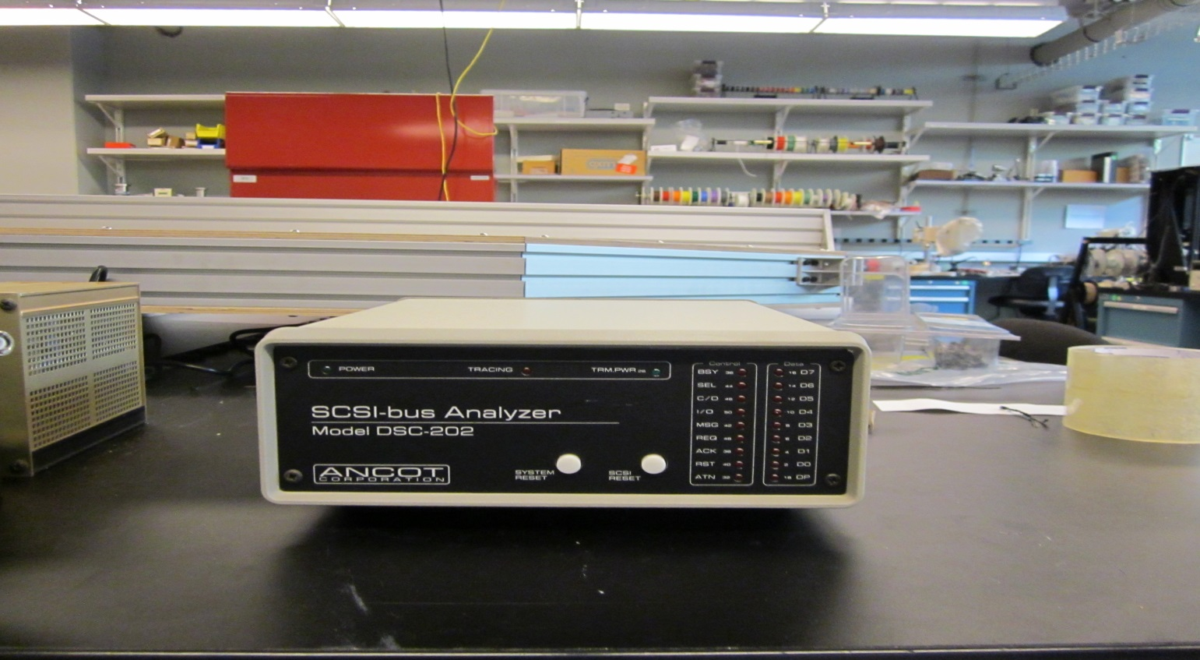

Pictorial Physical Inventory Sheet For COO Storage
Item# 42 | Synthesizer/ Function Generator | Date | 06/06/2016
Mfr | HP | P/N | 3325B
Serial# | 2847A07246 | Note | Caltech 000005992

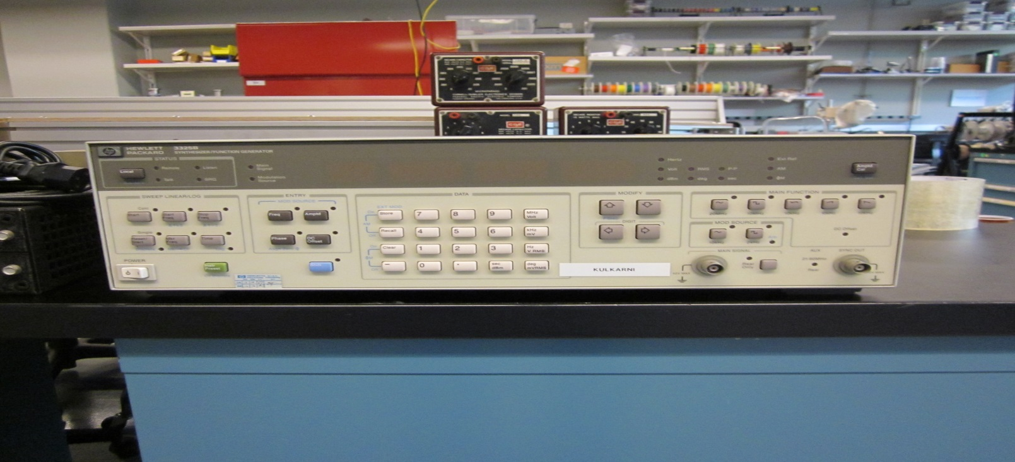

Item# 43 | Variable Auto transformer | Date | 06/06/2016
Mfr | Superior Electric Company | P/N | 3PN117B
Serial# |  | Note

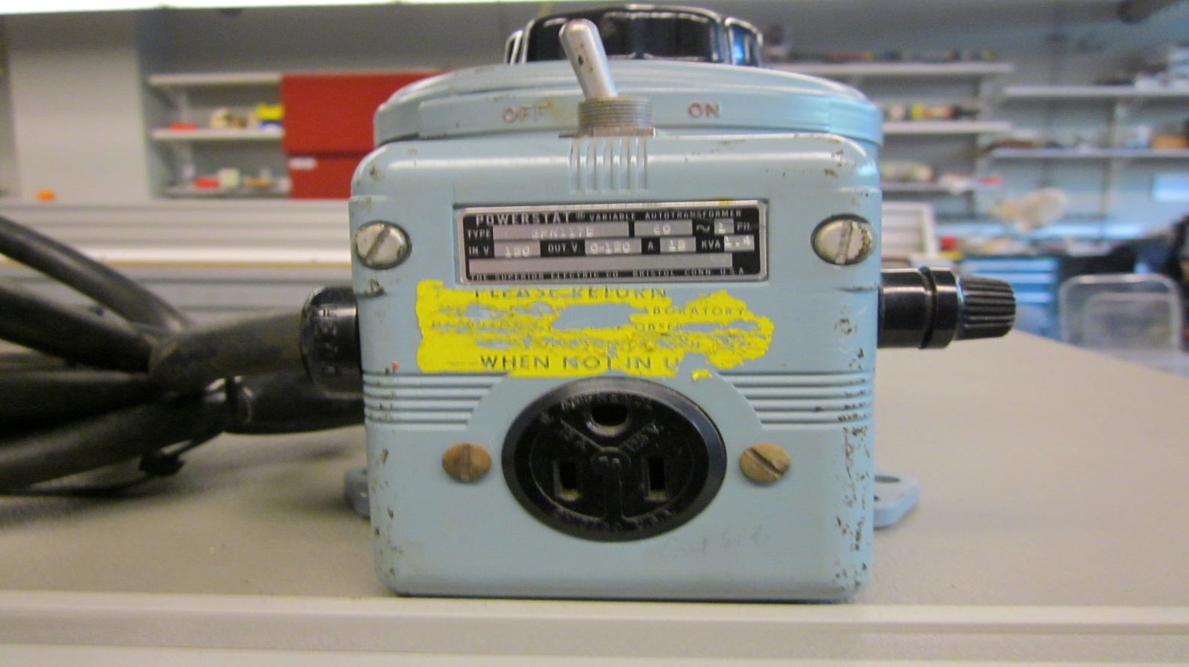

Pictorial Physical Inventory Sheet For COO Storage
Item# 44 | Autotransformer | Date | 06/06/2016
Mfr | Variac | P/N | W5MT3
Serial# |  | Note

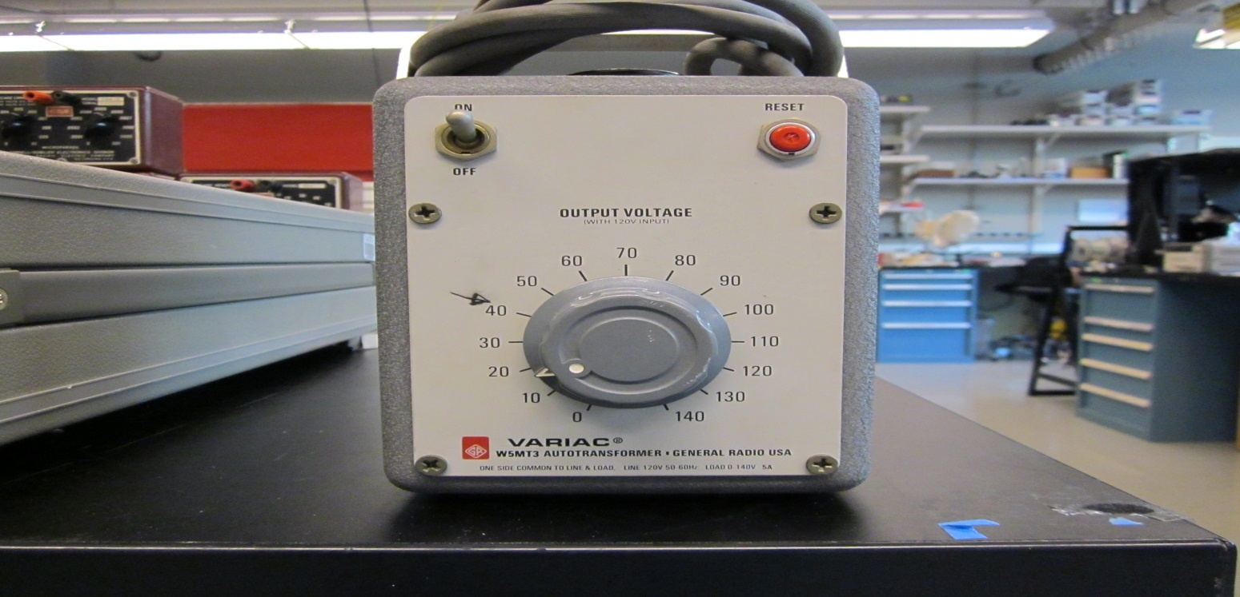

Item# 45 | 2 MHz Function Generator | Date | 06/06/2016
Mfr | Tektronics | P/N | CFG250
Serial# | CFG-250TW22659 | Note | Caltech000054513

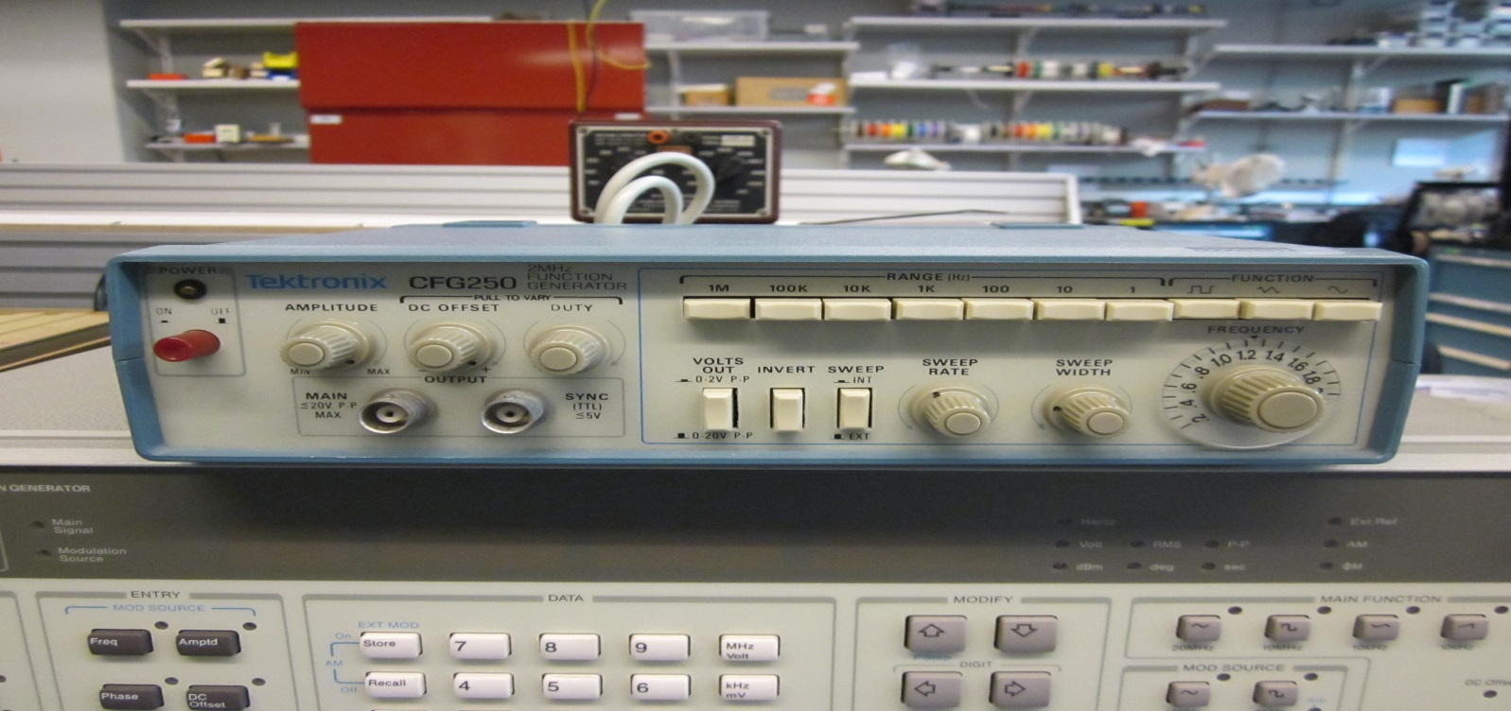

Pictorial Physical Inventory Sheet For COO Storage
Item# 46 | Electrolytic capacitor | Date | 06/06/2016
Mfr | Federal Pacific Electric Co. | P/N | CDE
Serial# |  | Note | 10-150 microfarads

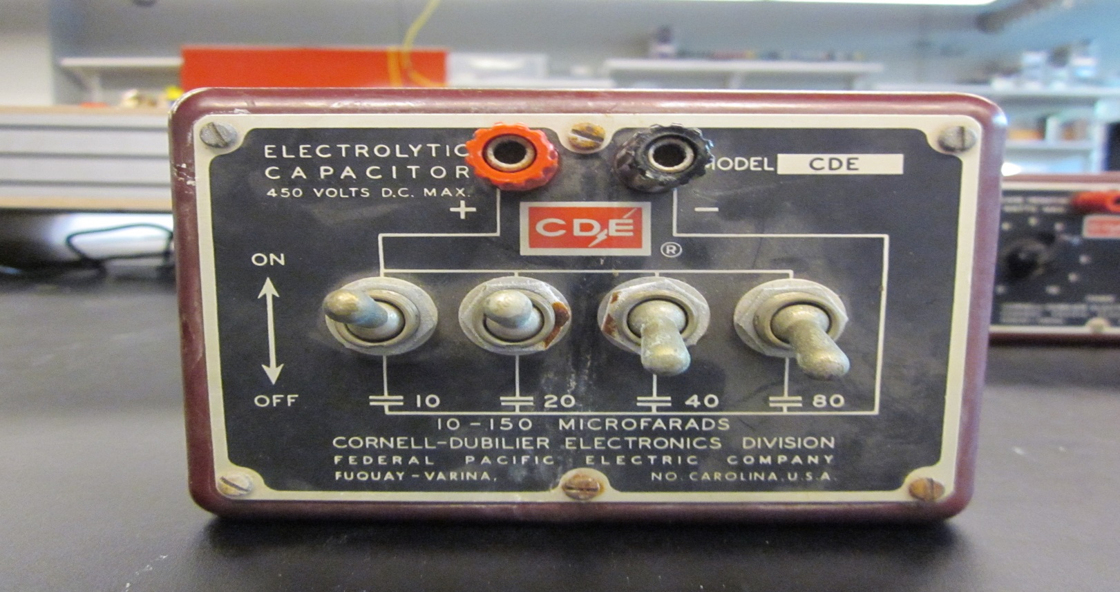

Item# 47 | Decade Resistor | Date | 06/06/2016
Mfr | Federal Pacific Electric Co. | P/N | RDA
Serial# | 0 -100 Ohms | Note | 10 watt Max

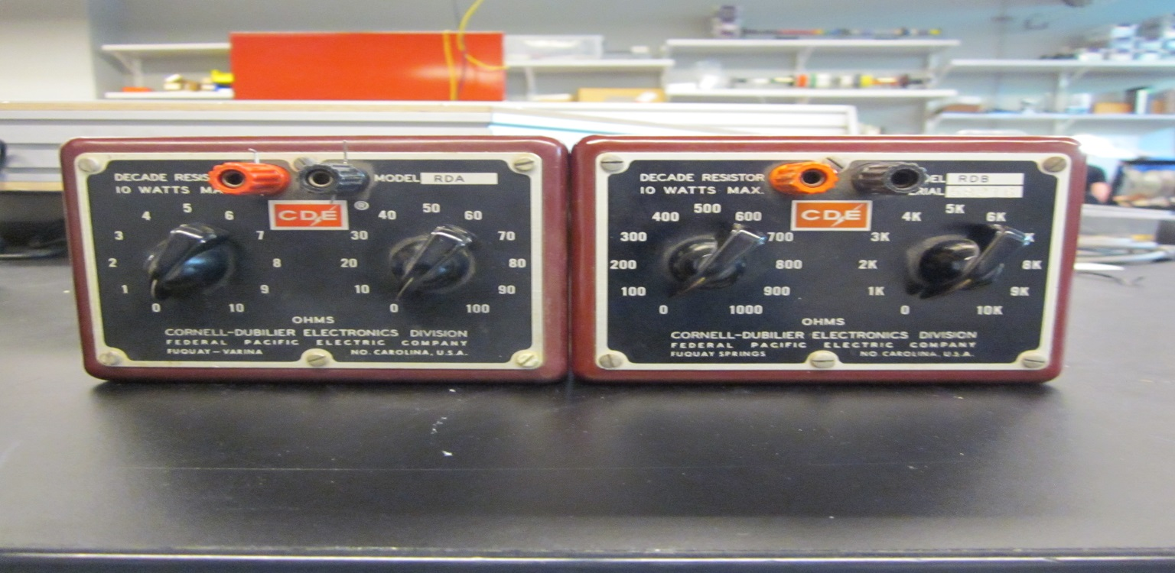

Pictorial Physical Inventory Sheet For COO Storage
Item# 48 | Decade Resistor | Date | 06/06/2016
Mfr | Federal Pacific Electric Co. | P/N | RDB
Serial# | - 10 KOhms | Note | 10 Watt max

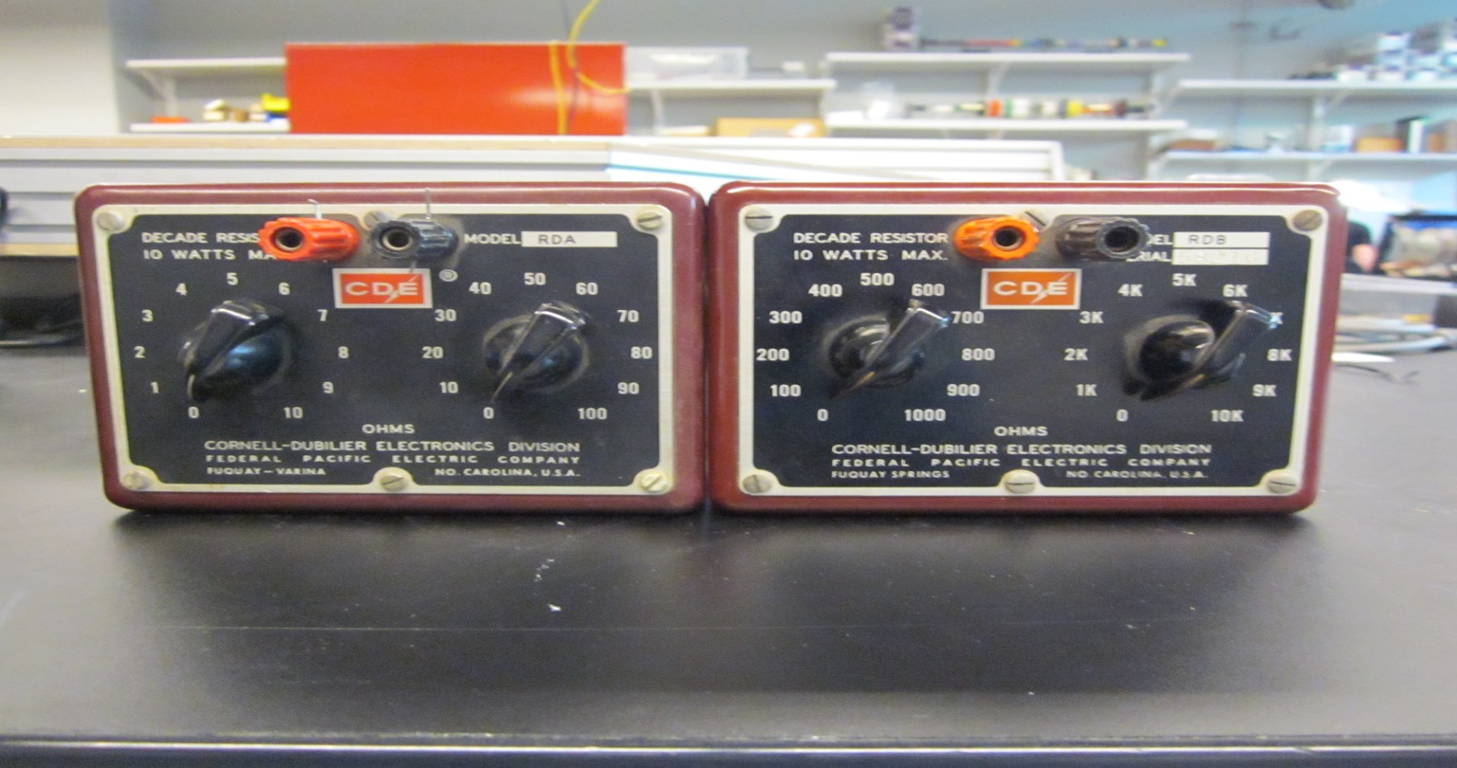

Item# 49 | Decade Capacitor | Date | 06/06/2016
Mfr | Federal Pacific Electric Co. | P/N | CDC 5
Serial# | 56349 | Note | 0-10 microfarads

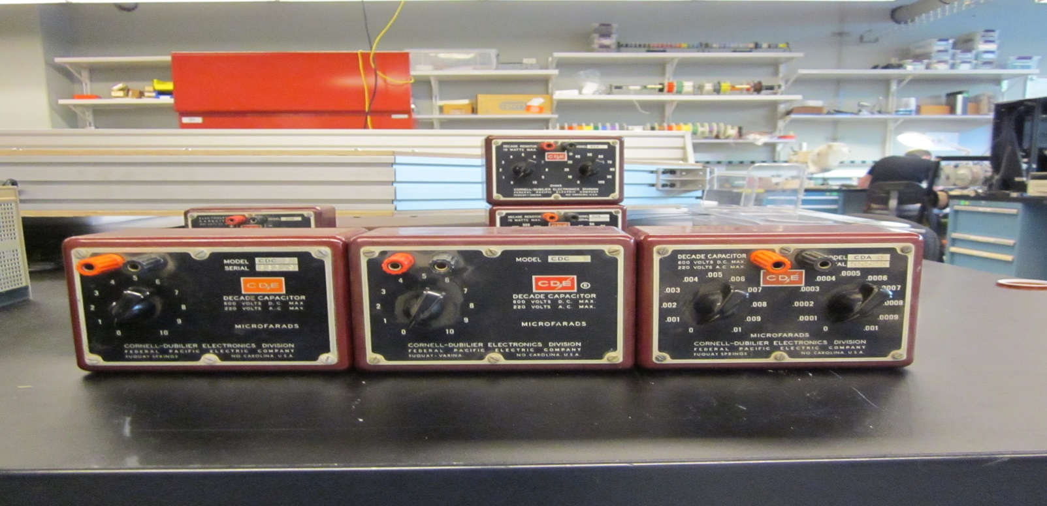

Pictorial Physical Inventory Sheet For COO Storage
Item# 50 | Decade Capacitor | Date | 06/06/2016
Mfr | Federal Pacific Electric Co. | P/N | CDC 3
Serial# | 0-10 microfarads | Note

Item# 51 | Decade Capacitor | Date | 06/06/2016
Mfr | Federal Pacific Electric Co. | P/N | CDA 5
Serial# | 55525 | Note

Pictorial Physical Inventory Sheet For COO Storage
Item# 52 | Chipmaster 3000 | Date | 06/07/2016
Mfr | Logical Devices | P/N
Serial# |  | Note

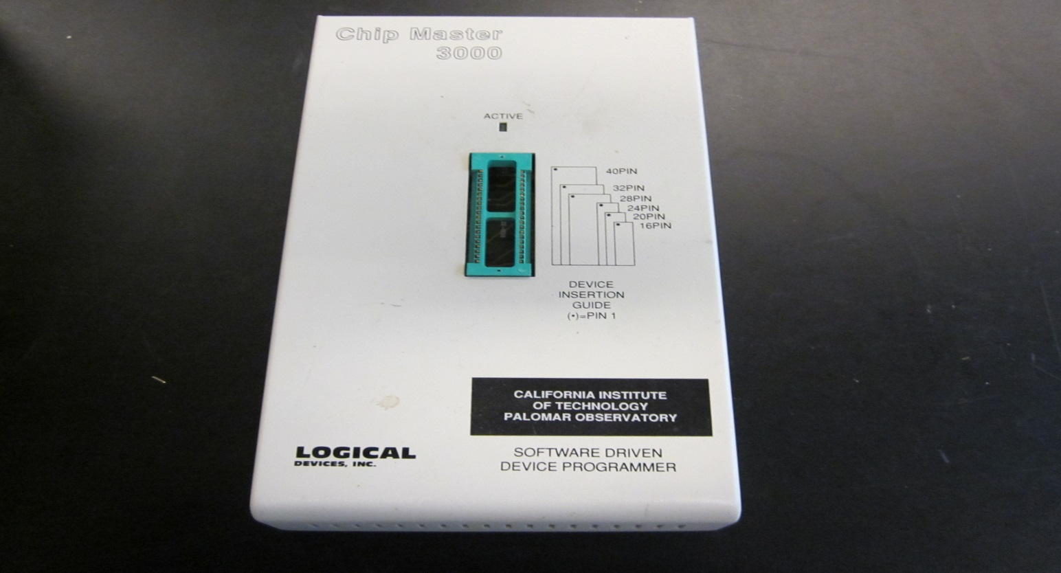

Item# 53 | 50 MHz Universal Counter | Date | 06/07/2016
Mfr | HP | P/N | 5300B Measuring System
Serial# | 1452A02429 and 144408067 | Note

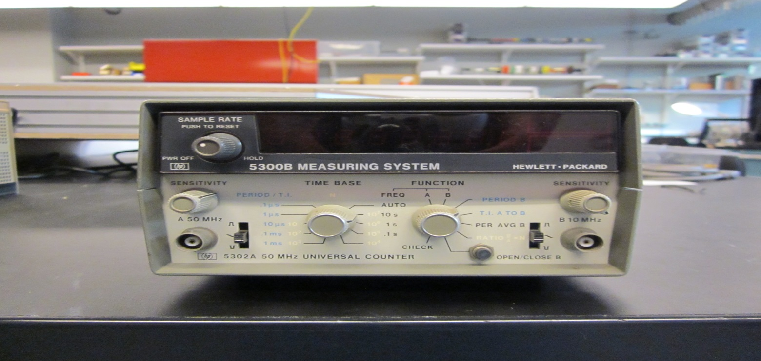

Pictorial Physical Inventory Sheet For COO Storage
Item# 54 | 10kHz to 1000MHz Signal Generator | Date | 06/07/2016
Mfr | Marconi Instruments | P/N | 52022-900C
Serial# | 119004 | Note

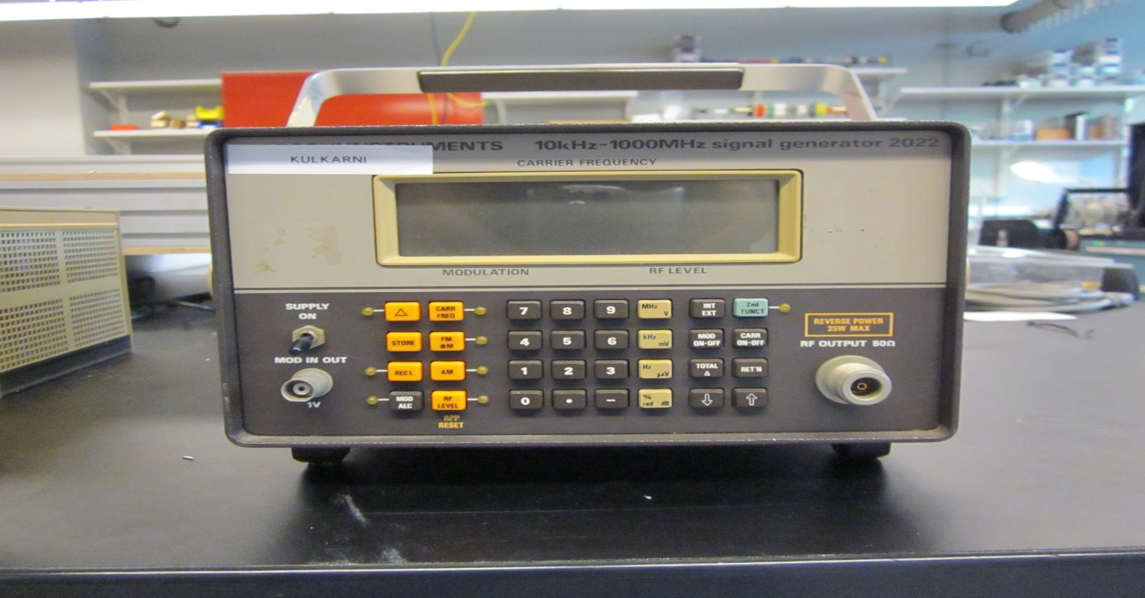

Item# 55 | Frequency Counter | Date | 07/12/2016
Mfr | Hewlett Packard | P/N | 5326C
Serial# |  | Note

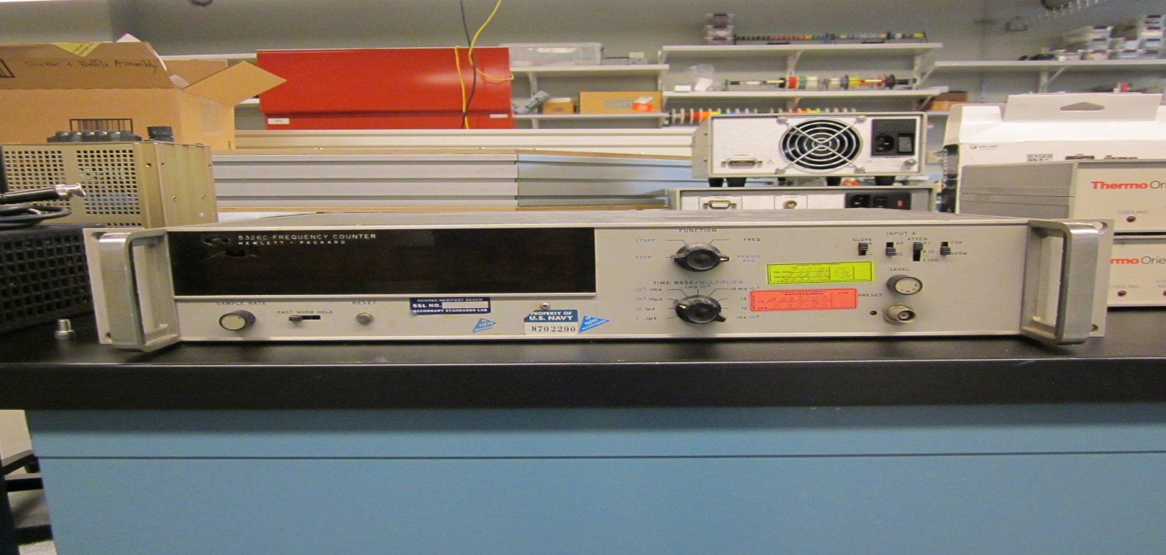

Pictorial Physical Inventory Sheet For COO Storage
Item# 56 | Thermistor resistor | Date | 07/12/2016
Mfr | Thermo Oriel | P/N | 77055
Serial# | 132 | Note

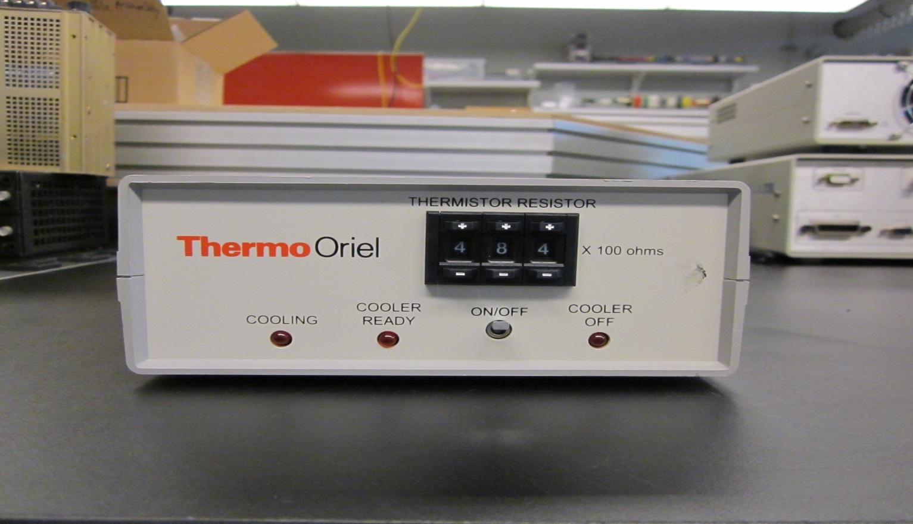

Item# 57 | Thermistor Resistor | Date | 07/12/2016
Mfr | Thermo Oriel | P/N | 77055
Serial# | 133 | Note

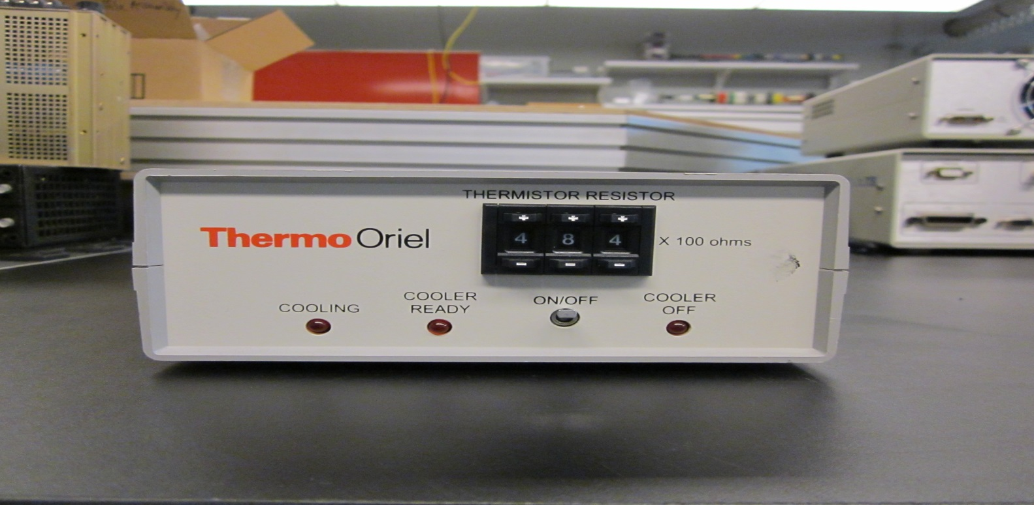

Pictorial Physical Inventory Sheet For COO Storage
Item# 58 | Power Supply | Date | 07/12/2016
Mfr | Thermo Oriel | P/N | 68938
Serial# | 283 | Note | Caltech 000058678

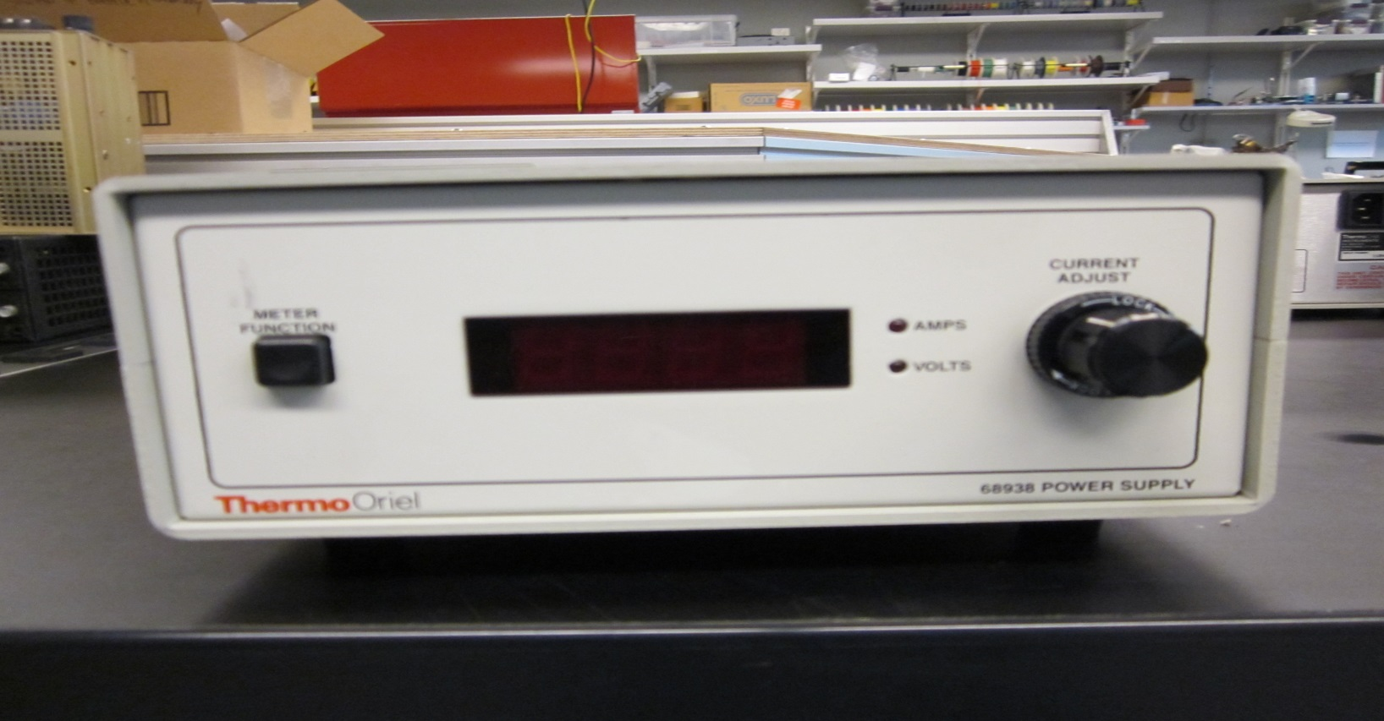

Item# 59 | Optical Power Meter | Date | 07/12/2016
Mfr | Oriel Instruments | P/N | 70310
Serial# | 377 | Note

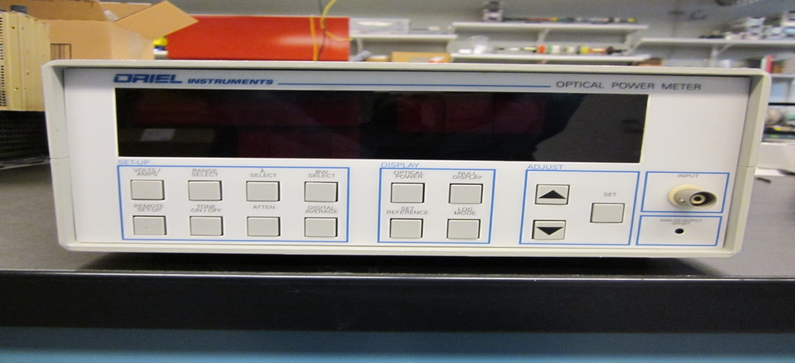

Pictorial Physical Inventory Sheet For COO Storage
Item# 60 | 1.32 Laser Power Supply | Date | 07/12/2016
Mfr | Spectra Diode Labs | P/N | SDL 928-10
Serial# | 042 | Note | MIT L.L. # 0003-62012-1

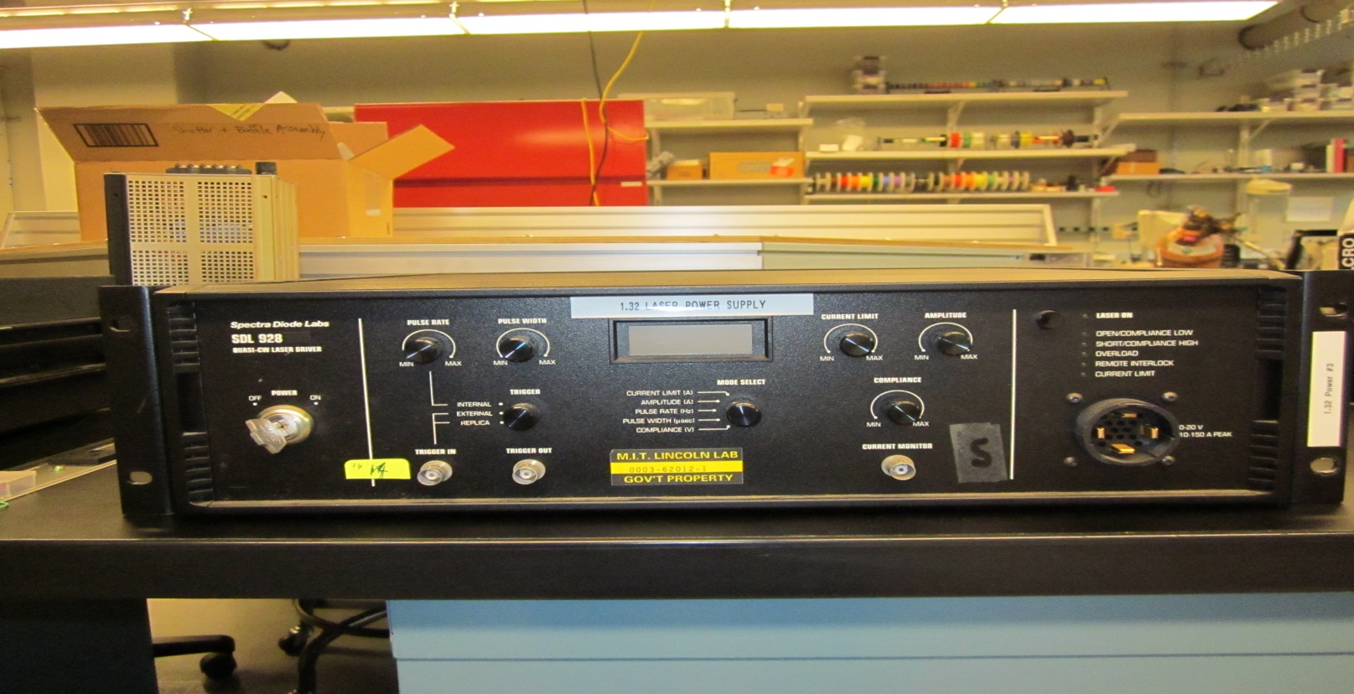

Item# 61 | Pulse Generator | Date | 07/21/2016
Mfr | Hewlett Packard | P/N | 8007B
Serial# |  | Note | Caltech 000054556

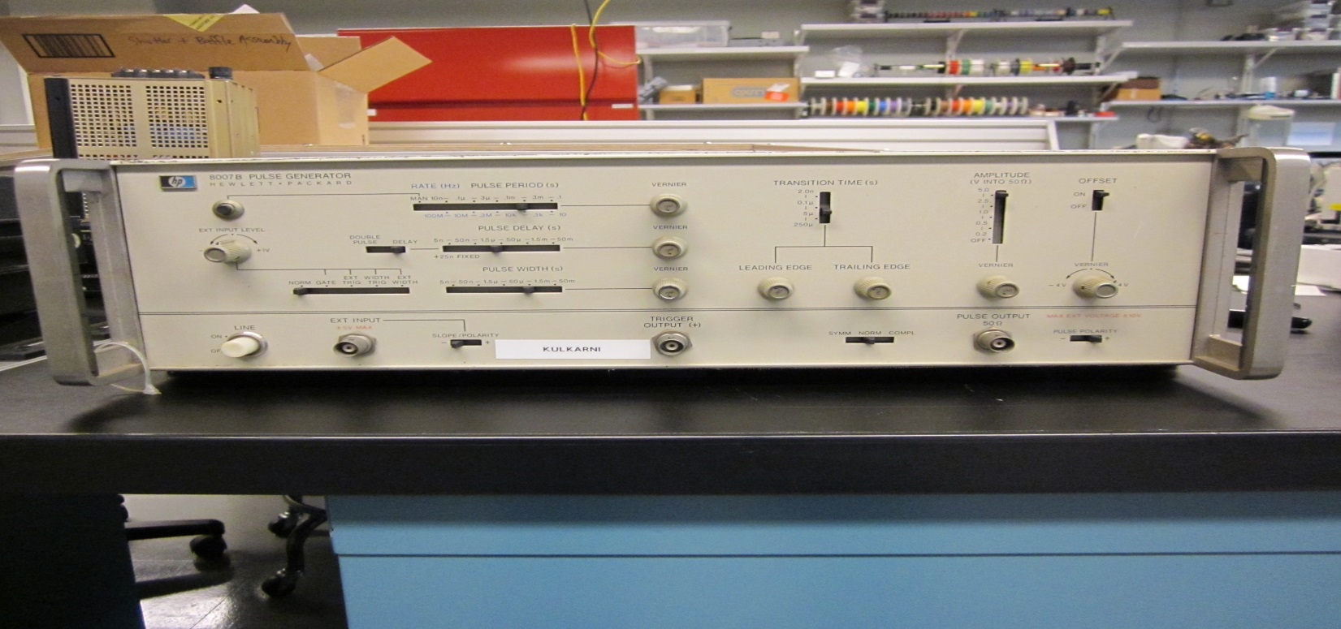

Pictorial Physical Inventory Sheet For COO Storage
Item# 62 | Synthesized RF Signal Generator 10kHz to 1060 MHz | Date | 07/12/2016
Mfr | Fluke | P/N | 6060B
Serial# |  | Note | Caltech 000054557

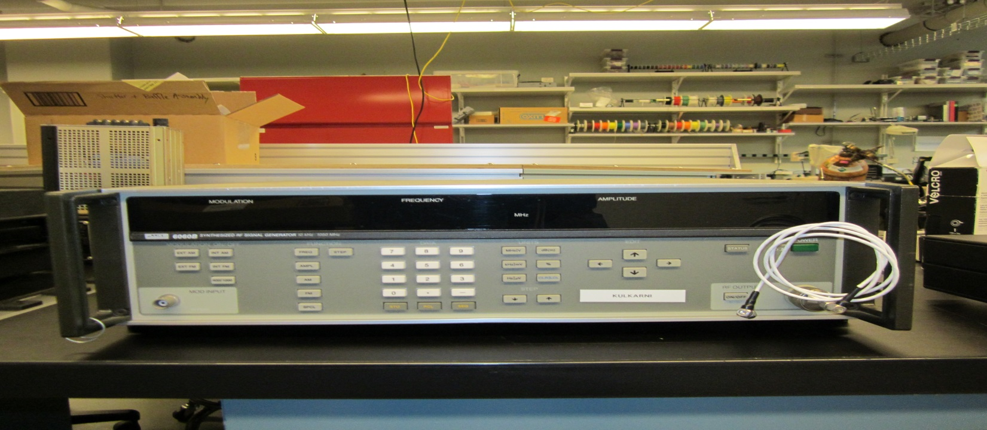

Item# 63 |  | Date
Mfr |  | P/N
Serial# |  | Note

Pictorial Physical Inventory Sheet For COO Storage
Item# 64 |  | Date
Mfr |  | P/N
Serial# |  | Note

Item# 65 |  | Date
Mfr |  | P/N
Serial# |  | Note

Pictorial Physical Inventory Sheet For COO Storage
Item# 66 |  | Date
Mfr |  | P/N
Serial# |  | Note

Item# 67 |  | Date
Mfr |  | P/N
Serial# |  | Note

Pictorial Physical Inventory Sheet For COO Storage
Item# 68 |  | Date
Mfr |  | P/N
Serial# |  | Note

Item# 69 |  | Date
Mfr |  | P/N
Serial# |  | Note

Pictorial Physical Inventory Sheet For COO Storage
Item# 70 |  | Date
Mfr |  | P/N
Serial# |  | Note

Item# 71 |  | Date
Mfr |  | P/N
Serial# |  | Note

Pictorial Physical Inventory Sheet For COO Storage
Item# 72 |  | Date
Mfr |  | P/N
Serial# |  | Note

Item# 73 |  | Date
Mfr |  | P/N
Serial# |  | Note

Pictorial Physical Inventory Sheet For COO Storage
Item# 74 |  | Date
Mfr |  | P/N
Serial# |  | Note

Item# 75 |  | Date
Mfr |  | P/N
Serial# |  | Note

Pictorial Physical Inventory Sheet For COO Storage
Item# 76 |  | Date
Mfr |  | P/N
Serial# |  | Note

Item# 77 |  | Date
Mfr |  | P/N
Serial# |  | Note

Item# |  | Date
Mfr |  | P/N
Serial# |  | Note

