

The Next Generation Adaptive Optics System
at the
W. M. Keck Observatory

A Proposal for Design and Development

June 8, 2006
Version 7

1 Executive Summary 12
2 Introduction 13
2.1 A Next Generation AO System for the Keck Observatory 13
2.2 Recent History and Planning 13
2.3 The Competitive Landscape 14
2.3.1 Background 14
2.3.2 Gemini Observatory 15
2.3.3 European Southern Observatory 16
2.3.4 Subaru 16
2.3.5 LBT 16
2.3.6 Summary 17
2.4 Science with the Existing Keck AO Systems 17
3 Science Case 19
3.1 Introduction 19
3.2 Solar System Science 19
3.3 Galactic Science 19
3.3.1 The Galactic Center: Black Holes, General Relativity, and Dark Matter 19
3.3.1.1 Scientific Background 19
3.3.1.2 Proposed observations and targets 19
3.3.1.2.1 General relativity 19
3.3.1.2.2 Extended matter 20
3.3.1.2.3 R₀ and the dark matter halo 21
3.3.1.2.4 Scattering by stellar-mass BHs 21
3.3.1.3 Comparison of NGAO w/ current LGS AO 22
3.3.1.4 AO and instrument requirements 22
3.3.1.5 References 22
3.3.2 Next-Generation Debris Disk Science 22
3.3.2.1 Scientific Background 23
3.3.2.2 Proposed observations and targets 24
3.3.2.2.1 Debris disk demographics 24
3.3.2.2.2 Evolution of low-mass planets and planetesimals 26
3.3.2.3 Comparison of NGAO w/ current LGS AO 27
3.3.2.4 AO and instrument requirements 27
3.3.2.5 References 28
3.3.3 Imaging and Characterization of Extrasolar Planets 28
3.3.3.1 Scientific Background 29
3.3.3.2 Proposed observations and targets 29
3.3.3.2.1 Planets around low-mass stars and brown dwarfs 29
3.3.3.2.2 Very young planets in the nearest star-forming regions 31
3.3.3.3 Comparison of NGAO w/ current LGS AO 32
3.3.3.4 AO and instrument requirements 33
3.3.4 Diffraction-Limited Imaging of Protostellar Envelopes and Outflows 33
3.3.4.1 Scientific Background 33
3.3.4.2 Proposed observations and targets 35
3.3.4.3 Comparison of NGAO w/ current LGS AO 36
3.3.4.4 AO and instrument requirements 36
3.3.4.5 References 37
3.4 Extragalactic Science 37
3.4.1 Introduction 37
3.4.2 High-Redshift Galaxies 37
3.4.2.1 Dissection of Distant Galaxy Mergers 37
3.4.2.1.1 Scientific Background 37
3.4.2.1.2 Proposed observations and targets 41
3.4.2.1.3 Comparison of NGAO with current LGS AO 42
3.4.2.1.4 AO and instrument requirements 43
3.4.2.1.5 Program Summary 43
3.4.3 Strong Gravitational Lensing 45
3.4.3.1.1 Scientific Background 45
3.4.3.1.1.1 Introduction: 45
3.4.3.1.1.2 Galaxy versus Cluster Lensing 45
3.4.3.1.1.3 Cluster-Scale Lensing 47
3.4.3.1.2 Proposed Observations and Targets 48
3.4.3.1.2.1 Overview 48
3.4.3.1.2.2 Comparison of NGAO with Current LGS AO and with HST-NICMOS 49
3.4.3.1.2.3 Sample Observational Programs 51
3.4.3.1.3 AO and instrument requirements (needs to be completed) 52
3.4.3.1.4 Program Summary (text and/or tables): 52
3.4.4 Active Galactic Nuclei and Black Holes 53
3.4.4.1 Scientific Background 53
3.4.4.1.1 Introduction 53
3.4.4.1.2 Black hole masses in nearby galaxies 54
3.4.4.1.3 Quasar Host Galaxies 55
3.4.4.2 Proposed observations and targets 56
3.4.4.3 Comparison of NGAO w/ current LGS AO 57
3.4.4.4 AO and instrument requirements 58
3.4.4.5 Program Summary (text and/or tables): this needs to be filled in 59
3.5 Science Requirements 59
3.6 References for Section 3, Science Case 59
3.7 Science Requirements 60
4 Technical 61
4.1 Introduction 61
4.2 Requirements 65
4.2.1 Observatory Requirements (Design Constraints) 65
4.2.2 Mauna Kea Site Conditions 68
4.2.3 Requirements Flow Down 69
4.2.3.1 Performance Requirements 69
4.2.3.2 Implementation Requirements 71
4.2.3.3 Design Requirements 71
4.3 Technical Approach 72
4.3.1 Initial Point Design 72
4.3.2 Components and Component Subsystems 77
4.3.2.1 Wavefront Sensing 77
4.3.2.1.1 Laser guide star high-order WFS 77
4.3.2.1.2 Natural guide star high-order WFS 78
4.3.2.1.3 Low-order WFS – visible 78
4.3.2.1.4 Low-order WFS – infrared TT/FA 79
4.3.2.1.5 Calibration/Truth WFS 79
4.3.2.2 Wavefront Correction 80
4.3.2.2.1 Deformable mirrors 80
4.3.2.2.1.1 Piezo-actuated 80
4.3.2.2.1.2 MEMS based 81
4.3.2.2.2 Tip/Tilt Control 82
4.3.2.2.3 Metrology 82
4.3.2.3 Real-time Controller 82
4.3.2.3.1 Real-time control requirements 82
4.3.2.3.2 Architecture and algorithms 83
4.3.2.3.2.1 Massive parallel processing paradigm 83
4.3.2.3.2.2 Image processing and wavefront sensing 83
4.3.2.3.2.3 Tomography 85
4.3.2.3.2.4 Projection and fitting to DMs 86
4.3.2.3.3 Estimate of processor requirements 87
4.3.2.3.4 Diagnostic and Telemetry Streams 89
4.3.2.4 Laser Guide Star Facility 89
4.3.2.4.1 Requirements 89
4.3.2.4.1.1 Number of guidestars 90
4.3.2.4.1.2 Brightness of guidestars 90
4.3.2.4.1.3 Pulse format 90
4.3.2.4.1.4 Elongation 91
4.3.2.4.1.5 Rayleigh gating 91
4.3.2.4.1.6 Bandwidth 91
4.3.2.4.2 Laser technology 91
4.3.2.4.2.1 Sum-frequency Micro-macropulse 92
4.3.2.4.2.2 Sum-frequency CW 92
4.3.2.4.2.3 Continuous micropulse 93
4.3.2.4.2.4 Sum-frequency CW fiber (LLNL) 93
4.3.2.4.2.5 Sum frequency waveguide 93
4.3.2.4.3 Transport options 93
4.3.2.4.3.1 Optical transport 94
4.3.2.4.3.2 Fiber transport 94
4.3.3 System Performance versus Requirements 94
4.3.3.1 Throughput and Emissivity 94
4.3.3.2 RMS Wavefront Error Budget 95
4.3.3.2.1 Narrow-field science with LGS and tip/tilt NGS stars (KBO science program) 96
4.3.3.2.2 Moderate-field science with LGS and bright tip/tilt NGS star (Galactic Center program) 99
4.3.3.2.3 Wide-field deployable IFU science with LGS with off-axis tip/tilt guide star (GOODS-N program) 99
4.3.3.2.4 Narrow-field science under the most favorable conditions 103
4.3.3.2.5 Narrow-field NGS Observations of Io 105
4.3.3.3 Point Spread Function Simulations 106
4.3.3.3.1 Linear Adaptive Optics Simulator Code 107
4.3.3.3.1.1 Tomography: 107
4.3.3.3.1.2 Atmospheric model and propagation: 108
4.3.3.3.1.3 DM and WFS models 108
4.3.3.3.1.4 Segmented telescope primary (M1) 109
4.3.3.3.2 Simulations for NGAO science case 109
4.3.3.3.2.1 Simulation of narrow field of view AO, on axis PSF 109
4.3.3.3.2.2 High contrast simulations 111
4.3.3.3.2.3 Seeing variability simulations 112
4.3.3.3.3 Future simulations 112
4.3.3.4 Predicted Point Source Sensitivities 112
4.3.3.5 Photometric Accuracy 113
4.3.3.6 Astrometric Accuracy 113
4.3.3.7 Polarimetry Accuracy 113
4.3.3.8 Companion Sensitivity 113
4.3.3.9 Long Exposure Considerations 116
4.3.3.10 Observing Efficiency and Up-Time 116
4.3.4 Science Instruments 116
4.3.4.1 Parameter Space 116
4.3.4.2 Overall Concepts 116
4.3.4.3 Instrument Priorities 117
4.3.4.4 Reuse of Existing Instruments 118
4.3.4.5 Imaging 118
4.3.4.5.1 Visible Imager 118
4.3.4.5.2 Near-IR Imager 119
4.3.4.5.3 Mid-IR Imager 119
4.3.4.6 Spectroscopy 120
4.3.4.6.1 Visible IFU 120
4.3.4.6.2 Deployable Near-IR IFU 121
4.3.4.7 Interferometry 122
4.3.5 Technical Design and Performance Trade Space 122
4.3.6 Key Technical Issues 129
5 Management 130
5.1 Introduction 130
5.2 Project Plan and Schedule 130
5.3 System Design 132
5.3.1 System Design Deliverables 132
5.3.2 System Design Plan 133
5.4 Risk Assessment and Risk Management Plan 134
6 Budget 138
6.1 System Design Phase 138
6.2 Preliminary and Detailed Design through Full Scale Development 138
6.3 Science Instruments 138
6.4 Operations 138
7 References 138
8 Appendix A. The Global Landscape for Next Generation AO Systems 139
9 Appendix B. AO System Key Features 140
10 Appendix B. Wavefront Error Budget Terms 145
10.1 Atmospheric Fitting Error 146
10.2 High-order WFS Measurement Error 146
10.3 LGS Tomography Error 146
10.4 Asterism Deformation Error 147
10.5 Scintillation Error 147
10.6 WFS Scintillation Error 148
10.7 Static WFS Zero-point Calibration Error 148
10.8 Dynamic WFS Zero-point Calibration Error 148
10.9 Go-To Control Errors 148
10.10 Residual Na Layer Focus Change 149
10.11 Residual Centroid Anisoplanatism 149
10.12 Residual Atmospheric Dispersion 150
10.13 Science Instrument Mechanical Drift 150
10.14 Long Exposure Field Rotation Errors 150
10.15 Residual Telescope Pointing Jitter 150
10.16 Other Terms Not Considered Here 151

Figure 1. Expenditures and future plans for adaptive optics for ESO and for the US. 17
Figure 2 Keck AO science papers by year and type of science. 18
Figure 3 Required astrometric precision for detecting, from top to bottom, GR effects associated with relativistic prograde precession, extended mass within the stellar orbits, and frame-dragging effects due to the spin of the BH (based on Weinberg et al. 2005). The estimates are based on measurements of stellar orbits and positions from diffraction-limited images obtained with Keck (thick, solid lines). These include 16 stars within 0.5” of Sgr A* with orbital fits obtained from speckle imaging measurements and 142 stars within 1” of Sgr A* with stellar positions obtained with new, deep AO maps. For comparison, we also show estimates based on measurements of just the short-period star S0-2 (thin, dashed line). The results are for a 10-year baseline with 10 integrations per year. Low-order GR and extended matter effects are easily detectable (at the >5σ level) with a precision of ~200 μas, while the detection of BH spin requires either better precision or improved SNR from the observation of multiple high-eccentricity, short-period, stars over multiple orbits. 20
Figure 4 Error contours for BH mass and GC distance estimated for current Keck AO surveys (dashed line, scaled down by 0.01), Keck-NGAO (solid line), and a 30 m extremely large telescope (ELT; dotted line). The Keck-NGAO and ELT numbers in parentheses are the number of stars that are likely observable, and the assumed astrometric and radial velocity errors. The Keck-NGAO will allow BH mass and GC distance estimates with more than two orders of magnitude greater precision than current studies; this improvement will not be greatly surpassed even in the ELT era. 21
Figure 5 The HR 4796A (Schneider et al 1999) and AU Mic (Liu 2004) debris disks resolved in near-IR scattered light with HST (2.5” across) and Keck natural guide star AO (10” across), respectively. The observed ring-like structures, clumps, and gaps are frequently attributed to perturbations by unseen planetary companions. The Keck image of AU Mic represents the current state-of-the-art for ground-based AO, which is limited to the very brightest, edge-on disks. Keck NGAO will enable a much larger sample of debris disks to be imaged, with the necessary multi-wavelength coverage to study their constituent properties. 24
Figure 6 Simulated H-band images of two variants of the Keck NGAO system compared to the present-day Keck AO system, based on a scattered light model of solar-system debris (S. Wolf, private communication) as seen at the distance of the Pleiades cluster (133 pc, 120 Myr). The fractional luminosity of the scattered light is 10^{-3.5} relative to the central star, comparable to mid-IR Spitzer observations of G-type stars in the Pleiades (Stauffer et al 2005). The bright ring in the model corresponds to grains in 1:1 resonance with an outer giant planet (Neptune). The simulated images represent PSF-subtracted 3-hour long integrations taken under median, time-varying seeing conditions at Mauna Kea, with the Fried length r₀ sampled from a log-normal distribution with a mean of 21 cm and a standard deviation of 0.48 dex. The Strehl ratios of the simulated images are 82% (panel b), 47% (panel c), and 28% (panel d). The AO images have been binned to a pixel scale of 31 mas/pix to enhance the signal-to-noise per resolution element and are shown with the same linear grayscale. The size of the smallest coronagraph available on HST is overlaid on panel (d) to illustrate the new phase space that will be opened at <0.3” separations by Keck NGAO. 25
Figure 7 JHK color image of the 2MASS 1207-3932 system, as observed with the VLT NGS system equipped with a near-IR wavefront sensor (Chauvin et al 2005). The primary is a young brown dwarf, with an estimated age of ~12 Myr and ~25 MJup. The companion has an estimated mass of only ~5 M_{Jup}. Only a small number of brown dwarfs can be imaged with sufficient sensitivity and angular resolution with current LGS AO to detect Jovian-mass companions. Keck NGAO will be a major advance for detection and characterization of planets around low-mass stars and brown dwarfs. 30
Figure 8 Planet detection sensitivity for Keck NGAO for two different primary masses and ages, based on models by Baraffe et al. (1998, 2003) and high contrast simulations described in section 4.3.3.8. NGAO will be able to search for Jovian-mass companions around large numbers of low-mass stars and brown dwarfs. (Most of the detection limits are contrast-limited, but the outer floor seen in the curves is set by the raw sensitivity of the system. The primary is assumed to be at 30 pc with an on-source integration time of 20 minutes.) 31
Figure 9 Schematic comparison of the relative parameter space for direct imaging of planets probed by Keck NGAO and ExAO systems in development by Gemini and VLT. The optical faintness of low-mass stars, brown dwarfs, and the youngest stars makes them inaccessible to ExAO systems, but hundreds of these objects can be imaged with Keck NGAO. 33
Figure 10 Seeing-limited (0.5-0.6”) I-band (0.8 m) images of protostars in Taurus-Auriga, showing the resolved scattered light structure from the circumstellar environment (from Eisner et al 2005). Each image is 30” on a side, with the “+” symbol indicating the centroid of the mm-continuum dust emission. 34
Figure 11 Integrated-light SEDs, I-band scattered light images, and millimeter continuum images for a flared disk model at a range of viewing angles (i increases from the bottom to top panels). More edge-on models exhibit deeper absorption at mid-IR wavelengths and higher extinction of the central star. For small inclinations (i ~ 30), the central star is visible and dominates the I-band emission. For moderate inclinations an asymmetric scattered light structure is observed, while for nearly edge-on orientations a symmetric, double-lobed structure is observed (from Eisner et al 2005). 36
Figure 12 Point Design: Zemax optical layout on the Nasmyth platform. 73
Figure 13 NGAO system on Keck left Nasmyth platform. 74
Figure 14 Point Design: Dichroic Switchyard 75
Figure 15 Point Design: NGAO transmitted field showing LGS asterism, NGS and science field. 76
Figure 16 Point Design: DM actuators and WFS subapertures projected onto the Keck telescope pupil. 76
Figure 17 Multi-guidestar AO processing architecture 83
Figure 18 Background in the K band due to point design NGAO system cooled to 258 K (red) compared to that due to the sky plus telescope (black), assuming a total telescope emissivity of 0.10. 95
Figure 19. Error budget summary for LGS mode having an on-axis tip/tilt reference source, corresponding to an observation of a KBO having m_{H} = 15.75, in median seeing conditions. Error terms highlighted in light blue are allocations; other terms are based on point design parameter choices. 97
Figure 20. NGAO point design performance vs. KBO target brightness. For compact narrow-angle targets brighter than about m_{H} = 17, it is favorable to use the target itself for low-order wavefront information. For fainter targets, use of field NGS stars is preferred. The excellent performance for large sky fraction relies on MOAO compensation of the low-order guide stars and variable control of the LGS asterism radius (between 10 and 50"). 98
Figure 21. Error budget summary for Galactic Center observations, using a single NGS tip/tilt/focus/astigmatism star IRS 7, in median seeing conditions. Error terms highlighted in light blue are allocations; other terms are based on point design parameter choices. 100
Figure 22. GC wavefront error performance vs. Fried's parameter, r₀, for constant turbulence-weighted wind speed of 14.9 m/s and other parameters as above, with optimal choice of HOWFS and LOWFS camera rates. 101
Figure 23. Error budget summary for the particularly challenging GOODS-N field with 30% sky fraction, using a two NGS tip/tilt stars and one tip/tilt/focus/astigmatism star in median seeing conditions. In this particular case, optimum performance is found by distributing the 10 LGS beacons over an asterism of diameter 2.6 arcmin. This helps the performance of the MOAO correction on the tip/tilt stars, at the cost of large tomography error for the science target itself. For smaller desired sky fraction (even for 20%), the optimal asterism diameter is less, improving science target tomography (see Figure 23). 102
Figure 24. Deployable IFU imaging performance vs. sky fraction, for different zenith angles. NGAO point design J-band Strehl ratio in normal zenith = 10° extragalactic fields would be expected to be thrice the Strehl obtained in GOODS-N, for ~30% sky fraction. 103
Figure 25. "Best-case" error budget under the most favorable conditions on Mauna Kea. Uncorrectable telescope, instrument, and NGAO aberrations dominate, followed by several flavors of calibration error. In the absence of these implementation errors, the entire visible-light spectrum of science wavelengths opens up to diffraction-limited discovery science. 104
Figure 26. Error budget for NGAO observations of Io in N=62 subaperture NGS mode and median seeing and wind speed conditions. 106
Figure 27 Grid of 120 nm PSF from LAOS simulations, each column represents a different wavelength band columns starting from the left are wavelengths of 0.55 μm, 0.65 μm, 0.85 μm, 1.2 μm, 1.65 μm, 2.2 μm, corresponding to the centers of the V, R_{c}, I_{c}, J, H, and K photometric bands. Each row corresponds to different tip/tilt errors starting at the top single axis tip tilt errors are: 0 mas, 8 mas, 15 mas, and 25 mas. Each individual PSF is approximately 0.8 arcseconds on a side. The total rms wavefront error for the second row down from the top is 120 nm. 111
Figure 28: Comparison of different sources of scattered light. The upper curve shows the Keck diffraction pattern. The middle curve shows speckle noise from residual wavefront errors and a near-perfect coronagraph. The bottom curve shows a Keck telescope with no wavefront errors and a coronagraph that removes the effects of diffraction from the outer edge but not from segment gaps. 114
Figure 29: Comparison of the effects of static wavefront errors on NGAO high-contrast performance. Internal errors are simulated as non-common-path optical errors with a -2.5 power spectral density index. 115
Figure 30: Effects of residual segment aberrations on contrast. 116
Figure 31 Top-Level WBS 131
Figure 32 Project Plan showing WBS and schedule 132
Figure 33 System Design Phase Plan showing WBS and Schedule 134

Table 1 Next-generation AO systems under development for 8-10 meter telescopes. 15
Table 2 TAC-Allocated Keck II Science Nights for Semesters 2006A/B. 18
Table 3 Mauna Kea C_{n}² Profile. 68
Table 4 Performance Budgets 69
Table 5 Specifications for high order LGS wavefront sensors 77
Table 6 Detectors for high order wavefront sensors 78
Table 7 Specifications for high speed low order wavefront sensors 79
Table 8 Truth wavefront sensor specifications 79
Table 9 Piezo deformable mirror for Keck NGAO 80
Table 10 MEMS deformable mirror for K-NGAO 81
Table 11 Deformable mirror technology status 81
Table 12 Real time control specifications for Keck NGAO 82
Table 13 Definition of symbols 84
Table 14 Processing steps from Hartmann slopes to wavefront phase. 85
Table 15 Tomography processing steps 85
Table 16 Deformable mirror real time processing steps 86
Table 17 Estimated compute power requirements for NGAO real-time processing 88
Table 18 Laser Beacon Requirements 89
Table 19 Sodium laser technology in use in astronomical adaptive optics systems. The latter two in this list are under development through the NSF/NOAO Adaptive Optics Development program. 91
Table 20 Emissivity and temperature of each element in the IR science path. 95
Table 21 Performance summary for the Keck NGAO point design for several key science cases. 96
Table 22 The various terms used in the current point design error budget for NGAO. 110
Table 23: Estimated limiting magnitudes for generic visible and IR imaging cameras behind the point-design NGAO system, for different total RMS wavefront error budgets. 112
Table 24: Basic Requirements for the Visible Imager 119
Table 25: Basic Requirements for the Near-IR Imager 119
Table 26: Basic Requirements for the Mid-IR Imager 120
Table 27: Basic Requirements for the Visible IFU 121
Table 28: Basic Requirements for Each Unit of the near-IR IFU 122
Table 29 Trade Studies. 122
Table 31 Risk Assessment and Mitigation Plans 134
Table 32 Instruments for use with AO systems 139

Executive Summary
Background: The twin 10 m Keck telescopes were the first of a new generation of ground-based, large optical/infrared telescopes, offering major improvement in light gathering power and angular resolution. A 2002 Visiting Committee of distinguished U.S. astronomers, reviewing the performance and standing of the Observatory, wrote: “The Keck Observatory has dominated ground-based...astronomy for a decade. It is scientifically extremely productive.” Keck has continued its lead by being the first to implement both natural guide star (NGS) and laser guide star (LGS) adaptive optics (AO) systems in order to achieve angular resolutions that match the capabilities of the Hubble Space Telescope in the visible. Over ninety refereed science papers have been produced using the Keck AO systems. The WMKO 2002 Strategic Planning Workshop identified “Maintaining world leadership in high angular resolution astronomy” as a 20-year strategic goal paramount to the Observatory’s mission. In this proposal we describe how we plan to implement the next major step toward this vision. In this proposal we describe the next major step toward this vision.

Broader Impacts: The significant new science capabilities produced through this proposal will be directly available to a broad community of astronomers including those in the Caltech, University of California and University of Hawaii communities through their time allocation committees. The entire US community will have access through NASA membership in the WMKO partnership and the NSF-funded National Optical Astronomical Observatories Telescope System Instrumentation Program.
WMKO has already demonstrated leadership in the training of world experts in the field of AO. The educational impact of this proposal will be significant with graduate students and postdocs, potentially the next generation of leaders in this critical field, directly engaged in the technical and scientific aspects of this proposal. On the local level WMKO offers many educational programs and services to work with residents, educators and especially students.

Introduction
This proposal continues W.M. Keck Observatory’s (WMKO) leadership in high angular resolution astronomy by providing a next generation science facility capable of probing new domains of astrophysics.

A Next Generation AO System for the Keck Observatory
We propose to study the feasibility of a Next Generation AO system for the Keck Observatory. This new system will build upon Keck’s current leadership in high-spatial-resolution laser guide star adaptive optics. It will provide substantially higher Strehl ratios in the near infrared and, for the first time, good AO correction in R, I, and z bands. It will have unique capability for extragalactic astrophysics, through a multi-object AO system that feeds deployable integral field units. The latter take advantage of MEMS deformable mirror development at the Center for Adaptive Optics and of the demonstrated capabilities of AO integral field spectroscopy through OSIRIS, and paves the way for such an instrument on the Thirty Meter Telescope.
In this proposal we present a powerful science case for the Next Generation AO system (NGAO), derive the science requirements, describe a point design capable of fulfilling these requirements, and outline instrument concepts that would take full advantage of NGAO. In the coming year we propose to begin the design development phase by doing a feasibility study that deepens our understanding of the science requirements; explores trade studies between the AO system, instrument designs, and science case; and brings us to the System Design Review stage. During the coming year we will develop modular options for potential funding of the new AO system and its instrumentation suite, by identifying specific packages suitable for funding by separate donors and agencies. We will outline scenarios for phased funding.
The proposed new AO system will give Keck a genuinely unique role within the next-generation systems under development in the rest of the world. While ESO, Gemini, and other 8 – 10 meter telescopes are devoting very generous funding to extreme AO planet-finding systems and to wide-field ground-layer AO systems for seeing improvement, none are yet occupying the niche which we find most compelling scientifically: “precision AO” that takes full advantage of Keck’s larger aperture, and that effectively multiplies that aperture for multi-object work through use of deployable IFUs.

Recent History and Planning
The precision AO approach we propose here has a strong heritage within the Keck Adaptive Optics Working Group strategic planning process.
In November 2002, the Keck Adaptive Optics Working Group (AOWG) completed a strategic plan for future AO systems at the Observatory. This plan was subsequently approved by the Science Steering Committee (find out when). An updated version was issued by the AOWG in September 2004 (KAON 271).
We are now in 2006, and the first three vital areas of the strategic plan have been successfully completed: the Keck II AO system has been optimized, the laser guide star is in science operation, and OSIRIS has been commissioned. The LGS and OSIRIS, working together, are leading the world at the moment. A fourth component of the strategic plan, the Next-Generation Wavefront Controller upgrade, is also going very well: commissioning is scheduled for late 2006 on Keck I and early 2007 on Keck II. The new wavefront controller will increase sensitivity to faint guide stars by at least one magnitude, and will replace obsolete components so as to give robust AO operations on both telescopes for the coming five to ten years.
The fifth component of the 2002 strategic plan, an extreme AO planet-finder for Keck, has not come to pass. Instead this instrument is now funded by Gemini and will be installed at the Gemini South Telescope.
Subsequent to preparation of the AOWG strategic plan in 2002, the National Science Foundation awarded funding for a solid-state laser guide star on Keck I. The infrastructure for this laser is currently being designed, and the laser is scheduled for delivery to Keck in mid-2007. Following laser commissioning, OSIRIS will be moved to Keck I to provide laser guide star AO capability at both telescopes starting in 2008.
The sixth and final part of the 2002 strategic plan was development of a new AO facility called Keck Precision Adaptive Optics System (KPAO). While in 2002 there was not yet a specific hardware concept for this new system, it was envisioned to provide substantially higher Strehl performance in the near infrared as well as good AO correction in the visible, perhaps even down to Hα wavelengths. Approximately one Keck FTE per year and part of a post-doc’s time has been allocated to fleshing out the KPAO concept since the start of FY05.
In the fall of 2005 the AOWG and the Science Steering Committee decided that it was time to look into potential future Keck AO systems in a more intensive manner. To accomplish this goal, the AOWG and the WMKO AO group jointly assembled a science team and a technical working group, which have been working together to flesh out the science case and point design for Next Generation AO at Keck. The current proposal is the outcome of this six-month effort.

The Competitive Landscape

Background
A key component of any strategic planning exercise is to identify the competitive landscape, and to us this global perspective to focus on opportunities and barriers for future projects. To accomplish this, the NGAO team (science plus technical working groups) did a broad survey of current and future AO systems worldwide. Within the scope of our science goals we would prefer to position Keck NGAO to take a global leadership role in AO, rather than building the second or third or fourth version of a specific type of next-generation AO system.
We found that the VLT and Gemini Observatories are planning on Ground Layer AO and Extreme AO. Gemini South and (eventually) the LBT plan to have MCAO systems. By contrast precision AO, which has been the AOWG’s goal for the past four years, has been neglected in the plans of the other 8-10 meter telescopes. This leaves an important and exciting competitive niche which Keck NGAO is well-poised to exploit. We shall report in Section Error: Reference source not found of this proposal that precision AO enables a compelling science case for the Keck community.
The full result of our survey of planned AO science instruments is found in Section 8. In Table 1 we give merely an overview of plans of other observatories for what we call “next-generation AO systems” on 8-10 m telescopes. By next-generation AO we mean those systems that go beyond single-conjugate AO with one laser guide star, or that aim for a special-purpose application such as high-contrast imaging or interferometry. We obtained our information from published papers, web sites, and the May 2006 SPIE meeting in Orlando FL.
Table 1 Next-generation AO systems under development for 8-10 meter telescopes.
Next-Generation AO Systems Under Development for 8 - 10 meter Telescopes
Type | Telescope | GS | Next-Generation AO Systems for 8 to 10 m telescopes | Capabilities | Dates
High-contrast | Subaru | N/LGS | Coronagraphic Imager (CIAO) | Good Strehl, 188-act curvature, 4W laser | 2007
High-contrast | VLT | NGS | Sphere (VLT-Planet Finder) | High Strehl; not as ambitious as GPI | 2010
High-contrast | Gemini-S | NGS | Gemini Planet Imager (GPI) | Very high Strehl | 2010
Wide-field | Gemini-S | 5 LGS | MCAO | 2’ FOV | 2007
Wide-field | Gemini | 4 LGS | GLAO | Feasibility Study Completed | ?
Wide-field | VLT | 4 LGS | HAWK-I (near IR imager) + GRAAL GLAO | 7.5' FOV, AO seeing reducer, 2 x EE in 0.1'' | 2012
Wide-field | VLT | 4 LGS | MUSE (24 vis. IFUs) + GALACSI GLAO | 1' FOV; 2 x EE in 0.2" at 750nm | 2012
Narrow-field | VLT | 4 LGS | MUSE (24 vis. IFUs) + GALACSI GLAO | 10” FOV, 10% Strehl @ 650 nm | 2012
Inter-ferometer | LBT | NGS | AO for LINC-NIRVANA (IR interferometer) | Phase 1: Single conj., 2 tel’s Phase 2: MCAO 1 telescope Phase 3: MCAO both telescopes | Phase 1 in 2008

Gemini Observatory
Gemini has three ambitious new adaptive optics systems and two new AO-dedicated instruments under development and/or study:
- Gemini Planet Imager: The observatory has funded a very ambitious extreme adaptive optics project called the Gemini Planet Imager (PI: Bruce Macintosh, LLNL). This $24M endeavor consists of an adaptive optics system with about 1800 active degrees of freedom, a coronagraph, and a low spectral resolution IFU (PI: James Larkin, UCLA). It is aimed at detecting giant planets around young stars.
- MCAO with Dedicated IR Imager: Gemini has funded and is close to installing its multi-conjugate AO system (MCAO) on Gemini South. This system will have 5 laser guide stars and a 2 arc min field of view. Its back-end instrument is GSAOI, the Gemini South AO Imager; this is a 2 arc min near-infrared imager built by Australian National University.
- GLAO: Gemini has completed a feasibility study for a Ground Layer AO system (Herzberg Institute of Astrophysics, Durham University, and University of Arizona). The intended completion date is not yet clear.

European Southern Observatory
The VLT has embarked on an impressive long-term plan for adaptive optics that includes three new AO systems, a new laser facility, and five new AO-fed instruments:
- SPHERE, the VLT planet-finder. This is a high-order AO system with three different back-end instruments (a differential imager, an integral field spectrograph, and a visible-red coronagraph
- The “AO Facility,” a four-laser-guide-star facility feeding two different AO systems, and using a new 1170-actuator adaptive secondary (description of AO systems follows)
- GRAAL, a ground-layer AO system that sends light to the new wide-field HAWK-I infrared imager (7.5 arc min field of view)
- GALACSI, a ground-layer AO system that sends light to the new MUSE instrument (this remarkable instrument consists of 24 visible-light IFUs, each with a 1 arc min field of view)

Subaru
Subaru is replacing its previous AO system and dye laser with a higher-order system aimed at high-contrast imaging. This is a 188 degree of freedom curvature system (the largest such system every built) together with a new 4 watt solid-state sum-frequency laser. The new instrument that will utilize this LGS AO system is Hi-CIAO, a near-IR coronagraphic imager.

LBT
The LBT’s main AO system is LINC-NIRVANA, and feeds the infrared interferometer. In its first phase it will provide single-conjugate AO to both telescopes, using two adaptive secondaries. In the second phase an MCAO system will be added to one of the telescopes. In the third phase both telescopes will get MCAO systems.

Summary
Overall, ESO’s investments in ambitious AO projects and multiple AO-fed instruments makes it the most formidable competitor for Keck in the coming decade. Figure 1, compiled by J. Frogel of AURA, illustrates this very graphically. In addition to its higher level of funding, Europe’s depth and breadth in AO-trained engineers and astronomers are impressive indeed. We believe the message of Figure 1 is that we should not shy away from being technologically ambitious, and indeed that we must be clever and courageous if Keck is going compete successfully with ESO in the future. The proposed NGAO system for Keck fulfills both of these criteria. NGAO will provide very substantial improvements in science capability, and will compete in a niche (precision AO) in which neither ESO nor Gemini has current plans for investment.
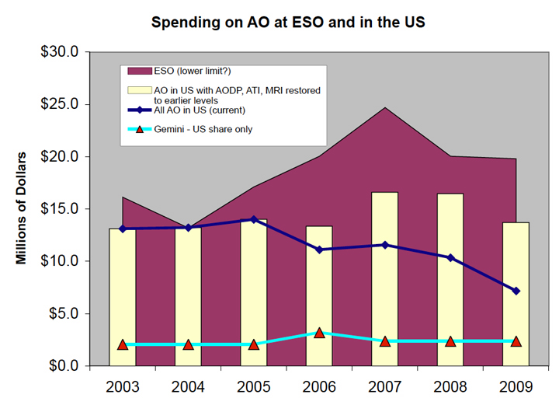

Figure 1. Expenditures and future plans for adaptive optics for ESO and for the US.

Science with the Existing Keck AO Systems
The Keck AO systems, both with and without laser guide star, have been extremely fruitful. Through May 2006 a total of 98 refereed science papers have been accepted for publication based on Keck AO data. The distribution with respect to subfield is as follows: 32% solar system, 52% galactic, and 16% extragalactic as shown in Error: Reference source not found; this total includes nine papers from the Keck Interferometer. A total of 13 LGS science papers have been published or accepted beginning in 2005 (23% solar system, 46% galactic and 31% extragalactic). .

Figure 2 Keck AO science papers by year and type of science.

Table 2 summarizes the TAC-allocated Keck II science nights in Semesters 06A and 06B by three criteria: the science category, the science instrument and the AO mode (NGS or LGS). Although the number of AO nights has increased the percent demand for galactic science nights remains at about 50%. The percentage of solar system versus extragalactic science nights has switched in favor of extragalactic science. The demand for NIRC2 and OSIRIS is roughly equal. The demand for LGS AO mode is very high although a significant number of NGS nights are still requested.
Table 2 TAC-Allocated Keck II Science Nights for Semesters 2006A/B.

 | AO Science Category |  |  | AO Science Instrument |  |  |  | AO Mode
 | Solar System | Galactic | Extra-Galactic | NIRC2 | NIRSPEC | OSIRIS | KI | NGS | LGS
06A (# nights) | 8 | 38.5 | 21 | 34 | 0 | 28.5 | 5 | 23 | 44.5
06B (# nights | 11.5 | 30.5 | 23 | 30 | 4.5 | 25.5 | 5 | 18 | 47
06A+B (%) | 15% | 52% | 33% | 48% | 3% | 41% | 4% | 31% | 69%

Science Case

Introduction

Solar System Science

Galactic Science

The Galactic Center: Black Holes, General Relativity, and Dark Matter
Authors: Nevin Weinberg (UCSB), Andrea Ghez (UCLA), Jessica Lu (UCLA)

Scientific Background
The proximity of our Galaxy's center presents a unique opportunity to study a massive black hole (BH) and its environs at much higher spatial resolution than can be brought to bear on any other galaxy. In the last decade, the orbital motions of several stars around the massive BH at the Galactic center (GC) have been measured in the near-infrared with astrometric precisions of 1 mas, constraining the central mass to be ~4 x 10⁶ M21_{Sun} (Ghez et al. 2003, Ghez et al. 2005; Schodel et al. 2002; Schodel et al. 2003). When combined with radial velocity measurements, the orbits also provide the most accurate measurement of the GC distance R₀, constraining it to within a few percent (Eisenhauer et al. 2003). With the high precision astrometry afforded by Keck NGAO along with radial velocity measurements accurate to ≈ 10 km/s, several new experiments are achievable.

Proposed observations and targets

General relativity
Using the ~100 microarcsecond (μas) astrometric precision attainable with Keck NGAO, we can monitor the orbits with sufficient precision to enable a measurement of post-Newtonian general relativistic effects associated with the BH. These include the prograde precession of orbits and possibly a measurement of the black hole spin. Weinberg et al (2005) have developed analytic expressions for the signal-to-noise ratio (SNR) with which various GC phenomena can be detected, as a function of astrometric precision, number of stars and orbits observed, and orbital eccentricities. As Figure 1 illustrates, the prograde precession can be measured even for single orbits of known stars (e.g., S0-2, K=14.1 mag) if we have an astrometric precision of ~100 μas. Furthermore, precision astrometry has the potential to detect the ``frame-dragging" of orbits due to the BH spin. Such a measurement would provide a fundamental test of GR and help constrain the formation process of the BH. While this is a challenging observation requiring very high precision astrometry (~10 μas; Figure 3), if the SNR is improved by observing multiple high-eccentricity stars over multiple orbits, this effect may be detectable with Keck NGAO.
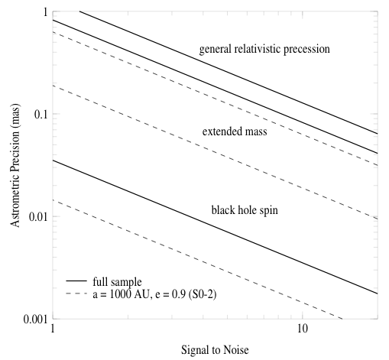
Figure 3 Required astrometric precision for detecting, from top to bottom, GR effects associated with relativistic prograde precession, extended mass within the stellar orbits, and frame-dragging effects due to the spin of the BH (based on Weinberg et al. 2005). The estimates are based on measurements of stellar orbits and positions from diffraction-limited images obtained with Keck (thick, solid lines). These include 16 stars within 0.5” of Sgr A* with orbital fits obtained from speckle imaging measurements and 142 stars within 1” of Sgr A* with stellar positions obtained with new, deep AO maps. For comparison, we also show estimates based on measurements of just the short-period star S0-2 (thin, dashed line). The results are for a 10-year baseline with 10 integrations per year. Low-order GR and extended matter effects are easily detectable (at the >5σ level) with a precision of ~200 μas, while the detection of BH spin requires either better precision or improved SNR from the observation of multiple high-eccentricity, short-period, stars over multiple orbits.

Extended matter
If the extended matter distribution enclosed by the orbits has a mass greater than approximately 1000 M22_{Sun} at 0.01 pc from the BH, it will produce deviations from Keplerian motion detectable with an astrometric precision of ~100 μas (Figure 1). Thus, if the concentration of exotic dark-matter at the Galactic center matches theoretical predictions (Gondolo 1999), its influence on the orbits will be measurable with Keck NGAO. A detection would constitute a measurement of dark matter at the smallest scales yet.

R₀ and the dark matter halo
As shown in Figure 4, the Galactic center distance R₀ will be measured to ~0.1% accuracy with Keck NGAO. By measuring R₀ to within a few parsecs, the Galactic dark matter halo shape can be measured to similarly high precision (Olling et al 2000). The halo shape is a sensitive probe of dark-matter models and structure formation scenarios; currently it is very poorly constrained.

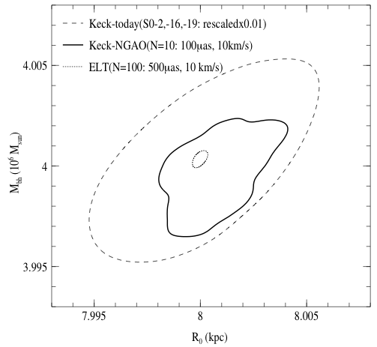
Figure 4 Error contours for BH mass and GC distance estimated for current Keck AO surveys (dashed line, scaled down by 0.01), Keck-NGAO (solid line), and a 30 m extremely large telescope (ELT; dotted line). The Keck-NGAO and ELT numbers in parentheses are the number of stars that are likely observable, and the assumed astrometric and radial velocity errors. The Keck-NGAO will allow BH mass and GC distance estimates with more than two orders of magnitude greater precision than current studies; this improvement will not be greatly surpassed even in the ELT era.

Scattering by stellar-mass BHs
The stellar mass function inside the dynamical sphere of influence of the BH is likely dominated by massive remnants, including stellar-mass black holes, ~20,000 of which are thought to lie within 1 pc of the central BH (Miralda 2000). Perturbations from remnants deflect stellar orbits and change their orbital energy at a rate proportional to the mass of the remnants. The monitoring of stellar proper motions can therefore be used to directly probe the remnants' mass function. Based on the estimates in Weinberg et al. (2005), over a ten-year baseline approximately 10% of all stars monitored with a precision of ~100 μas will undergo detectable encounters with background remnants if the remnants are stellar-mass black holes.

Comparison of NGAO w/ current LGS AO
Current measurements of the central black hole's properties from stellar dynamics are limited by systematic errors that NGAO and ancillary instrumentation can overcome. The astrometric measurements are limited by stellar confusion, which can induce large measurement biases. NGAO would permit the brightest orbiting stars to be limited by photon noise. In the Galactic Center, the brightest star with a known orbit has a K-band magnitude of 14.0 and the confusion limit is 19.0. The proposed NGAO observations would permit the first meaningful measurements or upper limits on the extended mass distribution (see Figure 1) and would improve estimates of R₀ over current estimates by a factor of 100 (see Figure 2). Further improvements could be achieved if higher spectral resolution IFU data could be achieved than is currently possible with OSIRIS (R=4,000). Current measurements are limited by line blending to 20 km/sec. While modest improvements can be achieved from the higher Strehl offered by NGAO, much more significant improvements (possibly a factor of ten as well as a reduction in systematic errors from assumed line ratios of the blended lines) could be achieved with a spectral resolution of 15,000.

AO and instrument requirements
Essential: High contrast near-IR imager with excellent astrometric performance.
Desirable but not absolutely essential: High resolution (R~15000) IFU spectroscopy.

References
Eisenhauer, F., Schodel, R., Genzel, R., Ott, T., Tecza, M., Abuter, R., Eckart, A., & Alexander, T. 2003, ApJL, 597, L121
Ghez, A. M., Salim, S., Hornstein, S. D., Tanner, A., Lu, J. R., Morris, M., Becklin, E. E., & Duchene, G. 2005, ApJ, 620, 744
Ghez, A. M., et al. 2003, ApJL, 586, L127
Gondolo, P., & Silk, J. 1999, Physical Review Letters, 83, 1719
Miralda-Escude, J., & Gould, A. 2000, ApJ, 545, 847
Olling, R. P., & Merrifield, M. R. 2000, MNRAS, 311, 361
Schodel, R., Ott, T., Genzel, R., Eckart, A., Mouawad, N., & Alexander, T. 2003, ApJ, 596, 1015
Schodel, R., et al. 2002, Nature, 419, 694
Weinberg, N. N., Milosavljevic, M., & Ghez, A. M. 2005, ApJ, 622, 878

Next-Generation Debris Disk Science

Authors: Stanimir Metchev (UCLA) and Michael Liu (IfA/Hawaii)

Scientific Background
After dissipation of their primordial planet-forming disks of gas and dust, many stars possess debris disks (e.g. Backman & Paresce 1993; Rieke et al. 2005). The dust in debris disks is continually generated from collisions of larger parent bodies that are otherwise undetectable. These parent bodies are the detritus of the planet formation process, and debris disk systems as a whole represent the extrasolar analogs of the asteroid belt and Kuiper Belt in our own solar system.
Theory predicts that planet growth and disk dissipation are intimately linked (e.g., Lissauer 1993). During the post-T Tauri stages of stellar evolution (~10-100 Myr), simulations show that significant debris can arise from large stochastic collisions (e.g., the Earth-Moon formation event) and/or gravitational stirring by recently formed small (Pluto-sized) rocky planets (Kenyon & Bromley 2004). In addition, dynamical interactions between planets and the remaining dust and planetesimals are expected to perturb the orbits of the smaller bodies and to imprint characteristic signatures on the spatial distribution of circumstellar dust (e.g., Roques et al. 1994; Wyatt et al. 1999; Kuchner & Holman 2003); the high prevalence of ring-like and/or clumpy structures seen in scattered light images of debris disks lends supports to this idea (Figure 1). Thus, there is an intimate connection between debris disks and the larger unseen planetesimals and planets that constitute extrasolar planetary systems.

A small fraction of the brightest (L_{dust}/L_{star} >~ 10⁻⁴), nearest debris disks found by IRAS and ISO have been spatially resolved in scattered light at optical and near-IR wavelengths with HST and/or ground-based natural guide star AO systems. The information gained from these few spatially resolved observations has greatly enhanced our knowledge of the structure of debris disks (e.g., Schneider et al. 1999; Golimowski et al. 2006) and of the physical properties of their constituent dust grains (e.g. Artymowicz 1990; Li & Lunine 2003). The limited data have also posed numerous new questions regarding disk evolution and morphology, such as:
- How do primordial disks transition into debris disks?
- What is the role of planets in this transition?
- How do planets interact with the disks in which they are embedded?
- How significant are stochastic collisions in establishing debris disk properties?
Only about a dozen debris disks have been spatially resolved to date and with limited wavelength coverage --- thus we have only begun to address these central questions. These can be pursued with Keck NGAO through two complementary paths: (1) greatly expanding the resolved census of debris disks and (2) more intensive, multi-wavelength studies of currently resolved systems.
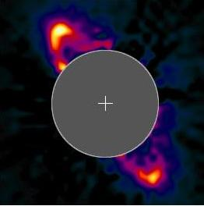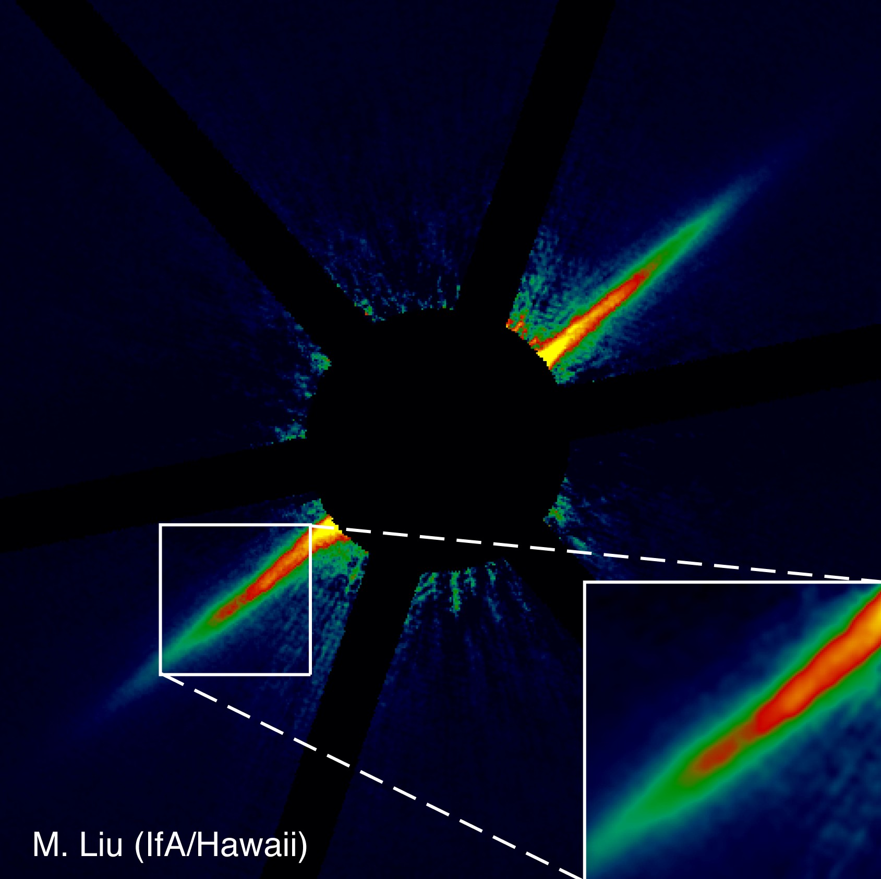
Figure 5 The HR 4796A (Schneider et al 1999) and AU Mic (Liu 2004) debris disks resolved in near-IR scattered light with HST (2.5” across) and Keck natural guide star AO (10” across), respectively. The observed ring-like structures, clumps, and gaps are frequently attributed to perturbations by unseen planetary companions. The Keck image of AU Mic represents the current state-of-the-art for ground-based AO, which is limited to the very brightest, edge-on disks. Keck NGAO will enable a much larger sample of debris disks to be imaged, with the necessary multi-wavelength coverage to study their constituent properties.

Proposed observations and targets

Debris disk demographics
One key path to understanding the properties and evolution of debris disks is to assemble a much larger census of spatially resolved systems, spanning a wide range of the physical parameter space of age, stellar host mass, formation environment, planet content, etc. The most easily detectable signature of circumstellar dust disks around main- sequence stars is the integrated-light thermal emission from optically thin dust at mid-IR and longer wavelengths. New samples of debris disks are presently being furnished through various observing programs conducted with the Spitzer, which offers orders of magnitude improved sensitivity over IRAS and ISO.
While imaging studies of debris disks have been pursued with ground-based AO, the current results are very limited. Keck NGAO will represent a significant new capability for high-contrast imaging of circumstellar dust disks in scattered light. Figure 6 illustrates the expected improvement with simulated deep H-band images from a high Strehl (small FOV) NGAO system, a multi-conjugate NGAO system, and the current Keck natural guide star AO system. The simulation is based on a scattered light model of a massive Kuiper Belt analog around a solar-type star, analogous to conditions that may have existed during the epochs of late planet formation and heavy bombardment in the young (10-300 Myr) solar system (Dominik & Decin 2003; Kenyon & Bromley 2005). The angular scale of the simulations is chosen to correspond to the distance (133 pc) of the 120~Myr old Pleiades open cluster, an ideal population for studying debris disks in the post planet-formation stage.

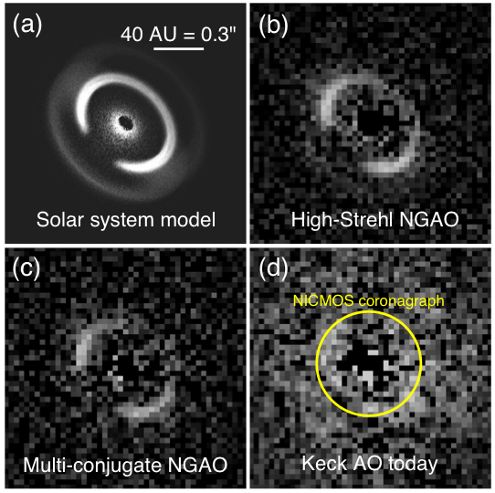
Figure 6 Simulated H-band images of two variants of the Keck NGAO system compared to the present-day Keck AO system, based on a scattered light model of solar-system debris (S. Wolf, private communication) as seen at the distance of the Pleiades cluster (133 pc, 120 Myr). The fractional luminosity of the scattered light is 10^{-3.5} relative to the central star, comparable to mid-IR Spitzer observations of G-type stars in the Pleiades (Stauffer et al 2005). The bright ring in the model corresponds to grains in 1:1 resonance with an outer giant planet (Neptune). The simulated images represent PSF-subtracted 3-hour long integrations taken under median, time-varying seeing conditions at Mauna Kea, with the Fried length r₀ sampled from a log-normal distribution with a mean of 21 cm and a standard deviation of 0.48 dex. The Strehl ratios of the simulated images are 82% (panel b), 47% (panel c), and 28% (panel d). The AO images have been binned to a pixel scale of 31 mas/pix to enhance the signal-to-noise per resolution element and are shown with the same linear grayscale. The size of the smallest coronagraph available on HST is overlaid on panel (d) to illustrate the new phase space that will be opened at <0.3” separations by Keck NGAO.

By virtue of its unprecedented angular resolution and stable PSF, Keck NGAO will extend direct-imaging surveys to distances of >100 pc. This will greatly expand the imaging sample due to the disproportionately large number of young (<100 Myr) stars compared to the immediate solar neighborhood; young stellar associations at 100—200 pc contain thousands of sun-like stars. High angular resolution NGAO surveys will harvest a much larger sample of resolved debris disks, opening the door to comparative studies of debris disk properties (e.g. sizes, substructures, and grain properties) as a function of stellar host mass, age, environment, etc. For example, Spitzer mid-IR data reveal remnant debris around at least 10% of Sun-like stars in the 120 Myr old Pleiades cluster (Stauffer et al. 2005), allowing numerous opportunities to scrutinize the outcomes of planet formation in a coeval, homogenous environment. Such a survey will offer the first comprehensive external view of what the solar system may have looked like at a young age.
In addition to resolving larger numbers of debris disks, Keck NGAO can extend debris disk studies to lower mass stars. Most of present-day debris disk science has concentrated on A-G type stars, because of their larger bolometric luminosities and hence relatively brighter debris disks. However, very little is known about debris disks around M dwarfs, as only a handful of examples have been identified. Past IRAS and ISO searches for debris disks have largely neglected and/or overlooked low-mass stars, due to sensitivity limitations and choice of science focus. The greater far-IR sensitivity of Spitzer will enable more debris disks around late-type stars to be discovered. These will be prime targets for future investigations in scattered light with the Keck NGAO system, as their primary stars will be too faint for high contrast natural guide star AO. The scientific potential of the M dwarfs is demonstrated by the young star AU Mic, the first identified M dwarf debris disk system (Liu et al 2004; Kalas, Liu & Matthews 2004). Adaptive optics near-IR and HST optical imaging achieves a spatial resolution of 0.4~AU (Liu 2004; Krist et al. 2005a; Metchev et al. 2005) and reveals a rich variety of substructure, suggestive of planetary companions.
Disks around substellar objects are also potential science targets for high-contrast, high-angular resolution imaging. Indeed, ground-based and space-based IR photometric studies have already identified many, optically thick disks around young brown dwarfs in the nearest (~150 pc) star-forming regions (e.g. Liu et al 2003; Luhman et al. 2005). Spatially resolved imaging of their disks, which is expected to be within the resolving power of the Keck NGAO system in the visible, will open a window into studying the properties and evolution of circum-sub-stellar disks.

Evolution of low-mass planets and planetesimals
Intensive study of the most observable (nearest and brightest) systems is an important means to advance our understanding of debris disks. Spatially resolved high-contrast, multi-wavelength imaging offers a unique opportunity to study their circumstellar material and their embedded low-mass planets.

High resolution Keck NGAO optical imaging will be a powerful diagnostic tool. Scattered light imaging studies are best performed at shorter wavelengths, where the lower sky brightness and favorable scattering properties of sub-micron dust grains allows optimal imaging contrast between the parent star and the circumstellar dust. However, previous ground-based AO observations of debris disks have mostly focused on H-band observations, a necessary compromise since current AO performance at shorter wavelengths is poor. Keck NGAO will overcome this limitation, enabling near diffraction-limited imaging in the optical (~0.015”) with modest Strehl ratios, providing the very highest possible angular resolution.
NGAO optical imaging will be a powerful means to identify and diagnose the substructure in debris disks. This new capability can reveal dynamical signatures (rings, gaps) in disks due to embedded planets out to three times greater distances than previous studies. Similarly, it will allow scrutiny over smaller physical scales around nearby systems. The majority of resolved debris disks to date show substructure down to the limit of detectability, suggesting that even higher angular resolution imaging will be fruitful. Such embedded low-mass planets (~Neptune) have too large orbital separations to be detectable by radial velocity surveys and are too faint to be directly imaged. Hence, observation and theoretical modeling of disk substructure is a unique probe of the outer regions of other solar systems.

An additional benefit of visible AO imaging studies arises from the relation between the scattering properties of grains and their size. Grain scattering efficiency peaks for incoming radiation of wavelength λ ∼ 2πa, where a is the grain diameter. By extending the capabilities of the Keck NGAO to wavelengths as short as 0.6 μm, we would gain sensitivity to circumstellar grains as small as 0.1 μm. Such small grains are common in primordial circumstellar disks and may dominate the outskirts of the debris disk around late-type stars, where they are blown on highly eccentric orbits by stellar radiation pressure (e.g. Augereau et al. 2001, 2006; Strubbe & Chiang 2006). Visible-wavelength AO capability on Keck will thus be an important asset for measuring the outer radii of these extrasolar Kuiper Belt analogs, an elusive parameter that is often difficult to constrain from long wavelength far-IR/mm unresolved observations.
Finally, Keck NGAO near-IR data will provide an excellent match in angular resolution and contrast with HST optical, enabling high precision multi-wavelength color measurements. Such data are sensitive to the grain size distribution, porosity and composition; spatially resolved maps will allow for comparative studies of the properties of circumstellar material in different systems. Sub-mm resolved imaging from ALMA of the brightest systems traces the dust emission properties, providing complementary information to scattered light data. The value of such studies resides not just in ascertaining the properties of the dust grains. Such measurements are needed to ascertain the physical effects acting on the grains, which depend on the grain sizes, and thus are crucial in attempting to understand the linkage between disk substructure and embedded low-mass planets.

Comparison of NGAO w/ current LGS AO
Current debris disk studies with natural guide star AO are limited to only the brightest, edge-on disks, and current LGS AO does not have sufficient Strehl or PSF stability. Keck NGAO will provide a precise, stable PSF for high contrast imaging in the near-IR, suitable for detecting fainter, smaller and or non-edge-on systems. Keck NGAO will also add diffraction-limited imaging in the optical, a novel and powerful capability.

AO and instrument requirements
Essential: Near-IR and optical imagers.
Desirable but not absolutely essential: Polarimetry, PSF reconstruction from AO telemetry, near-IR detector with substantially lower read noise and/or more dynamic range than NIRC2.

References
Artymowicz et al. 1990, Advances in Space Research, 10, 81
Backman, D. E., & Paresce, F. 1993, in Protostars and Planets III, 1253--1304
Beichman, C. A., et al. 2005, ApJ, 622, 1160
Decin, G. et al. 2003, ApJ, 598, 636
Dominik, C. & Decin, G. 2003, ApJ, 598, 626
Els, S. G. et al. 2001, A&A, 370, L1
Kalas, P., Liu, M. C., & Matthews, B. C. 2004, Science, 303, 1990
Kenyon, S. J. & Bromley, B. C. 2005, AJ, 130, 269
Kim, J. S., et al. 2005, ApJ, 632, 659
Krist, J. E. et al. 2005, AJ, 129, 1008
Li, A. & Lunine, J. I. 2003, ApJ, 590, 368
Liou, J. & Zook, H. A. 1999, AJ, 118, 580
Lissauer, J. J. 1993, ARAA, 31, 129
Liu, M. C. 2004, Science, 305, 1442
Liu, M. C. et al. 2004, ApJ, 608, 528
Luhman, K. L., et al. 2005, ApJL, 631, L69
Metchev, S. A., et al. 2005, ApJ, 622, 451
Plavchan, P., Jura, M., & Lipscy, S.~J. 2005, ApJ, 631, 1161
Plets, H. & Vynckier, C. 1999, A&A, 343, 496
Roques, F. et al. 1994, Icarus, 108, 37
Schneider, G., et al. 1999, ApJL, 513, L127
Stauffer, J. R., et al. 2005, AJ, 130, 1834
Wyatt et al. 1999, ApJ, 527, 918

Imaging and Characterization of Extrasolar Planets
Authors: Michael Liu (IfA/Hawaii), Bruce Macintosh (IGPP/LLNL)

Scientific Background
The last decade has witnessed a revolution in astronomy with the discovery and characterization of substellar objects, brown dwarfs and extrasolar planets. The next 10 years promise to be even more rewarding. Observational capabilities are now on the horizon for direct detection of these objects and hence for determining the diversity of planetary systems around other stars.
The Keck Telescope has played a major role in these discoveries, primarily through radial velocity surveys. While these studies have been very successful at finding extrasolar planets, such discoveries are inherently limited since they measure only the orbital properties and lower limits on the masses. Direct imaging would allow us to measure colors, luminosities and spectra, thereby probing temperatures and compositions. At relatively young ages (<~1 Gyr), Jupiter-mass planets continue to radiate their internal heat at near-IR wavelengths far above their expected blackbody emission, and thus are amenable to direct imaging.
By virtue of its unparalleled 10-meter primary mirror, Keck adaptive optics imaging can produce the highest angular resolution images of any telescope in existence. The next generation of discoveries require with AO systems that produce much higher contrast (the ability to detect faint objects next to bright ones), greater PSF stability, and broader wavelength coverage. Both the Gemini and VLT observatories are developing ``extreme AO systems'' (ExAO) to achieve very high contrast images for direct imaging of planets around nearby, young solar-type stars. While very powerful, such systems are by their nature restricted to bright stars (I <~ 8-9 mags) and thus address only a portion of the physical parameter space.

Proposed observations and targets

Planets around low-mass stars and brown dwarfs
Direct imaging of substellar companions (brown dwarfs and extrasolar planets) is substantially easier around lower mass primaries, since the required contrast ratios are smaller for a given companion mass. Indeed, the first bona fide L dwarf and T dwarfs were discovered as companions to low-mass stars (Becklin & Zuckerman 1988, Nakajima et al 1995). Thus, searching for low-mass stars and brown dwarfs is an appealing avenue for planet detection and characterization. Given that low-mass stars are so much more abundant than higher mass stars, they might constitute the most common hosts of planetary systems.
Keck NGAO will be a significant advance from previous imaging surveys, reaching much lower companion masses and correspondingly much cooler temperatures. These targets are optically faint, and thus unobservable with current or future NGS/ExAO systems. Current single-LGS systems are only able to reach modest contrast ratios at K-band. Direct detection is more favorable at J and H-bands, where planetary mass companions are brighter and higher angular resolution can be achieved; good performance at these wavelengths is only possible with Keck NGAO.

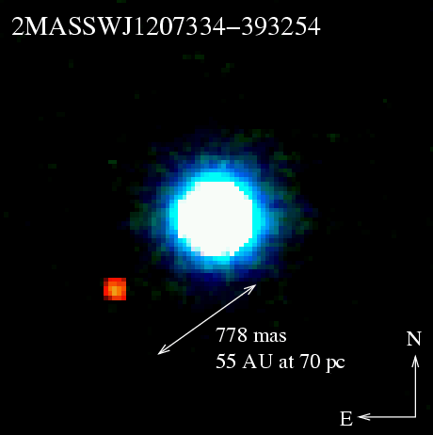
Figure 7 JHK color image of the 2MASS 1207-3932 system, as observed with the VLT NGS system equipped with a near-IR wavefront sensor (Chauvin et al 2005). The primary is a young brown dwarf, with an estimated age of ~12 Myr and ~25 MJup. The companion has an estimated mass of only ~5 M_{Jup}. Only a small number of brown dwarfs can be imaged with sufficient sensitivity and angular resolution with current LGS AO to detect Jovian-mass companions. Keck NGAO will be a major advance for detection and characterization of planets around low-mass stars and brown dwarfs.

One very low-mass companion, 2MASS 1207-39B, has recently been directly imaged around a young (~10 Myr) field brown dwarf (~25 M_{Jup}), with an estimated mass of ~5 M_{Jup} and a projected separation of 60 AU (Chauvin et al 2005). The incidence of similar systems is unknown; given that 2M1207~B was found in a search of only two objects, it is promising that many more wide, planetary companions to brown dwarfs. Discovery of Jovian-mass companions around brown dwarfs would be difficult to explain in conventional theories where planets form in circumstellar disk. While disks around common around young brown dwarfs (e.g., Liu et al 2003), they are unlikely to be massive enough to form such companions (Klein et al 2003). But regardless of their origin, such planetary-mass companions would constitute relatively easily observed systems for studying the spectral characteristics of planetary atmospheres.
Spectroscopic follow-up of the coldest companions will be an important path in characterizing the atmospheres of objects in the planetary domain. Strong molecular absorption features from water and methane provide diagnostics of temperature and surface gravity at modest (R~100) resolution. Below ~500 K, water clouds are expected to form and may mark the onset of a new spectral class, a.k.a. ``Y dwarfs''. Such objects represent the missing link between the known T dwarfs and Jupiter, but are probably too faint and rare to be detected as free-floating objects in shallow all-sky surveys such as 2MASS and SDSS. Furthermore, the coolest/lowest mass objects may not exist as free-floating objects if there is a low-mass cutoff to the initial mass function of the star formation process, e.g., from opacity-limited fragmentation of molecular clouds (M_{min} ~ 5-10 M_{Jup}; Silk 1977). Even cooler/lower mass objects might only form via fragmentation, akin to the formation of binary stars, and only be found as companions.
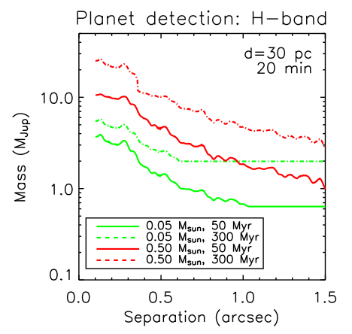
Figure 8 Planet detection sensitivity for Keck NGAO for two different primary masses and ages, based on models by Baraffe et al. (1998, 2003) and high contrast simulations described in section 4.3.3.8. NGAO will be able to search for Jovian-mass companions around large numbers of low-mass stars and brown dwarfs. (Most of the detection limits are contrast-limited, but the outer floor seen in the curves is set by the raw sensitivity of the system. The primary is assumed to be at 30 pc with an on-source integration time of 20 minutes.)

Very young planets in the nearest star-forming regions
Revealing the earliest stages of planet formation, the first few Myr, is a significant observational challenge. The nearest star-forming regions are >~125 pc away, and thus high angular resolution imaging is needed. In addition, young stars and brown dwarfs can be enshrouded by substantial dust extinction, both from the natal molecular cloud and their own circumstellar material. Thus most young (T Tauri) stars are too optically faint for current NGS AO systems or future ExAO systems.
Imaging searches and characterization at the very youngest (T Tauri) stages provide a unique probe of the origin of extrasolar planets, by constraining their formation timescales and orbital separations. Keck NGAO imaging can probe physical separations of >~5-10 AU around these stars. Multiple methods exist for studying disk evolution at such young ages --- direct imaging of massive outer planets around T Tauri stars can help to understand the co-evolution of young planets and their natal disks.
Most current models indicate that circumstellar disks are not massive or dense enough to form Jovian-mass planets farther than 10-20 AU. However, brown dwarf companions (~15-70 M_{Jup}) have been found at >~100 AU around young stars (e.g., TWA-5B; Lowrance et al. 1999), indicating that substellar companions can exist at larger separations than expected in conventional wisdom. And even if the models are correct, angular momentum exchange between giant planets can induce orbital migration, potentially sending some Jupiters spirally inward and propelling others to much larger separations. Likewise, the early luminosity evolution of giant planets as they are forming is highly uncertain (e.g., Fortney et al. 2005), and direct imaging searches with Keck NGAO can provide insight.
It is still an open question whether giant planets form extremely rapidly (<~10⁴ yr) due to disk instabilities (e.g. Boss 1998) or if they first assemble as ~10 M_{earth} rocky cores and then accrete ~300 M_{earth} of gaseous material over a total timescale of ~1-10 Myr (e.g. Lissauer 1999). Potentially both mechanisms may be relevant, depending on the range of orbital separations and circumstellar disk masses. In addition, imaging searches of both young T Tauri stars with disks (classical TTS) and without disks (weak TTS) can help to constrain the formation timescale. In particular, weak T Tauri stars with planetary companions would suggest that planet formation could occur even when disk evolution/dissipation happens rapidly.

Comparison of NGAO w/ current LGS AO
Current LGS AO can detect Jovian-mass planets only around the youngest (<~30 Myr) low-mass stars and brown dwarfs, which are quite rare in the solar neighborhood. Keck NGAO will be able to achieve sufficient contrast for planet detection around primaries as old as ~500 Myr, and thus a much larger sample can be surveyed. For T Tauri star searches, by their very nature, these objects are in highly extinction regions, where optical tiptilt star availability is poor.
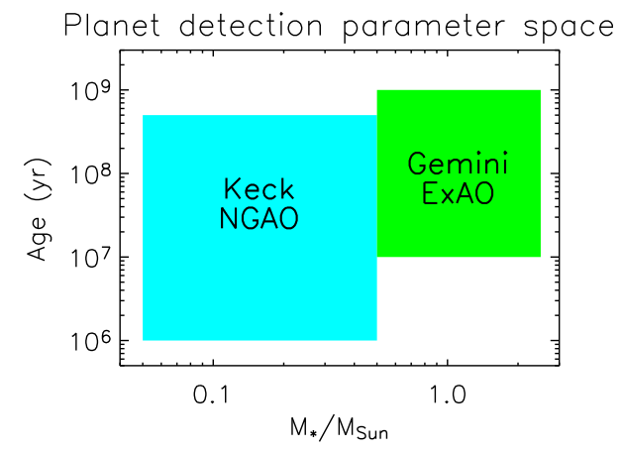
Figure 9 Schematic comparison of the relative parameter space for direct imaging of planets probed by Keck NGAO and ExAO systems in development by Gemini and VLT. The optical faintness of low-mass stars, brown dwarfs, and the youngest stars makes them inaccessible to ExAO systems, but hundreds of these objects can be imaged with Keck NGAO.

AO and instrument requirements
Essential: High contrast near-IR imager with coronagraph, along with means to obtain follow-up low-resolution (R~100) spectroscopy.
Desirable but not absolutely essential: Thermal IR (L-band) photometry and spectroscopy.

Diffraction-Limited Imaging of Protostellar Envelopes and Outflows
Authors: Tom Greene (NASA/Ames), Lynne Hillenbrand (Caltech)

Scientific Background
The accepted scenario for low mass star formation starts with the gravitational collapse of a dense core within an opaque molecular cloud. As collapse proceeds, the core flattens along its rotational axis and forms a central protostar, a circumstellar disk, and an infalling envelope (e.g., Terebey et al. 1984; Shu et al. 1987, 1993), all on timescales of less than a few hundred thousand years. The subsequent evolution of the circumstellar material – from initial formation of the protostar through to a bona fide pre-main-sequence star surrounding by an optically thin, post-planet building, disk – is associated with concomitant evolution in the spectral energy distribution (SED). SEDs peak first at far infrared and sub-millimeter wavelengths and later at shorter near-infrared wavelengths, as the system moves from dominance by cold dust to warmer dust (Lada 1987; Adams et al. 1987; Andre et al. 1993).
Establishing this SED evolutionary scenario has greatly advanced the understanding of low mass star formation, but major puzzles remain unsolved. In particular, there is much conflicting evidence in three areas:
- the geometry of circumstellar material, especially in the early ``Class I' phase;
- the accretion mechanism and resulting properties of the central stars themselves, again, especially in the early ``Class I" phase;
- the origin and nature of material that is outflowing in jets and winds.
Seeing-limited images at I-band (Eisner et al. 2005) and in the near-IR (Tamura et al. 1991; Whitney et al. 1997) have shown that Class I systems in the nearby (d = 140 pc) Taurus-Auriga dark clouds have large, extended circumstellar envelopes which are resolved in scattered light (Figure 10). Model fits to the imaging data along with the spectral energy distributions for these objects indicate that they are surrounded by both massive disks and envelopes, with envelope matter infalling at high rates. Recent optical (White & Hillenbrand 2004) and near-IR (Doppmann et al. 2005) high resolution spectroscopic studies have confirmed that the central stars of some Class I objects appear to be accreting matter from the disk onto the star at the high rates expected from infalling envelope material, but many others are not, suggesting that disks may have widely varying (and perhaps episodic) accretion rates.
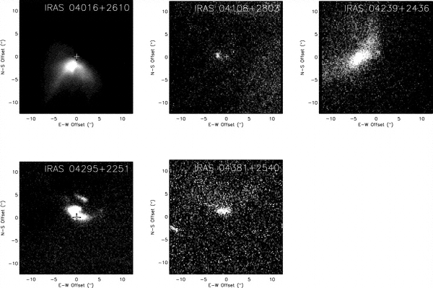
Figure 10 Seeing-limited (0.5-0.6”) I-band (0.8 m) images of protostars in Taurus-Auriga, showing the resolved scattered light structure from the circumstellar environment (from Eisner et al 2005). Each image is 30” on a side, with the “+” symbol indicating the centroid of the mm-continuum dust emission.

Proposed observations and targets
Diffraction-limited AO imaging with Keck would help greatly in resolving the protostellar/circumstellar environment and its connection to the early evolution of the young stars themselves. Existing model fits are not well constrained (Eisner et al. 2005), hampered by seeing-limited spatial resolution and limited wavelength coverage. In particular, multi-color high resolution AO observations from visible-to-near-IR wavelengths would help separate the effects of grain properties (size, composition) from those of the envelope density distributions. Resolved optical and near-infrared imaging from Keck NGAO can be combined with integrated-light SEDs and resolved sub-mm/mm interferometric imaging (e.g. from CARMA and ALMA) to constrain better the physical properties of the circumstellar environment such as the viewing inclination, disk mass, outer size, mass accretion rate, and disk scale height (Figure XX).
The ability to make AO assisted polarization measurements would further improve the uniqueness of model fits (Whitney et al. 1997), providing more certainty to the nature of these objects. Furthermore, mid-IR AO spectroscopy would trace the spatial distribution of grain properties in the disk and enable a new level of geometric modeling. Finally, high dispersion AO spectroscopy would enable study of both infalling and outflowing material at these early stages. In particular, the kinematics of the outflows are relatively unprobed, but observable with Keck NGAO at the spatial scales necessary to separate continuum from various line emission regions, e.g. H2 and [FeII] in the near-infrared or [SII] and [OI] in the optical.
More importantly, stable diffraction-limited images would extend studies from the handful of Class I objects in Taurus-Auriga that have been studied thus far to many more in the more distant ρ Oph, Serpens, and Perseus (140 - 330 pc) regions as well as the even further regions which are undergoing high mass star formation. This would allow some of the first direct measurements of the circumstellar envelopes of high mass protostars, and model fits would provide unique insights into their matter distribution and accretion properties. This would result in detailed statistical study of the similarities and differences in the formation of high and low mass stars and their circumstellar systems. In Orion alone there are at least 20 objects with Class I (protostar) SEDs and associated nebulosity. Many of the objects beyond the Taurus-Auriga region are in high extinction clouds where few stars are visible in the optical, so an IR tip-tilt sensor will be required.

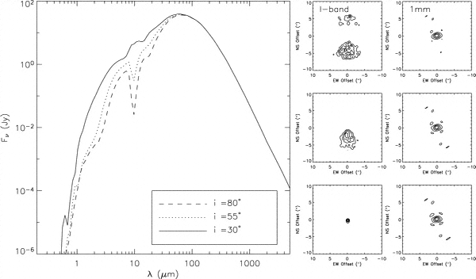
Figure 11 Integrated-light SEDs, I-band scattered light images, and millimeter continuum images for a flared disk model at a range of viewing angles (i increases from the bottom to top panels). More edge-on models exhibit deeper absorption at mid-IR wavelengths and higher extinction of the central star. For small inclinations (i ~ 30), the central star is visible and dominates the I-band emission. For moderate inclinations an asymmetric scattered light structure is observed, while for nearly edge-on orientations a symmetric, double-lobed structure is observed (from Eisner et al 2005).

Comparison of NGAO w/ current LGS AO
Diffraction-limited studies of protostars are very challenging for current LGS AO. Imaging of such complex morphologies requires a stable and/or well-known PSF to be able to distinguish circumstellar structure from imaging artifacts and for quantitative modeling of imaging data. High-resolution multi-wavelength imaging is critical to probe the circumstellar grain properties; this is likewise not possible with current LGS AO.
By their very nature, these objects are in high extinction regions, where optical tiptilt star availability is poor. In addition, while some of the sources themselves are optically visible, their extended morphologies are not well suited for tip-tilt sensing. Near-IR tiptilt sensing is required, not available with current LGS AO.

AO and instrument requirements
Essential: Diffraction-limited optical and near-IR imager. The small field of view of current OSIRIS is not well suited for this program,
Desirable but not absolutely essential: Imaging polarimetry, near-IR echelle spectroscopy, mid-IR spectroscopy.

References
Adams, F. C., Lada, C. J., & Shu, F. H. 1987, ApJ, 312, 788
André, P., Ward-Thompson, D., & Barsony, N. 1993, ApJ, 406, 122
Doppmann, G. W., Greene, T. P., Covey, K. R., Lada, C. J. 2005, AJ, 130, 1145
Eisner, J. A., Hillenbrand, L. A., Carpenter, J. M., & Wolf, S. 2005, ApJ, 635, 396
Lada, C. J.. 1987, IAU Symp. 115: Star Forming Regions, 115, 1
Shu, F. H., Adams, F. C., & Lizano, S. 1987, Ann Rev Astron & Astrophys, 25, 23
Shu, F. H., Najita, J., Galli, D., Ostriker, E., & Lizano, S. 1993, in Protostars and Planets III, 3
Tamura, M., Gatley, I., Waller, W., & Werner, M. W. 1991, ApJL, 374, L25
Terebey, S., Shu, F. H., & Cassen, P. 1984, ApJ, 286, 529
White, R. J., & Hillenbrand, L. A. 2004, ApJ, 616, 998
Whitney, B. A. Kenyon, S. J., Gomez, M. 1997, ApJ, 485, 703

Extragalactic Science

Introduction
Claire still has to write this

High-Redshift Galaxies

Dissection of Distant Galaxy Mergers
Contributors: Mark Ammons (UCSC), Don Gavel (UCSC), Patrik Jonsson (UCSC), David Koo (UCSC), James Larkin (UCLA), David Law (Caltech), Claire Max (UCSC), Greg Novak (UCSC), Chuck Steidel (Caltech)

Scientific Background
While cosmologists, both theoretical and observational, have made enormous strides in the last decade, three profound mysteries are likely to dominate the extragalactic field for years to come in the era being considered for NGAO: the nature of dark energy, the nature and role of dark matter, and how the Universe transformed its baryons into the incredible diversity of galaxies found today. This diversity reflects the complex mix in space, time, and motions/energy of basic galaxy constituents: gas, stars, dust, and black holes. These are usually categorized into physically related subcomponents of galaxies: gaseous and stellar halos, bulges, disks, AGNs, bars, spiral arms, rings, etc., each with their own but intertwined star formation histories, dynamics, and chemical abundances.

Within the suite of physical processes that govern the formation of galaxies and their subcomponents, hierarchical merging remains a fundamental paradigm within the LCDM model, the leading cosmology to explain the assemblage of galaxies, groups, and clusters. Moreover, mergers and galaxy interactions are believed to play a key role in the formation of luminous infrared galaxies and other starbursts; in the balance of early to late type galaxies through the formation of ellipticals/ spheroids/ bulges and the destruction or thickening of disks; the triggering of AGNs and feeding of their supermassive black holes; and the initiation of high energy input via starbursts and AGN that result in blowing gas into the IGM, heating of existing gas, and thus perhaps quenching of future star formation. In the context of environment playing a role in galaxy evolution, mergers represent perhaps the most violent and rapidly changing conditions experienced by galaxies.
Finally, mergers are important in providing unique laboratories to study and understand many of the key physical processes believed to play a role in galaxy formation: time evolution in gas exhaustion, gas compression, activation of AGN, intense star formation, outflow and inflow of gas, ordered cold gas in disks and turbulent gas; violent and rapid changes in the distribution and interactions among dark matter, gas, and stars; generation, destruction, and distribution of dust; secular evolution of bulges by disk instabilities and bars; etc.
Despite the broad impact and importance of mergers in our understanding of many astrophysical problems, detailed theoretical studies of mergers have yet to be achieved due to the computational challenges of handling huge dynamic range in densities of gas and stars, radiative processes, energies, etc. Moreover, the theoretical studies will remain complex and very rich, due to as yet unknown dependence of final observable properties on impact velocities of the colliding systems, ratio of hot vs cold gas (halo vs disk gas), ratio of hot vs cold stars (B/D), relative angles of angular momentum vectors of the colliding components, etc.
Observational tests of mergers will clearly be a major challenge as well. Intensive observations of large samples of mergers in the NGAO era 5 to 10 years downstream will be timely, for theoretical simulations (ref.??) have already achieved a high level of maturity (i.e., reaching AO relevant scales of 0.3 kpc and with full radiative transfer and inclusion of dust and kinematics in generating observables) and will continue to improve over the next decade, providing unique opportunities for observers and theorists to work synergistically in pushing for advances in both areas. Moreover, NGAO observations with Keck will serve as a natural transition to other dramatic improvements in relevant observations on several different fronts as ALMA, JWST, & LGS AO IFU on ELT become reality.
Thumbnails will show enlargements of selected galaxies, comparing NGAO with current LGS AO performance
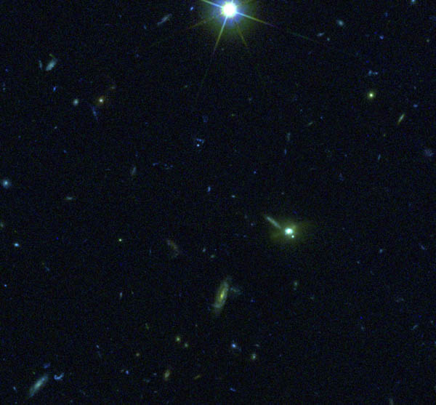
Figure 3 40” x 40” section of the GOODS South field, showing the large numbers of distant galaxies; the incredible diversity of galaxies in colors, shapes, and subcomponents; merging galaxies; and the small sizes of galaxy components. There is enormous potential for AO follow-up studies of regions with deep existing HST data. To date, very deep panchromatic survey regions with HST imaging have covered about 8,000 square arc min of sky. Thus 1000’s of galaxies imaged also with Chandra, Spitzer, and the VLA will assure the science potential of NGAO on Keck.

High level objectives and goals
While nearby mergers are already being studied in detail and across a broad spectral range with the current generation of telescopes and instruments, far more challenging will be the proposed program of undertaking detailed NGAO studies of distant mergers. Yet such studies are critical if we are to understand the role of mergers in three of the observationally discovered global evolutionary changes since redshifts of z~2: the rapid decline of co-moving star formation rate and LIRGs; the parallel drop in AGN activity; and the transformation of Lyman Break Galaxies with irregular and peculiar morphologies to the symmetrical and regular Hubble forms seen today.
How does AO help?
AO with the 10 m Keck provides a spatial resolution in the near infrared (1.2um to 2um) that is nearly ideal to study galaxy subcomponents on the scale of ~0.4 to 1 kpc at high redshifts z > 0.5 (0.05 to 0.1 arcsec). While HST with its 2.4 m diameter mirror can probe to these resolutions in the optical, at high redshifts, the observed optical is viewing the restframe ultraviolet while the Keck AO in the NIR is observing the restframe optical to near-infrared. Such high resolution NIR imaging provides a better probe of older stellar populations, adds complementary data to HST images by widening the spectral range to study stellar populations at the same spatial resolution – i.e. same galaxy subcomponents, and is far less affected by dust extinction. Moreover, spectroscopy in the NIR provides access to strong and highly probative emission lines of Hα, NII, OIII, Hβ, and OII for highly redshifted galaxies. These lines at high spatial and spectral resolutions provide direct and powerful measures of star formation rates; AGN activity; gas ionization, density, shocks, and metallicity; dust extinction; and kinematics that yield dynamical masses, gas outflows, and direct signatures of the strength of mergers and interactions.
How would NGAO help?
The higher sensitivity/speed of NGAO and especially the multiplexing advantage of multiple IFU will allow a total gain of 10-100x in total throughput. This gain is essential for the study of distant mergers where the complexity of the problem requires large samples of many 100’s of targets, the faintness of the targets requires long exposures, and the relatively low surface density of the best targets benefits from wider FOV. Also of high importance in taking advantage of existing very deep complementary data from HST, Spitzer, Chandra, and eventually JWST and ALMA, will be access to the maximum sky coverage through NGAO use of AO corrected TT stars, since only a few very special regions of the sky (GOODS, EGS, GEMS, COSMOS) are likely to have the full suite of such data over the next decade or so.
A detailed and yet comprehensive study of distant mergers will require samples of many 100’s to even 1000’s due to the large number of relevant parameters with which to divide into subsamples. Obvious parameters include redshifts (e.g., 3 for each of the JHK windows through which Ha-NII can be observed; using OII in H and K adds another 2), 4 levels of AGN activity (off, weak, medium, high), perhaps 4 similar levels of associated SF activity, 5 stages of mergers (large separation before first pass, first encounter, post first pass, second encounter at medium separation, encounters at very close separation), 3 mass ratios (major mergers of less than 1:3; minor mergers of less than 1:10; and control sample of isolated galaxies), etc.
LGS AO NIR spectroscopy of these distant mergers will be very challenging on Keck, with typical exposures of several hours per NIR window. Without NGAO, even a modest program of 25 z~2 systems may take 10hs/filter including weather x3 filters x25 targets /8 hours per night or nearly 100 LGS AO nights. If even 10 nights of a total of 50 LGS AO nights per semester are devoted to this program, it would not be completed for another 5 years using the current system. With NGAO, this subprogram alone would take perhaps a total of 5 nights. Finishing a complete program with say 100 z~1, 100 z~1.5, and 100 z~2 targets, requiring access to 1, 2, and 3 windows, and exposures of 1, 2, and 4 hours, respectively, with the more sensitive NGAO system, means a total of 1700 hours on target or say 2400 hours with bad weather. With one IFU, this would then take 2400/8 or 300 nights. If we have an MOAO system with just 10 IFUs, this massive program would take only 30 nights!
The target density can be estimated from the observed redshift distributions of z > 1.7 galaxies observed by Steidel et al and from redshift surveys of lower redshift galaxies by DEEP2 and other surveys. To R~25mag, a conservative estimate of galaxies with z> 0.8 would be about 20/sqarcmin. Among these, more than half have redshifts that will allow key emission lines to lie within the NIR windows and between strong OH lines (assuming a spectral resolution of ~4000). Thus we can expect an average target density of more than 10/square arc min, i.e. a total of potentially 80,000 targets in the 8000 square arc min in the best studied fields, with over 40 viable targets within a 2’x2’ FOV of the proposed MOAO system. Thus a 10 IFU system would have plenty of high redshift galaxy targets to choose from. As for the number of mergers and interacting galaxies, the number density will be lower, but the fraction may still be quite large (e.g., Conselice 200X estimates that more than half the galaxies at redshifts z > 1 appear to have morphological structures suggestive of mergers and interactions.) The main point is that the sky has enough targets to take advantage of a 5 to 10 IFU MOAO system.
Moreover, an adjustable LGS MOAO system provides enormous flexibility in choice of wavelengths of filters per target, exposures per target, optimization of use of different atmospheric conditions, etc.
How do ground-based optical-infrared observations complement space-based observations and information from other wavelengths?

The diffraction limited spatial resolution with the Keck 10 m in the NIR is almost identical to that achieved by HST in the optical, so the complementarity is ideal in probing to the same spatial scales and thus same subcomponents. The Keck observations provide photometry, allowing wider spectral range for dust, AGN, and stellar population studies, and NIR spectroscopy, allowing improved diagnostics for star formation rates, metallicity, ionization, AGN, and kinematics. This complementarity applies to almost any sample of high redshift galaxies. Even with JWST with a 6-m mirror, the Keck resolution will be superior.
While JWST is still alive after the most recent NASA cutbacks, its viability is never assured, given the high risk for damage or unsuccessful launch in any space mission. If JWST does not become reality or until JWST becomes reality, any period after HST is no longer in operation will be one in which AO will provide almost the only high spatial resolution imaging and spectroscopy.
ALMA is expected to reach some level of scientific operation by the era of NGAO. With spatial resolutions of 0.01 to 0.1 arcsec, ALMA will provide complementary data on molecular gas and dust content, spatial distributions, and kinematics to the gas emission line information from the proposed NGAO program. Such molecular clouds will likely be included in the more advanced theoretical simulations and thus provide additional constraints for our understanding of mergers and their associated physical processes.

Proposed observations and targets
As discussed above, a major legacy program would be detailed study of mergers and interacting galaxies during the epoch of high star formation, of high AGN activity, and of rapid morphological transformation.
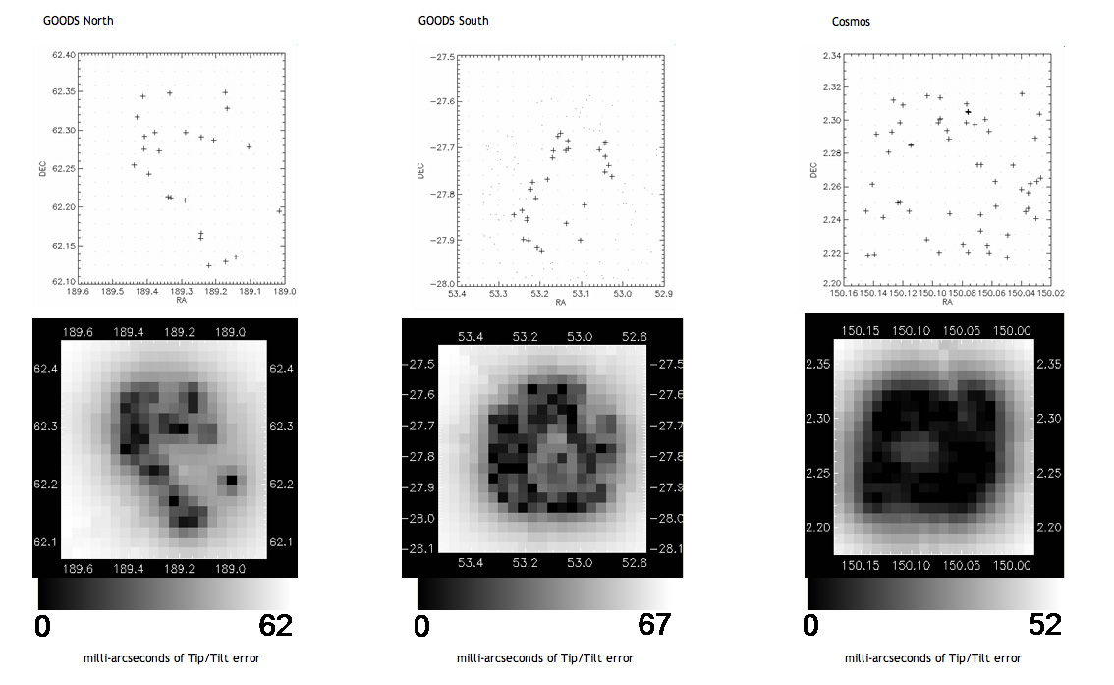

Figure 4 Map of tip-tilt blurring, in mas, in the GOODS-North, GOODS-South, and part of the COSMOS deep fields. With the possible exception of GOODS-North, a large fraction of these three deep fields is accessible to tomographic observations with NGAO, with less than 25 mas of tip-tilt blurring.

Comparison of NGAO with current LGS AO
Figure 5: will show SAURON like maps of SFR, O/H, kinematics, dust extinction, SF age or history

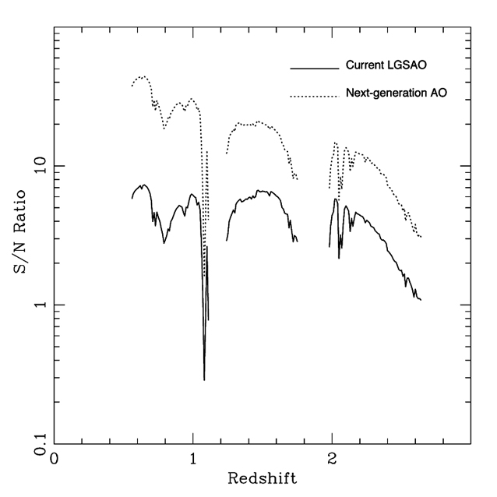

Figure 6: Signal to noise ratio for an OSIRIS-like integral field unit with NGAO (upper curve), compared with today’s OSIRIS with LGS AO. Over the redshift range 0.6 – 1.7, NGAO shows a factor of 3 improvement in signal to noise ratio. For redshifts of 2 or greater the gain in signal to noise is a factor of two.

NGAO will yield a signal to noise ratio that is 2 - 3 times higher for the same exposure times within a given IFU, yielding an exposure gain of roughly 10x. Adding multiple IFUs in the system will multiply the efficiency by the same factor. Thus even a 5 IFU MOAO system will yield a potential total gain of 50x in completion rate for survey-level programs over the current LGS AO OSIRIS IFU system. This is a genuine leap forward in the potential of AO systems to do deep spectroscopic surveys of the distant universe.

Figure 7. Top: images of the z=2-2.6 galaxy BX1332 with OSIRIS. Bottom: recovered velocity fields.

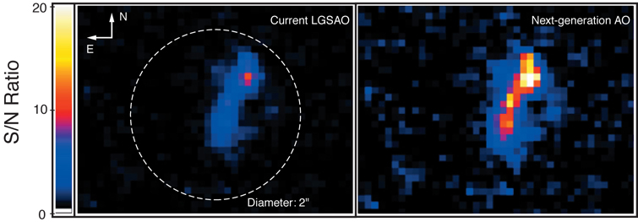
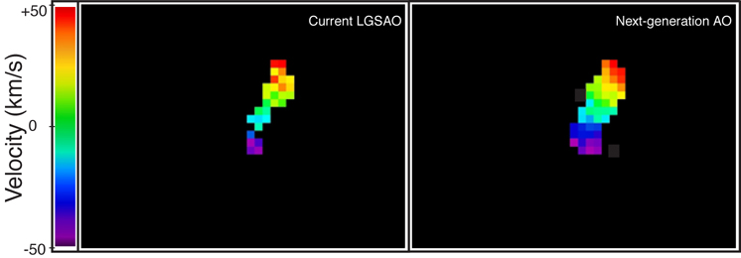

AO and instrument requirements
Essential:
- 0.1 arcsec samplings with IFU over 2”x2” of sky (20x20 spaxels per IFU).
- Accessible FOV for MOAO of 2 arcmin diameter field.
- Reach R = 19 TT stars to reach a good fraction of special regions such as GOODS.
- ADC so we can reach high airmass.
- Spectral resolution of >3500.
- Thermally cooled so K band is accessible at lower noise levels than current OSIRIS.
- Strehl > 20% in J under typical seeing conditions,
- As many IFU’s as possible. Absolute minimum of 3 and ability to add more, perhaps up to 20. Each IFU is the equivalent of having another Keck telescope.
Desirable, but not absolutely essential:
- More IFU – 10 is a good number; 20 is probably upper limit given density of targets and total accessible targets.
- 0.05 arcsec samplings over >4” of sky in IFU (mergers are more extended than typical galaxies).
- Reach R > 19 TT.
- Background limited work at spectral resolution of 5,000, 10,000 (velocity dispersions to 30 km/s), 20,000 (line profile shapes for winds); one has more accessible redshift space with higher spectral resolution.
- Strehl > 30% in J under typical seeing conditions.
What could be achieved with brand new instruments (e.g. super-NIRC2, super-OSIRIS, visible imager, visible IFU, near-IR deployable IFUs). Factors of 100X in total speed of program completion.

Program Summary
Intrinsic brightness of targets
X,Y, Z x 10-17 ergs/s/…. For 1 Mo/year SFR emission in Ha at z ~ 1, 1.5, 2

Specific observables (including images or spectra, what wavelength bands, etc)
IFU 2-D spectra within J, H, and K band windows

Sample targets: These would be mergers at different stages, with different galaxy properties, and at different redshifts (z ~ 1, 1.5, 2.1) within fields that already have had enormous investment from HST, Spitzer, Chandra, etc.
Target density on sky, if more than ~ 1 target per few square arc minutes
Conselice et al 200? claim that at redshifts z ~1, 1.5, and 2, the fraction of objects with signs of interactions/mergers is at the 40%? level. The surface density of galaxies to R~25 is about 20/sqarcmin in the redshift range of z > 0.8 (see Fig from ref??) , and if 40% of these show disturbances, this would yield about 8 potential targets/sqarcmin.
Observing requirements:
What spatial resolution is needed spectroscopic sampling of 0.1”
What spectral resolution is needed R~4,000 or better to decrease OH line
What photometric or astrometric accuracy is needed 5%-10% photometric precision with astrometry within 0.1”
What SNR is needed Primary info will be strong emission lines, and for these, perhaps S/N within spectral resolution FWHM of ~10 to enable measurements of centroid, strength, width
Estimate of exposure time per target current experience suggests 2 – 10 hours for faintest targets currently being tackled;
Special requirements on tip-tilt stars: fainter TT stars will improve sky coverage, which is especially important to get maximal data from hard-wired regions like GOODS, GEMS, COSMOS, and EGS.
Required PSF stability: Not high if one MOAO or offset camera is dedicated to monitoring the PSF during an exposure.
Total number of nights needed to complete observing program Depending on number of MOAO IFU units, but 10 MOAO IFU would allow completion of a 300 merger sample of 6-7 hours/filter as described above in about 30 nights.

Strong Gravitational Lensing
Authors: Tommaso Treu (UCSB), Laura D. Melling (UCSB)

Scientific Background

Introduction:
Massive clusters and galaxies produce a local perturbation of the Robertson-Walker metric that distorts our view of background objects. Gravitational lensing is achromatic and preserves surface brightness. Under appropriate circumstances, if the deflector is dense enough and the impact parameter is small enough, multiple images of the background source appear to the observer. This regime is called strong gravitational lensing. Strong gravitational lensing is extremely useful for the study of the high redshift universe for two main reasons: i) the astrometry of the lens configuration depends on the mass distribution of the deflector and on angular size distances, and thus can be used to “weigh” galaxies/clusters, determine the structure and substructure of dark matter halos, and/or to measure cosmography; ii) the background source is highly magnified both in terms of apparent size and apparent luminosity, so that lenses act as natural gravitational telescopes; magnification is quite significant, typically in the range 10 to 25 in luminosity.
Precision astrometry is the name of the game for gravitational lensing. So far the Hubble Space Telescope has been the unchallenged leader in this field. Laser guide star adaptive optics has the potential to change the field. The large mirror-size of Keck can deliver a factor of 4 improvement in angular resolution over HST if high Strehl ratios can be achieved with NGAO. Furthermore, coupling an AO system with integral field spectrographs will open the way for high spatial resolution studies of dynamics and chemistry of galaxies in the distant universe and for detection and spectroscopy of the first galaxies and sources of reionization at a redshift z > 7-8. As illustrated by the simulations shown below, Keck with NGAO is better than HST for these purposes and will dominate the subject after the demise of HST.

Galaxy versus Cluster Lensing
It is useful to separate two regimes: cluster/group lensing and galaxy size lensing. The angular size is set by the Einstein radius, which in turn scales as the velocity dispersion squared. Hence typical galaxies will have Einstein radii of order 1”, while massive clusters in the same redshift configuration will have Einstein radii of order 30” (Figure 1).
Furthermore, clusters – with their longer caustics – have much higher chances than galaxies to lens multiple background objects and in general to be strong lenses. So clusters are rarer in the sky but they are very efficient lenses. Galaxies are more common in the sky, but they are much more unlikely to be lenses. From a practical point of view galaxy and cluster scale lenses require different strategies for finding them, for scientific exploitation and have different instrumental requirement. Galaxy scale lenses have the more stringent requirements in terms of spatial resolution and ratios, while cluster scale lenses are more demanding in terms of field of view. Therefore they will be treated separately in this document. The intermediate regime, group size lensing, is a very poorly known subject. In general NGAO will be useful for group size lensing as well, but with intermediate requirements between galaxy and cluster scale lensing for spatial resolution and field of view. Therefore we do not discuss group size lensing in this document.

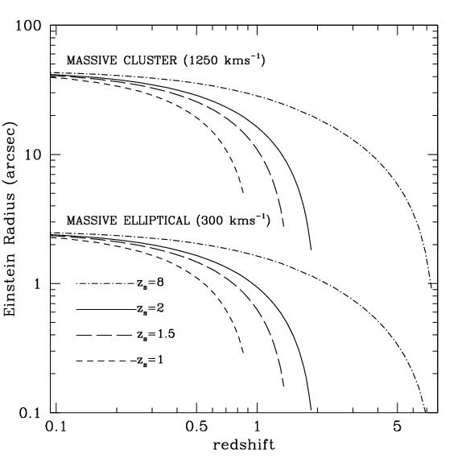
Figure 1: Typical angular scales of cluster-size lensing and galaxy-size lensing. The curves show the size of Einstein radius for a massive cluster (velocity dispersion 1250 km/s) and a massive elliptical (300 km/s) as a function of deflector redshift. A field of view of 3-4" is well matched to galaxy-size lensing, while a field of view of 1-2' is well matched to cluster-scale lensing.

Galaxy-Scale Lensing
The main science goals for this subfield are:
- Mass distribution of (deflector) galaxies, mostly early-type galaxies. What is the mass profile of dark matter halos? What is the fraction of dark matter as a function of galaxy radius, redshift, mass? Do galaxy-size halos have dark matter substructure as predicted by cosmological numerical simulations.
- Morphology, resolved kinematics and star formation history/chemistry of faint spiral irregular galaxies. Exploiting lensing magnification galaxies can be super-resolved. Using NGAO + lensing, the effective diffraction limit in the source plane will typically be ~0.005”. This means that galaxies at z=2 (angular distance 1.7Gpc) can be studied with the same detail as a galaxy in the Virgo cluster (17Mpc) in 0.5” seeing.
- Cosmography through time-delays. If relative photometric precision of order a few percent can be achieved across the field, monitoring of variable lensed sources (such as AGN) can be used to determine cosmological parameters. Effectively, every time delay acts as a standard rod. For every system angular size distances can be obtained with 10-15% and therefore there are real prospects of determining the Hubble Constant to 5% precision if a sample of a few dozen time-delays can be obtained. NGAO would be exceptionally good at this since one needs to do photometry of sources separated by less than 1 arc sec.
Galaxy-size lenses are rare on the sky, their density is of order 10 per square degree (depending on depth and resolution). NGAO will not be a good instrument to search for lenses but by the time NGAO will be available hundreds of lenses will have been discovered with current technology (e.g. SLACS, Haggles, CFHT Legacy Survey). Thousands of lenses are expected to be discovered by ongoing and future spectroscopic and imaging surveys, such as DEEP2, z-Cosmos, Panstarrs and LSST. The scientific exploitation of these samples of lenses will require high resolution imaging that only NGAO can provide. Analyzing a large number of objects is vital for the applications listed above. For example, in order to detect substructure, satellites must be close to the critical lines, which will happen only in a small fraction of cases. To beat down small number statistics samples of hundreds of lenses are needed.
AO requirements. Crucial: High Strehl, field of view of at least 2”, possibly up to 4”. Desirable: high at J and in the optical, to extend range of redshifts and diagnostics. Spectroscopic capabilities with R=3000 or better for internal kinematics and spectral diagnostics.

Cluster-Scale Lensing
The main science goals for this sub-field are:
- Mass distribution of clusters. Do cluster halos resemble those in numerical simulations in terms of mass profiles, substructure, shape etc? What is the accuracy of X-ray mass estimates for cosmography?
- Clusters as gravitational telescopes. Can we identify the first galaxies/quasars? What is their luminosity function to the faint limits? What are the source of reionization? With typical magnifications of order 20, searches for zJH dropouts can be extended 3 magnitudes deeper than possible without gravitational telescopes.

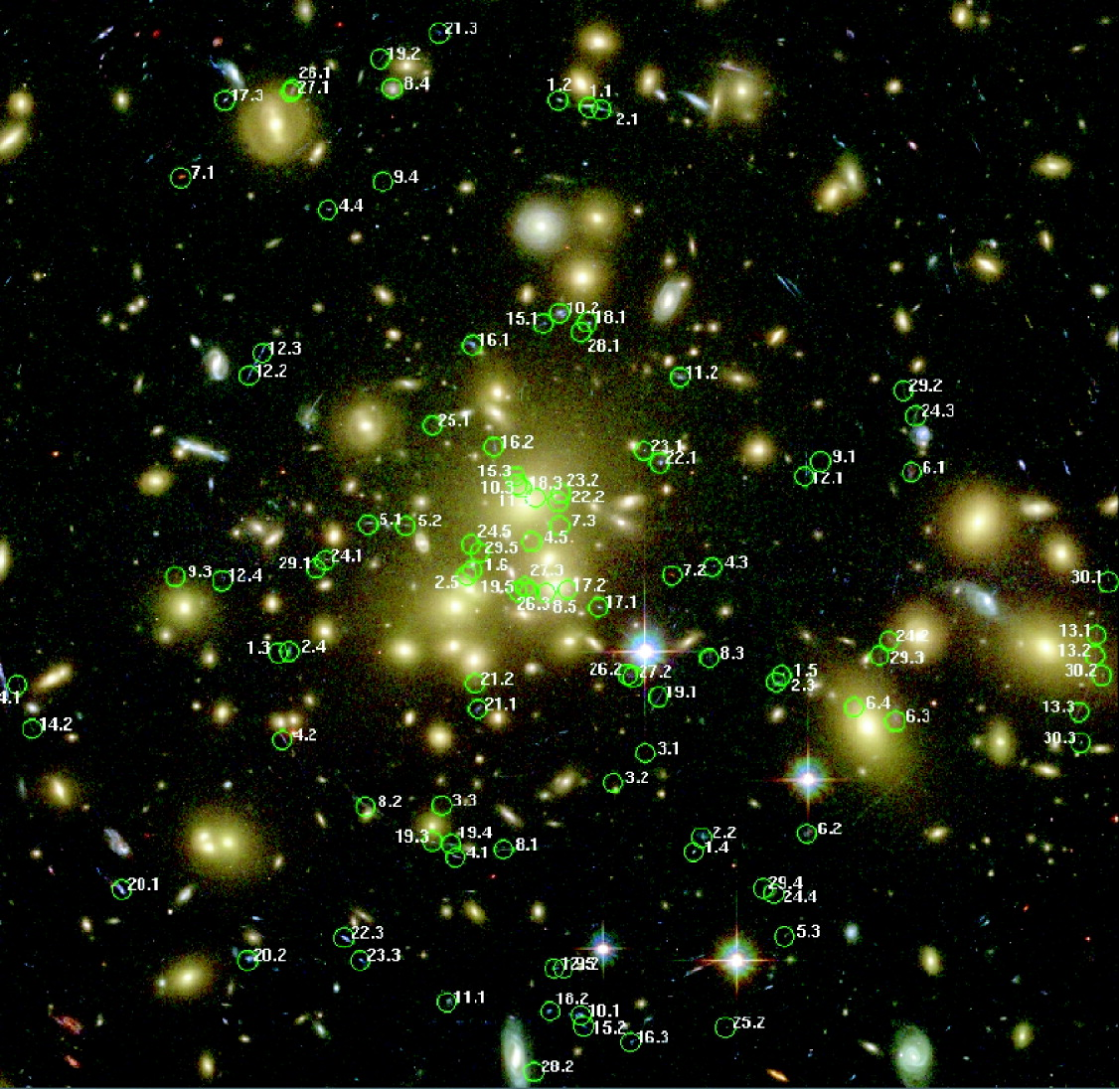

Figure 2: Searching for multiple images. At HST-like depth and resolution there are many multiple images of background sources for each massive cluster; The case of Abell 1689, an enormous cluster with an Einstein radius of 50'' is shown (the image is approximately 3' on a side); 106 multiple images have been detected in this case (Broadhurst et al. 2005).

Most clusters show strong lensing when imaged deep enough at high resolution. For example, in relatively shallow HST images (~1 orbit WFPC), Sand et al. (2005) found 104 giant arcs in 128 clusters. NGAO system will have a similar performance, and thus a success rate close to 100% can be assumed, with a density of multiply imaged sources of a few per square arcminute. In extreme cases a density of 10 per square arcminutes can be achieved (see Abell 1689. Figure 2).
As for galaxy size lenses, NGAO will not be competitive for finding cluster lenses, so the main mode of operation would be follow-up of known clusters. Current and future surveys (X-ray, red sequence) will find thousands of high redshift clusters. Targets will be abundant, high resolution follow-up will be the domain of NGAO.
AO requirements:
Crucial: high Y/J band for Y/J dropouts, field of view of 1-2’ on a side for imaging.
Desirable: multiple deployable IFU units for simultaneous spectroscopy of lensed sources.
Spectral resolution of 5000 or better is required to take spectra in between the OH lines.

Proposed Observations and Targets

Overview
For simplicity we will consider the ideal case of an early-type galaxy at z=0.8 lensing a galaxy at z=7. The deflector is a typical L* early-type galaxy with velocity dispersion 250 km/s K=18, while the source is chosen to represent a candidate source of reionization. A young galaxy of ~100Myr age, a few billion solar masses of stellar mass, small size (0.05” length scale), similar to the one identified by Kneib et al. (2004) behind Abell 2218. The unlensed AB magnitude of the source are F814W=28.6, F850LP=26.3, J/F110W=25, H/F160W=24.2, K/F222M=24.4. This case illustrates simultaneously the strength of NGAO for mass modeling of lens galaxies/clusters and for studying faint magnified galaxies. The quantitative results found for this case can be extrapolated to other observing programs such as a survey for z-band dropouts.

Comparison of NGAO with Current LGS AO and with HST-NICMOS
Figure 3 shows the lens system as observed with NICMOS (top row), NGAO with an upgraded version of NIRC2 (middle row), and the current Keck II LGS AO system with NIRC2 (bottom row). We simulate observations in the J, H and K band. For NICMOS in the J and H band (F110W and F160W) we used the NIC-1 camera because the pixel scale is very similar to that of NIRC2 (0.043” vs. 0.04”). In K band the closest configuration we could find for HST was NIC2 with the F222M filter. We show the results of this simulation even though it is not competitive, because Hubble has a high thermal background and was not optimized for observations in K band. For NGAO we used PSFs from simulations by Donald Gavel. We assumed the science instrument was an upgraded version of NIRC2 with half the background currently measured, assuming that this can be improved in the next generation AO system. For LGSAO, we assumed natural seeing of 0.5” and Strehl ratios of 0.15, 0.2 and 0.3 respectively for J, H, and K. The exposure time is 3600s in all cases. Each image is 4” on a side. Details of the simulations are given at the end of this Gravitational Lensing subsection.
From Figure 3 it is apparent that NGAO performs markedly better than both NICMOS and the current LGS AO system. At J and H bands NICMOS performs better than the current LGSAO system (largely due to lower background), whereas at K band LGS AO performs better than NICMOS. For NGAO the gain in resolution and collecting area more than offsets the extra background seen by NGAO with respect to NICMOS.

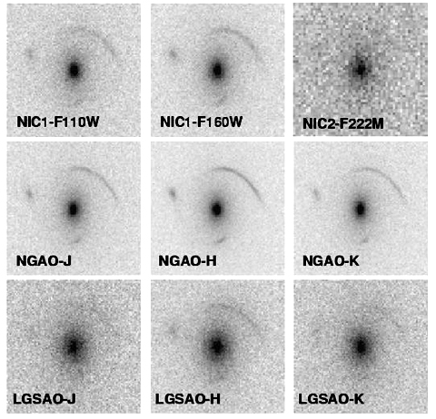
Figure 3: Simulated observations of a gravitational lens with NGAO (middle row), HST-NICMOS (top row) and the current LGSAO system (bottom row). Each image is 4" on a side and the exposure time is 3600s. For NGAO we adopted the same detector properties as NIRC2 and half the background. The lens is an L* elliptical at z=0.8 and 250km/s velocity dispersion. The background source is a galaxy at z=7 with 0.05" half light radius, and J H K AB magnitudes of 25, 24.2, 24.4, as obtained for a few billion solar masses of a young stellar population (see text for details). Note that NGAO is superior in all cases.
Quantitative estimates of the uncertainties on the source parameters are shown in Figure 4 (68% and 95% contours). Those are obtained by measuring the likelihood in the full multidimensional space of lens and source parameters using a Markov Chain Monte Carlo sampler (Melling & Treu 2006, in prep). The signal to noise ratio of the NIC2-F222M image was too faint to derive any useful constraints on the source properties. Similarly the signal to noise ratio of the Keck LGS AO-J band image was sufficiently low that the method failed to converge at the right minimum.
As is apparent from Figure 3, the proposed NGAO system strongly reduces the uncertainty in measurements of lensed galaxy size and mass. For example the derived uncertainty in size of the lensed galaxy at H band was a factor of four smaller with NGAO than with current LGS AO, and more than a factor of two smaller with NGAO than with NICMOS.
Likewise the uncertainty on the velocity dispersion decreases by a factor of 6 going from LGS AO to NGAO, and by a factor of 2 going from NICMOS to NGAO in J and H bands. Formal statistical uncertainties of better than 0.1% on the velocity dispersion can be achieved with NGAO; this is a stunning achievement for any AO system.
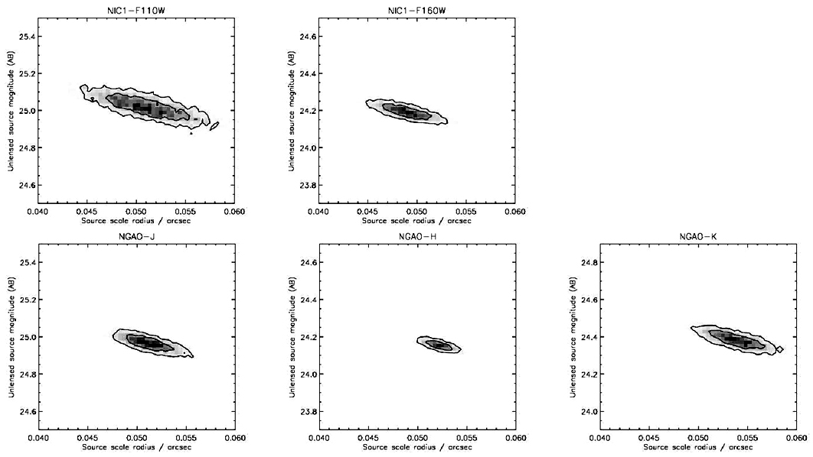
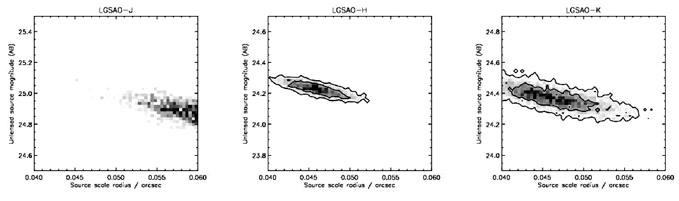
Summarizing these results, for typical galaxy lensing cases the proposed NGAO system is expected to perform four to six times better than the current LGS AO system in its ability to correctly recover the key properties of the lensed galaxies.
Figure 4: Reconstructed 68% and 95% confidence contours for the source parameters, from a Markov Chain Monte Carlo algorithm. The contours for NGAO are a factor of six smaller than for LGAO and half the size of those for NICMOS. Note also that the half radius of 0.05 arc sec is clearly resolved and precisely measured. The SNR of the simulated data is too low for LGSAO-J and NIC2-F222M to obtain meaningful results.

Sample Observational Programs
The luminosity and size distribution of redshift 7-8 galaxies, using gravitational telescopes. Assuming that high Strehl ratio images can be obtained in the z band, NGAO would be extremely efficient for doing a survey of massive clusters at zJHK and for measuring the size and luminosity function of redshift 7-8 galaxies. The luminosity function of z>7 galaxies is currently very poorly known. Bouwens et al. (2004) found 5 z-band dropout candidates in the NICMOS followup of the Hubble Ultra Deep Field finding (5.76 square arc min), with F160W luminosity ~27 AB. Pello et al. (2005) surveyed the high magnification regions of two lensing clusters with ISAAC on the VLT, to a depth of H=26 AB, finding several promising photometric candidates in an area of approximately 8 square arc min. The brightest sources are estimated to have stellar masses of order of a few times 10⁸ solar masses. Kneib et al. 2004 report one z~7 candidate that is very similar to the one adopted for our simulations, in terms of apparent magnitudes in the image plane.
As shown above, if similar Strehl ratios can be achieved over a 2’ field, it will be possible to image the highly magnified regions of clusters to comparable depths in just 1 hour per band. This makes it feasible to survey dozens of clusters to this depth and achieve an order of magnitude improvement in area in just a few nights of telescope time.
Kinematics of faint galaxies. With an integral field unit behind NGAO system one can obtain spatially resolved kinematics of galaxies at z up to 2.2 (with Hα in the K band). See Moller & Noordermeer (2006) and Law, Steidel & Erb (2006) for more details.

AO and instrument requirements (needs to be completed)
Essential
Desirable but not absolutely essential
For instrument requirements:
What can be achieved with OSIRIS plus a modest upgrade to NIRC2?
What could be achieved with brand new instruments (e.g. super-NIRC2, super-OSIRIS, visible imager, visible IFU, near-IR deployable IFUs)

Program Summary (text and/or tables):
Intrinsic brightness of targets:
Specific observables (including images or spectra, what wavelength bands, etc):
Sample targets
Target density on sky, if more than ~ 1 target per few square arc minutes
Observing requirements:
What spatial resolution is needed
What spectral resolution is needed
What photometric or astrometric accuracy is needed
What SNR is needed
Estimate of exposure time per target
Special requirements on tip-tilt stars
Required PSF stability
Total number of nights needed to complete observing program

Active Galactic Nuclei and Black Holes
Contributors: Aaron Barth (UC Irvine), Claire Max (UCSC)

Scientific Background

Introduction
During the past several years it has become increasingly clear that black holes play a key role in galaxy formation and evolution. The most important evidence for a close connection between black hole growth and galaxy evolution comes from the observed correlations between black hole mass and the bulge velocity dispersion of the host galaxy (the “M-σ relation”), and from the correlation between black hole mass and bulge mass. Despite the fact that black holes contain only about 0.1% of the mass of their host bulge, their growth is evidently constrained very tightly by the kiloparsec-scale properties of their environment. In addition, simulations and theory have highlighted the importance of feedback from active galactic nuclei (AGNs), in the form of winds or outflows which can serve to shut off AGN fueling and potentially expel a significant fraction of the host galaxy's gas into the intergalactic medium following a major merger. AGN feedback is frequently invoked as a mechanism to limit black hole growth and to shut off star formation in early-type galaxies, but observational evidence for this scenario remains sketchy.

Key observational goals in this field include accurate determination of the demographics of black holes in nearby galaxies over the widest possible range in black hole mass, investigations of the redshift evolution of the M-σ relation, and studies of the host galaxies of quasars out to high redshifts. AO observations will be crucial in addressing these issues over the next decade. Currently, with no spectroscopic capability on HST, AO observations are the only way to pursue dynamical measurements of black hole masses, apart from the very few special cases of AGNs hosting water megamaser disks. AO data is already beginning to play an important role in this field and near-IR observations have the important advantage of being able to probe the central regions of dust-obscured galaxies, for example in Centaurus A (Silge et al. 2005). AO observations in the near-IR will be used to search for starlight from quasar host galaxies at high redshifts, but to date results have been severely limited by the quality of AO corrections available with current-generation facilities.

Here we discuss just a few possible AGN and black hole projects that will benefit from NGAO at Keck. For the observations described below, the most desirable AO capability will be a high-Strehl AO correction in the near-IR with a highly stable PSF, even if only over a narrow field of view (~15 arcsec). An AO correction operating at wavelengths as short as the Ca II triplet (8500 A) will have important applications for black hole mass measurements as well.

Black hole masses in nearby galaxies
Detections of the black holes in the Milky Way and in the megamaser galaxy NGC 4258 remain the “gold standard” in this field, but the majority of black hole detections to date have been done with HST, and are limited to galaxies without significant dust obscuration. In the best cases, observations of spatially resolved stellar or gas dynamics can yield black hole masses with uncertainties in the range ~10-20%, which is sufficient for an accurate determination of the M-σ relation. Currently, although there are about 30 detections of massive black holes, the slope and the amount of scatter in the M-σ relation remain somewhat controversial. In particular, the extreme ends of the black hole mass spectrum, above 10⁹ and below 10⁷ solar masses, remain poorly determined. Improvements in angular resolution lead directly to increased accuracy in black hole mass measurements, and NGAO at Keck will be the next significant new capability in this field.

In order to detect a black hole with high significance, the observations must resolve the black hole's dynamical sphere of influence-- the region in which the black hole dominates the gravitational potential. As an example, the projected radius of the gravitational sphere of influence for a 10⁸ solar mass black hole in a galaxy with σ = 200 km/sec at D = 20 Mpc is only 0.1 arcsec. Currently, black holes with masses below 10⁷ solar masses can only be detected out to distances of a few Mpc, severely limiting the opportunities to measure the low-mass end of the M-σ relation. At the high-mass end, for black holes above 10⁹ solar masses, there are only a handful of potential targets within reach of current observations.

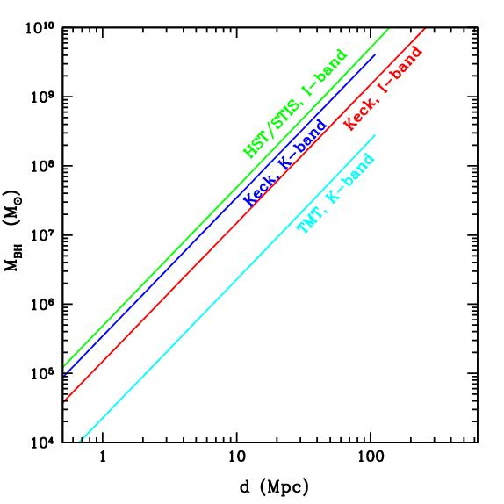
Figure 1-- Minimum detectable black hole mass as a function of galaxy distance, under the assumption that the black holes follow the local M-σ relation, and assuming a minimum of 2 resolution elements across the black hole's radius of influence. For Keck NGAO, this figure assumes a PSF core with FWHM = 0.075” in K, and 0.049” in I. Minimum detectable black hole mass scales approximately as (distance * angular resolution)². For distances beyond ~100 Mpc, the CO bandhead is redshifted out of the K band and is no longer observable.

For black hole detection, NGAO offers two important advantages over current capabilities. First, compared with current LGSAO, the improved PSF quality and stability will significantly reduce the measurement uncertainty in black hole masses, for observations in the near-IR. Second, an AO capability in the I band will open up the possibility of using the Ca II triplet lines, giving a PSF core that is narrower than in the near-IR, which will extend the distance out to which the most massive black holes can be detected. The minimum black hole mass detectable with a given angular resolution can be roughly estimated under the assumption that black holes lie on the M-σ relation. As Figure 1 shows, Keck NGAO in the K-band can offer slightly better sensitivity to black holes than that of HST/STIS. In comparison with NGAO at K-band, for a given limiting distance an I-band NGAO capability with a PSF core FWHM of 0.05” can allow detections of black holes smaller by approximately a factor of 2.

Quasar Host Galaxies
At present, the most detailed quantitative studies of quasar host galaxies have been done with HST imaging. AO observations are beginning to play an increasingly important role, particularly due to the inherent advantages of observing in the near-IR, where the underlying host galaxy structure can be more clearly revealed and where the central AGN point source is less prominent than in the optical. However, even for low-redshift quasars, temporal variability of the AO PSF can make it difficult or impossible to extract quantitative information about the host galaxy structure for radii smaller than 1” (Guyon et al. 2006). Thus, even for low-redshift quasars, determining accurate bulge luminosities and profiles is at or beyond the limits of current capabilities, and for high-redshift quasars (z beyond about 2), even the most basic detection of host galaxies has often proved very difficult with current-generation AO (Croom et al. 2004). HST/NICMOS has been used for quasar host galaxy imaging in the H band, and has the advantage of an extremely stable PSF, but Keck NGAO will offer better spatial resolution by a factor of 4.

Key observational goals in this area include:

  - At low to moderate redshifts (z < 1): detailed structural measurements of quasar hosts and bulge/disk decompositions from AO imaging, using GALFIT or similar tools, to extend the black hole mass/bulge mass correlation and examine the relationship between quasar activity and galaxy mergers. Integral-field unit observations to study emission line velocity fields and outflows. IFU observations can be used to determine the evolution with redshift of the M-σ relation, for example by measuring bulge velocity dispersions with the Ca II triplet for Seyfert 1 galaxies at z~1.
  - At high redshifts (z>1): detection of host galaxies in AO images, measurement of asymmetry/lopsidedness parameters to investigate the relationship to the host galaxy merger history, and measurement of integrated magnitudes and colors to constrain the overall stellar population.

Proposed observations and targets
Supermassive black holes: Numerous nearby galaxies will be promising targets for observation with NGAO. Many galaxies previously observed with HST or other AO systems will be re-observed with Keck NGAO, to improve the accuracy of the black hole mass measurements. Giant ellipticals at distances less than ~100 Mpc will be good candidates for studying the high-mass end of the M-σ relation.

Spectral features useful for kinematic measurements include:
  - Stellar dynamics: the CO bandhead (2.29 μm), and the Ca II triplet (~8500 A)
  - Gas dynamics: [S III] (9533 A), [Fe II] (1.26 μm), Pa β (1.28 μm), H₂ (2.12 μm), Br γ (2.17 μm)

For stellar-dynamical detections of black holes, S/N = 30 or better (per resolution element) is typically needed for the stellar continuum. For nearby galaxies this can typically be accomplished in a few hours of observing with OSIRIS. For gas dynamics, the S/N requirements for a given galaxy are lower since emission lines rather than absorption lines are used, but only about ~10% of nearby galaxies have sufficiently “clean” rotation in their emission-line velocity fields to be good targets for gas-dynamical studies.

In addition to the spectroscopic data, AO imaging of the host galaxies is needed in order to determine the distribution of stellar mass in the host galaxy. For the imaging, either NIRC2 or an upgraded IR imaging camera would be used.

One galaxy sample of particular interest is the set of 17 Seyfert galaxies having black hole mass estimates from reverberation mapping (Peterson et al. 2004). This sample serves as the bottom rung on a “distance ladder” of indirect techniques used for estimating black hole masses in quasars. Since all estimates of black hole masses in quasars are calibrated against this sample, it is important to verify the accuracy of the reverberation-based black hole masses by performing stellar-dynamical observations on these same galaxies. With NGAO, approximately 10 of these galaxies should be within reach.

Quasar host galaxies:
  - For low-redshift samples such as the PG quasar sample (z~0.1-0.3), typical H-band magnitudes are ~12-14 mag for the AGN point source, and 13-15 mag for the host galaxy.
  - High-z quasars: at z=2, typical bright quasars have K~16-18 mag. Luminous elliptical host galaxies (~2L*) would have K~19 mag with half-light radii of ~0.5 arcsec.

Comparison of NGAO w/ current LGS AO
Black hole science will benefit greatly from both the higher Strehl ratio and the better PSF stability of NGAO in comparison with current LGSAO. Figure 2 below illustrates one example: the improvement in the measurement of the velocity field of an emission-line disk around a black hole. To detect the black hole with high significance, it is imperative to resolve the central, nearly Keplerian region of the disk. In this simulated example of a 10⁸ solar mass black hole at distance 20 Mpc, the current LGSAO capability would detect a steep velocity gradient across the nucleus due to the presence of the black hole, but not detect the nearly Keplerian rise in velocity toward the nucleus. With NGAO, the rise in velocity toward the nucleus is detectable, and provides the “smoking gun” evidence for the presence of an unresolved central mass. With HST, this central Keplerian rise in velocity in emission-line disks has only previously been detected clearly in 2 giant elliptical galaxies, M84 and M87. Stellar-dynamical observations at the CO bandhead will similarly benefit from the enhanced ability of NGAO to resolve the black hole's sphere of influence in nearby galaxies.
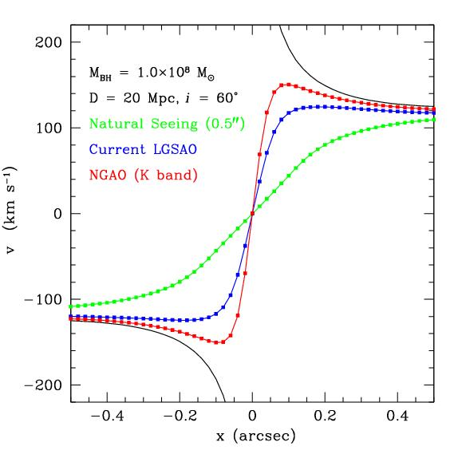
Figure 2. Simulation of radial velocities observed along the major axis of an emission-line disk surrounding a black hole in a galaxy center, similar to disks observed in M87 and other early-type galaxies. The black hole has mass 10⁸ solar masses, and is surrounded by a bulge with a power-law mass profile. The galaxy is at D = 20 Mpc and the disk is inclined by 20 degrees to the line of sight. The simulation was performed for observations of an emission line in the K-band (e.g., Br γ) with OSIRIS using a spatial sampling of 0.02”/pixel. The black curve shows the true major-axis velocity profile of the disk with no atmospheric or instrumental blurring. The blue and red curves show the velocity curves obtained from a 1-pixel wide cut along the disk major axis, after convolution of the intrinsic spectral data cube with a typical K-band PSF for current LGSAO (assuming a PSF core containing 30% of the total flux), and for NGAO (assuming a PSF core containing 72% of the total flux). The green curve shows the velocity profile that would be measured without any AO correction.

The improvement in PSF structure will also be particularly beneficial for stellar-dynamical observations of the most massive elliptical galaxies, which have flat cores rather than strongly peaked cusps in the stellar light profile. For these objects, it is essential to minimize the flux in the PSF wings in order to measure accurate line-of-sight velocity distributions for the stars orbiting close to the black hole.

AO and instrument requirements
Projects that can be done with existing instrumentation:
  - Black holes in massive galaxies: for IR observations (CO bandhead), OSIRIS is suitable, although a near-IR IFU with a wider field of view at the highest spatial sampling would increase observing efficiency and improve black hole mass determinations.
  - AGN host galaxies: NIRC-2 for IR imaging of host galaxy structure, OSIRIS for measurement of stellar velocity dispersions and emission-line velocity fields.
Projects requiring new instrumentation:
  - For measurements of black hole masses in nearby galaxies, the most important new capability would be an optical IFU for observations of the Ca II triplet. Spectral resolution of R~5000 is optimal for most black hole searches in elliptical and spiral galaxies. An imaging camera able to image the full NGAO field of view in the I-band would also be beneficial for measuring the distribution of starlight in the host galaxies.

Program Summary (text and/or tables): this needs to be filled in
Intrinsic brightness of targets
Specific observables (including images or spectra, what wavelength bands, etc)
Sample targets
Target density on sky, if more than ~ 1 target per few square arc minutes
Observing requirements:

What spatial resolution is needed
What spectral resolution is needed
What photometric or astrometric accuracy is needed
What SNR is needed
Estimate of exposure time per target
Special requirements on tip-tilt stars
Required PSF stability
Total number of nights needed to complete observing program

References for black hole section (move to end of section 3?)

Croom, S. M., et al. 2004, ApJ, 606, 126
Guyon, O., Sanders, D. B., & Stockton, A. 2006, astro-ph/0605079
Peterson, B. M., et al. 2004, ApJ, 613, 682
Silge, J. D., Gebhardt, K., Bergmann, M., & Richstone, D. 2005, AJ, 130, 406
Woo, J.-H., Treu, T., Malkan, M. A., & Blandford, R. D. 2006, astro-ph/0603648

Science Requirements

References for Section 3, Science Case

Science Requirements
Table 4 (see http://www2.keck.hawaii.edu/optics/ScienceCase/TechSciInstrmnts/ScienceCaseReqmnts033106.xls for now) provides a summary of the technical requirements needed to achieve the science cases discussed in the previous three sections.

Technical

Introduction
AO is firmly established in astronomy because of the considerable impact of the gains in resolving power and sensitivity possible with AO on the science programs where AO can be used. With the beginning of LGS AO the range of science targets has expanded, and with this expansion the use of AO is starting to move from a specialist technique for early adopters to a capability of interest to a growing number of observers. A key motivation of our desire to develop a NGAO system at WMKO is our belief that there is a level of performance above which an AO system can begin to address a much broader range of science programs and move from a specialist tool restricted to a narrow range of targets, to a progressively more ubiquitous tool meeting the demands of almost any science program.

In the science cases explored in this proposal we have worked with members of our observing community to expand the range of science that we believe will be done with AO, and the science requirements for the NGAO system are based on a range of science cases that illustrate the potential for NGAO to expand into new fields as well as the dramatic advances that are possible in the fields where AO is already an established observing tool.

The example observations explored in each of the science cases demonstrate the considerable scientific potential of improved AO system performance and suggest that if the performance levels established in the science requirements can be achieved there are great opportunities for many new and exciting scientific results. These performance levels are not arbitrary, but as we will show are based on the growing body of research into AO system performance including the analysis of on-sky performance of current LGS AO systems and advances in the modeling and simulation of new AO system designs.

To date the problem of optimizing AO system performance has appeared to require a choice between high angular resolution over a narrow field of view and more modest performance over wider fields. Problems such as PSF stability and uniformity have only recently been recognized as limiting the potential of MCAO systems, and this suggests that obtaining the best balance between angular resolution (or Strehl ratio), and field of view will continue to be challenge for new AO systems.

For NGAO we have considered science cases that require high angular resolutions over instantaneous fields of view ranging from 1” to ~30”. We have also considered confusion limited science cases requiring multi-object observations at high angular resolution over a wide field of 4’ diameter. This has led us to a system that emphasizes achieving very high Strehls with good sky coverage over a comparatively narrow FOV of 40” with a high degree of PSF stability and uniformity. We then combine this capability with a wide field multi-object AO (MOAO) capability delivering near IR performance exceeding that of the current Keck AO system over a significant sky coverage fraction.

The science cases have also evaluated the benefits of extending the short wavelength limit of the AO system, and based on the science benefits we intended to achieve a significant level of AO performance down to 0.6 µm.

The key elements of an AO system capable of delivering both narrow and wide fields are illustrated in figure AA.
Multiple LGS launch facility with flexible asterisms

SCAO relay with multiple LGS WFS, multiple IR NGS WFS and calibration facilities

Multiple guide star lasers and beam transfer optics

Beam switching facility
Visible and IR wavelength imaging and spectroscopic instrumentation

Figure AA: NGAO Architecture

The Path to a NGAO Point Design

The members of the NGAO technical advisory team devoted the past 6 months to exploration of possible architectures for the next generation adaptive optics system. The teams first task was to review the preliminary requirements from the 3 science teams, these were essential those of section Error: Reference source not found. We summarize these requirements in the abbreviated list below.

- High sky coverage for AO correction (exclusive of tracking )
- High sky coverage for tracking
- Best possible levels of AO correction (High Strehl, low RMS wfe)
- Ability to multiplex AO observations (one contiguous or several discrete fields of view, science case dependent)
- High optical transmission and low IR background
- Calibration of AO system effects on observations

The technical teams then worked to develop an AO system consistent with these desiderata. In order to fulfill these somewhat contradictory requirements the technical team felt that NGAO must consist of the following components/features

- Multi laser guider stars (sky coverage, multiplex, Strehl)
- Measurement of the 3-D turbulence structure (sky coverage, multiplex, Strehl, Cal.)
- AO correcting elements with order 1000 actuators (Strehl)
- Multiple AO corrector elements (sky, multi, Strehl)
- Optical fields of up to an 2 arc minutes (4 as goal) (TT sky cov., multiplex)
- Use of multiple natural guide stars for tip/tilt correction (TT sky cov.)
- Separate AO correction for natural tip/tilt guide stars (TT sky
- Use of the fewest number of optics (Trans. IR back.)
- Cooling of AO system (IR back.)

We next discuss the implication of each of these features of NGAO in turn.

Multiple laser guide stars:

With the successful commissioning of the Keck LGS the use of laser for AO correction has become routine, it is perhaps redundant to state that the number of science target available for AO correction has increased many times over systems that use only NGS. The sky coverage gain in most dramatic in the area of extragalactic astronomy where the science target is typically faint and is usually not placed near bright field stars. However, in those cases when a natural guide star is available (or is the science target itself) the correction of turbulence is better with the NGS than with a LGS because the wavefront from the NGS correctly samples the atmospheric turbulence, this is the well know cone effect. Currently using a single LGS the Keck telescope limits the achievable wavefront error to 150 nm rms or a K Strehl of 0.35 in typical conditions. In order to maintain high sky coverage and achieve the high Strehl performance needed to accomplish the science cases of section Error: Reference source not found will require overcoming the cone effect with the use of multiple laser guide star that correctly sample the atmosphere.

In addition to the cone effect another limitation of current Keck AO systems, both NGS and to lesser extent LGS, is the decline in AO correction as one moves across the field of view. This feature is called angular anisoplanatism. In principle one could measure and correct for this effect using a set of natural guide stars scattered across the field of view. A multiple NGS AO prototype is planned by ESO. However the number of field with several suitable bright guide stars is very small (estimated as few hundred at best) so this system is only a proof of concept not an operational instrument. Only with the use of multiple LGS can one hope to simultaneously achieve the required levels of sky coverage, high Strehl and multiplex AO observations outlined in science cases for NGAO.

Measurement of 3-D turbulence structure

In order to realize the gains from the use of multiple laser guide star to sense the atmospheric turbulence one needs to use a wavefront sensor to measure the 3-D turbulence structure of the turbulence. The simplest schemes allocate one conventional single guide star wavefront sensor to each beacon in the LGS asterism, this is often called star oriented wavefront sensing. The wavefront sensor could be any of the currently used types, Shack-Hartmann, curvature or pyramid. Each wavefront sensor provides a unique line of sight through the atmospheric turbulence. This information can be used to infer the 3-D structure of the atmospheric from a separate digital computation. This measurement and computation processes often is often called tomography. Testing of these concepts was recently completed at Palomar. Measurement errors using 3 off axis NGS to infer the wavefront of a fourth on axis star were consistent with the noise and calibration error of the system. (See Velur et. al. SPIE).

A novel scheme proposed by Raggazoni, the so called layer oriented adapted optics, uses a series of pyramid type wavefront sensor each assigned to measure the optical distortion from a unique layer in the atmosphere directly. This scheme has the advantage that disentanglement of the effect of each layer is done directly and at the same speed that wavefront is sensed without computational overhead. At present the ultimate accuracy of this technique is not understood. It will be tested on the sky as part of the ESO multiconjugate adaptive optics demonstrator (MAD) in the future. Because of these uncertainties the technical team only consider a “star oriented” system for the point design in this proposal.

Multiple AO corrector elements

Once the 3D turbulence structure is understood this information can be used to drive optical correction elements, such as deformable mirrors. Many of the science cases consider above have requirements for relatively small correct field of view that are close to the isoplanatic patch size (~10” arcseconds). If only one such target required observation, or were observable in the unvignetted field of view of the AO system then it would be possible to correct the wavefront for this single line of sight with a single deformable mirror. However, several science case would benefit from the ability to observe several small AO corrected fields simultaneously. An example would be observation of each member of a distance cluster of galaxies, the individual objects are relatively small (few arc seconds) in extended and are clustered across an few arc minute portion of the sky. The multiplex gains are significant when one considers that using the current OSISIRS system an observation of a single galaxy can take up to 8 hours. Still other science cases would benefit from the correction of a every point in a contiguous field of view of order a few arc minute square. An example of this type of science case is the observation of stellar populations in globular clusters and nearby galaxies. In this observation the field is filled to the confusion limit with point sources and to achieve good statistics one would like to observe all of these sources.

In multiple object adaptive optics (MOAO) separate deformable mirror work in parallel with one assigned to correct each line of site, this architecture is best suited to the galaxy cluster type cases mentioned above. A second type of multiplexed AO system is multi conjugate adaptive optics (MCAO), in this architecture the correct elements are allocated to correction of individual turbulent layers, this results in correction across a contiguous field of view. The MCAO case is most suitable for the

The MCAO approach is thought to come at a somewhat decreased level of peak Strehl performance and a field of reguard

The technical team considered two architectures that can provide AO correction with a multiplex advantage each is best suited to certain types of observations and no clear winner can be decided based on scientific merit or technical utility at the present preliminary stage in our design process. Future detail is provided in the technical approach section.

Initial description
- key parameters
- kind of system that we need
- basic components
- comparison to current Keck LGS AO

Feasibility is important, this leads us to a point design:
- AO system
- Instrumentation

Then on to the details in a way that emphasizes the key problems to be addressed in the system design phase…(include only some details here, put the rest in appendices)

Requirements
The top-level requirements are the science requirements summarized in Section 3.7. Additional requirements and constraints imposed by the Observatory and the site are summarized in the following two sections.

Observatory Requirements (Design Constraints)
The following three tables define a list of potential additional requirements or design constraints imposed by the existing facility and instruments (see KAON 237 for more details) and Observatory operational needs. These are in addition to the science requirements defined in section C.6.

# | Potential Facility Requirements | Discussion
1 | NGAO system & science instruments to be located on the Nasmyth platform of one of the Keck telescopes | The Keck telescope foci and Nasmyth deck storage locations are already heavily utilized. The current AO systems occupy the left Nasmyth platform locations of both telescopes. HIRES occupies the right Nasmyth on Keck I while DEIMOS and NIRSPEC share the right Nasmyth on Keck II. The Cassegrain foci are occupied by LRIS (and MOSFIRE in the future) on Keck I and by ESI on Keck II. The bent Cassegrain ports are believed to have inadequate space and weight capacities. The prime focus could potentially be available but there would be many constraints on an instrument at this location. The most viable option is in the location of an existing AO system. Alternatives would be to decommission HIRES or for the existing AO system and the NGAO system to be able to share the same platform.
2 | The NGAO system should accommodate the entire Keck pupil | The Keck primary has a maximum edge-to-edge diameter of 10.949 m.
3 | If the existing f/15 or f/40 secondary mirrors are used then the NGAO system will be constrained by the resultant f/#, focal plane and pupil location | Both telescopes have f/15 secondary mirrors, as well as chopping secondary units that can accommodate f/25 and f/40 secondary mirrors. The choice of f/15 secondary mirrors for the current AO systems was largely driven by the resultant reduced size of the AO systems and the availability of PCS (Phasing Camera System) via a rotation of the tertiary mirror. The inability of the current systems to chop at the telescope pupil has been a limitation for thermal IR observations.  The focal length of the telescope with the f/15 secondary mirror is 150 m. The 10.949 m primary corresponds to an f/13.66 beam with an exit pupil diameter of 1.460 m located 19.948 m in front of the focal plane.

# | Potential Additional Instrument Requirements | Discussion
1 | The NGAO system should operate with OSIRIS and/or NIRC2 | (Note: These requirements are more properly generated from the science requirements. However this partly addresses the associated design constraint.) NIRC2 is at the fixed output of the Keck II AO system and OSIRIS will be located at the fixed output of the Keck I AO system (currently it moves in on rails for Keck II). Requiring that both instruments go with NGAO implies that neither instrument will be available for the AO system on the other telescope. We can consider new implementations of these instruments.
2 | The NGAO system should operate with the Keck Interferometer (KI) | The KI dual star modules (DSM) currently move into both AO enclosures on rails to feed the KI. The requirement to feed the KI requires that collimated light can be fed to the DSM and that the field rotation, pupil rotation, longitudinal dispersion and polarization from the NGAO system and the AO system on the other telescope be identical.
3 | The NGAO system should operate with the OHANA interferometer | Injection modules are currently placed on each AO bench to feed an optical fiber that goes to the KI. In future the output from these fibers will be interfered with those from multiple telescopes.

# | Potential Observatory Operational Requirements | Discussion
1 | The NGAO system must be facility-class | Facility-class has many implications on safety, operability, reliability, maintainability, lifetime, documentation, configuration management, etc.
2 | The NGAO system must complete an operations transition review where operational responsibility is transferred from development to operations | This has implications on defining transition requirements and on training.
3 | The time between decommissioning an AO capability on the telescope where the NGAO system is to be installed and making NGAO available for limited shared-risk science must not be longer than 6(?) months | If/then  Impact on Interferometer
4 | The telescope downtime required to implement NGAO must not be longer than 5(?) days
5 | The NGAO system must be capable of operating 50% of the nights over the year with observing runs as long as 3 weeks in duration.
6 | The Mauna Kea laser projection requirements must be satisfied | This includes requirements on laser power, wavelength, laser traffic control participation, aircraft safety and space command.
7 | The NGAO system must operate within specifications under the normal summit temperature and humidity conditions.

Mauna Kea Site Conditions
To provide the NGAO point design with the latest information regarding atmospheric turbulence conditions at WMKO, an evaluation of existing seeing data has been performed (KAON 303). The KAON 303 profile was modified to include a stronger ground layer and the standard r₀ value was lowered from 20 to 18 cm. The resultant baseline median C_{n}² profile is presented in Table 3. From this model we calculate the following turbulence parameters for 0.5 μm wavelength:
- r₀ = 18 cm
- θ₀ = 2.5 arcsec
- f_{G} = 39 Hz

In addition, where relevant to our studies, we have adopted a standard deviation of r₀ of σ_{r0} = 3 cm with a characteristic evolution time of t = 3 min.
Table 3 Mauna Kea C_{n}² Profile.
Altitude (km) | Fractional C_{n}² | Wind Speed (m/s)
0.0 | 0.471 | 6.7
2.1 | 0.184 | 13.9
4.1 | 0.107 | 20.8
6.5 | 0.085 | 29.0
9.0 | 0.038 | 29.0
12.0 | 0.093 | 29.0
14.8 | 0.023 | 29.0

A median outer scale of 75 m is assumed (Dekens, PhD thesis). The atmospheric surface pressure is assumed to be 600 mbars and the average ambient temperature is 0C.

The above values will be updated as new C_{n}² monitoring data are obtained, primarily as part of the current TMT site survey effort.

An evaluation of existing sodium density data has been performed resulting in the use of a median sodium density of 4x10⁹ atoms/cm².

Requirements Flow Down
A requirements document will be developed early in the preliminary design phase of the NGAO system project. The requirements will be divided into the following three categories:
- Performance.
- Implementation.
- Design.

Note that separate requirements documents will be needed for the science instruments.

In this section we take an initial look at how the top-level requirements (science, observatory and site) flow down into the performance, implementation and design categories for the NGAO system and at the implications of these requirements.

Performance Requirements
The performance/error budgets listed in Table 4 will need to be developed (these will be a major set of System Design phase deliverables). A major input to many of these error budgets will be the Mauna Kea site conditions:
Table 4 Performance Budgets
Budget | Recommended Value | Based on Requirements
Throughput to Science Instrument (telescope + AO) | >= 70% at 0.6-5.5 um | Science object wavelength
Throughput to Science Instrument (telescope + AO) | >= 60% at 5.5-14 um | Magnitude limit
Throughput to Science Instrument (telescope + AO) |  | Desired SNR
Throughput to Science Instrument (telescope + AO) |  | Typical exposure time
Emissivity to Science Instrument (telescope + AO) | <= sky emissivity at K, L & M | Science object wavelength
Emissivity to Science Instrument (telescope + AO) |  | Magnitude limit
Emissivity to Science Instrument (telescope + AO) |  | Desired SNR
Emissivity to Science Instrument (telescope + AO) |  | Typical exposure time
Emissivity to Science Instrument (telescope + AO) |  | Companion sensitivity
Wavefront Error Budget | 140 nm for 1% sky coverage at galactic latitude b=60° | Image quality
Wavefront Error Budget | 160 nm for 20% sky coverage at galactic latitude b=60° | Sky coverage
Wavefront Error Budget | 200 nm for 80% sky coverage at galactic latitude b=60°
Photometric accuracy | 0.01 mag at 0.7-2.5 um for < 5" from H < 16 NGS
Photometric accuracy | 0.02 mag at 0.7-3.5 um for < 10" from H<16 NGS
Photometric accuracy | 0.05 mag at 0.9-2.5 um for < 20" off-axis & 20% sky coverage
Photometric accuracy | 0.1 mag at 0.7-2.5 um for < 20" off-axis & 20% sky coverage
Astrometric accuracy | 0.1 mas for Galactic Center
Astrometric accuracy | < 10 mas for 0.7-3.5 um & 30% sky coverage
Astrometric accuracy | < 50 mas for 0.7-3.5 um & 50% sky coverage
Polarimetry accuracy | < 0.5%
Companion Sensitivity | > 4 magnitudes at 0.055" at 1-2.5 um for Galactic Center
Companion Sensitivity | > 10 mags at 0.5" at 0.7-3.5 um for 30% sky coverage & < 20" object diameter
Observing Efficiency | <= 20 min overhead per night | Facility-class
Observing Efficiency | <= 120 sec between end of slew & ready for science exposure
Observing Efficiency | <= 10 sec between start of nod command & ready for science exposure
Observing Efficiency | <= 120 sec to switch between LGS & NGS mode
Observing Efficiency | <= 600 sec to switch between NGS & LGS mode (assuming daytime setup)
Observing Efficiency | <= 120 sec to switch between science instruments (assuming daytime setup)
Up-time | <= 5% of time lost to problems | Facility-class
Electrical Power | <= 10 kW for AO system
Electrical Power | <= 20 kW for laser system
Thermal Dissipation | <= 100W from AO system
Thermal Dissipation | <= 100W from laser system
Thermal Dissipation | <= 50W at top-end
Weight | <= 10,000 kg for AO system
Weight | <= 10,000 kg for laser system

The subsystem performance budgets will need to be developed as a flow down from the above budgets.

Implementation Requirements
- Location
- Focal ratio
- Interfaces

Design Requirements
All of the error budgets listed in 4.2.3.1 will have implications on the design requirements.

Additional design requirements from the science requirements include:
- Science wavelength (0.5 to 13 μm).
  - Requires visible, near-IR and mid-IR instrumentation. Presumably the wavelengths beyond 5 μm are adequately served by the Keck Interferometer’s nuller camera.
  - Requires that the AO system transmit this range of wavelengths to the science instruments.
  - The science beyond 2 μm puts a low emissivity requirement on the AO system and telescope.
  - Only one science case requires working to 0.5 μm. Increasing the lower limit to 0.6 μm would allow the use of a simpler dichroic beamsplitter to separate the science and wavefront sensor light.
- Science instantaneous field of view (< 30” diameter)
  - Science objects per square arcmin
    - For the case of faint science objects and a MOAO system the question arises of how do you center the MOAO units on the science objects? This observing case would require that the knowledge of the science object location and the positioning accuracy of the MOAO units be a fraction of the MOAO field size (e.g., likely < 0.5”).
  - Polarimetry

Additional design requirements from the Keck telescope design:
  - Field rotation
    - The Alt-Az Keck telescope design requires compensation for field rotation in order to keep the science field fixed on the science instrument.
  - Pupil rotation
    - The irregular shape of the Keck primary mirror requires that the reconstructor take into account pupil rotation.
    - Any science coronagraph will have to compensate for the rotating pupil.
  - LGS constellation rotation
    - In order to keep the LGS constellation fixed on the science field the constellation must rotate to compensate for the field rotation.

Additional design requirements from the science instruments and observations:
  - f/#, pupil and back focal distance
    - NIRC2 and OSIRIS were designed to accept an f/15 input beam with the pupil located at the same position with respect to the image plane as the Keck telescope exit pupil. These instruments were designed to have their focal planes between 100 and 250 mm from the front surface of the instrument. The use of these instruments requires that the NGAO system provide the same f/#, pupil location and minimum back focal distance.
  - Nodding
  - Chopping

Technical Approach

Initial Point Design
An initial NGAO point design has been developed to demonstrate the feasibility of satisfying the science requirements, to evaluate the areas of complexity and risk, and to use for cost estimation purposes. This design should only be regarded as one possible approach to satisfying the requirements; other potential designs architectures will be considered and numerous design trade studies will be performed to determine the optimal approach to meeting the NGAO science requirements.

The point design has been developed to enable both the science that requires high Strehl ratios (at the cost of narrow fields) and the science that requires a wider field (at the cost of lower Strehls); these are referred to as the “High Strehl” and “Wide Field” modes, respectively. Both modes consist of multiple LGSs for atmospheric tomography, a basic AO relay (Figure 12), and a dichroic switchyard (Figure 14) to divide the light amongst the science instruments and wavefront sensors. The fundamental difference between the AO modes is the number and placement of the LGSs as illustrated in Figure 15.

The optical relay (Figure 12) begins with a window that isolates the AO enclosure from the dome environment while also acting as a field lens. As in the existing AO system a K-mirror rotator is used to correct for image rotation and a pair of identical off-axis parabolas (OAPs) are used. The first OAP collimates the light and reimages the telescope primary mirror onto the deformable mirror (DM). The DM is mounted on a fast tip/tilt stage. The second OAP reconverges the light with the same f/# and pupil location as initially provided by the telescope. The first OAP was chosen to be conjugate to a high altitude (9.0 km) to allow the capability of converting this OAP into a DM in order to provide a multi-conjugate AO (MCAO) option.

The size of the optical relay is driven by the telescope’s f/13.66 focal ratio (corresponding to a 10.949 m circumscribed primary mirror), the choice of field size (4 arcmin) and the size of the DM. The DM size is driven by the number of actuators (chosen to be 63 actuators from edge-to-edge of the 10.949 m primary mirror) and the actuator spacing (chosen to be 3.5 mm). The OAP focal length is therefore f = 13.66 * (63-1) actuators * 3.5 mm/actuator = 2.964 m (67% longer than those used in the existing Keck AO systems).

Figure 12 Point Design: Zemax optical layout on the Nasmyth platform.

The initial Zemax design in Figure 12 has been incorporated into the mechanical model shown in Figure 13.

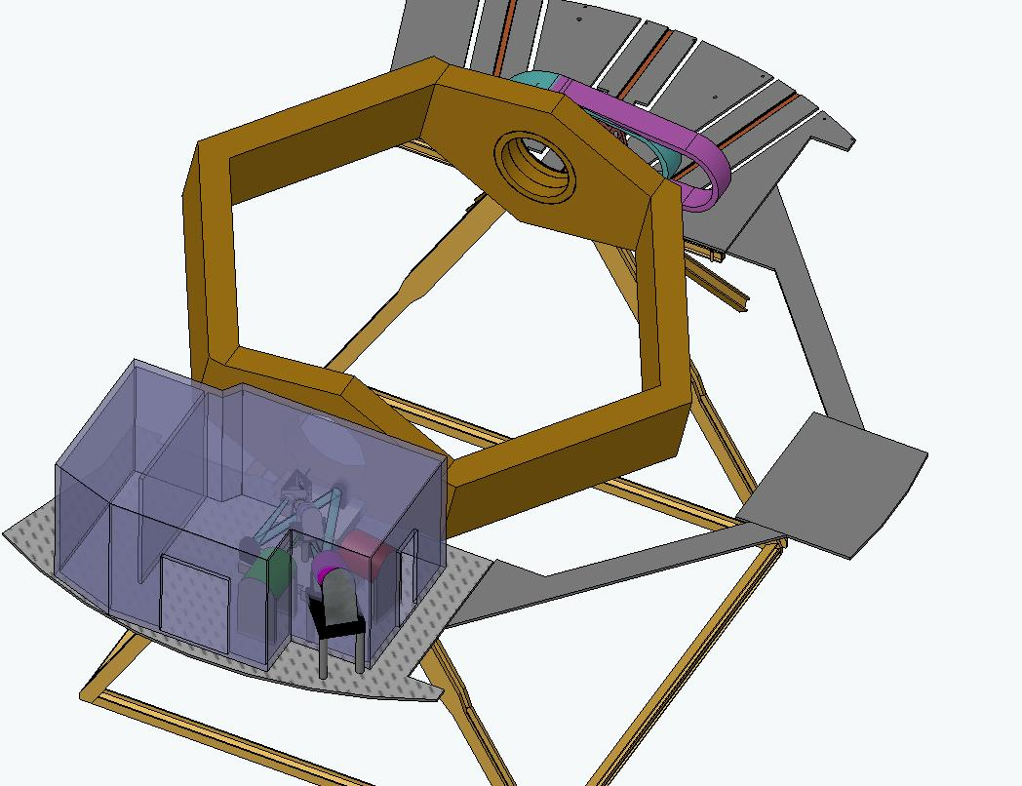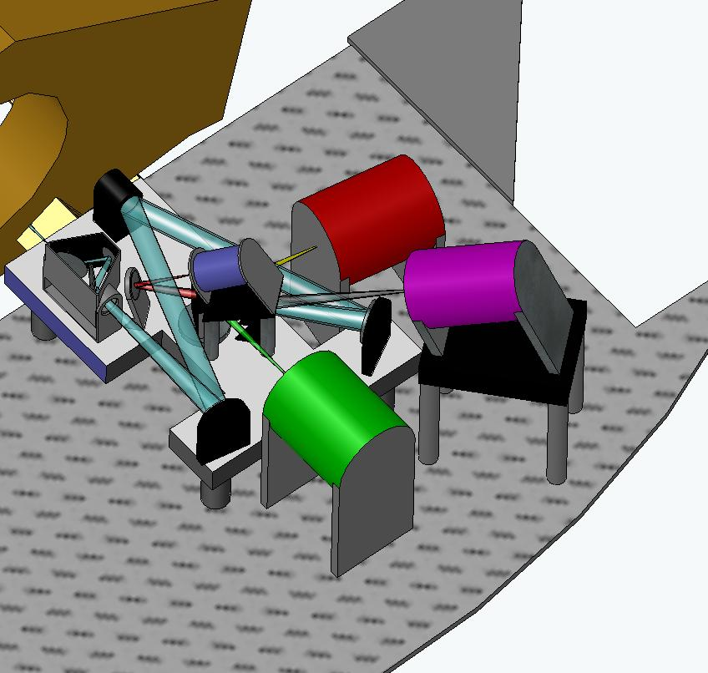
Figure 13 NGAO system on Keck left Nasmyth platform.

The distribution of the light between the science instruments and various wavefront sensors can be seen more clearly in the schematic shown in Figure 14. This schematic is also useful for identifying the various sensors.

The first dichroic transmits the long wavelength light through an atmospheric dispersion corrector to the IR science instruments and a Low Order (LO) WaveFront Sensor (WFS) assembly. The LOWFS assembly consists of three near-IR pyramid sensors used to sense tip, tilt, focus and astigmatism from three NGS located randomly over the field. Each LOWFS unit includes a 32x32 actuator MEMs to provide MOAO-correction. The LOWFS uses the wavelengths not currently used by the IR science instruments with the assistance of a changeable dichroic that reflects the light to the science instruments.

The short wavelength light reflected by the first dichroic goes to a second dichroic that divides the between the various visible wavelength detectors. The reflected light goes to the visible science instrument and a NGS acquisition camera (ACAM). The short wavelength transmitted light goes to a slow WFS and the LGS WFS assembly. The LGS assembly includes an LGS acquisition camera and multiple Shack-Hartmann LGS WFS. The LGS assembly is mounted on a translation stage used to keep the assembly conjugate to the sodium layer. The slow (Shack-Hartmann) WFS acts as a truth sensor by monitoring an NGS in order to correct for aberrations introduced by the LGS. In NGS AO mode only the NGS (Shack-Hartmann) WFS is used (the LOWFS, visible slow WFS and LGS WFS are not required).

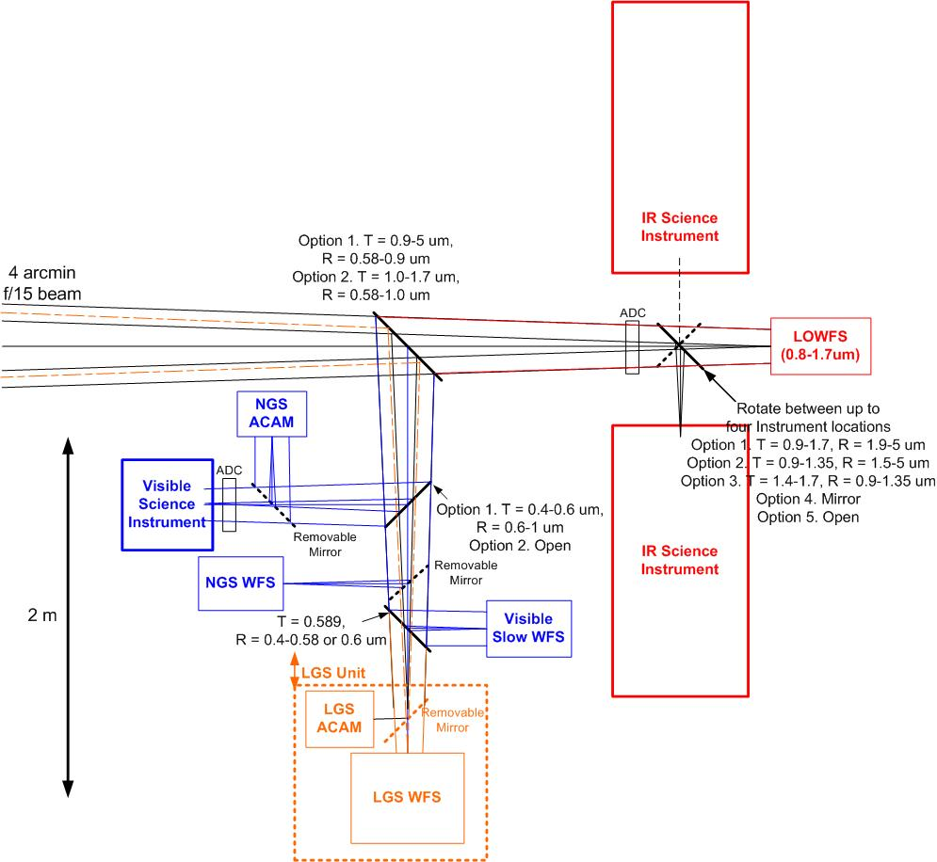
Figure 14 Point Design: Dichroic Switchyard

The optical relay is designed to pass a 4 arcmin diameter field as shown in Figure 15. The LOWFS units are configurable to acquire three NGS in this field. The LOWFS are currently envisioned to be pyramid sensors. In the high Strehl mode a single LGS is located on-axis with four LGS on a ring with a configurable radius. In the wide field mode a second ring of six LGS is available also with a configurable radius.

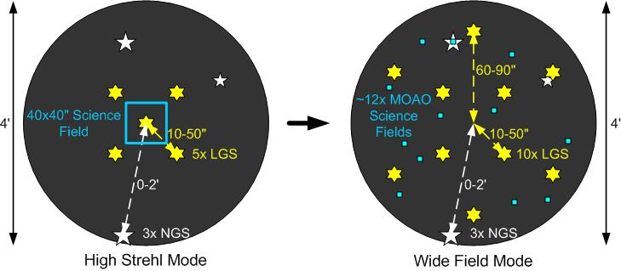
Figure 15 Point Design: NGAO transmitted field showing LGS asterism, NGS and science field.

The key features of the AO system portion of the point design are summarized in Appendix A. More details of this design will be discussed in the performance budgets. One key feature is shown in Figure 16 which shows the registration of the DM actuators and WFS subapertures to the DM.

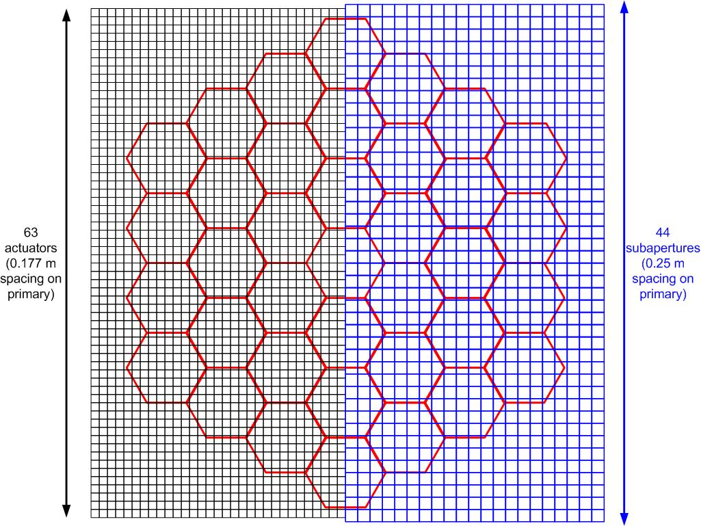
Figure 16 Point Design: DM actuators and WFS subapertures projected onto the Keck telescope pupil.
Several other conceptual designs have not yet been evaluated to determine their relative merits. These are included in the list of trade studies identified in section .

The point design assumes four 50 W mode-locked CW lasers, similar to the 50W laser currently being built by LM/CTI for Gemini Observatory. The lasers will be housed in an enclosure on or below one of the Nasmyth platforms. Each LGS will be routed via a separate photonic crystal fiber to a 50 cm diameter projection telescope located behind the f/15 secondary mirror. All of these technologies (laser, fiber and on-axis projection telescope) will be demonstrated in the development of the Keck I LGS AO facility.

Components and Component Subsystems
Figure 1 shows a block diagram of the proposed architecture for Keck Next Generation Adaptive Optics with the key hardware components labeled. Although the MCAO / MOAO architecture for the Keck-NGAO system is novel and provides capabilities far beyond that of current AO systems, all of the subsystems will use technology that is available today. A summary of components along with current status of the technology is given in the following sections.

Figure 1. Block Diagram of NGAO MOAO/MCAO architecture
[Figure xxx Block Diagram of NGAO MOAO/MCAO architecture]

Wavefront Sensing
The system uses a number of various kinds of wavefront sensors in order to achieve the tomography, tip/tilt, and calibration measurements.

Laser guide star high-order WFS
Real-time tomographic measurement of the turbulent atmosphere is achieved using laser guide stars (LGS). The NGAO multiple (5 to 10) LGS configuration will require multiple high speed low noise wavefront sensors, one per guide star. These will be Shack-Hartmann wavefront slope sensors each requiring a lenslet array mapped to the telescope pupil and a CCD to measure Hartmann spot deflections. Typical characteristics of these wavefront sensors are summarized in Table 5.
Table 5 Specifications for high order LGS wavefront sensors
Specification | Range of values for K-NGAO | Comments
Number of Hartmann Subapertures | 3217 (64 across pupil diameter) | Sets fitting and measurement error budget terms
Sensor | Low noise, high readout rate CCD | Lincoln Lab CCID56 polar coordinate array  Lincoln Lab 128x128
Sensor read noise | ~ 2 electrons per pixel
Sensor frame rate | 1 – 1.5 kHz | Sets bandwidth error budget term
Pixels | 8x20 per subaperture | Formatted for elongated laser spot

The Lincoln Laboratory CCID56 detector is currently being developed under a grant from the NSF Adaptive Optics Development Program (AODP). The design is specific to the special situation of elongated Hartmann spots caused by the finite thickness of the Sodium layer from which the return flux of the LGS originates. The CCD layout allows for either centroiding an elongated spot on a radially symmetric pattern of spots, or synchronizing the clocking of charge on the CCD with the return from a pulsed laser (Adkins, 2006).

A fallback option is a detector that is presently fielded in AO systems, the Lincoln Laboratories 128x128 high speed wavefront sensor chip. This chip has 6 electrons read noise per pixel and is currently used on AO systems at the Starfire Optical Range 3.5 m telescope and on the AMOS 3.6 m telescope. Using this chip format would force imaging of the elongated laser spot onto a non-ideal arrangement of pixels resulting in loss of sensitivity and it probably would limit the number of subapertures to less than 64 across.
Table 6 Detectors for high order wavefront sensors
Detector | Technology Status
Lincoln Laboratories 128x128 2kHz | Incorporated in SOR AO system successfully
Lincoln Laboratories CCID56 Polar Format 1.5 kHz | Under development:  Delivered: CCID56a test chip. Amplifier and pixel clocking performance verification tests underway  CCID56b chip layout design in progress for late 2006 / early 2007 foundry run. Format is polar coordinate for ¼ of the TMT pupil.

Natural guide star high-order WFS
NGS mode operation is intended as an alternative AO configuration under conditions where LGS operation is impossible. CCDs such as those discussed for LGS wavefront sensing can be used in the visible.

Infrared wavefront sensors with the desired NGAO order of correction are problematic because current detectors have high read noise at fast readout rates. This becomes a trade between star brightness, sky coverage, and science wavelengths. Given the present IR sensor limitations, this will likely be degraded from the nominal NGAO goals. A trade study on this issue is recommended for conceptual design phase.

Low-order WFS – visible
A low-order visible wavefront sensor will be used for sensing a bright off-axis star at high speed in order to measure (and compensate for) telescope wind shake. An 80x80 CCD-39 chip manufactured by E2V-Marconi provides excellent sensitivity, read noise, and frame readout speeds. A commercial vendor, SciMeasure Inc., packages this chip with a camera controller that allows considerable flexibility in pixel binning and fast readout of regions of interest. These cameras are presently in use as wavefront sensors and tip/tilt sensors in both the Lick and Palomar Observatory AO systems.

Low-order WFS – infrared TT/FA
These low-order wavefront sensors measure natural starlight at high speed to supplement information from the LGSs. The lasers are not able to probe the tip/tilt component, and only poorly sense the focus component, hence a number of these sensors are needed to fill in the unsensed modes. A summary of requirements is given in Table 7.

Table 7 Specifications for high speed low order wavefront sensors
Specification | Range of Values for K-NGAO | Comments
Order of sensing | Tip/Tilt/Focus/Astigmatism
Sensing method | Pyramid wavefront sensing | Highest Signal to Noise at low order when beam is partially corrected.
Sensing wavelength | Infrared (1.2 – 1.6 microns) | Partially corrected spot in focal plane. Trade off with sky background.
Number of sensors | 3 | Resolve LGS unsensed modes
Detector technology | Multiplexed infrared detector  Hawaii 2RG in fast subarray readout mode | Showing potential for <10 e- readout in lab [experiments by Gustavo Rahmer, Caltech]
Optical component technology | Pyramid-Lenslet with microfabricated lenslet array | High SNR performance demonstrated in the Laboratory with visible light (Johnson et al., 2006)

Calibration/Truth WFS
The so-called “truth” wavefront sensor looks at a natural star over a long time scale to determine the static aberrations of the closed loop adaptive optics system. The static aberration is fed back as wavefront sensor offsets to the real-time controller. The static aberration is measured relative to that of a flat wavefront reference source, which was obtained earlier during the calibration and setup process. The truth wavefront is high order, to match that of the high order wavefront sensors.

Table 8 Truth wavefront sensor specifications
Specification | Range of Values for K-NGAO | Comments
Type | Shack-Hartmann
Order | 44 across | To match high order WFS pointed at laser guidestars
Integration time | Seconds to minutes | Average out atmospheric seeing
Noise considerations | Low dark current  Matched filter algorithm | Reasonably periodic update at high SNR

Wavefront Correction

Deformable mirrors

Piezo-actuated
Piezo-electric actuated deformable mirrors have been the mainstay for astronomical adaptive optics systems, with a long history of development for aerospace application since the 1980s. They are still the only means of achieving high order actuation of large optics at the high speeds required for AO. The NGAO system will use one high order deformable mirror to address the entire AO field of regard. A summary of parameters is given in Table 9.

Table 9 Piezo deformable mirror for Keck NGAO
Specification | Range of Values for K-NGAO | Comments
Order of correction | 44 – 64 across | Impact on fitting error and static telescope correction budget terms
Interactuator spacing | 5 mm | Current technological minimum with required stroke
Overall size | >~300 mm | Minimize pupil magnification distortion and Lagrange invariant angles
Stoke | 3-5 microns surface | Dynamic range of incoming wavefront aberrations
Speed of response | >1.5 kHz | Impact on control bandwidth error

The technology for piezo actuated mirrors, although mature, is challenged by the high actuator count and high stroke to interactuator spacing ratio demands of NGAO. A mirror that meets these requirements is currently under development for TMT by the CILAS Corporation. They have finished a feasibility design study for a 4200 actuator mirror for the TMT NFIRAOS instrument and have tested a 5x5 actuator prototype, designed specifically for sub-zero operating temperatures, in the laboratory. Xinetics Inc. also has significant expertise in electrostrictive actuator DM fabrication, and is currently under contract to develop a 66² actuator DM having 1.8mm actuator pitch and > 1.5 μm physical stroke for use in the Palomar Observatory Adaptive Optics System. Xinetics, Inc. has also been developing a novel DM technology using bimorph-like actuation of large SiC mirrors. This technology has been shown to provide large physical stroke on coarse actuator spacing and is thought to be scalable to finer scales for potential application for correction of atmospheric turbulence. One interesting advantage of this technology is the straightforward process by which both spherical and aspheric deformable mirrors could be produced, potentially improving NGAO optical transmission.

MEMS based
MEMS actuators are a relatively new technology that promises high order correction in a small low cost package. Since MEMS deformable mirrors are based on electrostatic actuation, their response to applied voltage is precisely repeatable and predictable, as compared to the hysteretic behavior of piezo actuators.

Current MEMS technology is limited in stroke and aperture size however, and can only be used in tandem with a large stroke deformable mirror functioning as the “woofer.” Hence the NGAO design has one woofer in the wide field relay optics upstream of the MEMS mirrors.

MEMS will be used in NGAO as MOAO deformable mirrors operating in open-loop. They function to remove the large field-dependent anisoplanatic error that would result from using only one DM, enabling the multiple channel MOAO mode on a wide field. They also greatly improve AO sky coverage by making dimmer natural stars usable for tip/tilt determination.

Table 10 MEMS deformable mirror for K-NGAO
Specification | Range of Values for K-NGAO | Comments
Order of correction | 4096 (64 across) | Impact on fitting error and anisoplanatic error budget terms
Interactuator spacing | 400 microns | Current BMC mirror design
Overall size | 25 mm
Stoke | 3.5 - 4 microns surface
Speed of response | >2.7 kHz
Go to accuracy | < 30 nm rms | Operated open loop

A summary of both piezo-actuated and MEMS deformable mirror technology development is given in Table 11.

Table 11 Deformable mirror technology status
DM Technology | Technology Status
Piezo-actuated
Stroke | 5 microns / 200V (CILAS TMT protype)
Hysteresis | 5% Hysteresis (CILAS TMT protype)
Development status | - CILAS 5 mm pitch device at feasibility design stage, with prototype actuators tested  - Xinetics 7 mm pitch mirror demonstrated on sky
MEMS electrostatic actuated
Stroke | - 4 microns (on 140 actuator device sold commercially by BMC)  - 3.5 microns on 4096 actuator device for Gemini Planet Imager (now under contract with BMC)
Repeatability, Open Loop | - <1 nm (wavefront phase) repeatability for any voltage change, demonstrated in the lab with a 1024 actuator mirror  - <30 nm (wavefront phase) go-to proscribed surface shape in open-loop, demonstrated in lab with a 1024 actuator mirror
Development status | - Boston Micromachines Inc. produces the only high order MEMS shown capable of correcting atmospheric aberrations (tests at LLNL, 2003)  - Several other manufacturers working on higher stroke actuator designs

Tip/Tilt Control

Metrology
In the current Keck AO system a phase-shifting interferometer is used to set the DM to a desired shape as part of the process of image sharpening on the science instrument focal plane (required because of DM actuator hysteresis). It has also proved to be a useful qualitative tool for evaluating the seeing and diagnosing problems with the DM. A similar tool will need to be evaluated for the NGAO system.

Other metrology may be required to monitor the relative position of the science instruments with respect to the AO system to compensate for any mechanical drift.

Real-time Controller
A key challenge of implementing a multi-guidestar AO system on a large astronomical telescope is the extraordinary amount of computation needed to perform tomography calculations hundreds of times per second in order to keep up with the changing atmosphere. Our investigation of the algorithms and data flow needed for AO real time processing and control has suggested that a massively parallel architecture using current state-of-the-art field-programmable gate arrays (FPGAs) can readily accomplish this task.

Real-time control requirements
Real-time control issues are summarized in Table 12.

Table 12 Real time control specifications for Keck NGAO
Control bandwidth | >100 Hz
Wavefront sensor frame rate | 1 kHz
Number of wavefront sensors | Up to 10
Number of tip/tilt sensors | 3
Number of deformable mirrors | Up to 13 (10 for MOAO science, 3 for tip/tilt sensors)
Reconfigurable for number of guide stars and DMs. Allows differing asynchronous data rates from various wavefront and tip/tilt sensors
Adapts and optimizes for changing seeing and signal-to-noise conditions and incorporates information from external measurements of the Cn2 profile
Full telemetry and diagnostics streams

Architecture and algorithms

Massive parallel processing paradigm
The proposed massively parallel processing (MPP) system pipeline architecture is depicted in Figure 17. Multiple wavefront sensors, corresponding one to each LGS and NGS, feed data to a centralized tomography unit. The tomography unit determines an estimate of the differential optical path differences within volume elements of a model atmosphere. This information is then in turn used, in MCAO mode, to project best fits onto the finite layers represented by each conjugate DM, or, in MOAO mode, to project along paths to the multi-object science fields. Finally, since the DMs commonly have inter-actuator influence functions, a deconvolution and/or lookup table access must be done for the actuator commands so that the resulting DM shape best fits the new wavefront estimate.

The three step process, wavefront measurement, tomography, DM fitting, is evident in the figure. Also evident is the inherent parallelization of operations specific to wavefront sensors or to DMs. Within each of the boxes shown, the calculation is further parallelized across the spatial dimensions (two dimensions x and y for wavefront sensor and deformable mirrors, and three dimensions x, y, and z for tomography, where z is the vertical direction). For algorithmic reasons, data in x, y planes parallel to the aperture are represented by their Fourier coefficients. Calculations are spread out among processors dedicated to pieces of the x-y Fourier space, slices in the z vertical space, individual wavefront sensors, and individual DMs.

Figure 17 Multi-guidestar AO processing architecture

The MPP architecture described above has a distinct advantage over a traditional single CPU implementation in that it can scale with the number of guide stars, number of DMs, and number of subapertures by simply adding processor cards without affecting the data throughput rate or the software program significantly.

Image processing and wavefront sensing
In the proposed MPP control architecture the processing tasks are divided up logically and associated as much as possible with the corresponding hardware. Each wavefront sensor has a wavefront reconstructor unit associated with it such that the data are preprocessed noise-optimally at the wavefront sensor level according to the signal to noise conditions for that sensor. Data are presented to the tomography unit in the form of wavefront phase, as if each sensor were a direct phase sensor. Sensors dedicated to measuring only low order modes, such as tip/tilt/focus/astigmatism, will also present their data to the tomography unit as wavefronts in order to facilitate tomographic processing. The wavefront phase estimates provide all the information that is inherent in the measurements for the tomography unit to optimally estimate the volumetric distribution of turbulence.

Pre-processing pixel data from a Hartmann wavefront sensor is itself massively parallelizable. The steps include
- read data from the sensor array
- background subtract
- flat field
- compute centroids using template-multiply (templates exist for quad-cell, center of mass, and matched filter algorithms)

Since multiple processors can be interfaced to the array along parallel interface lines, the array itself should be designed with many parallel readout amplifiers to minimize transfer time. The interface to the new CCID56 polar coordinate CCD will be designed with this in mind.

Computing the wavefront phase given the slopes is a problem related to that of solving Poisson’s equation in two dimensions within the bounded region defined by the aperture. These calculations can be performed very rapidly in the Fourier domain since, once the Fourier coefficients of slope-x and slope-y are determined, one simply multiplies by a scalar coefficient at each spatial frequency to determine the Fourier coefficients of phase. These scalar coefficients are determined by the slope operator and the signal to noise ratio. They are computed by a separate processor and fed as low bandwidth updates to the real time processor.

The processing of wavefront sensor camera data is summarized in Table 14

Table 13 Definition of symbols
Symbol | Meaning
N | Number of subapertures across one dimension of the aperture
Ngs | Number of guide stars = number of wavefront sensors
Ndm | Number of deformable mirrors
NL | Number of layers in model atmosphere
Npix | Number of pixels on CCD chip (total)
Nsub | Number of pixels in a Hartmann subap (total)
fs, T=1/fs | Wavefront sensor sample rate, Hz; sample cycle time, seconds

Table 14 Processing steps from Hartmann slopes to wavefront phase.
Processing step |  | Algorithm | Number of Processors | Number of Clock Cycles
1 | Read data from camera | Parallel readout from CCD |  | Npix / # of read amps
2 | Background subtract and  Flat field multiply | Multiply-add | N×N×Ngs | Nsub
3 | Compute centroids | Template multiply, sum, and scale result | N×N×Ngs | 1+Nsub + 1 (assumes 3 adders in each processor)
4 | Boundary slope conditioning | Curl-free extension (Poyneer, 2002) | 2πN×Ngs | 2πN
5 | Fourier transform | FPGA/DFT [per Mark Reinig] | N×N×Ngs | 3N
6 | Slope to phase | Complex multiply-add | N×N×Ngs | 3
7 | Pupil distortion correction | Cubic spline | N×N×Ngs | 16
8 | Transfer data to tomography processor |  |  | N

Tomography
Tomography is accomplished with an iterative back-propagation algorithm depicted in Figure 3 (Gavel, 2004).
Figure 3. Block diagram of tomography calculation unit.
Table 15 Tomography processing steps
Processing step |  | Algorithm | Number of Processors | Number of Clock Cycles
1 | Subtract estimate from data | Add | N×N×Ngs | 1
2 | Precondition | Complex Multiply | N×N×Ngs | Ngs
3 | Inverse transform | FPGA/DFT | N×N×Ngs | 3N
4 | Aperture mask | Multiply | N×N×Ngs | 1
5 | Transform | FPGA/DFT | N×N×Ngs | 3N
6 | Back propagate, interpolating LGS cone beams | Multiply accumulate, cubic spline | N×N×NL | NL+16
7 | Post condition | Multiply | N×N×NL | 1
8 | Forward propagate, interpolating LGS cone beams | Sum, cubic spline | N×N×NL | NL+16
9 | Inverse transform | FPGA/DFT | N×N×Ngs | 3N
10 | Aperture mask | Multiply | N×N×Ngs | 1
11 | Transform | FPGA/DFT | N×N×Ngs | 3N
 | Iterate steps 1-11 approximately 5 times per sample time step T to get a solution consistent with WFS measurements

Projection and fitting to DMs
Projection is the process of determining the desired phase correction at each DM given the tomographically determined estimate of differential phase aberrations over the atmospheric volume. For MOAO, this is simply the line integral of the turbulence estimate through the volume in the direction of interest. For MCAO, each conjugate mirror uses a weighted integral through the volume. From the prospective of the MPP architecture, this computation is identical in both configurations; it merely uses different weighting coefficients in the line integral.

Fitting involves deconvolving the DM’s unit response function so that a voltage command can be determined given the desired surface shape. In the case of MEMS in open loop operation, it is necessary to use an additional cascade of two non-linear lookup tables. The computationally equivalent “deconvolution” step for MEMS determines the plate forces that need to be applied to the mirror to give the desired plate displacement. Then two lookup tables determine a) the actuator spring return force at the desired displacement and b) the actuator voltage necessary for the electrostatic force to equilibrate the resultant actuator forces.

MPP processing steps are summarized in Table 16.

Table 16 Deformable mirror real time processing steps
Processing step |  | Algorithm | Number of Processors | Number of Clock Cycles
1 | Projection | Multiply accumlate | N×N×NL | NL
2 | Pupil distortion correction | Cubic spline | N×N×Ndm | 16
3 | Deconvolution | Complex multiply | N×N×Ndm | 1
4 | Inverse transform | FPGA/DFT | N×N×Ndm | 3N
5 | Voltage lookup | Lookup table | N×N×Ndm | 2
 | Possibly 3 iterations of steps 3, 4, and an aperture masking to suppress ringing at the edge of the aperture

Estimate of processor requirements
We can use the scaling laws in Tables 10, 11, and 12 to give estimates of processor hardware requirements including clock speeds, number of FPGA chips, and number of boards, along with estimates of electrical power and cooling requirements.

Table 17 Estimated compute power requirements for NGAO real-time processing

Diagnostic and Telemetry Streams
The MPP architecture is amenable to real-time data-streaming to RAID disks for later post-processing and / or diagnosis at full frame rate. The data streaming I/O is established on a separate FPGA data bus so that its overhead almost transparent to the real-time control processing [Mark Reinig to supply more details].

Laser Guide Star Facility

Requirements
Laser beacons for large telescopes should preferably be at high altitude in order to 1) probe the entire atmosphere and 2) minimize the cone beam effects, which otherwise would drive up the number of beacons required. For this reason, 10 meter class telescopes benefit most from lasers that stimulate fluorescent scattering in the mesosphere at 90 km altitude. The largest cross section atomic resonance is from Sodium on the D2 line at 588.9 nm wavelength. This line is Doppler broadened to about 1.5 GHz. Unfortunately, this is not a natural resonance line for typical laser materials and also this wavelength is not of much commercial interest, so only a few lasers are currently in existence that can put out the 10’s of Watts needed to provide a reasonably bright beacon for wavefront sensing. There are promising developments of solid state lasers for adaptive optics however, which we describe in the Laser Technology section below.

For Keck NGAO, the nominal requirements on the laser are summarized in Table 18. Each of these requirements is described in subsequent sections.

Table 18 Laser Beacon Requirements
Number and altitude of guidestars | 5 at 90 km
Brightness of guidestars | Return > 100 photons/subaperture/beacon/sample time
Pulse format | Chosen to efficiently stimulate the mesospheric Sodium. Preferably formatted to allow Rayleigh rejection and elongation compensation.
Launch telescope | Behind the telescope secondary. Large enough projection aperture to minimize beacon spot size in normal seeing.
Transport from laser to launch telescope | Low loss. Preferably by fiber for preservation of beam quality and ease of design

Number of guidestars
Multiple laser guidestar beacons are needed in order to provide enough data for tomographic reconstruction of the atmospheric volume above the telescope. Sufficient numbers and sample density of guidestars on the sky 1) assure that all the atmosphere in the science field is sampled by guide star rays and 2) resolve the atmosphere vertically so to determine field angle dependent wavefront corrections.
To properly sample the upper atmosphere it is necessary to keep the guidestar constellation tight enough that ray cones still overlap at the upper turbulent layers. Assuming the significant turbulence occurs below 15 km, the guidestars must be spaced no more than 10m/15km = 137 arcsec apart for cone beam overlap.
To resolve the vertical structure of the atmosphere, the guidestar sample density will scale as
$Θ\text{\sim }r_{0}/δ_{0}$
where r₀ is Fried’s seeing parameter and ₀ is a characteristic thickness of the atmosphere. The Cn2 model we are using for the point design has a ₀  of about 1km and r₀ of 15-20 cm, therefore a guidestar every 30-40 arcseconds on the sky is required. Sampling of the 1.5-2 arcminute field envisioned for Keck NGAO can be accomplished with a guidestar pattern consisting of 4 or 5 guidestars on the field radius and one guidestar in the middle of the field.

Brightness of guidestars
Guidestars must be bright enough to accurately sense the wavefront in the presence of photon and detector noise. The number of detected photons required to achieve a given wavefront measurement error is proportional to the apparent solid angle of the beacon on the sky. For example with a round 2 arcsecond spot and a 23 cm subaperture, 100 photons will give a centroiding error of 0.2 arcsecond, translating to about 20 nm wavefront error after reconstruction. Extensive error budget calculations and tradeoffs will adjust this number but generally, on the order of 100 photons/beacon/subaperture/integration time will be required.
Models of return counts vs laser power are complicated and have large factors of both modeling uncertainty and variability due to statistics of the mesospheric Sodium density. We discuss the options and technologies available in the Laser Technology section below. On-sky testing of the various lasers, continued development of physical phenomenological models, and measurements of the mesospheric Sodium layer properties are ongoing efforts aimed toward the goal of establishing reliable return prediction models.

Pulse format
The macro-pulse format of the laser (pulse widths or bursts greater than 1 microsecond long) can be set up for ideally addressing the Sodium in the mesosphere and rejecting noise from lower altitudes. The micro-pulse format (pulse widths on the order of a nanosecond) can determine the linewidth and other Sodium cross-section properties that will effect the power efficiency or return photons per laser Watt.

Elongation
The beacon formed by a CW laser propagating through the Sodium layer will appear elongated when it is imaged into Hartmann subaperture, spreading out radially by an amount proportional to the Hartmann subaperture’s distance from the center of the aperture. For Keck, the elongation is as much as 1.3 arcseconds, assuming the laser is projected from behind the secondary mirror. The elongated spot will degrade the centroiding accuracy proportionally unless the laser return is increased equally in proportion to compensate. A pulsed laser with on the order of 3 microsecond pulse width could in principle be tracked as it traverses through the Sodium layer, eliminating the elongation smearing and reducing laser power requirements.

Rayleigh gating
An appropriately pulsed laser has an advantage of allowing the wavefront sensing system to gate in the mesosphere return while blocking the Rayleigh backscatter from lower altitudes, thus eliminating some of the background noise. The distance to the sodium layer is approximately 90 km at zenith while Rayleigh backscatter is significant for the first ~30 km or so. The round trip time to the sodium layer is 600 microseconds and round trip time from a 30 km altitude is 200 microseconds, thus up to 400 microsecond pulse width could be Rayleigh gated. Shorter pulses will allow more than one pulse to be in the air at one time but the “gate” must be open for at least 67 microseconds, the round trip time through the sodium layer, plus the pulse width.

Bandwidth
Since the Sodium D2 line in the mesosphere is Doppler broadened to about 1.5 GHz, the width of the laser line will matter for return efficiency. A narrow band CW laser can use the peak of the absorption profile for maximum return per what but is subject to saturation because of the limited number of atoms in that Doppler bin. There are a number of ways to broaden the laser line: electro-optic phase modulation, transform broadening with a narrow pulse, and modeless (broad spectrum) lasing. Surprisingly, both the highest return per Watt and the highest total return at high power have been demonstrated with a very narrow band (10 kHz) CW laser.

Laser technology
A summary of Sodium laser technology is given in Table 19.

Table 19 Sodium laser technology in use in astronomical adaptive optics systems. The latter two in this list are under development through the NSF/NOAO Adaptive Optics Development program.
Laser Technology | Telescope | Pulse Format | Bandwidth | Output Power | Return Efficiency  Photons/s/cm²/Watt
Dye | Lick, Keck | 100 ns, at 11-25 kHz | EO broadened to 2 GHz | 12 W | ~10
Sum Frequency CW | Starfire Optical Range | CW | 10 kHz natural line width | 50 W | 75-150
Sum Frequency Micro-Macro pulse | Palomar | Mode-locked 2 ns micro-pulse, in 300 μs 100 MHz bursts at 400? Hz | Transform broadened to1 GHz | 4 W | 40
Sum Frequency Micro | Gemini North | 1 ns micro, continuous burst | Transform broadened to 1 GHz | 10 W | Not yet completely determined. Appears to be ~20
Frequency doubled Raman shifted | VLT | CW | EO broadened to 500 MHz | 3.5 W? | unknown
Sum Frequency Fiber | (under development at Lawrence Livermore National Lab) | CW bursts at 10-20% duty cycle | 10-100 kHz? | 3 W in the lab to date | untested
Sum Frequency Waveguide | (under development at Lockheed Martin Coherent Technologies) | Adjustable both micro pulse and macro bursts, or pure CW | Transform broadened | 3 W in the lab to date | untested

Because of the cumbersome transport and maintenance of liquid dye, along with the low power conversion efficiency (wall plug power to output power), it is probably infeasible to consider using dye lasers for multiple laser beacons at high power. The remaining laser technologies use solid state IR lasers which are combined in nonlinear mixing crystals to form the 589 nm light. These are described below.

Sum-frequency Micro-macropulse
Solid-state sum-frequency lasers based on the 1.06 μm and 1.32 μm transitions of Ni:YAG can directly produce the 589 nm light required to excite the D₂ transition of sodium residing in the mesosphere. Using quasi-CW pump excitation and mode-locking, a macropulse/micropulse laser pulse format can be generated having particularly favorable return cross-section. One example of this technology is the Chicago Sum Frequency Laser (CSFL), in active use at Palomar Observatory. To date, the CSFL has produced 8.5W of D₂ line power at 500 Hz macropulse repetition rate in the field, with the CSFL team (led by Prof. Edward Kibblwhite of U Chicago) pursing a one-year upgrade path to approximately 12-15 W at 800 Hz pulse rate.

Sum-frequency CW
The Starfire Optical Range has developed a CW sum frequency laser that has been tested on the sky at their 3.5 meter telescope site in New Mexico. So far two versions of this laser have been built, with output powers of 11 W and 50 W, and have been tested on the sky for beam quality and return efficiency. The beam quality is struggling (3 arcsecond spot), but the return results, thoroughly documented for the 11 W in two PASP papers, and presented for the 50 W at the 2006 SPIE Telescopes meeting, are quite high, 3-5 times higher than any of the lasers previously used by the astronomical community. The narrow (10 kHz) linewidth addresses the peak of the Sodium response curve which may be responsible for much of this improvement, however the exact Sodium physics response to CW versus the continuous micropulse format (Gemini laser) remains an open subject of investigation.

Continuous micropulse
The recently delivered 10 Watt laser for the Gemini Observatory North telescope is still undergoing integration and testing. Preliminary measurements show it to be performing on par with the Keck dye laser, possibly brighter due to the narrower line width. This laser is transform broadened by the micropulse duration. The laser was built by Lockheed Martin Coherent Technologies (formally Coherent Technologies Incorporated) under contract with the Gemini Observatory.

Sum-frequency CW fiber (LLNL)
The Lawrence Livermore National Laboratory is developing, under AODP and CfAO support, a sum-frequency fiber laser that mixes 1530 and 938 nm IR lasers with a PPSLT mixing crystal. The otherwise CW format is broken into macropulses as short as 60 microseconds at 10-20% duty cycle. Since it provides a CW signal for microseconds the Sodium layer should respond with the same return efficiency as the SOR laser, which has already proven on the sky to yield as much as 5 times higher return efficiency as any other laser. The LLNL fiber laser demonstrated 3.5 W of 589 nm light in the laboratory last year. It is expected to produce 10 W given extrapolated predictions of PPSLT performance but this is yet to be demonstrated and (presumably) LBO is a fall back option (LBO is producing 10 W in the Gemini laser). One shortcoming of this laser is that although its pulse format is suitable for rejecting Raleigh it may not be capable of producing 3 microsecond pulses needed for mitigating spot elongation.

Sum frequency waveguide
This laser, being developed by Lockheed Martin Coherent Technologies with an express interest of targeting the astronomical ELT market, is also still in the laboratory under development. The laser is of a master oscillator / power amplifier design with waveguide amplifiers operating in saturation, so that there is great flexibility in chopping the oscillator into pulses using electro-optic modulators. The result is a completely adjustable pulse format, from CW to macro pulse to micro pulse. Should pure CW prove the best format for return efficiency (as is strongly indicated by the SOR laser results) then an “ideal” format would be a Rayleigh blocking 60 microsecond CW pulse at 2-3 kHz (multiple pulses in the air at once) or a 3 microsecond CW pulse for pulse tracking. LMCT, like LLNL, is depending on PPSLT frequency mixing crystals at high power but could also presumably fall back to LBO.

Transport options
Most of the lasers described need a stable, gravity invariant platform to remain aligned and operating with maximum efficiency and at proper wavelength. Therefore some means of transporting the output high power laser light to the beam projector mounted to the telescope must be provided.

Optical transport
“Traditional” beam transport is through a series of relay optics and mirrors that take the beam from a Nasmyth or Coude position to the top of the telescope. This requires a rather complicated active pointing and centering system to assure that the laser ends up at the launch telescope input pupil with good stability and beam quality.

Fiber transport
Fiber transport is a potentially elegant and straightforward solution to the beam transport problem. Single mode polarization maintaining fibers that work at 10’s of Watts and ~100 m transport links are only in their infancy stages of development and implementation however. Air core and photonics crystal type fibers offer enhanced power handling capability before unwanted nonlinear effects such as SBS and Raman shifting rob power from the main laser line. The VLT has employed a photonics crystal fiber to bring 8 Watts of CW light to its launch telescope behind the telescope secondary mirror. Such fibers still need to be shown to be feasible for pulsed format lasers and polarization maintaining versions need to be developed.

System Performance versus Requirements

Throughput and Emissivity
The error budget tool discussed in the next section includes a table listing each component in the optical path and its assumed throughput, including the atmospheric transmission at 30° zenith angle and the telescope optics. The throughput to the IR instrument is 51% including the IR ADC or 77% excluding the atmospheric transmission and telescope optics. This exceeds the ≥ 70% requirement.

To reduce the thermal background seen by the infrared instruments, the point design includes an insulated enclosure cooled to -15ºC (258 K). Below this temperature, the K band background due to emission and scattering within the AO system falls below the sum of the sky and telescope, limiting the utility of further cooling (see Figure 18). While cooling below -15ºC may benefit observations at wavelengths longer than 2.5 µm, the question of whether the increased operational complexity would be justified will be addressed by a trade study in the next phase. The total emissivity of the point design NGAO system, from the AO entrance window to the infrared science instrument entrance window, is 0.37 (see Table 20).

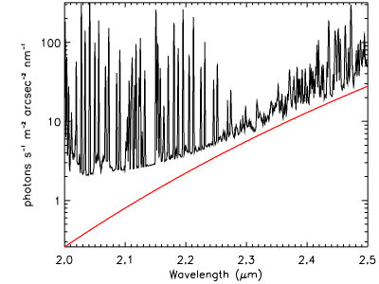
Figure 18 Background in the K band due to point design NGAO system cooled to 258 K (red) compared to that due to the sky plus telescope (black), assuming a total telescope emissivity of 0.10.

Table 20 Emissivity and temperature of each element in the IR science path.
Component | Effective emissivity | Temperature
CaF₂ window bulk emission | 7.5 x 10⁻⁴ | 273 K
CaF₂ window reflection | 0.02 | 258 K
Rotator mirrors (3) | 0.03 x 3 | "
Off-axis parabolas (2) | 0.03 x 2 | "
Deformable mirror | 0.03 | "
IR/visible dichroic bulk emission | 5 x 10⁻⁴ | "
IR/visible dichroic reflection | 0.05 | "
ADC prisms bulk emission (2) | (1.5 x 10⁻³) x 2 | "
ADC prism reflections (2) | 0.02 x 2 | "
IR dichroic reflection | 0.05 | "
Science camera CaF₂ window | 5 x 10⁻⁴ | "
Total | 0.37

RMS Wavefront Error Budget
The flow down of residual wavefront error performance requirements to system and subsystem design parameters is facilitated through the use of residual wavefront error budgets. Increased understanding of current LGS AO systems, gained through extensive experimentation and analysis of on-sky performance, has refined the development of wavefront error budgets in practical applications. For NGAO planning purposes, we have developed a number of wavefront error budgets as guidelines for the design trade studies to be performed in the System Design phase.

We chose here to organize the discussion of wavefront error budgets into high spatial frequency (high-order) and low spatial frequency (low-order) error terms, because the impact of these terms on AO system performance differ. High-order terms typically scatter light away from the diffraction-limited core of the point spread function (PSF), whereas low-order aberrations blur the core, but retain useful science information within a narrow angular radius around the target. Tip/tilt aberrations are the lowest order aberrations and typically have the effect of blurring the diffraction limited core by 5-50 milliarcseconds (the natural diffraction limit at a wavelength of 1.65 microns is 31 mas for the Keck telescopes). Details regarding the calculation of each of the high- and low-order error budget terms are described in Appendix B. Wavefront Error Budget Terms.

The applicability of NGAO over the viewable sky is determined by the availability of NGS capable of providing low-order wavefront information with sufficient fidelity to maintain overall performance. NGAO, like all LGS AO systems, will be usable over the entire viewable sky. However, it's delivered performance will vary as a function of the specific NGS constellations available in the direction of each science target. Thus, we will typically quote the percentage of sky correctable at a particular performance level, as the sky fraction.

In each of the specific error budget cases described below, we take the liberty, on a point by point basis, of independently optimizing the high-order and low-order wavefront sensor sample rates to find the optimal balance between quality of wavefront measurement and latency in the application of the AO system correction. While truly continuous optimization of detector sample times is usually not available, experience with existing systems has shown that a finite set of 5-10 sample rates is sufficient to run near peak performance levels.

The bottom-line results of the following sections are summarized in Table 21.

Table 21 Performance summary for the Keck NGAO point design for several key science cases.
Science Case  (typically under median conditions) | AO mode | Seeing | Field of View (arcsec) | Wavefront Error  (nm, rms) | Corresponding Guide Star Brightness or Sky Fraction
Io | 1 NGS | Median | 1" | 105 | m_{V} = 5.5
"Best-conditions" narrow-field | 5 LGS | Superior | 2" | 97 | 20%
KBO | 5 LGS | Median | 2" | 141 | m_{H} = 15.75
Galactic Center | 5 LGS | Median | 10" | 194 | m_{H} = 8.8 (IRS 7)
Field Galaxies | 10 LGS | Median | 2" | 329 | 30%

Narrow-field science with LGS and tip/tilt NGS stars (KBO science program)
NGAO will support multiple sources of low-order wavefront information, augmenting the higher-order wavefront aberration estimate provided by the LGS beacon asterism. In the simplest observing mode, the science target itself is used to determine the missing tip/tilt and focus information. In this case, there is no anisokineticism to degrade the value of the tip/tilt measurement and no angular anisoplanatism to compromise the sharpening of the low-order aberration source. A typical error budget for this case, assuming a target having m_{H} = 15.75 and science field of view of only 2 arcsec (e.g. OSIRIS observations), is shown in Figure 19.

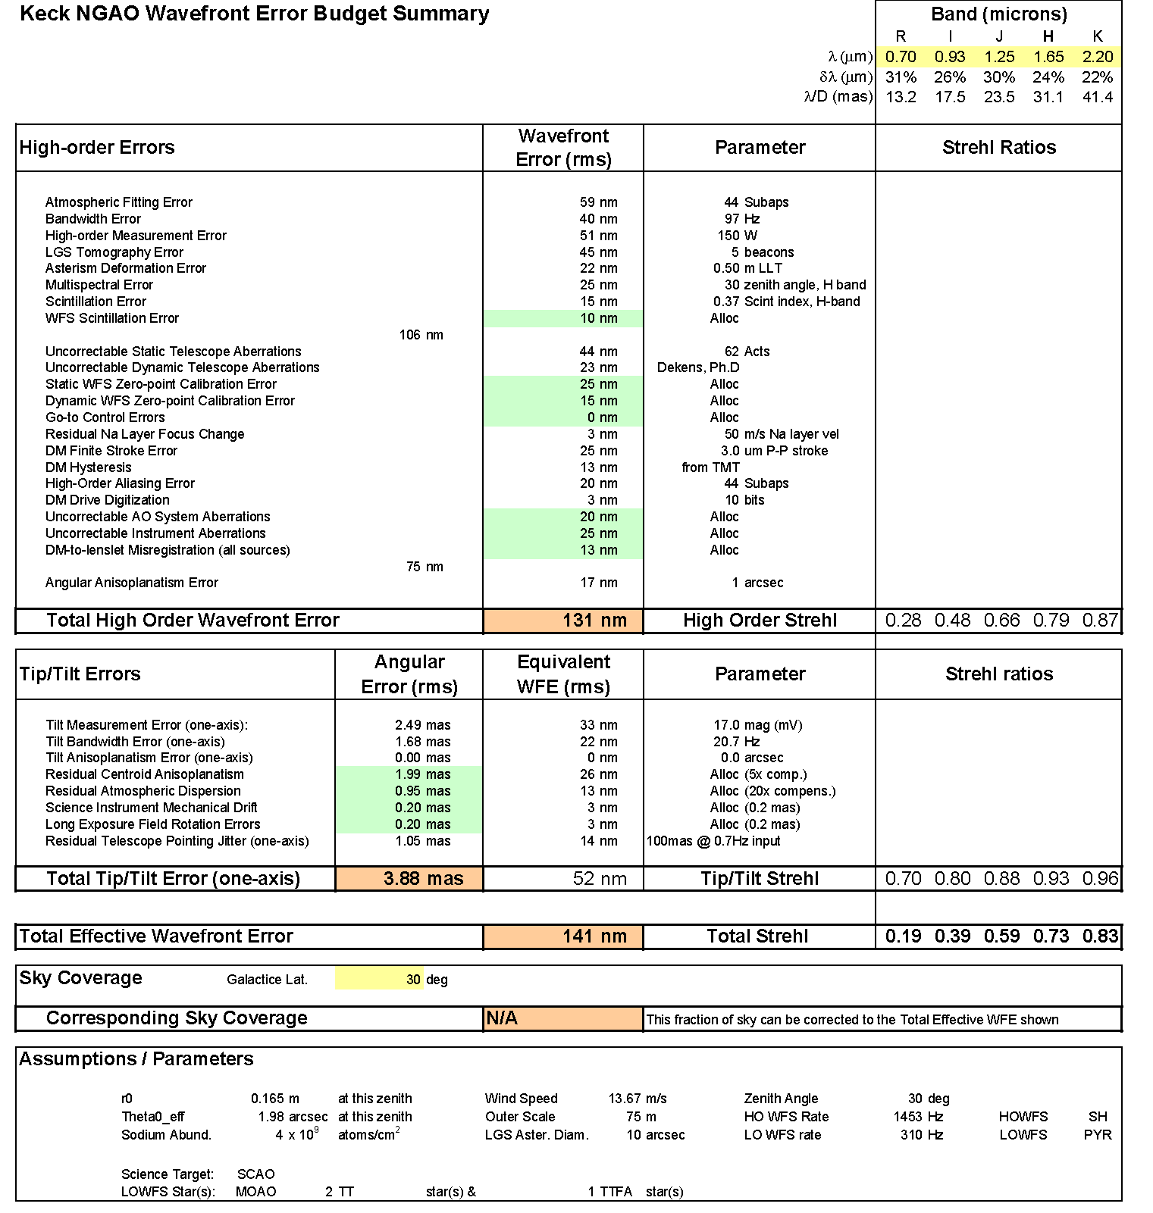
Figure 19. Error budget summary for LGS mode having an on-axis tip/tilt reference source, corresponding to an observation of a KBO having m_{H} = 15.75, in median seeing conditions. Error terms highlighted in light blue are allocations; other terms are based on point design parameter choices.

When the science target is fainter than approximately m_{H} = 17, it is often better to use natural field stars to provide low-order wavefront information. The performance behavior of the NGAO point design, making the optimal choice of target or field star, is shown in Figure 20 for a variety of sky fractions. We assume the use of two MOAO-compensated tip/tilt stars and one MOAO compensated tip/tilt/focus/astigmatism star for these results.

A classically scheduled KBO observing program (e.g. one in which telescope allocations are made in quanta of full-nights), would likely follow the behavior of the 30% sky coverage curve. Although multiple targets would need to be observed during any one night, some optimization within the night to catch favorable target appulses with field stars could be arranged (A. Bouchez, private communication).

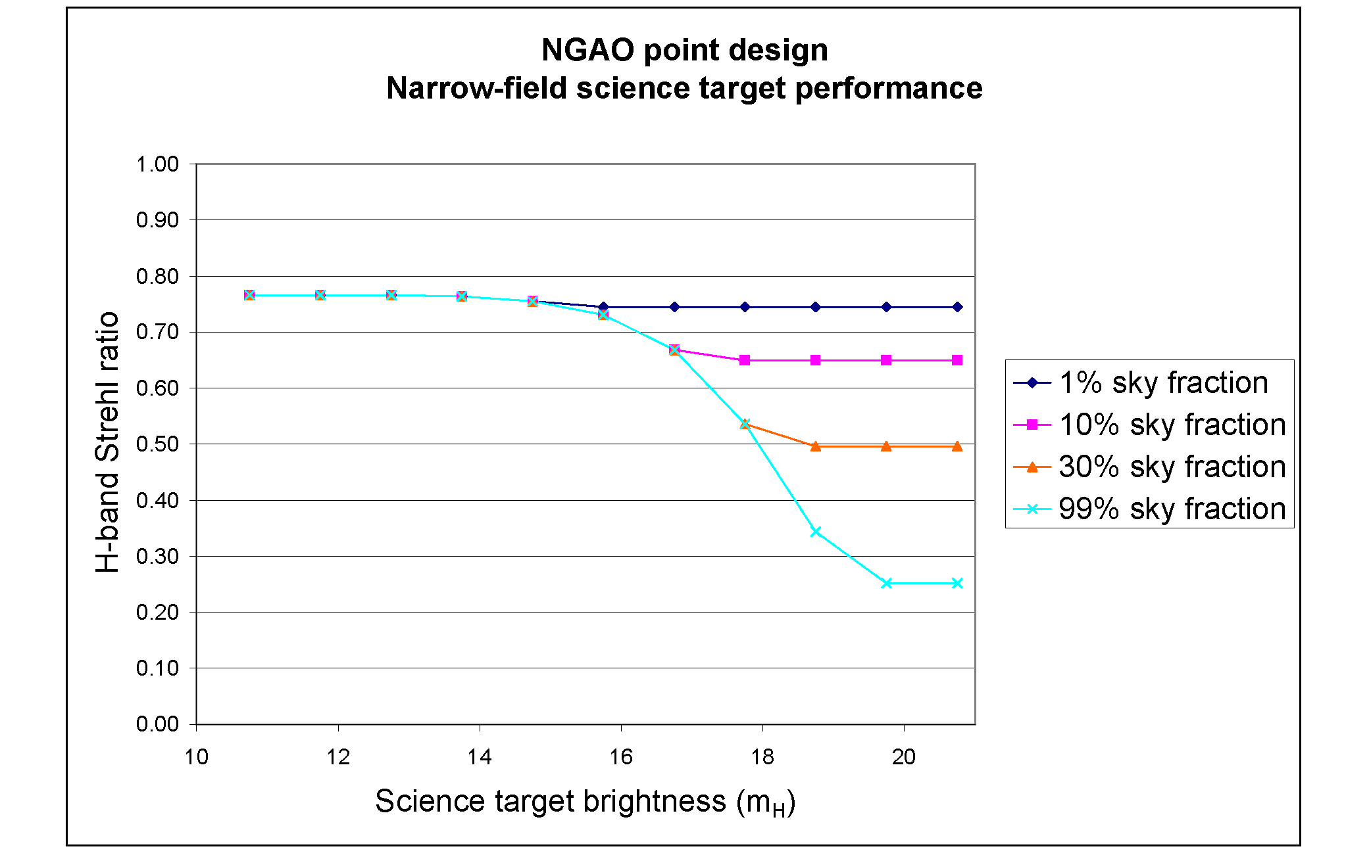
Figure 20. NGAO point design performance vs. KBO target brightness. For compact narrow-angle targets brighter than about m_{H} = 17, it is favorable to use the target itself for low-order wavefront information. For fainter targets, use of field NGS stars is preferred. The excellent performance for large sky fraction relies on MOAO compensation of the low-order guide stars and variable control of the LGS asterism radius (between 10 and 50").

Moderate-field science with LGS and bright tip/tilt NGS star (Galactic Center program)
The Galactic Center (GC) offers a different challenge than that posed by the KBO observations. For the GC case, we have a more challenging geometry, with observations from Keck not climbing higher than a zenith angle of 48°. Furthermore, we are interested in science field of view of 10 arcsec, which increases the anisoplanatism in a single-conjugate AO system correction. (A dual-conjugate MCAO corrected field of view would have similar performance to the following SCAO science results, with a reduced value of the angular anisoplanatism error term. In the case shown below, this would reduce the total WFE from 192 nm rms to 172 nm rms. The detailed trades between SCAO and MCAO for GC science will be performed during the NGAO System Design phase.)

On the other hand, the GC has as a resource an extremely bright and nearby infrared low-order wavefront guide star, IRS 7. Using IRS 7 with the NGAO point design infrared pyramid low-order wavefront sensor essentially eliminates the tip/tilt error contribution to the overall error budget, as shown in Figure 21.

The performance on the GC in the presented case of median seeing conditions is dominated by high-order wavefront measurement error. GC observations in these conditions are being limited by our point design choice of 150W of sodium laser power. Figure 22 presents the variation in H-band Strehl ratio as a function of seeing conditions, as indicated by the Fried parameter, r₀. As the seeing improves, the contribution to the error due to finite laser guide star power falls, so that in good conditions, performance comparable to that nearer to zenith in median conditions is obtained (as low as 135nm rms error in 0.33 arcsec seeing conditions (r₀ = 30 cm)).

Wide-field deployable IFU science with LGS with off-axis tip/tilt guide star (GOODS-N program)
The study of the assembly and evolution of field galaxies in the GOODS-N field poses yet another challenge to the NGAO system. GOODS-N has been chosen specifically to avoid bright natural stars, making high Strehl ratio performance over large sky fraction difficult. This is compounded by GOODS-N relatively large zenith angle as seen from Mauna Kea.

We present in Figure 23 an example error budget for deployable integral field unit (d-IFU) imaging and spectroscopy in the GOODS-N field, in this case invoking a total of 10 laser guide star beacons having changeable asterism diameter. Again, the large angle away from zenith hurts the overall performance. To better understand this behavior, we have plotted in Figure 24 the J-band performance as a function of sky fraction, for three different zenith angles, 10, 25 and 45° (the last corresponding to a GOODS-N zenith angle as viewed from Keck).

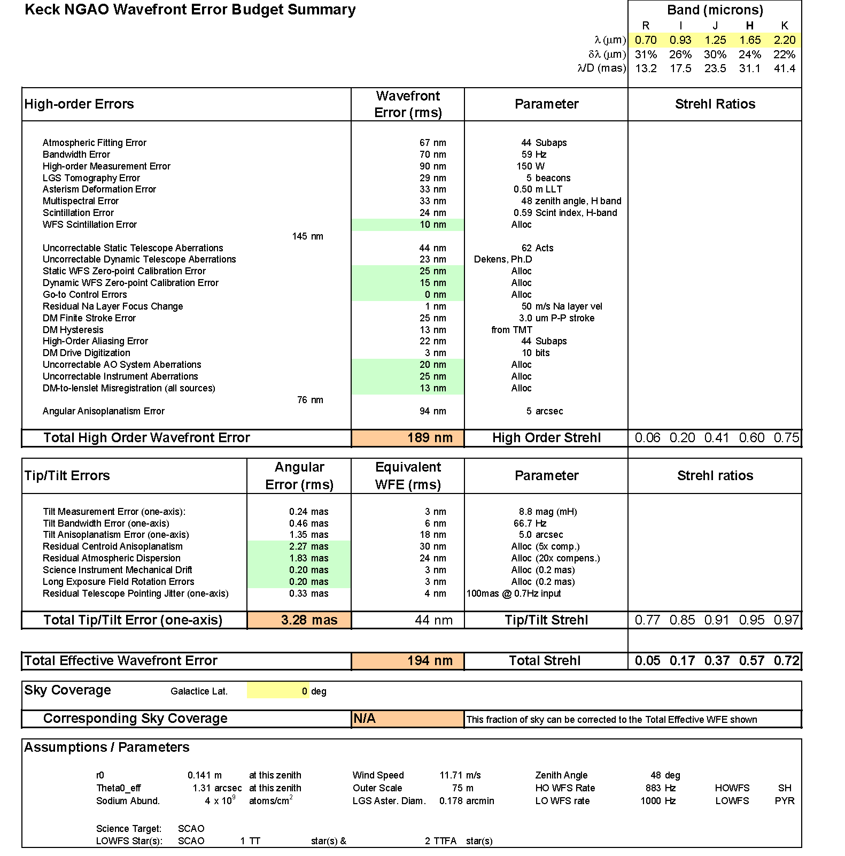
Figure 21. Error budget summary for Galactic Center observations, using a single NGS tip/tilt/focus/astigmatism star IRS 7, in median seeing conditions. Error terms highlighted in light blue are allocations; other terms are based on point design parameter choices.
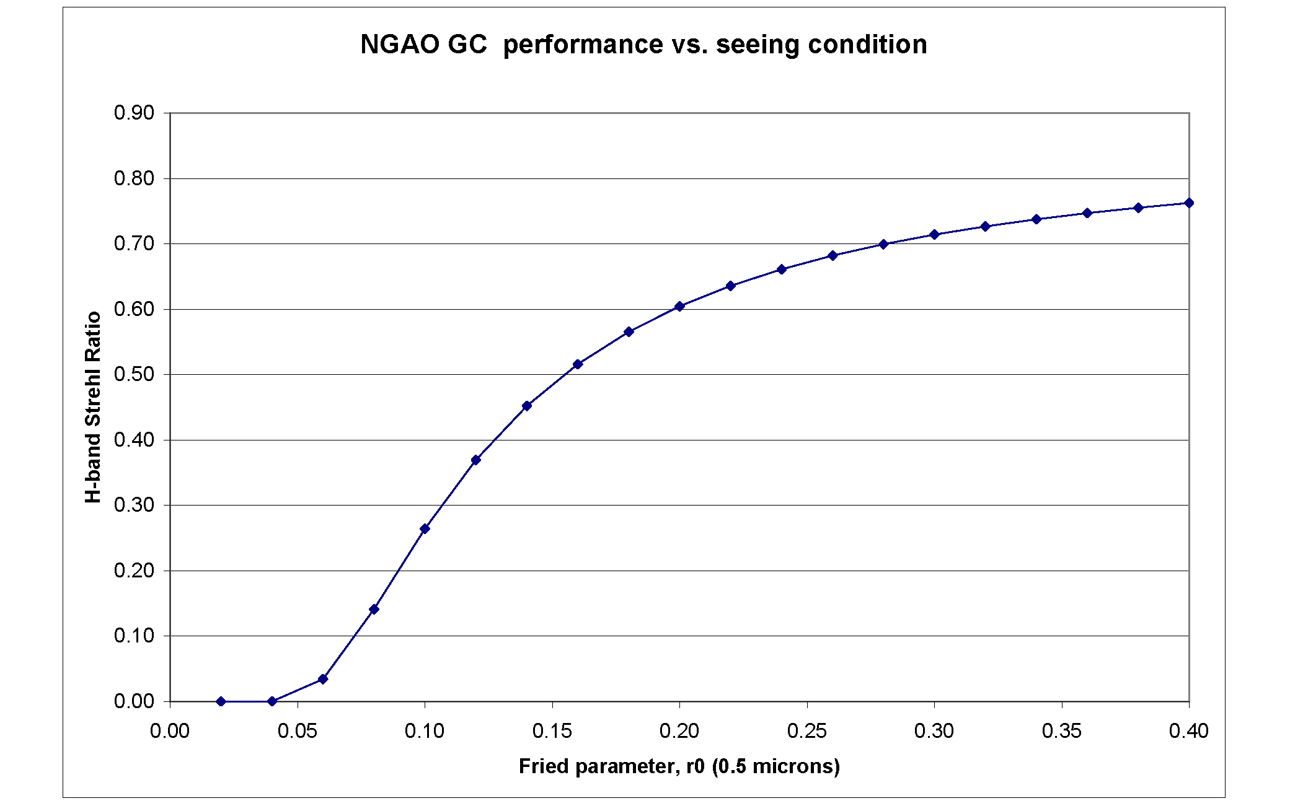
Figure 22. GC wavefront error performance vs. Fried's parameter, r₀, for constant turbulence-weighted wind speed of 14.9 m/s and other parameters as above, with optimal choice of HOWFS and LOWFS camera rates.

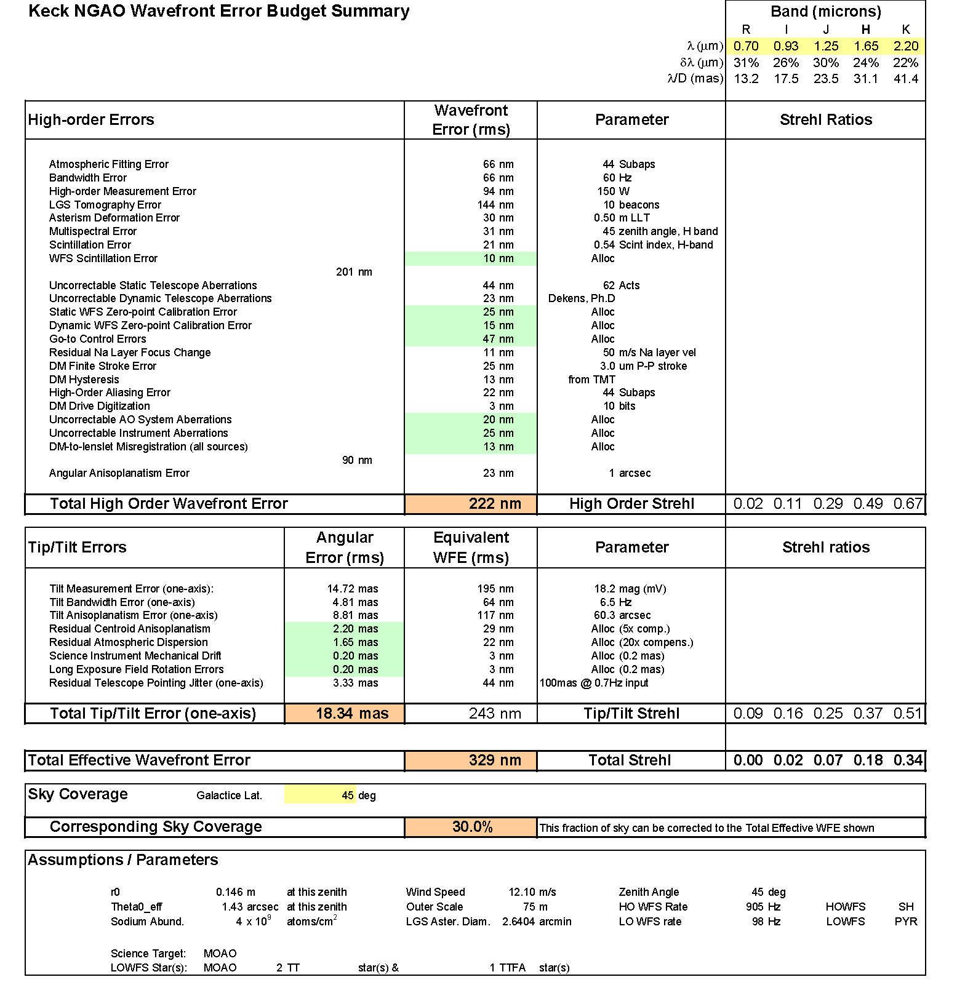
Figure 23. Error budget summary for the particularly challenging GOODS-N field with 30% sky fraction, using a two NGS tip/tilt stars and one tip/tilt/focus/astigmatism star in median seeing conditions. In this particular case, optimum performance is found by distributing the 10 LGS beacons over an asterism of diameter 2.6 arcmin. This helps the performance of the MOAO correction on the tip/tilt stars, at the cost of large tomography error for the science target itself. For smaller desired sky fraction (even for 20%), the optimal asterism diameter is less, improving science target tomography (see Figure 24).

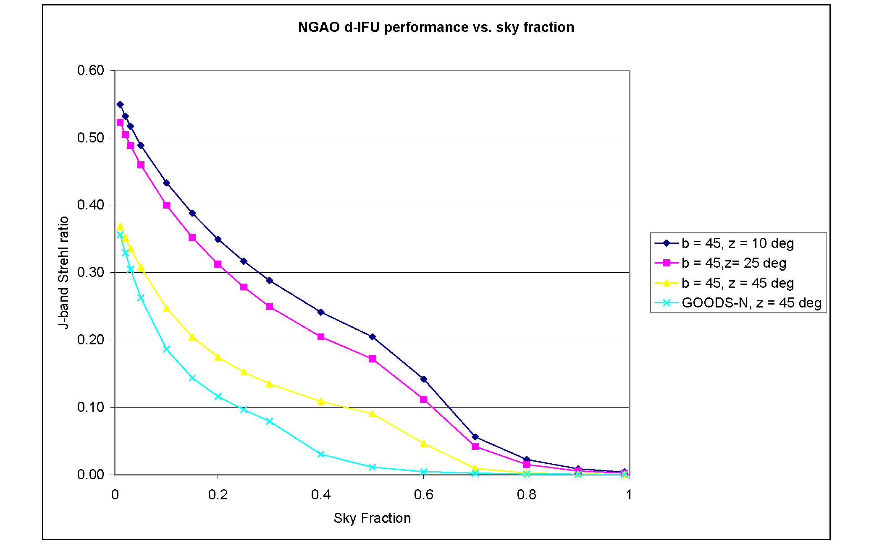
Figure 24. Deployable IFU imaging performance vs. sky fraction, for different zenith angles. NGAO point design J-band Strehl ratio in normal zenith = 10° extragalactic fields would be expected to be thrice the Strehl obtained in GOODS-N, for ~30% sky fraction.

Narrow-field science under the most favorable conditions
Until now, we have generally considered the performance of the NGAO point design in median seeing, wind speed, and sodium abundance conditions for practical observing geometries. It is informative, however, to consider the very best performance to be expected in the most favorable conditions, as both a reflection of the potential 'discovery space' of NGAO and to understand the issues Keck NGAO will face as it follows an upgrade path toward better visible-light performance. In Figure 25 we present just such an 'idealized' error budget, assuming 0.25 arcsec seeing, 1/3rd the median wind speeds, high sodium abundance, zenith angle = 5°, and galactic latitude = 10°. While this is admittedly a rare coincidence of superior conditions and benign target distributions, these conditions are known to occasionally occur on Mauna Kea.

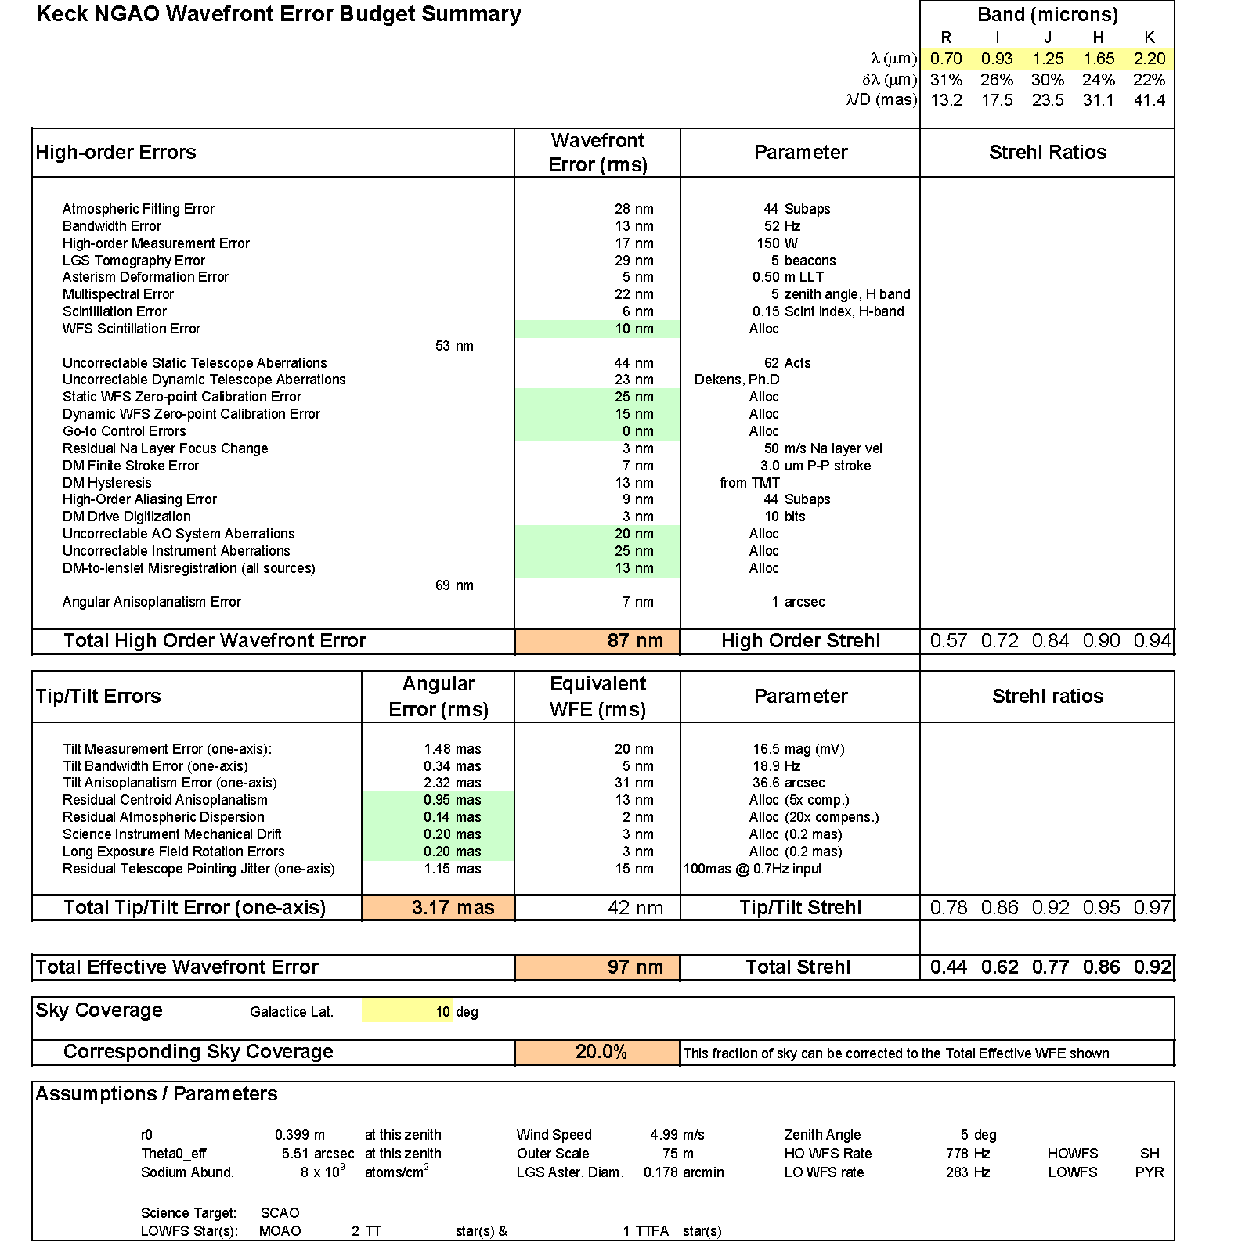
Figure 25. "Best-case" error budget under the most favorable conditions on Mauna Kea. Uncorrectable telescope, instrument, and NGAO aberrations dominate, followed by several flavors of calibration error. In the absence of these implementation errors, the entire visible-light spectrum of science wavelengths opens up to diffraction-limited discovery science.

In the best-case error budget, we see that NGAO's ability to correct static telescope aberrations is the largest single contributor (at 44 nm rms), greater than all sources of tip/tilt error combined. Next in contribution are the combination of uncorrectable internal aberrations in the science instruments and NGAO system itself, followed by zero-point calibration errors, and, in this model of the telescope, uncorrectable dynamical aberrations. In almost all ways, the atmospheric contributions to the error budget have dropped out, leaving us with a system limited by our own instrumentation and the Keck telescope itself. Currently, we know of certain cases, e.g. NIRC2's mid-scale camera, where internal aberrations are in fact the limiting factor in wavefront error performance.

This raises a key question for the System Design phase of the NGAO project, namely 'what is the extent to which the NGAO program requires facility upgrades to the telescope and existing instruments to realize it's potential?' Ensuring that the performance of NGAO is not unduly degraded will require consideration of questions such as 'can existing instruments be appropriately upgraded for NGAO, or is an entirely new suite of instruments necessary?' Similarly, we will consider whether improved diagnostics and, potentially, improved control of the Keck primary mirror is justified and/or necessary to meet the NGAO science goals.

Narrow-field NGS Observations of Io
Natural guide star (NGS) adaptive optics, first instantiated at Keck Observatory in 1999, remains an interesting mode of operation for both scientific and engineering purposes. Scientifically, the NGAO performance guiding on bright NGS will exceed that available in any foreseen LGS observing mode. The crossover brightness between NGS and LGS, the star brightness at which these two modes are comparable, is today about m_{V} = 11. In other words, for NGS fainter than m_{V} = 12, today's observer would typically obtain better performance in LGS mode. With the brighter laser return expected for NGAO, this crossover brightness will likely rise to m_{V} = 8, making the use of NGS mode more specific to bright stellar targets and the brightness compact solar system objects (such as the Galilean satellites of Jupiter).

To explore the potential performance on relatively bright NGS, we present an error budget for Jupiter's moon Io in Figure 26, returning to our median atmospheric conditions and guiding both high-order and tip/tilt information from Io itself. Again, the NGAO performance is expected to be excellent, reliably providing good Strehl ratio for R-band observations. Unlike the previous case of LGS operating in excellent seeing, the Io case considered here benefits from the (expected) absence of several LGS-related terms in the error budget. This is offset by the finite diameter of Io, but we assume here good calibration of the high-order wavefront sensor so that no significant degradation due to e.g. unknown centroid gains, is induced.

This particular example allows NGAO to utilize all N=62 subapertures available in the point design. During the System Design phase, we will consider fainter NGS performance and consider issues such as the case for optimizing NGAO for faint (e.g. m_{V} = 12-15) NGS.

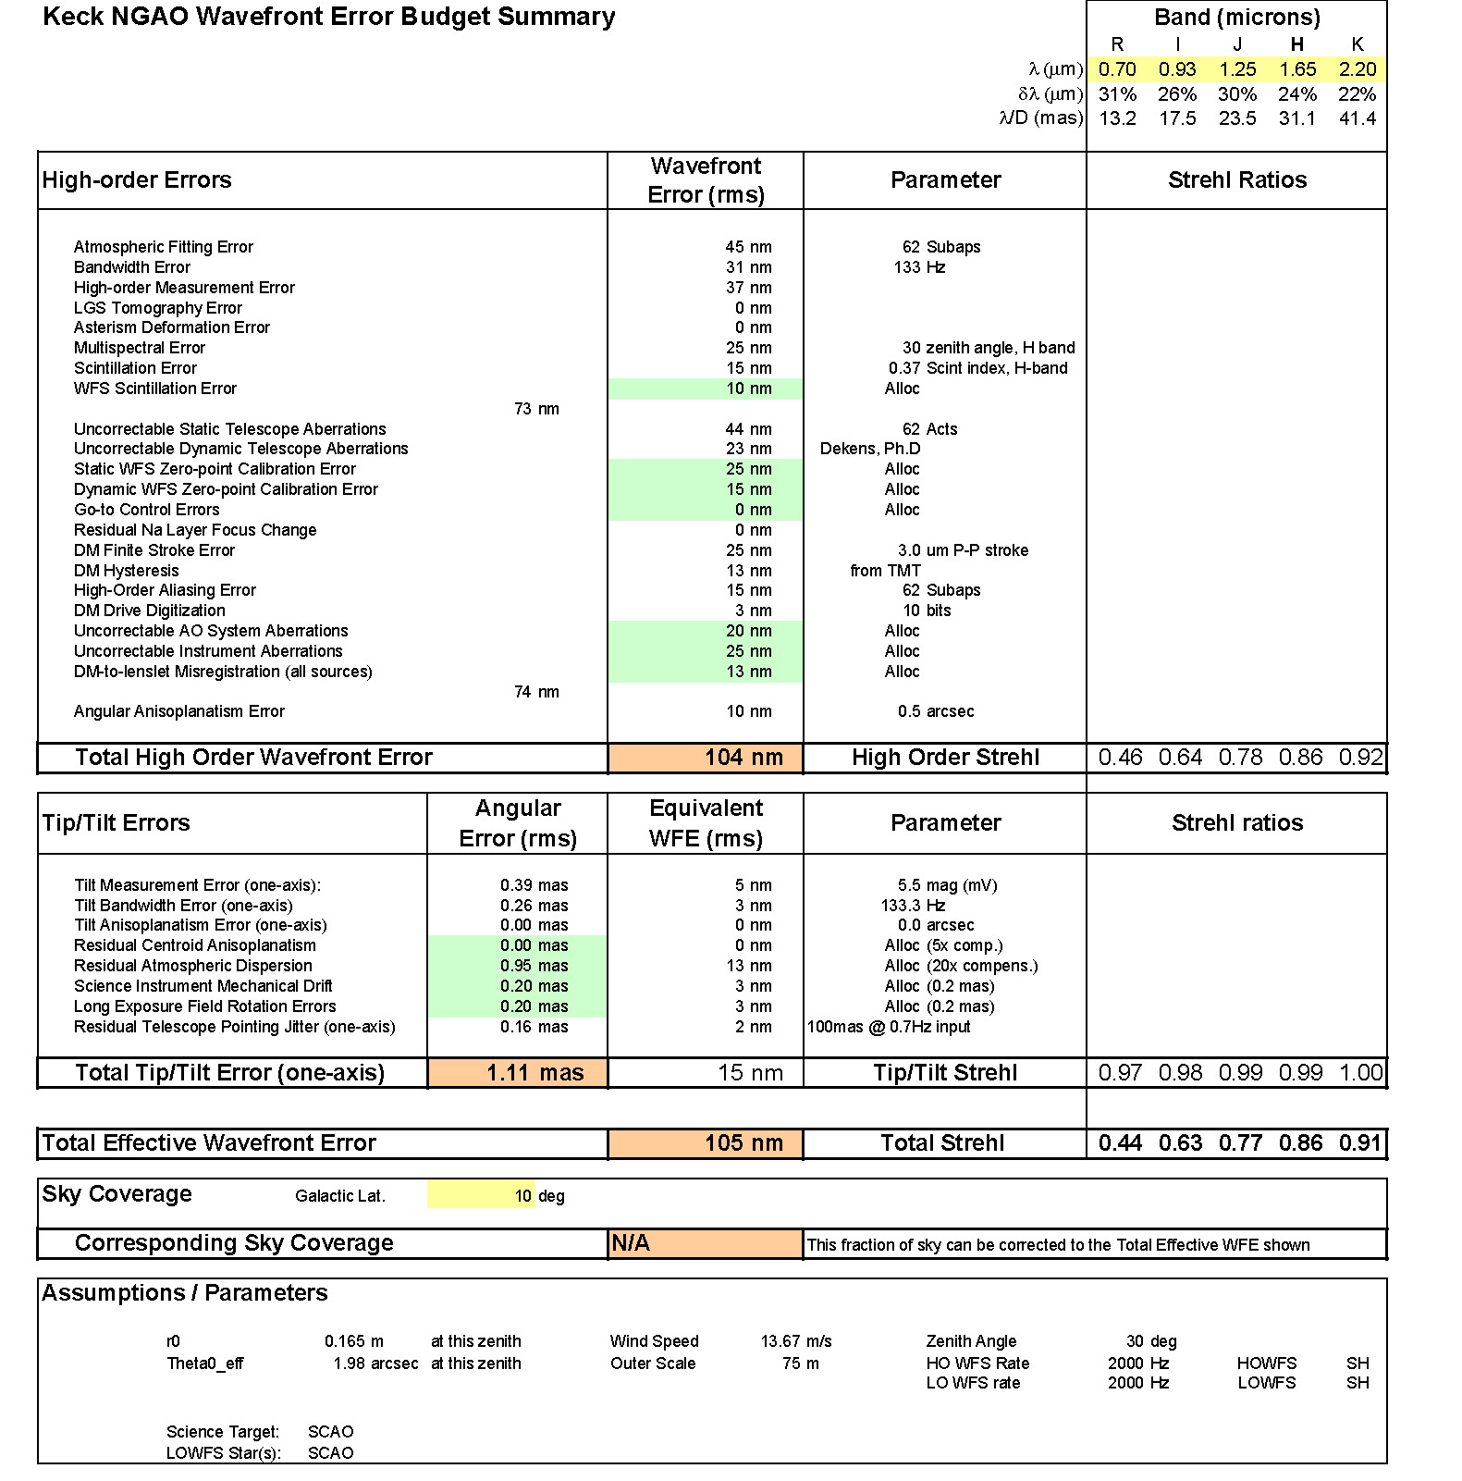
Figure 26. Error budget for NGAO observations of Io in N=62 subaperture NGS mode and median seeing and wind speed conditions.

Point Spread Function Simulations
Several sets of point spread functions (PSF) for the NGAO system were generated using computer simulations. The simulations were intended to represent the image morphology of various high Strehl AO systems for determining the feasibility of example science cases. The simulations were not intended to be high fidelity representations of any “point” or system design. Many effects that must be evaluated in the final system error budget are not currently included in the computer models and were left out of the PSF simulations. However it is hoped that, the simulations are still useful for determining the level of correction that is needed for a particular science case to be feasible

Linear Adaptive Optics Simulator Code
The PSF were generated using a computer simulation developed at the Thirty Meter Telescope project office by Brent Ellerbroek and Luc Gilles. The computer code: Linear Adaptive Optics Simulator (LAOS) is a Monte Carlo simulation of a basic multiple laser guide adaptive optics system. Like all Monte Carlo simulations LAOS determines the performance of an AO system by using random number generators to simulate random processes in the physical system then averaging over these random events to determine the likely behavior of the system. LAOS uses random number generators to simulate atmospheric turbulence and noise in the photo detection process. Each randomly generated wavefront is measured and corrected using the computer in a way that is analogous to how it is corrected by the actual AO system.

The LAOS simulation is coded in the MATLAB computer language, a high level language optimized for numerical computation. The LAOS simulation’s distinguishing feature from other AO Monte Carlo simulations is its minimum variance wavefront estimators using sparse matrix techniques (Ellerbroek, 2002). The user can select between two sparse matrix solvers, a computationally efficient multigrid preconditioned conjugate gradient (MG-PCG) algorithm (Ellerbroek, Gilles, and Vogel, 2003) or (ii) a sparse Cholesky solver (Ellerbroek, 2002). Further details of the LAOS code are discussed in its user manual published by TMT. The LAOS code has been checked by Ellerbroek and Gilles, against analytical models of AO performance on 8-m telescopes.

Tomography:
The correction of the atmospheric turbulence is performed in two steps, the first is an estimation of the three dimensional turbulence above the telescope (tomography), followed by a fitting of the estimate to user selectable number of tip/tilt and deformable mirrors. In the tomography step the volume turbulence is estimated from a set of NGS and LGS measured with Shack-Hartmann sensors. This measurement is then used to generate the commands to a set of tip/tilt and deformable mirrors so that the residual wavefront error is minimized over a set of user selectable scientific observation points in the field of regard of the telescope. LAOS fitting step can be performed for both multiconjugate scenarios (MCAO) using a set of mirrors effectively located at different attitudes above the telescope pupil or multi object scenarios (MOAO) where independent deformable mirrors are used to correct each science direction.

Atmospheric model and propagation:
The atmospheric turbulence is modeled as a series, typically 7, of the infinitely thin phase perturbations or phase screens located at altitudes above the telescope pupil corresponding to strong layers of atmospheric turbulence. Each screen is statically independent random realization of the turbulence. The statistics of each screen are matched to Kolmogorov turbulence with or without a finite outerscale. The time evolution of the atmosphere is simulated by shifting the screen between updates of the AO control loop that are consistent with the wind velocity measured at altitude. The wavefronts for both NGS and LGS are calculated by summing the phase perturbations along ray paths from the source through the phase screens to the entrance aperture of the telescope. The LGS wavefronts are rescaled to simulate the conical ray paths that finite range LGS take through the atmosphere. This ray optics model of the atmospheric is generally considered appropriate when observing at astronomical sites where the wavefront amplitude variations (scintillation) are small.

DM and WFS models
Any simulation on an AO system must simulate the performance by a series of approximations. The LAOS code simulates the actuators on DMs by linear spline between actuator locations. This results in some increase in the AO system actuator fitting error over actuator models that use Gaussian functions or higher order polynomials.

The wavefront sensor is simulated by the calculation of the average gradient of the wavefront phase over the subaperture area (technically it is the line integral of the phase around the boundary, but these are equivalent by Green’s theorem). This gradient is used as the noise free measurement. Other AO simulations actually calculate the image from each lenslet subaperture by a series of parallel diffraction calculations, one for each lenslet. In LAOS using the wavefront gradient directly results in a sensor model that is perfectly linear for all wavefront slopes. Further the response is not a function of the seeing or the size of the LGS spot and as such is immune to calibration errors that occur when the spot size is different than the spot size used to calibrate the system. Noise in the measurement process is simulated by a Gaussian noise added to the gradient measurement. The user can set this value to simulate the magnitude of the guide star. For laser guide stars the effects of spot elongation are modeled by a directionally dependent noise for the gradient measurements.

The AO control loop delay can be set to zero in LAOS to simulate perfect temporal correction (infinite bandwidth control system). Delays can also be added to the control loop to simulate the delay between sensing and correction that occur in any realistic control system. LAOS is unique in that it uses wavefront estimators (reconstructors) that require knowledge of the open loop wavefront error. LAOS simulation estimates the open loop wavefront error from the closed loop measurements and the shape of the deformable mirrors. It has been shown that this type of control results in closed loop stability and robustness against system errors, see Gilles 2005 for more detail on pseudo open-loop control.

Segmented telescope primary (M1)
The LAOS simulation has the ability to simulate the effects of static aberrations located at the telescope primary mirror (M1). The aberrations are defined on segments that tile the entrance pupil of the telescope. The aberrations can be the result of positioning the segments relative to one another and higher order aberrations of the individual segment shapes or “optical figures” up to fifth order Zernike polynomials. The rms values of these segment errors are used to generate a random set of errors for the segments on the telescope. The same error set was used for all simulations. The rms values used were taken from typical values from measurements from the PCS system on the two Keck telescopes. Its is important to note that these errors don’t correspond to the exact values on either Keck I or Keck II but should give a reasonable estimate to the performance expected from using AO systems behind one of these telescopes.

Simulations for NGAO science case
All simulations for the NGAO science case were done using the November 2005 release of the LAOS code. It was modified to accommodate a Keck pupil in the PSF computations but the AO simulation was conducted on a round 11 m pupil. The resulting AO corrected wavefront was masked to a Keck segmented pupil and Fourier transformed to produce the final PSF. The segment gaps were accounted for using the gray pixel approximation of Troy and Chanan. A circular secondary obscuration was added to the final pupil mask; secondary supports (spiders) were not modeled.

Simulation of narrow field of view AO, on axis PSF
The original baseline for NGAO (then KPAO) performance was 120 nm rms wavefront error delivered to the user as detailed in KAON 237. This level of performance is a significant enhancement over both the current Keck NGS performance, 250 nm, and the LGS performance, 350 nm. As mentioned in the introduction these simulations were undertaken to simulate the performance gains when observing with an AO system with sub 200 nm rms wavefront error. The following terms, see Table 22, were not included in the modeling of the PSF but they are included in error budgets for the current proposed point design.

The terms left out of the PSF modeling account for about ~80 nm in the higher order error budget of the point design. The terms included in the point design error budget and in the simulations total for the same seeing conditions would total about ~70 nm in the point design. In order to achieve the mandated 120 nm for the simulations of the PSF, the AO systems that were simulated have fewer actuators, more noise, lower bandwidth and fewer lasers than in the point design. The resulting higher order error was 90 nm rms; when this is combined with an 8 mas tracking blur the resulting total wavefront error is 120 nm.

Error Term | Point Design | PSF simulation | Comments
Atmospheric Fitting Error | Yes | Yes
Bandwidth Error | Yes | Yes
High-order Measurement Error | Yes | Yes
LGS Tomography Error | Yes | Yes
Multispectral Error | Yes | No
Scintillation Error | Yes | No
WFS Scintillation Error | Yes | No
Uncorrectable Telescope Aberrations | Yes | Partial | Only lower order Zernikes
Static WFS Zero-point Calibration Error | Yes | No
Dynamic WFS Zero-point Calibration Error | Yes | No
Residual Na Layer Focus Change | Yes | No
DM Finite Stroke Error | Yes | No
DM Hysteresis | Yes | No
High-Order Aliasing Error | Yes | Yes
Uncorrectable AO System Aberrations | Yes | No
Uncorrectable Instrument Aberrations | Yes | No
DM-to-Lenslet misregistration | Yes | No
Table 22 The various terms used in the current point design error budget for NGAO.

In addition to the KAON 237 wavefront error of 120 nm, similar simulations were run with 140 nm rms wavefront error and 170 nm wavefront error (these are sums of higher order wavefront error and tracking errors of 5 mas). A single LGS simulation was also run that produced 250 nm wavefront error as a simulation of the “best possible” performance with the upgraded Keck I LGS AO system. The sets of simulations all represented one second of integration. A set of 10 second integrations were produced for the 120 nm wavefront case. These PSF were similar so that it was felt that the one second integration time was an adequate representation. A grid of simulation PSF is for the 120 nm case is shown in Figure 27.

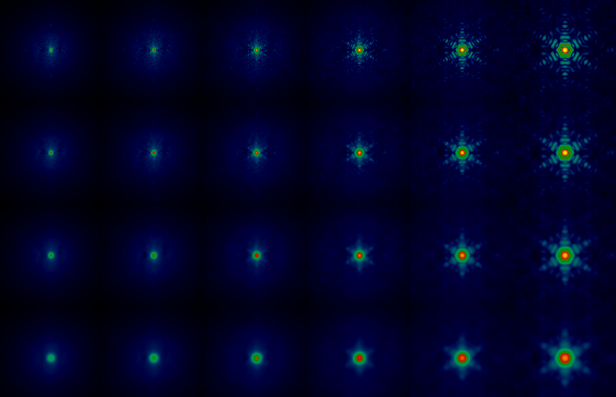

Figure 27 Grid of 120 nm PSF from LAOS simulations, each column represents a different wavelength band columns starting from the left are wavelengths of 0.55 μm, 0.65 μm, 0.85 μm, 1.2 μm, 1.65 μm, 2.2 μm, corresponding to the centers of the V, R_{c}, I_{c}, J, H, and K photometric bands. Each row corresponds to different tip/tilt errors starting at the top single axis tip tilt errors are: 0 mas, 8 mas, 15 mas, and 25 mas. Each individual PSF is approximately 0.8 arcseconds on a side. The total rms wavefront error for the second row down from the top is 120 nm.

High contrast simulations
At the request of the science teams some additional simulations were produced to access the contrast obtainable when observing dim targets. A typical science observation of this type would be the detection of dimmer companion in a binary brown dwarf. The simulations included running the narrow field case for a five second integration. The effects of an idealized coronagraph were simulated by applying a Blackman window to the pupil of the telescope. This apodization effectively suppresses diffraction at angular scales greater than ~5 times the diffractions limit (λ/D) at the expense of degrading angular resolution. While such an apodization is not easy constructed it is similar in performance to a Lyot coronagraph and is easier to simulate. In addition the apodization still allows the central star to be visible in the simulation PSF, but with suppressed wings of the diffraction pattern, this should make is possible to combine the PSF with a model of the science object.

Seeing variability simulations
In addition to the KAON 237 based simulations for 120nm wavefront error with good seeing, a set of ten one second simulations with different values of r₀ were produced to estimate the effects of observations made in changing atmospheric conditions. The values of r₀ range from 9 cm to 24 cm at 0.5 μm wavelength.

Future simulations
The current set of PSFs are only in approximate agreement with the point design error budget. This is not surprising since the PSFs were simulations to match the wavefront error from KAON 237. At present almost 90 nm of wavefront error (only increase high order wavefront error from 100 to 135 nm rms) is not included in the simulations. We will be working with the TMT project office to include these effects in the LAOS simulations. The present May 2006 LAOS release includes a physical optics model for the wavefront sensor and now includes errors for three of the eleven terms not currently included in the simulation. The other five error terms will be added over the summer and fall of this year. It is not planned to include either scintillation or multispectral error in the LAOS simulation but these are relatively small terms in the final error budget.

Predicted Point Source Sensitivities
Estimates of the point source sensitivity of generic visible and infrared imaging cameras fed by the point-design NGAO system, as a function of total wavefront error, is illustrated in Table 23. The measured performance of LRIS and NIRC2 are faithfully used as the basis of these calculations, with only the pixel scale varied to sample the diffraction limit at each wavelength. The expected transmission and thermal background of the NGAO system (cooled to 258K) are included, as is the effect of varying optimum photometric aperture from diffraction-limited to seeing-limited in the low Strehl limit.

Filter | Z (magnitudes) | S (mag. arcsec⁻²) | Point source limiting magnitude  (5σ in 1 hr of integration)
Filter | Z (magnitudes) | S (mag. arcsec⁻²) | 105 nm | 140 nm | 195nm | 330nm
V | 27.09 | 21.3 | 29.9 | 28.7 | 27.6 | 27.6
R | 27.10 | 20.4 | 29.9 | 29.0 | 27.1 | 27.1
I | 26.98 | 19.3 | 29.6 | 29.0 | 27.7 | 26.5
J | 25.47 | 16.1 | 27.3 | 27.0 | 26.5 | 24.4
H | 25.51 | 13.8 | 26.0 | 25.8 | 25.6 | 24.4
K’ | 24.84 | 13.5 | 25.3 | 25.2 | 25.0 | 24.4
L’ | 23.60 | 4.31 | 19.5 | 19.5 | 19.4 | 19.2
Ms | 21.42 | 1.10 | 16.6 | 16.6 | 16.5 | 16.4
Table 23: Estimated limiting magnitudes for generic visible and IR imaging cameras behind the point-design NGAO system, for different total RMS wavefront error budgets.

Photometric Accuracy

Astrometric Accuracy

Polarimetry Accuracy

Companion Sensitivity
One key area of operation – both for current generation adaptive optics systems and future AO systems – is high-contrast imaging; studies of faint objects – pointlike companions or diffuse emission from a galaxy or debris disk – next to brighter objects such as stars or AGN. As discussed in section 3.3, there are several scientific areas in which NGAO, with its combination of high Strehl ratio and broad sky coverage – can play a unique role. However, performance in this regime can easily be limited by design choices, particularly in the area of systematic errors; development of a contrast error budget, distinct from the normal Strehl-based imaging error budget, will be important to ensure that NGAO achieves its full potential in this area.

There are several factors that limit high-contrast imaging performance. Detailed treatment of these requires end-to-end models and attention to interactions between the major sources of scattered light, but for the purpose of this discussion and analysis we will treat them as independent. The first – and most fundamental – is the diffraction pattern of the telescope. For the Keck telescope, this is a complex hexagonal pattern containing features from the secondary mirror supports, outer edge of the primary, and gaps between segments. In the NGAO regime, the latter can be neglected, but diffraction from the serrated outer edge is significant. This, however, can be controlled through the use of a coronagraph. Since NGAO high-contrast science emphasizes moderate contrast on bright targets, it is likely that a simple variant of the Lyot coronagraph will meet most science goals. During the design phase we will study various coronagraph architectures to select one well-matched to the Keck pupil and NGAO performance. For this study, we have used simple diffraction analysis and compared the true Keck pupil to an idealized coronagraph represented as a smooth pupil apodization.

The second factor that limits scattered light is the PSF halo caused by residual wavefront errors. To first order, the intensity of this scales as 1-S where S is the Strehl ratio, giving the high-Strehl NGAO a considerable advantage over current systems. This halo is broken up into a pattern of individual speckles which average out over time. On bright targets, the noise from these speckles is the main limiting factor; on dimmer targets, photon shot noise instead dominates. These errors will decrease with longer integration times. We have used the AO simulations described in Section 4.3.3.3, combined with the pupil apodization coronagraph, to predict sensitivity in short exposures and extrapolated these to longer exposure times – which requires that quasi-static errors not dominate. Figure 28 compares the effects of diffraction (from the whole telescope and from the gaps) with residual AO/atmospheric wavefront errors. Residual static errors at the 30 nm level (the middle curve) will require advanced image sharpening/phase retrieval and a stable AO system. Reducing errors to the 10 nm level could require a dedicated high-precision low-bandwidth wavefront sensor, on-the-sky phase retrieval, or similar techniques for monitoring non-common-path errors during science integrations. We will study these approaches during the design phase.
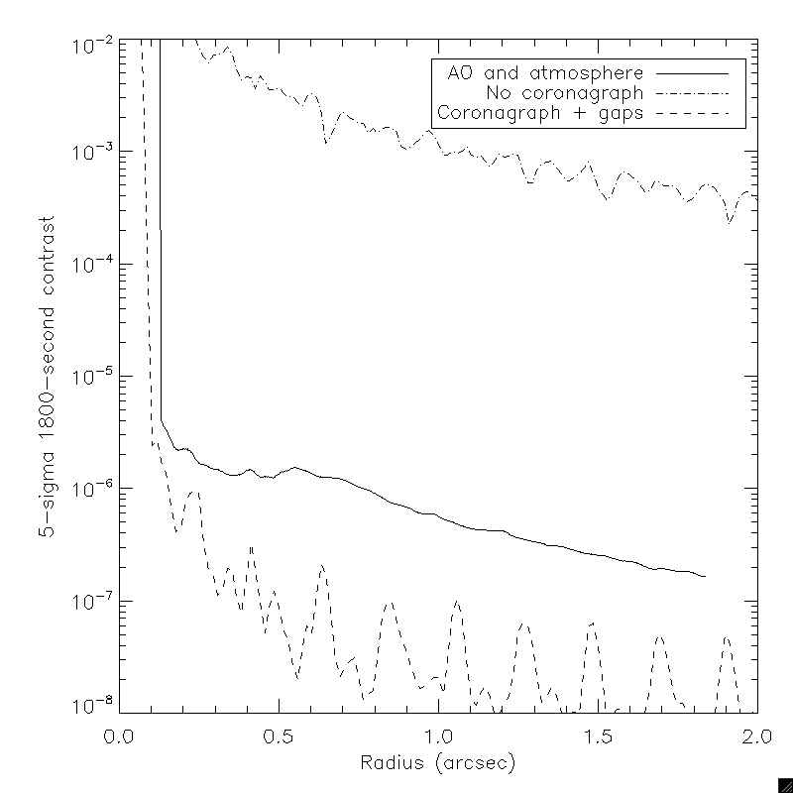
Figure 28: Comparison of different sources of scattered light. The upper curve shows the Keck diffraction pattern. The middle curve shows speckle noise from residual wavefront errors and a near-perfect coronagraph. The bottom curve shows a Keck telescope with no wavefront errors and a coronagraph that removes the effects of diffraction from the outer edge but not from segment gaps.

The final factor, most complicated and also most significant, are residual static wavefront errors – for example, mis-calibrated non-common-path errors – that produce “quasi-static” speckle artifacts. For even brief (~1 minute) integrations, these completely dominate the high-contrast sensitivity of current AO systems. PSF subtraction techniques (e.g. Marois et al 2006) can partially remove these, but generally they evolve on timescales of minutes, too stable to randomly average out but too unstable to be completely removed through PSF reference observations. These errors must be addressed during the design phase. Figure 29 shows the effects of 50, 30 and 10 nm of such NCP errors compared to atmospheric errors in a 1800-second integration.
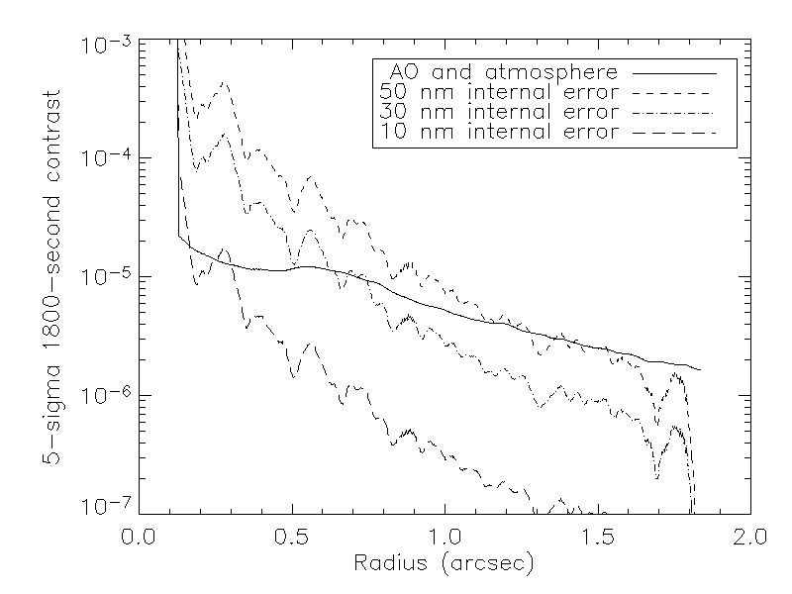
Figure 29: Comparison of the effects of static wavefront errors on NGAO high-contrast performance. Internal errors are simulated as non-common-path optical errors with a -2.5 power spectral density index.

A particularly significant class of static errors are those from the telescope primary mirror. An AO system without a spatial filter to prevent aliasing (Poyneer&Macintosh 2004) will allow some fraction of these to leak through to the final image. For the segmented Keck telescopes, the two largest sources of such error are the “dimples” in the center of each segment and the discontinuities at segment boundaries caused by segment figure errors. Figure 30 shows a comparison between segment aberrations and residual AO/atmosphere errors for a simple AO architecture with a classic Shack-Hartmann wavefront sensor. These errors could significantly limit contrast at small radii. During the system design phase we will study approaches to mitigate these errors, including Lyot masks that block segment edges. These errors can in principal be partially cancelled by the deformable mirror, given sufficient information (Poyneer & Macintosh, 2004); such information could come from UFS segment data, image-plane phase retrieval, or a high-order low-bandwidth wavefront sensor.
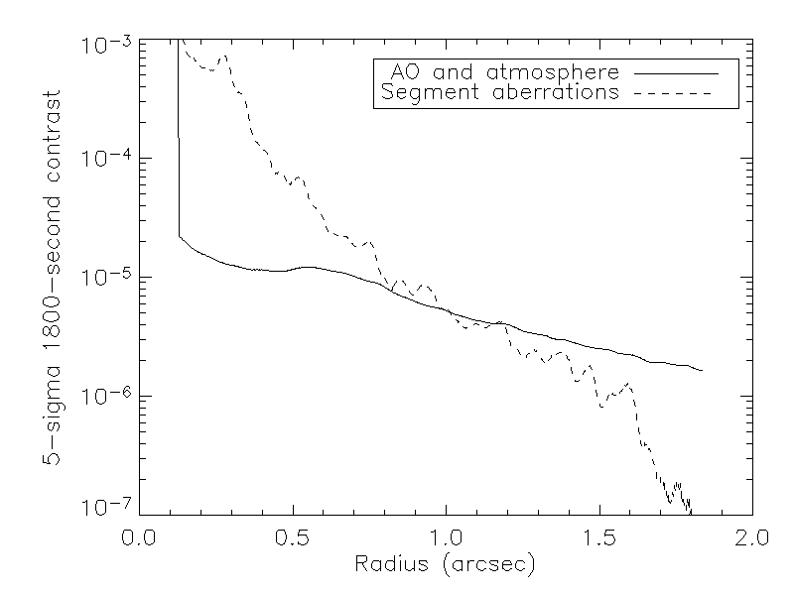
Figure 30: Effects of residual segment aberrations on contrast.

      - Long Exposure Considerations

Observing Efficiency and Up-Time

Science Instruments
In this section we briefly discuss the science instruments for the NGAO system. The focus is on identifying the parameter space defined by the science requirements and identifying instruments that meet these requirements in a straightforward manner.

Parameter Space
[A discussion of the parameter space with diagram(s)]

Overall Concepts
The philosophy for the NGAO instrument compliment is to address the large parameter space offered by NGAO with a selection of simple, specialized instruments. By separating wavelength ranges along natural breakpoints based on optical and thermal design considerations and by providing spectroscopy with integral field units (IFUs) we can meet the science needs without requiring complex multimode instruments. The one exception is a deployable near-IR IFU spectrometer that is of necessity a more complex instrument with a greater number of operating modes.

Instruments are designed for Nasmyth platform operation with a single axis of rotation. The current arrangement of the AO system dichroic “switchyard” will support upward or downward looking instruments and this may be attractive to simplify the instrument design and flexure requirements. Downward looking instruments will be more difficult to access and it appears that the envelope sizes and allowable weights will be more limited as well. Downward looking configurations appear most suited to the imaging instruments, all of which are relatively simple and of modest size.

All of the instruments are based on currently available detector technology with some instruments taking advantage of anticipated evolutionary developments of current detector technology that we believe will become available within the ~5 year timeframe of NGAO development.

Instrument control software and data reduction requirements are expected to be evolutionary developments of current instruments and data reduction tools. It will be important to emphasize close integration with the AO system control software, and features that promote efficient AO observing will be an integral part of the software for every NGAO instrument.

Instrument Priorities
We have identified five instruments for the NGAO system and considered priorities for their deployment taking into account the new science opportunities offered by NGAO, and the expected development timescales for each instrument. Based on these considerations the instrument priorities are as follows:

- Visible imager, near-IR imager
- Visible IFU
- Deployable near-IR IFU
- Mid-IR imager

The visible and near-IR imagers will provide the first light commissioning instruments for NGAO. These are simple instruments with comparatively short development timelines. The visible IFU is ranked second because this will be a unique capability offering a number of possibilities for breakthrough science. The deployable near-IR IFU is also important, but it is expected to have a longer development timeline than the other instruments, leading to its arrival as instrument number 3. The mid-IR imager is also a simple instrument that could be started at any time, but given the more limited number of science cases we have assigned it the fourth priority.

Reuse of Existing Instruments
We have considered the possibility of using both NIRC-2 and OSIRIS with the NGAO system. However, there are several factors that have led us to conclude that this will not offer significant long-term benefits and in fact may complicate the AO system design or lead to performance compromises.

Neither instrument was designed to be rotated about its optical axis, making it necessary to include a K-mirror or other image derotator in the NGAO system. This adds surfaces that adversely affect emissivity and throughput. The space required by the rotator also complicates the layout of the AO relay.

For NIRC-2 we have considered the feasibility of improving on the ~110 nm of wavefront error contributed by the instrument and concluded that no practical redesign of the existing three camera scales would significantly reduce this value. Given that the NGAO system demands instrument wavefront error contributions on the order of 25 nm, we have concluded that NIRC-2 is not a good choice for use with the NGAO system. Finally, NIRC-2 is equipped with only a 1K x 1K detector and obsolete control and readout electronics. When the costs of the upgrades to NIRC-2 are compared with the cost of new, better performing near-IR and mid-IR imagers it does not seem logical to re-deploy NIRC-2 with the NGAO system.

OSIRIS is better suited to the NGAO system, but it is not compatible with a rotator. It is also likely that there will continue to be significant demand for OSIRIS with the Keck I AO system, and it seems essential to maintain this capability during installation and commissioning of the NGAO system on Keck II.

Imaging
For imaging we have identified three simple imagers. A visible imager covering 0.6 µm to 1.1 µm, a near-IR imager covering 1.1 to 2.5 µm equipped with a high performance coronagraph, and a mid-IR imager covering 2.5 to 5.3 µm. All of the imagers are designed to provide Nyquist sampled diffraction-limited images at their respective short wavelength cutoffs.

Visible Imager
For the short wavelength cutoff of 0.6 µm Nyquist sampling at the diffraction limit requires ~6 mas pixels. While it is tempting to make a visible camera that covers the entire corrected field of the NGAO system (~40”), the majority of the science cases require modest FOVs, typically 3”. With the appropriate focal reducer a single deep depletion 4K x 4K CCD with 10 µm pixels will provide a FOV of approximately 20” x 20” with a 6 mas plate scale. The focal reducer would operate at f/41.

The basic requirements for the visible imager are summarized in Table 24.

Wavelength coverage | FOV | Limiting Magnitudes |  | Imaging
(µm) |  | Bright | Faint | SNR | Sampling
0.6 to 1.1 | 20” x 20” | V=7  I=9 | V=17  I=24 | 5 to 200 | Nyquist  (6 mas)
Table 24: Basic Requirements for the Visible Imager

The imager should be equipped with a filter wheel offering the appropriate standard photometric passbands and should also provide a polarimetric mode with ~1% accuracy.

Near-IR Imager
Diffraction limited sampling of 10 mas will result in a FOV of approximately 20” x 20” for a 2K x 2K detector. This meets the requirements of the majority of the science cases with the exception of observations of the protostar circumstellar disks. A 4K x 4K detector would offer a FOV of nearly 41” x 41”. Since we anticipate good uniformity for the PSF across the NGAO FOV, and since 4K x 4K detectors (Hawaii 4RG) are expected within the time frame of the NGAO development, it seems reasonable to choose a detector to take advantage of the full NGAO FOV. Based on a Hawaii 4RG detector or equivalent, the basic requirements of the near-IR imager are summarized in Table 25.

Wavelength coverage | FOV | Limiting Magnitudes |  | Imaging
(µm) |  | Bright | Faint | SNR | Sampling
1.0 to 2.45 | 40” x 40” | V=5 | V=17  H<20  K=24 | 10 to 200 | Nyquist  (10 mas)
Table 25: Basic Requirements for the Near-IR Imager

At a minimum the imager should be equipped with broadband filters suitable for imaging. Specialized narrowband filters may also be required for some coronagraphic imaging applications. The design of the instrument should be optimized for high contrast operation with the coronagraph (companion delta magnitude sensitivities of 10 in K-band with 0.5” separations). It is also desirable that the near-IR imager offer a polarimetric mode with ~0.5% accuracy.

Mid-IR Imager
The lower backgrounds expected with the NGAO system should make practical a mid-IR imager for L and M-bands. The selection of detectors offering state of the art performance in these longer wavelength ranges is more limited, and currently these are offered in a maximum size of 1K x 1K. Based on diffraction limited sampling of 25 mas the resulting FOV is approximately 25” x 25” which is close to the <30” requirement of the protostars case and more than adequate for the other cases requiring mid-IR imaging.

The basic requirements for the mid-IR imager are summarized in Table 26.

Wavelength coverage | FOV | Limiting Magnitudes |  | Imaging
(µm) |  | Bright | Faint | SNR | Sampling
2.5 to 5.3 | 25” x 25” | V=5  I=9 | V=17  I=24 | 15 to 200 | Nyquist  (25 mas)
Table 26: Basic Requirements for the Mid-IR Imager

The instrument will require a modest filter wheel and may benefit from selectable cold stops.

Spectroscopy
For spectroscopy we believe that the best choice is spatially sampled or integral field spectroscopy. The high spatial resolution of the NGAO system will result in a sensitivity gain that will reduce the significance of the loss in efficiency experienced with IFUs in comparison to single slit spectrographs. Being able to simultaneously sample the spectra at many points on an object enables a number of important diagnostics and allows the efficient characterization of radial velocities.

We have identified a requirement for two IFU instruments for the NGAO system, a visible wavelength IFU with a single sampling field and a near-IR IFU with a modest number of deployable sampling fields.

Not all of the science requirements for visible spectroscopy require an IFU, but it does appear possible to meet all of the visible spectroscopy requirements with an IFU as long as the instrumental throughput is high enough to allow the required faint magnitude limits to be achieved with reasonable exposure times.

Visible IFU
The visible IFU will be an on axis instrument with some similarity to OSIRIS. Although many configurations are possible, we have identified a mirror slicer based arrangement that meets the requirements of the science case using a single 4K x 4K detector. With a format of 3600 spectra along the 4K dimension the resulting IFU format is 60 x 68 samples for broadband spectra with 2000 samples per spectrum, and 120 x 68 samples for narrowband spectra with 1000 samples per spectrum. At the 100 mas spatial sampling the resulting broadband FOV is 6” x 6.8” and 12” x 6.8” for narrowband. Additional plate scales of 50 and 20 mas (or similar) may also be provided.

The range of sampling scales provided by the visible IFU meets or exceeds all of the science case requirements. A range of spectral resolutions are stated in the science requirements, and with one exception these can all be met with R ~3,000. There is one case for the measurement of outflow velocities in protostar circumstellar environments with a requirement for R ~20,000. While a higher resolution mode might be provided in the IFU, the complication of a moving grating and the limited spatial sampling imposed by the much higher spectral resolution may make this impractical.

Mechanisms will be required for scale selection, filter selection and masking of the slicer output for the broadband modes.

The basic requirements for a visible IFU are summarized Table 27.

Wavelength coverage (µm) | FOV | Limiting Magnitudes |  | Spectroscopy
Wavelength coverage (µm) | FOV |  |  |  | Sampling
Wavelength coverage (µm) | FOV | Bright | Faint | SNR | Spatial (IFU, mas) | Spectral  (pixels/spectra) | Resolution
0.6 to 1.1 |  | V=7 | V=17 | 40 to 200 |  |  | ~3,000
 | 6” x 6.8” |  |  |  | 100 | ~2,000  (broad band)
 | 12” x 6.8” |  |  |  | 100 | ~1,000 (narrow band)
 | 3” x 3.4” |  |  |  | 50 | ~2,000  (broad band)
 | 6” x 3.4” |  |  |  | 50 | ~1,000 (narrow band)
 | 1.2” x 1.36” |  |  |  | 20 | ~2,000  (broad band)
 | 2.4” x 1.36” |  |  |  | 20 | ~1,000 (narrow band)
Table 27: Basic Requirements for the Visible IFU

A significant reduction in complexity compared to OSIRIS results from ambient temperature operation of the entire optical train. While a more innovative design than a simple mirror slicer may be possible, several instruments using high performance slicers are currently being designed so building on this work will provide important risk reduction benefits.

Deployable Near-IR IFU
The deployable near-IR IFU is the only instrument proposed for NGAO that has significant complexity. We propose the use of MOAO with high order AO correction using a MEMs deformable mirror incorporated in each IFU unit. The field of regard (FOR) for the deployable IFU is modest, approximately 1.5’ x 1.5’. With object densities are on the order of 5 to 10 per square arc minute, a reasonable trade off between complexity and efficiency appears to lie in the range between 5 and 10 deployable units.

There are galactic center and protostar science cases that require larger FOVs than we are proposing for the individual IFUs, and to address these cases the IFU deployment mechanism should permit dense packing of the IFUs with minimal gaps between unit fields.

A 2K x 2K detector will allow a maximum format of 30 x 34 samples with 2000 samples per spectrum. Each IFU unit would have a fixed sampling of 100 mas, and a spectral resolution of approximately R=4,000 for processing of spectra to suppress the OH lines. Each IFU requires a filter wheel containing order-sorting filters for the near-IR bands.

The basic requirements for each deployable IFU are shown in Table 28.

Wavelength coverage (µm) | FOV | Limiting Magnitudes |  | Spectroscopy
Wavelength coverage (µm) | FOV |  |  |  | Sampling
Wavelength coverage (µm) | FOV | Bright | Faint | SNR | Spatial (IFU, mas) | Spectral  (pixels/spectra) | Resolution
0.6 to 1.1 | 3” x 3.4” | V=7 | V=17  K=22 | 40 to 200 | 100 | ~2,000 | ~4,000
Table 28: Basic Requirements for Each Unit of the near-IR IFU

By dense packing the IFUs an instrument with six units can acquire a contiguous field of approximately 6” x 10.2”, and with 9 units the maximum contiguous field is 9” x 10.2”. Object selection can be accomplished using probe arms or perhaps a tiled focal plane configuration. Provisions for AO performance monitoring including a “truth” wavefront sensor may also be required.

Interferometry
The Keck Interferometer and participation in the ‘OHANA Interferometer require AO systems on both Keck telescopes. How and if the NGAO system can be made compatible with the Interferometer requirements will be evaluated during the system design phase. Modifications to the Interferometer beam train will also be considered.

Technical Design and Performance Trade Space
Table 29 contains the currently identified list of trade studies to be performed during the System Design phase (or later where specifically identified).

Table 29 Trade Studies.
# | Section | Topic | Details | Priority | Scope | Impact
1 | 4.3.1 | Relay Optical Design | Consider the relative performance, cost & risk of an OAP & Offner relay. Consider image quality vs. FoV, pupil image quality & the flowdown of requirements onto the (variable distance) LGS wavefront sensor(s). Confirm that off-axis LGS aberrations out to 90" field radius are acceptable. | High | Complete when an NGAO baseline optical design is selected | Performance, cost, schedule, technical risk, maintainability.
2 | 4.3.1 | Relay Optical Design | Consider the relative performance, cost, reliability & maintainability of compensating field rotation using 1 or more K-mirrors vs using 1 or more instrument rotators | High | Complete when baseline approach & instrument requirements documented | Performance, cost, maintainability.
3 | 4.3.1 | Dichroics | Determine the observation requirements for 1 or more dichroic changers. Different observing programs may desire different distributions of light among HO WFS, LO WFS & science light paths. | High | Complete when dichroic changer requirements documented | Performance, cost, schedule, upgradability, maintainability
4 | 4.3.1 | NGAO architecture | Consider the feasiblity of upgrading one of the existing Keck AO systems incrementally to meet NGAO science requirements. Consider optomechanical constraints & upgradability of embedded & supervisory control systems. Consider impact on science operations during NGAO commissioning | High | Complete when option assessment documented | Performance, cost, schedule, science productivity, reliability & maintainability
5 | 4.3.1 | NGAO architecture | Consider relative performance, cost, risk & schedule of an NGAO implementation based on an ASM. Quantify the benefit of an ASM to both NGAO and non-NGAO instruments | High | Complete when NGAO baseline architecture selected | Performance, cost, schedule, technical risk, maintainability.
6 | 4.3.1 | NGAO architecture | Consider the relative performance, cost, risk, and schedule of GLAO compensation using an ASM for non-NGAO instruments | Medium | Complete when expected performance benefit for each instrument documented | Performance, cost, schedule, technical risk, maintainability.
7 | 4.3.1 | Keck Interferometer support | Consider the relative performance, cost, risk & schedule of feeding KI with NGAO or a repackaged version of the current AO system. Decoupling of NGAO from interferometer support may simplify & improve performance of NGAO. The feasibility of maintaining a version of the two current AO systems for KI use should be evaluated. | High | Complete when NGAO baseline architecture selected | Performance, cost, schedule, technical risk, maintainability.
8 | 4.3.2.2.1 | DM stroke requirement | Determine required DM stroke based on performance, cost, risk, reliability & maintainability. Consider both global & inter-actuator stroke & quantify the performance penalty for different levels of actuator saturation. Determine DM stroke offloading requirements to other NGAO system elements | Medium | Complete when DM stroke, stroke offloading & related system requirements documented | Performance, cost, schedule
9 | 4.3.2.2.2 | Tip/tilt | Consider the performance, cost, risk, reliability, and maintainability of a stand-alone tip/tilt mirror vs. mounting an otherwise necessary mirror (e.g. a DM) on a fast tip/tilt stage. Note that high BW correction is difficult with a large or heavy mirror. | High | Complete when tip/tilt approach selected | Performance, cost
10 | 4.3.2.2.2 | Tip/tilt | Consider the performance, cost, risk, reliability, and maintainability of performing the highest bandwidth tip/tilt correction using DM actuators. Note that allocation of some time/tilt control to the DM complicates the control system, may increase the stroke requirement & thus the DM cost. | High | Complete when control system & DM stroke requirements determined | Performance, cost
11 | 4.3.2.2.2 | Tip/tilt | Evaluate the maturity of advanced techniques for determining tip/tilt from the LGS beacons. Note that a number of techniques, including the use of polychromatic LGS, have been suggested. | Medium | Complete when a literature review & technical discussion documented | Performance, cost, schedule, technical risk
12 | 4.3.2.2.3 | DM metrology | Consider the need & requirements for a DM-viewing interferometer. Note that DM in-situe calibration & testing may benefit. MOAO implementations also typically require good knowledge of DM actuator position | Low | Complete when DM metrology requirements documented | Performance, cost, schedule, technical risk, maintainability.
13 | 4.3.2.4.4 | Wavefront sensing | Evaluate the impact of unwanted Rayleigh backscatter to NGAO system performance. Consider the relative performance, cost, risk & schedule of various strategies for mitigation of LGS Rayleigh backscatter. Techniques include background subtraction, modulation & optimizing projection location. This issue is closely coupled to laser pulse format, with pulsed lasers generally providing more options for Rayleigh mitigation than CW lasers. | High | Complete when NGAO baseline architecture selected | Performance, cost, schedule, technical risk, maintainability.
14 | 4.3.2.4.6 | Laser beam transport | Consider the performance, cost, risk, upgradability, reliability & maintainability of free-space guide star laser transport vs hollow core fiber transport | Medium | Complete when a beam transport system has been selected | Performance, cost, upgradability
15 | 4.3.3.1 | System emissivity | Consider the relative performance, cost, risk, and schedule of different strategies for K and L-band science optimization. Compare a Nasmyth relay, an ASM & a separate lower-order Nasmyth AO cryo-system | High | Complete when performance estimates & strategy for K- & L-band observing documented | Perfomance, cost, schedule, maintainability
16 | 4.3.3.1 | System emissivity | Consider the performance, cost, risk, reliability & maintainability of cooling a Nasmyth NGAO enclosure. Calculate sensitivity impact as function of waveband (V through L-band) | Medium | Complete when enclosure operating temperature selected | Performance, cost, commissioning effort, maintainability
17 | 4.3.3.2 | Telescope wavefront errors | Improve our understanding of the actual primary mirror wavefront errors and NGAO ability to correct for them. Consider both static &, more importantly, dynamical segment alignment & phasing errors | Medium | Complete when impact on current system documented & impact on NGAO reviewed | Performance, cost, schedule, technical risk, maintainability
18 | 4.3.3.10 | Long exposures | Evaluate the unique considerations for enabling long science exposures (e.g., 1 hr). Note that visible-light & photon-starved IR IFU observations with NGAO will likely require longer exposures than today. The impact of mechanical, thermal & atmospheric changes should be understood. | Low | Complete when an analysis of the unique issues has been documented & incorporated into the NGAO requirements | Performance, cost, schedule
19 | 4.3.6 | Telescope phasing | Consider the segment tip/tilt & piston control requirements for NGAO. Does NGAO require real-time phasing information & thus need PCS-like functionality? | Low | Complete when NGAO WFS requirements documented | Performance, cost, schedule, technical risk, maintainability
20 | 4.3.6 | Telescope & segment vibrations | Evaluate the impact of the known telescope & segment vibrations on NGAO. Determine the performance benefit of large LOWFS patrol field to enable use of the brightest possible NGS. Would a separate sensor outside the NGAO FoV be useful? | Low | Complete when LOWFS patrol range requirements documented | Performance, cost, schedule, maintainability
21 | 4.3.6 | DM & tip/tilt offloading | Determine the requirements for NGAO offloading of high-order & tip/tilt aberrations to ACS, M2 position & telescope pointing. The available DM stroke & time-evolution of seeing & telescope wavefront errors affect this requirement. Would the error budget be significantly reduced by offloading segment tip/tilt and/or piston to ACS? | Low | Complete when offloading requirements documented | Performance, cost, schedule
22 | 4.3.6 | Instrument balance | Consider the relative merit of installing NGAO on Keck I vs Keck II. This must take into account the long-term instrumentation strategy for Keck, available laser infrastructure, and impact on operations. | Medium | Complete when architecture & location requirements documented | Cost, schedule, Observatory science productivity
23 |  | Optimal tilt | Optimal tilt to remove? Should we be looking at the difference between the mean centroid tilt the minimum WFS tilt, g-tilt, etc.
24 |  | Optimal LGS spot & sensing | Alternative WFS & need for mechanical pulse tracker. To take advantage of smaller uplink corrected LGS spot, you will need a WFS that doesn’t blur the spot. Hartmann subapertures < 70 cm blur the spot by diffraction. Pyramid is diffraction-limited by telescope diameter – but will need a pulse tracker to keep LGS in focus on pyramid apex.
25 |  | # of beacons & IFU multiplex | Laser count versus field and encircled energy. Specify EE implies number of lasers for FOV. FOV & surface density implies mux advantage.
26 |  | LGS constellation size | How big for the LGS constellation? How many t/t stars will be needed? What is the sky coverage given several t/t stars are needed, & natural availability of t/t stars? What is the best diameter of LGS constellation to, on average, over the sky, give best Strehl / sky coverage.
27 |  | LGS asterisms | Wide & narrow LGS asterisms. If best wide-field asterism is 1 on axis, 3 at next radius and 6 at outside radius then is 1 + 3 sufficient for narrow-field performance?
28 |  | LGS asterism | Determine appropriate/necessary radial scaling of quincunx asterism.
29 |  | LGS asterism | Narrow field asterism geometry. Should the narrow-field quincunx asterism be flexible over 30 to 8.5” radius to optimize on-axis science?
30 |  | LOWFS | MEMS-based correction for LOWFS. (DG, RD) | 1
31 |  | Sky coverage | Trade sky coverage versus rms wavefront error for 3 cases of increasing complexity: one NGS for fast low order WFS (vis or NIR), 3 NGS and 3 NGS with MOAO.
32 |  | LGS WFS pixels | Does 4x4 pixels per subaperture help versus 2x2 pixels for LGS projection on-axis? Marcos said this is not useful for LG off-axis projection. Need to ask him if on-axis makes a difference.
33 |  | Science instruments | Consider all-new instruments. (SA) | 1
34 |  | Long exposures | Long science exposures. Error budget development to understand issues.
35 |  | NGS HOWFS | Do we need two NGS HOWFS (vis & IR) to meet science &/or optical constraints? (PW -> science teams) | 1
36 |  | LGS WFS subaps | 31x31 subaperture LGS sensors? Are lower order LGS WFS lenslets necessary to meet science requirements in poor atmospheric conditions?
37 |  | NGS HOWFS ADC | Is this necessary? Could a restricted delta lambda meet the science requirements? NGS science requirements need to be better specified. (PW -> science teams) | 1
38 |  | LOWFS spatial order | 2x2 or 3x3 or mix? Trade against sky coverage and wf error.
39 |  | LOWFS performance | Trade possible upgrade paths for LOWFS: 1) MOAO correction? 2) MCAO correction? 3) More/less sensors? 4) Separate NGS LOWFS? (RD, DG) | 1
40 |  | Slow WFS | Can the HOWFS be pressed into service for this purpose (with another lenslet array)? Issue of dark current in longer exposures.
41 |  | PSF calib/predict | PSF calibration/prediction. Which science cases require this? If Strehl is high enough, is it not necessary? (PW -> science teams) | 1
42 |  | Error budget | Verify error budget predictions. Needed to tie error budget to K2 LGS AO error budget and simulation/lab results for tomography. (AB, RD) | 1
43 |  | Focus comp | Focus compensation. Proper combination of LGS focus, LOWFS focus and Slow WFS focus.
44 |  | Error budget | Determine rms wavefront error over representative science fields. GOODS-N. (AB) | 1
45 |  | DM-lenslet registration | DM-lenslet misregistration error. Quantify including effect of rotator between DM & WFS and latency in reconstructor update.
46 |  | Closed loop timescale | Note: For hysteresis calculation check that closed loop timescale is used in error budget. (CN) | 1
47 |  | Slow WFS | Slow WFS sensitivity. Can we get away with only sending lambda < 589 nm light to SWFS?
48 |  | RT computing | Real-time computing approach.
49 |  | LGS asterism | Radial versus square LGS WFS.
50 |  | Optimal LOWFS | Optimal LOWFS choice. Pyramid, Shack-Hartmann, STRAP, visible versus IR, number of pixels, etc.
51 |  | Laser architecture | CW vs mode locked CW. Consider Na return, Rayleigh background, cost, complexity, fiber transport, etc.
52 |  | Field stars | Consider use of field stars to maintain telescope focus or phasing, etc

Key Technical Issues

Management

Introduction
We have received the following guidance from Hilton Lewis:

“The management structure will be determined early in the System Design phase (the next phase of the project) by the Observatory Directors/Deputy Director (Armandroff, Lewis, Bolte and Kulkarni). It is expected that this decision will be made on the timescale of a few months after approval of the science case and point design portion of this proposal. The management structure will be designed to include staff from the Observatory and its partner institutions in leadership roles, and will include appropriately defined roles for the principal investigator, project manager, project scientist and system architect functions.

The initial management structure for the System Design phase will continue to follow the current model, with Wizinowich continuing to lead the effort in coordination with Max and Liu of the AOWG and with the continued participation of Caltech (Dekany), UC (Gavel) and WMKO (Neyman, Adkins) personnel. This will evolve to its final form once the final management structure has been determined.”

Given the above statements the proposal team has focused on providing an overall draft definition of the project plan and schedule (section 5.2), on defining the work that needs to happen to successfully complete the SD phase (section 5.3), and on providing a risk assessment and management plan (section 5.4).

Project Plan and Schedule
A top-level work breakdown structure (WBS) is shown in Figure 31Error: Reference source not found. This WBS assumes a single delivery of the NGAO system. If the NGAO project consists of multiple deliveries (i.e., a narrow field initial delivery followed by a wider field upgrade) then additional WBS elements would be required.

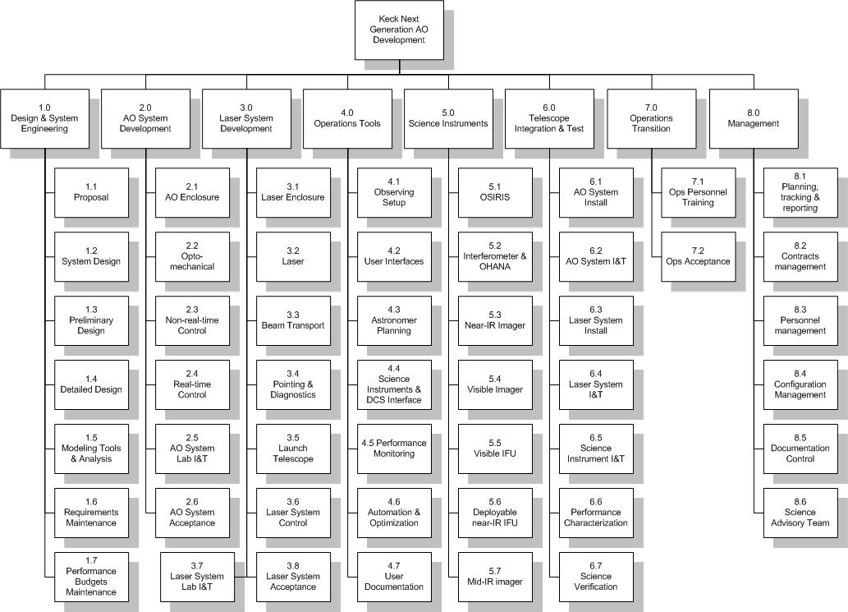
Figure 31 Top-Level WBS

The overall program schedule is shown in Figure 32.

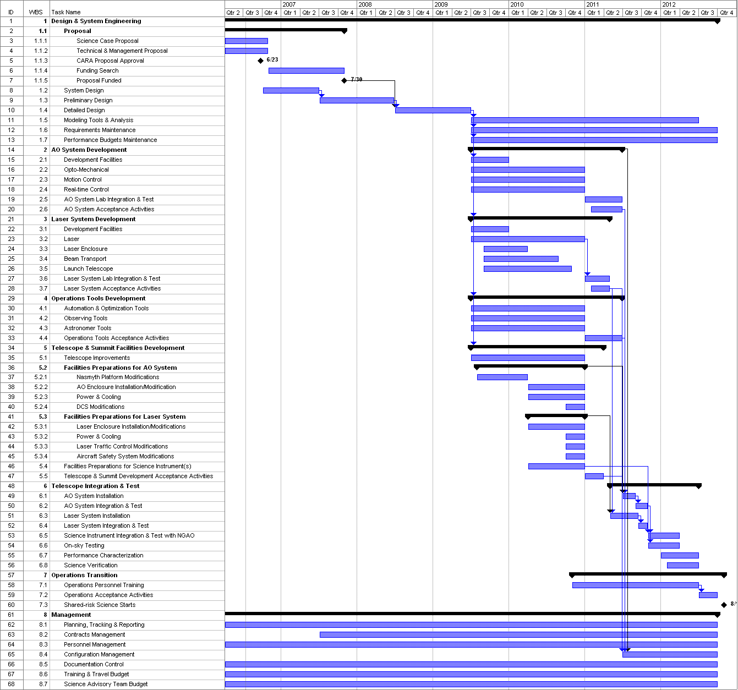
Figure 32 Project Plan showing WBS and schedule

System Design

System Design Deliverables
WMKO provides the following standard guidance for the system design (SD) phase of a development project (Adkin, 2005):

“The principle objective of a system design is to establish a design approach that meets the scientific and user requirements established for the system. System design will establish a discipline integrated engineering plan for the proposed design, understand the technical risks, explore trade-offs, and determine estimates for performance and cost to completion.

The key deliverables from the system design phase are a Systems Requirements Document, a Systems Engineering Management Plan, a System Design Manual and a System Design Report.”

The SD phase of this project will deliver the four documents listed above.

The Systems Requirements Document will include:
- A list of the science requirements
- A list of the additional Observatory requirements
- A list of the technical requirements with a clear flow down from the above requirements

The System Design Manual will include the following components:
- Definitions of the functional requirements.
- Descriptions of the design approach for major subsystems.
- A summary of technology drivers and the associated research needs.
- Performance budgets, including an error budget.
- A technical risk analysis.

The Systems Engineering Management Plan (SEMP) document will include the following components:
- The Microsoft Project Plan for the remainder of the project. This will be developed following the planning process sequence of system level requirements, WBS, task list, schedule, budget and MS Project.
- A table of major project milestones.
- A risk assessment and a risk management plan.
- A plan for the preliminary design phase of the project.
- Initial plans for subsystem testing and lab and telescope integration and test.
- A configuration management plan, for documentation and development.
- A project management plan.

The System Design Report provides a high level summary of the work done during the SD phase.

System Design Plan
A proposed schedule for the SD phase is shown in Figure 33. This plan is focused on the production of the documents defined in the previous section. The preliminary work estimate in Figure 33 totals 5.3 FTEs (assuming the WMKO standard of 1940 hrs/FTE).

The feasibility of achieving this plan will depend on the availability of personnel to perform the required tasks and thus depends on how the work is to be distributed among the potential participants at WMKO, Caltech, UC and elsewhere. To the extent possible we intend to continue the successful collaborations developed during the proposal phase in order to draw upon the expertise and energy of the Keck community. This must be balanced within the Observatory’s FY07 plan and budget.

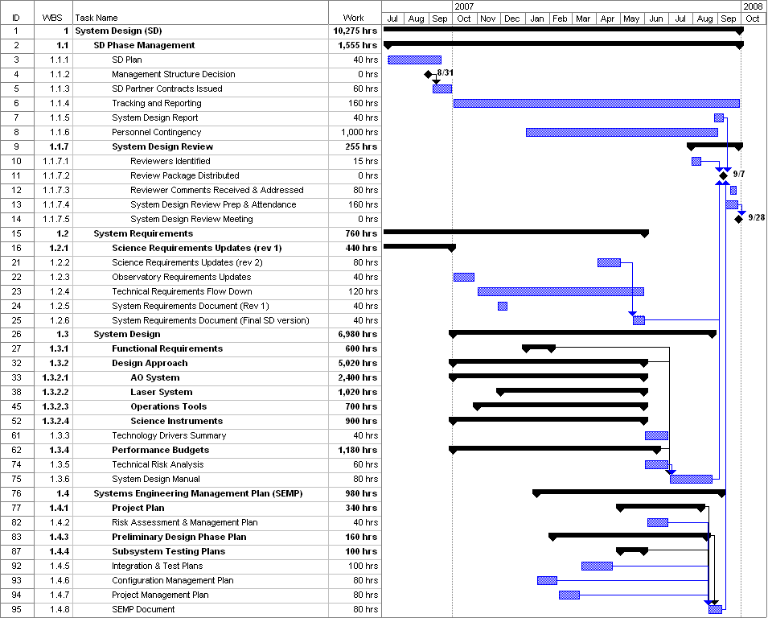
Figure 33 System Design Phase Plan showing WBS and Schedule

Risk Assessment and Risk Management Plan
Table 30 Risk Assessment and Mitigation Plans
Ref. # | Description | Severity | Probability 1st WAG | Mitigation Plans
1 | Achieving science requirements.
a | Long exposure time performance. | Moderate | Likely | On instrument metrology
b | (add other parameters?)
2 | Science requirements inadequately understood & changing. | Major | Likely | Talk to the astronomers a lot
3 | Delivered PSF too variable (spatially and temporally) to satisfy astrometry and photometry requirements | Moderate | Possible
4 | Adequately meeting interferometer needs | Unk | Likely | Review proposed performance with KI team
 | Rayleigh background on LGS WFS cannot calibrated out. | Major | Possible | Issue for GS MCAO, will be tested by them. Use long period pulsed laser and eletronic shutter on HOWFS CCD to gate out Rayleigh
5 | Wavefront error budget assumptions & accuracy
a | Bandwidth error assumptions. Assumption that closed loop bandwidth is 1/15 of sample rate. The rate of ~1/20 has been demonstrated, but would significantly impact error budget. | Moderate | Unlikely | Invesitgate and simulate control loop impact.
b | Sodium return expectations not met | Major | Possible | Refine and adjust assumptions based on data from current systems
c | 1e- CCDs for WFS. | Major | Possible | Another design turn for CCID-56, more laser power
d | Impact of telescope vibration. | Moderate | Possible | Reduce telescope vibrations
e | Tomography. No sky demonstration.
i | Codes contain assumptions that are untested in actual operating conditions | Major | Possible | Refine and adjust assumptions based on testing
ii | Alignment and registration - beacons and WFS | Major | Likely | Design opto-mechanics for closed loop beacon positioning and stability. Implement test procedures during I&T to ensure proper alignment and registration.
g | Tip/tilt tomography. No sky demonstration of benefits of multiple TT stars | Moderate | Unlikely
 | Rotating LGS constellation limits performance for long exposures | Moderate | Likely | De-rotate, configurable add beacons?
 | MCAO mirrors are not at proper conjigates or correct "statistical position" for the actual Cn^2 profile | Moderate | Possible | Get MASS/DIMM data for Mauna Kea before detailed design phase
6 | Achieving contrast performance budget. | Unk | Possible | (Need to verify science requirements)
7 | Achieving defined photometry budget | Unk | Possible | (Need to verify science requirements)
8 | Achieving defined astrometry budget | Unk | Possible | (Need to verify science requirements)
9 | Achieving desired SNRs | Unk | Possible | Managing throughput in optical design, making provisions for long exposure stability
10 | Achieving polarimetry requirement | Unk | Possible | Control effects that rotate or scramble polarization
11 | Risk of not being able to find adequate tip/tilt stars for certain science cases. | Minor | Likely | System provides gradual degradation, TT stars AO corrected
12 | Fiber transport. Mitigation is conventional beam transport. | Moderate | Likely | Testing programs underway for fibers.
13 | Availability of 65 actuator DM with 3.5 mm pitch with adequate stroke. | Major | Possible | Use 48 x 48, 5 mm, add a second DM
14 | DM on a tip/tilt stage. | Major | Likely
 | DM incompatible with operation on TT stage | Major | Unlikely | Use a separate TT mirror
 | Problems with DM interface cabling on TT stage | Major | Likely | Address in DM design
 | Insufficient TT rejection | Moderate | Possible | Add a second TT mirror
15 | Switchyard approach:
a | Dichroics. Size and performance. | Major | Likely | (at report we will not have this level of risk). Test coating samples to confirm performance before completing design
b | Performance and reliability of dichroic changers. | Moderate | Unlikely
16 | K-mirror. Size, performance. | Moderate | Possible | Other architectures for derotation, better coatings
17 | Achieving real-time control performance requirements | Major | Possible | Benchmark tests, simiulations anchored to RTC hardware performance, prototype testing
18 | Fitting system on telescope. | Major | Unlikely | Design process will ensure compatible system
19 | Thermal/mechanical performance of AO system environmental enclosure. | Moderate | Unlikely | Careful design, thermal performance modeling including FEA.
20 | Design & cost of interfacing with existing instruments exceeds value of doing so | Unk | Possible | Replace those instruments
21 | Availability of required lasers. | Major | Likely | Continue to pursue laser development
22 | MOAO not demonstrated. | Moderate | Likely | MCAO gives reasonable sky coverage, VILLAGES testing planned. Other testing programs, perhaps on existing Keck AO system.
23 | Fast LOWFS IR (SNAP) based camera.
 | Detector performance | Moderate | Possible | Some performance data on hand. Testing continues.
 | Detector availability | Major | Unlikely | Two sources of supply
24 | Calibration unit with LGS simulators.
a | Finding space for it | Major | Possible | Will be designed in from the beginning as an essential capability
b | Achieving required level of performance | Moderate | Possible | On-sky calibration can substitute at greater expense.

Budget
The following sections provide budget estimates for the system design phase and the remaining design and development costs through facility class operation of the NGAO system, as well as budget estimates for science instruments and operations.

The total budget to design and implement the NGAO facility, from system design phase through the start of facility class operation is estimated to be XX. The system design phase costs are estimated to be XX.

System Design Phase

Preliminary and Detailed Design through Full Scale Development

Science Instruments

Operations

References
Adkins, S., An Overview of the WMKO Development Phases (2005).
Adkins, S., et al., “The design and optimization of detectors for adaptive optics wavefront sensing,” SPIE Proc. 6272-60 (2006).
Gavel, D., “Tomography for multiconjugate adaptive optics systems using laser guide stars,” SPIE Proc. 5490, 1356-1373 (2004).
Hardy, J.W., Adaptive Optics for Astronomical Telescopes, Oxford University Press (1998).
Johnson, J.A., et al., “Pyramid wavefront sensing: theory and component technology development at LAO,” SPIE Proc. 6272-165 (2006).
Neyman, C., “Atmospheric Parameters for Mauna Kea,” KAON 303 (2004).
Poyneer, L., JOSA (2002).
Wizinowich, P. et al., “Keck Precision Adaptive Optics: Technical Requirements and Constraints,” KAON 237 (2003).

Appendix A. The Global Landscape for Next Generation AO Systems
Table 31 Instruments for use with AO systems

Appendix B. AO System Key Features
Subsystem | Key Features | Motion Control | Discussion | Risk | Trade Study
AO Enclosure | Located on Keck II left Nasmyth platform |  | Replaces oldest AO system
AO Enclosure | Clean room
AO Enclosure | Humidity control
AO Enclosure | Background light suppression
AO Enclosure | Optics area cooled to -15C |  | Based on emissivity budget.
AO Enclosure | Separate electronics enclosure wih glycol cooling
AO Enclosure | Shutter to protect window | 1
AO Enclosure | Ventilation for personnel
AO Enclosure | Mounting to Nasmyth platform
Support Structure | Optics bench
Support Structure | Cover
Support Structure | Mounting to Nasmyth platform
Optical Relay | 4 arcmin diameter unvignetted field
Optical Relay | Window to transmit 0.55-14 um |  | Required by cooled AO enclosure | Window availability
Optical Relay | 3 mirror (K-mirror) image rotator | 1
Optical Relay | Off-axis parabola (OAP1) |  | Collimates beam & reimages primary onto DM. Conjugate to altitude for MCAO upgrade.
Optical Relay | Option to upgrade above mirror to SiC DM |  | Conjugate to 9.0 km.
Optical Relay | DM location at telescope pupil
Optical Relay | Off-axis parabola (OAP2) |  | Identical to OAP1. Reconverges beam at same focal ratio & with same pupil location as that of the telescope.
Deformable Mirror | 62 subapertures across 10.949 m telescope primary mirror (65 actuator DM)
Deformable Mirror | 3.5 mm actuator pitch (217 mm pupil at DM)
Deformable Mirror | 3 um surface stroke
Tip/Tilt Stage | DM mounted on tip/tilt stage | 2 |  | Impact on DM performance | Impact on DM performance
Tip/Tilt Stage | ± 2" on sky at 50 Hz closed loop BW |  | Tip/tilt correction
Tip/Tilt Stage | ± 5" on sky at 5 Hz |  | Chopping at pupil
Tip/Tilt Stage | Option for DM to perform high BW
Optical Switchyard | 2-position dichroic changer with: 1) T=1-14 & R=0.5-1.0 um. 2) T=0.9-5 & R=0.5-0.9 um. | 1 | Transmits light to IR science instruments & wavefront sensors | Large & difficult dichroics. Changing will impact lenslet-DM registration. | Dichroic capabilities
Optical Switchyard | 5-position dichroic changer with: 1) T=0.9-1.7 & R = 1.9-5 um. 2) T=0.9-1.35 & R = 1.5-5 um. 3) T = 1.4-1.7 & R = 0.9-1.35 um. 4) Mirror. 5) Open | 1 | Reflects z & J or H or K-band or all light to IR science instrument. Transmits to low order WFS & possibly an IR WFS.
Optical Switchyard | 2x Rotation stages for dichroics | 1 | One to select IR science instrument & one to select visible science instrument
Optical Switchyard | 2-position dichroic changer with: 1) T = 0.4-0.6 & R = 0.6-1.0 um. 2) Open | 1 | Reflects light to science instrument & transmits to visible WFS
Optical Switchyard | 2x 2-position mirror: in & out | 1 | One each to reflect light to NGS acquisition camera & LGS acquisition camera
Optical Switchyard | Sodium transmissive dichroic (T=0.589 & R = 0.4-0.58 or 0.6 um) | 1 | Reflects light to either the NGS WFS or the slow NGS WFS.
Atmospheric Dispersion Correction | Pointing corrections between wavefront sensing & science wavelengths
Atmospheric Dispersion Correction | Removable visible atmospheric dispersion corrector (ADC) for visible science instruments | 3
Atmospheric Dispersion Correction | Removable IR ADC for NIR science instruments & low order wavefront sensor | 3
LGS Wavefront Sensors (WFS) | 5 Shack-Hartmann WFSs (need space for 6 more in future) |  |  | Rayleigh light on WFS | How to remove or calibrate out Rayleigh background
LGS Wavefront Sensors (WFS) | Additional 6 WFSs for WF mode |  |  | Rayleigh light on WFS | How to remove or calibrate out Rayleigh background
LGS Wavefront Sensors (WFS) | 48x48 subaperture baseline |  | Motion to register lenslets. | Lenslets not registered to actuators
LGS Wavefront Sensors (WFS) | 62x62 & 31x31 subaperture option |  | 62x62 offers a graceful fallback from 48x48. 31x31 for low sodium return case
LGS Wavefront Sensors (WFS) | 4x4 pixels/subaperture |  |  |  | Relative performance of 2x2, 4x4 & 8x8
LGS Wavefront Sensors (WFS) | 256x256 pixel CCD with 1e read-noise at 1 kHz readout rate |  | CCID-56 under development | CCD not demonstrated yet
LGS Wavefront Sensors (WFS) | Center WFS located on-axis
LGS Wavefront Sensors (WFS) | Four WFS translate radially from 10-50". Also need z-adjustment for field curvature. | 4
LGS Wavefront Sensors (WFS) | x,y control for 5 lenslets for DM registration & changing lenslets | 10
LGS Wavefront Sensors (WFS) | Outer 6 WFS translate radially from 50-90" for WF mode. Also need z-adjustment for field curvature. | 6
LGS Wavefront Sensors (WFS) | x,y control for assembly | 2 | For dispersion correction
LGS Wavefront Sensors (WFS) | Tracking to stay conjugate to Na layer | 1
Fast low order (LO) NGS WFS | 3 pyramid WFSs |  | Tip, tilt, focus, astigmatism sensing from NGS | Not yet demonstrated to provide good sky correction
Fast low order (LO) NGS WFS | 2x2 subapertures per WFS
Fast low order (LO) NGS WFS | 2x2 pixels per subaperture
Fast low order (LO) NGS WFS | 0.9-1.7 um SNAP detector thermoelectrically cooled to -40C |  | Based on SNAP tests at Caltech | Camera not yet demonstrated
Fast low order (LO) NGS WFS | Sodium rejection notch filter
Fast low order (LO) NGS WFS | MOAO-correction for each LOWFS with 32x32 actuator MEMs mirror |  | MOAO & MEMs being demonstrated in Lick AO laboratory | MOAO/MEMs not demonstrated on sky
Fast low order (LO) NGS WFS | Move over 4' field to acquire NGS | 9
Fast low order (LO) NGS WFS | Tracking | 6 | To compensate for differential atmospheric refraction between science & NGS wavelengths, &/or differential tracking. Could use 1-stage?
Slow NGS WFS | Visible light Shack-Hartmann |  | To sense slowly varying sodium layer induced aberrations seen by LGS WFS
Slow NGS WFS | 12x12 subapertures
Slow NGS WFS | 8x8 pixels/subaperture
Slow NGS WFS | 5-120 sec exposures
Slow NGS WFS | Sodium rejection notch filter |  | To reject Rayleigh
Slow NGS WFS | Move around 2' diameter field | 3 | To acquire NGS
NGS WFS | Same as LGS WFS but over visible |  | NGS mode only
NGS WFS | 62x62 & 31x31 lenslet options
NGS WFS | Spatial filter
NGS WFS | Move around 1' diameter field | 3
NGS acquisition camera | 4' diameter fixed field at NGS focus
LGS acquisition camera | 4' diameter fixed field at LGS focus
LGS acquisition camera | Translate to stay conjugate to Na layer | 3
Calibration unit | Telescope simulator
Calibration unit | Rotating pupil | 1
Calibration unit | 3 NGS sources (1 movable) | 2
Calibration unit | 5 (expandable to 11) LGS sources with variable focus | 1
Calibration unit | 6 LGS sources with variable focus for WF | 1
Calibration unit | Turbulence generator | 2
Calibration unit | Translating fold mirror to insert beam | 1
Calibration unit | White light source with ND filter wheel | 1
Calibration unit | ~ sodium wavelength light source
Calibration unit | Instrument calibration arc lamps
Alignment & Diagnostic Tools | Interferometer to look at DM?
 | Total = | 72

Appendix B. Wavefront Error Budget Terms
The wavefront error budgets developed for the NGAO point design incorporate the following physical sources of residual high-order (non-tip/tilt) wavefront error:

Atmospheric Fitting Error
Bandwidth Error
High-order Measurement Error*
LGS Tomography Error*
Asterism Deformation Error*
Multispectral Error
Scintillation Error*
WFS Scintillation Error*
Uncorrectable Static Telescope Aberrations
Uncorrectable Dynamic Telescope Aberrations
Static WFS Zero-point Calibration Error*
Dynamic WFS Zero-point Calibration Error*
Go-to Control Errors*
Residual Na Layer Focus Change*
DM Finite Stroke Error
DM Hysteresis
High-Order Aliasing Error
DM Drive Digitization
Uncorrectable AO System Aberrations
Uncorrectable Instrument Aberrations
DM-to-lenslet Misregistration (all sources)
Angular Anisoplanatism Error

and the following terms pertaining to tip/tilt errors:

Tilt Measurement Error
Tilt Bandwidth Error
Tilt Anisoplanatism Error
Residual Centroid Anisoplanatism*
Residual Atmospheric Dispersion*
Science Instrument Mechanical Drift*
Long Exposure Field Rotation Errors*
Residual Telescope Pointing Jitter*.

Most of these error terms are described in detail in the excellent text by J. W. Hardy, Adaptive Optics for Astronomy, and will not be described here. Some terms, however, require special description in this Appendix because they are either non-standard, or because critical assumptions have been made in their estimation. These terms are indicated with asterisks above and described in detail in the following sections.

Atmospheric Fitting Error
The residual wavefront error variance that arises from imperfect deformable mirror fitting of Kolmogorov spectrum atmospheric turbulence has been tabulated by Hardy as,

$σ_{{\text{atm} \text{fit}}^{2}}=α_{F} {\left(\frac{d_{\text{act}}}{r_{0}}\right)}^{\frac{5}{3}}$[rad²]

where d_{act} is the projected actuator spacing in the entrance pupil, r₀ is Fried's coherence parameter, and α_{F} depends on the deformable mirror influence function. For this proposal, we assume a pyramidal influence function corresponding to a coefficient α_{F} = 0.28.

High-order WFS Measurement Error
Our NGAO error budget incorporates the following physical effects in the determination of wavefront estimates in our model Shack-Hartmann wavefront sensor system:

Photon noise
Read noise
Dark current noise
Sky background
Rayleigh background
CCD charge diffusion
LGS perspective elongation
Laser beam quality
Uplink compensation (as an optional switch)
Shack-Hartmann vs. pyramid sensor (an optional switch)
Error propagation

we have, where appropriate, incorporated real-world values for these parameters, as measured in existing LGS AO systems, and/or noted 'next generation technology' in our discussion of risk areas central to System Design phase consideration.

LGS Tomography Error
Estimation of the residual wavefront error arising from incomplete or incorrect tomographic wavefront sensing has been explored in detailed covariance code models (D. Gavel, private communication) and through Monte Carlo simulations (C. Neyman, private communications). The input parameters are the atmospheric turbulence profile, the laser guide star asterism beacon count and geometry, the field of view over which wavefront estimation is to be made, and certain assumptions regarding the mode of AO operation (e.g. single- vs. double-conjugate correction) and auxiliary sources of sensing information (e.g. concurrent measurement of certain wavefront spatial modes (such as focus and astigmatism) using natural guide stars).

For the purpose of the point design, we have selected a specific asterism for narrow-field science applications and conducted a small trade study for wider-field science applications to identify the key areas for further investigation. For the corresponding error budgets, we have entered the estimated wavefront error determined from these detailed codes.

[??? insert example trade study result here???]

Asterism Deformation Error
Tomographic reconstruction of multiple LGS wavefront measurements typically requirements an assumption on the actual geometry of the laser asterism on the sodium layer. However, due to tilt indeterminacy of the individual beacons, the true sampling of the volume of atmosphere above the telescope is instantaneously variable. For example, the nominal square geometry of an asterism is at any given time in reality a general quadrilateral. Independent of blind modes in the reconstruction process, this unknown asterism deformation will lead to additional residual wavefront errors.

We estimate the magnitude of this error by supposing that the wavefront reconstruction is diabolically bad, representing a volume of atmosphere in which the entire asterism has (unknowingly) conspired to shift in the same direction. In this case, the upper limit to the error is equivalent to an angular anisoplanatism error corresponding to the angular variance of the uplink laser tip/tilt, typically 0.2 to 0.3 arcsec, depending on zenith angle. The equivalent wavefront error in this case, for the CN-M2 atmospheric model, is typically 15 to 30 nm rms.

Scintillation Error
Via propagation, phase errors imparted on the wavefront at high altitudes in the Earth's atmosphere couple into amplitude errors generating the phenomenon of scintillation. We assume only phase compensation for the NGAO point design, resulting in a residual Strehl ratio degradation even for a system performing perfect phase conjugation. Standard formulae are therefore used to estimate the impact to Strehl in H-band and from this (via the Marechal approximation), an equivalent rms wavefront error in nanometers is determined.

Note, this error budget term is chromatic and is most accurately presented in our point design budgets for wavelengths around H-band. More detailed analysis of this effect will be undertaken in the System Design phase.

WFS Scintillation Error
Just as scintillation directly degrades the delivered science image quality of NGAO, it also indirectly introduces wavefront compensation errors via coupling of phase and amplitude terms in our high-order wavefront sensors. Across the dimension of one WFS subaperture, scintillation of the wavefront would have no impact on a pure local tilt error alone. However, in the presence of local focus and other aberrations within a subaperture, amplitude fluctuations can be misinterpreted by the sensor as false tip/tilt signal, resulting in reconstruction errors.

The magnitude of this error is typically small, but grows as subaperture dimension is reduced. We use estimates generated from diffractive wave-propagation Monte Carlo simulations of Shack-Hartmann wavefront sensor AO systems (Matt Britton, private communication) as the basis for a wavefront error estimate for the NGAO point design.

Static WFS Zero-point Calibration Error
Static WFS zero-point calibration errors represent the difference between the physically obtainable internal wavefront calibration errors (e.g. those not outside the spatial bandwidth of deformable mirror actuator correction) and the actual internal calibration error.

Dynamic WFS Zero-point Calibration Error
Static zero-point calibration errors can be accentuated in the presence of changing atmospheric and other conditions. The centroid offset values, for example, representing the closed-loop desired target point for the AO system depend on the subaperture centroid gain function mapping true wavefront tilt to measured centroid tilt (all slope sensors are to some degree non-linear meters of the instantaneous wavefront state). Shack-Hartmann sensor systems design to operate away from strict 'quad-cell' centers are particularly susceptible to this error.

For the NGAO point design, we estimate this error based on our experience with existing LGS AO systems that use Shack-Hartmann sensing in the presence of changing seeing and potentially changing laser beam quality. Interpreted as an allocation to the error budget, this would set an acceptable level of static wavefront errors and/or reference centroid positions.

Go-To Control Errors
Multi-Object AO (MOAO) implementations considered in the NGAO point design require operation of individual high-order deformable mirrors in a go-to control mode. By this, we mean that no wavefront sensor witnesses the effects of the correction, rather it is imprinted upon the astronomical science light alone.

Experiments are underway at UCSC's LAO (D. Gavel, private communication) to establish the practical residual errors imparted by go-to AO systems. For the NGAO point design error budgets, we have assumed that the root-sum-squared total of each of:

Incorrect measurement of woofer DM - 30nm rms
Incorrect calibration of WFS - 20 nm rms
Incorrect actuation of MEMS DMs - 2 nm rms

or equivalently 36 nm rms in all. Note, this applies only to the wide-field science modes of NGAO, as the narrow-field laser beacons do, in fact, witness compensation (if only partially). The detailed performance of go-to control systems will be further investigated in the System Design phase, including feedback from concurrently planned experimental verification.

Residual Na Layer Focus Change
The altitude of the Earth's sodium (Na) layer is ever-changing, resulting in the impression of an unpredictable focus error into the high-speed LGS wavefront sensor signal. The effect of these focus changes can be measured in the low-order WFS system, where focus is continually and concurrently being measured using natural guide stars. The focus information necessary to compensate for Na layer altitude changes, however, can only be provided at the closed-loop correction bandwidth of the LOWFS, resulting in a residual Na layer focus error.

Experimentally, we have data tracking the Na layer fluctuations over Mauna Kea (Antonin Bouchez, private communication). For the NGAO point design error budget, we assume conservatively an unpredictable sinusoidal altitude variation of 50 meters/sec vertical. This results in an input error of 37 nm rms per second, which is then reduced by the compensation provided by the LOWFS bandwidth (e.g. 5x reduction for 5 Hz -3db bandwidth).

Residual Centroid Anisoplanatism
Ideally, tip/tilt sensors would measure wavefront tilt but in practice they usually measure centroid motion as a surrogate to true tilt in the Zernike sense. Because other wavefront aberrations (notably coma) can also move the wavefront centroid, a centroid anisoplanatism error is introduced. A number of techniques have been proposed to mitigate this potentially significant effect (Dekens, F., Ph. D. thesis, University of Irvine). Current LGS systems typically rely on averaging of effects that arise because of the high characteristic frequency of coma and higher-order aberrations, relative to wavefront tilt.

For the NGAO point design error budget, we make an allocation corresponding to a 5x reduction in the intrinsic centroid anisoplanatism error, as measured by Dekens using ultra-fine-screen data from the Keck Phasing Camera System (PCS). This allocation can be realized via a number of techniques, but will require further analysis in the System Design phase before a particular strategy can be recommended.

Residual Atmospheric Dispersion
Atmospheric dispersion becomes an increasingly difficult problem as NGAO moves Keck science both to shorter wavelength and higher Strehl ratio. Atmospheric dispersion is a chromatic effect, wherein one cannot easily represent the error via the Marechal approximation. Still, we do just this in our error budgets, adopting the residual atmospheric dispersion that would be present across the J-band. (The import of this effect grows with shorter science wavelength.)

For the NGAO point design, we have assumed that the natural atmospheric dispersion can be reduced by a factor of 10x, setting an infrared design target for the System Design phase. Visible light science will need detailed analysis to determine the practical limits of compensator design, in the context of more highly developed visible-light science cases.

Science Instrument Mechanical Drift
Due to typical non-common optical paths between the science focal plane and the NGAO tip/tilt sensor, slow thermal or gravitational drifts can cause blurring on the long-exposure science image.

For the NGAO point design, we assume 0.2 milliarcseconds as an allocation for the allowable non-common-path mechanical drift for short exposures (e.g. 10 seconds) and 2 milliarcseconds for the long exposures (e.g. 4 hours). Meeting these allocations may or may not require active metering of the non-common path.

Long Exposure Field Rotation Errors
Imperfect field derotation of the alt-az provided science field relative to the science focal plane will result in a blurring. We allocate 0.2 milliarcsec for short exposure and 2 milliarcsec for long-exposures, as above, to these effects. Note, long-exposure in this case can represent any exposure that undergoes significant field derotation, including relatively short duration exposures need the keyhole.

Residual Telescope Pointing Jitter
Telescope windshake and other disturbance sources result in an equivalent solid-body pointing jitter. Work conducted on Keck Interferometer in recent years has significantly reduced the global vibration environment for the telescopes, but some pointing jitter remains.

For NGAO, we assume a sinusoidal model of jitter in which an initial disturbance having 0.1 arcsecond peak-to-peak amplitude and 0.7 Hz frequency is rejected at the NGAO tip/tilt -3db closed-loop bandwidth.

Other Terms Not Considered Here
For completeness, we note that our error budget development currently does not include the following error terms, almost always because we believe the impact to the system performance can be made negligible through appropriate design choice:

Non-linear DM Actuator Superposition Error (can addressed via proper reconstructor)
Tilt Sensor Scintillation Error (effect is small in IR w/ large subaps)
Blind (e.g. Waffle) Modes (can be controlled via servo law)
Non-Common-Path Air Turbulence
Non-Common-Path Mechanical Vibrations
Temperature Dependent DM Gain Changes (realized as a servo gain change)
LGS Finite Altitude Error (negligible for Na beacons)
Errors due to incorrect control of 'guard ring' DM actuators
Reconstructor Round-off Error

Some of these terms may be added to the design error budgets during system development, though none is currently envisioned to contribute a term larger than 10nm rms to be added in quadrature to the overall wavefront error budget.

LAOS: Linear Adaptive Optics Simulator, Luc Gilles and Brent Ellerbroek, TMT publication: TMT.AOS.TEC.05.084.DRF01
The latest release of LAOS in spring 2006 includes a both a gradient model and physical optics model of the wavefront sensor; we will be using these new features in future trades studies for the NGAO system design.

