Executive Summary

Introduction
The Keck telescopes are the world’s largest optical and infrared telescopes. They represent a major resource for astronomical observation, one that has been highly productive and continues to be in great demand. Because of their large apertures the Keck telescopes offer the highest potential sensitivity and angular resolution currently available. Unfortunately, without a means to overcome the performance limits imposed by the turbulence of the earth’s atmosphere much of the superiority of the Keck telescopes would remain unrealized.

Adaptive optics (AO) is now an established and fundamental technique for overcoming the performance limiting effects of atmospheric turbulence. The Observatory has been among the leaders in the application of AO and the benefits to astronomy have been clearly demonstrated by the many discoveries that have been made using AO on the Keck telescopes. The importance of achieving the full potential of the Keck telescopes is recognized in the Observatory’s strategic plan which identifies leadership in high angular resolution astronomy as a key long-term goal.

At this time we face a number of challenges to our leadership in high angular resolution astronomy because of the aggressive development efforts in AO that are being carried out by the world’s other large telescope observatories. In addition, as we look towards the future we can anticipate the construction of even larger telescopes, leading to the end of the era where the shear size of our telescopes give us an inevitable lead over our competitors.

In order to maintain our leadership we must take the next steps in the development of AO systems and in the development of instrumentation to exploit these systems. Our consideration of the competitive landscape has led us to the conclusion that there are real opportunities for the Observatory to assert continued leadership in AO thorough an ambitious development program that will address what we believe is are clearly differentiable and unique objectives for AO on the Keck telescopes.

Our focal point for this effort is called the “Next Generation Adaptive Optics System” or NGAO. This next generation system will offer significant improvements over the capabilities of our present AO system and will greatly expand the range of science problems that can be addressed with AO. These improvements include near diffraction limited performance in the infrared wavelengths, increased sky coverage, more stable imaging performance, and wavelength coverage extending into the red portion of the visible spectrum.

A key motivation of our desire to develop NGAO is our belief that there is level of performance that we can achieve above which an AO system can begin to address a much broader range of science programs, moving AO from a specialist tool restricted to a narrow range of targets to a progressively more ubiquitous tool meeting the demands of almost any science program.
In the science cases explored in this proposal we have worked with members of our observing community to expand the range of science that we believe will be done with AO, and the science requirements for the NGAO system are based on a range of science cases that illustrate the potential for NGAO to expand into new fields as well as the dramatic advances that are possible in the fields where AO is already an established observing tool. The example observations explored in each of the science cases demonstrate the considerable scientific potential of improved AO system performance and suggest that if the performance levels established in the science requirements can be achieved there are dramatic opportunities for new and exciting scientific results.

From a competitive point of view, extending the application of adaptive optics into the visible wavelengths will open new territory for high angular resolution astronomy, a territory where we can once again be the first to produce scientific results. In addition, while future extremely large telescopes will have adaptive optics systems from the beginning, achieving diffraction limited correction in the infrared will be at least as difficult as achieving visible wavelength correction on the Keck telescopes, making it unlikely that they will pursue visible wavelength adaptive optics capability. This will provide a long-term opportunity for the Observatory, even after the construction of much larger telescopes.

Visible wavelength adaptive optics capability will become increasingly important in an era when the Hubble Space Telescope are no longer available. Today, most users of AO couple their ground-based near-infrared observations with Hubble’s visible-light data. But in five to ten years Hubble will no longer exist, and astronomers will wake up to the need for high-resolution visible-wavelength capability on the ground.

The nature of the opportunity presented by NGAO is that it is technically challenging and therefore risky. In this regard we have attempted to mitigate some of that risk by examining the feasibility of meeting the science requirements for a broader application of AO at the Observatory, and we believe that we have a plausible path forward to carry out a system design phase effort that will result in a fuller understanding of the achievable performance levels, the technical risks and the estimated schedule and cost to completion. The current concept for the NGAO system is similar in concept but less sweeping in scope to the systems proposed for larger telescopes such as the TMT, and is accompanied by a relatively lower risk suite of instruments.

It will be necessary to carefully assess the expected performance of the NGAO system at every design review milestone and to maintain a process of involving our scientific community in the goals and requirements for the new system and its instrumentation. We will also have to carefully consider the levels of risk that we are willing to accept. We believe that the science cases for NGAO are very strong, and that there is a strong possibility that the system is technically feasible. NGAO has the potential to have major positive impact on the scientific leadership of the WMKO observer community and is an opportunity for WMKO to continue to do what it does best: get their first.

Large Telescope Adaptive Optics
At the present time the world’s other large-telescope observatories (Gemini, Subaru, and ESO) are developing a total of 9 new AO systems all of which represent efforts towards second-generation AO systems and instrumentation. This formidable competition is led by ESO where a steady increase in funding since 2004 has resulted in significantly higher levels of spending on AO compared to US observatories. Figure 1 shows an estimate of the current and future funding levels for astronomical AO recently complied by J. Frogel of AURA, and does not even include the additional ~ $2M per year from the European Union’s Opticon program.

Interestingly, all of the second-generation AO systems are directed either at seeing improvements, primarily ground layer AO, or extremely high contrast “planet finding” AO. None of the second-generation AO developments are directed at achieving general purpose near diffraction-limited performance in the infrared, and no large telescope AO systems are currently proposed to extend useful AO correction to the visible wavelengths.

While the science possible with extremely high contrast systems is of great interest, the approach being taken to optimize the performance of these systems defines them as specialist instruments with a finite lifetime based on their sensitivity and the number of targets available. The ground layer AO systems will provide a useful improvement in observing efficiency, and will make significant improvements in the resolution obtained with wide field imagers, but they will not allow the truly diffraction limited performance needed for key problems in solar system science, galactic, and extra-galactic science.

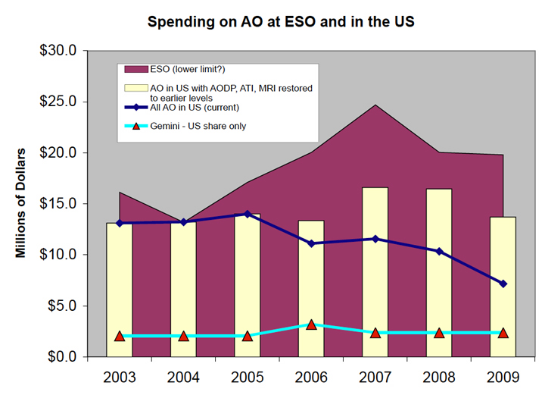

Figure 1: European and US investment in astronomical AO.

We believe that the current direction of AO development at other large telescope observatories creates a well-defined opportunity to pursue high performance AO, emphasizing diffraction limited performance over narrow and moderate fields. With this system we will enable a wide range of science that depends on the precision possible with higher resolution and the sensitivity gains that accompany near diffraction limited imaging. Achieving this performance in the infrared will give us a system capable of providing image quality similar to current AO systems at the red end of the visible wavelength band. WMKO can be the first large telescope observatory to offer this capability and this will create many opportunities for breakthrough discoveries.

Science Overview
The central and most important reason for our belief that NGAO is the right major development priority for WMKO is found in the results of an intensive effort to identify and understand the science potential for AO at the Observatory. While we have not tried to describe every kind of science of interest to the WMKO community, we have been pleased with the breadth of opportunities identified so far and we have developed the sense that the right NGAO system will be of wide utility to a broad community of users, and that this will move AO from being a specialist tool to a fundamental Observatory facility capable of meeting the demands of almost any science program.

The three broad areas of science considered here, solar system science, galactic science and extragalactic science are all reflected to varying degrees in the current time allocations for NGS and LGS AO observing at WMKO. The best known areas, planetary science and galactic center science are just two out of many that are benefiting from the improved angular resolution and sensitivity possible with AO. Extending these benefits to a greater range of science comes down to three important characteristics for a next generation AO system: high Strehl near-IR observing (near diffraction-limited), visible wavelength capabilities to allow the highest angular resolutions and access to the important R and I-band wavelengths, and multiplexing capability over narrow to moderate fields of view. Achieving near diffraction-limited performance in the near-IR leads to visible wavelength performance similar to the near-IR performance of the present LGS AO system, and also leads to a much more stable PSF in the near infrared.

In the following sections we summarize key science cases from each of the major science areas discussed in the proposal and identify the benefits that NGAO will bring to each topic. It is important to keep in mind that these science cases are only a limited set of the possible topics in each area. Within the scope of this proposal we have selected these cases based on the high level of interest from our community, the availability of astronomers interested in those areas and willing to assist us in the analysis and simulation of science with NGAO, and with an eye to including a sufficiently diverse range of cases that we truly challenge the parameter space of a new AO system.

Solar System Science
Adaptive optics has enabled ground-based telescopes to make a significant contribution to the study of our solar system. While earlier progress in planetary science was largely driven by space missions, we are now poised to enter an era where ground based telescopes greatly expand the study of planets, planetary satellites and the asteroid and Kuiper belts.

Ground based telescopes can efficiently perform the regular observations needed for the monitoring of planetary atmospheres and geology, and ground based telescopes can quickly respond to transient events. The timescales needed for planning and launch of spacecraft are incompatible with the need to respond quickly to transient events. The comparatively short observational lifetimes of most space missions are incompatible with the need for regular observations to monitor and understand planetary atmospheres and geology.

The high angular resolution and increased sensitivity offered by NGAO are two key parameters that will enable a broad range of new solar system studies. Integral field spectroscopy with NGAO will take advantage of both increased spatial resolution and the extension to shorter wavelengths.

The study of the remnants from the formation of our solar system provides important information about the proto-planetary conditions that existed at the time of formation. Asteroids generally do not undergo endogenic evolution, so their surfaces still show evidence of collision scars and early geologic processes. Clues to the mechanisms of solar system formation and accretion have been left behind the in orbits and properties of main belt asteroids and binary asteroid systems. At the present time approximately 85 binary asteroid systems have been discovered, and while the study of binary systems, both kinematically and geologically, is important to understanding solar system formation, no space missions are currently planned to study such binaries. It is not an exaggeration to state that the important field of asteroids is left to ground based telescopes.

Observations are needed of a large number of well characterized systems in order to find these clues and begin to understand the initial conditions and evolutionary process such as disruption and fragmentation that have led to the diversity we see today. High angular resolution will allow more precise measurements of sizes and orbital parameters. Well-calibrated size distributions will allow progress in understanding disruption and fragmentation. More precise measurement of sizes is also important to understanding the population of potentially hazardous near earth objects (NEOs). At present very few NEO sizes are known. Higher sensitivity will increase the number of detections allowing the larger sample sizes needed to establish statistics to anchor and constrain models of solar system formation and evolution.

An example of the gains expected from NGAO is shown in Figure 2. This figure shows a simulated multiple asteroid system based on the triple system 87 Sylvia. Two artificial moonlets have been added to the system, one much smaller than the two known moonlets and located between their orbits, and one intermediate in size between the two known moonlets but located closer to the primary. The simulation uses an exposure required to reach an SNR of 2000 (corresponding to ~2 min integration time for a M_{v} = 12 target).

Using aperture photometry to measure the brightness of each moonlet, the detection rate for each moonlet was 100% in R-band with NGAO. Using NIRC-2 with the current AO system the detection rate ranged between 82% for the largest known moonlet, and 11% for the smaller but more distant artificial moonlet. The close artificial moonlet was undetectable with the present system.

Another figure of merit for NGAO is the increase in the number of observable asteroids. The present AO system has a limiting magnitude of ~ M_{v} = 13.5 in NGS mode, resulting in ~1000 observable main belt asteroids. NGAO is expected to achieve a limiting magnitude of M_{v} = 17 or deeper through use of AO-corrected tip-tilt stars, increasing the number to >10% of the known main belt population or ~30,000 objects.

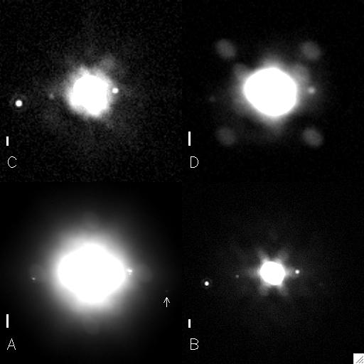

Figure 2: Simulation of a multiple asteroid system based on 87 Sylvia.
The short vertical bar in each image represents 0.1″. C is a simulated HST R-band image using ACS, D is a simulated H-band image using the current AO system in NGS mode with NIRC-2. A is a simulated R-band image with NGAO, and B is a simulated H-band image with NGAO.

The study of planetary atmospheres and geology is important to understanding the geology of our solar system and also enables a better understanding of how our solar system formed. Titan is an important subject because unlike the other satellites of Saturn it has retained an atmosphere. In the atmosphere of Titan methane plays the role that water does on earth, coupling the surface to the atmosphere in a methane based meteorological cycle. Given that one year on Titan is ~30 earth years, observing seasonal changes requires many periodic observations. Ground based telescopes are the central tools for these observations. Space missions such as Cassini have provided very high spatial resolution measurements over a comparatively short time scale, but these observations will require follow up to understand and confirm the implications for longer term seasonal variations. The improved resolution and sensitivity resulting from NGAO will enable greater sensitivity to dynamical variations and improve discrimination between surface features and atmospheric phenomena.

Figure 3 compares the performance of the current AO system with simulations of the performance of the NGAO system. The simulation was developed using a high-resolution surface map of Titan from Cassini/ISS at 0.9 µm.
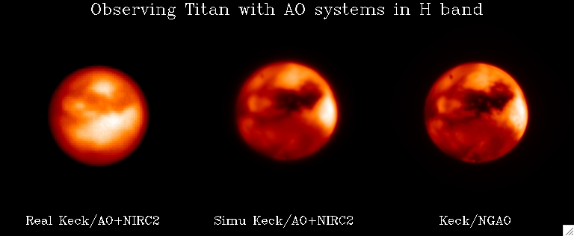

Figure 3: Simulated H-band images of Titan.
The angular diameter of Titan is 0.8″. The left hand image is a real image taken with NGS AO and NIRC2. The center image is a simulation of the current AO system performance using NGS AO and NIRC2. The right hand image shows the results obtained from a simulation of NGAO. The simulated images differ from the real observation because of variations in the color of surface features, for instance the bright southern pole is rather dark on our simulation.

The surface of Titan is also of considerable interest. The mechanism for replenishment of the atmospheric methane is not understood, but if releases of methane from the interior of Titan through cryovolcanism are responsible then resurfacing due to this volcanic activity should be observed. The high angular resolution of NGAO should permit observations of released cryovolcanic material. Figure 4 shows a simulated NGAO observation of a new surface feature ~100 km across resulting from a cryovolcanic eruption.

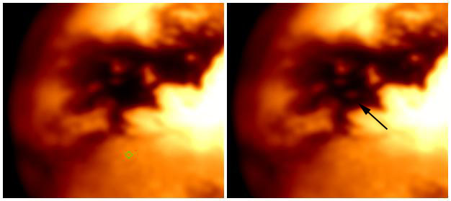

Figure 4: Simulated NGAO image of Titan showing a resurfacing feature ~100 km across.
The left image shows the surface prior to resurfacing and the right image shows the resurfacing feature at the tip of the black arrow.

Io is another important subject because of its active geology. It is the only place besides earth where we can observe large-scale volcanic activity. Io is also the best target to study tidal heating, a fundamental process in the evolution of planetary satellite systems and one that may expand the range of habitable zones for extraterrestrial life. Future plans for space missions to Io are unclear, and in the mean time ground based observation is the only way to study this important planet.

The angular diameter of Io at opposition is ~1.2″ and with high surface brightness it is an excellent NGS AO target. Figure 5 shows a simulation of observations of Io with NGAO in various wavelength bands. Two emission hot spots were added to an image generated from a 12 km resolution composite map based on Voyager/Galileo data. A realistic solar reflection component for an observation close to opposition was assumed. The northern hot spot has a brightness four times lower than the limit of detection for the current NGS AO system. Spatial resolution in the simulated image corresponds to 40 km on the surface of Io, compared to ~100 km for the NIR observations of the Galileo mission.

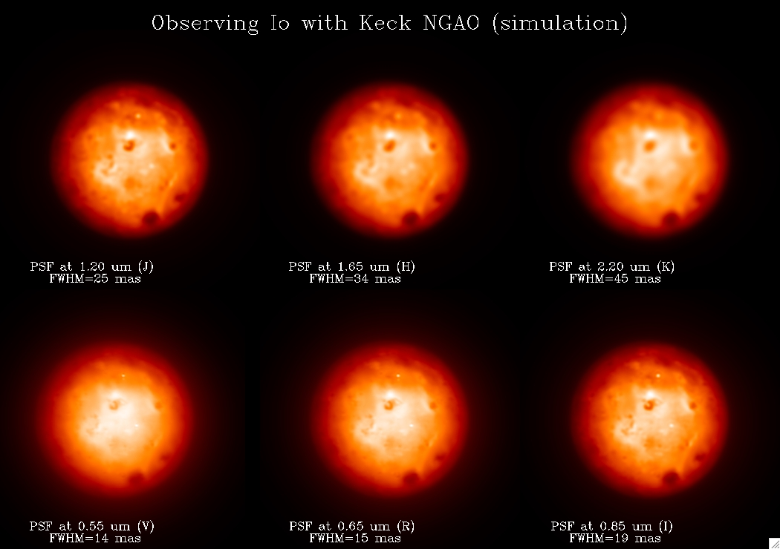

Figure 5: Simulated observations of Io using NGAO in various wavelength bands.
Two artificial hot spots have been added as indicated by the arrows on the lower left image.

Galactic Science
Significant contributions to galactic science have resulted from adaptive optics observations. Topics such as the study of the galactic center have been made possible by NGS AO and are now enabled at an even higher level by LGS AO. The study of galactic science topics will be further augmented by the near diffraction-limited performance of NGAO in the infrared and the significantly improved astrometry made possible by the system’s highly stable PSF.

Observations of low mass stars and circumstellar disks offer important opportunities to better understand star formation and provide better constraints for models that seek to resolve the connection between protostellar and circumstellar environments and the evolution of young stars. Current observations of these systems are limited by angular resolution and wavelength coverage. High angular resolution observations at multiple wavelengths, from visible to near IR are required to separate circumstellar disk grain properties from density distributions. Observations with NGAO will compliment sub-millimeter and millimeter interferometric observations from CARMA and ALMA to better constrain the physical properties of the circumstellar environment.

Accretion rates and the kinematics of infalling and outflowing material will be observable with the high spatial resolution integral field spectroscopy possible with NGAO, and the high angular resolution of NGAO will enable some of the first direct measurements of the circumstellar envelopes of high mass protostars. This will in turn lead to a statistical study of the similarities and differences in the formation of high and low mass stars. Figure 6 shows simulated I-band observations of an outflow cavity in the circumstellar dust around a Class I object. The simulation is based on a model consisting of a massive disk (0.1 M_{sun}) embedded in a massive envelope (5 x 10-3 M_{sun}) with an outflow cavity. The advantages of NGAO are dramatic.

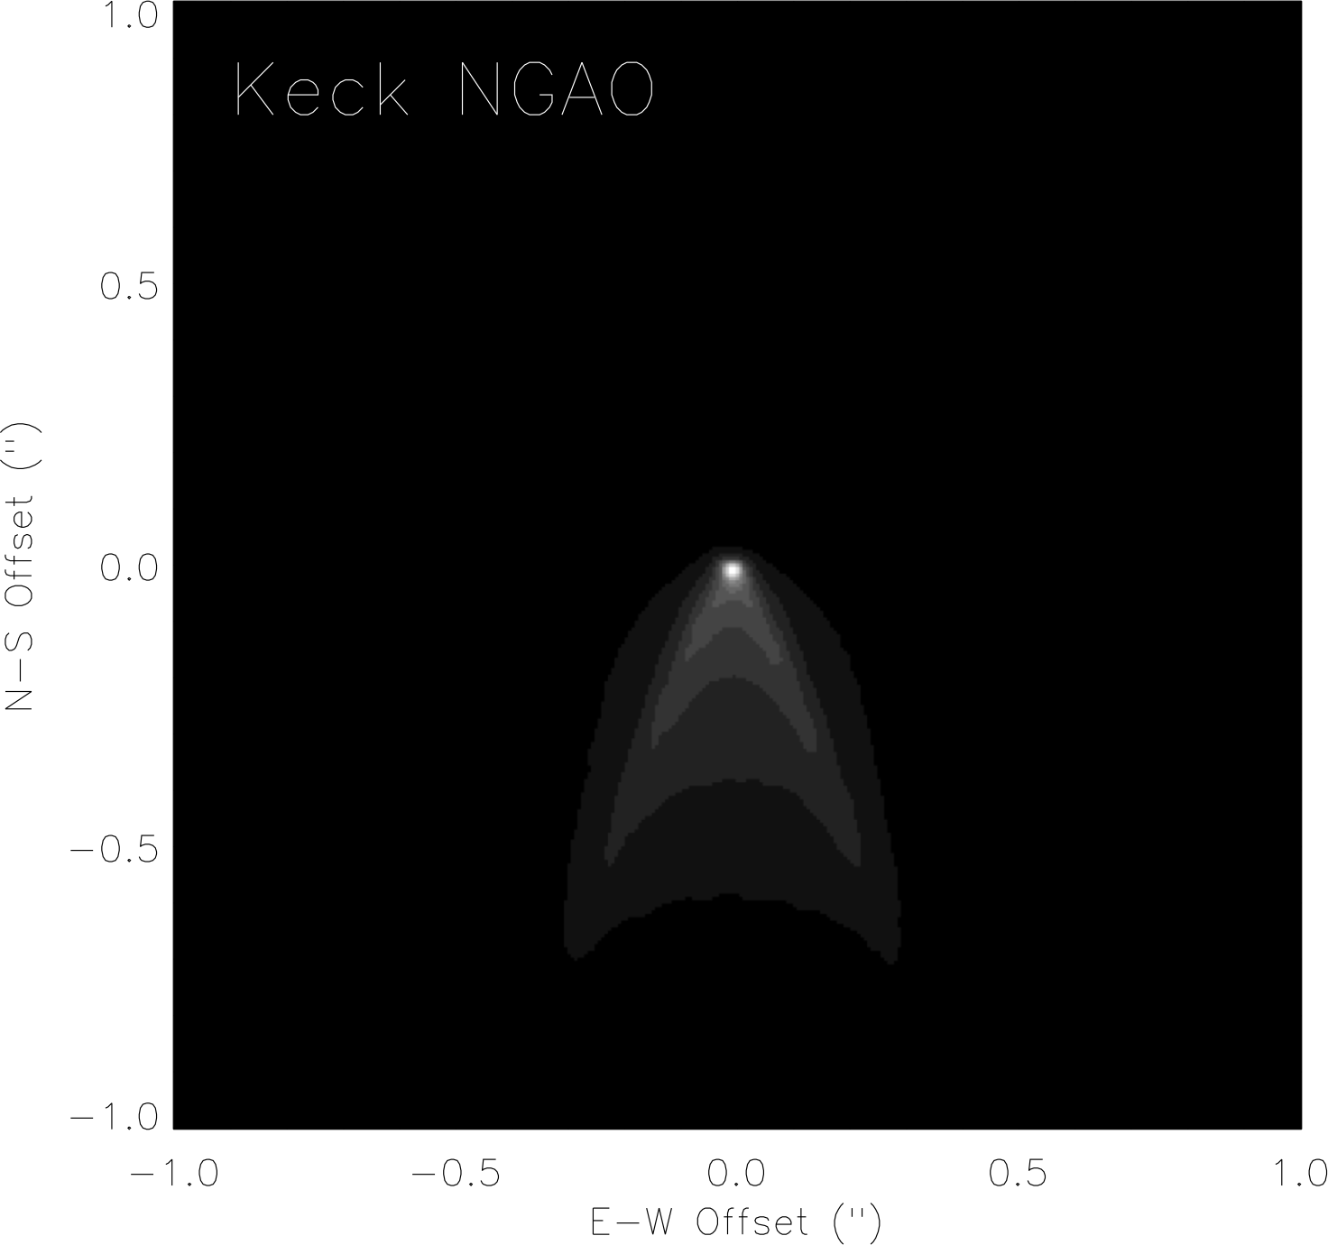
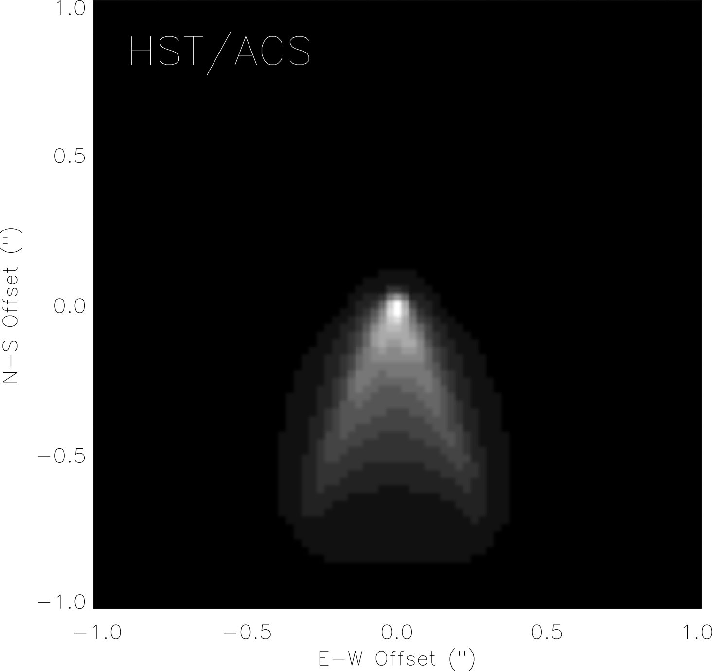
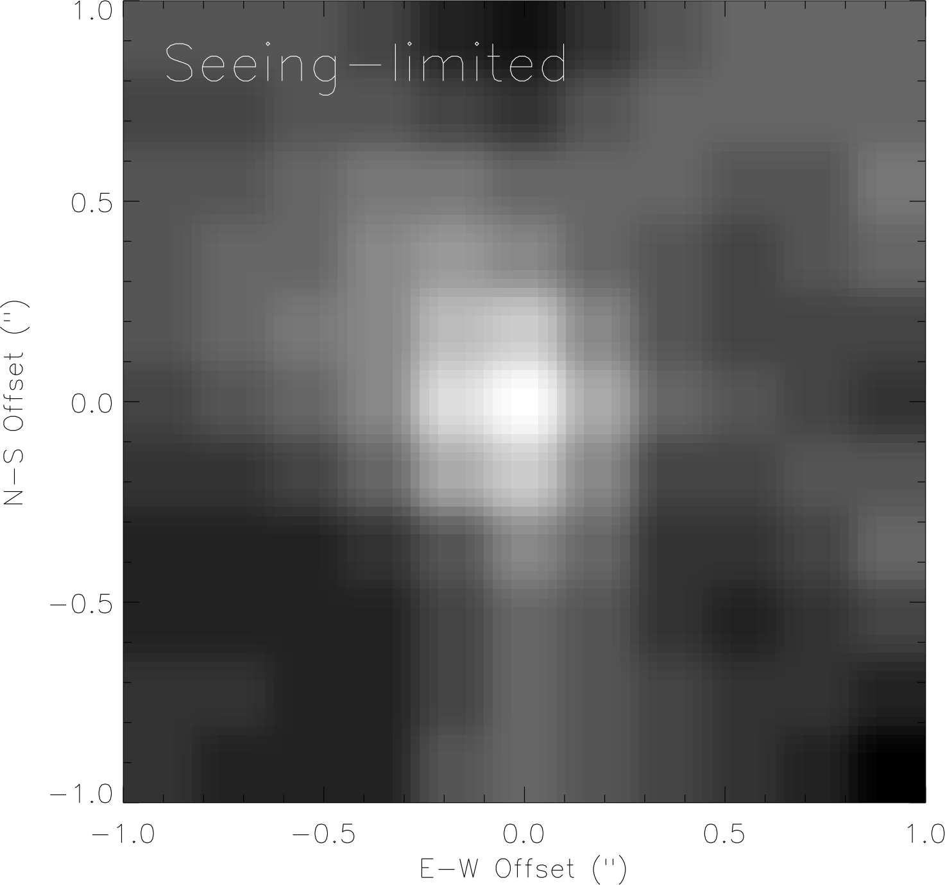

Figure 6: Simulated I-band observations of an outflow in circumstellar dust.
The observation is at an inclination of 55º, and each image is 2″ x2″. The left image is seeing limited, the center image is simulated for the HST ACS/HRC and the right image is simulated for NGAO.

During the past decade WMKO has played a major role in the discovery and characterization of extrasolar planets, brown dwarfs and substellar objects, primarily through radial velocity surveys. These discoveries are now motivating significant development efforts in high contrast AO in order to allow the direct imaging of extrasoloar planets for the measurement of colors, luminosities and spectra, and from these measurements will come knowledge about the temperatures and compositions of extrasolar planets.

Both the Gemini Observatory and ESO are developing specialized “planet finding” AO systems with extremely high contrast for direct imaging of planets around nearby young solar type stars. These “extreme AO” systems are very powerful, but their specialized design restricts them to 8th or 9th magnitude (I-band) targets. This addresses only a portion of the parameter space, and creates an opportunity for NGAO to search for planets around low mass stars and brown dwarfs. Low mass stars are much more abundant, and this abundance may make them the most common hosts of planetary systems. These are cooler, optically faint targets that will be unobservable with specialized extreme AO systems.

NGAO on the Keck telescope will have the highest angular resolution of any such system, and the high angular resolution and PSF stability of the NGAO system with a high contrast conronagraph will enable sensitive direct imaging in the J and H-bands where the planetary companions are brighter, increasing the probability of detection. Figure 7 shows the planet detection sensitivity for NGAO in the H-band from high contrast simulations based on models by Baraffe et al. (1998, 2003). The primary is assumed to be at 30 pc with and on source integration time of 20 minutes. The simulations indicate that NGAO will be able to search for Jovian mass companions around large numbers of low mass stars and brown dwarfs. Most of the detections are contrast limited, but the outer floor seen in the curves is set by the raw sensitivity of the system.
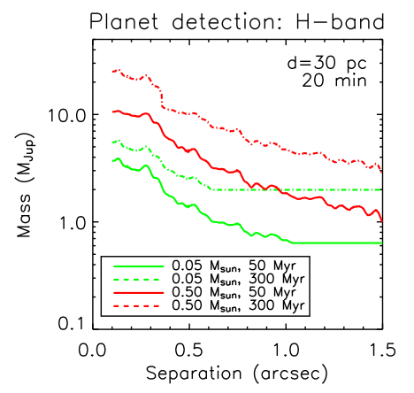

Figure 7: Planet detection sensitivity for NGAO.
Studies of the very earliest stages of planet formation around young T Tauri stars will provide unique information about the origin of extrasolar planets. The nearest star forming regions are more that 125 pc away, requiring the very highest angular resolution. With NGAO, separations as small as 5 to 10 AU can be imaged, allowing the study of the circumstellar environments of these young stars. This research will lead to important understandings about the formation mechanisms for giant planets and help answer current questions about the variations in their formation and the relationship to disk evolution and dissipation.

Figure 8 shows that high contrast imaging for planet detection using NGAO covers a parameter space complimentary to other extreme AO systems such as the Gemini Planet Imager (Gemini ExAO in the figure). The optical faintness of low mass stars, brown dwarfs and the youngest stars make them inaccessible to extreme AO systems.
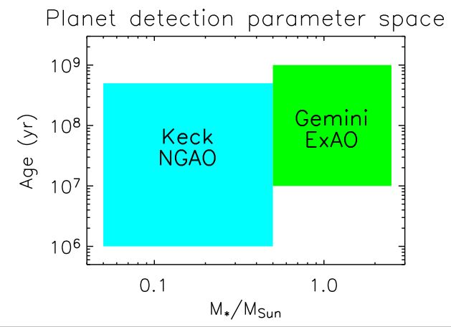

Figure 8: Direct imaging parameter space for NGAO and the Gemini Planet Imager.

Debris disks have been found around many stars, and these disks, analogs to our asteroid and Kuiper belts, contain important clues to planet formation and carry the signatures of unobservable planets and larger planetismals. A small number of the brightest disks have been imaged using HST or current ground based AO systems. These observations have raised new questions regarding disk evolution and morphology, how disks transition from primordial to debris disks, the role of planets in the transition, the interaction of disks with embedded planets and the significance of stochasitic collisions with respect to disk properties.

Answering these questions requires a much larger number of observations in order to establish a more comprehensive profile of debris disks that will help define disk models, leading to a better understanding of solar system evolution. The high contrast imaging possible with NGAO, combined with greater wavelength coverage of NGAO will enable the study of many more disk properties and extend the range of direct imaging surveys to over 100 pc. This will greatly expand the sample size due to the large number of young (< 100 Myr) stars found at distances of 100 to 200 pc. For example, Spitzer mid-IR data has revealed debris disks around approximately 10% of solar type stars in the ~120 Myr old Pleiades open cluster, offering numerous opportunities for the examination of planet formation in a coevolving, homogenous environment. These observations could lead to the first comprehensive view of what the solar system may have looked like at an early age. NGAO observations of debris disks in the near-IR will be complimentary to HST optical data, and complimentary to future ALMA sub-millimeter dust emission studies.

Figure 9 shows a simulation based on a scattered light model of a massive Kuiper belt analog around a solar-type star, analogous to conditions that may have existed during the epochs of late planet formation and heavy bombardment in the young (10 to 300 Myr) solar system (Dominik & Decin 2003; Kenyon & Bromley 2005). The angular scale of the simulations is chosen to correspond to the distance (133 pc) of the Pleiades cluster, an ideal population for studying debris disks in the post planet-formation stage.

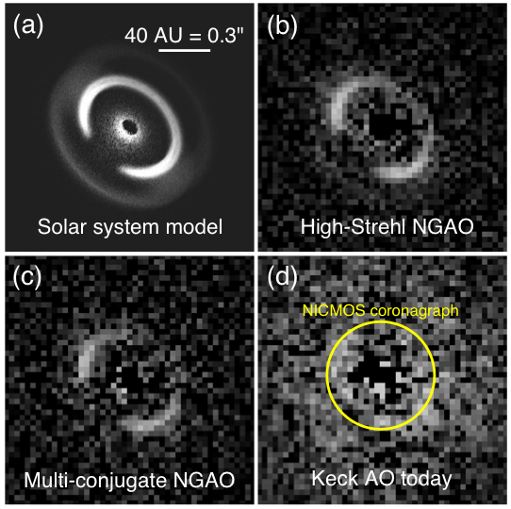

Figure 9: Simulated H-band images of a massive Kuiper belt analog around a solar-type star.
The Strehl ratios of the simulated images are 82% (panel b), 47% (panel c), and 28% (panel d). The AO images have been binned to a pixel scale of 31 mas/pix to enhance the signal-to-noise per resolution element and are shown with the same linear grayscale. The size of the smallest coronagraph available on HST is overlaid on panel (d) to illustrate the new phase space that will be opened at <0.3″ separations by Keck NGAO.

The fractional luminosity of the scattered light in the simulation is 10-3.5 relative to the central star, comparable to mid-IR Spitzer observations of G-type stars in the Pleiades (Stauffer et al 2005). The bright ring in the model corresponds to grains in 1:1 resonance with an outer giant planet (Neptune).

The study of disk structure will be significantly advanced by the visible wavelength coverage possible with NGAO. Scattered light imaging studies are best performed at shorter wavelengths, where the lower sky brightness and favorable scattering properties of sub-micron dust grains allows optimal imaging contrast between the parent star and the circumstellar dust. NGAO optical imaging will be a powerful means to identify and diagnose the substructure in debris disks. This new capability can reveal dynamical signatures (rings, gaps) in disks due to embedded planets out to three times greater distances than previous studies. Detailed observations of disk substructure may make it possible to detect embedded low mass planets (~ Neptune size) not observable by direct imaging or radial velocity surveys.

The discovery of a black hole at the center of our galaxy has prompted significant observational activity because of the opportunity to study a massive black hole, and the opportunity to gain insights into the way in which the presence of such a mass is part of the process of galaxy formation and evolution. Measurements of the orbits of stars near the galactic center have allowed the first determinations of the mass of this black hole, and the continued progress in AO at WMKO has played a key role in these observations as illustrated in Figure 10 which shows images of galactic center observations made with the Keck II NGS and LGS AO systems.

Figure 10: The Galactic center comparing Keck NGS and LGS AO performance in the L' band (3.4 µm).
Left: NGS AO image from 2004 June, created by co-adding the 46 best 60 s exposures from the night. The achieved Strehl ratio is 0.34, with a FWHM of 92 mas. Right: LGS AO image from 2004 July 26, created by co-adding all of the eight 30 s exposures from this first LGS AO Galactic center observation. A Strehl ratio of 0.7 was achieved, with a FWHM of 81 mas. Both images are 5.5" x 5.5".
NGAO will enable new galactic center science, particularly because the high angular resolution will reduce stellar confusion that leads to measurement bias. The increased sensitivity will result in improved SNR and when combined with the more stable NGAO PSF will permit significantly improved astrometric precision. More precise astrometry will allow the detection of relativistic effects that are expected in the presence of a massive black hole. These include prograde precession of orbits around the black hole and the detection of inertial “frame dragging” in these orbits due to the black hole spin. Detection and measurement of these effects will provide a fundamental test of general relativity and help constrain the formation process of the black hole.

Predictions have suggested that extended dark matter is present at the galactic center, and if the concentration of dark matter matches the theoretical predictions then detection of the effects of the mass that should be enclosed by the orbits of the stars at the galactic center will be possible with NGAO. This measurement would then be the smallest scale measurement so far obtained for dark matter.

The astrometric precision required for these detections is illustrated in Figure 11.
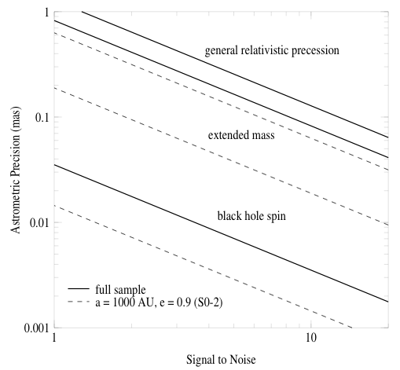

Figure 11: Required astrometric precision for detecting GR effects.
Shown from top to bottom are the astrometric precisions required to detect GR effects associated with relativistic prograde precession, GR effects due to extended mass within the stellar orbits, and frame-dragging effects due to the spin of the BH (based on Weinberg et al. 2005).

The figure shows the estimated precision based on measurements of stellar orbits and positions from diffraction-limited images obtained with Keck telescope observations (thick, solid lines). These include 16 stars within 0.5” of Sgr A* with orbital fits obtained from speckle imaging measurements and 142 stars within 1” of Sgr A* with stellar positions obtained with new, deep AO maps. For comparison, we also show estimates based on measurements of just the short-period star S0-2 (thin, dashed line). All of the estimates assume a 10-year baseline with 10 integrations per year. Low-order general relativity and extended matter effects are easily detectable (at the >5σ level) with a precision of ~200 mas, while the detection of black hole spin requires either better precision or improved SNR from the observation of multiple high-eccentricity, short-period, stars over multiple orbits. We expect that astrometric precision on the order of 100 µas will be obtained with NGAO.

This improved astrometric precision will also allow much more accurate measurement of the distance to the galactic center. Measurements accurate to ~0.1% are expected, and will also allow high precision measurement of the galactic dark matter halo. The expected improvement in measurement accuracy is illustrated in Figure 12, which compares error contours for black hole mass and galactic center distance obtainable with the current LGS AO system and the expected performance of NGAO. NGAO will allow black hole mass and galactic center distance estimates with more than two orders of magnitude greater precision than current studies; this improvement will not be greatly surpassed even in with future extremely large telescopes (ELTs).
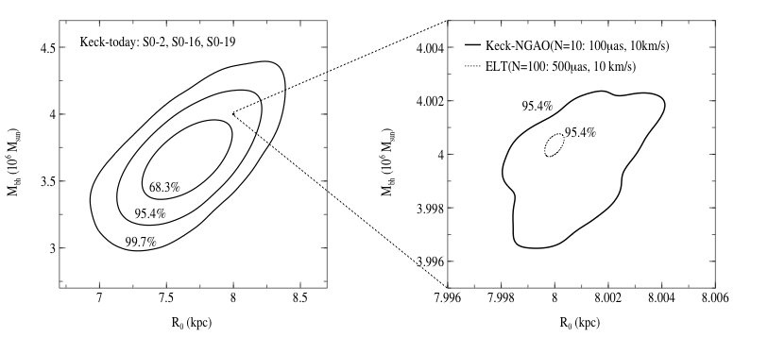

Figure 12: Error contours for black hole mass and galactic center distance.
The left panel shows the current Keck-AO constraints and the right panel zooms in by a factor of ~100 to show the estimate of future constraints from Keck NGAO (solid line) and a 30 m extremely large telescope (ELT; dotted line). The Keck NGAO and ELT numbers in parentheses are the number of stars that are likely observable and the assumed astrometric and radial velocity errors. The small box in the left panel indicates the size of the Keck NGAO constraint on the scale of the current Keck AO constraint.
Stellar mass black holes are also thought to exist with 1 pc of the central black hole. Perturbations of stellar orbits due to these black holes and other massive remnants can be detected with sufficiently accurate measurement of stellar proper motions. Based on estimates in Weinberg et al. (2005), over a ten-year baseline approximately 10% of all stars monitored with a precision of ~100 μas will undergo detectable encounters with background remnants if the remnants are stellar-mass black holes.

Extragalactic Science
Until the past year with the advent of the laser guide star at Keck, adaptive optics did not have high impact on extragalactic science. Extragalactic AO papers have typically focused on at most a few galaxies at a time. Recent results in this year’s papers have begun to be important, as with J. Cohen’s demonstration that many of the “young globular clusters” in Andromeda are not globular clusters after all, and considerably higher-precision measurement of AGN black hole masses.

Keck NGAO will dramatically improve this situation in key ways.

NGAO will have 3 to 6 times better signal to noise ratio for near infrared spectroscopy and imaging of high-z galaxies. This will result in a factor of 9 to 36 times shorter integration time to a given signal to noise ratio. For example, Figure 13 shows results from a simulation of the performance of an integral field spectrograph, observing the z~2 galaxy BX 1332 from the catalogue of Erb et al. (2004). In this case the NGAO system shows a factor of 3 improvement in signal to noise ratio, enabling study of galaxy morphology for large surveys in practical amounts of telescope time. The NGAO system also allows extraction of a velocity map over more than 3 times the area within the galaxy than the current LGS AO system.
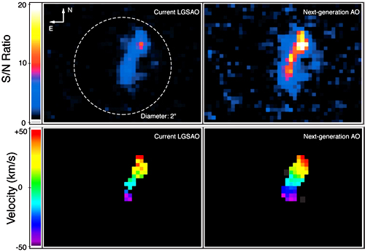

Figure 13. Computer simulation of imaging and spectroscopy of the z ~ 2 galaxy BX 1332. For the velocity maps, only those pixels within 3σ of the mean SNR are shown. We have assumed an IFU spaxel size of 0.1 arc sec.

Spatially resolved spectroscopy of the caliber shown in Figure 13 will enable study of the hierarchical assembly of galaxies in the early universe, their star formation histories, and the role of mergers and black hole feedback in creating the so-called m-σ relation between the mass of a central black hole and the velocity dispersion of the galaxy’s spheroid.

The space density of various classes of high-z galaxies on the sky is in the range 0.1 to 10’s of galaxies per square arc minute. Since each galaxy subtends an area of only a few square arc seconds, and since there are large empty gaps between galaxies, the deployment of individual, narrow-field MEMS-fed integral field units beneath each galaxy is a perfect application for NGAO, as shown in Figure 14 using SAURON IFU data. While designs for such Multi-Object AO (MOAO) instruments on the Thirty Meter Telescope are considering 20 to 30 deployable MEMS-assisted IFUs, we have settled on a much more modest “sweet spot” for the Keck NGAO system: on the order of a half-dozen deployable IFUs over a field that is about 2 arc min in diameter. Our motivation for considering only a half-dozen deployable IFU units was initially to lower the cost and the technical risk. However taken together with the improved signal to noise ratio obtained with NGAO, the proposed modest level of IFU multiplexing will result in a staggering factor of 50 to 200 improvement in overall telescope throughput!

This level of qualitative advance will strongly distinguish Keck NGAO from all other planned AO systems on 8-10 meter telescopes.
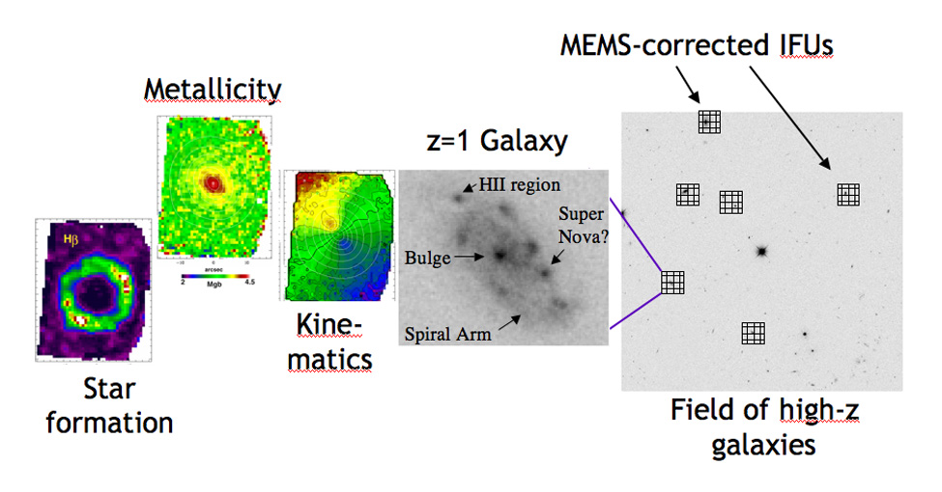

Figure 14. Schematic illustration of the benefits of Multi-Object Adaptive Optics. Maps of velocity, metallicity, and star formation rate are based on SAURON IFU data obtained in seeing-limited mode.

Keck NGAO will have notably higher Strehl and PSF stability than current LGS AO, enabling significantly improved supermassive black hole mass determination by pushing down toward lower black hole masses; by calibrating mass estimates from other techniques such as reverberation mapping; and by permitting much better characterization of quasar host galaxies. The majority of black hole mass determinations done by HST are limited to unobscured galaxies. NGAO’s high Strehl at near infrared wavelengths will extend this capability to the large class of AGNs with heavy dust obscuration.

NGAO will qualitatively improve the study of high-redshift galaxies by making it possible, for the first time, to do AO surveys of large numbers of galaxies in a given class with good statistics. With the multiplexed near-infrared spectroscopy enabled by multi-object AO, we will have access to thousands of galaxies at high enough redshifts that we are seeing lines emitted in the rest-frame optical. Among other things, this will enable use of the impressive arsenal of spectroscopic analyses and indices developed at visible wavelengths for lower-z galaxies. In our study we probed one area in detail: use of NGAO to understand the merger history of galaxies in the early universe. We found that the signal to noise improvement due to NGAO was a significant factor in being able to carry out the necessary measurements on a sufficiently large sample of merging galaxies.

Gravitational lenses, either on the cluster scale or the galaxy scale, permit the study of even higher-z galaxies by magnifying their light and their spatial features. They also allow study of the mass distribution of the lens source (cluster or galaxy). Our simulations (Figure 15) show that NGAO will be significantly more sensitive than current LGS AO for detecting lens arcs against the sky background, and for spectroscopy of both lensed and lensing galaxies.

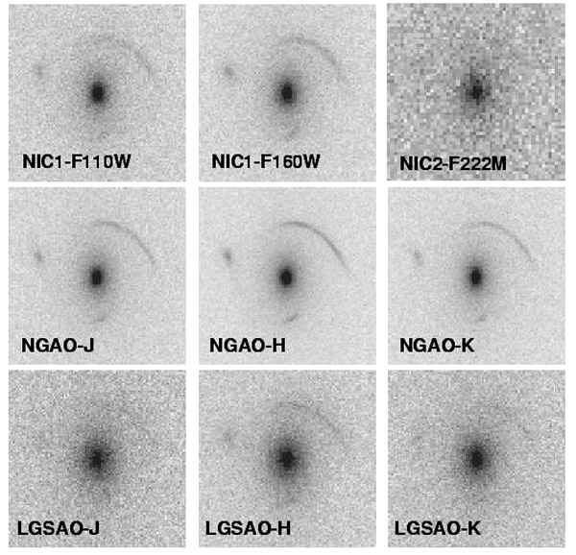
Figure 15. Simulated observations of a gravitational lens with NGAO (middle row), HST-NICMOS (top row) and the current LGSAO system (bottom row). Each image is 4" on a side and the exposure time is 3600s. For NGAO we adopted the same detector properties as NIRC2 and half the background. The lens is an L* elliptical at z=0.8 and 250 km/s velocity dispersion. The background source is a galaxy at z=7 with 0.05" half light radius, and J H K AB magnitudes of 25, 24.2, 24.4, as obtained for a few billion solar masses of a young stellar population. Note that NGAO is superior in all cases.

In summary the higher signal to noise ratios attainable because of Keck NGAO, coupled with modest multiplexing of MEMS-corrected deployable integral field spectrographs, will multiply the extragalactic science-gathering capability of Keck AO by large factors (50 to 200). This kind of dramatic improvement will bring AO-corrected extragalactic astrophysics to a new level of achievement.

Science Requirements
Summarize the summary, include Mike’s figures…

NGAO Overview
Concept, top level technical items, problem space, system design intentions

Summary
Plan, timeline, funding challenges

