LGS Wavefront sensor sub-system preliminary design

## KECK ADAPTIVE OPTICS NOTE xxx

November 12, 2009

-

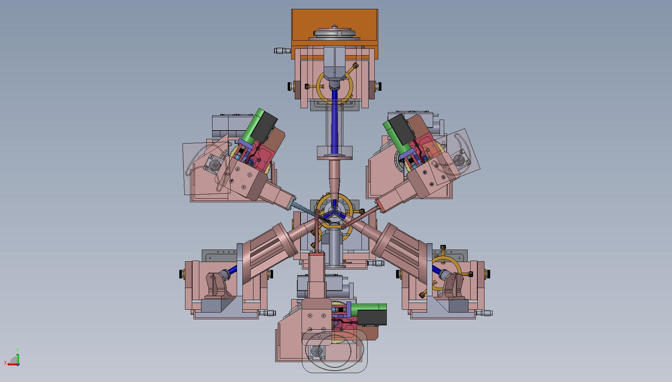

# Introduction and Overview of concept

This document describes the preliminary design of the Laser Guide Star Wavefront Sensors (LGSWFS) for Keck’s Next Generation Adaptive Optics (NGAO) system.

Following the conceptual design review a Build-to-Cost (B2C) review was conducted which led to considerable changes in the system architecture, in particular to the LGS WFS architecture[1]. Firstly, the deployable quincunx asterism was de-scoped to a fixed LGS asterism with one on-axis LGS and three fixed symmetrically located LGS’s located at 10” radius. The FoV of the three movable PnS LGS used to sharpen the NGS TT stars was reduced from 150” to 120”. To further simplify the architecture and ease implementation, the wavefront measurements from these TT stars and the corresponding LGS WFS will be used to run separate AO systems that sharpen the TT stars but don’t contribute to the tomographic reconstruction.

Another significant change is the implementation of the LGS differential TT on the downlink rather than stabilize the laser beacon on sky. This provides for better control bandwidth as the time-delay between a measurement and TT position signal is much smaller as compared to the cycle time of light traveling up and down to the sodium layer.

The LGSWFS team has tried to design the simplest, cheapest and most transmission efficient system that fulfills the requirements.

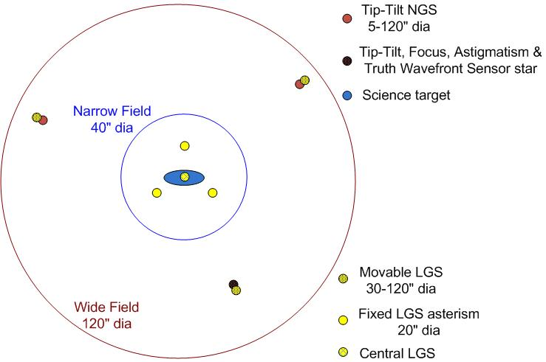

Figure - LGS “3+1” tomography asterism for the science field and three point and shoot lasers for image sharpening of the tip-tilt stars

# Reference documents

[KAON 551 Wavefront Sensor System Conceptual Design Report](http://www.oir.caltech.edu/twiki_oir/pub/Keck/NGAO/AOSystemDesign/WFS_design_report_rev5.pdf)

[511 System Design Manual v2.1 (doc)](http://www.oir.caltech.edu/twiki_oir/pub/Keck/NGAO/NewKAONs/KAON511_NGAO_SDM_v2.1.doc), dated March 30th, 2008

[Preliminary Design Manual](http://www.oir.caltech.edu/twiki_oir/pub/Keck/NGAO/NewKAONs/KAON_NGAO_PDM_v0.3.doc) (as of November 12th, 2009)

[685 Opto-mechanical Design Document](http://www.oir.caltech.edu/twiki_oir/bin/viewfile/Keck/NGAO/NewKAONs?rev=2;filename=PDR_AOrelay_design_v4.pdf)

[666 Fixed Pupil Mode](http://www.oir.caltech.edu/twiki_oir/pub/Keck/NGAO/NewKAONs/KAON666_NGAO_Fixed_Pupil_Mode.doc)

# AO relay path to LGSWFS input

The Laser guide star light path is shown in Figure 2, the laser light traverses through the K mirror and the fold followed by the 1st AO relay OAP, after which it is incident on the DM. Following the DM it is folded by a notch dichroic and a plano-convex lens, with the convex surface being a parabola, focuses the beam to a tilted focal plane. Figure 2 shows the layout of the LGS light path within the AO relay. The LGSWFS module begins at the focus created by the AO relay. Figure 3 shows the spot diagram from the AO relay at 90 Km Na layer distance.

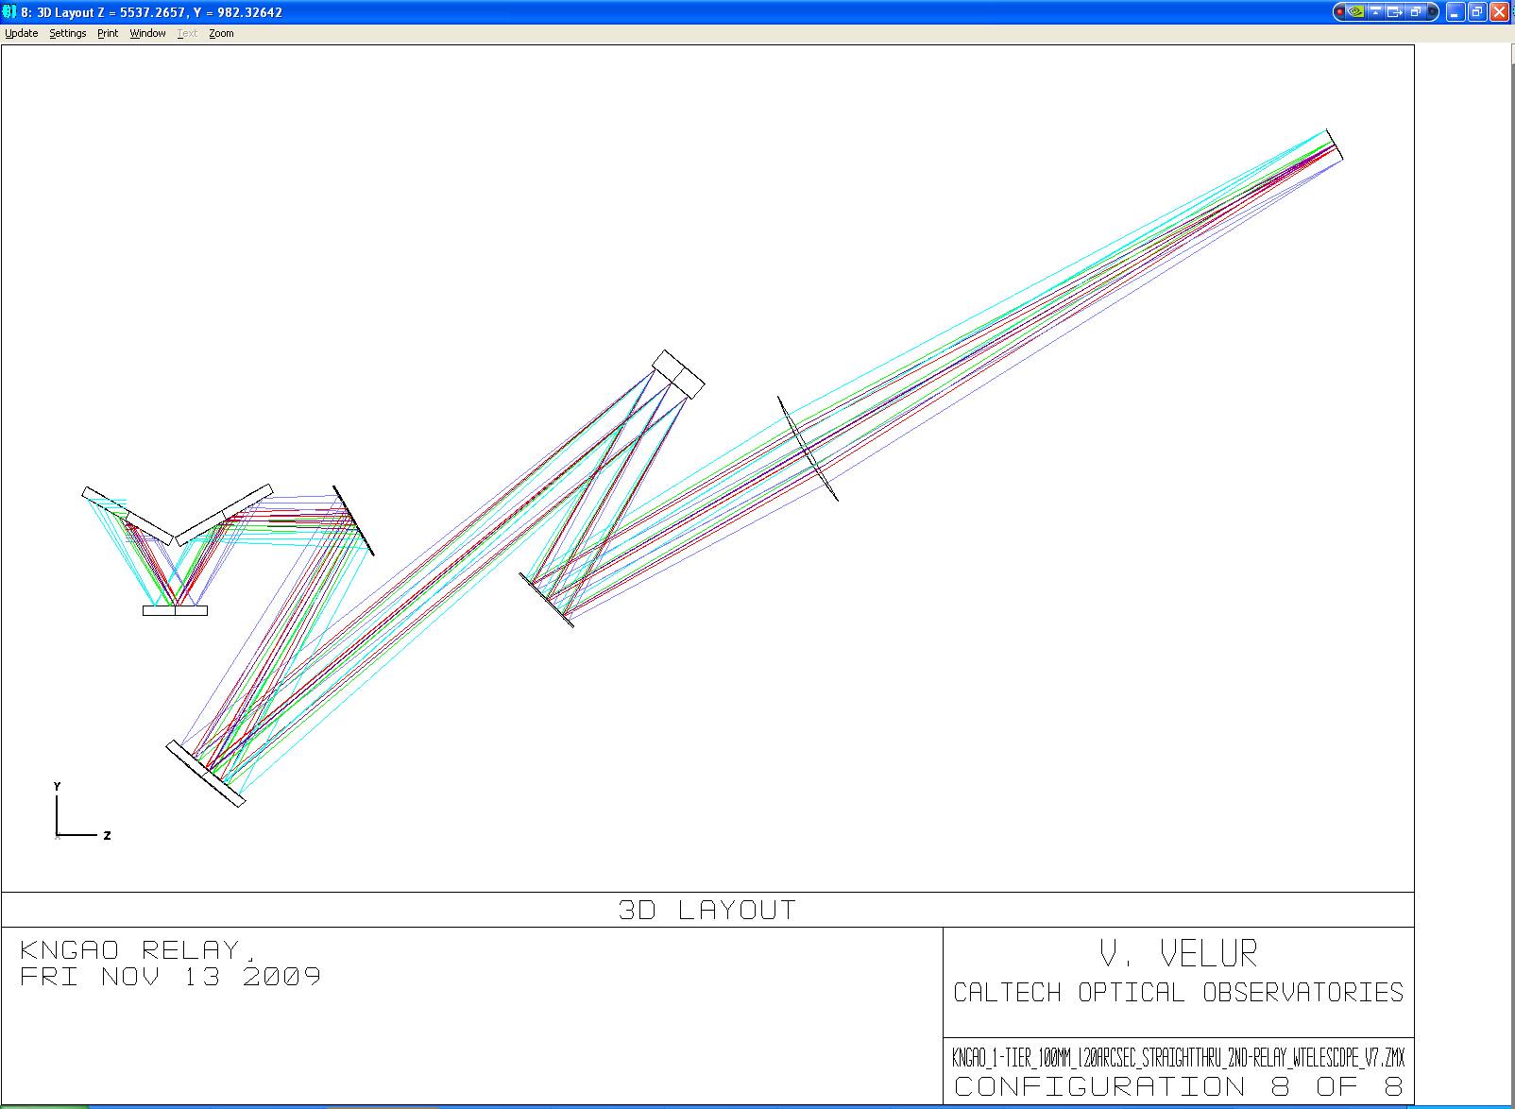

Figure - Laser guide star light path starting from the K mirror to the LGSWFS pick-off focal plane.

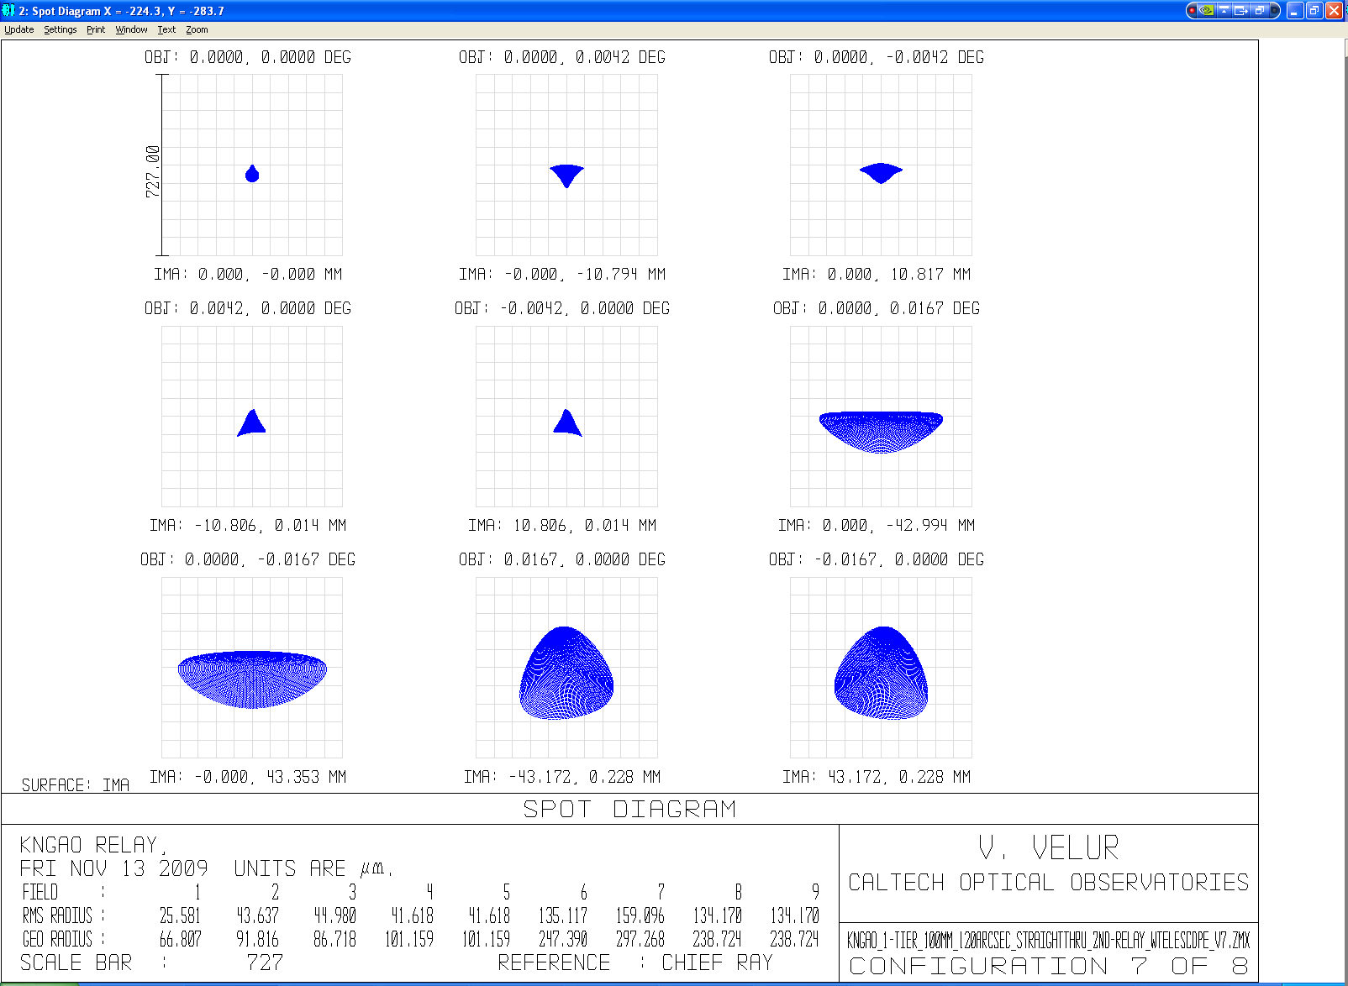

Figure - LGSWFS spots when the telescope is pointing at zenith. The fixed LGS spots at the LGSWFS pick-off focal plane is 25-45 um (RMS) radius while the PnS LGSWFS spots are as big as 160 um (RMS) at the edge of the field.

To understand the effect of the AO relay as seen by the LGS WFS sub-apertures, we swap the Keck primary mirror with movable aperture that is 1/31st of the primary mirror and de-center this aperture to the extreme points of the primary mirror to look at the resulting spots to understand what happens at the Shack-Hartmann sub-apertures. One can see RMS radii of almost 6 um at the edge of the field.

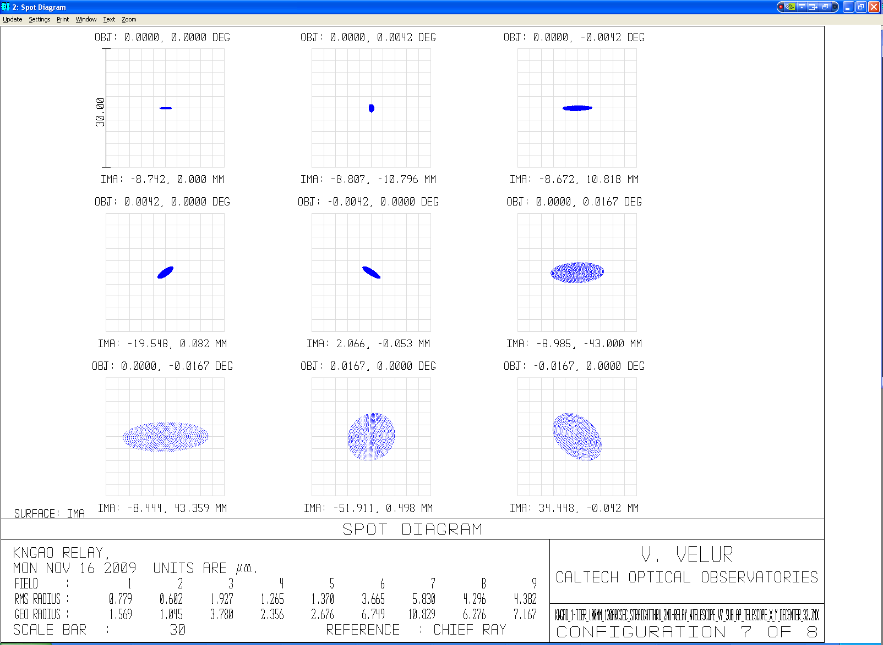

Figure LGS spots as seen by a single PnS LGSWFS sub-aperture. The spots diagram was generated by creating a de-centered 353.2 mm aperture on the primary mirror and making the entrance pupil the size of a single sub-aperture. The aperture parameter in the Surface Property menu was set to the primary mirror radius (5297.9 mm) to accommodate ray tracing. The worst case sub-aperture spots are 5 um (RMS) radius.

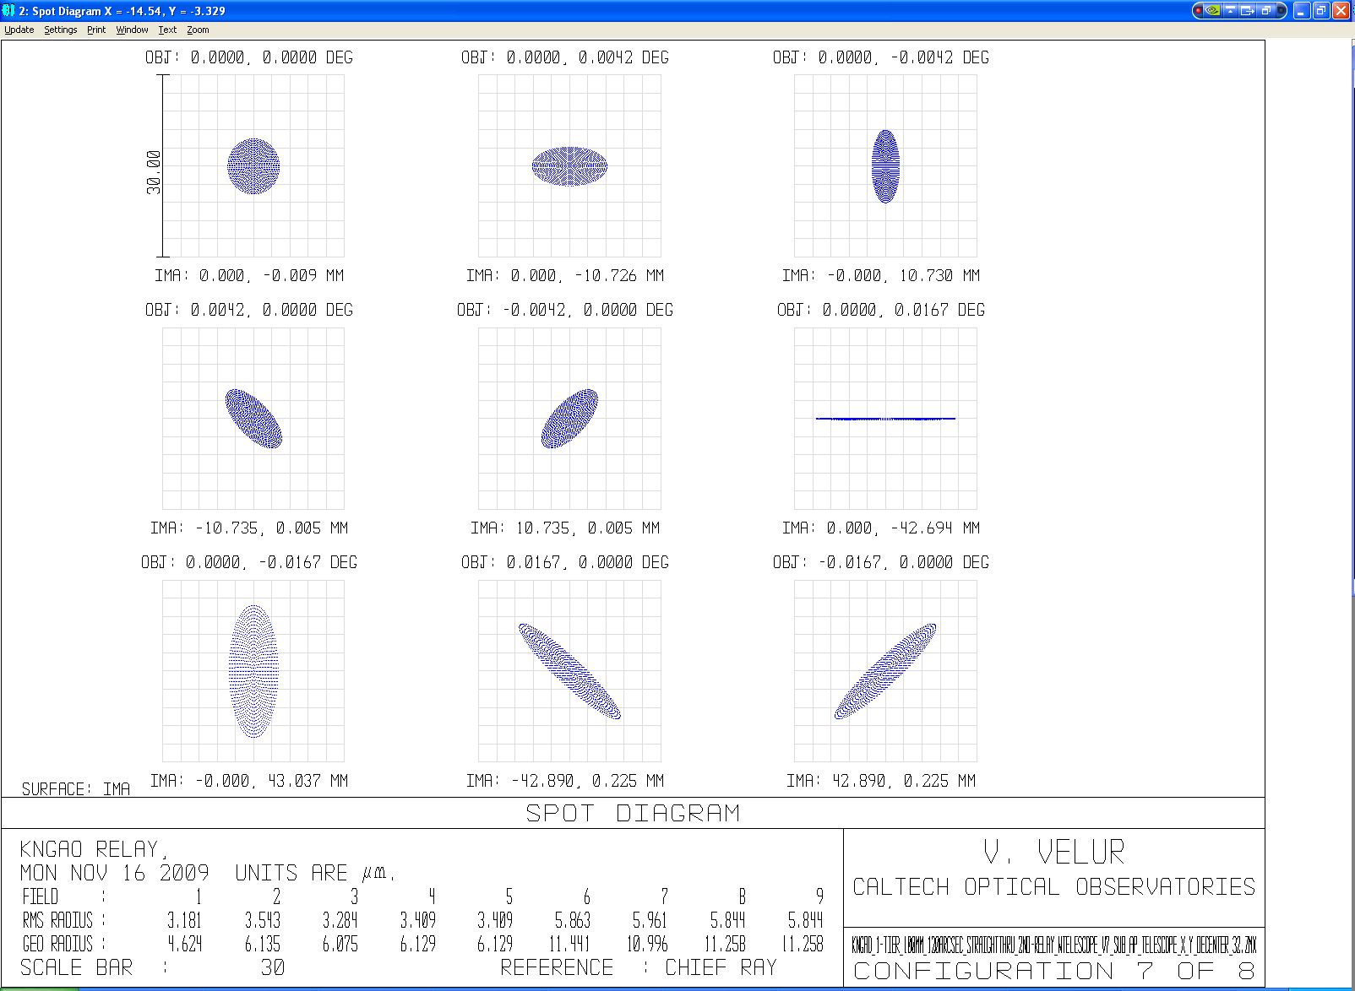

Figure - LGS spots as seen by a fixed LGSWFS sub-aperture (Y de-center of 5297.9mm of a 79 mm radius sub-ap). Worst case sub-apertures are 6 um (RMS) radius.

# Requirements highlights

# Design

## Relevant Analysis

### Pixel scale choice

Pixel scale is chosen to be the apparent spot size (sans charge diffusion) being the size of a detector pixel to get maximum linearity for the tilt measurement range. From experience we know that characterizing and calibrating each sub-aperture of the 4 sensors with 64x64 sub-apertures and the 3 sensors with 32x32 sub-apertures to make up for non-linear response is not practical and hence we choose the plate-scale to ensure that the sensor operates in its linear regime.

For the fixed LGS asterism, the 1D tilt error is 50 mas and the sub-ap spot size is 699 mas. We choose p=0.5 from Table 1 to accommodate capture range and keep the sensor very linear with the tilt measurement range being +/- 421.5 waves.

For the variable asterism the 1D tilt error is 329 mas and the sub-ap diffraction limited spot size is 343 mas. We choose P=1.0 for this sensor based on Table 1 to be able to measure +/-2.5 waves of tilt.

|  |  |  |  |
| --- | --- | --- | --- |
| Detector size per subaperture | Pixel Size/ spot size (p) | Useful tilt range +/- waves | Departure from linearity |
| 2x2 | 1.0-1.5 | 0.5 | 0.024 |
| 2x2 |  | 1.0* | .13* |
| **4x4** | **0.5** | **1.5** | **0.019** |
| 4x4 | 0.67 | 2 | 0.085 |
| **4x4** | **1** | **2.5** | **0.19** |
|  |  |  |  |
| * - nonlinear response |  |  |  |

Table - Dynamic range and linearity of Shack-Hartmann quad-cells (this is same as Table 5.3, Pg. 149 of Hardy). NGAO PnS LGS WFS’s use a 4x4 pixel sub-aperture with p=1; while we choose a p of 0.5 for the fixed LGSWFS’s.

Telescope Plate scale (TPS) = Working f# of LGS focal plane * telescope dia. (mm/rad) /206265 (arcsec/rad) = 13.52 * 10.949 /2062645 = 717 um (Zemax says 720 um/sec).

 

Figure apparent spot size measurement at the detector due to various effects for the fixed tomographic LGS WFS spots (left) and that of deployable PnS (TT sharpening) LGS WFS spots (right). Charge diffusion term is set to 0 to come up with a estimate of the detector platescale.

### Downlink TT mirror choice

To determine the TT mirror of choice, we need to specify the resolution and the throw required for the mirror.

Pupil de-magnification at the TT mirror= 10.949 m /(12.5 mm /1000 mm/m) = 875.92

TT resolution on sky = 1 milliarcsec (say)

Hence, TT mirror resolution = 0.001 (arcsec) * 875.92 = 0.875” = 4.2 microradians

Capture need, say is, 0.5 aSec (on sky angle) = 0.5*875.92 “ /206265 (“/rad) = 2.12 millirad

We choose the following mirror from Physik Instrumente’s catalog:

<http://www.physikinstrumente.com/en/products/prspecs.php?sortnr=300700>

S-330.8SL has 10 mrad of tilt travel with 0.5 microrad open-loop resolution is the mirror of choice. The mirror has a resonance frequency of 1 KHz with a 1” diameter optic with ¼” thickness.

***--------------------Need to add a check based on 1D tilt measurement -------------***

### Calibration requirement in case we use one global focusing stage and no individual focusing stages.

A very simplistic model follows which indicates that the without calibration a single LGS WFS focus stage there is defocus due to two effects, viz. change in ROC of the LGS focal plane with change in distance to the sodium layer, this effect is shown in Table 2 and due to the finite size of the LGS asterism on sky. The physical distance between the innermost and outermost LGS on-sky and the telescope varies with zenith angle as shown in Figure 7. Both these effects are entirely deterministic given the position and geometry of the LGS asterism and so the defocus can be calibrated away.

|  |  |  |  |
| --- | --- | --- | --- |
| Sodium layer altitude | ROC of focal plane (from Zemax) | Focal plane size | Sagitta |
| 90 km | 883.2 mm | 7.27 mm | 0.0299 mm |
| 180 km | 2064 mm | 7.27 mm | 0.0128 mm |
|  |  |  |  |
|  |  | **difference in sag =** | **0.0171 mm** |

Table - Radii of curvature of the LGS focal plane as delivered by the NGAO optical relay at 90 and 180 km Na layer object distance and the change in focus due to the changing RoC.



Figure - Schematic showing defocus between the innermost and outermost LGS due variation in physical distance of those with zenith angle.

α = 1.221 degrees (at 70 degrees off zenith pointing)

β = 7.2722 * 10^(-2%) deg.

b = **h/cos(**α**) \*** β

x = **b*tan(**α**)**

|  |  |  |
| --- | --- | --- |
| Guide star radius | defocus error due to geometry of the asterism (um) | Error in waves |
| 10 | 17 | 0.0778 waves |
| 50 | 68 | 0.311 waves |

Figure -shows the error due to change in focus between the innermost and outermost LGS with zenith angle. For reference λ/4 depth of focus is 147 nm of WFE and 219 um of defocus (as given by 2*λ*F/#2).

### LGS WFS relay performance specification

Allocation as per EBS for internal WFS aberrations is 0.25” (FWHM). The LGS spots delivered by the OSM are 3-8 times better than the input spots from the AO relay for the fixed and deployable LGSWFS’s. The OSM’s contribution corresponds to an FWHM of 0.05 arcsec. So, almost all the allocation can be used for the WFS relay design.

Hence, the LGSWFS relay performance needs to have:

Spot size (RMS as indicated by Zemax) at the detector = Allocation (arcsec FWHM)/2.355 (FWHM/RMS) * 21 (um/pixel)/1.49 (arcsec/pixel) = 0.25/2.355*21/1.49 = **1.5 um**

### Field stop specification

## Optical design and performance

### Fixed LGS WFS

#### Wavefront sensor design math

Pixel size/spot size = 0.5 (as per Table 1)

From the AO system optical design, 720 um is an arcsec.

Hence, 1.41” corresponds to 42 um (2*21 um detector pixels).

fcollimator/flenslet * 1/m = Plate scale at the input of the sensor(um/asec)/ Detector plate scale (um/asec)

= 720/29.78 = 24.4064 (720 is the # obtained from Zemax).

d each lenslet = fcollimator/f# * 1/(# of sub-aps) = 80/13.56 * (1/63) = 93.6 um (choose a 80 mm focal length lens).

m = 0.084/0.0936 = 0.896

f2 = fcollimator/m * (29.78/720) = 80/0.89699 * (1/24.17145) = 3.68 mm (f/# lenslet = 39.42)

lenslet array Fresnel # = (d each lenslet /2)2/(f*λ) = 1.01.

#### Fixed LGS pick off design and performance

To accommodate mechanical packaging and keep the optical surfaces to a minimum, a 1:1 relay was chosen with a total length of 640 mm (Alex to add reasons for packaging). Figure 7 and Figure 9 show the optical layout and spot diagrams from the relay. The relay has a FoV of 5” (FR xx) is telecentric in order to not introduce any spurious tilts in the beam due to the incidence position of the LGS light. The spots sizes are 16 um RMS compared to 40 um RMS spots that the AO relay generated from the AO relay.

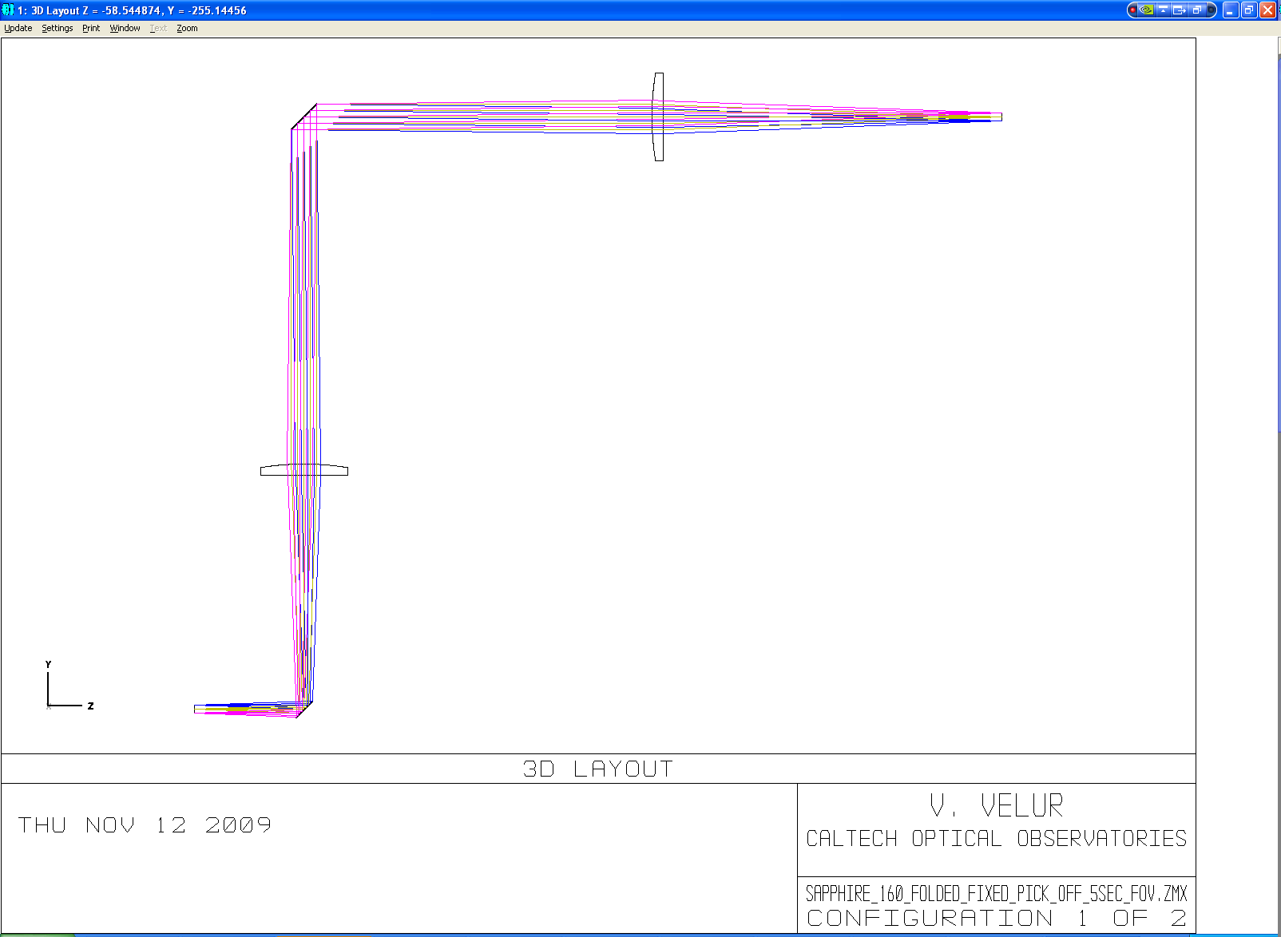

Figure - Telecentric 1:1 fixed LGSWFS pick off relay. The total length of the relay is 640 mm (limited by packaging constraints).

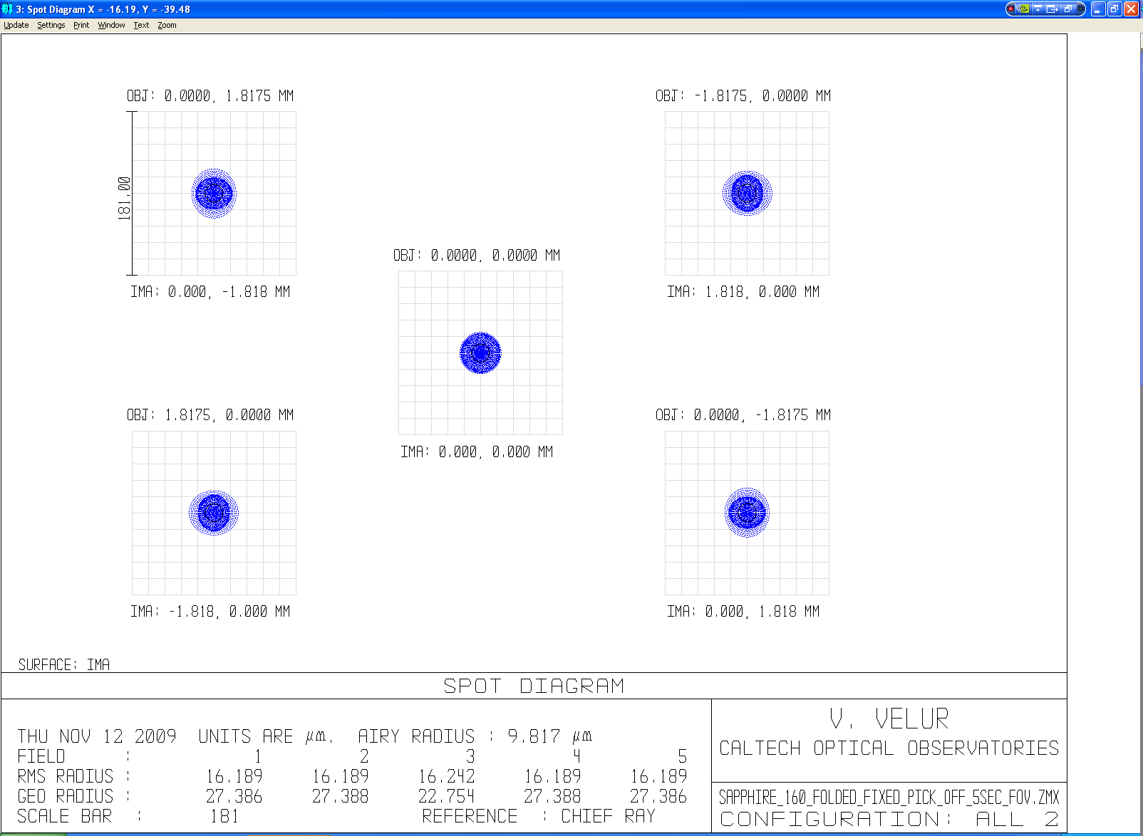

Figure - Spot diagram showing the performance of the fixed LGSWFS pick-off over a 5 arcsec FoV (scale bar corresponds to ¼ arcsec.).

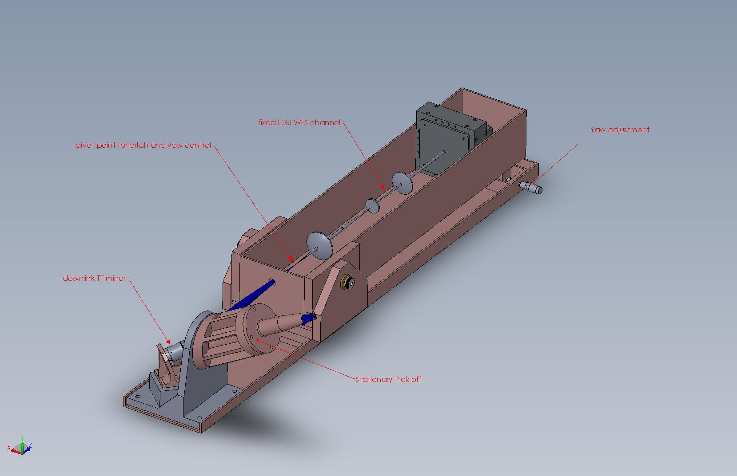

Figure - Mechanical design of stationary fixed LGSWFS channel with stationary 1:1 relay with the downlink tip-tilt mirror at the relay’s pupil location.

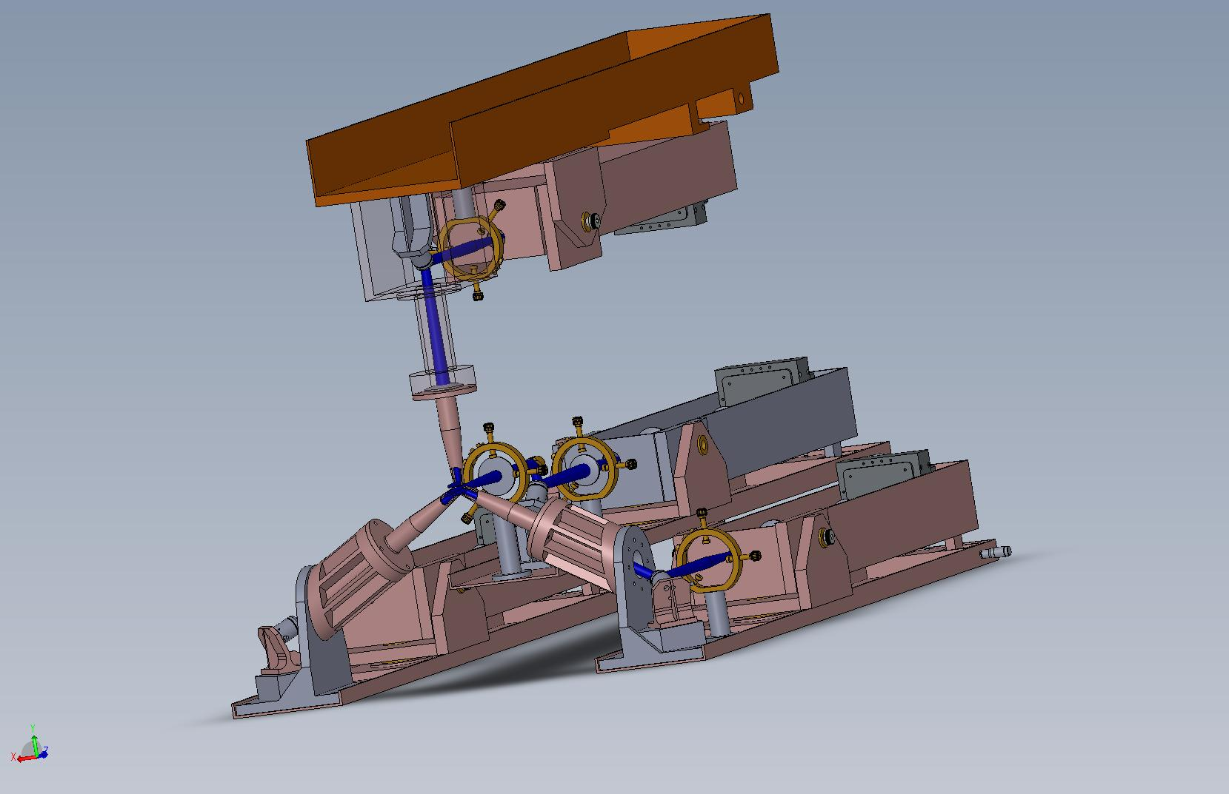

Figure – Mechanical assembly of the fixed asterism pick offs and sensors assembly showing the 4 fixed LGSWFS’s with one located in the middle and other three located equidistant from each other on a 10 arcsec circle about the central axis.

#### Post-lenslet relay design and performance

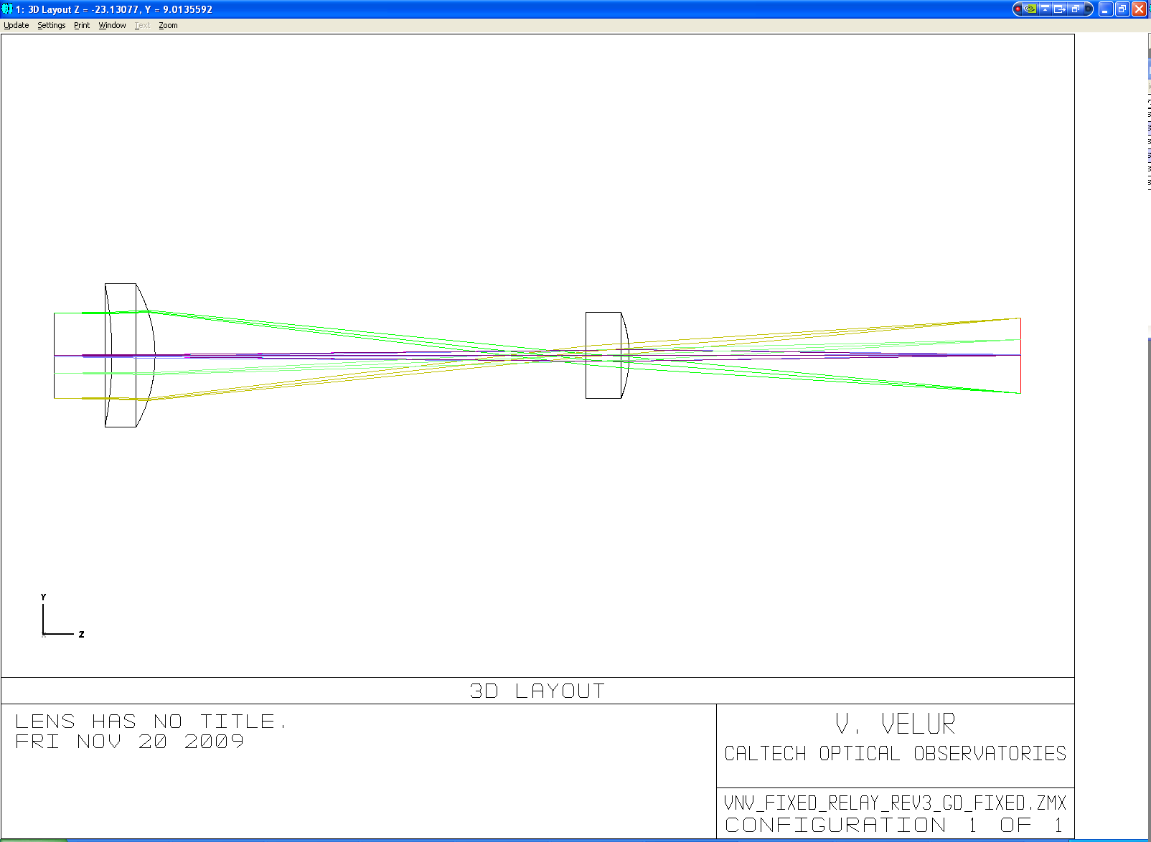

Figure - fixed LGSWFS post-lenslet WFS relay layout.

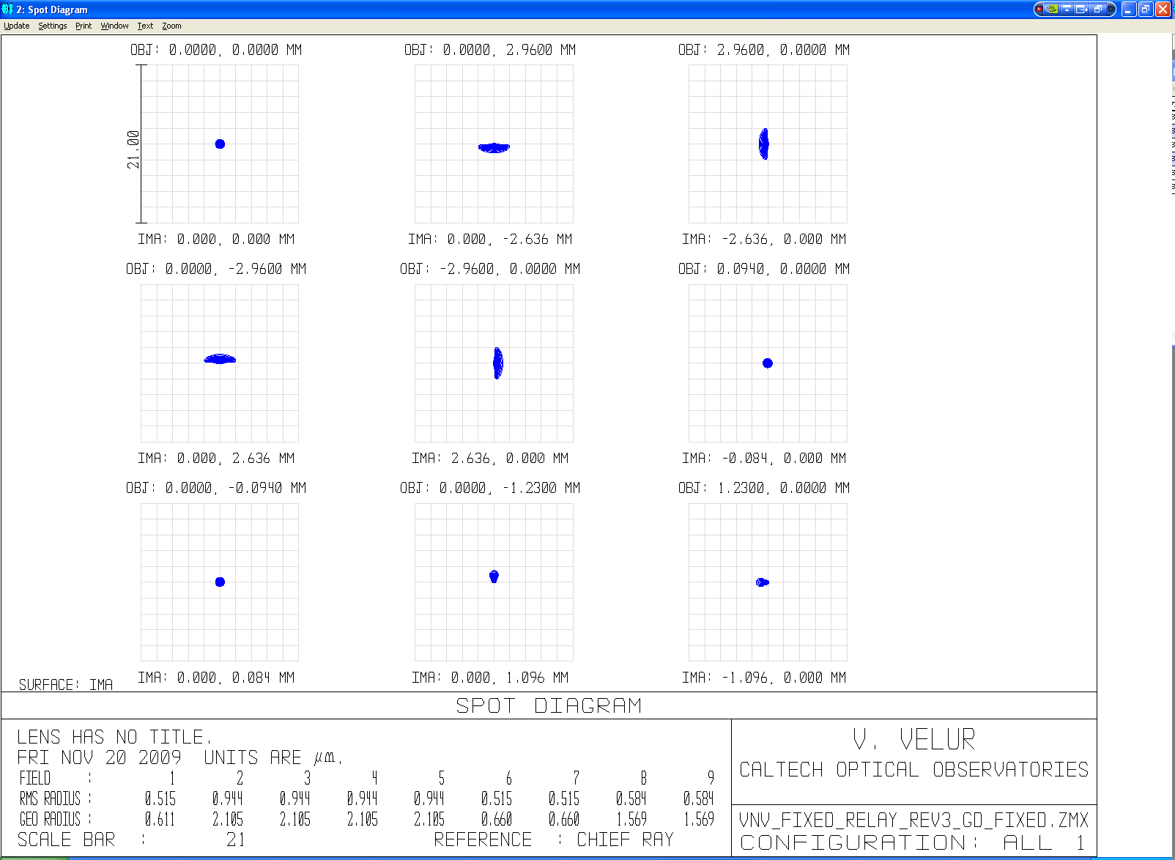

Figure – Spot diagram showing an on-axis point and 4 extreme points of the lenslet spots with the worst case spot size being 0.95 um RMS radius. Detector pixel size is 21 um for reference. The last 2 spots are one lenslet spot away indicating that the magnification is matched to 84 um spot separations at the detector. The grid distortion of the relay is 0.03%.

#### WFS design and performance

#### 

Figure - layout of fixed LGSWFS, The total length of the sensor is 230 mm. The relay is composed of a best-form lens for a collimator, a custom lenslet array and a set of custom singlet relay lenses.

#### 

Figure – fixed LGSWFS spot diagram showing 64x64 sub-apertures

#### 

Figure - footprint diagram with 2 field points, on on-axis point and one 1.41 arcsec (1205.7 um) away showing that the plate scale at the detector is 0 .705arcsec/pixel

### Point and Shoot LGS WFS

#### Wavefront sensor design math

Pixel size/spot size =1.0 (as per Table 1)

Hence, 1.49” on sky corresponds to 21 um (detector has 21 um pixels).

fcollimator/flenslet * 1/m = Plate scale at the input of the sensor(um/asec)/ Detector plate scale (um/asec)

= 720*2/14.0939 = 102.171 (720 is the # obtained from Zemax).

d each lenslet = fcollimator/f# * 1/(# of sub-aps)=95/27.12 * (1/31) = 112 um

m = 0.084/0.112998 = 0.74

f2 = fcollimator/m * (29.78/720) = 95/0.74337 *(1/102.1714) = 1.25 mm (lenslet f# = 11.06)

lenslet array Fresnel # = (d each lenslet /2)2/(f*λ) = 4.33.

#### Fixed LGS pick off design and performance

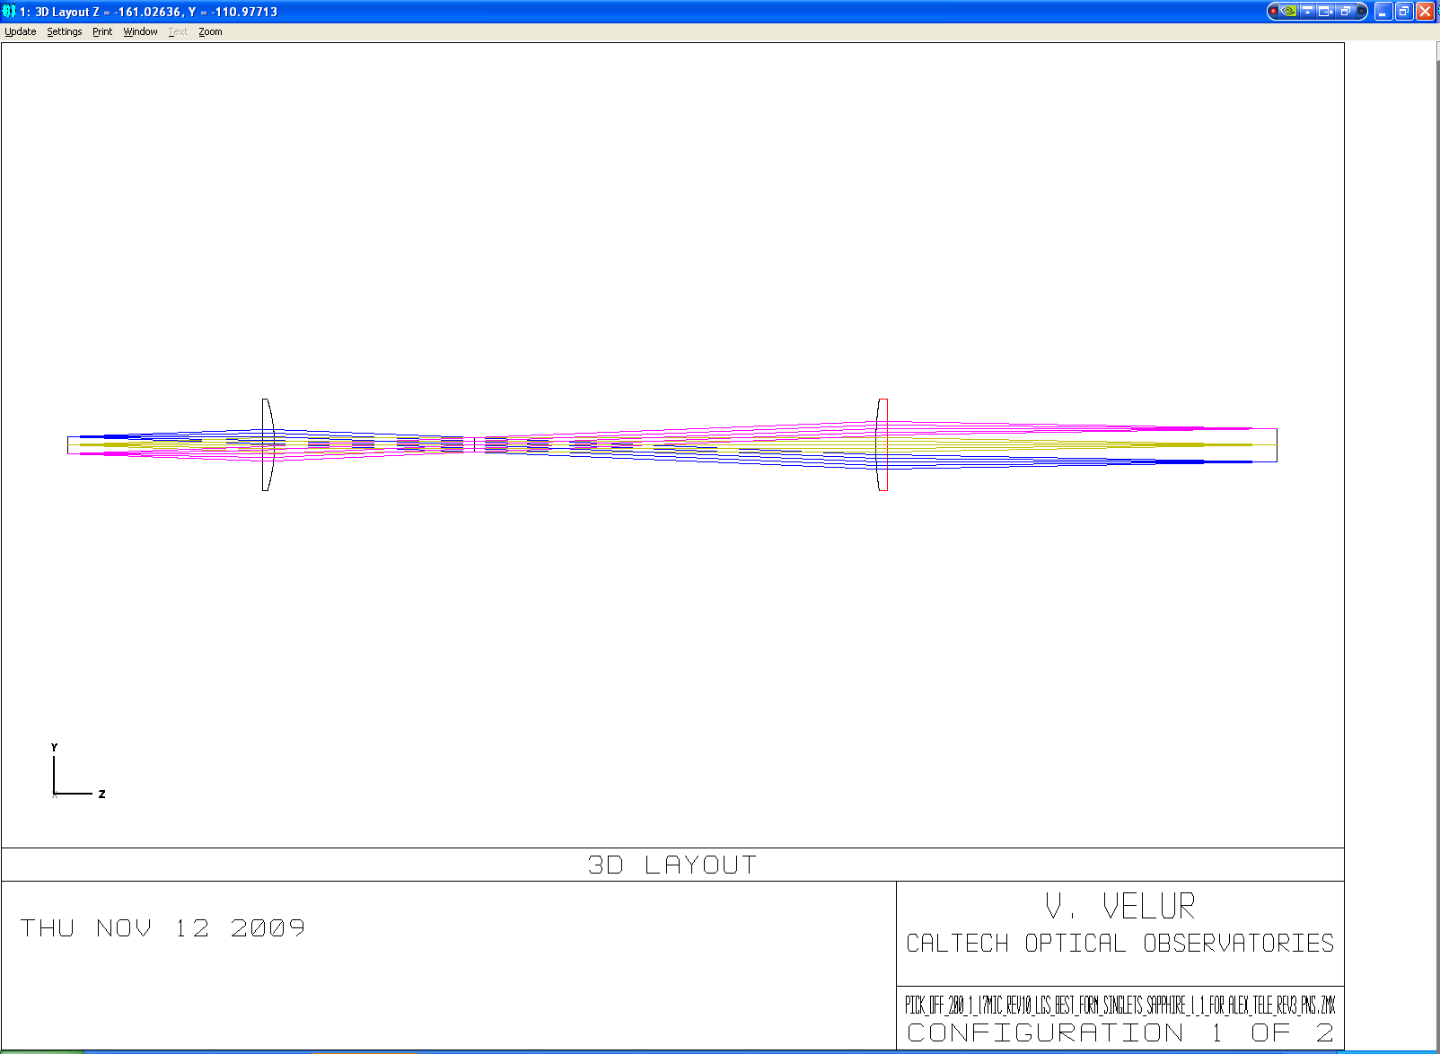

Figure – Figure showing the telecentric unfolded layout of the PnS LGSWFS pick off. The relay is 1:2 due to packaging constraints.

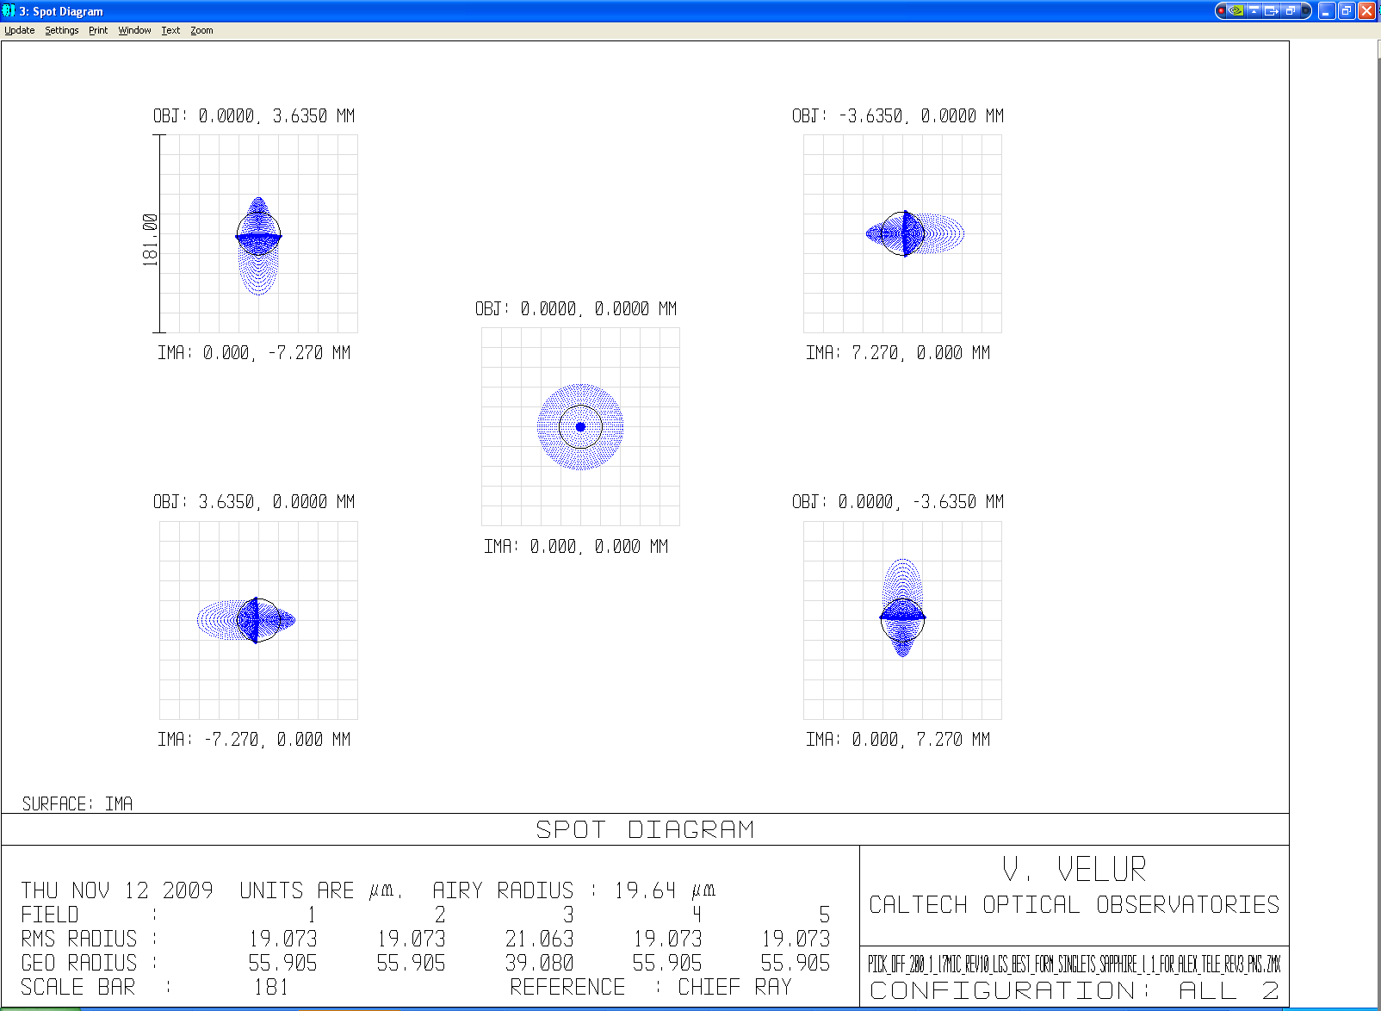

Figure – Spot diagrams from the 1:2 PnS pick off relay showing spots with rms spot radius of 21 um as compared to 130um rms spots delivered by the AO relay. For reference 101 um is 1/4 arcsec.

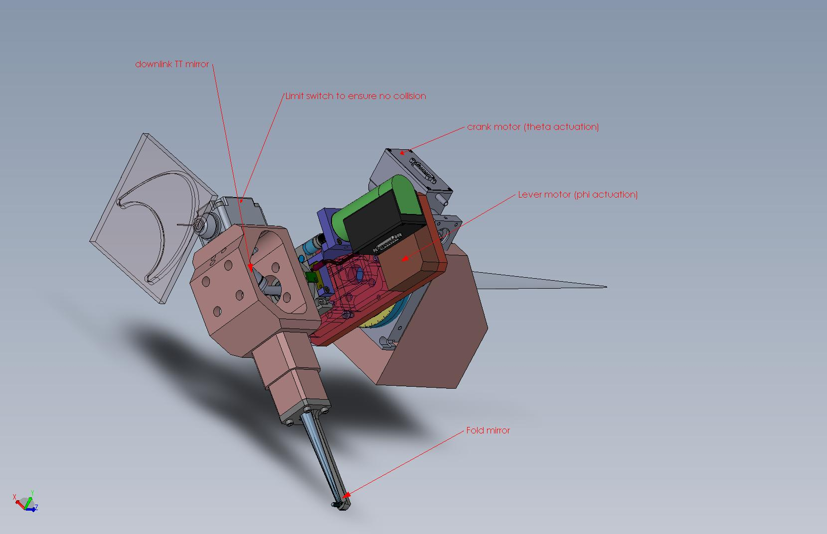

Figure - mechanical assembly of a single deployable PnS pick-off showing the theta-phi mechanism with a downlink TT mirror located at the pupil. The blue and green parts are commercial motors that move the crank and lever.

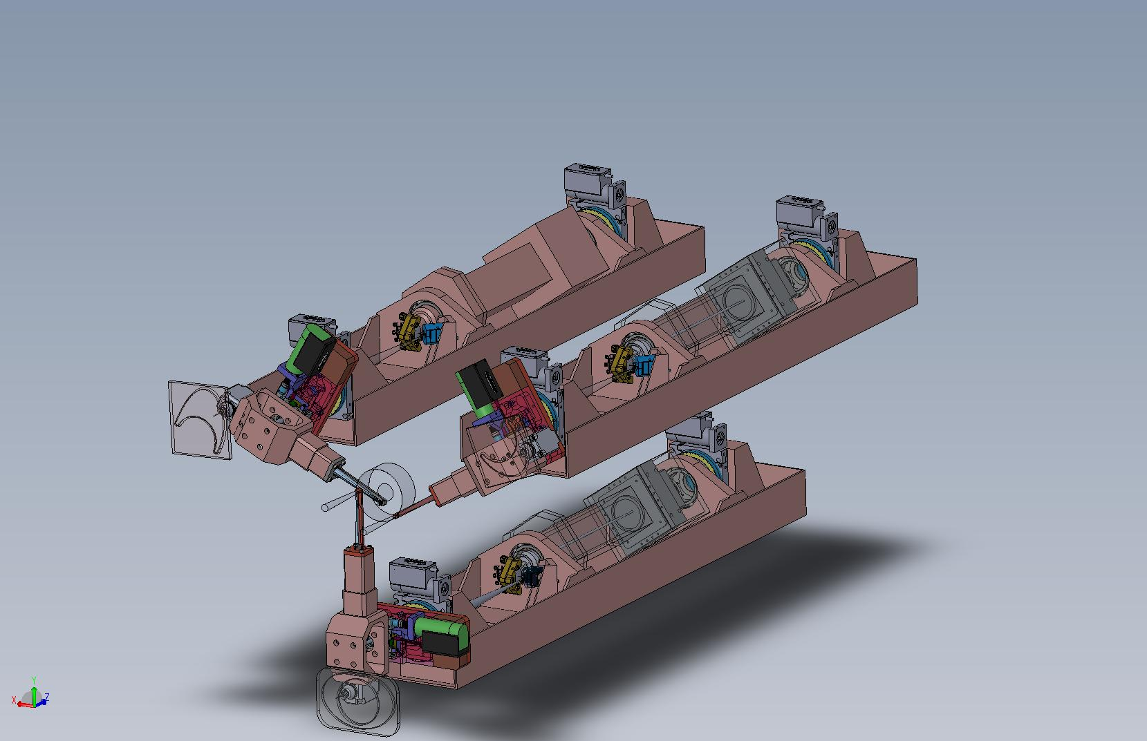

Figure – Mechanical assembly of the PnS WFS channels showing the lenslet, the post-lenslet relay and the detector mounted on a bearing and a rotary stage to keep the lenslet and the LODM actuators registered with respect to each other for any pick off position in the FoR. Each of the PnS WFS channel is also equipped with a TT mirror near the focus of the pick-off relay to keep the DM pupil registered onto the lenslet; this is necessary to eliminate pupil wander.

#### Post-lenslet relay design and performance

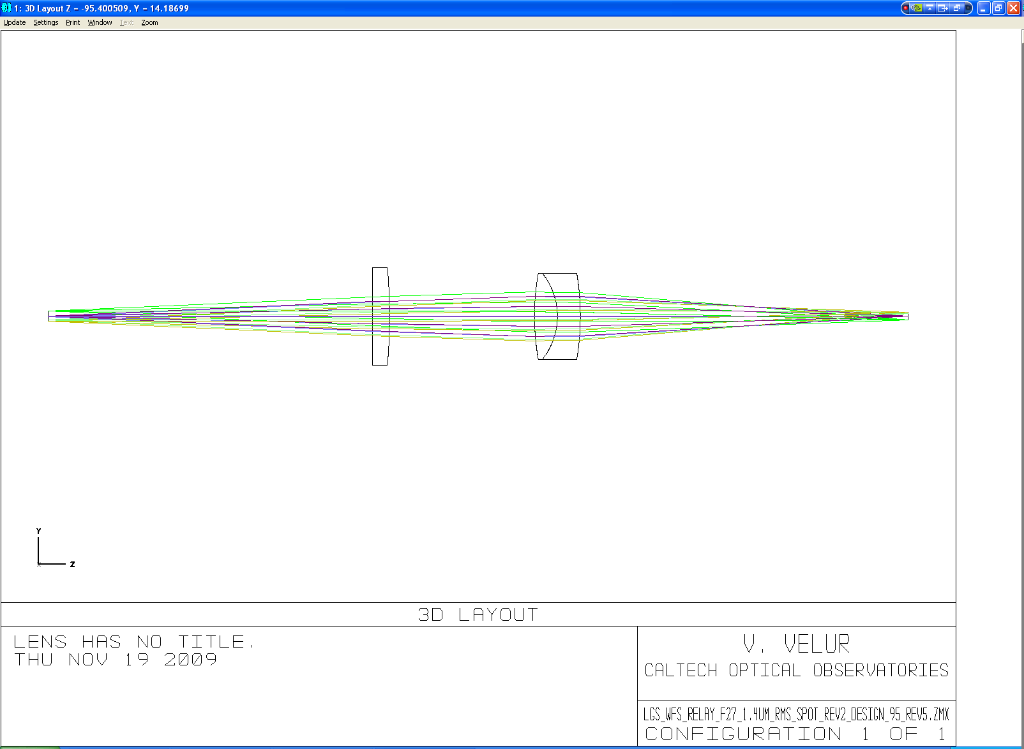

Figure – Shows the layout of the post lenslet relay in the PnS LGSWFS, the length of the relay is 300 mm.

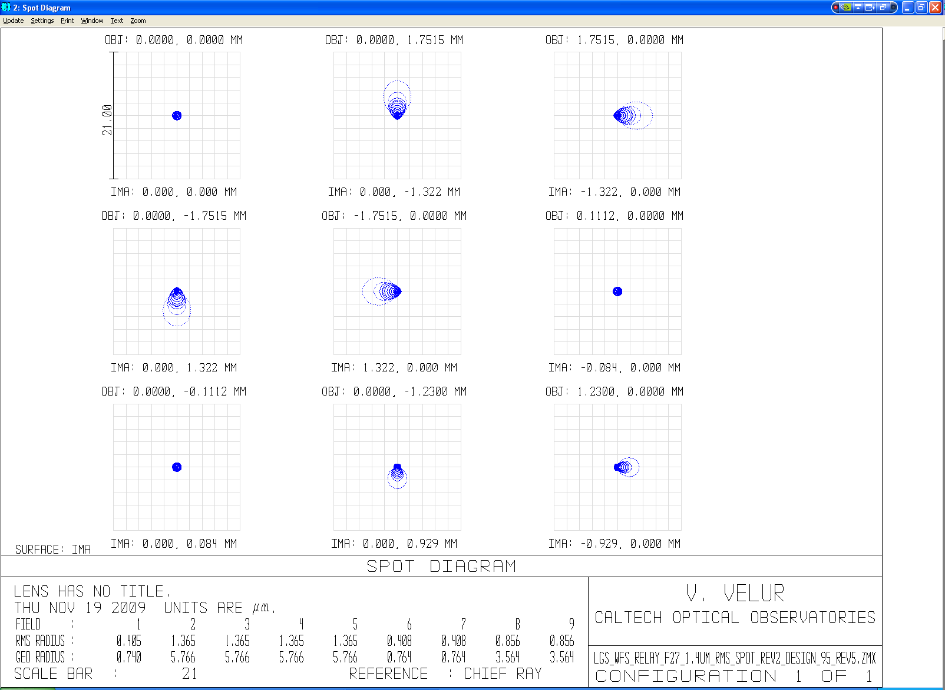

Figure - Spot diagrams of the relay with on-axis and extreme field points. There are also 2 field points to indicate that the magnification is correct and 2 more located at 1/√2 of the field size.

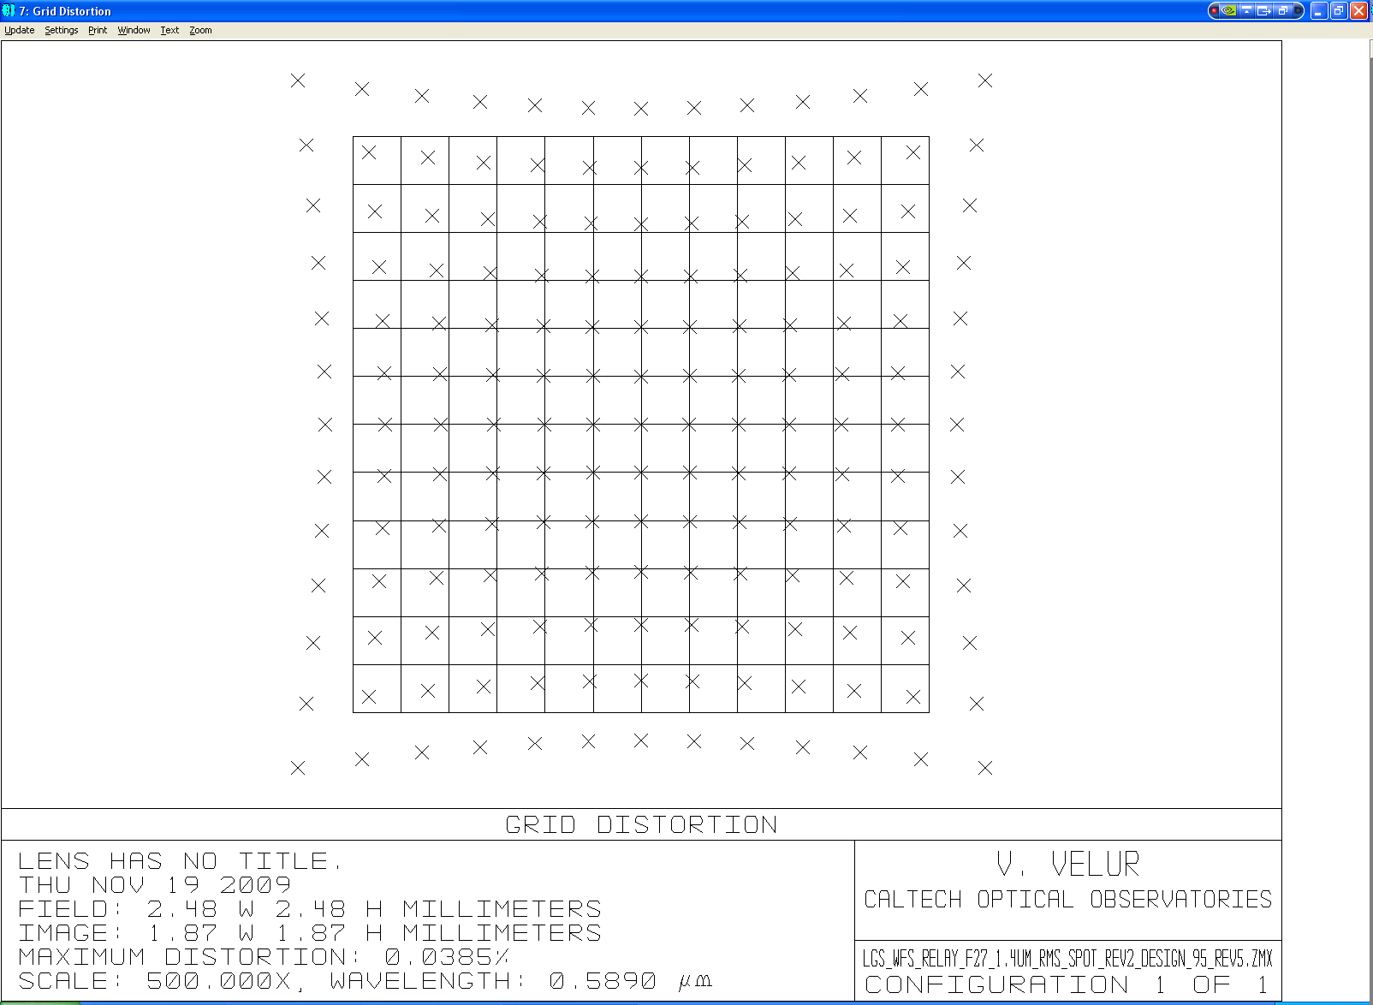

Figure - grid distortion of the relay (@ 500x)

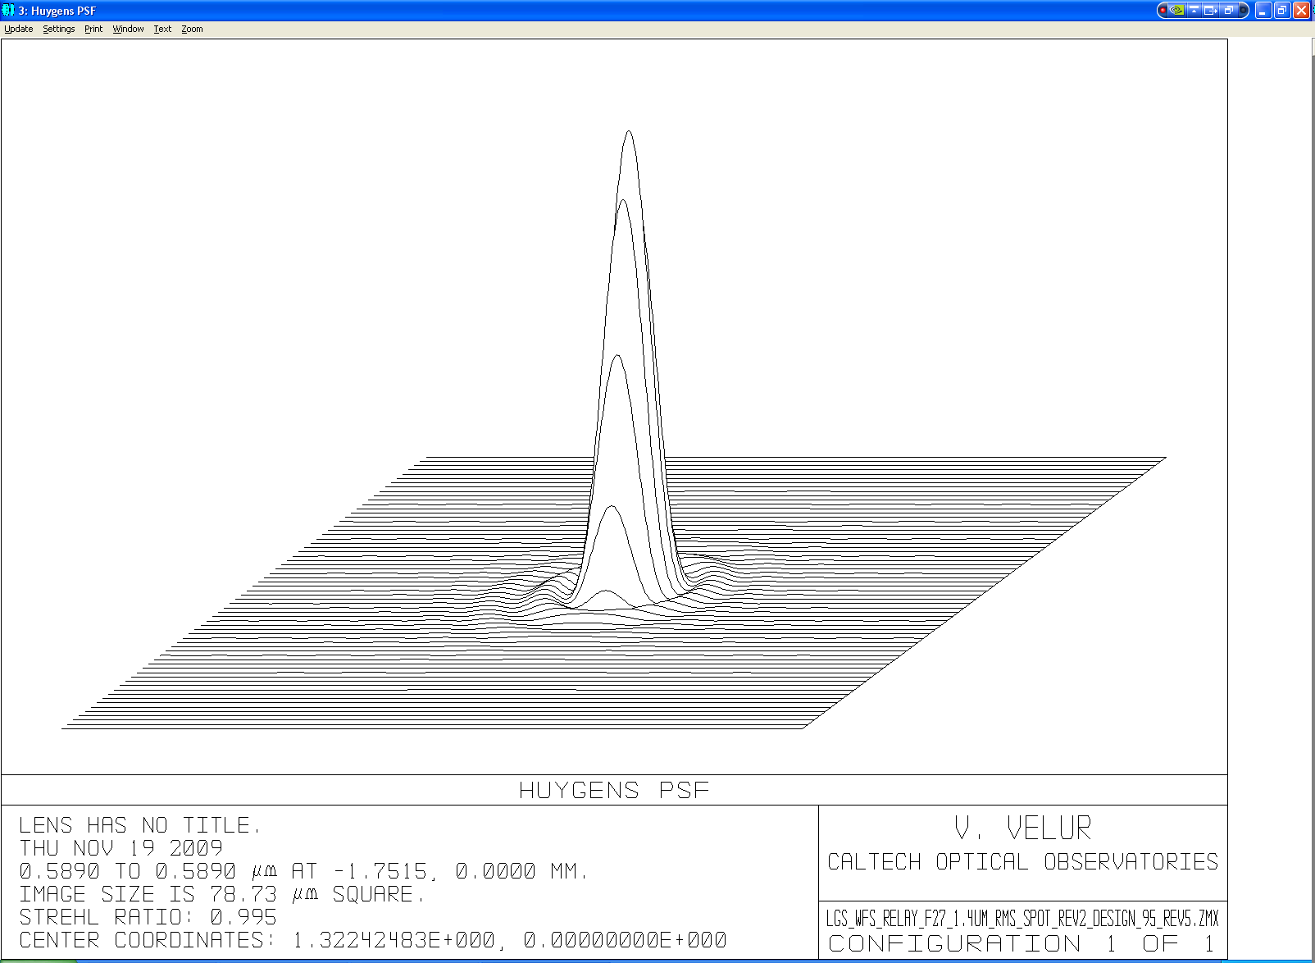

Figure - PSF at the worst field point (field point #5 in Figure 24

#### WFS design and performance

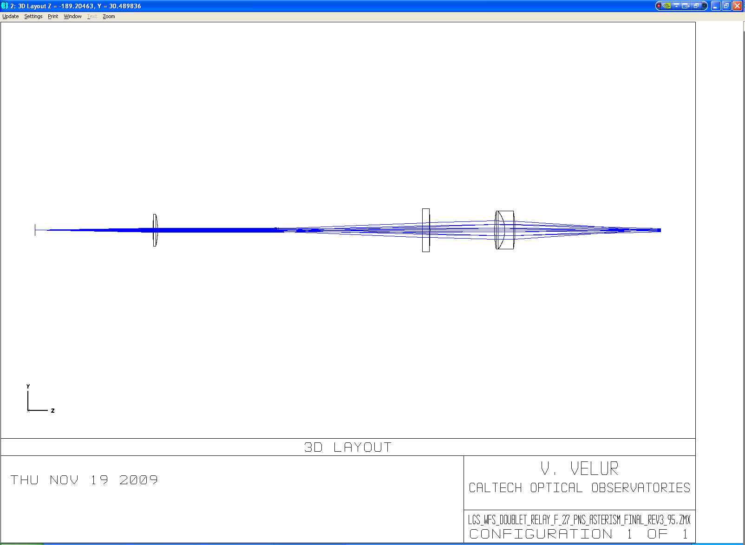

Figure - layout of the PnS WFS; the total length of the sensor is 490 mm. (I can make the relay longer to get better spots at the detector).

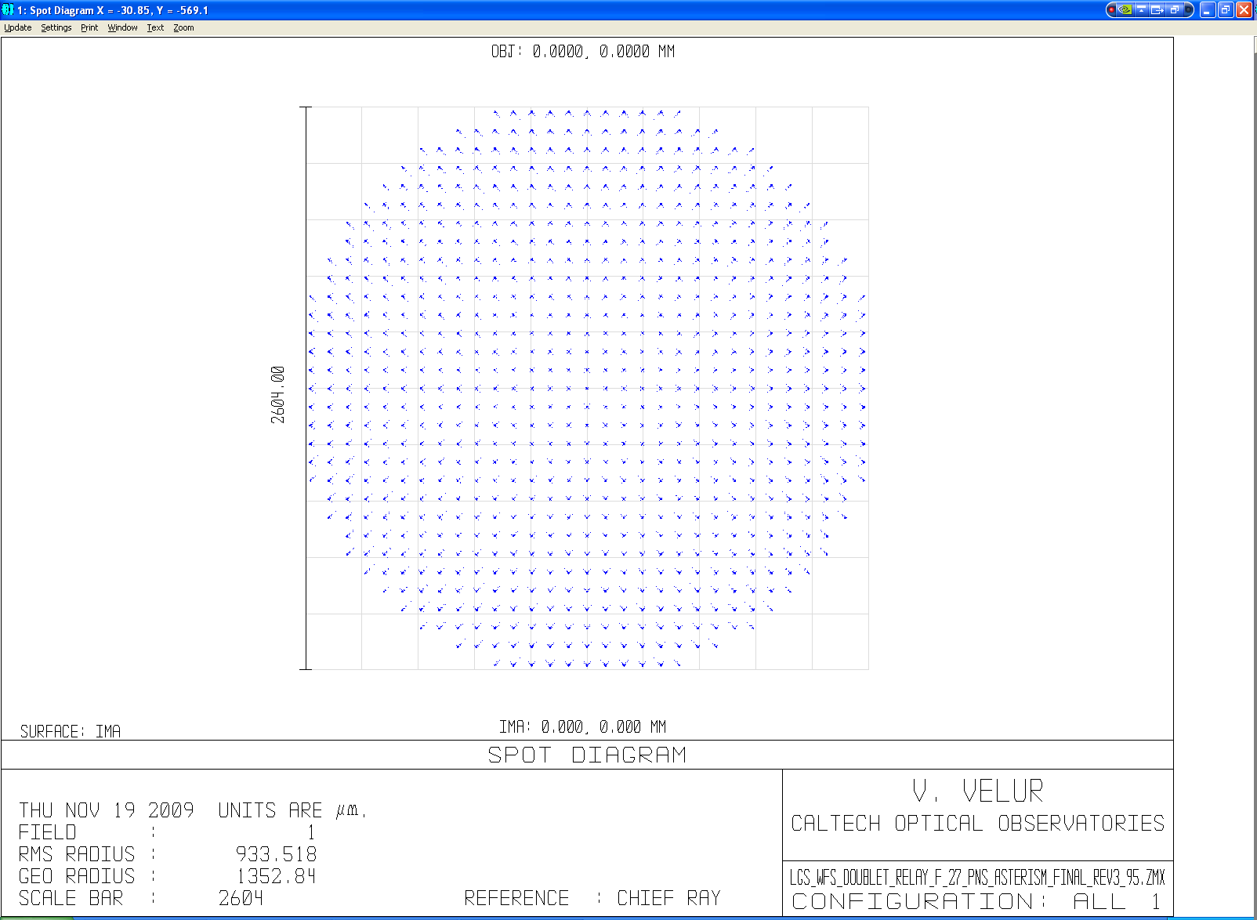

Figure - spot diagram at the detector

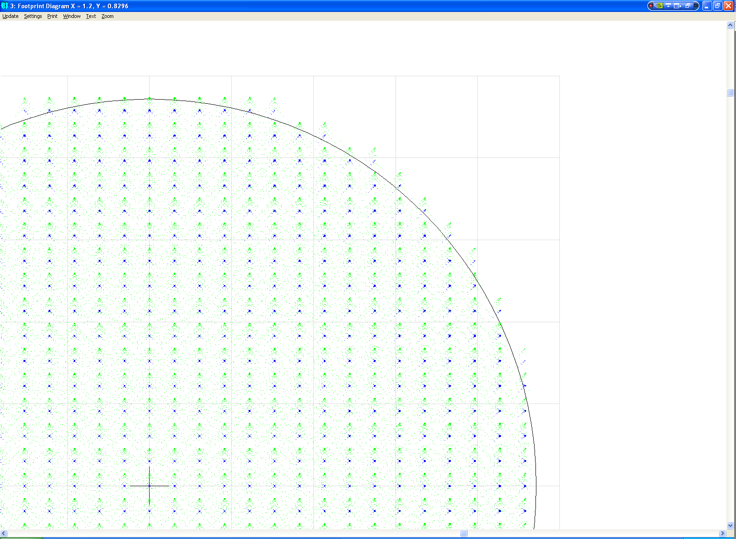

Figure - footprint diagram indicating that the detector plate scale corresponds 1.49" (on sky) /pixel

### Performance of the sensors with the AO relay

## Mechanical Design



Figure - mechanical assembly of the LGSWFS

### Design Requirements

### Conceptual design

### Pupil registration and TT corrector

Because the LGS light path to the WFS is not perfectly telecentric it is necessary to register the DM actuators and the lenslet for each point in the field for the PnS WFS (if the effect is not measured and calibrated). For this process we have a slow TT mirror near the pick-off focus to register the LODM actuators to the lenslet. We also provide a pitch and yaw mechanism to align the fixed LGS WFS lenslets to the LODM. Each LGS arm has a downlink TT mirror to correct the differential motion of LGS light WRT the science light at the pupil formed in the pick-off mechanism.

### Hardware choice

### Stress analysis

### Preliminary Integration Plan

## Requirements compliance

## Risk and risk mitigation plan

## Deliverables

## Work left to do

Stray light (including Rayleigh scatter) analysis -

1. [KAON 644 - Build-to-Cost Architecture Wavefront Error Performance](http://www.oir.caltech.edu/twiki_oir/bin/viewfile/Keck/NGAO/NewKAONs?rev=3;filename=NGAO_B2C_architecture_performance_v4.pdf)

   Pick off mechanism for the fixed LGSWFS:

   Pick off mechanism for the PnS LGSWFS: