Keck Adaptive Optics Note 414

Keck Next Generation Adaptive Optics:
System Design Phase
Systems Engineering Management Plan

Version 2
Date: September 29, 2006

W. M. Keck Observatory
California Association for Research in Astronomy
65-1120 Mamalahoa Highway
Kamuela, Hawaii 96743
808-885-7887

Author List
Name | Function
Peter Wizinowich | NGAO Executive Committee (EC) Chair
Richard Dekany | NGAO EC Member
Don Gavel | NGAO EC Member
Claire Max | NGAO EC Member & NGAO Science Team Chair

Contributors
Name | Function
Sean Adkins | Instrument Program Manager
David Le Mignant | Science Operations

Approval Control
Control | Name | Function
Revised by:

Approved by:
Authorized by:

Document Change Record
Issue | Date | Change Description
Initial offering | 9/12/06 | Draft to Directors
Version 2 | 9/29/06 | Release to Directors

Preface
This document is the Systems Engineering Management Plan for the system design phase of the Keck Next Generation Adaptive Optics (NGAO) project.

The Systems Engineering Management Plan describes the project objectives, major milestones, project organization and project management process. The Systems Engineering Management Plan also defines the project decision process and major decision points, the risk assessment and risk management process, and configuration management plans for hardware, software and documentation.
Table of Contents
Section Page

1 Introduction 5
2 System Design Phase Organization 5
3 System Design Phase Plan 5
3.1 Introduction and Overview 5
3.1.1 The System Design Phase 5
3.1.2 SD Phase Documentation 6
3.1.3 SD Phase Objectives 6
3.2 Planning Assumptions 7
3.3 Work Breakdown Structure 8
3.4 Schedule 8
3.5 Budget 10
3.6 Milestones 11
3.7 Risk assessment and Risk Management 12
3.8 Configuration Management 13
3.9 Requirements Management 13
4 Process 13
4.1 Work Flow and Decision Points 13
4.2 Science Requirements Development and Performance Budget Process 14
4.3 Core Science and Engineering Team 16
4.4 Contracts 16
4.5 Scope of Authority 16
4.6 Performance Management 16
4.7 Reviews 16
4.8 Reporting 16
5 Coordination 17
6 References 17
6.1 Keck Adaptive Optics Notes (KAON) 17
6.2 Other Documents 17
7 Appendix: Establishment of the NGAO SD Phase Executive Committee 18
8 Appendix: The NGAO System Design Phase 19
8.1 Introduction 19
8.2 System Design 19
8.3 System Design Phase Documentation 19
8.3.1 The System Requirements Document 20
8.3.2 System Design Manual 21
8.3.3 Systems Engineering Management Plan 22
8.3.4 System Design Report 22
8.4 Specific NGAO System Design Objectives 23
9 Appendix: System Design Phase Work Breakdown Structure Dictionary 24
10 Appendix: System Design Phase Schedule 44
11 Appendix: System Design Phase Team Meeting Schedule 49

Introduction
A proposal for the W.M. Keck Observatory’s (WMKO) Next Generation Adaptive Optics (NGAO) system was presented at the June 21, 2006 meeting of the Observatory’s Science Steering Committee (SSC).¹⁻³ This plan was well received by the SSC and Observatory management. An Executive Committee has been established by the Observatory Directors (WMKO, UC and CIT) to manage the system design phase of the NGAO project (see section 7). This committee consists of Rich Dekany, Don Gavel, Claire Max (chair of the NGAO science team) and Peter Wizinowich (Executive Committee chair).

A Systems Engineering Management Plan (SEMP) is a standard part of the project documentation for development efforts at WMKO. Because we anticipate further development of the management structure of the NGAO project in subsequent development phases this version of the SEMP covers only the system design phase of the project. This plan is also intended to fulfill the request of the Observatory Directors for a management plan for the work to take place in the system design phase.

System Design Phase Organization
The NGAO system design phase will be managed by the NGAO EC. Leadership responsibilities for specific parts of the system design are indicated in the MS Project Plan in section 3.4. Additional discussion of science and engineering management can be found in sections 4.2 and 4.3.

System Design Phase Plan

Introduction and Overview

The System Design Phase
The system design (SD) phase is the initial design phase for WMKO development projects. This phase precedes the preliminary design phase. The SD phase includes a significant emphasis on systems engineering.
WMKO provides the following standard guidance for the system design phase of a development project (Adkins, 2005):

“The principle objective of a system design is to establish a design approach that meets the scientific and user requirements established for the system. System design will establish a discipline integrated engineering plan for the proposed design, understand the technical risks, explore trade-offs, and determine estimates for performance and cost to completion.”

The SD phase is fundamentally an iterative process where design concepts are developed, evaluated and revised based on their ability to meet the science and user requirements. The goal of the process is to establish a preferred design concept and a system architecture (partitioning of needed functions across subsystems and components) that will in turn allow defining subsystems and established detailed functional requirements for each subsystem. The essential product of the SD phase is not a finished design for the actual system; instead it is the basis from which the design will be developed, a basis that is firmly tied to the scientific and user requirements and a basis that offers the best approach to optimizing performance, risk and cost.

The iterative nature of the process implies a high level of interaction between all members of the design team. The responsibility for practicing “systems engineering” extends to every member of the design team.
The process of developing and refining the science and user requirements must be included in this interaction because it is vital that the technical feasibility of meeting these requirements is considered as the capabilities of the system are defined, and it also vital that every design choice be carefully examined for its impact on the scientific performance of the system.

The identification of trade-offs and the development of trade studies is essential in the process of refining the design concepts and architecture. The results of trade studies are used to guide further iteration of the design and the establishment of system level requirements. Performance budgets are the key tools for evaluating how well the proposed designs will meet the science and user requirements. Performance budgets will also guide choices between design alternatives and lead to initial values for system level parametric performance requirements.

SD Phase Documentation
The SD phase is documented in four standard documents: a system requirements document, a system design manual, a systems engineering management plan and a system design report. Each of these documents is briefly summarized here, with additional details provided in section 8 of this document.

The System Requirements Document will include:
- A description of the science and user requirements
- A description of the technical requirements organized by engineering discipline with a clear flow down from the science and user requirements

The System Design Manual will include the following components:
- Definitions of the functional requirements.
- Descriptions of the design approach for major subsystems.
- A summary of technology drivers and the associated research needs.
- Performance budgets and error budgets.
- A technical risk analysis.

The Systems Engineering Management Plan (SEMP) for the balance of the project will be produced near the end of the SD phase. A complete SEMP consists of the following components:
- A description of the project objectives and major milestones.
- A description of the project organization.
- A description of the project management process.
- A description of the project decision process and major decision points.
- A risk assessment plan and a risk management plan.
- Configuration management plans for hardware, software and documentation.

The System Design Report provides a high level summary of the work done during the SD phase and makes a proposal for the preliminary design phase of the project including a plan for the remainder of the project. This will be developed following a planning sequence based on the system level requirements, and proceeding from a WBS to task identification and description, schedule and budget development and finally a Microsoft Project plan.

SD Phase Objectives
The SD phase activities will be chosen and organized to achieve a set of well defined and specific objectives. These objectives are grouped into five categories, one for general objectives and the other four are grouped according to the documentation product they are most closely associated with.

General Objectives
- Carry out the system design process as described in this and other WMKO documents.
- Document the system design in the following documents:
  - System Design Manual
  - System Requirements Document
  - Systems Engineering Management Plan
  - System Design Report
- Update the project schedule and budget to completion.
- Update and revise the science and use case documentation for the project.
System Requirements Document
- Develop and document the scientific and user requirements for the NGAO system including the adaptive optics system, laser guide star facility and instrumentation.
- Establish and document a flow down from the scientific and user requirements to an initial set of system requirements.

System Design Manual
- Determine and document an optimal design concept for the NGAO system including the adaptive optics system, laser guide star facility and instrumentation.
- Determine and document an architecture and partitioning of function for the NGAO system including the adaptive optics system, laser guide star facility and instrumentation.
- Develop functional requirements for each subsystem as determined by the architecture and document these functional requirements and their flow down from the system requirements.
- Perform trade studies as required and thoroughly document these trade studies including technical background, methodology and results.
- Validate the design concept and architecture through performance estimates anchored to documented performance budgets and error budgets.
- Analyze and document the technology and research needs of the NGAO system including the adaptive optics system, laser guide star facility and instrumentation.
- Analyze and document the technical, schedule and budget risks for the NGAO system including the adaptive optics system, laser guide star facility and instrumentation.
- Develop and document initial risk mitigation plans and reduction strategies for each of the identified risks.

Systems Engineering Management Plan
- Develop and document an initial SEMP for the System Design Phase of the NGAO project.
- Revise the SEMP as required to reflect the planned management process and objectives for the remaining phases of the NGAO development.

Planning Assumptions
The following assumptions were used in producing the system design phase plan:

- We do not need to prepare any funding proposals during the SD phase of this project (we will likely need to do so early in the preliminary design phase). This is based on the fact that WMKO is currently in active negotiation with NASA to provide additional funding in FY07 to FY09 through the exchange of 10 telescope nights/year and that the WMKO Director has advised us that a significant amount of this additional funding would be available to the NGAO project after CARA Board approval.

- We do not need to take any of the science instruments to a system design level during the NGAO system design phase, with the one partial exception described below. We do need to take the science instruments to a proposal level, similar to the level in the June 2006 NGAO proposal; this is necessary to understand the impact of the science instruments on the NGAO system design and to provide a good starting point for starting on the science instrument system designs. The one exception is that we intend to take the AO portion of the deployable near-IR IFU instrument to the system design level.

- The need to distribute the system design phase between FY07 and FY08 due to the limited availability of funds in FY07.

- Some Keck engineering observing time may be needed in support of the NGAO system design phase. We assume 1/2-night during semester 07A and 1-night during 07B can be made available to the NGAO system design team if it is required.

Work Breakdown Structure
The following is the top level Work Breakdown Structure for the system design phase. Each level one WBS element has a key deliverable indicated with italics:

- System Design Phase Management
  - Planning & Contracting
  - Project Meetings
  - Tracking & Reporting
  - Proposals & Fundraising
  - System Design Report & Review

- System Requirements
  - Science Requirements
  - Observatory Requirements
  - System Requirements Document

- System Design Approach
  - Systems Engineering
  - AO System
  - Laser Facility
  - Science Operations
  - Science Instruments
  - System Design Manual

- Systems Engineering Management Plan
  - Project Plan
  - Risk Assessment & Management Plan
  - Preliminary Design Phase Plan
  - Integration & Test Plans
  - Configuration Management Plan
  - Project Management Plan
  - Systems Engineering Management Plan

Further WBS detail, including a WBS dictionary can be found in section 9.

Schedule
Below is the level three version of the SD schedule. Our approach to developing this schedule has so far been: 1) understand the SD phase deliverables, 2) define the WBS, 3) appropriately phase the WBS elements, 4) apply resources to the MS project plan, 5) iterate to produce a realistic schedule and 6) iterate to produce a realistic budget. We will continue to update this schedule as our understanding of the project requirements, technical plans and available resources increases through the SD phase of the project. The complete SD schedule can be found in section 10. It is important to note that this WBS was developed to serve the needs of the SD phase. A new WBS will be developed (under SD WBS item 4) to better represent the needs of the preliminary design detailed design, full scale development, and commissioning phases.

The bottom line is a system design review date of March 31, 2008.

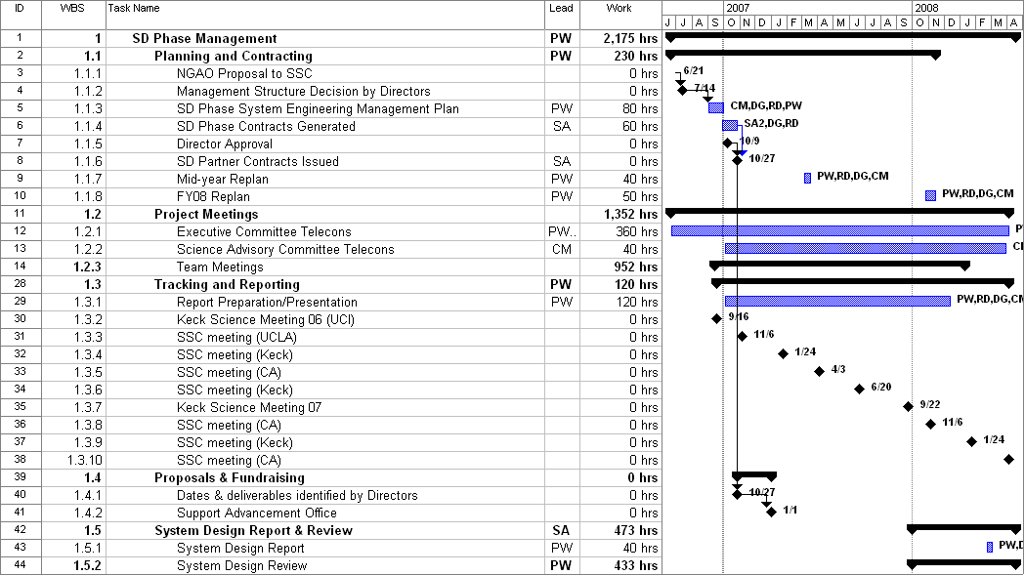

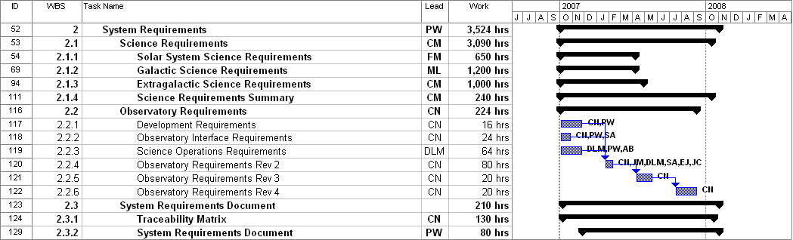

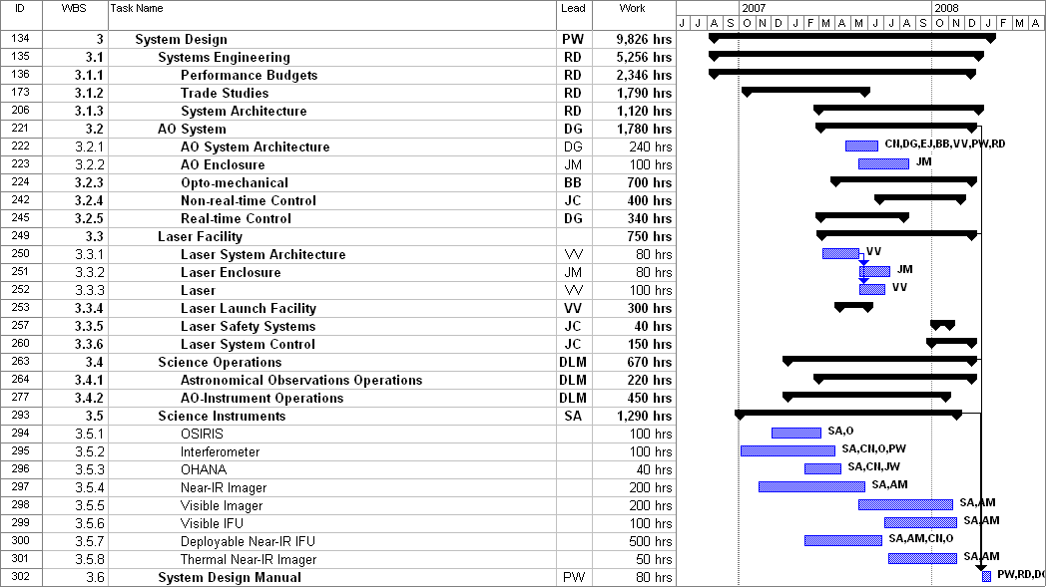

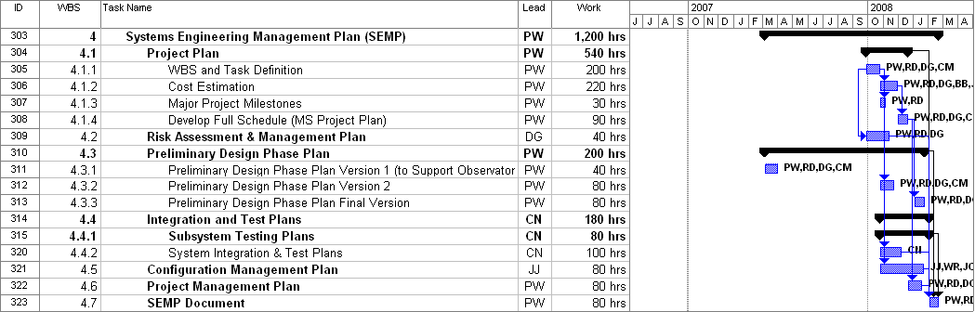

Note that the total labor estimate is 16,725 hours without contingency versus 17,905 hours in the NGAO proposal, which included 1,000 hours of contingency.

Budget

The budget estimate for the system design phase of the NGAO project is $1143k in FY07 dollars. The dollars by WBS and fiscal year are summarized in the following table. The costs in the four WBS rows are for labor and correspond to the actual cost of the work in the “Work” column of the schedules shown in the previous section. Efforts to produce this plan in FY06 are not included in this total; these costs have already been covered by Caltech, UC and WMKO for their relevant personnel.

WBS | Name | Cost ($k)
WBS | Name | FY07 | FY08 | Total
1 | SD Phase Management | 74.4 | 49.2 | 123.6
2 | System Requirements | 118.7 | 3.2 | 121.9
3 | System Design | 559.9 | 89.8 | 649.7
4 | Systems Engineering Management Plan | 4.9 | 78.8 | 83.7
 | Travel/Procure | 40.0 | 20.0 | 60.0
 | Contingency (10%) | 10.0 | 93.9 | 103.9
 | Total ($k) = | 807.9 | 334.9 | 1142.8

This budget total represents a $163k increase over the $980k proposal budget. This increase is due to the cost of labor at Caltech and UC. The proposal estimate was based on the following: “A preliminary labor cost estimate is $920k using the following assumptions: the WMKO FY07 labor rate of $120k/FTE, $90k for three graduate students and $60k for one postdoc.” We had assumed that the WMKO rates would be adequate since we had also stated “It may be reasonable to assume the Caltech, UC and WMKO will not add overheads since these funds are toward the construction of new instrument capabilities.” Unfortunately the labor rates have turned out to be higher at Caltech and UC and there is some overhead included (19% at Caltech and 6.8% at UC). Since we have not yet negotiated contracts there remains some risk to this budget estimate.

The travel and procurement budget has not changed from the proposal values. The proposal contained 1000 hours of contingency labor; this has been turned into a 10% or $104k contingency in this budget.

The breakdown of work (hours) and personnel costs by institution and fiscal year is shown in the following table (excluding the travel and contingency shown in the previous table). Note that these hours are slightly less than the total hours in the WBS plan since some of this planned effort was already used in FY06 (294 hours and $18k); these FY06 costs have already been absorbed by our three organizations.

Institute |  | Work (hours) |  |  |  | Work Cost ($k)
Institute |  | FY07 | FY08 | Total |  | FY07 | FY08 | Total
COO |  | 2836 | 702 | 3589 |  | 232.5 | 62.4 | 295
UCSC |  | 2991 | 845 | 3926 |  | 162.6 | 55.5 | 218
WMKO |  | 5355 | 1852 | 7360 |  | 305.5 | 103.0 | 409
Students |  | 1850 | 0 | 1850 |  | 57.4 | 0.0 | 57
Total = |  | 13032 | 3399 | 16725 |  | 757.9 | 221.0 | 979

The $808k in the proposed FY07 budget is $169k higher than the $639k currently committed to this project in WMKO’s FY07 budget. In addition it requires that WMKO send a total of $453k to Caltech and UC in FY07 and reduce its own planned NGAO FY07 labor by ~1.3 FTES (from 4.15 FTEs).

WMKO management will need to determine whether this cost increase and distribution of funds is feasible, at least for FY07. If this budget is not acceptable then we will need guidance from the Directors on the required reduction and/or options for reducing the cost to the WMKO budget.

Some options for overall cost reduction include cost sharing by Caltech and UCSC, or more work being performed at WMKO. Additional options for FY07 cost reduction, at the expense of higher overall costs, include descoping the system design phase or transferring more work into FY08.

Note that some cost sharing is already happening in this plan at Caltech and UCSC by the use of personnel free to the NGAO project (~1000 hours), and a considerable amount of work has already been transferred into FY08 for the explicit purpose of reducing the FY07 costs. We intend to continue to look for opportunities to reduce costs and to leverage other efforts during the system design phase.

Milestones
Major milestones for the NGAO SD phase are shown below in Table 1. These milestones are derived from the project schedule shown in section 3.4. A more detailed set of milestones, driven by our regular project team meetings, can be found in Section 11.
Table 1: Milestones
MILESTONE | DATE | DESCRIPTION
SD SEMP Approved | 10/9/06 | Approval of this plan by the Directors. Initial SEMP version released to Directors for comment on 9/12 & final version on 9/29/06.
SD phase contracts in place | 10/27/06 | Contracts issued to Caltech & UCSC for the system design phase.
Science Requirements Summary v1.0 Release | 10/27/06 | Initial Release of the Science Requirements as input to trade studies and performance budgeting
System Requirements Document (SRD) v1.0 Release | 12/8/06 | Initial release of System Requirements with emphasis on the science requirements
Performance Budgets Summary v1.0 Release | 2/27/07 | First round of all performance budgets complete & documented
SRD v2.0 Release | 3/22/07 | Second release of System Requirements Document
Trade Studies Complete | 5/25/07 | All trade studies complete & documented (as a series of Keck Adaptive Optics Notes)
SRD  v3.0 Release | 7/12/07 | Third release of System Requirements
System Design Manual (SDM)  v1.0 Release | 8/31/07 | First release of System Design Manual
Technical Risk Analysis  V1.0 Release | 11/13/07 | First round of project risk analysis complete & documented
Cost Review Complete | 11/30/07 | Project cost estimates complete, documented & internally reviewed
SDM  v2.0 Release | 1/8/07 | Second release of System Design Manual
System Design Review  Package Distributed | 3/4/08 | SDR documents sent to reviewers
System Design Review | 3/31/08 | SDR meeting
SDR Report & Project Planning Presentation at SSC meeting | 4/14/08 | Final SD phase report including results of SDR & project plans

Risk assessment and Risk Management
As discussed above this version of the SEMP is intended only to apply to the SD phase of the project. A new SEMP will be developed during the SD phase that will cover the balance of the project’s design and development phases.

An initial risk assessment and mitigation plan for the NGAO project was developed during the proposal phase of the NGAO project and can be found in section 17 of the NGAO proposal. During the SD phase a new risk analysis will be completed as part of the system design manual. This risk analysis will cover requirements risks, technology risks and risks related to schedule and budget. Based on this risk analysis the NGAO project the new SEMP will include a risk assessment and risk mitigation section for each of the identified risks.

The new SEMP will also include sections describing a Risk Assessment Plan and a Risk Management Plan. The Risk Assessment Plan section will describe how the risk assessment process will be carried out and the risk assessment and risk mitigation plans will be maintained throughout the project. The Risk Management Plan section will describe the process for risk management, including the identification of the project decision points related to major/likely risks and how the project will ensure that risks are mitigated or retired as the project proceeds.

A major risk to the overall project that could potentially occur in the SD phase is a significant increase in the budget estimates made in the proposal. We will need to maintain cost vigilance during the SD phase and ensure that we understand the cost impact of the requirements and architecture choices.

The remainder of this section only addresses the risks for the SD phase on the NGAO project. Risks have been categorized into three types: technical, schedule and budget. These are briefly discussed in the following paragraphs.

There are no specific technical risks associated with the SD phase. The SD plan is designed to reduce future technical and budget risks by ensuring that we understand the requirements and have evaluated the impact of the achievability of these requirements through the development of performance budgets and initial design choices.

Clearly defining the deliverables for the SD phase and then managing the project to stay focused on these deliverables will minimize the schedule and budget risks for the SD phase. There is schedule and budget risk associated with having not yet negotiated contracts (we will have done this by the time the final version of this document is released). The other schedule and budget risk that we feel is important to consider is the possibility that other projects at one or more of the participating institutions has a schedule or cost overrun of sufficient magnitude to impact the availability of personnel for this project.

Configuration Management
We will develop a detailed configuration management plan to establish and maintain the integrity of the NGAO software and hardware systems for the remainder of the project during the SD phase. This plan will be consistent with the current standards and practices at WMKO including those used for the current Keck AO systems. We anticipate that this plan will include sections describing the following: configuration identification, configuration control, configuration status accounting, configuration audits and software source code repository organization and maintenance policies.

Requirements Management
We will produce a plan during the SD phase for how we intend to manage requirements over the course of the project. During the SD phase the System Requirements releases listed in the project schedule will be approved by the EC.

Process

Work Flow and Decision Points
During the proposal phase we made one pass through the following design process loop to demonstrate the feasibility of achieving the science requirements. This resulted in an initial architecture or “point design.” This process will begin anew and complete several iterations during the system design phase.

Science Requirements
Technical Implications
Initial Concept

Performance Assessment

Using this design process, the overall approach during the system design phase will be the following:
- The initial focus will be on the requirements and performance budgets to ensure that we understand the largest levers on the design. (See Section 4.2)
- We will then make an initial attempt at defining the AO system architecture and then draft the first version of the functional requirements for the major systems (AO, LGS facility, operations tools and science instruments).
- In parallel with items 1 and 2 we will work on a number of trade studies to better understand the appropriate design choices.
- A process of iteration and refinement will lead to the final version of the AO architecture and major systems requirements. This will include continue development of performance budgets and functional requirements.
- We will then develop cost estimates and the plans for the remainder of the NGAO project.

The MS project schedule and the team meeting schedule (section 11) will be used to assess the progress and timeliness of the project’s activities. The team meetings will allow regular review of work to ensure that the objectives are being met.

Where possible and appropriate we will seek opportunities to leverage other ongoing work or previous design work. Potential examples include: benefiting from priorities and facilities at the UCSC Lab for Adaptive Optics; reviewing and utilizing the TMT NFIRAOS conceptual design study; keeping NGAO in mind during the construction of the Keck I LGS AO system; and benefiting from experiments and experience at Palomar, Lick and Keck.

Science Requirements Development and Performance Budget Process
The Project Scientist will be responsible for development of science requirements in three major areas: Solar System, Galactic, and Extragalactic Astronomy. Science team leaders for these areas are F. Marchis (Solar System), M. Liu (Galactic), and C. Max (Extragalactic); the team leaders will be assisted by specialists in specific topics as needed. A Science Advisory Committee will provide advice and guidance to the NGAO Team.

Performance budgets (error budgets) will be a key interface between the science team and the AO design team. Within each of the three science areas, early emphasis will be placed on the developing that subset of science cases which provides the strongest drivers for AO system performance. For example, imaging of substellar and planetary companions will be the strongest driver for the contrast error budget, which in turn will constrain the allowable static optical aberrations in the AO system.

When a first version of the science requirements and their corresponding performance budgets has been assembled, the AO engineering design team will consider the implications for AO systems architecture and design. The design team will develop an NGAO system concept that is as nearly as possible consistent with all of the performance budgets. The science requirements, performance budgets, and system concept will then be iterated between the science team and the design team until a design is arrived at that is both scientifically compelling and technically feasible.

This process is illustrated in further detail in the following figure.
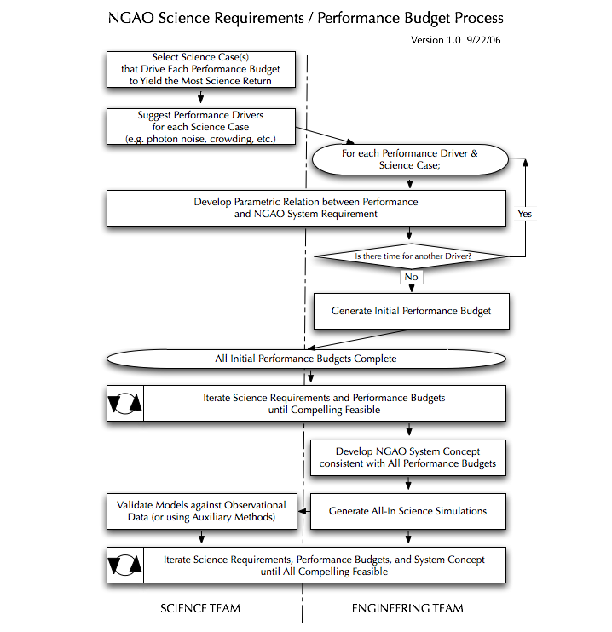
Detailed performance budgeting during the system design phase will begin with development of parametric representations of each of the major error terms that our science team believe currently limit the corresponding science performance. For example, it is believed that tilt anisoplanatism significantly contributes to the astrometric precision of the current Keck LGS system. We will understand how this error is diminished as a function of the number of low-order wavefront sensors (independent of other effects). Similar parametric relationships will allow the system architecture to emerge from an understanding of a global optimization of performance. Because this process is constrained by available time and resources, it will not be possible to parametrically understand every performance limitation. In some cases, allocations in the performance budget will be made, imposing further requirements onto, for example, the science instruments and as yet unselected individual NGAO components.

This approach represents a new level of design maturity, expanding upon the traditional metric of adaptive optics residual wavefront error (or, correspondingly, Strehl), to consider the science-based astrometric, high-contrast, photometric, and other performance metrics.

Core Science and Engineering Team
In addition to the EC we have identified a limited number of individuals as part of a core science and engineering team for the NGAO SD phase. These individuals bring a great deal of relevant experience to the project. In general they will be devoting a significant fraction of their time to NGAO during the SD phase; overall they represent 63% of the SD phase labor. They will represent the tasks for which they have leadership in the plan and the input of other participants working on these tasks. They are in general expected to attend the NGAO team face-to-face meetings. Other individuals will be invited to these meetings on an as needed basis. The core team members and their areas of expertise relevant for the NGAO SD phase are listed in the following table.

Name | Initials | Institute | Hours | NGAO-relevant Expertise
Bouchez | AB | COO | 310 | AO systems & science
Dekany | RD | COO | 888 | EC; AO systems & mgmt
Moore | AM | COO | 854 | Instruments
Velur | VV | COO | 1,049 | Lasers & wavefront sensors (mechanical)
Bauman | BB | UCSC | 574 | Optics
Gavel | DG | UCSC | 880 | EC; AO systems & mgmt
Max | CM | UCSC | 612 | EC Science Team chair
Postdoc | pd | UCSC | 1,260 | AO science
Adkins | SA | WMKO | 407 | Instruments & Project Mgmt
Johansson | EJ | WMKO | 486 | AO Control (software & electronics)
Le Mignant | DLM | WMKO | 422 | AO science operations
Neyman | CN | WMKO | 1,842 | AO systems
Wizinowich | PW | WMKO | 992 | EC chair; AO systems & mgmt

Contracts
WMKO will be issuing contracts to CIT and UC to fund personnel at these institutions to participate in the system design phase. There is some risk that costs could go up during this contracting process.

Scope of Authority
Deviations from the NGAO project objectives must be approved in writing by the NGAO EC.

Decisions regarding schedule and budget are the responsibility of the NGAO EC. The NGAO EC must approve in writing all deviations from statements of work affecting the NGAO project objectives.

Cost accounting and other financial and administrative matters will be done by WMKO.

Performance Management
The EC will be responsible for maintaining a task plan, budget and schedule for the SD phase of the NGAO project.

Reviews
A System Design Review (SDR) will be held as the culmination of this design phase. This review will be conducted in accordance with WMKO standards.

Reporting
Project Reporting will occur at each SSC meeting. A written report will be provided prior to these meetings. We will use the guidelines in the document Management Guideline for the Preparation of Monthly Reports, version 1.2, Sean Adkins, July 7, 2003, in preparing our reports.

Coordination
The schedule (sections 3.4 and 11) calls for various meetings and teleconferences to be held during the course of the project.

The NGAO EC will have weekly telecons throughout the SD phase of this project.

E-mail will be used as a primary means of intra-project communications.

A working document area has been set up at http://www.oir.caltech.edu/twiki_oir/bin/view.cgi/Keck/NGAO/SystemDesignPhasePlanning.
Documents will be archived as Keck Adaptive Optics Notes on the KeckShare site at http://keckshare.keck.hawaii.edu/dsweb/View/Collection-218.

References

Keck Adaptive Optics Notes (KAON)
All of the documents listed below are available on the KeckShare site at http://keckshare.keck.hawaii.edu/dsweb/View/Collection-218.

- KAON 399. NGAO Proposal Executive Summary
- KAON 400. NGAO Proposal
- KAON 409. NGAO Presentation to the SSC – 6/21/06

Other Documents
- Management Guideline For the Preparation of Monthly Reports, version 1.2, Sean Adkins, 7/7/2003
- Draft Engineering Guideline For the Preparation of Requirements Documents, version 1.1, Sean Adkins 9/6/2006
- New Instrument Design and Development, The System Design Phase, by Sean Adkins, 12/11/2003
- The NGAO System Design Phase, Sean Adkins, 9/6/2006 (See section 8)

Appendix: Establishment of the NGAO SD Phase Executive Committee

This appendix contains the text of a letter dated 7/14/06 from the Observatory Directors establishing the NGAO SD phase Executive Committee.

Peter, Richard, Don and Claire,

We propose the following as the appropriate management structure for the next 18-month phase of NGAO. This is the largest program we have undertaken since the original construction of the telescopes. As a community we are fortunate to have world-class expertise in AO development at Keck, UC and Caltech. The NGAO project presents the perfect opportunity to build a strongly collaborative effort between Keck (Hawaii) and the mainland groups. This management structure explicitly takes advantage of the geographically-distributed expertise in our community and emphasizes the collaborative nature of the effort.

The proposed structure is to have the top level of management be comprised of an Executive Committee (EC) chaired by Peter Wizinowich with Rich Dekany, Don Gavel and Claire Max (as Chair of the NGAO Science Team) as the other members. As Chair, Peter will have overall responsibility for delivery of the System Design Phase deliverables. Budget authority will be held by the EC. We also endorse the idea of a funded Science Team led by Claire.

Very early in the next phase, we’d like the EC to develop an explict plan for how the development work will be distributed between the three centers (Keck, Santa Cruz and Caltech).

This is an extremely important project for the future of the Keck Observatory. The systems as conceived of in this early phase would maintain the Keck leadership in groundbased astronomy into the next decade. The strongly collaborative model for undertaking a major development effort is also an important experiment that we need to make work.

Thank you very much for taking on such a large and important project.

Taft, Hilton Shri, Mike

Appendix: The NGAO System Design Phase
The NGAO System Design Phase
August 30, 2006 Revised September 6, 2006
By Sean Adkins

Introduction
The summary description of the system design phase given in the overview of the WMKO development phases is the following:
“The principal objective of system design is to establish a design approach that meets the scientific and user requirements established for the system. System design will establish a discipline integrated engineering plan for the proposed design, understand the technical risks, explore trade-offs, and determine estimates for performance and cost to completion.”
In order to describe the objectives for the system design phase, we will expand on this summary description in an effort to clarify the activities that will take place in the system design phase and also to clarify the relationship of the key document products, the System Requirements Document and the System Design Manual.

System Design
The term system design was chosen for the first phase of development in order to emphasize the desirability of using “systems engineering” as a key strategy for determining requirements and selecting among alternative design concepts. Systems engineering emphasizes a “total view” of the system and the problem space and seeks to integrate the various scientific and engineering disciplines required in the project into a unified effort that maximizes the opportunities to explore trade offs and achieve synergies.
The central activity required in system design is an iterative process that starts with the high level scientific and user requirements, proposes a design concept and then evaluates the ability of the concept to meet the requirements. The design concept includes an “architecture” that partitions the needed functions across subsystems or components. Where viable alternatives exist for a particular design concept or architecture there is an opportunity to make trade-offs or to explore a trade space.
As the process of system design continues, a preferred design concept should emerge, accompanied by a preferred architecture. The architecture defines subsystems or components, and the same iterative process is applied to each subsystem until the design is well enough understood to allow writing the system requirements.
At the end of the system design phase a broad concept for the design has been portioned into subsystems, establishing the system architecture. Trade spaces have been identified, and trade studies performed in order to guide the system design process and select the best design concepts and allocation of function to subsystems and components. The scientific and user requirements have been used to establish system requirements for performance, implementation and design.
The term “design approach” is used for the main product of the system design phase because the product of system design is not a finished design for the actual system, but is instead the basis from which the design will be developed, a basis that is firmly tied to the scientific and user requirements and a basis that offers the best approach to optimizing performance, risk and cost.

System Design Phase Documentation
The two key documents in the system design phase are the System Design Manual (SDM) and the System Requirements Document (SRD). In both of these documents the term “requirements” is used, so it may be helpful to be clear about what we mean by requirements and identify the different types of requirements that we will develop during the system design phase and in later phases of the project.
We define system requirements as statements of need or preference that describe what a system will do and how well but as much as possible do not imply or explicitly request a particular design approach or implementation. To use the terminology of software engineering, requirements should be “implementation free” whenever possible. We describe these requirements as “system requirements” because they are the requirements based on an overall and largely external view of the system. They are also developed at the system design stage, when the details of implementation such as architecture and definition of subsystems may be incomplete or subject to change.
We also use the term functional requirements and here the term is not used in the sense that it is often found in software engineering. Here we mean requirements that are directly related to form and function; they are not implementation free and are in fact intended to define the implementation. These requirements are given in the SDM since they can only be developed after the architecture and subsystems are defined during the system design process.
The SRD is organized by discipline (optical, mechanical, electronic/electrical, safety, software and interfaces) as a way of addressing the problem of completeness and consistency. This organizational approach avoids duplicating requirements within the document. For example, in a spectrometer with refractive optics, one often has a field lens, a collimator and a camera. In a requirements document based on the product structure, there would be requirements for each of these subsystems. Instead, we give requirements for optics, and now we only have to describe the requirements for mounting lenses in one place, rather than in perhaps three places, once for the field lens, once for the collimator and once for the camera. Our organizational approach also allows the specialists in each discipline to see all of their requirements in one place, and it is easier to see if the requirements for each discipline are complete.
The SDM is organized according to the general chronology of the system design phase activities. This is a more flexible format, and should be adjusted to match the scope and nature of the system being designed.
In summary, the SDM documents the preferred design approach, architecture and functional requirements for each of the design’s subsystems. The SRD documents the system level requirements and is organized by discipline. Within each section requirements are grouped into requirements for performance, implementation and design.

The System Requirements Document
The purpose of the SRD is to articulate in one place the requirements for the system, what it must do and how well, and to the minimum extent possible how it will do it. This latter point is emphasized in order to preserve maximum freedom for development of the detailed design, and reflects the fact that the system design phase is not intended to establish actual designs.
The SRD describes the new system in terms of the needed scientific and technical performance. The document also expresses specific requirements for implementation or design where those requirements are essential to satisfactory integration and interoperation of the new system with other observatory systems. The SRD references consensus standards approved by recognized standards organizations for specific guidance on technical matters related to implementation, measurement of performance, compatibility and safety. The requirements given in the SRD provide the definitive reference for all design decisions during the entire design process.
Requirements for areas of the system where uncertainty exists with respect to the achievable performance or the feasibility of a design approach are described as goal requirements. In the case of parametric requirements the SRD provides for goal parameters and typical parameters. Typical parameters are used where enough is known to establish a range of values for the parameter. Goal parameters are used where significant scientific or technical uncertainty exists that must be addressed before the range of values can be known. By the time the detailed design phase of the project is completed all of the goal parameters and goal requirements will have been finalized into typical values and firm requirements.
The first release of the SRD takes place during the system design phase, and the document is revised during the preliminary design phase. At the end of the preliminary design phase the SRD is used to develop the preliminary specifications for the system.
Prior to the drafting of a SRD, three things have occurred:
- A need has been identified for a new or improved system (instrument, AO system, etc.).

- User requirements (science, technical, features, functions, etc.) have been listed at least in part.

- Some concepts have been explored for how a system might be implemented to meet the need, and how that system will operate.

In addition it is very desirable for the actual use of the system to be considered, resulting in so-called "use cases" that are very important tools for identifying what features and functions the system should have. Use cases can also help establish clear boundaries for the system, and clear boundaries are essential for avoiding scope creep or featurism during the design process.
The origin of the scientific and user requirements is not the same for every project. In some situations these requirements are developed in a process that precedes the initiation of the project. This is common for instrumentation at WMKO where the significant commitment of resources to the project needs to be justified by extensive development of a science case and initial science requirements in order for the project to start. In other cases the process may be more organic, with the full development of the science case taking place at the beginning of the system design phase. In either case the science case and the scientific and user requirements need to be refined, updated and maintained during the entire design process (system design, preliminary design and detailed design) as a response to performance and feasibility estimates resulting from the various design activities. The problems posed in the science case may also need to be revised to reflect progress by other researchers during the design phase, and also changes in the anticipated scientific landscape that are expected to take place prior to the delivery of the system.
Scientific and user requirements may be maintained as a separate document, a common practice for instrumentation, or integrated with the SRD. In all cases the flow down between the scientific and user requirements and the performance, implementation and design requirements needs to be clearly established and documented. In cases where the scientific and user requirements are part of the SRD the flow down should be documented here. Otherwise the flow down should be documented in the SDM.

System Design Manual
In the early phases of the system design process, three key decisions are made:
- Determination of the "flow down" or connection between the science and user requirements and the system requirements, implementation details, features and functions. It is very important that the flow down provides for traceability between various requirements such as for example between a science requirement and a performance requirement. This can be done by consistent naming and/or cross-referencing as needed.

- Determination of the system architecture and partitioning of the system into subsystems.

- Generation of specific functional requirements for subsystems, and design concepts for these subsystems. Functional requirements are derived from system requirements, and unlike system requirements they describe or prescribe how the design will achieve the functions needed to fulfill the system requirements. This process also implies a flow down that should be documented in the SDM.

As these decisions are made, the system design process iterates until we have converged on a preferred architecture and design concept. This is then documented in the SDM, and the iterative process continues through the development of the subsystems that are the result of the system architecture and partitioning of function. During this process trade studies may be required, and the SDM should thoroughly document these trade studies including a narrative describing the technical background, the trade study methodology and the results of the trade study.
As the design concepts evolve, initial consideration should be given to technical feasibility, and to the technological needs of the designs. The SDM should identify technology drivers and describe any new technologies (available now or not) that must be available in order to complete the design, build it and meet the requirements. A “technology driver” is a technology where the choice to use it drives the design either in terms of performance, risk, schedule or cost. The SDM should also identify areas where research and development is needed in order to produce the required technologies or to advance an existing technology to the needed level of performance or cost and thereby complete the design, build it and meet the requirements.
By technology we mean something more fundamental than a new pc board, or new software. For example, new integrated circuit designs, new detectors, new electro-optics, new materials, or new discoveries/inventions in all of the related fields without which the design cannot be built or the requirements met.
Once the design approach is documented, functional requirements established, and technology needs identified these decisions are used to make initial performance predictions, establish error budgets, and identify and analyze the risks to performance, cost and schedule.
In summary the SDM does the following:
- Documents the flow down between the scientific and user requirements and the system requirements in the case where the scientific and user requirements are not part of the SRD
- Describes the architecture
- Describes the functional requirements and documents the flow down from the system requirements
- Describes the design concepts for the system and subsystems
- Describes and documents the trade studies performed to choose between design alternatives or refine requirements
- Identifies the needed internal and external interfaces for the system
- Indicates technology drivers and research needs
- Establishes performance budgets and error budgets
- Gives a risk analysis

Systems Engineering Management Plan
The Systems Engineering Management Plan (SEMP) describes the management processes that will be used throughout the development project.
The SEMP includes the following:
- Staff and organization
- Roles and responsibilities
- Project work flow
- Decision making process
- Reporting and documentation requirements

System Design Report
The System Design Report summarizes the work accomplished in the system design phase and presents the initial estimate of performance for the system, the work plan for the preliminary design phase and an estimate of the cost and schedule to completion.

Specific NGAO System Design Objectives
Based on the above discussion, specific objectives can be defined for the NGAO system design phase. These objectives are grouped into five categories, one for general objectives and the other four are grouped according to the documentation product they are most closely associated with.
General Objectives
- Carry out the system design process as described in this and other WMKO documents.
- Document the system design in the following documents:
  - System Design Manual
  - System Requirements Document
  - Systems Engineering Management Plan
  - System Design Report
- Update the project schedule and budget to completion.
- Update and revise the science and use case documentation for the project.

System Requirements Document
- Develop and document the scientific and user requirements for the NGAO system including the adaptive optics system, laser guide star facility and instrumentation.
- Establish and document a flow down from the scientific and user requirements to an initial set of system requirements.

System Design Manual
- Determine and document an optimal design concept for the NGAO system including the adaptive optics system, laser guide star facility and instrumentation.
- Determine and document an architecture and partitioning of function for the NGAO system including the adaptive optics system, laser guide star facility and instrumentation.
- Develop functional requirements for each subsystem as determined by the architecture and document these functional requirements and their flow down from the system requirements.
- Perform trade studies as required and thoroughly document these trade studies including technical background, methodology and results.
- Validate the design concept and architecture through performance estimates anchored to documented performance budgets and error budgets.
- Analyze and document the technology and research needs of the NGAO system including the adaptive optics system, laser guide star facility and instrumentation.
- Analyze and document the technical, schedule and budget risks for the NGAO system including the adaptive optics system, laser guide star facility and instrumentation.
- Develop and document initial risk mitigation plans and reduction strategies for each of the identified risks.

Systems Engineering Management Plan
- Develop and document an initial SEMP for the System Design Phase of the NGAO project.
- Revise the SEMP as required to reflect the planned management process and objectives for the remaining phases of the NGAO development.

Appendix: System Design Phase Work Breakdown Structure Dictionary

- System Design Phase Management
- Management of the SD Phase of the NGAO project, including budget and schedule, and regular reporting to the SSC and Observatory Directors. The Executive Committee (EC) has overall responsibility for the delivery of the key products of the SD Phase.
  - Planning & Contracting
    - NGAO Proposal to SSC
- Submission of the NGAO SD phase proposal to the Keck SSC (complete)
    - Management Structure Decision by Directors
    - EC committee structure established via letter from Keck Director to EC members (complete)
    - SD Phase System Engineering Management Plan (SD SEMP)
- Preparation of the SD phase System Engineering Management Plan (this document). Replanning as appropriate during the SD phase, including support for the Observatory FY planning.
    - SD Phase Contracts Generated
- WMKO intends to issue contracts to Caltech and UCSC, and possibly elsewhere, to provide funding for these groups to support the SD phase. This WBS element covers the effort to prepare contract documentation, including statements of work, and to implement these contracts.
    - Director Approval
- SD SEMP Plan Endorsed
    - SD Partner Contracts Issued
- SD phase partner contracts issued by CARA and signed by partner institutions
    - Mid-year Replan
- The EC assess progress against the SD plan and incorporate new information generated by the science requirements, performance budget development process, and technical trade studies. This is an opportunity to realign SD phase tasks toward the key science drivers identified early in the SD phase.
    - FY08 Replan
- The EC will replan the SD phase for FY08 in light of the prospect of increased SD phase funding, in response to new technical information generated during FY07, and in order to align FY08 work toward the construction phase WBS (though adoption of the new WBS is expected at the completion of the SD phase).
  - Project Meetings
- Effort in support of regular project meetings.
    - Executive Committee Telecons
- The EC will have regular telecons to manage the SD phase. This WBS covers the effort to participate in these telecons.
    - Science Advisory Committee Telecons
- The Project Scientist will hold regular telecons with the other members of the SAC. This WBS covers the effort to participate in these telecons.
    - Team Meetings
- Team meetings will be held every ~ 6 weeks during the SD phase. These meetings will alternate between 8 hr in-person meetings and 4hr teleconferences. The in-person meetings will generally be held at either Caltech, UCI or WMKO in an alternating fashion.
  - Tracking & Reporting
- We will be reporting on the SD phase status and plans at each SSC meeting. This WBS covers the effort to prepare for these meetings, including tracking our progress, and to present at these meetings.
- We will also be providing more global overviews of the SD progress at the Keck Science Meetings. This WBS covers the effort to prepare for these meetings.
  - Funding Proposal(s)
- Generation of proposals for funding. The current assumption is that no work will be needed in this area during the SD phase.
  - System Design Review
    - System Design Report
- Provides a high level summary of the work done during the SD phase and makes a proposal for the preliminary design phase of the project including a plan for the remainder of the project.
    - System Design Review Activities
- This WBS covers the following activities: identifying reviewers, distributing the four SD phase documents to the reviewers, responding to the reviewer questions, preparing and presenting at the SDR and responding to the SDR reviewer report.

- System Requirements
- Development and documentation of science and system requirements.
  - Science Requirements
    - Solar System Science Requirements
      - Companions & Multiplicity of Small Solar System Bodies
        - Point Source Companion Sensitivity Requirements
- Understand & document requirements vs. sky coverage. Iterate with performance budget.
        - Spectral Sensitivity & Spectral Resolution Requirements
- Understand & document requirements vs. sky coverage. Iterate with performance budget.
        - Observing Scenarios
- Develop & document observing scenarios, including examples of calibration, acquisition, exposure scripting, dithering, etc.
        - Science Instrument Requirements
- Understand & document science instrument (imaging and integral field spectroscopy) specific requirements. Develop prioritized instrument list. Iterate with instrument selection & error budgets.
      - Moons of the Giant Planets
        - Performance Requirements
- Understand & document requirements vs. sky coverage. Iterate with performance budget.
        - Observing Scenarios
- Develop and document observing scenarios (e.g., for monitoring over periods of months, weeks, days) , including examples of calibration, acquisition, exposure scripting, dithering, etc.
        - Science Instrument Requirements
- Understand & document science instrument (imaging and integral field spectroscopy) specific requirements. Develop prioritized instrument list. Iterate with instrument selection & error budgets.
      - Shape & Size of Asteroids
        - Spatial Resolution Requirements
- Understand & document requirements vs. sky coverage. Iterate with performance budget.
        - Spectral Sensitivity & Spectral Resolution Requirements
- Understand & document requirements vs. sky coverage. Iterate with performance budget.
        - Observing Scenarios
- Develop & document observing scenarios, including examples of calibration, acquisition, exposure scripting, dithering, etc.
        - Science Instrument Requirements
- Understand & document science instrument (imaging and integral field spectroscopy) specific requirements. Develop prioritized instrument list. Iterate with instrument selection & error budgets.
    - Galactic Science Requirements
      - Galactic Center Proper Motions: Astrometry
        - Astrometry Performance Requirements
- Understand & document the astrometry performance requirement. Iterate with astrometry performance budget effort, & the resultant design choices, to analyze the effect of the astrometry requirements (e.g., will the astrometry requirement push some aspect of the AO design over some threshold of feasibility or cost?). Compare with the capabilities of the Keck Interferometer.
        - Observing Scenarios
- Develop & document observing scenarios, including examples of calibration, acquisition, exposure scripting, dithering, etc.
        - Science Instrument Requirements
- Understand & document science instrument specific requirements. Develop prioritized instrument list. Iterate with instrument selection & error budgets.
      - Galactic Center Radial Velocities & Stellar Populations: Integral Field Spectroscopy
        - Performance Requirements
- Understand & document the performance requirements for the IFU science cases. Iterate with performance budget efforts, & the resultant design choices.
        - Observing Scenarios
- Develop & document observing scenarios, including examples of calibration, acquisition, exposure scripting, dithering, etc.
        - Science Instrument Requirements
- Analyze & document the effect of IFU spectroscopy on instrument selection, architecture and performance. Iterate with instrument concepts.
      - Galactic Center Nature of Sgr A*: 3-5 μm Color & 2 μm Polarimetry Variability
        - Performance Requirements
- Understand & document the performance requirements. Iterate with the performance budget efforts. Compare with the capabilities of the Keck Interferometer.
        - Observing Scenarios
- Develop & document observing scenarios, including examples of calibration, acquisition, exposure scripting, dithering, etc.
        - Science Instrument Requirements
- Understand & document science instrument specific requirements. Develop prioritized instrument list. Iterate with instrument selection & error budgets.
      - Planets around Low Mass Stars & Brown Dwarfs: Companion Sensitivity
        - Companion Sensitivity Performance Requirements
- Understand & document point-source companion sensitivity versus sky coverage requirements. Iterate with the companion sensitivity error budget effort.
        - Observing Scenarios
- Develop & document observing scenarios, including examples of calibration, acquisition, exposure scripting, dithering, etc.
        - Science Instrument Requirements
- Understand & document science instrument (imaging and integral field spectroscopy) specific requirements. Develop prioritized instrument list. Iterate with instrument selection & error budgets.
      - Debris Disks, Protostellar Envelopes & Outflows: Contrast
        - Contrast Performance Requirements
- Understand & document the contrast performance requirements versus sky coverage. Iterate with the performance budget efforts.
        - Observing Scenarios
- Develop & document observing scenarios, including examples of calibration, acquisition, exposure scripting, dithering, etc.
        - Science Instrument Requirements
- Understand & document science instrument specific requirements. Develop prioritized instrument list. Iterate with instrument selection & error budgets.
      - Debris Disks, Protostellar Envelopes & Outflows: Polarimetry
        - Polarimetry Performance Requirements
- Understand & document the polarimetry performance requirements versus sky coverage and contrast. Iterate with the performance budget efforts.
        - Observing Scenarios
- Develop & document observing scenarios, including examples of calibration, acquisition, exposure scripting, dithering, etc.
        - Science Instrument Requirements
- Understand & document science instrument specific requirements. For example, if dual-channel polarimetry is required then a place may be needed in the AO system for a deployable polarization modulator. Develop prioritized instrument list. Iterate with instrument selection & error budgets.
    - Extragalactic Science Requirements
      - Resolved Stellar Populations in Crowded Fields
        - Performance Requirements
- Understand & document photon flux, PSF characteristics & contiguous field science requirements needed to recover stellar populations. Iterate with the performance budget efforts. Consider how Gemini’s MCAO focus in this area should impact the science priority of this topic for NGAO.
        - Observing Scenarios
- Develop & document observing scenarios, including examples of calibration, acquisition, exposure scripting, dithering, etc.
        - Science Instrument Requirements
- Understand & document science instrument specific requirements. Develop prioritized instrument list. Iterate with instrument selection & error budgets.
      - High Redshift Galaxies
- Interested in evolution, mergers and QSO hosts.
        - Encircled Energy (& d-IFU) Performance Requirements
- Understand & document the encircled energy requirements, including how this interacts with sky coverage & sky background requirements. Iterate with the performance budget efforts for various AO architectures. Understand & document the d-IFU optimum lenslet scale.
        - Observing Scenarios
- Develop & document observing scenarios, including examples of calibration, acquisition, exposure scripting, dithering, etc.
        - Science Instrument Requirements
- Understand & document science instrument specific requirements. Develop prioritized instrument list. Iterate with instrument selection & error budgets.
      - Nearby Galaxies
        - Encircled energy & PSF Performance Requirements
- Understand & document the encircled energy & PSF requirements, including how they interact with sky coverage & sky background requirements. Iterate with the performance budget efforts for various AO architectures.
        - Observing Scenarios
- Develop & document observing scenarios, including examples of calibration, acquisition, exposure scripting, dithering, etc.
        - Science Instrument Requirements
- Understand & document science instrument specific requirements. Develop prioritized instrument list. Iterate with instrument selection & error budgets.
      - Gravitational Lensing
        - Encircled Energy & PSF Performance Requirements
- Understand & document the encircled energy & PSF requirements, including how they interact with sky coverage & sky background requirements. Iterate with the performance budget efforts for various AO architectures.
        - Observing Scenarios
- Develop & document observing scenarios, including examples of calibration, acquisition, exposure scripting, dithering, etc.
        - Science Instrument Requirements
- Understand & document science instrument specific requirements. Develop prioritized instrument list. Iterate with instrument selection & error budgets.
    - Science Requirements Summary
- Provide a concise summary of the science requirements as developed through the consideration of key science questions and observing scenarios. Provide a cross-referencing structure for correlation with the System Requirements Document.
- Each revision (as appropriate) should be distributed to some science reviewers for comment. Their input (as appropriate) should be incorporated in the next revision.
      - Revision 1
- The first release should be largely a summary of the work done for the NGAO proposal.
      - Revision 2
      - Revision 3
      - Final SD Version
  - Observatory Requirements
    - Development Requirements
  - Understand & document the requirements from the Observatory during the phase of instrument development & integration: how the new instrument development will impact the ongoing AO science observations, the Observatory operations & on-going engineering projects.
    - Observatory Interface Requirements
  - Define & document any requirements for the hardware & software compliance with the Observatory hardware & software.
  - Define & document any requirements for the interface compliance with the Observatory facility interfaces (power, cooling, etc)
    - Science Operations Requirements
  - Define & document the requirements for the support of science operations:
    - maintenance of the AO-instrument & tools,
    - direct science operations support (how many nights & support staff)
    - possible upgrade (e.g.,new science instrument, wider field of view, new monitoring tools, etc)
  - System Requirements Document
- Summary of products produced in WBS 2 including descriptions of the science requirements and technical requirements organized by engineering discipline with a clear flow down from the science and Observatory requirements.
    - Traceability Matrix
    - The relationship between each of the user and functional requirements in the SRD will be correlated with the corresponding science requirement. The goal is to ensure that system requirements are all generated by a compelling scientific need. The traceability matrix is intended to facilitate a process of simplification and control requirements and scope creep.
    - System Requirements Document
      - Revision 1 Release
      - Revision 2 Release
      - Revision 3 Release
      - Final SD Version Release

- System Design Approach
  - Systems Engineering
    - Performance Budgets
- Development of systems level engineering budgets for a variety of astronomical performance metrics, organized around key observing scenarios. The level of detail available to each budget will depend on the state of the art, the resources dedicated to budget generation during the SD phase, and astronomical user experience. All performance budgets should parameterize the performance behavior versus the corresponding sky coverage fraction. (when appropriate, coverage levels of 5, 30, and 90% should be assumed).
      - Model Assumptions
- The goal of this WBS is to document the assumptions (and rationale) for the key parameters to be adopted for the development of all performance budgets, including such items as the median C_{n}²(h), sodium column density and Keck telescope optical performance. In some cases work will be required to acquire and evaluate data to determine the appropriate assumptions to be used.
        - TMT Site Monitoring Data Mining
- Develop tools for data mining from the database of TMT Mauna Kea site survey data. Analyze such data to determine for example, nominal, 10, 25, 75, and 90 percentile seeing conditions (r0, theta0, Cn2, wind, etc.) and publish in a form usable as input to system performance simulation models. Work with system modelers to assure appropriately interpreted data is being used and provide metrics of data integrity and/or reliability.
        - Telescope Dynamic Performance Data
- Improve/document our understanding of the actual primary mirror wavefront errors.
        - Telescope Static Wavefront Errors
- Improve/document our understanding of the actual primary mirror wavefront errors.
        - Sodium Return versus Laser Format
- Improve/document our understanding of the actual sodium return versus various laser formats. Should base this on experience with the Keck, Gemini, Palomar and Subaru lasers.
      - Model/Tool Validation
- Execution of a series of quantitative checks on the validity of key NGAO models and development tools, as compared to results obtained from various laboratory and sky tests with existing AO systems.
        - Agreement between Tomography Codes
- Understand the differences between tomography codes in use at WMKO and UCSC, modify the codes as appropriate and document the result that should be used.
        - Agreement between Sky Coverage Codes
- Understand and document methods of making sky coverage calculations. Validate/compare codes using sample data sets and resolve discrepancies.
        - Anchor to Keck II LGS AO PSFs
- Demonstrate the ability to produce PSFs that are adequately similar to PSFs obtained with the Keck II LGS AO PSFs. Understand and make changes to the models to achieve this result. Document the result and use the result in updating the appropriate performance budgets.
        - Anchor to On-sky MGSU Experiments
- Use the results of the Palomar (and possibly MMT) MGSU experiments to validate and/or correct the tomography model and its assumptions.
        - Anchor to LAO Lab Experiments
- Determine what high leverage experiments should and can be performed at LAO to validate our models and tools, perform these experiments, and use the results to update the appropriate models, tools and performance budgets. Tomography and MOAO demonstrations are likely to be performed.
      - Throughput
- Development of optical transmission budgets for each of the science path(s), HOWFS, LOWFS(s), and slow WFS.
      - Background
- Development of thermal background budget for the IR science and wavefront sensor instruments.
      - Wavefront Error
- Development of residual wavefront error budgets for a set of key observational scenarios. The first step is to document the budget and tool used in the proposal.
      - Encircled Energy
- Development of encircled energy budgets for a set of key observational scenarios.
      - Photometric Accuracy
- Development of a deviation budget for differential photometric precision for a set of key observational scenarios. To be manageable, this budget should assume statistical independence among the key physical sources of degradation of photometric precision. Physical effects to be considered may include wind-induced PSF anisoplanatism, photon noise, read noise, flat-fielding variations, field-dependent optical aberrations, imperfect estimation of the anisoplanatism contribution to PSF shape, atmospheric scintillation, filter bandpass uncertainty, transparency waves in the atmosphere, imperfect atmospheric color correction, PSF sampling issues, and nonlinear detector response. Investigation of the impact of certain terms in the budget may require detailed AO performance simulations. Calculation of other terms may be beyond the scope of the SD phase, resulting in a top-level allocation to the performance budget until otherwise updated.
      - Astrometric Accuracy
- Development of a deviation budget for differential astrometric precision for a set of key observational scenarios. To be manageable, this budget should assume statistical independence among the key physical sources of degradation of astrometric precision. Physical effects to be considered may include atmospheric tilt anisoplanatism, wind-induced PSF anisoplanatism, field-dependent optical aberrations, photon noise, read noise, flat-fielding variations, PSF sampling issues, telescope plate scale fluctuations, and nonlinear detector response. Investigation of the impact of certain terms in the budget may require detailed AO performance simulations. Calculation of other terms may be beyond the scope of the SD phase, resulting in a top-level allocation to the performance budget until otherwise updated.
      - Polarimetric Accuracy
- Develop polarmetric accuracy performance budget. Develop methods of assessing optical designs for polarimetric accuracy and stability and fold these into the process of system design analysis so that important impacts are identified early.
      - Companion Sensitivity
- Development of a companion sensitivity performance budget, based on a strawman coronagraph approach meeting the science requirements. Develop a contrast-driven spatio-temporal wavefront error budget that includes not just AO performance but realistic values for static/internal effects, so that we can see what instrument design choices (e.g. optics quality) are important now.
      - Observing Efficiency
- The purpose of this performance budget is to determine what will be required to meet the Observing Efficiency requirement. Also, report on the lessons learned with current LGS AO systems (Keck, Gemini, ESO, etc). A list of all the items contributing to the loss of LGS AO-corrected integration time will be produced along with reasonable allocations of the observing efficiency budget amongst these items.
      - Observing Uptime
- The purpose of this performance budget is to determine what will be required to meeting the observing uptime requirement. This budget is only intended to cover the NGAO facility and science instruments (and not the telescope or facility). A list of all the items contributing to downtime will be compiled along with a distribution of the uptime budget amongst these items.
      - Performance Budgets Summary
- This document will capture in one location the several performance budgets generated during the SD phase and will be a convenient reference for engineering team / science team iterations.
      - Science Products
- We will generate a set of science products based upon the emerged NGAO system design in order to verify science suitability and to document predicted performance for use during the commissioning phase
        - All-in Science Simulations
    - The engineering team will provide field-dependent PSFs to the respective science team subgroups, simulating the delivered median condition performance of the NGAO system design concept. If time and resources allow, variations of performance with different seeing conditions will be investigated.
      - Additional Science Characterization Results
- Based on the system design, we will generate other science characterization products that capture key views of the NGAO system performance.
          - Point Source Sensitivities
- The purpose of this WBS is to produce a summary table of predicted point source sensitivities based on the relevant performance budgets.
          - PSF Uniformity and Stability
    - The purpose of this WBS is to produce a document, including sample PSFs, summarizing the predicted PSF stability based on the relevant performance budgets. The appropriate timescales of interest for PSF stability should be determined and used in this evaluation (i.e., 3 seconds, 3 minutes, 3 hours and 3 days).
    - Trade Studies
- The system engineer in charge of trade studies shall assure that trade studies are cohesively coordinated, that results are published at a consistent level of accuracy relevant to the system design at this phase, that the appropriate interfaces/interactions are made with other system engineering efforts, and that the studies are being performed efficiently in view of the system design phase schedule.
      - System Architecture Trade Studies
        - MOAO & MCAO
- This trade study is intended to build our expertise with Multi Object and Multi Conjugate AO. The existing MOAO and MCAO design studies should be reviewed. The product should be a summary of the issues related to these two approaches, including an understanding of the potential risks, technical challenges, limitations, advantages and room for improvement with each of these approaches.
        - NGAO versus Keck AO Upgrades
- Consider the feasibility of upgrading one of the existing Keck AO systems incrementally to meet NGAO science requirements. Consider opto-mechanical constraints & upgradeability of embedded & supervisory control systems. Consider impact on science operations during NGAO commissioning. Complete when option assessment documented.
        - Adaptive Secondary Mirror Option
- Consider relative performance, cost, risk & schedule of an NGAO implementation based on an ASM. Quantify the benefit of an ASM to both NGAO and non-NGAO instruments. Complete when NGAO baseline architecture selected.
        - K & L-band Science
- Consider the relative performance, cost, risk, and schedule of different strategies for K and L-band science optimization. Compare a Nasmyth relay, an ASM & a separate lower-order Nasmyth AO cryo-system. Complete when performance estimates & strategy for K- & L-band observing documented.
        - Keck Interferometer Support
- Consider the relative performance, cost, risk & schedule of feeding KI with NGAO or a repackaged version of the current AO system. Decoupling of NGAO from interferometer support may simplify & improve performance of NGAO. The feasibility of maintaining a version of the two current AO systems for KI use should be evaluated. Complete when NGAO baseline architecture selected.
        - Instrument Balance
- Consider the relative merit of installing NGAO on Keck I vs Keck II. This must take into account the long-term instrumentation strategy for Keck, available laser infrastructure, and impact on operations. Complete when architecture and location requirements documented.
        - GLAO for non-NGAO Instruments
- Consider the relative performance, cost, risk, and schedule of GLAO compensation using an ASM as a wide-field optical relay for non-NGAO instruments. Complete when expected performance benefit for each instrument documented.
        - Instrument Reuse
- Consider the cost/benefit of reuse of existing Keck AO instruments, particularly OSIRIS and NIRC2, versus the benefit of design freedom for an all-new instrument suite. Complete when Observatory strategy adopted.
        - Telescope Wavefront Errors
- Review new data on the telescope static and dynamic wavefront errors. Determine how and whether NGAO can correct for these errors. Determine the performance benefit of a large LOWFS patrol field to enable use of the brightest possible NGS. Consider whether a separate sensor outside the NGAO FOV would be useful for measuring/correcting the telescope errors. Complete when impact on current Keck LGS AO system understood and impact on NGAO reviewed.
        - Observing Model
- Report on the relative merits of various observing models (classic, queue, service) for the NGAO science cases. In particular, include the possible impact from weather, space command approval, laser traffic control, instrument inefficiency and time on target to achieve a desired science performance (i.e., SNR).
      - Adaptive Optics System Trade Studies
- The following are the medium and high priority trade studies identified in an Appendix of the NGAO proposal. Low priority trade studies have been deferred.
        - AO Enclosure Temperature
- Consider the performance, cost, risk, reliability & maintainability of cooling a Nasmyth NGAO enclosure. Calculate sensitivity impact as function of waveband (V through L-band). Complete when enclosure operating temperature selected.
        - Optical Relay Design
- Consider the relative performance, cost & risk of OAP, general 2-mirror & Offner relays. Consider image quality vs. FoV, pupil image quality & the flowdown of requirements onto the (variable distance) LGS wavefront sensor(s). Evaluate science path and wavefront sensor paths to 150” radius, while optimizing the design over a 90” radius (after confirming that these are the correct radii to consider). Complete when an NGAO baseline optical design is selected.
        - Field Rotation Strategy
- Consider the relative performance, cost, reliability & maintainability of compensating field rotation using 1 or more K-mirrors vs using 1 or more instrument rotators. Complete when baseline approach & instrument requirements documented.
        - Dichroics and Beamsplitters
- Determine the observation requirements for all beam directing dichroics and beamsplitters, configured into 1 or more motorized dichroic changers. Different observing programs may desire different distributions of light among HO WFS, LO WFS & science light paths. Complete when dichroic changer requirements documented.
        - Rayleigh Rejection
- Evaluate the impact of unwanted Rayleigh backscatter to NGAO system performance. Consider the relative performance, cost, risk & schedule of various strategies for mitigation of LGS Rayleigh backscatter. Techniques include background subtraction, modulation & optimizing projection location. This issue is closely coupled to laser pulse format, with pulsed lasers generally providing more options for Rayleigh mitigation than CW lasers. Complete when NGAO baseline architecture selected.
        - LGS Wavefront Sensor Type
- Consider alternative WFS designs (e.g. Shack-Hartmann vs. pyramid) for different laser pulse formats. Evaluate and compare the advantages of e.g. short pulse tracking using radial geometry CCDs and mechanical pulse trackers. Complete when LGS WFS requirements have been documented.
        - LGS Wavefront Sensor Number of Subapertures
- Consider the cost/benefit of supporting different format LGS wavefront sensors (e.g. 44 subaps across, vs. 32, vs 24.) Consider the operational scenarios required to meet science requirements in poor atmospheric seeing or cirrus conditions?
        - Slow Wavefront Sensor
- Determine the requirements, if any, for slow wavefront sensor for tracking of non-common-path aberrations between the HOWFS and science instruments. Determine potential waveband for slow WFS operation. Consider if a single NGS HOWFS can be pressed into service for this purpose (with another lenslet array)? Consider impact of dark current in longer exposures. Complete when Slow WFS requirements are documented.
        - Low Order Wavefront Sensor Architecture
- Consider the cost/benefit and technical maturity of MEMS-based correction within the LOWFS, using MOAO control techniques. Include consideration of additional metrology systems required, if any. Compare with cost/benefit of MCAO system to provide tip/tilt star sharpening. Complete when LOWFS requirements and sky coverage estimates have been documented.
        - Number and Type of Low Order Wavefront Sensors
- Perform a cost/benefit analysis for the optimal type, waveband, and number of tip/tilt and tip/tilt/focus low-order WFS. Complete when LOWFS requirements and sky coverage estimates have been documented.
        - Centroid Anisoplanatism
- Consider the impact of centroid anisoplanatism (e.g. the tip/tilt error due to coma in the low-order WFS) and mitigation strategies, if necessary. Evaluate the difference between Zernike (z-tilt) and centroid tilt (g-tilt) for NGAO sensors. Complete when documented and mitigation strategy adopted.
        - Deformable Mirror Stroke Requirement
- Determine required DM stroke based on performance, cost, risk, reliability & maintainability. Consider both global & inter-actuator stroke & quantify the performance penalty for different levels of actuator saturation. Determine DM stroke offloading requirements to other NGAO system elements. Complete when DM stroke, stroke offloading & related system requirements documented.
        - Stand-alone Tip/Tilt Mirror versus DM on Tip/Tilt Stage
- Consider the performance, cost, risk, reliability, and maintainability of a stand-alone tip/tilt mirror vs. mounting an otherwise necessary mirror (e.g. a DM) on a fast tip/tilt stage. Note that high BW correction is difficult with a large or heavy mirror. Complete when tip/tilt approach selected.
        - Correcting Fast Tip/Tilt with DM
- Consider the performance, cost, risk, reliability, and maintainability of performing the highest bandwidth tip/tilt correction using DM actuators. Note that allocation of some time/tilt control to the DM complicates the control system, may increase the stroke requirement & thus the DM cost. Complete when control system & DM stroke requirements determined.
        - Focus Compensation
- Consider cost/benefit of different approaches to focus compensation due to sodium layer motion. Include consideration of the proper combination of LGS focus, LOWFS focus and Slow WFS focus. Complete when focus tracking strategy has been documented and reflected in error budgets.
      - Laser Facility Trade Studies
        - Laser Pulse Format
- Consider the performance, cost, risk, reliability, and maintainability of different sodium laser pulse formats, including usability under various weather scenarios, infrastructure and beam transport issues, and commercial readiness. Complete when laser pulse format requirements have been documented.
        - Free Space versus Fiber Relay
- Consider the performance, cost, risk, upgradability, reliability & maintainability of free-space guide star laser transport vs hollow core fiber transport. Complete when a beam transport system has been selected.
        - LGS Asterism Geometry and Size
- Find the simplest LGS asterism geometry meeting the performance budget goals (e.g. quincunx, ring, 1+triangle, or hex) and the asterism radii. Consider optimization of the Strehl of the tip/tilt stars and the resultant sky coverage as well. Complete when LGS asterism, HO WFS, and LO WFS requirements have been documented.
        - Variable versus Fixed LGS Asterism Geometry
- Consider the cost/benefit of continually varying the LGS asterism radius vs. a fixed number of radii (e.g. 5", 25", 50"). Complete when LGS asterism requirements have been documented.
    - System Architecture
- Produce strawman system architectures in consideration of input from the system/science requirements, performance budgets and trade studies, and iterate with these efforts. Provide top-level guidance on architectural choices that meet project goals, in order to allow the designs of the major systems (AO system, LGS facility, science operations and science instruments) to proceed. Document the system architecture considerations, trade-offs and decisions. Participate in the writing of the system design manual.
      - System Architecture Document Version 1
- This document will be integrated into the SDM – it may, but need not, be stand alone.
      - System Architecture Document Version 2
      - Functional Requirements
- Based on the system requirements, performance budgets and the system architecture choices, develop functional requirements for the AO system, laser system, science operations and science instruments. A second iteration will be performed late in the SD phase after the system design concepts are better understood.
        - AO System Functional Requirements Version 1
- Based on the system requirements, performance budgets and the system architecture choices, develop functional requirements for the AO system.
        - AO System Function Requirements Version 2
- Based on the AO system (WBS 3.2) design results provide updates and more detail on the functional requirements for the AO system.
        - Laser Facility Functional Requirements Version 1
- Based on the system requirements, performance budgets and the system architecture choices, develop functional requirements for the laser facility.
        - Laser Facility Functional Requirements Version 2
- Based on the Laser system (WBS 3.3) design results provide updates and more detail on the functional requirements for the AO system.
        - Science Operations Functional Requirements Version 1
- Based on the system requirements, performance budgets and the system architecture choices, develop functional requirements for the operations tools.
        - Science Operations Functional Requirements Version 2
- Based on the Laser system (WBS 3.4) design results provide updates and more detail on the functional requirements for the AO system.
        - Notional Allocation of Function to Science Instruments Version 1
- The AO system requirements, performance budgets and the system architecture choices will imply allocation of function to the science instruments. This will be considered and documented here. Establishment of functional requirements for the instruments will not be possible because a system design phase will not have been performed for the instruments at this time.
        - Notional Allocation of Function to Science Instruments Version 2
- Based on the Laser system (WBS 3.4) design results provide updates and more detail on the functional requirements for the AO system.
      - Technology Drivers Summary
- Identify the technologies that are key determinants of the performance budgets. Identify the technologies that are critical to meeting the functional requirements.
      - Technical Risk Analysis Document Version 1
- Perform the technical risk assessment on meeting the performance budgets and functional requirements.
      - Technical Risk Analysis Document Version 2
- Perform the technical risk assessment on meeting the performance budgets and functional requirements, as well as assessment of component-level risks. Identify areas of likely early investment for risk mitigation.
  - AO System
    - AO System Architecture
- Based on system requirements, develop a design concept for the opto-mechanical configuration and specify components for the optical paths of the receiver system (“receiver” means guidestar, tip/tilt star, and science beam handling and diagnostics; as distinguished from “transmitter” which indicates the laser transport and launch system).
    - AO Enclosure
- Based on system requirements and performance budgets, develop a design concept for an enclosure to control air flow, temperature, humidity, scattered light, etc. as required. Input to this process are results of a trade study determining optical surface temperatures required to meet emissivity requirements. Also input to this process is a determination of humidity requirements for certain components such as DMs. The work includes interaction with the optical designer to assess scattered light issues and to design appropriate baffles and beam blocks. Output is an enclosure system design with specifications for components of this system along with recommendations for vendor sources.
    - Opto-Mechanical
- Based on system requirements and performance budgets, develop a design concept for the optical relays and specify optical components for the optical paths of the receiver. Perform analyses to verify performance consistent with system error budgets (terms assigned to static and non-common path wavefront errors, temperature induced drifts, and optical component tolerances) and modify design accordingly to meet these error budgets. Perform similar analyses and rectifications for meeting throughput, emissivity, and stability budget requirements.
      - Field Rotation
- Based on system requirements and performance budgets, determine the optimal approach to addressing field rotation for the science instruments and NGAO system, and provide a conceptual design. Different approaches can be considered for the rotational needs of the science instruments, the wavefront sensors and the laser launch asterism.
      - Optical Relay
- Based on system requirements and performance budgets, develop a design concept for the optical system layout that supports the optical design for the receiver. Perform analyses to verify performance consistent with system error budgets: terms assigned to mechanical drift, flexure, temperature, and machine tolerances.
      - Optical Switchyard
- Based on system requirements and performance budgets, develop a design concept for the optical switchyard that will distribute light between the various wavefront sensors, acquisition cameras and science instruments, and determine the requirements on this system and its components.
      - Optical Support Structure
- Based on system requirements and performance budgets, design the mechanical system that supports the optical and electronic components of the receiver. Perform analyses to verify performance and rectify as necessary
      - Wavefront Sensors
- Develop a design concept for each of the required NGAO wavefront sensors.
        - High Order LGS Wavefront Sensors
- Given the functional and performance requirements, develop a design concept for the laser guide star high order wavefront sensors. Take into consideration the possible need for both open and closed loop wavefront sensing.
        - High Order NGS Wavefront Sensor
- Given the functional and performance requirements, develop a design concept for the natural guide star high order wavefront sensor(s). Take into consideration the possible need for both open and closed loop wavefront sensing. Include consideration of ADC packaging (ADC design is covered in WBS 3.2.3.8).
        - Low Order NGS Wavefront Sensors
- Given the functional and performance requirements, develop a design concept for the low order natural guide star wavefront sensors for the purpose of determining tip/tilt and other low order modes in laser guide star observing mode. Take into consideration the possible need for both open and closed loop wavefront sensing. Include consideration of ADC packaging (ADC design is covered in WBS 3.2.3.8).
        - Calibration Wavefront Sensor
- Given the functional and performance requirements, develop a design concept for the calibration wavefront sensor which will use natural guide star light as a truth wavefront. This sensor will be periodically used to reset the references of the high order wavefront sensors in laser guide star mode. Include consideration of ADC packaging (ADC design is covered in WBS 3.2.3.8).
      - Wavefront Correctors
        - Tip/Tilt
- Given the functional and performance requirements, develop a design concept or specify the tip/tilt wavefront correction elements for the AO system (receiver).
        - Deformable Mirror
- Given the functional and performance requirements, develop a design concept or specify the high order wavefront correction element(s) for the AO system (receiver).
      - Acquisition Cameras
        - NGS Acquisition Camera
- Develop a design concept for acquiring the natural guide stars and providing a means of transferring their coordinates to the natural guide star and low-order wavefront sensors. Develop a design concept or specify this camera system.
        - LGS Acquisition Camera
- Develop a design concept for acquiring the laser guide stars and providing a means of giving coordinates so as to be able to steer them into the laser guide star wavefront sensors. Develop a design concept or specify this camera system.
      - Atmospheric Dispersion Correction
- Given the functional and performance requirements, develop a design concept that addresses atmospheric dispersion including pointing corrections between the wavefront sensing and science wavelengths, and as appropriate visible and IR ADC optical prescriptions for the science instruments and wavefront sensors. ADC packaging within the wavefront sensors are contained in WBS 3.2.3.5.2 to 4.
      - Alignment, Calibration, Diagnostics, Metrology and Monitoring
- Define the tools needed to support routine alignment and calibration and to provide the required routine metrology and diagnostics. Monitoring tools that are not part of the AO system, such as an external MASS/DIMM should be included under this category. Alignment, calibration and diagnostics tools will likely include a telescope simulator with multiple NGS and LGS sources and a means of simulating turbulence, as well as arc lamps for science instrument calibration.
    - Non-Real-Time Control
      - Non-RTC Software Design
- Based on system and operations requirements develop a software architecture and maintenance plan for all remote and automatic real time control software. Also, develop data collection and management systems.
      - Non-RTC Electrical Design
- Based on system requirements and in collaboration with the optical and mechanical designers, develop the electrical system requirements for supporting the optical bench including motors, shutters, filter wheels, and other robotic or remotely operable control stages and devices. Also, determine requirements for drive electronics and control boxes for these stages and the associated cabling, connectors, and interfacing. Also, determine the power requirements and design the control signal and power routing to meet overall system noise requirements (this is exclusive of real-time control and wavefront sensing, which is covered in a separate description). Collaborate with the software team to determine computer interface and operability requirements. Output is an electronic/electrical component and wiring layout, control box placement (in corroboration with the mechanical designer), power load analyses, specifications for components, and review/summary of vendor sources for the components.
    - Real-time Control
- Based on system requirements, operations requirements, and error budgets, develop an architecture for the real-time controller, including both hardware and software configuration. Input to this process includes candidate wavefront sensing, tomography, tip/tilt, and DM control and signal processing algorithms as provided by the system engineering group as a result of trade studies. Design work includes specification of hardware interface requirements, hardware processor speed, data rate, and storage requirements, design of the data flow, design of the algorithm implementation software, and design of the diagnostic and telemetry streams. Work includes analysis and modeling of performance at the low-level of implementation, e.g. taking into account data transmission delays, processor delays, and data resolution.
      - RTC Architecture Analysis and Design Study
- Based on system requirements, operations requirements, and error budgets, develop an architecture for the real-time controller, including both hardware and software configuration. Input to this process includes candidate wavefront sensing, tomography, tip/tilt, and DM control and signal processing algorithms as provided by the system engineering group as a result of trade studies. Output of this process is an analysis of candidate architectures, simulations of expected real-time performance, and guidance (in the form of strawman designs) for the RTC software module definition and RTC hardware module definition tasks.
      - RTC Software Module Definition
- Given the architectural design and results of the RTC design study, specify the software development environment tools required (& analyze vendors of such), develop a software top level block diagram, define software data structures and data flow paths, define software command language for interface to the system controller/user interface, design diagnostic and telemetry streams, specify software module functions at a detailed level. Develop a real-time software implementation and test plan.
      - RTC Hardware Module Definition
- Given the architectural design and results of the RTC design study, perform a rough initial specification of the hardware platform (or platform options, through PDR phase), the hardware interfaces and the required cabling. In consideration of real-time data flow and diagnostic/telemetry streams, determine the overall size, mounting, and power requirements. If specifying custom processor boards (likely, with a transputer/FPGA architecture) design the board layout in conformance with fab-house design rules, specify the component processors and all other components needed to enable assembly of the boards. Develop a hardware acceptance test plan. Specify test equipment needed.
  - Laser Facility
    - Laser System Architecture
- Based on system requirements and the error budgets, develop a system for producing laser beacons sufficient for NGAO. An input to this process is the result of a trade study determining the field of view, number of guide star beacons, and constellations for various science observing conditions. Produce as output: the system architecture and design/specifications for creating and projecting the guide stars, controlling the pointing, maintaining output beam quality, diagnostics, and user control.
    - Laser Enclosure
- Develop a design concept for an enclosure to house the laser and its electronics and to control air flow, temperature, humidity, etc. as required.
    - Laser
- Based on system requirements and error budgets, specify a laser or set of lasers to produce guide stars. Take into consideration the current state of the art and availability of lasers. An input to this process is the result of a trade study determining the desirable pulse format or formats and power per guide star. Produce as output: a summary of the laser options versus requirements.
    - Laser Launch Facility
- Based on system requirements and error budgets, develop the design concept for the systems required for delivering the laser power from the laser to the sky. Consider potential future upgrades to laser power or changes to laser pulse format.
      - Laser Beam Transport
- Develop the design concept for the system for delivering the laser power from the laser to the launch telescope. Consider potential future upgrades to laser power or changes to laser pulse format.
      - Laser Pointing and Diagnostics
- Develop the design concept for the system for determining and controlling the alignment and pointing of the laser beams. Develop the system concept for regular monitoring the beam quality, laser power, and health of the laser launch system. Consider potential future upgrades to laser power or changes to laser pulse format.
      - Laser Launch Telescope
- Develop the design concept or specify the telescope needed to launch multiple laser beacons. Consider potential future upgrades to laser power or changes to laser pulse format.
    - Laser Safety Systems
- Design safety systems for the laser to protect aircraft, satellites, personnel and equipment.
      - Personnel and Equipment Safety Systems
- Identify the required safety interlock systems. Identify means of protecting equipment from inadvertent damage during operation. Specify the top-level safety interlock systems logic sequences and specify hardware components that provide these functions.
      - Aircraft, Satellite & Laser Traffic Control Safety Systems
- Develop the design concept or specify the safety systems needed to protect aircraft pilots (eye safety) and spacecraft from the laser beacons. All telescopes on Mauna Kea are currently required to participate in the Laser Traffic Control System. Determine what changes will be needed to accommodate NGAO in this system.
3.3.6 Laser System Control System
- Identify the requirements and design concept for laser system control, for example wavelength control, mode behavior maintenance, and a system to tune off wavelength for Rayleigh background exposure. Identify key parameters for monitoring laser status and develop design concepts for such measurement and monitoring.
3.3.6.1 Laser System Software
- Design the architecture for the laser system control and diagnostics software, including laser, beam transport, and launch system. Software must be integrated with the laser safety system, AO system, science instruments, and the telescope operating system.
3.3.6.2 Laser System Electronics
- Specify and develop the design concept for the electronics systems needed to provide laser control and diagnostics functions.
  - Science Operations
    - Astronomical Observations Operations
- Identify the requirements and a design concept for software tools & infrastructure requirements for the science operations for the astronomer / observer, including:
      - Pre-Observing Interfaces
- Specify and design the software tools and interfaces that the observer will require to prepare for the science observations.
        - AO Guide Star Interface
- Specify and design the Method and Interfaces to search for suitable Guide Star given a science field, the isoplanatic (isokinetic) patch, and position angle requirements. Explore the requirements on parameters and format for the Guide Star information (proper motion, color, extended, etc), to be used for space command submission and the science operations.
        - Science Observations Simulation Tools
- Define Method and design Interfaces to Simulate Science Observations scenarios, including image performance (SR, EE) as a function of observing conditions (seeing, elevation, etc); throughout; background emission and calibrations requirements. Explore the ability to compare various possible scenarios and conditions and save the output parameters.
      - Observing Interfaces
- Specify and design the software tools and interfaces that the observer will require to perform the observations, including:
        - Acquisition
- Define method, information and design interfaces for acquiring guide stars and science object/field. Particularly, look into the requirements for the nature of the AO guide stars (extended objects?), the space command and laser traffic control clearance for the target, and for using telescope or other sub-system pointing information to register the science frames within the field of regard.
        - Observing Sequences
- Define method and design interfaces to acquire science data (target, background emission and calibrations) including the ability to plan various observing sequences, save them and then execute them at the telescope.
        - Instrument, AO & Telescope Observer Interfaces
- Define the methods and design the interfaces required by the observer to perform and monitor the observations and observing conditions. This topic has to be addressed very closely with the science instrument design.
        - Science Data Quality Monitoring
- Define method and design interfaces to estimate, record and monitor the quality of science data including suitable image quality metric (WF residual, EE, etc) at the science detector, seeing, photometry, astrometry, etc based on the NG AO science use cases.
      - Post-Observing Interfaces
- Define the method & interfaces required for an efficient use of the science data.
        - Generic Data Products
- Define top-level data product outputs from a generic science instrument: raw, reduced and calibrated.
        - Science Data Quality Assessment
- Define method and design interface for a-posteriori quality metric estimate from the recorded data (see 1.2.4), including science PSF reconstruction.
        - Science Data Archiving
- Define the method and design interfaces required to archive the data. Particularly, define which calibrations would be required to be archived depending on the science use cases and explore various options for data archive quality.
    - AO-Instrument Operations
- Define the software tools and design infrastructure for the operations of the AO-fed instrumentation for the observatory / support.
      - AO-Instrument Operations Architecture
- Define the overall architecture, the method and design the interfaces for operating the sub-systems of the NG AO-instrumentation. Here AO-instrument refer to AO, laser, SC, science instrument, etc.
        - AO-Instrument Observing Modes
- Define top-level observing modes and design interfaces given the the NG AO science use cases requirements for rotator modes; telescope pointing accuracy; closed loop(s) pointing accuracy, field registration and astrometry (including the effect of differential atmospheric refraction); science acquisition, field rotation, dither/nodd/chopping modes for the various AO modes. Particularly, study the requirements on the observing time overheads using the various science use cases and the current and future AO science instruments at Keck. Also report on the lessons learned with current observing methods at Keck, Gemini and other places.
        - AO-Instrument Operations Support
- Define the personnel required to support AO operations. Clearly establish the level of AO-expertise for operating the sub-systems and the overall instrument (configuration, setup, calibrations, science readiness, nighttime operations). Particularly, anticipate for the nature of plausible common problems and the level of expertise for troubleshooting them.
        - AO-Instrument Configuration & Setup
- Define the method and design interfaces required for configuring the AO-instrument with a detailed description on the requirements for the various sub-systems from cold startup to science readiness.
        - AO-Instrument Calibrations
- Define the method and design interfaces required for calibrating the AO-instrument, including requirements on calibrations stability and a detailed description on the management of the calibrations files.
        - AO-Instrument Nighttime Operation Modes
- Define the method and design interfaces required for operating the AO-instrument in the various possible configurations (NGS AO, SLGS AO, MLGS AO) and switching from one configuration to another.
        - AO-Instrument Science Acquisition & Control
- Define method and design interfaces required to acquire the Natural and Laser Guide Star(s) for a science field, close the control loops on the various sub-systems, check and optimize AO performance, adjust telescope parameters (pointing and focus offload), etc. Explore the possibility of executing these commands in parallel. Also, consider management of situations where some of the control loops would have to be open automatically and the science paused/resumed due to marginal sky transparency or other events.
        - AO-Instrument Health Monitoring & Automated Recovery
- Define the method and design interfaces required for a generic monitoring of the health (primarily hardware and software) and describe in a generic way, the method to troubleshoot the problem. Explore the requirements to recover automatically from most common problems.
        - AO-Instrument Laser Traffic Control
- Define the methods and design the interfaces for a laser traffic control system that will take into account observing parameters from other telescopes, and possible new policies from the MK LGS TWG.
        - AO-Instrument User Interfaces
- Define the method and design the interfaces required to build a user/operator friendly interface that will include all above operations aspects.
        - AO-Instrument Maintenance Plan
- Define the requirements, the method and the interfaces to establish a maintenance plan. Explore the resources required for the Observatory.
      - AO-Instrument Operations Optimization
- Define the requirements, the method and the interfaces to ensure optimal science data quality and science observing efficiency as a function of the science program.
        - AO-Instrument Performance Prediction
- Define method and interfaces to predict instrument performance in a given parameter space, given a set of observing parameters. This should include the AO performance (SR, EE, etc) as well as observing efficiency (open-shutter time, dither, read-out). Particularly, explore the possibility of using these tools on the science use cases, characterizing the tools during the commissioning phase and using them to monitor the system performance (see below).
        - AO-Instrument Real-time Optimization
- Define method and interfaces required to ensure a constant monitoring of the AO performance metrics and optimize this metrics as a function of observing and atmospheric conditions (seeing, elevation, Na density, GS brightness) and the science drivers (SR, EE). This process is to be real-time, automated and the tune-up parameters should be saved for each target.
        - AO-Instrument Environment Monitoring
- Define the method and design the interfaces to record and monitor environment data which would impact directly and indirectly the science operations and the science data quality, including Na density and profile, relevant atmospheric turbulence parameters, sky transparency, % humidity, instrument optics and outside temperatures, etc
  - Science Instruments
- Existing Instruments: the existing AO instrumentation suite at WMKO will be impacted by the NGAO system. The activities under this WBS element will evaluate the potential for reuse of OSIRIS with NGAO (NIRC-2 will be addressed in the WBS element for a Mid-IR Imager) and also evaluate the impact on the Keck-Keck Interferometer and OHANA. It will be essential to continue to allow Keck-Keck Interferometer with no adverse impact and it may be desirable to continue to facilitate the development of OHANA.
    - OSIRIS
- The OSIRIS instrument may be used as a science instrument with the NGAO system.
- Estimate the performance of OSIRIS with NGAO
- Determine the nature, feasibility and ROM cost of possible improvements to OSIRIS to take advantage of NGAO such as an increased FOV.
- Review and summarize the constraints on NGAO design that are imposed by the current OSIRIS ICD.
- Assuming that OSIRIS will be moved to Keck I when the new Keck I LGS system is ready, evaluate the cost impact of moving OSIRIS back to Keck II and identify what would replace OSIRIS on Keck I AO
    - Keck-Keck Interferometer
- Investigate the performance impact of NGAO on the Keck-Keck Interferometer, assuming that Keck I AO will not be further upgraded beyond the current work (NGWFC and Keck I LGS).
- Evaluate the feasibility of feeding one channel of the Keck-Keck Interferometer with NGAO.
- Review and summarize the constraints on NGAO design that are imposed by the current Keck-Keck Interferometer ICD.
- Consider how best to support the Keck-Keck Interferometer after the commissioning of NGAO.
    - OHANA
- Based on the work done for the Keck-Keck Interferometer in WBS element 3.5.2 consider the impact of NGAO on OHANA and determine if there are any unique feasibility issues in this regard.
- Review and summarize the constraints on NGAO design that are imposed by the current OHANA ICD.
- Consider how commissioning of NGAO might affect future plans for a multi-observatory OHANA system on Mauna Kea.

- Initial Concepts and Proposals for New AO Instruments: in the proposal phase five potential new AO instruments were identified for NGAO along with initial priorities for these instruments. The activities under this WBS element will include:
- Interaction with the NGAO science team on instrument requirements
- Refinement of the instrument definitions and priorities
- Interaction with the NGAO AO design process on the partitioning of performance budgets and subsystem functions between the AO system and the instruments
- Development of proposal level concepts and notional costing for each instrument.
    - Near-IR Imager
- Develop initial system requirements for a near-IR imager
- Develop a design concept for a near-IR imager
- Refine notional costing
    - Visible Imager
- Develop initial system requirements for a visible imager
- Develop a design concept for a visible imager
- Refine notional costing
    - Visible IFU
- Develop initial system requirements for a visible IFU
- Develop a design concept for a visible IFU
- Refine notional costing
    - Deployable Near-IR IFU
- Develop initial system requirements for a near-IR IFU
- Develop a design concept for a near-IR IFU. The portion of this design that is an AO system will be taken to the SDR level.
- Refine notional costing
    - Thermal Near-IR Imager
- Develop initial system requirements for a “thermal near-IR” (L & M band) imager
- Develop a design concept for a Thermal Near-IR imager
- Refine notional costing
- Estimate the performance of NIRC-2 with NGAO, particularly for “thermal near-IR” (L & M band) imaging and spectroscopy.
- Determine the nature, feasibility and ROM cost of possible improvements to NIRC-2 to take advantage of NGAO.
- Review and summarize the constraints on NGAO design that are imposed by the current NIRC-2 ICD.
  - System Design Manual
- Summary of the products produced in WBS 3 including definitions of the functional requirements, descriptions of the design approach for major subsystems, a summary of technology drivers and the associated research needs, performance budgets and error budgets and a technical risk analysis.

- Systems Engineering Management Plan
- Note that this document (KAON 414) represents a simplified version of the SEMP that will need to be prepared under this WBS for the entire NGAO project.
  - Project Plan
- A task definition, cost estimation, list of major milestones, WBS structure and an MS project plan will be prepared for the entire NGAO project (excluding the SD phase).
    - WBS and Task Definition
    - Develop a work breakdown structure (WBS) for the remainder of the NGAO project following the system design phase. Organize around a corresponding Product Breakdown Structure (PBS). Team members must have significant input to this development. Document the WBS using a detailed WBS dictionary and can also serve as the initial basis for an construction cost estimate.
    - Cost Estimation
    - Generate an initial cost estimate for completion of the work in the WBS. Document the basis for the cost estimate, including methodology for estimating management contingency.
    - Major Project Milestones
    - Based on the logical sequencing and connection of work packages in the WBS, identify key project milestones for the remainder of the NGAO project. These should be verifiable accomplishments that facilitate project tracking and controls, possibly described as clear points for the reporting of Earned Value.
    - MS Project Plan
    - Develop a schedule using tools designed to facilitate project tracking and controls. Identify critical path and flag early investments that can accelerate project completion.
  - Risk Assessment & Risk Management Plan
- The risk assessment prepared as Section 17 of the NGAO proposal can be used as a starting point.
  - Preliminary Design Phase Plan
- A detailed project plan for the PD phase of the NGAO project.
    - Version 1 to Support Observatory FY08 Planning
    - PD phase plan Ver 2
    - PD phase plan Ver 3
  - Integration & Test Plans
    - Subsystem Integration & Test Plans
- Initial project plans for each subsystem’s integration and test.
      - AO System Test Plan
- Initial testing plan for adaptive optics system laboratory integration and testing, including validation of the calibration unit, closed-loop testing for both NGS and LGS modes, and verification of functionality such as effective closed-loop bandwidth.
      - Laser System Test Plan
- Initial testing plan for all aspects of the laser system, including verification of laser performance, beam transfer efficiency, safety systems, diagnostics, and active systems such as high-speed pointing control
      - Science Operations Test Plan
- Initial testing plan for science operations, including verification of observation planning tools and verification of observing efficiency performance budgets.
      - Science Instruments Test Plan
- Initial testing plan for science instrument interfaces to NGAO. Includes verification of NGAO data products (e.g. telemetry) required to meet science and user requirements for NGAO. Does not include any testing of science instrument performance or functionality.
    - System Integration & Test Plans
- Initial project plan for overall system integration and test.
  - Configuration Management Plan
  - Project Management Plan
- This section of the SEMP provides additional information on the management structure, including communications, reporting, oversight, and the role of external reviewer and advisors.
  - Systems Engineering Management Plan
- Document summarizing the products produced in WBS 4 including a description of the project objectives and major milestones, a description of the project organization, a description of the project management process, a description of the project decision process and major decision points, a risk assessment and a risk management plan, and configuration management plans for hardware, software and documentation.

Appendix: System Design Phase Schedule

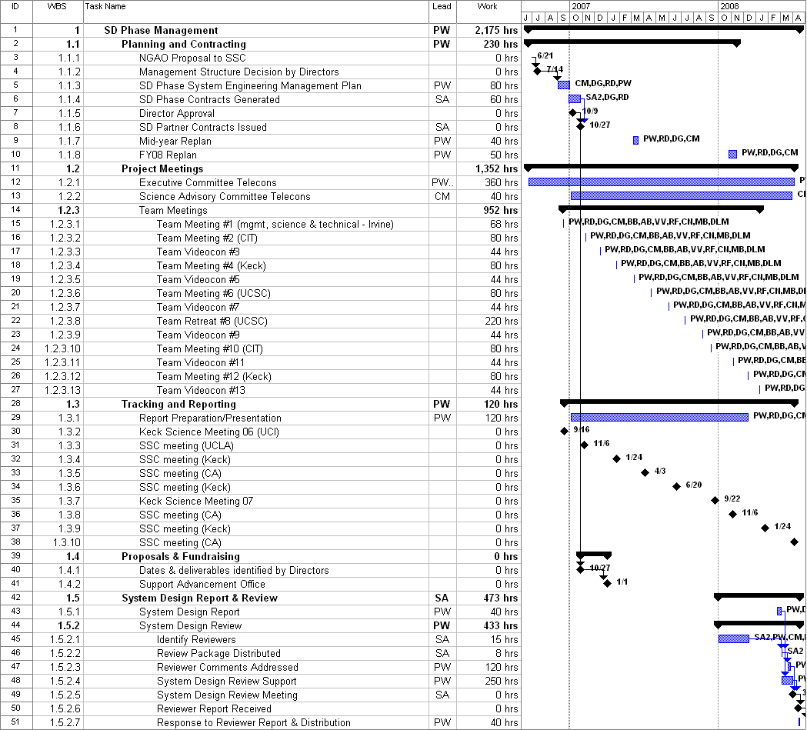

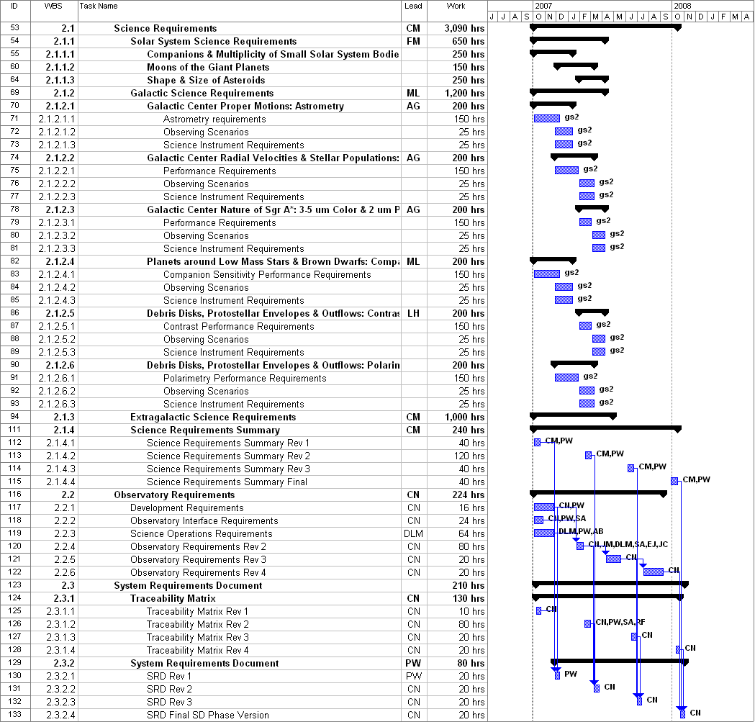

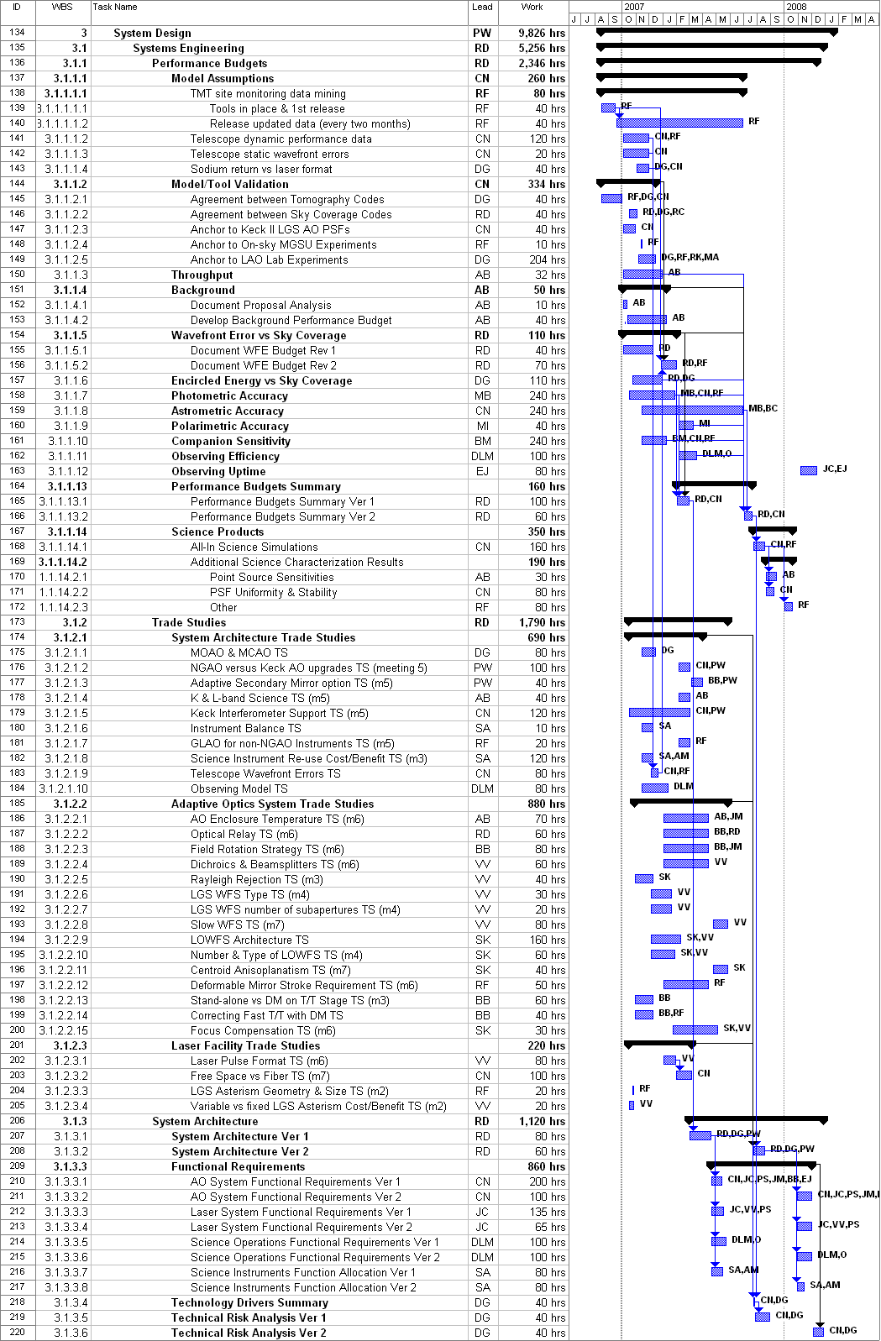
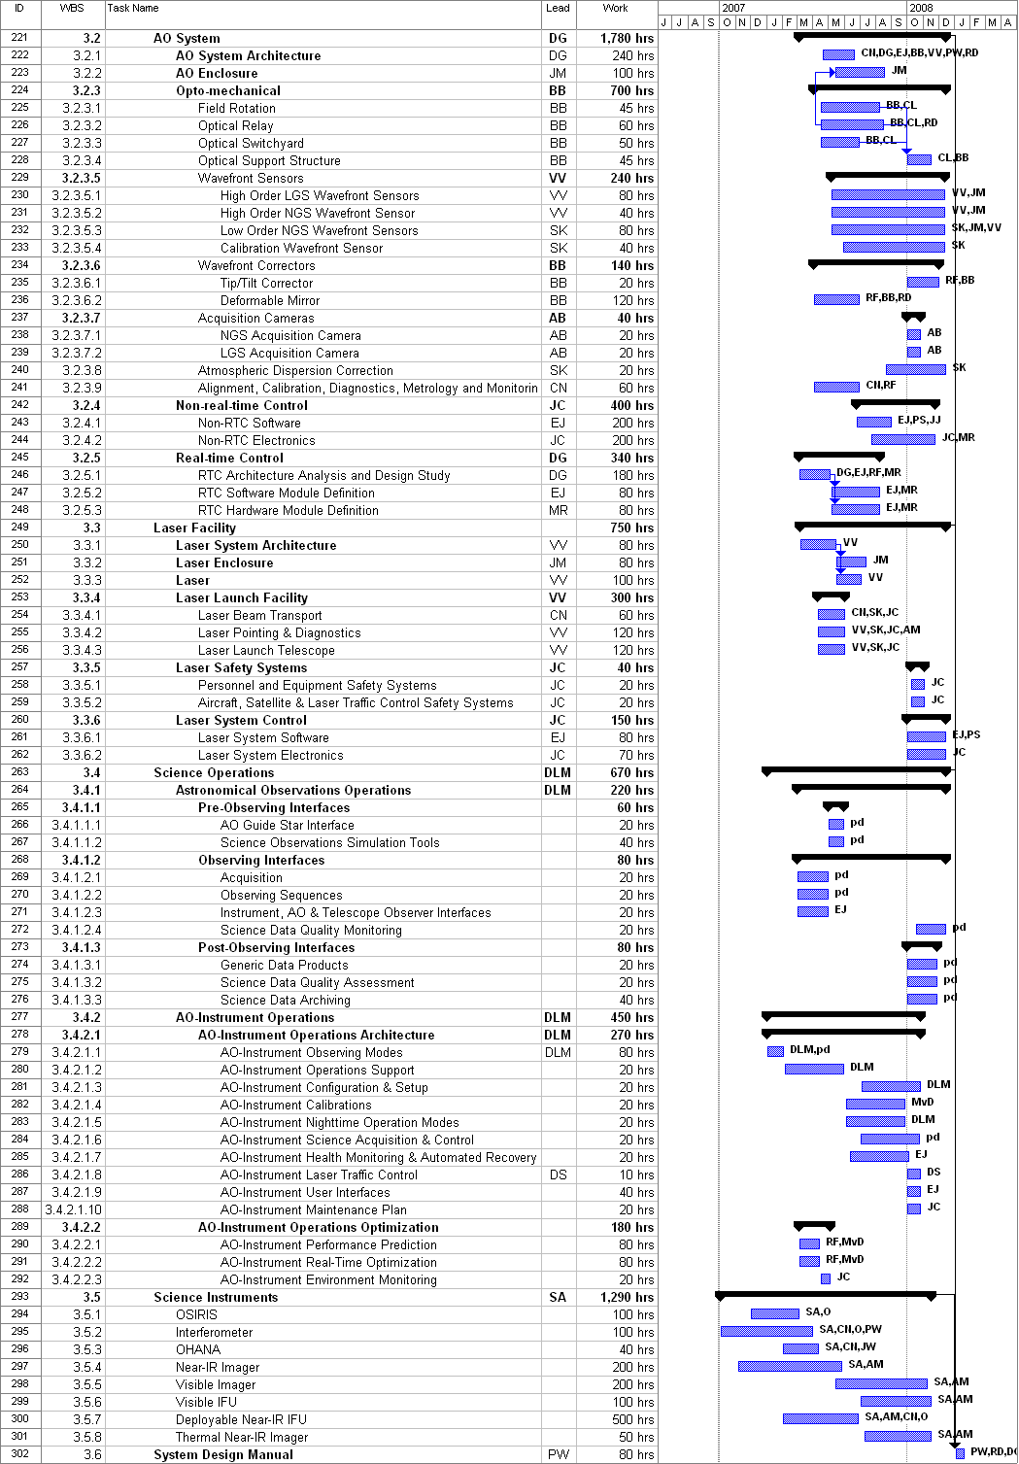
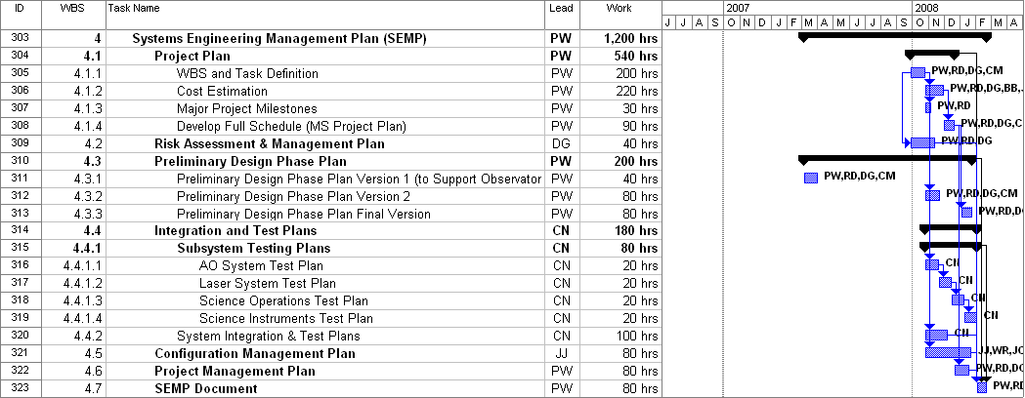

Appendix: System Design Phase Team Meeting Schedule

[This page intentionally left blank.]

