Keck Adaptive Optics Note 414

Keck Next Generation Adaptive Optics:
System Design Phase
System Engineering Management Plan

DRAFT

Version 0.8 Date: September 11, 2006

W. M. Keck Observatory
California Association for Research in Astronomy
65-1120 Mamalahoa Highway
Kamuela, Hawaii 96743
808-885-7887

Author List
Name | Function
Peter Wizinowich | Executive Committee (EC) Chair
Richard Dekany | EC Member
Don Gavel | EC Member
Claire Max | EC Member & Project Scientist

Approval Control
Control | Name | Function
Revised by:

Approved by:
Authorized by:

Document Change Record
Issue | Date | Change Description
Initial offering | 9/11/06

Preface
This document is the System Engineering Management Plan for the system design phase of the Keck Next Generation Adaptive Optics project.

The Systems Engineering Management Plan describes the project objectives, major milestones, project organization and project management process. The Systems Engineering Management Plan also defines the project decision process and major decision points, the risk assessment and risk management process, and configuration management plans for hardware, software and documentation.
Table of Contents
Section Page

1 Introduction 5
2 System Design Phase Organization 5
3 System Design Phase Plan 5
3.1 Project Scope and Objectives 5
3.2 Planning Assumptions 6
3.3 Work Breakdown Structure 6
3.4 Schedule 7
3.5 Milestones 7
3.6 Risk assessment and Mitigation Plans 8
3.7 Configuration Management 8
3.8 Requirements Management 8
4 Process 9
4.1 Work Flow and Decision Points 9
4.2 Contracts 9
4.3 Scope of Authority 9
4.4 Performance Management 9
4.5 Reviews 9
4.6 Reporting 9
5 Coordination 9
6 References 10
6.1 Keck Adaptive Optics Notes (KAON) 10
6.2 Other Documents 10
7 Appendix: Establishment of the NGAO SD phase Executive Committee 11
8 Appendix: The NGAO System Design Phase 12
8.1 Introduction 12
8.2 System Design 12
8.3 System Design Phase Documentation 12
8.3.1 The System Requirements Document 13
8.3.2 System Design Manual 14
8.3.3 Systems Engineering Management Plan 15
8.3.4 System Design Report 15
8.4 Specific NGAO System Design Objectives 15
9 Appendix: System Design Phase Work Breakdown Structure Dictionary 17
10 Appendix: System Design Phase Team Meeting Schedule 32

Introduction
A proposal for the W.M. Keck Observatory’s (WMKO) Next Generation Adaptive Optics (NGAO) system was presented at the June 21, 2006 meeting of the Observatory’s Science Steering Committee (SSC).¹⁻³ This plan was well received by the SSC and Observatory management. An Executive Committee has been established by the Observatory Directors (WMKO, UC and CIT) to manage the system design phase of the NGAO project (see section 7). This committee consists of Rich Dekany, Don Gavel, Claire Max (chair of the NGAO science team) and Peter Wizinowich (Executive Committee chair).

A Systems Engineering Management Plan (SEMP) is a standard part of the project documentation for development efforts at WMKO. Because we anticipate further development of the management structure of the NGAO project in subsequent development phases this version of the SEMP covers only the system design phase of the project. This plan is also intended to fulfill the request of the Observatory Directors for a management plan for the work to take place in the system design phase.

System Design Phase Organization
The NGAO system design phase will be managed by the NGAO EC. Leadership responsibilities for specific parts of the system design are indicated in the MS Project Plan in section 3.4.

System Design Phase Plan

Project Scope and Objectives
The system design (SD) phase is the initial design phase for WMKO development projects. This phase precedes the preliminary design phase. The SD phase includes a significant emphasis on systems engineering.
WMKO provides the following standard guidance for the system design phase of a development project (Adkins, 2005):

“The principle objective of a system design is to establish a design approach that meets the scientific and user requirements established for the system. System design will establish a discipline integrated engineering plan for the proposed design, understand the technical risks, explore trade-offs, and determine estimates for performance and cost to completion.

The key deliverables from the system design phase are a Systems Requirements Document, a Systems Engineering Management Plan, a System Design Manual and a System Design Report.”

The SD phase of this project will deliver the four documents listed above. A description of the SD phase and its deliverables and objectives is provided in Section 8.

The Systems Requirements Document will include:
- A description of the science and user requirements
- A description of the technical requirements organized by engineering discipline with a clear flow down from the science and user requirements

The System Design Manual will include the following components:
- Definitions of the functional requirements.
- Descriptions of the design approach for major subsystems.
- A summary of technology drivers and the associated research needs.
- Performance budgets and error budgets.
- A technical risk analysis.

The Systems Engineering Management Plan (SEMP) for the balance of the project will be produced near the end of the SD phase. A complete SEMP consists of the following components:
- A description of the project objectives and major milestones.
- A description of the project organization.
- A description of the project management process.
- A description of the project decision process and major decision points.
- A risk assessment plan and a risk management plan.
- Configuration management plans for hardware, software and documentation.

The System Design Report provides a high level summary of the work done during the SD phase and makes a proposal for the preliminary design phase of the project including a plan for the remainder of the project. This will be developed following a planning sequence based on the system level requirements, and proceeding from a WBS to task identification and description, schedule and budget development and finally a Microsoft Project plan.

Planning Assumptions
The following assumptions were used in producing the system design phase plan:
- The NGAO proposal included a budget of $980k for the SD phase. Only $600k of this amount is currently available in the WMKO FY07 budget. However, WMKO is currently in active negotiation with NASA to provide additional funding in FY07 to FY09 through the exchange of 10 telescope nights/year and the WMKO Director has advised us that a significant amount of this additional funding would be available to the NGAO project after CARA Board approval. Based on these funding assumptions we have reached the following conclusions:

  - We do not need to prepare any funding proposals during the SD phase of this project (we will likely need to do so early in the preliminary design phase).
  - We can accelerate the SD phase once we reach FY08 (since the remaining $380k will be available early in the FY and adequate preliminary design phase funds will be available to take the project through FY08).

- We will not take any of the science instruments to a system design level. We will take the science instruments to a proposal level, similar to the level in the NGAO proposal; this is necessary to understand the impact of the science instruments on the NGAO system design and to provide a good starting point for starting on the science instrument system designs.

- During the proposal phase we made one pass through the following design process loop to demonstrate the feasibility of achieving the science requirements. This resulted in an initial architecture or “point design.” This process will be repeated during the system design phase.

Science Requirements
Technical Implications
Initial Concept

Performance Assessment

Repeat as required while making improvements & balancing trade offs

Work Breakdown Structure
The following is the top level Work Breakdown Structure for the system design phase. Each level one WBS element has a key deliverables that is highlighted with italics:

- System Design Phase Management
  - Planning & Contracting
  - Meetings
  - Tracking & Reporting
  - Funding Proposal(s)
  - System Design Review

- System Requirements
  - Science Requirements
  - Observatory Requirements
  - System Requirements Document

- System Design Approach
  - System Engineering
  - AO System
  - Laser Facility
  - Operations Tools
  - Science Instruments
  - System Design Manual

- System Engineering Management Plan
  - Project Plan
  - Risk Assessment & Management Plan
  - Preliminary Design Phase Plan
  - Integration & Test Plans
  - Configuration Management Plan
  - Project Management Plan
  - System Engineering Management Plan

A more detailed breakdown of the WBS including a WBS dictionary can be found in Section 8.

Schedule
Below is the level three version of the SD schedule. Our approach to developing this schedule has so far been: 1) understand the SD phase deliverables, 2) define the WBS elements and 3) appropriately phase the WBS elements. The fourth step, not yet completed, is to apply resources to the MS project plan and then iterate to produce a realistic schedule. We will continue to update this schedule as our understanding of the project requirements, technical plans and available resources increases through the SD phase of the project. The complete SD schedule can be found in section .

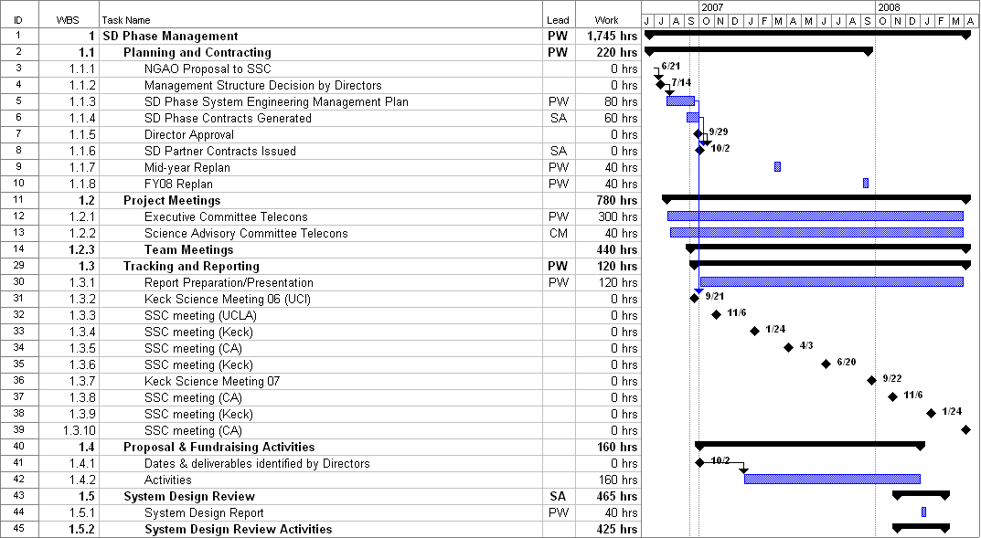
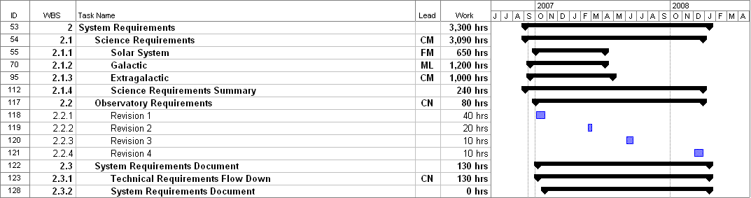
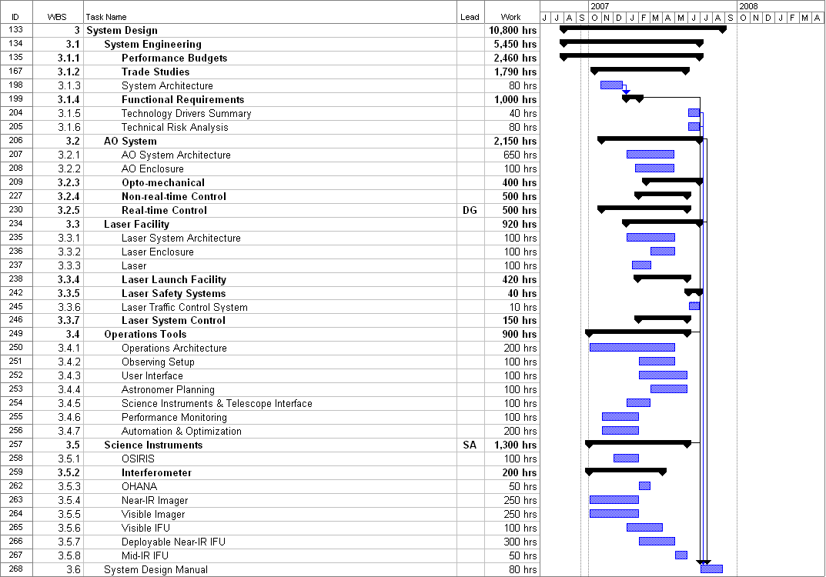
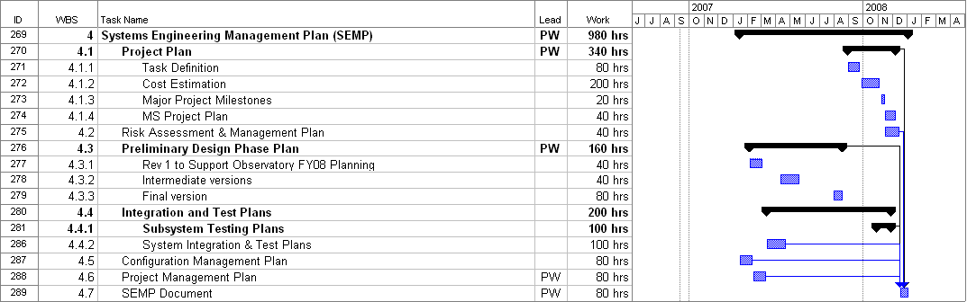

Milestones
Major milestones for the NGAO SD phase are shown below in Table 1. These milestones are derived from the project schedule shown in section 3.4. A more detailed set of milestones, driven by our regular project team meetings, can be found in Section 11.
Table 1: Milestones
MILESTONE | DATE | DESCRIPTION
SD SEMP Approved | 10/9/06 | Approval of this plan by the Directors. Initial SEMP version released to Directors for comment on 9/12 & final version on 9/29/06.
SD phase contracts in place | 10/27/06 | Contracts issued to Caltech & UCSC for the system design phase.
System Requirements v1.0 Release | 10/27/06 | Initial release of System Requirements with emphasis on the science requirements
Individual Performance Budgets Released | 2/16/07 | First round of all performance budgets complete & documented
System Requirement v2.0 Release | 3/9/07 | Second release of System Requirements
Initial Risk Analysis Released | 4/18/07 | First round of project risk analysis complete & documented
Trade Studies Complete | 6/16/07 | All trade studies complete & documented
System Requirement v3.0 Release | 6/29/07 | Third release of System Requirements
System Design Manual v1.0 Release | 8/31/07 | First release of System Design Manual
System Design Manual v2.0 Release | 10/31/07 | Second release of System Design Manual
Cost Review Complete | 12/12/07 | Project cost estimates complete, documented & internally reviewed
SDR Package Distributed | 1/15/08 | SDR documents sent to reviewers
System Design Review | 2/4/08 | SDR meeting
SSC final SDR Report | 4/3/08 | Final SD phase report including results of SDR

Risk assessment and Mitigation Plans
An initial risk assessment and mitigation plan for the NGAO project was developed during the proposal phase of the NGAO project and can be found in section 17 of the NGAO proposal. More detailed investigation and mitigation plans will be developed as a part of the system design efforts. Part of our risk mitigation planning will include looking at the likelihood that each individual risk will impact the project and a separate estimate of how severe the impact could be on the project. These two data points will be used to prioritize the risks so that we are able to put our mitigation efforts toward areas where we will get the most likely benefit.

A major risk to the overall project that could potentially occur in the SD phase is a significant increase in the budget estimates made in the proposal. We will need to maintain cost vigilance during the SD phase and ensure that we understand the cost impact of the requirements and architecture choices.

The remainder of this section only addresses the risks for the SD phase on the NGAO project. Risks have been categorized into three types: Technical, Schedule and Budget. These are briefly discussed in the following paragraphs.

There are no specific technical risks associated with the SD phase. The SD plan is designed to reduce future technical and budget risks by ensuring that we understand the requirements and have evaluated the impact of the achievability of these requirements through the development of performance budgets and initial design choices.

Clearly defining the deliverables for the SD phase and then managing the project to stay focused on these deliverables will minimize the schedule and budget risks for the SD phase. There is schedule and budget risk associated with having not yet assigned personnel to this project and having not yet negotiated contracts (we will have done this by the time the final version of this document is released). The other schedule and budget risk that we feel is important to consider is the possibility that other projects at one or more of the participating institutions has a schedule or cost overrun of sufficient magnitude to impact the availability of personnel for this project.

Configuration Management
We will develop a detailed configuration management plan to establish and maintain the integrity of the NGAO software and hardware systems during the SD phase. This plan will be consistent with the current standards and practices at WMKO including those used for the current Keck AO systems. We anticipate that this plan will include sections describing the following: configuration identification, configuration control, configuration status accounting, configuration audits and software source code repository organization and maintenance policies.

Requirements Management
We will produce a plan during the SD phase for how we intend to manage requirements over the course of the project. During the SD phase the System Requirements releases listed in the project schedule will be approved by the EC.

Process

Work Flow and Decision Points
The MS project schedule and the team meeting goals will be used to ensure that work is on track and that decisions are made per the schedule.

The overall work flow approach is the following:
- The initial focus will be on the requirements and performance budgets to ensure that we understand the largest levers on the design.
- We will then break down the requirements into functional requirements on the major systems (AO, LGS facility, operations tools and science instruments).
- In parallel with items 1 and 2 we will work on a number of trade studies to better understand the appropriate design choices.
- As we work on the overall AO architecture and concepts for the major systems we will continue to iterate with the requirements and performance budgets.
- We will then work on cost estimates and the plans for the remainder of the NGAO project.

Where possible and appropriate we will seek opportunities to leverage other ongoing work or previous design work. Potential examples include: benefiting from priorities and facilities at the UCSC Lab for Adaptive Optics; reviewing and utilizing the TMT NFIRAOS conceptual design study; keeping NGAO in mind during the construction of the Keck I LGS AO system; and benefiting from experiments and experience at Palomar, Lick and Keck.

Contracts
WMKO will be issuing contracts to CIT and UC to fund personnel at these institutions to participate in the system design phase.

Scope of Authority
Deviations from the NGAO project objectives must be approved in writing by the NGAO EC.

Decisions regarding schedule and budget are the responsibility of the NGAO EC. The chair of the NGAO EC must approve in writing all deviations from statements of work affecting the NGAO project objectives.

Purchasing, cost accounting and other financial and administrative matters will be done by WMKO.

Performance Management
The EC will be responsible for maintaining a task plan, budget and schedule for the SD phase of the NGAO project.

Reviews
A System Design Review (SDR) will be held as the culmination of this design phase. This review will be conducted in accordance with WMKO standards.

Reporting
Project Reporting will occur at each SSC meeting. A written report will be provided prior to these meetings. We will use the guidelines in the document Management Guideline for the Preparation of Monthly Reports, version 1.2, Sean Adkins, July 7, 2003, in preparing our reports.

Coordination
The schedule (sections 3.4 and 11) calls for various meetings and videoconferences to be held during the course of the project.

The NGAO EC will have weekly telecons throughout the SD phase of this project.

E-mail will be used as a primary means of intra-project communications.

A working document area has been set up at http://www.oir.caltech.edu/twiki_oir/bin/view.cgi/Keck/NGAO/SystemDesignPhasePlanning.
Documents will be archived as Keck Adaptive Optics Notes on the KeckShare site at http://keckshare.keck.hawaii.edu/dsweb/View/Collection-218.

References

Keck Adaptive Optics Notes (KAON)
All of the documents listed below are available on the KeckShare site at http://keckshare.keck.hawaii.edu/dsweb/View/Collection-218.

- KAON 399. NGAO Proposal Executive Summary
- KAON 400. NGAO Proposal
- KAON 409. NGAO Presentation to the SSC – 6/21/06

Other Documents
- Management Guideline For the Preparation of Monthly Reports, version 1.2, Sean Adkins, 7/7/2003
- Draft Engineering Guideline For the Preparation of Requirements Documents, version 1.1, Sean Adkins 9/6/2006
- New Instrument Design and Development, The System Design Phase, by Sean Adkins, 12/11/2003
- The NGAO System Design Phase, Sean Adkins, 9/6/2006 (See section 8)

Appendix: Establishment of the NGAO SD phase Executive Committee

This appendix contains the text of a letter from the Observatory Directors establishing the NGAO SD phase Executive Committee.

Peter, Richard, Don and Claire,

We propose the following as the appropriate management structure for the next 18-month phase of NGAO. This is the largest program we have undertaken since the original construction of the telescopes. As a community we are fortunate to have world-class expertise in AO development at Keck, UC and Caltech. The NGAO project presents the perfect opportunity to build a strongly collaborative effort between Keck (Hawaii) and the mainland groups. This management structure explicitly takes advantage of the geographically-distributed expertise in our community and emphasizes the collaborative nature of the effort.

The proposed structure is to have the top level of management be comprised of an Executive Committee (EC) chaired by Peter Wizinowich with Rich Dekany, Don Gavel and Claire Max (as Chair of the NGAO Science Team) as the other members. As Chair, Peter will have overall responsibility for delivery of the System Design Phase deliverables. Budget authority will be held by the EC. We also endorse the idea of a funded Science Team led by Claire.

Very early in the next phase, we’d like the EC to develop an explict plan for how the development work will be distributed between the three centers (Keck, Santa Cruz and Caltech).

This is an extremely important project for the future of the Keck Observatory. The systems as conceived of in this early phase would maintain the Keck leadership in groundbased astronomy into the next decade. The strongly collaborative model for undertaking a major development effort is also an important experiment that we need to make work.

Thank you very much for taking on such a large and important project.

Taft, Hilton Shri, Mike

Appendix: The NGAO System Design Phase
The NGAO System Design Phase
August 30, 2006 Revised September 6, 2006
By Sean Adkins

Introduction
The summary description of the system design phase given in the overview of the WMKO development phases is the following:
“The principal objective of system design is to establish a design approach that meets the scientific and user requirements established for the system. System design will establish a discipline integrated engineering plan for the proposed design, understand the technical risks, explore trade-offs, and determine estimates for performance and cost to completion.”
In order to describe the objectives for the system design phase, we will expand on this summary description in an effort to clarify the activities that will take place in the system design phase and also to clarify the relationship of the key document products, the System Requirements Document and the System Design Manual.

System Design
The term system design was chosen for the first phase of development in order to emphasize the desirability of using “systems engineering” as a key strategy for determining requirements and selecting among alternative design concepts. Systems engineering emphasizes a “total view” of the system and the problem space and seeks to integrate the various scientific and engineering disciplines required in the project into a unified effort that maximizes the opportunities to explore trade offs and achieve synergies.
The central activity required in system design is an iterative process that starts with the high level scientific and user requirements, proposes a design concept and then evaluates the ability of the concept to meet the requirements. The design concept includes an “architecture” that partitions the needed functions across subsystems or components. Where viable alternatives exist for a particular design concept or architecture there is an opportunity to make trade-offs or to explore a trade space.
As the process of system design continues, a preferred design concept should emerge, accompanied by a preferred architecture. The architecture defines subsystems or components, and the same iterative process is applied to each subsystem until the design is well enough understood to allow writing the system requirements.
At the end of the system design phase a broad concept for the design has been portioned into subsystems, establishing the system architecture. Trade spaces have been identified, and trade studies performed in order to guide the system design process and select the best design concepts and allocation of function to subsystems and components. The scientific and user requirements have been used to establish system requirements for performance, implementation and design.
The term “design approach” is used for the main product of the system design phase because the product of system design is not a finished design for the actual system, but is instead the basis from which the design will be developed, a basis that is firmly tied to the scientific and user requirements and a basis that offers the best approach to optimizing performance, risk and cost.

System Design Phase Documentation
The two key documents in the system design phase are the System Design Manual (SDM) and the System Requirements Document (SRD). In both of these documents the term “requirements” is used, so it may be helpful to be clear about what we mean by requirements and identify the different types of requirements that we will develop during the system design phase and in later phases of the project.
We define system requirements as statements of need or preference that describe what a system will do and how well but as much as possible do not imply or explicitly request a particular design approach or implementation. To use the terminology of software engineering, requirements should be “implementation free” whenever possible. We describe these requirements as “system requirements” because they are the requirements based on an overall and largely external view of the system. They are also developed at the system design stage, when the details of implementation such as architecture and definition of subsystems may be incomplete or subject to change.
We also use the term functional requirements and here the term is not used in the sense that it is often found in software engineering. Here we mean requirements that are directly related to form and function; they are not implementation free and are in fact intended to define the implementation. These requirements are given in the SDM since they can only be developed after the architecture and subsystems are defined during the system design process.
The SRD is organized by discipline (optical, mechanical, electronic/electrical, safety, software and interfaces) as a way of addressing the problem of completeness and consistency. This organizational approach avoids duplicating requirements within the document. For example, in a spectrometer with refractive optics, one often has a field lens, a collimator and a camera. In a requirements document based on the product structure, there would be requirements for each of these subsystems. Instead, we give requirements for optics, and now we only have to describe the requirements for mounting lenses in one place, rather than in perhaps three places, once for the field lens, once for the collimator and once for the camera. Our organizational approach also allows the specialists in each discipline to see all of their requirements in one place, and it is easier to see if the requirements for each discipline are complete.
The SDM is organized according to the general chronology of the system design phase activities. This is a more flexible format, and should be adjusted to match the scope and nature of the system being designed.
In summary, the SDM documents the preferred design approach, architecture and functional requirements for each of the design’s subsystems. The SRD documents the system level requirements and is organized by discipline. Within each section requirements are grouped into requirements for performance, implementation and design.

The System Requirements Document
The purpose of the SRD is to articulate in one place the requirements for the system, what it must do and how well, and to the minimum extent possible how it will do it. This latter point is emphasized in order to preserve maximum freedom for development of the detailed design, and reflects the fact that the system design phase is not intended to establish actual designs.
The SRD describes the new system in terms of the needed scientific and technical performance. The document also expresses specific requirements for implementation or design where those requirements are essential to satisfactory integration and interoperation of the new system with other observatory systems. The SRD references consensus standards approved by recognized standards organizations for specific guidance on technical matters related to implementation, measurement of performance, compatibility and safety. The requirements given in the SRD provide the definitive reference for all design decisions during the entire design process.
Requirements for areas of the system where uncertainty exists with respect to the achievable performance or the feasibility of a design approach are described as goal requirements. In the case of parametric requirements the SRD provides for goal parameters and typical parameters. Typical parameters are used where enough is known to establish a range of values for the parameter. Goal parameters are used where significant scientific or technical uncertainty exists that must be addressed before the range of values can be known. By the time the detailed design phase of the project is completed all of the goal parameters and goal requirements will have been finalized into typical values and firm requirements.
The first release of the SRD takes place during the system design phase, and the document is revised during the preliminary design phase. At the end of the preliminary design phase the SRD is used to develop the preliminary specifications for the system.
Prior to the drafting of a SRD, three things have occurred:
- A need has been identified for a new or improved system (instrument, AO system, etc.).
- User requirements (science, technical, features, functions, etc.) have been listed at least in part.
- Some concepts have been explored for how a system might be implemented to meet the need, and how that system will operate.

In addition it is very desirable for the actual use of the system to be considered, resulting in so-called "use cases" that are very important tools for identifying what features and functions the system should have. Use cases can also help establish clear boundaries for the system, and clear boundaries are essential for avoiding scope creep or featurism during the design process.
The origin of the scientific and user requirements is not the same for every project. In some situations these requirements are developed in a process that precedes the initiation of the project. This is common for instrumentation at WMKO where the significant commitment of resources to the project needs to be justified by extensive development of a science case and initial science requirements in order for the project to start. In other cases the process may be more organic, with the full development of the science case taking place at the beginning of the system design phase. In either case the science case and the scientific and user requirements need to be refined, updated and maintained during the entire design process (system design, preliminary design and detailed design) as a response to performance and feasibility estimates resulting from the various design activities. The problems posed in the science case may also need to be revised to reflect progress by other researchers during the design phase, and also changes in the anticipated scientific landscape that are expected to take place prior to the delivery of the system.
Scientific and user requirements may be maintained as a separate document, a common practice for instrumentation, or integrated with the SRD. In all cases the flow down between the scientific and user requirements and the performance, implementation and design requirements needs to be clearly established and documented. In cases where the scientific and user requirements are part of the SRD the flow down should be documented here. Otherwise the flow down should be documented in the SDM.

System Design Manual
In the early phases of the system design process, three key decisions are made:
- Determination of the "flow down" or connection between the science and user requirements and the system requirements, implementation details, features and functions. It is very important that the flow down provides for traceability between various requirements such as for example between a science requirement and a performance requirement. This can be done by consistent naming and/or cross-referencing as needed.

- Determination of the system architecture and partitioning of the system into subsystems.

- Generation of specific functional requirements for subsystems, and design concepts for these subsystems. Functional requirements are derived from system requirements, and unlike system requirements they describe or prescribe how the design will achieve the functions needed to fulfill the system requirements. This process also implies a flow down that should be documented in the SDM.

As these decisions are made, the system design process iterates until we have converged on a preferred architecture and design concept. This is then documented in the SDM, and the iterative process continues through the development of the subsystems that are the result of the system architecture and partitioning of function. During this process trade studies may be required, and the SDM should thoroughly document these trade studies including a narrative describing the technical background, the trade study methodology and the results of the trade study.
As the design concepts evolve, initial consideration should be given to technical feasibility, and to the technological needs of the designs. The SDM should identify technology drivers and describe any new technologies (available now or not) that must be available in order to complete the design, build it and meet the requirements. A “technology driver” is a technology where the choice to use it drives the design either in terms of performance, risk, schedule or cost. The SDM should also identify areas where research and development is needed in order to produce the required technologies or to advance an existing technology to the needed level of performance or cost and thereby complete the design, build it and meet the requirements.
By technology we mean something more fundamental than a new pc board, or new software. For example, new integrated circuit designs, new detectors, new electro-optics, new materials, or new discoveries/inventions in all of the related fields without which the design cannot be built or the requirements met.
Once the design approach is documented, functional requirements established, and technology needs identified these decisions are used to make initial performance predictions, establish error budgets, and identify and analyze the risks to performance, cost and schedule.
In summary the SDM does the following:
- Documents the flow down between the scientific and user requirements and the system requirements in the case where the scientific and user requirements are not part of the SRD
- Describes the architecture
- Describes the functional requirements and documents the flow down from the system requirements
- Describes the design concepts for the system and subsystems
- Describes and documents the trade studies performed to choose between design alternatives or refine requirements
- Identifies the needed internal and external interfaces for the system
- Indicates technology drivers and research needs
- Establishes performance budgets and error budgets
- Gives a risk analysis

Systems Engineering Management Plan
The Systems Engineering Management Plan (SEMP) describes the management processes that will be used throughout the development project.
The SEMP includes the following:
- Staff and organization
- Roles and responsibilities
- Project work flow
- Decision making process
- Reporting and documentation requirements

System Design Report
The System Design Report summarizes the work accomplished in the system design phase and presents the initial estimate of performance for the system, the work plan for the preliminary design phase and an estimate of the cost and schedule to completion.

Specific NGAO System Design Objectives
Based on the above discussion, specific objectives can be defined for the NGAO system design phase. These objectives are grouped into five categories, one for general objectives and the other four are grouped according to the documentation product they are most closely associated with.
General Objectives
- Carry out the system design process as described in this and other WMKO documents.
- Document the system design in the following documents:
  - System Design Manual
  - System Requirements Document
  - Systems Engineering Management Plan
  - System Design Report
- Update the project schedule and budget to completion.
- Update and revise the science and use case documentation for the project.

System Requirements Document
- Develop and document the scientific and user requirements for the NGAO system including the adaptive optics system, laser guide star facility and instrumentation.
- Establish and document a flow down from the scientific and user requirements to an initial set of system requirements.

System Design Manual
- Determine and document an optimal design concept for the NGAO system including the adaptive optics system, laser guide star facility and instrumentation.
- Determine and document an architecture and partitioning of function for the NGAO system including the adaptive optics system, laser guide star facility and instrumentation.
- Develop functional requirements for each subsystem as determined by the architecture and document these functional requirements and their flow down from the system requirements.
- Perform trade studies as required and thoroughly document these trade studies including technical background, methodology and results.
- Validate the design concept and architecture through performance estimates anchored to documented performance budgets and error budgets.
- Analyze and document the technology and research needs of the NGAO system including the adaptive optics system, laser guide star facility and instrumentation.
- Analyze and document the technical, schedule and budget risks for the NGAO system including the adaptive optics system, laser guide star facility and instrumentation.
- Develop and document initial risk mitigation plans and reduction strategies for each of the identified risks.

Systems Engineering Management Plan
- Develop and document an initial SEMP for the System Design Phase of the NGAO project.
- Revise the SEMP as required to reflect the planned management process and objectives for the remaining phases of the NGAO development.

Appendix: System Design Phase Work Breakdown Structure Dictionary

- System Design Phase Management
- Management of the SD Phase of the NGAO project, including budget and schedule, and regular reporting to the SSC and Observatory Directors. The Executive Committee (EC) has overall responsibility for the delivery of the key products of the SD Phase.
  - Planning & Contracting
    - Planning
- Preparation of the SD phase System Engineering Management Plan (this document). Replanning as appropriate during the SD phase, including support for the Observatory FY planning.
    - Contracting
- WMKO intends to issue contracts to Caltech and UCSC, and possibly elsewhere, to provide funding for these groups to support the SD phase. This WBS element covers the effort to prepare contract documentation, including statements of work, and to implement these contracts.
  - Project Meetings
- Effort in support of regular project meetings.
    - Executive Committee Telecons
- The EC will have regular telecons to manage the SD phase. This WBS covers the effort to participate in these telecons.
    - Science Advisory Committee Telecons
- The Project Scientist will hold regular telecons with the other members of the SAC. This WBS covers the effort to participate in these telecons.
    - Team Meetings
- Team meetings will be held every ~ 6 weeks during the SD phase. These meetings will alternate between in-person meetings and teleconferences. The in-person meetings will generally be held at either Caltech, UCI or WMKO in an alternating fashion.
  - Tracking & Reporting
- We will be reporting on the SD phase status and plans at each SSC meeting. This WBS covers the effort to prepare for these meetings, including tracking our progress, and to present at these meetings.
- We will also be providing more global overviews of the SD progress at the Keck Science Meetings. This WBS covers the effort to prepare for these meetings.
  - Funding Proposal(s)
- Generation of proposals for funding. The current assumption is that no work will be needed in this area during the SD phase.
  - System Design Review
    - System Design Report
- Provides a high level summary of the work done during the SD phase and makes a proposal for the preliminary design phase of the project including a plan for the remainder of the project.
    - System Design Review Activities
- This WBS covers the following activities: identifying reviewers, distributing the four SD phase documents to the reviewers, responding to the reviewer questions, preparing and presenting at the SDR and responding to the SDR reviewer report.

- System Requirements
- Development and documentation of science and system requirements.
  - Science Requirements
    - Solar System
      - Companions & Multiplicity of Small Solar System Bodies
        - Point Source Companion Sensitivity Requirements
- Understand & document requirements vs. sky coverage. Iterate with performance budget.
        - Spectral Sensitivity & Spectral Resolution Requirements
- Understand & document requirements vs. sky coverage. Iterate with performance budget.
        - Observing Scenarios
- Develop & document observing scenarios.
        - Science Instrument Requirements
- Understand & document science instrument (imaging and integral field spectroscopy) specific requirements. Develop prioritized instrument list. Iterate with instrument selection & error budgets.
      - Moons of the Giant Planets
        - Performance Requirements
- Understand & document requirements vs. sky coverage. Iterate with performance budget.
        - Observing Scenarios
- Develop and document observing scenarios (e.g., for monitoring over periods of months, weeks, days)
        - Science Instrument Requirements
- Understand & document science instrument (imaging and integral field spectroscopy) specific requirements. Develop prioritized instrument list. Iterate with instrument selection & error budgets.
      - Shape & Size of Asteroids
        - Spatial Resolution Requirements
- Understand & document requirements vs. sky coverage. Iterate with performance budget.
        - Spectral Sensitivity & Spectral Resolution Requirements
- Understand & document requirements vs. sky coverage. Iterate with performance budget.
        - Observing Scenarios
- Develop & document observing scenarios.
        - Science Instrument Requirements
- Understand & document science instrument (imaging and integral field spectroscopy) specific requirements. Develop prioritized instrument list. Iterate with instrument selection & error budgets.
    - Galactic
      - Galactic Center Proper Motions: Astrometry
        - Astrometry Performance Requirements
- Understand & document the astrometry performance requirement. Iterate with astrometry performance budget effort, & the resultant design choices, to analyze the effect of the astrometry requirements (e.g., will the astrometry requirement push some aspect of the AO design over some threshold of feasibility or cost?). Compare with the capabilities of the Keck Interferometer.
        - Observing Scenarios
- Develop & document observing scenarios.
        - Science Instrument Requirements
- Understand & document science instrument specific requirements. Develop prioritized instrument list. Iterate with instrument selection & error budgets.
      - Galactic Center Radial Velocities & Stellar Populations: Integral Field Spectroscopy
        - Performance Requirements
- Understand & document the performance requirements for the IFU science cases. Iterate with performance budget efforts, & the resultant design choices.
        - Observing Scenarios
- Develop & document observing scenarios.
        - Science Instrument Requirements
- Analyze & document the effect of IFU spectroscopy on instrument selection, architecture and performance. Iterate with instrument concepts.
      - Galactic Center Nature of Sgr A*: Flares, Spectra & Time Behavior
        - Performance Requirements
- Understand & document the performance requirements. Iterate with the performance budget efforts. Compare with the capabilities of the Keck Interferometer.
        - Observing Scenarios
- Develop & document observing scenarios.
        - Science Instrument Requirements
- Understand & document science instrument specific requirements. Develop prioritized instrument list. Iterate with instrument selection & error budgets.
      - Low-mass Companions: Planets & Binary Brown Dwarfs
        - Companion Sensitivity Performance Requirements
- Understand & document point-source companion sensitivity versus sky coverage requirements. Iterate with the companion sensitivity error budget effort.
        - Observing Scenarios
- Develop & document observing scenarios.
        - Science Instrument Requirements
- Understand & document science instrument (imaging and integral field spectroscopy) specific requirements. Develop prioritized instrument list. Iterate with instrument selection & error budgets.
      - Debris Disks, Protostellar Envelopes & Outflows: Contrast
        - Contrast Performance Requirements
- Understand & document the contrast performance requirements versus sky coverage. Iterate with the performance budget efforts.
        - Observing Scenarios
- Develop & document observing scenarios.
        - Science Instrument Requirements
- Understand & document science instrument specific requirements. Develop prioritized instrument list. Iterate with instrument selection & error budgets.
      - Debris Disks, Protostellar Envelopes & Outflows: Polarimetry
        - Polarimetry Performance Requirements
- Understand & document the polarimetry performance requirements versus sky coverage and contrast. Iterate with the performance budget efforts.
        - Observing Scenarios
- Develop & document observing scenarios.
        - Science Instrument Requirements
- Understand & document science instrument specific requirements. For example, if dual-channel polarimetry is required then a place may be needed in the AO system for a deployable polarization modulator. Develop prioritized instrument list. Iterate with instrument selection & error budgets.
    - Extragalactic
      - Resolved Stellar Populations
        - Performance Requirements
- Understand & document photon flux, PSF characteristics & contiguous field science requirements needed to recover stellar populations. Iterate with the performance budget efforts. Consider how Gemini’s MCAO focus in this area should impact the science priority of this topic for NGAO.
        - Observing Scenarios
- Develop & document observing scenarios.
        - Science Instrument Requirements
- Understand & document science instrument specific requirements. Develop prioritized instrument list. Iterate with instrument selection & error budgets.
      - High Redshift Galaxies
- Interested in evolution, mergers and QSO hosts.
        - Encircled Energy Performance Requirements
- Understand & document the encircled energy requirements, including how this interacts with sky coverage & sky background requirements. Iterate with the performance budget efforts for various AO architectures. Understand & document the d-IFU optimum lenslet scale.
        - Observing Scenarios
- Develop & document observing scenarios.
        - Science Instrument Requirements
- Understand & document science instrument specific requirements. Develop prioritized instrument list. Iterate with instrument selection & error budgets.
      - Nearby Galaxies
        - Encircled energy & PSF Performance Requirements
- Understand & document the encircled energy & PSF requirements, including how they interact with sky coverage & sky background requirements. Iterate with the performance budget efforts for various AO architectures.
        - Observing Scenarios
- Develop & document observing scenarios.
        - Science Instrument Requirements
- Understand & document science instrument specific requirements. Develop prioritized instrument list. Iterate with instrument selection & error budgets.
      - Gravitational Lensing
        - Encircled Energy & PSF Performance Requirements
- Understand & document the encircled energy & PSF requirements, including how they interact with sky coverage & sky background requirements. Iterate with the performance budget efforts for various AO architectures.
        - Observing Scenarios
- Develop & document observing scenarios.
        - Science Instrument Requirements
- Understand & document science instrument specific requirements. Develop prioritized instrument list. Iterate with instrument selection & error budgets.
    - Science Requirements Summary
      - Revision 1
      - Revision 2
      - Revision 3
      - Final SD Version
  - Observatory Requirements
  - System Requirements Document
- Summary of products produced in WBS 2 including descriptions of the science requirements, additional Observatory requirements and the technical requirements organized by engineering discipline with a clear flow down from the science and Observatory requirements.
    - Technical Requirements Flow Down
    - System Requirements Document Writing
      - Revision 1 Release
      - Revision 2 Release
      - Revision 3 Release
      - Final SD Version Release

- System Design Approach
  - System Engineering
    - Performance Budgets
- Development of systems level engineering budgets for a variety of astronomical performance metrics, organized around key observing scenarios. The level of detail available to each budget will depend on the state of the art, the resources dedicated to budget generation during the SD phase, and astronomical user experience. All performance budgets should parameterize the performance behavior versus the corresponding sky coverage fraction. (when appropriate, coverage levels of 5, 30, and 90% should be assumed).
      - Model Assumptions
- The goal of this WBS is to document the assumptions (and rationale) for the key parameters to be adopted for the development of all performance budgets, including such items as the median C_{n}²(h), sodium column density and Keck telescope optical performance. In some cases work will be required to acquire and evaluate data to determine the appropriate assumptions to be used.
        - TMT Site Monitoring Data Mining
- Develop tools for data mining from the database of TMT Mauna Kea site survey data. Analyze such data to determine for example, nominal, 10, 25, 75, and 90 percentile seeing conditions (r0, theta0, Cn2, wind, etc.) and publish in a form usable as input to system performance simulation models. Work with system modelers to assure appropriately interpreted data is being used and provide metrics of data integrity and/or reliability.
        - Telescope Dynamic Performance Data
- Improve/document our understanding of the actual primary mirror wavefront errors.
        - Telescope Static Wavefront Errors
- Improve/document our understanding of the actual primary mirror wavefront errors.
        - Sodium Return versus Laser Format
- Improve/document our understanding of the actual sodium return versus various laser formats. Should base this on experience with the Keck, Gemini, Palomar and Subaru lasers.
      - Model/Tool Validation
- Execution of a series of quantitative checks on the validity of key NGAO models and development tools, as compared to results obtained from various laboratory and sky tests with existing AO systems.
        - Agreement between Tomography Codes
- Understand the differences between tomography codes in use at WMKO and UCSC, modify the codes as appropriate and document the result that should be used.
        - Agreement between Sky Coverage Codes
- Understand and document methods of making sky coverage calculations. Validate/compare codes using sample data sets and resolve discrepancies.
        - Anchor to Keck II LGS AO PSFs
- Demonstrate the ability to produce PSFs that are adequately similar to PSFs obtained with the Keck II LGS AO PSFs. Understand and make changes to the models to achieve this result. Document the result and use the result in updating the appropriate performance budgets.
        - Anchor to On-sky MGSU Experiments
- Use the results of the Palomar (and possibly MMT) MGSU experiments to validate and/or correct the tomography model and its assumptions.
        - Anchor to LAO Lab Experiments
- Determine what high leverage experiments should and can be performed at LAO to validate our models and tools, perform these experiments, and use the results to update the appropriate models, tools and performance budgets.
      - Throughput
- Development of optical transmission budgets for each of the science path(s), HOWFS, LOWFS(s), and slow WFS.
      - Background
- Development of thermal background budget for the IR science and wavefront sensor instruments.
      - Wavefront Error
- Development of residual wavefront error budgets for a set of key observational scenarios. The first step is to document the budget and tool used in the proposal.
      - Encircled Energy
- Development of encircled energy budgets for a set of key observational scenarios.
      - Photometric Accuracy
- Development of a deviation budget for differential photometric precision for a set of key observational scenarios. To be manageable, this budget should assume statistical independence among the key physical sources of degradation of photometric precision. Physical effects to be considered may include wind-induced PSF anisoplanatism, photon noise, read noise, flat-fielding variations, field-dependent optical aberrations, imperfect estimation of the anisoplanatism contribution to PSF shape, atmospheric scintillation, filter bandpass uncertainty, transparency waves in the atmosphere, imperfect atmospheric color correction, PSF sampling issues, and nonlinear detector response. Investigation of the impact of certain terms in the budget may require detailed AO performance simulations. Calculation of other terms may be beyond the scope of the SD phase, resulting in a top-level allocation to the performance budget until otherwise updated.
      - Astrometric Accuracy
- Development of a deviation budget for differential astrometric precision for a set of key observational scenarios. To be manageable, this budget should assume statistical independence among the key physical sources of degradation of astrometric precision. Physical effects to be considered may include atmospheric tilt anisoplanatism, wind-induced PSF anisoplanatism, field-dependent optical aberrations, photon noise, read noise, flat-fielding variations, PSF sampling issues, telescope plate scale fluctuations, and nonlinear detector response. Investigation of the impact of certain terms in the budget may require detailed AO performance simulations. Calculation of other terms may be beyond the scope of the SD phase, resulting in a top-level allocation to the performance budget until otherwise updated.
      - Polarimetric Accuracy
- Develop polarmetric accuracy performance budget. Develop methods of assessing optical designs for polarimetric accuracy and stability and fold these into the process of system design analysis so that important impacts are identified early.
      - Companion Sensitivity
- Development of a companion sensitivity performance budget. Potential tasks include: Identify a strawman coronagraph (basic questions like whether it's part of the AO system or part of the science instrument; higher order questions like architecture choice so we can do more realistic simulations and understand how it affects the AO system). Develop a contrast error budget that includes not just AO performance but realistic values for static/internal effects, so that we can see what instrument design choices (e.g. optics quality) are important now.
      - Point Source Sensitivity
- The purpose of this WBS is to produce a summary table of predicted point source sensitivities based on the relevant performance budgets.
      - PSF Stability
- The purpose of this WBS is to produce a document, including sample PSFs, summarizing the predicted PSF stability based on the relevant performance budgets.
      - Observing Efficiency
- The purpose of this performance budget is to determine what will be required to meet the Observing Efficiency requirement. This budget is only intended to cover the NGAO facility and science instruments (and not the telescope or facility). A list of all the items contributing to the loss of LGS AO-corrected integration time will be produced along with reasonable allocations of the observing efficiency budget amongst these items.
      - Observing Uptime
- The purpose of this performance budget is to determine what will be required to meeting the observing uptime requirement. This budget is only intended to cover the NGAO facility and science instruments (and not the telescope or facility). A list of all the items contributing to downtime will be compiled along with a distribution of the uptime budget amongst these items.
      - Performance Budgets Summary
    - Trade Studies
- The system engineer in charge of trade studies shall assure that trade studies are cohesively coordinated, that results are published at a consistent level of accuracy relevant to the system design at this phase, that the appropriate interfaces/interactions are made with other system engineering efforts, and that the studies are being performed efficiently in view of the system design phase schedule.
      - System Architecture Trade Studies
        - NGAO versus Keck AO Upgrades
- Consider the feasibility of upgrading one of the existing Keck AO systems incrementally to meet NGAO science requirements. Consider opto-mechanical constraints & upgradability of embedded & supervisory control systems. Consider impact on science operations during NGAO commissioning. Complete when option assessment documented.
        - Adaptive Secondary Mirror Option
- Consider relative performance, cost, risk & schedule of an NGAO implementation based on an ASM. Quantify the benefit of an ASM to both NGAO and non-NGAO instruments. Complete when NGAO baseline architecture selected.
        - K & L-band Science
- Consider the relative performance, cost, risk, and schedule of different strategies for K and L-band science optimization. Compare a Nasmyth relay, an ASM & a separate lower-order Nasmyth AO cryo-system. Complete when performance estimates & strategy for K- & L-band observing documented.
        - Keck Interferometer Support
- Consider the relative performance, cost, risk & schedule of feeding KI with NGAO or a repackaged version of the current AO system. Decoupling of NGAO from interferometer support may simplify & improve performance of NGAO. The feasibility of maintaining a version of the two current AO systems for KI use should be evaluated. Complete when NGAO baseline architecture selected.
        - Instrument Balance
- Consider the relative merit of installing NGAO on Keck I vs Keck II. This must take into account the long-term instrumentation strategy for Keck, available laser infrastructure, and impact on operations. Complete when architecture and location requirements documented.
        - GLAO for non-NGAO Instruments
- Consider the relative performance, cost, risk, and schedule of GLAO compensation using an ASM for non-NGAO instruments. Complete when expected performance benefit for each instrument documented.
        - Instrument Reuse
- Consider the cost/benefit of reuse of existing Keck AO instruments, particularly OSIRIS and NIRC2, versus the benefit of design freedom for an all-new instrument suite. Complete when issues documented Observatory strategy adopted.
        - Telescope Wavefront Errors
- Review new data on the telescope static and dynamic wavefront errors. Determine how and whether NGAO can correct for these errors. Determine the performance benefit of a large LOWFS patrol field to enable use of the brightest possible NGS. Consider whether a separate sensor outside the NGAO FOV would be useful for measuring/correcting the telescope errors. Complete when impact on current Keck LGS AO system understood and impact on NGAO reviewed.
      - Adaptive Optics System Trade Studies
- The following are the medium and high priority trade studies identified in an Appendix of the NGAO proposal. Low priority trade studies have been deferred.
        - AO Enclosure Temperature
- Consider the performance, cost, risk, reliability & maintainability of cooling a Nasmyth NGAO enclosure. Calculate sensitivity impact as function of waveband (V through L-band). Complete when enclosure operating temperature selected.
        - Optical Relay Design
- Consider the relative performance, cost & risk of an OAP & Offner relay. Consider image quality vs. FoV, pupil image quality & the flowdown of requirements onto the (variable distance) LGS wavefront sensor(s). Confirm that off-axis LGS aberrations out to 90" field radius are acceptable. Complete when an NGAO baseline optical design is selected.
        - Field Rotation Strategy
- Consider the relative performance, cost, reliability & maintainability of compensating field rotation using 1 or more K-mirrors vs using 1 or more instrument rotators. Complete when baseline approach & instrument requirements documented.
        - Dichroics
- Determine the observation requirements for 1 or more dichroic changers. Different observing programs may desire different distributions of light among HO WFS, LO WFS & science light paths. Complete when dichroic changer requirements documented.
        - Rayleigh Rejection
- Evaluate the impact of unwanted Rayleigh backscatter to NGAO system performance. Consider the relative performance, cost, risk & schedule of various strategies for mitigation of LGS Rayleigh backscatter. Techniques include background subtraction, modulation & optimizing projection location. This issue is closely coupled to laser pulse format, with pulsed lasers generally providing more options for Rayleigh mitigation than CW lasers. Complete when NGAO baseline architecture selected.
        - LGS Wavefront Sensor Type
- Consider alternative WFS designs (e.g. Shack-Hartmann vs. pyramid) for different laser pulse formats. Evaluate and compare the advantages of e.g. short pulse tracking using radial geometry CCDs and mechanical pulse trackers. Complete when LGS WFS requirements have been documented.
        - LGS Wavefront Sensor Number of Subapertures
- Consider alternative WFS designs (e.g. Shack-Hartmann vs. pyramid) for different laser pulse formats. Evaluate and compare the advantages of e.g. short pulse tracking using radial geometry CCDs and mechanical pulse trackers. Complete when LGS WFS requirements have been documented.
        - Slow Wavefront Sensor
- Determine the requirements, if any, for slow wavefront sensor for tracking of non-common-path aberrations between the HOWFS and science instruments. Determine potential waveband for slow WFS operation. Consider if a single NGS HOWFS can be pressed into service for this purpose (with another lenslet array)? Consider impact of dark current in longer exposures. Complete when Slow WFS requirements are documented.
        - Low Order Wavefront Sensor Architecture
- Consider the cost/benefit and technical maturity of MEMS-based correction within the LOWFS, using MOAO control techniques. Include consideration of additional metrology systems required, if any. Compare with cost/benefit of MCAO system to provide tip/tilt star sharpening. Complete when LOWFS requirements and sky coverage estimates have been documented.
        - Number and Type of Low Order Wavefront Sensors
- Perform a cost/benefit analysis for the optimal type, waveband, and number of tip/tilt and tip/tilt/focus low-order WFS. Complete when LOWFS requirements and sky coverage estimates have been documented.
        - Centroid Anisoplanatism
- Consider the impact of centroid anisoplanatism (e.g. the tip/tilt error due to coma in the low-order WFS) and mitigation strategies, if necessary. Evaluate the difference between Zernike (z-tilt) and centroid tilt (g-tilt) for NGAO sensors. Complete when documented and mitigation strategy adopted.
        - Deformable Mirror Stroke Requirement
- Determine required DM stroke based on performance, cost, risk, reliability & maintainability. Consider both global & inter-actuator stroke & quantify the performance penalty for different levels of actuator saturation. Determine DM stroke offloading requirements to other NGAO system elements. Complete when DM stroke, stroke offloading & related system requirements documented.
        - Stand-alone Tip/Tilt Mirror versus DM on Tip/Tilt Stage
- Consider the performance, cost, risk, reliability, and maintainability of a stand-alone tip/tilt mirror vs. mounting an otherwise necessary mirror (e.g. a DM) on a fast tip/tilt stage. Note that high BW correction is difficult with a large or heavy mirror. Complete when tip/tilt approach selected.
        - Correcting Fast Tip/Tilt with DM
- Consider the performance, cost, risk, reliability, and maintainability of performing the highest bandwidth tip/tilt correction using DM actuators. Note that allocation of some time/tilt control to the DM complicates the control system, may increase the stroke requirement & thus the DM cost. Complete when control system & DM stroke requirements determined.
        - Focus Compensation
- Consider cost/benefit of different approaches to focus compensation due to sodium layer motion. Include consideration of the proper combination of LGS focus, LOWFS focus and Slow WFS focus. Complete when focus tracking strategy has been documented and reflected in error budgets.
      - Laser Facility Trade Studies
        - Laser Pulse Format
- Consider the performance, cost, risk, reliability, and maintainability of different sodium laser pulse formats, including usability under various weather scenarios, infrastructure and beam transport issues, and commercial readiness. Complete when laser pulse format requirements have been documented.
        - Free Space versus Fiber Relay
- Consider the performance, cost, risk, upgradability, reliability & maintainability of free-space guide star laser transport vs hollow core fiber transport. Complete when a beam transport system has been selected.
        - LGS Asterism Geometry and Size
- Consider the technical performance tradeoff for different LGS asterism geometries (e.g. quincunx, ring, 1+triangle, or hex) and asterism radii. Include consideration of fixed or variable asterism radius in terms of optimizing Strehl of the tip/tilt stars and resulting sky coverage. Complete when LGS asterism, HO WFS, and LO WFS requirements have been documented.
        - Variable versus Fixed LGS Asterism Geometry
- Consider the cost/benefit of continually varying the LGS asterism radius vs. a fixed number of radii (e.g. 5", 25", 50"). Complete when LGS asterism requirements have been documented.
    - System Architecture
- Produce strawman system architectures in consideration of input from the system/science requirements, performance budgets and trade studies, and iterate with these efforts. Provide top-level guidance to allow the designs of the major systems (AO system, LGS facility, operator tools and science instruments) to proceed. Document the system architecture considerations, trade-offs and decisions. Participate in the writing of the system design manual.
    - Functional Requirements
- Based on the system requirements, performance budgets and the system architecture choices, develop functional requirements for the AO system, laser system, operations tools and science instruments.
      - AO System
- Based on the system requirements, performance budgets and the system architecture choices, develop functional requirements for the AO system.
      - Laser Facility
- Based on the system requirements, performance budgets and the system architecture choices, develop functional requirements for the laser facility.
      - Operations Tools
- Based on the system requirements, performance budgets and the system architecture choices, develop functional requirements for the operations tools.
      - Science Instruments
- Based on the system requirements, performance budgets and the system architecture choices, develop functional requirements for the science instruments.
    - Technology Drivers Summary
- Identify the technologies that are key determinants of the performance budgets. Identify the technologies that are critical to meeting the functional requirements.
    - Technical Risk Assessment
- Perform the technical risk assessment on meeting the performance budgets and functional requirements.
  - AO System
    - AO System Architecture
- Based on system requirements, design the opto-mechanical layout and specify components for the optical paths of the receiver system (“receiver” means guidestar, tip/tilt star, and science beam handling and diagnostics; as distinguished from “transmitter” which indicates the laser transport and launch system).
    - AO Enclosure
- Based on system requirements and performance budgets, design an enclosure to control air flow, temperature, humidity, scattered light, etc. as required. Input to this process are results of a trade study determining optical surface temperatures required to meet emissivity requirements. Also input to this process is a determination of humidity requirements for certain components such as DMs. The work includes interaction with the optical designer to assess scattered light issues and to design appropriate baffles and beam blocks. Output is an enclosure system design with specifications for components of this system along with recommendations for vendor sources.
    - Opto-Mechanical
- Based on system requirements and performance budgets, design the optical relays and specify optical components for the optical paths of the receiver. Perform analyses to verify performance consistent with system error budgets (terms assigned to static and non-common path wavefront errors, temperature induced drifts, and optical component tolerances) and modify design accordingly to meet these error budgets. Perform similar analyses and rectifications for meeting throughput, emissivity, and stability budget requirements.
      - Field Rotation
- Based on system requirements and performance budgets, determine the optimal approach to addressing field rotation for the science instruments and NGAO system, and provide a conceptual design. Different approaches can be considered for the rotational needs of the science instruments, the wavefront sensors and the laser launch asterism.
      - Optical Relay
- Based on system requirements and performance budgets, design the optical system layout that supports the optical design for the receiver. Perform analyses to verify performance consistent with system error budgets: terms assigned to mechanical drift, flexure, temperature, and machine tolerances.
      - Optical Switchyard
- Based on system requirements and performance budgets, design the optical switchyard that will distribute light between the various wavefront sensors, acquisition cameras and science instruments, and determine the requirements on this system and its components.
      - Optical Support Structure
- Based on system requirements and performance budgets, design the mechanical system that supports the optical and electronic components of the receiver. Perform analyses to verify performance and rectify as necessary
      - Wavefront Sensors
        - High Order LGS Wavefront Sensors
- Given the functional and performance requirements, develop a design concept for the laser guide star high order wavefront sensors. Take into consideration the possible need for both open and closed loop wavefront sensing.
        - High Order NGS Wavefront Sensor
- Given the functional and performance requirements, develop a design concept for the natural guide star high order wavefront sensor(s). Take into consideration the possible need for both open and closed loop wavefront sensing.
        - Low Order NGS Wavefront Sensors
- Given the functional and performance requirements, develop a design concept for the low order natural guide star wavefront sensors for the purpose of determining tip/tilt and other low order modes in laser guide star observing mode. Take into consideration the possible need for both open and closed loop wavefront sensing.
        - Calibration Wavefront Sensor
- Given the functional and performance requirements, develop a design concept for the calibration wavefront sensor which will use natural guide star light as a truth wavefront. This sensor will be periodically used to reset the references of the high order wavefront sensors in laser guide star mode.
      - Wavefront Correctors
        - Tip/Tilt
- Given the functional and performance requirements, develop a design concept or specify the tip/tilt wavefront correction elements for the AO system (receiver).
        - Deformable Mirror
- Given the functional and performance requirements, develop a design concept or specify the high order wavefront correction element(s) for the AO system (receiver).
      - Acquisition Cameras
        - NGS Acquisition Camera
- Provide a strawman design for acquiring the natural guidestars and providing a means of transferring their coordinates to the natural guidestar and low-order wavefront sensors. Develop a design concept or specify this camera system.
        - LGS Acquisition Camera
- Provide a strawman design for acquiring the laser guide stars and providing a means of giving coordinates so as to be able to steer them into the laser guide star wavefront sensors. Develop a design concept or specify this camera system.
      - Atmospheric Dispersion Correction
- Define the software and hardware needed to address atmospheric dispersion including pointing corrections between the wavefront sensing and science wavelengths, and as appropriate visible and IR ADCs for the science instruments and wavefront sensors.
      - Alignment, Calibration, Diagnostics, Metrology and Monitoring
- Define the tools needed to support routine alignment and calibration and to provide the required routine metrology and diagnostics. Monitoring tools that are not part of the AO system, such as an external MASS/DIMM should be included under this category. Alignment, calibration and diagnostics tools will like include a telescope simulator with multiple NGS and LGS sources and a means of simulating turbulence, as well as arc lamps for science instrument calibration.
    - Non-Real-Time Control
      - Non-RTC Software Design
- Based on system operations requirements and in corroboration with the AO Optical Bench design and AO System design, develop a software architecture and maintenance plan for all remote and automatic real time control software. Also, develop data collection and management systems.
      - Non-RTC Electrical Design
- Based on system requirements and in collaboration with the optical and mechanical designers, determine the electrical system requirements for supporting the optical bench including motors, shutters, filter wheels, and other robotic or remotely operable control stages and devices. Also, determine requirements for drive electronics and control boxes for these stages and the associated cabling, connectors, and interfacing. Also, determine the power requirements and design the control signal and power routing to meet overall system noise requirements (this is exclusive of real-time control and wavefront sensing, which is covered in a separate description). Collaborate with the software team to determine computer interface and operability requirements. Output is an electronic/electrical component and wiring layout, control box placement (in corroboration with the mechanical designer), power load analyses, specifications for components, and review/summary of vendor sources for the components.
    - Real-time Control
- Based on system requirements, operations requirements, and error budgets, determine an architecture for the real-time controller, including both hardware and software configuration. Input to this process includes candidate wavefront sensing, tomography, tip/tilt, and DM control and signal processing algorithms as provided by the system engineering group as a result of trade studies. Design work includes specification of hardware interface requirements, hardware processor speed, data rate, and storage requirements, design of the data flow, design of the algorithm implementation software, and design of the diagnostic and telemetry streams. Work includes analysis and modeling of performance at the low-level of implementation, e.g. taking into account data transmission delays, processor delays, and data resolution.
      - RTC Architecture Analysis and Design Study
- Based on system requirements, operations requirements, and error budgets, determine an architecture for the real-time controller, including both hardware and software configuration. Input to this process includes candidate wavefront sensing, tomography, tip/tilt, and DM control and signal processing algorithms as provided by the system engineering group as a result of trade studies. Output of this process is an analysis of candidate architectures, simulations of expected real-time performance, and guidance (in the form of strawman designs) for the RTC software module definition and RTC hardware module definition tasks.
      - RTC Software Module Definition
- Given the architectural design and results of the RTC design study, specify the software development environment tools required (& analyze vendors of such), develop a software top level block diagram, define software data structures and data flow paths, define software command language for interface to the system controller/user interface, design diagnostic and telemetry streams, specify software module functions at a detailed level. Develop a real-time software implementation and test plan.
      - RTC Hardware Module Definition
- Given the architectural design and results of the RTC design study, specify the hardware platform (or platform options, through PDR phase), specify the hardware interfaces, including required cabling, in consideration of real-time data flow and diagnostic/telemetry streams, determine the overall size, mounting, and power requirements. If specifying custom processor boards (likely, with a transputer/FPGA architecture) design the board layout in conformance with fab-house design rules, specify the component processors and all other components needed to enable assembly of the boards. Develop a hardware acceptance test plan. Specify test equipment needed.
  - Laser Facility
    - Laser System Architecture
- Based on system requirements and the error budgets, develop a system for producing laser beacons sufficient for NGAO. An input to this process is the result of a trade study determining the field of view, number of guidestar beacons, and constellations for various science observing conditions. Produce as output: the system architecture and design/specifications for creating and projecting the guidestars, controlling the pointing, maintaining output beam quality, diagnostics, and user control.
    - Laser Enclosure
    - Laser
- Based on system requirements and error budgets, specify a laser or set of lasers to produce guidestars. Take into consideration the current state of the art and availability of lasers. An input to this process is the result of a trade study determining the desirable pulse format or formats and power per guidestar. Produce as output: a summary of the laser options versus requirements.
    - Laser Launch Facility
- Based on system requirements and error budgets, develop the design concept for the systems required for delivering the laser power from the laser to the sky.
      - Laser Beam Transport
- Develop the design concept for the system for delivering the laser power from the laser to the launch telescope.
      - Laser Pointing and Diagnostics
- Develop the design concept for the system for determining and controlling the alignment and pointing of the laser beams. Develop the system concept for regular monitoring the beam quality, laser power, and health of the laser launch system.
      - Laser Launch Telescope
- Develop the design concept or specify the telescope needed to launch multiple laser beacons.
    - Laser Safety Systems
- Design safety systems for the laser to protect aircraft, satellites, personnel and equipment.
      - Personnel and Equipment Safety Systems
- Identify the required safety interlock systems. Identify means of protecting equipment from inadvertent damage during operation. Specify the top-level safety interlock systems logic sequences and specify hardware components that provide these functions.
      - Aircraft and Satellite Safety Systems
- Develop the design concept or specify the safety systems needed to protect aircraft pilots (eye safety) and spacecraft from the laser beacons.
    - Laser Traffic Control
- All telescopes on Mauna Kea are currently required to participate in the Laser Traffic Control System. Determine what changes will be needed to accommodate NGAO in this system.
    - Laser System Control System
- Identify the requirements and design concept for laser system control, for example wavelength control, mode behavior maintenance, and a system to tune off wavelength for Rayleigh background exposure. Identify key parameters for monitoring laser status and design means of measurement and monitoring.
      - Laser System Software
- Design the architecture for the laser system control and diagnostics software, including laser, beam transport, and launch system. Software must be integrated with the laser safety system, AO system, science instruments, and the telescope operating system.
      - Laser System Electronics
- Specify and develop the design concept for the electronics systems needed to provide laser control and diagnostics functions.
  - Operations Tools
    - Operations Architecture
- Define the overall software and computer architectures needed to support the operations tools.
    - Observing Setup
- Define the software tools needed to perform AO and laser system configurations and calibrations in preparation for the night’s observng.
    - User Interface
- Define the user interface tools and on-line documentation to be used for routine daytime preparation and nighttime operation, including an astronomer user interface, an operator user interface and troubleshooting.
    - Astronomer Planning
- Define the software tools and on-line documentation that will be needed to support observation planning by astronomers.
    - Science Instruments and Telescope Interfaces
- Define the software tools and interfaces needed to support pointing offloads, focus offloads, automated focus correction versus instrument configuration, nodding and chopping.
    - Performance Monitoring
- Define the software tools and performance needed to 1) monitor and record the observing conditions, 2) predict performance based on AO telemetry and/or external seeing monitors, 3) to monitor and record the current performance, and 4) to compare the performance versus prediction.
    - Automation and Optimization
- Define the software tools and performance needed to automate the NGAO nighttime operation for optimal observing efficiency and for optimal performance.
  - Science Instruments
- For the first three science instruments, and possibly the last, listed below we need to understand the issues for existing instruments. The remaining instruments are new instruments that would be specifically designed to work with NGAO.
    - OSIRIS
- The OSIRIS instrument may be used as an science instrument fed by the NGAO system. Determine if OSIRIS is feasible as an NGAO instrument. Identify changes that might improve its science output given the increased capabilities of NGAO. Identify constraints imposed on the NGAO system if it is required to feed OSIRIS.
- Estimate the performance of OSIRIS with NGAO. If NGAO is to be on Keck II then evaluate the cost impact of moving OSIRIS back to Keck II and identify what would replace OSIRIS on Keck I AO.
    - Interferometer
- Explore the feasibility of feeding the Keck interferometer with the NGAO system. Identify extra requirements imposed on the NGAO system needed to accomplish this.
- Investigate the performance impact of NGAO on the interferometer, assuming that Keck I AO will not be further upgraded beyond the current work (NGWFC and Keck I LGS). Consider how best to support the interferometer after the commissioning of NGAO.
    - OHANA
- Explore the feasibility of feeding the OHANA (fiber interferometer) with the NGAO system. Identify extra requirements imposed on the NGAO system needed to accomplish this.
- Consider how commissioning of NGAO might affect future plans for a multi-observatory OHANA system on Mauna Kea.
    - Near-IR Imager
- Set performance requirements and provide a strawman design for a near-IR imager that will meet a subset of the NGAO science goals. As well as being an instrument for particular science observations such as crowded field imaging, the near-IR imager’s wide-field imaging capability may also be useful as a precursor observation tool for IR spectroscopy, e.g. for astrometric measurements in order to place spectrograph slits. The design should be down with this possible use in mind, e.g. there need to be techniques for transferring the metrology from the near-IR imager to the spectrographs.
- Develop/update/revise science and user requirements. Develop initial system requirements. Develop a design concept. Refine notional costing.
    - Visible Imager
- Set performance requirements and provide a strawman design for a visible imager that will meet a subset of the NGAO science goals. As well as being an instrument for particular science observations such as crowded fields, the visible imager’s wide-field imaging capability may also be useful as a precursor observation tool for visible spectroscopy, e.g. for astrometric measurements in order to place spectrograph slits. The design should be down with this possible use in mind, e.g. there need to be techniques for transferring the metrology from the visible imager to the spectrographs.
- Develop/update/revise science and user requirements. Develop initial system requirements. Develop a design concept. Refine notional costing.
    - Visible IFU
- Set performance requirements and provide a strawman design for a visible wavelength integral field unit (spectrometer/imager) that takes advantage of the enhanced capability of NGAO and meets the identified subset of science goals.
- Develop/update/revise science and user requirements. Develop initial system requirements. Develop a design concept. Refine notional costing.
    - Deployable Near-IR IFU
- Set performance requirements and provide a strawman design for a near-IR wavelength integral field unit (spectrometer/imager) that takes advantage of the enhanced capability of NGAO and meets the identified subset of science goals.
- Develop/update/revise science and user requirements. Develop initial system requirements. Develop a design concept. Refine notional costing.
    - Mid-IR IFU
- Set performance requirements and provide a strawman design for a mid-IR wavelength integral field unit (spectrometer/imager) that takes advantage of the enhanced capability of NGAO and meets the identified subset of science goals in the mid-IR.
- Develop/update/revise science and user requirements. Develop initial system requirements. Develop a design concept. Refine notional costing. Consider whether NIRC2 could be used for this purpose.
  - System Design Manual
- Summary of the products produced in WBS 3 including definitions of the functional requirements, descriptions of the design approach for major subsystems, a summary of technology drivers and the associated research needs, performance budgets and error budgets and a technical risk analysis.

- System Engineering Management Plan
- Note that this document (KAON 414) represents a simplified version of the SEMP that will need to be prepared under this WBS for the entire NGAO project.
  - Project Plan
- A task definition, cost estimation, list of major milestones, WBS structure and an MS project plan will be prepared for the entire NGAO project (excluding the SD phase).
  - Risk Assessment & Management Plan
- The risk assessment prepared as Section 17 of the NGAO proposal can be used as a starting point.
  - Preliminary Design Phase Plan
- A detailed project plan for the PD phase of the NGAO project.
  - Integration & Test Plans
    - Subsystem Integration & Test Plans
- Initial project plans for each subsystem’s integration and test.
    - System Integration & Test Plans
- Initial project plan for overall system integration and test.
  - Configuration Management Plan
  - Project Management Plan
  - System Engineering Management Plan
- Document summarizing the products produced in WBS 4 including a description of the project objectives and major milestones, a description of the project organization, a description of the project management process, a description of the project decision process and major decision points, a risk assessment and a risk management plan, and configuration management plans for hardware, software and documentation.

System Design Phase Schedule

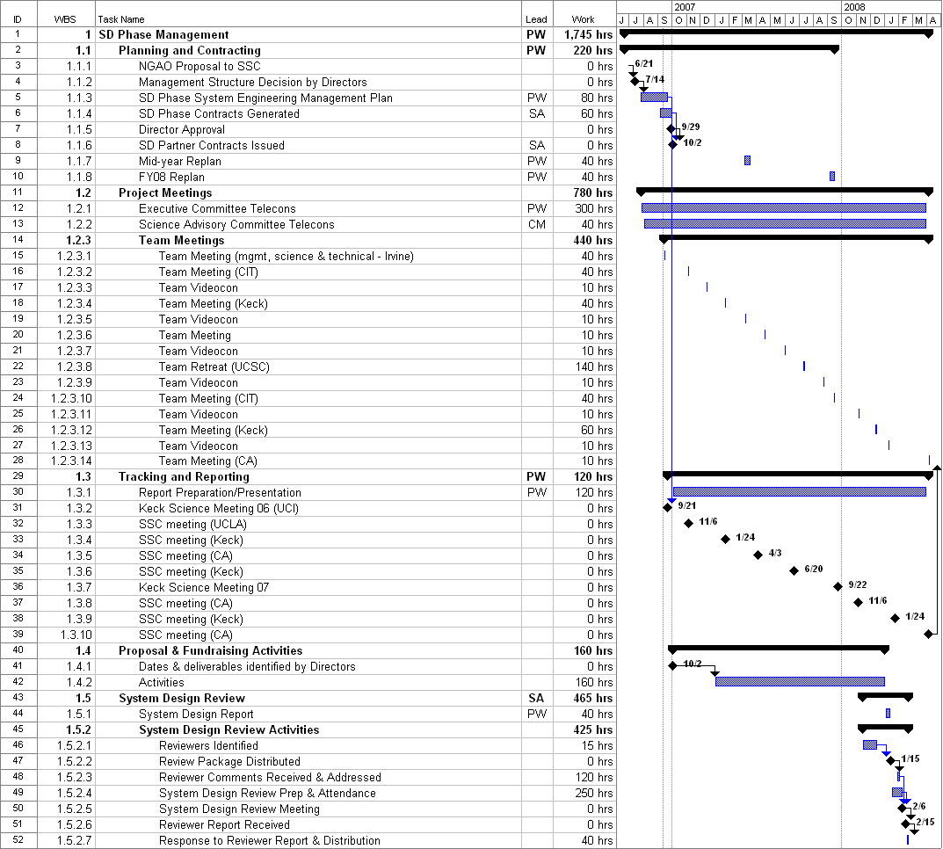

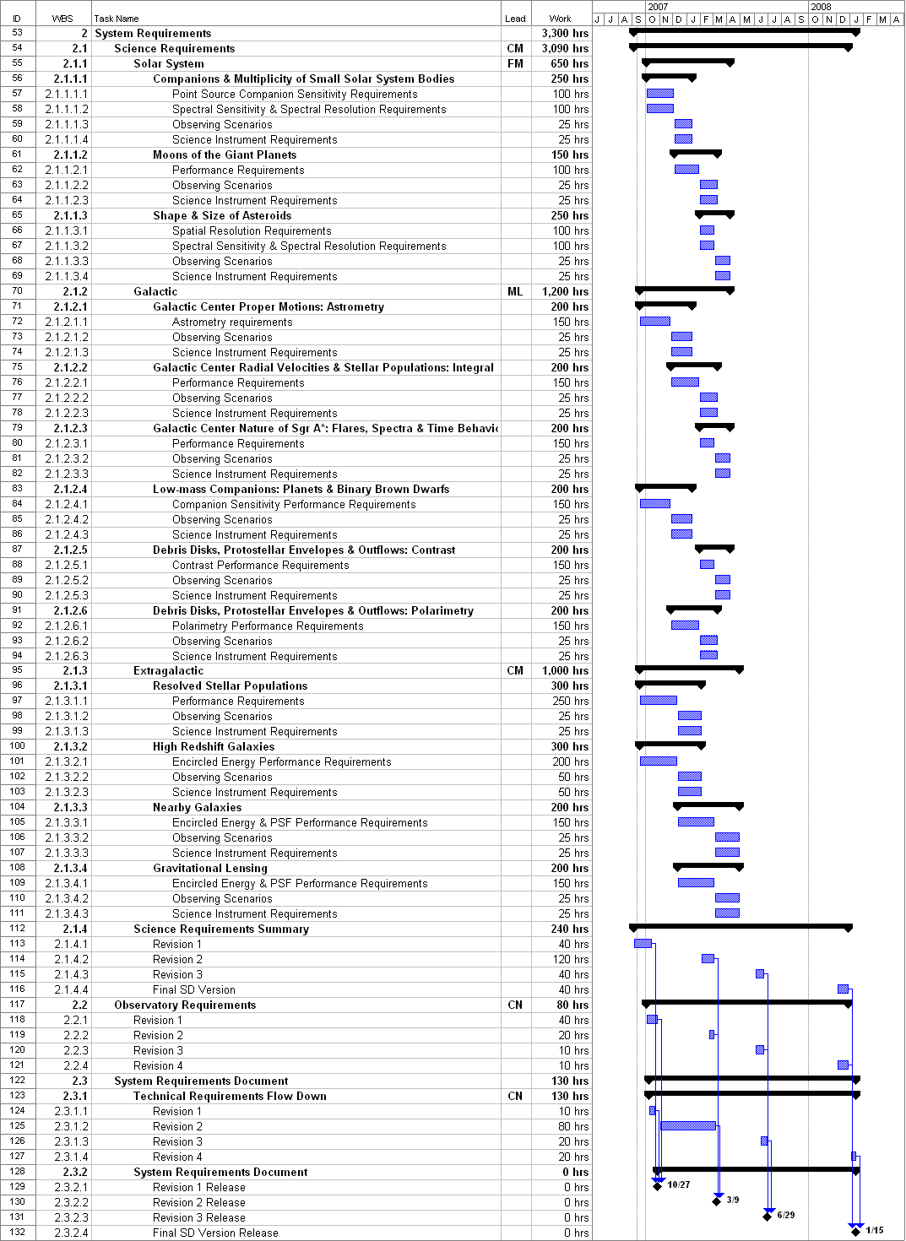

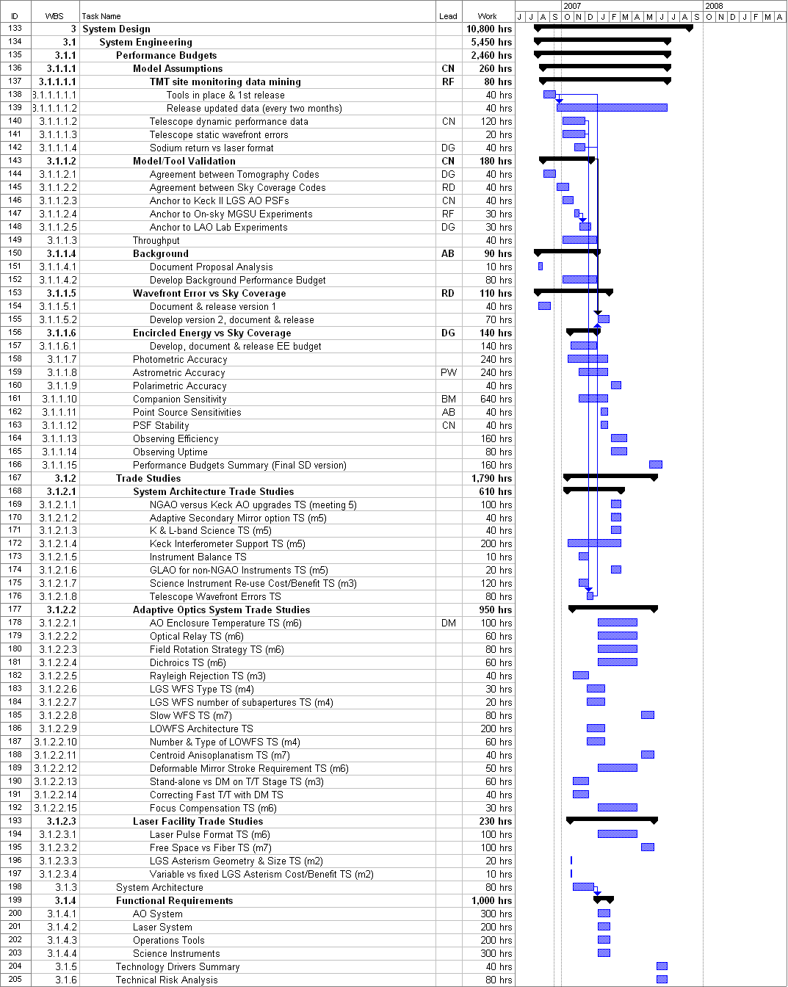
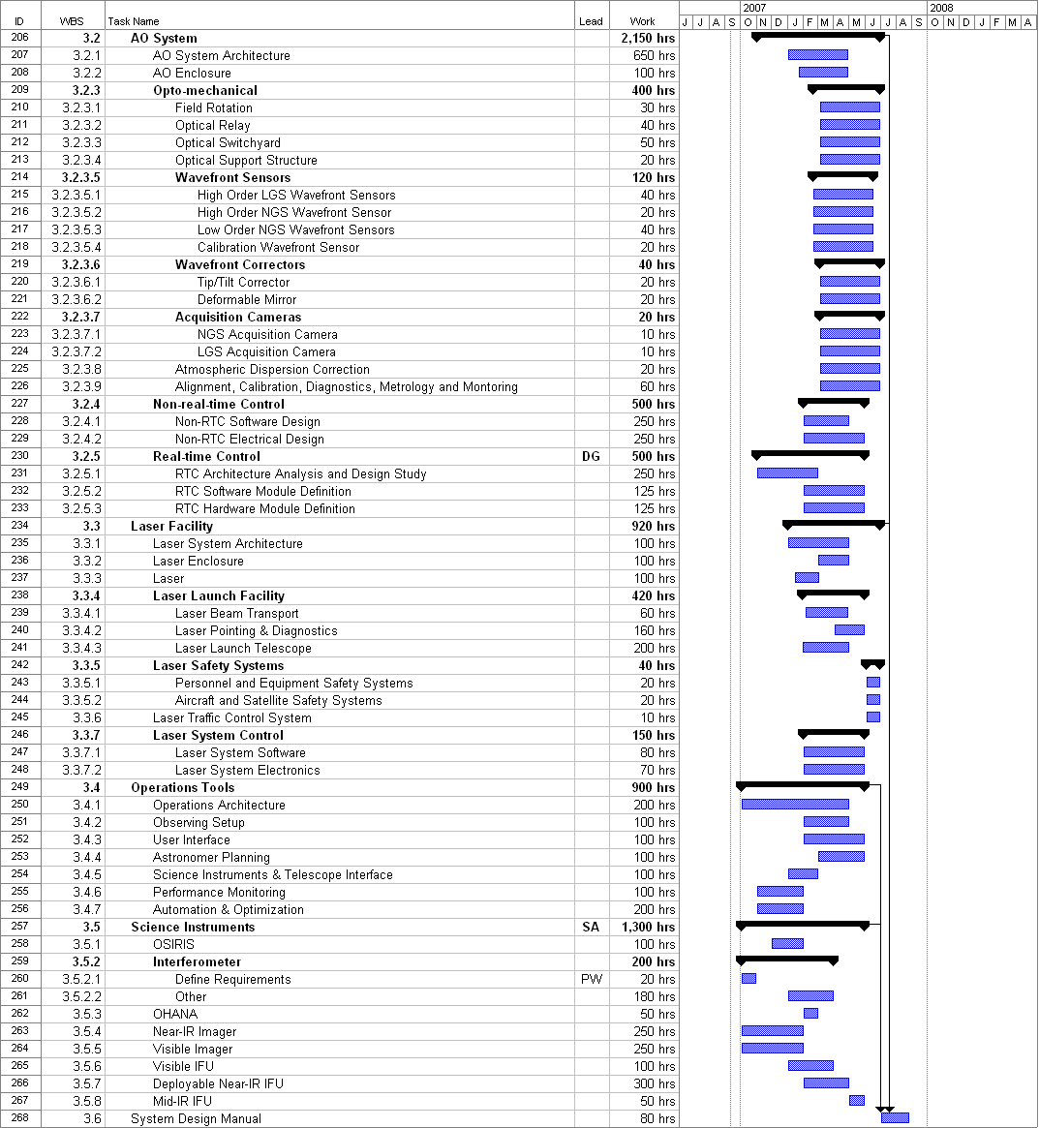
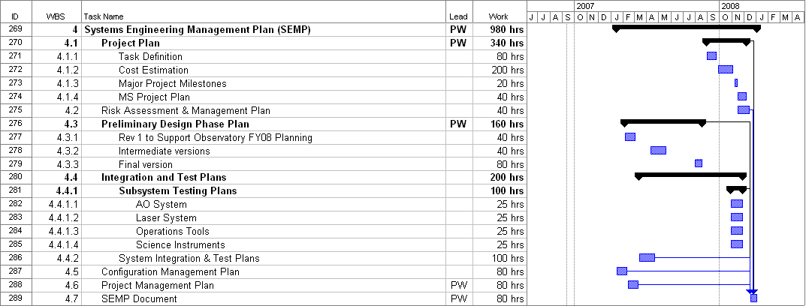

Appendix: System Design Phase Team Meeting Schedule

