Minutes from the Architecture Meeting August 2, 2007
Antonin and Viswa produced 2 documents: Analysis of thermal background and surface counts for each architecture, respectively.
Viswa starts off by describing the architecture surface counting & assumptions
- Should study: trade of using MEMS without a window. Trade the thermal/throughput benefit vs the complexity of maintaining the correct environment for an unwindowed MEMS.
- Issue: whether or not there is a double window into the cold chamber. Needs design study.
- Do we need to support a non-rotating pupil (on non sky tracking rotator) with multiple tip/tilt stars? Could this particular mode be accommodated with the science instrument? Consequence is a second field derotation scheme for the tip/tilt sensors.
- Instrument switchyard has at least one reflection.
- An architecture-independent assumption is to put an optional tip/tilt pickoff in the narrow science field – to allow an on-axis tip/tilt star
- No window needed on AM2 architecture (not cooled). But this will force a separate cool space and window for d-NIRI
- Antonin needs to analyze the d-NIRI emissivity/throughput. One trade is that d-NIRI has an upfront window and a cool chamber vs open to the cool environment of the AO system. Another trade is fully cryo cooling the d-NIRI AO pickoffs.
- There are 2 Keck1 upgrade options: 1) DM is high order 2) follow with cascaded MEMS. Costing was based on cascaded case. We’ll assume, as at the retreat, that we are looking at option 2. It will be hard to get a DM with the required actuator spacing (2.5 mm) for option 1.
- Pickoffs for acquisition and PSF cameras – need to account if they are in the path of the science. Claire notes from retreat that the need and requirements for the PSF camera should be solicited from the science teams.
- LGS WFS dichroic should be after the d-NIRI splitter in all cases.
SolidWorks model: exact drawings of the elevation bearing is needed, especially for packaging the split wavefront sensor. Viswa will take this to the next level with a SolidWorks drawing of the packaging (initially do the WFS).
Antonin’s
- Assumptions are being made about the emissivity of the telescope and AO system. Antonin had to put in fudge factors to account for measurements with NIRC of total values. Is there other data or possible measurements to be made to separate telescope from AO contribution? LWS 10 microns was measured at 7.5% Al primary and Gold secondary.
- Peter: possible we could use a window exchanger to optimize window emission and throughput for each wave band. Problem is the warm window surface is a large contributor to emission.
- Antonin suggests we specify emissivity performance in terms of surface brightness. This allows suggesting improvements to the telescope, and would work toward meeting the science needs.
- Don suggests Antonin put all the spreadsheets with specific optics assumptions included in an appendix to his document
- Question for Claire. Is the narrow field requirement really as stringent at the d-NIRI requirement. Claire has already commented on this at the retreat
- K1 upgrade needs to count the extra surfaces of the cascaded stage
- Rich: transmission to LGS WFS is important for laser power needs. Viswa will do surface counts to WFS and the transmission/reflectivities in the WFS optical path. Trade is putting WFS behind several optics of a relay vs in front.
Rich – discussed his “homework.”
- Some discussion on a possible trade of tip/tilt being infrared or visible wavelength sensing. Advantages of visible: lower read noise, higher QE, cheaper. Disadvantage: lower Strehl, may force 4K MEMS instead of 1K.
- Rich’s System Architecture document is a capture of the retreat’s architecture definition and ranking process. The document is uneven in the treatment of risks. Chris is tasked with creating a risk register. Plan for next phase must include addressing and retiring risks. Chris to propose an outline that captures the level of detail that will go into this document.
Brian – homework: do optical layout of the cascaded relay
- Has done 2 OAP relays 10 nm rms on 30” field, 50 nm rms on the intermediate focal plane at 2’ field, all reflective. Beams through windows not included, but probably not an issue. 100 mm, 25 mm collimated spaces. Brian posted a document (unfolded_cascaded_relay_layout.doc) on the SystemArchitecture page.
- 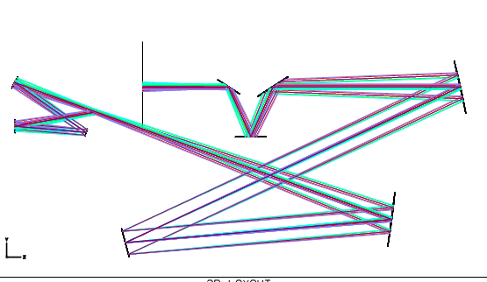
- OAP1 is 1.5 meters from telescope bearing.
- 1:1 relays seem to be forcing the need for 2 packaging folds to keep the beam lines from re-entering the telescope space.
- Rich: there is an issue with the back focal distance after the 2nd relay not being long enough. Distance from OAP4 to focus is 16 inches (400mm), only 4 inches (100mm) is out of any optical path. Lego block switchyard has trouble. Brian is suggesting that non-collimated spaces and non-paraboloid powered optics (3 instead of 4) may allow a better back-focal distance package.
- (will continue as Brian does some more drawings)
- Brian sends a Y-Ybar diagram that shows how a 3-mirror design can double the bfd to 12 inches (300mm), but Rich says this is not enough. More comfortable with 18 inches (450mm). Brian to try this out. Pupil size in 2nd space is also an option (64x64 piezo 64mm diam instead of 25mm pupil). Lots of discussion on what is really the necessary bfd and correspondingly the necessary instrument footprints.
- 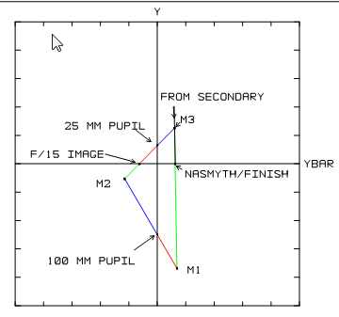
- Assuming OSIRIS, visible IFU (SWIFT), infrared imager (PHARO), visible imager less than IR imager, we think all instruments can huddle around a notional 500mm edge-length cube. Action: pursue 500mm bfd with 3-mirror design.
- Other options: refractive 2nd relay, instruments on a sled-changer, 2nd relay in each instrument. Refractor (according to Antonin’s analysis) may not cost us much.

Peter
- Peter has thought about the alternative K1 upgrade paths. At the retreat there was a difference between Peter’s and Rich’s upgrade sequence.
- Peter to check with Sean on volume envelope estimates for each instruments.
Sean
- Needs to convene the IWG to solicit input on instrument envelopes.

