Strong Gravitational Lensing
Authors: Tommaso Treu (UCSB), Laura D. Melling (UCSB)

Scientific Background

Introduction
Massive clusters and galaxies produce a local perturbation of the Robertson-Walker metric that distorts our view of background objects. Gravitational lensing is achromatic and preserves surface brightness. Under appropriate circumstances, if the deflector is dense enough and the impact parameter is small enough, multiple images of the background source appear to the observer. This regime is called strong gravitational lensing. Strong gravitational lensing is extremely useful for the study of the high redshift universe for two main reasons: i) the astrometry of the lens configuration depends on the mass distribution of the deflector and on angular size distances, and thus can be used to “weigh” galaxies/clusters, determine the structure and substructure of dark matter halos, and/or to measure cosmography; ii) the background source is highly magnified both in terms of apparent size and apparent luminosity, so that lenses act as natural gravitational telescopes; magnification is quite significant, typically in the range of 10 to 25 in luminosity.

Precision astrometry is the name of the game for gravitational lensing. So far the Hubble Space Telescope has been the unchallenged leader in this field. Laser guide star adaptive optics has the potential to change the field. The large mirror-size of Keck can deliver a factor of four improvement in angular resolution over HST if high Strehl ratios can be achieved with NGAO. Furthermore, coupling an AO system with integral field spectrographs will open the way for high spatial resolution studies of dynamics and chemistry of galaxies in the distant universe and for detection and spectroscopy of the first galaxies and sources of reionization at a redshift z > 7-8. As illustrated by the simulations shown below, Keck with NGAO is better than HST for these purposes and will dominate the subject after the demise of HST.

Galaxy versus Cluster Lensing
It is useful to separate two regimes: cluster/group lensing and galaxy size lensing. The angular size is set by the Einstein radius, which in turn scales as the velocity dispersion squared. Hence typical galaxies will have Einstein radii of order 1”, while massive clusters in the same redshift configuration will have Einstein radii of order 30” (Figure 1).
Furthermore, clusters – with their longer caustics – have much higher chances than galaxies to lens multiple background objects and in general to be strong lenses. So clusters are rarer in the sky but they are very efficient lenses. Galaxies are more common in the sky, but they are much more unlikely to be lenses. From a practical point of view, galaxy and cluster scale lenses require different strategies for detection and scientific exploitation, and have different instrumental requirements. Galaxy scale lenses have the more stringent requirements in terms of spatial resolution and Strehl ratios, while cluster scale lenses are more demanding in terms of field of view. Therefore they will be treated separately in this document. The intermediate regime, group size lensing, is a very poorly known subject. In general NGAO will be useful for group size lensing as well, but with intermediate requirements between galaxy and cluster scale lensing for spatial resolution and field of view. Therefore we do not discuss group size lensing in this document.

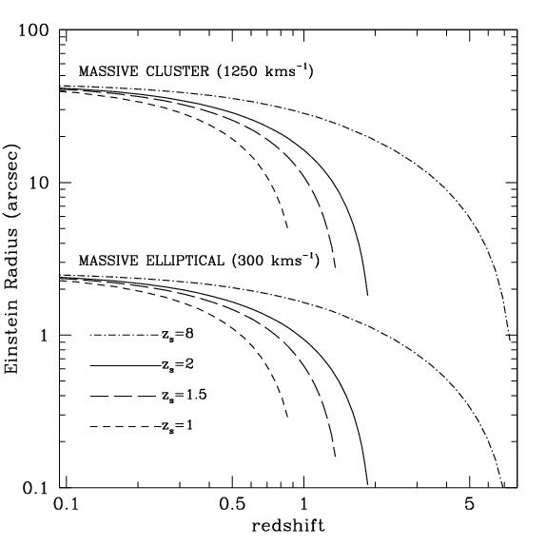
Figure 1: Typical angular scales of cluster-size lensing and galaxy-size lensing. The curves show the size of Einstein radius for a massive cluster (velocity dispersion 1250 km/s) and a massive elliptical (300 km/s) as a function of deflector redshift. A field of view of 3-4" is well matched to galaxy-size lensing, while a field of view of 1-2' is well matched to cluster-scale lensing.

Galaxy-Scale Lensing
The main science goals for this subfield are:
- Mass distribution of (deflector) galaxies, mostly early-type galaxies. What is the mass profile of dark matter halos? What is the fraction of dark matter as a function of galaxy radius, redshift, mass? Do galaxy-size halos have dark matter substructure as predicted by cosmological numerical simulations?
- Morphology, resolved kinematics and star formation history/chemistry of faint spiral irregular galaxies. Galaxies can be super-resolved by exploiting lensing magnification. Using NGAO + lensing, the effective diffraction limit in the source plane will typically be ~0.005”. This means that galaxies at z=2 (angular distance 1.7Gpc) can be studied with the same detail as a galaxy in the Virgo cluster (17Mpc) in 0.5” seeing.
- Cosmography through time-delays. If relative photometric precision of order a few percent can be achieved across the field, monitoring of variable lensed sources (such as AGN) can be used to determine cosmological parameters. Effectively, every time delay acts as a standard rod. For every system angular size distances can be obtained with 10-15% and therefore there are real prospects of determining the Hubble Constant to 5% precision if a sample of a few dozen time-delays can be obtained. NGAO would be exceptionally good at this since one needs to do photometry of sources separated by less than 1 arc sec.
Galaxy-size lenses are rare on the sky, their density is of order 10 per square degree (depending on depth and resolution). NGAO will not be a good instrument to search for lenses but by the time NGAO will be available hundreds of lenses will have been discovered with current technology (e.g. SLACS, Haggles, CFHT Legacy Survey). Thousands of lenses are expected to be discovered by ongoing and future spectroscopic and imaging surveys, such as DEEP2, z-Cosmos, Panstarrs and LSST. The scientific exploitation of these samples of lenses will require high resolution imaging that only NGAO can provide. Analyzing a large number of objects is vital for the applications listed above. For example, in order to detect substructure, satellites must be close to the critical lines, which will happen only in a small fraction of cases. To beat down small number statistics samples of hundreds of lenses are needed.

Cluster-Scale Lensing
The main science goals for this sub-field are:
- Mass distribution of clusters. Do cluster halos resemble those in numerical simulations in terms of mass profiles, substructure, shape etc? What is the accuracy of X-ray mass estimates for cosmography?
- Clusters as gravitational telescopes. Can we identify the first galaxies/quasars? What is their luminosity function to the faint limits? What are the sources of reionization? With typical magnifications of order 20, searches for zJH dropouts can be extended 3 magnitudes deeper than possible without gravitational telescopes.

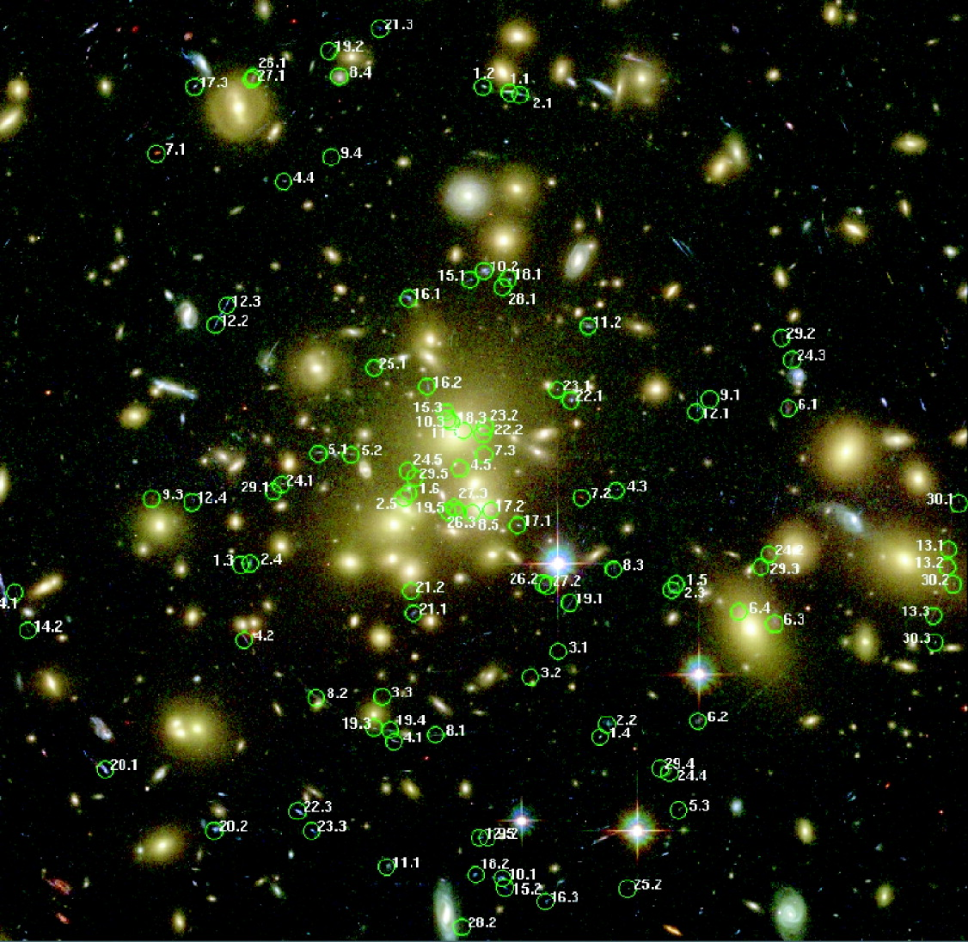
Figure 2: Searching for multiple images. At HST-like depth and resolution there are many multiple images of background sources for each massive cluster; The case of Abell 1689, an enormous cluster with an Einstein radius of 50'' is shown (the image is approximately 3' on a side); 106 multiple images have been detected in this case (Broadhurst et al. 2005).

Most clusters show strong lensing when imaged deep enough at high resolution. For example, in relatively shallow HST images (~1 orbit WFPC), Sand et al. (2005) found 104 giant arcs in 128 clusters. NGAO system will have a similar performance, and thus a success rate close to 100% can be assumed, with a density of multiply imaged sources of a few per square arcminute. In extreme cases a density of 10 per square arcminutes can be achieved (see Abell 1689. Figure 2).

As for galaxy size lenses, NGAO will not be competitive for finding cluster lenses, so the main mode of operation would be follow-up of known clusters. Current and future surveys (X-ray, red sequence) will find thousands of high redshift clusters. Targets will be abundant, high resolution follow-up will be the domain of NGAO.

Proposed Observations and Targets
For simplicity we will consider the ideal case of an early-type galaxy at z = 0.8 lensing a galaxy at z = 7. The deflector is a typical L* early-type galaxy with velocity dispersion 250 km/s, K = 18. The source is chosen to represent a candidate source of reionization: a young galaxy of ~100Myr age, a few billion solar masses of stellar mass, with small size (0.05” effective radius), similar to the one identified by Kneib et al. (2004) behind the galaxy cluster Abell 2218. The unlensed AB magnitude of the source are F814W=28.6, F850LP=26.3, J/F110W=25, H/F160W=24.2, K/F222M=24.4. This case illustrates simultaneously the strength of NGAO for mass modeling of lens galaxies/clusters and for studying faint magnified galaxies. The quantitative results found for this case can be extrapolated to other observing programs such as a survey for z-band dropouts.

Comparison of NGAO with Current LGS AO and with HST-NICMOS
Figure 3 shows the lens system as observed with NICMOS (top row), NGAO with an upgraded version of NIRC2 (middle row), and the current Keck II LGS AO system with NIRC2 (bottom row). We simulate observations in the J, H and K band. For NICMOS in the J and H band (F110W and F160W) we used the NIC-1 camera because the pixel scale is very similar to that of NIRC2 (0.043” vs. 0.04”). In K band the closest configuration we could find for HST was NIC2 with the F222M filter. We show the results of this simulation even though it is not competitive, because Hubble has a high thermal background and was not optimized for observations in K band. For NGAO we used PSFs from simulations by Donald Gavel. We assumed the science instrument was an upgraded version of NIRC2 with half the background currently measured, assuming that this can be improved in the next generation AO system. For LGS AO, we assumed natural seeing of 0.5” and Strehl ratios of 0.15, 0.2 and 0.3 respectively for J, H, and K. The exposure time is 3600s in all cases. Each image is 4” on a side. Details of the simulations are given at the end of this Gravitational Lensing subsection.
From Figure 3 it is apparent that NGAO performs markedly better than both NICMOS and the current LGS AO system. At J and H bands NICMOS performs better than the current LGS AO system (largely due to lower background), whereas at K band LGS AO performs better than NICMOS. For NGAO the gain in resolution and collecting area more than offsets the extra background seen by NGAO with respect to NICMOS.

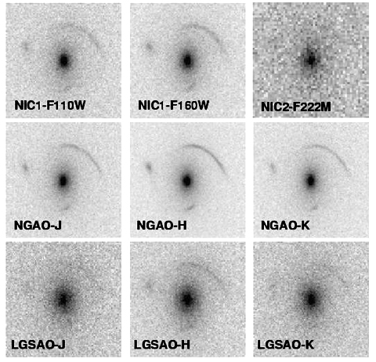
Figure 3: Simulated observations of a gravitational lens with NGAO (middle row), HST-NICMOS (top row) and the current LGSAO system (bottom row). Each image is 4" on a side and the exposure time is 3600s. For NGAO we adopted the same detector properties as NIRC2 and half the background. The lens is an L* elliptical at z=0.8 and 250km/s velocity dispersion. The background source is a galaxy at z=7 with 0.05" half light radius, and J H K AB magnitudes of 25, 24.2, 24.4, as obtained for a few billion solar masses of a young stellar population (see text for details). Note that NGAO is superior in all cases.
Quantitative estimates of the uncertainties on the source parameters are shown in Figure 4 (68% and 95% contours). Those are obtained by measuring the likelihood in the full multidimensional space of lens and source parameters using a Markov Chain Monte Carlo sampler (Melling & Treu 2006, in prep). The signal to noise ratio of the NIC2-F222M image was too faint to derive any useful constraints on the source properties. Similarly the signal to noise ratio of the Keck LGS AO-J band image was sufficiently low that the method failed to converge at the right minimum.
As is apparent from Figure 4, the proposed NGAO system strongly reduces the uncertainty in measurements of lensed galaxy size and mass. For example the derived uncertainty in size of the lensed galaxy at H band was a factor of four smaller with NGAO than with current LGS AO, and more than a factor of two smaller with NGAO than with NICMOS.
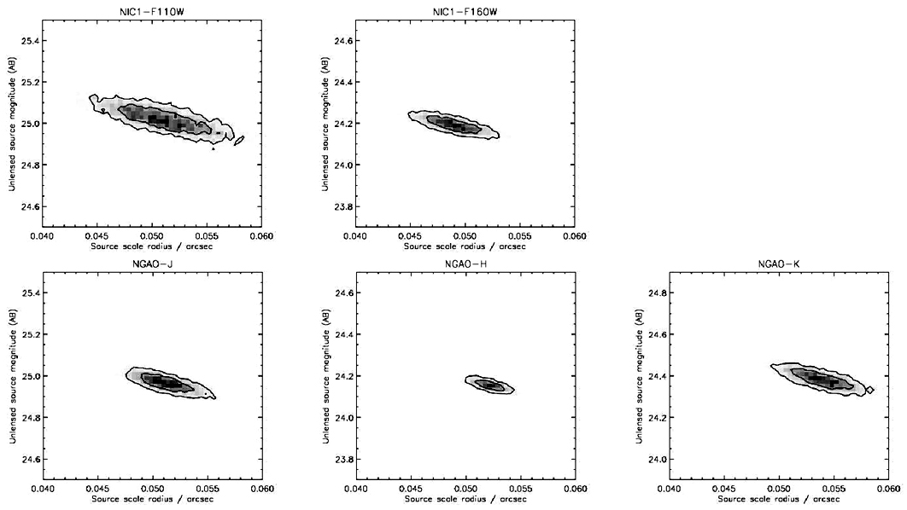
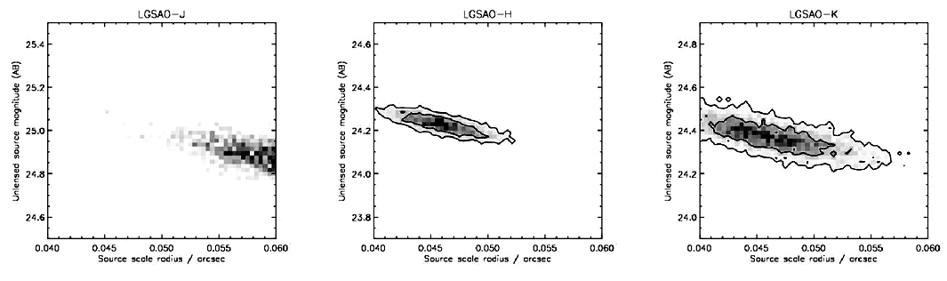
Likewise the uncertainty on the velocity dispersion decreases by a factor of 6 going from LGS AO to NGAO, and by a factor of 2 going from NICMOS to NGAO in J and H bands. Formal statistical uncertainties of better than 0.1% on the velocity dispersion can be achieved with NGAO; this is a stunning achievement for any AO system.
Summarizing these results, for typical galaxy lensing cases the proposed NGAO system is expected to perform four to six times better than the current LGS AO system in its ability to correctly recover the key properties of the lensed galaxies.
Figure 4: Reconstructed 68% and 95% confidence contours for the source parameters, from a Markov Chain Monte Carlo algorithm. The contours for NGAO are a factor of six smaller than for LGSAO and half the size of those for NICMOS. Note also that the half radius of 0.05 arc sec is clearly resolved and precisely measured. The SNR of the simulated data is too low for LGSAO-J and NIC2-F222M to obtain meaningful results.

Sample Observational Programs
The luminosity and size distribution of redshift 7-8 galaxies, using gravitational telescopes. Assuming that high Strehl ratio images can be obtained in the z band, NGAO would be extremely efficient for doing a survey of massive clusters at zJHK and for measuring the size and luminosity function of redshift 7-8 galaxies. The luminosity function of z>7 galaxies is currently very poorly known. Bouwens et al. (2004) found 5 z-band dropout candidates in the NICMOS follow-up of the Hubble Ultra Deep Field finding (5.76 square arc min), with F160W luminosity ~27 AB. Pello et al. (2005) surveyed the high magnification regions of two lensing clusters with ISAAC on the VLT, to a depth of H=26 AB, finding several promising photometric candidates in an area of approximately 8 square arc min. The brightest sources are estimated to have stellar masses of order of a few times 10⁸ solar masses. Kneib et al. 2004 report one z~7 candidate that is very similar to the one adopted for our simulations, in terms of apparent magnitudes in the image plane.
As shown above, if similar Strehl ratios can be achieved over a 2’ field, it will be possible to image the highly magnified regions of clusters to comparable depths in just 1 hour per band. This makes it feasible to survey dozens of clusters to this depth and achieve an order of magnitude improvement in area in just a few nights of telescope time.
Kinematics of faint galaxies. With an integral field unit behind an NGAO system one can obtain spatially resolved kinematics of galaxies at z up to 2.2 (with Hα in the K band). See Moller & Noordermeer (2006) and Law, Steidel & Erb (2006) for more details.

AO and instrument requirements (needs to be completed)
Galaxy-lensing. AO requirements:
Crucial: high Strehl at H and K (>0.5), field of view of at least 2”, possibly up to 4”.
Desirable: high Strehl (>0.5) at J and in the optical, to extend range of redshifts and diagnostics. Spectroscopic capabilities with R=3000 or better for internal kinematics and spectral diagnostics. PSF stability for relative photometry to a few percent, to allow monitoring of lensed quasars for gravitational time delays.
Cluster-lensing. AO requirements:
Crucial: high Strehl, Y/J band for Y/J dropouts, field of view of 1-2’ on a side for imaging.
Desirable: multiple deployable IFU units for simultaneous spectroscopy of lensed sources. Spectral resolution of 5000 or better is required to take spectra in between the OH lines.

References
Bouwens et al. 2004, ApJ, 616, L79
Broadhurst T. et al. 2005, ApJ, 621, 53
Kneib J.-P. et al. 2004, ApJ, 607, 697
Law D., Steidel, C.C & Erb. D 2006, AJ, 131, 70
Moller O. & Noordermeer 2006, MNRAS, 365, 469
Pello R. et al. 2005, preprint, astro-ph/0510180
Sand D.J., Treu T., Ellis R.S., Smith G.P. 2005, ApJ, 627, 32

