High-Redshift Galaxies and Mergers
Contributors: Mark Ammons (UCSC), Don Gavel (UCSC), Patrik Jonsson (UCSC), David Koo (UCSC), James Larkin (UCLA), David Law (Caltech), Claire Max (UCSC), Greg Novak (UCSC), Chuck Steidel (Caltech)

Scientific Background
While cosmology theory and observations have made enormous strides in the past decade, three deep questions are likely to dominate the extragalactic field in the era being considered for Keck NGAO: the nature of dark energy, the nature and role of dark matter, and how the Universe transformed its baryons into the incredible diversity of galaxies found today. This diversity reflects the complex mix in space, time, kinematics, and energy of basic galaxy constituents: gas, stars, dust, and black holes. The latter are usually categorized into physically related subcomponents of galaxies: gaseous and stellar halos, bulges, disks, AGNs, bars, spiral arms, rings, etc., each with their own but intertwined star formation histories, dynamics, and chemical abundances.
In this section we first investigate the general capabilities of Keck NGAO for the study of high-z galaxies, through computer simulations of the performance of the integral field spectrographs used to dissect these galaxies and to study their kinematics and chemical composition. Then we inquire in more detail into just one of the many potential branches of future high-z galaxy studies: mergers and their relation to galaxy assembly, star formation, and black hole feedback.
The study of high-redshift galaxies is a powerful driver for multiplexed observations, for example via deployable integral field spectrographs. Arial densities of one to ten per square arc minute on the sky are typical. For example:

How Much Multiplicity is Needed?
The first question to address is how large a field of regard, and how many separate integral field units, are needed in order to accumulate reasonable statistics. Table 1 shows the density on the sky of several galaxy categories, ranging from specific to braod.
Type of Object | Approx density  per square arc minute | Reference
SCUBA sub-mm galaxies  to 8 mJy | 0.1 | Scott et al. 2002
Old passively evolving galaxies, 0.85 < z < 1.1 | 1 | Yamada et al. 2005
Lyman break galaxies  R < 24.5 | 1 | Von Dokkum et al. 2006
M > 10¹¹M_{sun} galaxies,  1.5 < z < 2.5 | 2 | Kong et al. 2006
All HDF galaxies  20 < I < 22 | 4 | Metcalfe et al. 2001
All galaxies K < 19.5 | 12 | Olsen et al. 2006
Table 1. Space Densities of Various Categories of Extragalactic Targets

It is these arial densities which drive the desired field of regard and multiplexing for the integral field spectrographs that will accompany Keck NGAO. Our preferred solution for extragalactic astrophysics is a “multi-object” AO system (MOAO) in which there are a modest number of deployable IFU arms, each having its own MEMS-based AO system.
Our current notional goal is a field of regard of around 2 arc min diameter, with a circular area of ~3 square arc min. While surveys that encompass, e.g. all galaxies with K < 20 would require a shockingly high 35 separate deployable integral field units within this area, one can see from Table 1 that studies directed at specific subclasses of galaxies can benefit from no more than about a half-dozen deployable IFUs within 3 square arc min. Hence our nominal goal for the NGAO point design is a half dozen deployable IFUs within a 2 arc min diameter field of regard.

What Sky Coverage Fraction can we Expect?
The forefront of extragalactic research today depends heavily on the “deep fields” that have been imaged by Hubble, Chandra, XMM, Spitzer, GALEX, and many ground-based telescopes (e.g. the Hubble Deep Fields north and south, the GOODS fields north and south, the Extended Groth Strip, the COSMOS field). Because of the large investment in spacecraft time for these deep fields, it is our judgment that they will remain key areas of the sky for extragalactic research for at least the next decade, and quite possibly longer.
Many of these fields were selected precisely because of their lack of stars. But even tomographic laser guide star adaptive optics needs faint natural guide stars (for tip, tilt, and focus correction). Hence the lack of sufficiently bright stars within these fields might potentially limit the utility of Keck NGAO in exactly the most important areas of the sky for extragalactic work.
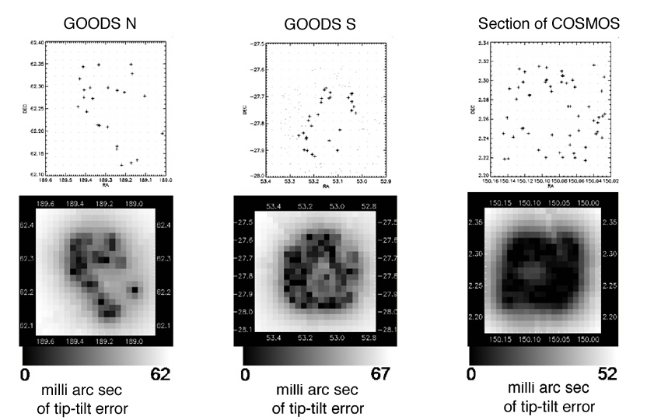
Hence we used the exact configuration of stars in GOODS north and south and in part of COSMOS to calculate the expected blurring of the central diffraction-limited core of the AO PSF, due to lack of a perfect tip-tilt-focus correction.

Figure 1 Map of tip-tilt blurring, in milli-arc sec, in the GOODS-North, GOODS-South, and part of the COSMOS deep fields. A respectable fraction of these three deep fields is accessible to tomographic observations with NGAO, with less than 25 mas of tip-tilt blurring. GOODS North poses the greatest challenge, but even here more than 20% of the area produces acceptable tip-tilt errors. For further details of these calculations see Section ????.
We have performed computer simulations to evaluate the potential improvements provided by Keck NGAO, compared with the current laser guide star AO system on Keck 2, focusing on galaxies at z > 0.6. We assumed that each integral field spectrograph was similar in performance to OSIRIS, but with the improved background levels described in Section ???. Further details of the simulation model are found in Law et al. 2006.

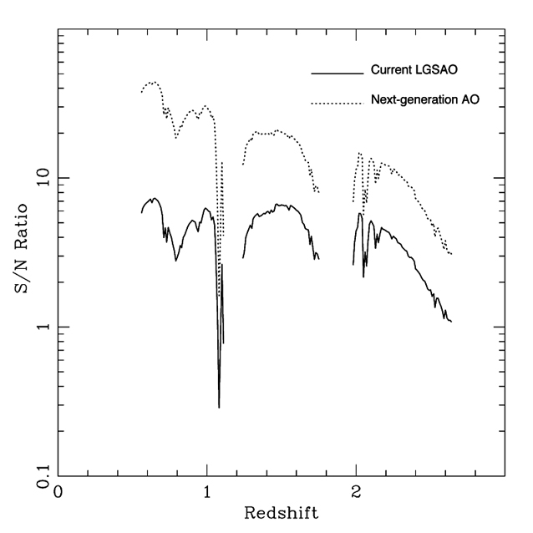

Figure 2: Signal to noise ratio for an OSIRIS-like integral field unit with NGAO (upper curve), compared with today’s OSIRIS with LGS AO (bottom curve). Over the redshift range 0.6 – 1.7, NGAO shows a factor of 3 to 6 times improvement in signal to noise ratio. Here we have assumed lenslet sizes of 0.1 arc sec, and the improved thermal backgrounds described in Section XX.

-

NGAO will yield a signal to noise ratio 3 - 6 times higher for the same exposure times. For background-limited measurements this would yield an exposure-time reduction of a factor of 9 to 36. Adding multiple IFUs in the system will multiply the efficiency yet again. Thus even a 6 IFU MOAO system will yield a dramatic total gain of a factor of 50 to 200 in the completion rate for survey-level programs, relative to the current LGS AO OSIRIS system. This is a genuine leap forward in the potential of AO systems to do deep spectroscopic surveys of the distant universe!
Figure 3 shows a simulation of integral field unit imaging and spectroscopy for the current LGS AO system and for NGAO. The galaxy being observed is BX 1332 from Law et al. (2006). It is a z ~ 2 star-forming galaxy from the catalog of Steidel et al. (2004). In Figure 3 one can clearly see the advantage of improved signal to noise ratio: one can image a larger fraction of the galaxy so as to study its morphology, and one can recover a velocity curve over a region of the galaxy that is more than twice as large. These results are highly motivating for the development of deployable integral field spectroscopy working with the NGAO system.

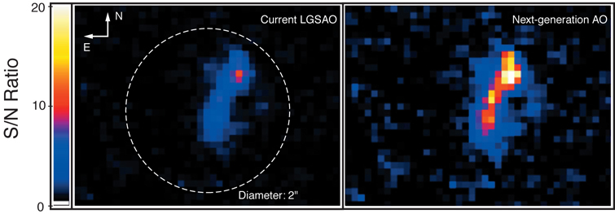
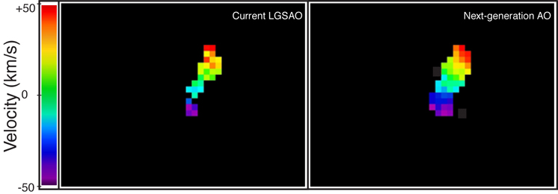

Figure 3. Computer simulation of imaging and spectroscopy of the z ~ 2 galaxy BX 1332 from the catalog of Steidel et al. (2004). The planned next-generation AO system shows a factor of three improvement in signal to noise ratio for the same exposure time, enabling the study of galaxy morphology over a large fraction of the galaxy. The NGAO system also allows extraction of a velocity map over about three times more area than the current LGS AO system. For the velocity maps, only those pixels within 3σ of the mean are shown. We have assumed a lenslet size of 0.1 arc sec.

Case Study: Mergers of High Redshift Galaxies
In order to evaluate the scientific benefits of the higher signal to noise ratio of NGAO, here we focus on one particular science example: mergers of high z galaxies. Within the suite of physical processes that govern the formation of galaxies and their subcomponents, hierarchical merging remains a fundamental paradigm within the ΛCDM model, the leading cosmology to explain the assemblage of galaxies, groups, and clusters. Moreover, mergers and galaxy interactions are believed to play a key role in the formation of luminous infrared galaxies and other starbursts; in the balance of early to late type galaxies through the formation of ellipticals/ spheroids/ bulges and the destruction or thickening of disks; in the the triggering of AGNs and feeding of their supermassive black holes; and in the initiation of high energy output via starbursts and AGNs that results in blowing gas into the intergalactic medium, heating of surrounding gas within the galaxy, and perhaps quenching of future star formation. In the context of environment playing a role in galaxy evolution, mergers represent perhaps the most violent and rapidly changing conditions experienced by galaxies.
Finally, mergers are important in providing unique laboratories to study and understand many of the key physical processes believed to play a role in galaxy formation: time evolution of galactic gas and dust; activation of AGNs; intense star formation; rapid changes in the distribution and interactions among dark matter, gas, and stars; secular evolution of bulges by disk instabilities and bars; etc.
Despite the broad impact and importance of mergers in our understanding of many astrophysical problems, detailed theoretical studies of mergers have yet to be achieved due to the computational challenges of handling huge dynamic range in densities of gas and stars, radiative processes, energy densities, etc. Moreover, the theoretical studies will remain complex and very rich, due to as yet unknown dependence of final observable properties on the impact velocities of the colliding galaxies, the ratio of hot to cold gas (halo vs disk gas), the ratio of hot to cold stars (B/D), and the relative angles of the angular momentum vectors of the colliding galaxies.
Observational tests of merger theories and simulations will clearly be a challenge. Intensive observations of large samples of mergers in the NGAO era will be timely, for theoretical simulations have already achieved a high level of maturity (i.e., reaching AO relevant scales of 0.3 kpc, with post-processing for full radiative transfer and inclusion of dust and kinematics in generating observables) and will continue to improve over the next decade. This maturity will provide unique opportunities for observers and theorists to work together in order to advance both areas. NGAO observations with Keck will serve as a natural transition to other dramatic improvements in relevant observations on several different fronts as ALMA, JWST, and ELTs become a reality.
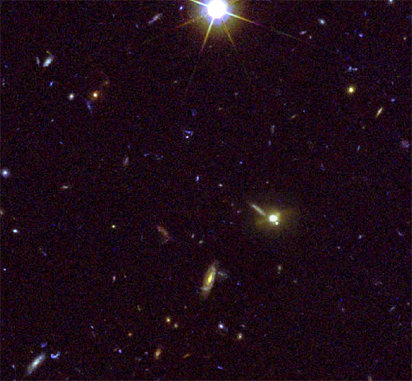
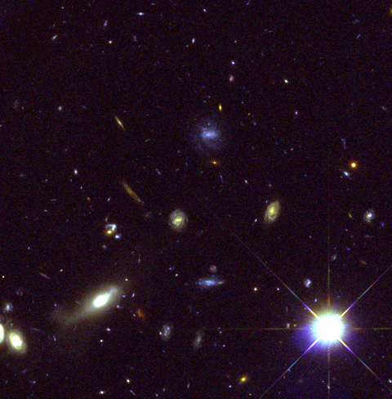

Figure 4 40” x 40” sections of the GOODS North (left) and South (right) fields, showing the large numbers of distant galaxies; the incredible diversity of galaxies in colors, shapes, and subcomponents; merging galaxies; and the small sizes of galaxy components. There is enormous potential for AO follow-up studies of regions with deep existing HST data. To date, very deep panchromatic survey regions with HST imaging have covered about 8,000 square arc min of sky. Thus 1000’s of galaxies imaged with HST, Chandra, XMM, Spitzer, GALEX, and the VLA will assure the science potential of NGAO on Keck. Red: Keck AO, green and blue: HST.

Mergers: High level objectives and goals
While nearby mergers are already being studied in detail and across a broad spectral range with the current generation of telescopes and instruments, far more challenging will be the proposed program of undertaking detailed NGAO studies of distant mergers. Yet such studies are critical if we are to understand the role of mergers in three of the observationally discovered global evolutionary changes since redshifts of z~2: the rapid decline of co-moving star formation rate; the parallel drop in AGN activity; and the transformation of Lyman Break Galaxies with their irregular and peculiar morphologies to the symmetrical and regular Hubble sequence seen today.

How does NGAO help?
AO with the 10 m Keck provides a spatial resolution in the near infrared (1.2 μm to 2 μm) that is nearly ideal to that of HST in the ultraviolet and visible. This will allow us to study galaxy subcomponents on the scale of ~0.4 to 1 kpc at high redshifts z > 0.5 (0.05 to 0.1 arcsec). While HST with its 2.4 m diameter mirror can probe to these resolutions in the optical, at high redshifts the observed optical is viewing the restframe ultraviolet while Keck AO in the near infrared is observing the restframe optical to near-infrared. Such high resolution near infrared imaging provides a better probe of older stellar populations, adds complementary data to HST images by widening the spectral range to study stellar populations at the same spatial resolution – i.e. same galaxy subcomponents, and is far less affected by dust extinction. Moreover, spectroscopy in the near infrared provides access to strong and highly probative emission lines of Hα, NII, OIII, Hβ, and OII for highly redshifted galaxies. These lines at high spatial and spectral resolutions provide direct and powerful measures of star formation rates; AGN activity; gas ionization, density, shocks, and metallicity; dust extinction; and kinematics that yield dynamical masses, gas outflows, and direct signatures of the strength of mergers and interactions.
The higher sensitivity/speed of NGAO together with the multiplexing advantage of multiple IFUs will allow a total gain of 50 - 200 in total throughput. This is essential for the study of distant mergers where the complexity of the problem requires large samples of many 100’s of targets, the faintness of the targets requires long exposures, and the relatively low surface density of the best targets benefits from the multiplexing that is provided by MOAO. Also of high importance in taking advantage of existing very deep complementary data from HST, Spitzer, Chandra, and eventually JWST and ALMA, will be access to the maximum sky coverage through NGAO use of AO corrected TT stars, since only a few very special regions of the sky (GOODS, EGS, GEMS, COSMOS) are likely to have the full suite of multiwavelength data for the foreseeable future.
A detailed and comprehensive study of distant mergers will require samples of 100’s up to 1000’s of objects, due to the large number of relevant parameters needed which to divide into physically distinct subsamples. As an example one might want to divide the sample into redshift ranges (e.g., 3 for each of the JHK windows through which Ha-NII can be observed; using OII in H and K adds another 2), 4 levels of AGN activity (off, weak, medium, high), 4 levels of associated star formation activity, 5 stages of mergers (large separation before first pass, first encounter, post first pass, second encounter at medium separation, final encounter at very close separation), 3 mass ratios (major mergers of less than 1:3; minor mergers of less than 1:10; and control sample of isolated galaxies), etc.
Near infrared spectroscopy of these distant mergers will be challenging as well, with typical exposures of several hours per near infrared window. Without NGAO, even a modest program of 25 z~2 systems would take: 10hours/filter including weather x3 filters x25 targets /8 hours per night or nearly 100 LGS AO observing nights. If even 10 nights of a total of 50 LGS AO nights per semester are devoted to this program, it would not be completed for 5 years using the current system!
With NGAO, this subprogram would take a total of only 5 nights. Finishing a complete program with say 100 z~1, 100 z~1.5, and 100 z~2 targets, requiring access to 1, 2, and 3 windows, and exposures of 1, 2, and 4 hours, respectively with the more sensitive NGAO system, would require a total of 1700 hours on target or say 2400 hours when bad weather is included. With one IFU, this would then take 2400/8 or 300 nights. If we had an MOAO system with, say, 10 IFUs, this massive program would take only 30 nights!
The target density can be estimated from the redshift distributions of z > 1.7 galaxies observed by Steidel et al. (2004) and from redshift surveys of lower redshift galaxies by DEEP2 and other surveys. To R ~ 25mag, a conservative estimate of galaxies with z > 0.8 would be about 20/square arc min. Among these, more than half have redshifts that will allow key emission lines to lie within the near infrared windows and between strong OH lines (assuming a spectral resolution of ~4000). Thus we can expect an average target density of more than 10/square arc min, i.e. a total of potentially 80,000 targets in the 8000 square arc min in the best studied deep fields, with over 40 viable targets within a 2’x2’ FOV of the proposed MOAO system. Thus even a 6 - 10 IFU system would have plenty of high redshift galaxy targets to choose from. The number density of mergers and interacting galaxies will be lower, but the fraction may still be quite large (e.g., Conselice 200X estimates that more than half the galaxies at redshifts z > 1 appear to have morphological structures suggestive of mergers and interactions.) The main point is that the sky has enough targets to take advantage of a 5 to 10 IFU MOAO system!

How do ground-based optical-infrared observations complement space-based observations and information from other wavelengths?
The diffraction limited spatial resolution with the Keck 10 m in the near infrared is almost identical to that achieved by HST in the optical, so the complementarity is ideal in probing to the same spatial scales and thus same subcomponents. Keck observations provide photometry, allowing wider spectral range for dust, AGN, and stellar population studies, and spectroscopy, allowing improved diagnostics for star formation rates, metallicity, ionization, AGN, and kinematics. This complementarity applies to almost any sample of high redshift galaxies. Even when JWST is operating with its 6-m mirror, the Keck resolution will be superior.
While the JWST project is still alive after the most recent NASA funding cuts, its schedule and viability are by no means assured, given the high risk for schedule delay, damage, or unsuccessful launch in any space mission. If JWST does not become a reality (or until JWST becomes a reality), any period after HST is no longer in operation will be one in which AO will provide almost the only high spatial resolution imaging and spectroscopy.
ALMA is expected to reach some level of scientific operation by the era of NGAO. With spatial resolutions of 0.01 to 0.1 arcsec, ALMA will provide complementary data on molecular gas and dust content, spatial distributions, and kinematics to the gas emission line information from the proposed Keck NGAO program. Such molecular clouds will likely be included in the more advanced theoretical simulations of galaxy interactions, and thus will provide additional constraints on our understanding of mergers and their associated physical processes.

Proposed observations and targets
A major legacy program for NGAO would be a detailed study of mergers and interacting galaxies during the epoch of high star formation, of high AGN activity, and of rapid morphological transformation.

AO and instrument requirements
Program description:
Specific observables: IFU 2-D spectra within J, H, and K band windows
Sample targets: Mergers at different stages, with different galaxy properties, and at different redshifts (z ~ 1, 1.5, 2.1) within fields that already have had enormous investment from HST, Spitzer, Chandra.
Density on sky: 1 to 10 per square arc minute
Spatial resolution: 0.05 to 0.1 arc sec (for IFU the best signal to noise performance is for 0.1 arc sec lenslets or slits)
Exposure time per target: 1 to 10 hours
Fainter TT stars will improve sky coverage, which is especially important to get maximal data from hard-wired regions like GOODS, GEMS, COSMOS, and EGS.
Total number of nights needed to complete observing program Depending on number of MOAO IFU units, but 10 MOAO IFU would allow completion of a 300 merger sample of 6-7 hours/filter as described above in about 30 nights.

Essential:
0.1 arc sec sampling with an IFU over 2”x2” of sky.
Field of regard for MOAO of 2 arc min diameter.
ADC so we can reach high airmass.
Spectral resolution >3500 to “see” in between the OH lines.
Thermally cooled AO so that K band is accessible at lower noise levels than current OSIRIS.
Strehl > 20% in J under median seeing conditions.
5%-10% photometric precision
As many IFU’s as possible. Absolute minimum of 3 and ability to add more, perhaps up to 20. Each IFU is the equivalent of having another Keck telescope.

Desirable, but not absolutely essential:
More IFUs – 10 is a good number; 20 is an upper limit given density of targets and total accessible targets.
Option for 0.05 arc sec sampling over >4” of sky for the IFU (mergers are more extended than typical galaxies).
Background limited work at spectral resolution of 5,000, 10,000 (velocity dispersions to 30 km/s), 20,000 (line profile shapes for winds).
Strehl > 30% in J under median seeing conditions.
Still need to investigate what could be achieved with brand new instruments (e.g. super-NIRC2, super-OSIRIS, visible imager, visible IFU, more numerous near-IR deployable IFUs).

References (need to be completed)
Kong et al. 2006
Metcalfe et al. 2001
Olsen et al. 2006
Scott et al. 2002
Steidel 2004
Von Dokkum et al. 2006
Yamada et al. 2005

