1. Active Galactic Nuclei and Black Holes

- Contributors: Aaron Barth (UC Irvine), Claire Max (UCSC)

- Scientific Background

3.1 Introduction
During the past several years it has become increasingly clear that black holes play a key role in galaxy formation and evolution. The most important evidence for a close connection between black hole growth and galaxy evolution comes from the observed correlations between black hole mass and the bulge velocity dispersion of the host galaxy (the “M-σ relation”), and from the correlation between black hole mass and bulge mass. Despite the fact that black holes contain only about 0.1% of the mass of their host bulge, their growth is evidently constrained very tightly by the kiloparsec-scale properties of their environment. In addition, simulations and theory have highlighted the importance of feedback from active galactic nuclei (AGNs), in the form of winds or outflows which can serve to shut off AGN fueling and potentially expel a significant fraction of the host galaxy's gas into the intergalactic medium following a major merger. AGN feedback is frequently invoked as a mechanism to limit black hole growth and to shut off star formation in early-type galaxies, but observational evidence for this scenario remains sketchy.

Key observational goals in this field include accurate determination of the demographics of black holes in nearby galaxies over the widest possible range in black hole mass, investigations of the redshift evolution of the M-σ relation, and studies of the host galaxies of quasars out to high redshifts. AO observations will be crucial in addressing these issues over the next decade. Currently, with no spectroscopic capability on HST, AO observations are the only way to pursue dynamical measurements of black hole masses, apart from the very few special cases of AGNs hosting water megamaser disks. AO data is already beginning to play an important role in this field and near-IR observations have the important advantage of being able to probe the central regions of dust-obscured galaxies, for example in Centaurus A (Silge et al. 2005). AO observations in the near-IR will be used to search for starlight from quasar host galaxies at high redshifts, but to date results have been severely limited by the quality of AO corrections available with current-generation facilities.

Here we discuss just a few possible AGN and black hole projects that will benefit from NGAO at Keck. For the observations described below, the most desirable AO capability will be a high-Strehl AO correction in the near-IR with a highly stable PSF, even if only over a narrow field of view (~15 arcsec). An AO correction operating at wavelengths as short as the Ca II triplet (8500 A) will have important applications for black hole mass measurements as well.

  - Black hole masses in nearby galaxies
Detections of the black holes in the Milky Way and in the megamaser galaxy NGC 4258 remain the “gold standard” in this field, but the majority of black hole detections to date have been done with HST, and are limited to galaxies without significant dust obscuration. In the best cases, observations of spatially resolved stellar or gas dynamics can yield black hole masses with uncertainties in the range ~10-20%, which is sufficient for an accurate determination of the M-σ relation. Currently, although there are about 30 detections of massive black holes, the slope and the amount of scatter in the M-σ relation remain somewhat controversial. In particular, the extreme ends of the black hole mass spectrum, above 10⁹ and below 10⁷ solar masses, remain poorly determined. Improvements in angular resolution lead directly to increased accuracy in black hole mass measurements, and NGAO at Keck will be the next significant new capability in this field.

In order to detect a black hole with high significance, the observations must resolve the black hole's dynamical sphere of influence-- the region in which the black hole dominates the gravitational potential. As an example, the projected radius of the gravitational sphere of influence for a 10⁸ solar mass black hole in a galaxy with σ = 200 km/sec at D = 20 Mpc is only 0.1 arcsec. Currently, black holes with masses below 10⁷ solar masses can only be detected out to distances of a few Mpc, severely limiting the opportunities to measure the low-mass end of the M-σ relation. At the high-mass end, for black holes above 10⁹ solar masses, there are only a handful of potential targets within reach of current observations.

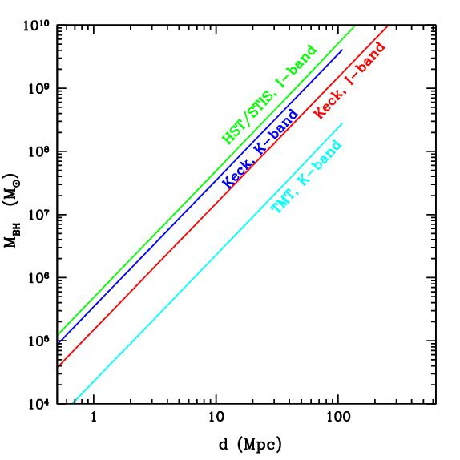
Figure 1-- Minimum detectable black hole mass as a function of galaxy distance, under the assumption that the black holes follow the local M-σ relation, and assuming a minimum of 2 resolution elements across the black hole's radius of influence. For Keck NGAO, this figure assumes a PSF core with FWHM = 0.075” in K, and 0.049” in I. Minimum detectable black hole mass scales approximately as (distance * angular resolution)². For distances beyond ~100 Mpc, the CO bandhead is redshifted out of the K band and is no longer observable.

For black hole detection, NGAO offers two important advantages over current capabilities. First, compared with current LGSAO, the improved PSF quality and stability will significantly reduce the measurement uncertainty in black hole masses, for observations in the near-IR. Second, an AO capability in the I band will open up the possibility of using the Ca II triplet lines, giving a PSF core that is narrower than in the near-IR, which will extend the distance out to which the most massive black holes can be detected. The minimum black hole mass detectable with a given angular resolution can be roughly estimated under the assumption that black holes lie on the M-σ relation. As Figure 1 shows, Keck NGAO in the K-band can offer slightly better sensitivity to black holes than that of HST/STIS. In comparison with NGAO at K-band, for a given limiting distance an I-band NGAO capability with a PSF core FWHM of 0.05” can allow detections of black holes smaller by approximately a factor of 2.

  - Quasar Host Galaxies
At present, the most detailed quantitative studies of quasar host galaxies have been done with HST imaging. AO observations are beginning to play an increasingly important role, particularly due to the inherent advantages of observing in the near-IR, where the underlying host galaxy structure can be more clearly revealed and where the central AGN point source is less prominent than in the optical. However, even for low-redshift quasars, temporal variability of the AO PSF can make it difficult or impossible to extract quantitative information about the host galaxy structure for radii smaller than 1” (Guyon et al. 2006). Thus, even for low-redshift quasars, determining accurate bulge luminosities and profiles is at or beyond the limits of current capabilities, and for high-redshift quasars (z beyond about 2), even the most basic detection of host galaxies has often proved very difficult with current-generation AO (Croom et al. 2004). HST/NICMOS has been used for quasar host galaxy imaging in the H band, and has the advantage of an extremely stable PSF, but Keck NGAO will offer better spatial resolution by a factor of 4.

Key observational goals in this area include:

  - At low to moderate redshifts (z < 1): detailed structural measurements of quasar hosts and bulge/disk decompositions from AO imaging, using GALFIT or similar tools, to extend the black hole mass/bulge mass correlation and examine the relationship between quasar activity and galaxy mergers. Integral-field unit observations to study emission line velocity fields and outflows. IFU observations can be used to determine the evolution with redshift of the M-σ relation, for example by measuring bulge velocity dispersions with the Ca II triplet for Seyfert 1 galaxies at z~1.
  - At high redshifts (z>1): detection of host galaxies in AO images, measurement of asymmetry/lopsidedness parameters to investigate the relationship to the host galaxy merger history, and measurement of integrated magnitudes and colors to constrain the overall stellar population.

- Proposed observations and targets

Supermassive black holes: Numerous nearby galaxies will be promising targets for observation with NGAO. Many galaxies previously observed with HST or other AO systems will be re-observed with Keck NGAO, to improve the accuracy of the black hole mass measurements. Giant ellipticals at distances less than ~100 Mpc will be good candidates for studying the high-mass end of the M-σ relation.

Spectral features useful for kinematic measurements include:
  - Stellar dynamics: the CO bandhead (2.29 μm), and the Ca II triplet (~8500 A)
  - Gas dynamics: [S III] (9533 A), [Fe II] (1.26 μm), Pa β (1.28 μm), H₂ (2.12 μm), Br γ (2.17 μm)

For stellar-dynamical detections of black holes, S/N = 30 or better (per resolution element) is typically needed for the stellar continuum. For nearby galaxies this can typically be accomplished in a few hours of observing with OSIRIS. For gas dynamics, the S/N requirements for a given galaxy are lower since emission lines rather than absorption lines are used, but only about ~10% of nearby galaxies have sufficiently “clean” rotation in their emission-line velocity fields to be good targets for gas-dynamical studies.

In addition to the spectroscopic data, AO imaging of the host galaxies is needed in order to determine the distribution of stellar mass in the host galaxy. For the imaging, either NIRC2 or an upgraded IR imaging camera would be used.

One galaxy sample of particular interest is the set of 17 Seyfert galaxies having black hole mass estimates from reverberation mapping (Peterson et al. 2004). This sample serves as the bottom rung on a “distance ladder” of indirect techniques used for estimating black hole masses in quasars. Since all estimates of black hole masses in quasars are calibrated against this sample, it is important to verify the accuracy of the reverberation-based black hole masses by performing stellar-dynamical observations on these same galaxies. With NGAO, approximately 10 of these galaxies should be within reach.

Quasar host galaxies:
  - For low-redshift samples such as the PG quasar sample (z~0.1-0.3), typical H-band magnitudes are ~12-14 mag for the AGN point source, and 13-15 mag for the host galaxy.
  - High-z quasars: at z=2, typical bright quasars have K~16-18 mag. Luminous elliptical host galaxies (~2L*) would have K~19 mag with half-light radii of ~0.5 arcsec.

- Comparison of NGAO w/ current LGS AO

Black hole science will benefit greatly from both the higher Strehl ratio and the better PSF stability of NGAO in comparison with current LGSAO. Figure 2 below illustrates one example: the improvement in the measurement of the velocity field of an emission-line disk around a black hole. To detect the black hole with high significance, it is imperative to resolve the central, nearly Keplerian region of the disk. In this simulated example of a 10⁸ solar mass black hole at distance 20 Mpc, the current LGSAO capability would detect a steep velocity gradient across the nucleus due to the presence of the black hole, but not detect the nearly Keplerian rise in velocity toward the nucleus. With NGAO, the rise in velocity toward the nucleus is detectable, and provides the “smoking gun” evidence for the presence of an unresolved central mass. With HST, this central Keplerian rise in velocity in emission-line disks has only previously been detected clearly in 2 giant elliptical galaxies, M84 and M87. Stellar-dynamical observations at the CO bandhead will similarly benefit from the enhanced ability of NGAO to resolve the black hole's sphere of influence in nearby galaxies.
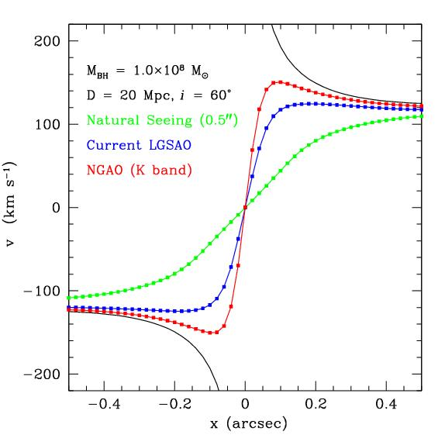
Figure 2. Simulation of radial velocities observed along the major axis of an emission-line disk surrounding a black hole in a galaxy center, similar to disks observed in M87 and other early-type galaxies. The black hole has mass 10⁸ solar masses, and is surrounded by a bulge with a power-law mass profile. The galaxy is at D = 20 Mpc and the disk is inclined by 20 degrees to the line of sight. The simulation was performed for observations of an emission line in the K-band (e.g., Br γ) with OSIRIS using a spatial sampling of 0.02”/pixel. The black curve shows the true major-axis velocity profile of the disk with no atmospheric or instrumental blurring. The blue and red curves show the velocity curves obtained from a 1-pixel wide cut along the disk major axis, after convolution of the intrinsic spectral data cube with a typical K-band PSF for current LGSAO (assuming a PSF core containing 30% of the total flux), and for NGAO (assuming a PSF core containing 72% of the total flux). The green curve shows the velocity profile that would be measured without any AO correction.

The improvement in PSF structure will also be particularly beneficial for stellar-dynamical observations of the most massive elliptical galaxies, which have flat cores rather than strongly peaked cusps in the stellar light profile. For these objects, it is essential to minimize the flux in the PSF wings in order to measure accurate line-of-sight velocity distributions for the stars orbiting close to the black hole.

For observations of quasar host galaxies, we consider a simplified simulation of a quasar at z=2 with a central AGN point source magnitude of K' = 17 and an elliptical host galaxy with magnitude of K' = 19 mag and half-light radius 0.65”. A simulated image of the quasar as seen with NIRC2 at 0.01”/pixel was created, for a total exposure time of 3600 sec and with noise added using the current NIRC2 specifications. The PSF was modeled as a double-Gaussian with core and halo sizes of σ = 0.032” and 0.232”, respectively, with 30% of the total flux in the core for current LGSAO and 72% for NGAO. Radial profiles were extracted for the simulated AGN image and also for a simulated PSF star observation having S/N equal to the AGN image. As shown in Figure 3, the host galaxy is only marginally detectable with the current LGSAO observation, but could be significantly detected with NGAO because of the greatly improved PSF structure. It should be noted that this simulation is highly oversimplified, particularly in that it does not take temporal variability of the PSF into account: for a realistic observation with current LGSAO the host galaxy would be considerably more difficult to detect than even this simulation suggests. With a highly stable PSF, NGAO can play a leading role in the study of AGN host galaxies at high redshift.

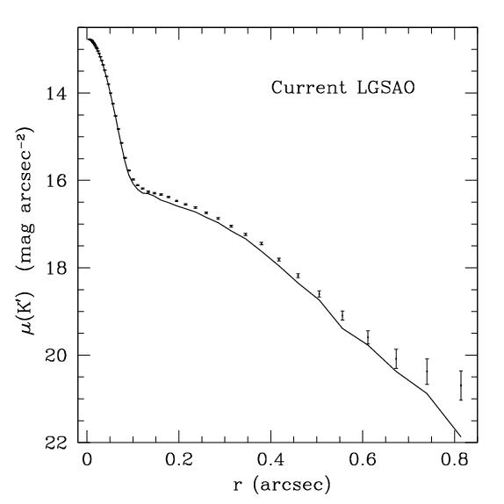
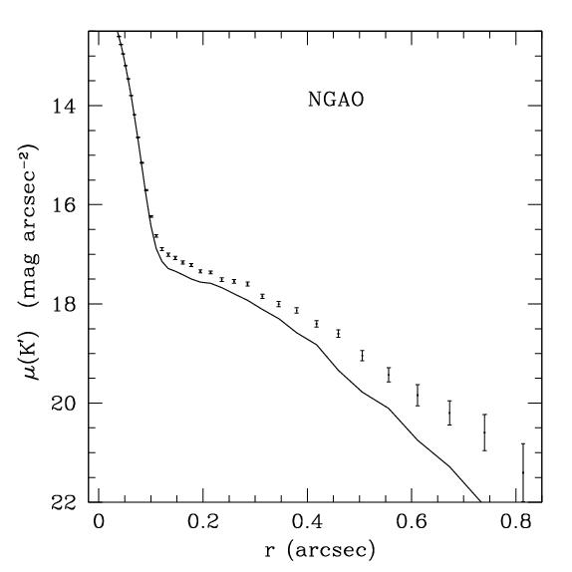
Figure 3. Simulated K' observation of a z=2 quasar with current LGSAO and with NGAO, both for a 1 hour exposure with NIRC2 and assuming the same background level. The solid curve is the PSF profile measured from a simulated PSF image with noise added, and scaled to the same peak flux as the quasar nucleus, and the points with error bars are the radial profile of the quasar plus host galaxy. The host galaxy is nearly undetectable with current LGSAO but can be significantly detected with NGAO.

- AO and instrument requirements
Projects that can be done with existing instrumentation:
  - Black holes in massive galaxies: for IR observations (CO bandhead), OSIRIS is suitable, although a near-IR IFU with a wider field of view at the highest spatial sampling would increase observing efficiency and improve black hole mass determinations.
  - AGN host galaxies: NIRC-2 for IR imaging of host galaxy structure, OSIRIS for measurement of stellar velocity dispersions and emission-line velocity fields.
Projects requiring new instrumentation:
  - For measurements of black hole masses in nearby galaxies, the most important new capability would be an optical IFU for observations of the Ca II triplet. Spectral resolution of R~5000 is optimal for most black hole searches in elliptical and spiral galaxies. An imaging camera able to image the full NGAO field of view in the I band would also be beneficial for measuring the distribution of starlight in the host galaxies.

- Program Summary (text and/or tables):

Intrinsic brightness of targets
Specific observables (including images or spectra, what wavelength bands, etc)
Sample targets
Target density on sky, if more than ~ 1 target per few square arc minutes
Observing requirements:

What spatial resolution is needed
What spectral resolution is needed
What photometric or astrometric accuracy is needed
What SNR is needed
Estimate of exposure time per target
Special requirements on tip-tilt stars
Required PSF stability
Total number of nights needed to complete observing program

References

Croom, S. M., et al. 2004, ApJ, 606, 126
Guyon, O., Sanders, D. B., & Stockton, A. 2006, astro-ph/0605079
Peterson, B. M., et al. 2004, ApJ, 613, 682
Silge, J. D., Gebhardt, K., Bergmann, M., & Richstone, D. 2005, AJ, 130, 406
Woo, J.-H., Treu, T., Malkan, M. A., & Blandford, R. D. 2006, astro-ph/0603648

