

Keck Adaptive Optics Note 769

Next Generation Adaptive Optics:
Post-PDR Systems Engineering Management Plan

May 29, 2010

Author List
Name | Function
Peter Wizinowich | NGAO Project Manager
Sean Adkins | NGAO Senior Manager
Richard Dekany | NGAO Senior Manager
Don Gavel | NGAO Senior Manager
Claire Max | NGAO Project Scientist
Jason Chin | NGAO Senior Engineer

Contributors: Reni Kupke, Chris Lockwood, Chris Neyman, Mike Pollard, Marc Reinig, Thomas Stalcup, Kevin Tsubota, Viswa Velur

Approval Control
Control | Name | Function
Revised by:

Approved by:
Authorized by:

Document Change Record
Issue | Date | Change Description

1 Introduction 7
2 Project Plan 7
2.1 Organization Structure 7
2.2 WMKO Design Phase and Deliverables 10
2.3 Work Breakdown Structure 11
2.3.1 Design WBS 11
2.3.2 Management WBS 12
2.3.3 Systems Engineering WBS 13
2.3.4 AO System WBS 14
2.3.5 Laser Guide Star Facility WBS 14
2.3.6 Control System WBS 14
2.3.7 Science Operations Tools WBS 14
2.3.8 Telescope and Summit Engineering WBS 15
2.3.9 Telescope Integration and Test WBS 15
2.3.10 Operations Transition WBS 15
2.4 Product Breakdown Structure 15
2.5 Project Milestones and Schedule 16
2.6 NSF Proposals 17
2.7 Cost Estimate 18
2.7.1 Introduction 18
2.7.2 Project Scope Error! Bookmark not defined.
2.7.3 Cost Estimation Process 19
2.7.3.1 Objectives 19
2.7.3.2 Project Phases 20
2.7.3.3 Costing Methodology 21
2.7.3.4 Resource Pricing 22
2.7.3.5 Labor Resources 22
2.7.3.6 Non-Labor Expenses 23
2.7.3.7 Travel 24
2.7.3.8 Shipping 24
2.7.3.9 Sales Tax 25
2.7.4 Previous Cost Estimates 25
2.7.4.1 System Design Cost Estimate 25
2.7.4.2 TMT AO Cost Comparison 26
2.7.4.3 Build-to-Cost Cost Estimate 26
2.7.5 Cost Estimates 27
2.7.5.1 Estimate to Completion Error! Bookmark not defined.
2.7.5.2 Cost Comparison 29
2.7.5.3 Detailed Design Phase Cost Estimate 29
2.7.5.4 Key Cost Risks 31
2.7.5.5 Estimate Refinement 31
2.8 Risk Assessment and Management 31
2.9 Configuration and Documentation Management 31
2.10 Interface Definition 32
2.11 Requirements Management and Compliance 32
2.12 Integration and Test 33
2.13 Component Failure and Spares Approach 36
3 Detailed Design Phase Plan 37
3.1 Decision Tree for Proceeding to DD 37
3.2 DD Phase Management 38
3.3 DD Phase Overview and Deliverables 38
3.4 DD Phase Work Breakdown Structure 39
3.5 DD Phase Planning Assumptions 39
3.6 DD Phase Schedule 39
3.7 DD Phase Milestones 40
3.8 DD Phase Personnel and Core Team 40
3.9 DD Phase Budget and Contingency 41
3.10 DD Phase Risk Assessment and Risk Management 41
3.11 DD Phase Management 41
4 Full Scale Development and Delivery and Commissioning Phase Management 42
5 Phased Implementation and Descope Options 42
6 System Design Phase Summary 42
7 Preliminary Design Phase Summary 42
7.1 PD Phase Plan 42
7.2 Build-to-Cost 43
7.3 PD Funding 43
7.4 PD Budget Actuals 43
7.5 PD Schedule Actuals 44
7.6 Staffing 44
8 Appendix: NGAO Detailed Design Cost Estimate Summary (in FY08 $K) 47
9 Appendix: NGAO Full Scale Development Cost Estimate Summary (in FY08 $K) 48
10 Appendix: NGAO Delivery and Commissioning Cost Estimate Summary (in FY08 $K) 49
11 Appendix: Full NGAO Detailed Design Phase Schedule 49

Figure 1. NGAO Detailed Design Phase Management Structure. 8
Figure 2. Proposed NGAO Detailed Design Management Structure as NGAO ramps up to full funding. 9
Figure 3. The WMKO Development Process. 10
Figure 4. NGAO Work Breakdown Structure. 11
Figure 5. NGAO Detailed Design Work Breakdown Structure. 12
Figure 6. NGAO Product Structure. 16
Figure 7. Modified V-diagram shown the requirements flowdown and relationship to testing. 33
Figure 8. NGAO Integration and Test Approach. 35
Figure 9: Decision tree to proceed (or not) to DD 38
Figure 10. DD phase Management schedule (WBS2). 40
Figure 11. DD phase Systems Engineering schedule (WBS3). 40
Figure 12. DD phase AO System schedule (WBS4). 40
Figure 13. DD phase Laser System schedule (WBS5). 40
Figure 14. DD phase Science Operations Tools schedule (WBS6). 40
Figure 15. DD phase Telescope and Summit Engineering schedule (WBS7). 40
Figure 16. DD phase Telescope Integration and Test schedule (WBS8). 40
Figure 17. DD phase Operations Transition schedule (WBS9). 40
Figure 18. Actual labor $ per month by month during the PD phase. 45

Table 1. WMKO Development Process Deliverables. 10
Table 2. NGAO Project milestones. 16
Table 3. TAC notifications associated with NGAO milestones. 17
Table 4. NGAO Project phases and durations. 20
Table 5. Estimating Methodology 21
Table 6. Labor categories. 22
Table 7. Non-labor categories. 23
Table 8. Travel destination categories. 24
Table 9. Travel duration categories. 24
Table 10. NGAO cost estimate (in FY08 $k) as presented at the SDR. 25
Table 11. NGAO SDR cost estimate with instruments added (in then-year $). 26
Table 12. Build-to-cost cost estimate (in then-year $). 27
Table 13. NGAO cost estimate (in FY08 $k) by WBS 27
Table 14. NGAO cost estimate (in FY08 $k) by project phase. 28
Table 15. NGAO cost comparison to similarly complex AO systems. Error! Bookmark not defined.
Table 16. NGAO cost comparison notes. Error! Bookmark not defined.
Table 17. Detailed Design phase cost estimate (FY08 $). Error! Bookmark not defined.
Table 18: DD phase milestones 40
Table 19. DD phase personnel assignments versus Fiscal Year (FY). 41
Table 20. Core DD phase team members. 41
Table 21. DD phase work distributed by Institution. 41
Table 22. PD Actuals through April 2010. 43
Table 23. PD actuals through April 2010 versus SDR plan. 44

Introduction
A Systems Engineering Management Plan (SEMP) is a standard part of the project documentation for W.M. Keck Observatory (WMKO) development efforts. This SEMP represents a key deliverable from the system and preliminary design phases for the WMKO Next Generation Adaptive Optics (NGAO) project. This document will be updated as a product of the NGAO detailed design phase.

The following sections document the proposed management process, schedules and budgets for the post-PDR phases of the NGAO project.

Project Plan

Organization Structure
The management structure proposed for the start of the Detailed Design (DD) phase is shown in Figure 1. As full NGAO funding is found we propose to make organizational changes during the DD to better manage the project as shown in Figure 2.

All items highlighted in yellow represent part of the NGAO DD phase project for which this SEMP is written. The NGAO project continues to be led by the same senior personnel as in the Preliminary Design phase. The NGAO Project Scientist will be assisted by an NGAO Science Advisory Team. The NGAO senior management group (Wizinowich, Adkins, Dekany, Gavel and Max) will provide project management.

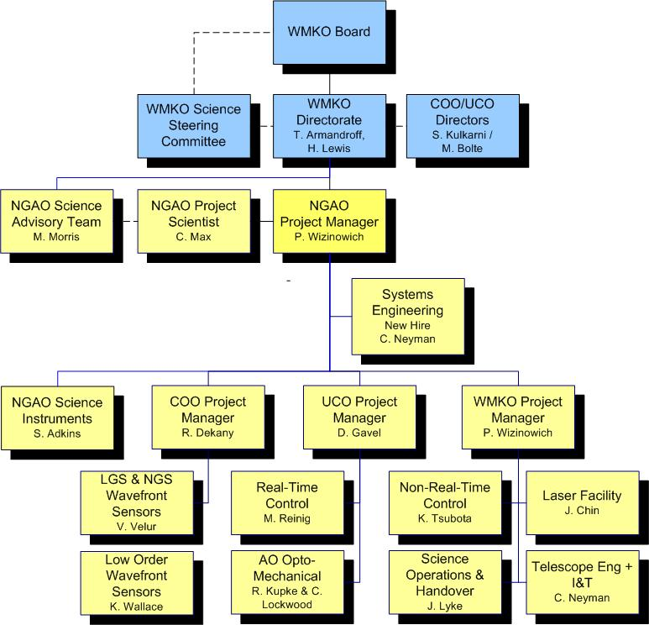
Figure 1. NGAO Detailed Design Phase Management Structure.
Solid lines are direct reports. Dashed lines are advisory or collaborative.

WMKO’s top-level management structure is highlighted in blue in Figure 1. The NGAO Project Manager reports directly to the WMKO Director, Taft Armandroff, and Deputy Director, Hilton Lewis. They in turn report to the WMKO Board. There is a close collaboration between the WMKO Directorate and the Director of the University of California Observatories (UCO), Mike Bolte, and the Director of the Caltech Optical Observatories (COO), Shri Kulkarni. A similar collaboration exists with the WMKO Science Steering Committee co-chaired by Chris Martin and X Prochaska.

Figure 2 shows what we believe is a more effective management structure for a project the scale of NGAO. The key changes are:
- Identify or hire a full time systems engineer as opposed to our current distributed systems engineering approach.
- Identify or hire a full time scientist to work with the project to ensure that the delivered NGAO system is scientifically powerful and operationally efficient. This person would also lead the development of the science operations tools. Ideally this person would lead the first year or more of NGAO science operations and ensure that the facility was properly handed over to night-time operations support.
- Formally identify a principal investigator that would lead the development of DAVINCI in collaboration with Adkins. We have been working toward DAVINCI being built in the UCLA IR lab under the leadership of James Larkin.
- Identify a WMKO project manager. One good candidate is Jason Chin who has played an effective role in managing the laser guide star facility development and works well with the WMKO leads.
- The above items would free Wizinowich up to more fully play the overall leadership role for NGAO.

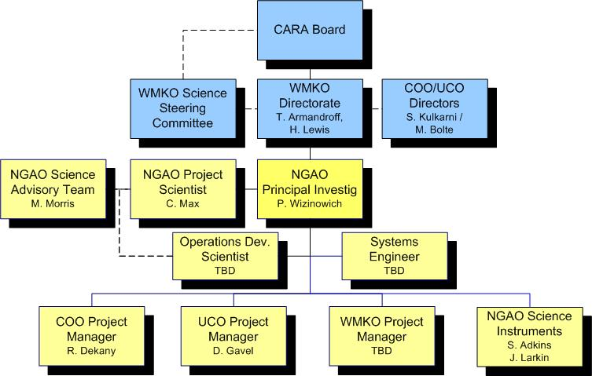
Figure 2. Proposed NGAO Detailed Design Management Structure as NGAO ramps up to full funding.

WMKO Design Phase and Deliverables
WMKO’s standard development process is shown in Figure 3. This document is being written as a product of the NGAO Preliminary Design and presents the SEMP for the remaining development phases starting with the Detailed Design and ending with the transition of NGAO into Facility Class Operation. Table 1 lists the standard deliverables for each of the development phases.
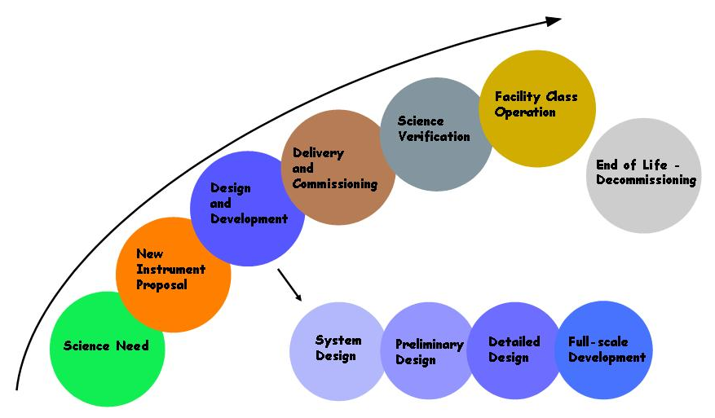
Figure 3. The WMKO Development Process.

The deliverables for the AO portion of the NGAO project consist of documentation and the actual AO Facility, Laser Facility and related interfaces. Major documentation items include:

Table 1. WMKO Development Process Deliverables.
System Design: | Preliminary Design:
Science Case Requirements Document | Requirements Documents for Key Subsystems
System Requirements Document | Operations Concept Document
System Design Manual | Preliminary Technical Specifications
Systems Engineering Management Plan | Interface Control Documents
System Design Report | Preliminary Design Report
Detailed Design:
Detailed Design Drawings and Bills of Material
Final Technical Specifications
Acceptance Test Plans
Detailed Design Report
Full Scale Development:
Hardware and Software Manuals and Maintenance Documentation
Pre-ship Review Reports
Installation/Commissioning:
Acceptance, Operational Readiness and Science Verification Review Reports

Work Breakdown Structure
The NGAO Project Work Breakdown Structure (WBS) is shown schematically in Figure 4. The top level structure reflects the transition from Design (1.0) through Full Scale Development (4.0 to 8.0 and 11.0) to Delivery and Commissioning (9.0 and 10.0). WBS 9.0 includes Science Verification and WBS 10.0 covers the handover to Facility Class Operation. Management (2.0) and Systems Engineering (3.0) are ongoing items through both Full Scale Development (FSD) and Delivery and Commissioning (DC). Each of the top level WBS elements is briefly described in the following section. More detailed WBS dictionary definitions are provided in the NGAO cost book.

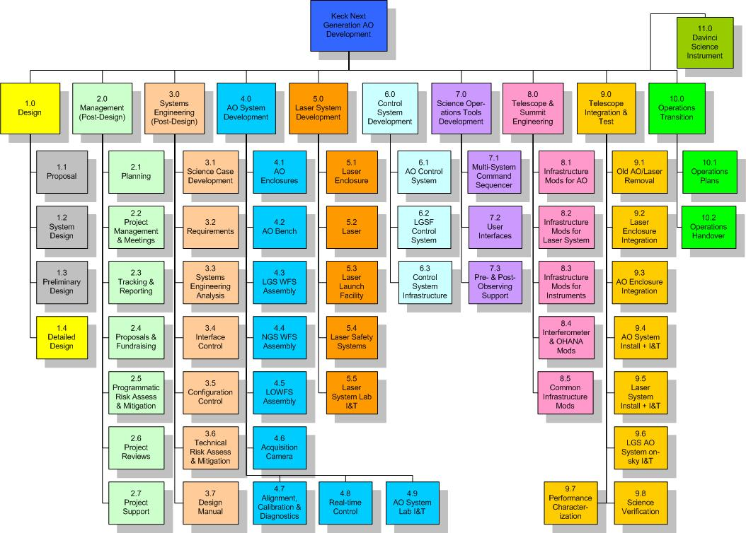
Figure 4. NGAO Work Breakdown Structure.

Design WBS
The three gray highlighted boxes in Figure 3 represent the project phases completed prior to the start of the Detailed Design. There is one remaining design phase, Detailed Design. In order to simplify the creation of separate project plans and budgets for each design phase a WBS numbering plan is used within each design phase WBS (1.3 and 1.4) that reflects the overall WBS numbering for each of the major elements shown in Figure 4. For example, the overall WBS contains an element number 4.0, named “AO System Development”. An identically named WBS element appears in each of the Preliminary Design and Detailed Design WBS outlines, but these elements are numbered 1.3.4 and 1.4.4 respectively. The WBS for the Detailed Design phase is shown in Figure 5. Note that the choice to have a separate WBS for each design phase was driven by the availability of funding only for 1 design phase at a time.

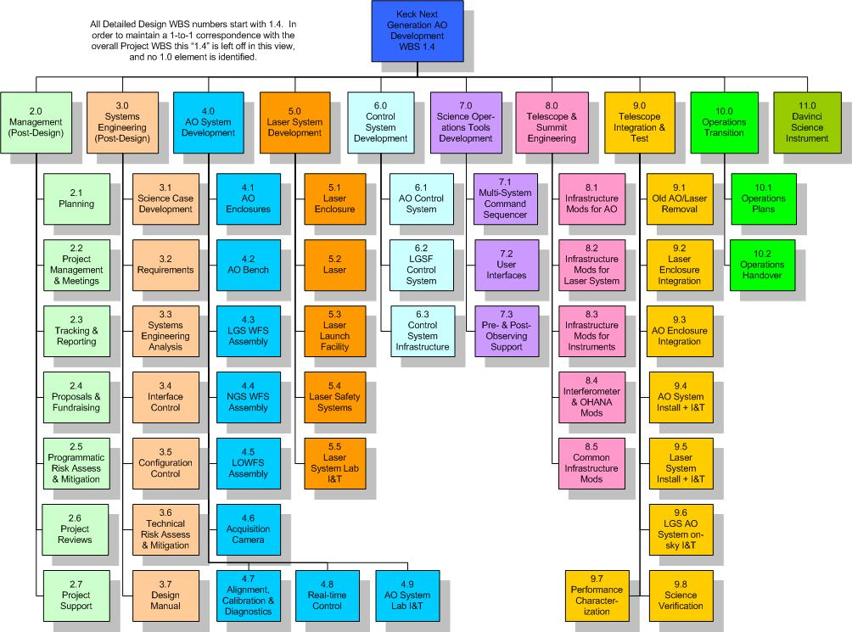
Figure 5. NGAO Detailed Design Work Breakdown Structure.

Management WBS
The management WBS has seven major elements:

- Planning. This WBS includes the normal adjustments to the plan during a development phase, supporting the Observatory’s fiscal year planning process and preparing the Systems Engineering Management Plan (SEMP). The SEMP, the document you are currently reading, will be updated during the Preliminary and Detailed Design phases.
- Project Management and Meetings. This category includes management telecoms and team meetings and telecoms. During the preliminary design phase for example management teleconferences will occur weekly and team teleconferences monthly with four face-to-face team meetings.
- Tracking and Reporting. Monthly status reports will be provided throughout the project and regular reporting will be made quarterly at WMKO SSC meetings. During the Preliminary Design phase the monthly reports will be provided to the TSIP and the Observatory Directors and monthly telecoms will be held with the TSIP representatives.
- Proposals. The NGAO team will need to write proposals and support fundraising. This is primarily a schedule item here since the WMKO labor for these activities is covered outside the NGAO budget. Some COO and UCO labor is covered here.
- Programmatic Risk Assessment and Mitigation. This WBS covers analysis of the programmatic risks and some mitigation activities. Some mitigation activities are covered under the appropriate development WBS.
- Project Reviews. Project reviews corresponding to major milestones are covered under this WBS. These include:
  - Preliminary Design Review.
  - Detailed Design Reviews.
  - An intermediate Full Scale Development Review as a checkpoint during development (we may revisit the need for this review).
  - A Pre-lab I&T Review to determine that the subsystems are ready for lab I&T.
  - A Pre-ship Review to determine that the system and telescope infrastructure are ready for telescope I&T.
  - An Operability Review to determine that NGAO is ready for shared-risk science.
  - An Operations Readiness Review to determine that NGAO and the operations team are ready for Facility Class Operation.
- Project Support. This category includes administrative and contract support, the procurement of shared infrastructure for development and/or testing purposes, and research time for postdocs and scientists working on the NGAO project.

Systems Engineering WBS
The Systems Engineering WBS has seven major elements:
- Science Case Development. This WBS is the primary home for the Project Scientist and Science Advisory Team activities. These include science case and requirements development, science observing planning, science performance input to the performance budgets, science operations tools and Operations Concept Document, understanding and updating the case for NGAO’s science competitiveness and liaising with the science community. This will continue to be an active area during the Preliminary Design and should move to more of a supporting role until we reach the telescope I&T and science verification phase.
- Requirements. This category includes the development and maintenance of the Operations Concept Document, System Requirements Document, Functional Requirements database, and the software and component standards that we select for NGAO. The System and Functional Requirements were developed during the System Design phase and will require updating during the remaining design phases. The initial Operations Concept and Standards Documents will be developed during the Preliminary Design.
- Systems Engineering Analysis. This is where all the performance budgets and the modeling and analysis tools are developed and maintained. There is a close connection with the Science Case Development WBS activities.
- Interface Control. This WBS covers the development and maintenance of the external interface definitions to the Observatory and to the NGAO science instruments, and the internal interface definitions between NGAO subsystems. One or more Interface Control Documents will be produced.
- Configuration Control. Initially this covers the definition of the configuration control process and subsequently the configuration control activity.
- Technical Risk Assessment and Mitigation. This WBS covers analysis of the technical risks and some mitigation activities. Most mitigation activities are covered under the appropriate development WBS.
- Design Manual. A System Design Manual was produced during the System Design phase. This Manual was updated during the Preliminary Design phase and will be updated again as a product of the Detailed Design phase. It will ultimately be further updated to reflect the as-built system in order to provide the operations team with a complete design reference.

AO System WBS
WBS 4.0 includes all of the elements related to the AO system itself. All of the subsystems are expected to be completed, including testing and demonstration of compliance at the subsystem level, within their WBS element. These subsystems, as well as the subsystems from WBS 6.0 and 7.0, are then delivered to WBS 4.9 AO system lab I&T. The output of WBS 4.9 is an AO system demonstrated to be ready for telescope I&T.

Laser Guide Star Facility WBS
WBS 5.0 includes all of the elements related to the laser facility itself. All of the subsystems are expected to be completed, including testing and demonstration of compliance at the subsystem level, within their WBS element. These subsystems, as well as appropriate elements of WBS 6.0, are then delivered to WBS 5.5 laser system lab I&T. The output of WBS 5.5 is a laser system demonstrated to be ready for telescope I&T.

Control System WBS
WBS 6.0 includes all of the elements related to non-real-time motion and device control within the AO and LGS facilities, as well as the control loops and offloads not provided by the real-time control system. The data server collects and temporarily stores the non-real-time data required to support science data reduction or system performance and diagnostics monitoring.

Science Operations Tools WBS
The science operations tools provide the high level coordination between the AO system, laser system, telescope and science instruments. These are the tools used to operate the NGAO system for science. The user interfaces provide the operator and astronomer interfaces to NGAO and the multi-system command sequencer provides the high level coordination. The pre- and post-observing tools are intended to support optimal observation planning and the generation of the data needed by the astronomer to make their observations scientifically useful.

Telescope and Summit Engineering WBS
This WBS covers the modifications needed to the telescope and summit facilities, and existing Keck II AO science instruments (NIRC2 which will be moved to Keck I) and the interferometer, needed to integrate with NGAO. Currently there is no effort in the area of telescope performance.

Telescope Integration and Test WBS
This WBS covers all NGAO activities at the summit, from installation through performance characterization and science verification.

Operations Transition WBS
This WBS covers the development of operations plans and training of operations personnel. These activities will overlap in time with elements of other WBS elements, especially integration and test. The cost of operations personnel to be trained is covered by the Observatory.

DAVINCI Science Instrument WBS
This WBS covers the design and development of the NGAO science instrument, DAVINCI.

Product Breakdown Structure
A partial view of the Product Breakdown Structure (PBS) is provided in Figure 6. MS Project was chosen as the tool to maintain the PBS since it allows easy roll-up of the structure. This PBS has been used to help develop the WBS and as a structure for the NGAO functional requirements database.

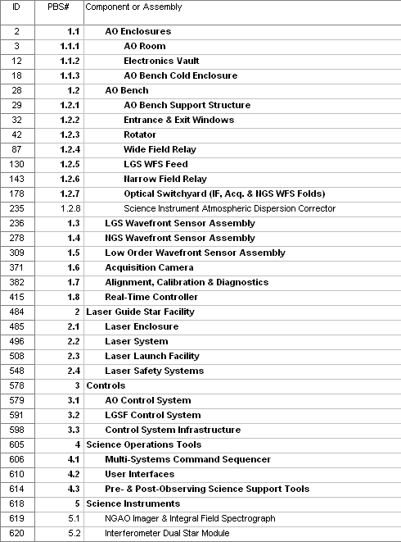
Figure 6. NGAO Product Structure.

Project Milestones and Schedule
The major project milestones are shown in Table 2. Our ability to meet these milestones will strongly depend on the availability and consistency of funding. It will also depend on advance knowledge of when funding will become available since it takes time to ramp up personnel and to set up contracts.

The 24 month Detailed Design, as discussed in section 3.5, is driven by the availability of funding, and by the need to allow time to significantly increase the number of personnel at the start of the Detailed Design phase. The 18 months between the end of the Detailed Design and the start of lab I&T will only be adequate if long lead procurements can be placed during the Detailed Design. The 1st laser procurement in particular will need to be placed during the Detailed Design.

Table 2. NGAO Project milestones.
Year | Month | NGAO Project Milestone
2008 | April | System Design Review
2010 | June | Preliminary Design Review
2010 | September | Detailed Design Phase Begins (if approved)
2012 | September | Detailed Design Review
2013 | May | 1st AO Subsystem Acceptance Review
2013 | July | 1st Laser Pre-Telescope Readiness Review
2014 | January | 1st Laser First Light with Keck II AO
2014 | February | Last AO Subsystem Acceptance Review
2014 | March | DAVINCI Pre-ship Review
2014 | November | AO Pre-Ship Readiness Review
2015 | February | NGS First Light
2015 | June | LGS First Light
2015 | October | Operational Readiness Review

WMKO’s observing time is scheduled in six month increments beginning in February and August. Generally speaking WMKO notifies the Time Allocation Committees (TACs) of instrument availability at least five months prior to the next observing semester. The NGAO summit integration effort needs to be coordinated with this process. The successful completion of the later NGAO project milestones would therefore result in notifications of AO science availability, shown in Table 3, being sent to the TACs. For example, the project milestone of the pre-telescope readiness review just prior to August, 2013 would be the milestone at which we would notify the TACs that the Keck II AO system would not be available for science in semester 14A. We would be performing science verification science in semester 14B, but no AO system would be available on Keck II for TAC-allocated science for a full year in this scenario. The Keck I AO system would be available for science during this period but the Keck Interferometer would not be able to be used for a year, except for some limited science verification in semester 14B.

Table 3. TAC notifications associated with NGAO milestones.
Date | Milestone | TAC Notification for Semester
Feb, 2013 | Laser Factory Readiness Review | LGS AO unavailable 2nd half of 13B
Aug, 2013 | 1st Laser Pre-Telescope Readiness Review | New laser available for 14A shared-risk
Feb. 2014 | 1st Laser 1st Light with Keck II AO | New laser available for 14B shared-risk
Aug, 2014 | Good progress on AO Lab I&T | AO system unavailable Dec/14 thru 15A
Feb, 2015 | Shared-Risk Science Availability Review | NGAO available for shared-risk for 15B
Aug, 2015 | Science Availability Review | NGAO available for science for 16A

NSF Proposals
This post-PDR SEMP makes some assumptions about three proposals submitted to the NSF:
- An awarded MRI proposal for a center launch telescope for the Keck II laser (KAON 707). This project started in FY10. This launch telescope will become the NGAO laser launch telescope. The schedule and budget for this project are already in place. The schedule will be tied via milestones to the NGAO schedule. The budget, excluding indirect costs, will be counted against NGAO’s budget cap.
- A submitted MRI proposal for a new Keck II laser that would start in FY11. This laser would become the first NGAO laser. For the purpose of NGAO planning we are assuming that this proposal will be funded. If this proposal is unsuccessful a replan activity will be required for the procurement and implementation of the first NGAO laser. The schedule and budget for this project are already defined in the proposal. The schedule will be tied via milestones to the NGAO schedule. The budget, excluding indirect costs, will be counted against NGAO’s budget cap. This proposal includes agreements with ESO and the TMT to share development costs.
- A submitted ATI proposal for a near-IR tip-tilt sensor for Keck I that would start in FY11. This would be a risk reduction activity for NGAO but provides no hardware for NGAO. From the NGAO perspective we will monitor the progress of this activity for our risk reduction purposes but we will not address the schedule or budget for this activity in our NGAO planning. If this proposal is funded we will use its schedule to help define decision points for the NGAO near-IR tip-tilt sensors.

Cost Estimate

Introduction
The purpose of the cost estimation process was to develop a cost to completion for the NGAO facility including the DAVINCI science instrument. This represents the fourth cost estimation process for the project. These cost estimates, as well as a cost comparison, are listed below:
- An initial cost estimate was prepared as part of the original NGAO proposal (KAON 400) dated June 2006. This included an estimate for NGAO and a suite of science instruments.
- A cost estimate was prepared as part of the system design. This cost estimate and the process are documented in the Systems Engineering Management Plan prepared for the SDR (KAON 574). This process utilized the TMT cost sheet based cost estimation process to generate labor, non-labor, travel and contingency estimates for each phase (PD, DD, FSD and DC) of ~100 WBS elements.
- The NGAO cost estimate was questioned at the April 2008 SDR in comparison to the higher cost estimate for the TMT first light AO system. A cost comparison with the TMT first light AO system was performed in collaboration with TMT. The report (KAON 625 dated November 2008) concluded that NGAO was traceably less expensive than the TMT system for reasons that were understood. The main additional finding was that the laser procurement estimate needed to be more solidly base. The overall conclusion was that the cost estimation methodology used for the SDR had given reasonable estimates.
- In August 2008 we received new guidance from the Directors to develop a build-to-cost concept for NGAO with a $60M cost cap in then year dollars. This cost cap included the NGAO science instruments and all costs from the start of the system design through completion. The team developed a simplified system (KAON 642) with a revised cost estimate (KAON 648) which successfully passed the build-to-cost review in March 2009 (KAON 650).

A full description of both the cost sheet based estimation process and estimator guidelines for our System Design phase cost estimate, which was repeated for the Preliminary Design phase, is provided in KAON 546.

For the preliminary design cost estimate we have taken the cost sheets one step further by generating MS project plans for the phases with labor rates based on individuals. The cost sheets and MS project plan supported each other in this development. The cost sheets were a useful working tool, often supported by separate more detailed costing tools preferred by the individual estimators, in developing the cost estimate and especially in the use of risk factors to determine contingency. Ultimately however we used the detailed MS project plan to develop the cost estimate and the cost sheets to provide the contingency rates.

Cost Estimation Process

Objectives
The primary objective of the PD phase cost estimation effort was set out to develop a comprehensive estimate of the total NGAO project cost, including science instruments. This includes the costs for engineering, design, analysis, procurement, fabrication, assembly, inspection, administration, installation, and commissioning of the telescope, instrumentation, and support facilities.

The cost estimates were prepared by responsible technical experts who are experienced in the various fields required to design, build, and commission the NGAO system. Vendor quotations, engineering calculations, analogies based on prior telescope programs, and parametric cost estimates were collected at appropriate levels of the project Work Breakdown Structure and by project phase. Approximately 175 cost estimation sheets were generated and organized into the NGAO PD Cost Book. This documentation includes the basic configuration information and all critical assumptions used during the estimating process. Two sample cost estimation sheets can be found in the Appendices.

Large, complex, and challenging projects entail uncertainty and cost risk. A contingency to cover anticipated costs resulting from this uncertainty has been developed using standardized risk analyses as established in the cost estimating plan. Contingencies have been developed at the same level of the WBS used to prepare the cost estimates.

NGAO costs will be monitored and controlled over the life of the project. The cost estimate has been integrated with the project schedule to establish a time phased budget baseline. This time-phased budget has been developed in detail for the Detailed Design phase and at an annual cost level for the full NGAO project. A more formal project management control system will be established in the DD phase to compare actual costs with the project’s budget baseline and the work accomplished.

The NGAO PD phase cost estimate is a detailed bottom-up estimate performed at the lowest reasonable level. The estimate is based on the project Work Breakdown Structure (WBS), a product-oriented hierarchy that identifies all the elements of the NGAO project and their parent/child relationships. The scope of work for each WBS element will be described in the NGAO WBS Dictionary entries. Each lowest-level WBS element has been estimated independently for each program phase including Detailed Design, Full Scale Development, and Delivery and Commissioning. The cost estimate for each activity is based on the scope of work defined for the WBS element for each defined program phase. Where strong parametric relationships have been established for specific portions of the estimate, a Cost Estimating Relationship (CER) has been utilized and referenced in the BOE. All estimates are given in FY10 dollars in the cost sheets.

Project Phases
For each WBS element, the full cost-to-completion is subdivided into the three project phases shown in Table 4.

NGAO Project Phase | Phase Code | Duration
Detailed Design | DD | 24 months
Full Scale Development | FSD | 24 months
Delivery and Commissioning | DC | 18 months
Table 4. NGAO Project phases and durations.

The durations are tentative for the purpose of the Preliminary Design phase cost estimation task and will be updated for future revisions of the project cost estimate. The majority of the work in the DC phase will be expended in the first 12 months, but the DC phase allows for an 18-month phase to fully complete transition to routine science operations.

For guidance on the level of maturity of design, we adopt for this costing exercise the WMKO Instrument Development Program Definitions of project phases (Adkins, S., “An Overview of the WMKO Development Phases”, December 8, 2005). This is, in part, as follows:

Preliminary Design

The preliminary design phase has two primary objectives. The first objective is to deliver documented designs for each system, sub-system and component, hardware or software, of sufficient detail to establish through inspection and analysis the feasibility of the proposed design, and the likelihood that the design will meet the requirements. The second objective is to present the project plan to completion, including a detailed schedule and budget.

Detailed Design

The detailed design phase has two primary objectives. The first objective is to complete the design, fabrication and assembly documentation for the system and all components, hardware or software, and show that the final design complies with all specifications and applicable standards. The second objective is to present the project plan to completion, including a schedule and budget.

Full Scale Development

The full-scale development phase builds the hardware, codes the software and integrates the complete system and performs laboratory testing culminating in the completion of an acceptance test plan followed by a pre-ship review.

Delivery and Commissioning

The objective of the delivery and commissioning phase is to install the AO instrument on one of the Keck telescopes, verify the correct operation of all hardware and software, perform first light observations and gather the data needed to complete the Acceptance Test Plan.

Costing Methodology
Each WBS Estimator provided data for each activity within the WBS, categorized by specific labor category, non-labor category, or travel. Each item in the cost estimate was tagged with a descriptor that characterizes the method used to derive the estimate. The categories established for this project in decreasing order of general confidence, and the associated code for entry in the Cost Estimating Input Form, are shown in Table 5.

Estimating Methodology | Input Code
Direct Historical Data (“done before”) | DH
Catalog Prices | CP
Vendor Quotes | VQ
Cost Estimating Relationship | CER
Engineering Estimate | EE
Table 5. Estimating Methodology

Each methodology is defined in the following fashion:
- Direct Historical Data - The use of costs demonstrated in immediate, applicable history for the same product or service.
- Catalog Prices - A known, advertised price from a potential supplier for a specific product or service.
- Vendor Quote - A quote from a potential supplier within the program estimate. Note: although useful to refining our current cost estimates, a balance must be found that satisfies project needs while not alienating vendors who often commit considerable resources for the generation of detailed price quotes.
- Cost Estimating Relationship – An estimate based on parametric relationships, analogy to another program, or by “Rule of Thumb.”
  - Parametric Estimate – A statistical model based on characteristics and costs of multiple previous observations.
  - Estimate by Analogy - Scaling of costs demonstrated in previous observations using subjective or objective factors.
  - Rule of Thumb - General cost relationships demonstrated by informal studies of past programs.
- Engineering Estimate – An estimate based on the judgment of a recognized authority.

Resource Pricing
Labor, Non-Labor, and Travel costs have been based directly on information provided by the cost estimator. All Labor Resource estimates were provided in hours of direct effort required to complete the work package and/or perform the task; the cost of labor resource estimates was calculated within the MS project plan utilizing the hours estimated and actual labor rates. Non-Labor expenses such as materials, subcontracts, and non-travel direct costs were estimated based on the unit cost and number of units required. Travel costs were based on the number of trips, general trip location, and duration of the trip. A narrative rationale for each resource estimate was developed and included in the estimate.

Labor Resources
Average NGAO labor rates for each labor category were used in the cost sheets for pricing direct labor. The labor categories used in the estimating process, the associated code for entry in the Cost Estimating Input Form, and comparable Salary Grade are provided in Table 6. However, these were replaced with actual rates for individuals in the MS project plan.

Resource | Input Code | Salary Grade
Technical Functions:
Post Doc | PostDoc | A
Technician | Tech | A
Junior Scientist / Engineer | JunSci | B
Associate Scientist / Engineer | AssoSci | C
Information Tech. Specialist | IT | C
Senior Scientist / Engineer | SrSci | D
Lead Scientist / Engineer | LdSci | E
Free Labor | FL | $0 / hr
Business Functions:
Administrative I | AsstAdmin | A
Administrative II | AssoAdmin | B
Management Functions:
Subsystem Manager | SubMgr | E
Project Manager | ProjMgr | E
Table 6. Labor categories.

All estimates were provided in hours of productive effort required to accomplish the task. The rates used to price labor hours have been adjusted to include paid leave such as sick leave, vacations, holidays, etc. All fringe benefits and other indirect costs have been included and applied by the cost estimating system utilizing demonstrated burdening factors.

Detailed salary figures are not included here in order to protect privileged personnel information however we can report this summary labor rate information. The total labor dollars and reported hours for the PD during FY10 are listed in Table 7. The CIT and UCO hours are hours based on a 40 hour week whereas the WMKO hours are actual hours. Depending on how many hours people work in excess of 40 hours on average the CIT and UCO average hourly rates could be a few percent lower.

Table 7: PD phase actuals during FY10

The weighted-average hourly salary rate of all labor on the NGAO project equals $72.11/hour in FY10 including burden and benefits.

Non-Labor Expenses
All non-labor and non-travel expenses that will be directly charged to NGAO have been included as a non-labor expense estimate. This includes, but is not limited to, all subcontracts, materials and equipment, and shipping costs. All non-labor estimates have been placed into the appropriate category to identify the type of activity that will take place. The categories, and the associated code for entry in the Cost Estimating Input Form, are provided in Table 8.

Category | Input Code
Equipment | EQP
Material | MAT
Subcontract | SUB
Shipping | SHIP
Other Direct Cost | ODC
Table 8. Non-labor categories.

Travel
All travel in support of an activity has been included as part of the input sheet submitted for that item. Travel estimates were performed by determining the number of trips that will be required based on the general location and duration. Travel destinations and durations, and the associated codes for entry in the Cost Estimating Input Form, are shown in Table 9 and Table 10, respectively.

Destination | Input Code
Intra – California | CALIF
Hawaii – California | HAWAII
International (Origination/Destination unspecific) | INTER
Other locations not included in above list | OTHER
Table 9. Travel destination categories.

Duration | Input Code
Extended: More than three weeks. | EXT
Long: Greater than one week but less than 3 weeks. | LONG
Mid: Greater than 3 days but less than 1 week. | MID
Short: Three days or under | SHORT
Table 10. Travel duration categories.

Travel applicable to conferences, project-wide reviews, outreach, and funding source meetings has been included as costs in the NGAO Project Management WBS 2 element and not as part of the input sheets submitted for a particular item.

Estimators assumed that entire Level 3 WBS elements (e.g. WBS 4.4) will be executed entirely within a single partnership organization. (I&T elements, of course, will require multiple institution participation and are expected to require considerable travel.)

We have included the labor costs for travel itself (e.g. time ‘sitting on a plane’) in the travel section of our cost summarizes, depending on the duration of each flight. Estimators therefore included in their WBS element labor resource estimates only the actual work hours spent at the destination site, and not labor hours while traveling.

Shipping
Shipping for each element to its integration point, assumed to be WMKO headquarters facility in Kamuela, HI, has been included with the estimate for that cost element. The cost of shipping integrated elements from WMKO to the summit has been estimated as a cost for the Integration and Test element of the WBS. Insurance costs for all shipments between California and Hawaii have not been specifically included, as each of WMKO, COO, and UCO/Lick typically self-insures.

Sales Tax
We assume the NGAO project will incur sales / use taxes on some but not all purchases, depending on the organization making the purchase, the location of the vendor, and other factors. Out-of-state procurements are charged sales tax in California but not in Hawaii. Based on a cursory assessment of a plausible procurement division between the NGAO partners, we have currently adopted an ‘effective’ sales tax rate of 3.00% which we apply to all non-labor EQP and MAT cost categories.

Previous Cost Estimates

System Design Cost Estimate
Table 11 is the cost estimate for NGAO presented at the SDR (from KAON 574 Table 11).

Phase | Labor (PY) | Cost Estimate (FY08 $k) |  |  |  |  |  | % of NGAO Budget
Phase | Labor (PY) | Labor | Non-Labor | Travel | Sub-Total | Contin-gency | Total | % of NGAO Budget
Preliminary Design | 21.0 | 2,582 | 216 | 224 | 3,022 | 458 | 3,479 | 8%
Detailed Design | 43.6 | 5,516 | 1,827 | 354 | 7,697 | 1,403 | 9,100 | 22%
Full Scale Develop | 50.5 | 5,661 | 14,510 | 626 | 20,797 | 5,234 | 26,031 | 62%
Delivery/ Commission | 22.4 | 2,287 | 250 | 478 | 3,015 | 602 | 3,617 | 9%
Total = | 138 | 16,045 | 16,804 | 1,681 | 34,531 | 7,697 | 42,227 | 100%
% = |  | 38% | 40% | 4% | 82% | 18% | 100%
Table 11: NGAO cost estimate (in FY08 $k) as presented at the SDR

As part of the build-to-cost exercise (see section 2.7.3.3) the SDR cost estimate was converted into then-year dollars and proposal level cost estimates were added for the initially proposed science instruments, excluding the deployable integral field spectrograph. The deployable integral field spectrograph was the primary casualty of the build-to-cost exercise. The resultant then-year $ cost estimate is shown in Table 12.

 | Actuals ($k) |  | Plan (Then-Year $k)
NGAO System | FY07 | FY08 | FY09 | FY10 | FY11 | FY12 | FY13 | FY14 | FY15 | Total
System Design | 739 | 495 |  |  |  |  |  |  |  | 1234
Preliminary Design |  | 214 | 1800 | 1144 |  |  |  |  |  | 3158
Detailed Design |  |  |  | 1600 | 5500 | 1426 |  |  |  | 8526
Full Scale Development |  |  |  |  |  | 5966 | 11115 | 7669 |  | 24750
Delivery & Commissioning |  |  |  |  |  |  |  | 1853 | 1918 | 3771
Contingency (22%) |  |  |  | 490 |  | 3111 | 2798 | 2300 | 383 | 9082
Added Contingency (25% total) |  |  |  |  |  |  | 300 | 400 | 445 | 1145
NGAO Total = | 739 | 709 | 1800 | 3234 | 5500 | 10504 | 14213 | 12223 | 2745 | 51667
NIR Imager |  |  | 200 | 482 | 907 | 1044 | 978 | 157 |  | 3769
NIR IFU |  |  | 50 | 240 | 606 | 1300 | 1400 | 1404 |  | 5000
Visible Imager |  |  |  |  | 499 | 1161 | 948 | 879 | 162 | 3650
Contingency (30%) |  |  |  | 50 | 300 | 600 | 1000 | 1775 |  | 3725
NGAO Instrument Total = |  |  | 250 | 772 | 2312 | 4105 | 4326 | 4216 | 162 | 16144
Overall Total = | 739 | 709 | 2050 | 4006 | 7812 | 14609 | 18539 | 16438 | 2908 | 67810
Table 12. NGAO SDR cost estimate with instruments added (in then-year $).

TMT AO Cost Comparison
The large cost difference between the NGAO SD cost estimate and the TMT first light AO cost comparison was a source of concern at the NGAO SDR. We followed up on this concern by performing a cost comparison between these two proposed systems. This comparison was summarized in KAON 625 with input and agreement on its conclusions from Brent Ellerbroek. The resultant report at the November 2008 WMKO SSC meeting was very positively received.

The conclusions from this comparison were:
- We & TMT agree that NGAO is traceably less expensive than the 1st light TMT AO system & we understand why
- Some areas identified that require more work:
  - Contingency rates need to be re-evaluated
    - At minimum should be increased for laser & potentially for RTC
  - Laser procurement estimate needs to be more solidly based
  - Minor items: Laser system labor & cost of RTC labor
- NFIRAOS comparison was worthwhile for determining confidence in NGAO estimate.
  - Methodology largely gave us reasonable system design estimates

Build-to-Cost Cost Estimate
In August 2008 the Directors provided the NGAO team with a cost cap of $60M in then-year dollars including the NGAO science instruments. This cost cap included the completed system design phase and extended through commissioning of the NGAO facility. The NGAO team was required to develop and present a feasible build-to-cost approach. This challenge was met (KAON 642) and successfully reviewed (KAON 650) in March 2009. The build-to-cost cost estimate is shown in Table 13.

 | Actuals ($k) |  | Plan (Then-Year $k)
NGAO System | FY07 | FY08 | FY09 | FY10 | FY11 | FY12 | FY13 | FY14 | FY15 | Total
System Design | 739 | 495 |  |  |  |  |  |  |  | 1234
Preliminary Design |  | 214 | 1240 | 1492 |  |  |  |  |  | 2946
Detailed Design |  |  |  | 1600 | 5500 | 978 |  |  |  | 8078
Full Scale Development |  |  |  | 400 | 500 | 7415 | 8715 | 5262 |  | 22293
Delivery & Commissioning |  |  |  |  |  |  |  | 1764 | 1825 | 3589
Contingency (24%) |  |  |  | 466 |  | 1741 | 3014 | 3119 | 611 | 8951
NGAO Total = | 739 | 709 | 1240 | 3958 | 6000 | 10134 | 11729 | 10145 | 2436 | 47090
IFS Design |  |  | 51 | 229 | 78 |  |  |  |  | 358
Imager and IFS Instrument |  |  | 123 | 443 | 4284 | 4264 | 486 | 12 |  | 9613
Contingency (10/30%) |  |  | 17 | 67 | 1309 | 1279 | 146 | 4 |  | 2822
NGAO Instrument Total = |  |  | 192 | 739 | 5670 | 5544 | 632 | 15 | 0 | 12793
Overall Total = | 739 | 709 | 1432 | 4697 | 11670 | 15678 | 12361 | 10161 | 2436 | 59883
Table 13: Build-to-cost cost estimate (in then-year $)

Cost Estimate

Full Project Cost Estimate
Our full project cost estimate is provided in Table 14. This is in the same format as the build-to-cost estimate in Table 13. The main format change reflects the fact that we have been awarded one NSF MRI proposal and we are budgeting with the assumption that a 2nd proposal will also be funded. The total cost is $58.5M including an average contingency rate of 26% on the NGAO system and 30% on DAVINCI.

Table 14: NGAO cost estimate (in then-year $)

A high-level comparison between the build-to-cost estimate and the current cost estimate can be found in Table 15. Overall the estimate has been reduced by $1.36M. The funding situation is also shown in this table. To date $6.1M has been committed to NGAO including funding for the system design phase from WMKO, funding for the preliminary design funding from TSIP and funding for the laser launch telescope from the NSF MRI program. The proposed and required funding to complete NGAO is also shown.

Table 15: Current NGAO cost estimate compared to funding and the build-to-cost estimate (then-year $)

A different view of the cost estimate for the NGAO system (excluding instrument) by phase is provided in Table 16. This provides the breakdown of cost by labor, non-labor and travel. Table provides the same information for DAVINCI.

Table 16: NGAO cost estimate by phase and category

Figure 7: DAVINCI cost estimate by phase and category

A view of the full cost estimate by WBS element and phase is provided in Table 17. This table provides the overall cost in FY10 dollars. The final column provides the percent contingency on the unspent dollars.

Table 17: Cost estimate by WBS and phase (FY10 $)

NGAO Cost Comparison
A cost comparison with other similar projects was presented in the system design SEMP (KAON 574). As already reported a detailed cost comparison was also performed versus the TMT first light AO system (KAON 625).

For comparison the spending profile for the Keck II LGS AO system is shown in Figure 8. Some key milestones are shown included the date of the critical design review and the dates of the first TAC-allocated science night for both NGS and LGS AO. The total cost through the first LGS AO science night was $10.4M in then-year dollars. The original budget was $8.3M of Keck Foundation and NASA matching funds. The 25% cost overrun is largely attributable to the multiple years of getting the laser, shipped to Keck HQ in February 1998, to an operational state. The total amount inflated to FY10 dollars, assuming 3.5% inflation, is $15.5M (with an extra $1M for each ½ percentage point).

Figure 8: Cost of Keck II LGS AO in actual then-year dollars

NGAO Detailed Design Phase Cost Estimate
A more detailed breakdown of costs during the detailed design phase is shown in Table 18. This table shows the WBS level at which the cost estimate was prepared. A rolled up version, just showing the top level WBS elements, is provided in Table 19.

Overall the DD phase budget has gone down by $1.6M. The items resulting in major reductions include shifting the launch telescope and laser costs to the MRI proposals, the choice of laser which has allowed for the reuse of the existing laser enclosure and the choice to reuse much of the existing Nasmyth platform enclosure for the NGAO system. The major cost increase was an overall increase in the cost of the RTC system, due to reducing the latency requirement, and the need to shift more of this work into the DD phase in order to have the RTC system ready for AO lab I&T. The reduction in science operations tools has come from shifting work under the responsibility of the control system and from the decision to re-use (with modifications) more of the existing user tools.

Table 18: Detailed Design phase cost estimate by costed WBS level (FY10 $)

Table 19: Detailed design phase cost estimate by WBS (FY10 $)

NGAO Full Scale Development Cost Estimate

NGAO Delivery and Commissioning Cost Estimate

DAVINCI Design and Development Cost Estimate

Risk Assessment and Management
A programmatic and technical risk assessment was performed and documented in KAON 720 along with proposed mitigation efforts. The JPL risk management approach of ranking risks by likelihood and consequences is used.

It is noted that NGAO programmatic risk also causes us to incur financial risk. The NGAO project is structured to rely on the successful raising of private funding. A 1 year slip in starting the presented schedule would result in a $1.5M cost increase in then-year dollars.

Configuration and Documentation Management
There are a number of configuration items that will need to be managed. These include requirements, interface definitions, designs, plans, spares inventory, etc. The requirements database and controlled documents are described in the preliminary design manual (KAON 768).

Documentation management is performed with the following tools:
- All technical and programmatic notes to continue to be given a Keck Adaptive Optics Note (KAON) number. These documents will be maintained on the NGAO Twiki site and also on the more protected Keck Docushare site.
- Requirements to continue to be maintained in the Contour database (see section 2.10).
- Interface definitions to be input and maintained in the Contour database.
- SolidWorks mechanical models to be maintained in a shared repository. Mechanical drawings to ultimately be maintained within the Keck Mechanical group database using assigned numbers.
- Electronics drawings to be maintained within the Keck Electronics group database using assigned numbers.
- Spares inventory to be integrated within the Keck Electronics group spares inventory.
- Preventative maintenance tasks to be integrated within the Keck Facilities group preventative maintenance program database.

An NGAO Configuration Control Board (CCB) has been formed to review and approve changes to the requirements, interfaces, designs and drawings. The CCB will use similar tools and procedures as used by existing Keck CCBs (for example the AO CCB and the Interferometer CCB). Keck’s existing Engineering Change Request (ECR) and Field Change Notices (FCN) will be used to request approval for changes.

CCB responsibilities will be handed over to a Keck operation’s CCB at the time of the Operability Review.

Interface Definition
The approach to interface control is defined in KAON 741. An N-squared diagram is also presented in this KAON to show the interfaces between NGAO subsystems and external to NGAO.

Requirements Management and Compliance
KAON 573 describes our approach to requirements development and management. All requirements from the Science Case Requirements and System Requirements, as well as the Functional Requirements, are maintained in a requirements management software database (e.g., the Contour tool by JAMA software). This database is web accessible from each of our three institutions.

Compliance testing versus requirements will be performed at the subsystem, system and science levels, corresponding to the functional, systems and science requirements, respectively as shown in Figure 9.

Compliance matrices were compiled for each subsystem during the preliminary design and are documented in KAON 772.
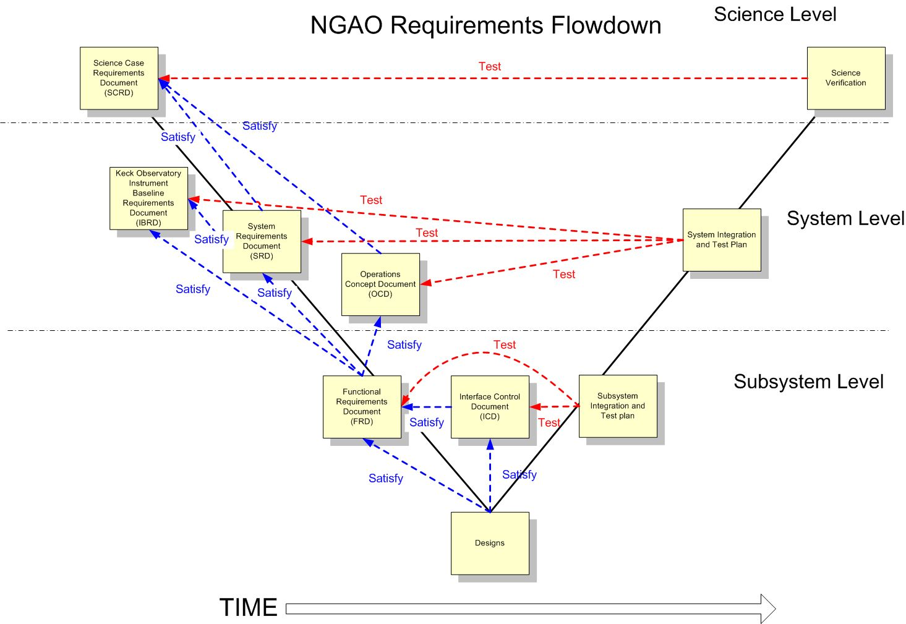
Figure 9. Modified V-diagram shown the requirements flowdown and relationship to testing.

Integration and Test
Our approach to integration and test is documented in KAON 581 and is shown schematically in Figure 10, along with the WBS numbers for each activity. This Figure is divided into subsystem development, lab I&T, summit preparation and telescope I&T sections. A philosophy that will be followed throughout this process is for subsystems and systems to be complete, including testing versus requirements, prior to transitioning to the next phase. This will be ensured by appropriate Reviews.

The subsystem development (WBS 4.0 to 6.0) and summit preparation (WBS 7.0) phase begins with the successful completion of the Detailed Design Review. These subsystems are intended to be complete and fully tested at the subsystem level prior to system lab I&T. Their readiness, as well as the readiness of the lab facilities, will be evaluated at a pre-lab I&T Readiness Review. The AO and laser systems undergo separate lab I&T efforts since they can largely be treated independently.

Readiness of the AO and laser systems, as well as the summit infrastructure to proceed to telescope I&T will be evaluated at a pre-ship review. Successful completion of this review will result in installation at the telescope followed by a sequence of I&T activities.

The pre-lab and pre-ship I&T Readiness Reviews will likely be separate events for the laser and AO system. Ideally the laser would have been implemented on the telescope prior to the AO system pre-ship review in order to minimize the time between decommissioning the existing AO system and implementing NGAO.

The Operability Review is a milestone intended to mark the point where the system and operations are ready to support shared-risk science observations. The system will continue to be characterized and optimized prior to the final handover to operations and regular science operations which will be marked by the Operations Readiness Review.

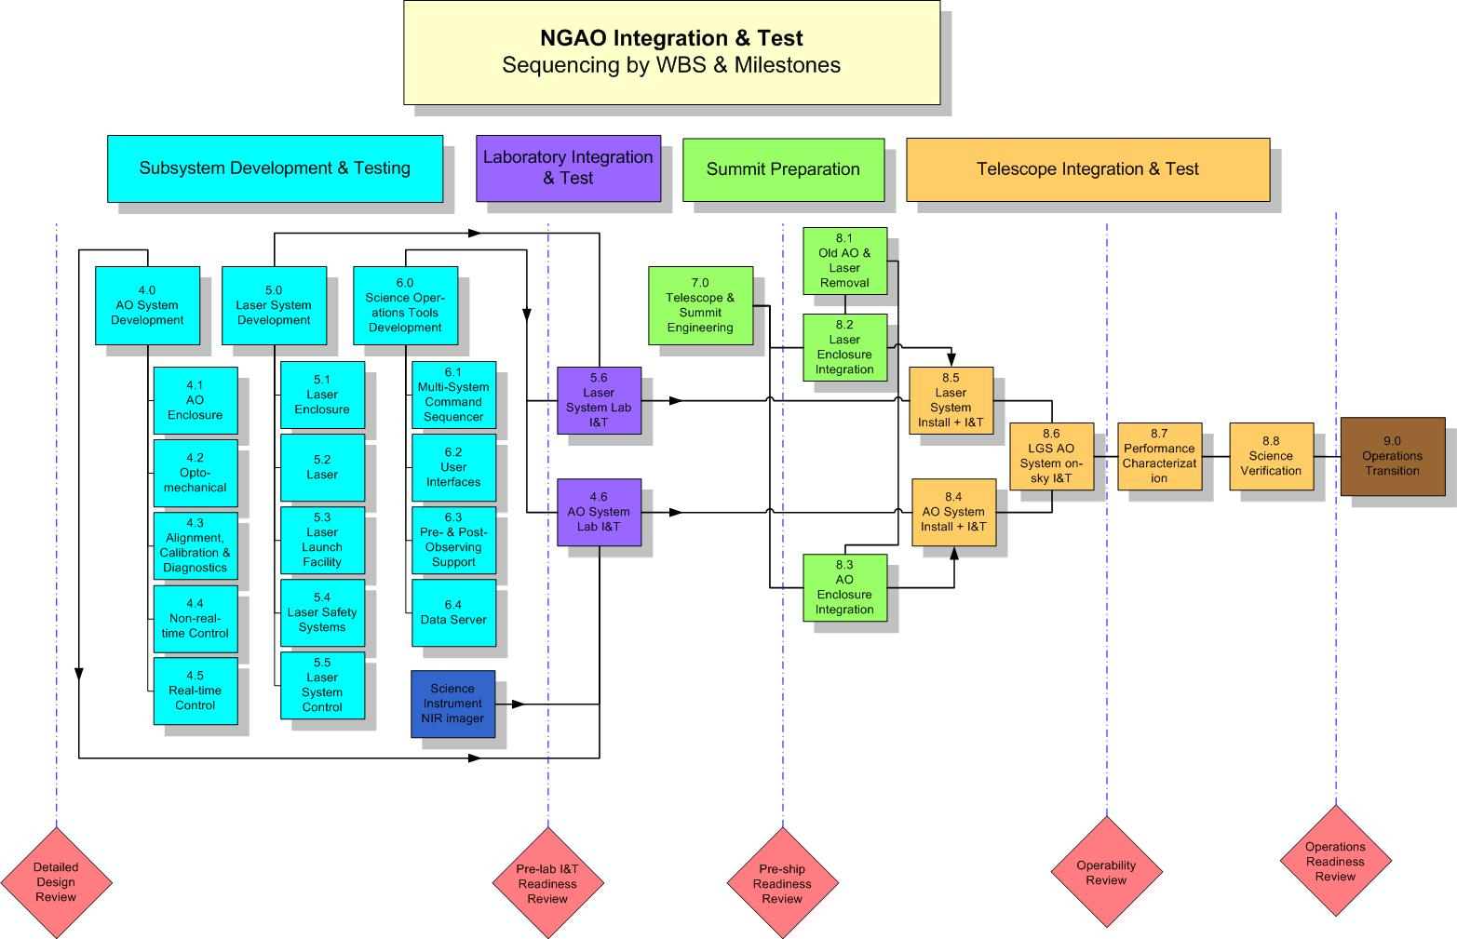
Figure 10. NGAO Integration and Test Approach.

Component Failure and Spares Approach
Two component failure issues need to be addressed: failures during development and failures during operations. The impact of failures during development and operations are different. Spares are one way to address failures and need to be considered in this context. Highly reliable components should be the standard.

The impact of a component failure depends on the development phase, its criticality to the subsystem and overall system, and the required time to troubleshoot, repair or replace the component. The failure of a key component during subsystem development could potentially result in the late delivery of a subsystem and the delay of system integration and test. The failure of a key component during lab or telescope integration and test could result in significant cost and schedule impacts.

A component failure during a science night must be addressed immediately, preferably by having a back-up mode of the instrument that does not require this component. It is important to have good tools and procedures for quickly identifying and repairing or replacing the failed component. The failed component should be able to be replaced or repaired prior to the next night or in the worst case before the next observing run.

A preventative maintenance program is required during operations to minimize the chance of component failures and to ensure the early detection of components that are starting to fail.

Failures can be addressed by a combination of troubleshooting and repair procedures, good component documentation, proper sparing, team expertise and vendor support (potentially including maintenance contracts).

Some component failures are more likely to happen during development than operations. Infant mortality is most likely during subsystem development, where more time is potentially available to replace it. An optic is more likely to be broken as it is being shipped or integrated during subsystem, lab or telescope integration.

For cost reasons not everything can be spared. We must therefore focus on the most critical components and the limited lifetime components. The likelihood and impact of a failure needs to be considered.

A partial list of key components and their recommended sparing was developed during the SD phase and was incorporated in the cost estimate. This list will be further defined during the remaining design phase. The sparing recommendation needs to include the number of units in the system, and some analysis of the consequence and likelihood of failure during both development and operations. This list could be integrated into the Product Structure MS Project tool.

Detailed Design Phase Plan

Decision Tree for Proceeding to DD
As of early May 2010 we do not have permission to proceed with the NGAO DD phase nor do we have the funding. This stems from the CARA Board decision in February 2009 that a lead private donor gift must be identified before proceeding beyond the PD phase. A lead gift will continue to be aggressively pursued at least through December 2010 but has not yet been identified. In the absence of a lead gift positive recommendations about NGAO, WMKO or new mid-scale proposal opportunities at the NSF in the Astro2010 decadal report, to be issued in August 2010, could influence the Board to allow the DD phase to proceed. The purpose of this section is to develop and discuss a decision tree for proceeding or not proceeding with NGAO.

The decision tree shown in Figure 11 assumes that we will use the existing NGAO PD phase TSIP funding to wrap up the PD phase, especially responding to reviewer recommendations, through the end of August 2010. This will provide the opportunity to determine the impact of the Decadal review report and more time for the lead gift search.

A decision will be made as to whether to proceed with the DD phase starting in September 2010 or whether the team should switch to developing an alternative AO plan. If the Astro2010 report recommends mid-scale project funding at the NSF or a lead gift is identified we could ask the Board for permission to proceed with the DD phase. In the mid-scale project funding scenario we would need to seek DD funds through TSIP in the September/October call for proposals in order to keep the project moving while mid-scale project funding was sought.

In the event of insufficient financial confidence we would at least temporarily switch to developing an alternative AO plan. This decision would be revisited at the end of CY10 in the event that the financial prospects for NGAO have changed. Ultimately we would either pursue the NGAO DD or the AO backup plan.

The goal of the backup approach is twofold. The near-term goal is to keep the NGAO team together through the end of CY10 to provide more time for seeking a lead gift. This is only partially accomplished in the WMKO FY11 budget. The NGAO development team at WMKO would stay fully employed in FY11 with the funded AO activities (the backup plan, completing the Keck I LGS implementation and developing the Keck II center launch telescope) and two proposed, but as yet unfunded proposals (ATI Keck I near-IR tip-tilt sensor and MRI new Keck II laser; we should know about the ATI proposal by June and the MRI proposal by September 2010). The COO and UCO NGAO participants would need to rely on projects at their Observatories (the ATI near-IR tip-tilt sensor proposal would also employ COO personnel).

The second goal of the backup approach is to develop a plan that would ensure Keck AO scientific competitiveness in the mid-term, in the event that we need to abandon the scientific leadership offered by NGAO. This plan would be developed over a 4 month period in close collaboration with the Keck science community. The rough scale of the backup plan, as defined in the WMKO 5-year budget plan would be $15M over 5 years.
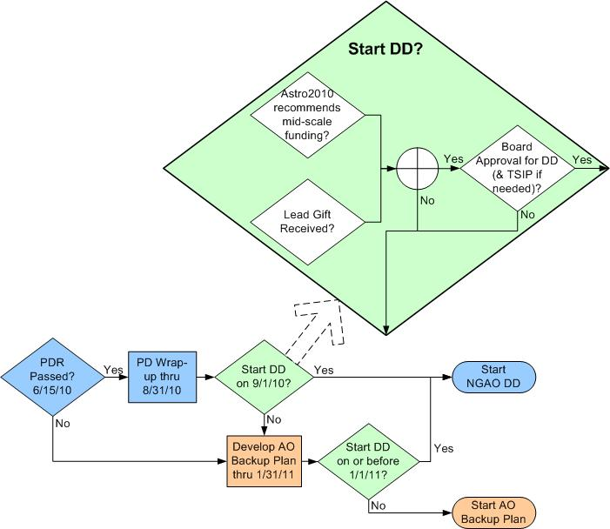
Figure 11: Decision tree to proceed (or not) to DD

DD Phase Management
The Detailed Design (DD) Phase management structure was shown in Figure 1.

Leadership responsibilities for specific parts of the detailed design are indicated in the MS Project Plan in section 3.6.

DD Phase Overview and Deliverables
The DD phase is the third and final design phase for WMKO development projects. This phase follows the preliminary design and precedes the full scale development phase.

In the Observatory’s development program, the detailed design phase has two primary objectives. The first objective is to complete the design, fabrication and assembly documentation for the system and all components, hardware or software, and show that the final design complies with all specifications and applicable standards. The second objective is to present the project plan to completion, including a schedule and budget.

DD Phase Work Breakdown Structure
The WBS structure for the DD is identical to this WBS numbering in Figure 4 except that each WBS element number is preceded by “1.4” and there is no WBS 1.4.1. For example, WBS 1.4.2 is the Detailed Design Phase Management and WBS 1.4.4.1 is the detailed design of the AO enclosure. This approach to the design phase WBS numbering was chosen to allow a separate budget and plan for the design phases.

DD Phase Planning Assumptions
The following assumptions were used in producing the detailed design phase plan:

- The collaboration between WMKO, COO and UCO will continue in the DD phase.
- The DD phase will start on October 1, 2010 in order to allow time to receive approval to proceed to this phase (note that approval requires the identification of funding).
- The availability of funding will force the DD phase to take 24 months.
- The NGAO launch telescope MRI proposal was funded. This development effort is not included in the DD phase plan, but it is linked with milestones.
- The MRI laser proposal will be funded. A replan will be needed, taking elements of the plan from this proposal, if this proposal is not funded. This development effort is not included in the DD phase plan, but it is linked with milestones.
- We can hire two new full-time NGAO positions at WMKO with start dates of January, 2011.

DD Phase Schedule
The level three version of the DD schedule (ignoring the initial “1.4”) is shown in Error: Reference source not found through Error: Reference source not found. The complete DD schedule can be found in section 11. The schedule includes WBS numbers, task names, number of work hours, start and end dates, dependencies, assigned personnel, actual labor rates, travel and procurements. The schedule at another level down is shown in Figure 13. This level of the WBS is the level at which the costs in Table 18 were taken.

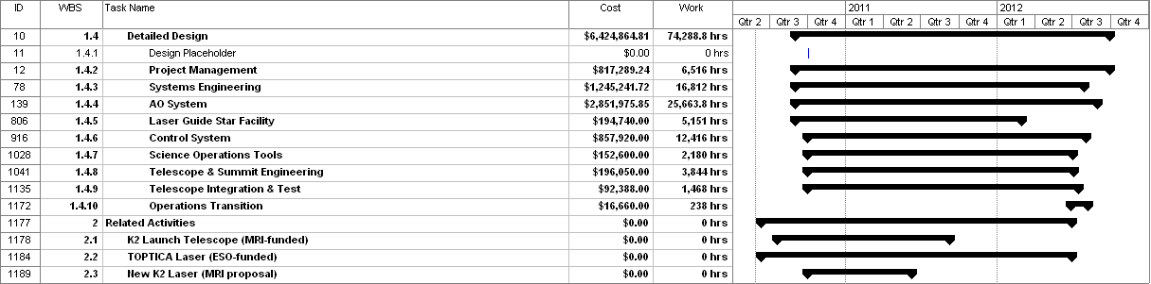
Figure 12: Top level view of the detailed design phase schedule

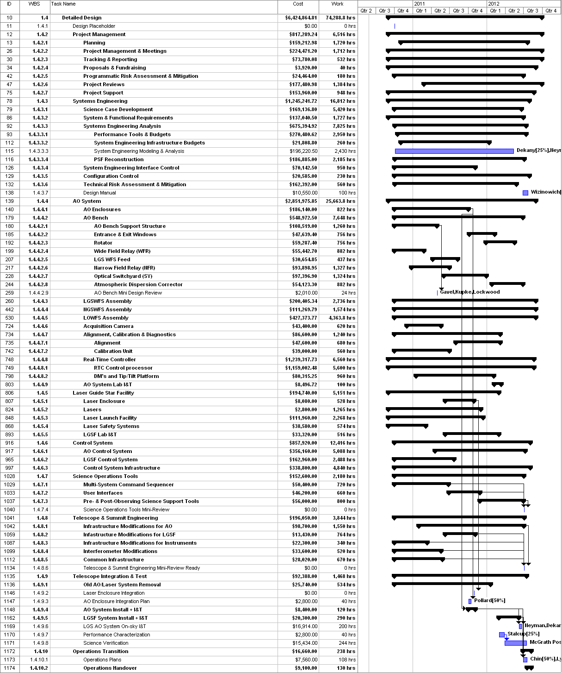
Figure 13: Detailed design phase schedule at the cost sheet level

The approach to developing this schedule was to: 1) develop the WBS and product structure, 2) incorporate this structure into an MS project plan, 3) apply the work hours from the cost estimation work sheets, 4) apply resources to the MS project plan, 5) iterate to produce a realistic schedule and 6) iterate to produce a realistic budget. Some non-DD phase tasks are included with zero hours in order to maintain WBS numbering for future phases.

We will track performance versus this baseline schedule. We will also update this schedule, with the original baseline maintained, as needed during the DD phase to ensure we achieve the DD goals within schedule and budget. Two replanning activities are included in the plan to address new information about the design or such issues as changing personnel availability or external constraints.

DD Phase Milestones
We did not find the major milestones identified as part of the SD SEMP to be particularly useful for driving the PD phase schedule (perhaps because we had to replan multiple times during the PD). What we did find to be very successful was to setup a series of mini-design reviews as described in section 7.6.

A list of the mini-design reviews we intend to hold during the DD phase is given in Table 20. Each of these reviews corresponds to a major design WBS element. The dates are the dates from the current MS project plan, but these will need to be verified to determine their viability.

Table 20: DD phase mini-design reviews

Unfortunately the mini-design reviews do not provide many useful milestones for earlier stages of the DD. For these earlier parts of the DD we will instead be careful to continue to track progress versus budget.

In addition to the mini-design review we also have key milestones associated with the MRI funded activities listed in Table 21.

Launch Telescope Milestone | Date
PDR | 7/21/10
DDR | 10/29/10
Delivery | 1/7/11
Commissioning complete | 9/7/11
Laser Milestone
Kick-off meeting & delta review | 6/10/10
DDR | 6/10/11
Pre-Production unit complete | 12/30/11
Laser unit 1 factory readiness | 6/29/12
Table 21: MRI funded related activity milestones

DD Phase Risk Mitigation
A risk assessment was performed in KAON 720. The technical risk matrix from this KAON is shown in Figure 14.

Figure 14: Technical risk matrix

The DD activities that directly respond to the moderate (yellow) technical risk items include the following (there are no high technical risks):
- Item 1. Inadequate PSF calibration to support precision astrometry, photometry and companion sensitivity science. A PSF reconstruction activity has been included in the plan. This plan has a total of 2185 hours, including 1665 hours of a PSF reconstruction expert, Laurent Jolissaint as a contractor. We have an existing collaboration through the end of CY10 with Gemini Observatory and the University of Groningen to demonstrate PSF reconstruction for the on-axis NGS case on the Gemini and Keck AO systems. The DD plan includes defining the appropriate PSF metrics for the key science cases, and developing and demonstrating on-sky with the Keck AO system the algorithms for the off-axis NGS, on-axis LGS and off-axis LGS cases, as well as the full NGAO algorithm.
- Item 5. Inadequate tomographic reconstruction accuracy to support the wavefront error budget and hence specific science cases. No budgeted activity other than the monitoring activities listed in the risk evaluation KAON.
- Item 6. Astrometry performance requirement not achieved. 260 hours have been assigned to the development of a full astrometry error budget during the DD. This effort will be led by Julien Woillez who has developed similar astrometry error budgets for the Keck Interferometer ASTRA upgrade. This work will be done in collaboration with the UCLA Galactic Center group.
- Item 26. Scattering from hybrid image slice reformatting optics exceeds acceptable limit. The most direct approach would be to procure a test optic, but this is not currently budgeted.
- Item 3. Required lasers unavailable. This is addressed by our MRI laser proposal and by our associated collaborations with ESO and TMT.
- Item 9. Complexity and instability of interactions in the overall software control system. This risk will be worked as part of the detailed design of the control system.
- Item 10. Adequate wavefront sensor CCDs not available. We have put financial resources into risk mitigation to address this issue. The budgeted approach is to prototype a CCID-74 camera. However, we will review this approach carefully versus other options before proceeding.
- Item 25. H4RG chip not available for DAVINCI. No budgeted action to be taken other than to develop a backup plan if needed.
- Item 4. Wavefront error budget not achieved due to inadequate assumptions and calculations. This is addressed in multiple ways in the plan. There are 700 hours assigned under systems engineering to the further development of the wavefront error budget and tool including component budgets. Under risk mitigation we have budgeted the effort and dollars needed to implement the proposed parametric oscillator approach for tip-tilt vibration mitigation on the existing Keck AO system to determine that it will satisfy our assumed vibration reduction.
- Item 11. Photometry performance requirement not achieved. 260 hours budgeted to further develop this error budget.

DD Phase Personnel and Core Team
Table 22 was used as a modified output of the MS Project Plan to help balance individuals and the hours per fiscal year. This table lists the names of all of the DD phase personnel. The work hours do not include any contingency time. Some cases of over assigning work to an individual are in italics. These will be addressed by a combination of transferring work to others and/or moving work into another FY.

Table 22. DD phase personnel assignments versus Fiscal Year (FY).

Table lists the 18 core team members and their roles during the DD phase. These include all individuals assigned to the plan at a level ≥ __%. These core team members bring a great deal of relevant experience to the project. Overall they represent __% of the DD phase labor. We consider __ and Neyman to be full-time on this project.

Table 23. Core DD phase team members.

DD Phase Budget and Contingency
The cost risks for the DD phase were tabulated in the DD phase cost worksheets. Overall we have identified 22% contingency for the DD phase. The estimated work is scheduled toward the beginning of the DD phase leaving contingency dollars at the end of the phase to cover work slippage. Problems will be handled as they arise but we will have funded schedule contingency at the end of the phase to ensure that the work is completed. We will also make sure that key personnel have some available time in the last few months of the project to be able to use these contingency dollars. To the extent that we can leave the contingency untouched we can also pull in the Detailed Design Review date.

As can be seen from Error: Reference source not found all of the contingency dollars are in FY11 and FY12 and as can be seen from the FY10 column of Table 22 we also have people available to use these contingency dollars on in FY10. To the extent that contingency is not needed we may therefore be able to complete the Detailed Design ahead of the current schedule. To the extent that contingency is required we have the people to perform the work.

DD Phase Management
NGAO management will be responsible for maintaining the DD phase budget and schedule for the DD phase.

Cost accounting and other financial and administrative matters will be done by WMKO. WMKO will be issuing contracts to CIT and UC to fund personnel at these institutions to participate in the DD phase, as was done for the SD and PD phases. COO and UCO will provide monthly financial reports to WMKO by the 20th of the following month. The PD phase actual expenditures will be tracked at the 1.3.X level of the WBS (i.e., 1.3.2 Management through 1.3.9 Operations Transition).

A monthly written project report will be provided to the Observatory Directors as was done during the PD phase. This input will also be used to give quarterly updates at the WMKO SSC meetings.

The team will have monthly teleconferences throughout the DD phase. Face-to-face meetings will be held on an as-needed basis. The NGAO senior management will alternate between weekly and bi-weekly telecons depending on the issues that need to be addressed.

Email will be used as a primary means of intra-project communications. Working documents will continue to be posted on the NGAO Twiki site:

http://www.oir.caltech.edu/twiki_oir/pub/Keck/NGAO/WebHome,

which proved to be a very productive shared work environment during the SD and PD phases. Documents will continue to be archived as Keck Adaptive Optics Notes on the KeckShare site at:

http://keckshare.keck.hawaii.edu/dsweb/View/Collection-218.

A Detailed Design Review (DDR) will be held as the culmination of this design phase. This review will be conducted in accordance with WMKO standards. To the extent practical we are expecting the same reviewers as for the Preliminary Design Review.

Full Scale Development and Delivery and Commissioning Phase Management

Phased Implementation and Descope Options

System Design Phase Summary
A summary of the system design phase performance versus plan (KAON 414) can be found in the preliminary design phase SEMP (KAON 574). The original schedule had the System Design Review on March 31, 2008. This review was held three weeks later on April 21, 2008. The system design phase plan had a total budget of $1170k (FY07 dollars) and was completed for $1234k (actual dollars); $739k in FY07 and $495k in FY08.

Preliminary Design Phase Summary

PD Phase Plan
The preliminary design phase SEMP, presented at the March, 2008 SDR, was documented in KAON 574. The PD phase cost estimate was $3479k in FY08 dollars, including $458k of contingency. The PDR date was February, 2010. This plan did not include any NGAO science instruments which were intended to be addressed separately.

Build-to-Cost
In August, 2008 the Directors requested the NGAO team to produce a new plan for a $60M NGAO cost cap (in then year $ from the start of the SDR to completion). Science instruments were to be included in this cost cap and were also added to the NGAO preliminary design task. A build-to-cost review was successfully completed in March, 2009. The revised PD phase cost estimate in FY08$ was $3284k including $441k of contingency. This did not include the cost to produce the instrument PDR (at that point we were still assuming separate instrument funding).

PD Funding
The original funding plan was to use $2047k of TSIP funding with the remainder of the PD budget coming from the Observatory. Due to financially difficult times a decision was made by the Directors to seek additional TSIP funding to complete the PD with a cap of $1228k. The September 2009 proposal to TSIP was successful. The result was that the total NGAO PD budget was reduced slightly (versus the build-to-cost budget) to $3275k. Unfortunately, the NGAO instrument ATI proposal was unsuccessful, so the TSIP funding was also needed to cover the instrument design work.

PD Budget Actuals
The PD phase actuals by WBS through April 2010 are shown in Table 24. The $197k of non-labor and $36k of travel can be compared to the SDR plan estimates of $216k and $214k, respectively (from Table 18 of KAON 574). The travel will be significantly underspent, but the non-labor $ should be fairly close (due to open subcontracts) by the time of the PDR.

Table 24. PD Actuals through April 2010.

A comparison with the labor hour estimate from the SDR SEMP (Table 14 in KAON 574) and with the Build-to-Cost estimate is shown in Table 25. We are currently running at ~1900 hours per month so by the time of the PDR the actuals will be very close to the original plan.

Table 25. PD actuals through April 2010 versus SDR and B2C plans.

There are significant discrepancies between the plan and the actuals in management and systems engineering. Part of this is due to the fact that research hours had originally been book-kept under management but ended up being charged to systems engineering (~2000 hours for McGrath). The Management hours are expected to increase significantly in May as the team focuses on the scheduled costing, planning and PDR activities in May and June.

Systems engineering also grew by ~1200 hours for requirements, partially as a result of the build-to-cost, but primarily due to the fact that the requirements needed significantly more work than we realized at the SDR. The additional systems engineering growth can primarily be assigned to the unplanned build-to-cost effort.

We were unsuccessful in applying significant resources toward WBS 1.3.7 to 1.3.9 during the PD phase, which will force much of this work into the DD phase.

The work on the NGAO science instruments was assumed to be covered outside the NGAO project at the time of the SDR. The instrument became part of the NGAO project with the build-to-cost guidance. Our ambitious plan, in the build-to-cost estimate, to get the instrument to a full PDR level by the time of the NGAO PDR was not accomplished due to a slow ramp-up of personnel.

PD Schedule Actuals
The SEMP presented at the SDR had a February 2010 PDR (Table 2 in KAON 574). Our June 2010 actual PDR date represents a 4 month slip on an originally 22 month plan (18% schedule slip).

PD Mini-Reviews
Toward the end of the PD phase we began scheduling a series of mini design reviews. These reviews were intended to wrap up the subsystem designs. Generally, three reviewers were assigned to each review. NGAO members not directly involved in the subsystem were frequently used as reviewers, although non-NGAO personnel were also used where sufficient expertise was not available within the NGAO team. The approach was to distribute the design KAON sufficiently in advance of the meeting in order for the reviewers to read the document and provide comments. Many of the comments were then addressed prior to the review and major points were discussed at the 3 to 4 hour review. The review committee provided a written report, the design team produced their own list of action items to address and the systems engineering team kept track of requirements and system level issues to be addressed. The goal for each subsystem was to use the mini-review input to ensure that that subsystem was at a PDR level prior to the actual PDR. The mini-design reviews that were held during the PD phase are listed in Table 26. The name of the review, the initials of the subsystem lead, the date of the review, the names of the reviewers (with the chair’s name in bold) and the KAON number for the reviewer’s report are provided in this table.

Table 26: PD phase mini-design reviews

PD Staffing
We encountered significant challenges in ramping personnel up for the PD phase. The slow ramp up is illustrated in Figure 15.

Figure 15. Actual labor $ per month by month during the PD phase.

The reasons for the slow ramp in the first 9 months of the PD phase were discussed in Project Report 9 (KAON 637): “The following items provide much of the explanation as to why we are so far behind versus the SDR schedule:
- There have been several significant unplanned tasks that were added at or after the SDR. These have especially impacted management time and attention. The result has been that some tasks had to be delayed because of design uncertainties, some tasks had to be delayed because people were assigned to new tasks and some tasks did not start because management did not have the time to get them started. These unplanned tasks have included:
  - The build-to-cost direction received in August 2008 has had the biggest impact.
    - Time has been spent on identifying and evaluating design options. Prior to receiving this guidance we had been evaluating phased implementation options per the SDR recommendation (a task that was included in the plan presented at SDR).
    - The development of science instrument preliminary designs and costs was a new task for NGAO management.
    - Uncertainties about the science direction have made it more challenging to make some of the build-to-cost decisions. The NGAO Science Advisory Team has not been established in time to support the build-to-cost exercise. The Keck Strategic Planning Meeting held in September 2008 and documented subsequent to the November 2008 SSC meeting has provided some guidance but in some cases the intent of the strategic plan has not been entirely clear and we have had to add our own interpretation.
  - The NFIRAOS cost comparison, which was successfully completed.
  - The ATI and MRI proposals. Both were successfully submitted.
  - The opportunity for joint preliminary designs and risk reduction activities on lasers has also been an originally unplanned task, however it has actual largely allowed us to stay on schedule at lower cost. We have leveraged our interests to include a 500 kEuro investment by ESO in preliminary designs and $300k of funds from AURA to be used for risk reduction.
- The availability of personnel has been an issue at all three of our organizations.
  - Immediately after the SDR two key personnel (Britton and Zolkower) became unavailable at Caltech. One was replaced in January and the other position was not refilled. Dekany has also been less available than planned.
  - The departure of Le Mignant from WMKO has impacted the science operations requirements and tool design. Similarly Flicker’s departure has had a significant impact on our parallel PSF reconstruction risk reduction demonstrations. There were also delays in ramping up Johansson and other members of the controls team from other projects (this is complete).
  - At UCO our Project Scientist has been less available than planned. The delayed availability of a real-time programmer has been mainly offset by more of Reinig’s time.”

Appendix: NGAO Detailed Design Cost Estimate Summary (in FY08 $K)

Appendix: NGAO Full Scale Development Cost Estimate Summary (in FY08 $K)

Appendix: NGAO Delivery and Commissioning Cost Estimate Summary (in FY08 $K)

Appendix: Full NGAO Detailed Design Phase Schedule
