Keck NGAO Relay Design
Renate Kupke
March 16, 2009
Revised, June 12, 2009

- Introduction
This document presents the preliminary optical design for the Keck Next Generation Adaptive Optics Relay. The design is based on results of the conceptual design study, KAON 549, and subsequent build-to-cost reductions and guidelines. Section 2 of this document outlines some of the main requirements the optical design must satisfy. Section 3 describes the components of the optical relay in more detail, and in Section 4 the performance of the relay with regard to science instruments and wavefront sensors is discussed.

- Requirements
The requirements, as defined in KAON 549 for the conceptual design, have altered somewhat due to build-to-cost guidelines. The current requirements include, but are not limited to:
- Location:
- The AO system will reside on the Nasmyth platform
- Field and Pupil Rotation:
- The optical relay will have a K-mirror upstream of the science instruments, wavefront sensors, and tip-tilt sensors.
- Field of View:
- A high Strehl science relay with a field of view (FOV) of between 20 and 40 arcseconds.
- A 120 arcsecond diameter FOV at the focal plane of the first relay, providing natural guide stars (NGS) for tip-tilt and low-order wavefront sensing (LOWFS).
- Pupil Diameter:
- The first relay shall contain a low-order, 20x20 actuator “woofer” mirror, conjugate to the telescope primary, with a diameter of 100mm (we also considered a 7mm pitch, 140mm diameter DM).
- The second relay shall contain a high-order MEMs “tweeter” deformable mirror, conjugate to the telescope primary, with a diameter of 25mm.
- Output pupil location:
- The exit pupil for the first relay will be telecentric to simplify design of the LOWFS and HOWFS pick-off mechanisms.
- Output focal ratio:
- The output focal ratio of the first relay shall match the focal ratio of the f/15 Nasmyth telescope focus
- The output focal ratio of the second relay shall be greater than f/45 to allow for the optical switchyard.
- Laser-guide star wavefront sensor:
- The optical relay shall provide an unvignetted focal plane for the laser guide star wavefront sensor (LGS WFS), conjugate to the sodium layer varying from 90km to 180km above the telescope depending upon zenith angle varying from 0 to 60 degrees, respectively.

- First-Order Optical Layout
An annotated optical layout is shown in Figure 1. The following sub-sections describe each component of the optical relay in detail.
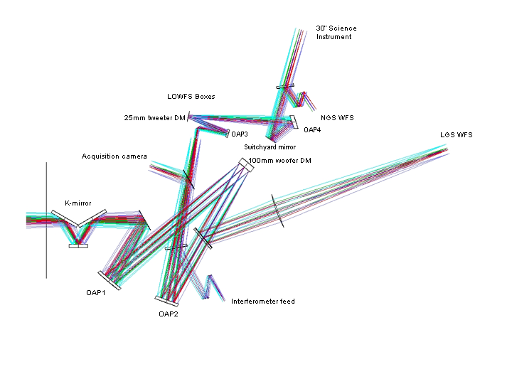

Figure 1 Annotated optical layout of the 1-tier, cascaded relay. Light from the telescope tertiary mirror enters from the left. The first, f/15 matched-OAP relay contains a 100mm woofer DM conjugate to the telescope primary. The second, f/46 OAP relay contains the 25mm MEMs tweeter DM conjugate to the telescope primary. The LGS dichroic picks off laser light, which is directed to the LGS WFS. Pick-offs for the tip-tilt and low-order wavefront sensors (LOWFS) lie at the focal plane of the f/15 relay, and are not shown in this figure. There are also removable dichroic beamsplitters for the interferometer, the acquisition camera, and the natural guide star wavefront sensor

  - K-mirror rotator

As in the conceptual design phase, the Nasmyth focus lies between the first and second mirrors of the K-mirror assembly (K1 and K2, respectively). The focal plane is located 121mm after K1. The location of the focus provides adequate space for the first off-axis parabola (OAP) of the relay, as described in the next section. The existing Keck AO relay has the first element of the K-mirror positioned after focus. The decision to move the focus to a point within the K-mirror assembly was based on the need to accommodate a smaller woofer DM (100mm versus the existing 140mm diameter), and thus a shorter focal length OAP1.

The K-mirror consists of 3 mirrors, the first and third being tilted at 60 and -60 degrees, respectively, to the Nasmyth optical axis. The tilt angles are identical to the present Keck AO K-mirror assembly. The mirrors diameters are as follows: K1=250mm, K2=160mm, and K3=270mm. K1 is slightly larger than the present Keck AO K-mirror’s K1 because of the need to pass both the LGS and NGS 120 arcsecond FOV. K2 is the same size as the existing K2, and K3 is slightly smaller. The distance between K1 and K2, and K2 and K3, is 243.5mm, as in the existing Keck image rotator. The mechanical design of the K-mirror assembly can therefore be very similar to that of the existing K-mirror.

  - First Relay
The first relay consists of two matched off-axis parabolas, the first of which produces, in collimated space, a plane conjugate to the primary mirror at which the 100mm woofer DM is placed. In the collimated space after the 100mm diameter deformable mirror lies a dichroic designed to reflect laser guide star light (589nm) to the LGS WFS, and pass all other wavelengths. The second OAP of the matched pair relays the Nasmyth focus to a second focal plane, preserving the f-number of the input beam. In the converging light following OAP2 are removable dichroic pick-offs to the interferometer and acquisition cameras.

It has been decided that in order to reduce cost and complexity of the mechanical design, and due to the smaller field and thus smaller K-mirror assembly, the previous 2-tier cascaded relay from the conceptual design phase would be redesigned on one level. In order to accommodate the-one tier design, an additional fold mirror was needed in the diverging optical space following the K-mirror. This fold mirror lies 450mm after K3, with an incidence angle of 30 degrees and a diameter of 200mm. The present Keck AO relay contains a similar fold mirror, which is used also as a tip-tilt steering mirror. It was decided not to incorporate this fold as a tip-tilt location, as its conjugate location is 22km above the telescope, and a location conjugate to the telescope pupil was preferred to lessen the stroke requirement of the tip/tilt stage.

OAP1 has a focal length determined to meet the requirement of a 100mm pupil on the woofer DM by the following equation:

where and are the diameters of the deformable mirror (100mm) and the telescope primary (10.949m), respectively, and is the focal length of the telescope (149.583m). This gives a focal length for OAP1 of 1366.2mm.

In an effort to reduce cost the off-axis angles (OAA) of the OAPs have been reduced from 25° to 20° in the preliminary design phase. This also results in slightly less wavefront error in the path of the laser guide star wavefront sensors. This wavefront error results from the laser guide stars’ location at a finite conjugate, while the relay is optimized for an infinite conjugate (discussed in more detail in section 4). The OAA of 20° results in a decenter of 481.8mm from the center of the parent parabola.

The woofer DM follows OAP1, at a distance from OAP1 conjugate to the telescope primary mirror:
Equation gives a total OAP1 to woofer DM distance of 1603mm.

The woofer DM is nominally 20x20 actuators (5mm pitch), and will be mounted on a real-time, tip-tilt platform. Due to the incident angle of 10° the pupil will be elongated by 1.5%.

In collimated space, 700mm after the woofer deformable mirror, lies the dichroic beamsplitter that will pick off the 589nm light of the sodium laser guide stars and direct it to the laser guide star wavefront sensors. The beamsplitter has an incidence angle of 20° to the optical axis, and a diameter of 225mm

Following the woofer DM is OAP2, an off-axis parabola whose parameters exactly match those of OAP1 to minimize aberrations at infinite conjugate. It is located one focal length (1366mm) away from the woofer DM, projecting the pupil to infinity and providing a telecentric beam for the second relay and low-order wavefront sensor (LOWFS) relays. A telecentric system was chosen to simplify the design of the LGS WFS and LOWFS pick-off mechanisms and wavefront sensors. A telecentric system does not require tilt with field to keep the chief ray constant on entering the wavefront sensor. There are also no pupil scale changes with conjugate distance for the LGS WFS.

  - Tip-tilt platform
During the preliminary design stage, inquiries were submitted to vendors regarding the mounting of the woofer deformable mirror on a fast tip-tilt stage. Primarily, we desired a comparison between the performance and cost of mounting a 100mm diameter piezo-electric DM versus the larger 140mm diameter DM. CILAS provided information about the SAM 416 (Gemini 4.5) and the SAM 349, (GTC), 349 actuator deformable mirrors, shown in Table 1. These two mirrors are similar to our requirements for 100mm and 140mm woofer DM.
Table 1 Characteristics of existing CILAS DMs.
DM | # actuators | pitch | aperture | Max stroke PV | weight | volume
SAM 416 | 416 | 5.0mm | 106mm | 7.8μ | 6.5kg | 15x16x10cm³
SAM 349 | 349 | 7.0mm | 140mm | 8.4μ | 14.4kg | 22x22x20cm³

The mirrors listed in the table above were not intended for mounting on a tip/tilt platform. CILAS estimated that the weight of these DMs could be decreased by as much as 20% by changing the mechanical packaging in consideration of the tip/tilt platform mounting. When contacting the vendors, I specified a 38.5Hz closed-loop bandwidth (the most stringent tip/tilt bandwidth requirement contained in the science cases), the ability to compensate for the 28Hz telescope vibration in an as-yet-unspecified feed-forward fashion, and a maximum mechanical stroke of approximately 1 miliradian (to achieve the 3 arcseconds stroke indicated in the requirements database). Momentum compensation was also required to minimize vibration on the optical table.

Three vendors responded positively: CILAS, Physik Instrumente, and Left-hand Design. The bandwidth requirements, considering the weight and dimensions of the deformable mirror, are challenging. Table 2 summarizes the results of the inquiry. Physik Instrumente and Left Hand design indicated that the 140mm, with its 14.4kg weight, would be difficult to achieve at the specified bandwidth. CILAS, although not giving exact bandwidth values, suggested the 140mm diameter mirror would operate at a 30% decreased bandwidth over the 100mm. For this reason, the 100mm DM was chosen as baseline for the AO relay design.

In appendix A I’ve included the correspondence from the vendors regarding system performance.
Table 2 Results of initial vendor inquiries into tip/tilt stage.
 | CILAS | PI | Left-hand Design
Cost, ROM pricing | Adds 50-100% to cost of a DM | $240K | 450-950K over 4 development stages
Predicted achievable bandwidth | ? has reached 50Hz for TMT prototype | 200Hz resonant frequency, claims 50Hz closed-loop | Open-loop servo control: Phase 1:20Hz, Phase 2: 50Hz, Phase 3 100Hz, Phase 4 200Hz
sensor |  | Capacitive
type | Voice coil? | Piezo | Voice coil

  - Laser Guide Star WFS
As illustrated in Figure 1, between the woofer DM and OAP2 is a fixed dichroic beamsplitter which will reflect sodium guide star light to the laser guide star wavefront sensors (LGS WFS). The dichroic was placed in collimated space to minimize aberrations in the science and low-order wavefront sensor beams. The LGS WFS does not receive a performance benefit from the matched OAPs due to the finite location of the laser guide star objects, nor do they share the same static aberrations as the science and tip-tilt stars, thus no loss in performance or increase in calibration complexity is incurred by using a separate focusing element for the laser guide stars.

The dichroic pick-off will ideally be a notch filter, reflecting only the sodium (Na) laser guide star wavelength of 589nm. A notch filter was chosen to allow visible light below 600nm to be available to the visible truth wavefront sensor (TWFS) located in the low-order wavefront sensor (LOWFS) assembly. The dichroic has an incidence angle of 20°. The optical layout for only the LGS WFS section of the AO relay is shown in Figure 2. Because the LGS WFS dichroic lies downstream of the woofer DM, the LGS WFS will operate in closed-loop.
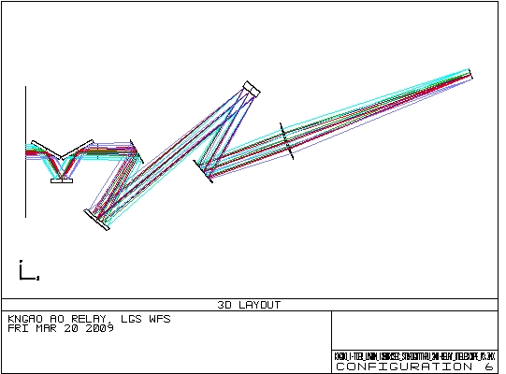

Figure 2 The LGS WFS optical relay.

The object selection mechanism (OSM) for the LGS WFS requires a focal plane, thus the collimated light reflected from the LGS dichroic is brought to focus by a single glass plano-convex lens. Zemax modeling indicates that this lens will produce less wavefront error if the convex surface is a parabola (see figure 3). The radius of curvature of the lens was chosen to maintain the 1:1 magnification of the relay, and gives an working f/# of 13.52.The lens is located one focal length away from the woofer DM, to provide a telecentric beam for the LGS OSM and relays.

In the converging beam following the lens, there is adequate space for a removable mirror providing a 90° reflection to a visible laser guide star acquisition camera if one is desired.
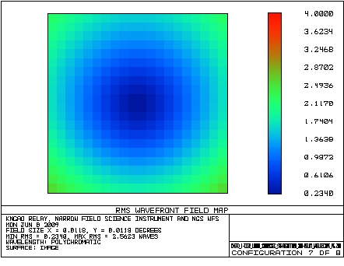
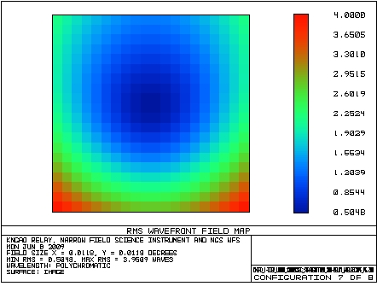

Figure 3 Comparison of RMS wavefront error over the LGS WFS field with a parabolic plano-convex focusing lens (left) and a spherical plano-convex focusing lens (right). Final focal planes are adjusted for tilt and field curvature.
  - Interferometer Feed
Located 500mm after OAP2 is a removable dichroic available to feed the Keck interferometer. The interferometer will be used in conjunction with Keck NGAO, and therefore simultaneously with the LOWFS. The dichroic will therefore transmit J-band light to the LOWFS, while reflecting H and K. The dichroic has an incidence angle of 20° and a diameter of 190mm. A wedge of 0.17° on the second surface of the dichroic removes lateral color over J-band at the LOWFS plane.

The interferometer dichroic directs the starlight to two field-steering mirrors, which in turn steer the beam into the dual star-module in a way that is still TBD.

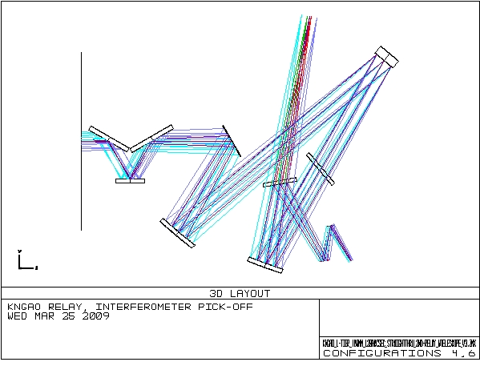

Figure 4 KNGAO relay showing interferometer pick-off and LOWFS focal plane.

  - Wide-Field Relay to Acquisition Camera and LOWFS.
After the dichroic LGS WFS pick-off, the beam is refocused by OAP2 to produce an f/13.66 focal plane at the LOWFS pick-off plane. Located 350mm before the focal plane is a removable mirror, allowing an 100° reflection to an acquisition camera. The NGS acquisition camera will obtain images of the entire 120 arcsecond diameter field and allow acquisition of the natural guide stars for the LOWFS. The LOWFS focal plane and acquisition camera pick-off are shown in Figure 5.

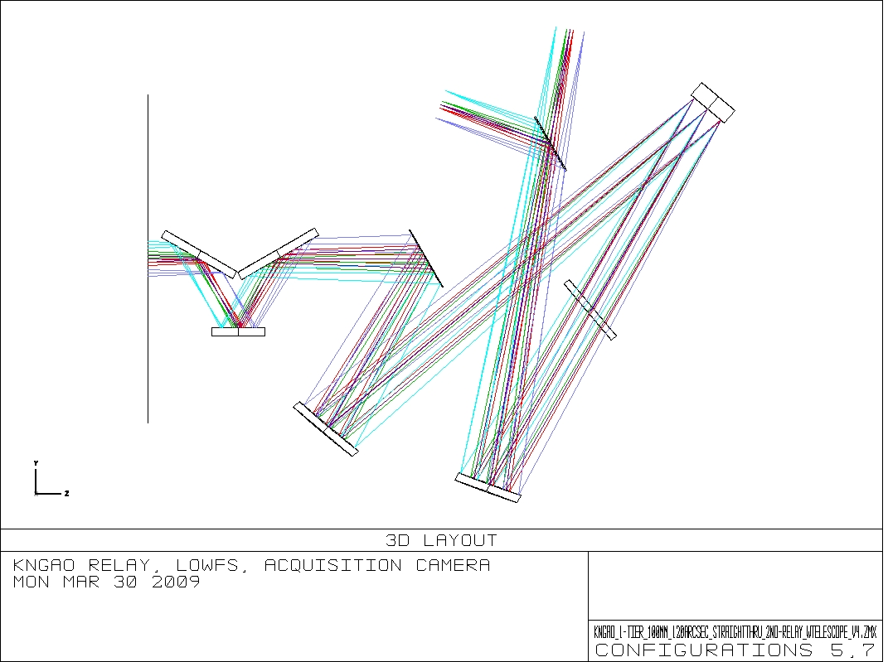

Figure 5 Wide-field relay, passing 120 arcseconds to tip-tilt sensors and low-order wavefront sensors. A removable mirror provides the acquisition camera with the entire 120 arcsecond field of view.

  - Narrow-field, High Strehl Relay
Within the plane of the LOWFS pick-offs will be an unobstructed aperture to pass a 40x60 arcsecond rectangular field of view to a narrow-field, high Strehl relay. Although the science instruments require only a 40 arcsecond field of view (FOV), the larger 40x60 arcsecond rectangle was chosen to increase the patrol field of the natural guide star wavefront sensor. The optical path is shown in Figure 6. Directly after the focal plane, a fold mirror directs the light perpendicular to its original direction to allow space for following optics (specifically the MEMs deformable mirror package) within the LOWFS pick-off packages.

The narrow-field relay of the KNGAO consists of two unmatched OAP mirrors producing a 25mm pupil image on the tweeter DM and a f/46 output beam to feed the NIR imager, the deployable integral field spectrograph (dIFS), and the natural guide star wavefront sensor (NGS WFS). The tweeter deformable mirror is a 64x64 actuator MEMs device accommodating a 25mm diameter pupil. The tweeter mirror has an incidence angle of 10°.

Using Equation (1), we can determine the focal length of the OAP needed to produce a collimated beam with a 25mm telescope primary image on the tweeter DM. In this case, we substitute for and for , to get .5mm, or exactly th the focal length of OAP1. The pupil, at the end of the first relay, is telecentric, so the tweeter DM lies away from OAP3. The requirements dictated a focal ratio greater than f/45 for the beam exiting the relay, in order to provide space an optical switchyard and instruments. . is thus 3 times larger than , or 1024.5mm. It is located exactly one focal length away from the tweeter mirror, to provide a telecentric beam for the instruments.

A switchyard mirror, at 400mm beyond OAP4, directs the beam to the science instrument(s). The incident angle of the mirror is 20°. This mirror could, in principal, be used to direct the beam to other instrument locations, including below and above the optical plane. This allows easy expansion of KNGAO to feed additional instruments in the future.
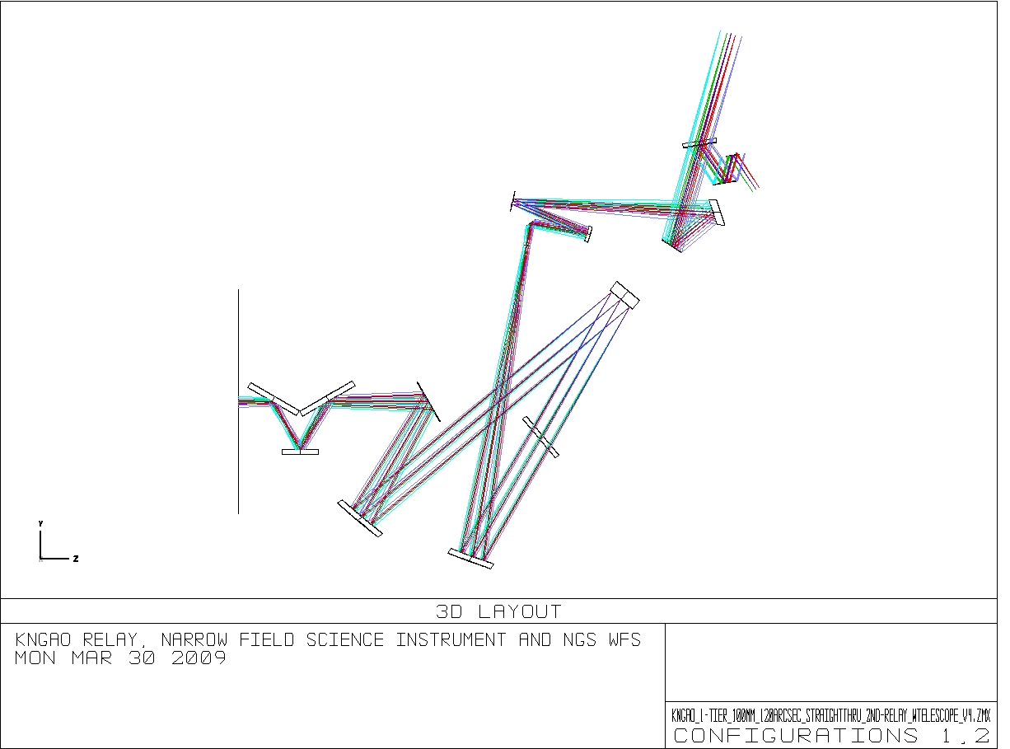

Figure 6 The 40 arcsecond FOV science instruments and NGS WFS are fed by the second OAP relay.

  - Natural Guide Star Wavefront Sensor (NGS WFS)

A set of removable dichroics is located 505mm beyond the switchyard mirror, with an incidence angle of 25°. The field for the NGS WFS can be acquired using two field steering mirrors in the NGS WFS optical path. A patrol field larger than the science FOV was desired for the NGS WFS, so the 2nd relay optics were designed to accommodate a rectangular 40x60 arcsecond field. A diagram of the field, and it’s relation to the science and LOWFS fields, is shown in figure 6.

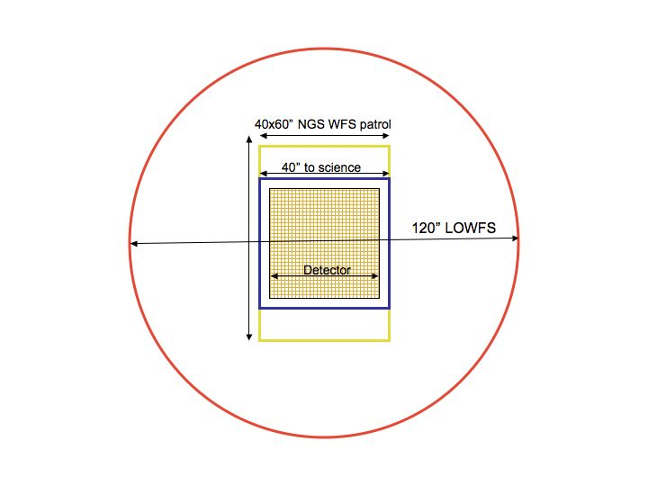

Figure 7 Outline of respective fields of view. The 120” diameter LOWFS patrol field (red), the rectangular 40x60” NGS WFS patrol field (yellow), the field available to the science instrument (blue) and the detector area (orange hatched).

It is expected that the science instrument will be required to operate down to wavelengths as short as 0.8 μ (possibly 0.6μ?). There are times, therefore, when the NGS WFS dichroic will be required to transmit light from 0.8-1.0μ to the science instrument. For science observations at wavelengths greater than 1.0 μ it would be unfortunate to waste light between 0.8-1.0μ which could be reflected to the NGS WFS. Therefore, there will be options available for a dichroic which passes everything under 0.8μ, a dichroic which passes everything under 1.0μ, and no dichroic, when the LGS WFS is being used.

It has also been proposed that the NGS WFS could act as a LOWFS when the observer requires the science object as a wavefront sensor reference.

  - Science Instrument
The NIR instruments are fed directly by the f/46 narrow-field relay output. In the beam between OAP4 and the instrument is one removable dichroic. The dichroic has a wedge angle of 0.4° to correct lateral color at the instrument plane. When the dichroic is removed, the focal position of the beam will shift both laterally and along the optical axis. The lateral shift can be compensated with a re-pointing of the telescope. The shift in focal plane may be removed with a telescope focus adjustment. A 20mm thick dichroic tilted at 25° causes roughly 7mm of focal plane shift. The instrument focal length has a finite curvature (discussed in the performance section 4.2).

- Performance

To determine the performance of the optical system, several sources of optical degradation were analyzed using Zemax in the wavelength passbands used by the individual science instruments and wavefront sensors. The passbands are defined in KAON 530.

The optical relay was modeled in conjunction with the Keck primary and secondary mirrors, to ascertain the combined effects of the two optical systems.

Field points used were the maximum off-axis fields defined for each instrument. The wavefront errors and RMS spot radii quoted are the worst-case for the field points analyzed.

According to Zemax, the working f/# of the wide-field relay is f/13.66 and of the narrow-field relay is f/46.42. Airy disk sizes are defined by
and the depth of focus (DOF ) is defined by.

In the Zemax model, both the woofer and tweeter DMs are represented by Zernike Standard Sag surfaces. This allows correction of wavefront errors in the same way a deformable mirror would compensate for static errors. I used coefficients from the Zemax Zernike coefficient analysis tool, converted to mm Sag, to determine the magnitude of zernike applied to the surface. Of course, in most cases the aberration was field dependent, so an effort was made to achieve good performance over the entire field of regard.

Chromatic focal shift and lateral color, where applicable, were evaluated for different wavelength ranges using the Zemax analysis tools. Lateral color and chromatic focal shift arise only in beam paths in which there are transmissive optics, such as dichroic beamsplitters, and not at all in purely reflective systems.

- LOWFS
Except in the case of interferometer observations, the only non-reflective optic preceeding the LOWFS is the LGS dichroic beamsplitter, which is located in collimated space. Chromatic aberrations over the wavelength range used by the tip-tilt and low-order wavefront sensors is thus very small.

The insertion of the dichroic during interferometer use will lead to both lateral color and chromatic focal shift. Chromatic aberrations are uncorrectable with a deformable mirror, but the lateral color can be minimized by introducing a small wedge angle to the second surface of the interferometer pick-off dichroic (on the order of tenths of a degree). This wedge angle will introduce astigmatism in the wavefront of the LOWFS beam, which can be removed by the DMs located on each natural guide star’s optical path (see KAON 551, Wavefront Sensor System Design Report).

The matched OAPs used in the first relay give excellent performance over a wide field at infinite conjugate. The values given in Table 1 indicate the maximum wavefront error and RMS spot radius over the 120 arcsecond field of patrol. The woofer mirror was deformed to provide excellent performance across the entire field, but even with a flat woofer mirror the first relay gives diffraction-limited performance over the entire 120 arcseconds. Additionally, each LOWFS path will have it’s own deformable mirror for correction at each natural guide star direction.

Table 3 Performance of the LOWFS in simultaneous J and H bands
Instrument  (mode) | λ (μ) | F/# | FOV ″ | Fld curv.  (mm) | RMS WFE (nm) | RMS Spot Radius (μ) | RMS Spot Radius (mili-″) | Airy radius  (μ) at 1.17μ | Lateral color (μ) | Chrom. Focal shift (μ) | Depth of focus*  (mm)
LOWFS | 1.17-1.78 | 15 | 120 | 1200 | 35 | 4 | 5.5 | 19.5 | 0 | 0 | 0.9
LOWFS with interferometer | 1.17-1.78 | 15 | 120 | 1200 | 45 | 5 | 7 | 19.5 | 1.3 | 91 | 0.9

- Science Instruments, Narrow-field Relay
As explained in section 3.6, the narrow-field relay passes a rectangular 40x60 arcsecond field of view, the central 40x40 arcseconds of which are intended for science observations. It consists of two unmatched OAPs resulting in an increase of focal ratio to f/46. The larger focal ratio results in an image scale of 2.45mm/arcsecond at the focal plane, and an Airy radius of 56.6μ (23 mili-arcsecond) at 1μ wavelength. The science instrument is intended to cover a wavelength range from z-band (0.8 μ) to K-band (2.4μ).

In optimizing the second relay science path with the deformable mirrors, the correction applied to the woofer DM when evaluating the LOWFS in section 4.1 also provided the best correction over the field in the second relay. The aberrations resulting from the non-matching pair of OAPs in the second relay are strongly field dependent, so a correction applied to the tweeter DM does not result in better performance over the whole field.

When the science instrument is being used with the NGS WFS dichroic in place, a very small amount of chromatic aberration results. The NGS WFS has been designed with a small wedge (0.4°) angle on the second surface to minimize lateral color over the entire wavelength range. The astigmatism the NGS WFS dichroic produces is easily corrected by the tweeter DM, but will not be seen on the NGS WFS and so will need to be measured through another means (image sharpening, etc.).

Table 4 Performance of the Narrow-field relay with the NGS dichroic in place.
Observing band | λ (μ) | F/# | FOV ″ | Fld curv.  (mm) | RMS WFE (nm) | RMS Spot Radius (μ) | RMS Spot Radius (mili-″) | Airy radius  (μ) | Lateral color (μ) | Chrom. Focal shift (μ) | Depth of focus*  (mm)
z-band | 0.85-1.05 | 46 | 40 | 300 | 25 | 22 | 9 | 48 | 2.9 | 28 | 6.8
Y-band | 0.97-1.07 | 46 | 40 | 300 | 25 | 22 | 9 | 55 | 0.7 | 11.8 | 8.4
J-band | 1.17-1.33 | 46 | 40 | 300 | 25 | 22 | 9 | 66 | 1.2 | 17 | 10
H-band | 1.49-1.78 | 46 | 40 | 300 | 25 | 22 | 9 | 84 | 1.9 | 34 | 13
K-band | 2.03-2.37 | 46 | 40 | 300 | 25 | 22 | 9 | 115 | 2.9 | 53 | 18
NGS | 0.6-1.0 | 46 | 40 patrol | 300 | 24 | 22 | 9 | 34 | 0 | 0 | 3.5

The NGS WFS encounters only reflective optics, so does not suffer from chromatic aberrations. The analysis above does not include the effects of an atmospheric dispersion corrector, which may be required in the instruments’ beam path and for the NGS WFS.

Figures 7 shows the degradation of the optical performance with field angle, due to the unmatched OAPs used in the second relay. Figure 8 shows an example of the spots at the on-axis, mid, and extreme field angles of the science instrument.

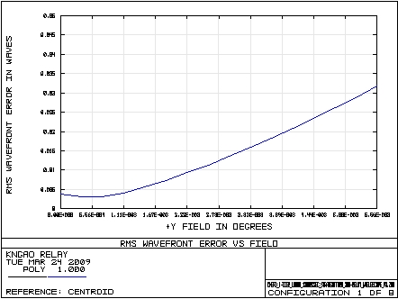

Figure 8 WFE as a function of field at the output of the second relay. Field size is 40 arcseconds diameter. Wavelength is 1μ.

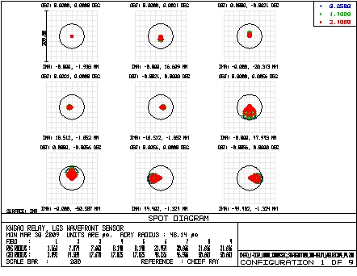

Figure 9 Spots at the focal plane of the second relay. Extreme field points correspond to a 40 arcsecond diameter field.

  - Laser Guide Star Wavefront Sensor (LGS WFS)

The LGS WFS dichroic pick-off lies in the collimated space between the woofer DM and OAP2. The laser guide stars, over a 120 arcsecond diameter patrol field, are re-imaged using a 1-glass biconvex lens with an parabolic convex surface. The lens chosen need only work at the wavelength of the sodium line (589nm), so chromatic aberrations are not an issue. This lens was optimized for 90km, but as mentioned in section 3.3, other zenith angles may be considered (the performance varies by only 10s of mas between 90 and 180km, so this is not seen as a huge potential improvement). Table 5 details the performance of the LGS WFS relay. The focal plane of the LGS WFS is tilted by 4 degrees and has negligible field curvature.

Values quoted in Table 5 are at the edges of the field, and thus represent the worst case performance. Figure 9 displays the RMS wavefront error as a function of field. Figure 10 shows spot diagrams on-axis and at extreme field positions.

Table 5 Performance of LGS WFS
Conjugate height | FOV, arcsec | Field Curvature (mm) | RMS WFE (μ) | RMS Spot Radius (milli-arcseconds)
90km | 120 | none | 1.4 | 233
180km | 120 | none | 1.6 | 265

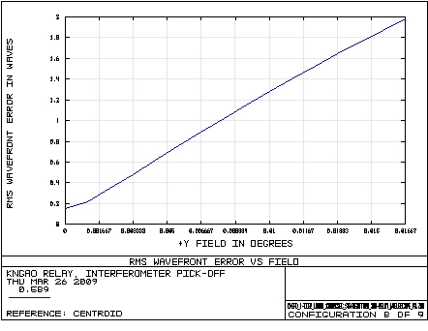

Figure 10 WFE as a function of field at the LGS WFS. Wavelength is 0.589μ, observations at zenith (distance is 90km). Field is 120 arcseconds in diameter.

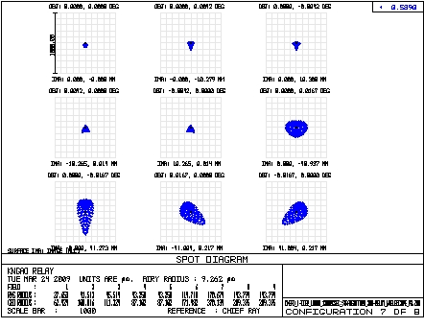

Figure 11 Spots at the focal plane of the LGS WFS. Wavelength is 0.589μ, observations at zenith (distance is90km). The spots on the edge of the 120 arcsecond diameter field are roughly 235 miliarcseconds on-sky.

To determine whether this amount of laser guide star wavefront aberration is acceptable requires further analysis. As seen in Figure 10, the spot size of the laser guide stars produced by the OAP/bi-convex relay is roughly 250 milli-arcseconds at the edges of the 120 arcsecond diameter field. According to KAON 551, WFS sub-system conceptual study report, this compares to other factors as follows: diameter of point source laser at Na layer, 1.08 arcseconds; seeing, 470 milli arcseconds; elongation, 850 milli-arcseconds; diffraction limit of subaperture, 660 mili-arcseconds. The aberration contribution is smaller than all of these, and is much smaller than the combined 1.47 arcsecond expected laser guide star size. The error budget allows 250 miliarcsecond spot size for the laser guide star path. The current design meets this requirement.

Another concern is the effect of the wavefront error on the dynamic range of the Shack-Hartmann wavefront sensors. The static aberration will cause movement of the Hartmann spots from the centers of the subapertures. If the static aberrations cause the Hartmann spots to move a significant fraction of a subaperture, that subaperture will be compromised in its dynamic range. To evaluate the extent of this problem, the position of the Hartmann spots in the subaperture, due to static aberrations, were evaluated in three ways: through Zemax modeling of LGS WFS, a simplified analytic approach, and through computer modeling of the Hartmann sensor.

In Zemax the wavefront sensors were modeled using non-sequential components. Each field point encountered its own collimating lens, which imaged the telescope pupil onto a lenslet array. The resulting Hartmann pattern allowed visual inspection of the placement of the Hartmann dots, given the static aberrations at each field point. Figure 12 shows no gross Hartmann spot displacements on a 16x16 subaperture grid. Quantitative analysis of this effect is not done in Zemax.

Figure 13 shows an approximate calculation of the spot displacements given the wavefront errors in the extreme field points. The static aberrations consist mostly of astigmatism, and analysis in Zemax indicates about 9 microns peak-to-valley of astigmatism is present in the extreme field positions. This corresponds to a Hartmann dot shift of approximately 6% of the subaperture.

Finally, a Hartmann sensor simulator developed by Mark Ammons and Don Gavel of the LAO was used to assess the spot movement. Again, the static aberrations were assumed to be astigmatism with an approximate magnitude of 9 microns peak-to-valley. This wavefront error was Fresnel propagated through a 64x64 subaperture lenslet array, and the resulting centroid shifts were measured. Figure 14 shows an example of one pupil edge of the Hartmann sensor, with the subaperture boundaries drawn in and the shift of the Hartmann spots due to astigmatism clearly visible. The centroiding results shown in Figure 15 predict shifts of approximately 5-6% of a subaperture, consistent with our analytic calculations in Figure 13.

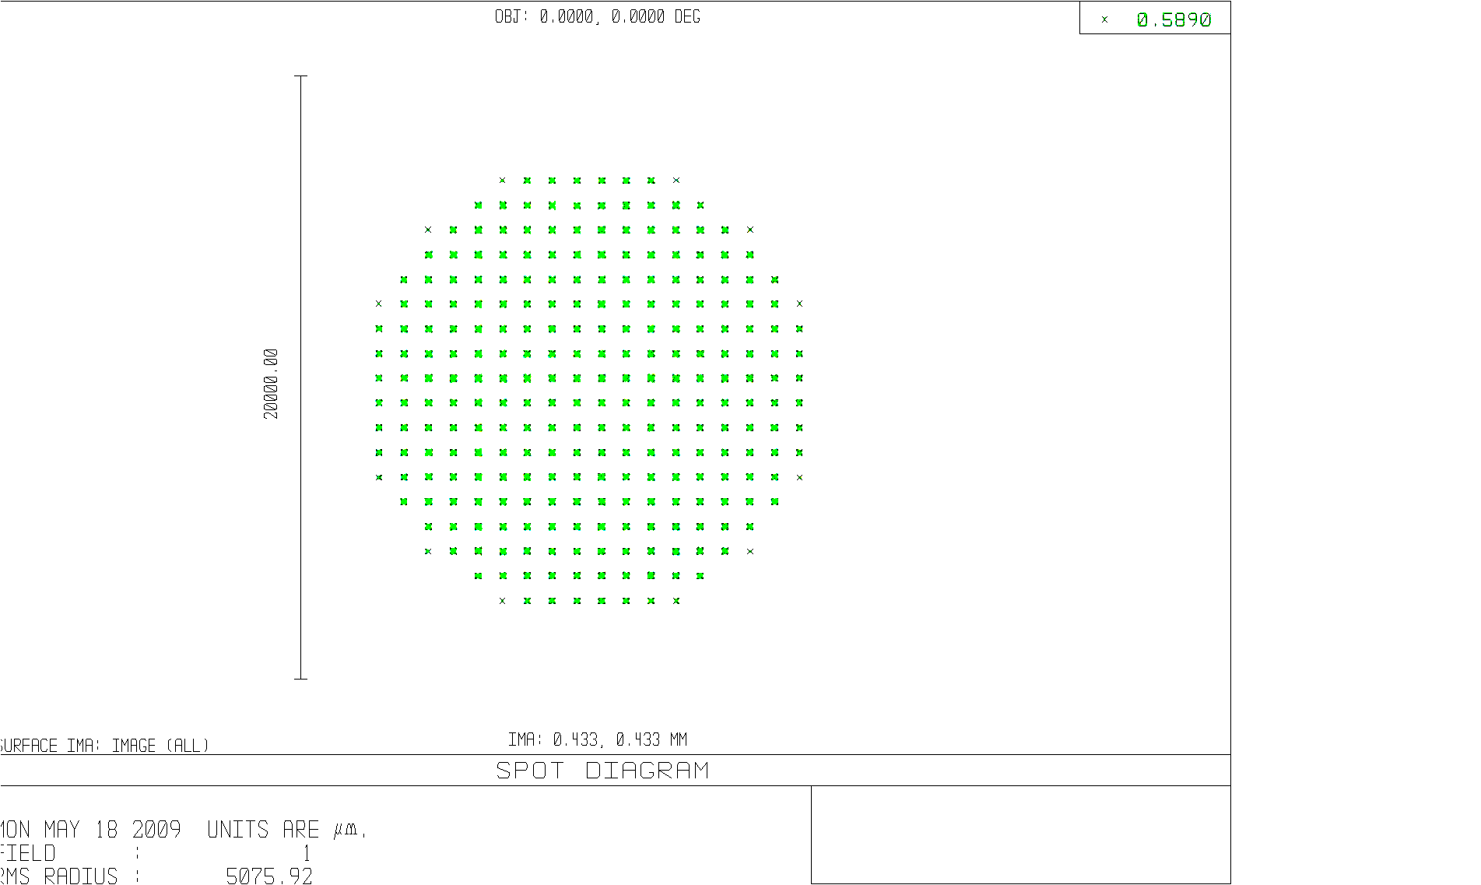
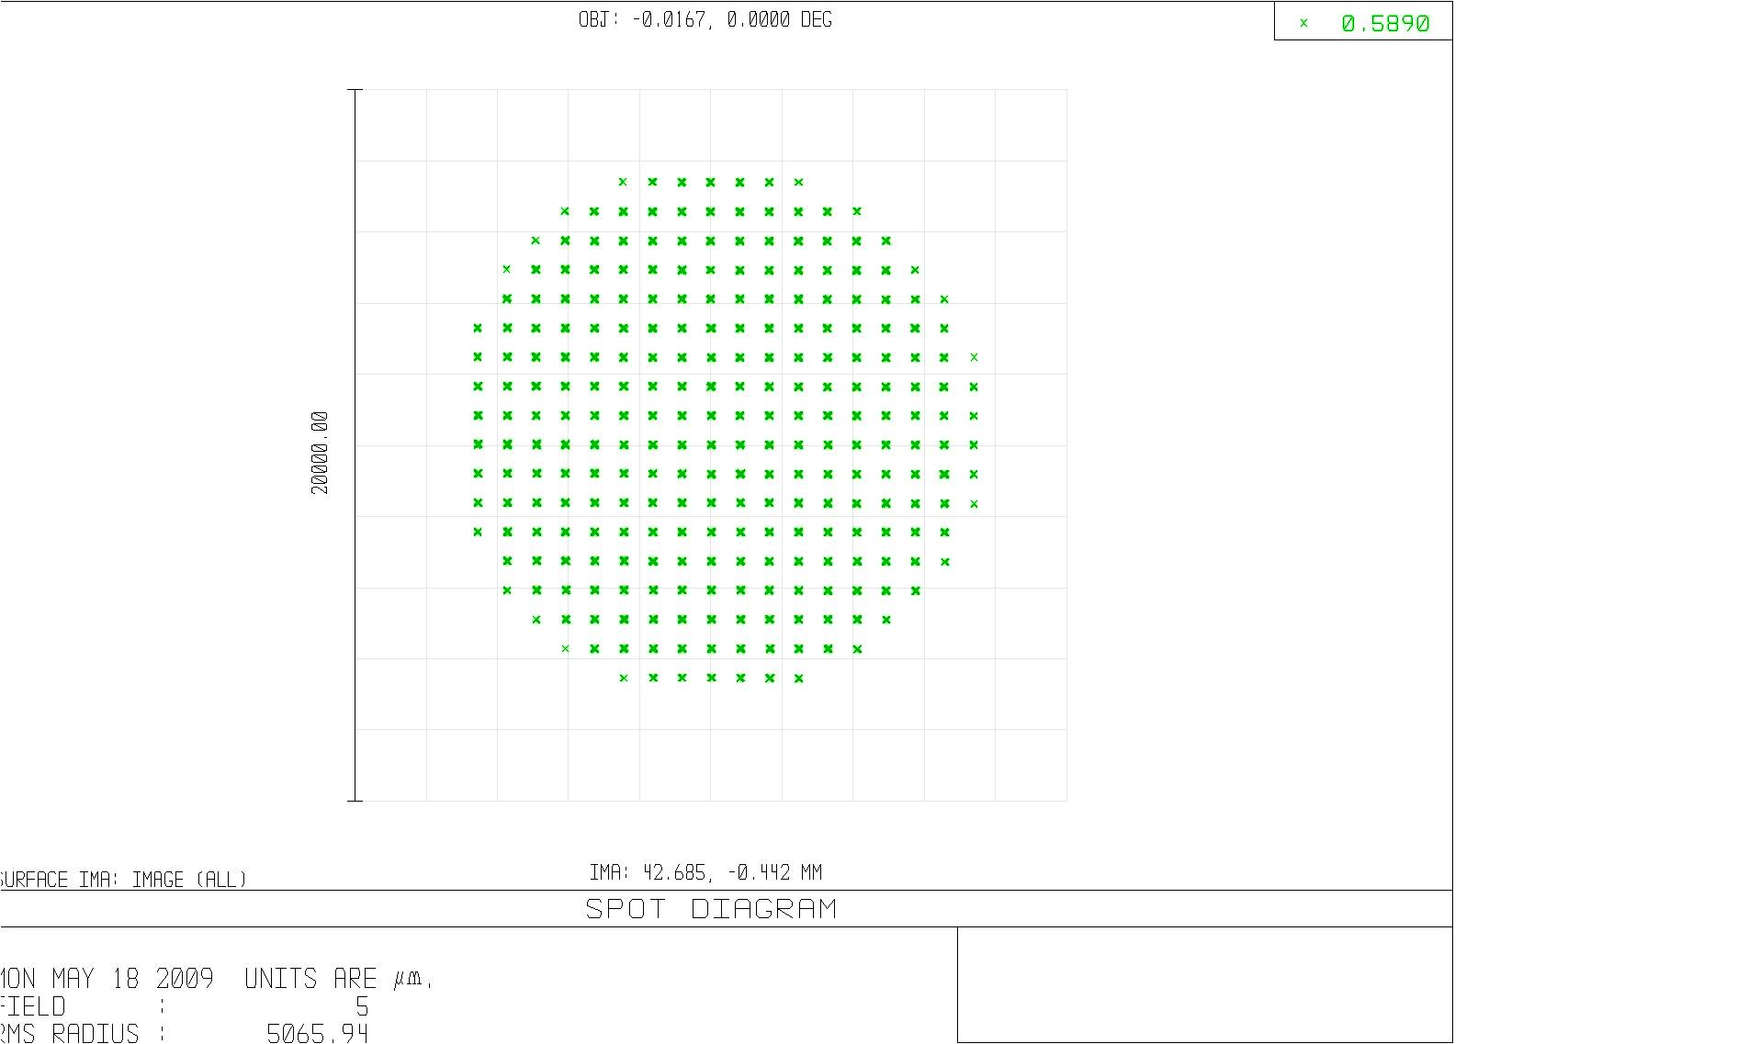
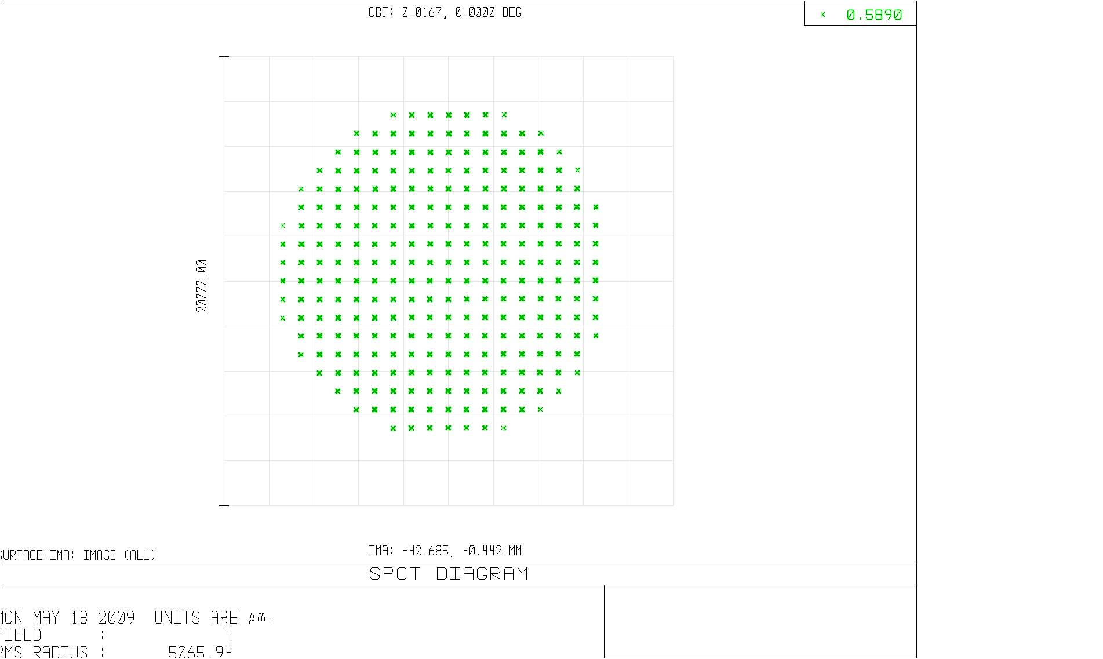
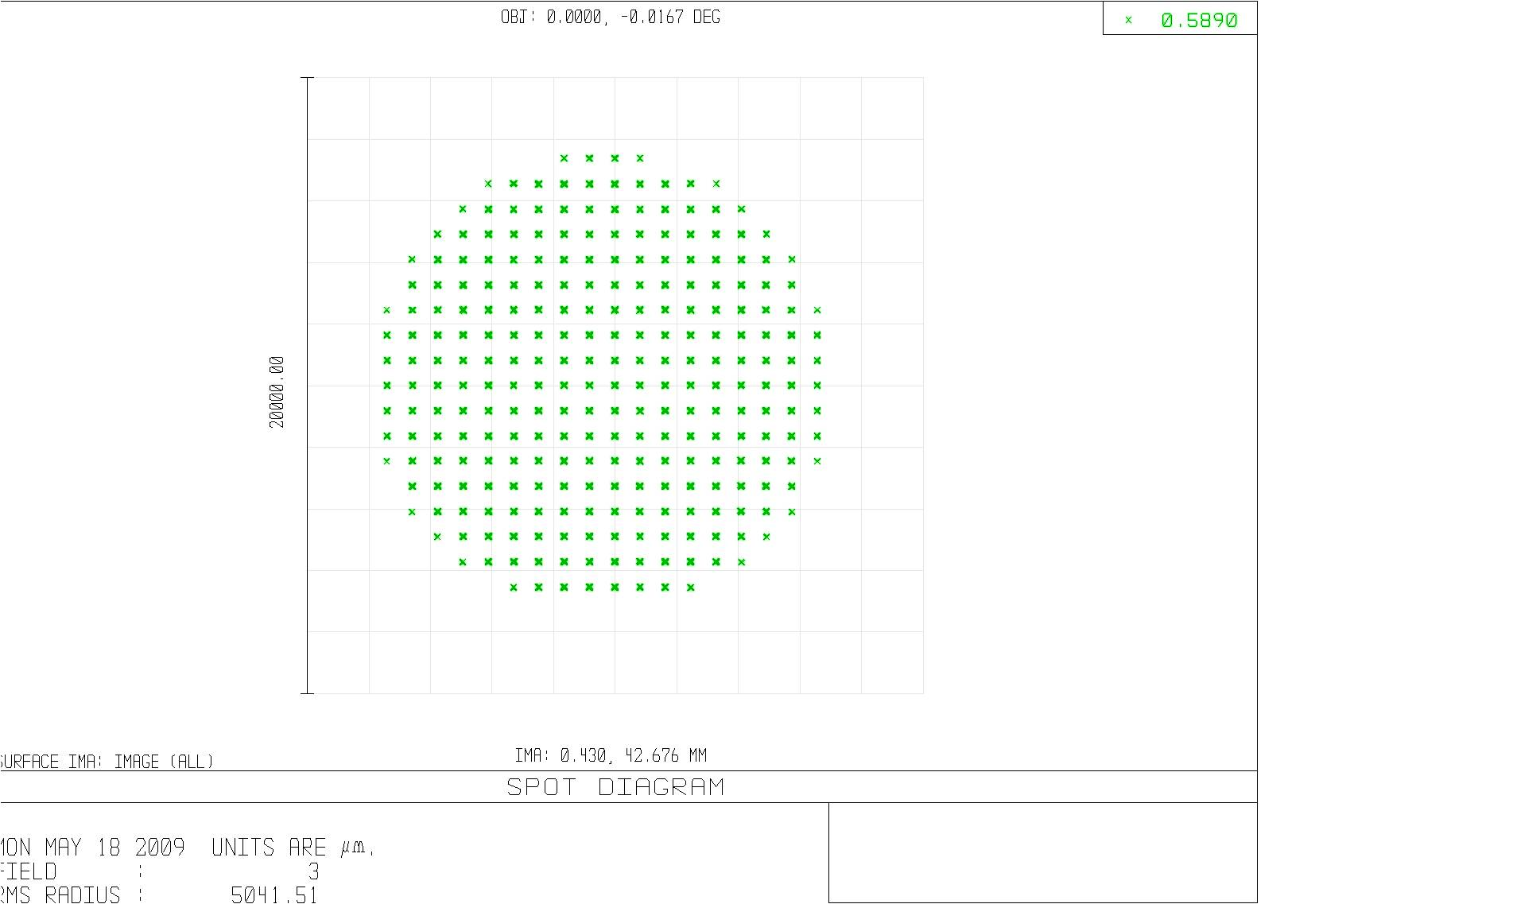
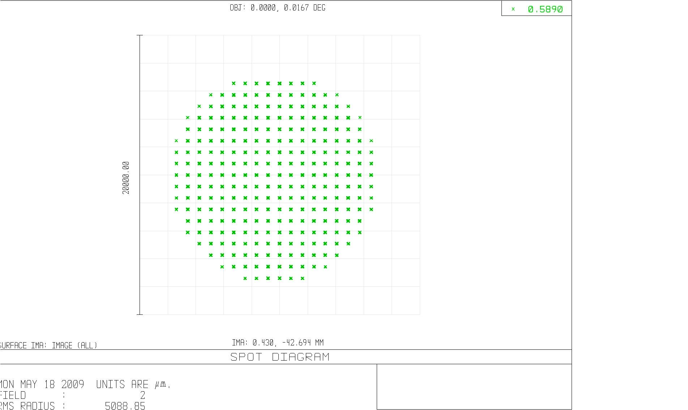

Figure 12 Zemax modeling of the on-axis (top, left) and extreme x and y field positions (120” diameter field of view) LGS WFS. For each field position, a separate f=180mm collimator lens imaged a pupil on a 18x18 subaperture lenslet arrays. Spot diagrams above show the Hartmann spots produced by each of the lenslet arrays. Visual inspection shows no pronounced displacement of spots due to static aberrations in the LGS relay. An 18x18 subaperture lenslet array was assumed for ease of display and speed of computation.
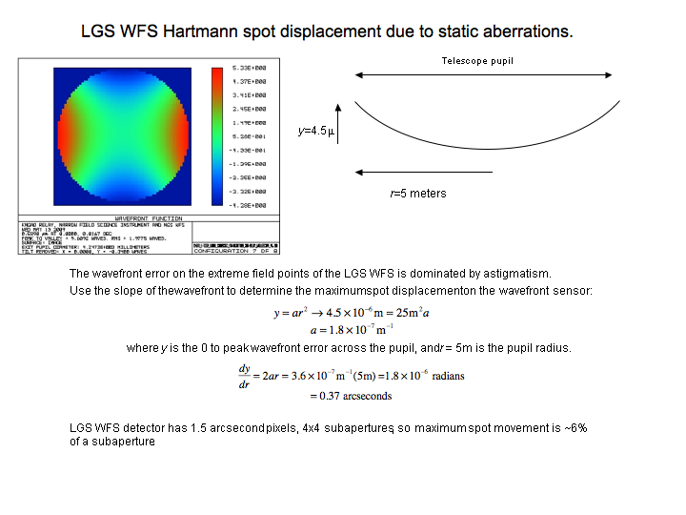

Figure 13 Simple analytical treatment of Hartmann spot displacement due to static aberrations in LGS WFS optical path. The static aberrations at the extreme field points are dominated by astigmatism, as shown in the false color wavefront in the upper left. This will cause a Hartmann spot displacement of roughly 6% of a subaperture at the edges of the pupil.

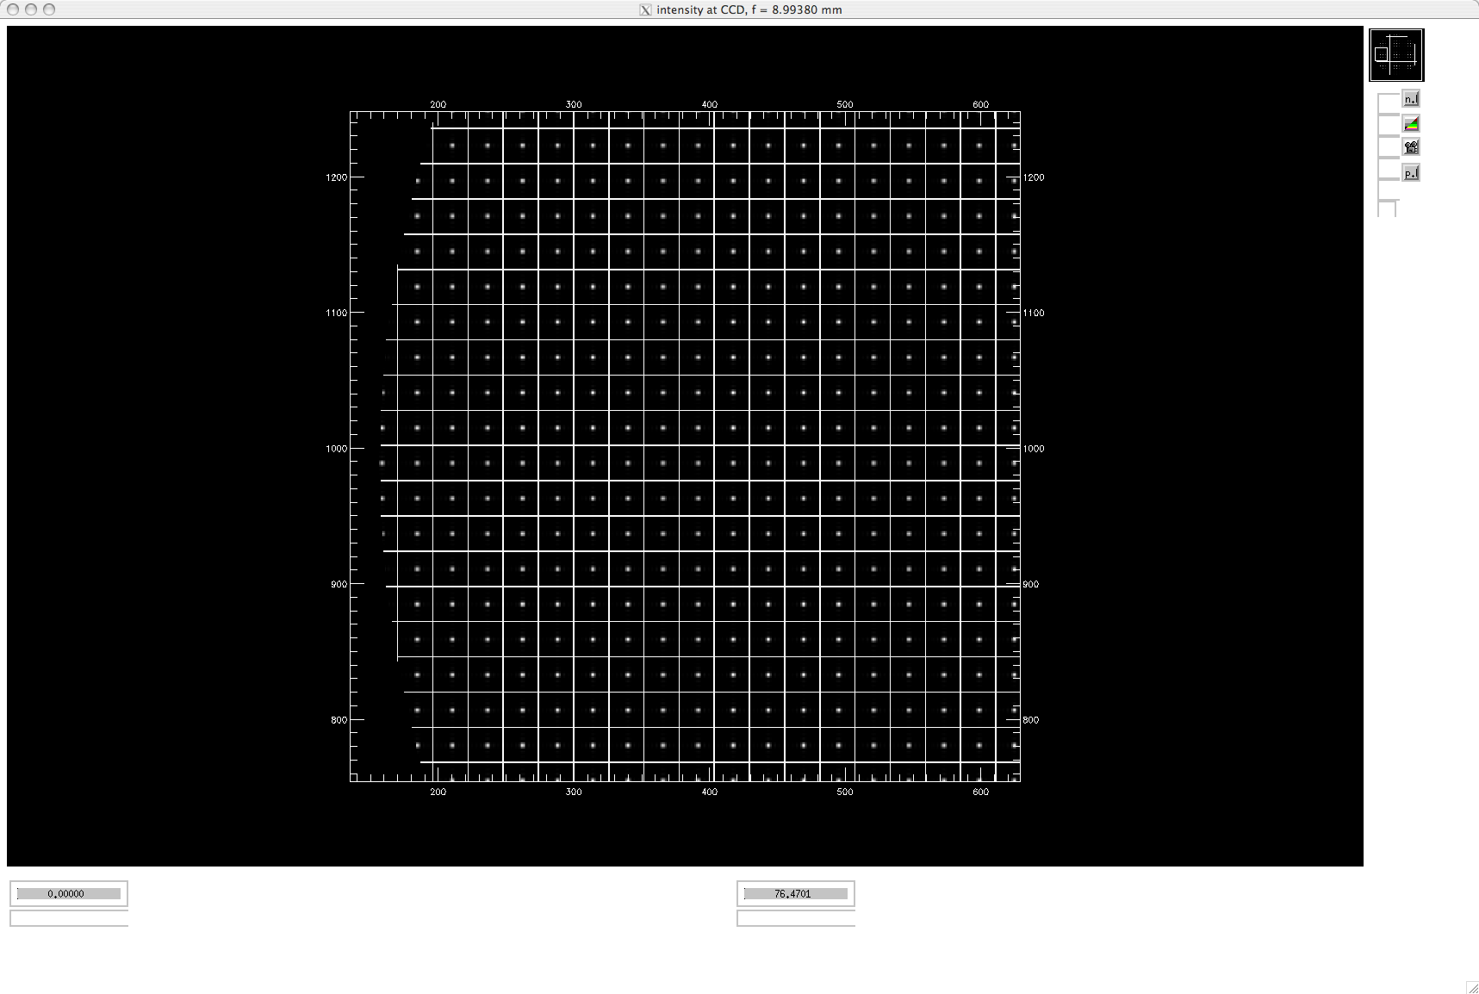

Figure 14 Results of a Hartmann sensor simulation given the static errors present in an extreme field position of the laser guide star wavefront sensor relay. At 60 arcseconds radius, the wavefront entering the wavefront sensor optics is expected to have as much as 9 microns peak-to-valley of predominantly astigmatism. This extreme static aberration is due to the optical relay’s optimization for objects located at infinity (natural stars), while the laser guide star varies between 90 and 180 km above the telescope. The image above shows the location of Hartmann spots with respect to the subaperture grid, at one edge of the pupil.

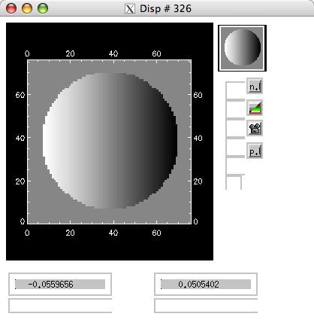
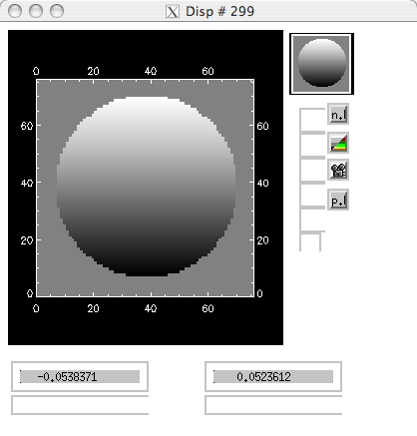

Figure 15 Given the Hartmann spot locations shown in Figure 12 over the entire pupil, centroids were calculated and are displayed above, normalized to the subaperture width. X centroids (left) and Y-centroids (right) are displaced by static aberrations by approximately +/- 5% of a subaperture at the edges of the pupil.

- Pupil Distortion on Deformable Mirrors
Pupil distortion in the NGAO Cascaded relay manifests itself in at least three ways. The first is the degree to which a grid of points on the primary mirror maps to a demagnified, but square grid on the DM. Another consideration is the field-dependent pupil aberrations. This effect causes the chief rays from the various field angles to not all pass through the center of the pupil (paraxially, the chief rays all pass through the center of the pupil, by definition, but for real rays, this is not generally true). In other words, the pupil (i.e., the DM and the correction it applies to the wavefront) is shifted with respect to the telescope primary by an amount depending on the field angle—this is similar to anisoplanatism caused by atmospheric aberrations at an altitude not conjugate to the DM. Finally, a third effect is DM-to-lenslet misregistration and scale errors. This depends on the pupil re-imaging optics chosen for the wavefront sensors.

In the analysis, the telescope primary became the “object”, and field points were defined on the edges of the primary mirror. Observed field angle was set by adjusting the “stop” size placed at the Nasmyth focus to accommodate a 120 arcsecond diameter field for the woofer, and a 40 arcsecond diameter field for the tweeter in the narrow-field relay. Results are shown in Table 6 and figures 16-19 on the following pages.
Table 6 Characteristics of the pupil image on the deformable mirrors.
 | Diameter (mm) | Field (″) | # actuators | Tilt (meters on sky, peak) | Curvature (mm) | Max Grid Distortion | Pupil PSF, (μ)
DM1, woofer | 100 | 120 | 20x20 | 176 | 4000 | 0.4% | 240
DM2, tweeter | 25 | 40 | 64x64 | 279 | 500 | 0.26% | 58
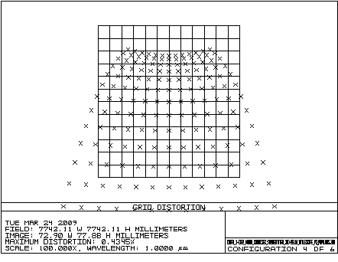

Figure 16 Grid distortion at the woofer mirror pupil location, magnified by a factor of 100 to emphasize shape.

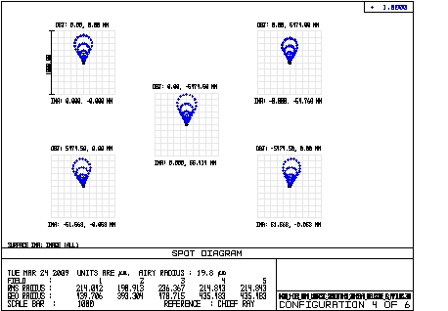

Figure 17 Spot diagrams for 5 places on the primary mirror, as imaged onto the woofer DM. Field considered is 120 arcsecond diameter. The chief rays from the on-axis field angles make up the point of the comatic pattern, while the chief rays for field angles of 60 arcseconds off axis make up the outer “radius” of points on the comatic pattern.

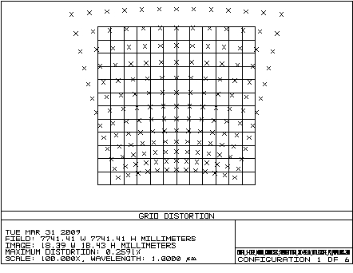

Figure 18 Grid distortion of pupil at 25mm DM. Scale is magnified 100x to emphasize shape of distortion. Maximum distortion is 0.26%.

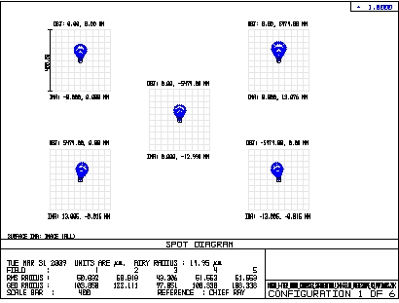

Figure 19 Spot diagrams for 5 places on the primary mirror, as imaged onto the 25mm DM. Field considered is 40 arcsecond diameter.

