Keck Adaptive Optics Note 685


NGAO Optical Relay Design
Renate Kupke
Revised, Oct 27, 2009

- Introduction
This document presents the preliminary optical design for the Keck Next Generation Adaptive Optics Relay. The design is based on results of the conceptual design study, KAON 549, and subsequent build-to-cost reductions and guidelines. Section 2 of this document outlines some of the main requirements the optical design must satisfy. Section 3 describes the components of the optical relay in more detail, and in Section 4 the performance of the relay with regard to science instruments and wavefront sensors is discussed.

- Design Choices and Requirements
The requirements, as defined in KAON 549 for the conceptual design, have altered somewhat due to build-to-cost design changes in KAON 642. The current requirements include, but are not limited to:
- Location:
- The AO system will reside on the left Nasmyth platform. (SR-744)
- Wavelength Range
- The AO relay shall transmit a wavelength range of 0.818μ - 2.4μ for the NIR imager (INT 157) and NIR integral field spectrograph (INT-382).
- The AO relay shall transmit 1.16-1.77μ to the LOWFS (FR-175) and shall not preclude K-band
- The AO relay shall transmit 1.1-4.1μ to the interferometer (SR-683).
- The NGS WFS will require 0.4-0.8μ light (FR-140 and KAON 642).
- THE LGS WFS will require 589nm sodium light (FR-523).
- Field of View:
- A high-Strehl science relay with an unvignetted field of view (FOV) of at least 20 arcseconds diameter with a goal of 40 arcseconds diameter. (FR 41)
- A 120 arcsecond diameter field of regard (FOR) at the focal plane of the first relay, providing natural guide stars (NGS) for the low-order wavefront sensors (LOWFS). (FR 40)
- A 120 arcsecond diameter unvignetted FOR for guidestars from 80 to 120km in altitude to the LGS WFS.
- There is currently no field of view requirement for the NGS WFS.
- Entrance Window
- The entrance window shall provide a thermal seal between the cold enclosure of the AO system and the ambient room temperature. It shall consist of two windows to prevent condensation, and it shall be big enough to transmit the entire 120” field of view.
- Field and Pupil Rotation:
- The optical relay will have a K-mirror upstream of the science instruments and wavefront sensors that can pass the entire field of view.
- Deformable mirrors
- The wide field relay shall contain a deformable mirror conjugate to the telescope pupil, with a pupil size of 100mm. The deformable mirror shall have 22 actuators across the pupil diameter. (FR-32 and FR-56). The requirements do not state whether this is circumscribed pupil diameter, maximum mirror diameter, active mirror area, or mirror area, so a primary mirror diameter of 10.949m circumscribed mirror diameter is assumed.
- The narrow field relay shall contain a deformable mirror conjugate to the telescope pupil with a pupil size of 24mm. The deformable mirror shall have 63 actuators across the pupil diameter. (FR-33 and FR-57).
- Output pupil location:
- The exit pupil for the first relay will be telecentric to simplify design of the LOWFS pick-off mechanisms. (FR-1502)
- The exit pupil for the entire relay will be telecentric to simplify design of the NGS WFS. (FR-1501)
- Output focal ratio:
- The output focal ratio of the first relay shall be the same as the input focal ratio of the telescope, and shall be made compatible with the input for the LOWFS, the second relay, the acquisition camera, and the interferometer. (F-1499)
- The output focal ratio of the second relay shall be greater than f/40 . (FR-1500) There is no requirement stating the upper bound for the output focal ratio.
- Optical Switchyard
- The relay design should provide for a LGS WFS sodium dichroic (FR-67), a removable NGS WFS dichroic (FR-39), and a removable acquisition camera fold (FR-68). There are currently no requirements for instrument selection.
- First-Order Optical Layout
An annotated optical layout is shown in Figure 1. The following sub-sections describe each component of the optical relay in detail.

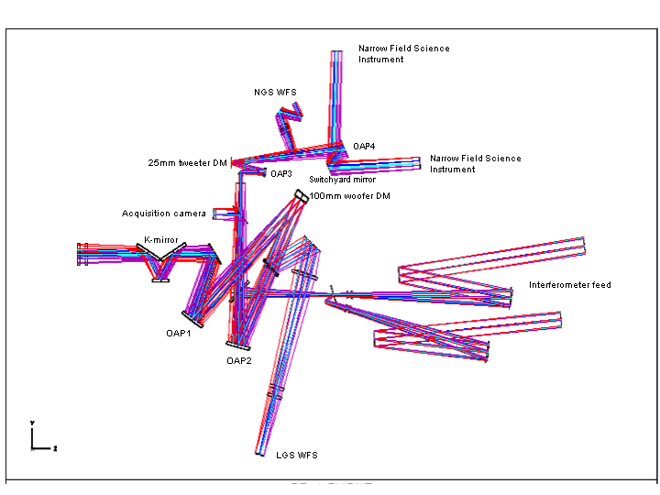
Figure 1 Annotated optical layout of the AO relay. Light from the telescope tertiary mirror enters from the left. The first, f/13.66 matched-OAP relay contains a 100mm woofer DM conjugate to the telescope primary. The second, f/46.38 OAP relay contains the 25mm MEMs tweeter DM conjugate to the telescope primary. The LGS dichroic picks off laser light, which is directed to the LGS WFS. Pick-offs for the low-order wavefront sensors (LOWFS) lie at the focal plane of the f/13.66 relay, and are not shown in this figure. There are also removable dichroic beamsplitters for the interferometer, the acquisition camera, and the natural guide star wavefront sensor.

  - Entrance Window

Because the AO relay is located in a temperature-controlled environment, sealed entrance and exit windows are required to isolate the AO bench from the ambient air. The entrance windows of the AO system are double-paned to prevent condensation, with dry nitrogen at air pressure between the two panes. The front face of the first window lies 795 mm before the telescope focus. Each of the 180 mm diameter windows is 25 mm thick. They are made of Infrasil substrate and coated with a broadband AR coating which will give good transmission from 0.4 -2.4 μ. This coating will be designed by the Lick Coating lab.

  - K-mirror rotator

The Nasmyth focus lies between the first and second mirrors of the K-mirror assembly (K1 and K2, respectively). The focal plane is located 121 mm after K1. The location of the focus is placed within the K-mirror to provide adequate space for the first off-axis parabola (OAP) of the relay, as described in the next section. The existing Keck AO relay has the first element of the K-mirror positioned after focus. The decision to move the focus to a point within the K-mirror assembly was based on the need to accommodate a smaller woofer DM (100mm versus the existing 140mm diameter), and thus a shorter focal length OAP1.

The K-mirror consists of 3 mirrors, the first and third being tilted at 60 and -60 degrees, respectively, to the Nasmyth optical axis. The tilt angles are identical to the present Keck AO K-mirror assembly. The mirror diameters (assuming a 90% clear aperture) are as follows: K1=250 mm, K2=160 mm, and K3=270 mm. K1 is slightly larger than the present Keck AO K-mirror’s K1 because of the need to pass both the LGS and NGS 120 arcsecond diameter FOV. K2 is the same size as the existing K2, and K3 is slightly smaller. The distance between K1 and K2, and K2 and K3, is 243.5 mm, as in the existing Keck image rotator. The mechanical design of the K-mirror assembly can therefore be very similar to that of the existing K-mirror. The K-mirror assembly was matched to that of the existing Keck system in an effort to maintain the polarization characteristics, in consideration of interferometer operation. It is therefore also desirable to match the coating of the new K-mirror to that of the K-mirror on the other Keck telescope. Presently, this would require a bare aluminum coating on the K-mirror.

  - First Relay
The first relay consists of two matched off-axis parabolas, the first of which produces, in collimated space, a plane conjugate to the primary mirror at which the 100 mm woofer DM is placed. In the collimated space after the 100 mm diameter deformable mirror lies a dichroic designed to reflect laser guide star light (589 nm) to the LGS WFS, and transmit all other wavelengths. The second OAP of the matched-pair relays the Nasmyth focus to a second focal plane, preserving the f-number of the input beam. In the converging light following OAP2 are removable pick-offs to the interferometer and acquisition cameras.

For packaging, an additional fold mirror is needed in the diverging optical space following the K-mirror. This fold mirror lies 397.5 mm after K3, with an incidence angle of 34.5° and a diameter of 190 mm. The present Keck AO relay contains a similar fold mirror, which is used also as a tip-tilt steering mirror. It was decided not to incorporate this fold as a tip-tilt location, as its conjugate location is 22 km above the telescope, and a location conjugate to the telescope pupil was preferred to stabilize the pupil and to lessen the stroke requirement of the tip/tilt stage.

OAP1 has an apparent focal length determined to meet the requirement of a 100mm pupil on the woofer DM by the following equation:

where and are the diameters of the deformable mirror (100mm) and the telescope primary (10.949 m), respectively, and is the focal length of the telescope (149.583 m). This gives an apparent focal length for OAP1 of 1366.2 mm.

The woofer DM follows OAP1, at a distance from OAP1 conjugate to the telescope primary mirror:
$t_{\text{OAP}1→\text{DM}}={\left(\frac{−1}{t_{\text{pupil}}+F_{\text{OAP}1}}+\frac{1}{F_{\text{OAP}1}}\right)}^{−1}$,

where t_{pupil} is the distance to the telescope exit pupil from telescope focus. Equation gives a total OAP1 to woofer DM distance of 1460 mm.

The focal lengths and distances derived above are derived assuming the parabola is used on-axis. The parent focal lengths of the off-axis parabolas were determined in Zemax given the off-axis distance and desired pupil size, are are F_{OAP1}=F_{OAP2}=1276.75 mm.

The woofer DM is nominally 22x22 actuators (5mm pitch), and will be mounted on a real-time, tip-tilt platform. Due to the incident angle of 10° the pupil will be elongated by 1.54%.

In collimated space, 625 mm after the woofer deformable mirror, lies the dichroic beamsplitter that will pick off the 589 nm light of the sodium LGS and direct it to the LGS WFS. This beamsplitter has an incidence angle of 19° to the optical axis, and a diameter of 190 mm.

Following the woofer DM is OAP2, an off-axis parabola whose parameters exactly match those of OAP1 to minimize aberrations at infinite conjugate. It is located one focal length away from the woofer DM, projecting the pupil to infinity and providing a telecentric beam for the second and LOWFS relays. A telecentric system was chosen to simplify the design of the LOWFS pick-off mechanisms and wavefront sensors. A telecentric system does not require tilt with field to keep the chief ray constant on entering the wavefront sensor. There are also no pupil scale changes with conjugate distance for the LGS WFS.

  - Tip-tilt platform
During the preliminary design stage, inquiries were submitted to vendors regarding the mounting of the woofer deformable mirror on a fast tip-tilt stage. Primarily, we desired a comparison between the performance and cost of mounting a 100 mm diameter piezo-electric DM versus the larger 140 mm diameter DM. CILAS provided information about the SAM 416 (Gemini 4.5) and the SAM 349 (GTC) deformable mirrors, shown in Table 1. These two mirrors are similar to our requirements for 100 mm and 140 mm woofer DM.
Table 1 Characteristics of existing CILAS DMs.
DM | # actuators | pitch | aperture | Max stroke PV | weight | volume
SAM 416 | 416 | 5.0mm | 106mm | 7.8μ | 6.5kg | 15x16x10cm³
SAM 349 | 349 | 7.0mm | 140mm | 8.4μ | 14.4kg | 22x22x20cm³

The mirrors listed in the table above were not intended for mounting on a tip/tilt platform. CILAS estimated that the weight of these DMs could be decreased by as much as 20% by changing the mechanical packaging in consideration of the tip-tilt platform mounting. When contacting the vendors the specifications included a 38.5Hz closed-loop bandwidth (the most stringent tip-tilt bandwidth requirement contained in the science cases), and the ability to compensate for the ~30Hz telescope vibration in an as-yet-unspecified feed-forward fashion.
The requirements database indicates a 3 arcsecond stroke is required on the tip/tilt platform (SR 688). At the tip/tilt platform at the woofer DM this corresponds to
$α_{\text{TT}}=\left(\frac{F_{\text{Tel}}}{F_{\text{OAP}1}}\right)α_{\text{Sky}}$,
where α_{Sky} is the 3 arcsecond stroke requirement on the sky, F_{Tel} is the focal length of the telescope and F_{OAP1} is the focal length of OAP1. This results in a α_{TT} of 1.6 milliradians peak-to-peak. Momentum compensation was also required to minimize vibration on the optical table.

Three vendors responded positively: CILAS, Physik Instrumente, and Left-hand Design. The bandwidth requirements, considering the weight and dimensions of the deformable mirror, are challenging. Table 2 summarizes the results of the inquiry. Physik Instrumente and Left Hand design indicated that the 140mm, with its 14.4kg weight, would be difficult to achieve at the specified bandwidth. CILAS, although not giving exact bandwidth values, suggested the 140mm diameter mirror would operate at a 30% decreased bandwidth over the 100mm. For this reason, the 100mm DM was chosen as baseline for the AO relay design.
Table 2 Results of initial vendor inquiries into tip/tilt stage.
 | CILAS | PI | Left-hand Design
Predicted achievable bandwidth | ? has reached 50Hz for TMT prototype | 200Hz resonant frequency, claims 50Hz closed-loop | Open-loop servo control: Phase 1:20Hz, Phase 2: 50Hz, Phase 3 100Hz, Phase 4 200Hz
Sensor |  | Capacitive
Type | Voice coil | Piezo | Voice coil

  - Laser Guide Star WFS
As illustrated in Figure 1, between the woofer DM and OAP2 is a fixed dichroic beamsplitter to reflect sodium guide star light to the LGS WFS. The dichroic was placed in collimated space to minimize aberrations in the science and LOWFS beams. The LGS WFS does not receive a performance benefit from the matched OAPs due to the finite location of the laser guide star objects.. Nor do they share the same static aberrations as the science and LOWFS stars, so no loss in performance or significant increase in calibration complexity is incurred by using a separate focusing element for the laser guide stars.

The dichroic pick-off will ideally be a notch filter, reflecting only the sodium LGS wavelength of 589nm. A notch filter was chosen to allow visible light below 600nm to be available to the visible truth wavefront sensor (TWFS) located in the LOWFS assembly, and the NGS WFS. The dichroic has an incidence angle of 19°. The optical layout for only the LGS WFS section of the AO relay is shown in Figure 2. The LGS WFS dichroic lies downstream of the woofer DM, so the LGS WFS will operate in closed-loop. Following the dichroic pick-off is a 250 mm diameter fold mirror. The fold mirror was added to locate the NGS WFS on the side of the AO system opposite the science output beam, in order to leave adequate space for two science instruments.

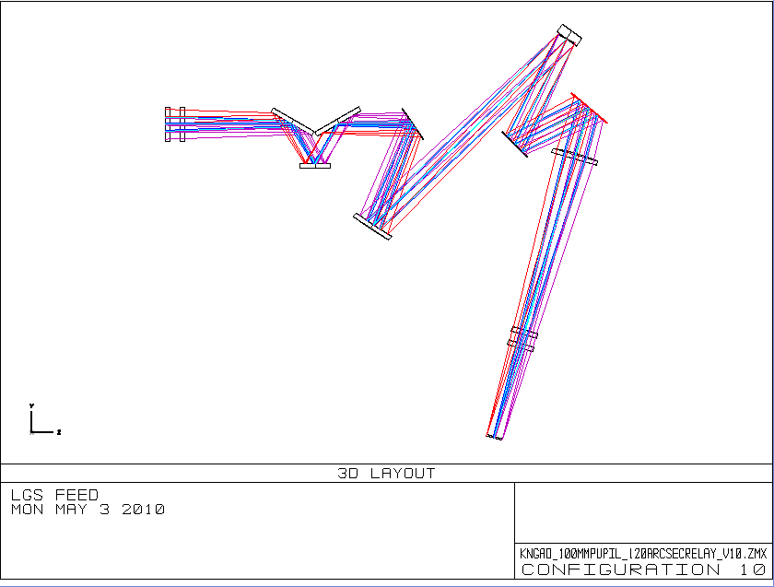
Figure 2 The LGS WFS optical relay.

The object selection mechanism (OSM) for the LGS WFS requires a focal plane, thus the collimated light reflected from the LGS dichroic is brought to focus by a single glass plano-convex lens. Zemax modeling indicates that this lens will produce less wavefront error if the convex surface is an asphere. The descrease in RMS wavefront error with an aspheric surface over a spherical surface is 14%. The lens is located one focal length away from the woofer DM, to provide a telecentric beam for the LGS OSM and relays. The output f/# of the LGS feed is approximately f/13.4.

In the converging beam, 950 mm after the plano-convex lens, is the 140 mm diameter double-paned exit window. The exit window need only transmit sodium wavelengths, so an AR-coated inexpensive crown glass such as BK7 should suffice.

Figure 3 Comparison of RMS wavefront error over the LGS WFS field with a parabolic plano-convex focusing lens (left) and a spherical plano-convex focusing lens (right). Final focal planes are adjusted for tilt and field curvature.
  - Interferometer Feed
Located 500 mm after OAP2 is a removable dichroic available to feed the Keck interferometer.. The interferometer utilizes J and H-band light for internal tracking (the J-band used primarily when doing H-band interferometer science). The interferometer dichroic will reflect J, H, K, and longer wavelength light, up to the required 4.1μ, to the interferometer. The LOWFS will not be used during interferometer operations. Instead, the NGS WFS will be configured to act as a LOWFS. The dichroic has an incidence angle of 45° and a diameter of 190 mm. A wedge of 0.17° on the second surface of the dichroic removes lateral color at the NGS WFS.

The interferometer dichroic directs the starlight to two field-steering mirrors. One of the mirrors has a hole which allows the on-axis light to pass straight through, while off-axis light is directed to the second field selection mirror. Both diverging beams are collimated with OAPs which are identical in diameter, focal length, and off-axis angle to the existing Keck DSM collimating OAPs. The collimated beams are directed to two steering dichroics, which both direct light to down-looking mirrors feeding the existing Nasmyth interferometer path, and provide light to diagnostic sensors located behind the dichroics.
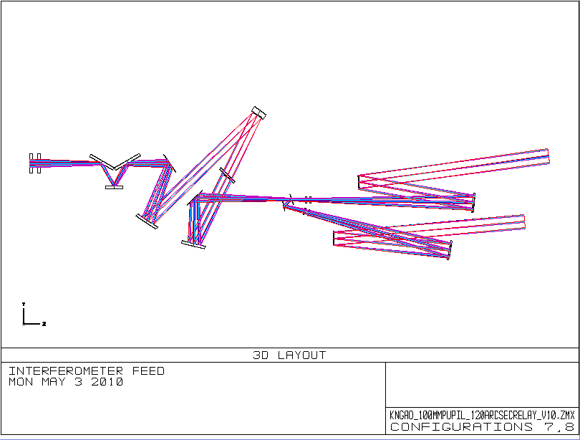
Figure 4 Relay showing interferometer reflective dichroic, field selection mirrors, collimating OAPs and fold dichroics of the Dual Star Module bench.
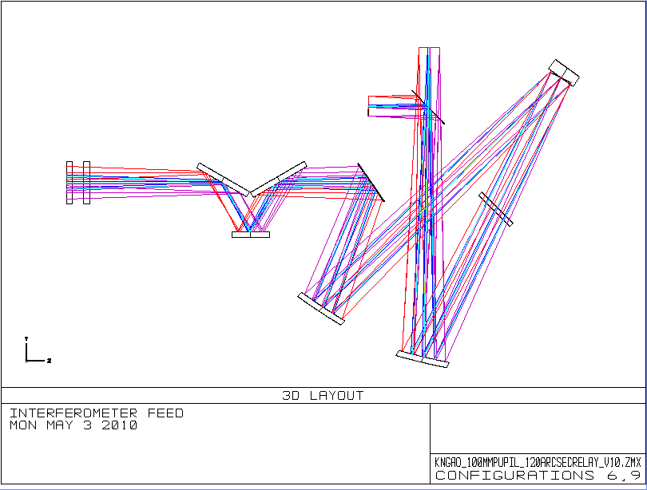Figure 5 Wide-field relay, passing 120 arcseconds to tip-tilt sensors and low-order wavefront sensors. A removable mirror provides the acquisition camera with the entire 120 arcsecond field of view.

  - Wide-Field Relay to Acquisition Camera and LOWFS.
After the dichroic LGS WFS pick-off, the beam is refocused by OAP2 to produce an f/13.66 focal plane at the LOWFS pick-off plane. Located 250 mm before the focal plane is a removable mirror, allowing a 90° reflection to an acquisition camera. The acquisition camera will obtain images of the entire 120 arcsecond diameter field and allow acquisition of the natural guide stars for the LOWFS and an initial acquisition of the LGS. The LOWFS focal plane and acquisition camera pick-off are shown in Figure 5. For the mechanical envelope, we have assumed that the acquisition camera design will be similar to the existing MAGIQ guider camera design, adapted to accommodate a slightly smaller field of view (2 arcminutes versus 3 arcminutes for the existing MAGIQ design). The acquisition camera must translate as a unit (field and camera lenses, as well as detector) to refocus up to 250 mm for the LGS acquisition. Note: Interferometer operation may require that this pick-off be a dichroic which reflects all wavelengths equal to and longer than 589 nm.

  - Narrow-field, High Strehl Relay
Within the plane of the LOWFS pick-offs will be an unobstructed aperture to pass a 40x60 arcsecond rectangular field of view to a narrow-field, high Strehl relay. Although the science instruments require only a 40 arcsecond field of view (FOV), the larger 40x60 arcsecond rectangle was chosen to increase the patrol field of the natural guide star wavefront sensor. The optical path is shown in Figure 6. Directly after the focal plane, a fold mirror directs the light perpendicularly to its original direction to allow space for following optics (specifically the MEMs deformable mirror package) within the LOWFS pick-off mechanisms.
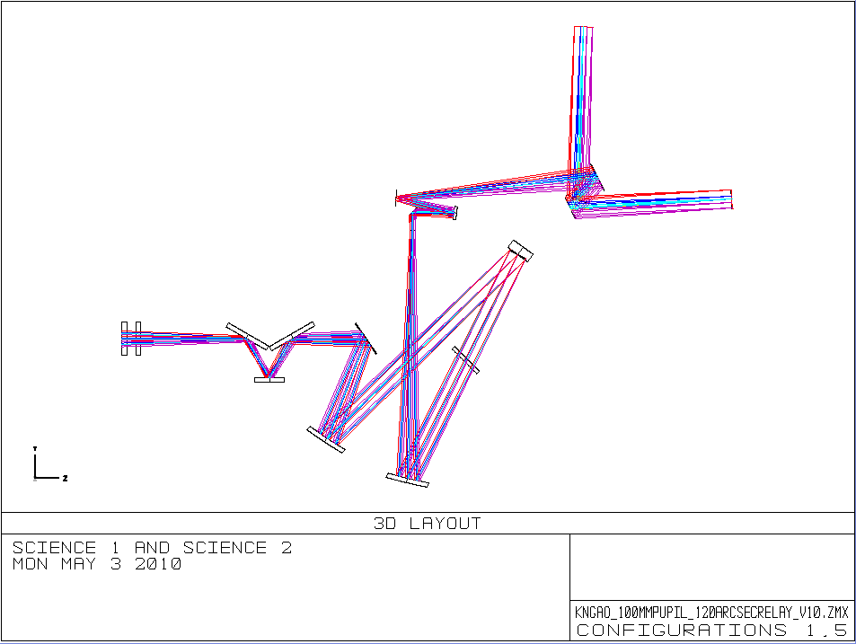Figure 6 Two narrow-field science instruments are fed by the second OAP relay, which contains a high-order DM conjugate to the telescope pupil.
The narrow-field relay consists of two unmatched OAP mirrors producing a 24 mm pupil image on the tweeter DM and an output beam to feed the NIR imager, the integral field spectrograph (IFS) and a future unspecified science instrument.

The tweeter deformable mirror is a 64x64 actuator MEMs device with 0.4mm actuator centers. The tweeter mirror has an incidence angle of 10°. The MEMs device will be mounted on a “slow” tip-tilt stage, as discussed in KAON 669, to provide a steering mirror that can be used for dithering, differential tracking, compensation of differential atmospheric refraction, or fine guidance and centering on a spaxel or detector. The performance requirements of this steering platform are outlined in KAON 669.

Using Equation (1), we can determine the first order focal length of the OAP needed to produce a collimated beam with a 24mm telescope primary image on the tweeter DM (this corresponds to 60x60 subapertures). In this case, we substitute for and for , to get F_{OAP3}=327.9mm. At an off-axis angle of 13° this corresponds to a parent focal length of 318 mm. The pupil at the output of the first relay is telecentric, so the tweeter DM lies away from OAP3. The requirement FR-1500 dictated a focal ratio greater than f/40 for the beam exiting the relay, in order to provide space for an optical switchyard and instruments. was chosen in consultation with the mechanical engineering team to provide adequate space for the science instruments. The output beam of the relay is f/46.3. OAP4 is located exactly one focal length away from the tweeter mirror, to provide a telecentric beam for the instruments. To obtain the optimum image quality, the off-axis angle of OAP4 must increase by roughly the same factor as the magnification of the unmatched relay (see Ghedina and Ragazzoni 1997). Thus OAP4 has an off-axis angle of 41.9°, and a parent focal length of F_{OAP4}=953.96 mm.

A switchyard mirror, 350 mm beyond OAP4, directs the beam to the science instrument(s). The incident angle of the mirror is 20°.

A removable dichroic is located 727 mm beyond the high-order deformable mirror, with an incidence angle of 30°. The dichroic is located in a collimated beam, and a triplet produces an f/20 beam which is steered by two fold mirrors into the NGS WFS (see figure blah). The triplet, designed by Velur, consists of BASF2, N15, and BASF2 glasses. Figure 7 shows the layout of the NGS WFS pick-off.

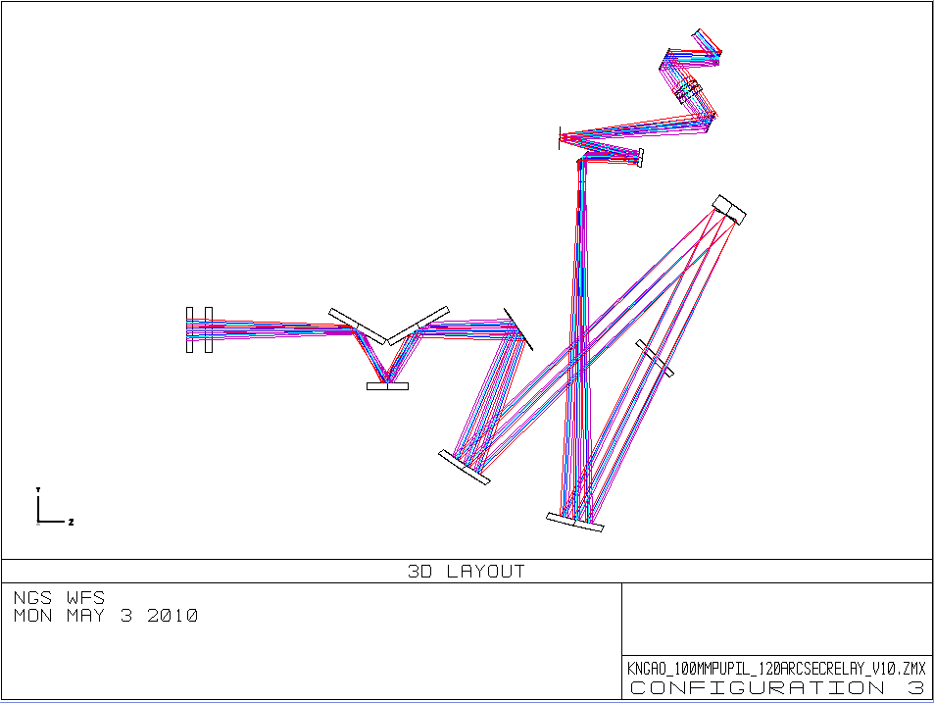
Figure 7 The relay to the NGS WFS, where a dichroic in the collimated space directs the beam to a triplet which produces an f/20 beam for the NGS WFS.
A patrol field larger than the science FOV was desired for the NGS WFS, so the 2nd relay optics were designed to accommodate a rectangular 40x60 arcsecond field. A diagram of the field, and it’s relation to the science and LOWFS fields, is shown in Figure 8..The first relay fold mirror is sized to accommodate a 40x60 arcsecond field of view, the 60” in the direction perpendicular to the optical bench. OAP3 is circular, and sized to accept a field of diameter 60”. The footprint of the 40”x60” rectangular field on OAP3 is shown in Figure 9.

It has also been proposed that the NGS WFS could act as a LOWFS when the observer requires the science object as a wavefront sensor reference in fixed pupil mode (see KAON 666).

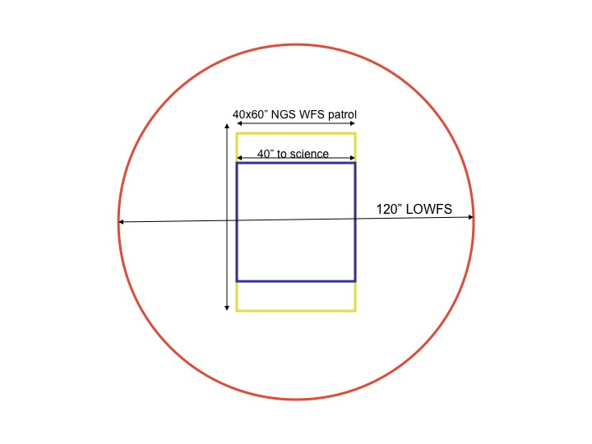

Figure 8 Outline of respective fields of view. The 120” diameter LOWFS patrol field (red), the rectangular 40x60” NGS WFS patrol field (yellow), the 40” field desired for the science instrument (blue) and a representative detector area (orange hatched).
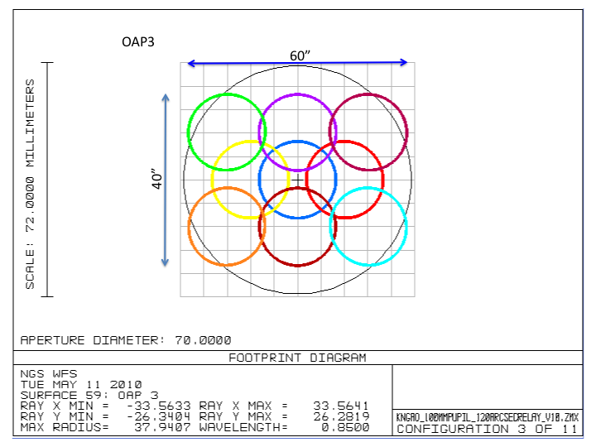

Figure 9 The first fold mirror of the second relay and OAP3 define the patrol field of the NGS WFS. The figure shows the footprint of the 40”x60” rectangular field of view accepted by the first fold of the second relay on OAP3.

  - Science Instrument ADC
A counter-rotating prism pair has been designed to compensate for the effects of atmospheric dispersion in the science instrument for the near-infrared wavelengths. Atmospheric dispersion will cause lateral separation of different wavelengths at the science image plane. The amount of displacement is a function of the wavelength and bandpass of the science observation, and the zenith distance of the observed object. It is therefore desirable to have a tunable ADC that can compensate at all wavelengths of interest, and all zenith distances.

We have based our design on NIRC2’s NIR ADC, using the glass pairs of Silica and Calcium Fluoride for each of the prisms, and adjusting the prism angles to achieve the desired dispersion correction at the science path f/# and distance from focus. The prisms will be required to co-rotate to maintain alignment with the field. Figure 10 shows the NIR ADC at with prisms positioned to provide maximum dispersion.

When the ADC is inserted, the science focus will shift by 10.4 mm toward the ADC.
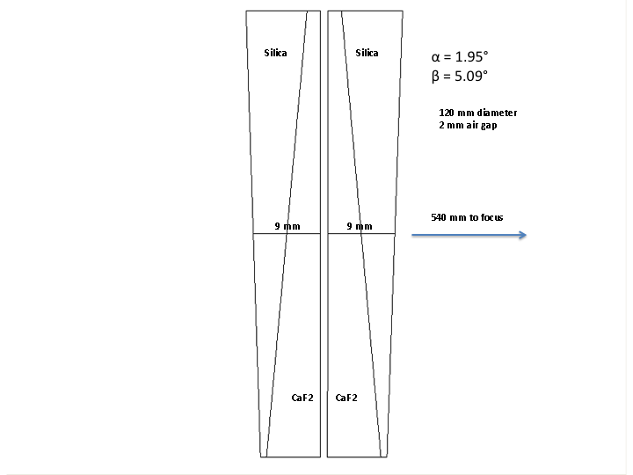
Figure 10 NGAO NIR ADC design.

The ADC described above corrects atmospheric dispersion down to wavelengths of 1 μ. For the visible wavelengths, a second ADC has been designed. It’s located 302 mm ahead of the second relay focus. Like the NIR ADC, it consists of two counter-rotating prism pairs. The rotation mounts are placed on a linear stage for movement in and out of the beam.
- Performance

To determine the performance of the optical system, several sources of optical degradation were analyzed using Zemax in the wavelength passbands used by the science instruments and wavefront sensors. The passbands are defined in KAON 530.

The optical relay was modeled in conjunction with the Keck primary and secondary mirrors, to ascertain the combined effects of the two optical systems.

Field points used were the maximum off-axis fields defined for each instrument. The wavefront errors and RMS spot radii quoted are the worst-case for the field points analyzed.

The working f/# of the wide-field relay is f/13.66 and of the narrow-field relay is f/46.3. Airy disk sizes are defined by
and the depth of focus (DOF ) is defined by.

Chromatic focal shift and lateral color, where applicable, were evaluated for different wavelength ranges using the Zemax analysis tools. Lateral color and chromatic focal shift arise only in beam paths in which there are transmissive optics, such as beamsplitters.

- LOWFS

The matched OAPs used in the first relay give excellent performance over a wide field at infinite conjugate. The values given in Table 3 assume a flat woofer DM and flat high order DMs in the individual LOWFS relays. The first relay gives diffraction-limited performance over the entire 120 arcsecond diameter field, as seen in Figure 11. Chromatic aberrations are due to the entrance window at the front of the AO relay.
Table 3 Performance of the LOWFS in simultaneous J and H bands
Instrument  (mode) | λ (μ) | F/# | FOV ″ | Fld curv.  (mm) | Sag due to fld curvatue (mm) | RMS WFE, on axis (nm) | RMS Spot Radius, on axis (mas) | RMS WFE, 60” radius (nm) | RMS Spot Radius, 60” radius, (mas) | Lateral color (μ) | Chrom. Focal shift (μ) | Depth of focus  (mm) | Grid distortion, %
LOWFS | 1.17-1.78 | 13.66 | 120 | 1200 | 0.9 | 9 | 3.5 | 42 | 7.2 | 0.5 | 180 | 0.9 | 1.5

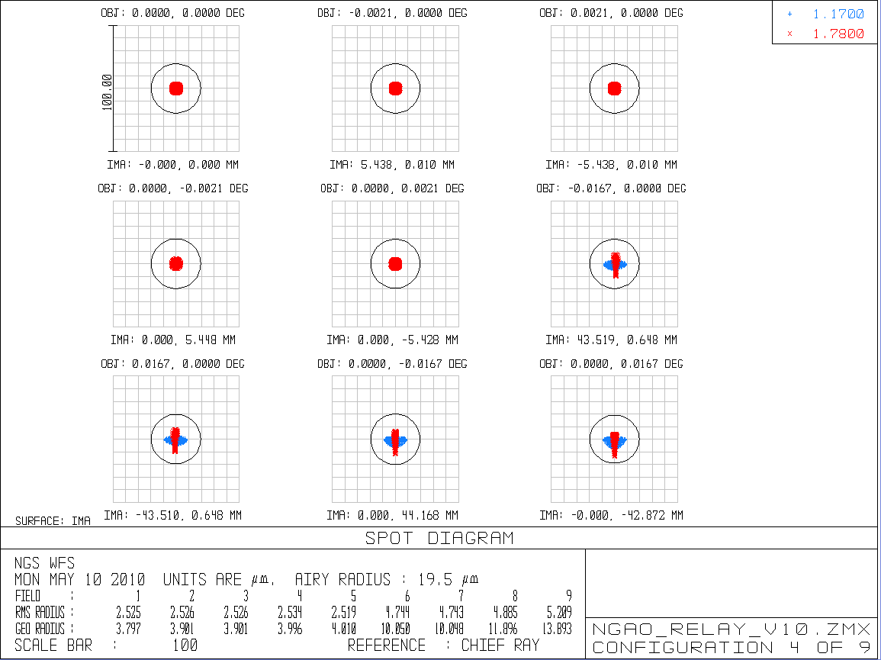Figure 11 Spots at focal plane of f/13.66 LOWFS relay. The LOWFS will operate over the J and H-bands simultaneously, from 1.17-1.78 μ. Spots shown assume no DM correction. Scale circle is the diffraction limit at 1.17 μ
- Science Instruments, Narrow-field Relay
The second relay consists of two unmatched OAPs resulting in an increase of focal ratio to f/46.3. The larger focal ratio results in an image scale of 2.46mm/arcsecond at the focal plane. The second relay passes a 40” diameter field of view to the science instrument. The science instrument is intended to cover a wavelength range from i-band (0.7 μ) to K-band (2.4 μ).

The aberrations resulting from the non-matching pair of OAPs in the second relay are strongly field dependent, so a correction applied to the tweeter DM does not result in better performance over the whole field. There is also a large amount of field curvature, which cannot be corrected by a DM at the pupil plane.

Table 4 Performance of the narrow-field relay.
Observing band | λ (μ) |  |  | Fld curv.  (mm) |  | RMS WFE (nm), on axis |  | RMS WFE (nm), 10” off axis |  | RMS WFE (nm), 20” off axis |  | RMS Spot Radius, on axis (mas) |  | RMS Spot Radius, 10” off axis (mas) |  | Airy radius  (mas) |  | Chrom. Focal shift (mm) |  | Depth of focus  (mm)
i-band | 0.7-0.85 |  |  | 220 |  | 29 |  | 18 |  | 70 |  | 10 |  | 10 |  | 14 |  | 1.5 |  | 6
z-band | 0.85-1.05 |  |  | 220 |  | 29 |  | 18 |  | 70 |  | 10 |  | 10 |  | 17.5 |  | 1.5 |  | 7
Y-band | 0.97-1.07 |  |  | 220 |  | 29 |  | 18 |  | 70 |  | 10 |  | 10 |  | 20 |  | 0.7 |  | 8
J-band | 1.17-1.33 |  |  | 220 |  | 29 |  | 18 |  | 70 |  | 10 |  | 10 |  | 24 |  | 1 |  | 10
H-band | 1.49-1.78 |  |  | 220 |  | 29 |  | 18 |  | 70 |  | 10 |  | 10 |  | 31 |  | 2 |  | 12
K-band | 2.03-2.37 |  |  | 220 |  | 29 |  | 18 |  | 70 |  | 10 |  | 10 |  | 42 |  | 3 |  | 17

The values presented in Table 4 include the effects of field curvature in the RMS WFE.

$\text{sag}=R−\sqrt{R^{2}−{\left(\frac{L}{2}\right)}^{2}}$

Figure 8 shows the degradation of the optical performance with field angle. Figure 9 shows an example of the spots at the on-axis, mid, and extreme field angles of the science instrument. Because the dominant source of wavefront error is field curvature, the focus can be shifted to provide the best wavefront error on axis. In figure 8 the focus has been adjusted to give the best performance over the central 20 arcsecond field of view.

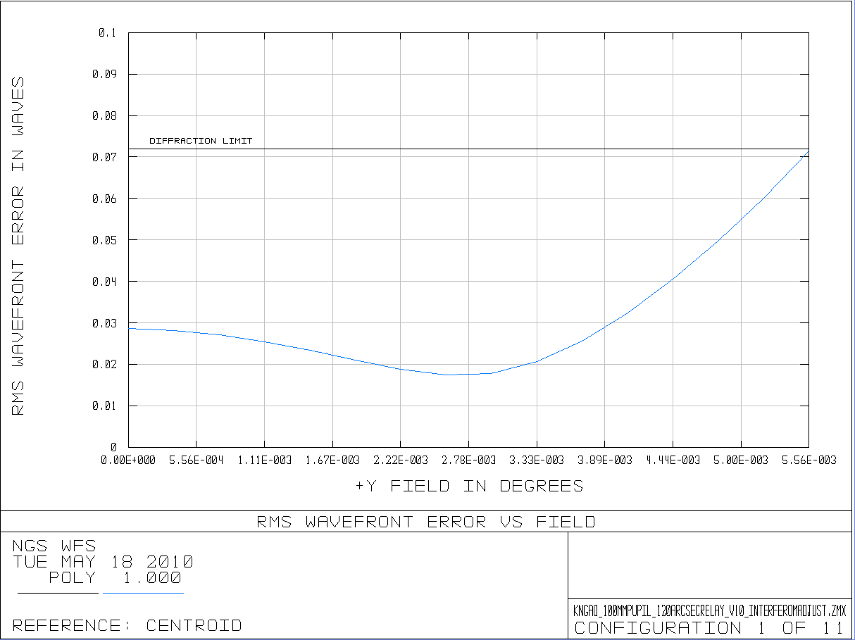
Figure 12 RMS wavefront error as a function of field. Field curvature is the dominant source of wavefront error. The focus has been adjusted to give the best performance over the central 20 arcsecond diameter field of view.

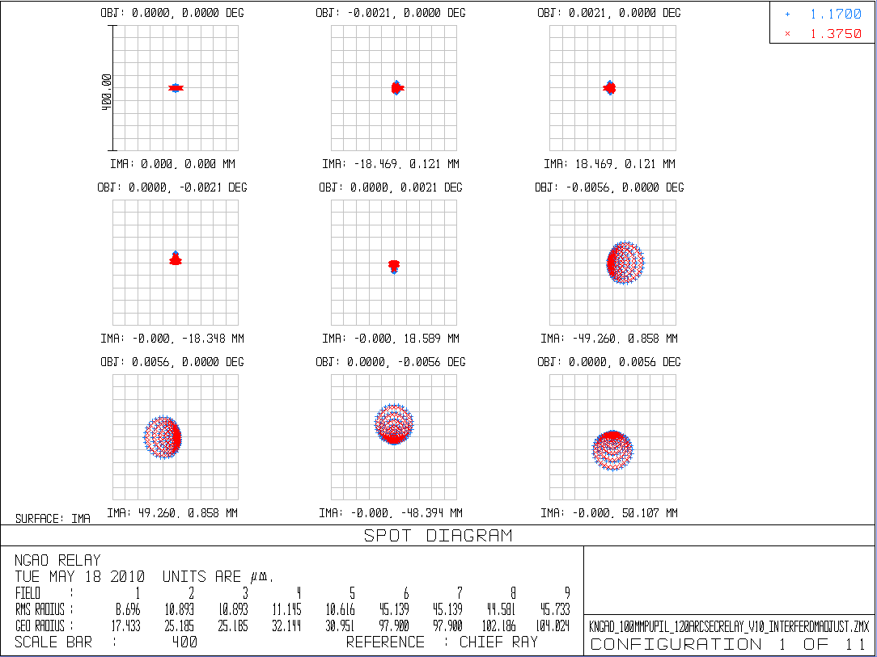
Figure 14 Spots in J-band at the focal plane of the science relay.

Figure 8 WFE as a function of field at the output of the second relay. Field size is 40 arcseconds diameter. Wavelength is 1μ.

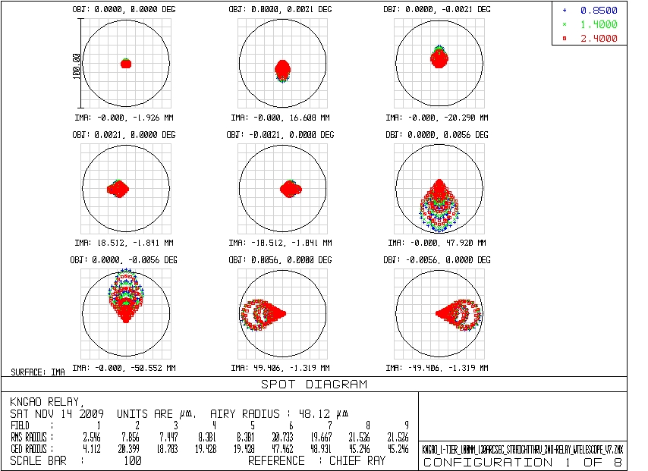

Figure 9 Spots at the focal plane of the second relay. Extreme field points correspond to a 40 arcsecond diameter field.

4.3 Laser Guide Star Wavefront Sensor (LGS WFS)

The LGS WFS dichroic pick-off lies in the collimated space between the woofer DM and OAP2. The laser guide stars, over a 120 arcsecond diameter patrol field, are re-imaged using a singlet biconvex lens with an aspheric convex surface. Because the relay passes only 589 nm sodium light, chromatic aberrations are not an issue. This lens was optimized for 90km (the spot size varies by only 10s of milliarcseconds between 90 and 180km). Table 5 details the performance of the LGS WFS relay. The tilt and curvature of the focal plane of the LGS WFS vary with the zenith distance of the guide stars.

Values quoted in Table 5 are at the edges of the field, and thus represent the worse case performance. Figure 10 displays the RMS wavefront error as a function of field. Figure 11 shows spot diagrams on-axis and at extreme field positions for a zenith distance of .

Table 5 Performance of LGS WFS
Conjugate height | FOV, arcsec | Focal plane tilt ° | Field Curvature (mm) | Grid distortion | RMS WFE, on axis (nm) | RMS WFE, at 60” radius (μ) | RMS Spot Radius, on axis (mas) | RMS Spot Radius , 60” radisus, (mas)
90 km | 120 | 4 | 4000 | 0.7% | 140 | 1.8 | 33 | 253
115 km | 120 | 3 | 9500 | 0.7% | 140 | 1.9 | 33 | 285
180 km | 120 | 2 | >10,000 | 0.8% | 140 | 2.2 | 33 | 323
* The effects of these field curvature values are negligible compared to the effects of astigmatism at the extreme field points.
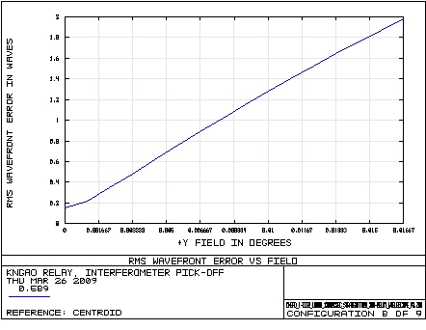

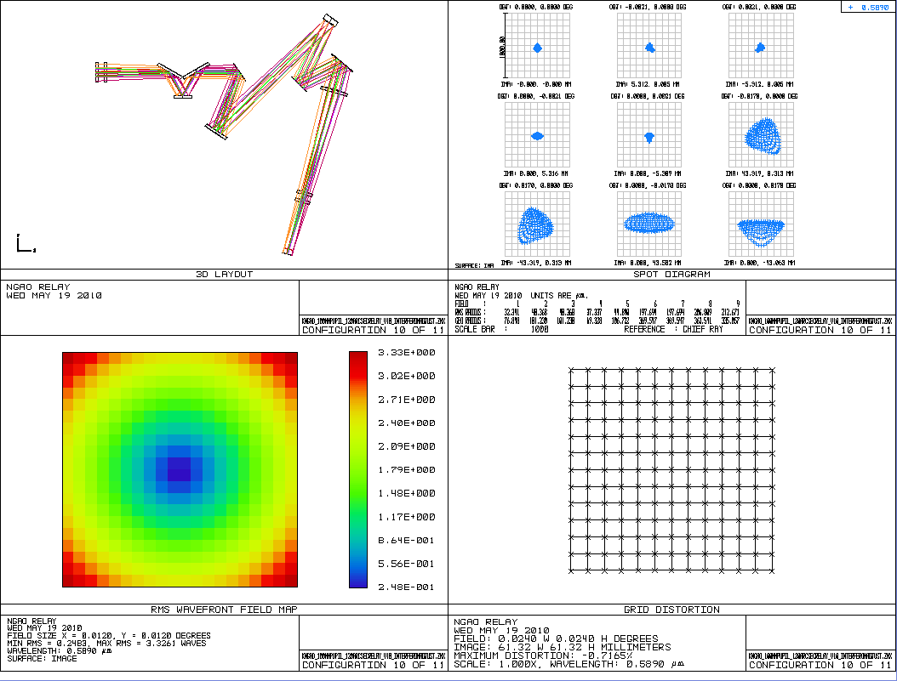Figure 13 Performance of the LGS WFS relay at an object distance of 115 km (about 39° zentith angle). Top right: full-field spot diagram over the entire 120 arcsecond patrol field. Bottom left: RMS wavefront error as a function of field position. Bottom right: distortion map over field.

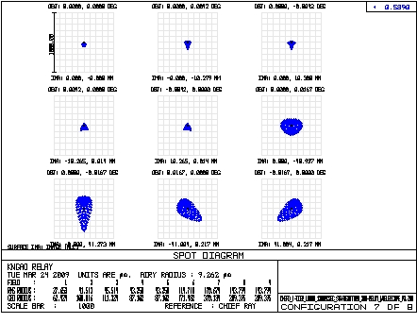

Figure 10 WFE as a function of field at the LGS WFS. Wavelength is 0.589μ, observations at zenith (distance is 90km). Field is 120 arcseconds in diameter.

Figure 11 Spots at the focal plane of the LGS WFS. Wavelength is 0.589μ, observations at zenith (distance is 90 km). The spots on the edge of the 120 arcsecond diameter field are roughly 235 milliarcseconds on-sky.

To determine whether this amount of laser guide star wavefront aberration is acceptable requires further analysis. As seen in Figure 11, the spot size of the laser guide stars produced by the OAP/bi-convex relay is roughly 250 milli-arcseconds at the edges of the 120 arcsecond diameter field. According to KAON 551, WFS sub-system conceptual study report, this compares to other factors as follows: diameter of point source laser at Na layer, 1.08 arcseconds; seeing, 470 milli arcseconds; elongation, 850 milli-arcseconds; diffraction limit of subaperture, 660 milli-arcseconds. The relay static aberration contribution to spot size is smaller than all of these, and is much smaller than the combined 1.47 arcsecond expected laser guide star size. The error budget shown in KAON 551, Table 2, allows a 250 milliarcsecond spot size ”due to aberrations in AO thru to WFS”. It’s not clear whether this includes contributions from the WFS optics. This requirement needs clarification. The current design meets this requirement.

Another concern is the effect of the wavefront error on the dynamic range of the Shack-Hartmann wavefront sensors. The static aberration will cause movement of the Hartmann spots from the centers of the subapertures. If the static aberrations cause the Hartmann spots to move a significant fraction of a subaperture, that subaperture will be compromised in its dynamic range. To evaluate the extent of this problem, the position of the Hartmann spots in the subaperture, due to static aberrations, were evaluated in three ways: through Zemax modeling of the LGS WFS, a simplified analytic approach, and through computer modeling of the Hartmann sensor.

In Zemax the wavefront sensors were modeled using non-sequential components. Each field point encountered its own collimating lens, which imaged the telescope pupil onto a lenslet array. The resulting Hartmann pattern allowed visual inspection of the placement of the Hartmann dots, given the static aberrations at each field point. Figure 12 shows no gross Hartmann spot displacements on an 18x18 subaperture grid. The 64x64 subaperture grid specified for NGAO is difficult to model in Zemax, due to computation time.

Figure 13 shows an approximate calculation of the spot displacements given the wavefront errors in the extreme field points. The static aberrations consist mostly of astigmatism, and analysis in Zemax indicates about 9 microns peak-to-valley of astigmatism is present in the extreme field positions. This corresponds to Hartmann spot displacements of approximately 6% of the subaperture.

Finally, a Hartmann sensor simulator developed by Mark Ammons and Don Gavel of the LAO was used to assess the spot movement. Again, the static aberrations were assumed to be astigmatism with an approximate magnitude of 9 microns peak-to-valley. This wavefront phase error, modeled as a Zernike polynomial with coefficients corresponding to pure astigmatism, was propagated through a 64x64 subaperture lenslet array, and the resulting centroid shifts were measured. The model assumes Fresnel propagation to the lenslet array focus. Figure 14 shows an example of one pupil edge of the Hartmann sensor, with the subaperture boundaries drawn in and the shift of the Hartmann spots due to astigmatism visible. The center of mass centroiding results shown in Figure 15 predict shifts of approximately 5-6% of a subaperture, consistent with our analytic calculations in Figure 13.

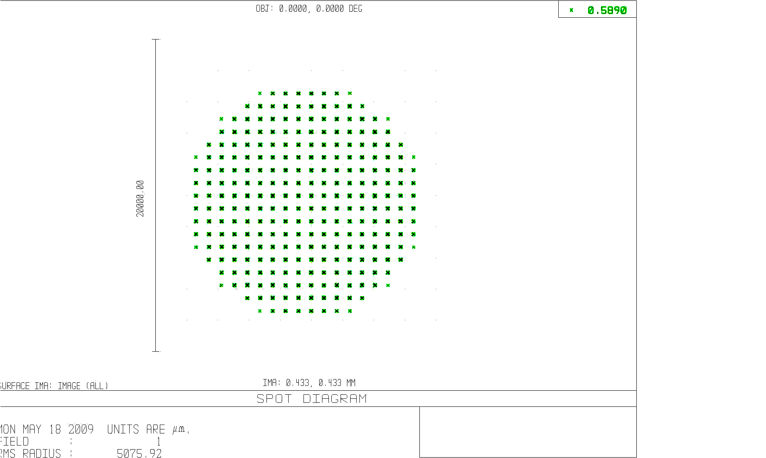
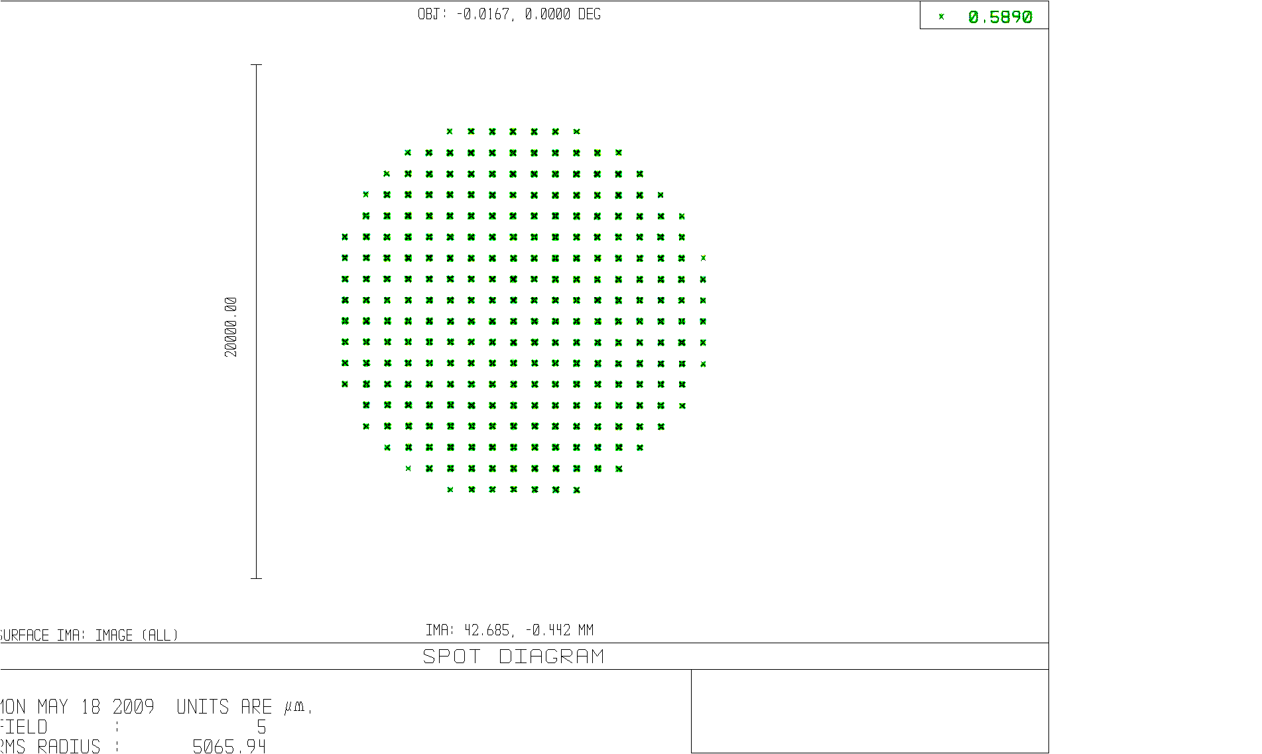
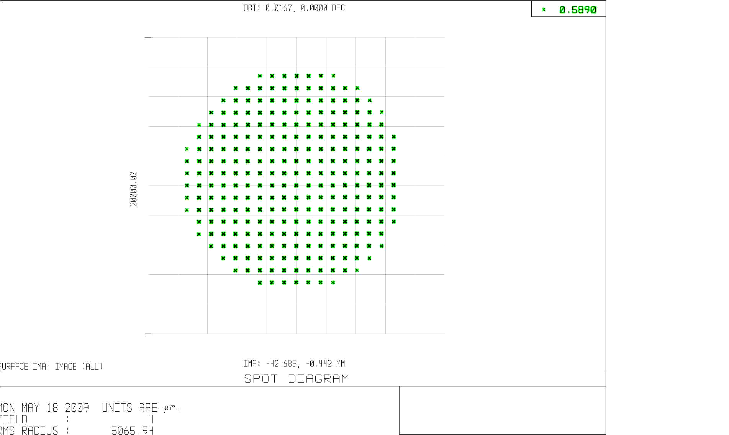
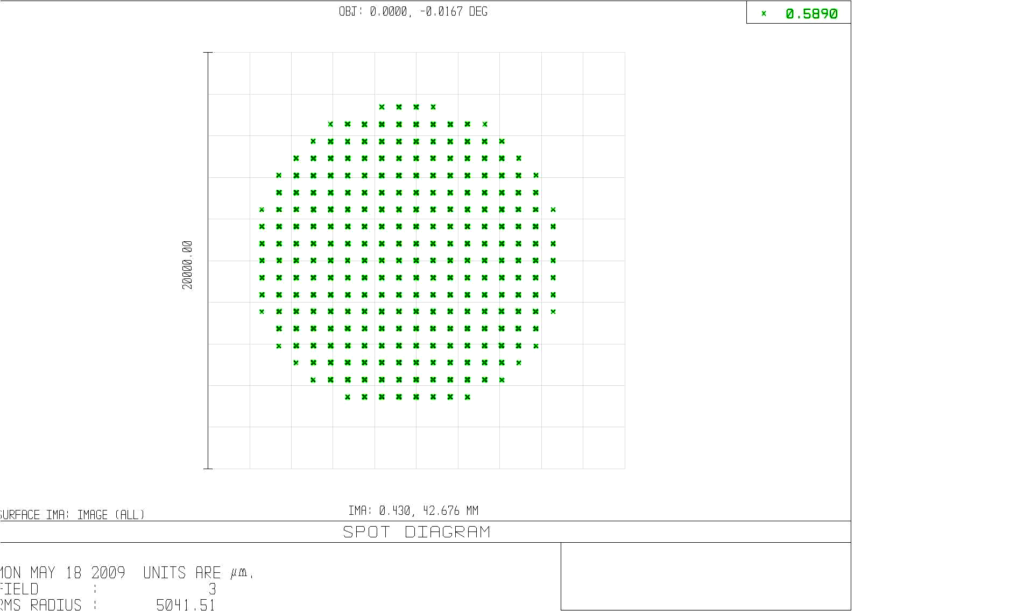
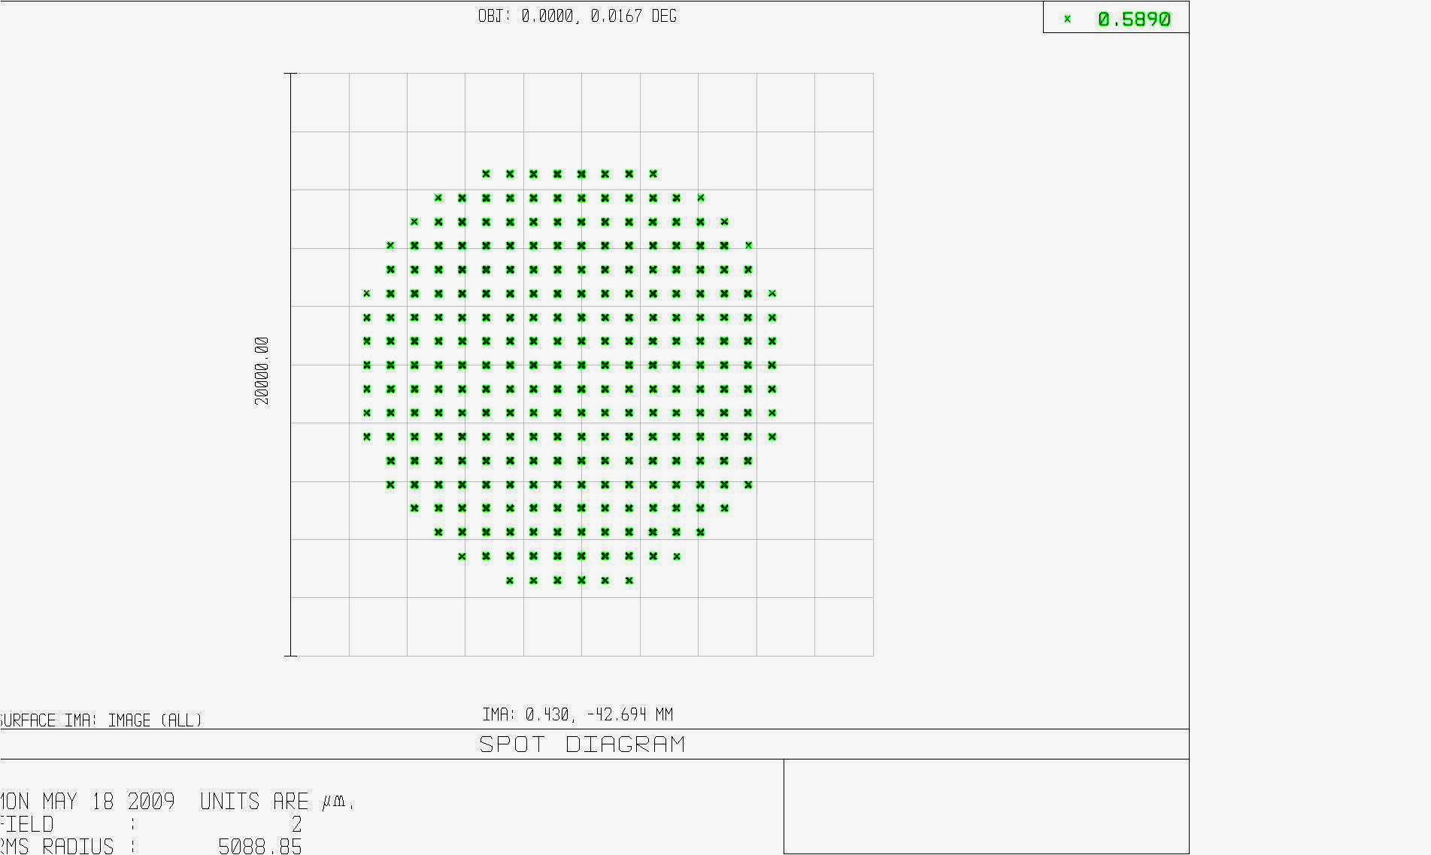

Figure 12 Zemax modeling of the on-axis (top, left) and extreme x and y field positions (120” diameter field of view) LGS WFS. For each field position, a separate f=180mm collimator lens imaged a pupil on an 18x18 subaperture lenslet arrays. The spot diagrams show the Hartmann spots produced by each of the lenslet arrays. Visual inspection shows no pronounced displacement of spots due to static aberrations in the LGS relay. An 18x18 subaperture lenslet array was assumed for ease of display and speed of computation.

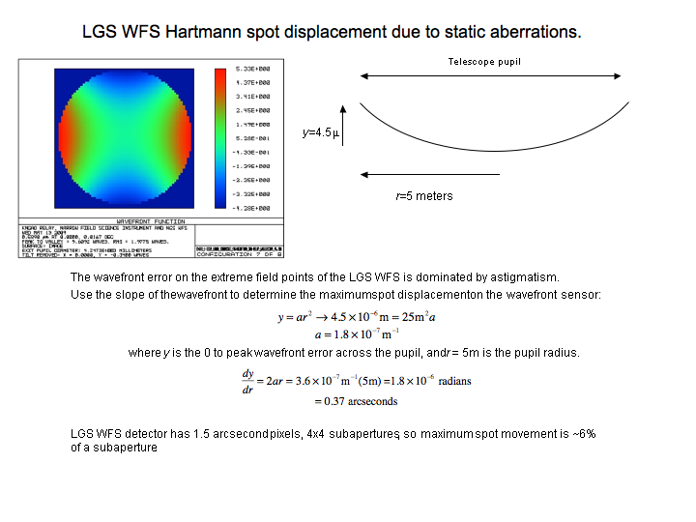
Figure 13 Simple analytical treatment of Hartmann spot displacement due to static aberrations in LGS WFS optical path. The static aberrations at the extreme field points are dominated by astigmatism, as shown in the false color wavefront in the upper left. This will cause a Hartmann spot displacement of roughly 6% of a subaperture at the edges of the pupil.

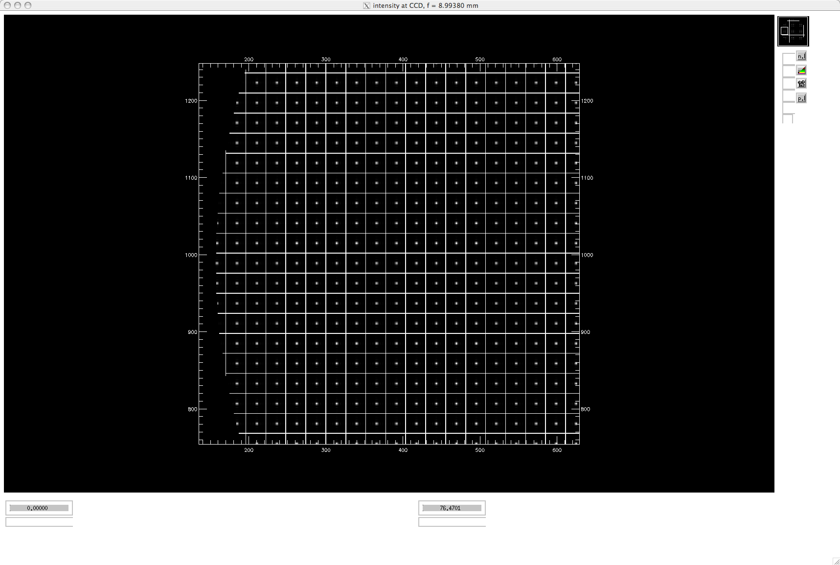

Figure 14 Results of a Hartmann sensor simulation given the static errors present in an extreme field position of the laser guide star wavefront sensor relay. At 60 arcseconds radius, the wavefront entering the wavefront sensor optics is expected to have as much as 9 microns peak-to-valley of predominantly astigmatism. This extreme static aberration is due to the optical relay’s optimization for objects located at infinity (natural stars), while the laser guide star varies between 90 and 180 km above the telescope. The image above shows the location of Hartmann spots with respect to the subaperture grid, at one edge of the pupil.

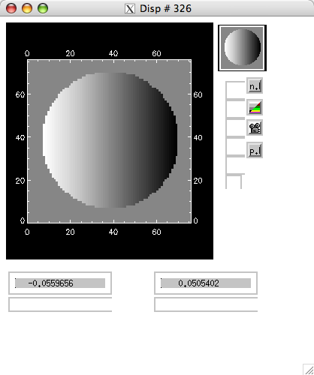
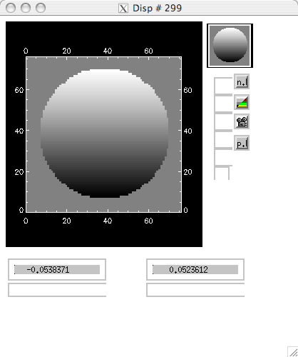

Figure 15 Given the Hartmann spot locations shown in Figure 12 over the entire pupil, centroids were calculated and are displayed above, normalized to the subaperture width. X centroids (left) and Y-centroids (right) are displaced by static aberrations by approximately +/- 5% of a subaperture at the edges of the pupil.

- Pupil Distortion on Deformable Mirrors
We have included drawings of the mapping of the Keck telescope primary mirror on the woofer (Figure 16) and tweeter (Figure 17) deformable mirrors. The mapping includes the 10 degree incidence angle on both the mirrors. The woofer mirror in Figure 16 is the Gemini DM4.5 designed by CILAS. It’s 22x22 actuators are on a 5mm pitch. The tweeter mirror in Figure 18 is the 64x64 MEMs device designed for the Gemini Planet Imager project. It’s actuators are on 0.4mm centers.

Figure 16 The 100mm pupil as mapped by the OAP on the woofer deformable mirror. The DM used in this drawing is the 22x22 actuator, 5mm pitch device designed for Gemini. Figure courtesy of Jim Bell.
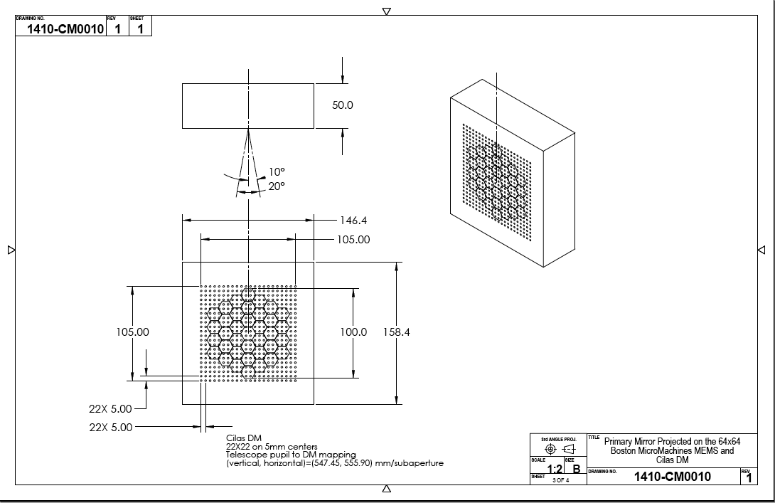

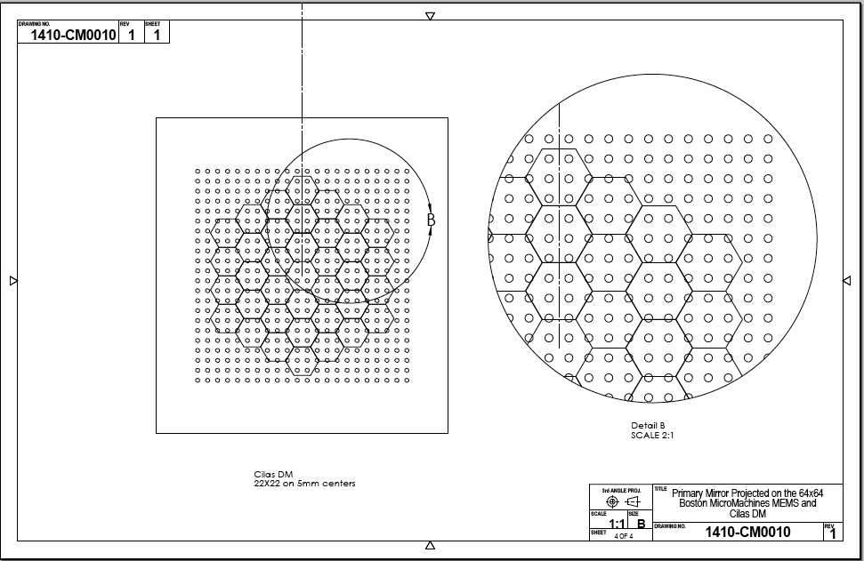
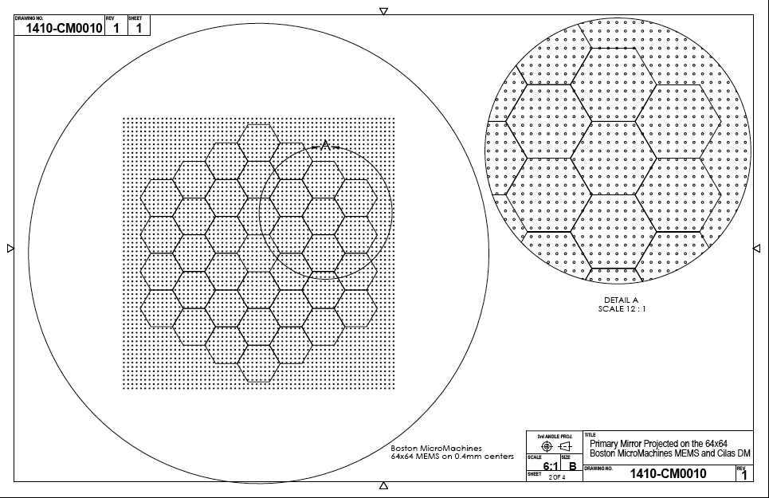
Figure 17 The telescope pupil, imaged on the tweeter DM by OAP3. The pupil image is 24mm in diameter, covering 60x60 actuators of the 64x64, 0.4mm pitch device. Figure courtesy of Jim Bell.
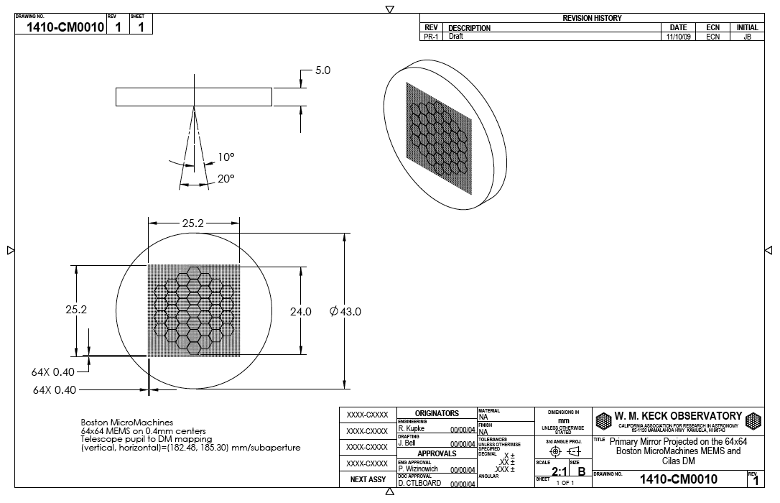

Pupil distortion in the NGAO relay manifests itself in at least three ways. The first is the degree to which a grid of points on the primary mirror maps to a demagnified, but square grid on the DM. Another consideration is the field-dependent pupil aberrations. This effect causes the chief rays from the various field angles to not all pass through the center of the pupil (paraxially, the chief rays all pass through the center of the pupil, by definition, but for real rays, this is not generally true). In other words, the pupil (i.e., the DM and the correction it applies to the wavefront) is shifted with respect to the telescope primary by an amount depending on the field angle—this is similar to anisoplanatism caused by atmospheric aberrations at an altitude not conjugate to the DM. Finally, a third effect is DM-to-lenslet misregistration and scale errors. This depends on the pupil re-imaging optics chosen for the wavefront sensors.

In the analysis, the telescope primary became the “object”, and field points were defined on the edges of the primary mirror. Observed field angle was set by adjusting the “stop” size placed at the Nasmyth focus to accommodate a 120 arcsecond diameter field for the woofer, and a 40 arcsecond diameter field for the tweeter in the narrow-field relay. Results are shown in Table 6 and figures 18-21 on the following pages. Requirement FR-1505 specifies that the first relay shall have no more than 0.5% grid distortion at the pupil. As seen in Figure 18, the first relay exhibits 0.43% grid distortion at the woofer DM. Requirement FR1506 specifies that the second relay have no more than 0.2% grid distortion. Unfortunately, the relay design does not meet his requirement, as Figure 20 show, having a grid distortion of 0.26% at the MEMs DM. FR-1507 and FR-1508 require that the pupil aberrations be no more than a tenth of a subaperture in the first and second relays, respectively. The first relay meets this requirement. As seen in Figure 19, the image of the pupil on the deformable mirror produces 0.24mm FWHM spots when considering a 120” field. This is 5% of a subaperture. The second relay, however, does not meet the 10% requirement. It produces 0.06mm spots on the 0.4mm subaperture, or 15% of a subaperture when the science field of 40” is considered.

Table 6 also summarizes the pupil tilt and curvature on the woofer and tweeter DMs. FR-1510 and FR-1511 specify that the pupil tilt will be no more than 1 km on sky for the tweeter and 250m on sky for the woofer. The design meets these requirements.

Table 6 Characteristics of the pupil image on the deformable mirrors.
 | Diameter (mm) | Field (″) | # actuators | Tilt (meters on sky, peak) | Curvature (mm) | Max Grid Distortion | Pupil PSF, (μ)
DM1, woofer | 100 | 120 | 20x20 | 134 | 3000 | 0.4% | 400
DM2, tweeter | 24 | 40 | 60x60 | 366 | 275 | 0.5% | 81

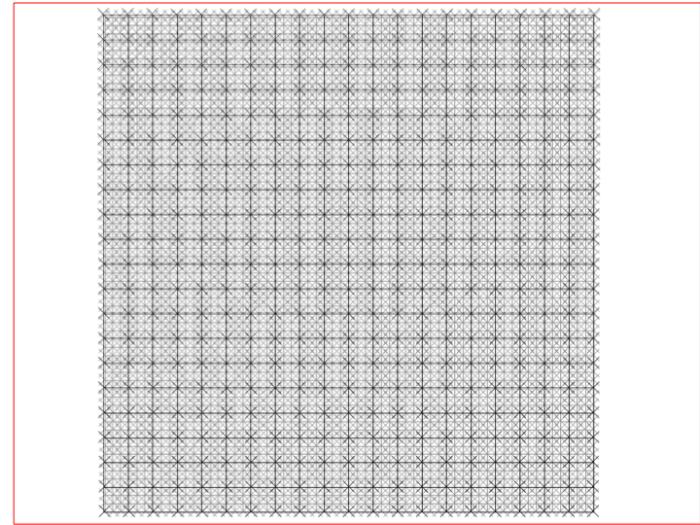
Figure 14 Mapping of the low order DM actuators (dark x’s, 20x20) onto the high order DM actuators (fainter x’s, 60x60). The grid lines represent the telescope primary, or perfect pupil image. Because the grid distortion is low for pupil imaging, the high order DMs map three actuators per one actuator low order DM out to the edge of the pupil.

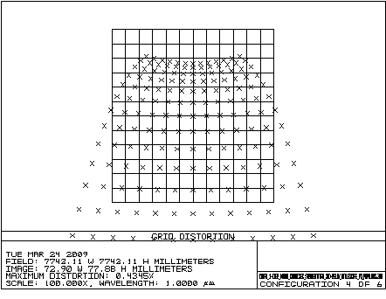

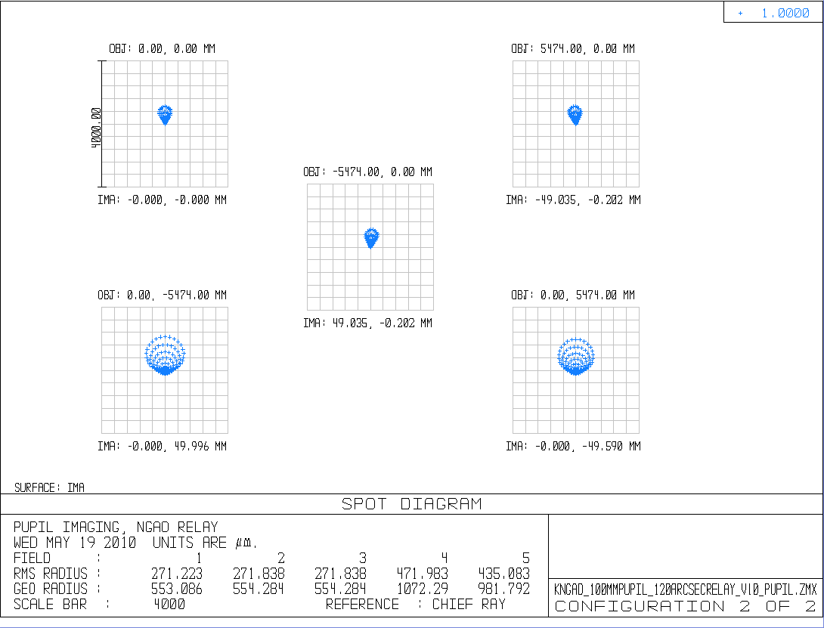
Figure 15 Geometric spot analysis of primary mirror imaged onto low order DM. Pupil tilt and curvature are included.

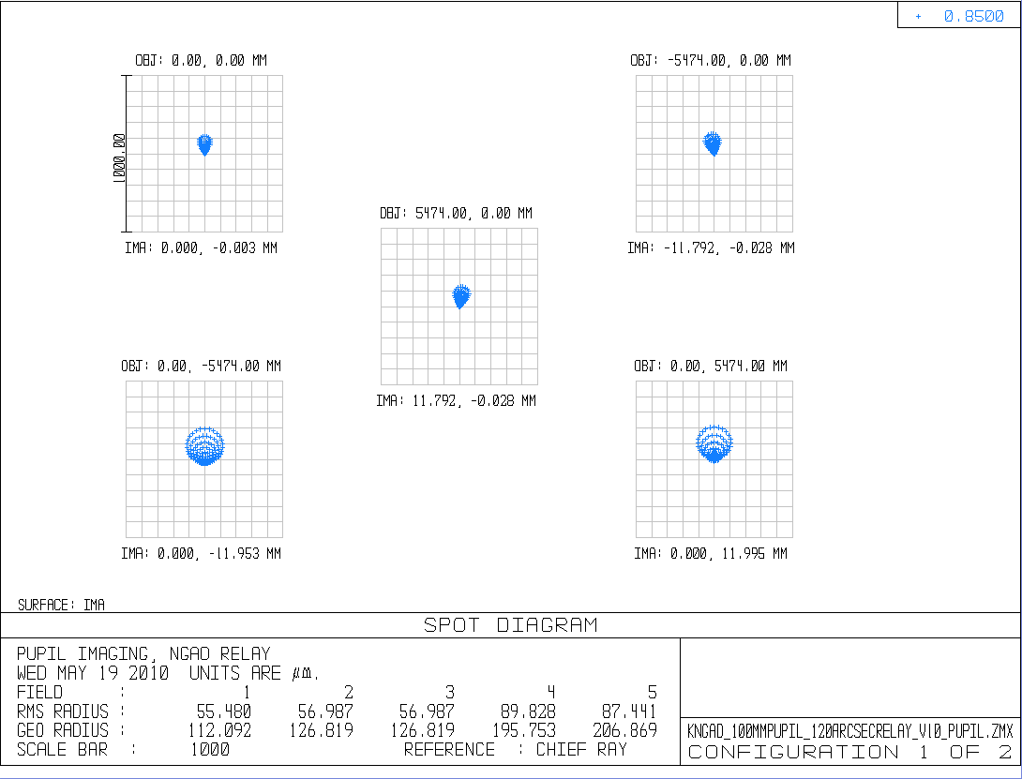
Figure 16 Geometric spot analysis of primary mirror imaged onto high order DM. Pupil tilt and curvature are included.

Figure 18 Grid distortion at the woofer mirror pupil location, magnified by a factor of 100 to emphasize shape.

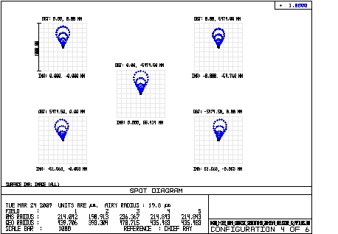

Figure 19 Spot diagrams for 5 places on the primary mirror, as imaged onto the woofer DM. Field considered is 120 arcsecond diameter. The chief rays from the on-axis field angles make up the point of the comatic pattern, while the chief rays for field angles of 60 arcseconds off axis make up the outer “radius” of points on the comatic pattern.

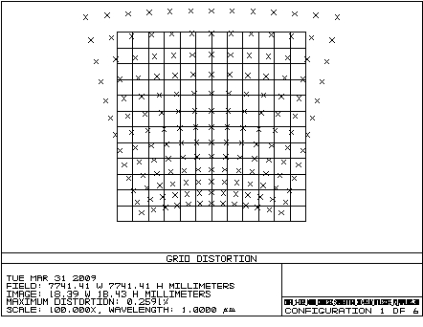

Figure 20 Grid distortion of pupil at 25mm DM. Scale is magnified 100x to emphasize shape of distortion. Maximum distortion is 0.26%.

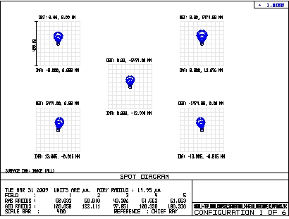

Figure 21 Spot diagram for 5 places on the primary mirror, as imaged onto the 25mm DM. Field considered is 40 arcseconds diameter.

4.4 Telecentricity
Three of the outputs of the relay require the exit pupil of the relay to be located at infinity. The Zemax EXPP (exit pupil position) operand unfortunately is not valid for decentered systems (Zemax manual, June, 2007, p442). To roughly check telecentricity a paraxial lens with a focal length of 200mm was added to the focal plane of each relay. A pupil at infinity will image at exactly 200mm from the paraxial lens. Figures 22, 23, and 24 show the re-imaged pupil planes of the LGS WFS relay, the LOWFS (first) relay, and the science (second) relay, respectively. The image of the pupil is the location where all the field points cross. In this way large deviations from telecentricity can be discovered.
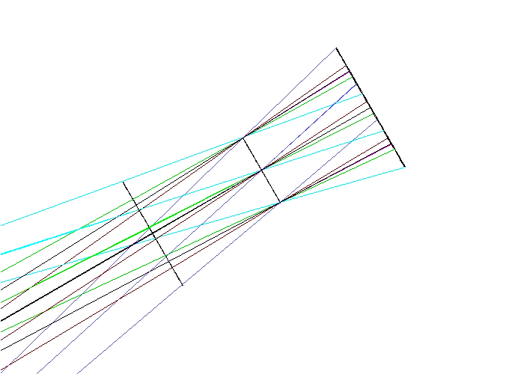
Figure 22 A paraxial lens has been placed at the focus of the LGS WFS relay. It produces a pupil image one focal length away (center line). For scale surfaces are placed 25mm before and after the focal length of the paraxial lens.
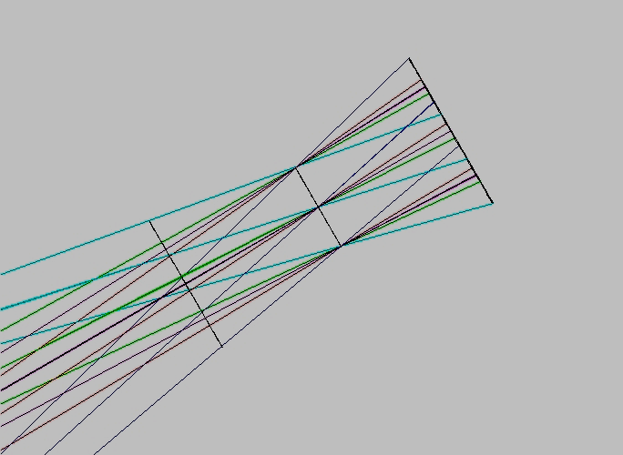
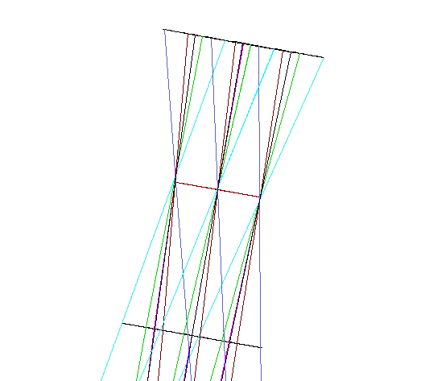
Figure 23 A paraxial lens has been placed at the focus of the LOWFS relay. It produces a pupil image one focal length away (center line). For scale surfaces are placed 25mm before and after the focal length of the paraxial lens.
Figure 24 A paraxial lens has been placed at the focus of the science relay. It produces a pupil image one focal length away (center line). For scale surfaces are placed 25mm before and after the focal length
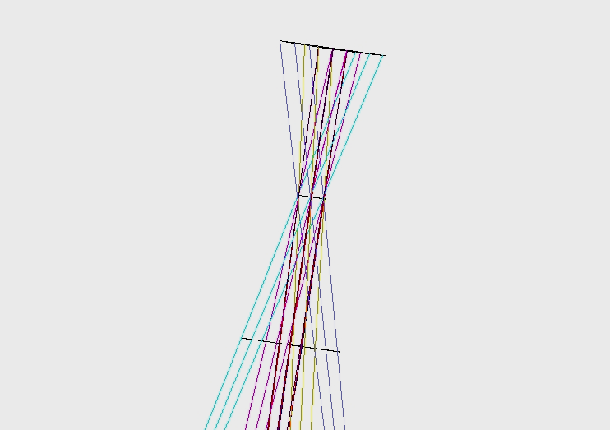

- Optical Tolerancing
  - OAP off axis angle and focal length

The tolerance analysis was carried out both analytically and within Zemax. The OAPs, in particular, were subjected to an analytical tolerance analysis similar to that performed in KAON 107, “Science Path Optical Design” to evaluate the effect of errors in both the focal length and off-axis angle on the DM position, pupil size, and exit pupil position.

Tolerancing work derived from KAON 107

Focal length tolerance

Impact of an error in radius of curvature or focal length, f=f+δf=f(1 + δf/f).

- Identical errors for both OAPs
Consider the case of an identical error for both OAPs of the first relay. The first-order solution to minimizing the impact is to move the components to compensate for this error.

- The first OAP will need to be located a distance δf farther from the telescope focal plane.

- The collimated beam diameter will be increased by d_{DM}'/d_{DM}=1 + δf/f.

- The DM will be moved to be conjugate to the new pupil location. The distance to the DM from OAP1 becomes:

$$t={\left[\frac{1}{f+df}−\frac{1}{t+(f+df)}\right]}^{−1}$$
where t is the distance from the focal plane of the telescope to the exit pupil.

- The second OAP will be moved to provide a telecentric beam to the LOWFS image plane. This new location will be $t_{\text{DM}\text{',}\text{OAP}2}=f+df$.
- The output focal ratio will not change.

B. Error on OAP1 only
If only one OAP has a error, δf, in focal length, then steps 1-3 above still apply.
4. The second OAP will be at a distance f from the DM.
5. The ratio of the output focal ratio to the input focal ratio will be $f{\text{/\#}}_{\text{out}}f{\text{/\#}}_{\text{in}}=\frac{f}{d_{\text{DM}'}}\left[\frac{f+df}{d_{\text{DM}'}}\right]={\left(1+\frac{df}{f}\right)}^{−1}$.
6. The DM, second OAP and science instrument do not move significantly.

C. Error on OAP2 only

If the first OAP is perfect, and OAP2 has an error in focal length of δf, then steps 1-3 of case A are not required since there is no change in the position of the collimated beam diameter or the separation of the DM from the first OAP. We can start at step 4 of case A:
4. The second OAP will be moved to provide a telecentric output, $t_{\text{DM}\text{',}\text{OAP}2}=f+df$.
5. The ratio of the output focal ratio to the input focal ratio will be the reciprocal of case B, step 5, or
$$f{\text{/\#}}_{\text{out}}f{\text{/\#}}_{\text{in}}=\left[\frac{f+df}{d_{\text{DM}'}}\right]/\frac{f}{d_{\text{DM}'}}=\left(1+\frac{df}{f}\right)$$

Summary: The above equations are used in the following table to calculate the impact of a 1% error in focal length. t = 19.95m, f=1.274m

First relay, off-axis parabolas, inpact of a +1% focal length error
OAP with error | OAP1 and 2 | OAP1 only | OAP2 only
Shift in OAP1 (mm) | 13.7 | 13.7 | 0
Ratio of new to old pupil size at DM | 1.01 | 1.01 | 1
Shift in DM distance from OAP1 (mm) | 13.7 | 13.7 | 0
Shift in OAP2 from DM (mm) | 13.7 | 0 | 13.7
Ratio of output focal ratio to telescope’s. | 1 | 0.99 | 1.01

Second relay, off-axis parabolas, inpact of a +1% focal length error
OAP with error | OAP1 and 2 | OAP1 only | OAP2 only
Shift in OAP1 (mm) | 3.2 | 3.2 | 0
Ratio of new to old pupil size at DM | 1.01 | 1.01 | 1
Shift in DM distance from OAP1 (mm) | 3.2 | 3.2 | 0
Shift in OAP2 from DM (mm) | 11.1 | 0 | 11.1
Ratio of output focal ratio to telescope’s. | 1 | 0.99 | 1.01

Off-axis angle tolerance

Impact of an error in off-axis distance or angle, θ; angular error, Δθ.

A. Identical error for both OAPs

First consider the case of an identical error for both OAPs. The first-order solution to minimizing the impact is to move the components to compensate for this error:

1. Ideally want to maintain the input and output beam directions. This requires that the first and second OAPs be tilted to the new angle with respect to these beams (i.e., OAP tilt = θ+Δθ).

This is a tight constraint and somewhat unnecessary. We do have some freedom, but not much, to change the input and output beam direction via the tip/tilt mirror and science instrument location.
2. The DM must then be moved to the intersection of the beams from the two OAPs; it will be at the same angle with respect to both beams. It will need to be displaced

Δx = t_{OAP1,DM}cosθ - t_{OAP1,DM}'cos(θ+Δθ) and
Δy = t_{OAP1,DM}sinθ - t_{OAP1,DM}'sin(θ+Δθ) ,

where positive Δx and Δy are defined to be to the right and up, respectively, on Figure 4 (note that this is not the normal coordinate system definition for this figure).

3. The separation between the first OAP and the DM will now be

t_{OAP1,DM}' = t_{OAP1,DM} + Δθ(t_{DM,OAP2}-t_{OAP1,DM}cosα)/sinα,

where α is the angle the center of the two OAPs subtend at the DM.

4. The separation between the DM and the second OAP will now be

t_{DM,OAP2}' = [t_{OAP1,DM}'sin(θ+Δθ)-t_{OAP1,DM}sinθ+t_{DM,OAP2}sin(θ-α)]/sin(θ-α+Δθ)

5. The pupil is located a distance t_{OAP1,DM}' - t_{OAP1,DM} in front of the DM (i.e., toward OAP1). The change in distance from the pupil location to OAP2 is

Δs₂ = t_{DM,OAP2} - t_{DM,OAP2}' + t_{OAP1,DM} - t_{OAP1,DM}'

The distance from the focal plane to the exit pupil is

t' = [1/(-t_{DM,OAP2}+Δs₂)+1/f]⁻¹ - f

B. OAP1 error only

Now consider the case of just the first OAP having an off-axis error.

1. We want to maintain the input and output beam directions. This requires that the first OAP be tilted to the new angle with respect to these beams (i.e., OAP tilt = θ+Δθ); while the second OAP is tilted to the nominal angle.

2. The DM must be moved to the intersection of the beams from the two OAPs; it moves along the line toward the second OAP by the amount t_{DM,OAP2}-t_{DM,OAP2}'; the equations in A.2. above are still valid.

3. The separation between the first OAP and the DM will now be

t_{OAP1,DM}' = t_{OAP1,DM} sinα/sin(α+Δθ).

4. The separation between the DM and the second OAP will now be

t_{DM,OAP2}' = [t_{OAP1,DM}'sin(θ+Δθ)-t_{OAP1,DM}sinθ+t_{DM,OAP2}sin(θ-α)]/sin(θ-α)

C. OAP2 error only

Now consider the case of just the second OAP having an off-axis error.

1. We want to maintain the input and output beam directions. This requires that the second OAP be tilted to the new angle with respect to these beams (i.e., OAP tilt = θ+Δθ); while the first OAP is tilted to the nominal angle.

2. The DM must be moved to the intersection of the beams from the two OAPs; it moves along the line to the first OAP by the amount t_{OAP1,DM}-t_{OAP1,DM}'; the equations in A.2 above are still valid.

3. The separation between the first OAP and the DM will now be

t_{OAP1,DM}' = t_{OAP1,DM} + t_{DM,OAP2}Δθ/sin(α-Δθ).

4. The separation between the DM and the second OAP will now be

t_{DM,OAP2}' = [t_{OAP1,DM}'sinθ-t_{OAP1,DM}sinθ+t_{DM,OAP2}sin(θ-α)]/sin(θ-α+Δθ)

Summary

Using the first-order design values for the first relay (t_{OAP1,DM} = 1.4595 m, t_{DM,OAP2} = 1.366 m, θ = 25.0 deg., α = 20 deg., DM diameter=100mm):

First relay off-axis parabolas, impact of a +0.1% error in off-axis angle
This corresponds to 1.5 arcmin delta angle
OAP with Error | OAP 1 and 2 | OAP1 only | OAP2 only
Ratio of old to new OAP1 to DM distance | 1.000 | 0.9988 | 1.0012
Ratio of old to new DM to OAP2 distance | 0.9998 | 0.9986 | 1.0012
x-shift of beam at DM (mm) | 0.3 | 1.9 | -1.3
y-shift of beam at DM (mm) | -0.6 | 0.2 | -1.3
Shift in pupil from DM (nn) | 0.0 | 1.7 | 1.7
Size of pupil on DM (mm) | 100 | 99.88 | 100.12
Location of exit pupil from OAP2 (m) | -8080 | 519 | 552

First relay off-axis parabolas, impact of a +1% error in off-axis angle
This corresponds to 15 arcmin delta angle
OAP with Error | OAP 1 and 2 | OAP1 only | OAP2 only
Ratio of old to new OAP1 to DM distance | 1.000 | 0.9882 | 1.012
Ratio of old to new DM to OAP2 distance | 0.9984 | 0.9865 | 1.012
x-shift of beam at DM (mm) | 2.8 | 18.3 | -13.2
y-shift of beam at DM (mm) | -5.7 | 1.6 | -13.3
Shift in pupil from DM (nn) | 0.1 | 17.3 | 17.6
Size of pupil on DM (mm) | 99.995 | 98.8 | 101.2
Location of exit pupil from OAP2 (m) | -824 | 53.7 | 55.9

Because the above analysis assumes that we have maintained the input beam direction to OAP1 and the output beam direction from OAP2, we can treat the second relay as decoupled from the first. Thus all the above analysis applies to the second relay.

Second relay off-axis parabolas, impact of a +0.1% error in off-axis angle
This corresponds to 0.78 arcmin delta angle
OAP with Error | OAP 1 and 2 | OAP1 only | OAP2 only
Ratio of old to new OAP1 to DM distance | 1.002 | 0.9994 | 1.0023
Ratio of old to new DM to OAP2 distance | 1.000 | 0.998 | 1.0006
x-shift of beam at DM (mm) | -0.5 | 0.2 | -0.7
y-shift of beam at DM (mm) | -0.2 | 0.0 | -0.2
Shift in pupil from DM (nn) | 0.5 | 0.2 | 0.7
Size of pupil on DM (mm) | 24.039 | 23.985 | 24.054
Location of exit pupil from OAP2 (m) |  | 2938. | 865

Second relay off-axis parabolas, impact of a +1% error in off-axis angle
This corresponds to 7.8 arcmin delta angle
OAP with Error | OAP 1 and 2 | OAP1 only | OAP2 only
Ratio of old to new OAP1 to DM distance | 1.016 | 0.9938 | 1.0227
Ratio of old to new DM to OAP2 distance | 1.004 | 0.9981 | 1.0063
x-shift of beam at DM (mm) | -5.0 | 2.1 | -7.1
y-shift of beam at DM (mm) | -1.9 | -0.3 | -2.4
Shift in pupil from DM (nn) | 5.3 | 2.0 | 7.4
Size of pupil on DM (mm) | 24.39 | 23.85 | 24.54
Location of exit pupil from OAP2 (m) | 123 | 296 | 87

  - Zemax tolerancing analysis
Analysis of tolerances in the optical design were also done with the Zemax EE tolerancing tool. The tolerances analyzed can be divided into two categories: mounting tolerances essential for the mechanical design and manufacturing tolerances important for the vendors producing the optics. Included in the mounting tolerances are the tilt and decentration of the optical elements, as well as distances between them. The manufacturing tolerances concern the radii of curvature (for the powered optics), flatness (for the flat mirrors and dichroics) and off-axis angles (OAAs). The telescope was not included in the tolerancing.
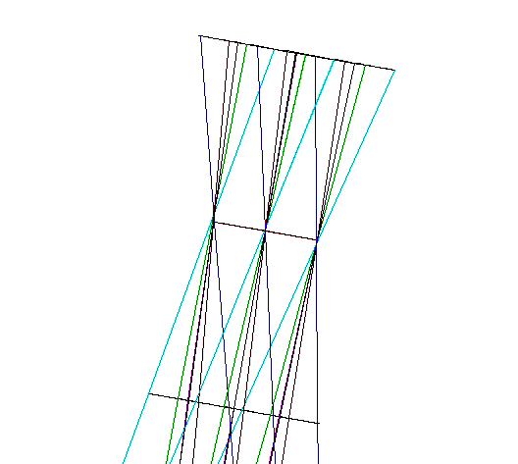
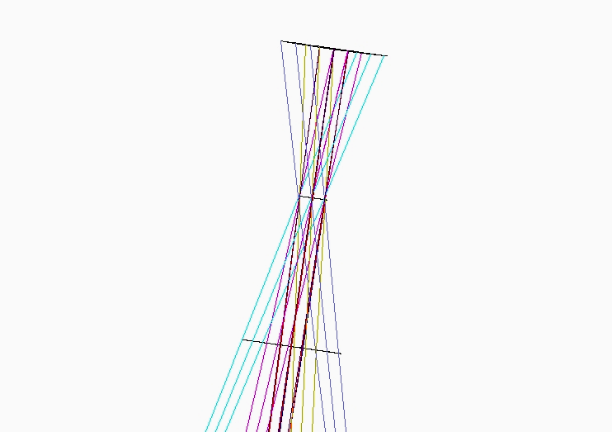
Figure 23 A paraxial lens has been placed at the focus of the LOWFS relay. It produces a pupil image one focal length away (center line). For scale surfaces are placed 25mm before and after the focal length of the paraxial lens.
Figure 24 A paraxial lens has been placed at the focus of the science relay. It produces a pupil image one focal length away (center line). For scale surfaces are placed 25mm before and after the focal length

Zemax allows tolerances to be evaluated by several different criteria. We have chosen the RMS wavefront error merit criteria, as this is directly comparable to values in the derived error budget. We’ve also performed a boresight criteria analysis, to ascertain stability requirements for the optical mounts. The analysis was performed at 1 micron wavelength. Because of the difficulty in performing tolerance analyses on multi-configuration operands, the Zemax file was reduced to the science path configuration only (figure 6). Tolerances may also be performed separately on the LGS WFS optical path, and the LOWFS, first relay if desired.

Compensators may also be defined in Zemax, and boundary values defined for the compensators. For these analyses we allowed compensation of the back focal distances of the first and seconds relays, with the boundary condition of +/- 10 mm. The compensators were optimized using orthogonal descent.

Initially, we performed a sensitivity analysis in which the change in merit criteria (RMS wavefront error or boresight) is calculated for each tolerance individually. This allows evaluation of the “worst offenders”, indentifying which tolerances must be tightened, and which can be relaxed. An aggregate performance is estimated by a root square sum (RSS) calculation.

Once reasonable tolerances are determined using the sensitivity analysis, a Monte Carlo analysis simulates the effect of all the tolerance perturbations simultaneously. Zemax does this by assuming a normal distribution (modified Gaussian) of tolerance values within the user defined range of the tolerances. To provide adequate statistics, the Monte Carlo analysis was permitted to run n² times, where n is the number of individual tolerances.

  - Mounting Tolerances
Assembly tolerances resulting in acceptable performance of the NGAO relay are listed in Table 7. These tolerances are typical of standard assembly methods, and will not require extraordinary efforts to achieve.
Table 7 Mechanical tolerance values used in Zemax.
Parameter | Value | Units
Thickness (TTHI) | ±0.200 | mm
Decentration (TEDX/Y) | ±0.100 | mm
Element Tilt (TETX/Y) | ±0.004 | degrees

Thickness tolerances were applied to distances between optical elements, decentration was applied to OAPs, and tilt tolerances were applied to every optical element, including the OAPs, the DMs, the fold mirrors, and the dichroic beamsplitters.

The tilt and decenter of the K-mirror’s individual mirrors, and the K-mirror unit as a whole, were included for completeness. However, the alignment and tolerancing of the K-mirror assembly, as it pertains to both pupil and image motion, has been analyzed in detail by previous generations of Keck optical engineers. This analysis is still pertinent, as the distance of the mirrors to focus is similar to the existing system (especially when compared to the 20 m distance to the exit pupil).
The subaperture width decreases by a factor of 64/20, and thus the tolerances to keep the pupil wandering less than 10% of a subaperture will be tighter by a factor of 3.2.

The sensitivity analysis indicates that the worst offenders are tilt errors in the woofer DM (not surprisingly) and OAP mounts. However, a tilt of 0.004 degrees (14.2 arcseconds) at OAP1 results in less than a nanometer additional RMS wavefront error. Table 8 summarizes the worst offenders that had an appreciable effect on the RMS wavefront error.
Table 8 Worst offenders, mechanical tolerances
Tolerance | Value (degrees tilt) | Criterion (RMS WFE, nm, nominal 18.8)
TETY 19, woofer | 0.004 | 22.1
TETY 19, woofer | -0.004 | 22.1
TETY 16, OAP1 | -0.004 | 19.7
TETY 16, OAP1 | 0.004 | 19.7
TETY 27, OAP2 | -0.004 | 19.7
TETY 27, OAP2 | 0.004 | 19.7

A Monte Carlo analysis of mounting errors leads to a similar conclusion. The nominal RMS wavefront error due to static aberrations for a perfectly aligned system is 18.8 nm (at 1 micron wavelength). For the tolerances listed in Table 7, a 2401 iteration Monte Carlo analysis predicts that 90% of the configurations will have less than 23.7 nm RMS wavefront error. This includes contributions from tilt error in the woofer DM mount (which in practice will be mitigated by its attachment to the tip/tilt stage).

A boresight analysis was also performed to ensure that mechanical tilts and decenters resulted in movement on the camera of much less than a tenth of a pixel.

  - Manufacturing Tolerances

Considered separately are manufacturing tolerances to be specified to the vendor during procurement. These include tolerances on the radii of curvature for the OAPs, off-axis angles for the OAPs, flatness of the fold mirrors and dichroics, and figure errors for the OAPs. The off-axis nature of the OAPs led to difficulties in defining Zernike figure errors (i.e. the TEZI tolerance operand) because Zemax centered these aberrations on the parent parabola. Thus the figure errors for the OAPs will be considered with an analytic approximation outside of Zemax.
Table 9 Manufacturing Tolerances
Parameter | Value | Units
Radius (TRAD) | 0.5% | Unitless
Flatness (TFRN) | ±0.200 | Fringes
Off-axis angle (TPAR) | ±3.5 x 10⁻⁵ | Degrees

Table 9 details the manufacturing tolerances used in the Zemax analysis. The radius of curvature was assigned a tolerance of 0.5% of the radius, as given by Space Optics Research Labs (SORL) as a standard tolerance. The flatness of dichroics and folds was assumed to be within 0.200 fringes, as measured in a double pass Newton’s rings type test. The off-axis angles (OAA) of the OAPs were given tolerances of 0.125 arcseconds, again as specified by Space Optics Research lab. The OAA tolerances were implemented by adjusting either the angle or off-axis distance in the coordinate break preceding the OAP surface. Chief ray solves were left in during tolerancing to ensure that off-axis angles and off-axis distances were consistent.

The worst offenders were OAP tolerances for radii of curvature. Again, the nominal criteria for RMS wavefront error is 18.8 nm. A change of 0.5% in OAP1’s radius of curvature corresponds to a 3 nm change in wavefront RMS. The back focal distances of relays 1 and 2 are allowed to change ±10mm in compensation. Table 10 summarizes the worst offenders that made an appreciable effect on the RMS wavefront error. If distance from Nasmyth focus to OAP1 had been allowed as a compensator (in effect, adjusting the position of the OAP to ensure that the optic produces a collimated beam) the criterion change is negligible. Likewise, for OAP3 if the distance from the 1st relay focus to OAP3 had been allowed as a compensator.

Table 10 Worst offenders, manufacturing tolerances.
Tolerance | Value | Criterion (RMS WFE, waves, nominal 18.8)
TRAD 16, OAP1 | 6.8 mm | 0.0221
TRAD 16, OAP1 | -6.8 mm | 0.0204
TRAD 34, OAP3 | -1.75 mm | 0.0189

A Monte Carlo simulation of manufacturing tolerances shows that these tolerances, like those adopted for mechanical mounting, are acceptable in terms of degradation to image quality. The 256 iteration Monte Carlo predicts that 90% of configurations will produce less that 20.5nm RMS wavefront error. The compensators in the Monte Carlo run had standard deviations which were 0.2% and 0.4% of the 1st relay back focal distance and 2nd relay back focal distance, respectively.

