Keck Next Generation Adaptive Optics
Opto-mechanical group
Meeting notes May 5, 2009

Don Gavel

Agenda:
- Opto-mechanical tolerancing analysis status
- Mechanical layout drawing status
- Interface discussions
  - Fields of regard available at ports
  - Cold area definition, and interfaces
  - AO throughput to interfaces
- ADC work to be done

Discussion

Tolerance main issues are sensitivity of design to manufacturers’ mis-figuring of optics, and adjustability and stability of mounts with the goal of non-custom mounts. Tolerance to temperature variation is of secondary importance because the AO enclosure will be temperature controlled.

Mechanical layout: Reni and Chris have met separately to start on this, but Chris will not be greatly available until after LRIS shipping.

There is a residual question of whether the 2nd dichroic can be a single splitter with in/out mechanism, or needs to be a selector between two splitters and open. This question affects NGS science; to be answered by the science team.

Clarification on fields of regard (see figure below):

TTFA pickoff field (outer circle), available through first relay: 120 arcsec diameter
Science detector (blue square): 40 x 40 arcsec
Field available through second relay (red outline): roughly 50 arcsec in along bench direction and 60 arcsec perpendicular to bench direction.

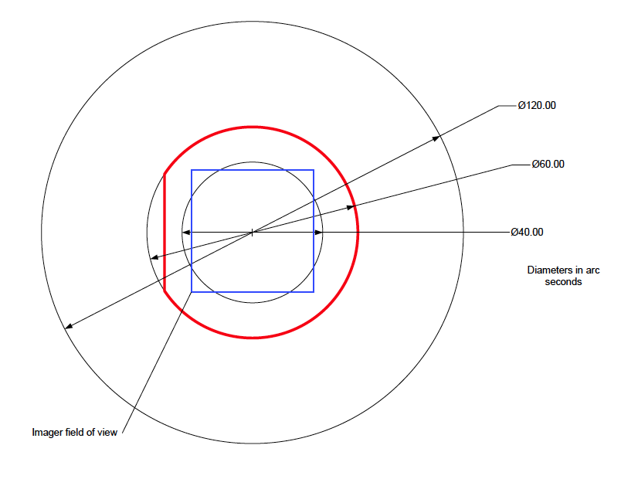
(Sean gets the credit for making this beautiful drawing in Visio)

The K mirror derotator will allow arbitrary orientation of the sky field with respect to this footprint.

Cold area interfaces. Discussion about where interfaces are needed:
1. input window (already dealt with)
2. window to LGS WFS (discussed earlier)
3. window to science camera (bellows and dewar window, already discussed with Sean)
4. window to acquisition camera? Or put camera inside cold area?
5. window to NGS WFS? Or put camera inside cold area? – if inside, would need provision for cooling camera heads.
To do: draft ICDs for Relay/LGSWFS, Relay/LOWFS, Relay/Science Instrument, Relay/Acquisition System, Relay/Cold Enclosure

AO throughput. Don is to post the throughput and emissivity calculator tool on to the twiki page. This has a representative set of surfaces corresponding to the current optical design, plus data on coatings, etc. This is not definitive or guaranteed to coincide with the FPR so use with caution and let me know if there are problems. http://www.oir.caltech.edu/twiki_oir/bin/view/Keck/NGAO/OptoMechanicalPDRPhase#Tools

ADC work. Reni needs to design ADCs for the visible and IR wavelengths science paths. There will be no further work on the LOWFS ADCs

Informational:
The LGS constellation is 10 arcseconds radius 3+1 as described in KAON 644

Next Meeting:
Changed for next week only: Monday May 11, 11:00 PDT

