Keck NGAO Opto-mechanical meeting June 23, 2009
Attendees: Sean Adkins, Alex Delecroix, Reni K.upke, Chris Lockwood, Viswa Velur
Chris described interference between the light path for the LGS and the interferometer DSM enclosure, note that the table does not interfere, just the enclosure. Chris has also been working on mounts for the AO bench and the image rotator design.
There is a possible interference between OAP4 and the NGS sensor, Chris and Reni need overall NGS sensor envelope dimensions from Viswa.
Viswa has completed the LGS WFS optical design, but needs to adjust it for a 21 μm pixel size (nominal size for the new 256 x 256 low noise CCD). He and Reni are working on incorporating the LGS WFS into the overall optical design and will be evaluating effects of over/under filling the subaperture pupils due to the f-number change that results from refocusing over the range of 90 to 180 km.
Alex notes that the LOWFS pickoff volume allowed for in the current SolidWorks model is too short in the vertical dimension.
Action Items from the meeting:
- Chris needs more information on the DSM optical bench layout to determine if the enclosure interference can be easily remedied. Chris will contact Ed Wetherall or Julien for photos of the DSM.
- We need to review the DSM position and optical path details to be sure we have properly accommodated it in the layout and then evaluate how well we are meeting the interferometer’s input beam requirements. We also need to understand any changes being made by the ASTRA project. Chris and Reni to continue working on this topic.
- Viswa will provide Chris and Reni with the estimated overall envelope dimensions of the NGS sensor.
- Viswa needs more information on cooling system selection for the AO bench enclosure. Jim Bell is on vacation so Viswa will contact Craig Nance at WMKO.
- Need to consider if ½ field coverage for the TTFA sensor is practical (will want the brightest of the three available TT stars), may interact with PA selection for IFS if a rectangular field is offered. The sketch on the next page shows how aligning the rectangular field to the ½ field boundary for the TTFA may minimize the impact of TTFA star selection on choice of PA for observations.
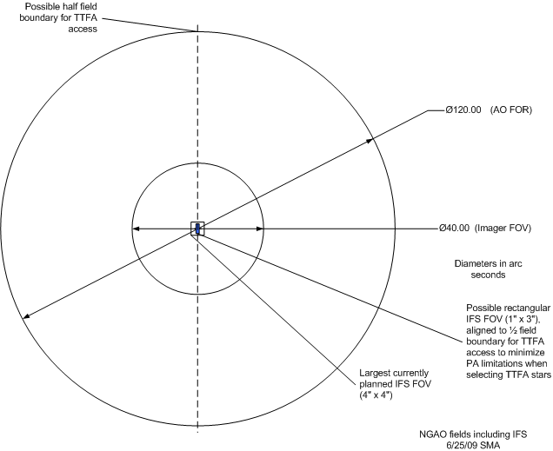
An enlargement of the central area of the above sketch.

