AO Performance Estimation Tool
for the NIR TTS Preliminary Design
Chris Neyman
March 16, 2010

Introduction
Telescope time is always oversubscribed at the Keck Observatory. As a result, the observer needs to determine if a particular target is observable before actually arriving at the telescope. The availability of natural guide stars is a crucial factor in determining the feasibility of any mode of AO observations. NIT TTS is required to provide a tool that predicts AO performance. This would allow an observer to determine what AO performance can be expected for a set of possible guide stars.
In addition, the tool can be used while observing to determine if expected performance is actually being achieved. This could be a useful diagnostic for problems and would allow the astronomer to adapt to the conditions. For example, on a given target they might be able to use brighter stars further off-axis if the high altitude turbulence was weaker that night or they might modify their observing plan to concentrate on targets with convenient NGS if the conditions are poor. The tool will not be part of the operational software and will not be built to AO operational standards. In any case the AO system could still observe without it. However, it should be the same tool the astronomer used for planning but with an automatic (or manual) input of the existing conditions.
After observations the tool would provide a check on the expected quality of the data. The validity of the tool would be updated using AO telemetry and science data as a basis for comparison. These periodic updates would improve the tools ability to predict performance in varying conditions.
It is anticipated that the NIR TTS system will use from one up to as many as three IR tip-tilt stars [1]. In addition, the observer might also want to consider using the current STRAP sensor which has peak sensitivity in the visible (R band). In either case, the observer will still need to select a visible band star for the AO Low Bandwidth Wavefront Sensor (LBWFS) which helps to compensate for changes in the sodium layer structure and range. Ideally, the performance estimation tool would be tightly interfaced to the future AO guide star selection tool. It would provide the capabilities to evaluate which of several guide star scenarios would provide the best AO performance. Another consideration is that the NIR TTS system will use an optical pickoff (dichroic or annular mirror) to send part of the NIR bands to both the NIR TTS sensor and the science instrument. An observer will have to evaluate which of several possible pickoff choices is optimal.
For the current Keck I and II AO systems, this need to find natural guide stars in close proximity to an astronomical target is met by the AO guide star tool [2]. The current NIR TTS design calls for a modified star list format that will be used as the interface between an updated AO guide star selection tool and the AO performance Tool. The user will use the AO guide star tool to configure the guide stars for the particular scenario and then save that star list to disk. The AO performance estimation tool will need to be able to read this file.

The output of the performance tool would be predictions for Strehl and ensquared energy, and possibly a point spread function image. The user-provided inputs to this tool would include:

- Star list: text file produced by user or by AO guide star selection tool
- Seeing conditions: several default conditions (i.e., median, good and poor seeing); also allow inputs from the Mauna Kea MASS/DIMM during observations and from its data archive. User can enter seeing values by hand from for example the value reported at night by the AO system
- Telescope elevation: input or calculated from object position, date, and time; possibly provided automatically at the telescope from DCS/TCS keywords
- NIR TTS observation wavelength: Include option for NIR TTS pickoff setting; possibly provided automatically at the telescope from AO keywords or input by user.
- Science instrument setup: including relevant parameters for science instrument. Including among others, the OSIRIS imager plate scale and filter or IFU plate scale and appropriate wavelength range for spectroscopy; provided possibly provided automatically at the telescope from DCS/TCS keywords

- Requirements
The following are the relevant requirements placed on the performance estimation software. The requirements reproduced below were originally taken from reference [3]. The abbreviation SR-## is used to indicate the unique identification number for each system requirement.
SR-47: The NIR TTS system shall provide the needed tools to support science observation planning.
SR-65: The NIR TTS system shall be provided with the documentation required to support science operations planning. This should include at least 3 months of performance characterization data after the system has begun being used for shared-risk science.
SR-66: Goal: The NIR TTS shall be provided with a performance estimator tool. This would be even more useful with a PSF simulator attached to it.

- Possible Performance Estimation Tool Methodologies

At least three techniques could be used to develop a prediction capability in a future performance estimation tool, in order from least to most complicated:
Report: Just a list or table of the performance either as measured during commissioning of the instrument or from a series of models or simulation runs. This method documents the performance but doesn’t allow the user to easily configure the tool to match the observing scenario.
Scaling Law Tool: The simple AO performance rules of thumb or scaling laws (see for example reference [4]) are simple analytical formulae that are often used to scale or predict AO performance based on perturbations to a measured or known performance point. For an idealized AO system, the scaling laws should be able to predict performance from first principles. However, in practice this usually proves unsatisfactory unless allowances are made for the non-ideal nature of some AO components. A possible way to design this tool would be to use the measure or simulated performance as a starting point. It would then use the scaling laws to interpolate or extrapolate the results to match the actual observing setup and atmospheric conditions. This technique combines the relative simplicity of method one (report) but allows the results to be adapted to the actual conditions and setups that an observer would be using.
Monte-Carlo Simulations: The best prediction of the performance on an AO system can be done by detailed computer simulation that use the Monte Carlo technique to model the behavior of the AO system. In the past, these codes were complicated and took long periods of time to run. As high computer performance continues to get cheaper, some of these obstacles can be removed. As an example: Matthew Britton (while at Caltech) provided a web interface to several of his AO simulation codes. The user submitted a request using a form on a web page. An input file was prepared from this web form and a computer simulation was added to a batch queue on the dedicated AO simulation computer at Caltech. When the computations were completed, the results could be retrieved by the user. Another advantage of this tool is that it can be easily configured to provide the observer with a PSF image if desired.
At present, it appears that the scaling law method provides the best path forward. It can be tailored to the observing setup and can provide rapid return of information. The Monte Carlo tool is appealing because it would simulate the exact observing scenario but it is likely to require more resources than are available at this time.
- Software Organization
At present, we assume that the combination of reported performance plus Scaling Law method is the basis for the future performance estimation tool design. Further, we assume that the main interface to the performance tool will be an upgraded version of the AO star list.
The processing steps on the graphical user interface (GUI) would be arranged as follows:
- User selects targets and AO guide stars configuration from Keck star list file. This configures the tracking mode (STRAP, NIR TTS, both, etc.).
- User configures date and checks elevation (air mass) and telescope limits (K1 for NIR TTS).
- User configures science instrument (pull down list or separate popup window).
- User selects AO atmospheric conditions. Choice of one of several default conditions (i.e., median, good and poor seeing); also allow inputs from the Mauna Kea MASS/DIMM during observations and from its data archive. GUI should show summary statistics (r0, Greenwood frequency) as well as profile.
- User selects a button to start computation of AO performance. GUI lets observer compare performance with different guide star configurations. Compare performance with different IR tracking modes, number of targets and compensation mode. GUI would return Strehl, ensquared energy and possibly an option to download a PSF model.
- User can modify the star list with NGS targets based on results from above steps.
- User can save the modified star list and AO performance results.
These steps would be selected from the main GUI and the user could vary his selections, recomputed results as needed. Default inputs would be provided except for loading a science target and a set of NGS guide stars.
- Interfaces to AO, NIR TTS, Telescope, and External software
The performance estimation tool will need to be interfaced to the following software; exact details are still to be determined:
- Keck Star List: Format [4] for these target lists will need to be modified in some fashion to indicate NIR targets, pickoff selection, and tracking mode. More details are given in the AO guide star selection note (in progress).
- AO Performance Tool: This will need to be interfaced to Mauna Kea MASS/DIMM profile information.
- Software Realization of AO Performance Tool
We anticipate that the software languages used to develop the AO performance tool will have the following features:
AO performance tool is not critical function needed during astronomical observations with the Keck I AO and OSIRIS. Therefore it does not need to be constructed to comply with all levels of the Keck operational software standards.
AO performance tool should be easy to modify by AO engineers or support astronomers. This allows the tool to reflect the current performance of the AO system in a timely manner without extensive software rewrites. While the needed changes would be confined as much as possible to configuration file that is read by the tool at startup, some parts of the code such as parametric fits to existing data might need to be modified inside some code sections. Personnel at the observatory will need to periodically update the tool.
AO performance tool should be written in a language that allows easy interfaces to plotting and other graphical visualization tools. The language should provide an easy means to interface with computational libraries for data fitting, Fourier transforms, and other mathematical functions.
AO performance tool should have an interface that can he used by the average AO observer.
AO tool should be useable by the average astronomer at their home institution.
Based on this list of desirable features, we would select IDL or possibly Python as the software language for the AO performance tool. Keck AO has used both Python and IDL to produce tools for the AO system in the past and either could be used for the AO performance tool. At present IDL, would be preferred as it is more familiar to the astronomical community, the Keck support astronomers, and the AO development team.
The development of this software will be tracked with a version control system, using cvs software current standard at Keck. It is not clear if the master version of the software would be kept on the summit K1 AO server or at the Waimea headquarters. An executable version of the software plus user documentation would be distributed from the Keck public website for use by outside astronomers. A nighttime version would be hosted on an appropriate AO or instrument workstation.
A high level flow chart of the processing steps is shown in Figure 1. A prototype user interface is shown in Figure 2.

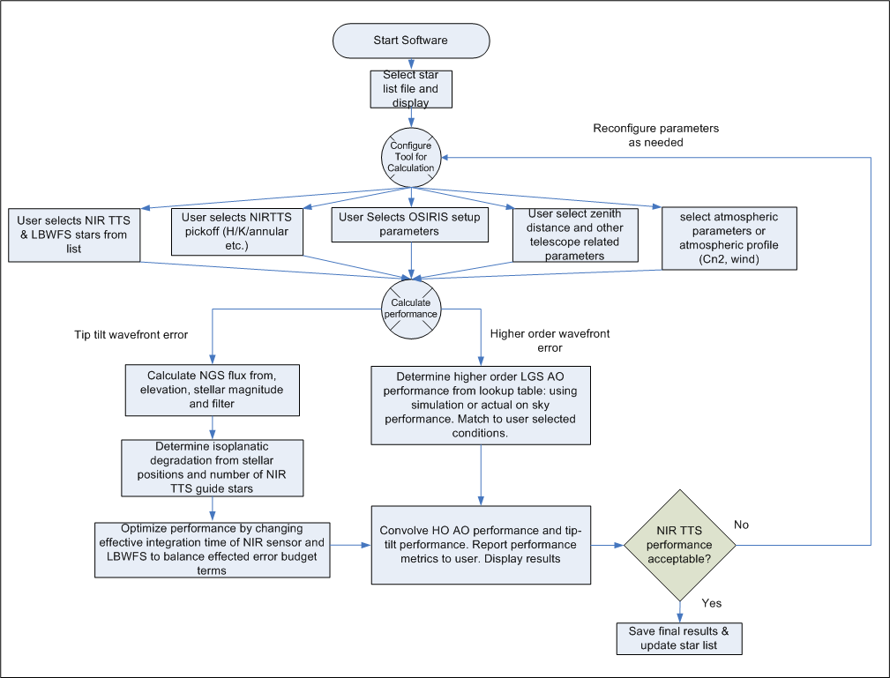
Figure 1: A simplified flow chart of the AO prediction tool.

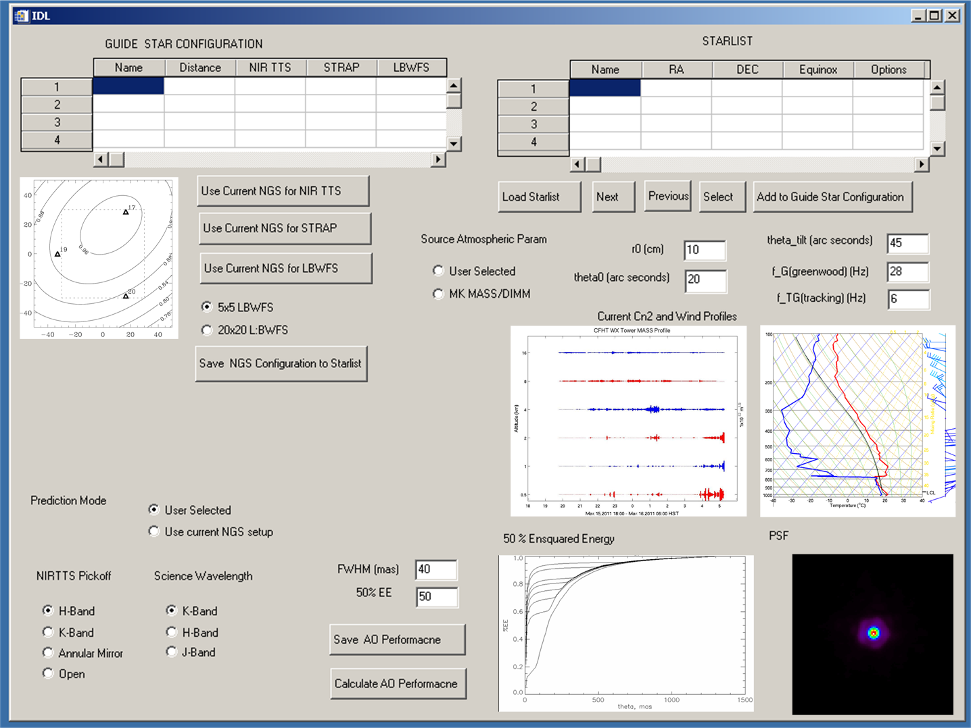
Figure 2: A prototype GUI for the AO prediction tool. Top portion of the GUI display the user star list. The user can select guide stars and add them to the current guide star configuration. Setups can be configured for STRAP, NIR TTS (1-3 stars) and the LBWFS. The user is also able to select the atmospheric and wind profiles using the middle right section of the GUI. The bottom section displays the estimated performance. This GUI is only a “sketch” the final GUI will likely look much different but incorporate some of the same functionality.

References
- Marcos van Dam, “Tip-tilt tomography for TRICK at Keck Observatory”, KAON 826, Version 4, November 1, 2010.
- Keck Adaptive Optics Guide Star Tool, available at: http://www2.keck.hawaii.edu/software/findChartGW/acqTool.php.
- Wizinowich, et al., “Near-Infrared Tip-Tilt Sensor System Requirements Document”, KAON 823, Version 0.1, October 22, 2010.
- J. Hardy, "Adaptive Optics for Astronomical Telescopes", Oxford University Press, 1998
- Keck Star List format can be found here: http://www2.keck.hawaii.edu/optics/lgsao/lgsstarlists.html.

