Keck Adaptive Optics Note 859

Near-Infrared Tip-Tilt Sensor
Observing Operations Concept Document

Version 2.0
March 17, 2011

Authors:
Chris Neyman, Jim Lyke, Elizabeth McGrath, and Peter Wizinowich

Contributors:
NIR TTS team

Document Revision History
Revision Number | Revision Date | Summary of Changes | Author
1.0 | 2/09/2011 | Initial release for preliminary design phase | C. Neyman
2.0 | 3/17/2011 | Added figures with prototype GUIs and discussion | C. Neyman
Table of Contents
Acronyms 4
1. Introduction 5
2. Scope and Applicability 5
3. Related Documents 5
4. Background and Overview of the Near-IR Tip-Tilt Sensor 6
4.1. Motivation for the Near-IR Tip-Tilt Sensor 6
4.2. Observing Configurations 6
4.3. Typical Users for the NIR TTS System 7
4.3.1. Observing Assistants 7
4.3.2. Support Astronomers 7
4.3.3. Astronomers 7
4.3.4. Operations Technicians and Engineers 8
4.3.5. Development Scientists and Engineers 8
5. NIR TTS Use Cases 8
5.1. Astronomer Use Case 8
5.1.1. Astronomer Pre-observing 8
5.1.2. Astronomer Observing 11
5.1.3. Astronomer Post Observing 14
5.2. Observing Assistant Use Case 15
5.2.1. Observing Assistant Pre-observing 15
5.2.2. Observing Assistant Observing 15
5.2.3. Observing Assistant Post Observing 17
5.3. Support Astronomer Use Case 18
5.3.1. Support Astronomer Pre-observing 18
5.3.2. Support Astronomer Observing 18
5.3.3. Support Astronomer Post Observing 19
6. Summary of Required Functionality, Services, and Products 20

Acronyms
2MASS 2 Micron All Sky Survey
ACAM AO Acquisition Camera
AO Adaptive Optics
DAR Differential Atmospheric Refraction
DM Deformable Mirror
DSS Digitized Sky Survey
EE Ensquared Energy
FOV Field Of View
FWHM Full Width at Half Maximum
GSC Guide Star Catalog from the Space Telescope Science Institute
GUI Graphical User Interface
IDL Interactive Data Language
IFU Integral Field Unit
KAON Keck Adaptive Optics Note
LBWFS Low Bandwidth WaveFront Sensor
LCH Laser Clearing House
LGS Laser Guide Star
LTCS LTCS: Laser Traffic Control System
MAGIQ Multifunction Acquisition, Guiding, and Image Quality
NGS Natural Guide Star
NGWFC Next Generation Wave Front Controller
NIR Near InfraRed
NIR TSS Near InfraRed Tip-Tilt Sensor
NSF National Science Foundation
OBS Optics Bench Subsystem
OA Observing Assistant
OSIRIS Oh-Suppression near InfraRed Integral field Spectrograph
PA Position Angle
Pan STARRS Panoramic Survey Telescope & Rapid Response System
PSF Point Spread Function
RMS Root Mean Square
RTC Real-Time Control
SA Support Astronomer
SC Supervisory Controller
SDM System Design Manual
SDR System Design Requirements
SDSS Sloan Digital Sky Survey
SR Strehl Ratio
SR System Requirement
STRAP System for Tip-tilt Removal with Avalanche Photodiodes
TAC Time Allocation Committee
TDB To Be Determined
TRICK Tip-tilt Removal with Ir Compensation at Keck
TRS Telemetry Recorder / Server
TT Tip-Tilt
TTM Tip-Tilt Mirror
TTS Tip-Tilt Sensor
UKIDSS UKIRT Infrared Deep Sky Survey
UKIRT United Kingdom Infrared Telescope
WFS WaveFront Sensor
WISE Wide-field Infrared Survey Explorer
WMKO W. M. Keck Observatory

Introduction
As defined in the W. M. Keck Observatory instrument development program, the Observing Operations Concept Document (OOCD) is written during the preliminary design phase. It is the third major design document written for a new instrument and follows the creation of the System Requirements Document (SRD) and the System Design Manual (SDM), both of which were written during the system design phase. Using these two documents as a foundation, the OOCD expands and clarifies them by answering the question: what functions, products, or services does the system provide to its users. Here the term user is broadly defined to encompass astronomers, observing assistants, support astronomers, and observatory engineers.

It is important to note that the OOCD does not attempt to determine the methods or the architecture used to achieve the desired results. This is the purpose of the design work done during the remainder of the preliminary design phase. The results of this work will be summarized in the preliminary design manual (PDM – KAON 860).

Scope and Applicability
This OOCD is limited to the Near-Infrared Tip-Tilt Sensor (NIR TTS) and associated systems that will be added to the Keck I AO system. Since the NIR TTS will be added to an existing capability at the observatory, this document is limited to new features and products that are part of the NIR TTS system. The document is not intended to be a complete OOCD for the full AO system. In a similar manner, the NIR TTS system will be used with the existing integral field spectrograph OSIRIS. Only the relevant parts of observation with OSIRIS are discussed here. More details of the OSIRIS instrument are found in its own documentation. Additional information on the Keck AO system and the OSIRIS instrument can be found in the reference documents, see section 3.0.
Like all OOCDs at Keck, this document takes as a starting point the science and system requirements detailed in the NIR TTS SRD (KAON 823). The OOCD also assumes that the instrument design in the NIR TTS PDM (KAON 860) is the baseline, which will be assumed in this document. In cases where the design of the previous phase is not able to comply with the functions or tasks in this OOCD, the authors of this document will provide that information to the systems engineering team, for requirement revisions and to the design teams, for design modifications. This process is iterative and changes can be made to any of the following: OOCD, requirements, and design. Modifications will continue during the preliminary design phase and will be documented in the OOCD and the preliminary design versions of the requirements and design manual.

Related Documents

This section lists the documents that provide relevant background information.
- KAON 823: NIR TTS System Requirements Document. The system requirements that impact science and science operations are described in Sec. 3, Science Requirements.
- KAON 860: NIR TTS Preliminary Design Manual. Presents an overview of the system design including NIR TTS optical design, detector specifications, controls hardware and software, science operations software, and predicted performance.
- KAON 777: Near-Infrared Tip-Tilt Sensor for Laser Guide Star Adaptive Optics
- KAON 515: How to query TRS from IDL
- OSIRIS Users Manual
- MAGIQ user interface, user manual http://www.keck.hawaii.edu/realpublic/inst/magiq/
- AO acquisition tool: http://www2.keck.hawaii.edu/optics/ao/ngwfc/aoacq.html
- AO optimization: http://www2.keck.hawaii.edu/optics/ao/optimizer/index.html

Background and Overview of the Near-IR Tip-Tilt Sensor

Motivation for the Near-IR Tip-Tilt Sensor
The NIR TTS system will use an NIR sensor to measure atmospheric tip and tilt in combination with laser guide star sensing of the higher order optical aberrations. The NIR wavelength provides several advantages over tip-tilt sensing with detectors that only have sensitivity at wavelengths shorter than ~1.0 micron used on the current Keck II system. The natural stars used with the NIR sensor will be partially corrected by the LGS AO system. The resulting smaller images allow much better tip-tilt performance than with sensors that work in the visible band where the AO correction is much poorer or nonexistent. The NIR TTS system will provide better overall performance and better sky coverage compared to the same AO system working with a visible-band tip-tilt sensor. More details of the scientific gains for NIR TTS are included in the original proposal to the NSF ATI program (KAON 777, section 3).

Observing Configurations
For the purpose of this document, we arbitrarily define nodding as a series of moves made during an observation greater than 5 arcseconds. Dithering is defined as a series of moves made during an observation of a single science target greater than 20 mas but ≤ 5arcseconds. Repositioning is a single move of ≤ 20 mas.
As mentioned above this document is not a complete operator’s manual for the Keck I AO systems or the OSIRIS instrument. However, a few salient features are noted here when observing with the NIR TTS system.
- The NIR TTS sensor works at NIR wavelengths covering the astronomical H and K bands. It is a substitute for the current STRAP sensor when observing with LGS.
- The current design of the NIR TTS sensor uses an IR array as its detector. The array can be read out in full frame mode for acquisition and target identification. The full frame mode will cover a square of approximately 102 arcseconds on a side. When it is used as a tip-tilt sensor with the AO system, only small regions of interest (ROI) around the tip-tilt star will be read out and processed by the AO wavefront controller. This allows both low read noise and fast image updates needed for AO tip-tilt correction.
- The fold options that determine which light is sent to the TTS and which light is sent to the science instrument are described in Section 3.2.3 of the SDM (KAON 838). The options that will be available at commission are repeated here in Table 1. They are open (case 1), K and H dichroics (cases 2 and 3). The option of using an annular mirror is currently planned as an upgrade.

Case | Science λ | IFU | Imager | NGS location | Tip-tilt λ | NIR fold
1 | JHK | Yes | Yes | 0-60" off-axis | Vis | n/a
2 | JH | Yes | Yes | 0-60" off-axis | K | K-dichroic
3 | K | Yes | Yes | 0-60" off-axis | H | H-dichroic
Table 1: Configuration options for tip-tilt sensing

- The current low bandwidth wavefront sensor (LBWFS) will still be needed to estimate aberrations from LGS elongation and sodium layer focus changes. The effects are greatly reduced with central projection of the laser beam on Keck I, but the need for the LBWFS is not eliminated. As such, the observing setup must select a visible guide star some place in the field of regard for the current AO system Tip-tilt Sensor Stage (TSS). This does not however need to be the same star as used with the NIR TTS sensor although that is not precluded by the current design.
- The NIR TTS sensor is placed after the AO IR transmissive dichroic and in the path of the “stationary instrument” port as opposed to the “removable instrument port”. OSIRIS will be moved from Keck II (movable port) to Keck I (stationary port) and be the only science instrument used with the NIR TTS. The OSIRIS imager will provide the only direct imager on Keck I for AO as the NIRC2 camera will remain located on Keck II.
- The performance benefit from tip-tilt correction in the NIR wavelength band is dependent on having a useful amount of AO correction for the off-axis guide stars. For a randomly chosen field, the observer must balance having a guide star close to the science object, typically fainter stars with greater frequency, with ones located further away, typically brighter with lower frequency. A similar trade off exists with the current visible tip-tilt sensors. However, the dependence on the specific level of AO correction will lead to different guide star choices depending on the atmospheric conditions. Current observer guidelines for choosing NGS used with the laser guide star will need to be updated.
- The use of the facility Mauna Kea MASS/DIMM system will likely be a useful predictor and diagnostic of the anisoplanatism tradeoff mentioned in the previous bullet. The MASS instrument can directly measure the distribution of turbulence with altitude. Hence, it can be used to estimate the isokinetic and isoplanatic angles.
- As a goal, the NIR TTS will support multiple tip-tilt stars. Simulations indicate that using several tip-tilt stars, when available, will provide better performance by reducing the effect of tip-tilt anisoplanatism. This capability is a goal, not a requirement and as such will receive lower priority during the NIR TTS project.
- As a goal, the NIR TTS will support making focus measurement as well as tip-tilt measurements. Simulations indicate that using the NIR NGS to sense focus can be helpful in reducing the need for focus measurement from the LBWFS (slow drifts in Na range) and possibly from the LGS WFS (atmospheric focus). This feature is a goal, not a requirement and as such will receive lower priority during the NIR TTS project.

Typical Users for the NIR TTS System
This document describes how observations will be implemented with the NIR TTS. It details tasks that a number of different individuals will need to perform. The next sections are an overview of the personnel required to carry out the observing operations with the NIR TTS. These general classes of users help to organize the use cases in section 5.

Observing Assistants
The job of an Observing Assistant (OA) is to operate the telescope and the AO system on the sky, on behalf of the astronomers, in order to maximize the amount of science that the observers can produce. The OA will need to have simple tools to initiate AO correction and monitor the system as the observation proceeds. The tools for the NIR TTS system ideally would be as integrated as possible into the current tools to minimize the learning curve, and the additional screen space required, for the new NIR TTS modes of the AO system.

Support Astronomers
The job of the support astronomer (SA) is to perform the setup and calibrations for the AO system and instrument before observations start. These are typically daytime functions. The SA also performs on sky tests to verify that the AO system is performing correctly at the start of the night before it is handed over to the astronomer and OA for science observations. The SA is also called upon to troubleshoot when problems arise. They may need to restart or reboot AO systems that may have faulted during observations. As the most knowledgeable users of the AO system, the SA may be requested to make minor modifications to the operation of the AO system and science instruments to better support specific observations.

Astronomers
Each astronomer will have unique needs for their science program, but their interaction with the NIR TTS system is generally done automatically or through the OA. Typically, the observer concentrates on operating the science instrument, OSIRIS in this case. However, because AO performance is so closely linked to the ultimate utility of the science data, the observer will need to have monitors and data recording to verify the level of AO performance. The astronomer will also need tools for planning and evaluating the observations before going to the telescope so that the telescope time can be used efficiently. In addition, the astronomer needs tools to help in the reduction and evaluation of the AO data to help verify the science instrument data.

Operations Technicians and Engineers
Various operations tasks must be performed, predominantly by the day crew, in order to maintain, reconfigure, and troubleshoot problems with the AO system. These tasks may require the addition of some additional functions to the operational user interfaces and tools. These tasks would likely be performed with support from a SA who will approve that the repairs or maintenance has been done successfully and the system is again ready for observations. Since these tasks are not strictly part of observing operations, they are not discussed further in this document.

Development Scientists and Engineers
Distinct from operations engineers and SAs, we can expect further development of operational modes of AO and the NIR TTS. It is difficult to predict what paths such development may take, but the operational tools should be designed such that they do not preclude the exploration of new techniques. An important related area is configuration management. The NIR TTS system should be designed such that the system can be returned to its previous operational state in a predictable and simple manner while new features are being developed, both as part of the installation of the NIRTTS system and throughout it operational life.

NIR TTS Use Cases

This section develops the needed features and tools for the NIR TTS system by discussing the typical steps or procedures that the various users of section 4 perform in the course of operating the system. The steps are discussed for astronomers, OAs, and SAs.

Astronomer Use Case

Astronomer Pre-observing
Each astronomer’s observations with the LGS AO system, the NIR TTS, and OSIRIS will be unique but this section will focus on the common tasks the NIR TTS and supporting systems will need to perform to achieve a successful observation.

Scheduling constraints at the observatory require the astronomer to request time up to six months or more before arriving at the telescope. An astronomer must first determine if an observation is feasible with the current system. This requires consulting the current documented performance for OSIRIS and AO. These will be updated to include observing modes that use the NIR TTS to make an estimate of the performance. The SDM section 8.12 discusses various design possibilities for an AO prediction tool that would allow the astronomer to input typical atmospheric conditions, elevation angles, and tip-tilt guide star configurations. The tool would provide a look up table or a calculated prediction of the expected Strehl, encircled energy, and other performance metrics at the wavelengths requested to match the anticipated OSIRIS observing wavelength. The current NIR TTS performance prediction tool is limited to AO performance. It is not planned to link this tool with OSIRIS data to make a standalone OSIRIS exposure time calculator. The future release of the AO prediction tool and the AO guide star selection tool should be integrated as much as possible. At a minimum, the AO performance prediction tool should be able to read the star lists produced by the AO guide star selection tool. A prototype mock up of the AO prediction tool is show in Figure 1.

Another tool that the astronomer would use to plan an observation is an updated version of the current AO guide star selection tool see http://www2.keck.hawaii.edu/software/findChartGW/acqTool.php and Figure 2. The tool would be updated to function with the NIR TTS sensor and the constraint of still needing a visible-band star for the LBWFS. The guide star tool will be configurable to work with either the NIR TTS or the STRAP guide stars (R band). In either case, an R-band guide star will be needed for the LBWFS, which compensates for LGS elongation and changes in the effective distance to the sodium layer (focus). The astronomer would use the guide star tool and AO prediction tool in an iterative manner to determine the likely NGS guide star configurations and sensor (NIR TTS or STRAP) to be used, as well as other settings for the AO system such as the position angle on the sky. The guide star tool would also be used to review the field orientation and dither geometry to ensure guide stars remain accessible to the sensor throughout the observation.

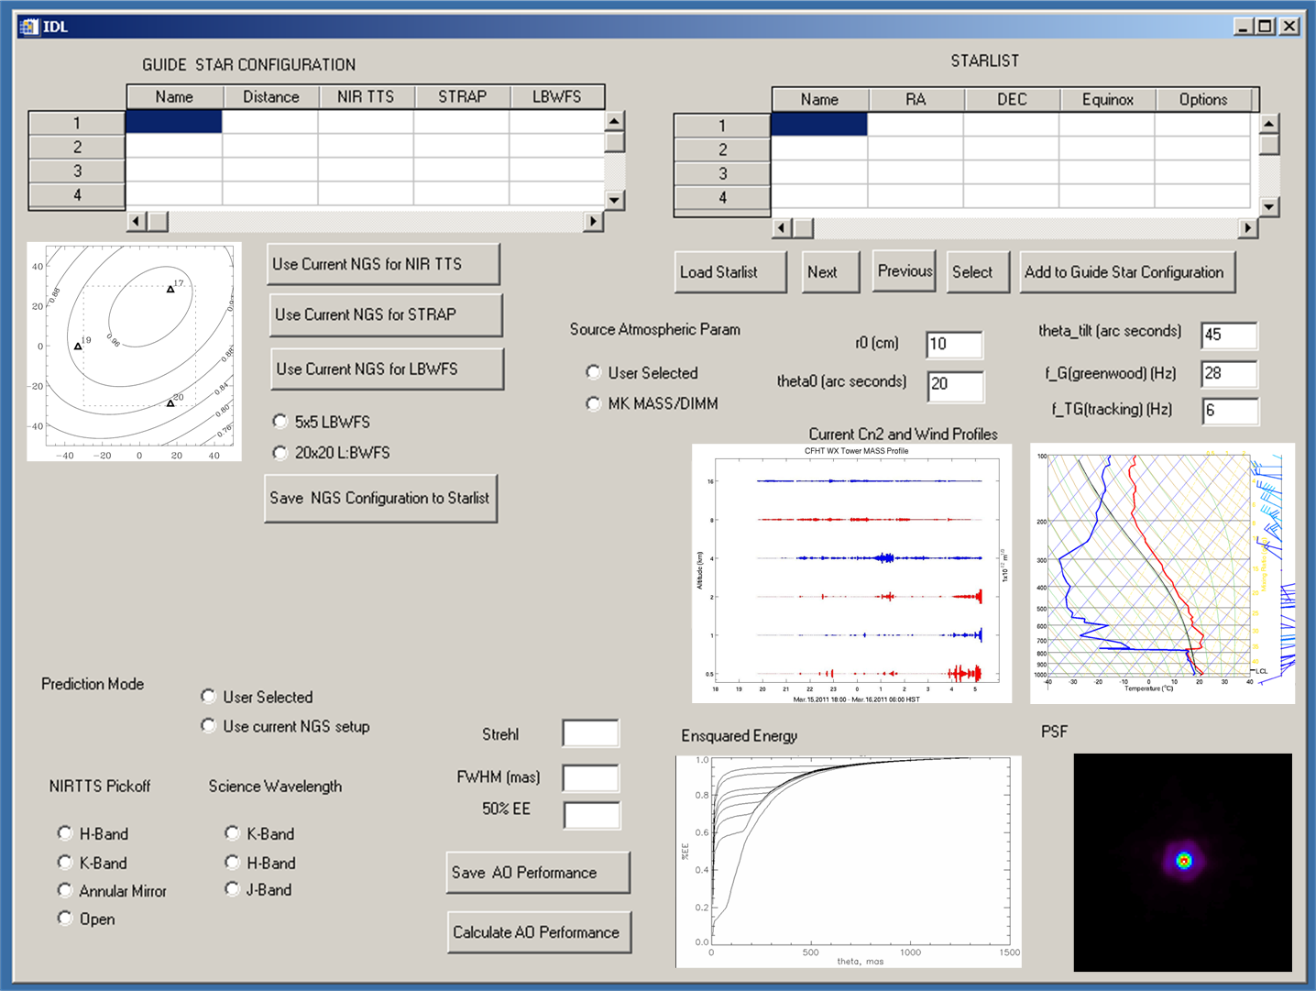
Figure 1: Mock up of proposed AO prediction tool GUI. Top portion of the GUI displays the user star list. The user can select guide stars and add them to the current guide star configuration. Setups can be configured for both STRAP and the NIR TSS (with 1-3 stars), and the LBWFS. The user is also able to select the atmospheric and wind profiles using the middle right section of the GUI. The bottom section displays the estimated performance. This GUI is only a sketch. The final GUI will likely look much different but incorporate some of the same functionality

When the configurations are finalized, the tools allow the observer to save these targets and guide stars as a Keck format star list. The format of the star list will be extended to be compatible with NIR tip-tilt stars and the possibility of multiple NIR tip-tilt stars used simultaneously. At present, the AO star list is the mechanism that is used to transfer AO setup information from the astronomer to the AO system software, including rotator offsets and DAR offsets among others. At present the “lgs=1” string is used to denote LGS science targets with the possible visible NGS tip-tilt stars following on lines immediately after (NGS science target are denoted by “lgs=0”). When used with multiple NIR guide stars, some means of indicating simultaneous guide stars and the beamsplitter configuration must be included so that the star list is successfully interpreted. Likely, this can be done by adding a few new strings to the star list format. The observer will also have the option of producing the star list using other tools; the only requirement is that it must comply with the modified format.

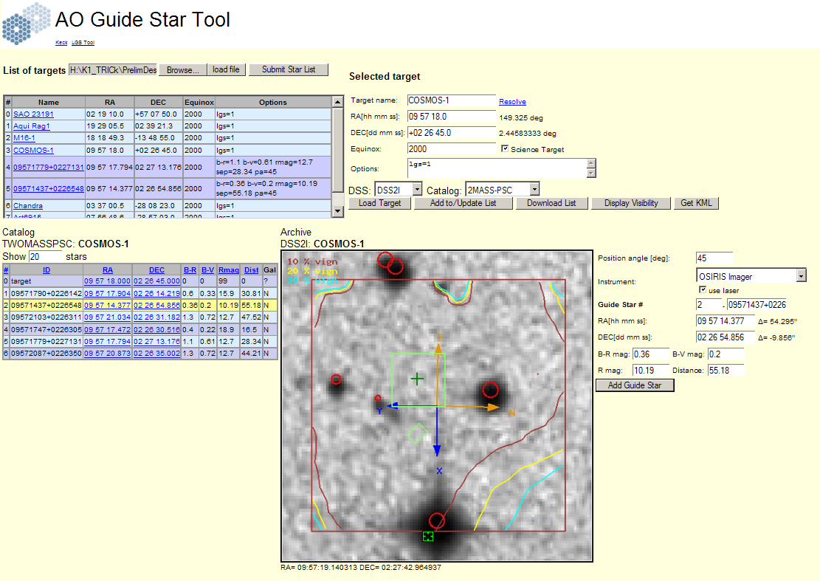
Figure 2: Screen shot of current web based AO guide star selection tool. This tool will be modified to provide IR magnitudes from the Infrared catalogs.

The observer would also likely save the intended setup for OSIRIS, standard calibration stars to observe, and other relevant parameters, but this is not part of the functionality of the NIR TTS system and its software. The normal mode of observation with the NIR TTS system will be with the LGS. As such, the observers need to finalize all laser pointing and submit them through a SA at Keck to the Laser Clearing House at least three business days in advance of the observations. This is the standard procedure and no change is anticipated when using the NIR TTS system.

The NIR sensor will use stars as faint as K~16 for tip-tilt correction. Since this is fainter than the completeness limit of the current standard NIR all sky star survey 2MASS, a further word about the star catalogs used with the updated AO guide star selection tool is relevant. The guide star selection tool would be extended to support queries of current (2MASS, SDSS, GSC 2.3) and future IR catalogs that would provide fainter NIR guide stars than the current 2MASS catalog. Examples of such upcoming surveys include UKIDSS, WISE, and Pan STARRS. Most current and new catalogs have adopted a format that makes for easy web based queries. The exact format of future catalogs is seen as only a minor issue as the current guide star tool already queries similar web resources. The guide star tool should also provide options to display images from the 2MASS catalog over the full sky and the SDSS in regions of the sky where it is available.

In the case of visible band catalogs such as SDSS or GSC-2, that do not include measurements in the NIR, conversions can be made using several cataloged bands and the proper conversion formulae. Because of its anticipated use with JWST, several studies have been performed on the conversion of GSC-2 and SDSS magnitudes to NIR magnitudes. These studies find that GSC-2 is complete to magnitudes slightly fainter than J = 17, which is similar to the NIR TTS magnitude limit of K~16 assuming a late spectral type for the average field star. The AO guide star selection tool would be modified to perform the magnitude conversion to NIR bands as needed on queries made from visible band catalogs such as GCS 2.3 or the SDSS. At present, this same technique will be used for JWST, as they do not plan to issue any future electronic versions of the GSC merged with 2MASS or SDSS.

Astronomer Observing
As discussed in section 4.3, during observations the astronomer will concentrate on the operation of the science instrument, OSIRIS, while the OA will operate the AO system and telescope. The SA will verify that the AO system is calibrated correctly and functioning on sky after performing some system checks, then hand the system over to the astronomer and OA.

At this point, the astronomer would verify that first target is available in a LCH window and other related LGS traffic issues using the same interface as presently employed. The first target on the star list would be selected from the MAGIQ user interface. After the telescope is moved to the new field, the MAGIQ system would display the ACAM image (R-band). The OA would then set the telescope to acquire and guide on the marked object using the MAGIQ offset guiding mode (science object centered guide star off axis). MAGIQ will be the primary means to adjust pointing at the start of observation.

At present the NIRTTS project is not planning to integrate the NIRTSS sensor into the observatory wide MAGIQ system. However the observer will be able to operate the NIRTSS sensor in a full frame mode along with ACAM. Both images can be used to help the astronomer identify the field and specify the correct source or sources for the NIR TTS. The full frame NIR image could be used to check the signal level on the guide stars as a final check of the field identification and that the stars can provide suitable signal levels. A conversion from counts to magnitudes in H or K as part of the acquisition GUI is anticipated. It is currently planned to take the relative orientation of the NIR guides stars (1-3) and the science object directly from the star list. The current asterism should be displayed over the NIR full frame image display with boxes at the anticipated location of the guide stars and another indicator for the science object. A mock up of such a GUI is shown in Figure 3. After the telescope centers the science field, the guider displays updates to show the off-axis regions of interest (ROI) indicators surrounding the NIR guide star image(s).

Once the target is identified and approximately centered, the astronomer asks the OA to setup the science object and close the AO loops. The OA would handle the operation of the NIR TTS in an automatic fashion similar to the current STRAP sensor; more details of the steps are given in the OA use case section below.

The astronomer would monitor the AO displays to verify that the acquisition was successful and that the AO system is performing satisfactory. In particular, the observer would monitor the current AO displays (WFS intensity, LBWFS displays). The observer would also monitor a new AO display that shows the intensity in the NIR sensors. It would be configured to display the one or more regions of interest (ROI) and show the current tip-tilt error in each ROI. This new display would be an analog of the STRAP “Tip/Tilt Sensor Status” display for the NIR TTS sensor, see Figure 4. The astronomer would also monitor the current “tip-tilt graphs” GUI that shows the total tip-tilt error and tip-tilt mirror position. This GUI would be updated from the error commands from the NIR sensor as it currently is from the STRAP sensor during LGS operations.

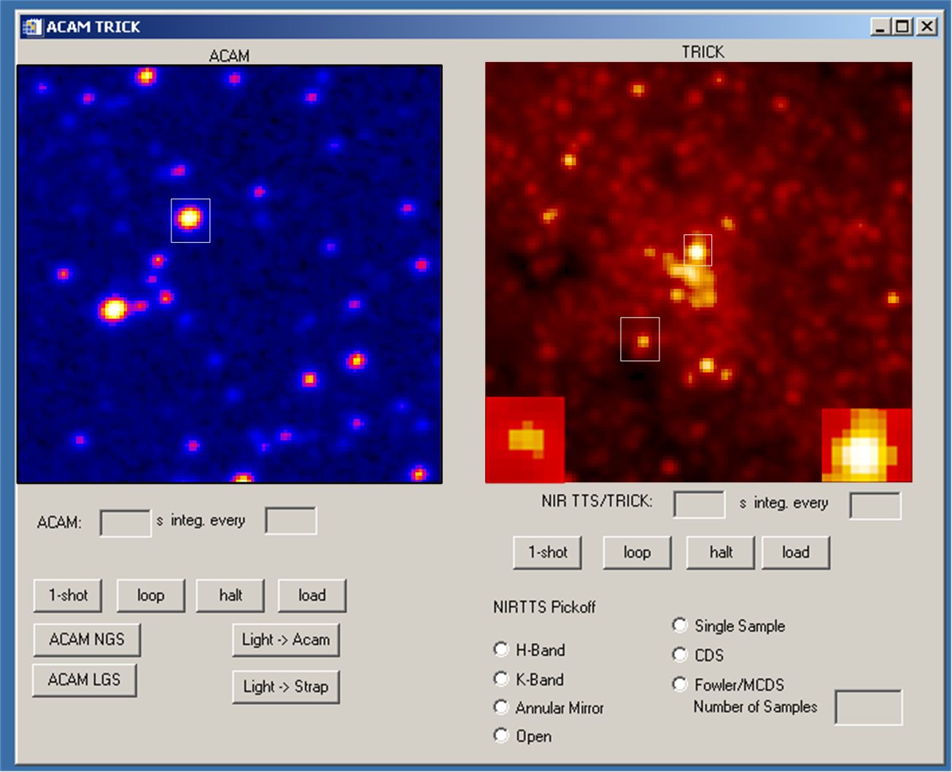

Figure 3: The GUI will allow the user to operate ACAM and TRICK. The selected guide stars for LBWFS or STRAP will be shown as squared boxes on the ACAM display. The TRICK display will have boxes around the selected guide stars and a “zoom” window for each ROI in the bottom edge of the display. The NIRTTS section of the display shown in the figure has only two of the possible 4 ROI windows.
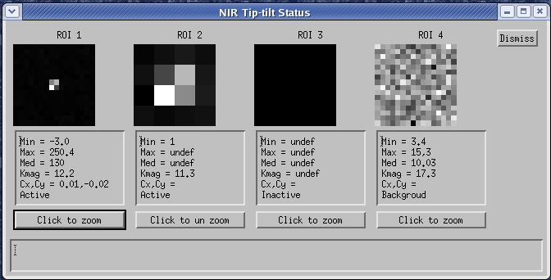

Figure 4: Mock up of NIR TSS tip-tilt sensor status display. The ROIs used for tip-tilt correction will be displayed along with statistics and status information. In the above GUI, ROI 4 is used for background estimation and ROI 3 is inactive. The final GUI will likely include the option of displaying a strip chart showing the total signal in each ROI over that past few minutes.

If the tip-tilt correction were satisfactory at this point, the observer would use OSIRIS without any changes to the current observer procedures. New AO operational software to support the NIR TTS system is required to be backwards compatible with the current science instrument, so that the astronomer does not need to change observing procedure for the science instrument. In particular, dither sequences would continue to be initiated by having the science instrument’s computer point the telescope to another position using telescope (DCS) keywords. The telescope and AO system supervisory controller (SC) perform the needed operations to achieve the move requested by the instrument and resume AO correction. A dither or nodding sequence is simply a scripted set of these moves between science exposures.

Occasionally the astronomer may want to make a small (< 20 mas) positioning correction on the OSIRIS instrument. Moves this small could be used to ensure that a feature is properly positioned in an IFU pixel element. Moves this small can be instigated by changing the NIR TTS centroid offsets (or null position) within the ROI being readout. These small moves could be made on a “hand paddle” type GUI that would allow the astronomer to request the desired position update. The GUI should convert from NIR TTS camera pixel space to RA, Dec, or instrument pixel space so that the movement is intuitive and simple for the astronomer.

If the tip-tilt correction is poor, the astronomer could decide to change to a different set of NIR guide stars or switch to a visible guide star with the STRAP sensor. In this case, the AO loops would be opened and the observation would start again at the acquisition step. The new configuration would be a separate entry in the star list.

If problems were encountered, the observer would consult with the OA and SA who would diagnose the problems as needed and take appropriate action to recover or restart the faulted system. Tools for troubleshooting are covered in more detail in the SA use case section.

The preceding discussion assumed standard observations using the LGS AO and the new NIR TTS. Next, we consider some untypical observational modes and how they are handled by the NIR TTS system. At present, the LGS AO system supports vertical angle mode, also known as fixed pupil mode, only when the NGS source is on axis. At present, the NIR TTS has no requirement to support this mode when the NGS is off-axis, although it appears it could be supported by calculating how the centroid offset and ROI should move as the NGS star rotates on the NIR TTS detector. The non-sidereal mode is already supported by STRAP, but this is not a standard operating mode; this mode could be supported in a manner similar to the fixed pupil mode above but now the calculation of changing centroid offset and ROI would need to consider the non-sidereal objects ephemeris. Non-sidereal tracking is a goal, not a requirement, for the NIR TTS.

If the astronomical program requires a change from imager to spectrograph on OSIRIS, this move can be initiated from the current OSIRIS tool by re-pointing the telescope (AO loops are opened during move). At present, the current tool does not warn the astronomer if the move will take the current NGS guide star out of range for the TSS (i.e. TSS will attempt to follow the move and fault). Careful planning with the AO guide star selection tool should avoid this. Some consideration for a new tool to avoid this issue and warn the astronomer before attempting a bad move should be discussed during the design of the control software. A possible pre-observing planning tool that addresses these observing issues is shown in Figure 5. It is based on the current “TSS WIDGET” IDL tool. This tool provides similar functionality to the AO guide star selection tool but because it is running on an AO server it would have access to the current telescope and rotator keywords. As such it can show a “live” update of the correct field of view and rotation for either ACAM or NIRTTS. These can then be compared to the images from the tool shown in Figure 3. It is this functionality that is most useful for the new tools because the MAGIQ display of a catalog images does not match the FOV of ACAM.

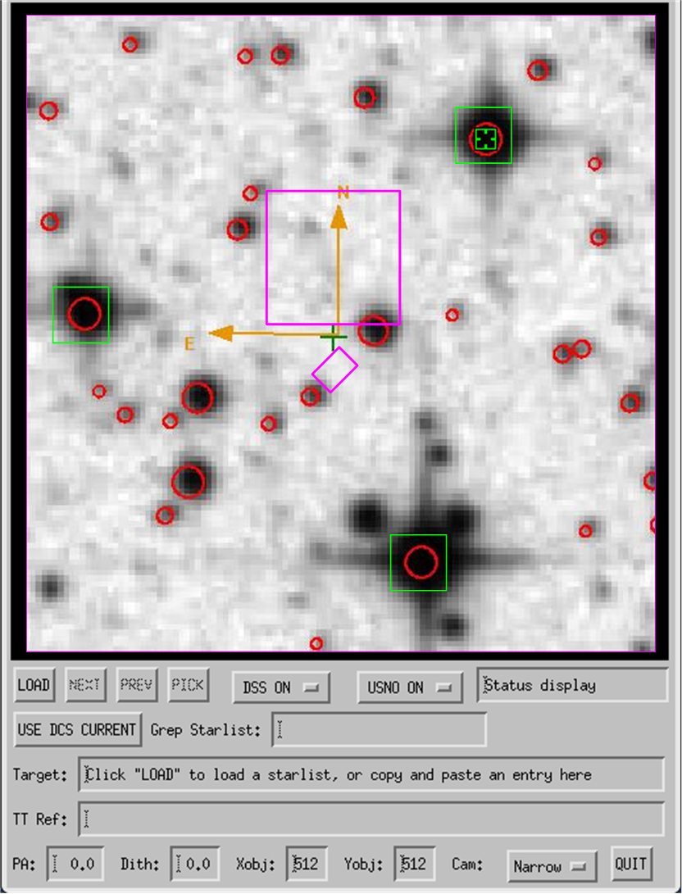

Figure 5: Mock up of a proposed NIR TTS planning tool, based on the current TSS_WIDGET. The ROIs used for tip-tilt correction will be displayed (green boxes) along with instrument field of view (magenta boxes). The observer would be able to test observational parameters such as dither size, pointing offsets, and position angles. Additional overlays would show the NIRTSS and TSS technical fields.

Astronomer Post Observing

The observer would continue to execute the observing program throughout the night until astronomical twilight or sunrise; the relevant data would be saved using the same mechanisms as employed currently. The data from the ORISIS instrument would be unchanged from its current format with the addition of FITS header keywords that would show the NIR TTS configuration and performance. The NIR TTS system will allow the logging of status and acquisition images (similar to the current ACAM practice); however, this data typically is not used by observers.

At the end of observations, the observer would have the option of querying the AO telemetry database for AO wavefront controller data. It is anticipated that NIR TTS data such as tip-tilt error, ROI identification information, pixel intensities, and configuration data will be added to the telemetry recorder. At present, no new tools to analyze this data will be developed for this project beyond modifications to the current IDL tools (see KAON 515: How to Query TRS from IDL) to query the additional NIR TTS related SQL tables.

Observing Assistant Use Case

Observing Assistant Pre-observing
Typically the observing assistant OA would need to do nothing in the way of setup for observations with the NIR TTS mode of AO other than to login to an appropriate VNC session and start a new NIR TTS display along with the other existing AO tools. Any new tools would be integrated into the existing AO startup “MAORI” GUI or launched from the background window of the work station.

Observing Assistant Observing
During twilight at the start of the night the OA will focus on the telescope operations while the SA performs the AO checkouts (see section 5.3 SA use cases for details). Once the SA is satisfied with performance of the AO system, it is handed over to the astronomer and OA. The role of the OA is to support the astronomer by focusing on the operation of the telescope and AO system while the observer focuses on the operation of the OSIRIS instrument.

The OA and the astronomer will coordinate in the same manner as they do now: verbally over a video link and by having network access to the same computer displays using VNC sessions. When the system is ready for the first LGS target, the OA will coordinate the laser spotters and related laser traffic control issues as is done at present. The OA will select the astronomer’s star list so that the proper targets are observed. Next, the OA and astronomer will coordinate the acquisition of the first target using the MAGIQ GUI that will be revised to show both ACAM and NIR TTS full frame images. Once the astronomer is satisfied with the field identification, the astronomer will use the “Set Mark” command (right click on display) to indicate which star the OA should acquire and start telescope guiding in an off-axis mode (science target is brought to optical axis and the guide star remains off axis).

Now the OA starts the AO acquisition task. The NIR project will make appropriate modification to the existing AO acquisition tool display and underlying software. Current information on this tool can be found at http://www2.keck.hawaii.edu/optics/ao/ngwfc/aoacq.html and is reproduced in Figure 6.

The OA performs the same steps when using the AO acquisition tool with the NIR TTS as is done currently in LGS mode. These actions are: select the target list at start of the night, select the correct configuration and setup information on the AO acquisition GUI, select the SETUP BENCH button as telescope slews to the new target, and select ACQUIRE STAR once the field is identified by the astronomer and centered using MAGIQ with ACAM or the NIR TTS in full frame mode. The OA does not use the OFFSET TO TARGET button, as the NIR TSS will be setup to go directly to the science target; unlike current LGS observing where the tip-tilt star is brought to the AO optical axis and the OA must select OFFSET TO TARGET manually to bring the science object onto the pointing reference position. It is proposed that the NIR sensor, because of its full frame mode, should be able to acquire and start tip-tilt correction without moving the AO tip-tilt star to the pointing reference position. Because a visible band star is still required for LBWFS operation, the tip tilt sensor stage (TSS) will move to the appropriate location to acquire the visible band star as part of the SETUP BENCH command.

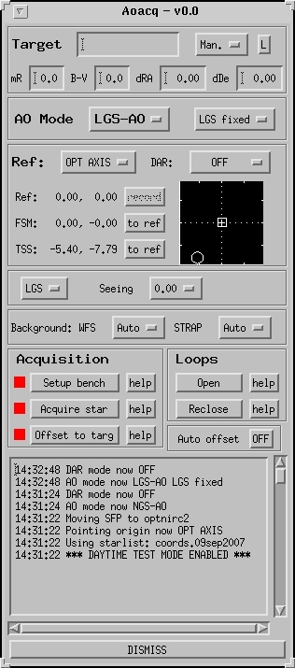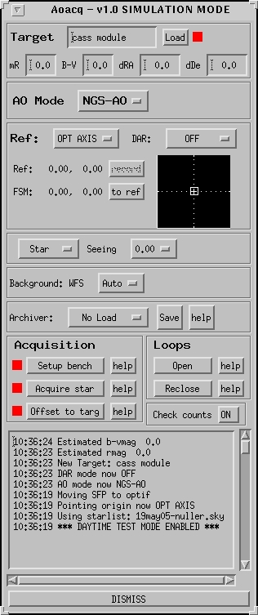

Figure 6: The current AO acquisition tools used by the OA, SA, and observer. The LGS mode is shown on the left and the NGS mode on the right.
The OA will interact with the modified AO acquisition GUI as the main method for controlling AO; this is consistent with the current procedure. Working down the current display from top to bottom the OA will see the following information:

Target: This tool will automatically pickup changes to the target (DCS keyword). For NIR TTS targets, the display will have a K or H band magnitude depending on the value of the NIR TTS pickoff optic (H or K dichroics, open or annular mirror). For a multiple ROI configuration, a magnitude list that corresponds to all the related star list entries would be displayed along with appropriate coordinate offsets (ra and dec). The list should also contain the LBWFS star with its R-magnitude. The appropriate magnitudes or color indices would also be displayed (B-V, J-K, etc).

AO Mode: The OA would select the AO mode, which would have a new choice “LGS-IRTT”. Selecting this mode would set the defaults for the NIR TTS and other AO systems automatically to function with the NIR TTS. The choice of “NGS-IRTT” would be supported for testing and setup at the start of observing.

Ref: The current pointing reference (DCS keyword) is used along with the star list information to configure the following devices:
- FSM so that LGS WFS is pointed to the laser location
- TSS so that the LBWFS is pointed to the visible guide star location
- ROI location(s) for the NIR tip-tilt star(s) so that the correct pixels and centroid offsets null position are used for tracking
Current values for this information will be displayed below the Pointing Reference Button. It will be displayed in mm at the AO input focal plane, the standard convention. The current display will be modified to show these locations graphically. The ROIs will be displayed with a new symbol (possibly triangles) along with the TSS (circle), FSM (box), and pointing reference (plus sign).

Object Type and Seeing Buttons: The default values will be the same as for the current LGS AO mode. Seeing can be set by hand if it differs from the default value.

Acquisition Button Group: These buttons will remain the same. Setup Bench will perform the needed configuration to have the AO system ready for the new target configuration; this button can be selected as the telescope is slewing to the new target. The Acquire Star button will acquire the star in each ROI and close the AO loops. The tip-tilt star will not be brought to the optical axis first. Selecting this button will also take NIR TTS, STRAP, and WFS sensor backgrounds, propagate the LGS, and start the LBWFS integration. The sequencing of these steps will be transparent to the user and will not require user intervention. The Offset to Target button will not be used as the acquisition step will center the science target. For testing, a button will be provided below the LOOPS button group to disable this behavior. A suggested name would be Center on NGS, with a pull down showing labels for the NIR TTS star (1-3) and the LBWFS star.

Loops Button Group: The behavior of the buttons to open and reclose the AO loops will remain the same from an OA perspective.

When the AO loops are closed, the OA would monitor the AO displays to verify that the acquisition was successful and that the AO system is performing satisfactorily. In particular, the OA would monitor the current AO displays (WFS intensity, LBWFS displays). The OA would also monitor a new display that shows the intensity in the NIR sensors. It would be configured to display one or more active ROI and show the current tip-tilt error in each ROI. This new display would be an analog of the STRAP “Tip/Tilt Sensor Status” display but unique to the NIR TTS sensor. The astronomer would also monitor the current “tip-tilt graphs” GUI that shows the total tip-tilt error and tip-tilt mirror position. This GUI would be updated from the wavefront controller error commands from the NIR sensor, as currently it is from the STRAP sensor during LGS operations.

Just as with the current system, the NIR TTS will have scripts and other software to optimize the exposure time and servo control loops for the NIR TTS. This optimization will happen automatically with no needed operator intervention. In particular, the configuration of the correlation algorithm used to determine centroids on the NIR sensor would be made adaptive to changing conditions. This includes changes to the reference image used in the correlation algorithm, seeing estimates, Strehl estimates, and dynamic background estimates if implemented. More details of these features are included in NIR TTS system design manual, see sections 5.3, 8.5.4, and 8.5.5. The take away for the OA is that these things are done automatically for the NIR TTS and supporting AO system and do not require extensive intervention for proper AO operation.

At this point, the OA hands the system over to the astronomer. The OA continues to monitor the AO system performance and would notify the astronomer of any problems. The NIR TTS system would be integrated into the AO alarm handler and the audio warnings messages.

Observing Assistant Post Observing
At the end of the observing night, the OA would normally put the AO system in an end of night standby state. Any additions for the NIR TTS would just be added to the current “end of night” script.

Support Astronomer Use Case
In this section, we envision how an observing run using the NIR TTS is prepared for and assisted by the SA.

Support Astronomer Pre-observing
The SA is in charge of making sure that the telescope, AO systems, and instruments will be ready for the science scheduled during the night. As is now standard practice, the SA contacts the astronomers two weeks before their scheduled nights to get a final target list. A meeting is scheduled with the astronomer to discuss instrument issues and their observing program. They would review any issue related to the selection of NGS stars for the NIR TTS. A list of targets and their observing configurations should be finalized 4 days before the run. The SA checks the list of targets and the observing configuration before submitting it to the Laser Clearing House. The use of the NIR TTS does not affect the interaction with the Laser Clearing House.

The other major pre-observing task for the SA is the calibration of the AO system. The NIR TTS SDM discusses these issues at some length in section 8.3. The current IDL AO calibration toolbox would be expanded to include functions for calibrations that need to interact with the rest of the AO control system. These procedures would be largely automated scripts run from IDL that would provide the user checks and verification that the calibration is within specification or, if out of the expected range, alert the SA to the possible problem. Calibrations of this type include setting the correct focus positions of the NIR TSS sensor, see SDM section 8.3.3 for algorithm details. The NIR camera also needs to have the orientation of its pixels registered to the tip-tilt mirror controller axes. This specific calibration is missing from the SDM and needs to be added to the preliminary design documentation. Another calibration that is needed is the distortion of the NIR TTS camera focal plane due to optical aberrations in the AO system and the NIR camera optics. These calibrations are discussed in the SDM section 8.3.3. All of these calibrations will need to be done only infrequently, perhaps once every month or less.

The other types of calibrations for the NIR TTS system are needed to correct for detector performance issues such as bad pixels, response non-uniformity, and detector noise. In addition, the NIR TTS should be calibrated so that its instrumental flux estimates can be converted to standard magnitudes. At present, this type of calibration is done periodically as needed by the instrument SA in an offline manner using analysis tools for astronomical data (IRAF, MIDAS, astronomy libraries in IDL). The NIR TTS would strive to add these calibrations to the system software in a more standardized and integrated way.

The NIR TTS system would be “started” each afternoon along with the other AO systems by the SA. Any startup scripts would be added to the current tools. In addition, the NIR TTS will support a keyword interface, so the SA can build new functions into the system using the same tools as they do now. The NIR TTS system is now calibrated and ready for the night’s observations.

Support Astronomer Observing

At sunset, the dome is opened and the telescope can be made ready for observations by the OA. Once these tasks are done, the SA is responsible for performing a checkout procedure for LGS observing with the AO system. The current procedure is found at: http://www.keck.hawaii.edu/inst/ao/osiris_checkout.html.
The SA interacts with the modified AO acquisition GUI as discussed in the OA use case, see section 5.2.2, using this as the main tool for performing the AO checkout.

A section of the checkout procedure would need to include checkout of the AO system in NGS-NIRTT mode and again in LGS-NIRTT mode. The purpose of this checkout would be to determine the default tip-tilt power spectrum to use for automatic optimization during the science observations made during the rest of the night. A similar procedure is now performed at night with STRAP. The current optimization procedure is described on the following web page:
http://www2.keck.hawaii.edu/optics/ao/optimizer/index.html.

For this section we restrict our discussion to NIR TTS observations with only a single NIR star measuring tip-tilt only and assume that the system is not being used to measure focus (see section SDM section 2.6 for a discussion of this technique). In this case, the NIR sensor control loop could be optimized using the current AO optimizer tool. It would need to have NIR TT settings and the ability to save the power spectra for later use when the astronomer is observing. (The proper telemetry items would need to be added to the TRS system as well). The optimization tool would function in the same way as it does currently when using STRAP. The checkout is now complete and the system can be turned over to the observers.

If problems occur during the rest of the night, the SA would use the same NIR TTS related displays, as mentioned earlier for the OA and astronomer use cases, to determine the likely cause and to resolve the problems. The alarm handlers and audio warning might also indicate the problem. Once the system is back in a non-faulted state, the SA gives the system back to the astronomer for observations

It is anticipated that the SA will have other interfaces that allow more direct control of the parameters for the subsystem of the NIR TTS system. These might be added to the SCGUI or the MAORI GUI; the exact level and design is still to be determined. In particular, the NIR TSS sensor will use a correlation algorithm to determine the current wavefront tip-tilt error. This algorithm, its setup, and optimization are discussed in the SDM in sections 5.3, 8.5.4, and 8.5.5. The correlation algorithm needs a reference image that matches the short exposure image on the NIR TTS. Presently, it is assumed that this image is well modeled in all cases by a diffraction limited peak and a halo. However, as the NGS moves further and further off axis, its image becomes composed of several bright speckles and not a single diffraction limited core. The necessary tools for this algorithm are still TBD.

Support Astronomer Post Observing
The SA does not have any specific end of night tasks for the NIR TSS system. However, the SA will often need to review logged information to understand issues related to faults that occurred during the previous night’s observing. The NIR TTS system should support logging of its full frame telescope acquisition images similar to ACAM at present. The NIR TTS would also log its ROI data and tracking errors into the current TRS system.

Summary of Required Functionality, Services, and Products
We anticipate that the following tools will be developed as part of the NIR TTS project and are the primary means the users will use to observe with the new system.

Tool, Script, Display, or Function | Uses | Key Features | New or modification | Key clients or users
AO performance estimation tool | Predict AO performance and plan observation  Check AO performance during observation | Tool reads star list and produces prediction of Strehl, EE and/or FWHM, based on AO model | New | Astronomer, SA
AO guide star selection tool | Guide selection from astronomical catalogs and star list generation | Query GSC, DSS, and SDSS for guide stars  Provide IR magnitudes and color indices  Check dithering size and PA selection | Modification | Astronomer,  OA
Modification to ACAM tool to display both ACAM and NIR camera in full frame mode | Telescope acquisition and field identification | Display full frame NIR image and ACAM simultaneously  Display estimate of H, K magnitude in ROI to help ID fields  Allow control of exposure time of NIR detector in full frame images  Display NIR ROIs and science target from star list as overlay on image display to help ID field | New | OA, Astronomer
Tool for small repositioning (< 20 mas) moves on OSIRIS | Move science target on OSIRIS IFU or imager by small amounts, for improved sensitivity, etc. Larger moves for nodding and dithering are handled outside the AO system as is currently the case | Handle paddle GUI that changes NIR TSS centroid offset (control point ) (range <= 20 mas)  Display moves in IFU/imager coordinates or Ra/Dec | New, or integrate into existing OSIRIS tools or DCS tools possibly hand paddle | Astronomer
IDL AO acquisition GUI and new keywords | Operate AO in an effective and reproducible manner | Reads new NIR TSS format star lists  Configures AO bench for NIR TTS still TBD what is automatic and what requires user intervention. Also TDB what the user can override  Adjust NIR effective exposure time automatically (the user does not need to understand underlying H2RG readout modes)  Adjust NIR control loop (gain, leak, etc.) automatically based on previous optimizations (detail of algorithm are still TDB) | Modification to IDL AO acquisition GUI (aoacq.pro) and new keywords | OA, SA, Astronomer
AO control loop optimization tool | Set the control loop parameter for single ROI tip-tilt correction with AO  (Multiple ROI optimization is still TBD) | For single ROI tip-tilt correction use the same tool and algorithm just ingest new NIR TT sensor telemetry stream  Save power spectrum for later optimization during the night. This power spectrum is used by the modified IDL based aoacq.pro tool | Modification to current tool the optimization tool also known as bandwidth widget | SA
Correlation algorithm reference image setup and diagnostic tool | Optimize correlation algorithm for best tip-tilt performance  Allow changing to centroid algorithm if needed | Need tool to estimate reference image for correlation algorithm  The SDM suggested a seeing estimate and Strehl estimate, assuming the reference image is well described by high Strehl AO PSF | New tool algorithm is still TBD | SA
NIR intensity display | Verification that NIR system is working and ability to request background be taken | Display NIR sensor ROI in a manner similar to current STRAP and WFS displays | New tool  New keywords | OA,SA, Astronomer
Tip-tilt mirror display | Verification that NIR system is working | Display tip-tilt total error and tip tit mirror position when NIR TT sensor is used | Modification to user interface | OA,SA, Astronomer
NIR TRS DATA | Needed for AO optimizer tool  Used for AO performance verification and troubleshooting | Include ROI intensities and centroids errors in a full frame rate SQL table  Other related configuration data such as centroid offsets, ROI pixel location, background values, etc, are also recorded, likely in the CONFIGURATION table and not the full frame rate table above | New SQL tables  New interface to Microgate real time system | SA, Astronomer
NIR TRS IDL query | Needed for AO optimizer tool  Used for AO performance verification and troubleshooting | Allow current tool to query new SQL tables for NIR TTS data | Modification | SA, Astronomer
NIR Full frame image logging | Used for telescope acquisition and AO performance verification and troubleshooting | Same full frame images, like ACAM at present | New | SA
Calibration tools for NIR detector | Setup AO for best performance  Photometric calibration helps ID fields | Calibration of NIR detector, bad pixel, dark frames, flat fields  Photometric observation of standard star for counts to magnitude conversion factors | New | SA
Calibration tools for NIR/AO interactions | Setup AO for best possible on sky performance | NIR focus stage calibration  Map NIR pixel to TT mirror controller axes  Distortion map | Modification to IDL tools  New calibration procedures | SA
AO Alarm handler | Alert users when problems occur  Avoids downtime | Add NIR TTS devices to current AO fault detector system | Modification | OA,SA
Updated AO checkout procedure | Confirm AO is working correctly before handing over to astronomer | Need to add NGS-IRTT and LGS-IRTT | Modification | SA
Startup and setup scripts | Starts AO system in known configuration | Start system in known state  Configure system for testing, calibration, observations | Modification | OA
End of night script | Stop AO system in safe mode when not used | Add NIR TTS to end of night scripts | Modification | OA

