NIR TTS Device Control ICD:

This document addresses the functional requirements for interface between Keck “AO Supervisory Controller” and the host computer that communicates with the NIR TTS camera device via the Leach controller shown in the picture below:

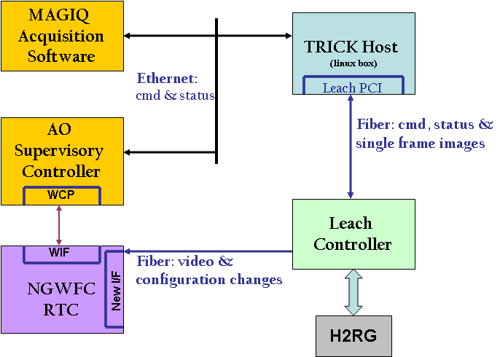

The communication between the supervisory controller and the host computer is via Ethernet. The host computer must support an EPICS channel access (keyword) interface to provide the required control and monitoring of the camera device. Commands and status information is exchanged between the supervisory controller and the host computer. The host computer translates the command/status requests to the Leach device controller.

Power On/Off: The supervisory controller must be able to control the on/off modes of the power supply to the combination of the camera device and associated electronics. The device must go to standby mode in the case where the power is ON for extended period of time with no load from the device (perhaps by monitoring shutter closed state TBD).
Keywords:
Channel | CA for read | CA for write | Type
 | PS_Status (OK, faulted) | Command PS_On/Off | Ascii ENUM
 | PS_Fault |  | Ascii ENUM
Fault information should be captured for troubleshooting purposes and indicated as such It can be over voltage, over current or any fault leading to the shut down of the power supply.
It is required to be able to cycle power to the power supply remotely via a remote controlled switch device (e.g., Pulizzi is used as a Keck standard) in cases of grid brownouts and whenever there might be transient events in the grid leading to unknown state of the power supply. Question: are we going to have the camera on UPS to protect against brown out and transients?

Device startup and shutdown: The appropriate startup sequence necessary for safe and correct operation of the device must be implemented. This includes initialization of the device control elements like the temperature setting, default filter position (blocked position in filter wheel). Upon completion of the startup sequence, the device must go to Standby state where it is ready for operation.
Keywords:
Channel | CA for read | CA for write | Type
 | Device_Status (Off, Standby, Initing, Normal, Faulted) | Command Start/stop | Ascii ENUM

Device Status: should represent the current status of the camera device. Standby means it’s ready for operation. If the device is operating properly, it should indicate normal status. A fault condition of the device is to be reported in the status as such. It is desired to have a second level of detail for fault information such as device failed, or communications to host computer ie., fiber link faulty (timeout for example), or communications problem to the RTC and report any other issues with protocol like unknown command requested. Caltech and Keck to work out reasonable level of information exchange to satisfy safe and correct operation of the device and electronics.

Shutdown of the device must incorporate the necessary sequence to shut the device down in the safe and correct manner.
Both the startup and shutdown sequences will be typically initiated by operator scripts.

Filter wheel blocked position control: The supervisory controller must be able to command the filter wheel to blocked position for measuring darks.
Keywords:
Channel | CA for read | CA for write | type
 |  |  | BOO
Priority: up to Caltech to implement this as part of the device sequence of operation as they deem fit.

Temperature control: The device head is to be maintained within +/- TBD deg C range. Command the temperature controller to go On/Off. Allow for sending setpoint to the temperature controller. Read back of status from temperature controller (normal, faulty) and the actual temperature measured.
Keywords:
Channel | CA for read | CA for write | type
 | Temperature measured | Setpoint for temperature controller | FLOAT
 | Temperature controller status (OK, Fault = overtemp) | Temperature controller command (OPEN, CLOSE, FAULT_ACK) | ENM

Filter Change Request: A three position filter mechanism is housed near or at the pupil within the camera dewar. The positions are for filter H, filter K and a filter mechanism to block the beam to the pupil so that dark current measurements can be made as well as for verifying read noise performance for diagnostic purposes. It is necessary to have the ability to command a filter change request as per science observation demands.
Keywords:
Channel | CA for read | CA for write | type
 | Current filter position | Filter position change request | ENM

Image Related keywords:
The image transfer from the camera device occurs in two separate ways.
- image request and image data exchange between MAGIQ and host computer
- uni-directional sub frame (ROI) image transfer from Leach controller to RTC
As the image data transfer to RTC is uni-directional, the supervisory controller will provide the parameters necessary to define the image to the host computer. The host computer must communicate this to the Leach controller so that it sends the appropriate image data to the RTC. The parameters for image definitions are ROI locations, sizes and time between resets.
Keywords:
Channel | CA for read | CA for write | type
 |  | ROI_1_Start_Xpos | integer
 |  | ROI_1_Start_Ypos | integer
 |  | ROI_1_Size | integer
 |  | ROI_2_Start_Xpos | integer
 |  | ROI_2_Start_Ypos | integer
 |  | ROI_2_Size | integer
 |  | ROI_3_Start_Xpos | integer
 |  | ROI_3_Start_Ypos | integer
 |  | ROI_2_Size | integer
 |  | Time between resets | integer
 |  | iTime (time between reads) | integer

Document Revision History
Revision Number | Revision Date | Summary of Changes | Author
0.1 | 01/20/2011 | Initial Draft | Sudha LaVen, Chris Neyman
0.2 | 02/08/2011 | Update for PW’s comments | Sudha LaVen

