AO User Interface for the NIR TTS Preliminary Design
Chris Neyman
March 16, 2010

Introduction
The current Keck I AO system will be modified to operate with a NIR tip tilt sensor. The user interface will be integrated into the existing interface which features tools written in IDL, so called “widgets” and the scripting language Python. Current design decision calls for all NIRTTS tools to written in IDL. Configuration management will be done with cvs using the current repository used for existing IDL tools. One exception to the use of IDL is the AO guide star selection tool, the existing tool is web based tool written in the PHP scripting language.

AO Prediction Tool
A mock up of the user interface for the AO prediction tool is shown in Figure 1. Top portion of the GUI displays the user star list. The user can select guide stars and add them to the current guide star configuration. Setups can be configured for STRAP, NIR TTS (1-3 stars) and the LBWFS. The user is also able to select the atmospheric and wind profiles using the middle right section of the GUI. The bottom section displays the estimated performance. This GUI is only a “sketch” the final GUI will likely look much different but incorporate some of the same functionality.
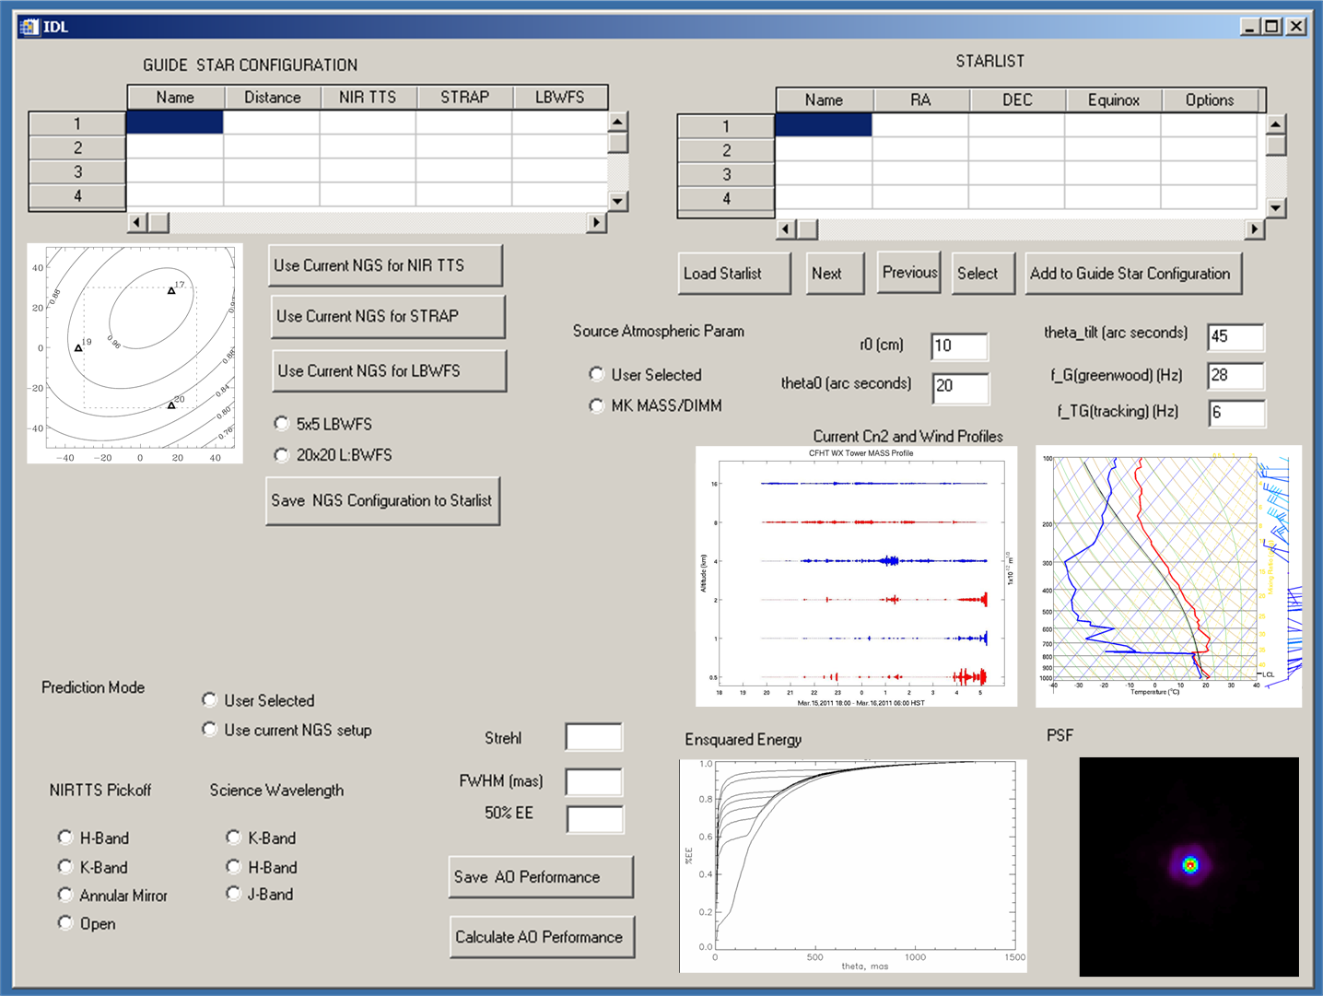
Figure 1: A prototype GUI for the AO prediction tool. .

AO Guide Star Selection Tool

The existing AO guide star tool will be modified to work with existing catalogs to produce estimated IR magnitudes.

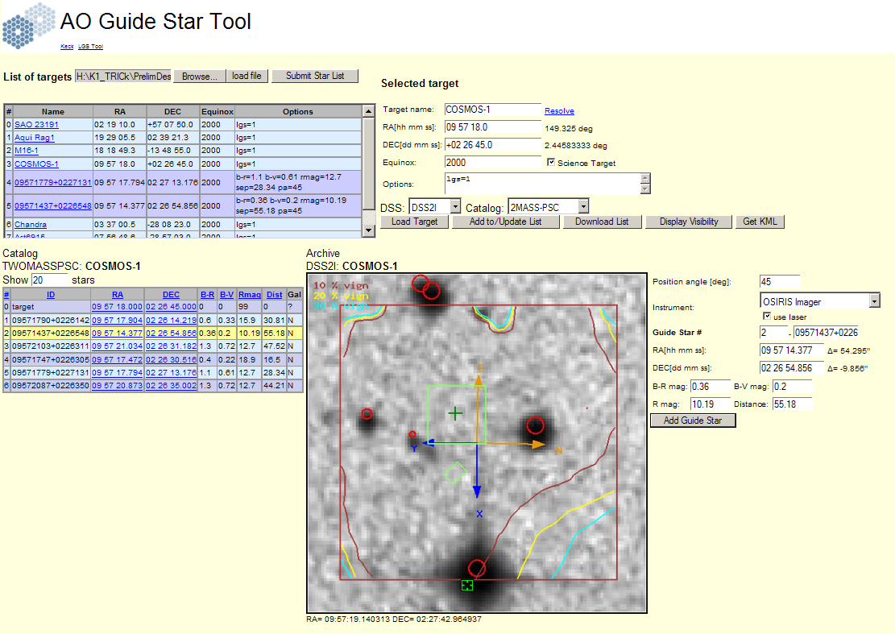
Figure 2: AO guide star selection tool

NIR TTS “Widget” Planning Tool
The proposed planning tool for position angles, dither sizes, and pointing offsets is shown in Figure 3. The tool is a modification of the current TSS widget used for LGS observation with the Keck II system. The tool duplicates some of the functionality of the current AO guide star selection tool, but allows the observer to test dither sizes and some other observing sequence functionality not available in the AO guide star selection tool of section 3. Also because it is installed on the summit, this tool will have access to DCS and AO keywords for pointing and rotator position angle. As such it can be used to identify targets on ACAM or NIRTTS sensor (full frame mode). The Modified version will include ROI display (green boxes) and the updated position of the OSIRIS instrument (magenta boxes)
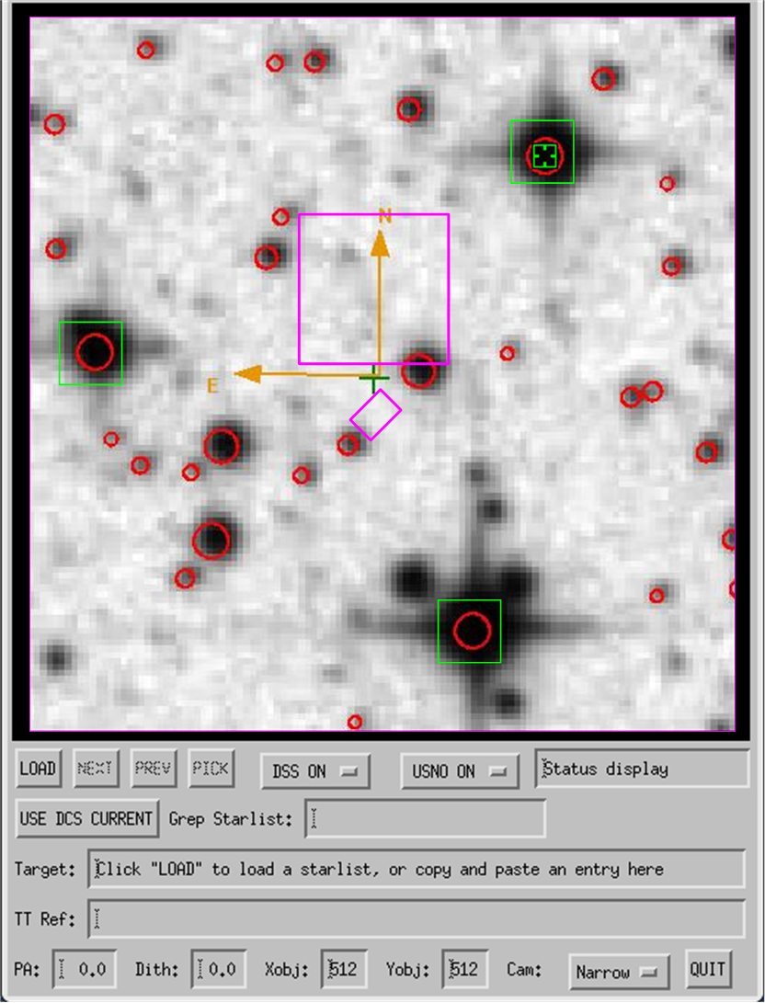
Figure 3: Updated TSS widget to include NIRTTS ROI display

ACAM and TRICK tool

The tasks of field identification and full frame operation of the TRICK camera will be done from the GUI shown in Figure 4. The GUI will allow the user to operate ACAM and TRICK. The selected guide stars for LBWFS or STRAP will be shown as squared boxes on the ACAM display. The TRICK display will have boxes around the selected guide stars and a “zoom” window for each ROI in the bottom edge of the display. The display shown in Figure 4 has only 2 active ROIs displayed of the possible 4 ROI windows supported by the software.

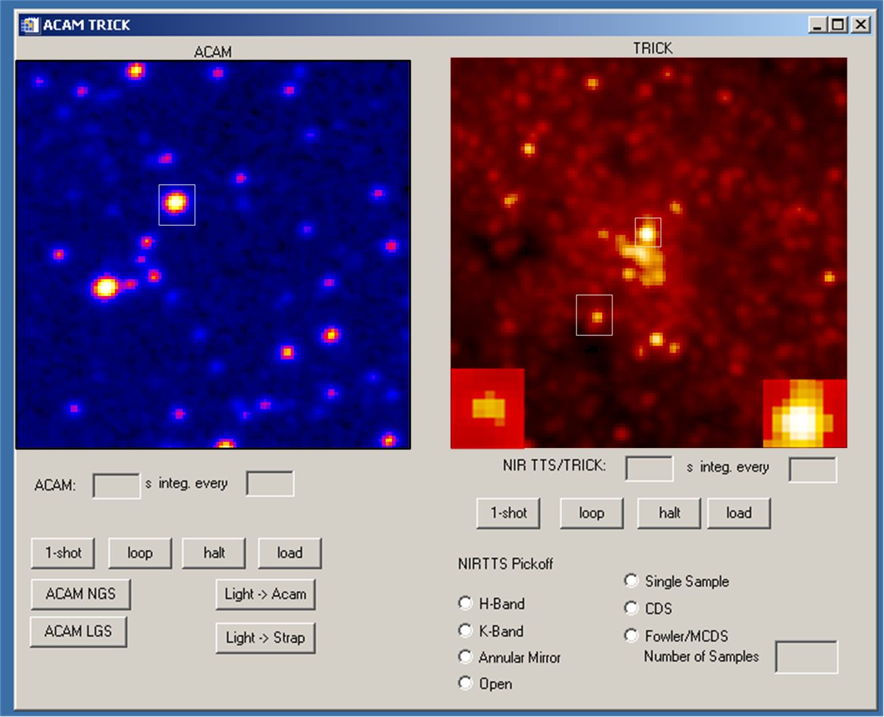
Figure 4: A combined ACAM and TRICK display for field identification

Tip-Tilt status Display

The status of the NIRTTS when it is used with the NGWFC will be monitored by the following GUI, see Figure 5. The ROIs used for tip tilt correction will be displayed along with statistics and status information. In the GUI ROI 4 is used for background estimation and ROI 3 is inactive. The final GUI will likely include the option of displaying a strip chart showing the total signal in each ROI over that past few minutes as this has proven to be a good system diagnostic with the STRAP sensor.

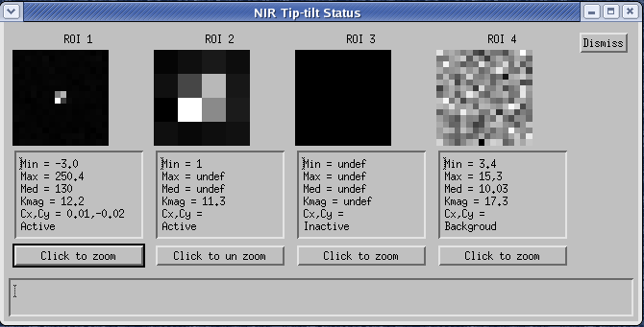

Figure 5: NIR TTS tip tilt status GUI

AO acquisition

The current AO acquisition GUIs will be modified to work with multiple NGS as is required for the NIRTSS project. The current GUIs are shown in Figure 6.
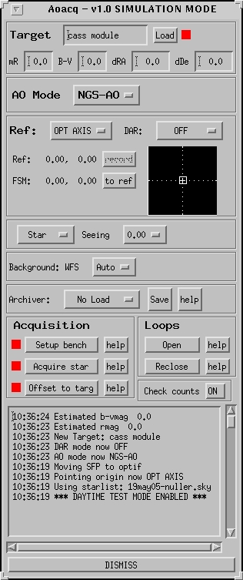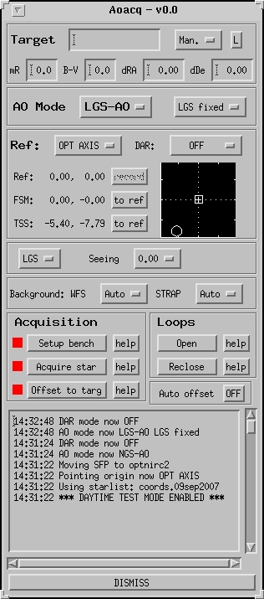

Figure 6: Current AO Acquisition GUIs natural guide star (left) and laser guide star (right), these will be modified to support multiple IR guide stars.

AO Calibration GUI
The current calibration widget will be modified to include calibration for the NIRTTS systems. The current calibration GUI is shown in Figure 7.
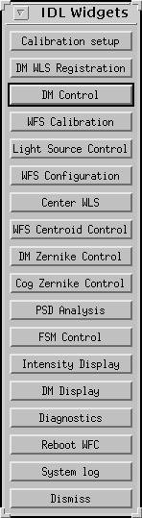

Figure 7: The current IDL calibration GUI.

