Background Measurement for the TRICK NIR TT Sensor

Jim Lyke

17 March 2011

Introduction
The optical tip/tilt sensor for the laser, STRAP, requires a background measurement for stars dimmer than about 12th magnitude. This background is recorded during acquisition by nodding the telescope 30 arcseconds and is usually sufficient for the duration of the science observation (up to several hours). Occasionally, due to changing backgrounds due to the moon or even a very thin layer of cirrus, a new background may be beneficial—especially for the dimmest tip/tilt stars. A new background requires observations to stop such that the AO operator can move the telescope off to the sky. Operationally, one STRAP background per acquisition is the standard.
The TRICK NIR TT sensor will require a background measurement; however, we anticipate that the background measurement may require more frequent updating. My understanding of the requirement is that the NIR TT Sensor will need to be able to take a background measurement. Our goal will be that additional background measurements do not interrupt science observations. This document discusses how background measurements on the NIR TT sensor will take place.

Required Operation
The NIR TT sensor will be able to change exposure time/coadds and take an exposure via keywords. For STRAP and the WFS, backgrounds are recorded by executing an IDL script that sets all the relevant keywords. These background scripts are run by the acquisition script or when the AO operator prompts the system to record a new background. We will match this functionality with the NIR TT sensor.
We anticipate that the background for the NIR TT sensor will change more rapidly than for either STRAP or the WFS. As such, we may require an ability to update the background. The brute force method will be to suspend operations and move off target to record another sky frame. Unfortunately, how the IR background changes differs from band to band, night to night, or even within a night; therefore, there may be no set time after which a new background is needed. A more robust solution would allow the periodic measurement of the background without interrupting science.

Goal Operation
Update the background without interrupting science observations. The following are suggestions on how one would update backgrounds on the fly. We have listed these in the order perceived ease of implementation from easiest to hardest. While none of the methods seem that difficult, these are just estimates.

Dedicated Background ROI
The NIR TT sensor is required to support 1-3 regions of interest (ROI) that correspond to the locations of 1-3 tip/tilt stars. The background measurement is subtracted from each ROI before the TT correction is calculated. If the NIR TT sensor can support 4 ROI, then one of the ROI can be reserved for background measurement. The current median value of the background ROI is compared to the median value of the original measurement. Once the two measurements deviate by a threshold, the backgrounds for the other ROI are scaled to the new background measurement. We select the median value as it is more robust to cosmic rays and bad pixels than a mean. The location of the dedicated ROI in the focal plane will be selected by the AO operator.

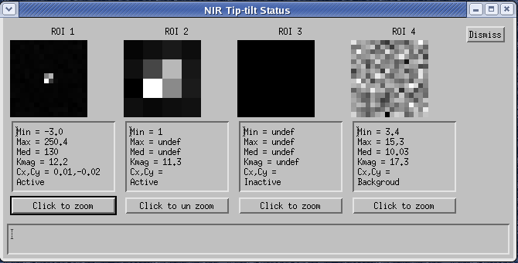

Figure 1: NIR TT Status Mock-up showing a dedicated background ROI (4).
Secondary Period
The Keck Observatory guiders support interleaved ROI and full-frame readout. For example, the full-frame is readout once for every 10 ROI reads and ten is referred to as the secondary period. The AO operator will select a background region within the full-frame that will be used to measure the background. If needed, the median background value for the ROI will be updated.

Increase ROI Size
As the TT stars will be corrected by the AO system, we anticipate that the ROI would be smaller during observations than during acquisition. The reduced size of the ROI should allow faster readout. Perhaps we will find there is no readout improvement for a 2x2 ROI versus a 16x16 ROI or that the larger ROI readout performance is adequate for the TT star. In these cases, we can leave the ROI large and estimate background changes via the outermost pixels in the ROI.
Alternatively, we can periodically increase the ROI size of one or more ROI to measure the background. This functionality will be much like the secondary period mentioned above.

ROI “nod”
If we multiple TT stars, but are unable to define a background ROI, one ROI can be moved to a background region for periodic background measurement. The software would have to zero the selected ROI’s contribution to the TT correction and electronically “nod” the ROI to a previously selected background region in the field. There, the background level is measured and if needed, the median background value for the ROI will be updated. The selected ROI would then be returned to its original location and its contribution to the TT correction would be restored.

