 Keck Adaptive Optics Note 562

Keck Next Generation Adaptive Optics
Interim LOWFS and LGS Object Selection Mechanism conceptual study report

A. Moore, V. Velur
March 5th, 2008

Introduction
The Next Generation Keck Adaptive Optics system is a multiple guide star Adaptive Optics system with a two stage reflective OAP relay designed to work between 100-170 nm wavefront error. This report presents concept solutions for the Object Selection Mechanisms (OSM) for the interim Low Order Wavefront Sensor assembly and Laser Guide Star assembly.

The LOWFS OSM is summarized in Section 2 of this report, followed by a description of the LGS OSM in Section 3. A summary of the assumptions regarding acquisition and dithering are presented in Section 4. Acronyms and document references are contained in sections 5 and 6 respectively.

Low Order Wavefront Sensor OSM
The Low Order Wavefront Sensor (LOWFS) assembly is located at the focus of the first relay and contains as a minimum 2 Tip/Tilt WFS, 1 TTFA WFS, 1 TWFS WFS and 1 PSF monitor. The NGAO LOWFS assembly is a critical part of the NGAO system as it initiates acquisition and all subsequent observation modes such as on and off-chip dithering, including sub-pixel dithering, and non-sidereal tracking at exquisite levels of performance.

The interim LOWFS assembly
The interim LOWFS assembly contains a 4-channel Object Selection Mechanism (OSM) feeding 2 Tip/Tilt WFS, 1 combined TTFA/Truth WFS and a wide field PSF monitor. Shown in Figures 1-3 the assembly attaches directly to the NGAO optical bench. The assembly can be viewed as two separate entities: the OSM consisting of a stable structural plate that supports the 4 roaming probe arms and the 4 beam-fed units located behind the structural plate that are fixed during an observation. This report is concerned with the specification and design of the OSM.

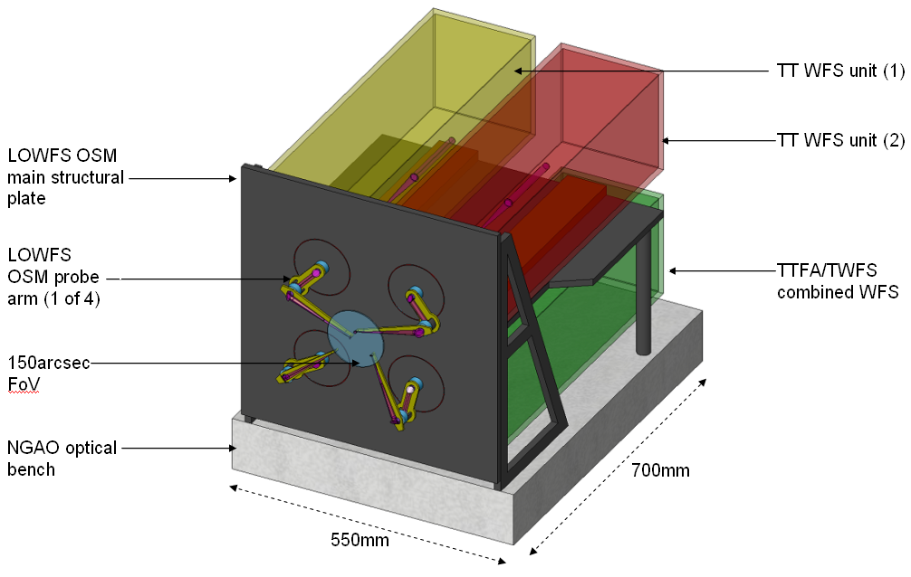
Figure 1: The Low Order WFS assembly for NGAO contains (a) a 4-probe arm Object Selection Mechanism and (b) 4 units comprising 2 Tip/Tilt WFS units, 1 combined TWFS/TTFA unit and 1 PSF monitor (hidden by main structural plate above). The LOWFS WFS assembly is roughly 500mm by 550mm by 700mm deep in volume.
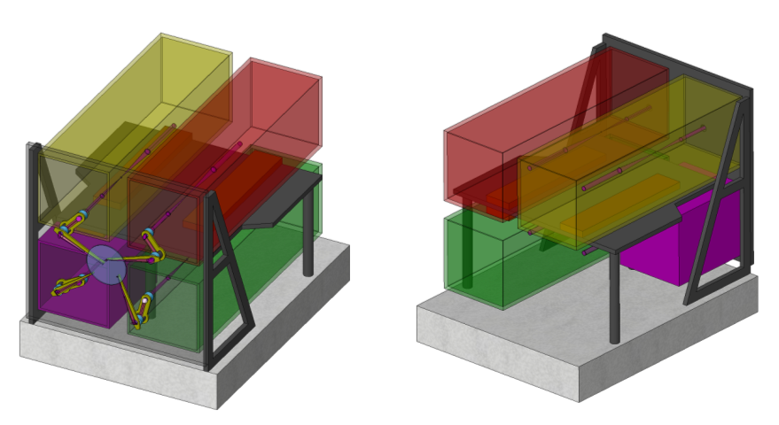
Figure 2: The rear of the LOWFS assembly showing the layout of the 4 units fed by the LOWFS OSM. The units, shown as volume indicators only, are color coded as follows: TT WFS 1 (red); TT WFS 2 (yellow); TWFS/TTFA combined unit (green) and; the PSF monitor (purple).
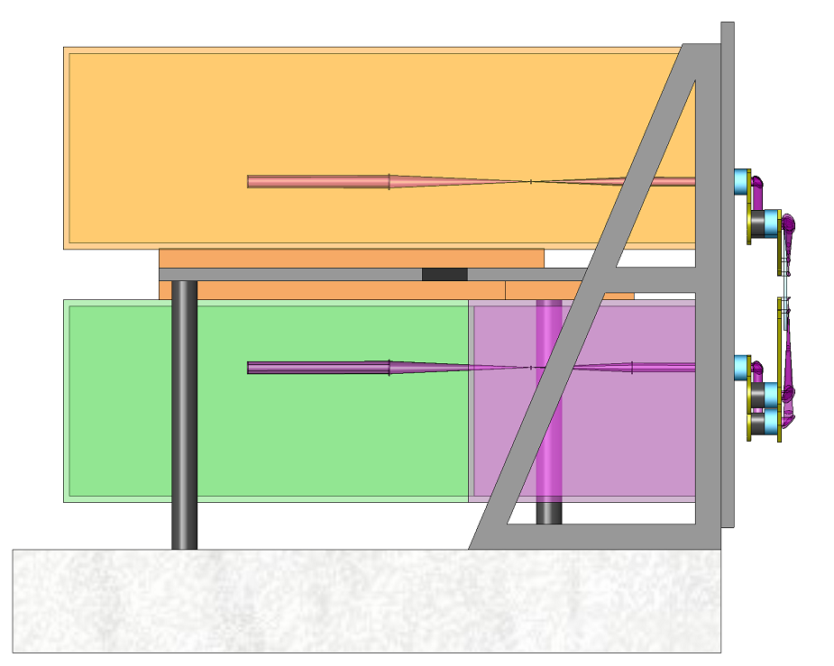
Figure 3: A side view of the interim LOWFS assembly. The optical beams shown terminate at the formation of a pupil image of size equivalent to the deformable MEMS mirror found in each of the LOWFS rear units

The interim LOWFS OSM versus the d-IFS OSM
The interim LOWFS assembly refers to a 4-pickoff WFS assembly that satisfies all requirements for the NGAO AO-assisted narrow field science instrument suite. The wide-field deployable Intergral Field Spectrograph, d-IFS, is undoubtedly the most complex instrument envisaged for NGAO and by field requirement must be located very close to the LOWFS assembly. Given the proximity it was found a restriction on the design freedom of the d-IFS to separate the spectrograph and LOWFS OSMs.

Given this, and the possibility that the d-IFS will be a second generation instrument not present for first light, we concentrate here on an interim LOWFS assembly, much simpler in design than the d-IFS OSM, that satisfies the narrow field requirements only. It is hoped that parts of this report will be helpful to the development of the d-IFS OSM and furthermore will serve as requirements for the d-IFS OSM.

LOWFS OSM Requirements

Basics
At the most basic level of functionality the LOWFS OSM must select 4 natural guide stars distributed randomly across the 150arcsec field of view delivered to the LOWFS location by the 1st NGAO optical relay. Each NGS is fed to a different unit, three of which are for low order wavefront sensing and one for PSF monitoring. There is no specific clustering requirement placed on the interim LOWFS unit, a value of 5 arcsec was assumed as a reasonable estimate for this study.

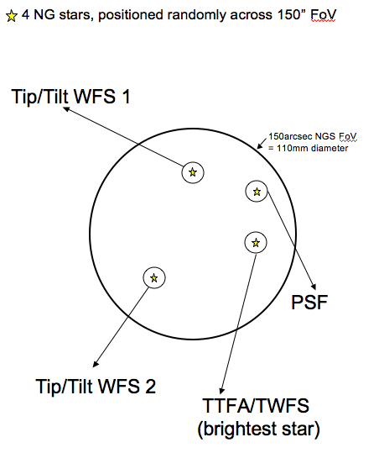
Figure 4: The layout of the LOWFS field of view delivered by the 1^{s} NGAO ^{t} relay. The LOWFS OSM must select 4 NG stars positioned randomly across the 150arcsec (110mm physical size) field. The brightest star is directed to the combined TTFA/TWFS channel.

Science requirements

The “rainbow” chart
The science requirements flowdown, nicely summarized in KAON 548, provides the starting point to the LOWFS OSM performance requirements. Summarized in Table 1 below are the required science performances for acquisition and dithering at the science detector. Given the LOWFS assembly, that contains the OSM, is the acquisition and dither initiator for the NGAO concept stage the performance requirements for the assembly itself must provide as a minimum this level of accuracy. This is discussed further in Section 2.3.2.3 below.

The acquisition and dither requirements are displayed in units of mas, physical distance at the LOWFS F/15 focal surface and, for interest, physical distance at the F/45 narrow field science focal surface. Requirements that are given as a function of observing wavelength are presented for Hα, J, H and K. The most stringent requirements correspond naturally to the micro-dither movements on the science detector for the shortest observing wavelength, that of Hα at 656nm. Here we see a dither accuracy of 6.8mas, a physical size of just under 5μm at the LOWFS OSM and 15μm at the narrow field science instrument. This is accompanied by a corresponding term called “position knowledge”, representing the error in the knowledge of the micro-dither movement at the science detector. For such cases, the position knowledge is only 1μm at the LOWFS OSM corresponding to 3μm at the narrow field science instrument.

Table 1: A summary of the science requirements that are relevant to the design of the LOWFS Object Selection Mechanism. Requirements that are wavelength specific are presented for each NIR band at both the F/15 LOWFS focus and for interest the F/45 narrow field science focus (NA=Not Applicable)
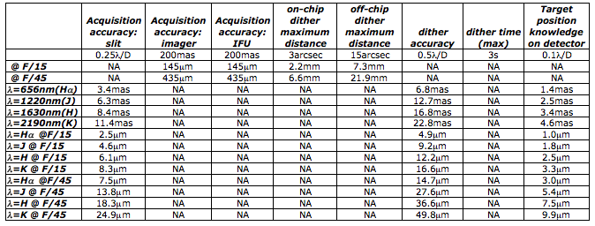

Spectrograph slit acquisition accuracy
For immediate clarity it is noted here that the stringent acquisition accuracy of any slit based narrow field spectrograph, listed as 0.25λ/D in Table 1, will be provided by the science instrument itself. The LOWFS OSM will provide substantially better than 200mas acquisition accuracy as discussed in Section 2.4.1, however, it is assumed that if a narrow slit based spectrograph is to be part of the NGAO instrument suite it must include an internal steering mirror or a device of similar functionality..

Further requirements

Chromatic effects
There is no atmospheric dispersion corrector in the wide field first relay of NGAO to increase throughput to the d-IFS. Instead, each LOWFS unit incorporates a mini-ADC that corrects the atmospheric dispersion across the LOWFS observing band to sufficient accuracy. However, there are further chromatic effects that cannot fully be corrected by the unit mini-ADCs and are described here.

Tilt error
This refers to the separation between the science target at the narrow field instrument and the location of the LOWFS stars in the wide field focus. The NGS are selected by a full field dichroic that directs the science target in the correct photometric band towards the narrow field instrument while passing NGS light in a different photometric band to the LOWFS OSM. The consequence is that if the LOWFS OSM were to track according to the location of the tip/tilt stars, the science target would move on the narrow field instrument detector as a function of elevation angle. The mini-ADCs likely will not correct this multi-band effect to the required level of accuracy. Another concern is that the accuracy of positioning a science object for position knowledge for co-adding images, only 1.4mas for the shortest visible mode, will be affected by this error.

→ Proposed solution: the LOWFS WFS units will be tracking devices that provide the variable offset required between the tip/tilt stars and science target. This offset will be provided by the TT stages of the WFS/PSF monitor units.

LOWFS Dichroic aberration
The tilted full field dichroic used to separate the LOWFS and science target light introduces both astigmatism and a lateral chromatic aberration to the LOWFS beam. Astigmatism is a MEMS-correctable error within each LOWFS unit while the chromatic dispersion is not. The magnitude of the effect is shown in Figure 4. The lateral dispersion created by the angled dichroic is roughly 50mas between Hα and H band, with J band roughly centered between the two.

→Proposed solution: the chromatic dispersion can be corrected using a glass wedge inserted into each of the LOWFS units at the expense of roughly double the astigmatism. The latter aberration can be corrected by the MEMS deformable mirror that is internal to each LOWFS unit.

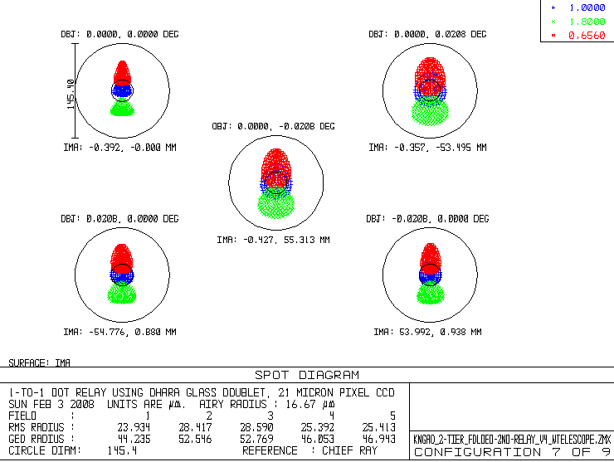
Figure 5: Chromatic and astigmatic aberration created by the LOWFS dichroic element in the 2-tier model. The fused silica element is 20mm thick and orientated at an angle of 20º to the incoming beam. The large black circle corresponds to a sky angle of 200mas; the smaller inset circle is the airy disk for J band. The atmospheric dispersion is zero.

Non-sidereal tracking
There are observing modes that require the science target to be non-sidereal, such as Kuiper Belt Objects (KBOs). This results in a variable offset pointing between the tip/tilt stars and the science target during the science observation.

→ Proposed solution: the LOWFS WFS/PSF monitor units will be tracking devices that provide the variable offset required between the tip/tilt stars and non-sidereal science target. The maximum range of correction permitted by each TT stage is not decided at this stage, and we assume a value of 0.5-1.0 arcsec. For offsets greater than this the LOWFS OSM probe arms will be repositioned, with a corresponding accuracy of 40mas or so (see Section 2.4.2.4). The position measurement from the probe arm encoders will be substantially better than this and will feedback to the TT stages to compensate for error in the probe arm positioning.

Discussion
It is important to note here that the science requirements listed in Table 1 refer to the performance as measured at the science detector. For example, a required science target acquisition accuracy of 200mas is the total error budget for a series of terms of which only 1 component is the acquisition accuracy of a single LOWFS TT unit fed by the LOWFS OSM. Other considerations that affect this error budget are misalignment inaccuracies in the dichroic interchange; AO enclosure thermal gradients; fold mirror interchange inaccuracies; instrument optical distortion; inaccuracy in the element performing the counter-dither motion such as the TT stage of the woofer; plus several other terms.

A full error budget analysis is a goal for the next phase of NGAO. Instead, we take a decision here to design the LOWFS OSM to be as accurate as it can possible be with off-the-shelf components or components already incorporated into the design, such as the very accurate TT stages of the deformable MEMS mirrors.

Basic design philosophy
With science requirements in mind, the LOWFS assembly adhered to the following design principles:

- Keep as much of the WFS unit as fixed as possible, especially during an exposure
- Be as modular as possible
- Assume the AO enclosure temperature is adequate for all LOWFS unit optics from an emissivity point of view, with the exception of the detector
- The preferable orientation, from a throughput perspective, of the LOWFS assembly, and hence OSM, is horizontal as shown in the 1-tier layout in Figure *
- The LOWFS assembly, and hence OSM, does not rotate as a whole
- The LOWFS assembly is the acquisition and dither initiator of the NGAO system. This is discussed further in Section 4.
- The pick-off arms (that guide the NGS to the respective fixed WFS unit) are designed to be as good as possible using off-the-shelf components. This is based on the prior knowledge that this is likely good enough for a positioning accuracy of around 40mas in the focal surface of the LOWFS assembly
- The position knowledge of the probe arms will be substantially better than 40mas with a goal of ±1μm at the LOWFS focal surface
- Fine positioning to better than 40mas or so is initiated by the Tip/Tilt stage of the MEMS deformable mirror, one being located in each WFS unit. The exact division between a TT stage sky movement and pick-off movement is not critical at this stage so long as it is smaller than the range of the stage mechanism. Software initiated dithering at this level is a further option though is not considered here
- Though not essential, we assume that providing an easily accessible location for the probe arm pupil is advantageous. For example, if the exit pupil is located close to the main structural plate a cold stop can be simply attached to the plate rather than the roving probe arm for the purpose of reducing background if deemed required.

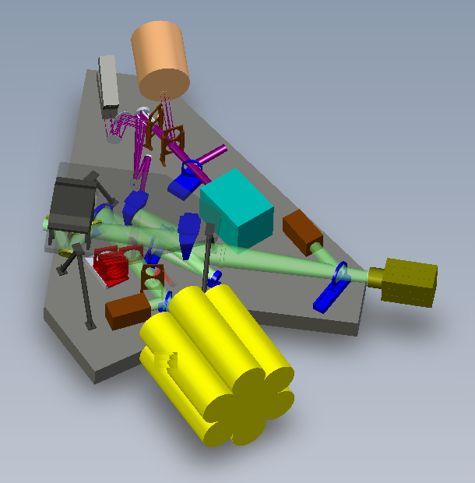
Figure 6: A schematic of the NGAO layout showing the location and orientation of the interim LOWFS unit change to interim LOWFS

LOWFS OSM flowdown requirements
Summarized in Table 2 are the specifications for the LOWFS OSM probe arms.
With an NGAO enclosure temperature of -20ºC and the assumption that none of the LOWFS optics requires cooling to less than this value, we have a reasonable set of requirements for the start of the conceptual design of the LOWFS OSM.
Table 2: LOWFS OSM probe arm specifications for NGAO
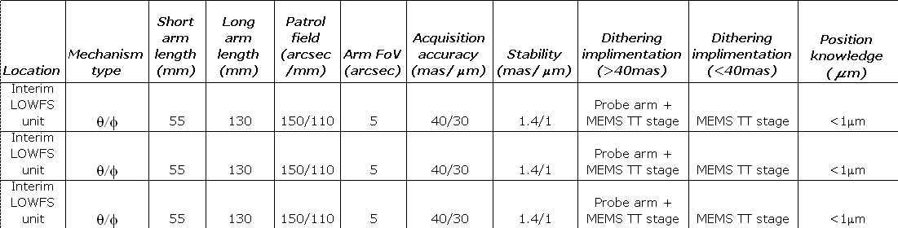

The LOWFS OSM theta/phi probe arm
We introduce an object selecting probe arm that is a simplified version of the TMT-IRMOS (University of Florida team) feasibility study.

Conceptual design and operation
The LOWFS OSM probe arm is a compact 2-motor device shown in Figures 7 and 8. The 2 degrees of freedom probe arm consists of 2 individual arms: a crank arm and a lever arm, driven by 2 corresponding rotation motors: the crank and lever motors.

The crank motor is secured to the main structural plate. It rotates the crank arm, and all hardware attached to it that includes the lever arm and lever arm motor, precisely about the rotation axis of the crank motor referred to as the theta axis in Figure 8. The lever arm motor provides the necessary second degree of freedom by rotating the lever arm and all associated optics, about the phi axis.

The lengths of the crank and lever arms are chosen to provide full coverage of the LOWFS OSM field of view. Any position in the LOWFS OSM field of view can be acquired by calculating appropriate values for theta and phi, noting that due to a mirror reflection there are always 2 possible solutions. Four basic configurations of the LOWFS OSM probe arms are shown in Figure 9, including (a) the non-LGS observing mode; (b) a probe arm at full range; (c) “home position” where all probe arms are outside the field and (d) a random configuration for LGS mode.

The probe arm tips can be designed to approach very closely – in fact it is possible to position 2 probe arms on natural guide stars 5 arcsec apart, as shown in Figure 10.

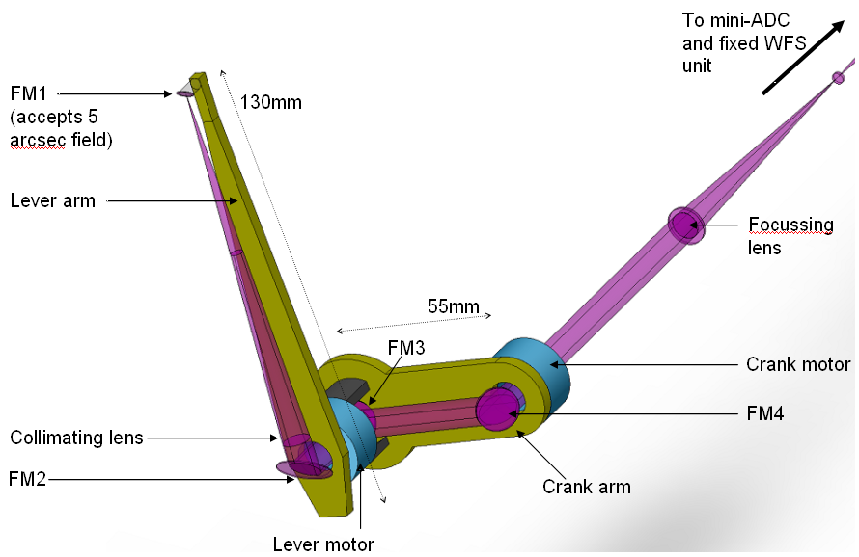
Figure 7: The LOWFS probe arm with dimensions and major items identified. The probe arm relays NGS light from any location within a 150arcsec field of view to a fixed rear unit, the direction of which is indicated by the arrow to the top right.

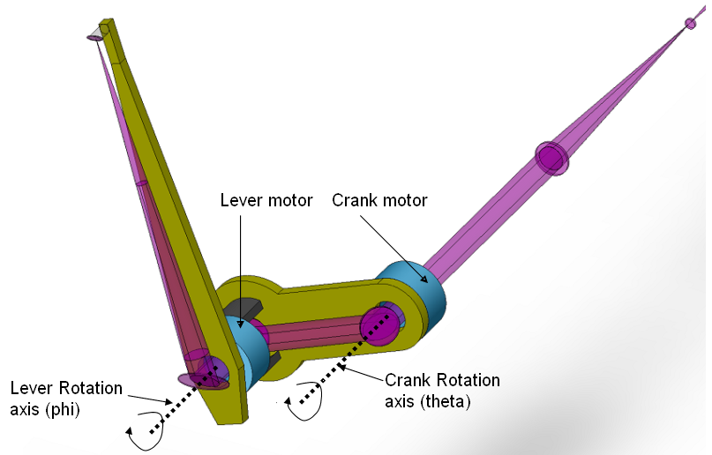
Figure 8: The LOWFS probe arm has 2 rotational degrees of freedom provided by 2 motors, as shown above. See text for further details.
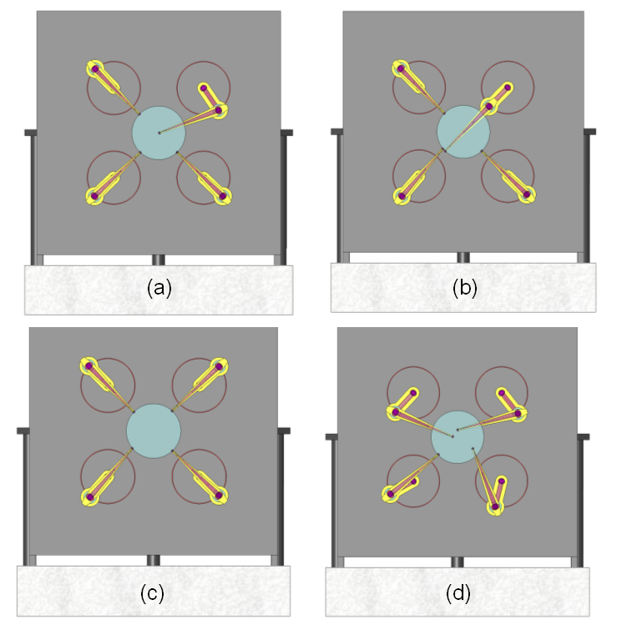
Figure 9: Four configurations for the LOWFS OSM probe arms: (a) One TT on-aixs with remaining 3 probes unused; (b) Showing the full range of the probe arm; (c) the OSM in the “home” position and; (d) a random field with all 4 probe arms in operation.

Zemax model of theta/phi arm for interim LOWFS OSM
We present the optical design of the LOWFS OSM probe arm. The telecentric feed from the AO system makes the optical design relatively simple.

Delivered field to interim LOWFS OSM
The delivered field to the LOWFS OSM is described in detail KAON 549, however we concentrate here on properties that are relevant to the LOWFS OSM design.

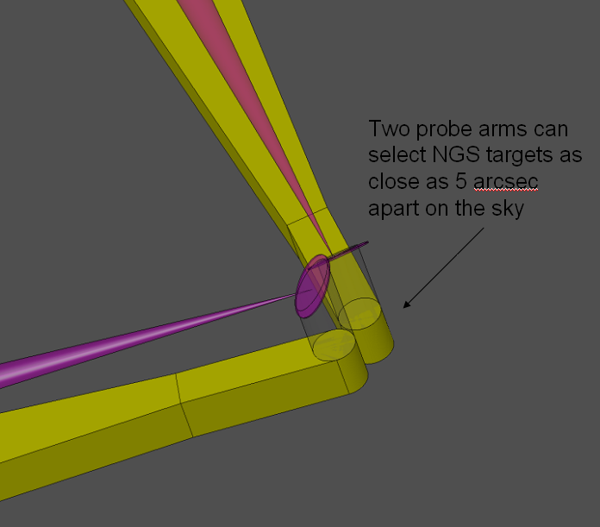
Figure 10: The tips of the LOWFS probe arms can be positioned to 5 arcsec separation on the sky

Telecentricity
As discussed in Figure 11 the optical feed to both the LOWFS and LGS fields is telecentric. The immediate benefit of this to a focal surface probe arm design is that the probe arms can patrol a flat field and not require any tilt of the optics to compensate for changing angle.

Field curvature
The LOWFS OSM focal surface though telecentic is curved, at a radius of -1320mm. As the probe arm moves from the center to edge of the field, this results in a defocus of approximately 1mm, as shown in Figure 11. The broadening of the beam at the first optical element FM1 is only 70μm and therefore negligible, however the focus position of the re-imaged star at the WFS unit (or PSF monitor) will change by a corresponding amount. The solution to this is to position all 4 LOWFS units on linear slides, as shown in the LOWFS assembly drawings. The units are moved to the correct focus position at the start of an acquisition procedure and do not need to be tracking devices.

An alternative solution is to keep the LOWFS units completely fixed and to place each of the 4 focusing lenses on linear stages. This may be preferable and will be the decision of the designers of the LOWFS units.
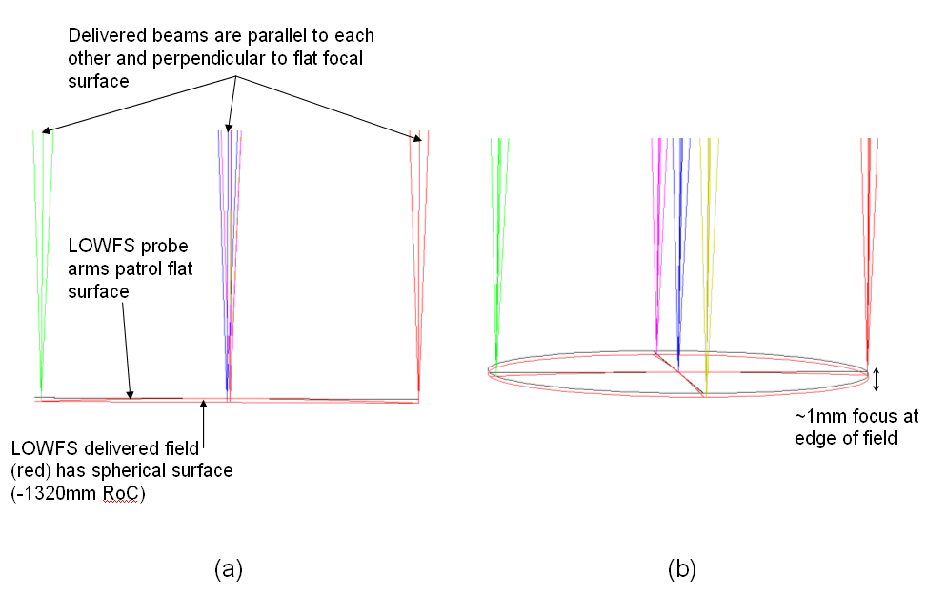
Figure 11: (a) The LOWFS field of view is a spherical surface of radius -1320mm whereas the probe arms patrol a flat surface. The delivered optical beam is telecentric however, a benefit to the probe arm design.. (b) The field curvature results in a probe arm being defocused by around 1mm when patrolling at the edge of the field of view. See text for further details.

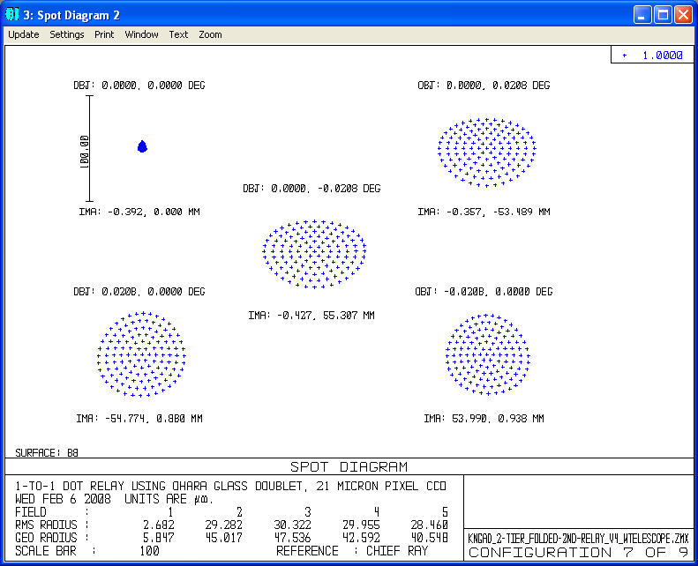
Figure 12: The image defocus at the edge of the field of view due to the probe arm patrolling a flat surface corresponds to an image broadening of only 70microns. This defocus is compensated by a small adjustment of the WFS or PSF monitor unit prior to NGS acquisition.

Zemax model of theta/phi arm
General description: the probe arm is optically a simple relay with lens as collimator to prevent beam broadening. The Focal length of the lens is governed by wanting the exit pupil to be close to the main structural plate – in case a cold stop is required to reduce thermal background/filters etc. The probe arm can have a smaller cross section otherwise, however this 4 probe arm OSM benefits from having 1/2inch optics that are easier to align than mm sized optics for example.

A field of view of 5 arcsec was chosen as a reasonable size of field to be large enough to always hit the target, but small enough that clustering tagets to 5 arcsec separation offers a large flexibility. The field can be stopped at the WFS/PSF monitor unit internally if required.

The designers of the WFS/PSf monitor units have the flexibility to choose the focal length of the focusing lens in (a). It is shown here to be the same as the collimating lens therefore providing a 1:1 relay, however this does not have to be the case. This flexibility may be of use.
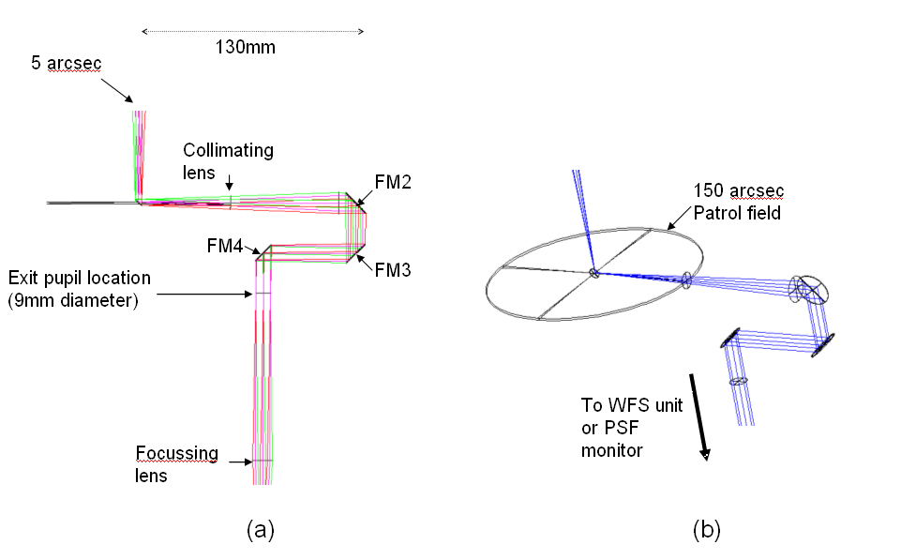
Figure 13: (a) Zemax model of interim LOWFS probe arm that relays a 5 arcsec field of view to a fixed exit pupil location; (b) the probe arm patrols a 150 arcsec field

Advantages/Disadvantages of theta/phi arm
The advantages of this design are:

1. The optical pathlength is naturally and accurately preserved as a function of field position.
2. As only 4 pick-offs are required one can allow larger mechanisms than otherwise allowed, resulting in readily available off-the-shelf rotary mechanisms using conventional worm gears rather than custom piezo or hybrid devices.
3. The theta/phi arm naturally allows for a fixed feed to the non-tracking WFS unit.
4. The arms can be balanced about the center of mass for each arm if this is an advantage to fine positioning in the future

There are two disadvantages of a theta/phi mechanism:
1. The pupil rotates as a function of field position, by ±180º. This creates a varying rotation of the woofer DM with respect to the lenslet arrays inside the TTFA and TWFS unit. The TT and PSF monitor units contain no lenslet arrays and the effect can be calibrated in software. As with the High Order LGS WFS discussed in Section 4, a solution to this is to include an extra non-tracking rotation mechanism in the WFS unit that rotates the entire unit about the z axis as a function of field position.
However, the low order nature of the TTFA and TWFS units is most likely sufficient that this mechanism is not required in the LOWFS assembly, and we therefore propose the effect to be calibrated in software.
2. In general, linear motors are more accurate than rotary.

Motor specifications
There are many approaches to the implementation of the phi and theta mechanisms. These range from off the shelf dc motors, to Ultrasonic motors found in high-end camera zoom lenses; to piezo based high precision linear motors driving the crank arm round a circular track.

The motor is a critical component of the LOWFS probe arm, in particular the phi motor that operates the longer lever arm. The motor is shown conceptually in Figures 7 and 8 to be 1 inch diameter disks with a clearance hole of roughly 0.5inch for passage of the optical beams, and is identical for each rotation axis. This volume marker was chosen assuming a novel custom motor design using piezo shear plates or possibly ultrasonic motors used as focus mechanisms in high end cameras. The diameter of the motor can in practice be much larger as shown in Table 4.

Given that all fine positioning (<40mas moves) is assumed to `be implemented by the TT stages of the internal MEMS mirrors, we consider here off-the-shelf package dc-motor solutions for the gross movements of the LOWFS OSM probe arms. The advantage of such solutions is that they incorporate control electronics and software for positioning and encoding, therefore an advantage over developing a custom solution.

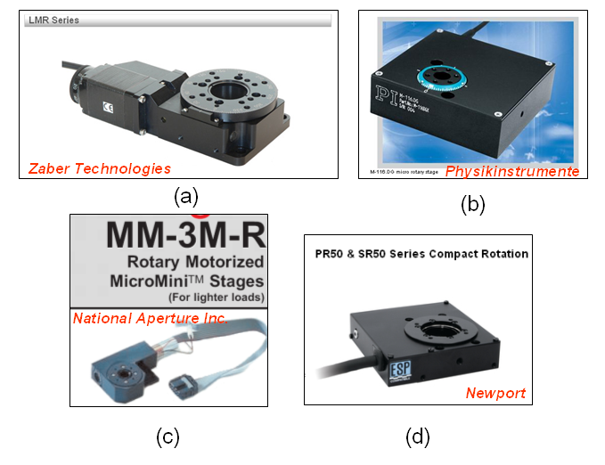
Figure 14 (a) – (e): Examples of off-the-shelf rotary motor packages as a possible solution for the phi/theta motors of the LOWFS OSM probe arm. References to each motor can be found in Section 6.

DC motor feasibility
A single worm gear with 70:1 reduction using 1.8º stepper motor employing factor of 10 microstepping will have a 0.005º minimum step size (9 arcsec). DC servo variants require feedback from an encoder, either inside the motor itself or preferably an encoder measuring the actual movement of the probe arms. As long as the encoder provides the level of accuracy required a well designed DC servo system should in theory be as good as a stepper motor driven equivalent. Furthermore, encoders measuring the actual movement of the arms rather than the motor rotation itself, will fair much better. In summary, it is feasible to consider DC motor solutions for the LOWFS OSM probe arms that incorporate a single high precision worm gear.

Table 3: Specifications for the off-the-shelf compact motor solutions for the LOWFS OSM probe arm. Resolution refers to the fineness of the encoder, whereas Step Size refers to the minimum repeatable mechanical step of the motor. The resulting movement at the probe arm tip for movements of the crank and lever arms of the smallest step size are presented, and this assumes a perfect system.
Motor name | Dimensions (mm) | Step size (minimum. in arcsec)) | Speed | Motor type | Resolution  (arcsec) | Crank min movement at tip  (μm/mas) | Lever min movement at tip  (μm/mas)
PI  M-116.DGH | 70x66x23.5 | ±10 | 20º/s | DC servo or Stepper Motor | 0.5 | ±2.7/3.7 | ±6.4/8.8
NAI  MM-3MR | 76.2x36x12.7 | ±15 | 1.5º/s | DC servo, brush | 0.4 | ±4.0/5.5 | ±9.4/12.9
Newport SR50 | 80x77x21 | ±14.4 | 1.6º/s | 2 phase stepper motor | 3.6 | ±3.8/5.2 | ±9.0/12.3
Zaber  LMR Series | 129x64x29 | Not stated | 33.6º/s | 2 phase stepper motor | 0.3 | - | -

Shown in Figure 14 are the basic specifications for a rotary motor package of size suitable for this application. All contain precision worm gears. As expected the motors are comparable in performance. Assuming perfect systems (zero hysteresis; perfect meshing between gears; zero stage wobble) the step size error as measured at the probe arm tip is worst case ±14mas (±10.2μm). We assume a factor of 3 performance degradation in reality at this early stage, hence an approximate error of 40mas.

The determination of the probe arm position can be substantially higher. The DC motor servos listed in Table 3 claim a resolution of ~0.5 arcsec, corresponding to 0.3μm for the 130mm long lever arm, and 0.1μm for the 55mm crank arm. Whether encoders that measure the motor rotation are adequate over encoders that measure the arm movement directly, a preferable design decision, is left for the prototyping stage it is reasonable to assume that the probe arm position can be measured to within ±1μm.

The Zaber LMR series motor contains a higher gear ratio than the others and is suitable for several kilogram loads, therefore maybe a little larger than required, in particular for the lever arm motor as it must be situated on the shorter crank arm (55mm pivot to pivot distance).

In summary, an off-the-shelf DC motor package is a reasonable starting point for the drives of the LOWFS OSM probe arms, when it is assumed that the TT stages of the MEMS deformable mirrors are capable of performing all fine positioning moves.

Temperature effects
The NGAO enclosure will be controlled to a temperature of -20ºC with an accuracy of 0.3ºC. A worst case scenario is that this corresponds to a temperature differential across the LOWFS OSM main structural plate, to which all components such as the probe arms and WFS units are structurally attached. Assuming a steel plate roughly 500mm square this corresponds to an expansion δl of (0.3×0.5×11E⁻⁶) or 1.7μm. This equates to 2.4mas on sky or ×5.7 the diffraction limit at Ha, for the most stringent of science cases.

Such a variation is of no immediate concern, however, careful consideration must be given to temperature induced variations between the LOWFS assembly and the narrow field science instrument that could be situated several meters away. This should become part of the error budget analysis for the preliminary design.

Calibrating the LOWFS OSM
In this concept design the LOWFS OSM dictates the pointing of the telescope as viewed by the science instrument. In the majority of cases this is an open loop system, as in there is no star at the science detector that can be used to ascertain the delivered image position. As such accurate calibration of the OSM is an important issue.

What needs calibrating?
The following require calibration:
1. The LOWFS OSM to the telescope field of view
2. The NGAO acquisition camera to the LOWFS OSM
3. The LOWFS OSM to the narrow field science instrument

For a well calibrated acquisition camera one in theory does not require step 1 as it is already well calibrated to the telescope field of view. We assume here that all 3 steps are required.

Method of LOWFS OSM calibration
We envisage a simple device located in the NGAO calibration unit that consists of a well defined grid of illuminated points spanning the 150 arcsec telescope field of view. This unit could consist of an etched piece of glass with 1 arcsec or so diameter transparent holes arranged to sub-micron level accuracy in a pre-defined grid. With illumination from behind, using electroluminescence sheet if a suitable wavelength exits, the grid of points will be re-imaged simultaneously at the LOWFS OSM focal surface and narrow field instrument, or acquisition camera with the camera fold mirror in place. This device could be used to provide transformations between LOWFS OSM probe arm positions to acquisition camera pixel coordinate and to narrow field detector pixel coordinate.

During commissioning the use of on-sky targets such as globular clusters would be useful in providing the final link between the calibration unit itself and the telescope field of view, as well as incorporating Keck telescope performance into the calibration procedure.

Hardware table for LOWFS OSM
Table 4 lists the required hardware for the LOWFS OSM. Note this does not include the rear WFS and PSF monitor units nor the mini-ADCs, contained within the units, that are detailed in the relevant KAON.

Table 4: List of hardware items for the LOWFS OSM
Item | Dimensions (for 5arcsec FoV) | Quantity | Comments
FM1 | 5.4mm diameter | 4 | Elliptical mirror for 5 arcsec FoV
Collimating lens | 14.6mm diameter | 4 | Circular lens
FM2 | 19mm diameter | 4 | Elliptical mirror for 5 arcsec FoV
FM3 | 17.8mm diameter | 4 | Circular mirror
FM4 | 16.0mm diameter | 4 | Elliptical mirror for 5 arcsec FoV
Focussing lens | 13.4mm diameter | 4 | Set by WFS unit designers, can be variable. Current value assumes 1:1 imaging
Crank motor (theta axis) | Less than 5” diameter by 1-2inch height | 4 | 360º range; minimum step size of ~15 arcsec. Position measurement to 2 arcsec.
Lever motor (phi axis) | Less than 2-3 inch diameter by 1 inch height | 4 | Length can be 4 inches or more if aligned to crank arm. 360º range; minimum step size of ~15 arcsec. Position measurement to 2 arcsec.
Main structural plate and support | 500mm square steel plate | 1
Probe arm structure |  | 4 | Support structure for probe arm elements

Preliminary costing for LOWFS OSM
A preliminary costing for the hardware items is presented. The costing assumes the motor definition to be adequate for the probe arms: this is a definite task for the preliminary design. It is expected that a certain amount of prototyping for one probe arm to be performed which includes assessing assembly tolerances and testing viable motors. This is not costed in the table below.

Table 5: Preliminary costs estimate for LOWFS OSM hardware
Item | Quantity | Cost/item | Total cost
Optics | 4 sets | 1,000 | 4,000
Motors | 8 | 5,000 | 40,000
Main structural plate and support + labor | 1 | 20,000 | 20,000
Probe arm structure | 4 sets | 5,000 | 20,000
 |  |  | 84,000

Laser Guide Star OSM
Probe arms are vitrtually ideantical and LGS requires much less accuracy
Present LGS assembly and OSM

Acquisition and Dithering
A summary of the acquisition and dithering basics for NGAO from a LOWFS and LGS OSM perspective is discussed in this section. This by no means should replace the relevant KAONs describing the NGAO acquisition and observing modes.

General Flow diagram of acquisition and dithering assumed for this study

Optimizing dithering strategy for NGAO
No thought so far to existing software, difficulty to interface to telescope pointing software, delays and errors in telescope repoints etc. Requires a study in the next phase.

Acronyms
On-chip dither
Off-chip dither
ADC
KBO
LOWFS
TT
TWFS
TTFA
PSF
NGAO
OSM
LGS assembly
NGS
LOWFS assembly
LGS unit
LOWFS unit
KAON
MEMS

References
Viswa WFS KAON
Sean A NGAO passbands
Reni’s optical report
Rainbow chart latest version
Chris Neyman acquisition
David – observation modes?
Chris Lockwood – EASM file
Steve E IRMOS probe arm
MM-3M-R reference website
Zaber motor website
PI motor website
NAI motor website
Jim Bell private communication

