NGS wavefront sensor preliminary design
KECK ADAPTIVE OPTICS NOTE 729
VERSION 1.0
Viswa Velur, Alex Delacroix, Richard Dekany
Caltech Optical Observatories, Pasadena, CA

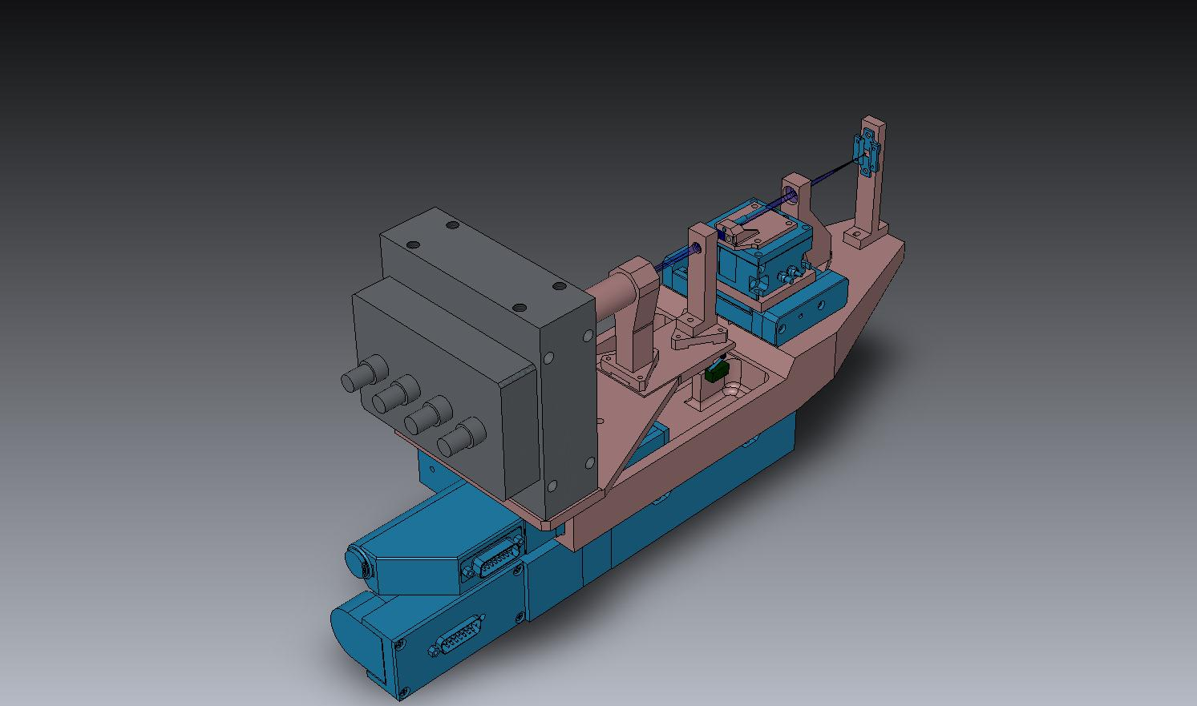

- Introduction
  - Scope
This document describes the preliminary design of the Natural Guide star Wavefront Sensor (NGS WFS) for Keck’s Next Generation Adaptive Optics System. We illustrate the key requirements that lead to certain design choices and explain the optical, mechanical aspects of the design. This document doesn’t cover NGSWFS detector technology, camera operation, reliability, interfaces or prototyping of the sub-system or its components.
  - Reference documents:
    - KNGAO Optical Design Version 10 (18th Mar. 2010)
    - KAON 551 Wavefront Sensor System Conceptual Design Report
    - KAON 511 - System Design Manual v2.1 (doc), dated March 30th, 2008
    - Preliminary Design Manual (as of November 12th, 2009)
    - KAON 642 - Design Changes in Support of Build-to-Cost
    - NGAO Contour
    - NGAO PD Phase Opto-Mechanical page
    - Flow-down Requirements Spreadsheet v 2.0 (KAON723)
    - NGAO WF Error budget tool Version 2.0
    - NGAO Config control page
    - NGAO Pupil mapping diagram (Drawing # 1410-CM0010)

  - Architecture
NGAO underwent a Build-to-Cost (B2C) exercise after the SDR phase wherein the design was altered to enable a cost cap as suggested by the Review Committee and The Directors. Following the B2C effort and subsequent discussions (documented in the requirements database), the NGS WFS:
- has no ADC
- supports only two pupil sampling scales, viz. 5x5 and 59x59. The 59x59 mode is used for high order WFS during NGS science observations while the 5x5 mode enables the NGS WFS to operate as a low-order sensing with the interferometer and to act as a truth sensor for the LOWFS assembly.
- The NGS WFS has a pupil imaging mode for alignment and calibration of the system.
- The field of regard of the NGS WFS was set to be 60 arcsec x40 arcsec.
- The NGS WFS shall operate from 0.5-0.9 um wavelength range.
The NGAO opto-mechanical design has also undergone considerable changes since the SDR to accommodate two science instruments, the LOWFS assembly, the 64x64 actuator MEMS HODM, the interferometer, the LGS WFS assembly and the NGS WFS assembly on the Nasmyth platform of the Keck telescope. This packaging problem was solved by picking off the light to feed the NGS WFS in the collimated space between the HODM mirror and OAP-4 using a dichoric beam-splitter. The current layout of the NGAO optical and mechanical designs are shown in Figure 1 and Figure 2. Based on the LGS WFS pick-off design experience COO designed a refractive triplet focusing element that formed a ~f/20 beam instead of the native f/46 science beam focus with acceptable optical quality for both the 59x59 and 5x5 modes of NGS WFS operation.
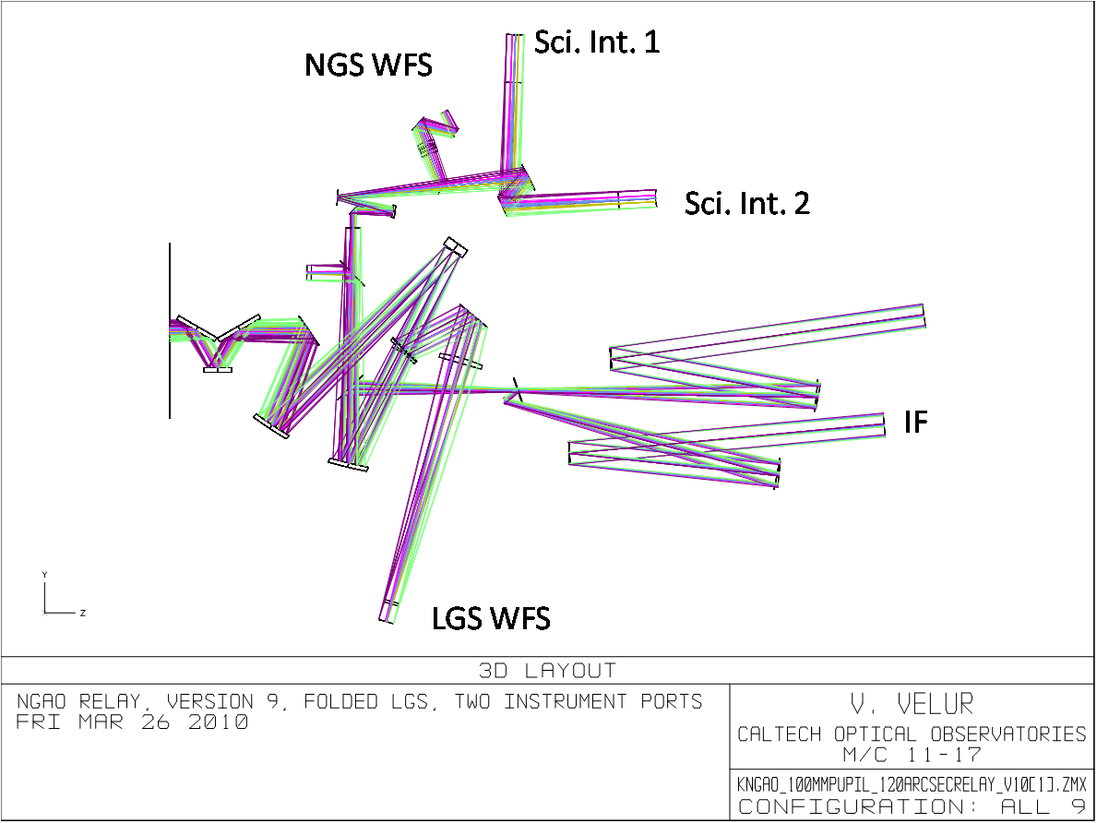
Figure 1 showing the NGAO optical design with output feeds to NGSWFS, 1st science instrument, 2nd science instrument, the interferometer and the LGS WFS. Light from the telescope comes in from the left in the above figure with the picture depicting components in the NGAO relay starting with the K- mirror (derotator).
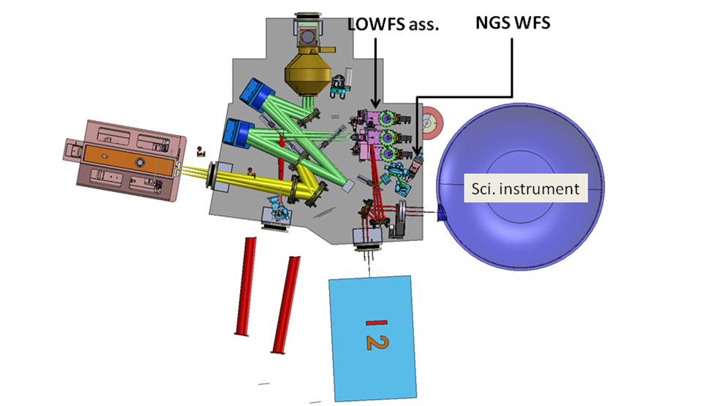
Figure 2 - - NGAO mechanical design with the NGS WFS located between the science instrument and the LOWFS assembly. The big purple oval object is the first Science Instrument, I2 is the second Science Instrument. Light from the telescope comes in from the top of the figure.
The context diagram with the interfaces between the NGSWFS and the NGAO sub-systems are shown in Figure 3. The AO supervisory control configures NGSWFS assembly’s the settings, viz. FSM motion, lenslet motion, detector settings, operating mode of the sensor etc. of the NGS WFS. The NGSWFS will have an optical and mechanical interface with the AO system. The WFS sends pixel data to the RTC, while there is no control path from the RTC to the NGSWFS. The NGSWFS control/ command signals come from the supervisory system entirely; the RTC is designed to be a data-sink, though there may be some universal clock that synchronizes the operation of the sub-system. The NGAO interfaces between the NGAO sub-systems are documented in NGAO ICD (work in progress).
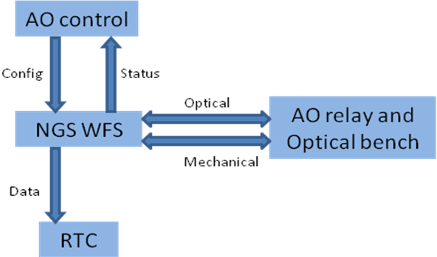
Figure 3- NGSWFS concept diagram
- Requirements:
  - The main requirements that drive the design are as follows:
- WFS modes of operation: 63x63, 5x5, pupil imaging [FR-130, FR-3247]
- Operating wavelength: 500-900 nm [FR-3444]
- Transmission: 0.55 um: 500nm: 78%, 550nm: 80%, 633nm: 77%, 700nm: 74%, 880nm: 78% [FR-203]
- Patrol FoR: 40x60 asec [FR-127]
- Operation with no ADC [B2C decision]
- WFS FoV: 4” [FR-131]
- NGS WFS Dynamic range: 1.77” in high order sensing mode @ 700 nm [FR-141]
- Non-calibratable aberrations in the NGSWFS = 25 nm [FR-138]
  - Motion Control Requirements:
A flowdown from the main requirements results in motion control requirements for the NGS WFS are listed in Table 1.
Motion Control Requirement
Component(s) | Purpose | Range | Accuracy
Field steering mirrors | Needed to guide star-light from the 60x40" FoR into the WFS | 25 deg. | 5 mas [on-chip dither requirement]
Lenslet motion | To support 5x5 and 63x63 pupil sampling and pupil imaging modes | 20 mm in X, 100 um in Y | 2.5 um [5% of the finest lenslet pitch]
Post-lenslet relay and detector | To image the focal spots created by the lenslet or the pupil onto the detector | 12 mm | 1 um
Whole WFS motion | the WFS must work with and without the IF dichoric and with and without the IR ADC’s in the science path (the telescope is refocused when ADC is in or out as the science instruments don’t have a focus mechanism) | 25 mm | 1 um
Table 1 - Motion control requirements for the NGSWFS
Dynamic Range and Linearity: We use a 4x4 pixel/sub-aperture sensor with P-value of 1.0 which gives us +/-2.5 waves of tilt measuring capability with 0.19 waves of departure from Linearity. This corresponds to +/-2.0” of tilt measuring capability [as the sub-aperture diffraction limited spot size is 830 mas].

- The NGS WFS architecture:
The basic functional relationship of the NGSWFS with the other NGAO sub-systems is indicated in Figure 3. The 63x63 and 5x5 modes are implemented in design to use the same collimator and the same post-lenslet relay magnification. Both the modes hence use the same optics except the lenslet. The detector along with the post-lenslet relay moves back and forth to compensate for the difference in focal length of the two lenslets. The camera is also enabled to image the pupil by moving lenslet out of the way and the post-lenslet relay imaging the WFS pupil onto the detector. The 5x5 mode will use the on-chip binning capability that is available with the CCID-74 CCD.
  - Pupil nutation
The projection of the primary mirror onto the HODM is indicated by Drawing #1410-CM0010 Rev. 1. As one can see, the 10.949 m primary is mapped onto 182.48 and 185.30 mm sub-apertures in the X and Y directions. The pupil diameter corresponds to a span that 60-sub-apertures would occupy in the longer direction though because of the geometry only 59 sub-apertures are fully illuminated at a time with the 59-sub-aperture-pupil nutates over a circular envelope with 63 sub-apertures depending upon the telescope (Alt-Az) pointing (c.f. Figure 4). We chose to design a sensor that maps the HODM to the WFS in a Fried geometry. At any point in time there are 59 active sub-apertures lit up at the NGSWFS and these eccentrically rotate inside envelope occupied by 63x63 sub-apertures. We chose 4x4 pixels/sub-aperture WFS pixel geometry with no guard bands as we will have a field stop that prevents cross-talk between sub-apertures. This choice gives us better linearity as compared to a 2x2 sensor and enables us to image a Keck primary mirror (with no lenslet) with high resolution with the WFS for calibration and alignment purposes.
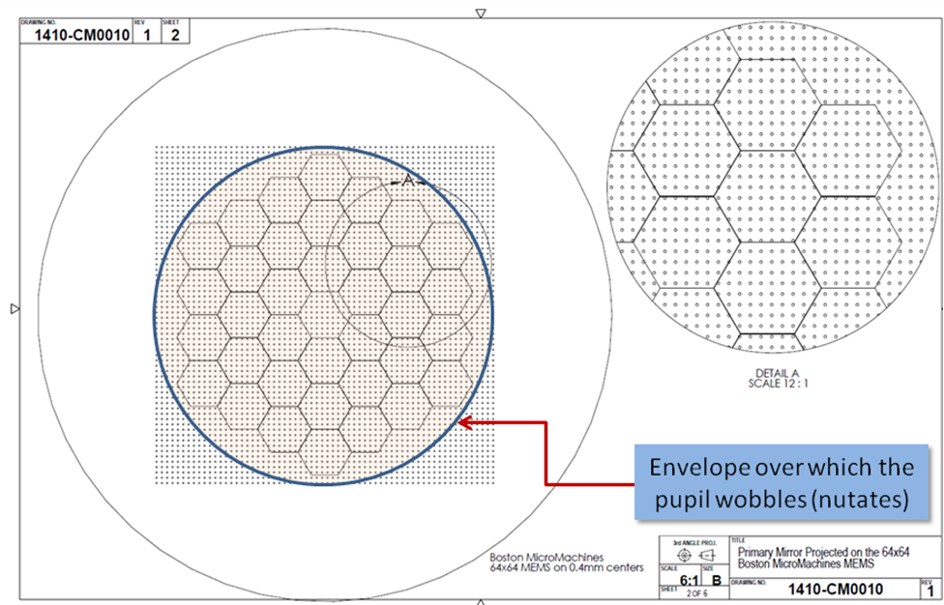
Figure 4 The mapping of the Keck pupil on the 64x64 HODM (in its ideal position). The blue circle shows the envelope over which the Keck primary pupil wobbles.
For the 5x5 mode of operation, one can either choose 50 pixels per sub-aperture resulting in 250 active pixels read out or 48 pixels per sub-aperture with 240 active pixels read out during each exposure. The 240 sub-aperture case enables both 2x2 and 4x4 (binned) pixel operation while the 250 pixel mode can use either 2x2 (binned) pixels or some non-standard pixel geometry. If there is excursion of the pupil due to nutation, both pixel geometry choices would suffer some loss of light at the extreme sub-apertures. We choose the latter option with 240 active pixels for ease of the RTC and to support a standard 4x4pixels/sub-aperture operation. It is to be noted that both 63x63 sub-aperture mode of operation and 59x59 sub-aperture mode of operation are used synonymously in this document as there are a total of 63x63 sub-apertures that can be read-out from the WFS though there are only 59x59 sub-apertures that are actually fully illuminated at any time.
- NGSWFS fore optics:
Packaging the two-stage OAP relay with two DMs with their cables, a MOSFIRE sized imager-IFU combination, a second science instrument, the LGS WFS, the NGS WFS, while maintaining the feed to the interferometer proved to be a considerable challenge for the NGAO opto-mechanical team. Many possible options were considered as shown in NGAO mechanical design , which led to the concept of picking-off the NGSWFS light in collimated space between the HODM and OAP4. Lick looked at using a separate OAP based focusing element to feed the NGSWFS while Caltech pursued a refractive focusing element option that worked from 500-900 nm with sufficient performance. The refractive focusing element option was chosen on March 16th 2010 as mechanical packaging of the OAP based focusing element was not viable. Caltech also designed a refractive doublet based NGSWFS feed that worked from 650-900nm. The triplet design was chosen as it complied with the requirements and covered the whole 500-900 nm wavelength range. Figure 5 shows a zoomed-in optical layout of triplet design to feed the NGSWFS.
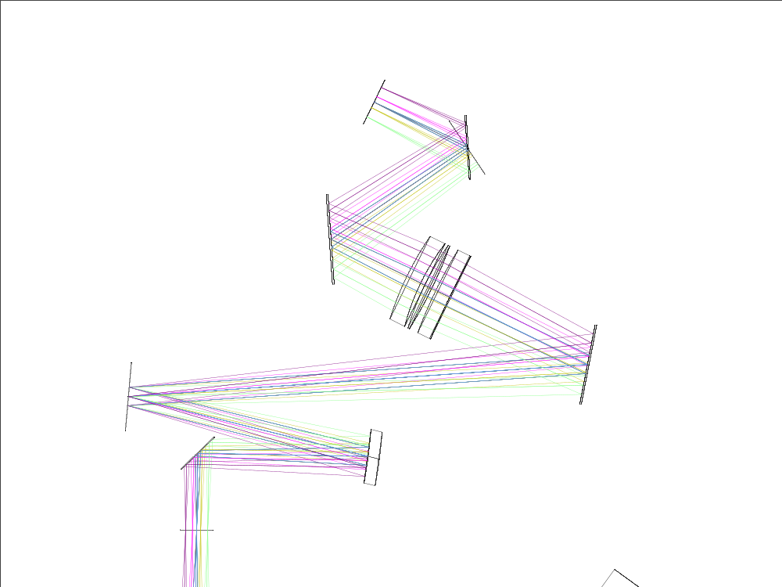
- Focusing element is a BASF2-N15-BASF2 triplet.
- f/# - 20.012
- Plate scale = 1.063 mm/”
Figure 5 - - NGSWFS feed from the AO relay showing the dichroic pick-off in collimated space. The beam path shows beam coming in from the bottom with OAP3, HODM, a fold mirror followed by the triplet focusing lens and the two FSM’s before the NGSWFS focus.
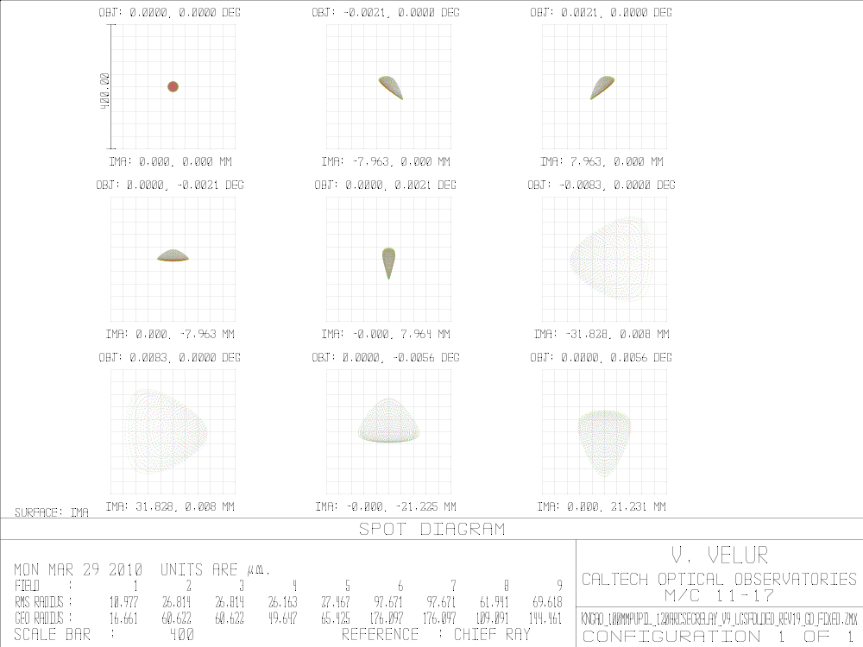
Figure 6 Spot diagram at the NGSWFS pick off focus showing 97 um RMS(worst case) radius spots at a focal plane with 1.06 mm/” plate scale.
  - Input optical aberrations from the NGAO optical relay
The wavefront delivered by the NGAO NGSWFS feed has 1.15 waves (6 waves P-P) @ 600 nm aberration at the extreme field points. The error is largely due to astigmatism resulting from the absence of an OAP to balance the aberrations created by OAP3 in the NGSWFS path. Section 4.1 in KAON 692 shows the analysis performed for the LGSWFS to understand the effect of having 150-200 mas RMS spot radii at the LGSWFS optical feed. The analysis looks at the sub-aperture level effect of having these larger spots by simulating extreme apertures at the Keck primary mirror in Zemax and looking at the focus at the WFS input. The analysis revealed worst case blur of >6um for the LGSWFS case. For the NGSWFS, we estimate a blur of 2um with is small compared to the 4 mm (4”) FoV of the sensor.
  - The effect of atmospheric dispersion
To understand the implication of excluding an ADC in the NGSWFS path we look at the effect of atmospheric dispersion on the NGSWFS. Figure 8 shows the results of this analysis; at 45 degrees from the zenith the effect of atmospheric dispersion is to create a spot that is 0.19” [as opposed to 10 mas (RMS) nominal spot with a ADC]. The atmospheric dispersion goes up to 320 mas at 60 degrees zenith angle. The 0.2” is accounted for in evaluating the spot size at the NGSWFS focal plane.
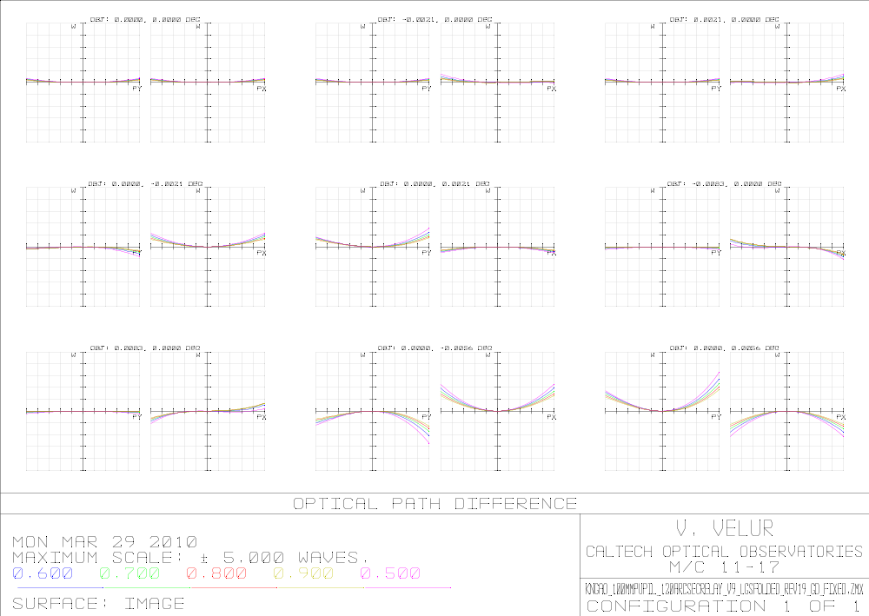
Figure 7 OPD’s at the NGSWFS pick off focal plane
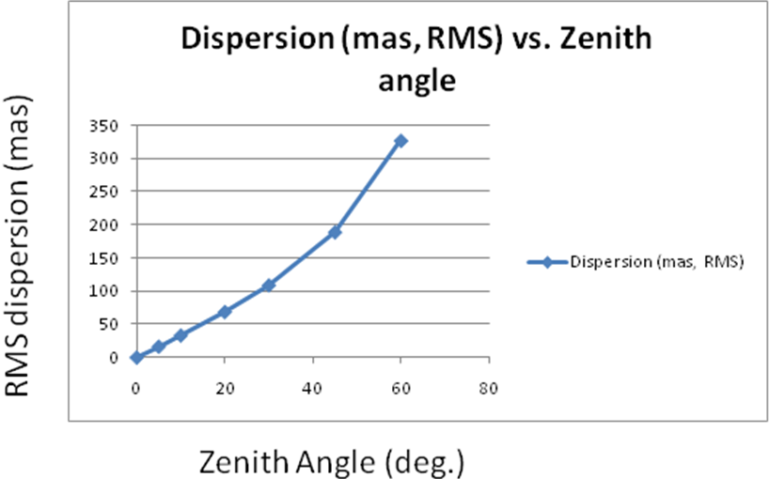
Figure 8 - Variation of atmospheric dispersion between 500-900 nm in RMS mas with zenith angle
  - Static aberration within the NGSWFS
The geometric spot size at the relay (RMS) is given by Error budget allocation (asec in FWHM)/2.355 (FWHM/RMS) * 21 (um/pixel) /(1asec/pixel). The NGSWFS relay design yields a 3um (RMS) spot leading to an error budget allocation of 0.33 asec instead of 0.25 asec. This leads to a 6% increase in apparent spot size at the detector which is taken into account in apparent spot size calculation and plate scale selection. It is to be noted that NGAO will primarily operate in LGS mode and will use NGSWFS for mostly bright objects (Mv>8) wherein atmospheric fitting error and not measurement error dominates the error budget by ~2X. The NGSWFS team did design an alternate WFS relay with a extra field-flattening optic that delivered better than 0.25 um (RMS) spots. The NGSWFS team chose the simpler design without the field flattener for better transmission. There was negligible change in the overall error from this choice based on analytical error budget model that NGAO uses.

Seeing |  |  |  |  | Seeing
Natural seeing FWHM at GS wavelength | 0.43 | arcsec |  |  | Natural seeing FWHM at GS wavelength | 0.43 | arcsec
Subaperture Tip/Tilt corrected FWHM | 0.20 | arcsec |  |  | Subaperture Tip/Tilt corrected FWHM | 0.20 | arcsec
AO-compensated FWHM | 0.06 | arcsec |  |  | AO-compensated FWHM | 0.06 | arcsec
Contribution due to seeing | 0.20 | arcsec |  |  | Contribution due to seeing | 0.20 | arcsec
System Aberrations |  |  |  |  | System Aberrations
Aberrations in AO thru to WFS | 0.25 | arcsec |  |  | Aberrations in AO thru to WFS | 0.40 | arcsec
Atmospheric Dispersion |  |  |  |  | Atmospheric Dispersion
ADC in HOWFS? (NO) |  |  |  |  | ADC in HOWFS? (NO)
RMS blurring due to atmospheric dispersion | 0.109 | arcsec |  |  | RMS blurring due to atmospheric dispersion | 0.109 | arcsec
Total size of detected return beam: | 0.34 | arcsec |  |  | Total size of detected return beam: | 0.34 | arcsec
Charge Diffusion |  |  |  |  | Charge Diffusion
Charge Diffusion | 0.25 | pixels |  |  | Charge Diffusion | 0.25 | pixels
Contribution due to Charge Diffusion | 0.40 | arcsec |  |  | Contribution due to Charge Diffusion | 0.40 | arcsec
Subaperture Diffraction |  |  |  |  | Subaperture Diffraction
Lambda/d (for sensing) | 0.83 | arcsec |  |  | Lambda/d (for sensing) | 0.83 | arcsec
Spot size used for centroiding | 0.99 | arcsec |  |  | Spot size used for centroiding | 1.05 | arcsec
Table 2 - Spot size estimation for centroiding showing the effect of WFS static aberrations being slightly higher than the specification being marginal.
  - Results of the analysis:
In summary, the wavefront error from the NGAO relay at the NGSWFS input is 1.15 waves (RMS) of WFE at the worst field point. This is mostly astigmatism and has the effect of blurring the sub-aperture spots of the high order sensor by about 2 um (RMS). So this has neglible impact on the spot-size and performance of the sensor. Acceptable centroid offsets (<0.1 pixel worst case) are obtained with the design that has a dynamic range of +/- 2 asec. The effect of atmospheric dispersion has been evaluated and included in apparent spot size calculation and plate scale selection. The WFS relay is slightly out-of-spec and we have requested a change of requirements rather than add an extra optic in the WFS relay as this has negligible impact on the performance of the NGAO system operating in NGS mode.
- WFS design
  - Design parameters
Table 3 shows the design parameters that drive the design of the NGSWFS. The input plate scale, which is determined by the design of the triplet that feeds the NGSWFS, is primarily set by packaging constraints and the ease of WFS design. We intend to use identical camera units for all the visible WFS’s with 256x256 pixels that can be read out at 2KHz.

Modes of operation
The NGSWFS operates in 63x63 sub-aperture mode (with 59 x 59 sub-apertures lit at any time), 5x5 mode and pupil imaging mode. We use 4 physical pixels per sub-aperture which can be binned on chip and read as 2x2 pixels per sub-aperture with almost zero read noise penalty. This gives us the flexibility of 2 modes, one with high linearity and another with lower read noise and better sensitivity. To simplify the design, size and number of moving parts while facilitating the two pupil sampling modes, we use the same collimator and post-lenslet relay for both the 63 and 5 sub-ap mode of operation. The NGSWFS also operates in pupil imaging mode.

Parameter | 59x59 mode | 5x5 mode | Units
f_collimator | 60 | 60 | Mm
Input plate scale | 1.0623 | 1.0623 | mm/"
Binned pixel size (# of pixels) | 1 | 12 | Pixels
Detector plate scale (mm/") | 0.021 | 0.252 | mm/"
Plate scale ratio (IPS/DPS) | 50.58 | 4.22
input f/# | 19.06 | 19.06
pupil sampling | 63 | 5 | sub-aps across pupil
d_lenslet | 0.05 | 0.6 | Mm
de-magnification (m) | 1.68 | 1.68
f_lenslet | 0.71 | 8.47 | Mm
f# lenslet | 14.12 | 14.12
wavelength (for worst case FN calc.) | 0.9 | 0.9 | Um
fresnel # | 0.98 | 11.8
radius of curvature of lenslet | 0.36 | 4.38 | Mm
Table 3 - NGSWFS design parameters
  - 63x63 sensor and 5x5 sensor
The optical layouts of the NGSWFS operating in 63x63, 5x5 and pupil-imaging of operation are shown in Figure 9, Figure 10 and Figure 11. The WFS is ~27 cm in length so as to accommodate alignment and motion control. The wavefront sensor works in visible wavelenghts using light from 500-900 nm. The components in the WFS consist of a collimating doublet, a lenslet array, field lens and a focusing doublet followed by the detector window and the CCD. The spot diagrams from the optical design from the WFS operating in 63x63 and 5x5 modes are shown in Figure 12 and Figure 13.

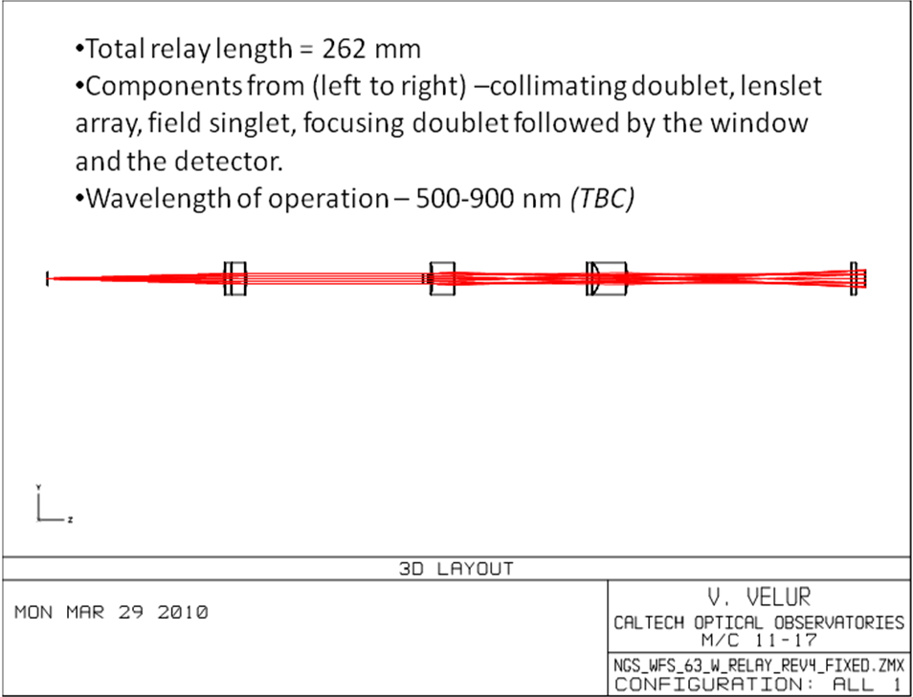
Figure 9 - Optical layout of a 63x63 NGSWFS

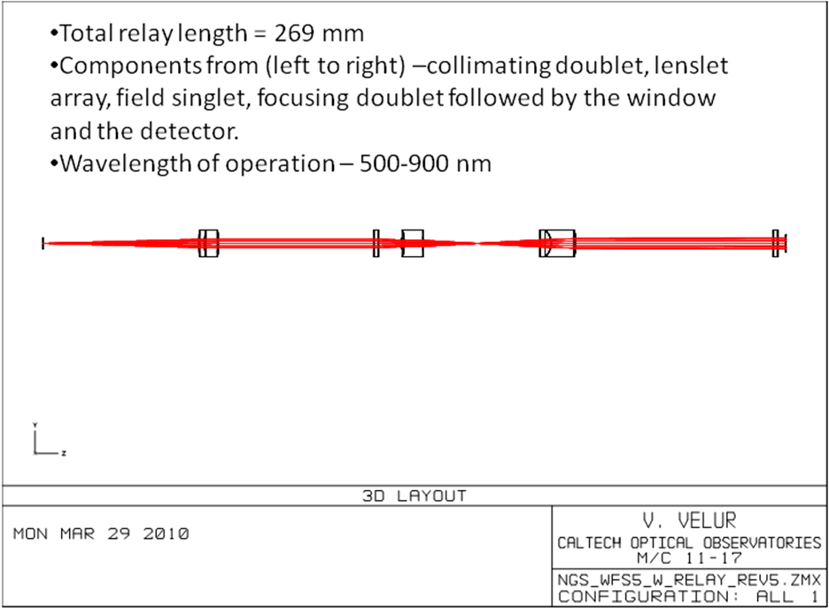
Figure 10 - Optical layout of the NGSWFS in 5x5 mode
All three modes of operation of the NGSWFS use the same collimator, the post-lenslet relay and the detector. The post-lenslet relay and the camera are co-mounted on a translation to be able to remain in focus when working in all three modes of operation. Figure 14 shows a solid-model of the WFS with the various stages. There are 2 lenslets mounted on a XY translation stage to facilitate 5x5 and 63x63 sub-apertures imaged onto the detector. In the pupil imaging mode, the post-lenslet relay images the pupil directly instead of the focal spots created by the lenslet. The Science Instrument is a large body with no focus control, it needs to operate with and without an ADC located after the NGSWFS pick-off and hence the telescope focus is used to keep the Science Instrument in focus in both modes. The NGS WFS also operates with the interferometer, this mode also shifts the focus of the sensor due to the introduction of a pick-off dichroic. Both these effects necessitate a translation stage to keep the NGSWFS in focus.

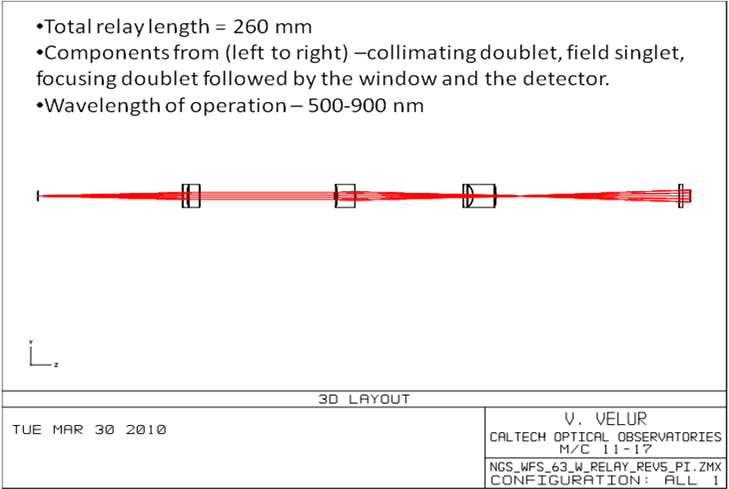
Figure 11 - Optical layout of the NGSWFS in pupil imaging mode.
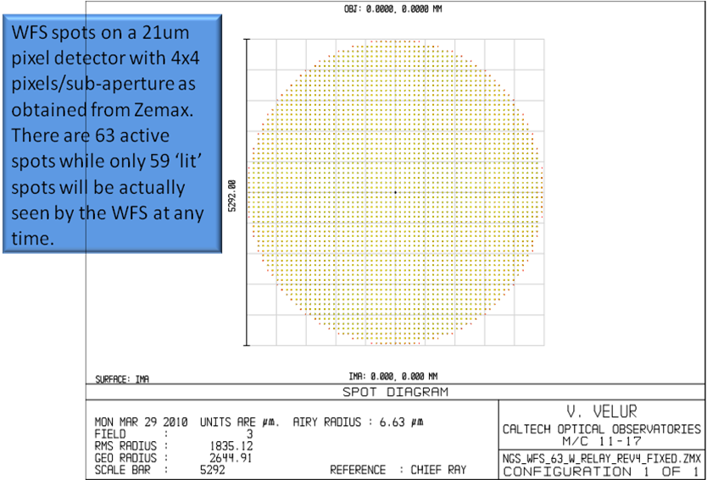
Figure 12 - Spot diagram of the NGSWFS running in 63x63 mode

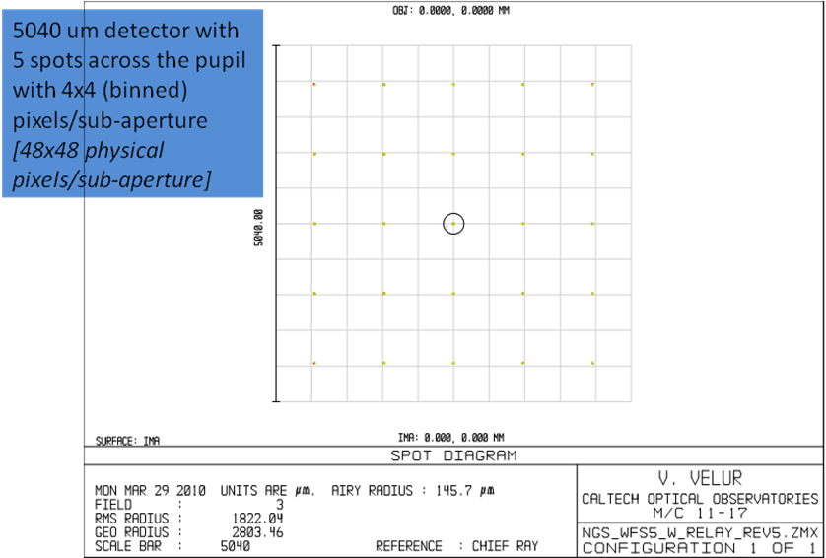
Figure 13 -Spot diagram from the NGSWFS running in 5x5 mode
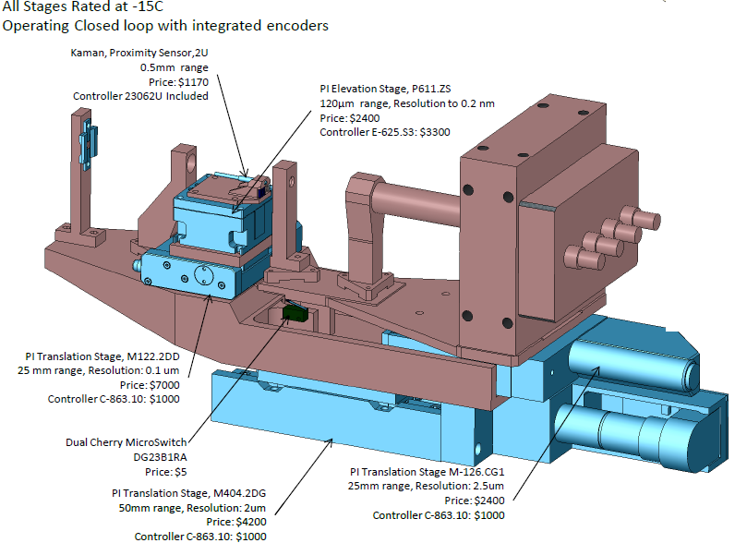
Figure 14 - NGS WFS showing all the motion control mechanisms [See Table 4 for more details on the motion control mechanisms].

  - WFS post-lenslet relay
The post-lenslet relay is a custom relay with a singlet field lens and a focusing doublet designed to keep the WFS short in length while providing WFS spots at the detector with good optical quality. The relay maps the WFS spots to the detector with a magnification of 1.68. The relay layout is shown in Figure 15and the spot diagrams from the relay are shown in Figure 16. The spots indicate 3 um (RMS) geometric spot size due to geometrical aberrations and strehls as high as 97% at the worst case field point. The grid distortion from the relay is 0.08% which leads to a grid-distortion of 0.1 pixels worst case, this can be split between the extreme sub-apertures to halve the distortion.
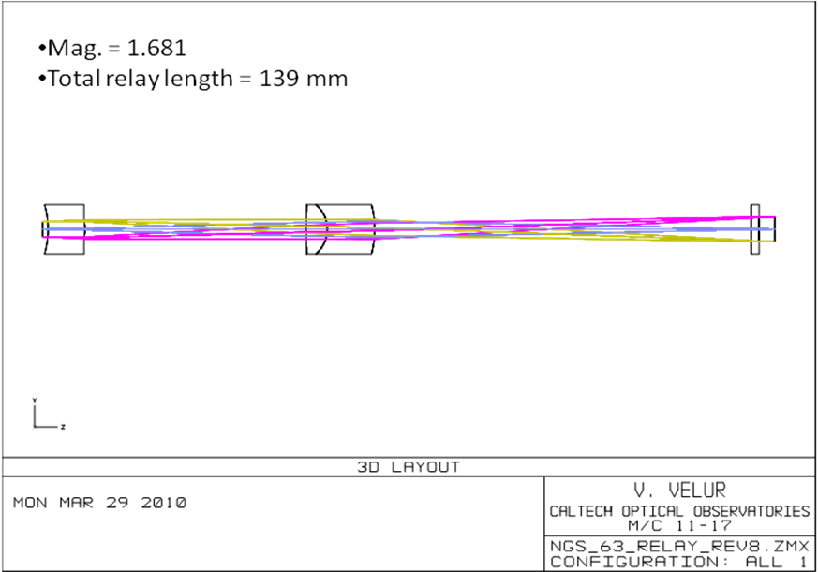
Figure 15 - NGSWFS post-lenslet relay
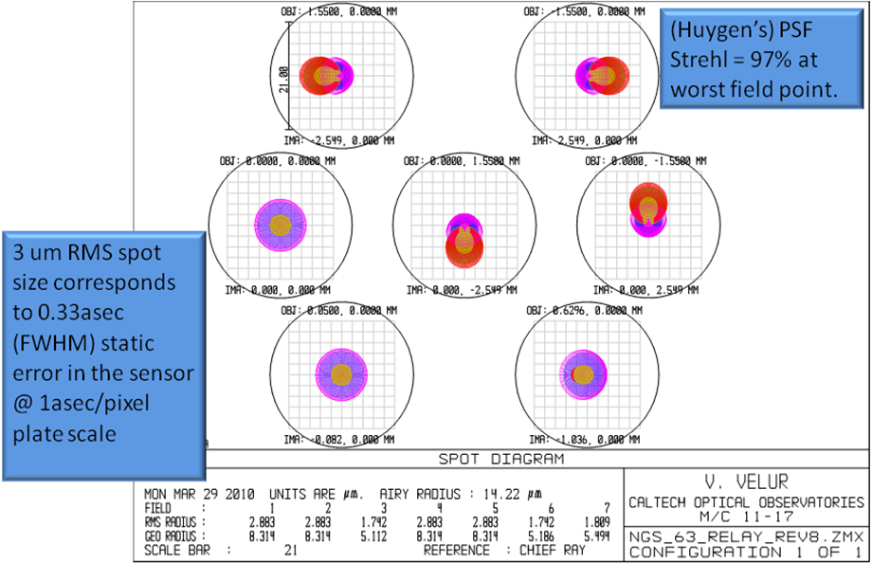
Figure 16 - Spots generated by post-lenslet relay.

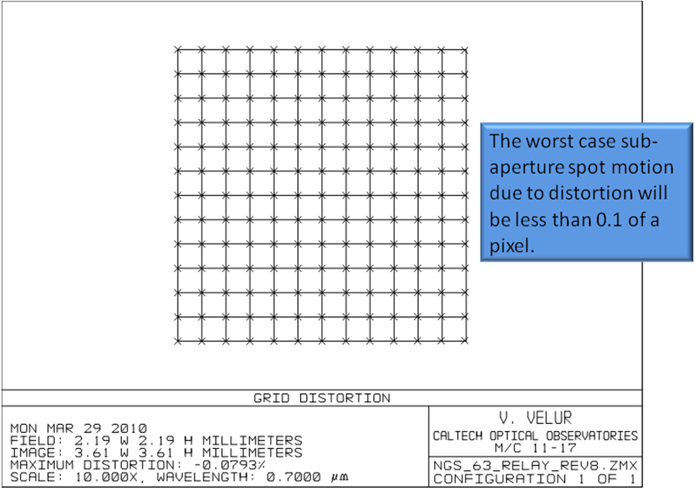
Figure 17 - Grid distortion of the post-lenslet relay

  - NGSWFS located behind the AO relay:
We positioned the NGSWFS behind the AO relay in Zemax and ensured that the spots generated lit the central 59x59 sub-apertures as shown in Figure 19. We also checked the magnification (spot separation) of the WFS spots, this is shown in Figure 20.
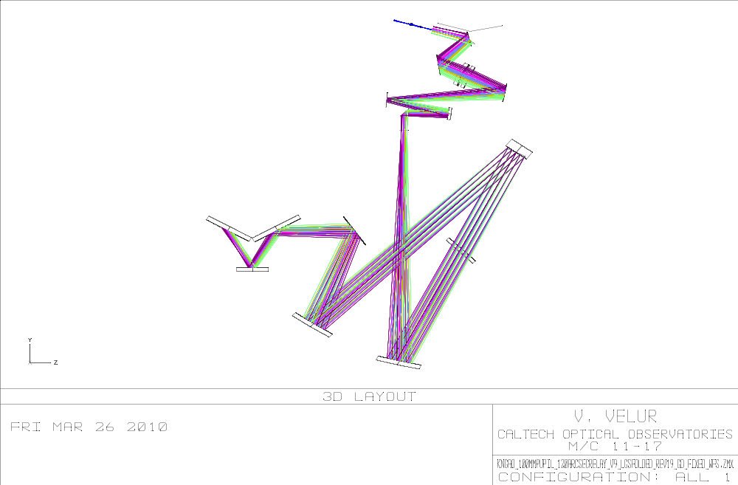
Figure 18 - NGSWFS behind the NGAO optical relay.
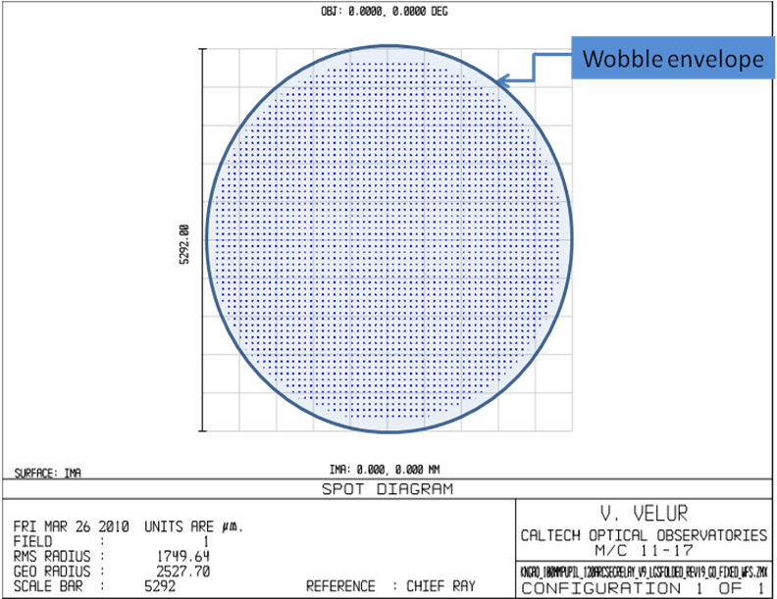
Figure 19 - NGSWFS spot diagram when it is located behind the NGAO optical relay with 59x59 lit sub-apertures. The blue circle indicates the envelope over which the WFS spots nutate due to motion of the whole primary mirro structure.

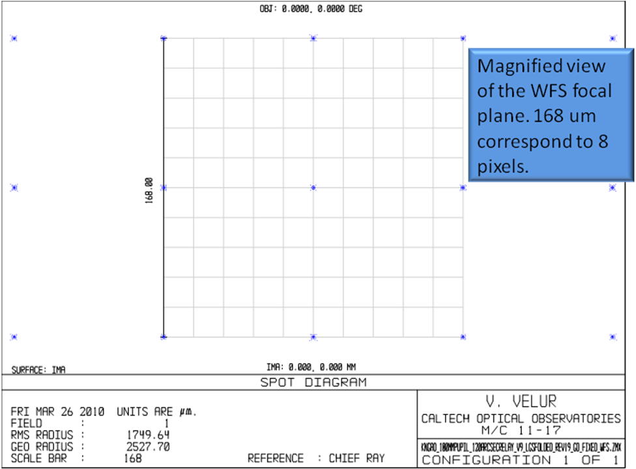
Figure 20 - Shows the spot separation of the NGS WFS operating in 59x59 sub-aperture mode.

- Pupil imaging mode:
The NGSWFS has a pupil imaging mode to facilitate alignment and calibration of the NGAO optical relay. Figure 21 and Figure 22 show this mode of operation.
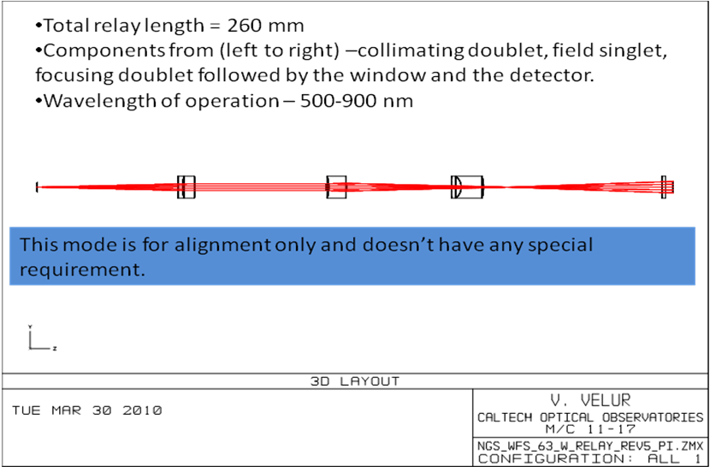
Figure 21 - NGSWFS running in pupil imaging mode with no lenslet in the beam.
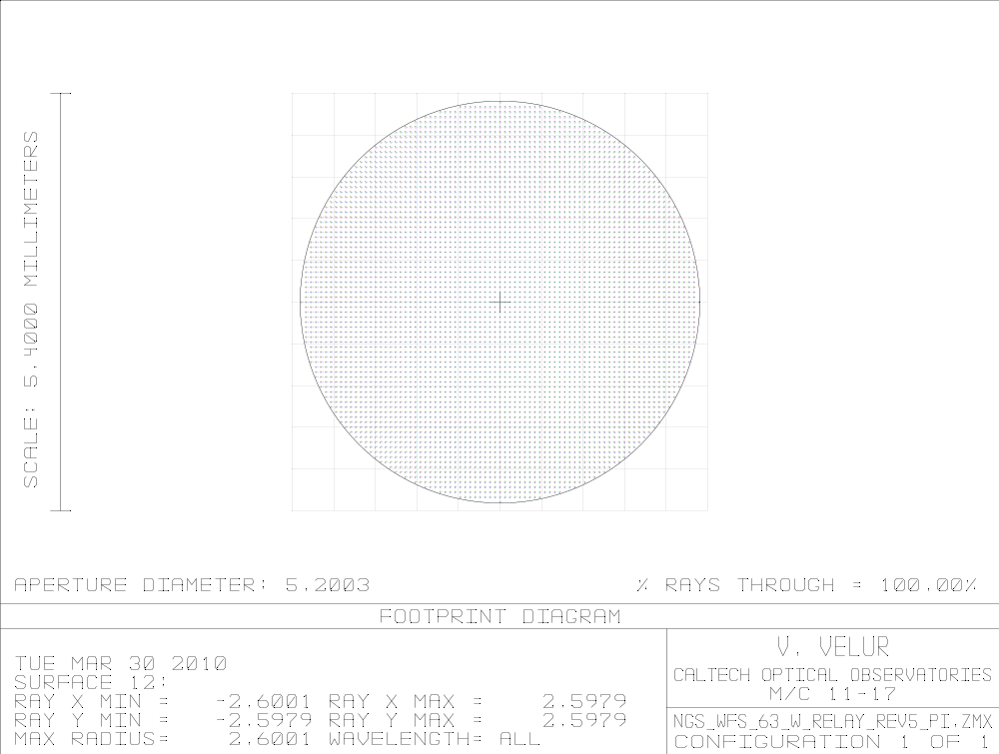
Figure 22 - Pupil imaged onto the detector. The pupil is resolved by ~256 pixels.

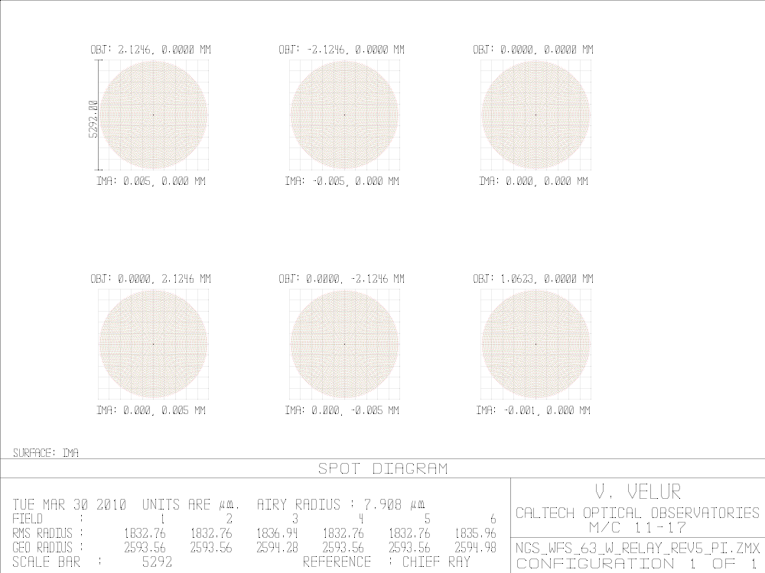

Preliminary tolerance analysis
Preliminary tolerance analysis was performed on the optical design using Zemax’s built in tolerancing in the optical design software and TEZI. Since, Zemax’s tools don’t work reliably when a lenslet in located in an optical relay, we tolerance the system as two separate systems default tolerance values in Zemax (0.2 mm tolerance on radius of curvature of the optics, 0.2 mm on thickness, 0.2 mm on X and Y decenter with 0.2 mm on tilt in X and Y) with no remarkable change in WFS performance when a Monte-Carlo based tolerancing analysis was run. We know that we can position our optics to 5X-10X better accurately as the tolerance settings using existing equipment. We intend to perform a thorough tolerance analysis in the next phase of the project.

Location of the WFS and Mechanical Model
The mechanical design of the WFS is as shown in Figure 2. Due to severe packaging constraints and for the stability of the sensor, it is located very close to the NGAO optical bench, below the nominal mechanical axis optics in the NGAO relay. The Field Steering Mirrors (FSM’s) are located at two different heights to be able to achieve this (c.f. Figure 23). This creates a known rotation in the mapping of the lenslet and the DM actuators, we can take this out be de-rotating the lenslets and the detector.
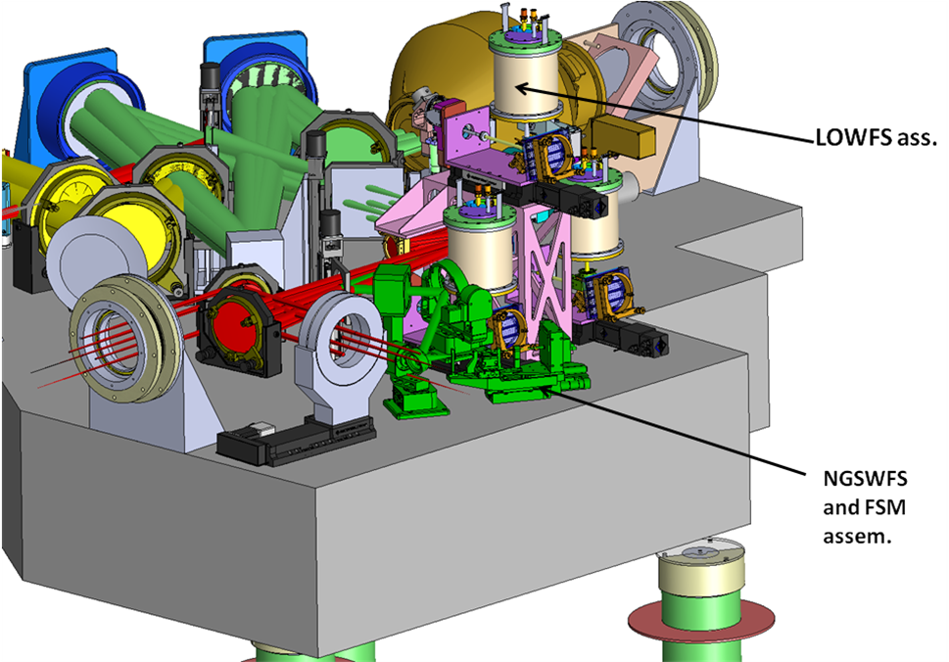
Figure 23- The NGAO relay with the various components. The bright green components show the NGSWFS assembly consisting of the triplet, the FSM’s, and the WFS.
Figure 24 shows the NGSWFS assembly in plan-view, the light from the HODM (located near the top-center of the figure) is picked off by a dichoric in collimated space and focused using a custom triplet. The beam is then folded down using Newmark Systems’ part # GMC-6 and a custom gimbal mirrors. These mirrors are motorized to be able to pick any point on the 60x40” field of regard of the NGSWFS with a repeatability of 5” and a resolution of 0.3”. The gimbal mounts continuous 360 deg. rotation capability with hard limit switches that can limit the range of tip and tilt. Table 4 lists the motion control in the NGSWFS assembly along with part #, vendor name and relevant specification. The NGSWFS team has ensured that these components work at -15 deg.C and that these meet the motion control requirements. The NGAO motion control team (Tsubota, Wetherell) has identified a couple of stages/ controllers that may need additional software effort, we intend to work with the motion-control team in the next phase of the project to identify alternate stages to make software integration of the NGSWFS easier. The air-spaced triplet will be mounted with carbon-fiber or invar spacers with delrin washers on either ends to secure the optics in its holder.
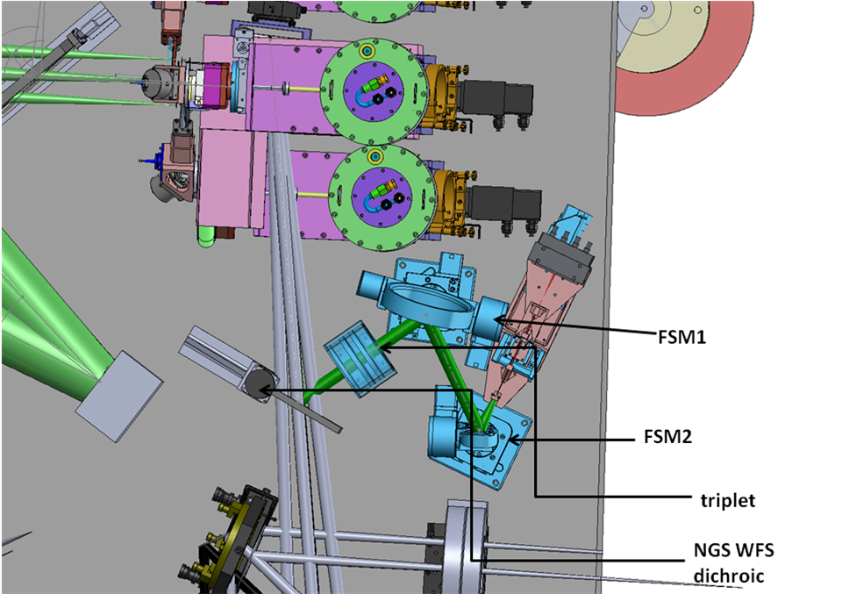
Figure 24 - NGSWFS assembly plan view

NGS WFS mechanical design
All the mounts on the NGSWFS will be located with nudgers and Faro co-ordinate measuring machine in conjunction with an alignment telescope based optical reference. The structural components are all made out of aluminum and the assembly has few adjustments so as to ensure minimal # of fasters to aid in cooling and warming up of the NGAO enclosure. All the baseplates are light-weighted and preliminary FEA analysis show worst-case deflections of the order of 4 um (max) of static deflection. The NGSWFS will procure glass (Fused Silica) lenslets and mount them using proven techniques. We will use a Lytron cold plate with re-circulating glycol to keep the heat generated by the camera to a minimum. The NGSWFS has a square field stop that is 4” on edge.

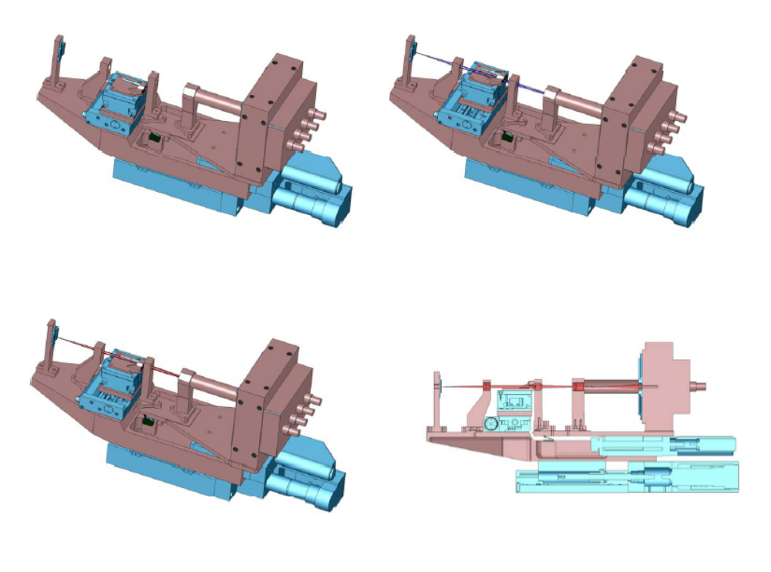
Figure 25 - NGSWFS operating in pupil imaging (top left), 5x5 (top right) and 63x63 (bottom left) modes. The bottom right figure shows a cross section of the sensor

Motion control
The NGSWFS mechanical design uses motion control stages that are commercial. We use a PI M122.2DD for lenslet X translation, PI’s 611.ZS pedestal stage for lenslet Y positioning. Since the optical design uses a field lens that is close to the lenslet, we have a hardware collision avoidance system with a Kaman #2U proximity sensor that prevents collision between the lenslet and the field lens due to motion of the focus stage that holds the post-lenslet relay and the camera. The proximity sensor diables the post-lenslet relay focus stage if it gets too close to the lenslet array holder. We also use Digikey DG23B1RA limit switch to avoid collision between the field lens and the lenslet holder due to X motion of the lenslet stage during pupil imaging mode. The limit switch disables the X lenslet translation when activated, so the focus stage has to move back before the lenslet can be brought back to operate the sensor in 5x5 or 59x59 sub-aperture wavefront sensing mode. We use a PI 404.2DG stage to move the whole NGSWFS (collimator, lenslet arrays, post-lenslet relay and camera with associated translation stages) to allow for NGS WF sensing with and without science ADC and in interferometry mode.
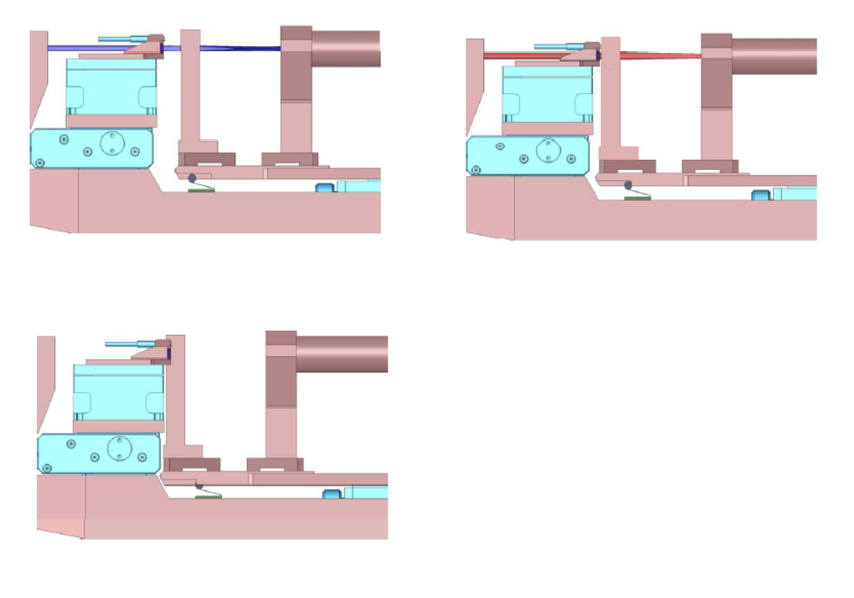
Figure 26 - NGSWFS collision avoidance system. Top left shows both the proximity sensor and the limit switch not activated. Top right shows the proximity switch activated (hence disabling the post-lenslet relay focus stage) when the field lens gets too close to the lenslet. Bottom right shows the limit switch activated in pupil imaging mode hence de-activating the lenslet X stage.
Summary
We have a opto-mechanical design that is based on previous sky-tested concepts and complies with all the requirements and fits into the NGAO package with all the motion control required. All except one stage are commercial and come with controllers that can be easily used to assemble and test the equipment at a partner institution.

- Pupil mapping analysis:
We modeled the mapping of HODM actuators onto the lenslet by imaging the HODM actuators onto the lenslet via the triplet to understand distortion and blurring in actuator-to-lenslet mapping. The layout for this analysis is shown in Figure 27 and the results are shown in Figure 28 and Figure 29. We note that the distortion in mapping of actuators to lenslets is <2% at the extreme sub-apertures. Actuators modeled as points are imaged as blobs that are lesser than 4 um RMS dia. blobs . Chromatic effects make this blob as big as 12um. One needs to compare this effect with the size of the influence function, this will be done in the next phase of the project along with modeling chromatic effects all the way from the field points on the primary mirror with entrance window, LGS dichroic, w/ and w/o IF dichroic in the optical relay to the WFS lenslet and compare the same with the actuator influence function.
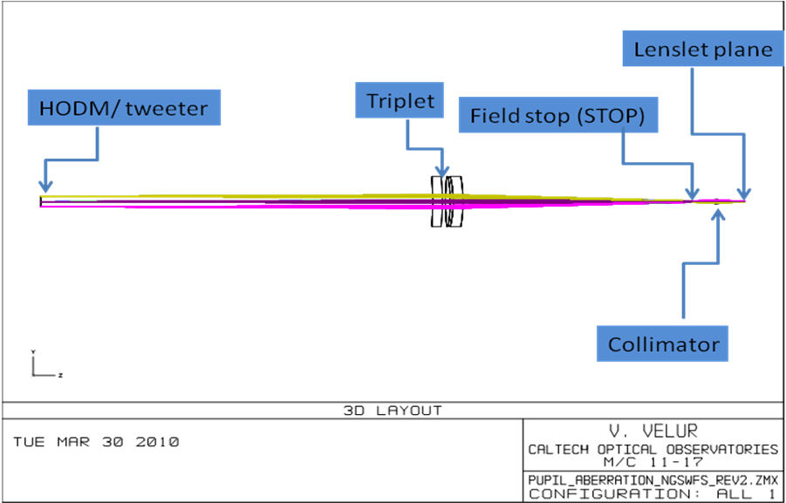
Figure 27 - Showing the mapping of HODM acutators onto the NGSWFS lenslet.
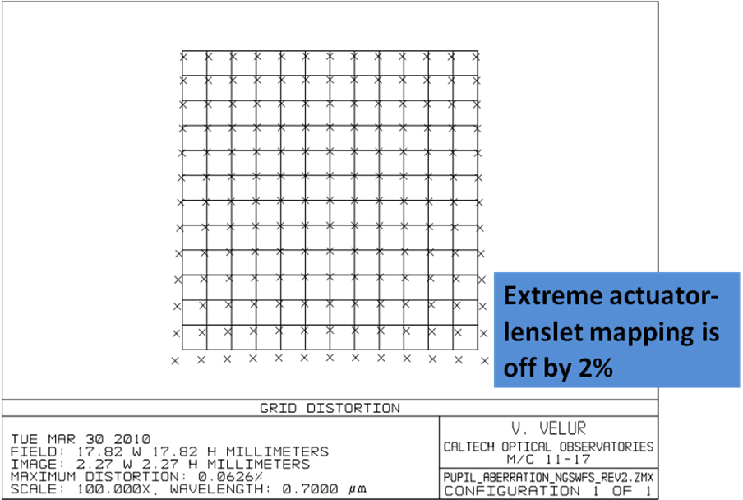
Figure 28 - distortion of the HODM actuator to lenslet mapping

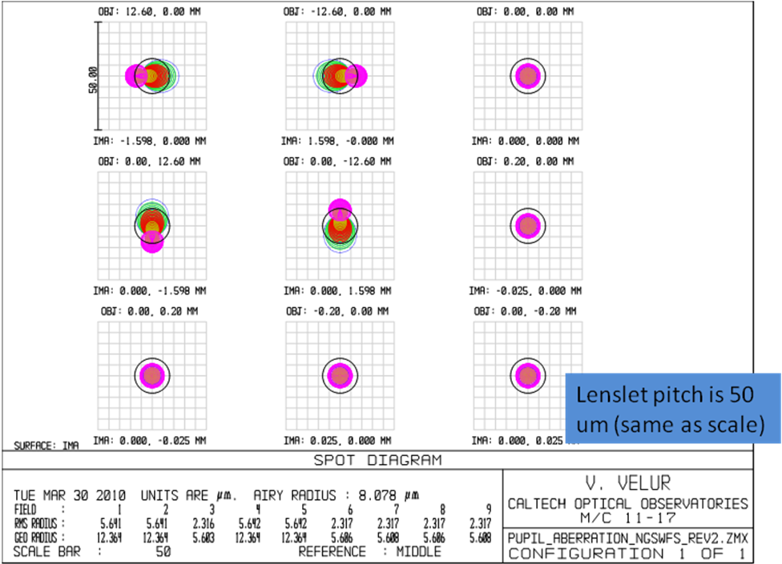
Figure 29 - Spot diagrams indicating chromatic effects of mapping HODM actuators onto the WFS lenslet.

Component(s) | Vendor | Part Number | Purpose | Range | Min. inc. motion (resolution)
FSM1 | Newmark | GMC-6 | Needed to guide star-light from the 60x40" FoR into the WFS | 26 deg Az & Horiz | (0.29 " res)
FSM2 | Newmark | Custom | Needed to guide star-light from the 60x40" FoR into the WFS | 26 deg Az & Horiz | (0.36" res)
Lenslet Translation Stage | PI | M122.2DD | To support 5x5 and 63x63 pupil sampling and pupil imaging modes | 25mm | 0.1 um (0.1 um)
Lenslet Elevation Stage | PI | P611.ZS | To support 5x5 and 63x63 pupil sampling and pupil imaging modes | 120um | 0.1 um (0.2 nm)
Lenslet Proximity sensor | Kaman | 2U | This is to avoid collisions when switching from pupil imaging mode to WFS mode when the order of camera focus and lenslet move is not followed | 0.5mm | (TBC)
Camera Translation Stage | PI | M-126.CG1 | To image the focal spots created by the lenslet or the pupil onto the detector | 25mm | 0.2 um (2.5 um res)
Limit switch | Digikey | DG23B1RA | Hard control to limit the motion range of the lenslet stage | N/A | N/A
Focus translation stage | PI | M404.2DG | the WFS must work with and without the IF dichoric and with and without the IR ADC’s in the science path (the telescope is refocused when ADC is in or out as the science instruments don’t have a focus mechanism) | 50mm | 0.2 um (2 um res)
Table 4Motion control and corresponding components in the NGSWFS assembly (including the FSM's).

- Summary of work done by NGS WFS design team
- Contributed to systems engineering and requirements ratification process
- Designed a NGS feed using a refractive triplet to solve NGAO’s packaging problem while delivering a f/20 beam to the NGS sensor and analyzed its performance
- Designed a compact WFS that works in 63x63, 5x5 and pupil imaging modes.
- Quantified the effects of color and distortion in mapping the HODM pupil to the lenslet.
- Did very preliminary tolerancing for the WFS.
- Made a list of outstanding issues and analysis for the DD phase.
- Built a compliance matrix and risk register.

Requirement compliance and Risk summary
Likelihood
Likelihood |  | FR-3239
Likelihood |  | FR-3280 | FR199, FR142 | FR-149
Likelihood |  |  | FR138 | FR-3279
 | Severity
Table 5 - Risk register for the NGSWFS assembly.
Short Name | ID | Description
Non-Operational Environment | FR-3239 | The NGS WFS shall meet all its performance requirements, while subjected to the non-operating environment conditions given in SR-250.
Static calibration errors (NGS WFS) | FR-138 | The maximum allowable static wavefront calibration error in the NGS WFS shall be 25 nm RMS.
Athermalization | FR-199 | The NGS WFS shall be able to satisfy its optical requirements at both cooled (-15 C) and ambient temperatures (2 C).
NGS WFS Positioning - time to acquire target | FR-142 | The NGS WFS shall be able to pick off a star in its field and guide on it in 14 sec by positioning the sensor.
NGS WFS Positioning - accuracy | FR-3279 | The accuracy of the mechanisms shall position the NGS WFS to 5% of the finest sub-aperture plate scale.
NGS WFS Positioning - on chip dithers | FR-3280 | NGS WFS mechanisms shall facilitate science dithers as small as 5 milli-arcsec.
CCD requirements (NGS WFS) | FR-149 | NGS WFS CCD shall meet the following specifications: dark current < 0.01 e-/sec/pixel at -40C, read noise < 2 e-/pixel/read at 500 fps.
Table 6 - List of requirements that appear in the risk register

Table 5.3, Pg. 149, Astronomical Adaptive Optics, Hardy
Face-to-face meeting at Caltech, 2/17 - 2/18 2010.
http://www.oir.caltech.edu/twiki_oir/bin/view/Keck/NGAO/100218Designs
NGAO Opto-mech meeting minutes (Mar. 16th 2010)
http://ao.jpl.nasa.gov/Palao/Publications/Technical/Multiple_guide_star_tomography_demonstration_at_Palomar.pdf

