 Keck Adaptive Optics Note 637

Keck Next Generation Adaptive Optics
Preliminary Design Phase Project Report #9

P. Wizinowich, the NGAO Team, and Sean Adkins
February 23, 2009

Narrative

This report is the ninth monthly project report for the Preliminary Design (PD) phase in the development of the W. M. Keck Observatory’s (WMKO) Next Generation Adaptive Optics (NGAO) facility. This report covers the PD phase work performed in January 2009.

Summary
Management efforts have continued to involve activities related to the design and build to cost requirement, and collaboration on laser preliminary designs. An MRI proposal for a new center launch telescope for the guide star laser used with the Keck II AO system and also suitable for use with NGAO was submitted in January.

Management Status
The PD phase plan presented at the SDR included work under the following management WBS elements through January. The progress in each of these areas is discussed below.

WBS 1.3.2.1 Planning
A draft build-to-cost presentation for the build-to-cost concept review was prepared. A second build-to-cost team meeting to review and recommend cost savings items has been scheduled for February 5.

The build-to-cost concept review will be held March 18 near the LA airport. The reviewers will be Brent Ellerbroek, Mike Liu and Jerry Nelson. The directors will also attend (or have a representative).

WBS 1.3.2.2 Project Management and Meetings
Alex Delacroix joined Caltech as a mechanical engineer and began working on the NGAO wavefront sensor designs.

Two phone interviews for the open AO scientist position were held in January. WMKO management determined that we cannot currently proceed with advertising for an AO post doctoral researcher to work on PSF reconstruction.

WBS 1.3.2.4 Proposals
An MRI proposal titled “Development of an Improved Keck II Laser Launch Facility – Enhancing the Scientific Return of Keck LGS AO” was submitted on January 22. The project team includes Wizinowich (PI), Mike Liu (Project Scientist), Andrea Ghez and Claire Max (Scientific Collaborators), Jason Chin (Project Manager) and Thomas Stalcup (Systems Engineer). The major cost item, the launch telescope, and part of the beam transport system is intended to be reused for NGAO.

WBS 1.3.2.5 Programmatic Risk Assessment and Mitigation
The $300k AURA sub-award to WMKO in support of the laser preliminary designs was finalized. Draft request for quote letters, a statement of work and an MOU were prepared for review. A request for quote package will be sent to the vendors (~ February 19) as soon as ESO notifies them of their preliminary design awards.

Technical Status
The PD phase plan presented at the SDR included work under the following technical WBS elements in January. The progress in each of these areas is discussed below.

A systems engineering core group has been set-up and began meeting bi-weekly. The first topics being addressed include the functional requirements and interfaces.

WBS 1.3.3.1 Science Case Requirements
In January, we worked on re-developing the observing scenario for the Galaxy Assembly Key Science Driver for the cases of (1) a new single (fixed) near-IR IFS, or (2) a new single channel (deployable) IFS used in conjunction with OSIRIS on-axis. We also provided input to the Observing Operations Concept Document (OOCD) in a more general sense, including what planning and observing tools will be required, as well as the most efficient way to perform certain observations and observing sequences. We have also been evaluating the science impact of changes to the baseline (SDR) design that have been proposed in order to meet the cost cap.

Next month we will focus on further evaluating the science impact of design changes required to meet our build-to-cost mandate, including looking into whether a new fixed IFS can provide the science capability we need to satisfy a range of science cases without simultaneously supporting OSIRIS for use with NGAO. We will also work on the nearby AGN observing scenario and will provide additional comments and input to the latest version of the OOCD.

WBS 1.3.3.2 Requirements
Franck Marchis visited WMKO from January 19 to February 6 to work with us on the OOCD. A telecon was held the week before his arrival to define actions items, check on progress and answer questions. Franck plans to continue to work with us on this document after his return to California.

Good progress was made on defining a process for requirements and interface review and change. This will be documented as a KAON in February.

WBS 1.3.3.3 Systems Engineering Analysis
The tip-tilt sharpening study report has been posted as KAON 635. The study gives results for the expected tomography error when deployable point and shoot beacons are used, or aren’t used, as part of the tomography solution.

WBS 1.3.3.4 System Architecture
Additional work has been performed to understand the impact of reduced laser power as part of our build-to-cost analysis.

Progress continues to be made on the software and control systems architecture options. Testing of the middleware software options awaits the procurement of new computers. A draft motion control architecture options trade study document is nearly ready to be distributed for comment.

WBS 1.3.3.5 External Interface & 1.3.3.6 Internal Interface Control
A methodology has been developed for integrating interface information into the requirements database.

WBS 1.3.3.9 Technical Risk Assessment and Mitigation
The TMT MASS/DIMM equipment was shipped to CFHT on January 30.

WBS 1.3.4.2.3 Optical Relays
Several new optical configurations suggested under the build-to-cost exercise have been carried forward for information gathering purposes, including the one and two-tiered cascaded relays, with two different options for the switchyard. We are endeavoring to provide reasonably supported performance versus cost information to help guide upcoming cost reduction decisions. As of the end of January:
- Both relays now have performance-optimized Zemax designs published on the Twiki site
- Most of the dichroic costs information relevant to the decker mechanism switchyard option is now in.
- Work has begun on the assignment of instrument and LOWFS volumes in the pickoff-switchyard configuration
- Some early information has been collected from multiple vendors on the difficulty and expense of tip/tilt stages for the DMs in both the first and second relays.
- A preliminary mechanical layout for the two-tier cascade relay architecture with pickoff switchyard has been produced. A one-tier version of this is underway.
- Significant progress has been made on designing the ADCs for the LOWFS.
- The relay configurations for both 100 mm and 140 mm options are still on the table even though the meeting of December 19 nominally established the 140 mm as the move-ahead design. The issues remaining are: 1) having to purchase the 140 mm DM because the present AO system’s DM is probably unsuitable, 2) requirements on the tip/tilt stage and whether this stage needs to handle full tip/tilt bandwidth or be a low frequency tip/tilt “woofer” in conjunction with a “tweeter” tip/tilt stage in the second relay, and 3) (this is new) the single-tier option might force a specialized mechanism to hold the large K-mirror derotator stage, which adds additional mechanical design/construction expense to this option, whereas the two-tier design has this already taken care of (the K-mirror is supported by the second tier). This investigation (140 mm single tier vs. 100 mm two-tier) is ongoing and we expect a final evaluation with suggested solution in mid-February.
- The option of a single high-order relay design without cooling has been evaluated. This exercise has highlighted our need to understand the achievable 589 nm optical throughput of window coatings. A PowerPoint memo was posted to the Twiki site.

WBS 1.3.4.2.5 LGS Wavefront Sensor Assembly
Some work has been performed on the development of a conceptual design for the LGS and LOWFS object selection mechanism in support of the build-to-cost architecture.

WBS 1.3.4.2.7 Low Order Wavefront Sensor Assembly

WBS 1.3.4.2.8.1 Tip-tilt Vibration Mitigation Analysis

WBS 1.3.4.4 Non-real-time Control

WBS 1.3.4.5 Real-Time Control
The documentation process was begun by outlining and filling in portions of four design documents: hardware and timing interface, hard-real-time processor design, hard-real-time processor algorithm, and the low level command interface to the hard-real-time processor. Work has also begun on documenting the test procedures.

The pre-conditioning and scaling processing requirements definition is complete. Tasks that are underway include the camera interface definition, centroider and reconstruction processing and diagnostic I/O requirements.

Science Instruments
The first draft of KAON 556, "Detectors for NGAO Instrumentation" was released for limited circulation. This KAON describes the expected performance of the baseline science detectors for NGAO instruments: the Teledyne Hawaii-2RG or 4RG for the near-IR, and a high resistivity, fully depleted thick substrate 4096 x 4096 pixel CCD for the visible wavelengths to ~700 nm. This KAON will be useful to the science team in developing performance estimates for various observing scenarios, and will also be used in a trade study to consider our options for the configuration of the NGAO imaging instruments.

The next steps in the development of NGAO instrumentation is to complete an initial optical design for the near-IR imager and to complete a refined cost estimate for a single object near-IR IFS. Work is also underway to provide short term estimates of resource needs for initial preliminary design work on the near-IR/visible imager(s).

Keck Adaptive Optics Notes
All of the NGAO KAONs can be found at:
http://www.oir.caltech.edu/twiki_oir/bin/view/Keck/NGAO/NewKAONs.

The following KAONs were produced in January:
KAON 556 Detectors for NGAO Instrumentation (1st draft)
KAON 634 NGAO Preliminary Design Report #8
KAON 635 Sharpening of Natural Stars using Deployable Laser Guide Stars for NGAO

Schedule and Budget Status

Milestones
The Systems Engineering Management Plan (SEMP; KAON 574) for the preliminary design phase identified the milestones shown in Table 1. The May 2008 milestone has been completed. The functional requirements milestone has been delayed as a result of changes to the plan, including the build to cost guidelines and is now expected to complete in March. Please note that the date for the internal interface document release 1 was mistakenly listed as February; this has been changed to April.

Year | Month | NGAO Project Milestone | Status
2008 | May | Preliminary Design phase begins | Completed
2008 | October | Functional Requirements PD Release 1
2009 | March | Operations Concept Document Release 1
2009 | April | External Interface Document Release 1
2009 | April | Internal Interface Document Release 1
2009 | May | Software & Controls Architectures PD complete
2009 | May | LGS WFS Assembly PD complete
2009 | June | Laser vendor identified & contract ready
2009 | June | Optical relay/switchyard PD complete
2009 | September | RTC Processing Requirements complete
2009 | November | Laser Launch Facility PD complete
2009 | December | LOWFS Assembly PD complete
2010 | February | Preliminary Design Review
Table 1: NGAO PD Phase Milestones

Schedule
A high level snapshot of the tracked version of the schedule through January is shown in Figure 1 with 18% of the work complete. This can be compared to the expected work complete in Figure 2 of 35% that we originally planned to achieve through January at the SDR. Some detail on the discrepancies between the % complete and the plan can be seen by comparing Figure 1 and Figure 2.

The following items provide much of the explanation as to why we are so far behind versus the SDR schedule:
- There have been several significant unplanned tasks that were added at or after the SDR. These have especially impacted management time and attention. The result has been that some tasks had to be delayed because of design uncertainties, some tasks had to be delayed because people were assigned to new tasks and some tasks did not start because management did not have the time to get them started. These unplanned tasks have included:
  - The build-to-cost direction received in August 2008 has had the biggest impact.
    - Time has been spent on identifying and evaluating design options. Prior to receiving this guidance we had been evaluating phased implementation options per the SDR recommendation (a task that was included in the plan presented at SDR).
    - The development of science instrument preliminary designs and costs was a new task for NGAO management.
    - Uncertainties about the science direction have made it more challenging to make some of the build-to-cost decisions. The NGAO Science Advisory Team has not been established in time to support the build-to-cost exercise. The Keck Strategic Planning Meeting held in September 2008 and documented subsequent to the November 2008 SSC meeting has provided some guidance but in some cases the intent of the strategic plan has not been entirely clear and we have had to add our own interpretation.
  - The NFIRAOS cost comparison, which was successfully completed.
  - The ATI and MRI proposals. Both were successfully submitted.
  - The opportunity for joint preliminary designs and risk reduction activities on lasers has also been an originally unplanned task, however it has actual largely allowed us to stay on schedule at lower cost. We have leveraged our interests to include a 500 kEuro investment by ESO in preliminary designs and $300k of funds from AURA to be used for risk reduction.
- The availability of personnel has been an issue at all three of our organizations.
  - Immediately after the SDR two key personnel (Britton and Zolkower) became unavailable at Caltech. One was replaced in January and the other position was not refilled. Dekany has also been less available than planned.
  - The departure of Le Mignant from WMKO has impacted the science operations requirements and tool design. Similarly Flicker’s departure has had a significant impact on our parallel PSF reconstruction risk reduction demonstrations. There were also delays in ramping up Johansson and other members of the controls team from other projects (this is complete).
  - At UCO our Project Scientist has been less available than planned. The delayed availability of a real-time programmer has been mainly offset by more of Reinig’s time.

We will be able to redo the plan once the build-to-cost choices are complete in March and will be in a position to refocus and significantly ramp up our activities. We will then be in a better position to determine if we will need to delay the February 2010 PDR date; to the extent possible we would like to maintain an early 2010 PDR.

Budget
The total NGAO PD phase budget is $3030k excluding contingency; the contingency is $449k. A total of $437k has been spent through January or 14% of the budget excluding contingency (compared to 18% of work completed).

Anticipated Accomplishments in the Next Period
The anticipated accomplishments from the June report along with their status in italics:
- Submission of a collaborative (GMT, TMT, WMKO and ESO) white paper to the NSF for commercial laser development. Complete.
- Completion of the tip-tilt sharpening study. Complete.

The anticipated accomplishments from the July report along with their status in italics:
- Good progress (preferably complete) on the replan. No progress in Nov.
- Startup of NGAO controls group responsible for all non-real-time control software and hardware. Complete, including replan of controls tasks.

The anticipated accomplishments from the August report along with their status in italics:
- Hold build to cost team meeting and identify next steps in this process. Complete.
- Identify success criteria for NFIRAOS cost comparison and internal build to cost review. Complete.

The anticipated accomplishments from the September report along with their status in italics:
- Understand laser tomography noise propagator behavior. Complete.
- Complete the NFIRAOS cost comparison report. Complete.

The anticipated accomplishments for November along with their status in italics:
- Submit ATI proposal. Complete.

The anticipated accomplishments for December along with their status in italics:
- Produce a baseline set of cost savings possibilities to fit within the cost cap. Complete.
- Document single relay optical design (cost savings) evaluation. Complete.
- Complete the tip/tilt sharpening study report. Complete.
- Complete the ESO laser preliminary design proposal review/recommendation process. Complete.

The anticipated accomplishments for January along with their status in italics:
- Submit a NSF MRI proposal for a Keck II LGS AO center launch telescope, as part of NGAO. Complete.
- Set up regular meetings of a systems engineering team and begin to address requirements and interface issues. Complete.

The anticipated accomplishments for February are the following:
- Issue requests for quote for laser risk reduction contracts.
- Post a working copy of the Observing Operations Concept Document as a KAON.
- Complete a KAON defining the requirements control and review process.

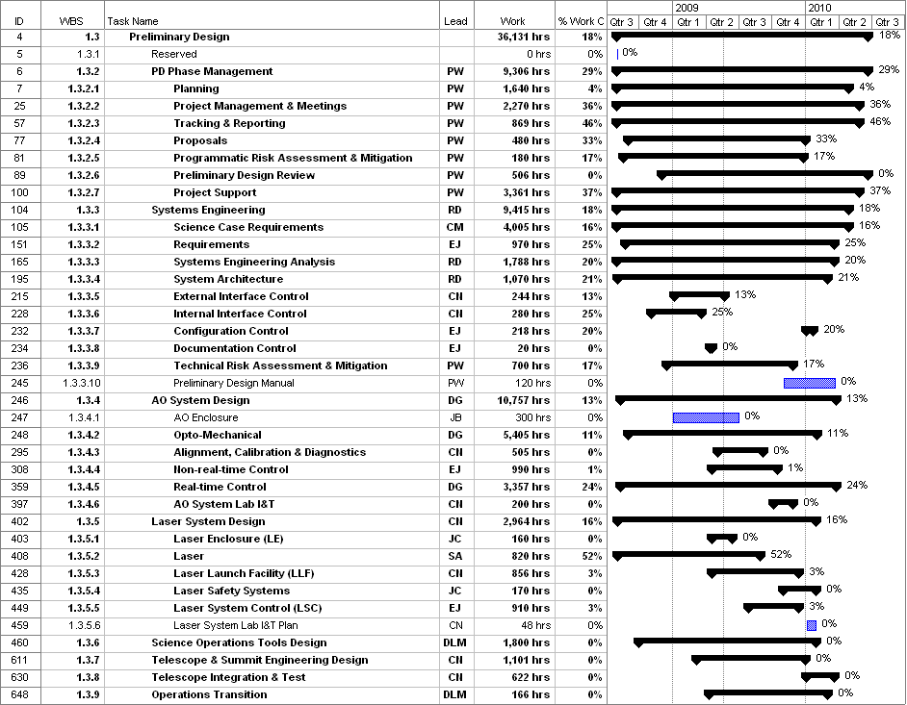
Figure 1: Tracked version of the PD phase schedule

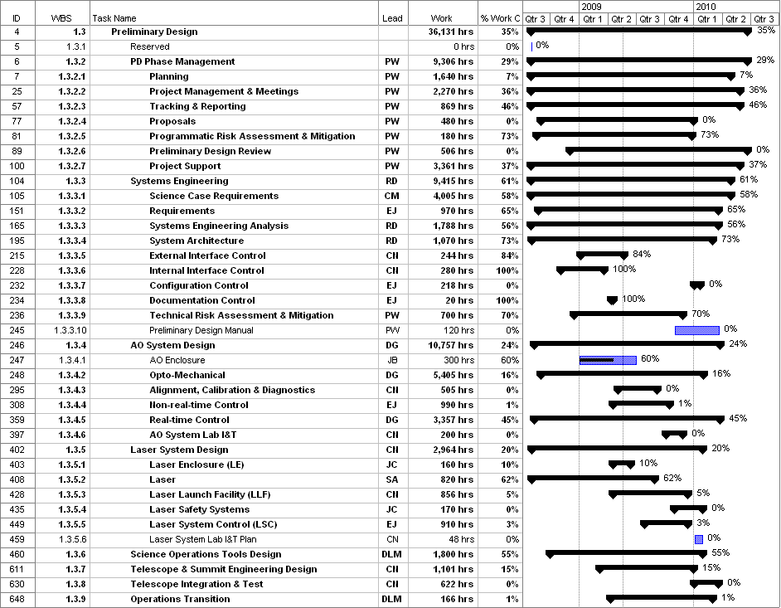
Figure 2: Planned % complete through Jan/09 from the plan presented at SDR

Financial Summary

The budget, expenditures to date and estimate to completion for year 1 of the NGAO project are shown in Table 2.
Table 2: NGAO PD Phase Expenditure Summary through February 2009

