 Keck Adaptive Optics Note 634

Keck Next Generation Adaptive Optics
Preliminary Design Phase Project Report #8

P. Wizinowich, the NGAO Team, and Sean Adkins
January 26, 2008

Narrative

This report is the seventh monthly project report for the Preliminary Design (PD) phase in the development of the W. M. Keck Observatory’s (WMKO) Next Generation Adaptive Optics (NGAO) facility. This report covers the PD phase work performed in December 2008.

Summary
Management efforts have continued to involve activities related to the design and build to cost requirement, and collaboration on laser preliminary designs. Work began on an MRI proposal for a Keck II center launch telescope in support of NGAO.

Management Status
The PD phase plan presented at the SDR included work under the following management WBS elements through December. The progress in each of these areas is discussed below.

WBS 1.3.2.1 Planning
A series of potential cost savings were identified along with initial cost savings estimates. A budget was developed in the-year dollars before and after these cost savings. The cost savings ideas were reviewed at a build-to-cost team meeting on December 19 (team meeting 4) along with new science guidance from the draft Keck Strategic Plan 2008. A set of action items were identified and assigned in order to help determine which cost savings will be adopted.

WBS 1.3.2.2 Project Management and Meetings
Advertisement for the AO scientist position began in December.

WBS 1.3.2.4 Proposals
Funding for the required cost share for an MRI proposal was approved. Progress was made on this proposal to implement an on-axis laser launch facility for the Keck II telescope. In addition to implementing a needed part of the NGAO facility this would provide significant LGS AO performance improvements for the existing Keck II AO system.

WBS 1.3.2.5 Programmatic Risk Assessment and Mitigation
A final report and recommendation on the evaluation of the five laser preliminary designs submitted by vendors to ESO was completed. The next level of ESO management concurred with this recommendation. The result will be presented to the ESO finance committee in February for final approval. A draft $300k NOAO sub-award was sent to Keck just before Christmas for review; these NSF funds provided on behalf of GMT and TMT are intended to be used toward the laser preliminary designs. We are keeping GMT, TMT, and AURA informed on the progress of this collaboration.

WBS 1.3.2.7 Project Support

Technical Status
The PD phase plan presented at the SDR included work under the following technical WBS elements in December. The progress in each of these areas is discussed below.

WBS 1.3.3.1 Science Case Requirements
In December we investigated alternative gas and stellar kinematic lines that could be used for the Black Hole Mass Measurements in Nearby AGN key science driver. Our current build-to-cost plan does not include plans for a visible IFU unless a new near-IR IFU is built that can be pushed to visible wavelengths. Therefore, we have been trying to find lines at J-band that would work for this science case. We also continued working on sensitivity and exposure time calculations for a variety of system designs, optical coatings, and instrumentation.

Next month we will work on the Observing Operations Concept Document, in particular, use cases and observing scenarios for some of the Key Science Drivers. Without a deployable IFU, we need to re-evaluate the observing scenario for the Galaxy Assembly Key Science Driver and optimize it for a single IFU design.

WBS 1.3.3.2 Requirements
Initial release of software standards document completed pending review.

Work continues on the first release of the functional requirements document. Portions have been posted to the NGAO Twiki for review.

WBS 1.3.3.3 Systems Engineering Analysis
NFIRAOS error budget comparison completed and documented as KAON 629.

Tip/tilt sharpening study simulations are complete and a draft KAON is near completion.

WBS 1.3.3.4 System Architecture
Degraded laser power trade study completed and results presented at December 19 team meeting. KAON needs to be completed.

Good progress on software and control system architectures. Options have been narrowed to three “middleware” possibilities, all of which require testing. Some progress on motion control design has also been made.

WBS 1.3.3.5 External Interface & 1.3.3.6 Internal Interface Control
Baseline N² diagram and template document for the NGAO interface control documents (ICDs) completed. Draft KAON outlining ICD work to date sent to NGAO team for comment.

WBS 1.3.3.9 Technical Risk Assessment and Mitigation
The collaboration to implement the TMT donated MASS/DIMM is continuing to make good progress. Drafting of memorandums of understanding between the various parties is underway. Discussions have begun regarding the shipping of equipment, and a bid was accepted for repainting of the MASS/DIMM tower. Work has also continued on review of the validation and requirements documents.

WBS 1.3.4.2.3 Optical Relays
Because of the need to investigate new configurations under the build-to-cost approach, the opto-mechanical portion (WBS 1.3.4.2) is still proceeding on a modified time schedule and order of events relative to the original project plan. The intention is to complete the key decision items first (relay options and high cost items driving decisions) and then proceed with the non-pacing items (e.g. ADCs). During December the following work was performed:
- The relay configurations for both 100mm and 140mm diameter deformable mirror (DM) options were been completed. The meeting of December 19 nominally established the 140mm option as the move-ahead design. However, there are two outstanding issues with this approach: 1) having to purchase the 140mm DM because the present AO system’s DM is probably unsuitable, 2) requirements on the DM tip/tilt stage and whether this stage needs to handle full tip/tilt bandwidth or be a low frequency tip/tilt “woofer” in conjunction with a “tweeter” tip/tilt stage in the second relay. This investigation continues into January.
- We received a firm quote (for the Laboratory for Adaptive Optics from Boston Micromachines Corp.) for a 32-across MEMS DM. The quote price is twice what was estimated in the system design phase.
- Work continues on the switchyard, in collaboration with the instrument manager to understand what we need to know to evaluate the performance and cost trades of dichroics vs. mirror pickoffs. We are still awaiting quotes on dichroics from various vendors.
- The design work for the image de-rotator has been begun assuming that it will be supported by the main AO optical bench.

WBS 1.3.4.2.5 LGS Wavefront Sensor Assembly

WBS 1.3.4.2.7 Low Order Wavefront Sensor Assembly

WBS 1.3.4.2.8.1 Tip-tilt Vibration Mitigation Analysis
Work in December investigated inclusion of tip-tilt vibration mitigation methods into sky coverage calculation originally developed by Richard Clare and reviewed baseline values from previous NGAO and Keck studies.

WBS 1.3.4.4 Non-real-time Control

WBS 1.3.4.5 Real-Time Control
Peck continues to be delayed because of other commitments within UCO/Lick but is slated to ramp to nearly full time in January. He has done some initial thinking about the WFS camera interface definitions.

Reinig continues to work most of his time on the RTC and has been filling in on the tasks originally assigned to Peck. Progress in December has included:
- The bit resolution requirement definition has been completed.
- Worked on the preconditioning and scaling processing (1.3.4.5.1.4 and 5).
- Camera interface definition work (WBS 1.3.4.5.1.9) is underway.
- Work on centroider and reconstruction processing (WBS 1.3.4.5.1.2 and 3).
- Meeting with vendors to gather information on products that will support the diagnostic I/O requirements (WBS 1.3.4.5.1.15).
- Began drafting a design manual for the RTC (WBS 1.3.4.5.1.18).

Science Instruments
At the SDR our plan for instrumentation included a visible imager and a near-IR imager, as well as at least a single object integral field spectrograph (IFS). However, the current cost cap makes it unlikely that we can provide all three of these instruments within the available funding. One way to address this problem is to examine the possibility of extending the wavelength coverage of the near-IR imager to ~800 or even 700 nm. Since the substrate removed Hawaii-2RG has been demonstrated to have good QE below 1000 nm, it is possible to consider this option. A trade study is now under way to compare the detector limited performance of an imager over the 700 to 1000 nm wavelength range using a CCD as the detector to the performance of a near-IR imager with extended short wavelength coverage equipped with a substrate removed Hawaii-2RG. Depending on the results of this trade study the next step will be to evaluate the impact of this extended wavelength coverage on the estimated optical performance of the near-IR imager, and to develop an estimate of the potential for realizing diffraction limited imaging in the 700 to 1000 nm wavelength range with such an instrument.

Keck Adaptive Optics Notes
All of the NGAO KAONs can be found at:
http://www.oir.caltech.edu/twiki_oir/bin/view/Keck/NGAO/NewKAONs.

The following KAONs were produced in December:
KAON 628 Optical Relay Redesign Evaluation
KAON 629 Wavefront Error Budget Comparison between Keck NGAO and TMT NFIRAOS
KAON 630 NGAO Preliminary Design Report #6

Schedule and Budget Status

Milestones
The Systems Engineering Management Plan (SEMP; KAON 574) for the preliminary design phase identified the milestones shown in Table 1. The May 2008 milestone has been completed. The functional requirements milestone has been delayed as a result of changes to the plan, including the build to cost guidelines and is now expected to complete in March, 2009.

Year | Month | NGAO Project Milestone | Status
2008 | May | Preliminary Design phase begins | Completed
2008 | October | Functional Requirements PD Release 1
2009 | March | Operations Concept Document Release 1
2009 | April | External Interface Document Release 1
2009 | February | Internal Interface Document Release 1
2009 | May | Software & Controls Architectures PD complete
2009 | May | LGS WFS Assembly PD complete
2009 | June | Laser vendor identified & contract ready
2009 | June | Optical relay/switchyard PD complete
2009 | September | RTC Processing Requirements complete
2009 | November | Laser Launch Facility PD complete
2009 | December | LOWFS Assembly PD complete
2010 | February | Preliminary Design Review
Table 1: NGAO PD Phase Milestones

Schedule
A high level snapshot of the tracked version of the schedule through January is shown in Figure 1 with 13% of the work complete. The team continues to ramp up.

Budget
The total NGAO PD phase budget is $3030k excluding contingency; the contingency is $449k. A total of $347k has been spent through December or 11% of the budget excluding contingency (compared to 13% of work completed).

Anticipated Accomplishments in the Next Period
The anticipated accomplishments from the June report along with their status in italics:
- Submission of a collaborative (GMT, TMT, WMKO and ESO) white paper to the NSF for commercial laser development. Complete.
- Completion of the tip-tilt sharpening study. Nearly complete.

The anticipated accomplishments from the July report along with their status in italics:
- Good progress (preferably complete) on the replan. No progress in Nov.
- Startup of NGAO controls group responsible for all non-real-time control software and hardware. Complete, including replan of controls tasks.

The anticipated accomplishments from the August report along with their status in italics:
- Hold build to cost team meeting and identify next steps in this process. Complete.
- Identify success criteria for NFIRAOS cost comparison and internal build to cost review. Complete.

The anticipated accomplishments from the September report along with their status in italics:
- Understand laser tomography noise propagator behavior. Complete.
- Complete the NFIRAOS cost comparison report. Complete.

The anticipated accomplishments for November along with their status in italics:
- Submit ATI proposal. Complete.

The anticipated accomplishments for December along with their status in italics:
- Produce a baseline set of cost savings possibilities to fit within the cost cap. Complete.
- Document single relay optical design (cost savings) evaluation. Complete.
- Complete the tip/tilt sharpening study report. Nearly complete.
- Complete the ESO laser preliminary design proposal review/recommendation process. Complete.

The anticipated accomplishments for January are the following:
- Submit a NSF MRI proposal for a Keck II center launch telescope, as part of NGAO.
- Set up regular meetings of a systems engineering team and begin to address requirements and interface issues.

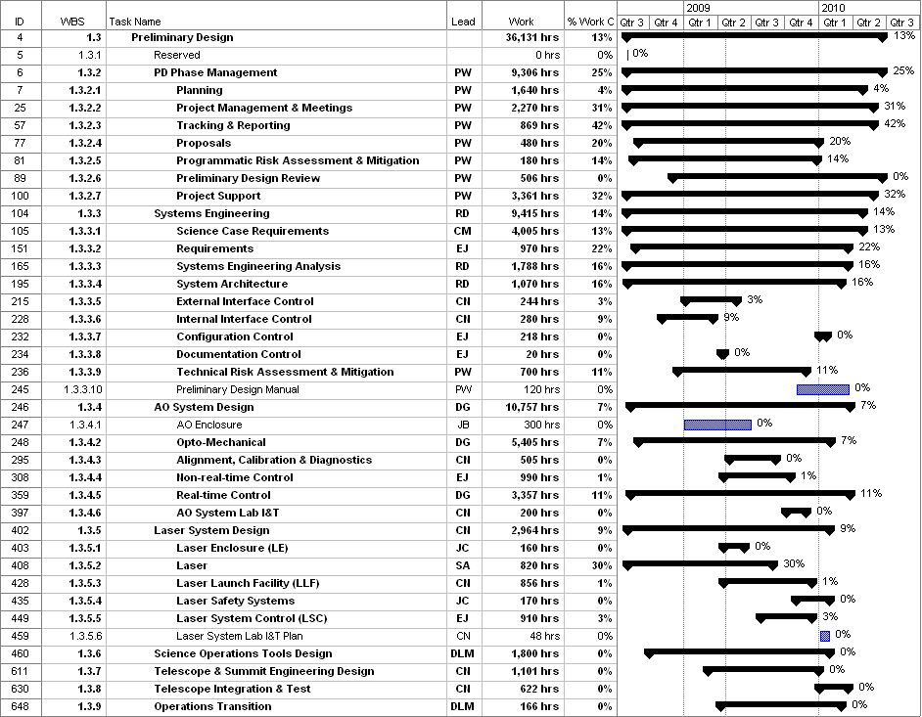
Figure 1: Tracked version of the PD phase schedule

Financial Summary

The budget, expenditures to date and estimate to completion for year 1 of the NGAO project are shown in Table 2.
Table 2: NGAO PD Phase Expenditure Summary through December 2008

