 Keck Adaptive Optics Note 630

Keck Next Generation Adaptive Optics
Preliminary Design Phase Project Report #7

P. Wizinowich, the NGAO Team, and Sean Adkins
December 22, 2008

Narrative

This report is the seventh monthly project report for the Preliminary Design (PD) phase in the development of the W. M. Keck Observatory’s (WMKO) Next Generation Adaptive Optics (NGAO) facility. This report covers the PD phase work performed in November 2008.

Summary
Management efforts have continued to involve planning efforts and activities related to the design and build to cost requirement.

Management Status
The PD phase plan presented at the SDR included work under the following management WBS elements through November. The progress in each of these areas is discussed below.

WBS 1.3.2.1 Planning
Wizinowich had an opportunity to participate in the TMT NFIRAOS preliminary design review. Several areas were identified where we could potentially benefit from the NFIRAOS experience (e.g., the refrigeration approach) and collaborate in the future (e.g., PSF reconstruction, tip-tilt sensing and object selection).

WBS 1.3.2.2 Project Management and Meetings
An AO scientist position recruitment to replace Le Mignant was approved. Advertisement will begin in December.

WBS 1.3.2.4 Proposals
Several options for a MRI proposal were evaluated. The proposal idea that we are likely to proceed with, pending the identification of 30% matching funds, is the implementation of an on-axis laser launch facility for the Keck II telescope. In addition to implementing a needed part of the NGAO facility this would provide significant LGS AO performance improvements for the existing Keck II AO system. The laser elongation would be halved, resulting in a direct wavefront sensing measurement error reduction as well as reducing the required update rate for LGS aberration corrections.

WBS 1.3.2.5 Programmatic Risk Assessment and Mitigation
The five laser preliminary design proposals submitted to ESO were reviewed by the two WMKO members
of the ESO technical review committee. One telecon was held with ESO to review initial impressions and to identify questions. Individual reviewer reports were due on December 5 and the consensus final report will be reviewed the week of December 8. We are keeping GMT, TMT and AURA informed on the progress of this collaboration and AURA is working on a MOU to transfer funds to WMKO to share funding of the preliminary design phase studies based on the proposals selected from the submissions to ESO.

WBS 1.3.2.7 Project Support

Technical Status
The PD phase plan presented at the SDR included work under the following technical WBS elements in November. The progress in each of these areas is discussed below.

WBS 1.3.3.1 Science Case Requirements
The departure of Le Mignant forced the postponement the planned science team work on the Observing Operations Concept Document. We continued working on sensitivity and throughput issues and have been working on exposure time calculations, which will also be applicable to future work on WBS 1.3.3.1.2, Observing Planning and Execution. We have worked on ranking desired instrument capabilities and AO performance by individual science cases in order to prioritize NGAO system requirements and provide a baseline for both phased implementation and cost-cutting measures.

In December we plan to continue looking at exposure time calculations given current detector characteristics to see where improvements in technology or design may be most helpful. We will also work on extending the discussion in the SCRD for a number of our less well-defined science drivers, and make sure that none of these compelling and unique science cases are ruled out by any potential de-scope options.

WBS 1.3.3.2 Requirements
Work continues on the first release of the functional requirements document. Good progress has been made on the software standards document.

WBS 1.3.3.3 Systems Engineering Analysis
Dekany and Neyman along with TMT modelers Ellerbroek, Gilles and Wang performed a detailed comparison between the NFIRAOS wavefront error budget and the Keck NGAO wavefront error budget and the extent to which they have been anchored with simulations or data. We now understand areas where additional simulations or improved parametric tools would benefit the NGAO preliminary design. These recommendations will be part of a forthcoming KAON.

In response to the build-to-cost guidelines, a new assessment of the performance tradeoffs of lower total laser power has begun. We are investigating total laser power levels ranging from 150 W, 125 W, 100 W, 75 W, and 50 W to determine the driving function between laser power and final system performance for four of our defined NGAO science cases (Galaxies lensed by galaxies, studies of the Galactic Center, a KBO survey, and a search for Black Holes in nearby AGNs).

In addition, we are revisiting our April 2008 SDM baseline approach of having nine patrolling LGS WFS probe arm pickoffs in favor of simpler and less expensive systems commensurate with the reduced overall power budget described above. Specifically, we are considering the allocation of the above powers into fixed asterisms of 4 or 6 LGS beacons, to trade tomography error versus measurement error under different conditions.

WBS 1.3.3.4 System Architecture
The tip/tilt sharpening study simulations are complete and are being documented as a KAON.

Simulations have been performed in support of the hybrid Rayleigh/sodium layer laser guide star trade study, including simulations consistent with the MMT Rayleigh return and dynamic refocusing.

Progress is continuing to be made on the software and control system architectures.

WBS 1.3.3.9 Technical Risk Assessment and Mitigation
A telecon was held with TMT and HIA to explore the possibility of collaboration in the area of PSF reconstruction. There was general enthusiasm and we identified some steps forward. WMKO will look at hiring a postdoc (to replace Flicker) to act as a focal point for this work. This new hire would likely spend time at HIA where Jean-Pierre Veran (an acknowledged expert in this area) would provide supervision. TMT is interested in developing some models and supporting tools.

Good progress continues to be made on the joint CFHT, UH, TMT and WMKO planning for the implementation of the TMT provided MASS/DIMM. Bi-weekly meetings are now being held under the leadership of the project manager, Kevin Ho from CFHT.

WBS 1.3.4.2.3 Optical Relays
In support of identifying cost savings an evaluation of potential single relay options was completed and will be documented in KAON 628. The conclusion was to retain the cascaded relay. Instrument switchyard options are now being evaluated. Because of the need to investigate new configurations to support the build-to-cost approach the opto-mechanical design is not proceeding according to the original plan.

WBS 1.3.4.2.5 LGS Wavefront Sensor Assembly

WBS 1.3.4.2.7 Low Order Wavefront Sensor Assembly

WBS 1.3.4.2.8.1 Tip-tilt Vibration Mitigation Analysis
Don Wiberg, supported by a CfAO grant, has agreed to review various techniques of vibration suppression for NGAO. He has already reviewed and commented on techniques described in: “First laboratory validation of vibration filtering with LQG control law for Adaptive Optics”, Cyril Petit, et al. Optics Express 2008.

WBS 1.3.4.4 Non-real-time Control

WBS 1.3.4.5 Real-Time Control
Michael Peck is now regularly engaged, starting with the wavefront sensor camera interface definition. It turns out that only the portion of the bit resolution issue associated with the tomography engine has been addressed. The bit resolution required with the slope-to-phase conversion step is still being evaluated. Work has been performed on the preconditioning and scaling processing and work has begun on the centroider and reconstruction processing and the diagnostic I/O requirements.

Science Instruments
Since the completion of the ATI proposal, instrumentation efforts have been focused on participation in the opto-mechanical design team’s efforts to explore alternative AO relay designs. Work is also underway to complete a KAON on the anticipated performance of detectors for the NGAO science instruments. The next effort planned for instrumentation is to develop a concept level optical design for the near-IR imager and to prepare a more detailed cost estimate for the single object near-IR IFS.

Keck Adaptive Optics Notes
All of the NGAO KAONs can be found at:
http://www.oir.caltech.edu/twiki_oir/bin/view/Keck/NGAO/NewKAONs.
The following KAONs were produced in November:
KAON 627 NGAO Preliminary Design Report #6

Schedule and Budget Status

Milestones
The Systems Engineering Management Plan (SEMP; KAON 574) for the preliminary design phase identified the milestones shown in Table 1. The May 2008 milestone has been completed. The functional requirements milestone has been delayed as a result of changes to the plan, including the build to cost guidelines and is anticipated to be completed in March, 2009.

Year | Month | NGAO Project Milestone | Status
2008 | May | Preliminary Design phase begins | Completed
2008 | October | Functional Requirements PD Release 1
2009 | March | Operations Concept Document Release 1
2009 | April | External Interface Document Release 1
2009 | February | Internal Interface Document Release 1
2009 | May | Software & Controls Architectures PD complete
2009 | May | LGS WFS Assembly PD complete
2009 | June | Laser vendor identified & contract ready
2009 | June | Optical relay/switchyard PD complete
2009 | September | RTC Processing Requirements complete
2009 | November | Laser Launch Facility PD complete
2009 | December | LOWFS Assembly PD complete
2010 | February | Preliminary Design Review
Table 1: NGAO PD Phase Milestones

Schedule
A high level snapshot of the tracked version of the schedule through January is shown in Figure 1 with 10% of the work complete (note that we mistakenly reported 17% complete through October in the laser report when we should have reported 9%). The team continues to ramp up.

Budget
The total NGAO PD phase budget is $3030k excluding contingency; the contingency is $449k. A total of $274k has been spent through November or 9% of the budget excluding contingency (compared to 10% of work completed).

Anticipated Accomplishments in the Next Period
The anticipated accomplishments from the June report along with their status in italics:
- Submission of a collaborative (GMT, TMT, WMKO and ESO) white paper to the NSF for commercial laser development. Complete.
- Completion of the tip-tilt sharpening study. Nearly complete.

The anticipated accomplishments from the July report along with their status in italics:
- Good progress (preferably complete) on the replan. No progress in Nov.
- Startup of NGAO controls group responsible for all non-real-time control software and hardware. Complete, including replan of controls tasks.

The anticipated accomplishments from the August report along with their status in italics:
- Hold build to cost team meeting and identify next steps in this process. Complete.
- Identify success criteria for NFIRAOS cost comparison and internal build to cost review. Complete.

The anticipated accomplishments from the September report along with their status in italics:
- Understand laser tomography noise propagator behavior. Complete.
- Complete the NFIRAOS cost comparison report. Complete.

The anticipated accomplishments for November along with their status in italics:
- Submit ATI proposal. Complete.

The anticipated accomplishments for December are the following:
- Produce a baseline set of cost savings possibilities to fit within the cost cap.
- Document single relay optical design (cost savings) evaluation.
- Complete the tip/tilt sharpening study report.
- Complete the ESO laser preliminary design proposal review/recommendation process.

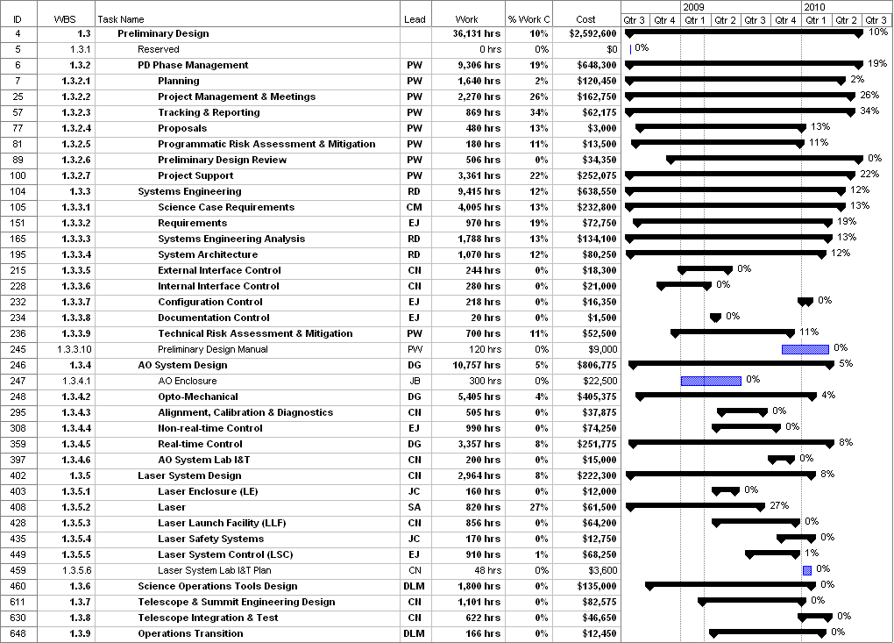
Figure 1: Tracked version of the PD phase schedule

Financial Summary

The budget, expenditures to date and estimate to completion for year 1 of the NGAO project are shown in Table 2. Actual expenditures from UCO have been included in this version.
Table 2: NGAO PD Phase Expenditure Summary through November 2008

