 Keck Adaptive Optics Note 627

Keck Next Generation Adaptive Optics
Preliminary Design Phase Project Report #6

P. Wizinowich, the NGAO Team, and Sean Adkins
November 22, 2008

Narrative

This report is the sixth monthly project report for the Preliminary Design (PD) phase in the development of the W. M. Keck Observatory’s (WMKO) Next Generation Adaptive Optics (NGAO) facility. This report covers the PD phase work performed in October 2008.

Summary
Management efforts have continued involve planning efforts and activities related to the design and build to cost requirement.

Management Status
The PD phase plan presented at the SDR included work under the following management WBS elements through October. The progress in each of these areas is discussed below.

WBS 1.3.2.1 Planning
The NGAO and TMT first light AO (NFIRAOS) cost estimate comparison was completed (KAON 625). As a result of the comparison we and TMT have agreed that NGAO is traceably less expensive than the first light TMT AO system and we understand why. We concluded that the cost estimation methodology employed during the NGAO system design did give us reasonable estimates. We identified some areas that require more work including re-evaluation of the laser and real-time control contingencies and improving the laser procurement estimate. This comparison was presented at the WMKO Science Steering Committee (SSC) meeting on November 3, 2008 and was well received.

Delays in hiring a mechanical engineer at Caltech have delayed the start of work on the wavefront sensor assemblies. A new hire is expected by January.

WBS 1.3.2.2 Project Management and Meetings
David Le Mignant, who was leading the development of the NGAO science operations tools, will be leaving WMKO for a position in France in November. We intend to replace this position.

WBS 1.3.2.4 Proposals
A proposal titled “High Performance Integral Field Spectrographs for Adaptive Optics” was submitted on November 3, 2008 to the NFS Advanced Technologies and Instrumentation program. This proposal would fund the system design and preliminary design phases of an advanced integral field spectrograph (IFS) optimized for the next generation of adaptive optics systems such as Keck NGAO. The IFS development will be based on lessons learned from the first generation of near-IR IFS instruments on AO systems (NIFS, OSIRIS, and SINFONI) and will emphasize increased sensitivity and larger fields of view.

WBS 1.3.2.5 Programmatic Risk Assessment and Mitigation
ESO received five proposals in response to their laser preliminary design call for tender. GMT, TMT and WMKO have agreed to provide a total of 250k Euros to fund one of these proposals (AURA is currently working on transferring the GMT/TMT funds to WMKO which will represent the US partners). Two WMKO representatives are being included in the ESO laser bid technical evaluation process to represent the US community interests. Up to three vendors could be selected to produce preliminary designs. An MOU will need to be worked out between all participants prior to funding the preliminary designs.

WBS 1.3.2.7 Project Support

Technical Status
The PD phase plan presented at the SDR included work under the following technical WBS elements in October. The progress in each of these areas is discussed below.

WBS 1.3.3.1 Science Case Requirements
The science team focused on simulating background and throughput to the wide-field and the narrow-field relays, as well as comparing current IFS sensitivities on a number of telescopes (e.g., NIFS on Gemini, SINFONI on the VLT, and OSIRIS on Keck). If we cool the entire AO system to approximately 260 K we can meet our requirements on the maximum allowable thermal contributions to the total background. Cooling the system further provides only marginal gains since the thermal background becomes dominated by the warm telescope. The next potential gain in throughput can be made with improved coatings on the telescope optics such as protected silver. In comparing current IFS technology, there was no clear winner in terms of throughput. While SINFONI’s image slicer design may allow for higher throughput than OSIRIS’s lenslet array other characteristics such as grating efficiency and AO system background levels are suspected as the more important factors in overall sensitivity and throughput.

The science team plans to work with the Science Operations team on the Observing Operations Concept Document in November. They will also be working to rank instrument capabilities and level of AO performance by individual science cases in order to prioritize the NGAO system requirements.

WBS 1.3.3.2 Requirements
A review of the functional requirements for AO and laser systems was begun. The interface requirements will form the basis for the Internal Interface Control documents and N² diagram.

WBS 1.3.3.3 Systems Engineering Analysis
A new investigation of the tradeoff between tomography error and measurement noise error in the presence of multiple laser beacons has been completed (with both theoretical and Monte Carlo simulation components). These results have been documented (KAON 621) and will be incorporated into future system trades to determine laser power requirements for NGAO. This will allow us to complete the tip/tilt sharpening study.

A preliminary NFIRAOS to NGAO error budget comparison was made, using the NFIRAOS PDR documents and the NGAO SDR documents, providing a basis for more detailed work planned for November. The comparison will attempt to understand the error budgets by identifying the differences in key features, assumptions or models. We will not seek to exactly duplicate the TMT numbers with the NGAO modeling tools.

The NGAO wavefront error (WFE) budget tool has been updated to more accurately estimate the multispectral error that arises when using a sensing wavelength (in our case usually 589nm) different from the science wavelength. Previously, this error term always assumed a science wavelength of 1.65 microns, but has now been updated to correctly calculate this error for each science waveband. This improves the fidelity of our performance estimate particularly for observations at high air mass.

Our simulation capability has been updated to run LAOS v11, which improves upon previous releases by improving compute speed for certain calculations and providing better support for MOAO. This new release is being used for the current set of tomography trade studies and the build to cost system modeling.

A simplified spreadsheet version of the throughput and emissivity code has been produced for quick science impact analysis at a few wavelengths and to aid in coating selection for the optical design and specifying the enclosure temperature for the AO system.

WBS 1.3.3.4 System Architecture
Preliminary simulations were performed in support of the hybrid Rayleigh/Sodium trade study and of the degraded laser power trade study. Work on both of these studies was delayed by our lack of understanding of the LGS wavefront sensor noise term.

Several “middleware” possibilities are being considered for the controls architecture, including EPICS, RTC, ICE, DDS and a few others. Information is being collected on the directions others are going in the astronomy/observatory community. Opportunities for synergy at WMKO (i.e., the TCS upgrade and Interferometer) are being evaluated.

Options for command sequencers are being evaluated including a Python-based object oriented sequencer being used in the astronomy/observatory community and an RTC-based sequencer used for the ASTRA upgrade to the Keck Interferometer.

WBS 1.3.3.9 Technical Risk Assessment and Mitigation
We have been pursuing risk reduction for the key area of PSF reconstruction through a CfAO funded project and through implementation of an atmospheric turbulence profiler. The departure of Ralf Flicker and David Le Mignant has brought a temporary halt to the PSF reconstruction work and we have begun looking at options for restarting this work. The PSF reconstruction phase 1 final report (KAON 626) documents the status of this work and can be found along with all documentation on this project at http://lao.ucolick.org/twiki/bin/view/CfAO/PsfReconstruction.

Good progress has been made on the joint CFHT, UH, TMT and WMKO planning for the implementation of the TMT provided MASS/DIMM. The necessary information has been assembled and we have agreed on requirements, responsibilities and a draft implementation plan. CFHT will be taking the lead on implementation and has assigned three staff members, including a project manager, to this task. TMT and WMKO are working on an MOU for the long term loan of this equipment; this is a necessary precursor for the Mauna Kea Observatories to devote resources to the implementation.

WBS 1.3.4.2.3 Optical Relays
Two single relay options continue to be evaluated as well as the possibility of eliminating the instrument switchyard in favor of a common pickoff system, with a goal of savings on cost and complexity.

WBS 1.3.4.2.5 LGS Wavefront Sensor Assembly

WBS 1.3.4.2.7 Low Order Wavefront Sensor Assembly

WBS 1.3.4.2.8.1 Tip-tilt Vibration Mitigation Analysis

WBS 1.3.4.4 Non-real-time Control

WBS 1.3.4.5 Real-Time Control
Good progress has been made on defining the centroid reconstruction processing requirements and test procedures. The bit resolution evaluation task has been completed. The new programmer has begun to ramp up.

Science Instruments
As part of the initial IFS work we are undertaking a performance comparison between IFS instruments, and will also develop estimates of the performance gains expected from a more advanced instrument.

From the science instrument perspective the main difference between the two single optical relay options currently under consideration is the output focal ratio. After further work on the anticipated performance of each configuration and the impact on instrument design we expect that a preferred configuration will emerge that allows a clear definition of the AO to instrument interfaces.

A conceptual design is also being developed for the NGAO near-IR imager, and a possible visible (0.7 to 1.0 μm wavelength range) imager. The goal is to keep these instruments as simple as possible in order to ensure the highest sensitivity and internal wavefront quality, supporting ~3 pixel sampling of the diffraction limit at 1 μm.

Keck Adaptive Optics Notes
All of the NGAO KAONs can be found at:

http://www.oir.caltech.edu/twiki_oir/bin/view/Keck/NGAO/NewKAONs.

The following KAONs were produced in October:
KAON 621 Laser Tomography Noise Propagator Analysis.
KAON 622 Preliminary Design Project Report 5.
KAON 625 Cost Comparison with First Light TMT AO.
KAON 626 PSF Reconstruction for Keck AO – Phase 1 Final Report

Schedule and Budget Status

Milestones
The Systems Engineering Management Plan (SEMP; KAON 574) for the preliminary design phase identified the milestones shown in Table 1. The May 2008 milestone has been completed. The functional requirements milestone has been delayed as a result of changes to the plan, including the build to cost guidelines.

Year | Month | NGAO Project Milestone | Status
2008 | May | Preliminary Design phase begins | Completed
2008 | October | Functional Requirements PD Release 1
2009 | March | Operations Concept Document Release 1
2009 | April | External Interface Document Release 1
2009 | February | Internal Interface Document Release 1
2009 | May | Software & Controls Architectures PD complete
2009 | May | LGS WFS Assembly PD complete
2009 | June | Laser vendor identified & contract ready
2009 | June | Optical relay/switchyard PD complete
2009 | September | RTC Processing Requirements complete
2009 | November | Laser Launch Facility PD complete
2009 | December | LOWFS Assembly PD complete
2010 | February | Preliminary Design Review
Table 1: NGAO PD Phase Milestones

Schedule
A high level snapshot of the tracked version of the schedule through January is shown in Figure 1 with 17% of the work complete. The team continues to ramp up.

Budget
The total NGAO PD phase budget is $3030k excluding contingency; the contingency is $449k. A total of $214k has been spent through September or 7% of the budget excluding contingency. The earned value is high when the 17% of work completed is considered. Note that personnel ramp up in September represented a 55% increase in personal versus the average of the previous two months.

Anticipated Accomplishments in the Next Period
The anticipated accomplishments from the June report along with their status in italics:
- Submission of a collaborative (GMT, TMT, WMKO and ESO) white paper to the NSF for commercial laser development. Complete at last report.
- Completion of the tip-tilt sharpening study. Nearly complete. No progress in October.

The anticipated accomplishments from the July report along with their status in italics:
- Good progress (preferably complete) on the replan. No progress in Oct.
- Startup of NGAO controls group responsible for all non-real-time control software and hardware. Complete, including replan of controls tasks.

The anticipated accomplishments from the August report along with their status in italics:
- Hold build to cost team meeting and identify next steps in this process. Complete.
- Identify success criteria for NFIRAOS cost comparison and internal build to cost review. Complete.

The anticipated accomplishments from the September report along with their status in italics:
- Understand laser tomography noise propagator behavior. Complete.
- Complete the NFIRAOS cost comparison report. Complete.

The anticipated accomplishments for November are the following:
- Submit ATI proposal. Complete.

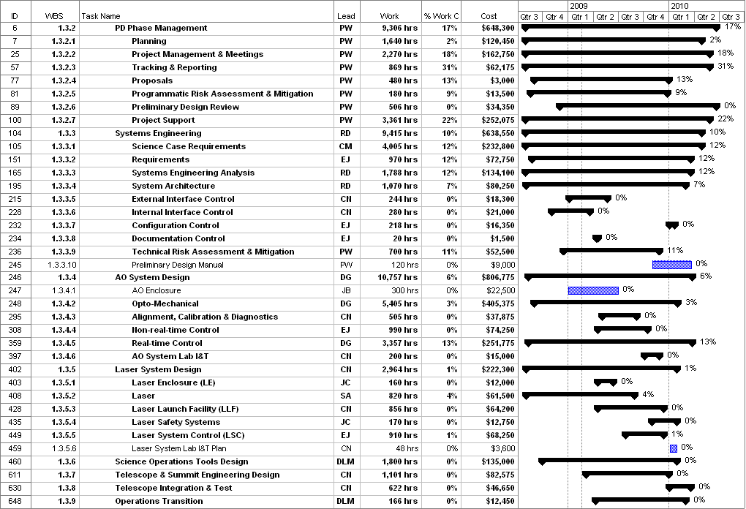
Figure 1: Tracked version of the PD phase schedule

Financial Summary

The budget, expenditures to date and estimate to completion for year 1 of the NGAO project are shown in Table 2. Actual expenditures from UCO have been included in this version.

Table 2: NGAO PD Phase Expenditure Summary through September 2008

