 Keck Adaptive Optics Note 622

Keck Next Generation Adaptive Optics
Preliminary Design Phase Project Report #5

P. Wizinowich, the NGAO Team, Sean Adkins
October 21, 2008

Narrative

This report is the fifth monthly project report for the Preliminary Design (PD) phase in the development of the W. M. Keck Observatory’s (WMKO) Next Generation Adaptive Optics (NGAO) facility. This report covers the PD phase work performed in September 2008.

Summary
Management efforts have continued to focus on planning, in particular with respect to a set of new guidelines from the Directors (see section 1.2.1).

Management Status
The PD phase plan presented at the SDR included work under the following management WBS elements through September. The progress in each of these areas is discussed below.

WBS 1.3.2.1 Planning
A (design) and build to cost team meeting was held at UCSC on September 11 and 12, 2008. The goals, agenda, presentation materials and summary of this meeting can be found at Meeting 3 Link. A number of potential requirement changes and cost savings ideas were identified for further study. The products of this meeting included draft success criteria for the NFIRAOS cost review and the internal build-to-cost review.

One of the outcomes of the NGAO SDR was a recommendation that the NGAO cost estimates should be refined to “…more conservatively reflect the challenge of implementing the NGAO system”. The NGAO team understands that this recommendation stems at least in part from the apparently large differential between the projected cost of Keck NGAO and TMT NFIRAOS. As a result we agreed to perform a cost comparison to be presented at the November 3, 2008 SSC meeting and work is underway on this detailed cost comparison.

As part of the longer range planning, a discussion document was produced reviewing the comments made in the NGAO SDR with respect to the plans for instrumentation development. This document describes the issues that needed to be addressed in order to contribute to the success of the NGAO PDR.

WBS 1.3.2.2 Project Management and Meetings
The Keck Observatory scientific strategic planning meeting was held at Half Moon Bay on September 22 and 23, 2008. The NGAO project manager’s interpretation is that NGAO was very highly ranked at this meeting. The resultant strategic plan is still under development and will be the major topic at the November, 2008 Science Steering Committee meeting.

WBS 1.3.2.4 Proposals
As part of the continued effort to fund NGAO, including instrumentation, we have been planning to make a submission to the NSF Advanced Technologies and Instrumentation (ATI) Program. At the build to cost team meeting various options were discussed for the content of that submission, including seeking funding to support NGAO instrumentation development. One option considered was to perform design work on a new single object near-IR integral field spectrograph for NGAO. Based on the Keck Strategic Planning meeting this seems to be a clearly needed instrument, and after discussion with WMKO management we are now developing a proposal titled “High Performance Integral Field Spectroscopy for Adaptive Optics”.

WBS 1.3.2.5 Programmatic Risk Assessment and Mitigation
ESO released its laser preliminary design call for tender in August with a deadline for responses of Oct. 24, 2008. A telecon to discuss the laser white paper was held with NSF and AURA personnel on September 29, 2008. All of the telecon participants were enthusiastic about the white paper. The white paper was subsequently updated to reflect the telecon and to include more recent information. Bill Smith of AURA took the action to discuss some initial funding with the GMT and TMT project managers.

WBS 1.3.2.7 Project Support

Technical Status
The PD phase plan presented at the SDR included work under the following technical WBS elements in September. The progress in each of these areas is discussed below.

WBS 1.3.3.1 Science Case Requirements
The science team began an assessment of the relative priority of the various science cases and capabilities as part of the effort to address the new build-to-cost guidelines.

In September, the science team spent time talking to astronomers at two meetings: the Keck Adaptive Optics Workshop held at UC Santa Cruz, September 16 and 17, 2008 and the Keck Science Meeting held at UC Santa Cruz, September 18, 2008. These discussions served to provide input from the community on topics such as the current limitations of IFS science with instruments such as OSIRIS, ideas for accurately determining the AO PSF for a variety of science cases, and discussion of places where NGAO can provide unique science capability compared with space-based observatories (present and future). In light of the build-to-cost guideline, we spent some time trying to determine what spectral lines from the host galaxy could be used for radial velocity measurements to support determination of Black Hole masses in nearby AGNs. In the near-IR observations are needed in J and H band, as well as K band to observe the CO band head. Another option that is of interest is to use the Ca II triplet at ~850 nm which may offer a sensitivity gain due to the lower sky background. Further work is needed to determine if this capability requires a visible IFS, since having both visible and near-IR IFSs may be difficult in light of the cost cap. Further work will also be done to investigate other possible spectral lines for radial velocity measurements. Finally, work has continued on estimating the sensitivity and background of the current NGAO architecture and IFS instrumentation.

In October, the science team will continue their sensitivity and background simulations, using new and improved values for coatings of optics, and assuming image slicer rather than lenslet array technology for the deployable IFS instrument. We hope to demonstrate better throughput than the current OSIRIS instrument with the current Keck AO system. With these updated simulations in hand, we will be able to determine the sensitivity for various extragalactic science cases and will be able to address multiplicity issues better (i.e., how many galaxies are there with a specified line flux greater than some threshold within a 1.5' diameter). We will also be working closely with the Science Operations team on the Observing Operations Concept Document.

WBS 1.3.3.2 Requirements
Progress continues to be made for release 1 of the Observing Operational Concept Document.

WBS 1.3.3.3 Systems Engineering Analysis

WBS 1.3.3.4 System Architecture

WBS 1.3.3.9 Technical Risk Assessment and Mitigation
A paper explaining how the UC Laboratory for Adaptive Optics could assist NGAO risk reduction experiments was distributed in early September. This needs further discussion and needs to be incorporated in our planning.

The high level success criteria for implementation of the MASS/DIMM were approved by the WMKO Directorate. A meeting was subsequently held with CFHT, Gemini and UH personnel to discuss whether to proceed and how to proceed with implementing the TMT-provided MASS/DIMM at the CFHT weather tower site. We are proceeding with a set of action items and a second meeting planned for October based on the assumption that we will collaborate on the implementation.

WBS 1.3.4.2.3 Optical Relays
Several new options for packaging the first relay and eliminating the dichroic beam switching system (“switchyard”) were considered with the goal of saving on cost and complexity. Two main options are now being evaluated.

WBS 1.3.4.2.5 LGS Wavefront Sensor Assembly

WBS 1.3.4.2.7 Low Order Wavefront Sensor Assembly

WBS 1.3.4.2.8.1 Tip-tilt Vibration Mitigation Analysis

WBS 1.3.4.4 Non-real-time Control

WBS 1.3.4.5 Real-Time Control
Work has continued on the centroider/wavefront reconstruction processing requirements and test definitions as well as the resolution requirements for the RTC digital data.

Keck Adaptive Optics Notes
All of the NGAO KAONs can be found at:

http://www.oir.caltech.edu/twiki_oir/bin/view/Keck/NGAO/NewKAONs.

The only new KAON produced in September was Project Report 4 (KAON 618).

Schedule and Budget Status

Milestones
The Systems Engineering Management Plan (SEMP; KAON 574) for the preliminary design phase identified the milestones shown in Table 1. The May 2008 milestone has been completed.

Year | Month | NGAO Project Milestone | Status
2008 | May | Preliminary Design phase begins | Completed
2008 | October | Functional Requirements PD Release 1
2009 | March | Operations Concept Document Release 1
2009 | April | External Interface Document Release 1
2009 | February | Internal Interface Document Release 1
2009 | May | Software & Controls Architectures PD complete
2009 | May | LGS WFS Assembly PD complete
2009 | June | Laser vendor identified & contract ready
2009 | June | Optical relay/switchyard PD complete
2009 | September | RTC Processing Requirements complete
2009 | November | Laser Launch Facility PD complete
2009 | December | LOWFS Assembly PD complete
2010 | February | Preliminary Design Review
Table 1: NGAO PD Phase Milestones

Schedule
A high level snapshot of the tracked version of the schedule through January is shown in Figure 1 with 6% of the work complete. The team continues to ramp up.

Budget
The total NGAO PD phase budget is $3030k excluding contingency; the contingency is $449k. A total of $152k has been spent through September or 5% of the budget excluding contingency. The earned value is high when the 6% of work completed is considered.

Anticipated Accomplishments in the Next Period
The anticipated accomplishments from the June report along with their status in italics:
- Submission of a collaborative (GMT, TMT, WMKO and ESO) white paper to the NSF for commercial laser development. Complete at last report.
- Completion of the tip-tilt sharpening study. Nearly complete. No progress in September.

The anticipated accomplishments from the July report along with their status in italics:
- Good progress (preferably complete) on the replan. Some progress in Sept.
- Startup of NGAO controls group responsible for all non-real-time control software and hardware. Complete, including replan of controls tasks.

The anticipated accomplishments from the August report along with their status in italics:
- Hold Build to Cost team meeting and identify next steps in this process. Complete.
- Identify success criteria for NFIRAOS cost comparison and internal build to cost review. Complete & given to Directors for review.

The anticipated accomplishments for October are the following:
- Understand laser tomography noise propagator behavior.
- Complete the NFIRAOS cost comparison report.
- Submit a proposal to the NSF ATI program for the development of an IFS instrument.

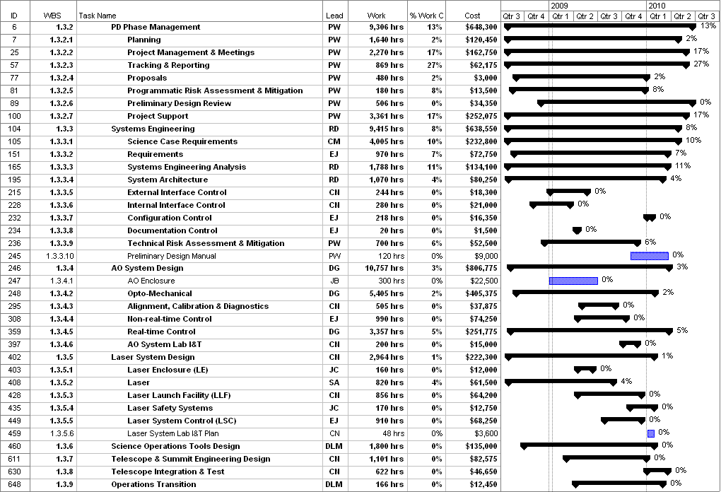
Figure 1: Tracked version of the PD phase schedule

Financial Summary

The budget, expenditures to date and estimate to completion for year 1 of the NGAO project are shown in Table 2. Actual expenditures from UCO have been included in this version.

Table 2: NGAO PD Phase Expenditure Summary through September 2008

KAON 588, p. 12.
http://www.ucolick.org/~jmel/cats_database/cats_workshop.php

