 Keck Adaptive Optics Note 618

Keck Next Generation Adaptive Optics
Preliminary Design Phase Project Report #4

P. Wizinowich, the NGAO Team, Sean Adkins
September 25, 2008

Narrative

This report is the fourth monthly project report for the Preliminary Design (PD) phase in the development of the W. M. Keck Observatory’s (WMKO) Next Generation Adaptive Optics (NGAO) facility. This report covers the PD phase work performed in August 2008.

Summary
Management efforts have continued to focus on planning, in particular with respect to a set of new guidelines from the Directors (see section 1.2.1). Good progress has been made on starting up the Control Systems group.

Management Status
The PD phase plan presented at the SDR included work under the following management WBS elements through August. The progress in each of these areas is discussed below.

WBS 1.3.2.1 Planning
A new set of guidelines and directions, prepared by the Directors and SSC co-chairs, were provided to the NGAO team in mid-August. The Directors established a $60M cost cap in then year dollars for the NGAO project. The project is defined as the AO facility and associated science instruments, and covers all phases of the project from the start of the System Design phase (completed in April 2008) through the completion of the project. The directions also require an internal review of the build to cost concept prior to the April 2009 Keck Science Steering Committee meeting. A subsequent meeting was held with the Directors to ensure that the NGAO senior management team understood these directions and to answer questions. The NGAO team has begun work on addressing the new directions.

Completion of the preliminary design replan activity has been delayed as a result of addressing the above change. However, some good progress was made on the replan in August. In particular replanning was completed for the controls (non-real-time software and hardware), mechanical engineering and facilities engineering activities at WMKO and the real-time control activities at UCO. Progress was also made on replanning the science operations tools activities.

Part of the new build to cost directions require inclusion of the science instruments. Previously generated schedules and budgets for the deployable Integral Field Spectrograph (d-IFS), near-IR imager and visible imager have been compiled with minor updates. Discussions were begun on how to incorporate the instrument designs in the NGAO preliminary design phase.

A cost comparison of the NGAO SDR cost estimate and the 2006 TMT NFIRAOS cost estimate has begun in preparation for a review of NGAO SDR cost estimate scheduled for November 2008.

WBS 1.3.2.2 Project Management and Meetings
A team meeting was held on Aug. 19. The status of the replan was discussed. The findings of the point and shoot trade study were presented and discussed. Each technical group (control systems, real-time control, science operations and science) presented their status, plans and issues.

A build to cost team meeting has been scheduled for September 11 and 12, 2008 at UCSC.

The controls team had a series of three kick-off meetings to pull the team together and give them context for the overall controls work to be done.

The Keck Observatory scientific strategic planning meeting is scheduled for September 22 and 23, 2008. In support of this meeting an internal presentation on NGAO was made and a white paper was drafted.

The Directors have identified the majority of the future members of the NGAO Science Advisory Team (SAT), but the names are not yet public. The SAT will have three members each from Caltech and UC and one member each from NASA and UH.

WBS 1.3.2.5 Programmatic Risk Assessment and Mitigation
Dekany and Gavel attended a meeting with Armandroff and Kulkarni at the ranch of an Observatory supporter. Options for NGAO funding were discussed.

WBS 1.3.2.7 Project Support

Technical Status
The PD phase plan presented at the SDR included work under the following technical WBS elements in July. The progress in each of these areas is discussed below.

WBS 1.3.3.1 Science Case Requirements
More time was spent working on paths to implement a phased development that would maximize the scientific return of NGAO. Meetings were held with several people to discuss background, throughput and sensitivity issues for OSIRIS to determine how this instrument could best serve the needs of NGAO science, and which aspects could be upgradeable to fulfill some of the goals of the d-IFS instrument. Currently, the grating is the limiting factor in terms of throughput, and would be relatively expensive to replace, with no firm technical certainty of a net improvement. There may be some gain from optimizing filters, although in most cases the filters already meet or exceed specifications.

If a new IFU (such as a d-IFS-like instrument) can be built we plan to explore alternatives to the lenslet array for throughput reasons. Concerns for both throughput and background are primarily directed at extragalactic, high-z science. Galactic and planetary users are more concerned with field of view and sampling scale.

WBS 1.3.3.2 Requirements
A new iteration of the Keck standard for observing operational concept documents (OOCD) was produced and a new layout for the NGAO OOCD that includes the necessary information in the required format. Several discussions were held to develop the OOCD contents.

WBS 1.3.3.3 Systems Engineering Analysis
A new science case, nearby black hole kinematics, has been added to our wavefront error budget model, allowing for analysis and optimization of requirements flow down in support of high Strehl ratios at high sky coverage fraction (30%), compared to the previously driving Kuiper Belt Object science case (10% sky coverage fraction).

Error budget comparisons to detailed simulations have revealed that the LGS wavefront sensor measurement noise in the error budget tool is optimistic. As a result, a detailed evaluation of the tomographic reconstruction noise propagator has begun. These analyses are leading us to update our total laser power and power distribution requirements.

WBS 1.3.3.4 System Architecture
A meeting was held to discuss distributed controls system options. Some initial discussions have occurred for the Multi-Systems Command Sequencer concept document.

WBS 1.3.3.9 Technical Risk Assessment and Mitigation
As part of the CfAO-funded PSF calibration task work has continued on reconstructing various sources of wavefront sensor noise introduced by the AO system and testing the resultant model against daytime (on fiber) and nighttime sky tests.

WBS 1.3.4.2.3 Optical Relays
Some work was started on revisiting the opto-mechanical design in support of developing ideas for the build to cost approach.

WBS 1.3.4.2.5 LGS Wavefront Sensor Assembly
We have begun considering new concepts for the LGS WFS object selection assembly that does not require full articulation of all channels. Currently, we are investigating a fixed subset of beacons in addition to the potential for three roving laser beacons for tip/tilt NGS sharpening.

WBS 1.3.4.2.7 Low Order Wavefront Sensor Assembly
We continue to monitor the development of on-instrument wavefront sensor designs as part of the TMT IRIS instrument concept study. Having similar requirements to NGAO, we hope to build upon TMT’s progress during the NGAO PD phase.

WBS 1.3.4.2.8.1 Tip-tilt Vibration Mitigation Analysis
We are collaborating with Don Wiberg at UCSC on vibration mitigation options. Wiberg has proposed a method of vibration cancellation using parametric oscillator control techniques similar to those used with the Lick Nickel telescope and the Keck Interferometer.

WBS 1.3.4.4 Non-real-time Control

WBS 1.3.4.5 Real-Time Control
A preliminary report summarizing the findings from the July 31, 2008 meeting with the TMT RTC team was completed and sent to Brent Ellerbroek for comment.

Work has begun on the centroid/reconstruction process development of the RTC. Mike Peck’s start date as part of the work at UCSC has been delayed to October 1, 2008.

Keck Adaptive Optics Notes
All of the NGAO KAONs can be found at:

http://www.oir.caltech.edu/twiki_oir/bin/view/Keck/NGAO/NewKAONs.

The only new KAONs produced in August were Project Report 3 (KAON 612).

Schedule and Budget Status

Milestones
The Systems Engineering Management Plan (SEMP; KAON 574) for the preliminary design phase identified the milestones shown in Table 1. The May 2008 milestone has been completed.

Year | Month | NGAO Project Milestone | Status
2008 | May | Preliminary Design phase begins | Completed
2008 | October | Functional Requirements PD Release 1
2009 | March | Operations Concept Document Release 1
2009 | April | External Interface Document Release 1
2009 | February | Internal Interface Document Release 1
2009 | May | Software & Controls Architectures PD complete
2009 | May | LGS WFS Assembly PD complete
2009 | June | Laser vendor identified & contract ready
2009 | June | Optical relay/switchyard PD complete
2009 | September | RTC Processing Requirements complete
2009 | November | Laser Launch Facility PD complete
2009 | December | LOWFS Assembly PD complete
2010 | February | Preliminary Design Review
Table 1: NGAO PD Phase Milestones

Schedule
A high level snapshot of the tracked version of the schedule through January is shown in Figure 1 with 5% of the work complete. The team is beginning to ramp up.

Budget
The total NGAO PD phase budget is $3030k excluding contingency; the contingency is $449k. A total of $106k has been spent through August or ~3.5% of the budget excluding contingency. The earned value is high when the 5% of work completed is considered.

Anticipated Accomplishments in the Next Period
The anticipated accomplishments from the June report along with their status in italics:
- Submission of a collaborative (GMT, TMT, WMKO and ESO) white paper to the NSF for commercial laser development. Complete at last report.
- Completion of the tip-tilt sharpening study. Nearly complete, but delayed by conflicting personnel commitments and vacations.

The anticipated accomplishments from the July report along with their status in italics:
- Good progress (preferably complete) on the replan. Good progress has been made however the replan is incomplete, and may need to be further delayed by the recent new directions.
- Startup of NGAO controls group responsible for all non-real-time control software and hardware. Complete, including replan of controls tasks.

The anticipated accomplishments for September are the following:
- Hold Build to Cost team meeting and identify next steps in this process.
- Identify success criteria for NFIRAOS cost comparison and internal build to cost review.

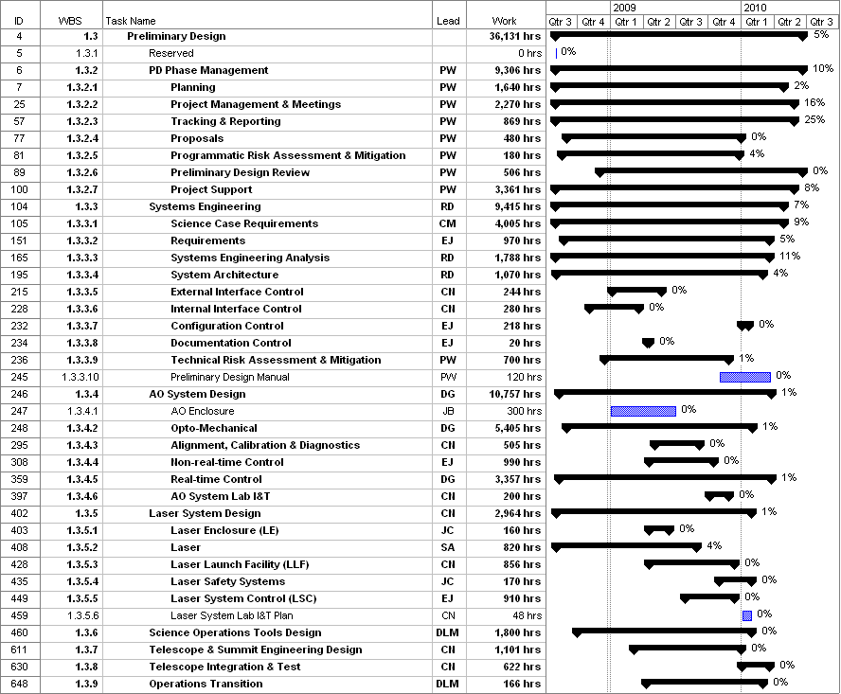
Figure 1: Tracked version of the PD phase schedule

Financial Summary

The budget, expenditures to date and estimate to completion for year 1 of the NGAO project are shown in Table 2. Actual expenditures from UCO have been included in this version.

Table 2: NGAO PD Phase Expenditure Summary through August 2008

http://www.oir.caltech.edu/twiki_oir/bin/view/Keck/NGAO/080815_Remote_NGAO_PD_Meeting_2

