 Keck Adaptive Optics Note 612

Keck Next Generation Adaptive Optics
Preliminary Design Phase Project Report #3

P. Wizinowich, the NGAO Team, Sean Adkins
August 20, 2008

Narrative

This report is the third monthly project report for the Preliminary Design (PD) phase in the development of the W. M. Keck Observatory’s (WMKO) Next Generation Adaptive Optics (NGAO) facility. This report covers the PD phase work performed in July 2008.

Summary
Management efforts have continued to focus on re-planning based on the SDR recommendations and personnel availability, as well as kicking off some design activity areas such as controls and science operations. Some progress has been made on both programmatic and technical risk mitigation efforts. Good progress has continued to be made on some system engineering analysis activities.

Management Status
The PD phase plan presented at the SDR included work under the following management WBS elements through July. The progress in each of these areas is discussed below.

WBS 1.3.2.1 Planning
Good progress has been made on addressing and incorporating the items identified for the replan into the MS project plan.

WBS 1.3.2.2 Project Management and Meetings
Progress has been made on improving the Twiki page for easier access to information. The top-level page was reformatted and reorganized. The Project Management section and several sub-pages were reorganized and updated. Other pages that have been updated include the KAONs page, and the Science Operations and Controls Systems pages under Systems Engineering.

WBS 1.3.2.5 Programmatic Risk Assessment and Mitigation
Four specific areas for programmatic risk mitigation were identified in our preliminary design phase plan: laser procurement, science instruments and funding.

In terms of the former, a collaborative (GMT, TMT, WMKO and ESO) white paper was submitted to Julian Christou at the NSF for commercial laser development.

WBS 1.3.2.7 Project Support
The UCO subcontract is complete and the Caltech subcontract is nearly complete.

Technical Status
The PD phase plan presented at the SDR included work under the following technical WBS elements in July. The progress in each of these areas is discussed below.

WBS 1.3.3.1 Science Case Requirements
Most of the science team’s time in July was spent on addressing the science aspects of a phased implementation plan and on determining the scientific competitiveness of NGAO with respect to current and planned facilities. Some effort was also spent on developing an observing scenario for the Galactic Center.

WBS 1.3.3.2 Requirements
The draft Observing Operations Concept Document (OOCD) outline was reviewed and updated. Guidelines for an Observatory standard OOCD were also generated since no previous standard was in place.

WBS 1.3.3.3 Systems Engineering Analysis
Several minor improvements to our wavefront error budget tool have been implemented and we have found and corrected a bug in the calculation of the high order wavefront sensor (HOWFS) sky background flux. Based on the results of the recent LGS “Point and Shoot” technical trade study, we also expect to make a revision to the algorithm employed in the wavefront error budget tool for calculating the tomography error term. This revision is needed to better reflect results from detailed wave optics simulations.

WBS 1.3.3.4 System Architecture
Two trade studies were identified in the plan in support of the system hardware architecture. The trade study to evaluate the benefits of a hybrid Rayleigh and sodium laser approach was begun in July.

WBS 1.3.3.9 Technical Risk Assessment and Mitigation
Three specific areas for technical risk mitigation were identified in our preliminary design phase plan: PSF calibration, sky coverage and on-sky and lab demonstrations.

We have been pursuing risk reduction for the key area of PSF calibration through a CfAO-funded project and through implementation of an atmospheric turbulence profiler. The CfAO agreed in July to fund year 2 of the PSF reconstruction activity led by Ralf Flicker and David Le Mignant at WMKO. The reviewer found that “The work described in the report is quite impressive and fully met the project milestones.” The projects report is documented as KAON 611.

In terms of an atmospheric profiler, the TMT recently agreed to provide WMKO with one of their site survey MASS/DIMM units and to provide technical support in its implementation. Some work was performed in terms of identifying issues and options. The detailed plan for implementing this unit at WMKO will need to be developed.

The risk mitigation approach we identified under sky coverage was to prototype a near infrared tip/tilt sensor. Collaborative development between NGAO and the TMT IRIS project in the area of infrared tip/tilt camera development has proceeded with TMT IRIS making a baseline design decision for their version of this sensor that is fully consistent with NGAO needs. We look forward to greater formalization of collaborative work between these two teams.

WBS 1.3.4.2.5 LGS Wavefront Sensor Assembly
No progress.

WBS 1.3.4.2.7 Low Order Wavefront Sensor Assembly
See the TMT IRIS item in section 1.3.5.

WBS 1.3.4.5 Real-Time Control
A meeting was held on July 31 between the NGAO RTC team (Gavel and Reinig) and the corresponding personnel at TMT (Ellerbroek, Boyer, Gilles + 1). The purpose of the meeting was to compare and review the methods, specifications and assumptions used by both groups in defining their RTC systems and cost estimates. The meeting was successful and a summary of the conclusions from the meeting will be produced.

The open UCO electronics/software engineer position to work on the RTC preliminary design has been filled. Mike Peck will be joining the team.

Keck Adaptive Optics Notes
All of the NGAO KAONs can be found at:

http://www.oir.caltech.edu/twiki_oir/bin/view/Keck/NGAO/NewKAONs.

The only new KAONs produced in July were Project Report 2 (KAON 607) and the CfAO PSF reconstruction report (KAON 611).

Schedule and Budget Status

Milestones
The Systems Engineering Management Plan (SEMP; KAON 574) for the preliminary design phase identified the milestones shown in Table 1. The May 2008 milestone has been completed.

Year | Month | NGAO Project Milestone | Status
2008 | May | Preliminary Design phase begins | Completed
2008 | October | Functional Requirements PD Release 1
2009 | March | Operations Concept Document Release 1
2009 | April | External Interface Document Release 1
2009 | February | Internal Interface Document Release 1
2009 | May | Software & Controls Architectures PD complete
2009 | May | LGS WFS Assembly PD complete
2009 | June | Laser vendor identified & contract ready
2009 | June | Optical relay/switchyard PD complete
2009 | September | RTC Processing Requirements complete
2009 | November | Laser Launch Facility PD complete
2009 | December | LOWFS Assembly PD complete
2010 | February | Preliminary Design Review
Table 1: NGAO PD Phase Milestones

Schedule
A high level snapshot of the tracked version of the schedule through January is shown in Figure 1 with 4% of the work complete. We are falling behind with respect to the original schedule largely due to personnel availability. Personnel availability will be improving within the next couple of months.

Budget
The total NGAO PD phase budget is $3030k excluding contingency; the contingency is $449k. A total of $66k has been spent through July or ~2% of the budget excluding contingency. The earned value is high when the 4% of work completed is considered.

Anticipated Accomplishments in the Next Period
The anticipated accomplishments from the last report along with their status in italics:
- Submission of a collaborative (GMT, TMT, WMKO and ESO) white paper to the NSF for commercial laser development. Complete.
- Completion of the tip-tilt sharpening study. Nearly complete.

The anticipated accomplishments for August are the following:
- Good progress (preferably complete) on the replan.
- Startup of NGAO Controls group responsible for all non-real-time control software and hardware.

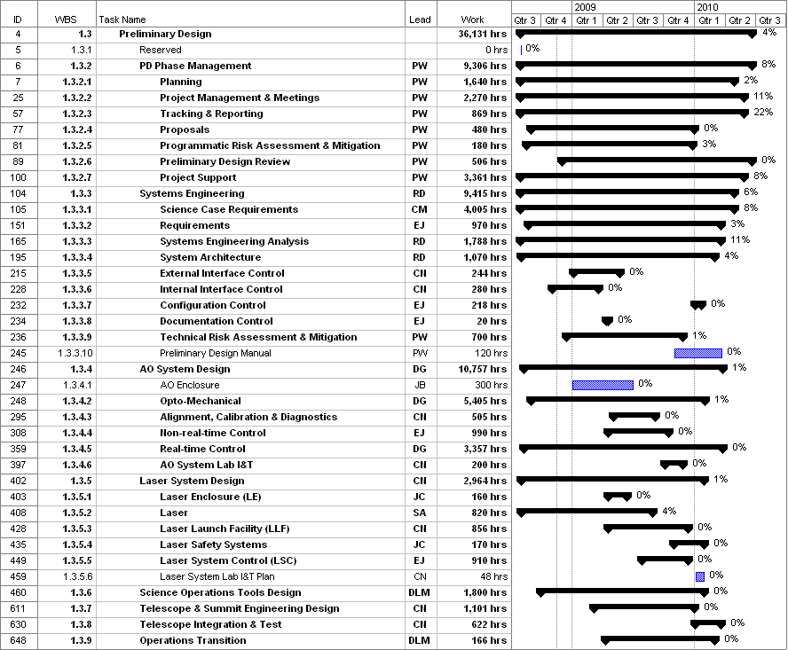
Figure 1: Tracked version of the PD phase schedule

Financial Summary

The budget, expenditures to date and estimate to completion for year 1 of the NGAO project are shown in Table 2. Actual expenditures were not available from UCO. The Table 2 budget does include the post doctoral researcher at UCO, but some corrections may need to be made once other UCO expenditures are known.

Table 2: NGAO PD Phase Expenditure Summary through July 2008

