 Keck Adaptive Optics Note 778

Keck Next Generation Adaptive Optics
Preliminary Design Phase Project Report #26

P. Wizinowich, Sean Adkins and the NGAO Team
July 22, 2010

Narrative

This report is the twenty-sixth monthly project report for the Preliminary Design (PD) phase in the development of the W. M. Keck Observatory’s (WMKO’s) Next Generation Adaptive Optics (NGAO) facility. This report covers the PD phase work performed in June 2010.

The PD review was successfully held on June 14 and 15, and the review panel report provides a strong endorsement for NGAO. From a technical perspective the Preliminary Design Manual (KAON 768) released on May 24 provides the best technical update on the subsystems.

Summary
The focus in June was on the preliminary design review, determining the post-PDR NGAO activities and preparing for the July 7 SSC meeting.

Management Status
The PD phase plan presented at the SDR included work under the following management WBS elements. The progress in each of these areas is discussed below.

WBS 1.3.2.1 Planning
Planning in late June focused on the post-PDR activities. These activities have been agreed to by NGAO senior management and have been distributed to the team. Overall we have chosen to focus on those NGAO activities that will 1) benefit science in the near-term, 2) reduce risk for NGAO and/or 3) will most easily allow us to pickup NGAO quickly when detailed design phase begins (nominally September 1, 2010).

The NGAO-related post-PDR development activities include the following items (in approximate order of priority):
- MRI-funded laser launch telescope
- ATI-funded near-IR tip-tilt sensor
- MRI-proposed laser
- PSF reconstruction demonstration
- Parametric oscillator implementation
- Reduced focal anisoplanatism error

Several additional NGAO risk reduction activities were also identified as appropriate to carry out:
- Differential motion between DAVINCI and the NGAO tip-tilt sensors
- Real-time control design
- Control system design
- Performance modeling
- Wavefront sensor camera path forward
- Mechanical model clean-up

In parallel with these activities NGAO management will focus on determining the path forward for NGAO funding.

WBS 1.3.2.2 Project Management and Meetings
The PDR was held on June 14 and 15 at the Westin LAX hotel. The review panel included Betsy Barton (UCI), Corinne Boyer (TMT), Brent Ellerbroek (TMT, chair), Jay Elias (NOAO), Andrea Ghez (UCLA), Norbert Hubin (ESO) and Matt Johns (GMT). The review panel report was very positive and supportive of NGAO.

Several NGAO papers were presented at the SPIE 2010 astronomical telescopes and instrumentation symposium in San Diego, CA:
- Wizinowich et al., “WMKO’s NGAO Facility,” SPIE Proc. 7736-19.
- Gavel & Reinig, “Wavefront control algorithms for the Keck NGAO system,” SPIE Proc. 7736-41.
- Dekany, “A comparison of tip-tilt star sharpening techniques for precision LGS AO systems,” SPIE Proc. 7736-75.
- Reinig & Gavel, “Real-time control for Keck Observatory NGAO,” SPIE Proc. 7736-130.
- Adkins et al., “DAVINCI: A high-performance imager and integral field spectrograph for WMKO’s NGAO facility,” SPIE Proc. 7735-287.

WBS 1.3.2.4 Proposals
The AST Director approved funding of the ATI proposal for a near-IR tip-tilt sensor. We are awaiting final NSF approval. A meeting was held at the SPIE 2010 meeting to kick off this project.

WBS 1.3.2.5 Programmatic Risk Assessment and Mitigation
The delta PDR for the TOPTICA/MPBC laser was successfully completed on June 10. The kick off meeting for the ESO laser contract and the laser final design was held on June 18. WMKO and TMT will be participating in this process based on the agreements in place with ESO and TOPTICA/MPBC.

Technical Status
No technical status has been provided in this report. The technical status was reported at the NGAO PDR held in June.

Keck Adaptive Optics Notes
All of the NGAO KAONs can be found at:
http://www.oir.caltech.edu/twiki_oir/bin/view/Keck/NGAO/NewKAONs.

The following KAONs were produced in June:
KAON 767, AO Bench Cold Enclosure Preliminary Design
KAON 768, AO Enclosure Preliminary Design
KAON 774, Scientific Case for NGAO
KAON 775, NGAO Preliminary Design Panel Report
KAON 776, Preliminary Design Report #25
KAON 777, Near-IR Tip-Tilt Sensor for LGS AO (ATI proposal)

Schedule and Budget Status

Milestones
The status of the preliminary design phase milestones are shown in Table 1. All are complete. The NGAO science instrument (DAVINCI) IFU SD and imager PD have been listed as complete for the optical design only.

Table 1: NGAO PD Phase Milestones

A series of mini-preliminary design reviews were identified in August, including tentative dates and reviewers (see Table 2). These reviews are intended to allow the NGAO team to wrap up and self review the designs for key subsystems in advance of the PDR. The last of these reviews was completed in May.

Table 2: Planned Mini-Preliminary Design Reviews

Schedule
A high level snapshot of the tracked version of the new schedule through June is shown in Figure 1 with 81% of the total PD phase work complete (versus 76% complete at the end of May 2010).

A tracked version of the DAVINCI MS Project plan, with a start date of May 1, 2009, is shown in Figure 2 with 52% of the overall work complete (versus 51% at the end of May 2010). Note that work in the instrument plan corresponding to the NGAO PD phase represents 71% of the total, so progress in support of the NGAO PD is actually at 73%. The optical design of DAVINCI, including the hybrid slicer is complete to a PDR level. The mechanical, electronics, and software designs are at a system design level, and the highest risk areas (the fore optics mechanical design, imager optics mechanical design, IFS scale changer, slicer, collimator, and camera mechanical designs, and the grating changer mechanical design) have all been planned in the detailed design phase to have an initial design phase with a tolerance analysis and internal review prior to starting the detailed design work. This will mitigate the potential risks for detailed design from not having completed preliminary designs for these areas in the PD phase. As noted in previous reports we did not reach PDR level in these areas due to a shortage of mechanical engineering resources.

Budget
The total NGAO PD phase budget (from the SEMP) was $3030k excluding contingency; the contingency was $449k. The revised total NGAO PD phase budget, based on the funded TSIP proposal, is $3276k including contingency (an overall reduction of $203k). The contingency in the new budget is $157k and we also assigned $149k for work in July and August to wrap up action items from the preliminary design review meeting. The new budget to complete the work through the design review, excluding contingency, is therefore $3276k - $157k - $149k = $2970k.

A total of $2826k has been spent through June or 95% of the budget excluding contingency (86% including contingency), compared to 81% of work completed excluding the science instrument.

Anticipated Accomplishments in the Next Period
All of the previously anticipated accomplishments through April have been completed and we have chosen not to list them here (see the April report for this list).

The anticipated accomplishments for May along with their status in italics:
- Complete functional requirements release 1. Complete.
- Complete observing operations concept document release 1. Complete.
- Complete the post build to cost replan and start tracking versus this plan. Complete.

The anticipated accomplishments for June along with their status in italics:
- Hold first NGAO Science Advisory Team meeting. Complete.

The anticipated accomplishments for July along with their status in italics:
- Document evaluation of fixed pupil mode design options. Complete.
- Document vibration mitigation work. Complete.
- Complete laser MRI-R² proposal. Complete.

The anticipated accomplishments for August along with their status in italics:
- Complete software architecture design review. Complete.

The anticipated accomplishments for September along with their status in italics:
- Complete TSIP proposal. Complete.
- NGAO presentation at the Keck Strategic Planning Meeting. Complete.

The anticipated accomplishments for October along with their status in italics:
- LGS launch facility design review. Complete.

The anticipated accomplishments for November along with their status in italics:
- Complete ATI proposal. Complete.
- AO optical design review. Complete.

The anticipated accomplishments for December along with their status in italics:
- LGS WFS design review. Complete.
- RTC design review. Complete.
- Laser preliminary design reviews. Complete.

The anticipated accomplishments for January along with their status in italics:
- Control electronics architecture review. Complete.

The anticipated accomplishments for February along with their status in italics:
- Begin work on the Systems Engineering Management Plan for the detailed design phase. Done.

The anticipated accomplishments for March along with their status in italics:
- Motion control architecture mini-review. Complete.
- Requirements database and documents put under configuration control. Complete.

The anticipated accomplishments for April along with their status in italics:
- NGS WFS mini-review. Complete.
- LOWFS mini-review. Complete.
- Control system software mini-review. Complete.
- NGAO instrument mini-review. Complete.
- Alignment, calibration & diagnostics mini-review. Complete.

The anticipated accomplishments for May along with their status in italics:
- Performance mini-review. Complete.
- Documents distributed to reviewers for PDR. Complete.

The anticipated accomplishments for June along with their status in italics:
- Preliminary Design Review. Complete.

The anticipated accomplishments for July are the following:
- NGAO presentation to the WMKO Science Steering Committee and CARA Board.

Financial Summary

The budget, expenditures to date and estimate to completion for the NGAO project is shown in Table 3.

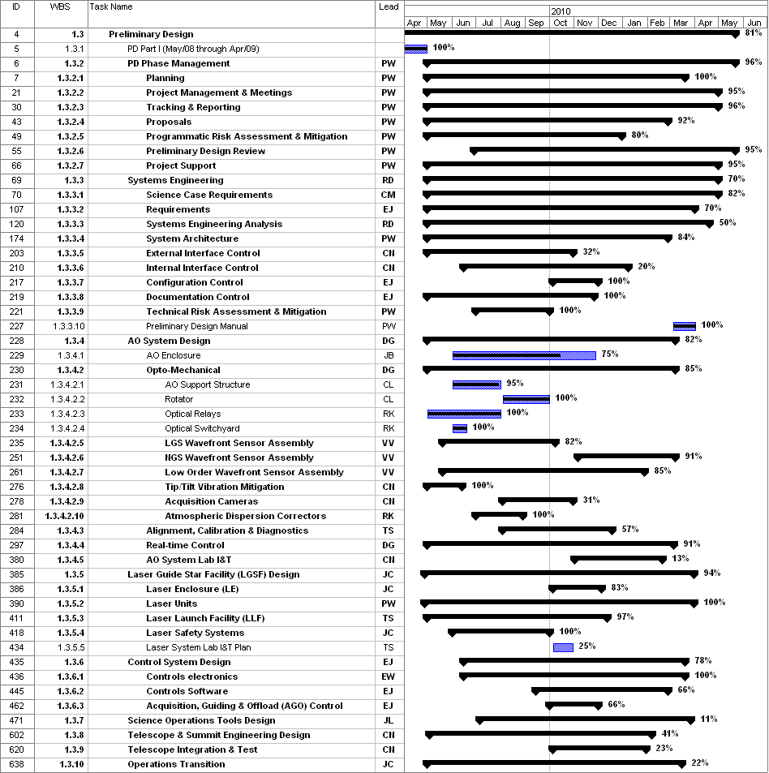
Figure 1: Tracked version of the new PD phase schedule through June 2010

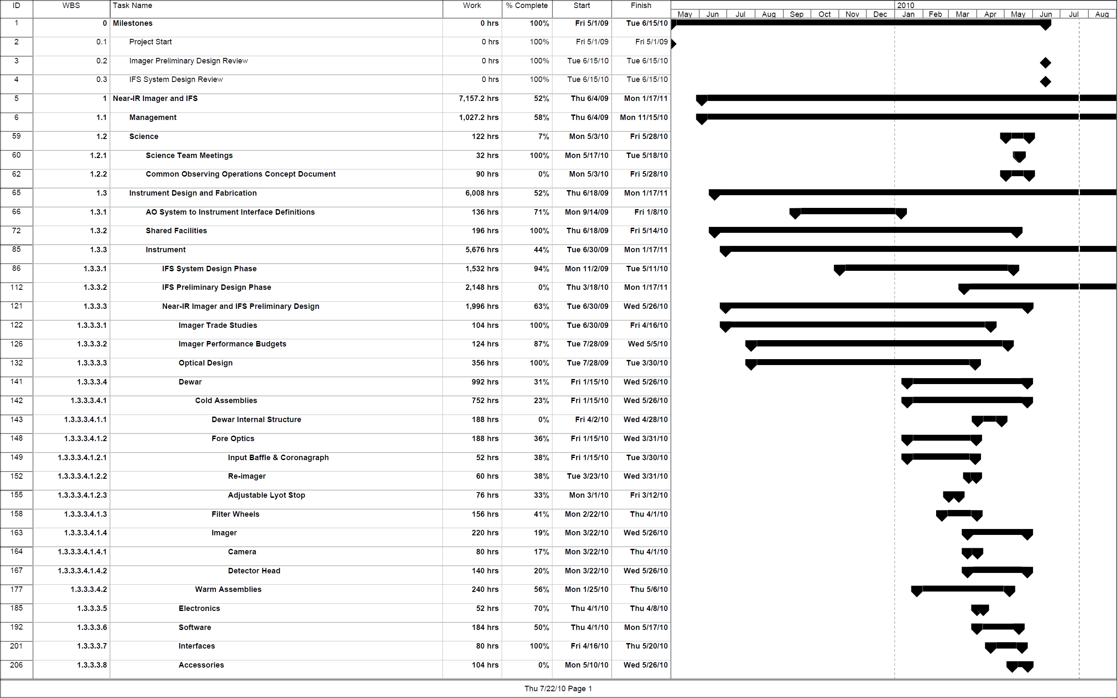

Figure 2: Tracked version of the NGAO Science Instruments schedule through June 2010

Table 3: NGAO PD Phase Expenditure Summary for Year 1 to 3 through June 2010

