 Keck Adaptive Optics Note 776

Keck Next Generation Adaptive Optics
Preliminary Design Phase Project Report #25

P. Wizinowich, Sean Adkins and the NGAO Team
June 25, 2010

Narrative

This report is the twenty-fifth monthly project report for the Preliminary Design (PD) phase in the development of the W. M. Keck Observatory’s (WMKO’s) Next Generation Adaptive Optics (NGAO) facility. This report covers the PD phase work performed in May 2010.

From a technical perspective the Preliminary Design Manual (KAON 768) released on May 24 provides the best technical update on the subsystems.

Summary
The focus in May was on wrapping up the preliminary designs, and preparing the planning and costing information to be presented at the PDR.

Management Status
The PD phase plan presented at the SDR included work under the following management WBS elements. The progress in each of these areas is discussed below.

WBS 1.3.2.1 Planning
Work continued on development of the MS Project Plan and costing spreadsheets for the Systems Engineering Management Plan.

WBS 1.3.2.2 Project Management and Meetings

WBS 1.3.2.4 Proposals
We had an initial indication that the ATI proposal for a near-IR tip-tilt sensor would be funded.

WBS 1.3.2.5 Programmatic Risk Assessment and Mitigation
The delta PDR for the TOPTICA/MPBC laser is scheduled for June 10 with the kick off meeting for the ESO laser contract and the laser final design on June 18. WMKO and TMT will be participating in this process based on the agreements in place with ESO and TOPTICA/MPBC.

Technical Status
No technical status has been provided in this report. The technical status was reported at the NGAO PDR held in June.

Keck Adaptive Optics Notes
All of the NGAO KAONs can be found at:
http://www.oir.caltech.edu/twiki_oir/bin/view/Keck/NGAO/NewKAONs.

The following KAONs were produced in May:
KAON 716, Wavefront Error Budgets
KAON 743, DAVINCI Review Report
KAON 744, Science Operations Tools
KAON 745, Calibration Unit
KAON 746, Alignment & Calibration Review Report
KAON 747, DAVINCI pupil registration
KAON 748, NGAO & the Keck Interferometer
KAON 749, Laser Enclosure Design
KAON 750, Laser Systems Support
KAON 751, LGSF Subsystem Control Sequencing
KAON 752, LGSF Safety System Controller Assembly
KAON 753, LGSF Safety System Interface Control Spreadsheet
KAON 754, LGSF Laser Traffic Control System
KAON 755, Laser Clearinghouse Planning
KAON 756, Aircraft Safety System
KAON 757, Preliminary Design Report #24
KAON 758, Laser Removal Plan
KAON 759, System Facility & Cooling
KAON 760, NGAO PDR Charge & Design Review Process
KAON 761, DAVINCI Overview & Optical Design
KAON 762, PSF Metrics, Characterization & Reconstruction
KAON 763, DAVINCI Pixel Scales & Sensitivities
KAON 764, DAVINCI Background & Zero Point Estimates
KAON 768, Preliminary Design Manual
KAON 769, Systems Engineering Management Plan
KAON 770, Preliminary Design Report
KAON 771, System Requirements Document
KAON 772, PDR Compliance Matrix

Schedule and Budget Status

Milestones
The status of the preliminary design phase milestones are shown in Table 1. The NGAO IFU SD and imager PD have been listed as complete for the optical design only.

Table 1: NGAO PD Phase Milestones

A series of mini-preliminary design reviews were identified in August, including tentative dates and reviewers (see Table 2). These reviews are intended to allow the NGAO team to wrap up and self review the designs for key subsystems in advance of the PDR. The last of these reviews was completed in May.

Table 2: Planned Mini-Preliminary Design Reviews

Schedule
A high level snapshot of the tracked version of the new schedule through May is shown in Figure 1 with 76% of the total PD phase work complete (versus > 72% complete at the end of April 2010).

A tracked version of the instrument MS Project plan, with a start date of May 1, 2009, is shown in Figure 2 with 51% of the overall work complete (versus 32% at the end of March 2009). Note that work in the instrument plan corresponding to the NGAO PD phase represents 71% of the total, so progress in support of the NGAO PD is actually at 72%. The project plan shown in figure 2 shows that while the optical design of the imager is substantially complete, and considerable progress was made on the IFS system design, the instrument’s mechanical design has not reached the level of completeness originally planned for the preliminary design phase.

Budget
The total NGAO PD phase budget (from the SEMP) was $3030k excluding contingency; the contingency was $449k. The revised total NGAO PD phase budget, based on the funded TSIP proposal, is $3276k including contingency (an overall reduction of $203k). The contingency in the new budget is $157k and we also assigned $149k for work in July and August to wrap up action items from the preliminary design review meeting. The new budget to complete the work through the design review, excluding contingency, is therefore $3276k - $157k - $149k = $2970k.

A total of $2629k has been spent through May or 89% of the budget excluding contingency (80% including contingency), compared to 76% of work completed excluding the science instrument.

Anticipated Accomplishments in the Next Period
All of the previously anticipated accomplishments through April have been completed and we have chosen not to list them here (see the April report for this list).

The anticipated accomplishments for May along with their status in italics:
- Complete functional requirements release 1. Complete.
- Complete observing operations concept document release 1. Complete.
- Complete the post build to cost replan and start tracking versus this plan. Complete.

The anticipated accomplishments for June along with their status in italics:
- Hold first NGAO Science Advisory Team meeting. Complete.

The anticipated accomplishments for July along with their status in italics:
- Document evaluation of fixed pupil mode design options. Complete.
- Document vibration mitigation work. Complete.
- Complete laser MRI-R² proposal. Complete.

The anticipated accomplishments for August along with their status in italics:
- Complete software architecture design review. Complete.

The anticipated accomplishments for September along with their status in italics:
- Complete TSIP proposal. Complete.
- NGAO presentation at the Keck Strategic Planning Meeting. Complete.

The anticipated accomplishments for October along with their status in italics:
- LGS launch facility design review. Complete.

The anticipated accomplishments for November along with their status in italics:
- Complete ATI proposal. Complete.
- AO optical design review. Complete.

The anticipated accomplishments for December along with their status in italics:
- LGS WFS design review. Complete.
- RTC design review. Complete.
- Laser preliminary design reviews. Complete.

The anticipated accomplishments for January along with their status in italics:
- Control electronics architecture review. Complete.

The anticipated accomplishments for February along with their status in italics:
- Begin work on the Systems Engineering Management Plan for the detailed design phase. Done.

The anticipated accomplishments for March along with their status in italics:
- Motion control architecture mini-review. Complete.
- Requirements database and documents put under configuration control. Complete.

The anticipated accomplishments for April along with their status in italics:
- NGS WFS mini-review. Complete.
- LOWFS mini-review. Complete.
- Control system software mini-review. Complete.
- NGAO instrument mini-review. Complete.
- Alignment, calibration & diagnostics mini-review. Complete.

The anticipated accomplishments for May along with their status in italics:
- Performance mini-review. Complete.
- Documents distributed to reviewers for PDR. Complete.

The anticipated accomplishments for June are the following:
- Preliminary Design Review.

Financial Summary

The budget, expenditures to date and estimate to completion for the NGAO project is shown in Table 3.

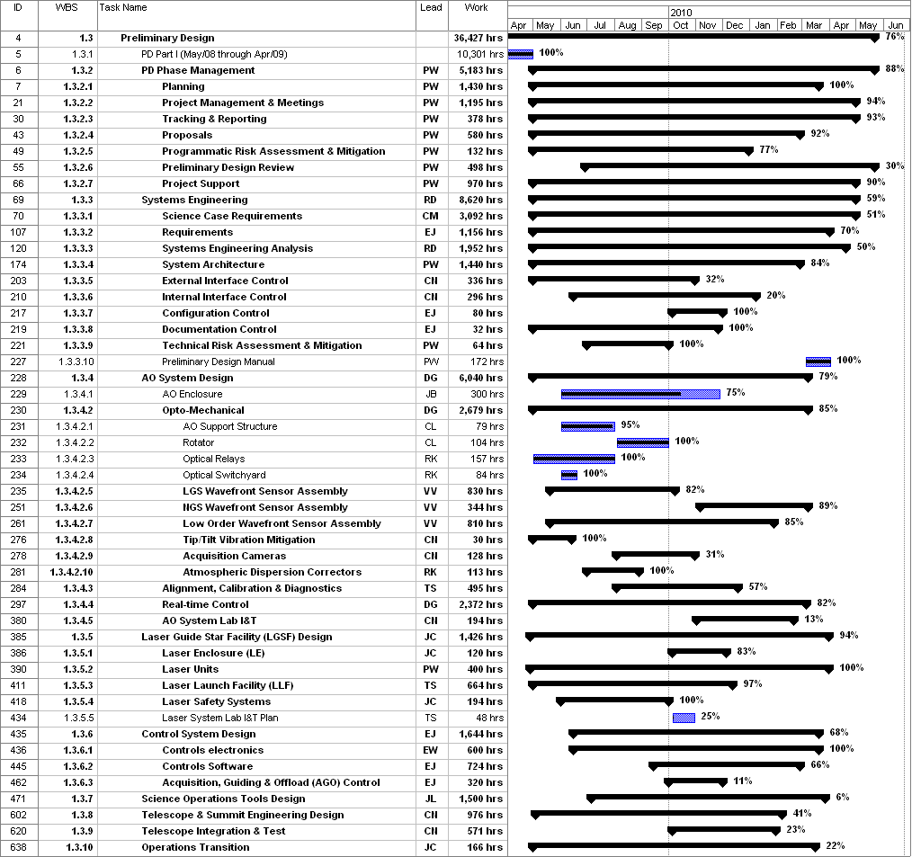
Figure 1: Tracked version of the new PD phase schedule through May 2010

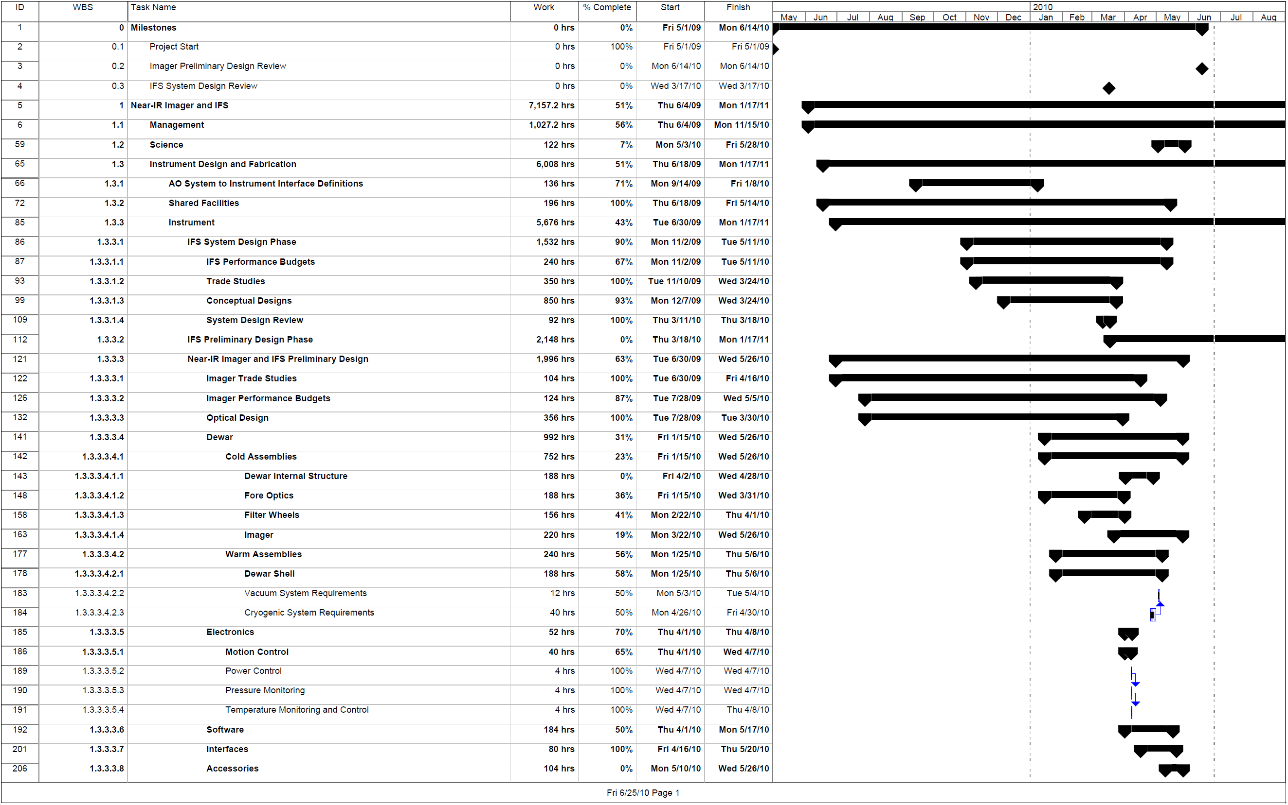

Figure 2: Tracked version of the NGAO Science Instruments schedule through May 2010

Table 3: NGAO PD Phase Expenditure Summary for Year 1 to 3 through May 2010

