 Keck Adaptive Optics Note 757

Keck Next Generation Adaptive Optics
Preliminary Design Phase Project Report #24

P. Wizinowich, Sean Adkins and the NGAO Team
May 29, 2010

Narrative

This report is the twenty-fourth monthly project report for the Preliminary Design (PD) phase in the development of the W. M. Keck Observatory’s (WMKO’s) Next Generation Adaptive Optics (NGAO) facility. This report covers the PD phase work performed in April 2010.

Unfortunately, due to the press of the upcoming PDR, updates were not available for some of the subsystems. From a technical perspective the Preliminary Design Manual (KAON 768) released on May 24 provides the best technical update on the subsystems. From a schedule update perspective we will have to fill in the missing information in a future report. The budget actuals are complete in this report.

Summary
The focus in April was on wrapping up and reviewing the preliminary designs, and preparing the planning and costing information to be presented at the PDR.

Management Status
The PD phase plan presented at the SDR included work under the following management WBS elements. The progress in each of these areas is discussed below.

WBS 1.3.2.1 Planning
Work continued on development of the WBS and MS Project Plan elements of the Systems Engineering Management Plan.

WBS 1.3.2.2 Project Management and Meetings

WBS 1.3.2.4 Proposals
The MRI proposal for a new laser was submitted.

WBS 1.3.2.5 Programmatic Risk Assessment and Mitigation
The ESO/WMKO agreement to participate in the laser final design and pre-production phases prior to WMKO funding for a laser is complete. The kick off meeting for the laser final design is scheduled for June 10.

Technical Status
The PD phase plan presented at the SDR included work under the following technical WBS elements. The progress in each of these areas is discussed below.

WBS 1.3.3.1 Science Case Requirements

WBS 1.3.3.2 Requirements

WBS 1.3.3.3 Systems Engineering Analysis

WBS 1.3.3.4 System Architecture

WBS 1.3.3.5 External Interface & 1.3.3.6 Internal Interface Control

WBS 1.3.3.7 Configuration Control

WBS 1.3.3.9 Technical Risk Assessment and Mitigation

WBS 1.3.4.1 AO Enclosure

WBS 1.3.4.2.3 Optical Relays

We completed all but two of the punch list of items from the November AO relay design mini-review (link). Alignment analysis over 0 to -15 degree cooling phase still needs to be done. Mapping the LODM/HODM pupils to the WFS pupils still needs to be done, and requires input from WFS group (the WFS optical prescriptions) to proceed.

We have resolved the major issues in the mechanical layout as it affects interfaces to the external instruments (two science instruments and interferometer) and sensors (laser and natural guidestar wavefront sensors, and LOWFS). Final beam paths and focal positions are now established (see meeting minutes here). The envelope of the cold space is well understood along with positions of the windows.

WBS 1.3.4.2.5 LGS Wavefront Sensor Assembly

WBS 1.3.4.2.6 NGS Wavefront Sensor Assembly

WBS 1.3.4.2.7 Low Order Wavefront Sensor Assembly

WBS 1.3.4.2.9 Acquisition Camera

WBS 1.3.4.3 Alignment, Calibration and Diagnostics
The design of the calibration unit continued with more optimization. The layout was adjusted to ensure there was enough room for the optical mounts and that there was no interference with the necessary motorized stages. Potential light sources were investigated, and models from Newport were found that had good features such as a power supply with control and status reporting via serial communication. A diode pumped solid state laser was found for a reasonable price from Roithner Lasertechnik that operates at 589 nm to provide the laser simulation source. These sources will be fed via fiber optics into the calibration unit to reduce heat inside the AO cold enclosure and make it easier to replace failed lamps. In an effort to reduce the overall complexity, a fixed grid of fibers will be used to provide multiple targets in the field instead of providing a reconfigurable pattern with a few movable sources. There are a few options for the flat field and spectral calibrations. In an effort to save space alternatives to a large integrating sphere were considered. One promising candidate is a woven fiber optic panel with an auxiliary diffuser. These are normally used for backlights and have good uniformity however it will require further experimentation to confirm that they are appropriate for this application.

Near the end of the month a mini-design review was held for the alignment, calibration procedures and calibration unit to help judge the project readiness for the upcoming NGAO PDR. The responses of the reviewers were favorable, and will be incorporated into the final documentation.

WBS 1.3.4.4 Real-Time Control
Work to complete the punch list of items from the review is complete.

The RTC board preliminary design work has begun. The selected contractor, Axelsys Consulting, has been meeting with us weekly and still remains on schedule to deliver in the required timeline.

WBS 1.3.5 Laser System Design
KAONs, cost estimates and MS project plans were prepared for the laser enclosure (KAON 749), laser support design (KAON 750), laser launch facility (updates to existing KAONs), safety system (KAONs 752-756). Cost estimates and MSproject plans were also prepared for the laser system lab I&T, infrastructure modifications, removal of the old laser and integration of the new laser system.

A Twiki web site was setup for management of the MRI-funded launch telescope. Design documents and weekly reports, and the initial completed monthly report, are being posted to this password protected Twiki. The following milestones have been set for the launch telescope PD phase.

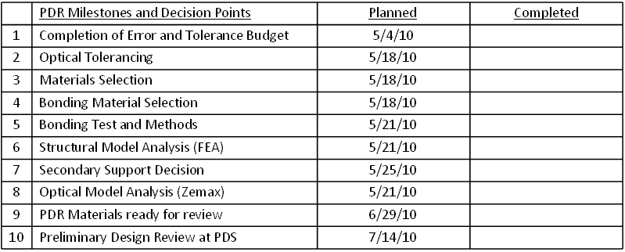

WBS 1.3.6 Control System Design
Prepared for and completed control system software mini-review on April 16, 2010. Still have not received final review committee report but it’s not holding us up. We continued to work on preliminary design software documentation in response to reviewer comments and in preparation for the actual preliminary design review and in the process completed the follow software design KAONs:
- KAON 714 Control System Design
- KAON 735 AO Facility Main Sequence
- KAON 736 LGS Facility Main Sequence
- AO and Laser Facility Collaboration Diagrams
- Incorporated comments and updates from mini-review.

WBS 1.3.7 Science Operations Tools

WBS 1.3.8 Telescope and Summit Engineering Design

WBS 1.3.9 Operations Transition

Science Instruments

Keck Adaptive Optics Notes
All of the NGAO KAONs can be found at:
http://www.oir.caltech.edu/twiki_oir/bin/view/Keck/NGAO/NewKAONs.

The following KAONs were produced in April:
KAON 714, AO Control System Design
KAON 721, Wavefront Error Budget Tool
KAON 722, High-Contrast Error Budget Tool
KAON 723, Performance Flowdown Budgets
KAON 725, DAVINCI Interface Control Document
KAON 739, Calibration Methods & Procedures
KAON 742, Preliminary Design Report #23

Schedule and Budget Status

Milestones
All of the milestones through June have been completed. The requirements PD release milestone continues to be delayed, although good progress is being made.

Table 1: NGAO PD Phase Milestones

A series of mini-preliminary design reviews were identified in August, including tentative dates and reviewers (see Table 2). These reviews are intended to allow the NGAO team to wrap up and self review the designs for key subsystems in advance of the PDR. The seventh of these reviews was completed in March.

Table 2: Planned Mini-Preliminary Design Reviews

Schedule
A high level snapshot of the tracked version of the new schedule through April is shown in Figure 1 with 72% of the total PD phase work complete (versus 65% complete at the end of March 2010). This does not include updates on the work performed at COO or on the science case requirements.

The science instrument has made considerable progress but an update is not available for this month.

Budget
The total NGAO PD phase budget (from the SEMP) was $3030k excluding contingency; the contingency was $449k. The revised total NGAO PD phase budget, based on the funded TSIP proposal, is $3276k including contingency (an overall reduction of $203k). The contingency in the new budget is $157k and we also assigned $149k for work in July and August to wrap up action items from the preliminary design review meeting. The new budget to complete the work through the design review, excluding contingency, is therefore $3276k - $157k - $149k = $2970k.

A total of $2402k has been spent through April or 81% of the budget excluding contingency (compared to >72% of work completed excluding the science instrument).

Anticipated Accomplishments in the Next Period
All of the previously anticipated accomplishments through April have been completed and we have chosen not to list them here (see the April report for this list).

The anticipated accomplishments for May along with their status in italics:
- Complete functional requirements release 1. Complete.
- Complete observing operations concept document release 1. Complete.
- Complete the post build to cost replan and start tracking versus this plan. Complete.

The anticipated accomplishments for June along with their status in italics:
- Hold first NGAO Science Advisory Team meeting. Complete.

The anticipated accomplishments for July along with their status in italics:
- Document evaluation of fixed pupil mode design options. Complete.
- Document vibration mitigation work. Complete.
- Complete laser MRI-R² proposal. Complete.

The anticipated accomplishments for August along with their status in italics:
- Complete software architecture design review. Complete.

The anticipated accomplishments for September along with their status in italics:
- Complete TSIP proposal. Complete.
- NGAO presentation at the Keck Strategic Planning Meeting. Complete.

The anticipated accomplishments for October along with their status in italics:
- LGS launch facility design review. Complete.

The anticipated accomplishments for November along with their status in italics:
- Complete ATI proposal. Complete.
- AO optical design review. Complete.

The anticipated accomplishments for December along with their status in italics:
- LGS WFS design review. Complete.
- RTC design review. Complete.
- Laser preliminary design reviews. Complete.

The anticipated accomplishments for January along with their status in italics:
- Control electronics architecture review. Complete.

The anticipated accomplishments for February along with their status in italics:
- Begin work on the Systems Engineering Management Plan for the detailed design phase. Done.

The anticipated accomplishments for March along with their status in italics:
- Motion control architecture mini-review. Complete.
- Requirements database and documents put under configuration control. Complete.

The anticipated accomplishments for April along with their status in italics:
- NGS WFS mini-review. Complete.
- LOWFS mini-review. Complete.
- Control system software mini-review. Complete.
- NGAO instrument mini-review. Complete.
- Alignment, calibration & diagnostics mini-review. Complete.

The anticipated accomplishments for May are the following:
- Performance mini-review.
- Documents distributed to reviewers for PDR.

Financial Summary

The budget and expenditures to date for year 1 of the NGAO project were provided in KAON 665 (Project Report 13; the year 1 expenditures totaled $729k). The budget, expenditures to date and estimate to completion for year 2 of the NGAO project, which began in May 2009, is shown in Table 3.

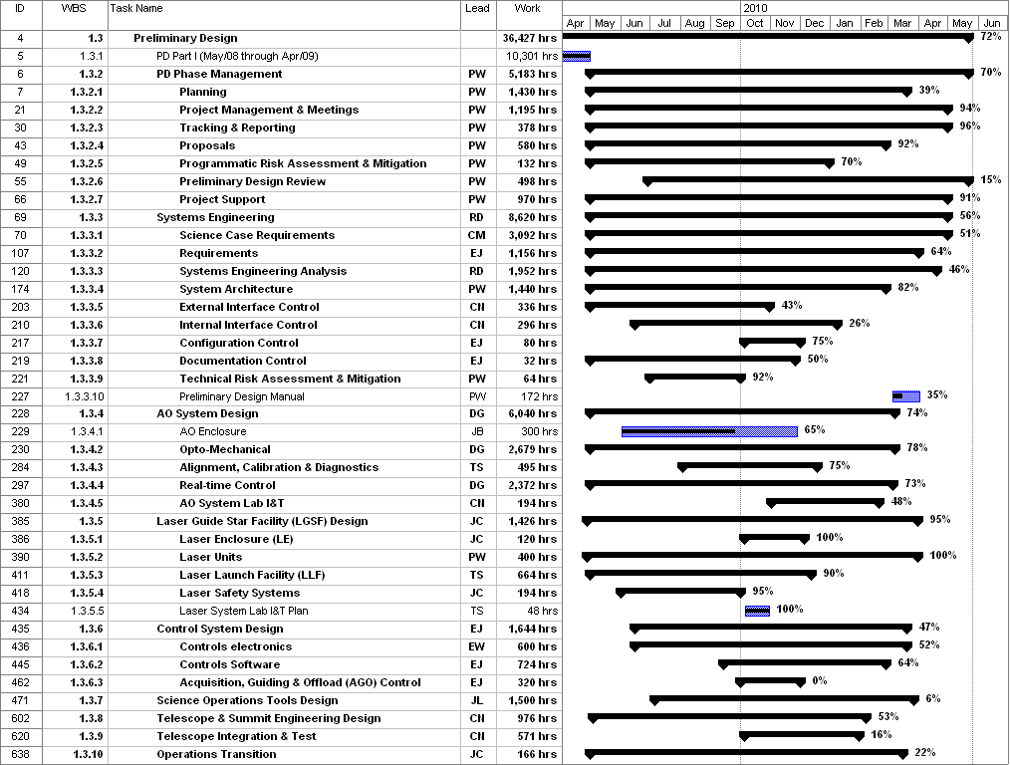
Figure 1: Tracked version of the new PD phase schedule through April 2010

Figure 2: Tracked version of the NGAO Science Instruments schedule through April 2010

Table 3: NGAO PD Phase Expenditure Summary for Year 2 through April 2010

