 Keck Adaptive Optics Note 742

Keck Next Generation Adaptive Optics
Preliminary Design Phase Project Report #23

P. Wizinowich, Sean Adkins and the NGAO Team
April 28, 2010

Narrative

This report is the twenty-third monthly project report for the Preliminary Design (PD) phase in the development of the W. M. Keck Observatory’s (WMKO’s) Next Generation Adaptive Optics (NGAO) facility. This report covers the PD phase work performed in March 2010.

Summary
The technical team is making good progress on the requirements and design.

Management Status
The PD phase plan presented at the SDR included work under the following management WBS elements. The progress in each of these areas is discussed below.

WBS 1.3.2.1 Planning
Work continued on development of the WBS and MS Project Plan elements of the Systems Engineering Management Plan.

WBS 1.3.2.2 Project Management and Meetings

WBS 1.3.2.4 Proposals
As reported earlier we plan to submit a MRI proposal for a new laser. A draft project description was generated and distributed for comment. Progress was made on the schedule and budget required for this proposal.

WBS 1.3.2.5 Programmatic Risk Assessment and Mitigation
The ESO/WMKO agreement to participate in the laser final design and pre-production phases prior to WMKO funding for a laser was signed on the WMKO side.

Technical Status
The PD phase plan presented at the SDR included work under the following technical WBS elements. The progress in each of these areas is discussed below.

WBS 1.3.3.1 Science Case Requirements
This month we worked with the instrument team to pin down background and zero point values for DAVINCI, the visible and near-IR imager and integral field spectrograph. We also spent time comparing our sensitivity with that of IRIS for the TMT and worked with the TMT science team to find suitable narrow-band images of local star-forming galaxies that can be used for IFU performance simulations of high-z galaxies. We have modified our scripts for the IFU simulations in order to bring them up-to-date with the current instrument design and will be starting full-scale simulations next month. We also participated in the mini-review of system and functional requirements early this month.

Next month we will work predominantly on IFU simulations and on writing up the findings from our imaging simulations for the PDR documents.

WBS 1.3.3.2 Requirements
As part of the requirements review process the systems engineering team has been preparing for placement of all requirements and change-controlled documents under formal change control. Details of the change-control review process outlined in KAON 638 during the system design phase are being reviewed ahead of this capture.

A major review of the preliminary phase requirements was performed in March. Over 200 work-hours of project effort were dedicated to finalizing the system requirements, derived subsystem functional requirements, and associated performance flowdowns. We adopted a two-tier system to complement the Contour requirements database with a set of change-controlled documents (often spreadsheets) that capture the system and subsystem-level flowdowns for allocable values such as observing sequence time allocation and electrical power consumption. Numerous minor issues of consistency among database requirements were ironed out, allowing the design teams to proceed to their final design choices ahead of the June preliminary design review. Revisions were made directly in the Contour database. The overall organization of the NGAO product in the database was changed to better reflect the Product Breakdown Structure.

Each major subsystem design will be checked for compliance with the requirements at the subsystem and system level. A standardized compliance matrix packet was produced from Contour. This report will be completed by the lead engineers of each system.

A glossary of standard NGAO terms was produced to aid in establishing consistent names for NGAO components.

WBS 1.3.3.3 Systems Engineering Analysis
An updated DM servo model was implemented as part of the v2.0 release of KAON 721, the Wavefront Error Budget Tool spreadsheet. The model allows for calculation of the servo bandwidth error as a function of the computation delay and CCD read out rate. This was implemented using KAON 710 eq. 13 and a quadratic fit to eq. 15. This was implemented for both the high order fixed LGS WFS and separately for the patrolling LGS WFS.

NGAO PSF links were provided to science team members to support science simulations.

WBS 1.3.3.4 System Architecture

WBS 1.3.3.5 External Interface & 1.3.3.6 Internal Interface Control

WBS 1.3.3.7 Configuration Control

WBS 1.3.3.9 Technical Risk Assessment and Mitigation

WBS 1.3.4.1 AO Enclosure

WBS 1.3.4.2.3 Optical Relays
The punch list of items from the November AO relay design mini-review (link) is nearly complete. However, during March work was instead focused on the instrument design and in responding to the needs of the systems engineering group regarding performance budgets. The expected completion date has been revised to April 30.

We continue to work on the details of the mechanical layout as it affects interfaces to the external instruments (two science instruments and interferometer) and sensors (LGS & NGS wavefront sensors, and LOWFS). Considerable progress has been made (see meeting minutes here) in establishing the final beam paths and focal positions. The envelope of the cold space is now fairly well understood with reasonable positions for output windows established.
We continue to have great difficulty in reliably connecting with the WMKO CAD vault system for SolidWorks/PDM Works. This problem, which has adversely affected productivity on the mechanical design activities, appears to have no resolution other than purchasing expensive server software add-ons or switching to a different software package.

WBS 1.3.4.2.5 LGS Wavefront Sensor Assembly
Progress was made on updating the LGS WFS KAON after the mini-review to release a final version that can be included as such in the NGAO design manual.

WBS 1.3.4.2.6 NGS Wavefront Sensor Assembly
A NGS WFS design was produced for review at the NGS WFS mini-review scheduled for April 1. The NGSWFS team is working now to complete a KAON that describes the design.

WBS 1.3.4.2.7 Low Order Wavefront Sensor Assembly
Most of the opto-mechanical design for the LOWFS was finalized. A first draft of the design document was prepared for the LOWFS mini-review scheduled for April 2. We have received initial reviewer comments, and we will be working on addressing these comments, and incorporating them into our design accordingly.

The cryostat packaging is settling down. The thermal calculations have been done and the cryo-cooler has sufficient cooling power for our needs. Packaging of the LOWFS system is also underway, and we are iterating on this design and the impact it has on the second stage relay design.

The preliminary optical design for the TT and TTFA is complete. This will be revised based upon the mini-review comments. This optical design has been incorporated into the opto-mechanical system design. The truth wavefront sensor, TWFS will be done in April and a method of incorporating it into the TTFA arm will be completed. Conversations have begun with a coating vendor on a custom J+H bandpass filter that will cover both bands. This will be pursued with other vendors as well.

Now that the cryostat design is complete, we are now working on packaging issues with the rest of the NGAO system. This stage of the process is likely to impose some changes in the LOWFS optical design which will then be iterated. We are confident that with minor changes, this design can be made to work.

WBS 1.3.4.2.9 Acquisition Camera

WBS 1.3.4.3 Alignment, Calibration and Diagnostics
Draft KAONs were produced on the alignment and calibration approaches and these were distributed for comment. A draft KAON on diagnostics was begun. The requirements for and design of the calibration unit were further developed.

Significant progress was made on the optical design of the calibration unit. Several different designs were examined, including ones based on off-axis Cassegrain telescope forms, Schwarzschild telescope forms, three mirror anastigmats, off-axis parabolas, and Offner relays. A design based on an Offner relay was chosen due to its low wavefront error, relatively compact nature, and spherical surfaces. A layout was created that allows simultaneous use of NGS and LGS simulation sources and includes a port with a beam splitter so that a flat field source can be included without the need for another active stage. The Offner design was then imported into the model of the AO bench to verify the availability of space and maintenance access.

WBS 1.3.4.4 Real-Time Control
The mini-review for the RTC design took place on December 10. Documents for the review, including reviewers’ comments and reviewers’ final report, are posted to the NGAO twiki page (link). Work to complete the punch list of items from the review in nearly complete. We expect full completion by mid April.
A study examining the relationship of latency to controller bandwidth error in the hybrid open-loop tweeter / closed-loop woofer system is being updated to account for wavefront sensor spatial filtering. A revision to the report is in progress.

A supplier for the RTC board preliminary design work has been selected based on an evaluation of three bidders (one of which was eventually a no-bid). The selected supplier is Axelsys Consulting, which has a strong background in FPGA design work, underbid Xilinx Design Services on cost, and appeared to be more likely to be able to achieve the deliverables in the required timeline. The no-bid was Microgate Engineering after it was established that they had no experience with our baselined Xilinx FPGA devices. The phase 1 deliverable from the contract to Axelsys will be completed in time for the PDR.

WBS 1.3.5 Laser System Design

A contract for the MRI funded Keck II launch telescope was issued to RC Optical. The project official start date is April 12.

Reviewed laser technical specification with manufacturer to determine if requirements can be scaled back for cost savings. The goal is to find commonality with the ESO specifications and not introduce unwarranted requirements. Laser manufacturer has produced a new quote for the MRI proposal. Additional information is required from the manufacturer for the quote process.

WBS 1.3.6 Control System Design
The bulk of the control system team’s time was spent preparing for the motion control architecture mini-review which was completed on March 11 and the controls software mini-review scheduled for April 16. The review committee report on the motion control architecture mini review can be accessed as KAON 731. This review involved gathering and reviewing of requirements and design document preparation. Work continues on the software controls collaboration diagrams and the AO sequencer. Effort is starting on the motion and device control software architecture.

WBS 1.3.7 Science Operations Tools
Progress was made on the science operations tools design document.

WBS 1.3.8 Telescope and Summit Engineering Design
The facility power and cooling requirements document is nearly complete regarding the availability of power and cooling for the NGAO system. With the removal of the Keck II laser there should be sufficient power and cooling to support NGAO.

WBS 1.3.9 Operations Transition

Science Instruments
In March we completed an all refractive design for the imager channel of DAVINCI. This design uses two pairs of off axis parabolas (OAPs). The first OAP pair forms a pupil image at a plane where a selection of pupil masks is located to provide cold stops for the near-IR bands, including a mask that is matched to the primary mirror pupil shape for the K band, and undersize masks for the coronagraphic mode. The output of the first OAP pair is an intermediate focal plane where a plane mirror sends all of the light to the imager, or a mirror with a central (~5" diameter) hole sends the on-axis light to the IFS channel of DAVINCI. The second OAP pair forms the image at the desired plate scale on the imager detector, a Hawaii-4RG.

We have obtained quotations for the hybrid slicer mirrors, one for fabrication using diamond turning, and the second for fabrication from Zerodur using conventional polishing and optical contact bonding. Both quotations support our requirements for surface quality and tolerancing.

We have also completed documents describing the predicted backgrounds and point source sensitivities for DAVINCI, and these are currently being reviewed by members of the science team.

Our next steps are to complete the modeling of the spectral formatting from the IFS, and to write the report document for the mini-review scheduled for April 19.

The modification of the MOSFIRE dewar for DAVINCI has been completed, and will form the basis for further development of the instrument’s packaging concept.

Keck Adaptive Optics Notes
All of the NGAO KAONs can be found at:
http://www.oir.caltech.edu/twiki_oir/bin/view/Keck/NGAO/NewKAONs.

The following KAONs were produced in March:
KAON 713, LTCS URL Interface Specifications
KAON 715, NGAO Preliminary Motion Control Design
KAON 717, NGAO Telescope Tube Flexure Measurements for Keck 2
KAON 719, NGAO AO System Alignment Plan
KAON 720, NGAO Preliminary Design Phase Risk Evaluation
KAON 728, Preliminary Design Report #22
KAON 731, Motion Control Architecture Reviewer Report

Schedule and Budget Status

Milestones
All of the milestones through June have been completed. The requirements PD release milestone continues to be delayed, although good progress is being made.

Table 1: NGAO PD Phase Milestones

A series of mini-preliminary design reviews were identified in August, including tentative dates and reviewers (see Table 2). These reviews are intended to allow the NGAO team to wrap up and self review the designs for key subsystems in advance of the PDR. The seventh of these reviews was completed in March.

Table 2: Planned Mini-Preliminary Design Reviews

Schedule
A high level snapshot of the tracked version of the new schedule through January is shown in Figure 1 with 65% of the total PD phase work complete (versus 62% complete at the end of February 2010).

A tracked version of the instrument MS Project plan, with a start date of May 1, 2009, is shown in Figure 2 with 32% of the overall work complete (versus 27% at the end of February 2009). Note that work in the instrument plan corresponding to the NGAO PD phase represents 71% of the total, so progress in support of the NGAO PD is actually at 45%. This schedule shows the tasks in progress now or that are planned to start in April 2010. Continued lack of mechanical resources will likely reduce the percentage of the instrument’s mechanical design that reaches the PDR level by the time of the June NGAO PDR. We are reasonably confident that the optical design will reach the PDR level.

Budget
The total NGAO PD phase budget (from the SEMP) was $3030k excluding contingency; the contingency was $449k. The revised total NGAO PD phase budget, based on the funded TSIP proposal, is $3276k including contingency (an overall reduction of $203k). The contingency in the new budget is $157k and we also assigned $149k for work in July and August to wrap up action items from the preliminary design review meeting. The new budget to complete the work through the design review, excluding contingency, is therefore $3276k - $157k - $149k = $2970k.

A total of $2187k has been spent through March or 74% of the budget excluding contingency (compared to 65% of work completed excluding the science instrument).

Anticipated Accomplishments in the Next Period
All of the previously anticipated accomplishments through April have been completed and we have chosen not to list them here (see the April report for this list).

The anticipated accomplishments for May along with their status in italics:
- Complete functional requirements release 1. Continues to be delayed.
- Complete observing operations concept document release 1. Complete.
- Complete the post build to cost replan and start tracking versus this plan. Complete.

The anticipated accomplishments for June along with their status in italics:
- Hold first NGAO Science Advisory Team meeting. Complete.

The anticipated accomplishments for July along with their status in italics:
- Document evaluation of fixed pupil mode design options. Complete.
- Document vibration mitigation work. Complete.
- Complete laser MRI-R² proposal. Complete.

The anticipated accomplishments for August along with their status in italics:
- Complete software architecture design review. Complete.

The anticipated accomplishments for September along with their status in italics:
- Complete TSIP proposal. Complete.
- NGAO presentation at the Keck Strategic Planning Meeting. Complete.

The anticipated accomplishments for October along with their status in italics:
- LGS launch facility design review. Complete.

The anticipated accomplishments for November along with their status in italics:
- Complete ATI proposal. Complete.
- AO optical design review. Complete.

The anticipated accomplishments for December along with their status in italics:
- LGS WFS design review. Complete.
- RTC design review. Complete.
- Laser preliminary design reviews. Complete.

The anticipated accomplishments for January along with their status in italics:
- Control electronics architecture review. Complete.

The anticipated accomplishments for February along with their status in italics:
- Begin work on the Systems Engineering Management Plan for the detailed design phase. Done.

The anticipated accomplishments for March along with their status in italics:
- Motion control architecture mini-review. Complete.
- Requirements database and documents put under configuration control. Complete.

The anticipated accomplishments for April are the following:
- NGS WFS mini-review.
- LOWFS mini-review.
- Control system software mini-review.
- NGAO instrument mini-review.
- Alignment, calibration & diagnostics mini-review.

Financial Summary

The budget and expenditures to date for year 1 of the NGAO project were provided in KAON 665 (Project Report 13; the year 1 expenditures totaled $729k). The budget, expenditures to date and estimate to completion for year 2 of the NGAO project, which began in May 2009, is shown in Table 3.

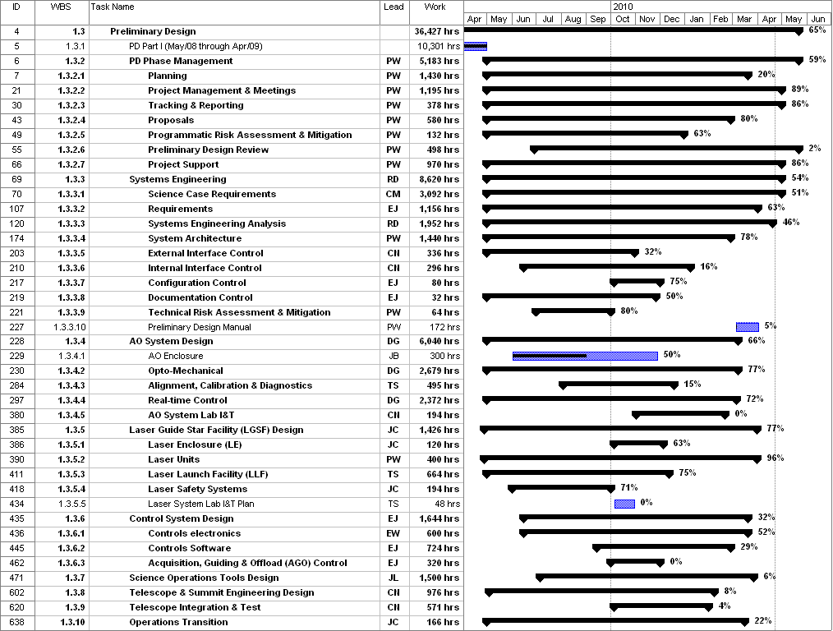
Figure 1: Tracked version of the new PD phase schedule through March 2010

Figure 2: Tracked version of the NGAO Science Instruments schedule through March 2010

Table 3: NGAO PD Phase Expenditure Summary for Year 2 through March 2010

