 Keck Adaptive Optics Note 712

Keck Next Generation Adaptive Optics
Preliminary Design Phase Project Report #21

P. Wizinowich, Sean Adkins and the NGAO Team
February 22, 2010

Narrative

This report is the twenty-first monthly project report for the Preliminary Design (PD) phase in the development of the W. M. Keck Observatory’s (WMKO’s) Next Generation Adaptive Optics (NGAO) facility. This report covers the PD phase work performed in January 2010.

Summary
The technical team is making good progress on the requirements and design.

Management Status
The PD phase plan presented at the SDR included work under the following management WBS elements. The progress in each of these areas is discussed below.

WBS 1.3.2.1 Planning

WBS 1.3.2.2 Project Management and Meetings
We continued to work with the Directors to identify the reviewers for the June 2010 NGAO PDR.

WBS 1.3.2.4 Proposals
The MRI-R2 proposal for the first NGAO laser was unsuccessful. The reviewer comments were quite positive and the proposal was recommended for funding, but did not sit high enough in the ranking to actually receive funds. Specific weaknesses were identified by the reviewers that we feel can be addressed. TMT supports resubmission of this proposal by WMKO for the April 2010 MRI proposal call. Observatory management is also favoring a re-submittal but an official decision has not yet been made.

WBS 1.3.2.5 Programmatic Risk Assessment and Mitigation

Technical Status
The PD phase plan presented at the SDR included work under the following technical WBS elements. The progress in each of these areas is discussed below.

WBS 1.3.3.1 Science Case Requirements
This month we reviewed and revised the science parameters to be used as inputs to the performance budgets. The largest adjustment was requiring that the performance be evaluated using a higher Galactic latitude for a few of the science cases. This change was made based on the desire to be able to target sources with large amounts of ancillary data from both ground and space-based observatories. We also continued working on the high-z galaxies simulations to evaluate NGAO’s potential to resolve galaxy structure and recover physical properties such as bulge-to-disk ratios, effective radii, and stellar populations using imaging.

Next month we plan to continue the high-z galaxy simulations and make progress on the integral field spectroscopic science case. We will work with the instrument team to modify our current spectral simulation tool to incorporate the latest instrument design. We also plan to collaborate with members of the TMT science team on these spectral simulations so that we can develop a consistent way to evaluate each system’s performance.

WBS 1.3.3.2 Requirements
Significant progress made towards SRD release 2. Most of the problem requirements from the original SRD have been resolved. The “instrument baseline” requirements (now called Keck Standards) have been included as a section of the SRD in Contour.

The FRD reorganization inside the Contour database has been completed. About 75% of the requirement revisions from the mini-reviews have been completed. The FRD review over the summer has left significant work for the systems engineering team to complete a releasable version of the functional requirements.

Relationships between the SRD and FRD requirements are continuing to be inserted. This will allow us to create a traceability matrix in the future. This process has identified a number of missing FRD requirements that were then created.

An initial update to the NGS WFS requirements has been made in the Contour database.

WBS 1.3.3.3 Systems Engineering Analysis
A list of analysis action items from the mini-reviews is being tracked. These lists contain items that require future analysis at a systems level to support future design work.

Evaluation of the revised key science cases has begun by inputting the new parameters in the wavefront error budget spreadsheet tool. A number of minor bug fixes will be applied to the spreadsheet tool prior to generation of a full set of performance predictions and corresponding modifications to the flowdown budgets.

WBS 1.3.3.4 System Architecture
In support of the control system design a KAON was produced describing the required control loops and functionality; the focus control algorithm was also provided.

WBS 1.3.3.5 External Interface & 1.3.3.6 Internal Interface Control
Discussions on the AO system internal interfaces continued with focus on the AO relay, bench, and wavefront sensor subsystems. Several packaging issues for the 2nd stage DM and LOWFS interface have been identified.

WBS 1.3.3.7 Configuration Control

WBS 1.3.3.9 Technical Risk Assessment and Mitigation

WBS 1.3.4.1 AO Enclosure

WBS 1.3.4.2.3 Optical Relays
We are continuing to complete the punch list items from the AO relay design mini-review. The AO design document, along with presentations and reviewer’s report from the review is posted on the NGAO Twiki page (link). Progress in January:
- We continue to work on the packaging and mounting issues of the second relay in the region of the LOWFS.
- We are trying to work details of the mechanical layout as it affects the cold enclosure. We are having difficulty reliably connecting to the Keck CAD vault system and this is significantly hampering our productivity in collaborating. It does not appear there is an easy solution to this problem as it has been traced down to an extremely slow data link between UCSC and WMKO.
- Revisions to the mechanical layout now show feasible interfaces with the telescope simulator and the acquisition camera. Work is ongoing to fit this in with the enclosure scheme.
- We have been hosting bi-weekly telecon meetings to facility discussions of engineering the interfaces to the LOWFS, HOWFS, enclosure, instruments, and telescope. Meeting notes are posted on the AO System Design web page.

WBS 1.3.4.2.5 LGS Wavefront Sensor Assembly
The LGS Solid Work 3D Model has been modified to comply with the mini-review request to decrease the overall length of the patrolling asterism optical beam by reducing the fold mirror angle. A 60 degree reduction of the fold mirror angle shortened the beam by 59 mm.

To also satisfy a request made during the mini-review, a video animation of the pick off arm was created to demonstrate the mechanism in motion.

A backlash elimination device was designed to eliminate the rotation stage internal play of the pick off stages.

Replacing the fixed asterism pick off with a tetrahedron is still in question pending the decision of individually adjusting each channel axially.

WBS 1.3.4.2.6 NGS Wavefront Sensor Assembly
A memorandum was written about the different possible configurations for NGS WFS indicating the pros and cons of each of the configurations. Two designs of the configurations of the NGS WFS will now be produced, viz. one which reformats the f/# feeding the NGS WFS and one where the lenslet and the post-lenslet relay will translate laterally as compared to just moving the lenslet.

WBS 1.3.4.2.7 Low Order Wavefront Sensor Assembly
We now have a Zemax optical design for the NGAO LOWFS TT. This design uses real lenses to do proper imaging onto the tip/tilt sensor. From the spot diagrams it’s clear that these lenses provide excellent imaging over the bandpass. For this system, we have a final f/# that is close to 6. This gives a ~50 mas/pixel plate scale assuming the 18 μm HAWAII 1 or 2RG pixels.

Randy Bartos (JPL) has come up to speed on SolidWorks. We had a productive meeting with Roger Smith where we gleaned valuable information about array mounting, electrical feedthrus, getters, shielding, and the like. We have also been in contact with engineers at both Teledyne and GL Scientific with regards to details of the array mounting and the flex cable and cable assemblies.

From these discussions, a conceptual mechanical design has been created and is in the process of further designing the model in Solid Works. Currently, the outer diameter of the cryostat housing is 6 inches. For the wiring, the current plan is to have a small number of flex cables that feed through the wall of the cryostat. These Hirose connectors will attach to an interface card where connectors for housekeeping and array electronics will mate.

WBS 1.3.4.2.9 Acquisition Camera

WBS 1.3.4.3 Alignment, Calibration and Diagnostics

WBS 1.3.4.4 Real-Time Control
The mini-review for the RTC design took place on December 10. Documents for the review, including reviewers’ comments and reviewers’ final report, are posted to the NGAO Twiki page (link).
- Work is in progress to complete the punch list of items resulting from the review. The design documents are being revised accordingly.
- A study examining the relationship of latency to controller bandwidth error in the hybrid open-loop tweeter/closed-loop woofer system was performed. A revision to the report is in progress incorporating suggestions given during the presentation to the systems engineering group.
- A considerable number of suggested functional requirement changes and additions have resulted from the mini-design review. These have been delivered to the systems engineering group.
- We have had fruitful discussions with some potential vendors for the FPGA initial hardware design work, who are now in the process of preparing quotations. We expect to initiate a short-term contract for preliminary level design work on board layout in mid-February, to be completed in time for the June 2010 PDR.

WBS 1.3.5 Laser System Design

Discussions are ongoing with the two laser vendors regarding common and delta specifications for the WMKO and TMT lasers. The final PDR reports were completed and both vendors met the PDR requirements. A decision with regards to the chosen vendor will be made in February.

The selection of the beam generation system (BGS) motors for the deployable lasers is still unanswered although the baseline design has a stage that is capable of meeting the specifications. The current drawings have this stage represented. The drawings have also been changed to reflect the changing gravity vector so there is minimal mass on the stage affected by gravity.

A new set of drawings have been completed to the PDR level to show the beam transport optics from the switchyard to the BGS. Final revisions are being made to complete this set.

New drawings have been generated to show the lasers in the switchyard assembly. This provides the relative scale of new lasers with respect to the switchyard and laser service enclosure. Considerations were made to support maintenance and servicing of the lasers.

The launch telescope selection has been narrowed down to two competitors. The team is visiting one competitor in February to assist with the selection process.

WBS 1.3.6 Control System Design
In preparing architecture documentation for the controls systems architecture mini-review we realized that we were shaky on the requirements and started probing for whatever requirements we could find. A search of the Contour database exposed how much we weren’t aware of and thus began the tedious process of reviewing each requirement and attempting to address them. An area of particular concern is the power budget and investigation into this continues. These were all presented as part of the mini-review which was acceptable to the review committee. The work of refining each controls systems requirement continues and will be also looked at from a motion control perspective as well. We also started detailed probing of the controls software requirements and will be going through the same process of reviewing and refining each requirement.

Detailed definition and documentation of the laser and AO sequences continue. We have also been continuing work on laser component design document and designing of loop control routines and of course requirements review. Prototyping of the SMC (state machine compiler) state machines with Java under Eclipse has started.

WBS 1.3.8 Telescope and Summit Engineering Design

WBS 1.3.9 Operations Transition

Science Instruments
In January work continued on the optical design for the imager and the IFS slicer. The imager design work included finalizing the collimator and the relay to the intermediate focal plane where the deployable IFS pick-off will be located. Further work was also done on simulation of the Coronagraph. The next step in the imager design is to complete the imager camera and then transfer the resulting Zemax layout into SolidWorks to determine any needed folds and the exact configuration in the dewar.
The hybrid slicer design has reached a sufficient state of maturity that we are able to estimate its throughput, and to begin contacting vendors for quotations on the two sets of mirrors required by the design. Once our new senior mechanical engineer is on board in February he will be tasked with preparing the necessary drawings for these mirrors and will also work with the optical designer for the imager (Renate Kupke at UCSC) to configure the imager’s optical path inside the dewar.

A portion of the preliminary design work for the mechanisms, in particular the filter wheels, pupil mask wheel, and coronagraph wheel will be subcontracted to UCO/Lick mechanical engineering staff due to the lack of mechanical engineering support at WMKO.

Progress has been made on the development of the instrument requirements and the development of performance predictions for the IFS. We are planning to hold a “mini” review of the optical design and performance predictions for the imager, the overall layout, and the conceptual design of the IFS in mid-March.

Keck Adaptive Optics Notes
All of the NGAO KAONs can be found at:
http://www.oir.caltech.edu/twiki_oir/bin/view/Keck/NGAO/NewKAONs.

The following KAONs were produced in January:
KAON 701, Preliminary Electronics Design
KAON 703, Preliminary Design Report #20
KAON 704, Opto-mechanical Registration Tolerances for “go-to” AO
KAON 705, AO-Level Control Loops

Schedule and Budget Status

Milestones
All of the milestones through June have been completed. The requirements PD release milestone continues to be delayed, although good progress is being made.
Table 1: NGAO PD Phase Milestones

A series of mini preliminary design reviews were identified in August, including tentative dates and reviewers (see Table 2). These reviews are intended to allow the NGAO team to wrap up and self review the designs for key subsystems in advance of the PDR. The sixth of these reviews was completed in January. The next reviews are scheduled for March. The dates for most of these reviews have been changed since the last report.

Table 2: Planned Mini Preliminary Design Reviews

Schedule
A high level snapshot of the tracked version of the new schedule through January is shown in Figure 1 with 59% of the total PD phase work complete (versus 57% complete at the end of December 2009).

A tracked version of the instrument MS Project plan, with a start date of May 1, 2009, is shown in Figure 2 with 20% of the overall work complete (versus 15% at the end of December 2009). Note that work in the instrument plan corresponding to the NGAO PD phase represents 71% of the total, so progress in support of the NGAO PD is actually at 28%. This schedule shows the tasks in progress now or that are planned to start in February 2010. Note that obtaining adequate mechanical engineering resources is now critical and must represent a significant portion of the effort completed in the coming months in order to make the needed progress to PDR.

Budget
The total NGAO PD phase budget (from the SEMP) was $3030k excluding contingency; the contingency was $449k. The revised total NGAO PD phase budget, based on the funded TSIP proposal, is $3276k including contingency (an overall reduction of $203k). The contingency in the new budget is $157k and we also assigned $149k for work in July and August to wrap up action items from the preliminary design review meeting. The new budget to complete the work through the design review, excluding contingency, is therefore $3276k - $157k - $149k = $2970k.

A total of $1875k has been spent through December or 63% of the budget excluding contingency (compared to 59% of work completed).

Anticipated Accomplishments in the Next Period
All of the previously anticipated accomplishments through April have been completed and we have chosen not to list them here (see the April report for this list).

The anticipated accomplishments for May along with their status in italics:
- Complete functional requirements release 1. Continues to be delayed.
- Complete observing operations concept document release 1. Complete.
- Complete the post build to cost replan and start tracking versus this plan. Complete.

The anticipated accomplishments for June along with their status in italics:
- Hold first NGAO Science Advisory Team meeting. Complete.

The anticipated accomplishments for July along with their status in italics:
- Document evaluation of fixed pupil mode design options. Complete.
- Document vibration mitigation work. Complete.
- Complete laser MRI-R² proposal. Complete.

The anticipated accomplishments for August along with their status in italics:
- Complete software architecture design review. Complete.

The anticipated accomplishments for September along with their status in italics:
- Complete TSIP proposal. Complete.
- NGAO presentation at the Keck Strategic Planning Meeting. Complete.

The anticipated accomplishments for October along with their status in italics:
- LGS launch facility design review. Complete.

The anticipated accomplishments for November along with their status in italics:
- Complete ATI proposal. Complete.
- AO optical design review. Complete.

The anticipated accomplishments for December along with their status in italics:
- LGS WFS design review. Complete.
- RTC design review. Complete.
- Laser preliminary design reviews. Complete.

The anticipated accomplishments for January along with their status in italics:
- Control electronics architecture review. Complete.

The anticipated accomplishments for February are the following:
- Begin work on the Systems Engineering Management Plan for the detailed design phase.

Financial Summary

The budget and expenditures to date for year 1 of the NGAO project were provided in KAON 665 (Project Report 13; the year 1 expenditures totaled $729k). The budget, expenditures to date and estimate to completion for year 2 of the NGAO project, which began in May 2009, is shown in Table 3.

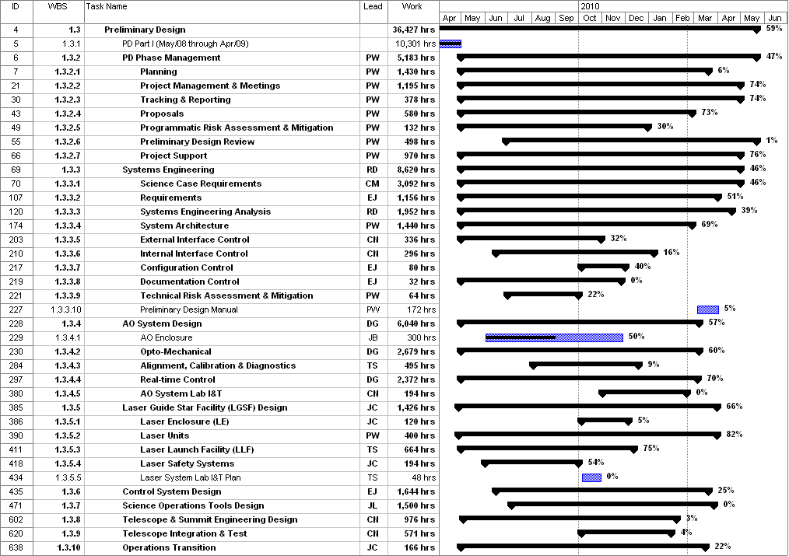
Figure 1: Tracked version of the new PD phase schedule through January 2010

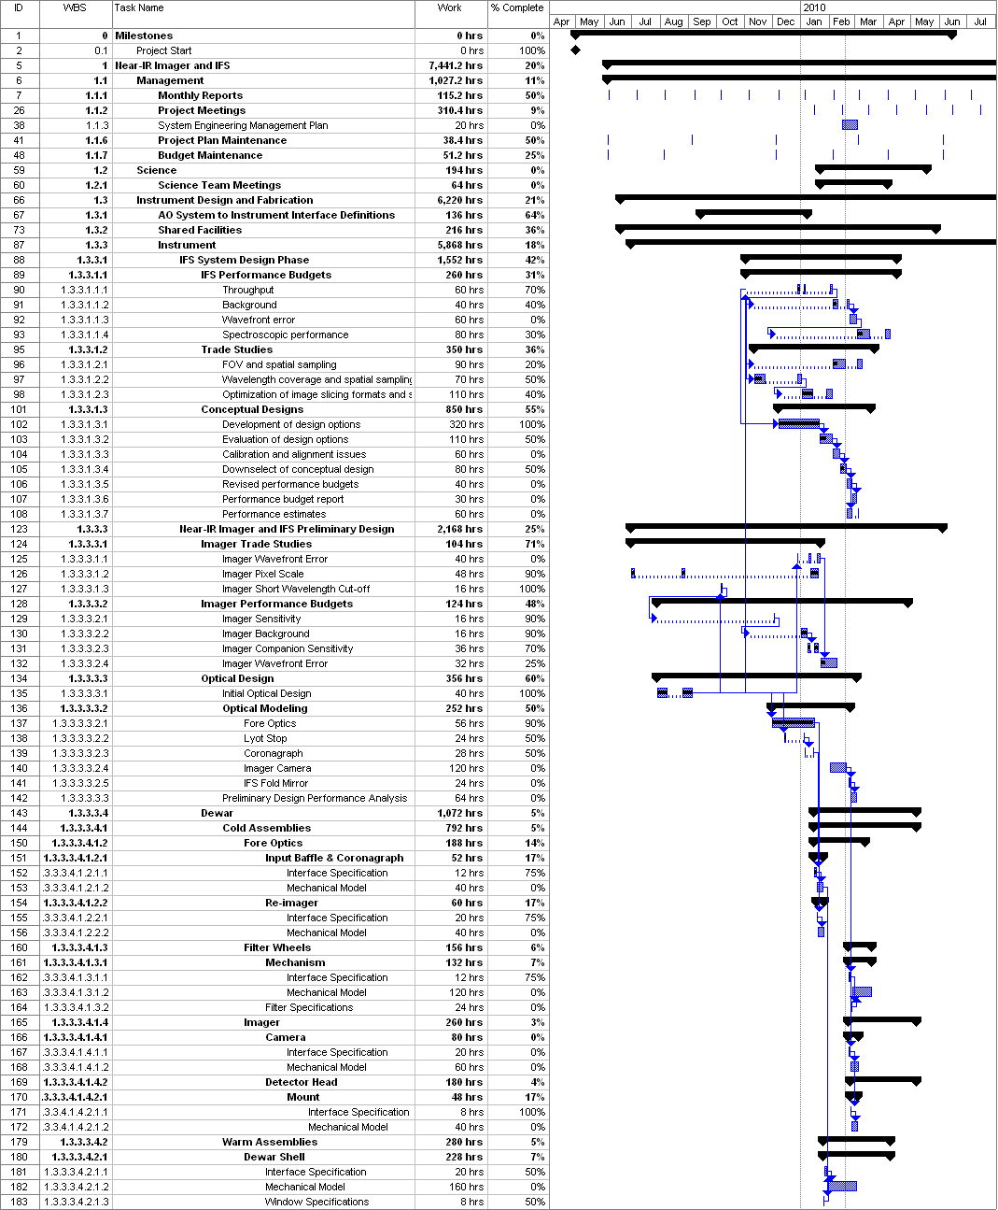
Figure 2: Tracked version of the NGAO Science Instruments schedule through January 2010

Table 3: NGAO PD Phase Expenditure Summary for Year 2 through January 2010

