 Keck Adaptive Optics Note 703

Keck Next Generation Adaptive Optics
Preliminary Design Phase Project Report #20

P. Wizinowich, Sean Adkins and the NGAO Team
January 26, 2010

Narrative

This report is the twentieth monthly project report for the Preliminary Design (PD) phase in the development of the W. M. Keck Observatory’s (WMKO’s) Next Generation Adaptive Optics (NGAO) facility. This report covers the PD phase work performed in December 2009.

Summary
The technical team is making good progress on the requirements and design.

Management Status
The PD phase plan presented at the SDR included work under the following management WBS elements through December. The progress in each of these areas is discussed below.

WBS 1.3.2.1 Planning

WBS 1.3.2.2 Project Management and Meetings
We are working with the Directors to identify the reviewers for the June 2010 NGAO PDR. Requests went out to Norbert Hubin and Brent Ellerbroek both of which accepted.

Erik Johansson left WMKO at the end of December. His controls responsibilities were transferred to Kevin Tsubota and his requirements responsibilities to Chris Neyman.

WBS 1.3.2.4 Proposals
The TSIP proposal for $1,228,416 to complete the NGAO preliminary design was successful. This is in addition to the $2,047,360 previously awarded by TSIP brings the total preliminary design phase budget to $3,275,776.

WBS 1.3.2.5 Programmatic Risk Assessment and Mitigation

Technical Status
The PD phase plan presented at the SDR included work under the following technical WBS elements in December. The progress in each of these areas is discussed below.

WBS 1.3.3.1 Science Case Requirements
We continued simulations of the high-z galaxies science case in order to determine what the required SNR is for a variety of sub-categories of high-z galaxies and how system quantities such as throughput, thermal emissivity, and sky background affect the achievable signal-to-noise for each case. We’ve been working on a tool that will allow us to input a model galaxy and change each system variable independently in order to see whether the requirements are met.

Next month we will continue working on this tool and the simulations. We will also revisit the optimal science parameters to be used as inputs to the performance budgets that the Systems Engineering group is working on.

WBS 1.3.3.2 Requirements
Requirements management responsibility was transferred from Johansson to Neyman.

Work continued on editing the SRD requirements. This work focused on identifying problem requirements and fixing them and identifying missing requirements that might be needed. Several of these were identified and several more are still being discussed.

There was also a structural reorganization of the FRD in the Contour database so that the FRD subsystems have the same organization as the SRD. Several subsystems were also broken down into additional subsystems. Feedback from the mini-reviews has been used to tag requirements that are incorrect, poorly worded or out of date. Significant work remains to complete a 2nd release of the functional requirements.

An outline for the organization of the science instrument requirements in the NGAO database was developed, but it not yet implemented in Contour.

WBS 1.3.3.3 Systems Engineering Analysis
Analysis action items from the mini-reviews are being tracked. These lists contain items that require system-level analysis to support future design work.

The sky-coverage calculation in the error budget was validated. A Monte-Carlo simulation was performed to calculate the probability of finding stars in a uniform distribution. There was an error in the calculation of the sky coverage probability. The calculation should be 1-exp(-1 * the number of stars on average in the FOV), the “-1” had been -0.5. This correction will be included in the next release of the error budget.

In order to understand the impact on the error budget, the following comparison case was run. NGAO LGS, Galaxy Assembly with a 10" LGS asterism, b=50°.

Sky Coverage (%) | Strehl from KAON 644 | Strehl from Error Budget V1.49 | Strehl with corrected sky coverage calculation
30 | ~0.7 | 0.71 | 0.74
50 | ~0.67 | 0.62 | 0.71
80 | ~0.6 | 0.25 | 0.58

The 2nd column is Strehl from KAON 644 Figure 15. The 3rd column is from Error Budget version 1.49. The performance degradation with increasing sky coverage is larger at least in part because the TWFS star is so dim and the corresponding "residual NA layer focus change" is large. The 4th column is the Strehl using the new sky coverage calculation. We obtain performance similar to that in column 2.

The net effect for the key science cases (most of which target 30% sky coverage) is therefore small, but more pronounced for large sky fractions and high galactic latitudes. In terms of error budgeting, the balance of laser power (for example) between the patrolling asterism beacons and the fixed asterism beacons will be revisited, which should allow (a very slight) improvement in on-axis performance.

WBS 1.3.3.4 System Architecture

WBS 1.3.3.5 External Interface & 1.3.3.6 Internal Interface Control

WBS 1.3.3.7 Configuration Control

WBS 1.3.3.9 Technical Risk Assessment and Mitigation

WBS 1.3.4.1 AO Enclosure
Design updated to include top and bottom sections. Work continued on the procurement specification for the cold enclosure.

WBS 1.3.4.2.3 Optical Relays
The AO relay design mini-review took place on November 17. We are now in the process of completing a “punch list” of items to be addressed as a result of that review. The AO design document, along with presentations and reviewer’s report from the review is posted on the NGAO Twiki page (link). Progress in December:
- The design of the optical feed to the Keck Interferometer Dual Star Module in now complete, including resolution of the issue of packaging within a reasonably shaped environmental enclosure envelope.
- We continue to work on the packaging and mounting issues of the second relay in the region of the LOWFS, in collaboration with the LOWFS design team.
- Velur visited UCSC in December to go over interface issues, resolving many of the uncertainties expressed at both the AO relay and HOWFS mini-design reviews.
- We have yet to settle on the final configuration of interfaces with the telescope simulator and the acquisition camera.
- Weekly meeting notes are posted on the AO System Design web page.

WBS 1.3.4.2.5 LGS Wavefront Sensor Assembly
The LGS WFS design mini-review was held on December 7. The WFS team presented multiple designs for both the fixed and deployable LGSWFS units with overall mechanical packaging and considerable analysis to show that the design met the requirements. The analyses also helped to identify additional design parameters that had not been included in the requirements. The mechanical design included the selection mechanisms for the 3 patrolling LGS (the “point and shoot” LGS).

The mini-review helped reveal some design discrepancies between mechanical and optical: e.g. the proposed TT mirror inside the OSM lever arm may not have sufficient throw to meet the LGS image stabilization requirements. This change is being addressed promptly since it could impact the mechanical design by requiring a larger TT mirror actuator stack.

WBS 1.3.4.2.7 Low Order Wavefront Sensor Assembly
A joint NGAO LOWFS and TMT IRIS LOWFS meeting was held December 17 at CIT to compare the requirements and preliminary designs of the low-order wavefront sensor subsystems. In general the subsystems were found to have comparable requirements with a couple of notable exceptions: the IRIS LOWFS requires larger region-of-interest readout for Teledyne HxRG HgCdTe arrays (baselined for both systems) and tighter mechanical stability requirements flowing down from a more aggressive astrometric precision budget.

Discussions of the NGAO LOWFS object selection mechanism (OSM) uncovered two areas of potentially overoptimistic design assumptions: the backlash of the crack and lever motors and the manufacturer’s published small motion precision for the same motors.

The meeting also served as an opportunity to bring the new LOWFS subsystem personnel, Wallace, Bartos, and Vashisht further up to speed on the issues pertinent to the LOWFS designs.

WBS 1.3.4.2.8 Tip-tilt Vibration Mitigation Analysis

WBS 1.3.4.2.9 Acquisition Camera

WBS 1.3.4.3 Alignment, Calibration and Diagnostics
An initial Zemax model was produced which was inserted into the mechanical drawing package, along with a mirror to fold the beam in front of the rotator.

WBS 1.3.4.4 Real-Time Control
The mini-review for the RTC design took place on December 10. Documents for the review, including reviewers’ comments and reviewers’ final report, are posted to the NGAO Twiki page (link).
- The designs of the front-end processors, tomography engine, and DM controllers are complete.
- The internal error budgets for tomography computational accuracy and time-latency in the processor are complete.
- The external and internal interface definitions are complete.
- FPGA physical hardware design tasks are on hold pending completion of the hardware layout and software design tasks. We are planning to pick up this work using an outside consultant. This approach will allow us to smoothly transition to working with outside vendors for board manufacturing.
- Most of the system documentation is complete. We are working on the missing portions pointed out by the review committee, the key items being: including more details on the independent point-and-shoot and tip/tilt control systems, and providing a description of the RTC parameter preparations that must be accomplished off-line in support of RTC operation.

WBS 1.3.5 Laser System Design
The FASORtronics and TOPICA laser preliminary design reviews were held on December 14 and 15. All the Review Item Discrepancies (RIDs) and Comments (RICs) were responded to by the vendors and either closed out prior to or at the reviews. Both vendors were recognized as having completely satisfied the requirements for the preliminary design phase.

The technical down-select meeting will be held on December 16. ESO will receive the vendor quotations on January 5 and will subsequent hold a cost down-select meeting (the quotations will be shared with WMKO).

Meetings were held with both laser vendors on December 16 to discuss the WMKO specific requirements. We expect to have quotations for the delta WMKO specifications by late January. ESO has indicated willingness to modify some of their specifications where mutually agreeable.

The four laser launch telescope proposals for the Keck II LGS center launch facility upgrade were reviewed and follow-up discussions were held with two vendors. The launch telescope contract should be placed in February.

WBS 1.3.6 Control System Design
Kevin Tsubota has taken over as NGAO controls team lead from Johansson and is working on coming up to speed on NGAO both hardware and software as well as managing the team.

We continued to work on reviewing and documenting the laser acquisition sequence as defined in the OOCD to help us better understand and define the control system software architecture. We have also started on a laser facility composite document that describes the highest level control for configuring and managing the entire laser system.

We have also started to design the AO acquisition sequence, started an outline for the AO facility controller, and started design of the NGAO operator’s control tools.

We have also been preparing for the control electronics architecture mini-review to be held on January 26. Thomas Stalcup has accepted the responsibility of review committee chair, Rich Dekany and Tomas Krasuski will be the other committee members. As part of the mini-review we continue to document the internal and external interfaces needed to accommodate the subsystem hardware. We have recently received a list of electronics requirements from Contour and are going through each requirement for compliance.

WBS 1.3.8 Telescope and Summit Engineering Design

WBS 1.3.9 Operations Transition

Science Instruments
Work continued on the optical design for the imager and the IFS slicer. The imager design work included further progress on the collimator design, and development of a coronagraph simulation based on earlier work done for the GPI instrument. Work on the IFS slicer also continued, with progress made on understanding the optical design issues for the hybrid slicer concept and establishing a path forward to developing a candidate design. Sensitivity estimation efforts were also in progress, as were further efforts towards the instrument ICD. A structure for the instrument requirements in the Contour database was also provided to the NGAO systems engineering team.

Overall progress was somewhat limited by vacation time in December, but work on the optical design and instrument performance estimates are expected to move forward more rapidly in January. We do expect to encounter some challenges in obtaining the required levels of mechanical engineering support need for the instrument in January and February due to limited availability of mechanical engineering staff.

Keck Adaptive Optics Notes
All of the NGAO KAONs can be found at:
http://www.oir.caltech.edu/twiki_oir/bin/view/Keck/NGAO/NewKAONs.

The following KAONs were produced in December:
KAON 689, Laser Launch Facility Reviewer Report
KAON 692, LGS Wavefront Sensor Preliminary Design
KAON 694, Opto-Mechanical Reviewer Report
KAON 695, Real-Time Controller Algorithms
KAON 696, Real-Time Controller Design
KAON 697, Real-Time Controller Reviewer Report
KAON 698, Preliminary Design Report #19
KAON 699, LGS Wavefront Sensor Reviewer Report
KAON 700, Real-Time Controller Testing

Schedule and Budget Status

Milestones
All of the milestones through June have been completed. The requirements PD release milestone continues to be delayed, although good progress is being made.
Table 1: NGAO PD Phase Milestones

A series of mini preliminary design reviews were identified in August, including tentative dates and reviewers (see Table 2). These reviews are intended to allow the NGAO team to wrap up and self review the designs for key subsystems in advance of the PDR. The fourth and fifth of these reviews was completed in December. The first January review has been delayed by 11 days and the science operations tools concept review date has not yet been set.

Table 2: Planned Mini Preliminary Design Reviews

Schedule
A high level snapshot of the tracked version of the new schedule through December is shown in Figure 1 with 57% of the total PD phase work complete (versus 54% complete at the end of November 2009).

A tracked version of the instrument MS Project plan, with a start date of May 1, 2009, is shown in Figure 2 with 15% of the overall work complete (versus 12% at the end of November 2009). Note that work in the instrument plan corresponding to the NGAO PD phase represents 71% of the total, so progress in support of the NGAO PD is actually at 21%. This schedule shows the tasks in progress now or that are planned to start in January 2010.

Budget
The total NGAO PD phase budget (from the SEMP) was $3030k excluding contingency; the contingency was $449k. The revised total NGAO PD phase budget, based on the funded TSIP proposal, is $3276k including contingency (an overall reduction of $203k). The contingency in the new budget is $157k and we also assigned $149k for work in July and August to wrap up action items from the preliminary design review meeting. The new budget to complete the work through the design review, excluding contingency, is therefore $3276k - $157k - $139k = $2970k.

A total of $1738k has been spent through December or 59% of the budget excluding contingency (compared to 57% of work completed).

Anticipated Accomplishments in the Next Period
All of the previously anticipated accomplishments through April have been completed and we have chosen not to list them here (see the April report for this list).

The anticipated accomplishments for May along with their status in italics:
- Complete functional requirements release 1. Continues to be delayed.
- Complete observing operations concept document release 1. Complete.
- Complete the post build to cost replan and start tracking versus this plan. Complete.

The anticipated accomplishments for June along with their status in italics:
- Hold first NGAO Science Advisory Team meeting. Complete.

The anticipated accomplishments for July along with their status in italics:
- Document evaluation of fixed pupil mode design options. Complete.
- Document vibration mitigation work. Complete.
- Complete laser MRI-R² proposal. Complete.

The anticipated accomplishments for August along with their status in italics:
- Complete software architecture design review. Complete.

The anticipated accomplishments for September along with their status in italics:
- Complete TSIP proposal. Complete.
- NGAO presentation at the Keck Strategic Planning Meeting. Complete.

The anticipated accomplishments for October along with their status in italics:
- LGS launch facility design review. Complete.

The anticipated accomplishments for November along with their status in italics:
- Complete ATI proposal. Complete.
- AO optical design review. Complete.

The anticipated accomplishments for December along with their status in italics:
- LGS WFS design review. Complete.
- RTC design review. Complete.
- Laser preliminary design reviews. Complete.

The anticipated accomplishments for January are the following:
- Control electronics architecture review.

Financial Summary

The budget and expenditures to date for year 1 of the NGAO project were provided in KAON 665 (Project Report 13; the year 1 expenditures totaled $729k). The budget, expenditures to date and estimate to completion for year 2 of the NGAO project, which began in May 2009, is shown in Table 3.

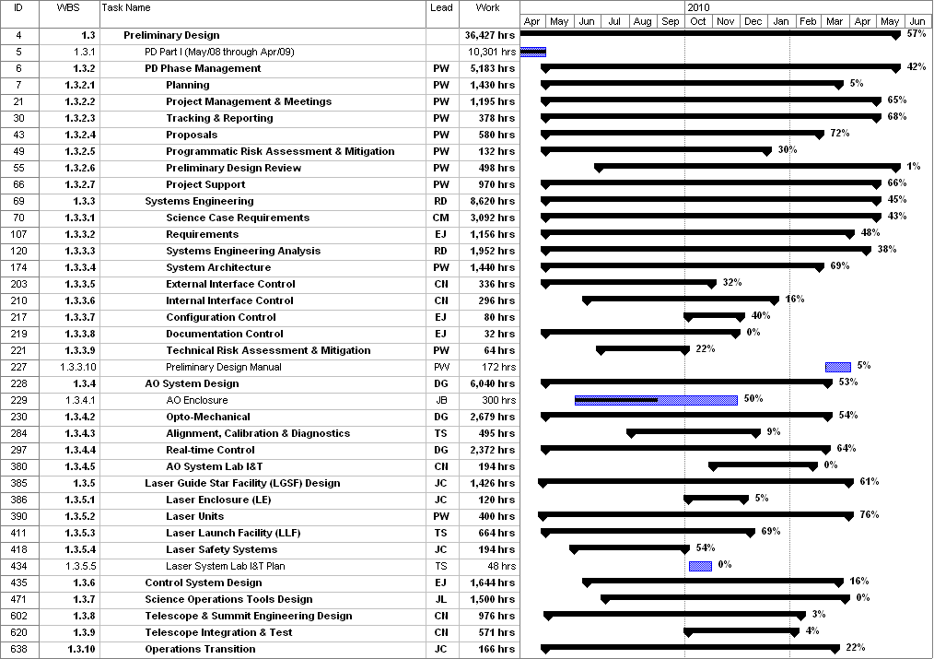
Figure 1: Tracked version of the new PD phase schedule through December 2009

Figure 2: Tracked version of the NGAO Science Instruments schedule through December 2009

Table 3: NGAO PD Phase Expenditure Summary for Year 2 through December 2009

