 Keck Adaptive Optics Note 607

Keck Next Generation Adaptive Optics
Preliminary Design Phase Project Report #2

P. Wizinowich, the NGAO Team, Sean Adkins
July 18, 2008

Narrative

This report is the second monthly project report for the Preliminary Design (PD) phase in the development of the W. M. Keck Observatory’s (WMKO) Next Generation Adaptive Optics (NGAO) facility. This report covers the PD phase work performed in June 2008.

Summary
The primary focus of our activities during this period has continued to be responding to the recommendations from the SDR and recommendations from the WMKO SSC, with the most significant effort devoted to developing an approach to producing a phased implementation plan. Approximately two weeks of June were largely dedicated to preparing for and attending the SPIE 2008 Astronomy Conference in Marseille where six papers on the NGAO project were presented.

Management Status
The PD phase plan presented at the SDR included work under the following management WBS elements in May and June. The progress in each of these areas is discussed below.

WBS 1.3.2.1 Planning
A PD phase replan based on the SDR recommendations and other changes, including the completion of WMKO’s fiscal year 2009 (FY09) planning process, was begun in May and continued in June. A response (KAON 596) to the SSC recommendations based on the SDR was approved by the Directors, and the results will be incorporated in the ongoing replan.

One of the major SDR panel recommendations was to develop a phased implementation plan for NGAO, including descope options, in order to accommodate the possibility of restricted or incremental funding. The team’s approach (KAON 594) to develop a phased implementation plan was approved by the Directors, and the work associated with this effort also needs to be incorporated in the replan.

A major SDR panel concern was the NGAO cost estimate. Our response includes a comparison of our cost estimate with the TMT early light AO system NFIRAOS, and accordingly we requested access to the most recent NFIRAOS detailed cost estimate. This has been provided by the TMT and will be compared to the NGAO budget over the next few months.

WBS 1.3.2.2 Project Management and Meetings
A follow-up meeting (to our May 1 meeting) was held with the Directors on June 9. The main discussion topics were the phased implementation and descope options, the response to the SSC recommendations, and setting up a Science Advisory Team. The Directors approved the KAONs for the first two items pending some minor changes (which were subsequently completed). The Directors formally informed the NGAO senior management team of their intent to take the lead in setting up the Science Advisory Team. Wizinowich and Max agreed to provide a draft charter document for the Science Advisory Team, and this was supplied to the Directors later that week.

Our second team meeting was held via telecom on June 13 and was focused on phased implementation and descopes. The draft phase implementation and descopes KAON was subsequently updated to reflect the results of the discussion.

An NGAO presentation was made at the June 18 SSC meeting. The presentation and discussion focused on the team’s response to the SDR reviewer and SSC recommendations, with special emphasis on the desired results of the phased implementation and descopes study. We are awaiting release of the minutes from the June 18 SSC meeting which may contain additional recommendations.

WBS 1.3.2.3 Tracking and Reporting
Three NGAO oral presentations and three posters were presented at the Marseille SPIE meeting. All six papers were submitted for inclusion in the proceedings (see the KAON list in section 1.4; two had been submitted in May). Some potential ideas for topical collaboration came out of the SPIE meeting that we will look at pursuing (e.g., MOAO, PSF reconstruction and IR detectors).

WBS 1.3.2.5 Programmatic Risk Assessment and Mitigation
Discussions continued with ESO and TMT on possible collaborative efforts for laser procurement. GMT and the NSF were added to the discussions. Meetings were held at the SPIE conference to discuss options for proceeding and good consensus was reached. At the request of Julian Christou, NSF Astronomical Sciences Program Officer, we are preparing a joint white paper for submittal to the NSF.

WBS 1.3.2.7 Project Support
The subcontracts to Caltech and UCO are nearing completion. The effective start date of these subcontracts will be May 1, so in the meantime work is proceeding at these two institutions on a 90 day pre-award spending basis.

Technical Status
The PD phase plan presented at the SDR included work under the following technical WBS elements in May and June. The progress in each of these areas is discussed below.

WBS 1.3.3.1 Science Case Requirements
Work has primarily been progressing on the sparse field astrometry and the crowded field resolved stellar population science case requirements (both are 50% complete), as well as some work on characterizing the sensitivity and background requirements (25% complete).

Some changes have been made with respect to the original preliminary design phase plans to address concerns raised by the SDR committee and to support development of a phased implementation plan that optimizes science return. Specifically we are looking into whether OSIRIS can accomplish some of the extragalactic science goals before the deployable Integral Field Spectrograph comes on-line; this could enable NGAO to remain competitive in a phased implementation by producing early science before TMT is commissioned. July will be spent mostly on characterizing PSF stability, knowledge and accuracy (WBS 1.3.3.1.1.3) and sensitivity and background requirements (WBS 1.3.3.1.1.4).

WBS 1.3.3.2 Requirements
The draft Operations Concept Document outline still needs review.

WBS 1.3.3.3 Systems Engineering Analysis
The first planned modeling activity was to perform a study to better understand the benefits of tip-tilt sharpening. This work was presented at the Marseille SPIE meeting. The conclusion of this study is that patrolling LGS can provide ~ 10% absolute Strehl advantage for 60" off-axis NGS. We will be weighing this performance advantage versus the practical considerations of increased system complexity.

We agreed with Brent Ellerbroek of the TMT to have a joint meeting to compare our wavefront error budgets for the purpose of better anchoring both of our budgets and identifying areas that require more work.

WBS 1.3.3.9 Technical Risk Assessment and Mitigation
No work had been planned in this area until September. However, an identified task is to support/monitor the implementation of an atmospheric profiler and we recognized an opportunity to acquire this equipment with the decommissioning of the TMT site monitor on Mauna Kea. This particular site monitor was not available, but after discussion with the TMT, we were offered another site monitor and support for its implementation at the WMKO summit facility. We are currently evaluating how and where to implement this monitor. Since we are primarily interested in the MASS data for NGAO, a likely location is on the roof between the two Keck telescopes, although other location options may also be explored.

WBS 1.3.4.2.5 LGS Wavefront Sensor Assembly
The first scheduled opto-mechanical task was to review the concept design for this assembly.

WBS 1.3.4.2.7 Low Order Wavefront Sensor Assembly
Some work in reviewing the concept for this assembly was performed ahead of schedule in May.

WBS 1.3.4.5 Real-Time Control
An EE/programmer has been identified at UCO to work on the RTC processor tasks.

A brief preliminary discussion took place with Brent Ellerbroek and Corrine Boyer of the TMT (at the SPIE meeting) about possible collaboration in the area of RTC development. A follow-up visit to TMT by the UCO RTC team is being planned.

Keck Adaptive Optics Notes
All of the NGAO KAONs can be found at:

http://www.oir.caltech.edu/twiki_oir/bin/view/Keck/NGAO/NewKAONs.

KAONs that were produced during the second month of the PD phase include the following:

594 Plan to Address Phased Implementation and Descope Options
596 NGAO SDR: SSC Recommendations and Response
597 WMKO’s NGAO Facility (SPIE 2008)
599 WMKO NGAO Facility: Science Operations (SPIE 2008)
600 Preliminary Design Phase Project Report #1
601 Sharpening of NGS for low-order wavefront sensing using patrolling LGS (SPIE 2008)
604 Concept for the Keck NGAO System (SPIE 2008)
605 The Science Case for the NGAO System at WMKO (SPIE 2008)
606 Low-order wavefront sensing in tomographic multi-beacon AO systems (SPIE 2008)

Schedule and Budget Status

Milestones
The Systems Engineering Management Plan (SEMP; KAON 574) for the preliminary design phase identified the milestones shown in Table 1. The May 2008 milestone has been completed.

Year | Month | NGAO Project Milestone | Status
2008 | May | Preliminary Design phase begins | Completed
2008 | October | Functional Requirements PD Release 1
2009 | March | Operations Concept Document Release 1
2009 | April | External Interface Document Release 1
2009 | February | Internal Interface Document Release 1
2009 | May | Software & Controls Architectures PD complete
2009 | May | LGS WFS Assembly PD complete
2009 | June | Laser vendor identified & contract ready
2009 | June | Optical relay/switchyard PD complete
2009 | September | RTC Processing Requirements complete
2009 | November | Laser Launch Facility PD complete
2009 | December | LOWFS Assembly PD complete
2010 | February | Preliminary Design Review
Table 1; NGAO PD Phase Milestones

Schedule
A high level snapshot of the tracked version of the schedule through January is shown in Figure 1 with 3% of the work complete. As stated in the May report and repeated here, there have been some minor delays in the project schedule. This is primarily due to more significant than planned activity associated with incorporating the SDR panel recommendations and other changes, especially the need for a phased implementation plan, into the PD phase replan. To a lesser extent there has also been some delay in ramping up people. The replanning effort will likely extend into July (versus the original planned May completion).

Budget
The total NGAO PD phase budget is $3030k excluding contingency; the contingency is $449k. A total of $39k has been spent through May or ~1% of the budget excluding contingency. The earned value estimate is high when the 3% of work completed is considered. This may be partly explained by lower costs in preparing the NGAO SPIE presentations and good science requirements progress with lower cost labor.

Anticipated Accomplishments in the Next Period
The anticipated accomplishments from the last report along with their status in italics:
- Completion and approval of the plan to develop a phased implementation approach, as well as progress on this plan. Plan completed and approved. Good progress made on the draft report.
- Completion and approval of the response to the SSC recommendations. Completed and approved.
- Development of a draft charter for the NGAO Science Advisory Team. Draft charter submitted to the Directors.
- Completion and presentation of the NGAO SPIE papers. All papers presented and completed.

The anticipated accomplishments for July are the following:
- Submission of a collaborative (GMT, TMT, WMKO and ESO) white paper to the NSF for commercial laser development.
- Completion of the tip-tilt sharpening study.
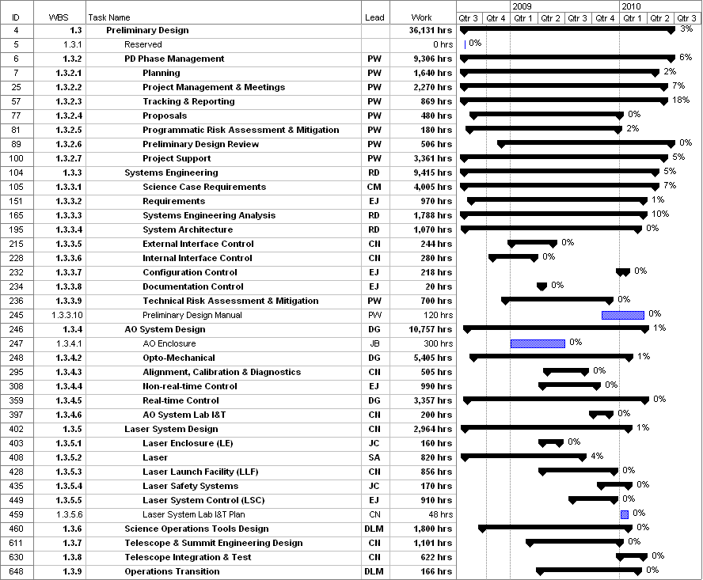
Figure 1: Tracked version of the PD phase schedule

Financial Summary

The budget, expenditures to date and estimate to completion for year 1 of the NGAO project are shown in Table 2. The preliminary design phase contracts are not yet in place at COO and UCO, and actual expenditures were not available from UCO. The Table 2 budget does include the post doctoral researcher at UCO, but some corrections may need to be made once other UCO expenditures are known.

Table 2: NGAO PD Phase Expenditure Summary through June 2008

