 Keck Adaptive Optics Note 698

Keck Next Generation Adaptive Optics
Preliminary Design Phase Project Report #19

P. Wizinowich, Sean Adkins and the NGAO Team
December 21, 2009

Narrative

This report is the nineteenth monthly project report for the Preliminary Design (PD) phase in the development of the W. M. Keck Observatory’s (WMKO’s) Next Generation Adaptive Optics (NGAO) facility. This report covers the PD phase work performed in November 2009.

Summary
Management efforts have been focused on proposal writing. The technical team is making good progress on the requirements, software architecture, opto-mechanical design, and real-time control design.

Management Status
The PD phase plan presented at the SDR included work under the following management WBS elements through November. The progress in each of these areas is discussed below.

WBS 1.3.2.1 Planning

WBS 1.3.2.2 Project Management and Meetings
Erik Johansson will be leaving WMKO for NSO at the end of December. The controls lead responsibilities are being handed over to Kevin Tsubota (who was the interferometer software lead) and we are currently advertising for a controls engineer.

WBS 1.3.2.4 Proposals
The ATI proposal for a near-infrared tip-tilt sensor for Keck I, a project related to risk reduction for NGAO, was submitted in November.

WBS 1.3.2.5 Programmatic Risk Assessment and Mitigation

Technical Status
The PD phase plan presented at the SDR included work under the following technical WBS elements in November. The progress in each of these areas is discussed below.

WBS 1.3.3.1 Science Case Requirements
This month we worked primarily on re-wording the science requirements to reflect the main, top-level requirements and we also worked on simulations for the high-z galaxy science case. In working on these simulations, we have begun to put together a KAON that describes how we arrived at certain requirements, the details of the simulations, and the assumptions in the modeling. We envision writing similar KAONs for other science cases as the appropriate simulations and the science requirements are further developed.

Next month we will continue working on the high-z galaxies simulations and on revising the science requirements where needed.

WBS 1.3.3.2 Requirements
A plan has been completed for revisions to the System and Science Requirements documents. The Contour requirements database software was upgraded from version 2.5 to 2.8, and the requirements management task was transitioned from Johansson to Neyman. Neyman understands the issues with Contour installation as well as how to perform database backups, database restorations, and generate reports, but implementation of new reports will require gaining experience with the needed software tools (SQL, Velocity, and HTML).

A substantial revision was made to the LGS WFS functional requirements, bringing them up to date with respect to the build to cost design revisions and the interface discussions with the AO relay design team. The revision to the Contour database organization initiated by the systems engineering team is expected to allow the LGS WFS design team better visibility into the current, and when updated, the complete set of functional requirements.

Work on revision 2 of the System Requirements in the Contour database was started, including rewriting some requirements, suggesting that some requirements be deleted or moved to the FRD, and tagging requirements needing additional work.

WBS 1.3.3.3 Systems Engineering Analysis
A small number of “punch list” fixes for the development of the LOWFS sharpening wavefront error budget were implemented. A new release of the wavefront error and HC budgets is planned to coincide with the release of version 2 of the flow down budget summary.

A review of the implementation of the sky coverage calculations was initiated in preparation for version 2 of the WFE budget tool. At issue is the implementation of the nearest-neighbor distance calculation. A review was made of KAON 470, “NGAO Sky Coverage Modeling” in which the TMT-based cumulative distribution function (probabilistic) approach was determined to be equivalent to the NGAO stellar density model for NGAO results. So far, we have determined that this comparison appears appropriate, but for a single point in the sky coverage / star brightness and distance parameter space.

WBS 1.3.3.4 System Architecture

WBS 1.3.3.5 External Interface & 1.3.3.6 Internal Interface Control

WBS 1.3.3.7 Configuration Control5

WBS 1.3.3.9 Technical Risk Assessment and Mitigation

WBS 1.3.4.1 AO Enclosure

WBS 1.3.4.2.3 Optical Relays
The opto-mechanical design mini-review took place on November 17. We are now completing punch list items from that review. The optical design is complete to a PDR level (minus the punch list items) and the mechanical design is complete to a conceptual design level. The AO design document, along with presentations and reviewer’s comments from the review is posted on the NGAO twiki page (link). Progress in November:

- Completed the design of the optical feed to the Keck Interferometer Dual Star Module (DSM). A remaining issue is that the DSM feed intertwines with the AO relay making the cold enclosure envelope complicated. The objective is to have the cold enclosure be as simple and small as possible – minimizing the number of components of the DSM feed in the enclosure and keeping the number of optical windows to a minimum.
- The interfaces to the LOWFS and HOWFS subsystems are complete. Some space envelope issues remain to be resolved, e.g. allowing space for a second science instrument.
- While workable options have been proposed, we have yet to settle on the final configuration of the interfaces with the telescope simulator and the acquisition camera.

WBS 1.3.4.2.5 LGS Wavefront Sensor Assembly
Significant progress was made in preparation for the mini design review scheduled for December. Flowing down the updated LGS WFS requirements resulted in a number of design modifications to the assembly, almost exclusively design simplifications. In particular each mechanism was closely scrutinized to confirm that it was appropriately designed and was necessary to meet the requirements. For example, it was determined that with the current two periscope object selection mechanism design, the patrolling WFS channels do have an internal pupil rotation as a function of object (LGS) location within the field of regard. This allowed the elimination of three rotational degrees of freedom from the patrolling LGS WFS design.

Reducing the volume of the LGS WFS assembly continues to be of interest in order to ease installation and conserve room on the Nasmyth platform. To date no definite volume requirement has been established for the LGS WFS, pending further solid modeling of support for a second science instrument, but initial efforts to explore the optical performance trade-off with total length of the LGS WFS assembly have been initiated. The design has already been significantly shortened compared to the October design, resulting in a more compact mechanism.

An aluminum honeycomb support structure is being considered as a lighter design than the thick flat aluminum sheet, with I and square beams being studied to hold each LGS WFS assembly on slide roller bearings actuated by a translation stage.

WBS 1.3.4.2.7 Low Order Wavefront Sensor Assembly
An updated preliminary optical design has been produced for the LOWFS. This design incorporates first order properties of the optical system to properly relay pupils and f-numbers in the system. We have preliminary optical designs for the NIR achromats that are used in the pupil and image plane relays. These lenses are fused silica and magnesium fluoride air spaced achromats and are diffraction limited over the J and H bands. Our next step is to properly interface to the cryostat that houses the IR array and properly size its outer casing and cold shields.

WBS 1.3.4.2.8 Tip-tilt Vibration Mitigation Analysis

WBS 1.3.4.2.9 Acquisition Camera

WBS 1.3.4.3 Alignment, Calibration and Diagnostics

WBS 1.3.4.4 Real-Time Control
A mini-review for the real-time control (RTC) design is scheduled for December 10. Documents for the review have been posted to the NGAO twiki page (link). Documents include the Algorithms Description, RTC Design, and Testing Plan documents.

- The designs of the front-end processors, tomography engine, and DM controllers are complete.
- The internal error budgets for tomography computational accuracy and time latency in the processor are complete.
- The external and internal interface definitions are about 90% complete.
- FPGA physical hardware design tasks are on hold pending completion of the hardware layout and software design tasks. We are planning to pick up this work using an outside consultant. This approach will allow us to smoothly transition to working with outside vendors to quotes for board manufacturing.
- Major progress has been made on system documentation in preparation for the review.

WBS 1.3.5 Laser System Design
The FASORtronics and TOPICA laser preliminary design documents were distributed and reviewed. The resultant Review Item Discrepancies (RIDs) and Comments (RICs) were collected and sent to the vendors for their response. The preliminary design reviews will be held on December 14 and 15. An initial technical down-select meeting will be held on December 16.

The NGAO laser requirements were completed, with inputs from TMT, and submitted to the laser vendors for comment. These requirements are similar but not identical to ESO requirements as they will pertain to the Keck II Telescope environment and U.S. regulatory standards. The next phase is to provide a Statement of Work to the selected vendor for a quote.

The laser launch facility team is following up on action items from the mini review. The vendor of the SMARTact motor has provided a quote and is doing a performance check to assure the unit can support the load and speed we will need. Once this risk is retired, the design can continue to include these smaller and lighter weight drive components.

Four proposals were received for the launch telescopes and are being evaluated. The telescope will be procured with the NSF provided MRI funds for the Keck II center launch telescope.

WBS 1.3.6 Control System Design
We continued our efforts on the design of both the electronics and software for the Laser Beam Generation System and expanded it to include the entire Laser Facility. Much of this time was spent on reviewing the acquisition use case in the Observing Operations Concept document to better understand how all of the NGAO subsystems and components will be used together to implement a unified system. We also met with several NGAO team members to get their input and feedback on the sequence of events during acquisition and to better define some of the actions (e.g., how tip-tilt offloading will be performed in the laser system). Although the increases in task percent completion looks low, it is indicative of the large learning curve we have encountered: in order to design the control system we must have a detailed understanding as to exactly how the system will be used during the various phases of observing. There is not much in the way of documentation on this topic, so we are entering somewhat uncharted territory.

WBS 1.3.8 Telescope and Summit Engineering Design

WBS 1.3.9 Operations Transition

Science Instruments
Work in November was concerned primarily with optical design for the imager and the IFS slicer. The imager design work started with a review of the issues related to pupil aberrations in the NGAO optical relay and the potential impact on the quality of the background suppression obtained by using a cold stop matched to the Keck pupil. Having such a cold stop, and rotating it to maintain registration with the serrated edges of the primary mirror image is beneficial to minimizing thermal background, especially in the K-band while also maximizing throughput. It appears that consideration of pupil image quality needs to be included in the consideration of the plate scales and FOVs for the imager. An initial collimator design has been created in Zemax to allow evaluation of the pupil quality. Work has also started on evaluation of the coronagraph performance for the instrument. The first step will be to take the pupil quality information from the optical modeling, and use that to model a simple Lyot coronagraph. This will allow us to determine how well (or how poorly) this simple coronagraph will perform before trying to evaluate more elaborate designs such as an apodized pupil coronagraph, or alternative approaches such as four quadrant phase masks and vortex coronagraphs.

The IFS slicer design work is underway with work on a “hybrid” slicer design that uses a lenslet array to sample the image, and a mirror array to reformat the image onto the detector for minimum crosstalk and maximum detector utilization. An initial study shows that best case efficiency for the same configuration of samples and pixels per spectra is 96% for a pure mirror slicer (like SINFONI), and 80% for a pure lenslet slicer (the OSIRIS design). When gaps are introduced to reduce crosstalk between spectra the lenslet slicer is more severely penalized, dropping to 56% utilization while the mirror slicer falls to only 83%. The objective of the hybrid design is to preserve the benefits of the higher quality image PSF sampling obtained with the lenslet array while also making more efficient use of the detector and minimizing crosstalk between spectra.

During December Mike Fitzgerald will be contributing to the analysis of imager sensitivity, particularly for faint extended objects, as well as reviewing the point source sensitivity estimates and methodology. Optical design work will proceed onto the camera for the imager, and work will also take place on adding to the instrument requirements, starting with the fourth level structure of those requirements for the Contour database. The ICD planned for release in November should now be available in early January.

Keck Adaptive Optics Notes
All of the NGAO KAONs can be found at:
http://www.oir.caltech.edu/twiki_oir/bin/view/Keck/NGAO/NewKAONs.

The following KAONs were produced in November:
KAON 689, Laser Launch Facility Reviewer Report
KAON 691, Preliminary Design Report #18

Schedule and Budget Status

Milestones
All of the milestones through June have been completed. The requirements PD release milestone continues to be delayed, although good progress is being made. The optical relay/switchyard mini-review was successfully completed in November but the follow-up work has not been completed. Two more mini-reviews will be held in December (per Table 2).

Table 1: NGAO PD Phase Milestones

A series of mini preliminary design reviews were identified in August, including tentative dates and reviewers. These reviews are intended to allow the NGAO team to wrap up and self review the designs for key subsystems in advance of the PDR. The third of these reviews was completed in November.

Table 2: Planned Mini Preliminary Design Reviews

Schedule
A high level snapshot of the tracked version of the new schedule through November is shown in Figure 1 with 54% of the total PD phase work complete (versus 52% complete at the end of October 2009).

A tracked version of the instrument MS Project plan, with a start date of May 1, 2009, is shown in Figure 2 with 12% of the overall work complete (versus 9% at the end of October 2009). Note that work in the instrument plan corresponding to the NGAO PD phase represents 71% of the total, so progress in support of the NGAO PD is actually at 17%. This schedule shows the tasks in progress as of the end of November 2009.

Budget
The total NGAO PD phase budget (from the SEMP) is $3030k excluding contingency; the contingency is $449k. A total of $1599k has been spent through November or 53% of the budget excluding contingency (compared to 54% of work completed).

Anticipated Accomplishments in the Next Period
All of the previously anticipated accomplishments through April have been completed and we have chosen not to list them here (see the April report for this list).

The anticipated accomplishments for May along with their status in italics:
- Complete functional requirements release 1. This will be delayed to September.
- Complete observing operations concept document release 1. Complete.
- Complete the post build to cost replan and start tracking versus this plan. Complete.

The anticipated accomplishments for June along with their status in italics:
- Hold first NGAO Science Advisory Team meeting. Complete.

The anticipated accomplishments for July along with their status in italics:
- Document evaluation of fixed pupil mode design options. Complete.
- Document vibration mitigation work. Complete.
- Complete laser MRI-R² proposal. Complete.

The anticipated accomplishments for August along with their status in italics:
- Complete software architecture design review. Complete.

The anticipated accomplishments for September along with their status in italics:
- Complete TSIP proposal. Complete.
- NGAO presentation at the Keck Strategic Planning Meeting. Complete.

The anticipated accomplishments for October along with their status in italics:
- LGS launch facility design review. Complete.

The anticipated accomplishments for November along with their status in italics:
- Complete ATI proposal. Complete.
- AO optical design review. Complete.

The anticipated accomplishments for December are the following:
- LGS WFS design review.
- RTC design review.
- Laser preliminary design reviews.

Financial Summary

The budget and expenditures to date for year 1 of the NGAO project were provided in KAON 665 (Project Report 13; the year 1 expenditures totaled $729k). The budget, expenditures to date and estimate to completion for year 2 of the NGAO project, which began in May 2009, is shown in Table 3.

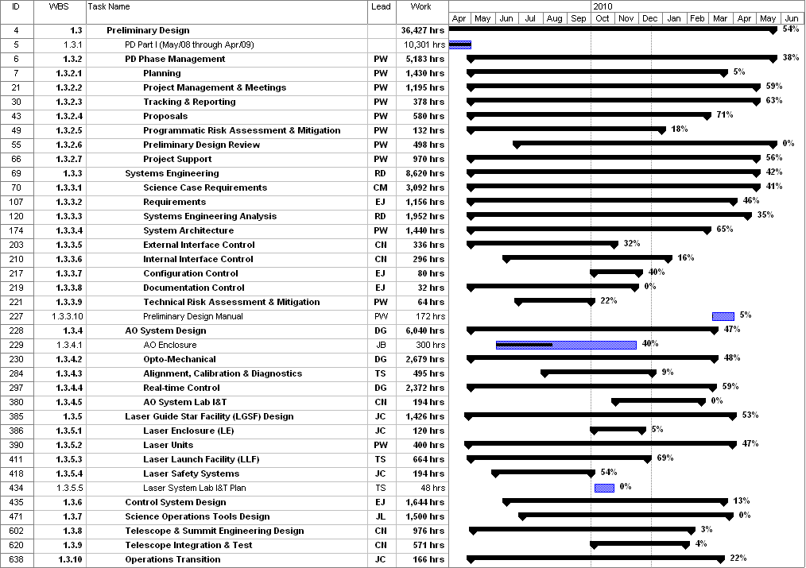
Figure 1: Tracked version of the new PD phase schedule through November 2009

Figure 2: Tracked version of the NGAO Science Instruments schedule through November 2009

Table 3: NGAO PD Phase Expenditure Summary for Year 2 through November 2009

