 Keck Adaptive Optics Note 691

Keck Next Generation Adaptive Optics
Preliminary Design Phase Project Report #18

P. Wizinowich, Sean Adkins and the NGAO Team
November 24, 2009

Narrative

This report is the eighteenth monthly project report for the Preliminary Design (PD) phase in the development of the W. M. Keck Observatory’s (WMKO) Next Generation Adaptive Optics (NGAO) facility. This report covers the PD phase work performed in October 2009.

Summary
Management efforts have been focused on proposal writing. The technical team is making good progress on the requirements, software architecture, opto-mechanical design, and real-time control design.

Management Status
The PD phase plan presented at the SDR included work under the following management WBS elements through October. The progress in each of these areas is discussed below.

WBS 1.3.2.1 Planning

WBS 1.3.2.2 Project Management and Meetings

WBS 1.3.2.4 Proposals

An ATI proposal was submitted on November 2 for the development and implementation of a near-infrared tip-tilt sensor with the Keck I LGS AO system. This effort, if funded, would both improve LGS science performance for faint tip-tilt stars and reduce NGAO risk by proving in an operational environment the performance, calibration techniques, and software control requirements for the NGAO low order wavefront sensor (LOWFS).

WBS 1.3.2.5 Programmatic Risk Assessment and Mitigation

Technical Status
The PD phase plan presented at the SDR included work under the following technical WBS elements in October. The progress in each of these areas is discussed below.

WBS 1.3.3.1 Science Case Requirements
We prepared a response to the comments from Lewis Roberts (JPL, invited in August to provide an external review of NGAO requirements) about the format and content of the science requirements, and continued reviewing the science requirements and their flowdown into system level requirements. We also worked with David Law (UCLA) to get his spectral simulation software working in order to simulate the performance of an OSIRIS-like IFU + AO system for a variety of science cases. This code will need to be modified with updated throughput numbers for NGAO as well as the new IFU. When we have completed the updates, it will be able to simulate the SNR for various spectral features at a range of target redshifts, and model how well we can resolve kinematics in galaxies, AGN, resolved stellar populations, and much more.

We also explored how pushing NGAO performance to shorter wavelengths may help the resolved stellar population science case. For a given stellar population that is coeval, a color-magnitude diagram can help distinguish the age of the cluster. However, H-K vs. K is highly degenerate (>2 dex in age). J-K is better, but still slightly degenerate. One needs to push to I-K (or bluer) vs. K to obtain the best discrimination. Discriminating between different metallicities is harder, but some constraints can be placed on this as well if you go blue-ward enough, especially if you can sample the upper red giant and/or asymptotic giant branch stars, which requires generating a large sample (because these stars are so rare), either through a large field of view or through sampling the densest part of the cluster.

WBS 1.3.3.2 Requirements
A number of revisions have been proposed to the Science Case Requirements Document and have been discussed with the science team.

System Requirements Document release 1 is complete and will be released as a KAON in November. Changes recommended in the recent review by Roberts will be made in the Contour database (this work has started) and released in version 2. Requirements needing additional work have been tagged.

The task of updating the Contour requirements database based on version 2.0 of the performance flowdown was assigned to some NGAO team members.

WBS 1.3.3.3 Systems Engineering Analysis
A small number of “punchlist” fixes for the development of the LOWFS sharpening wavefront error (WFE) budget were implemented. A new release of the WFE and high contrast budgets is planned to coincide with the formal release of Version 2 of the flowdown budget summary.

Work began on implementing a Truth Wavefront Sensor (TWFS) model into the WFE budget. We now have a working definition for what the TWFS will measure and a list of error terms for the TWFS as well as perturbations that it will correct. Mitch Troy (a new JPL participant) is in the process of documenting this list and implementing the error terms. To date the measurement error terms have been implemented.

Version 2.0 of all of the performance flowdowns was completed including: pupil registration, non-common path (NCP) long exposure, NCP non-sidereal tracking, point and shoot (PnS) high order wavefront sensor (HOWFS) transmission, internal LOWFS aberrations, dither errors budget, laser guide star (LGS) beam transfer optics (BTO) transmission, LGS spot size, go-to wavefront error budget, relative astrometry errors, bandwidth/latency flowdown, acquisition time, transmission and emissivity, and system uptime. Upon update of the Contour requirements database, this version will be frozen and released formally as a systems engineering foundation document.

A detailed physical optics simulation of LGS uplink propagation was produced in support of the LGS facility design. This needs to be reviewed for implications to the error budget and LGS facility specifications. Preliminary findings include:
- Better to focus the laser launch telescope than to have a collimated output.
- When turbulence is included, uplink image size is a weak function of the exact waist location or focus distance of the laser launch telescope.
- Large (125 nm) rms wavefront errors can meet the error budget allocation of 0.9"; however this allocation will likely be reduced as a result of the recent LGS facility review.

WBS 1.3.3.4 System Architecture

WBS 1.3.3.5 External Interface & 1.3.3.6 Internal Interface Control

WBS 1.3.3.7 Configuration Control

WBS 1.3.3.9 Technical Risk Assessment and Mitigation

WBS 1.3.4.1 AO Enclosure
The layout of the optical bench with legs, windows and insulated covers has been updated per the current opto-mechanical layout. This will need to be modified as the design progresses. As built measurements were added to the current AO enclosure based on measurements taken at the summit.

WBS 1.3.4.2.3 Optical Relays
Progress continues on developing the mechanical layout of optical components on the Nasmyth platform. The draft AO design report is posted on the NGAO twiki page (link). Progress in October included:
- The design of the optical feed to the Keck Interferometer Dual Star Module is nearly complete. The main issue is that the DSM feed intertwines with the AO relay making the cold enclosure envelope complicated. The objective is to have the cold enclosure be as simple and small as possible. This requires minimizing the number of components of the DSM feed in the enclosure and keeping the number of optical windows including the windows needed to feed the DSM to a minimum.
- The interfaces to the LOWFS and HOWFS subsystems are sufficiently complete for the CIT team to pick up and continue with these subsystem designs. Some space envelope issues remain to be resolved, e.g. allowing space for a second science instrument, which should now be arbitrated by the “space czar” (Jim Bell) working with the instrument and opto-mechanical teams.
- While workable options have been proposed, we have yet to settle on the final configuration of interfaces with the telescope simulator and the acquisition camera.
- Weekly meeting notes are posted on the AO System Design web page.

WBS 1.3.4.2.5 LGS Wavefront Sensor Assembly
The LGS HOWFS design is being refined. One early concept had a very long LGS HOWFS assembly, driven by a perceived desire for the very best image quality. Although the gravity vector is fixed for this subsystem, it was determined that the scale of the assembly could cause interference with (as yet unspecified, and therefore overlooked) services and mechanical interfaces on the Nasmyth platform. Review of the needed image quality performance showed that the LGS HOWFS could be shorted considerably while maintaining sufficient performance. One issue was that the image quality flowdown budgets had allocated a 0.25" FWHM to the optical system, but this has not been further flowed down into the allowable aberrations in the 1st optical relay and the LGS HOWFS assembly. Fortunately, the potential for double counting only applied to the patrolling PnS HOWFS arms (which patrol at a much larger field radius than the HOWFS assigned to the fixed LGS asterism). Now that this issue has been identified we can proceed to incorporate current design parameters into the missing flowdown budget.

The PnS LGS HOWFS will use the same object selection mechanism (OSM) as the LOWFS, without dewars and without a differential focus adjustment mechanism for each HOWFS channel. These were determined to be unnecessary to maintain common focus for the fixed LGS asterism as a function of zenith angle (and therefore sodium layer distance), and marginally needed (for maximum patrol field radius) for the patrolling PnS LGS HOWFS. Based on an argument regarding the expected field radii for our NGS tip-tilt stars, we adopted a design that excludes the differential focus mechanism even for the PnS LGS HOWFS (though a static focus shift will be needed to account for as-designed field curvature delivered by the 1st optical relay.)

In order to satisfy packaging constraints, the design of the central fixed asterism LGS WFS was updated to include an additional reflection to fold the beam in a direction such that all four channels of the tetrahedron sensor are aligned in the same ”downstream” direction.

WBS 1.3.4.2.7 Low Order Wavefront Sensor Assembly
In October, a new technical lead, Kent Wallace of JPL, began ramping up to take leadership of the LOWFS effort. It is expected that Kent will increase his weekly hours available to NGAO up to 20 hrs/week by the end of November 2009. Mechanical engineering and dewar system design support for the LOWFS will also be provided by JPL staff, in augmentation to the existing work package order open between CIT and JPL.

Thus far the team has created a preliminary design for the TTFA cryostat using an off-the-shelf Joule-Thomson cooler. The J-T cooler has been sized to have sufficient cooling capacity for the thermal load on the cryostat. We have received information from Teledyne on the suggested mounting of the IR array and we have received a preliminary quote for the H2RG readout electronics from Astronomical Research Cameras.

The pick-off assembly has been refined by having a fixed mount for the collimator lens in the pick-off that allows for a much smaller and lighter mechanism. A preliminary design for the pick off using CaF₂ and IRGN6 glasses was produced with satisfactory performance from 500 to 1800 nm.

The LOWFS design requires a focus translation to compensate for the insertion of the science ADC and ~1 mm to compensate for the planned movement of the probe within the curved focal plane. This is realized by installing each OSM on separate slides actuated by a precision linear stage.

Two concepts were explored to mount the cryo-cooler to the LOWFS dewar. Maintenance requirements dictate that the reciprocating refrigeration unit needs to be removable without dismantling the LOWFS assembly for maintenance.

WBS 1.3.4.2.8 Tip-tilt Vibration Mitigation Analysis
In support of producing a plan for follow-on risk reduction experiments for vibration mitigation, discussions were held relating to current implementation issues on the interferometer tracker and the current Keck AO system.

WBS 1.3.4.2.9 Acquisition Camera

WBS 1.3.4.3 Alignment, Calibration and Diagnostics
Revised requirements and updated calibration methods have been drafted and are awaiting review.

WBS 1.3.4.4 Real-Time Control
The in-progress RTC design documentation is posted on the NGAO twiki page (link):
- The design of the tomography engine is complete.
- The internal error budgets for tomography computational accuracy and time-latency in the processor are complete.
- The external and internal interface definitions are about 80% complete.
- We will carry forward the two options for the front-end video processors into the design review since the selection of GPU vs FPGA is not deemed critical at this time for the purpose of writing the detailed functional specifications, and it appears that either approach is capable of doing the job.
- FPGA physical hardware design tasks are on hold pending completion of the more high-level hardware layout and software design tasks. We are planning to start this work using an outside consultant later this year (~November). This approach should allow us to smoothly transition to working with outside vendors to obtain quotes for board manufacturing.
- Work on the back-end processors is ongoing. These back-end processors map the desired wavefront correction to DM voltages, taking into account the nonlinear influence functions of each DM.

WBS 1.3.5 Laser System Design

Effort was focused on completing the optical and mechanical designs for the LGS launch facility in support of the October 30 mini-review. Four KAONs were generated for the mini-review: KAON 659 (Beam Generation System); KAON 661 (Switchyard); KAON 662 (Beam Transport Optics) and KAON 686 (Laser Launch Facility System Performance).

The mini-review was held on October 30 with reviewers Olivier Martin (WMKO), Viswa Velur (CIT), and Renate Kupke (UCO/Lick). The review committee acknowledged that the designs were sound and the team passed the review. Areas that need additional work include determining the polarization scheme and impacts and verifying the design will fit in the volume suggested. The committee’s report is expected on November 9.

Several recommendations on the beam generation system will be examined. Other work remaining includes the design of the diagnostics and using lighter and smaller stages for moving elements.

Following the advice of the committee, the team plans to pursue the short relay design option for the BTO to ensure the design volume is within the space available on the telescope.

The team will re-examine the optical configuration in the switchyard to determine the proper sizing of the beam to the beam generation system. It may be advantageous to have a smaller beam at the switchyard to minimize beam quality impacts due to heat in the switchyard.

All five vendors have expressed interest in submission of a launch telescope proposal for the NSF-MRI funded Keck II laser launch telescope project. The team has been answering questions from the vendors.

WBS 1.3.6 Control System Design
We are now focusing both the electronics and software efforts on the design of the controls for each major NGAO sub-system. We have begun with the laser beam pattern generation system (BGS), which is fairly complex and includes both motion control devices and other devices (cameras, sensors, etc.). The effort is focused on two main areas: 1) understanding the control system requirements for the BGS, and 2) understanding the interaction between the BGS and the rest of the NGAO system. This analysis is helping us to design the appropriate hierarchical levels of control within this subsystem.

WBS 1.3.8 Telescope and Summit Engineering Design
The interferometer pick-off design was revised in preparation for a November mini-review of the AO bench opto-mechanical design.

WBS 1.3.9 Operations Transition

Science Instruments
Work in October on the science instruments included development of an error budget for throughput, background, and sensitivity. Further analysis of plate scale options for the imager has been performed, and discussions are planned with Mike Fitzgerald in November to review key issues for plate scale selection and the trade-off between sensitivity (larger pixels) and spatial resolution (smaller pixels). A resource at UCSC (Sandrine Thomas) was identified for work on modeling various coronagraph options for the imager, and this work will begin in November. Work is also underway on a discussion paper on IFS slicer designs; the goal is to start work on the slicer optical design in November.

Some progress has been made on ground work for the imager optical design activities at UCSC, but preparations for the AO system opto-mechanical review have taken priority.

The short wavelength cut-off for the instrument continues to be discussed, and at the October NSAT telecon it was agreed that I-K should be compared to J-K for color-color diagrams for stellar population studies (age, metallicity). An initial report on this topic is expected at the November NSAT telecon.

A meeting with the TMT instrumentation leads is planned for November with the goal of establishing a closer technical collaboration with the TMT IRIS instrument which has a number of common elements with the NGAO instrument. Finally, an ICD for the NGAO science instrument is in progress with a goal of releasing the first draft at the end of November.

Keck Adaptive Optics Notes
All of the NGAO KAONs can be found at:
http://www.oir.caltech.edu/twiki_oir/bin/view/Keck/NGAO/NewKAONs.

The following KAONs were produced in October:
KAON 659, Laser Launch Facility Beam Generation System Design
KAON 661, Laser Launch Facility Switchyard Design
KAON 662, Laser Launch Facility Beam Transport Optics Design
KAON 685, Relay Design
KAON 686, Laser Launch Facility System Performance
KAON 687, Preliminary Design Report #17
KAON 688, Software Architecture Reviewer Report

Schedule and Budget Status

Milestones
All of the milestones through June have been completed. The requirements PD release milestone has been delayed to November. The optical relay/switchyard and controls architecture milestones have been delayed to November and December respectively (per Table 2).

Table 1: NGAO PD Phase Milestones
A series of mini preliminary design reviews were identified in August, including tentative dates and reviewers. These reviews are intended to allow the NGAO team to wrap up and self review the designs for key subsystems in advance of the PDR. The second of these reviews was completed in October. A recently revised set of reviews and dates is presented in Table 2. Changes from the previous version are in italics; light green shading indicates agreed upon items.

Table 2: Planned Mini Preliminary Design Reviews

Schedule
A high level snapshot of the tracked version of the new schedule through September is shown in Figure 1 with 52% of the total PD phase work complete (versus 48% complete at the end of September 2009).

A tracked version of the instrument MS Project plan, with a start date of May 1, 2009, is shown in Figure 2 with 9% of the overall work complete (versus 6% at the end of September 2009). Note that work in the instrument plan corresponding to the NGAO PD phase represents 71% of the total, so progress in support of the NGAO PD is actually at 13% (this should have been clarified in previous reports). This schedule shows the tasks planned for completion through the end of November 2009.

Budget
The total NGAO PD phase budget (from the SEMP) is $3030k excluding contingency; the contingency is $449k. A total of $1464k has been spent through September or 48% of the budget excluding contingency (compared to 52% of work completed).

Anticipated Accomplishments in the Next Period
All of the previously anticipated accomplishments through April have been completed and we have chosen not to list them here (see the April report for this list).

The anticipated accomplishments for May along with their status in italics:
- Complete functional requirements release 1. This will be delayed to September.
- Complete observing operations concept document release 1. Complete.
- Complete the post build to cost replan and start tracking versus this plan. Complete.

The anticipated accomplishments for June along with their status in italics:
- Hold first NGAO Science Advisory Team meeting. Complete.

The anticipated accomplishments for July along with their status in italics:
- Document evaluation of fixed pupil mode design options. Complete.
- Document vibration mitigation work. Complete.
- Complete laser MRI-R² proposal. Complete.

The anticipated accomplishments for August along with their status in italics:
- Complete software architecture design review. Complete.

The anticipated accomplishments for September along with their status in italics:
- Complete TSIP proposal. Complete.
- NGAO presentation at the Keck Strategic Planning Meeting. Complete.

The anticipated accomplishments for October along with their status in italics:
- LGS launch facility design review. Complete.

The anticipated accomplishments for November are the following:
- Complete ATI proposal.
- AO optical design review.

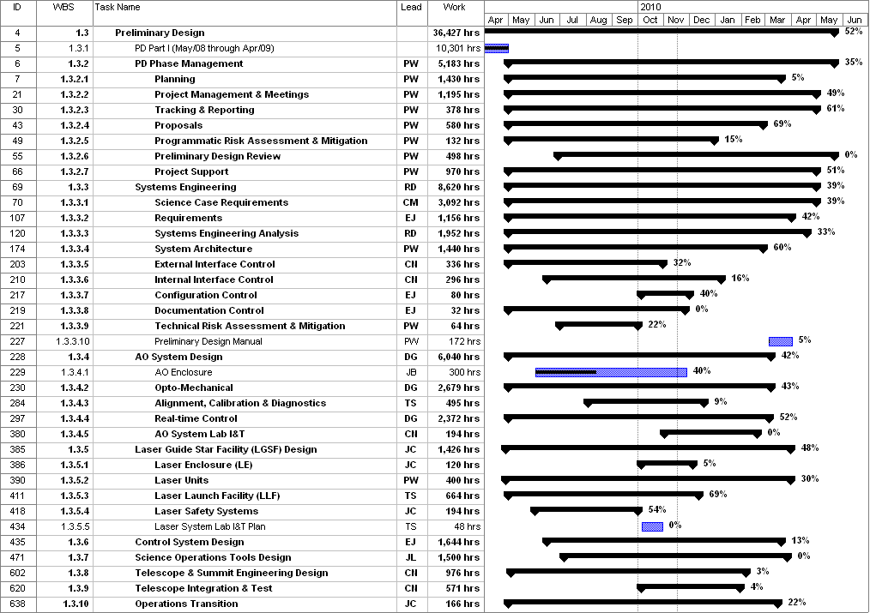
Figure 1: Tracked version of the new PD phase schedule through October 2009

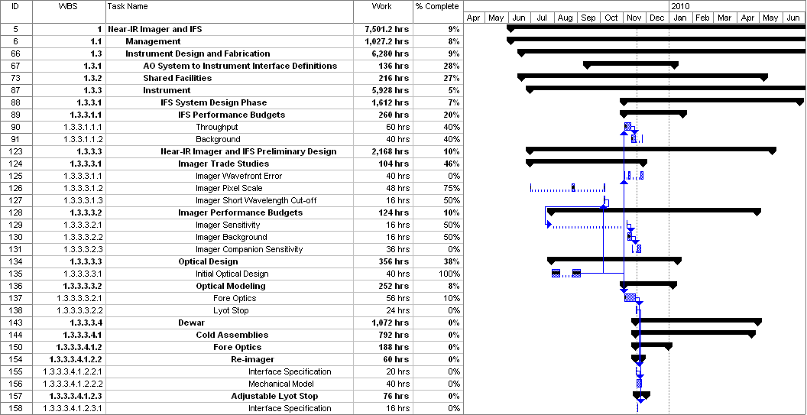
Figure 2: Tracked version of the NGAO Science Instruments schedule through October 2009

Financial Summary

The budget and expenditures to date for year 1 of the NGAO project were provided in KAON 665 (Project Report 13; the year 1 expenditures totaled $729k). The budget, expenditures to date and estimate to completion for year 2 of the NGAO project, which began in May 2009, is shown in Table 3.

Table 3: NGAO PD Phase Expenditure Summary for Year 2 through October 2009

