 Keck Adaptive Optics Note 687

Keck Next Generation Adaptive Optics
Preliminary Design Phase Project Report #17

P. Wizinowich, Sean Adkins and the NGAO Team
October 27, 2009

Narrative

This report is the seventeenth monthly project report for the Preliminary Design (PD) phase in the development of the W. M. Keck Observatory’s (WMKO) Next Generation Adaptive Optics (NGAO) facility. This report covers the PD phase work performed in September 2009.

Please note that the Caltech technical input and percent completes were not available for this report. This information will be included in the next report.

Summary
Management efforts have been focused on proposal writing. The technical team is making good progress on the requirements, software architecture, opto-mechanical design and real-time control design.

Management Status
The PD phase plan presented at the SDR included work under the following management WBS elements through September. The progress in each of these areas is discussed below.

WBS 1.3.2.1 Planning
The preliminary design review date was slipped from April to June, 2010 in the TSIP proposal that was submitted in September. This new date accounts for program slips and funding availability.

WBS 1.3.2.2 Project Management and Meetings
A NGAO presentation was made at the Keck Strategic Planning Meeting. The NGAO science advisory team presenters included Richard Ellis, Mike Liu, Tommaso Treu, and Mark Morris.

WBS 1.3.2.4 Proposals
The TSIP proposal for the completion of the NGAO preliminary design was submitted. Work began on evaluating potential ATI proposals in support of NGAO.

WBS 1.3.2.5 Programmatic Risk Assessment and Mitigation

Technical Status
The PD phase plan presented at the SDR included work under the following technical WBS elements in September. The progress in each of these areas is discussed below.

WBS 1.3.3.1 Science Case Requirements
We continued working on refining requirements for the High-z Galaxy Assembly and Black Holes in Nearby AGN science cases. We also received comments from Lewis Roberts (JPL) on all of the science requirements to date and their flowdown into system level requirements. We spent the last week of this month reviewing these and determining what modifications need to be made. This review process will continue into next month. Next month we also plan to talk with David Law (UCLA) about spectral simulations of high-z galaxies in order to determine what sensitivity/performance is required for the IFU + AO system for sub-categories of high-z galaxy research.

WBS 1.3.3.2 Requirements
The SCRD and SRD (partially) were reviewed and commented on by Lewis Roberts who is being contracted through CIT to review the requirements.

WBS 1.3.3.3 Systems Engineering Analysis
An initial observing uptime analysis has been performed and documented as KAON 684.

WBS 1.3.3.4 System Architecture
The electronics device control architecture document was completed and work began on the overall electronics design for the control system. The content level and flow of the electronics design document has been determined and this document is being filled as we proceed through the electronics design.

A copy of a VxWorks port of the Ice-E middleware (by ZeroC) was received from an open source collaborator and we are working to get it up and running in our VxWorks environment. This will help in our middleware evaluation. Progress has also been made on the design of state machines for the common components in the architecture.

WBS 1.3.3.5 External Interface & 1.3.3.6 Internal Interface Control

WBS 1.3.3.7 Configuration Control

WBS 1.3.3.9 Technical Risk Assessment and Mitigation
The MASS/DIMM installation was completed in September and data is now regularly available. Some minor weather tower issues continue to be worked. The following plot (provided by D. Salmon) shows a comparison between the CFHT dome DIMM (red points) and the new MKAM DIMM (blue points) from its first night of observation. The wind was from the southwest all night. Until 22:00 the CFHT was pointed essentially due west and the agreement between the two DIMMs is excellent. Building wake is a serious source of local seeing for the CFHT dome as seen when the telescope slewed east at 22:00 and then tracked through north to west, where, by around 03:00, the DIMMs once more agree. Live public access for the MKAM data can be found at http://weatherserv.cfht.hawaii.edu:8912.

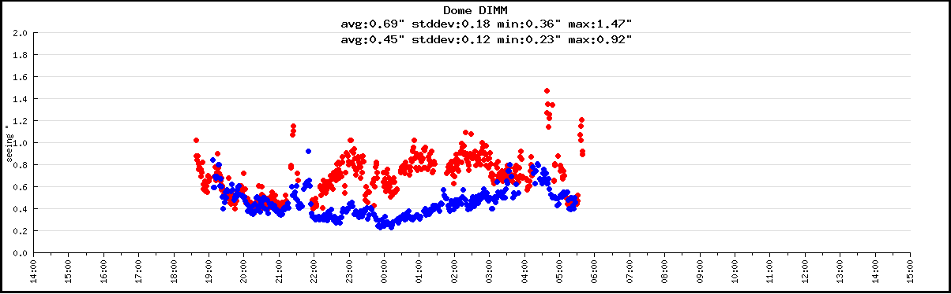

WBS 1.3.4.1 AO Enclosure

WBS 1.3.4.2.3 Optical Relays
Progress continues on developing the mechanical layout of optical components on the Nasmyth platform. The draft AO design report is posted on the NGAO Twiki page (link). Work in September has included:

Progress on the design of an optical feed to the Keck Interferometer Dual Star Module.

The mechanical layout and design is continuing.

The opto-mechanical group has been working closely with the wavefront sensor and instrument mechanical design teams to work out the interface details. The key issues are: the interface between cold space, LOWFS cryo-dewar, and ambient space, the interface with the telescope simulator, and the interface with the acquisition camera. Weekly meeting notes are posted on the AO System Design preliminary design web page.

WBS 1.3.4.2.5 LGS Wavefront Sensor Assembly

WBS 1.3.4.2.7 Low Order Wavefront Sensor Assembly

WBS 1.3.4.2.8 Tip-tilt Vibration Mitigation Analysis
Formula and subroutines for a power spectrum with finite outer scale have been developed for integration with the Simulink model.

WBS 1.3.4.2.9 Acquisition Camera
The acquisition approach was reviewed for operational implications and the design appears satisfactory. The WMKO MAGIQ camera model was provided to UCO for inclusion in AO bench model.

WBS 1.3.4.3 Alignment, Calibration and Diagnostics
Calibration methods were reviewed and notes distributed for comment. The simulator optical design work has started.

WBS 1.3.4.4 Non-real-time Control

WBS 1.3.4.5 Real-Time Control
The in-progress RTC design documentation is posted on the NGAO Twiki page (link). September progress included:
- The design of the tomography engine is complete. This includes the processor layout and the FPGA code definition. We have completed the internal error budgets for tomography computational accuracy and time latency in the processor and provided input to the systems engineering team.
- The external and internal interface definitions are ongoing.
- We have been carrying two options for the frontend video processors: GPUs and FPGAs. A GPU based solution is preferable because of its commercial availability and standardized support. We have reviewed the GPU capabilities and established that it will meet the frontend processing requirements, and are now designing it into the system.
- FPGA physical hardware design tasks have been postponed due to personnel availability. We are planning to do this work using an outside consultant starting later this year (~November) after the architecture for the tomography engine, video frontends, and DM driver backends is roughly 80% established. This approach should allow us to smoothly transition to working with outside vendors for quotes for board manufacturing.
- Work on the backend processors has begun. These backend processors map desired wavefront correction to DM voltages, taking into account the nonlinear influence functions of each DM. We are investigating GPU implementation of these functions also as a desirable cost saving approach.

WBS 1.3.5 Laser System Design

Current Keck II laser enclosure mechanical drawings are being placed into the vault for NGAO. The vault is a file server where drawings are sufficiently mature for collaborative work.

A laser preliminary design progress report was held at the FASORtronics facility and was attended by ESO, TMT, AURA, and WMKO representatives. Good progress was also made in subsequent discussions about how ESO, TMT, and WMKO can jointly select and procure lasers after the PDRs. The TOPTICA and FASORtronics PDRs are scheduled for December 14 and 15 at ESO headquarters.

Since the initial beam generation system (BGS) opto-mechanical design, a second design using smaller and simpler stages has been considered. The advantage of this new design is smaller and lighter mechanical stages on the BGS. The disadvantages are the beams will be smaller with tighter tolerances needed to control the beams, and higher power densities that must be considered. This new design will not be mature enough to be presented in detail at the October 30th mini-review. However, it will be presented as an option. For the review, the team will present the current opto-mechanical design which will meet the requirements. The models are being finalized and generated for the mini-review. Significant effort went into the documentation of the design as well.

Flexure testing was completed on the Keck II telescope. Measurements show that the motion of the beam from the elevation ring to the top structure near the current L4 optic is not more than 2 mm. This validates the beam motion accommodation range of the current opto-mechanical design. A model has been generated showing the optical path layout.

The final launch telescope request for proposals (RFP) documentation for the NSF-MRI funded center launch telescope project on Keck II was prepared and distributed with the help of Richard Haley. A RFP website was set up at http://www2.keck.hawaii.edu/realpublic/K2CLT/index.html for external vendors. Three vendors have confirmed that they will submit proposals in response to the RFP.

WBS 1.3.8 Telescope and Summit Engineering Design
Interferometer modifications are being addressed in the AO bench optical relay design; the current field selector approach being used for the Interferometer upgrade is being incorporated into the design.

WBS 1.3.9 Operations Transition

Science Instruments
Additional material was added to the science instrument concept description document and released as version 3 on September 14 with descriptions of each of the major elements of the design (optical, mechanical, electronics, and software) for both the imager and the IFS. This was reviewed with James Larkin on September 15. Work on the optical modeling by Kupke at UCSC is beginning, although lingering issues with accommodating the Keck Interferometer have taken up some of the time planned for instrument optical design work. Work has also been done on evaluating stock gratings from Newport for the IFS, and a concept is being developed for the grating selection mechanism.

In addition to developing the optical design, work has been done on the analysis of plate scale options for the imager and analysis of predicted imager sensitivity. In October we expect to review science input for finalizing the short wavelength cut-off for the AO system, and to being detailing budgets for key instrument performance parameters related to the optical design including throughput, background, and sensitivity. This will include the participation of James Larkin and Mike Fitzgerald.

Keck Adaptive Optics Notes
All of the NGAO KAONs can be found at:
http://www.oir.caltech.edu/twiki_oir/bin/view/Keck/NGAO/NewKAONs.

The following KAONs were produced in September:
KAON 668, NGAO Device Control Architecture
KAON 683, NGAO Preliminary Design Report #16
KAON 684, NGAO Uptime Allocation

Schedule and Budget Status

Milestones
All of the milestones through June have been completed. The OCD release milestone was completed August, as well as the software architecture portion of the software and controls architecture milestone. The requirements PD release milestone has been delayed to November. The optical relay/switchyard and controls architecture milestones have been delayed to November and December respectively (per Table 2).

Table 1: NGAO PD Phase Milestones

A series of mini preliminary design reviews (see Table 2) were identified in August, including tentative dates and reviewers. These reviews are intended to allow the NGAO team to wrap up and self review the designs for key subsystems in advance of the PDR. The first of these reviews was completed in August.

Table 2: Planned Mini Preliminary Design Reviews

Schedule
A high level snapshot of the tracked version of the new schedule through September is shown in Figure 1 with 48% of the total PD phase work complete (versus 44% complete at the end of August 2009); not including the September work at Caltech (not yet reported).

A tracked version of the Instrument MS Project plan, with a start date of May 1, 2009, is shown in Figure 2 with 6% of the total PD phase work complete (versus 4% at the end of August 2009). This schedule shows the tasks planned for completion through the end of November 2009.

Budget
The total NGAO PD phase budget (from the SEMP) is $3030k excluding contingency; the contingency is $449k. A total of $1302k has been spent through September or 43% of the budget excluding contingency (compared to 48% of work completed).

Anticipated Accomplishments in the Next Period
All of the previously anticipated accomplishments through April have been completed and we have chosen not to list them here (see the April report for this list).

The anticipated accomplishments for May along with their status in italics:
- Complete functional requirements release 1. This will be delayed to September.
- Complete observing operations concept document release 1. Complete.
- Complete the post build to cost replan and start tracking versus this plan. Complete.

The anticipated accomplishments for June along with their status in italics:
- Hold first NGAO Science Advisory Team meeting. Complete.

The anticipated accomplishments for July along with their status in italics:
- Document evaluation of fixed pupil mode design options. Complete.
- Document vibration mitigation work. Complete.
- Complete laser MRI-R² proposal. Complete.

The anticipated accomplishments for August along with their status in italics:
- Complete software architecture design review. Complete.

The anticipated accomplishments for September along with their status in italics:
- Complete TSIP proposal. Complete.
- NGAO presentation at the Keck Strategic Planning Meeting. Complete.

The anticipated accomplishments for October are the following:
- LGS launch facility design review.

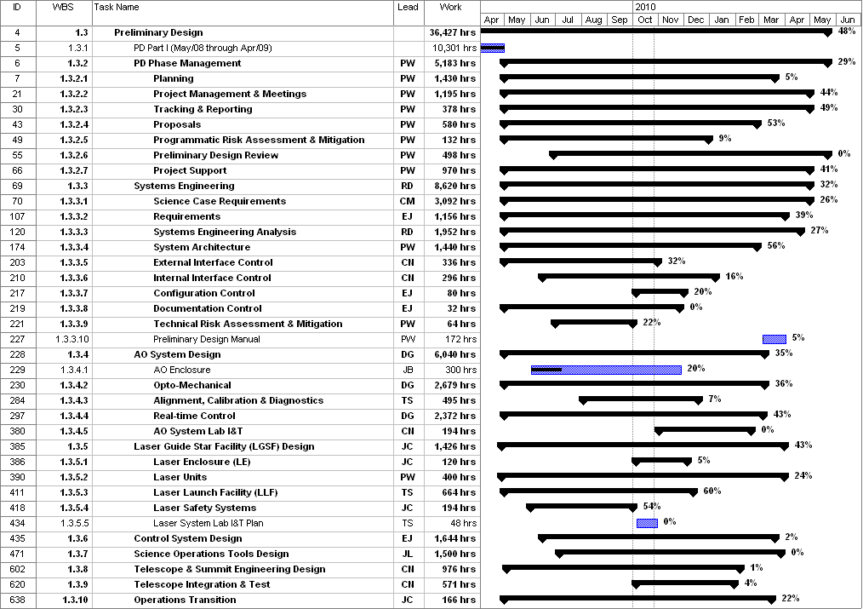
Figure 1: Tracked version of the new PD phase schedule through September 2009

Figure 2: Tracked version of the NGAO Science Instruments schedule through September 2009

Financial Summary

The budget and expenditures to date for year 1 of the NGAO project were provided in KAON 665 (Project Report 13; the year 1 expenditures totaled $729k). The budget, expenditures to date and estimate to completion for year 2 of the NGAO project, which began in May 2009, is shown in Table 3.

Table 3: NGAO PD Phase Expenditure Summary for Year 2 through September 2009

