 Keck Adaptive Optics Note 683

Keck Next Generation Adaptive Optics
Preliminary Design Phase Project Report #16

P. Wizinowich, Sean Adkins and the NGAO Team
September 24, 2009

Narrative

This report is the sixteenth monthly project report for the Preliminary Design (PD) phase in the development of the W. M. Keck Observatory’s (WMKO) Next Generation Adaptive Optics (NGAO) facility. This report covers the PD phase work performed in August 2009.

Summary
Management efforts have been focused on proposal writing. The technical team is making good progress on the requirements, software architecture, opto-mechanical design and real-time control design.

Management Status
The PD phase plan presented at the SDR included work under the following management WBS elements through August. The progress in each of these areas is discussed below.

WBS 1.3.2.1 Planning

WBS 1.3.2.2 Project Management and Meetings

WBS 1.3.2.4 Proposals
The MRI-R² proposal for the implementation of a new Keck II laser was submitted by WMKO. The MRI proposal for the implementation of a Keck II center launch telescope was officially awarded.

WBS 1.3.2.5 Programmatic Risk Assessment and Mitigation

Technical Status
The PD phase plan presented at the SDR included work under the following technical WBS elements in August. The progress in each of these areas is discussed below.

WBS 1.3.3.1 Science Case Requirements
Work continued on refining requirements for the High-z Galaxy Assembly and Black Holes in Nearby AGN science cases. Simulated galaxy mergers are being examined to determine how well the true galaxy morphology can be recovered based on the resolution and signal to noise ratio present in the final data. This will help determine which sub-categories of high-z galaxies are best suited to observation with NGAO. Work is also underway to determine the uniqueness space for black hole mass measurements with NGAO. These tasks, as well as reviewing requirements in the Contour database will continue into next month.

WBS 1.3.3.2 Requirements
Release 1 of the Observing Operations Concept Document was completed and posted as KAON 636.

A draft of release 1 of the PD version of the system requirements document (SRD) was completed and will be released to team members for review in early September.

Good progress continued to be made on the review of the functional requirements. A plan was produced for Lewis Roberts (JPL) to support an overall review of the NGAO requirements.

WBS 1.3.3.3 Systems Engineering Analysis
Elements of the LOWFS sharpening WFE budgets were updated to better annotate the tool for the start of planned tool upgrades to be performed by Mitchell Troy (JPL).

A summary of the error and performance budgets flowdown was prepared in preparation for a September NGAO team meeting. This technical memo addressed inconsistencies in the various flowdown budget assumptions and proposed resolutions to some thirty conflicts.

An Excel flowdown tool has been developed that uses the high contrast wavefront error budget results to constrain the optical quality of relevant hardware components. The results are directly tied to the two related key science cases: detection of planets orbiting low-mass stars and planets orbiting nearby very young stars. Based on rudimentary considerations a recommendation has been made that we look into potentially targeting more distant early-type stars. A preliminary version of a KAON summarizing this work has been written and will be posted once details related to RTC latency and DM hold time are sorted out.

Dekany continued writing a journal submission for the alternative hybrid sodium / Rayleigh LGS sensing scheme developed over the summer in conjunction with student Eduardo Bendek.

Work continued on the code modifications to add MOAO capabilities to LAOS.

WBS 1.3.3.4 System Architecture
The documentation for the software architecture is complete. We held a successful internal review of the software architecture, the main conclusion of which was that the architecture is sound and will support the design and development of a distributed control system for NGAO. We are incorporating feedback and suggestions from the review team.

Update 1 of the motion control architecture document was completed (KAON 643).

WBS 1.3.3.5 External Interface & 1.3.3.6 Internal Interface Control
Draft AO to telescope, interferometer and instrument ICD’s were posted to the NGAO Twiki for review and comments.

WBS 1.3.3.7 Configuration Control
The Keck SolidWorks vault for NGAO mechanical drawings was setup with access to CIT and UCO (some problems with UCO access are being addressed). The NGAO mechanical drawing tree, a living configuration controlled document, was also defined.

WBS 1.3.3.9 Technical Risk Assessment and Mitigation
Good progress continued to be made on preparing for a September summit installation of the MASS/DIMM equipment.

WBS 1.3.4.1 AO Enclosure
The concept for the design is complete. The AO bench layout needs additional detail (especially for the LOWFS and calibration unit) before the start of modeling.

WBS 1.3.4.2.3 Optical Relays
The AO relay optical design, design tolerancing, and the definitions of interfaces to science instruments, wavefront sensor packages, and acquisition system are complete. Progress continues on developing the mechanical layout of optical components on the Nasmyth platform. The in-progress AO design report is posted on the NGAO Twiki page (link).
Progress in August:
- Work has been performed on the design of an optical feed to the Keck Interferometer Dual Star Module.
- The mechanical layout and design has continued, with considerable interaction with the CIT and WMKO teams.
- The opto-mechanical group has been working closely with the wavefront sensor and instrument mechanical design teams to work out the interface details. The key issues we have been dealing with are: volume and heat load of the LOWFS; the interface between cold space, LOWFS cryo-dewar, and ambient space; and optical feed to the interferometer (WBS 1.3.4.2.1 and 1.3.4.2.3). Weekly meeting notes are posted on the AO System Design web page.

WBS 1.3.4.2.5 LGS Wavefront Sensor Assembly
Velur spent 2 days at UCSC to work on defining interface requirements for various WFS’s and cooling systems. Numerous interface definitions and constraints were identified between the AO optical relay and the WFS.

Development of the object selection mechanism (OSM) for the point-and-shoot (PnS) laser wavefront sensor subassembly continued. The crank-and-lever motor mechanism is intended to have reuse within the LOWFS OSM, so the design is proceeding, with both PnS and LOWFS requirements in mind. Currently, the design does not meet the torque ratings of the initial candidate motors, due to excessive side torque arising from higher than expected subassembly mass. Light weighting options for the OSM will be explored in the next iteration.

WBS 1.3.4.2.7 Low Order Wavefront Sensor Assembly
A document was started to compile the information from a LOWFS SPIE paper, CIT work on IR wavefront sensing, the interface requirements and constraints from the NGAO optical relay and the latest error budget spreadsheet. First-order tolerancing was performed for the pick-off mechanism to identify additional specifications. A preliminary level optical system design for the pick-off mechanism that works from 1 to 1.7 μm was developed.

WBS 1.3.4.2.8.1 Tip-tilt Vibration Mitigation Analysis
The vibration report was completed (KAON 680). This report recommends a parametric oscillator approach to vibration reduction. In the review process several modifications to the simulation were proposed to bring the results more in line with assumptions made in the NGAO error budget. This included adding a finite outer scale to the simulation input tilt power spectrum. Still need to provide the appropriate error budget parameters to run as “final” simulation cases. A request was also made to propose a plan for follow on risk reduction experiments for vibration mitigation using the current Keck AO system.

WBS 1.3.4.3 Alignment, Calibration and Diagnostics

WBS 1.3.4.4 Non-real-time Control

WBS 1.3.4.5 Real-Time Control
The in-progress documentation on the RTC design is posted on the NGAO Twiki page (link):
- The design of the tomography engine is about 75% complete. This includes the physical processor layout and the FPGA-code definition. We have made similar progress on defining the internal error budgets for tomography computational accuracy and time-latency in the processor.
- The external and internal interface definitions are ongoing and about 50% complete.
- We are still carrying two options for the front-end video processors: GPU and FPGA. GPU is preferable because of commercial availability and standardized support. The selection decision has been delayed to September, pending additional understanding of the GPU and its implementation of the wavefront reconstruction algorithms.
- FPGA board physical layout has been postponed due to low availability of Michael Peck for this work. We are now planning to do this work using an outside consultant starting later this year (~November), after the architecture for the tomography engine and the video front ends are roughly 80% established. This approach should allow us to smoothly transition to working with outside vendors to obtain quotes for board manufacturing.

WBS 1.3.5 Laser System Design

The focus of this effort was to complete the optical mechanical designs for the laser launch facility in support for the upcoming October 30 design review. Significant effort has gone into developing the launch telescope request for quote (RFQ); the RFQ should be issued during the week of September 14. Note that work in support of the Keck II center launch telescope will be charged to the recently funded NSF MRI grant, but progress will be reported here since it is relevant to NGAO.

Further work was also done on the beam generation system (BGS) for the laser asterism. In the previous design, the motion device selected was too large for the BGS optical bench. A new set of motion devices have been selected. New layouts and drawings are being generated for this design.

Drawings have been generated showing the beam transport optics (BTO) optical path layout. Documentation for the BTO has also started. Flexure testing has been scheduled for September 22 for the Keck II telescope “tube” (the structure that supports the secondary mirror spider above the telescope elevation ring). The BTO will mount to this structure, so the results of this flexure testing will help in determining the requirements for the design.

WBS 1.3.8 Telescope and Summit Engineering Design
A decision was made in consultation with the Interferometer team to support only the focused ASTRA pickoff for the interferometer with no support for the collimated AO output option. Interferometer pick-offs have been put into the AO relay optical design. These modifications were added to the requirements and ICD drafts.

WBS 1.3.9 Operations Transition

Science Instruments
The science instrument concept description document targeted for release this month was nearly complete as the month ended (it was released September 4). The concept document will be reviewed in mid-September with James Larkin and Mike Fitzgerald.

During the month of September we expect to start the optical modeling work by Kupke at UCSC and to begin work on the analysis of plate scale options for the imager with a focus on background limited capability with a minimum of complexity. The issue of the short wavelength cut-off will also receive further attention. Work will also begin on performance budgets for key parameters related to the optical design such as throughput, background, and sensitivity.

Keck Adaptive Optics Notes
All of the NGAO KAONs can be found at:
http://www.oir.caltech.edu/twiki_oir/bin/view/Keck/NGAO/NewKAONs.

The following KAONs were produced in July:
KAON 636, Observing Operations Concept Document (release 1)
KAON 643, Motion Control Architecture Study (release 1)
KAON 679, Control System Software Architecture
KAON 680, Vibration Mitigation
KAON 681, NGAO Preliminary Design Report #15

Schedule and Budget Status

Milestones
All of the milestones through June have been completed. The OCD release milestone was completed August, as well as the software architecture portion of the software and controls architecture milestone. The requirements PD release milestone has been delayed to September. The optical relay/switchyard and controls architecture milestones have been delayed to November and December respectively (per Table 2).

Table 1: NGAO PD Phase Milestones

A series of mini preliminary design reviews (see Table 2) were identified in August, including tentative dates and reviewers. These reviews are intended to allow the NGAO team to wrap up and self review the designs for key subsystems in advance of the PDR. The first of these reviews was completed in August.

Table 2: Planned Mini Preliminary Design Reviews

Schedule
A high level snapshot of the tracked version of the new schedule through August is shown in Figure 1 with 44% of the total PD phase work complete (versus 41% complete at the end of July 2009).

A tracked version of the Instrument MS Project plan, with a start date of May 1, 2009, is shown in Figure 2 with 4% of the total PD phase work complete (versus 3% at the end of July 2009). This schedule shows the tasks planned for completion through the end of September 2009.

Budget
The total NGAO PD phase budget (from the SEMP) is $3030k excluding contingency; the contingency is $449k. A total of $1149k has been spent through August or 38% of the budget excluding contingency (compared to 44% of work completed).

Anticipated Accomplishments in the Next Period
All of the previously anticipated accomplishments through April have been completed and we have chosen not to list them here (see the April report for this list).

The anticipated accomplishments for May along with their status in italics:
- Complete functional requirements release 1. This will be delayed to September.
- Complete observing operations concept document release 1. Complete.
- Complete the post build to cost replan and start tracking versus this plan. Complete.

The anticipated accomplishments for June along with their status in italics:
- Hold first NGAO Science Advisory Team meeting. Complete.

The anticipated accomplishments for July along with their status in italics:
- Document evaluation of fixed pupil mode design options. Complete.
- Document vibration mitigation work. Complete.
- Complete laser MRI-R² proposal. Complete.

The anticipated accomplishments for August along with their status in italics:
- Complete software architecture design review. Complete.

The anticipated accomplishments for September are the following:
- Complete TSIP proposal.
- NGAO presentation at the Keck Strategic Planning Meeting.

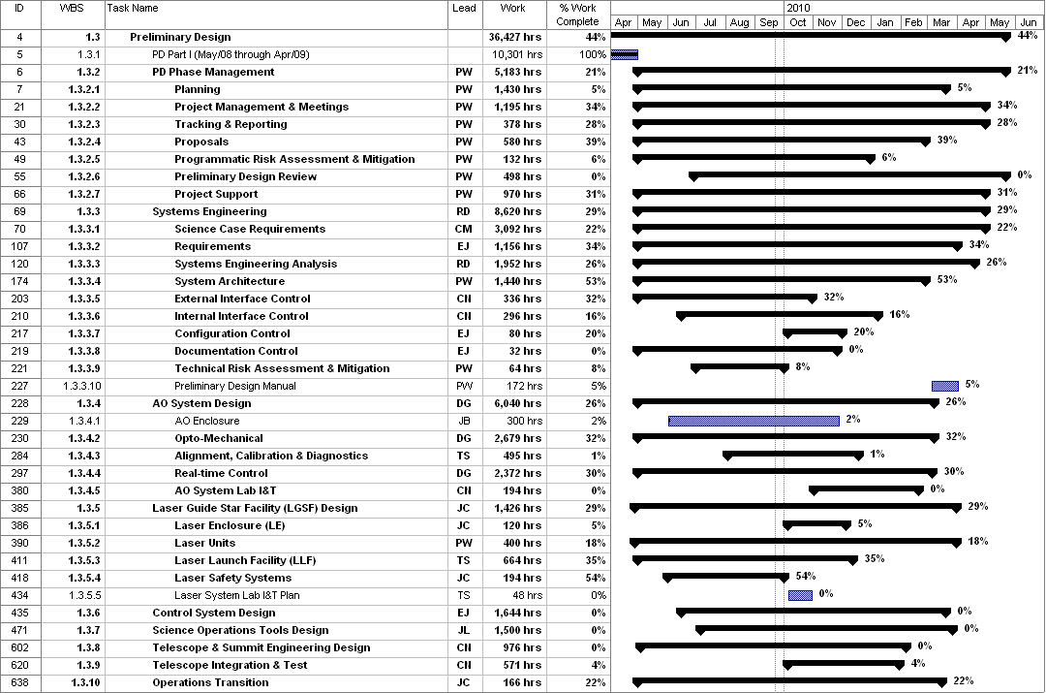
Figure 1: Tracked version of the new PD phase schedule through August 2009

Figure 2: Tracked version of the NGAO Science Instruments schedule through August 2009

Financial Summary

The budget and expenditures to date for year 1 of the NGAO project were provided in KAON 665 (Project Report 13; the year 1 expenditures totaled $729k). The budget, expenditures to date and estimate to completion for year 2 of the NGAO project, which began in May 2009, is shown in Table 3.

Table 3: NGAO PD Phase Expenditure Summary for Year 2 through August 2009

